Statement of Work for Advanced LIGO
HAM ISI Linear Voice Coil Actuators

General Requirements
- The revised large actuator shall be built in accordance with figures 1 and 2 shown
- below.
- Operating environment will be ultrahigh vacuum, 10-8 torr
- Actuators will not include proof masses/flexures, encoders/sensors or bearings/bushings
- (stated as a preference, not a requirement) Preferred voltage range is +/- 25 V, preferred current range is +/- 10 A
- The voice coil assembly shall be capable of being vacuum baked (by the customer) at 170C (non-operating) for indefinite duration (~48 hr.)
- The allowable temperature range of the coil should be at least from 15C to 200C (operating)
- For reference only (not a requirement): The nominal operating conditions are in vacuum at ~23C ± 5C for the large actuator (and ~25C ± 5C for the small actuator) and dissipating < 25 mW rms. Conduction dominates over radiation at these conditions. Operation at the maximum continuous force will be for periods of time considerably shorter than the thermal time constant. If operated continuously at the maximum allowable continuous force, radiation effects would reduce the interface resistances stated below.

General Design and Machining Requirements:
- No castings shall be used for any part of this assembly, machined parts only.
- None of the actuator parts shall have blind holes; if it’s impractical to use a through hole, a vent hole shall be added to vent the volume trapped by assembly (this is for both thoroughness in cleaning and to aid vacuum pump down)
- All tapped holes shall be tapped with a 0.005” oversize tap to reduce the risk of galling in the ultra clean condition
- All screws used shall be silver plated stainless steel, to reduce the risk of galling in the ultra clean condition
- LIGO shall inspect and approve winding process, clean assembly area and assembly procedure before production begins
- Magnet assembly and general assembly should be done in an environment free of metallic objects that may stick to the magnets both to prevent chipping of magnets and to prevent the pretense of extraneous materials in the final actuators
- Shipping screws shall be set in place to prevent the movement of the bobbin in the actuator assembly. Shipping screws should use non-magnetic washers to prevent these washers sticking to the magnets.

Clean room and Clean Handling Requirements:
- Assembly of unit shall take place in a class 10,000 clean room environment
- Good clean room practices shall be used including the use of lab coats, latex gloves, hair cover and facemask.
- Clean room environment shall be inspected by LIGO before assembly begins

Bobbins and Winding:
- Bobbin to be aluminum, with anodized areas limited to where required for electrical insulation
- Bobbin to be machined on all surfaces, then given to Caltech for pre-cleaning prior to winding; clean room gloves to be used for subsequent bobbin handling and winding/curing of adhesive
- Winding direction(s) and magnet placement designed to cancel external dipole moments; the design shall include two counter wound coils
- Wire insulation to be Polyimide-ML, or -HML
- Wire coating to be Polyimide: PI2525 (HD Microsystems)
- PEEK terminal blocks to be used at end of coil wires (AccuGlass part #111851, PEEK Terminal Block - 2 pole)
- Polarity orientation should be consistent on each actuator
- Terminal poles are to be marked +/- using a vacuum compatible marking method (engraving)
- Coils shall be evenly wound on the bobbin and not project out beyond the bobbin edges
- No over-run polyimide may be present on mating surfaces of the bobbin after winding is complete.

Magnet Assembly:
- Magnet material to be SmCo, baked at 177C for 96 hr and then Ni plated to seal surface voids from contamination.
- Care must be taken to avoid chips in magnet edges
- Actuator frame, screws and magnets to be given to Caltech for pre-cleaning prior to assembly; clean room gloves to be used for subsequent assembly, as well as any handling done prior to assembly
- Magnets to be secured mechanically, with no epoxy

Testing and Acceptance:
- Acceptance testing of first article will take place at vendor facility with a LIGO representative
- Visual inspection of all requirements and standards listed above will be performed by LIGO before acceptance of each unit; QA for interface dimensions and workmanship inspection
- Vendor shall perform high-pot testing of coil
- Acceptance testing includes of functional and performance testing (centered and at X & Y maximum offsets)
- Testing will also include (insert Fabrice's test plan here)
- Customer acceptance testing includes vacuum compatibility testing. All testing and liability with regard to compatibility with the LIGO vacuum system is the E070147-00-D customer's responsibility. The Manufacturer is only required to adhere to approved materials and processes.

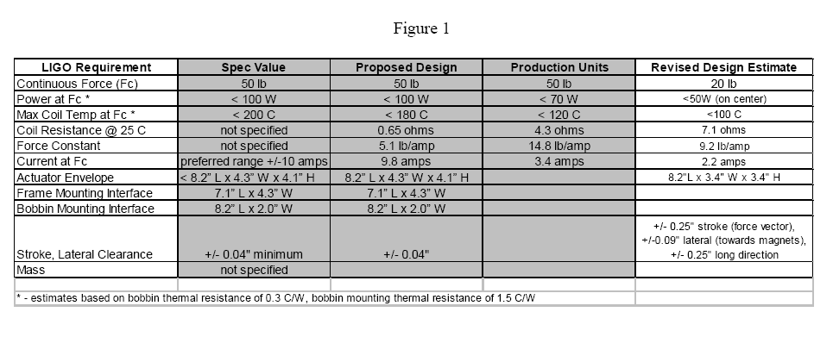

Figure 2
