LASER INTERFEROMETER GRAVITATIONAL WAVE OBSERVATORY
- LIGO -
CALIFORNIA INSTITUTE OF TECHNOLOGY
MASSACHUSETTS INSTITUTE OF TECHNOLOGY

LIGO-E0900047-v21 25 Feb 2013

aLIGO Contamination Control Plan

B. Bland, J. Fauver, M. Heintze and C.Torrie for LIGO
D. Coyne, editor

Distribution of this draft: LIGO Observatory Staff

This is an internal working note
of the LIGO Project.

California Institute of Technology  LIGO Project - MS 18-34  Pasadena CA 91125  Phone (626) 395-2129  Fax (626) 304-9834  E-mail: info@ligo.caltech.edu  WWW: http://www.ligo.caltech.edu/ | Massachusetts Institute of Technology  MIT LIGO Laboratory  NW 22-295  185 Albany Street  Cambridge, MA 01239  Phone (617) 253-4824
LIGO Hanford Observatory  127124 North Route 10  Richland, WA 99354  Phone (509) 372-8106  Fax (509) 372-8137  E-mail: info@ligo.caltech.edu | LIGO Livingston Observatory  19100 LIGO Lane  Livingston, LA 70754  Phone (225) 686-3100  Fax (225) 686-7189  E-mail: info@ligo.caltech.edu

CHANGE RECORD
Revision | Date | Authority | Description
V15 | 03 Jan 2012 | See DCC record | -Clean and Bake requests should be submitted through the Ticketing System  -Contamination Sensitive areas at CIT, MIT, LHO, LLO defined and clarified  -Garb user responsibilities emphasized  -Checklist for cleaning and staging a cleanroom added  -Clarification of requirement to garb after Phase 2 cleaning  -Acetone use in contamination sensitive areas restricted to trained staff
V16 | 25 June 2012 | See DCC record | -Foil related issues clarified including use of clean C-3 as an alternative  -Computer use in clean spaces/contamination sensitive spaces outlined and clarified  -Two wipes added to Section 4  -Best Practices added (Section 7)  -CTI gloves removed from Appendix 1due to particulate issues  -Appendix 1 updated with links etc. (There is still some work to do on this but I wanted to get the update posted ASAP. I will continue to fill in the gaps and re-post when the details are complete.)
V17 | 28 Nov 2012 | See DCC record | -The use of Garbing Rooms is emphasized as it is a REQUIREMENT  -Further clarification of Phase 1 and Phase 2 Cleaning of softwall cleanrooms  -Clarified staging of Class A-Class B parts  -Acetone/isopropanol wipe-downs  -MORE foil clarification  -Top down cleaning emphasized  -Guidance on returning C-3 covers to open chambers  -Sticky mats to be used in/at all cleanrooms, especially around optics  -Vectra Alpha 10 wipes to be used for any in-chamber wipe downs post-SEI install  -Solvent contamination  -Technical cleaning periodicity updated  -Additions to Section 7: Best Practices  -Section 8: Dust Removal added  -Section 9: Fasteners added  -Appendix 1: Beginning 01 January 2013, Contamination Control Supplies will be acquired under a consolidated contract system. Please see list for approved items. If you need something that is not on the list, let Calum/Jodi/Rich R. know so that we can start work on the required approval process.
V18 | 04 Dec 2012 | See DCC record | -M. Heintze added as author  -Table 1 reformatted  -3 sections added: Chamber Entry/Cleaning/Exit Checklist, Contamination Control Q & A, and Contamination Control Working Group  -Information about Gloves (expanded), Garb (expanded), Solvents and Wipes consolidated to Section 4: Specific Work Practices  -Table 4 reformatted  -Wipes used for dust removal should be wetted with isopropanol: dry wipes should not be used for this purpose.
V19 | 31 Jan 2013 | See DCC record | -Added information to Background and Scope  -Moved information about C-3 to front of document  -Added “The four states of bunny”  -Added section on veils  -Table 1:Location dependent Garb Requirements removed  -Table 1: LHO Specific Garb Requirements-Activity driven added  -Table 2: LLO Specific Garb Requirements-Activity driven added  -Added information on Nitrile inner gloves for those with latex allergy
V20 | 06 Feb 2013 | See DCC  record | -Minor changes
V21 | 21 Feb 2013 | See DCC record | -Pictures added  -Tables renumbered  -Change room to LVEA garb requirements clarified  -Cleanroom traffic flow clarified

Contents
Contents 4
1. ABSTRACT 5
2. BACKGROUND AND SCOPE 6
3. C-3 GARB AND COVERS 7
3.1. The Four States of “Bunny” 8
3.3. Donning Garb aka Getting Dressed 12
3.4. Doffing Garb aka Getting Un-dressed 12
3.5. Preserving Garb Clean for Later Use 13
3.5. Sorting Garb for Laundry Service 13
3.6. Dispositioning Unacceptable Garb 13
3.7. Garb Change-out Guidelines 13
3.8. Door, Dome and Specialty Covers 14
4.1. Work Activity Drives Garb Requirements 14
5. CONTAMINATION-SENSITIVE HARDWARE 16
5.1. CLASS A Hardware 16
5.2. CLASS B Hardware 17
5.2.1. CLASS B Tools 17
5.2.2. “Class B” Specialty Tools 17
5.3. Washer and oven use 18
5.4. Handling CLASS A and CLASS B Parts 18
5.4.1. CLASS A touching CLASS B and beyond 18
5.4.2. Removing CLASS A and CLASS B from bags 18
5.4.2.1. Preparing to Un-Wrap Clean Items 19
5.4.3.1. Procedure for Un-Wrapping Clean Items 19
5.5. History of UHV foil 20
5.5.1. Shear, don’t tear UHV foil 20
5.5.2. Maintaining Cleanliness 20
5.5.3. No Re-use of UHV foil 20
5.6. Special note on handling C-3 20
5.7. Special note on Work Surfaces 21
5.7.1. Cleaning Work Surfaces: Stainless steel/granite tables, aluminum plates 21
5.7.2. Periodic checks on cleanliness 21
6. GENERAL PRACTICES 22
6.1. Staging Portable Clean Room Enclosures 22
6.2. Cleaning Areas aka Transitional LVEA 23
6.3. LVEA 24
6.4. Garb rooms 24
6.5. Particle counting 25
6.6. Items allowed in cleanrooms 25
6.7. Computers 25
6.8. Unattended Hardware 26
7. SPECIFIC WORK PRACTISES 26
7.1. UHV Gloves 26
7.1.1. Choosing the Right Glove 26
7.1.2. The Layered Approach 26
7.1.3. Change, Change, Change… 27
7.2. Solvents 27
7.3. Wipes 28
8. MAINTENANCE OF CONTAMINATION SENSITIVE AREAS 29
8.1. Sensitive Areas 29
8.2 Recommended sequence for cleaning 29
8.3 Recommended Cleaning Frequency 29
9. BEST PRACTISES 30
9.1. Beware of “The Shedders” 30
9.2. Work-Appropriate Personal Hygiene 30
9.3. Practices/tools that help reach cleanliness target 31
9.3.1. General Practices 31
9.3.2. Tools 31
9.4. Work tidy, work clean 32
9.5. Fasteners 32
10. Dust Removal and Contamination Control links 33
10.1. Dust generated during assembly, install, and commissioning 33
10.2. Cleaning on-the-go 33
10.3. Wiping Class A in-vacuum components 33
10.4. Customized cleanroom vacuum cleaners for use on Class A in-vacuum components 34
10.5. Contamination Control Q&A Wiki 34
10.6. Contamination Control Working Group (and Wiki) 34
10.7. Contamination Control Q&A Wiki 35
11. ALIGO Chamber Entry/Cleaning/Exit Checklist 35
12. PROCUREMENT AND DISTRIBUTION OF CONTAMINATION-CONTROL SUPPLIES 35

Appendix 1 Contamination Control Supplies and Clothing………………………………….37

ABSTRACT
The LIGO interferometers are extremely sensitive to optical scattering or absorption losses induced by both particulate and hydrocarbon contamination. In order to minimize the likelihood of contamination on optical surfaces and fused silica fibers, numerous operational practices have been implemented at the LIGO Observatories. The major purpose of this document is to standardize these operational practices as a reference for observatory staff and visitors. It is expected that this document will be continuously updated as we gain experience with the new interferometer hardware and as practices evolve in the new era.

Contamination control should be considered as important almost as laser safety. If you don’t have experience using garb or if you have concerns about you competency where contamination control is concerned please ask.

BACKGROUND AND SCOPE
Contamination control is a concern during all phases of a LIGO part’s life cycle. All LIGO-approved materials/parts (commercial and custom designed) must undergo vacuum out-gassing and contamination evaluation to ensure compatibility with operation in high-power laser cavities within UHV systems. Fabricators must use approved materials for making parts. Vendors must wrap and ship parts cleanly. LIGO cleaning procedures are designed to robust specifications that provide parts with no or very little hydrocarbon and/or particulate contamination. Most cleaned parts are vacuum baked and RGA scanned to ensure reduced hydrocarbon levels. The few parts not vacuum baked are FTIR sampled and then air-baked at the maximum allowable temperature. Parts are removed from ovens to special cleanrooms for a defined wrap-bag-tag process that maintains a stringent level of cleanliness. If wrapped parts require storage prior to assembly, they are stored in clean space.

However, all of the precautions and efforts outlined above are wasted if clean and bake staff, technical cleaners, assemblers, installers, commissioners and visitors do not understand and practice good personal contamination control behavior. When handling UHV parts, our cleanliness target is ISO 5/Class 100 cleanroom levels= 100 particles >0.5 microns in size per cubic foot of air. This is easy to achieve when there are no humans present but hard to do when humans are performing work. The largest source of contamination is introduced by workers, their clothes, or items that they transport into contamination-sensitive areas. Since this is the case, LIGO has always taken measures to mitigate human contamination but these measures have not been standardized, implemented, or enforced systematically across all applicable facilities/observatories. To achieve the potential for aLIGO sensitivity, robust contamination control policies/procedures must be standardized, implemented and enforced systematically. Contamination control must become something that is considered and integrated into the everyday work life of those LIGO employees involved in cleaning, assembling, installing and/or commissioning aLIGO components.

The goal of this document is to provide standardized project-level approved contamination control practices and procedures for parts/assemblies that will reside within the ultra-high vacuum (UHV) systems of LIGO interferometers. Implementing and enforcing these practices and procedures will provide reasonable assurance against the inadvertent introduction into the LIGO vacuum envelope of material which could contaminate optics and/or produce excess phase noise by forward scattering, for examples of contaminates in the vacuum system refer to Figure (1) below. Practices and procedures that deviate from this document should be discussed with and vetted by a vacuum or system engineer prior to adoption.

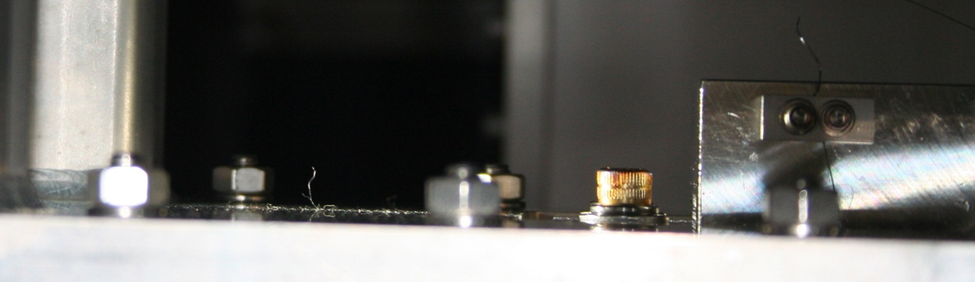
(a)
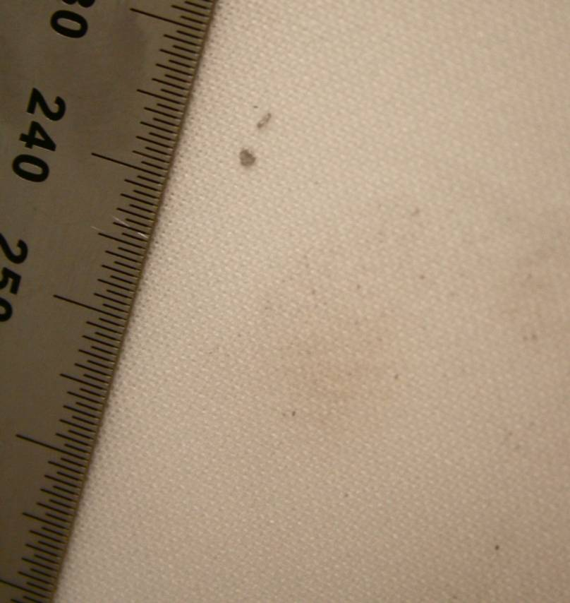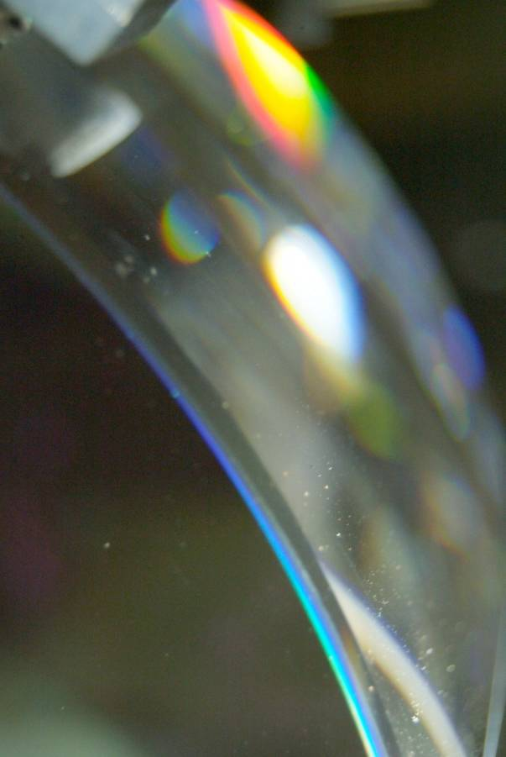

(b) (c)

Figure (1): - (a) Fiber (hair?) on optics cage-in chamber, (b) and Particulate from bottom of chamber (c) Particulate from glove on ETM

C-3 GARB AND COVERS
C-3 fabric (white polyester with a gray electrostatic-dissipative grid) is specially designed to contain the particulates and hydrocarbons generated by the human body and has long been LIGO’s choice for controlling this contamination. (Note: Investigation into the effectiveness, break-down, and possible replacement of C-3 is ongoing.) However, C-3 is only effective if the humans who wear it take care of it appropriately. The outside of C-3 garments should not come in contact with your skin or everyday clothes. Sweaters, jackets coats should not hang next to your C3 grab and ideally should not be in the change room to begin with. In addition and as another example, if you tie your coverall sleeves around your waist so that you can do a couple of chores outside of the cleanroom, you SHOULD NOT re-use that coverall for assembly or install work because the exterior of your coverall sleeves has been contaminated by being in contact with your “dirty” shirt/pants.
In addition, how humans put garb on and how they treat it when they take it off makes a significant difference in cleanliness. Please see the sections below for further detail on donning (putting garb on appropriately), preserving garb clean for later use, doffing (taking garb off appropriately), sorting garb for laundry service, dispositioning unacceptable garb, change-out guidelines, and issues associated with covers.

The Four States of “Bunny”
C-3 coveralls are routinely referred to as “bunny suits” so an easy shorthand to describe garb configurations is to define what kind of “bunny” you mean. (Note that C-3 garb is launderable and is supplemented by a variety of disposable items for hygienic or cleanliness reasons.) At LIGO, there are four acceptable garb configurations or states of “bunny” and they are described below in table 1.

There are a variety of work activities at the Observatories and each activity has minimum garb requirements. If you have any doubt about which “state of bunny” you should wear for a particular activity, “trade up” to the more stringent garb configuration.

Table 1: The Four States of “Bunny”
Description of Garb
Garb Type | Description of Items Available at LHO
Bouffant Cap | Launderable (LBC) or Disposable (DBC)
Veil | Disposable, with headband
Gloves | Ansell Accutech, 2 sets with outer gloves changed regularly for cleanliness (for back up gloves see appendix 1)
Hood (old LHO) | C-3 with snaps down the front
Hood (new LHO) | C-3, one-size-fits-all pullover with adjustment snaps in back
Hood (LLO) | C-3, pull-over with built-in mask *
Coveralls | C-3, sizes small, medium, large, extra-large
Assembly boots | C-3 with Hypalon sole
In-Chamber boots | Taffeta with Herculite soles
Mask | Disposable, surgical type with ear loops
Frock | C-3 with raglan sleeves, knit cuffs and zipper
Shoe covers | C-3 with ChemStat soles
Dedicated shoes* | Non-scuffing soles, cleanliness maintained by wearer
Minimum Garb for Specific Activities
“Full Bunny” Plus (See Figure 2 below)
aka In Chamber means you should wear Bouffant cap (DBC), veil / mask, gloves, hood, coveralls, assembly boots, in-chamber boots
_
“Full Bunny” (See Figure 3 below)
aka Full Garb means you should wear a Bouffant cap (DBC), veil / mask, gloves, hood, coveralls, assembly boots
_
“Skinny Bunny” (See Figure 4 below)
aka Partial Garb means you should wear a Bouffant cap (LBC or DBC), mask, gloves, frock, shoe covers or dedicated shoes
_
“No Bunny” (See Figure 5 below)
means you should wear shoe covers or dedicated shoes **
* If the built-in mask does not conform to the wearer’s face then the wearer must have a mask or a veil under the built-in mask.
** Dedicated clean-area shoes can be worn instead of the Overshoe Covers. It is the responsibility of the wearer to ensure that the dedicated clean-area shoes are kept clean. These shoes should be kept in the garb rooms or maybe transported between buildings in a plastic bag.

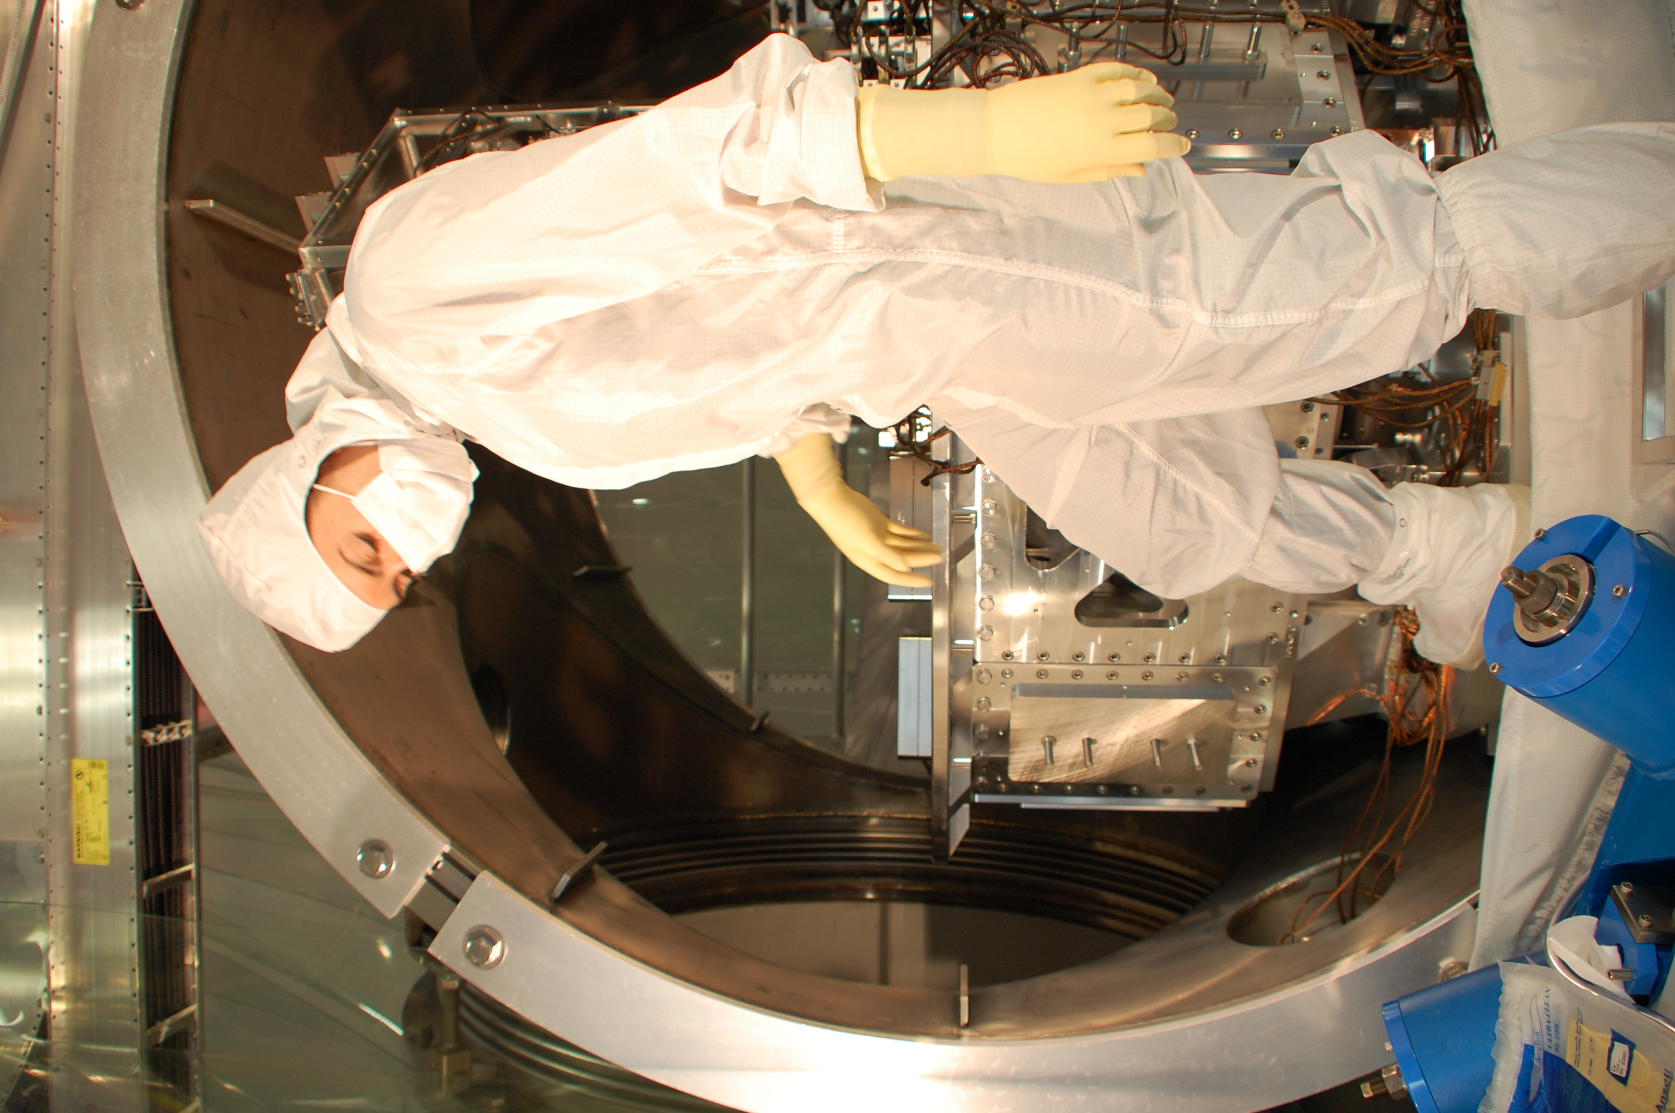  Figure 2: Model is shown in “Full Bunny” Plus (Bouffant cap, veil / mask, gloves, hood, coveralls, assembly boots, in-chamber boots) | 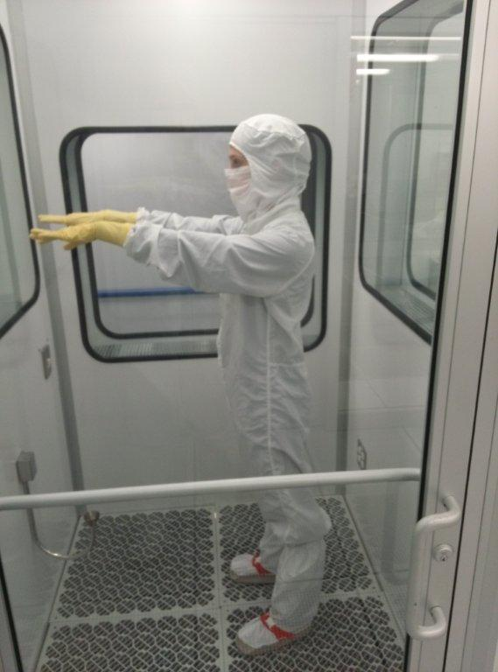  Figure 3: Model is shown in “Full Bunny”  ( Bouffant cap, veil / mask, gloves, hood, coveralls, assembly boots)
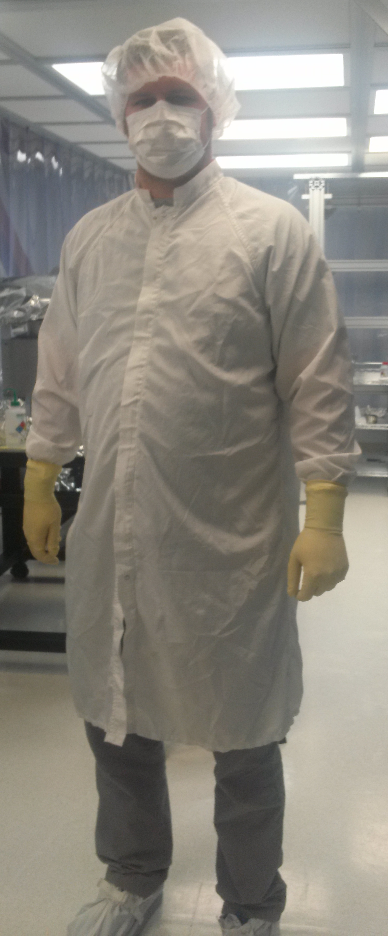  Figure 4: Model is shown in “Skinny Bunny”  (Bouffant cap, mask, gloves, frock, shoe covers or dedicated shoes) | 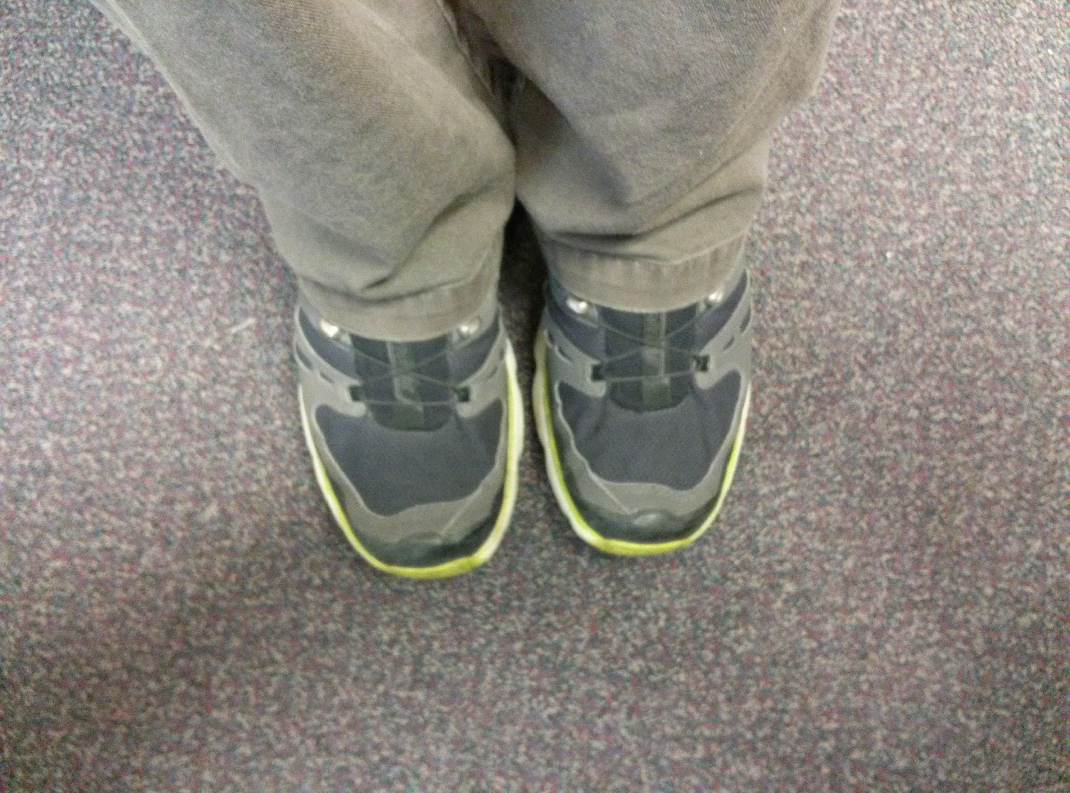  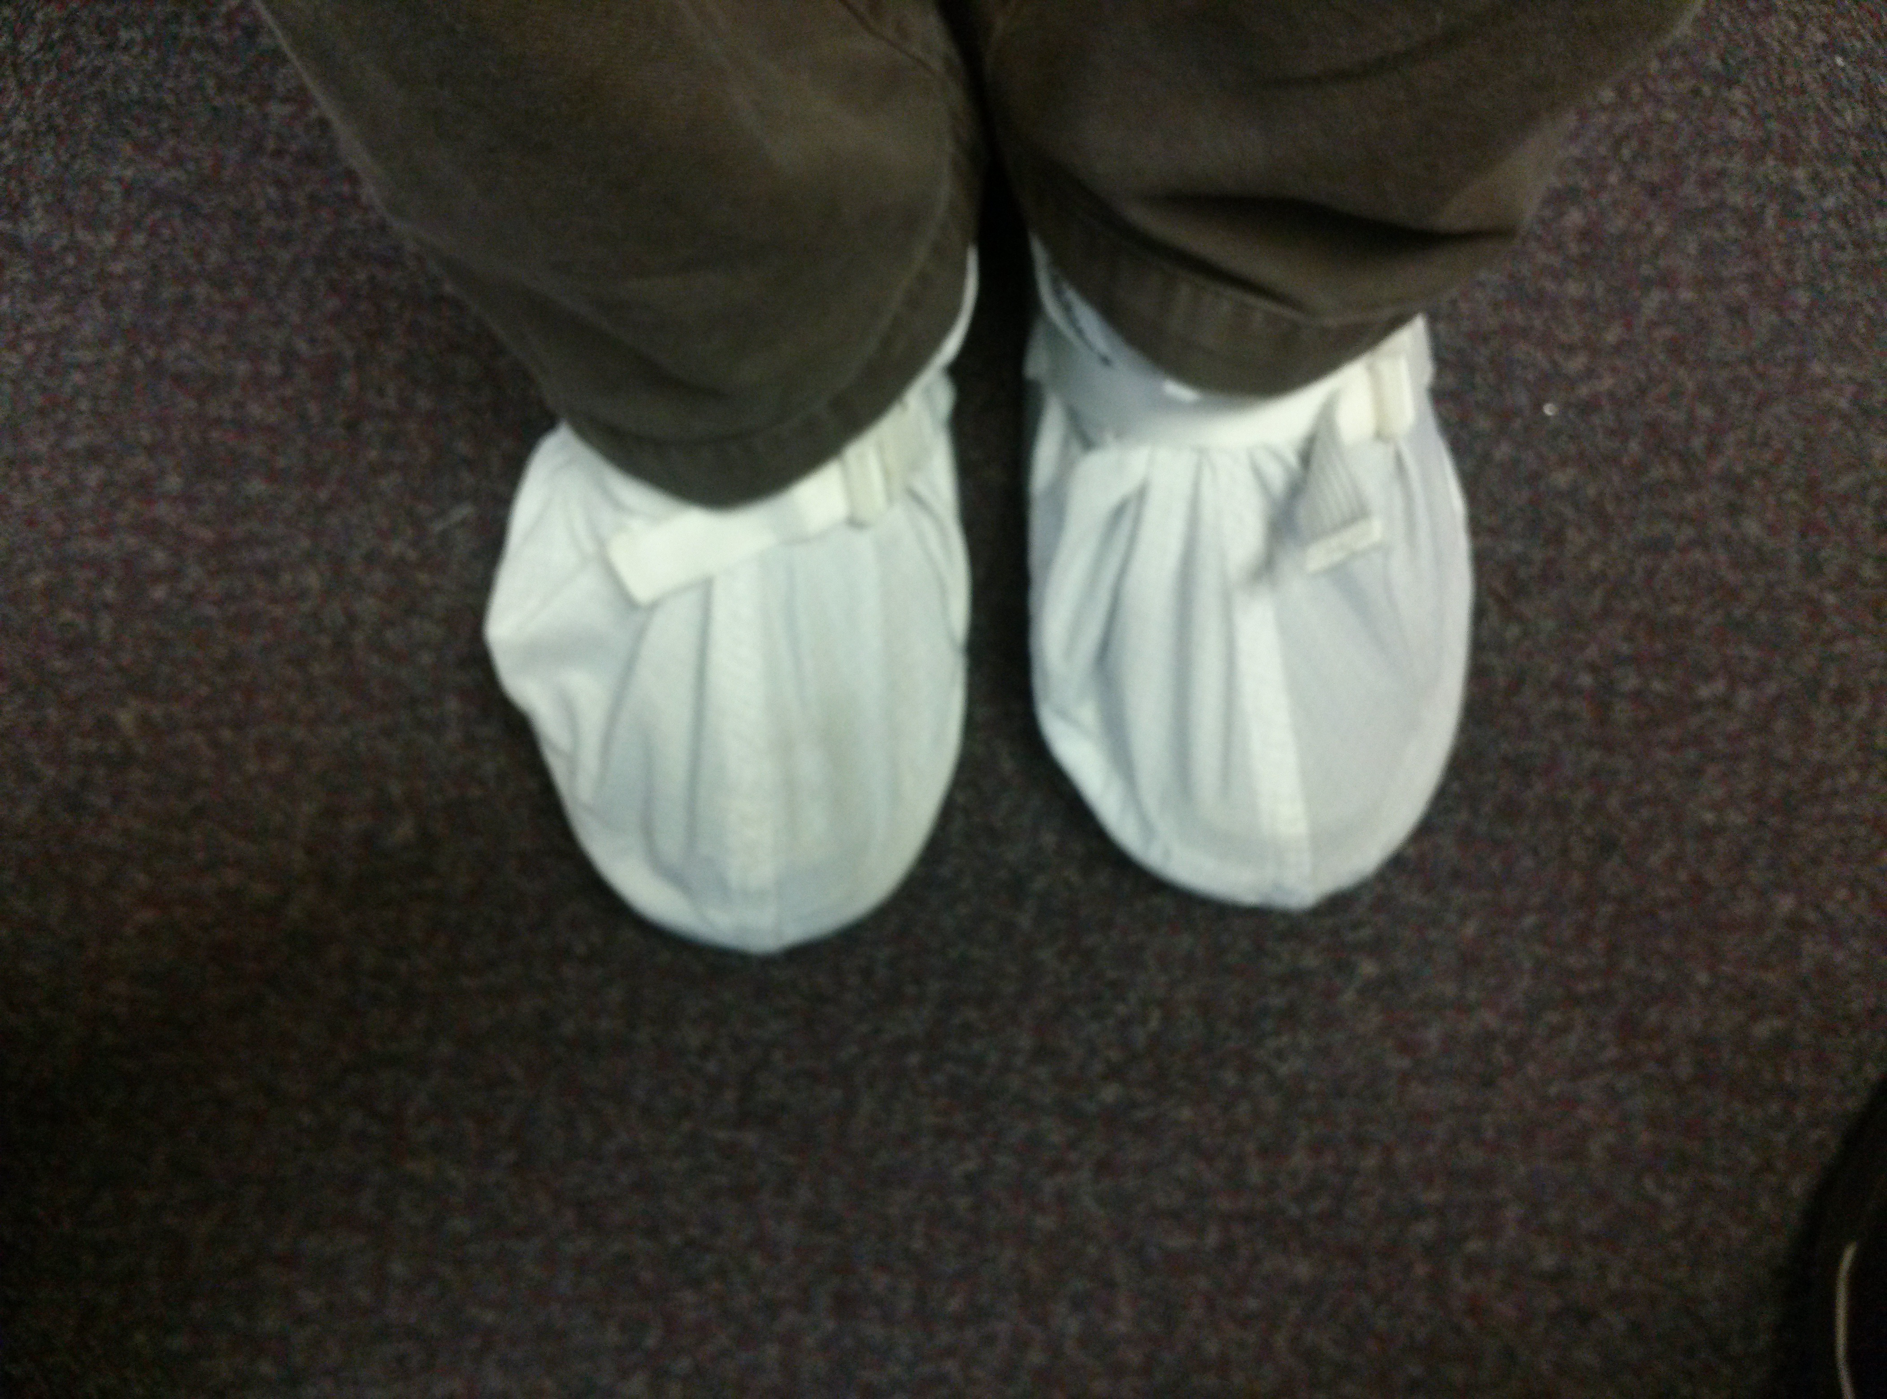  Figure 5: Model is shown in “ No Bunny”  (Shoe covers or dedicated shoes)

  - Why Veils?
Veils provide better coverage of face and neck areas than surgical masks do. Veils are encouraged for use regardless of the hood design for the following reasons: -
- The personal face veil is a single-use product designed as a hygienic alternative to face-mask provided as part of existing laundered hood.
- A covered nose piece allows these veils to conform to the nose and cheekbones, which eliminates the drooping that can occur with existing laundered hood, particularly if your head doesn't conform to the hood sizes available.
- The veil is constructed of low-linting apertured polyethylene film to provide filtration and minimize contamination.
- The veil provides exceptional breathability.
- The veils are 13" wide by 15" long Recommended for ISO Class 7 or higher cleanroom environments
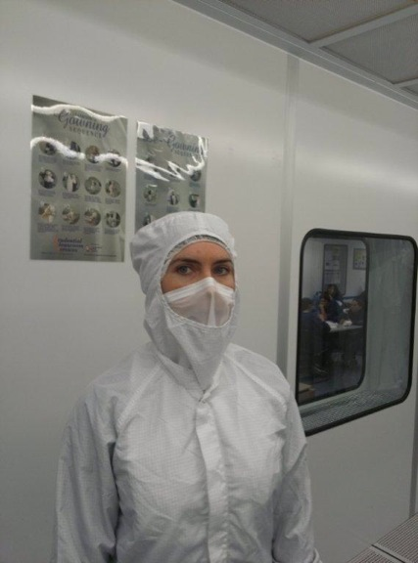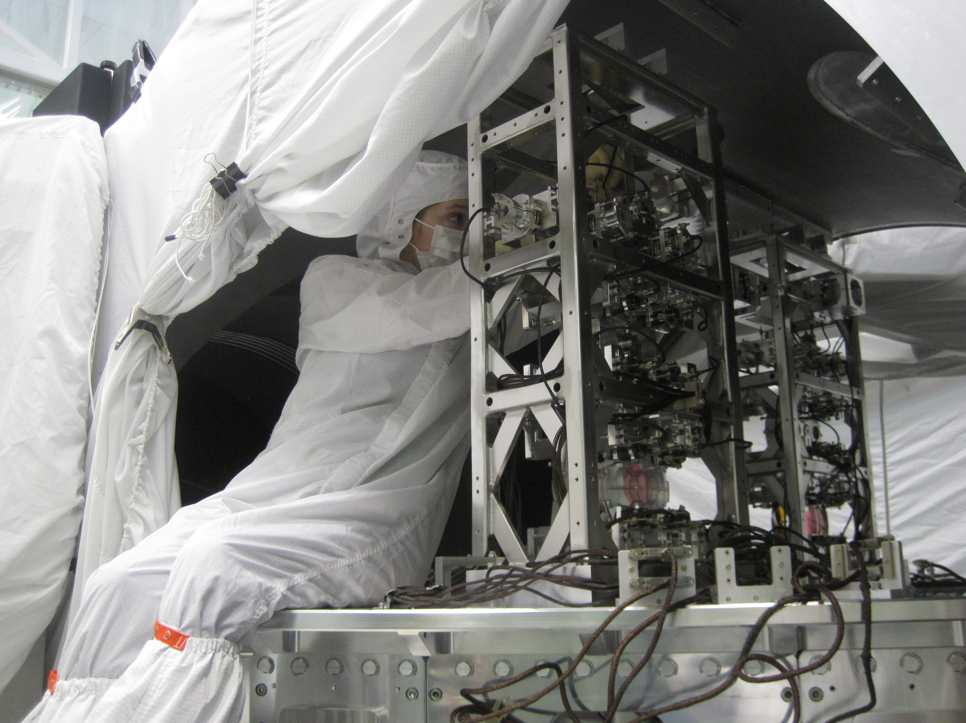
  - (b)
Figure 6: Mode is shownl in both veil (a) and mask (b) configuration. It is clear from the photographs which one offers the most coverage.
However, as per table 1 if e.g. a LLO hood conforms to your face then one can choose not to use the veil. Similarly if one has a preference for the mask (due to comfort) then that too is fine.

Donning Garb aka Getting Dressed
There is an advisable method of donning cleanroom garb and it should be followed to minimize the chances of contaminating garb. Try to garb from top to bottom to avoid contaminating the garb by shedding from exposed upper body parts. Put on mask and bouffant cap before inner gloves so that the gloves are clean when touching C-3 items.

For partial garb (aka ‘skinny bunny”) the order is as follows:
- mask,
- bouffant cap,
- frock
- and then shoe covers or dedicated shoes.

For full garb (aka “full bunny”) the order is as follows:
- mask or veil,
- bouffant cap,
- glove liners (optional),
- inner gloves,
- hood,
- coveralls,
- boots,
- and outer gloves.

If work requires entry INTO a chamber, then special In-chamber boots must be worn. They should be put on at the door of the chamber and they should not come in contact with anything but the vacuum chamber interior.

Doffing Garb aka Getting Un-dressed
There is an advisable method of removing garb and it should be followed to minimize the contamination load of the garb. Start from the bottom and work your way up. If you have been in-chamber, remove in-chamber boots at the chamber door and set them aside: DO NOT PUT THEM ON FLOOR.

Move to the garbing room and use the following sequence to remove garb:
- assembly boots,
- coveralls,
- hood,
- bouffant cap,
- mask or veil,
- and gloves.

Preserving Garb Clean for Later Use
Garb that has not become “dirty” during use may be preserved clean for later use if it has not reached the guideline limits outlined in Section 4.2.6. If the coverall exterior has touched something “dirty”, then it should not be re-used. As mentioned in the previous section to preserve garb clean, start de-garbing from the bottom and work your way up towards the head: this keeps contaminants from the upper body from shedding onto the garb on the lower parts of the body. For example, if you uncover your head first, then contaminants from your head are going to rain down on your coverall and you SHOULD NOT re-use the coverall. Hang garb to be preserved clean on provided racks with coverall and hood exteriors touching like surfaces. Garb may also be preserved clean in clean plastic bags as long as proper precautions are taken.

Sorting Garb for Laundry Service
Dirty garb is routinely sent out for cleanroom laundry service. LIGO’s garb laundry vendor, Prudential, has stringent contamination control protocols in place and we try to help by sorting garb like their protocols specify. C-3 items should be sorted into two categories/baskets/bags: “dirty” (footwear that touches the floor) and “clean” (all other items). Footwear that touches the floor is very dirty compared to any other C-3 items and is laundered in dedicated washing machines because otherwise they make everything else as dirty as they are. They are also washed for a longer period of time than other garb types because of their higher contaminant load. Keeping the “clean” C-3 away from the “dirty” C-3 reduces our overall contaminant load.

Dispositioning Unacceptable Garb
If you are donning or doffing garb and you find any of the following, please remove the item from service and take it to the appropriate person at your earliest convenience.
- Holes or tears
- Split seam
- Frayed edges or hanging threads
- Stains
- Embedded particulate on soles
- Broken zipper
- Anything that worries you

The appropriate person to receive unacceptable garb at CIT contact Bob Taylor, at LHO contact Jodi Fauver and at LLO contact Rich Reisen. The garb will be inspected, set for remediation or repair if possible, or removed from service.

Garb Change-out Guidelines
Users are responsible for getting fresh garb at appropriate intervals. Rough cumulative durations for use before laundering are as follows:

- Frocks: 16 hours (less if working in dirty or strenuous conditions)
- Bouffant Caps: 8 hours
- Overshoe covers: 8 hours (unless inspection shows particulates or soiling)
- Coverall/Hood: 4-8 hours, depending on work conditions
- Cleanroom Boots: 4-8 hours, depending on work conditions
- In-Chamber Boots: 4-8 hours, depending on work conditions

Door, Dome and Specialty Covers
In iLIGO, C-3 covers were mainly used for chamber doors and BSC domes. aLIGO has developed many specialty C-3 covers including those for ISIs and suspensions. C-3 covers should be treated like coveralls. That means they may be reused if they are preserved clean, they get sorted for laundry service with the “clean” C-3, they should be changed-out regularly, and they should pulled from service if you notice damage.

- WORK IN CONTAMINATION-SENSITIVE AREAS
All LIGO sites (CIT, MIT, LHO, LLO) have contamination-sensitive areas. Contamination- sensitive areas are locations where personnel will be working in the vicinity of unwrapped Class A or Class B hardware, including chamber interiors. (See Section 5 below for the definition/ description of Class A/B hardware.) All of these areas have HEPA-filtered air supplies and access is restricted to those wearing the required garb described below. People are also required to follow the procedures for handling and working in the vicinity of contamination-sensitive hardware as described in Section 5 of this document.

The contamination-sensitive areas at CIT and MIT are outlined below.
- At CIT - Vacuum Prep/Vacuum Bake Oven lab, Wrap-Bag-Tag space and all clean rooms
- At MIT - Large and auxiliary clean rooms
- At LHO and LLO Corner Stations:
  - Fiber pulling spaces
  - Welding/Bonding spaces
  - Optics Labs
  - Vacuum Prep-Vacuum Bake Oven spaces (including VPW)
  - SEI-SUS Assembly Areas
  - Active Clean Storage Areas
  - Laser and Vacuum Equipment Areas (LVEA)
  - All softwall cleanroom enclosures
- At LLO and LHO End Stations:
  - Cleaning Areas
  - Vacuum Equipment Areas (VEA)
  - All softwall cleanroom enclosures

Work Activity Drives Garb Requirements
The following tables summarize the minimum garb requirements for contamination sensitive work at the LIGO Observatories. The tables start with the most sensitive activities (most stringent garbing requirement) and end with the least sensitive activities (least stringent garbing requirement). Table 1 shows LHO’s specific garb requirements and Table 2 shows LLO’s specific garb requirements.

Table 2: Specific Garb Requirements
Description of Garb
Garb Type | Description of Items Available
Bouffant Cap | Launderable (LBC) or Disposable (DBC)
Veil | Disposable, with headband
Gloves | Ansell Accutech, 2 sets with outer gloves changed regularly for cleanliness
Hood (old LHO) | C-3 with snaps down the front
Hood (new LHO) | C-3, one-size-fits-all pullover with adjustment snaps in back
Hood (LLO) | C-3, pull-over with built-in mask *
Coveralls | C-3, sizes small, medium, large, extra-large
Assembly boots | C-3 with Hypalon sole
In-Chamber boots | Taffeta with Herculite soles
Mask | Disposable, surgical type with ear loops
Frock | C-3 with raglan sleeves, knit cuffs and zipper
Shoe covers | C-3 with ChemStat soles
Dedicated shoes* | Non-scuffing soles, cleanliness maintained by wearer
Minimum Garb for Specific Activities
“Full Bunny” Plus - Bouffant cap (DBC), veil / mask, gloves, hood, coveralls, assembly boots, in-chamber boots
In-Chamber work
“Full Bunny” - Bouffant cap (DBC), veil / mask, gloves, hood, coveralls, assembly boots
Any work with exposed Class A/Class B parts including:
- Assembly work including ALL Optic ( i.e. removing from cake tin, moving with ergo-arm, bonding, welding) and Fiber welding
- Test Stand work
- Chamber-side - HAMs or BSCs with dome/doors off and no C-3 covers on openings
- Chamber-side HAMs or BSCs with C-3 covers on openings and Class A / B parts exposed
“Skinny Bunny” - Bouffant cap (LBC or DBC), mask, gloves, frock, shoe covers or dedicated shoes
Work with dirty or wrapped/C-3 covered Class A/Class B parts including:
- Vacuum Prep-Pre Bake
- Vacuum Prep-Post Bake (A clean frock must be put on by all staff prior to working on an oven post-bake or when working on wrap-bag-tag. All Vacuum Prep frocks must be the type with a zip only, see figure (5) below.)
- Assembly Support only when Class A/B parts are covered
- Chamber-side support only when C-3 covers on openings and Class A / B parts are covered
- Fiber Pulling
“No Bunny” - Shoe covers or dedicated shoes **
General LVEA/VEA work

* If the built-in mask does not conform to the wearer’s face then the wearer must have a mask or a veil under the built-in mask.
** Dedicated clean-area shoes can be worn instead of the Overshoe Covers, refer to footnote on page 9.

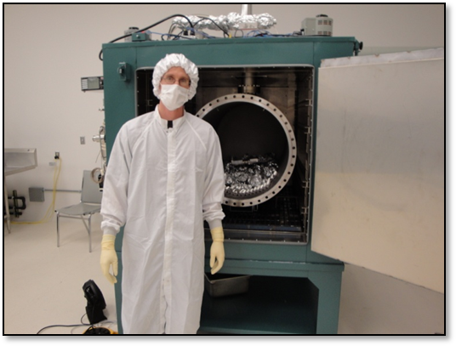

Figure (7) Vacuum Prep-Post Bake (It is essential when working Vacuum Prep, that a clean frock is put on by all staff prior to working on an oven post-bake or to wrap-bag-tag. All Vacuum Prep frocks must be the type with a zip only.)

CONTAMINATION-SENSITIVE HARDWARE

CLASS A Hardware

CLASS A hardware is defined as any item that will be exposed to the interferometer vacuum system while under vacuum. Some items are temporarily installed inside of vacuum equipment, while others are permanently mounted.

Included in this category are the internal seismic isolation units, suspensions/optics and all in-vacuo interferometer hardware that has been prepared for installation.

All CLASS A hardware is to be manufactured, cleaned, baked, and packaged in accordance with the specifications detailed in LIGO-E960022 LIGO Vacuum Compatibility, Cleaning Methods, and Qualification Procedures.

CLASS B Hardware
CLASS B hardware is defined as any item that will come into contact with CLASS A hardware or the surfaces of the interferometer vacuum equipment that will be exposed to vacuum (including the o-rings).

Follow cleaning and baking procedures dictated in LIGO-E960022 LIGO Vacuum Compatibility, Cleaning Methods, and Qualification Procedures, but substitute the airbake oven for the vacuum bake oven.

Please DO NOT bring Class B tools to the sites. There are standard Class B tool sets on site that should be used for most Class A assembly work. Please check with your site liaison to see if such a kit is available for your use. If not, team leads should procure tools which should be sent to the sites for proper Class B cleaning. Make sure to buy tools which are compatible with the Class B processing steps – ie. no oiled or plastic components. If you have a special tool or fixture that you will need, please coordinate with your site liaison to arrange for the tool to be properly prepared as Class B in advance. Your site liaison should be able to arrange for a specific subset of tools to be placed in a kit for you. Below is a list of Class B tools available at the sites in limited quantities.

CLASS B Tools
The following tools should be available on site to all teams. Specialty tools required should be shipped ahead of time for clean and bake. Site Supplied Class B Tools:
- Allen Key Sets
- T-Handled Allen Key Sets
- Metric Allen Key sets
- Flat head screw driver (all metal, S-shaped)
- Scissors
- Wire cutters
- Metal Rulers
- Open end wrench sets (Imperial)
- Dental Mirrors
- Tweezers – various sizes
- Helicoil insertion tools (various sizes)
- Helicoil removal tools (various sizes)

“Class B” Specialty Tools
Occasionally, there is a tool so special or unique that it is irreplaceable but it cannot go through the usual Clean and Bake procedure required to make it Class B. In this case, a waiver is required and steps must be taken to mitigate possible contamination. Please contact the appropriate site contamination control person to discuss options.

Washer and oven use
In general, only specially trained staff should use parts washers and bake ovens. CIT, LHO, and LLO have complete clean and bake facilities and dedicated staff for processing parts in preparation for UHV service according to LIGO-E960022, LIGO Vacuum Compatibility, Cleaning Methods, and Qualification Procedures.

ALL clean and bake requests should be submitted for coordination using the Clean and Bake Ticketing System (click here). Once a request is submitted, status update emails are automatically generated to the requestor as the request works its way through assignment to a site, assignment to an oven, assignment to a bake load, etc. If you have questions about Clean and Bake coordination or the Ticketing System, please contact Jodi Fauver (jodi.fauver@ligo.org).

Handling CLASS A and CLASS B Parts

CLASS A touching CLASS B and beyond
Ideally, CLASS A and CLASS B hardware should never come into contact with anything except other CLASS A or CLASS B hardware, appropriately cleaned stainless steel-aluminum-granite-C-3 surfaces, UHV Gloves, UHV Aluminum Foil (See Section 2.4.3 for limitations), lint-free Wipes, or the in-vacuo surfaces of the interferometer vacuum equipment.
All persons handling or working in the vicinity of CLASS A and CLASS B hardware shall, at all times wear, contamination control garb: see Table 2 for details. While working with CLASS A and CLASS B hardware, UHV gloves should contact only CLASS A or CLASS B hardware, appropriately cleaned stainless steel-aluminum-granite-C-3 surfaces, UHV Gloves, UHV Aluminum Foil, Lint-free Wipes, or the in-vacuo surfaces of the interferometer vacuum equipment; they must be changed immediately after contacting any other surfaces. See Section 6.1 for further details wrt UHV gloves.

Removing CLASS A and CLASS B from bags
CLASS A and CLASS B hardware is to be carefully unwrapped, handled only in a contamination sensitive area (see Section 6) and handled only with approved supplies to avoid recontamination.
CLASS A and CLASS B parts are packaged according to a standard protocol that requires two outer layers (Class 100 clean, electrostatic dissipative plastic sheeting-“CP Stat”, either zip-locked or closed with UltraTape) and an inner layer (Class B stainless steel or glass container/2 layers of UHV foil). The outside of the outer CP Stat layer/bag is “dirty” because it has an adhesive paper tag/UltraTape attached and has been exposed to uncontrolled environments: handling the outer CP stat layer requires no garb or gloves. The inside of the outer CP Stat layer and the outside of the inner CP Stat layer are much cleaner than the outside of the outer layer and should be handled using partial garb and should be unwrapped inside a cleanroom. The inside of the inner CP Stat layer and the layer touching the parts (container or foil) are considered Class B and should be handled as such.

Preparing to Un-Wrap Clean Items
Maintaining cleanliness while un-wrapping Class A/Class B items is crucial to avoid recontamination so it is best to make preparations prior to de-bagging. Physical preparation includes having a clean staging cleanroom, at least one stainless steel table (Ideally, having two tables is better, that way one can be designated “dirty” and one can be designated “clean”.), pre-saturated wipes, ConTec wipes, and isopropanol on hand. Use the “dirty” table for wipe dispenser, isopropanol, and inner CP Stat bags. In addition, best practice requires two people be available for unwrapping: one designated “dirty” and the other person designated “clean”.

Procedure for Un-Wrapping Clean Items
The following procedure outlines the steps required to unwrap Class A/Class B parts while preserving their cleanliness.
- Gross clean stainless steel table with pre-saturated wipes.
- “Clean” person dons partial garb (Bouffant cap, mask, frock, gloves, shoe covers)
- “Clean” person enters staging cleanroom
- “Dirty” person pushes gross cleaned table into staging cleanroom.
- “Clean” person cleans table(s) according to Section 2.6
- “Clean” person designates part of table ‘clean” and part of table “dirty” (In this case, “dirty” means acceptable to set an inner bag on.)
- “Dirty” person stations themselves on the outside of the staging cleanroom
- “Dirty” person unzips or cuts open the outer CP Stat layer
- “Dirty” person carefully positions item so that the “clean” person can remove the inner CP Stat bag inside the cleanroom.
- The “clean” person sets the inner bag down on the “dirty” part of the table.
- Repeat three steps above until all parts have been removed from outer bags
- At this point, the “dirty” person may garb (becoming a 2nd “clean” person ) or the “clean” person may continue alone.
- “Clean” person unzips or cuts the inner CP Stat layer
- “Clean” person uses the inside of the inner CP Stat layer to place the Class B container or foil-wrapped item on the “clean” surface
- “Clean” person disposes of inner CP Stat layer
- “Clean” person changes gloves or 2nd “clean” person comes to help
- “Clean” person unwraps the part which maybe set on the “clean” table

History of UHV foil
During iLIGO/eLIGO, E960022 specifically called for Class A and Class B processed hardware to be wrapped in UHV foil and then double-bagged in CPStat bags. By the start of Clean and Bake operations for aLIGO, particulation issues with UHV foil had been identified and documented. Therefore, it is preferred to store small Class A hardware in Class B hard enclosures as stated in the current version of E960022 . Stainless steel tool pans and small glass dishes with lids are very useful for storing some hardware. This type of storage is best suited for fastener stock and other small parts in bulk quantities. For large items (for example, entire ISI or SUS assemblies including HXTS or OMC) use C3 covers. As a last resort, for awkward items, use the UHV foil to cover the part before CP Stat bagging.

Shear, don’t tear UHV foil
If possible, shear the foil off the roll, as opposed to tearing, as we have some data which indicates that shearing might reduce the fine particulate generated during the cutting and the visible remnants of tearing. The plastic dispenser boxes from AllFoils come with a serrated edge that is meant to be used for tearing foil to the size required. This serrated edge is objectionable because it is attached with adhesive which can easily be transferred to the foil or your hands and the serrations generate small but visible, triangular pieces of foil that travel easily. Use UHV foil dispensers mounted to areas which will not shed foil particulate onto contamination sensitive hardware and surfaces. (Shearing can be carried out with a razor blade or equivalent.)

Maintaining Cleanliness
In order to maintain cleanliness over the coming months and years, inspect outer contamination control packaging as often as possible for tears and holes which are likely to occur as a result of moving or transporting items. If it appears that the contamination control packaging of Class A or Class B hardware is compromised, reprocess the part to restore its Class or obtain a waiver.

No Re-use of UHV foil
DO NOT RE-USE FOIL. IF YOU UNWRAP A PART OR OPEN A FOIL ENVELOPE/ PACKET (for example: to inspect or investigate a part), USE FRESH FOIL TO RE-WRAP. Crumpled foil particulates more easily than fresh foil.

Special note on handling C-3
Note: When the white clean room fabric similar to that used for the chamber door soft covers (Burlington C3, white static-dissipative, cleanroom fabric) is contacting or will come into contact with Class A or Class B hardware, it should be handled as Class B hardware.

Special note on Work Surfaces
It is preferable to place Class A or Class B objects (including garb) directly onto WELL cleaned stainless steel or aluminum surfaces, as opposed to foiling the surface. Clean the metal surfaces with acetone and then isopropanol. The metal surface should be wiped down daily or if there is any question as to cleanliness.
Granite surfaces may also be used, as long as they have been cleaned with acetone and then isopropanol. Like stainless steel or aluminum surfaces, a granite surface should be wiped down before every use.
This is a change from the iLIGO protocols which called for covering surfaces with UHV foil. However, it should be pointed out that a surface wrapped in foil is better than a dirty surface.

Cleaning Work Surfaces: Stainless steel/granite tables, aluminum plates

The method for cleaning surfaces is outlined below: -

- Apply solvent to a ConTec wipe or the table surface. (Because acetone evaporates quickly, it is easier to put the solvent on the wipe. Isopropanol does not evaporate very quickly, so putting the solvent either on a wipe or on the table surface works well.)
- Wipe from top to bottom and in linear, overlapping strokes. (Circular wiping re-contaminates the area just cleaned and is unacceptable.)
- Refold wiper to expose fresh wipe surface for each run (Otherwise, the wipe re-contaminates the area just cleaned and is unacceptable.) or replace wipe as needed.

Periodic checks on cleanliness
Inspect equipment periodically for cleanliness. Check horizontal surfaces for particulate. See Section 6 for cleaning schedule. Check internal areas of equipment, such as washer tanks, for particulate: flush or clean out as needed.

GENERAL PRACTICES

Staging Portable Clean Room Enclosures
Portable clean rooms are utilized to stage CLASS A and B equipment outside of chambers for installation. The general procedure for preparing a cleanroom to accept Class A/B occurs in two phases.

Phase 1 includes cleaning the general area the cleanroom will occupy; positioning cleanroom; inspecting, testing, repairing cleanroom, wiping down the chamber, initial wipe-down of curtains, and damp mopping the floor.

Phase 2 includes garbed workers re-cleaning the chamber, vacuum equipment, cleanroom, and damp-mopping the floor under the cleanroom. The checklist below provides more detail for each of the phases.

Cleanroom Staging Checklist (Phase 1)
- Phase 1 Cleaning in general area where cleanroom will be placed. Start at the top and work towards the bottom the recommended sequence for cleaning is as follows:
  - Ceilings
  - Walls
  - Equipment
  - Floor
- HEPA vacuum or sweep
- Damp mop with cleanroom acceptable materials
- Position cleanroom
- Crane or roll room into position
- Inspect, test, and repair cleanroom
- Check Fan-Filter Units and run for 24 hours
- Check output (ideally with anemometer)
- Check switches (Should be on HIGH)
- Replace unacceptable FFUs
- Check curtains
- Replace missing panels
- Clean CP Stat may be substituted for softwall material
- Wipe down from TOP-TO-BOTTOM
  - Chamber and vacuum equipment located within cleanroom
  - Cleanroom structure including softwall curtains
- Damp-mop floor

ONCE PHASE 1 CLEANING IS COMPLETE, ANY WORK WITHIN THE CLEANROOM REQUIRES PARTIAL GARB (GLOVES, BOUFFANT CAP, MASK, FROCK, SHOE COVERS) REGARDLESS OF VACUUM EQUIPMENT EXPOSURE. For example, if door bolts need to be broken but Phase 1 cleaning has already occurred, then the door crew should wear partial garb (Bouffant cap, mask, frock, shoe covers, gloves).

Cleanroom Staging Checklist (Phase 2)

- Phase 2 Cleaning with garbed workers re-cleaning the chamber, vacuum equipment, cleanroom, and damp-mopping the floor under the cleanroom
- Wipe down from TOP-TO-BOTTOM
  - Chamber and vacuum equipment located within cleanroom
  - Cleanroom structure including softwall curtains
- Damp-mop floor
- Place sticky mats at cleanroom entrances at all times and especially if optics are present

During periods of work inside the portable clean room enclosures, an “outside helper” is useful to avoid the need for garbed workers to exit the enclosure to retrieve supplies or perform other functions outside the enclosure. Portable radios also facilitate communication between portable clean rooms and reduce the need to physically transition between them.

Cleaning Areas aka Transitional LVEA
The area that is located just past the change room for the optics lab s but before the LVEA is called the cleaning area and should be treated as a Transitional LVEA. This means that EVERYONE should have shoe covers on before entering the area. In addition:
- There should be no packing paper or cardboard in this area.
- There should always be sticky mats at the entry to this area. These should be replaced regularly.
- There should always be sticky mats located by the roll up door entering this area.
- When using the roll up door to bring large items into the LVEA, you will have to transfer items/parts to a designated “clean” cart that is only for LVEA use.
- It is also acceptable to wipe down a cart or table made of acceptable materials to move an item from outside the LVEA to inside the LVEA. Using pre-saturated wipes, completely wipe down the cart. Pay special attention to the wheels: roll them over a sticky mat at least six times and then wipe them down with pre-saturated wipes.
- Pre-saturated wipes have been located at every entrance LVEA entrance. Please let the cleaning staff know if these run low.
- All items on cart must be wiped down e.g. plastic box with clean parts, gas bottles, metal containers etc ... before entering LVEA.
- Any work done in this transitional area (electronics, restocking garb, etc…) will have to be carried out while wearing shoe covers.
- Shoe covers are be worn ONCE and then put in basket to be laundered.

LVEA
NO packing paper, cardboard, wood etc is allowed in the LVEA. In fact, as stated elsewhere, no card board should be taken into any clean areas. If you require containers to hold equipment, both sites have ample plastic bins of many sizes available for this purpose.

If active cleanrooms (equipment on the floors, doors off the chamber) are not cleaned by the cleaning staff then daily floor cleaning should be used done by the teams who work in these areas before work commences. Cleanroom swiffer mops are available for this purpose.

Garb rooms
HEPA-filtered garb rooms shall be placed adjacent to all lab spaces, VEAs, assembly cleanrooms, and staging cleanrooms. Garbed workers shall go directly from a garbing or staging room into a chamber or assembly cleanroom. Fully garbed workers should not exit cleanrooms unless they remove and stow their garb. Utilize hangers and racks for re-useable garb items like frocks or coveralls: DO NOT USE GARB RACKS for hanging up personal items like sweaters or jackets. Coat racks are available outside of change rooms for coats and sweaters.

It has been noted that teams are using a single gowning room for several assembly/chamber cleanrooms rather than dedicating one garbing cleanroom per assembly/chamber cleanroom. In this situation, it is important to locate cleanrooms carefully. The traffic flow should always be from dirty to cleaner to cleanest. In other words, garbing cleanroom (dirty)→staging/assembly cleanroom (clean)→chamber cleanroom (cleanest). An acceptable arrangement involving one garbing, two staging and two chamber cleanrooms is shown below.

HAM3 CR
“Cleanest”
HAM1/2 CR
“Cleanest”
Staging
“Clean”
Garbing
“Dirty”
Staging
“Clean”

An unacceptable arrangement involving one garbing, one staging and one chamber cleanroom is shown below. This arrangement does not work because garbed workers trying to get from the staging cleanroom (clean) to chamber cleanroom (cleanest) or vice versa have to go through the garbing room (dirty).
BSC10 CR
“Cleanest”
Staging
“Clean”
Garbing
“Dirty”
BSC10 CR
“Cleanest”
Staging
“Clean”
Garbing
“Dirty”
BSC10 CR
“Cleanest”
Staging
“Clean”
Garbing
“Dirty”
BSC10 CR
“Cleanest”
Staging
“Clean”
Garbing
“Dirty”

If you have any doubt whether a proposed location for a garbing cleanroom is acceptable, default to one garbing room per assembly/chamber cleanroom. While it is appreciated that acquiring and fitting multiple rooms (and stocking each with garb) is difficult, it could well improve cleanliness so it is encouraged.

Garbed individuals should NOT walk in dirty spaces: This is not a good practice. There seems to be an attitude that transiting the dirty space in one's bunny suit is OK as long as one is reasonably quick about it: the so-called 30 second rule. This practice has to be discouraged. One way to support the crew in bunny suits and to counter this process would be have a "runner" person outside the cleanroom.

Particle counting

Particle counts MUST be taken before starting any work in a cleanroom area. If you have any questions on how to perform this task please ask your local site representative or installation lead.

Items allowed in cleanrooms
Precautions should be taken to minimize particulate and hydrocarbon generation and accumulation in Contamination Sensitive Areas. Paper products are prohibited in all Contamination-Sensitive Areas.
Paperwork such as drawings should be laminated or put into plastic sleeves to contain particulate that the paper generates. Items brought into the areas (including carts, racks, equipment, etc) should be wiped down with damp wipes. Items that are being received from shipping must be unpacked outside the area and particulates should be removed by vacuuming or wiping down with damp wipes.
For vacuuming in the aLIGO buildings, use only HEPA filtered vacuums, or ones that exhaust to the outside of the building. Baskets, totes and carts are available on site and should be used to transport bagged items into the contamination sensitive areas instead of cardboard boxes.

Computers
At LIGO, computers are frequently utilized for note taking, etc., especially in clean/contamination-sensitive spaces, but they present issues that require good judgment on the part of the computer-user to minimize the possibility of contamination. In general, three factors govern the use of computers in contamination-sensitive space: the type of computer (fan present vs fanless, open keyboard vs closed keyboard/touch screen), the criticality of the items that will be exposed to the computer, and the distance of the computer from the exposed parts. Obviously, tablet style computers (fanless with a closed or virtual keyboard) are much better suited to be close to exposed Class A hardware and/or open chambers but even they need to be treated as "dirty". In other words, wipe down the computer before using it in contamination-sensitive space and change gloves after you touch it. Keep computers with fans as far from Class A parts as possible, preferably outside the cleanroom curtains.

Each unique situation requires a decision but ALWAYS ERR ON THE SIDE OF PROTECTING CLASS A PARTS FROM POSSIBLE HYDROCARBON AND PARTICULATE CONTAMINATION.

  - Unattended Hardware
Whenever CLASS A or CLASS B hardware is left unattended, the area will be clearly marked. Exposed items will be covered, preferably with clean C-3 cover or un-crumpled UHV Foil.

SPECIFIC WORK PRACTISES

UHV Gloves
Because UHV gloves are the most common “tool” in contact with Class A surfaces, maintaining their cleanliness is critical to successful contamination control. However, keeping UHV gloves clean is particularly challenging so choosing the right glove, correctly layering gloves and changing outer gloves are specified below.

Choosing the Right Glove
LIGO approved UHV latex gloves come in a variety of sizes (6.0, 6.5, 7.0, 7.5, 8.0, 8.5, and 9.0). It is useful to choose a size appropriate to your work: very close fitting for fine work and something looser for less detailed tasks. Inner gloves are typically a half size smaller than outer gloves. Sizes 7.5-9.0 are the most commonly used and large supplies are kept at LIGO facilities. If you need an uncommon glove size, please let the site contamination control person know.

Some workers are allergic to latex. In that case, it is acceptable to wear Nitrile gloves as inner gloves. Nitrile is difficult to get another set of gloves over but putting on a set of fingerless glove liners will help this situation.

The Layered Approach
The easiest way to maintain outer glove cleanliness is to take a layered approach so that there are multiple levels (2-3) of protection between Class A parts and human skin. Approved polyester glove liners are optional and may be worn under inner gloves to absorb sweat and aid gloving. Inner gloves provide back-up to outer gloves and facilitate outer glove changes: they should be considered “dirty”. Inner gloves should entirely cover frock/coverall cuffs. Outer gloves come in direct contact with Class A parts and should be changed routinely. Always don UHV gloves without touching the outside surfaces of them except at the very top of the cuff.

If you are allergic to latex, your layered approach should be Nitrile gloves, glove liners and latex outer gloves.

Change, Change, Change…
Your “clean” gloved hands can touch:
- Class A/Class B parts
- Class B glass/stainless steel storage containers
- Clean Contec PNHS wipes
- Clean approved gloves
- Clean UHV foil (minimize use)
- Clean C-3 fabric
- Appropriately cleaned stainless steel, aluminum or granite work surfaces

If your gloved hands touch anything else, you MUST change outer gloves!
It is difficult to avoid accidentally touching surfaces that are neither Class A nor Class B when wearing UHV gloves intended for handling of contamination sensitive hardware, but outer gloves MUST be changed after such incidents.

For example:

- If you touch your face/uncovered wrists etc. with a gloved hand, then you MUST change outer gloves.
- If you touch Non-Class B tools/tool pans/shelving/table legs, etc with a gloved hand, then you MUST change outer gloves.
- If you touch cameras/computers (even if they are wiped down) with a gloved hand, then you MUST change outer gloves.
- If you touch ladders/step-stools (even if they are wiped down) with a gloved hand, then you MUST change outer gloves.
- If you touch Nalgene solvent bottles (even if they are gloved/foiled) with a gloved hand, then you MUST change outer gloves.

Each unique situation requires a decision but ALWAYS ERR ON THE SIDE OF PROTECTING CLASS A PARTS FROM POSSIBLE HYDROCARBON AND PARTICULATE CONTAMINATION.

Solvents
DO NOT bring any solvents to sites. Isopropanol is available at the sites and, for safety reasons, is the preferred solvent for general use. Methanol is also available for use on optics. Solvents are stored in yellow cabinets marked “FLAMMABLE” located throughout the VEAs and labs. Copies of Material Safety Data Sheets (MSDS) for chemicals on site are available in the site MSDS notebooks. Acetone is also available at the sites but its use is tightly controlled. Please contact the designated person at each site to obtain the proper training before using acetone in contamination sensitive areas.

It is best to use fresh solvent for all sensitive applications. Solvents stored in Nalgene bottles for long periods of time become contaminated; therefore, it is preferable to dispense the smallest possible quantity from the original glass bottle. To facilitate frequent rotation of solvent, dispenser bottles should be no larger than 250 ml. (See Appendix 1 for approved bottles.) If you do not know how long the bottle has been sitting around, get fresh solvent if your application warrants it.

Site usage for solvents can be categorized in the following table:

TABLE 3 - SOLVENTS
Solvent needed for | Examples | What to use | Solvent type | Handling
Cleaning equipment | Wiping down work surfaces | Acetone then  Isopropanol | Reagent Grade | Use standard, labeled (Right-to-Know, aka RTK), Nalgene bottled solvent
Cleaning Class A and Class B items | In-vacuum hardware and tool prep | Isopropanol | Reagent Grade | See E960022 for proper usage
Cleaning aLIGO Optics  Both UHV  and non-UHV | If you need solvents for optic cleaning purposes, please see the site optics liaison or talk to Margot Phelps at CIT before beginning your work. There are special cleaning procedures for optics and First Contact TM (the preferred aLIGO optics cleaning method) reacts badly with some solvents, methanol in particular. Document E1200266 is instructive.

Wipes
The sites supply several types of wipes which can be used for a variety of purposes. See the table below to identify which wipe to use for a particular task.

TABLE 4 - WIPES

Wipe | Use | Example
Vectra Alpha 10 Wipe | Optics  and installation wipe downs | aLIGO wet cleaning of optics  Assembly wipe down prior to chamber close-out  Lint free
Contec Polyester Heat Sealed Wipe (PNHS 99) | General purpose – most widely used | Daily wipe-down of work surfaces, drying clean parts  Lint free
Berkshire LensX 90 Wipe | Optics | Wet cleaning of optics  NOT Lint free
Berkshire Polysorb wipes | Optics | Wet cleaning of optics  NOT Lint free
Valutek Pre-saturated Polyester Wipers-Border Sealed (VTPNWPHS150R-99) | Gross cleaning of facilities and equipment,  cleanroom curtains | Clean forklift/man lift before bringing into LVEA, clean floor prior to cleanroom placement

MAINTENANCE OF CONTAMINATION SENSITIVE AREAS

Sensitive Areas
All contamination sensitive areas (aka cleanrooms) should be cleaned with specialty cleanroom cleaning equipment. In addition, cleaning staff need to be trained on appropriate garbing for specific areas when cleaning.

Recommended sequence for cleaning
Recommended sequence for cleaning: ceiling, walls, equipment and then floors. Wipe from top to bottom and in linear, overlapping strokes. Circular wiping re-contaminates area just cleaned. Refold wiper or replace as needed to expose a fresh wipe surface at the start of each run.

Recommended Cleaning Frequency

TABLE 5 Recommended Cleaning Frequency

Activity | Assembly Building Clean Spaces around cleanrooms | Assembly Cleanrooms | Bake Facility Clean Spaces | Cartridge Build-Up and Active Install
Trash Removal | Daily | Daily | Daily | Daily
Vacuum/Damp Mop Floors | 2-3x Weekly | 2-3x Weekly | 2-3x Weekly | Daily
Wipe down horizontal countertops/tables/handrail surfaces | Weekly | Weekly | Weekly | Daily
Wipe down horizontal hard-to-reach surfaces (tops of flowbenches, parts washer, cabinets, etc.) | Monthly | *Monthly | Monthly | *Monthly
Wipe down extremely hard-to-reach places (Crane rails, ceiling ledges, tops of cleanrooms) | *Monthly | *Monthly | *Monthly | *Monthly
Wipe down cleanroom curtains | Bi-weekly | Monthly | Bi-weekly | Weekly
Wipe down walls | Monthly | Monthly | Monthly | NA

If you believe work areas are not clean, please contact Michael Landry (LHO) or Brian O’Reilly. (LLO) immediately.

*Note for monthly items with a * this stands for sub-system assembly lead decision: when cleaning occurs.

Remember for all cleaning assemblies/ optics should be covered with Aluminum foil or C3.

BEST PRACTISES

Beware of “The Shedders”



Figure (7) Cartoon examples of known shedders

"Shedders" should not enter clean space. Known "shedders" include but are not limited to: wood, paper, cardboard, Styrofoam, fiberglass, hydrocarbons, wool, make-up, powder, aromatics-VOCs, plastic handles, paint, etc. "Clean Space" is loosely defined as a space with HEPA-filtered air including the LVEA and VEAs.

Work-Appropriate Personal Hygiene

Daily practice is best.
- Bath or shower to remove skin cells.
- Wash and brush hair to remove those ready to fall out.
- Brush teeth to remove detritus.
- Use unscented deodorant to minimize sweating.
- Do not wear perfume or cologne to prevent out-gassing.
- Wear long pants to work to help contain skin cells.
- If you smoke, drink a glass of water before restarting work to minimize out-gassing.

From a contamination control perspective, a good guideline for personal hygiene products is: If you (or anyone else) can smell it, you shouldn't have it on at work (as it is very likely a volatile organic compound aka hydrocarbon-ish).

The following items are problematic:
- Perfume/Cologne or After-shave lotion
- Hand/body lotion
- Hair gel/spray

In addition, cosmetics present potential particulate contamination as they are only lightly adhered and rub off easily or come off spontaneously. Foundation is impossible to remove from C-3 fabric and foundation contaminated items must be removed from service.

Practices/tools that help reach cleanliness target

General Practices
General Practices/tools that help reach cleanliness targets
- If a chamber is open (door/dome removed), C-3 covers shall be in place if the chamber is abandoned (not actively in use by personnel) for longer than 10 minutes.
- All staging and chamber cleanrooms must be cleared of gloves, glove packaging, wipes etc at end of your task or prior to breaks, whichever comes first.
- YOUR TRASH SHOULD NOT BE LEFT for CLEANER or the NEXT TEAM.
- As stated before, leaving cleanroom space in “full bunny” and then going back into the chamber/assembly space to work is UNACCEPTABLE, especially if you have been in close contact (for example, having a conversation) with an un-garbed person.
- There is NO “30-second rule”.
- If you find a hole in your C-3 garb, stop using it immediately and get new garb. Deliver the “holey” garb to Rich R./Jodi F. for repair.
- Put a glove on labeled RTK Nalgene solvent bottles to minimize paint migration: foil is unacceptable for this purpose. Gloved solvent bottles should be treated as “dirty”. For sensitive or in-chamber work, dispense solvents into Wheaton bottles.
- Use mirrors in garbing room to aid dressing. Mirrors and dressing guides should be at all dressing locations. If not contact to Rich R./Jodi F.
- If you don't know ask e.g. "Am I dirty?" or "Should I change my gloves?".
- Please get into the habit of checking on each other.

Tools
- Using stainless steel work tables when possible (wipe daily with acetone then isopropanol): Tables should NOT be laminate covered in foil (unless only item available)
- Using hard-sided containers as often as practical
- Using aluminum/stainless ladders or stools in cleanrooms (since they can be wiped down)
- Using real Class B tools (that means something that can be cleaned and baked, not a plastic-handled tool wrapped in foil). An irreplaceable tool may be waivered (wrapped in foil) but talk to the site contamination control person to discuss options and document situation.
- Never assume cleanliness
- Covering something dirty with C-3, aluminum foil or a ConTec wipe is NOT magic and will render it neither Class B nor clean!

Work tidy, work clean

If you work tidy, you are half way to working clean. All in-chamber areas must have items removed when you leave a task. An Allen key left by person #1 can become a dangerous drop hazard when not seen by person #2.

Fasteners
As per LIGO-T040111, there a number of particulates generated just from adjusting a Socket Head Cap Screw in a tapped hole. Work to minimize adjustment while optics are exposed and as per the next sections in this document. Consider what tools can be used to clean up the dust generated. In terms of fasteners and tapped holes ALL in vacuum class A components should have either
- Silver-plated SSTL screws in stainless steel parts (with appropriate oversize taps e.g. 1/4-20 UNC +0.005" OVERSIZE TAP)
- SSTL screws in Nitronic 60 inserts for aluminum parts (refer to guidelines below)
- SSTL screws in aluminum for rest of parts (with appropriate oversize taps e.g. 1/4-20 UNC +0.005" OVERSIZE TAP)
- SSTL screws when Nitronic 60 inserts are used in SSTL parts (refer to guidelines below)
In terms of inserts the following guidelines should have been applied by the designers / engineers:
- Nitronic 60 inserts chosen for parts that are adjusted or added / removed once or more than once adjacent to optic
- Thought should also be given to parts that are adjusted (adjacent to optic) once after optic protection is removed for the last time
- Nitronic 60 inserts should also be chosen for other items that are adjusted or added / removed more than twice elsewhere
In terms of fasteners:
- Holo-Krome is the aLIGO preferred manufacturer of SSTL socket products intended for in-vacuum use.
- U-C Components is the preferred supplier of silver-plated socket products.
- If you cannot find an item you need in Holo-Krome or U-C Component stock, alternative stock should be chosen to a Mil Spec or equivalent. Good quality fasteners are wanted for all applications.
- Whether or not specialized hardware is required should have already been considered by the designer / engineer, e.g. a vented silver-plated screw from U-C Components or a high torque screw from Holo-Krome. any specifics should be / will be called out on the engineering drawings.

In terms of tapped holes:

- If you feel there is a problem with a tapped hole (heli-coil or straight thread), the first port of call should be a Go-No-Go Gage (not a tap), which are now available on site.
- A Go-No-GO Gage should be with you when you are assembling items, along with your Allen key and torque wrench.
- Tapped holes should be checked prior to use during assembly. Poorly tapped holes or wrongly tapped holes generate more particles as per LIGO-T040111.
- During assembly, cross check material certs for fasteners since poor graded fasteners gall and also generate more particulates. If you want to find out more about fasteners, types of fasteners, heli-coils, Gages, Material selection refer to the Systems Wiki on Fasteners at the following link https://awiki.ligo-wa.caltech.edu/aLIGO/Fasteners
If you have any questions, contact Dennis Coyne or Calum Torrie in Systems Engineering.

Dust Removal and Contamination Control links

Dust generated during assembly, install, and commissioning
ALL build teams MUST think about the dust they are generating. Build teams include those who assemble, align, adjust (either pre- or post-alignment) on test stands/optics tables or install items in-chamber.

Cleaning on-the-go
The top level overall cleaning described in section 10.7 of the Advanced LIGO Chamber Entry / Cleaning / Exit Checklist, LIGO-E1201035, should not stop wiping and vacuuming (sucking) being done during assembly and install. In fact in process cleaning should be encouraged and performed on the go using the tools described below. When performing localized cleaning on e.g. a stage of a suspension structure it is not essential to protect the optic with first contact and lens cap. However, if an overall cleaning of in chamber components is being performed then the optics in that chamber should be protected with lens cap and first contact.

Wiping Class A in-vacuum components
An excellent method for wiping dust from assembled surfaces is to use a Vectra Alpha 10 cleanroom wipes or cleanroom swabs (See Appendix 1 for details), which should be available at both sites. An Alpha 10 wipe, wetted with isopropanol, may be used to remove dust from all surfaces, with the exception of optics.

Customized cleanroom vacuum cleaners for use on Class A in-vacuum components
Vacuum cleaners with custom attachments that allow both blowing and sucking are now available on site. These can be used both in chamber and in clean-rooms on in vacuum Class A components. Details of the vacuum cleaners can be found in LIGO-E1201035 the Advanced LIGO Chamber Entry / Cleaning / Exit Checklist and also at https://dcc.ligo.org/wiki/index.php/Engineering_for_LIGO/ContaminationControlWorkingGroup#3.29_Detail_note_associated_with_The_Tiger_Vacuum_Cleaners
At LHO see Betsy Weaver and at LLO see Matt Heintze or Gary Traylor for additional information and details for use/ access.

Contamination Control Q&A Wiki
There is now a Contamination Control Questions & Answers Wiki. It is at the following link: https://dcc.ligo.org/wiki/index.php/Engineering_for_LIGO/ContaminationControlWorkingGroupQ%26A (accessible using using your albert.einstein credentials).

If you have a question on Contamination Control please send your question to both Calum Torrie <ctorrie@ligo.caltech.edu> and Jodi Fauver <fauver_j@ligo-wa.caltech.edu>. The question will then be posted to the above wiki and an answer sought and posted.

Contamination Control Working Group (and Wiki)

Advanced LIGO has reformed a Contamination Control Working Group. From assembly and installation work to date we have observed more particulates than expected near the key areas in the suspension, which need control. Refer to particulate contamination in the HAM2 and HAM3 chambers at the alog entry 5220.

The Contamination Control Working Group is charged with implementing contamination (particulate) control solutions that will be deployed during assembly builds on test stands, and optics tables as well as during alignment, adjustment pre and post alignment and installation. The primary goal is to participate in minimizing contamination potential on both the fused-silica fibers and the optic surfaces.

The Contamination Control Working Group has setup a Wiki at the following link: -
https://dcc.ligo.org/wiki/index.php/Engineering_for_LIGO/ContaminationControlWorkingGroup. If you have any questions contact the Chair of the Contamination Control Working Group, Calum Torrie at <ctorrie@ligo.caltech.edu>.

Contamination Control Q&A Wiki
There is now a Contamination Control Questions & Answers Wiki. It is at the following link: -
https://dcc.ligo.org/wiki/index.php/Engineering_for_LIGO/ContaminationControlWorkingGroupQ%26A (accessible using using your albert.einstein credentials).

If you have a question on Contamination Control please send your question to both Calum Torrie <ctorrie@ligo.caltech.edu> and Jodi Fauver <fauver_j@ligo-wa.caltech.edu>. The question will then be posted to the above wiki and an answer sought and posted.

ALIGO Chamber Entry/Cleaning/Exit Checklist
A new Advanced LIGO Chamber Entry / Cleaning / Exit Checklist, LIGO-E1201035, is now posted and should be read by ALL installers and commissioners. The scope of the document is to summarize the general steps associated with entering HAM and BSC chambers, cleaning in-chamber items (as required) and then exiting the chambers. In general, these steps should be followed for all incursions subsequent to optics install: this includes initial install and any subsequent install/commissioning activity.

PROCUREMENT AND DISTRIBUTION OF CONTAMINATION-CONTROL SUPPLIES
Approved contamination control supplies are listed in Appendix 1, following this section. However, most readers do not need to read or refer to Appendix 1 as long as the following items are kept in mind.

Numerous items related to contamination control are procured and stocked at the sites. Reasonable quantities of each item will be on hand at all times but if you notice that supplies are short, please let Jodi Fauver or Rich Reisen know. ONLY designated LIGO personnel should procure and stock these supplies. (In fact, beginning 01 January 2013, Contamination Control Supplies will be procured under a consolidated contract.) Any visitor requiring an unusually large quantity of stock items should contact the site liaison in advance to ensure availability. Likewise, any visitor requiring non-stock/unique items should contact the site liaison so appropriate arrangements can be made.

The following rules apply to the procurement, receiving, stocking, and distribution of contamination control supplies:
- DO NOT procure items that are not listed in Appendix 1: all new or different items need proper approval.
- Supplies which have been delivered but not yet unboxed and inspected are to be stored in Long-term Storage rooms or Receiving Areas. Remove items from the cardboard boxes before introducing them to the clean areas.
- Solvents are to be stored in the outside Chemical Storage Areas. Small quantities of solvents are to be stored in the Flammable cabinets located in the VEAs or lab spaces.
- Solvent-contaminated materials should be disposed of in appropriately marked cans according to LIGO-M1200015.
- Contaminated garb items are to be discarded or placed in garment cleaning receptacles located in the Change Rooms.
- Do not introduce opened stock back into the fresh stock of supplies. For example, do not pour smaller dispenser bottles of solvents back into the larger distributor containers of solvents. If supplies can be used for lesser controlled applications, bag and label as such and then return to the storage area. An example of this would be a stack of wipes which had been exposed to VEA Class 10,000 for a few weeks could be used to wipe down table top surfaces and cleanroom equipment.
APPENDIX 1 CONTAMINATION-CONTROL SUPPLIES
AND CLOTHING

Cleaning Supplies (for Technical Cleaning)
Item | Vendor Information
Adhesive Rollers
Mop Heads
Sticky Mats
“Swiffer” Pads
Vacuum, HEPA
Wipes, Pre-saturated w/  50% IPA, 50% DI H2O | Valutek
Covers (Burlington C-3: Polyester, ESD cleanroom fabric)
Item |  | Vendor Information
BSC Dome Flat (~125”OD w/ shockcord & toggle @ perimeter) |  | Jonco Industries  POC: Jim Kittle  2501 W. Hampton Ave  Milwaukee WI 53209  Phone: 800 236 7311
BSC Dome Tall (~125” OD cylinder with top,~64” length w/ shockcord & toggle @ lower perimeter)
BSC Door (~68”OD w/ shockcord & toggle @ perimeter)
HAM Door (~106”OD w/ shockcord & toggle @ perimeter)
Hose/Tube (~1’ODx15’ w/ shockcord & toggle @ both ends)
Soft Roof
Support Tube (~4’x15’ w/ shockcord & toggle @ both ends, zipper)
Specialty (Various: Arm, Cartridge, ISI, Quad, Shelves) |  | Technical Product Services
Detergents and Soaps
Item | Vendor Information
Citrajet, Citranox | Alconox
Liquijet, Liquinox | Alconox
Arcair Protex AlClean | Specific Gravity - 1.1390 Color - Blue
Garb, Launderable (White Burlington C-3: Polyester, ESD cleanroom fabric)
Item | Vendor Information
Beard Covers/Facemask (Workon 1177)
Polyester Tricot
Boots, Cleanroom (Worklon 1117-939)
C-3 upper, Hypalon sole
Boots, In-Chamber
(Worklon 1096-Style 100)
White taffeta upper, Herculite sole,
ribbon tie
Bouffant Cap (Worklon 1066)
Polyester Tricot
Coverall (Worklon 1910)
Zipper, raglan sleeves, knit cuffs
Frock (Worklon 3442 preferred;
Worklon 3440 ok until out of service)
Hood (Worklon 1160 in C-3 preferred; Worklon 1050/1056 ok until out of service)
Shoe Covers (Worklon 1016)
Elastic top, C-3 upper, Hypolon sole
Garbing Supplies (Disposable)
Item | Vendor Information
Veils/Beard Covers:  KIMTECH PURE M7  Veil with headband | Use TechMart→Punch-out to VWR→Search for 83007-443
Bouffant Cap
Coverall -Emergency  (DuPont Tyvek ISO Class 5 or better) | VWR
Gloves, Ansell AccuTech Ultra-Clean Latex 91-300 (1st choice) | *Note-Phone vendor prior to ordering to make sure glove are in stock; otherwise, backorders can take months to arrive due to low production runs on these highly-specialized gloves.  VWR-Fischer-Grainger-Magid-SafetySaves-TEK Products
Gloves, Microflex CE4 Latex ISO 4
HSCE4-879 (Back-up)
Glove Liners (Berkshire BGL2.200BR)
Mask (Kimberly-Clark 62465) | Miller Safety ($128.51@case)  VWR Punch-out ($240.99@case)
Gases
Item | Vendor Information
Carbon Dioxide (99.998 or 99.999% pure) | Oxarc
Helium
Nitrogen,UHP Compressed | Oxarc Part# C34380
Miscellaneous
Item | Vendor Information
Containers, Stainless Steel  (for small parts) | To-Go-Ware (Sidekicks)  Vollrath (Super Pan 5)
Dispensers, Acrylic (for garb, wipes, etc) | AK Ltd Plastics Fabrication
ESD Bags, various  (Zippered, Class 100 clean) | Seco Industries
ESD Rolls  (~48”x1000’, Class 100 clean,  w/ plastic core) | Caltex Plastics
ESD Sheets (~8’x16’, Class 100 clean) | Seco Industries
Foil, UHV Aluminum (0.015”x24”x500’, 0.015”x48”x500’, UHV certified) | All Foils Part #ASTM B 479
Solvent Dispenser RTK Bottles, Nalgene  (250 ml,4-color, safety vented wash bottle) | Belart  Acetone DI Water Isopropanol Methanol
Tape, Cleanroom ( 3”x60 yd, for general use) | UltraTape Part # 1154
Solvents (delivered in glass bottles)
Item | Vendor Information
Acetone-4 liters (ACS grade for general use) | Use TechMart→Punch-out to VWR→Search for BDH1101-4LG→Choose glass bottles
Acetone | Sigma-Aldrich Acetone Chromasolv for HPLC #270725
Freon-113
Isopropanol -4 liters  (ACS grade for general use) | Use TechMart→Punch-out to VWR→Search for BDH1133-4LG→Choose glass bottles
Isopropanol (for in-chamber cleaning) | Sigma-Aldrich 2-Propanol LC-MS Chromasolv #34965
Methanol-4 liters (ACS grade for general use) | Use TechMart→Punch-out to VWR→Search for BDH1135-4LG→Choose glass bottles
Methanol (for optics) | Sigma-Aldrich Methanol Chromasolv for HPLC #34885
Wipes and Swabs
Item | Vendor Information
Absorbond Series Swabs (Example:TX762) | Quintana Supply ($17.20@pack of 100)  Specialty Optical ($21.62@pack of 100)  VWR Punch-out ($29.11@pack of 100)
Contec PNHS99  (Pack of 150, Case of 1200) | Pharmaquip ($299.60@case)  VWR Punch-out ($329.03@case)
Berkshire LensX 90 9x9 LN-90.0909.16 | Spectrum Chemical ($426.60@case)  VWR Punch-out ($649.03@case)
Spec-Wipe 7 9x9 (Replaces Fastsorb 820) | Optics Planet ($264.56@case)  VWR Punch-out ($279.23@case)
Vectra Alpha 10 | SOS Cleanroom ($336.59@case)  VWR Punch-out ($556.78@case)

