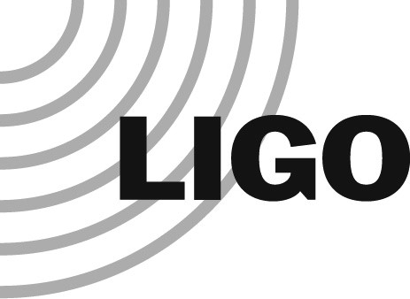LASER INTERFEROMETER GRAVITATIONAL WAVE OBSERVATORY

LIGO Laboratory / LIGO Scientific Collaboration

LIGO-M080401-v5 LIGO LABORATORY 26 September 2018

LIGO Contractor / Vendor Safety Requirements

Charles E. Taylor

Distribution of this document:

LIGO Scientific Collaboration

This is an internal working note of the LIGO Laboratory.

California Institute of Technology LIGO Project – MS 18-34 1200 E. California Blvd.  Pasadena, CA 91125  Phone (626) 395-2129  Fax (626) 304-9834  E-mail: info@ligo.caltech.edu | Massachusetts Institute of Technology  LIGO Project – NW22-295  185 Albany St  Cambridge, MA 02139  Phone (617) 253-4824  Fax (617) 253-7014  E-mail: info@ligo.mit.edu
LIGO Hanford Observatory  P.O. Box 1970  Mail Stop S9-02  Richland WA 99352  Phone 509-372-8106 | LIGO Livingston Observatory  P.O. Box 940  Livingston, LA 70754  Phone 225-686-3100 Fax 225-686-7189
Fax 509-372-8137

Introduction
LIGO requires all on-site work to be covered by a written safety plan consistent with LIGO safety requirements to ensure safe work practices are followed while performing construction, maintenance, or like activities at any of the LIGO facilities.

Safety Requirements
The following safety topics shall be considered as a minimum to be addressed in the safety plan:
- LIGO prefers to utilize the contractor's existing written safety plans to the fullest extent possible, consistent with the LIGO Laboratory Safety Program requirements. Caltech, MIT, and LIGO staff requests all bidders to submit either a copy of their existing safety plan/program or a written description/outline of their safety program with their proposal. The bidder must also submit their plan/program for managing their subcontractor’s safety related activities. In the event that a prospective contractor/vendor lacks an acceptable existing safety plan and/or program, the contractor/vendor shall develop and implement a system safety program in compliance with the requirements negotiated at contract/PO award.

- The existing contractor's written Safety Plan should include, but not be limited to, the critical safety topics that address the work activities that will be performed to fulfill the contract requirements.
- California Institute of Technology is committed to providing a drug and alcohol free environment for all its’ facilities. The unlawful use, possession, or distribution of drugs and alcohol is strictly prohibited while performing work under this contract.
- Prior to awarding a bid, the LIGO Contractor Safety Evaluation Form may be sent out to the contractor/vendor for completion. This form asks for basic safety information that will allow LIGO Safety to determine the level of safe work practices that the contracting company performs.
- When a bid package includes cost that exceeds the $100,000 threshold, or if multiple projects by same contractor exceed the threshold, the Contractor Safety Evaluation Form must be completed and returned with the bid.
- LIGO Contractor Safety Evaluation - F080010, current version.
F. The designated LIGO Safety Representative will review and approve all contractually required Safety Plans for all contractors/vendors when their contents are considered acceptable.
The LIGO contracting official will provide to the contractor/vendor, by means of a letter, the approval notification.
Any safety related questions can be directly handled by contacting the LIGO Safety Officer at Office (509) 372-8146 or Cell (509) 531-0474.

