LIGO Laboratory / LIGO Scientific Collaboration

LIGO 23 July 2010

Addendum to aLIGO HAM ISI Assembly Procedure

Andy Stein

Distribution of this document:
LIGO Scientific Collaboration

This is an internal working note
of the LIGO Laboratory.

California Institute of Technology  LIGO Project – MS 18-34  1200 E. California Blvd.  Pasadena, CA 91125  Phone (626) 395-2129  Fax (626) 304-9834  E-mail: info@ligo.caltech.edu | Massachusetts Institute of Technology  LIGO Project – NW22-295  185 Albany St  Cambridge, MA 02139  Phone (617) 253-4824  Fax (617) 253-7014  E-mail: info@ligo.mit.edu
LIGO Hanford Observatory  P.O. Box 1970  Mail Stop S9-02  Richland WA 99352  Phone 509-372-8106  Fax 509-372-8137 | LIGO Livingston Observatory  P.O. Box 940  Livingston, LA 70754  Phone 225-686-3100  Fax 225-686-7189
http://www.ligo.caltech.edu/

Adding Shipping Braces
Four Shipping Braces (D071490) should be installed in the HAM ISI, before the unit is removed from its assembly/test fixture. This document provides visual instructions on how to do this.

CAD Snapshots
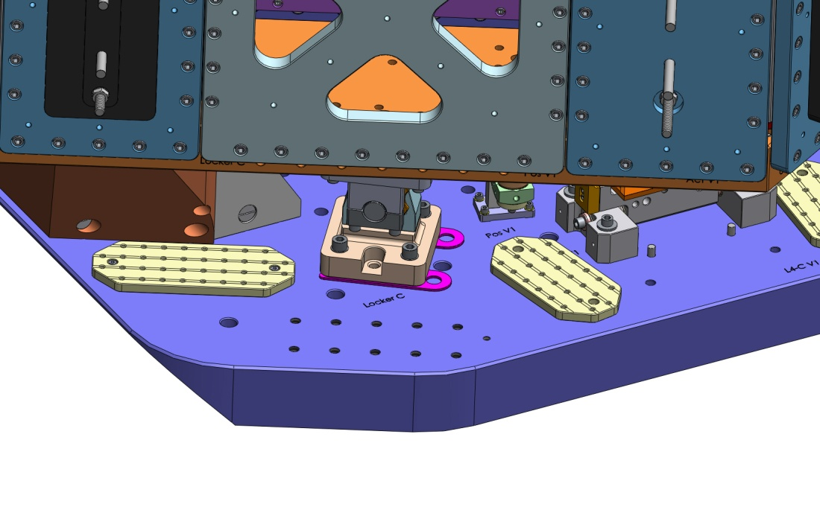
Remove one screw from Small Wiring Breadboards, and twist them out of the way.

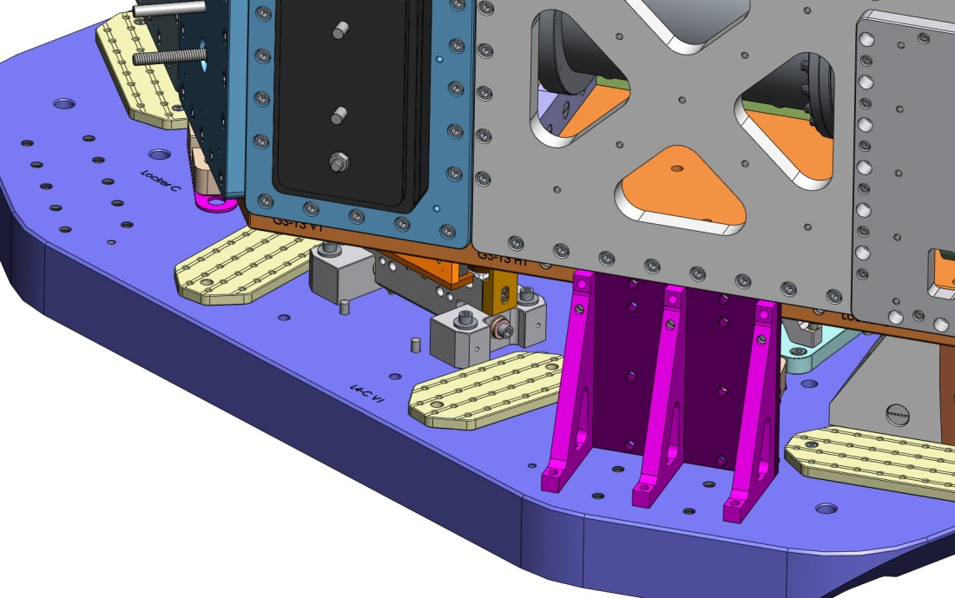
On this side, you can install the full Shipping Brace, as shown here.

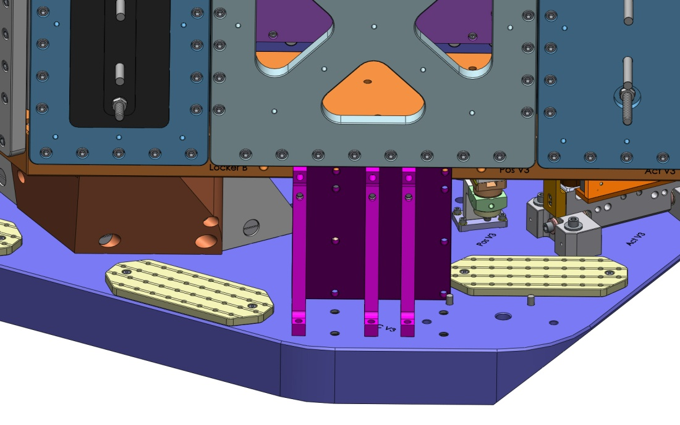
On the other end of Stage 0, you have to modify the Brace Assembly, to avoid the Vert L4-C pins. This involves shifting one of the D071301 pieces over 1 spot.

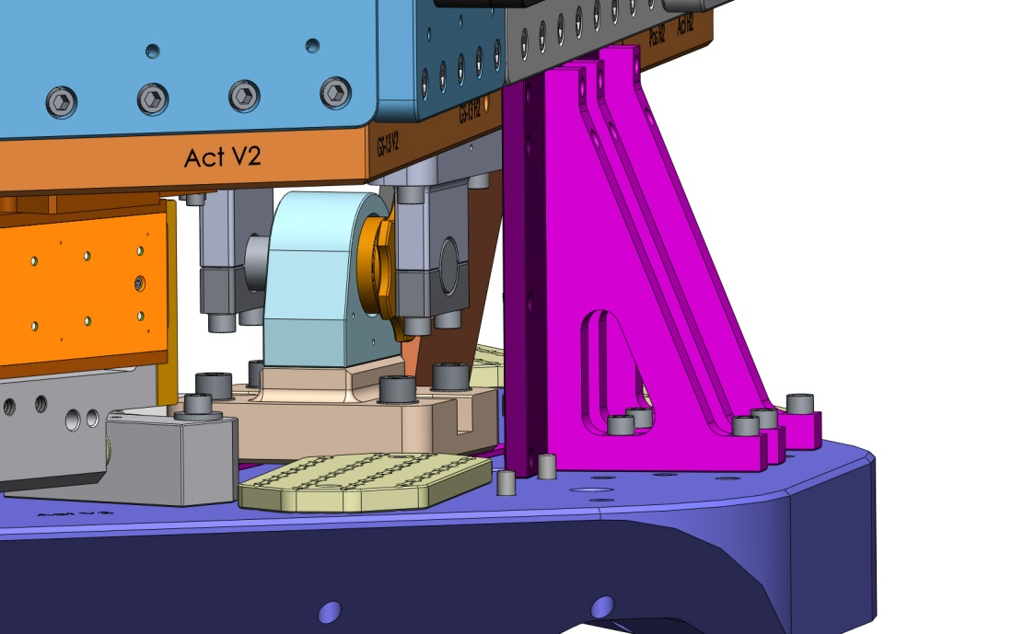
Lock Stage 1 BEFORE fastening the Shipping Braces. This "centers" the stage.

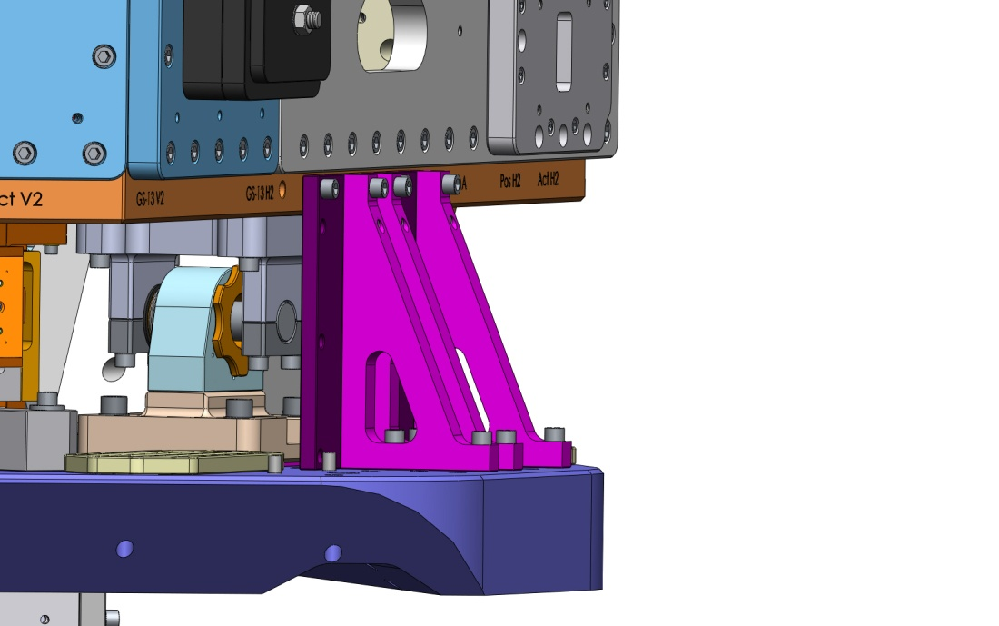
Release the Lockers BEFORE the Shipping Braces' mounting screws are torqued. Check that the Sleeve can move in/out freely.
IT'S CRITICAL THAT THE LOCKERS ARE NOT FORCED TO THEIR LIMITS BY THE SHIPPING BRACES.
Use dial indicators to check motion of Stage 1, while tightening all 4 Shipping Braces.

