LIGO Laboratory / LIGO Scientific Collaboration

LIGO-E0900216-v6 LIGO 01 Jan 2022

Assembly Procedure: HAM ISI, Advanced LIGO

Andy Stein

Distribution of this document:
LIGO Scientific Collaboration

This is an internal working note
of the LIGO Laboratory.

California Institute of Technology  LIGO Project – MS 18-34  1200 E. California Blvd.  Pasadena, CA 91125  Phone (626) 395-2129  Fax (626) 304-9834  E-mail: info@ligo.caltech.edu | Massachusetts Institute of Technology  LIGO Project – NW22-295  185 Albany St  Cambridge, MA 02139  Phone (617) 253-4824  Fax (617) 253-7014  E-mail: info@ligo.mit.edu
LIGO Hanford Observatory  P.O. Box 1970  Mail Stop S9-02  Richland WA 99352  Phone 509-372-8106  Fax 509-372-8137 | LIGO Livingston Observatory  P.O. Box 940  Livingston, LA 70754  Phone 225-686-3100  Fax 225-686-7189
http://www.ligo.caltech.edu/

Introduction
This document details the assembly of D0900124: HAM ISI Table, Advanced LIGO. These instructions are intended to compliment the assembly drawings, which can be found on the LIGO Document Control Center.
Before bolting parts together, always make sure there is no dust or debris in the interface. Except where noted, use a torque wrench to tighten all screws to specified torques.
All parts that will be included in the final assembly must be cleaned to LIGO standards, Class A. The list of parts to be Class A-cleaned includes screws, washers, inserts, and assorted other hardware. All tooling and other parts that are not included in the final assembly, but that contact Class A parts during assembly must be cleaned to LIGO standards, Class B.

Stage 0 Assembly
This chapter details the assembly procedure for D0900153: HAM ISI Stage 0.

Prep Work - General
- Prepare the BSC-HAM ISI Test Stand (D080464), in its short configuration. Fasten to the floor.
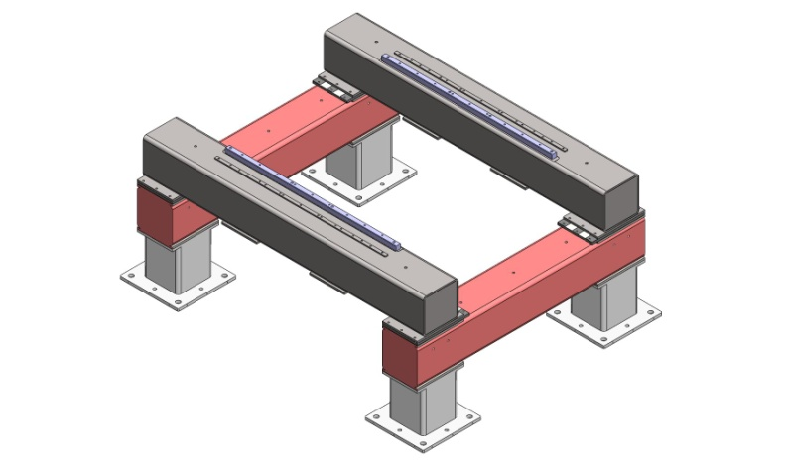
Figure 2.1. Test Stand configured for HAM ISI Assembly.

- Build the Assembly Stand (D070350). Place it near the Test Stand. Caution: do not lean on back corners of Assembly Stand, since the frame can rock on its 3 feet!
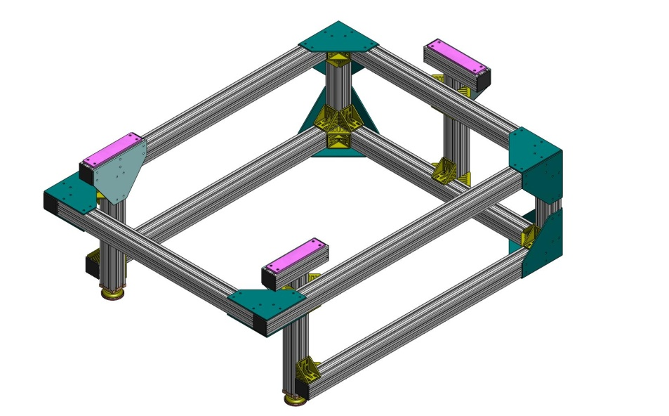
Figure 2.2. The Assembly Stand, which provides a platform for building up Stage 0 and Stage 1, before final integration on the Test Stand.

Tool Prep
- There are 3 sizes of Pin Install Tools available, to aid installation of press-fit dowel pins. They are D0900707 (for 1/4"-diameter pins), D071326 (for 3/8"-diameter pins), and D071327 (for 1/2"-diameter pins). These are short cylinders with bores slightly larger than the pins being inserted. As shown below, the intent is to first insert the pin in the lead-in section of the pin hole, then slip the Pin Install Tool over the pin. Then, slide another pin through the cylinder, so it touches the first pin. Gently hammer the top pin until the bottom pin is at the desired depth in the part.
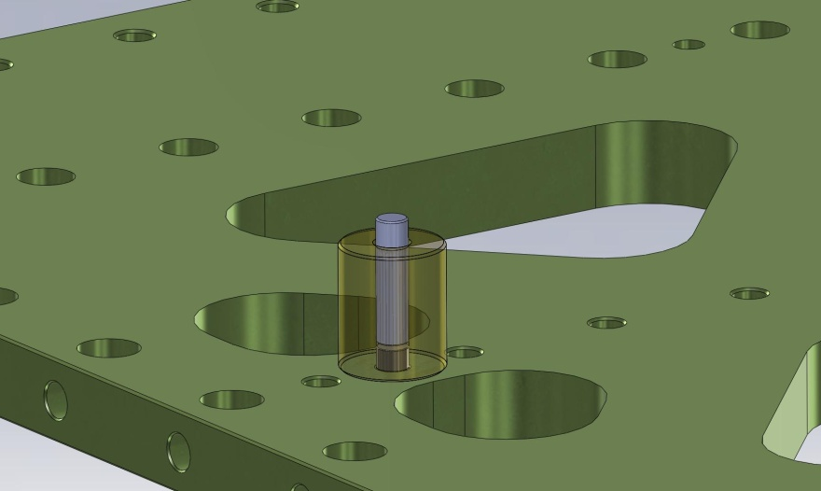
- Refer to Appendix B for list of tools required for assembly.

Prep Work – Stage 0 Base
- Install Nitronic 60 Heli-Coil threaded inserts into Stage 0 Base (D071001) for lifting eyes:
  - (3) 3/4”-10x2.0*Dia.
- Pick up Stage 0 Base and place onto Assembly Stand. Orientation should be as shown in Figure 2.3 and Figure 2.4.
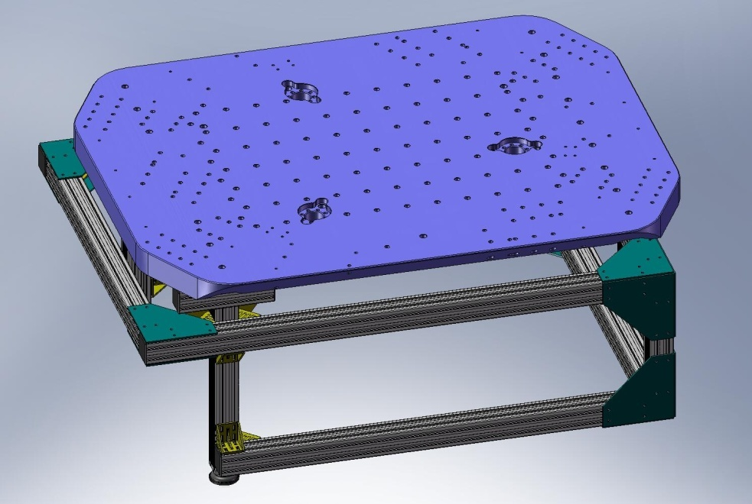
Figure 2.3. Stage 0 Base resting on Assembly Stand. Note orientation of (3) pockets for Spring Pull-Down tooling.

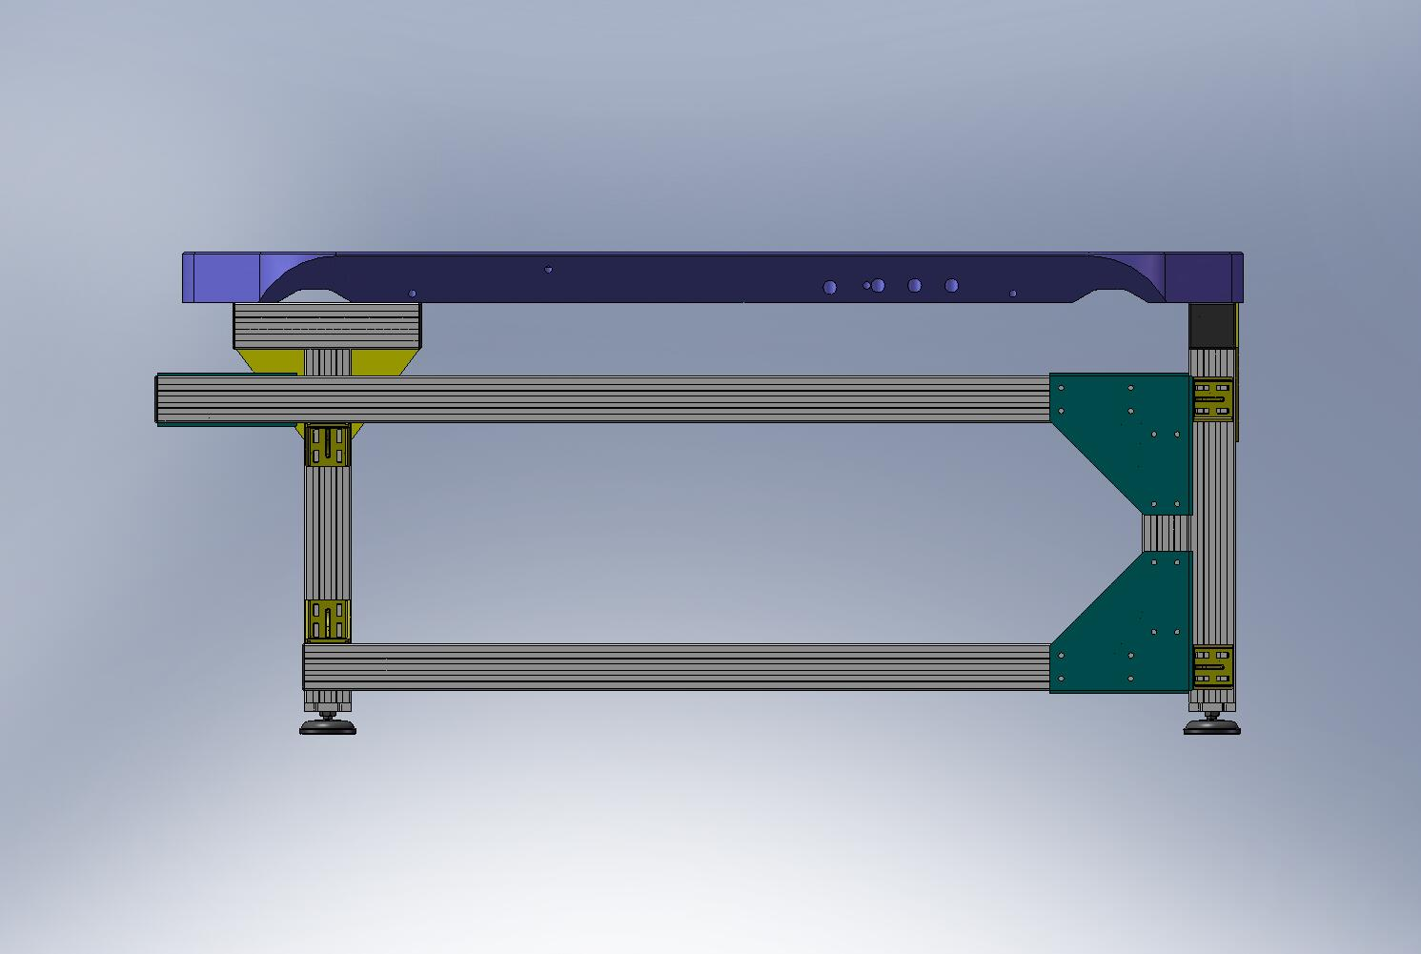
Figure 2.4. Back edge of Stage 0 Base should be close to back edge of Assembly Stand.

- Install remaining Heli-Coils into Stage 0 Base, per machine drawing D071001.
- Press or hammer (6) 1/2”x1.5” dowel pins into Stage 0 Base. Pins should sit .45”+/-.02” above the surface of the Base.
- Press or hammer (15) 3/8”x1.0” dowel pins into Stage 0 Base. Pins should sit .50" above the surface of the Base.

Prep Work – Support Posts
- Install Nitronic 60 Heli-Coil threaded inserts into (3) Support Posts, per machine drawing D071002.
- Press (2) 1/2”x1.5” dowel pins into each of the (3) Support Posts, for locating Springs. Pins should sit about 1.10” above top surface of Posts, as shown in Figure 2.5 and Figure 2.6.
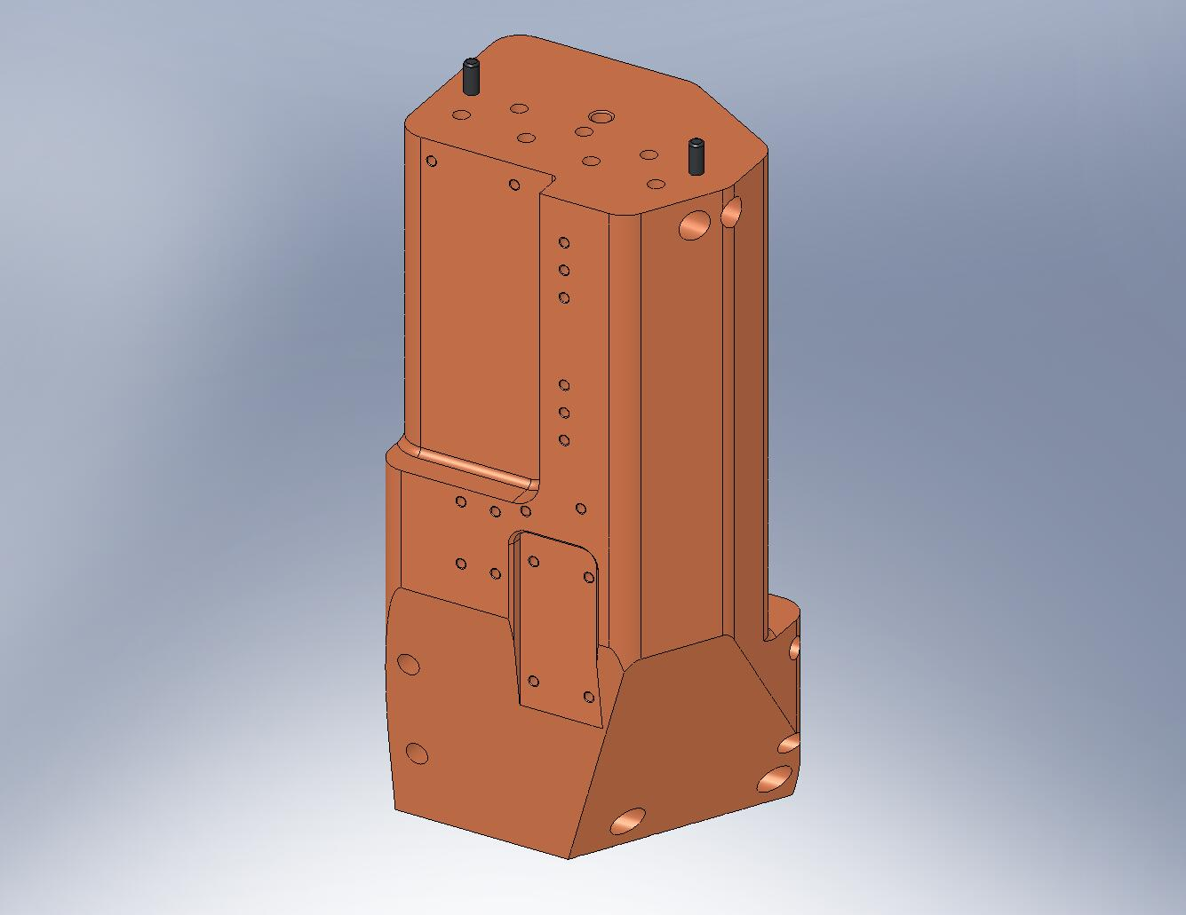
Figure 2.5. Press (2) dowel pins into top of each Support Post.
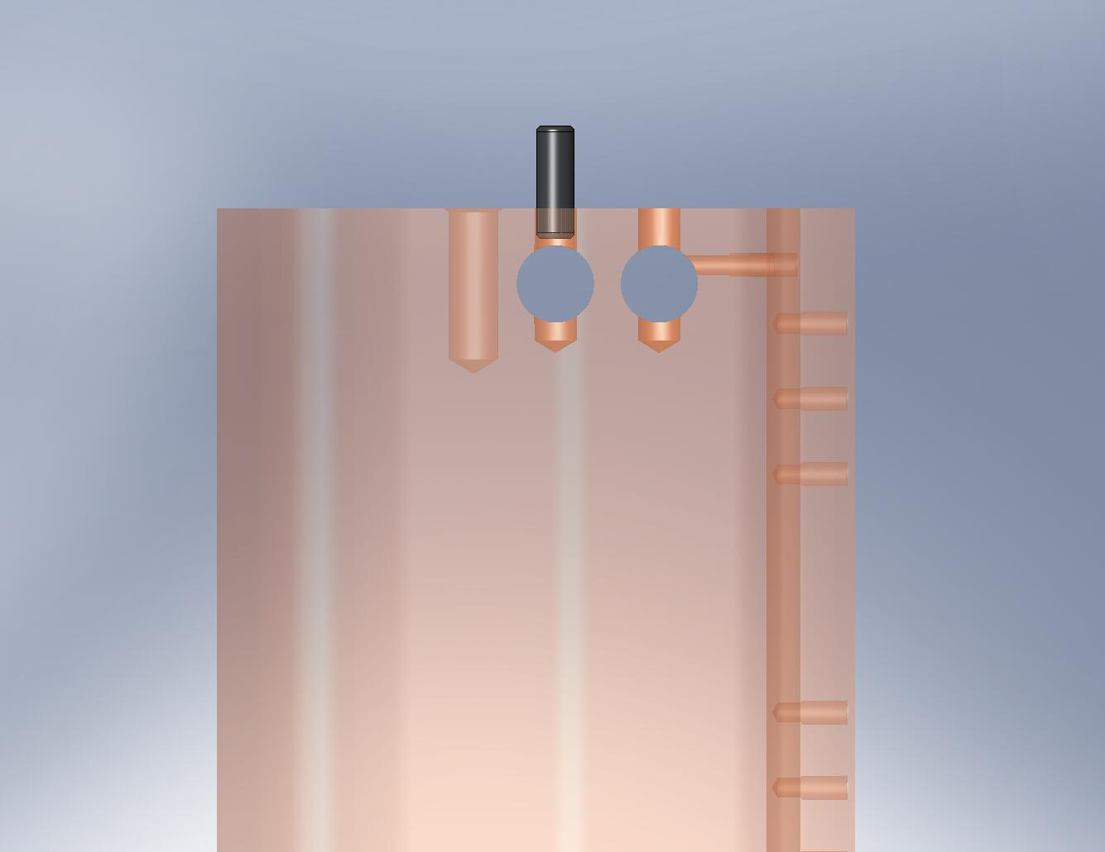
Don’t press the pins too far!

Figure 2.6. The pins must not stick into the Gang Barrel Nut holes.

Prep Work – (3) Horizontal L4-C Bracket Assemblies (D0900317)
- Install Nitronic 60 Heli-Coil threaded inserts into (3) Bracket Base pieces, per machine drawing D0900318.
- Install Heli-Coils into (3) Bracket Mount pieces, per machine drawing D0900319.
- Press or hammer (2) 1/4”x.875” dowel pins into Bracket Base. Pins should sit .25” above the surface.
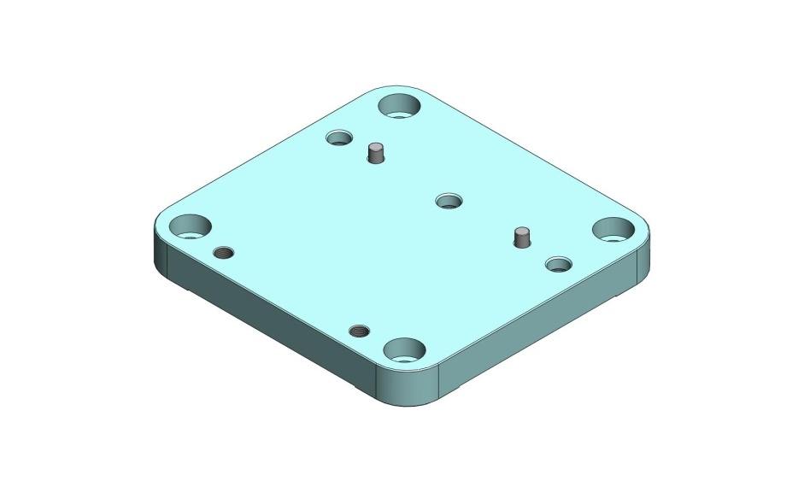
Figure 2.7. Press pins into Bracket Base.

- Mate Bracket Mount to Bracket Base, using dowel pins to locate. Note orientation of counterbores in Figure 2.8. Insert mounting hardware. Torque screws to final spec.
Hardware:
(3) 3/8"-16x1.0" SHCS
(3) 3/8" vented washers
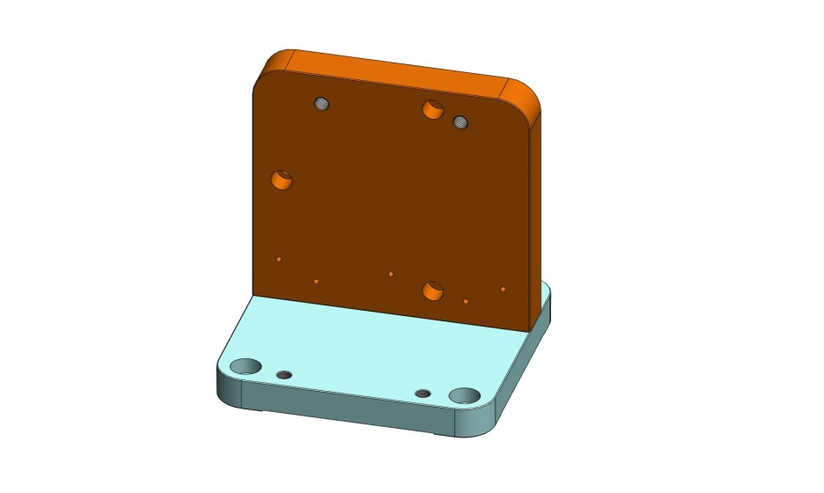
Figure 2.8. Bracket Mount on Bracket Base. Note orientation of counterbores in Mount, to identify proper assembly.

- Place two Gussets (D0900320) on Bracket Base, against Bracket Mount. Add mounting hardware. Snug all screws, then torque to spec.
Hardware:
(4) 1/4"-20x1.25" SHCS
(4) 1/4" vented washer
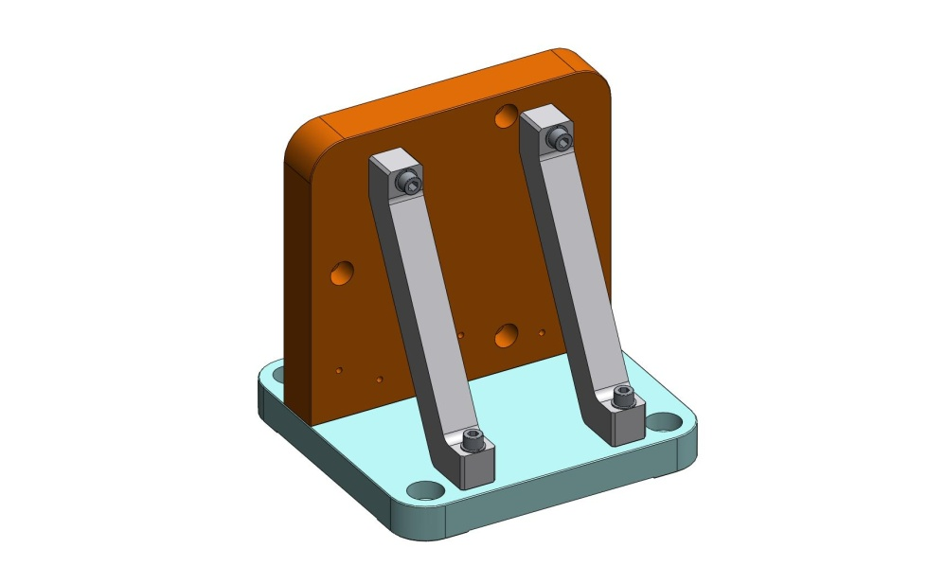
Figure 2.9. Final Horizontal L4-C Bracket Assembly.

- Repeat previous steps for remaining (2) Horizontal L4-C Bracket Assemblies.

Build Stiffener Assembly (D071412)
- Screw the (7) Stage 0 Stiffener Ribs (3x D071006 Type 00, 2x Type 01, and 2x Type 02) to the bottom of the Stage 0 Base (D071001). Hand tighten all of the screws – do not torque.
Hardware:
(74) 3/8"-16x1.75" SHCS
(74) 3/8" vented washers
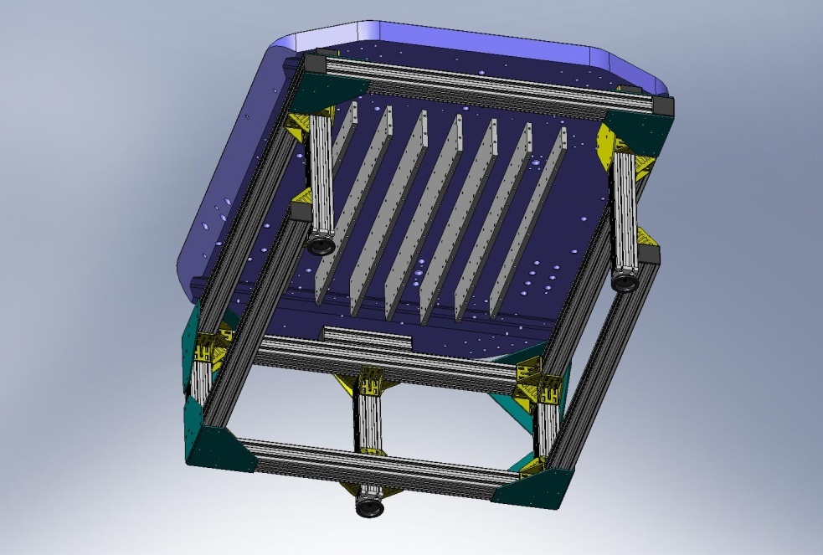
Figure 2.10. First step for installing Stiffener Assembly: hang vertical plates (D071006) from Stage 0 Base. The widest plates (Type 00) should hang from the middle 3 rows. The next widest (Type 01) should hang on either side of the Type 00 plates. Finally, the smallest (Type 02) should hang from the last row on either side.

- Place one of the outermost horizontal Stage 0 Stiffener Plates (D071007 Type 01) and snug all screws. Try to bring ends even with the ends of the adjacent vertical Ribs (D071006 Types 02 and 01). Torque the inner/side bolts to final spec. Bottom screws should not be torqued, yet.
Hardware:
(21) 3/8"-16x1.5" SHCS
(21) 3/8" vented washers
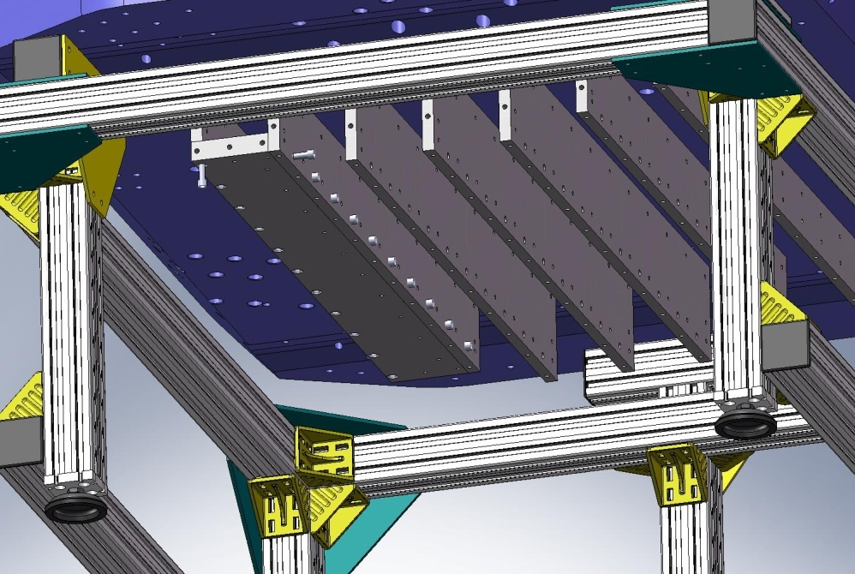
Figure 2.11. Next, place the smaller horizontal plate (D071007 Type 01) underneath one of the Type 02 vertical plates. After snugging all of the screws for this plate, torque the side screws to their final spec.

- Repeat last step, for outermost D071007 Type 01 Plate on other side of assembly.
Hardware:
(21) 3/8"-16x1.5" SHCS
(21) 3/8" vented washers

- Place next horizontal Stage 0 Stiffener Plate (D071007 Type 01) and snug all screws. Again, try to bring ends flush with ends of adjacent vertical ribs. Torque the inner/side bolts to final spec. Bottom screws should not be torqued, yet.
Hardware:
(21) 3/8"-16x1.5" SHCS
(21) 3/8" vented washers
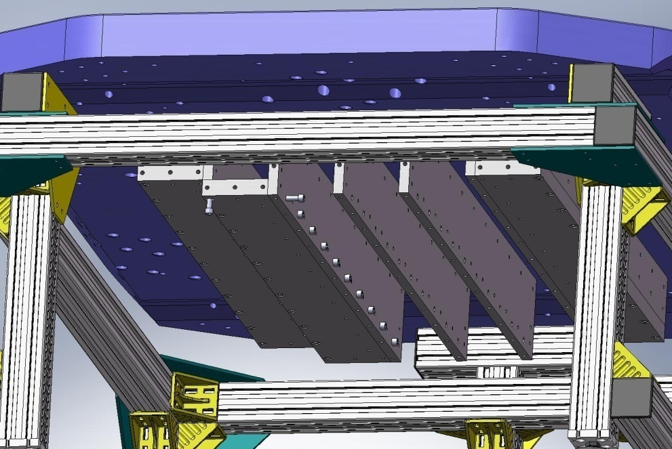
Torque to spec.
Figure 2.12. After both of the outer Type 01 horizontal plates are secured, install one of the inner Type 01 horizontal plates. Snug all of the screws for this plate, then torque the side bolts to final spec.

- Repeat last step, for fourth (and final) D071007 Type 01 Plate (on other side of assembly).
Hardware:
(21) 3/8"-16x1.5" SHCS
(21) 3/8" vented washers

- Place large Stage 0 Stiffener Plate (D071007 Type 00) under center of Stiffener Assembly. Caution: this plate is heavy (54 lbs)! Snug all bolts.
Hardware:
(33) 3/8"-16x1.5" SHCS
(33) 3/8" vented washers
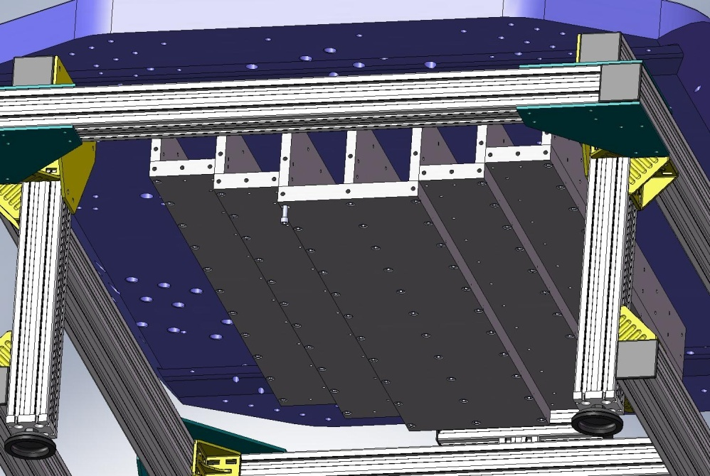
Figure 2.13. After both of the inner Type 01 horizontal plates are secured, install the center Type 00 horizontal plate. Snug the bolts, but do not torque, yet.

- Place Stage 0 Stiffener End Cap (D071008) under Stage 0 Base, on one end of Stiffener Assembly. Thread in top bolts from above the Base, and turn until snug. Thread in side bolts, and turn until snug.
Hardware:
(6) 3/8”-16x1.75” SHCS – from above
(29) 3/8"-16x1.5" SHCS – from side
(35) 3/8" vented washers – all screw locations
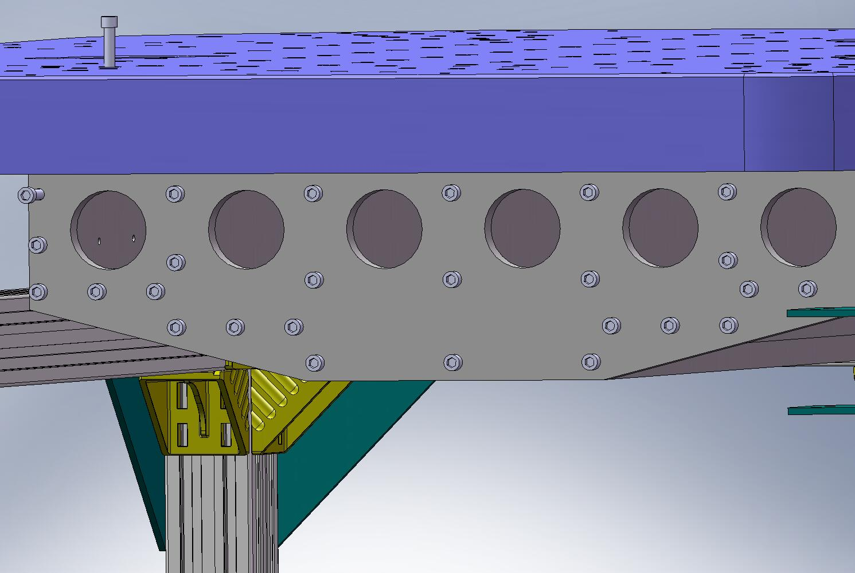
Figure 2.14. Bolt End Caps to both ends of the Stiffener Assembly.

- Repeat last step, mounting the second End Cap to the other end of the Stiffener Assembly.
Hardware:
(6) 3/8”-16x1.75” SHCS – from above
(29) 3/8"-16x1.5" SHCS – from side
(35) 3/8" vented washers – all screw locations

- Using staggered pattern, incrementally torque all (86) top bolts for Stiffener Assembly to final spec.
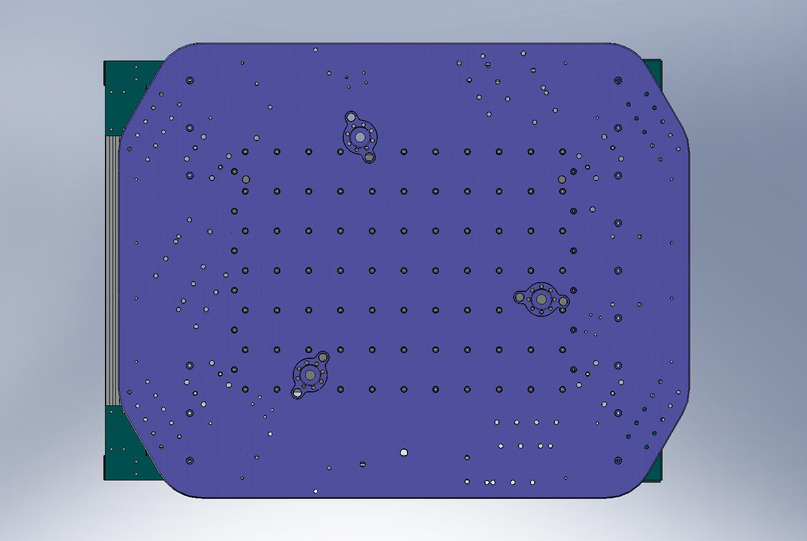
Figure 2.15. Torque top Stiffener Assembly bolts to final spec.

- Incrementally torque all (77) bottom screws to final spec.
- 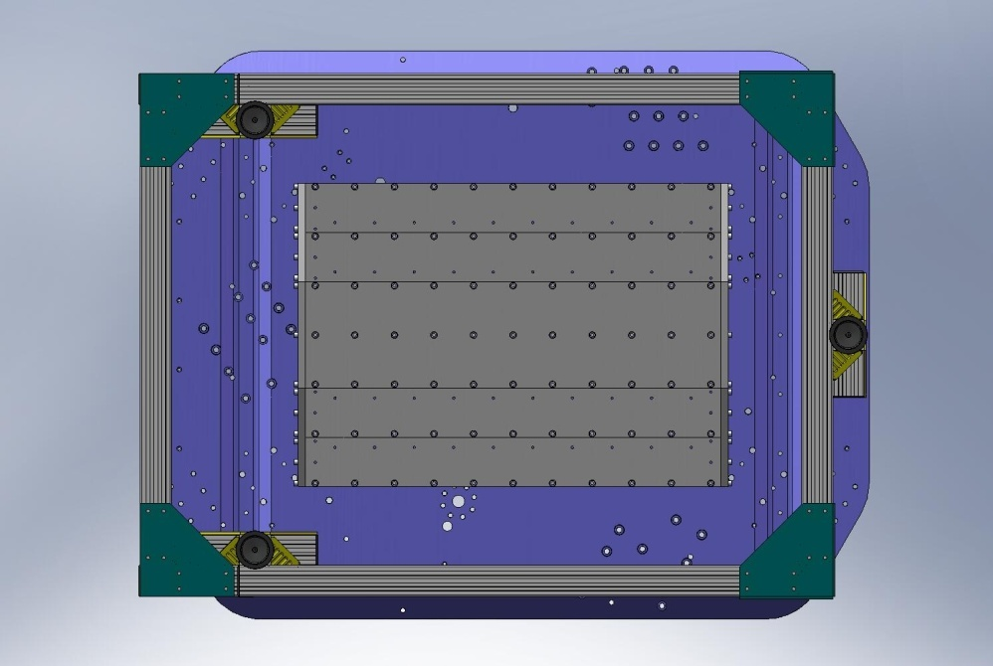
Figure 2.16. Torque bottom Stiffener Assembly bolts to final spec.

- Incrementally torque (2x 29) side End Cap screws to final spec.
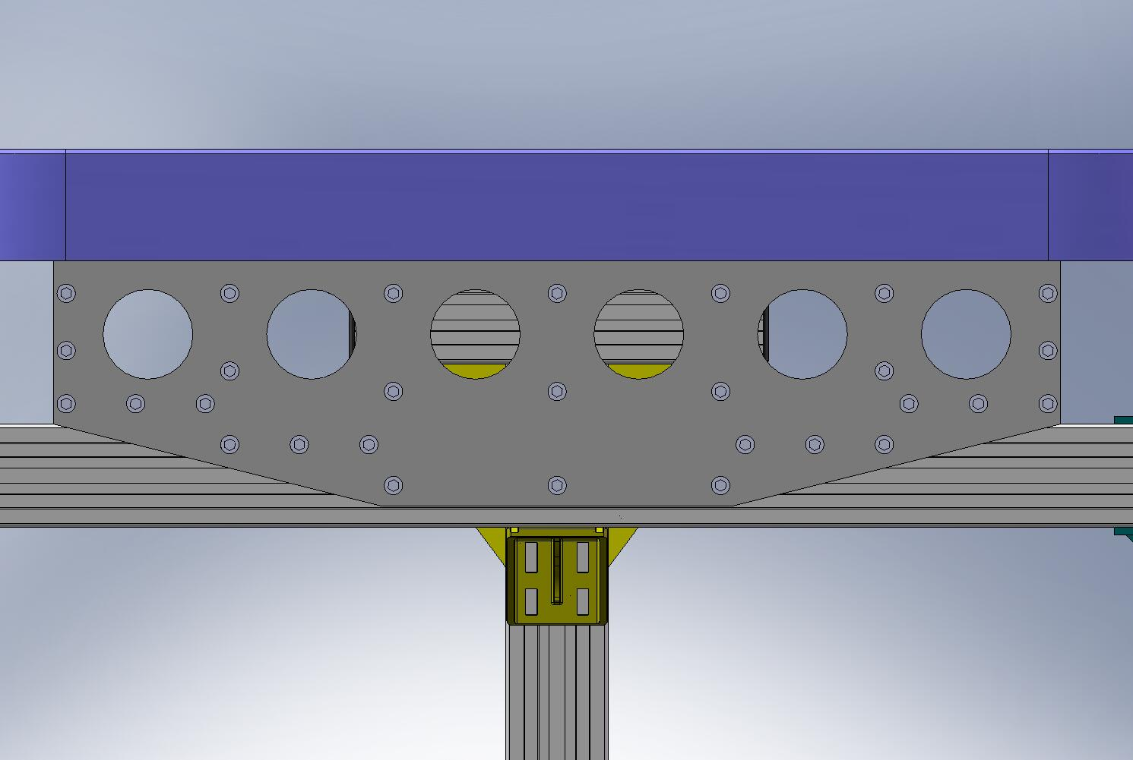
Figure 2.17. Torque side End Cap screws to final spec. Start in the middle, and work toward the edges. Exact order of tightening is not important.

Mount Support Posts and Gussets
- Lower (3) Support Posts (D071002) onto Stage 0 Base, allowing pins to seat in pin-holes and slots in bottom of Posts. Caution: Support Posts are heavy (180 lbs, each)! Use overhead crane to lower onto Base.
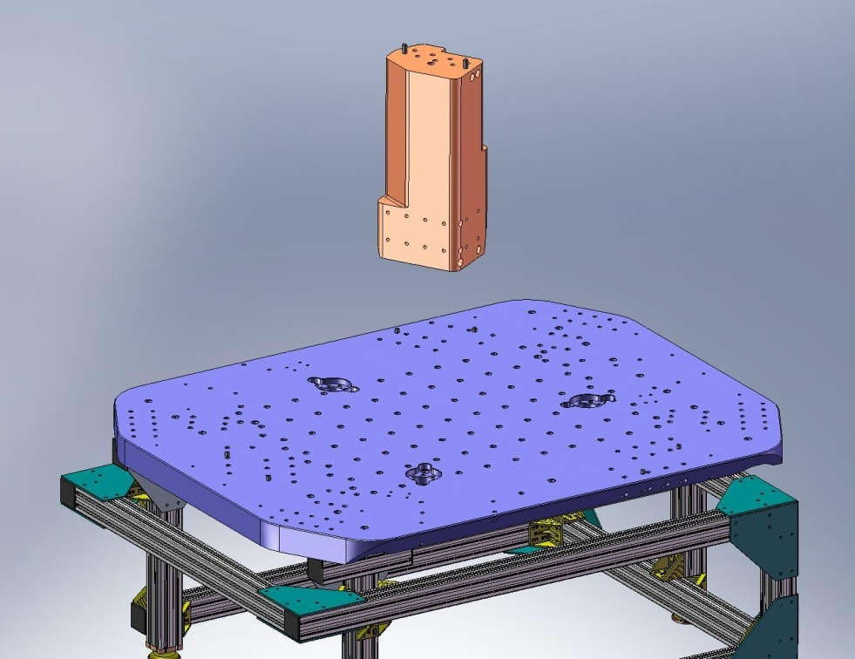
Figure 2.18. Using crane, lower Support Posts onto Stage 0 Base. Allow pins in Base to seat properly into the hole/slot combinations underneath the Posts.
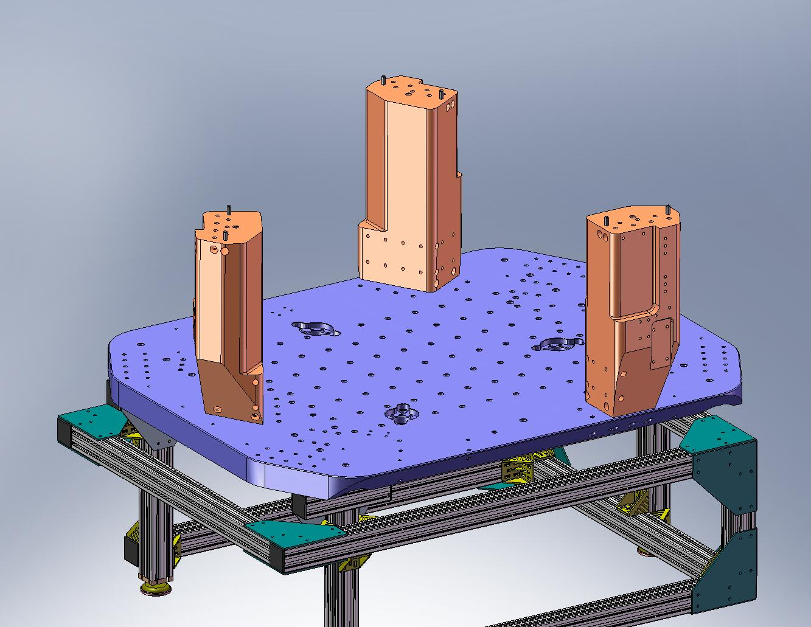
Figure 2.19. This view shows the correct orientation of the (3) Support Posts on the Stage 0 Base.

- Insert (2) 3-hole 1/2”-13 Gang Barrel Nuts (D071251 Type 03) in bottom of each Support Post. Thread in (18) D0900203 silver-plated screws from underneath the Stage 0 Base. Torque to final spec.
Hardware:
(18) 1/2”-13x2.0” Ag-plated SHCS (D0900203)
(18) 1/2” vented washers
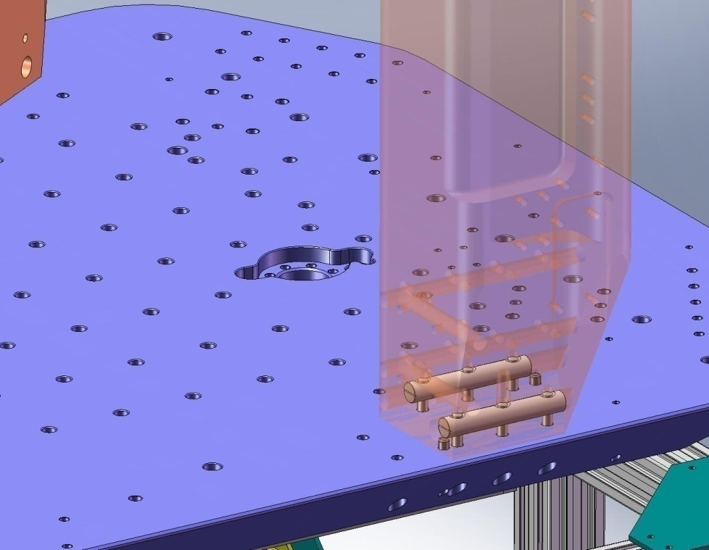
Figure 2.20. (2) Gang Barrel Nuts are inserted into each of the (3) Support Posts. The 1/2”-13 holes should line up with the thru holes in the Stage 0 Base. Thread in all the screws from underneath, and torque to final spec.

- Place (3) Support Post Caps (D071003) on top of the Support Posts, as shown in Figure 2.21. There are a hole and a slot in each Cap, which should slip around the dowel pins in the Posts.
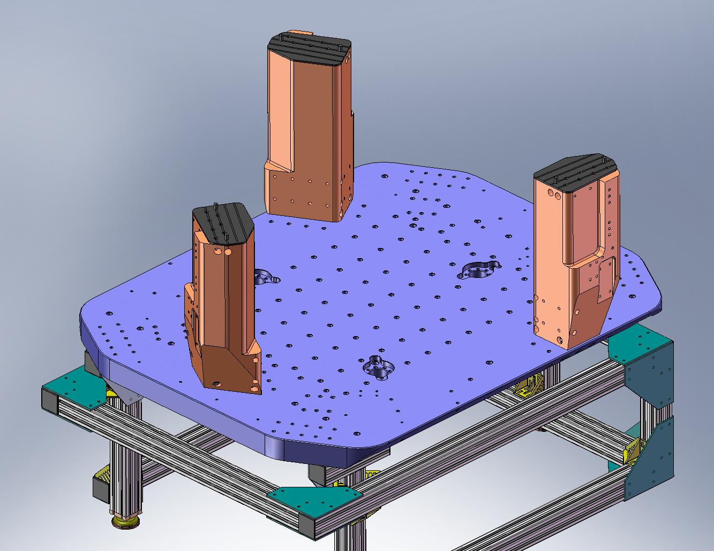
Figure 2.21. Support Post Caps placed on the Support Posts. Later, the Springs will be mounted on top of the Caps.

- Place (6) Support Post Gussets (D071004 and D071005) on Stage 0 Base, next to Support Posts. Proper orientation is shown in Figure 2.22.
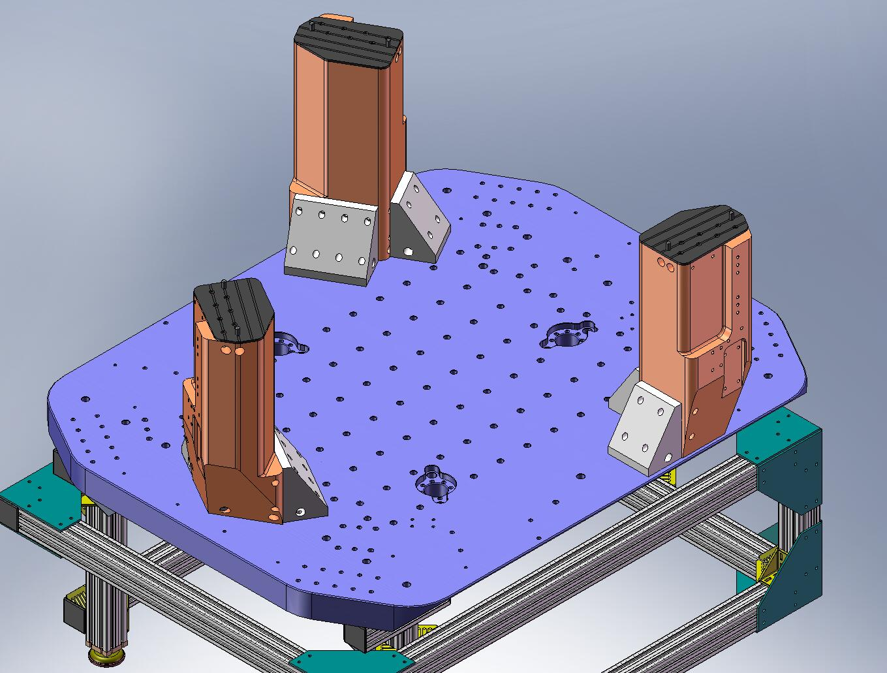
Figure 2.22. Place (3) Main and (3) Auxiliary Support Post Gussets against the sides of the Support Posts. Orient as shown in this image.

- Insert (2) 2-hole and (2) 4-hole 3/8”-16 Gang Barrel Nuts (D071251 Types 00 and 01, respectively) into each of the Posts. Start (18) D0900202 silver-plated screws through sides of Gussets. Snug, but do not torque, yet.
Hardware:
(36) 3/8”-16x2.5” Ag-plated SHCS (D0900202)
(36) 3/8” vented washers
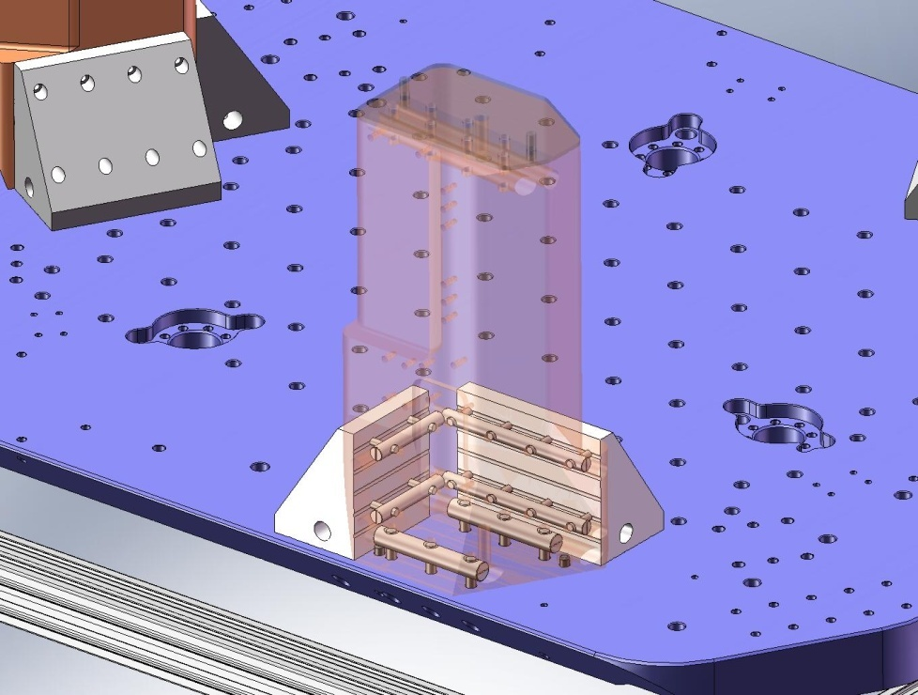
Figure 2.23. Transparent view of a Support Post, showing Gang Barrel Nuts with screws engaged.

- Insert 2-hole 1/2”-13 Gang Barrel Nuts (D071251 Type 02) into each Support Post Gusset, Aux (D071004). Insert 4-hole 1/2”-13 Gang Barrel Nuts (D071251 Type 04) into each Support Post Gusset, Main (D071005). Start (18) D0900203 silver-plated screws into the Nuts, from underneath the Stage 0 Base. Torque screws to final spec.
Hardware:
(18) 1/2”-13x2.0” Ag-plated SHCS (D0900203)
(18) 1/2” vented washers
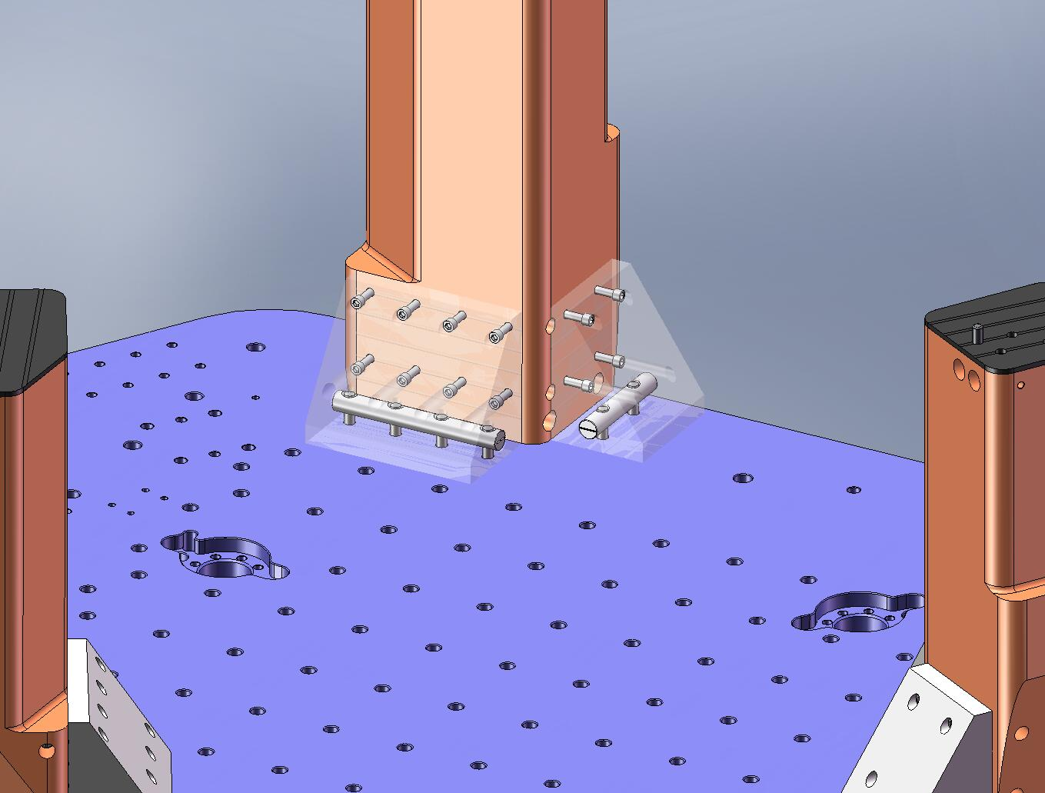
Figure 2.24. Transparent view of Support Post Gussets, showing Gang Barrel Nuts with screws engaged.

- Torque (36) screws in sides of Gussets to final spec.

Transfer Stage 0 to Test Stand
- Screw (3) 3/4”-10 lifting eyes into Stage 0 Base.
- Lift Stage 0 Assembly (2,150 lbs) with crane and move over Test Stand. Check that orientation of HAM ISI will be convenient for loading into the HAM chamber, after build is finished.
- Gently lower Stage 0 Assembly onto Test Stand. Start screws into mounting bosses, to help locate Stage 0. Note there are 6 mounting holes on one side of the Stage 0 Base, and 9 on the other.
Hardware:
(15) 3/8”-24x3.5” SHCS
(15) 3/8” vented washers
- Continue lowering Stage 0 until full load is supported by Test Stand. Torque mounting screws to final spec.
- Remove lifting eyes from Stage 0 Base.
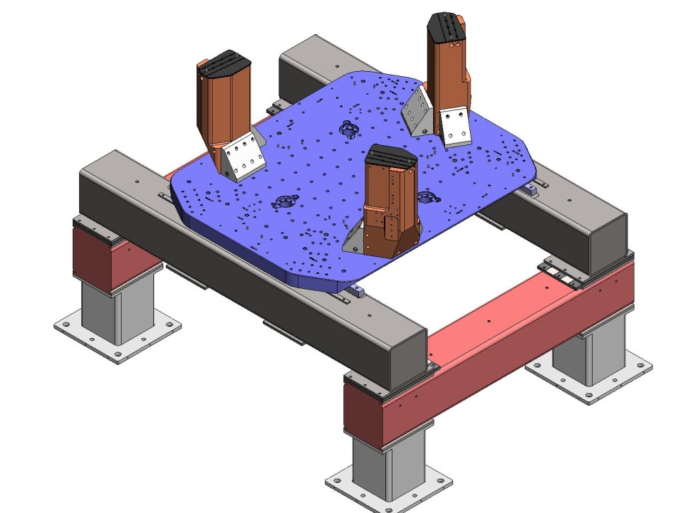
Figure 2.25. Stage 0 Assembly mounted to the Test Stand.

- Place Horizontal L4-C Bracket Assembly (D0900317) on Stage 0 Base, as shown in Figure 2.26. Register sides of Bracket Base against (3) dowel pins. Install mounting hardware. Snug screws, then torque to spec.
Hardware:
(4) 3/8”-16x1.0” SHCS
(4) 3/8” vented washers
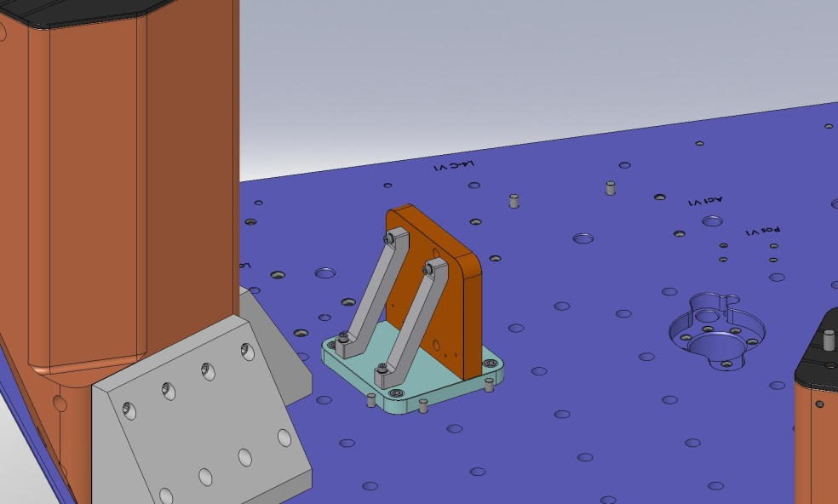
Figure 2.26. Assembly Bracket for Horizontal L4-C mounted on Stage 0 Base. Before tightening the mounting screws, push the Bracket Base against the (3) dowel pins to locate.

- Place Horizontal L4-C Pod Assembly (D047820) against Horizontal L4-C Bracket Assembly. Cable feedthrough flange should face outward. Insert mounting hardware. Snug all the screws, then torque to spec.
Hardware:
(2) #10-24x1.25" vented, silver-plated SHCS
(1) 1/4"-20x1.0" vented, silver-plated SHCS
(2) #10 vented washers
(1) 1/4" vented washer
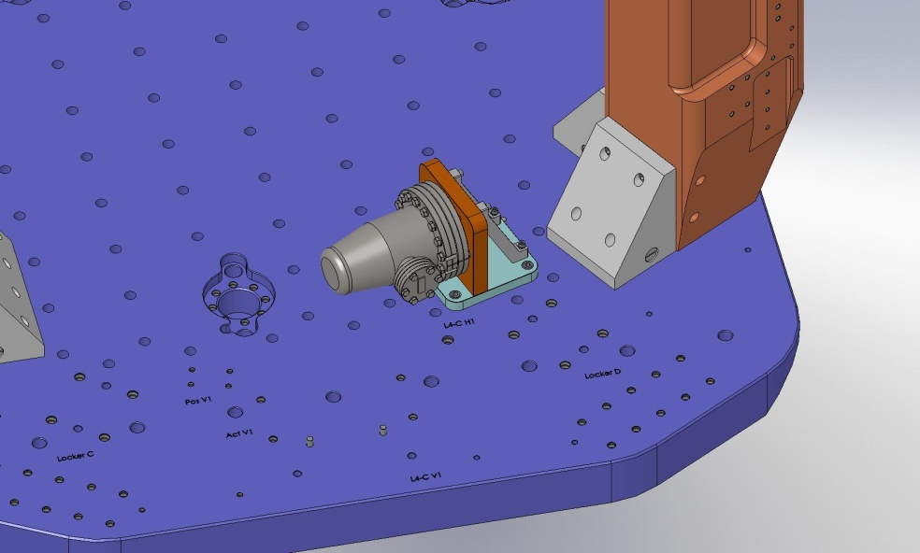
Figure 2.27. Horizontal L4-C Pod Assembly mounted to its Bracket Assembly.

- Repeat last 2 steps for remaining 2 Horizontal L4-C Brackets and Pods.
- Check level of Stage 0 Base at several points on its top surface, using bubble level. Record the numbers. Are they within spec?

Stage 1 Assembly
This chapter details the assembly procedure for D0900154: HAM ISI Stage 1 Pre-Assembly.

Prep Work – Stage 1 Floor
- Install Nitronic 60 Heli-Coil threaded inserts into Stage 1 Floor, per machine drawing D071051.
- Pick up the Stage 1 Floor and place it onto the Assembly Stand. Orientation should be as shown in Figure 3.1 and Figure 3.2.
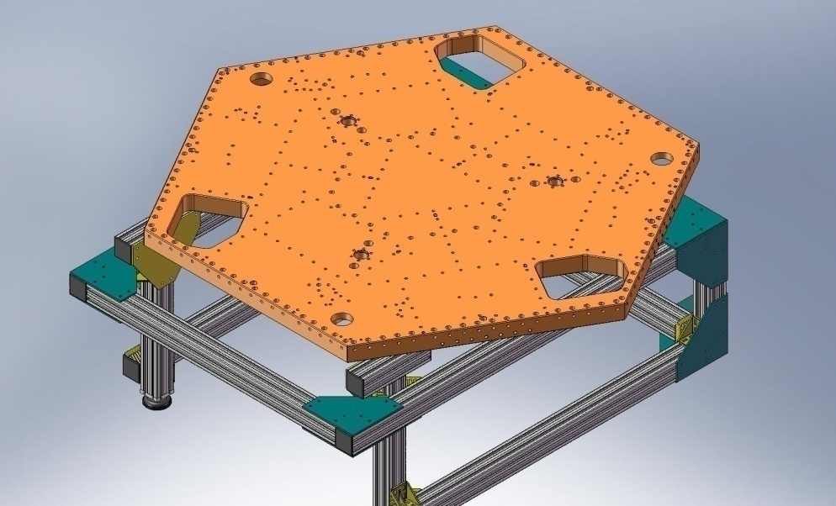
Figure 3.1. Stage 1 Floor resting on the Assembly Stand, for initial stage build-up. This orientation allows good access to the Boxwork mounting screws.

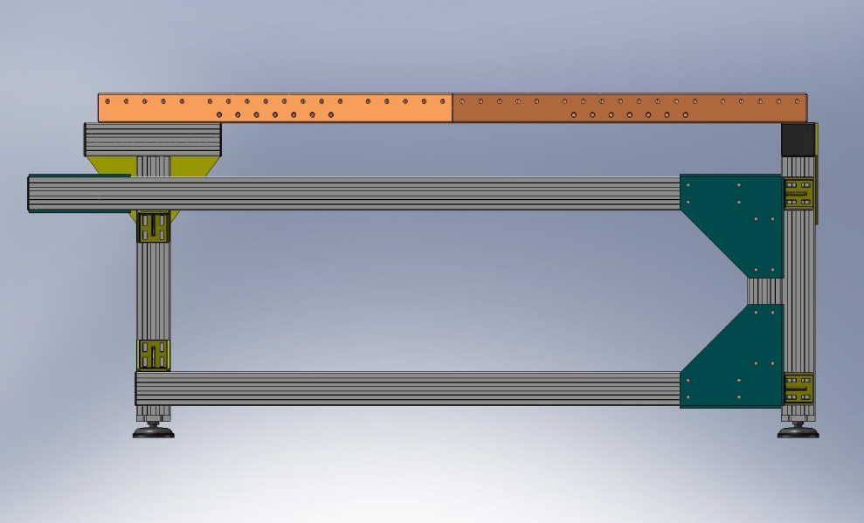
Figure 3.2. Side view of Stage 1 Floor on Assembly Stand.

Prep Work – Brackets, Posts, and Hatches
- Install Nitronic 60 Heli-Coil threaded inserts in (12) Outer Wall, Bracket 120 pieces, per machine drawing D071060.
- Install Heli-Coils in (9) Outer Wall, Bracket 90 pieces (D071061).
- Install Heli-Coils in (6) Rib Bracket, 60 Deg pieces (D071073).
- Install Heli-Coils in (3) Flexure Posts (D071074).
- Install Heli-Coils in (3) Spring Hatch, Optics Table pieces (D071067).

Prep Work – Ribs
- Press (1) 3/8”x.75” dowel pin into side of each of the (3) Rib, Rad, Flexure Out 1 plates (D071068) as shown in Figure 3.3. Pin should sit .25” proud of the mating surface. Do not press pin into bottom of this plate, yet!
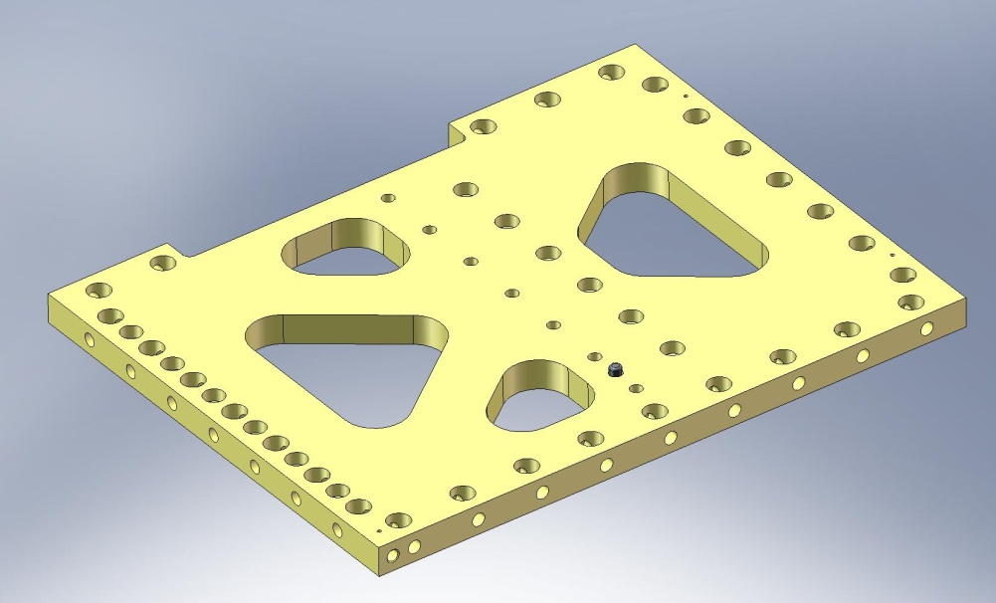
Figure 3.3. Dowel pin pressed into side of Radial Rib (D071068). Pin should sit .25” proud of surface.

- Install Heli-Coils in (3) Rib, Rad, Flexure Out 2 plates (D071069).
- Press (2) 3/8”x.75” dowel pins into side of each of (3) Rib, Rad, Flexure Out 2 plates (D071069) as shown in Figure 3.4. Pins should stand .25” proud of mating surface. Do not press pins into bottom of this plate, yet!
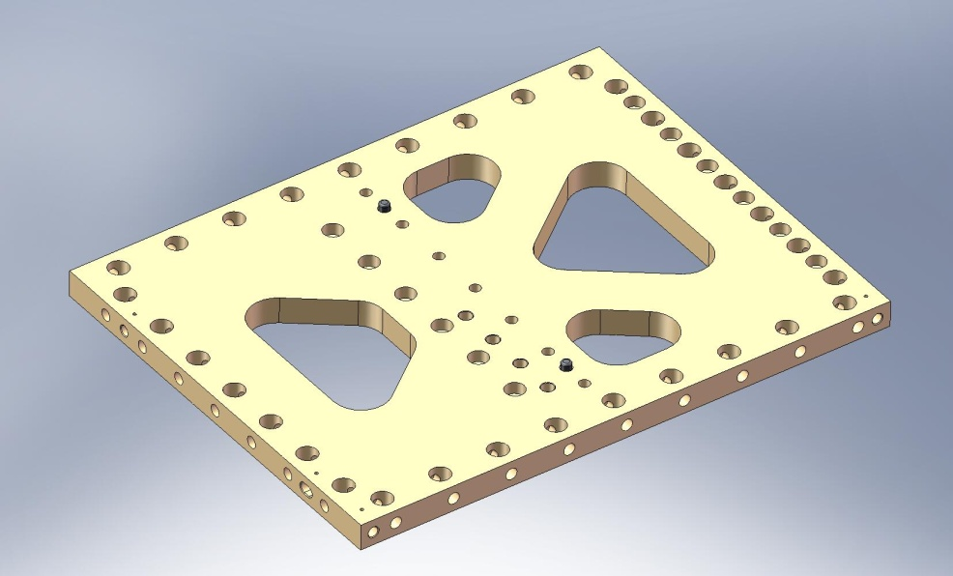
(4) Heli-Coils
Figure 3.4. Dowel pins pressed into side of Radial Rib (D071069). Heli-Coils are installed from the same side as the pins are pressed.

- Press (4) 3/8”x.75” dowel pins into each of (3) Rib, Tan, Flexure Cen plates (D071070). The pins should all stand .25” proud of the plate surface, as shown in Figure 3.5.
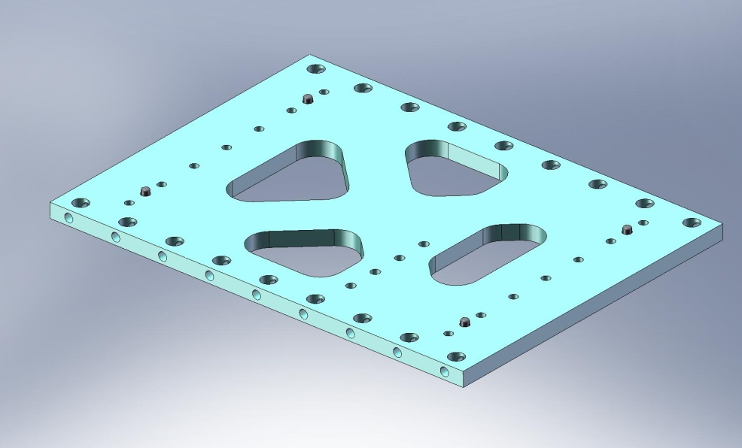
Figure 3.5. Dowel pins pressed into side of Tangential Rib (D071070).

- Insert Heli-Coils in (3) Rib, Tan, Flexure Mid plates (D071071).
- Press (4) 3/8”x.75” dowel pins into one side of each of (3) Rib, Tan, GS-13 Mid plates (D071052), as shown in Figure 3.6. The pins should all stand .25” proud of the plate surface. For each plate, press (2) more 3/8”x.75” pins into the opposite face, as shown in Figure 3.7. Again, the pins should sit .25” proud of the plate surface.
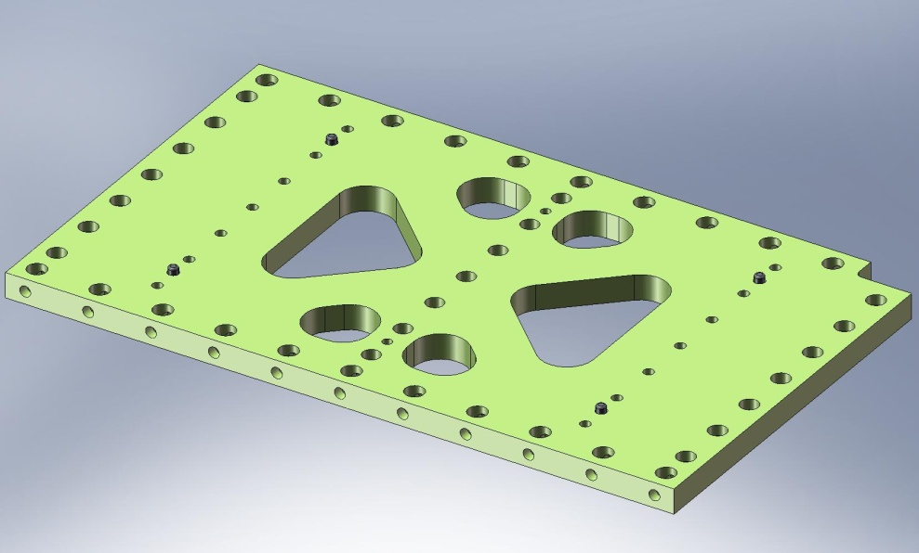
Figure 3.6. Dowel pins pressed into one side of Tangential Rib (D071052).
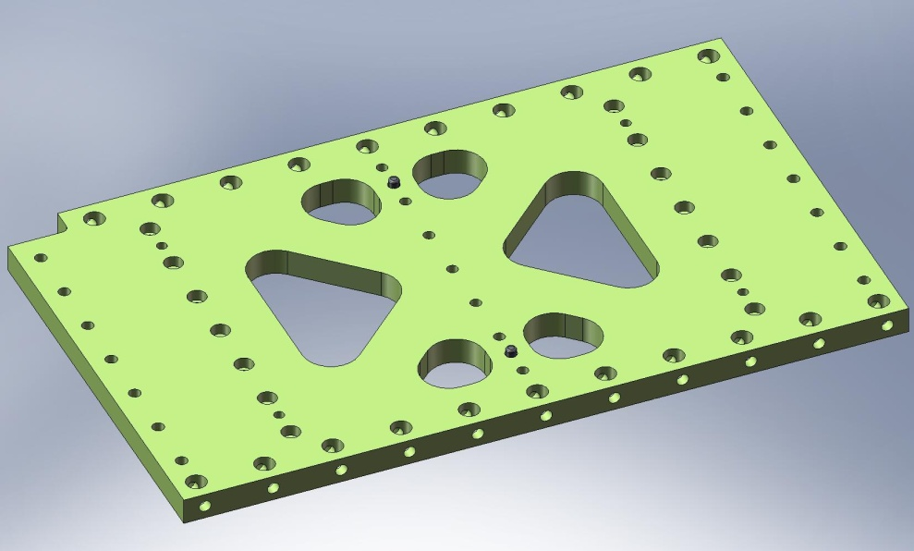
Figure 3.7. Dowel pins pressed into opposite side of Tangential Rib (D071052).

- Press (2) 3/8”x.75” dowel pins into one side of each of (3) Rib, Tan, GS-13 Cen plates (D071053), as shown in Figure 3.8. The pins should stand .25” proud of the plate surface.
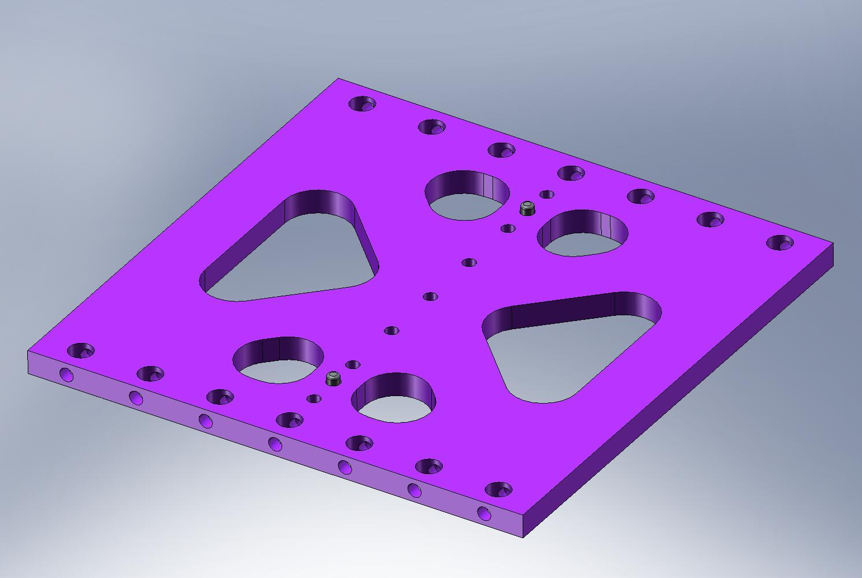
Figure 3.8. Dowel pins pressed into side of Tangential Rib (D071053).

- Insert Heli-Coils in (3) Rib, Rad, GS-13 Out 1 plates (D071055).

Prep Work – Wall Plates
- Insert Heli-Coils in (6) Keel Walls (D071063).
- Press (2) 1/2”x4.0” dowel pins into each of (6) Keel Walls, as shown in Figure 3.9. Pins should come flush with back surface on Wall. This completes the Keel Wall Assembly (D071425).
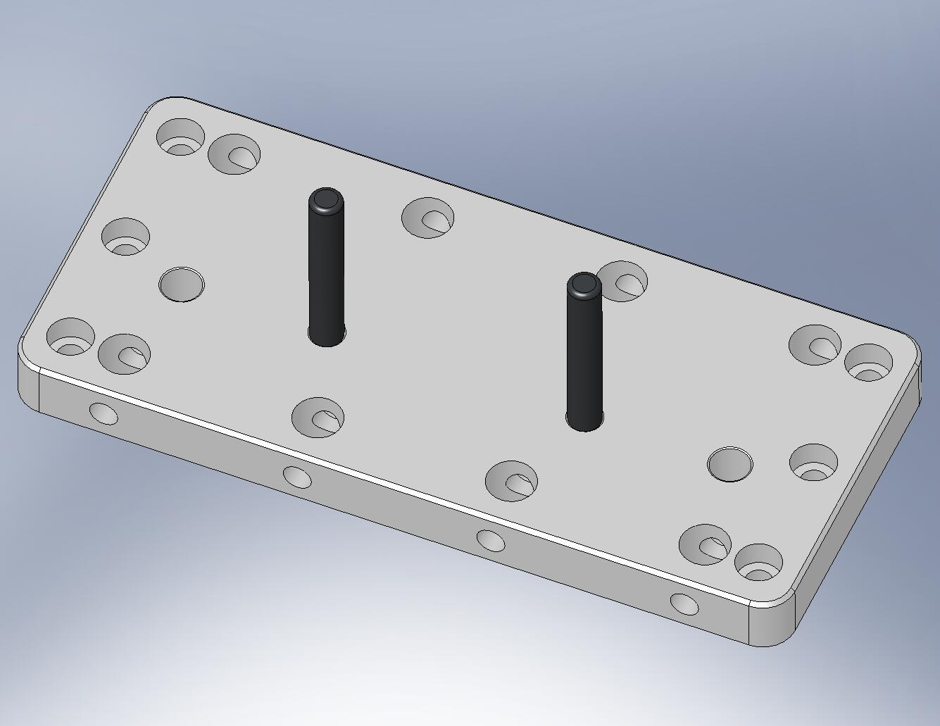
Figure 3.9. Dowel pins pressed into Keel Wall (D071063). Note orientation of counterbores on side mounting holes.

Prep Work – Optical Table
- Install Nitronic 60 Heli-Coil threaded inserts in Optical Table, per machine drawing D071050.

Prep Work – Build (4) Locker Assemblies (D071450)
- Press (2) 3/8”x1.0” dowel pins into each of (4) Locker Pin Bases (D047936), as shown in Figure 3.10. Pins should stand .25” proud of the bottom surface.
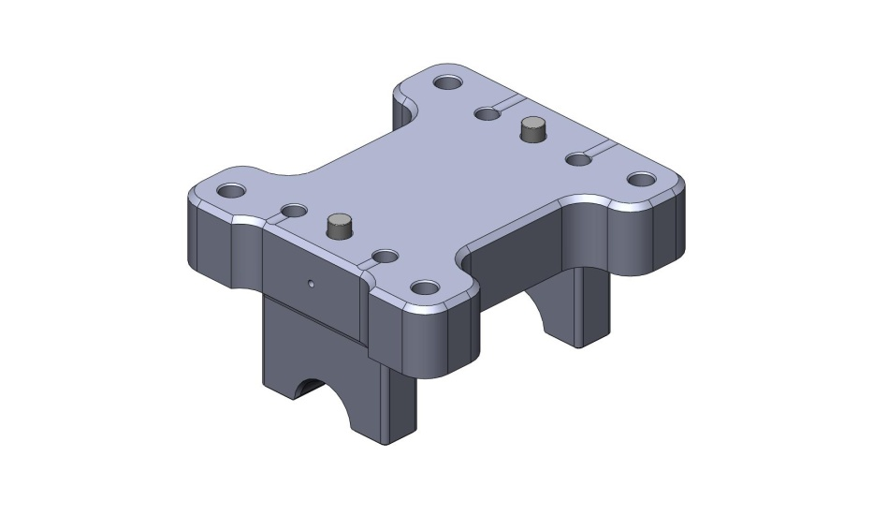
Figure 3.10. Dowel pins pressed into bottom of Locker Pin Base.

- Press (2) 3/8”x1.0” dowel pins into each of (4) Locker Sleeve Bases (D071140), as shown in Figure 3.11. Pins should stand .25” proud of the top surface.
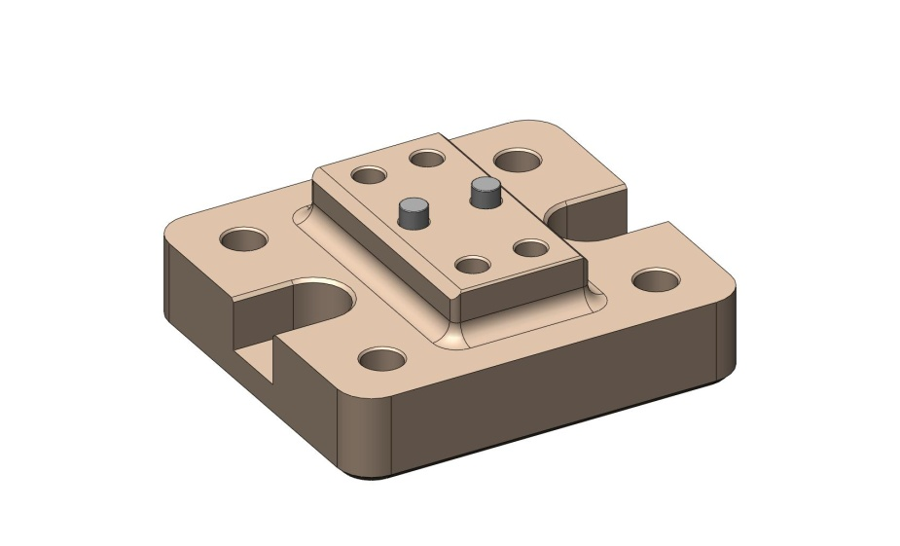
Figure 3.11. Dowel pins pressed into top of Locker Sleeve Base.

the following procedure describes the assembly of one D071450 assembly. This should be repeated for the other three D071450’s, as well:
- Place Locker Sleeve Housing (D047932) on top of Locker Sleeve Base, allowing pins to seat properly in mating hole and slot. Relative orientation of two parts does not matter. Start screws. Snug, then torque to final spec.
Hardware:
(4) 3/8”-16x2.0” SHCS
(4) 3/8” vented washers
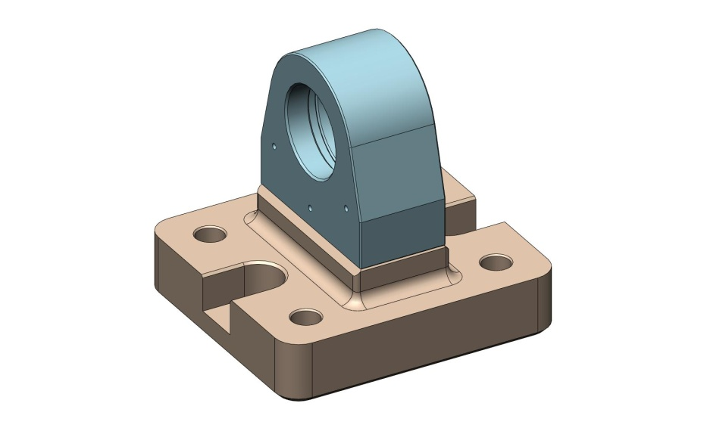
Figure 3.12. Locker Sleeve Housing bolted onto Locker Sleeve Base.

- Insert Locker Sleeve (D070270) into Locker Sleeve Housing as shown in Figure 3.13. The fit is very tight, and can easily bind! Thread Sleeve all the way into the Housing.
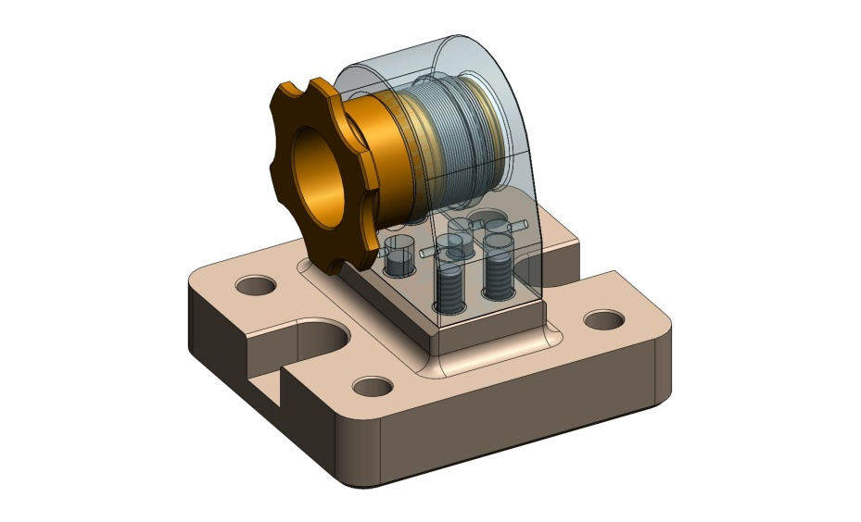
Figure 3.13. Locker Sleeve is inserted in the Locker Sleeve Housing. Run the Sleeve’s thread into the internal thread in back of Housing.

- Clip retaining ring (Smalley FSE-0175-S02) over groove at the end of the Locker Sleeve, as shown in Figure 3.14.
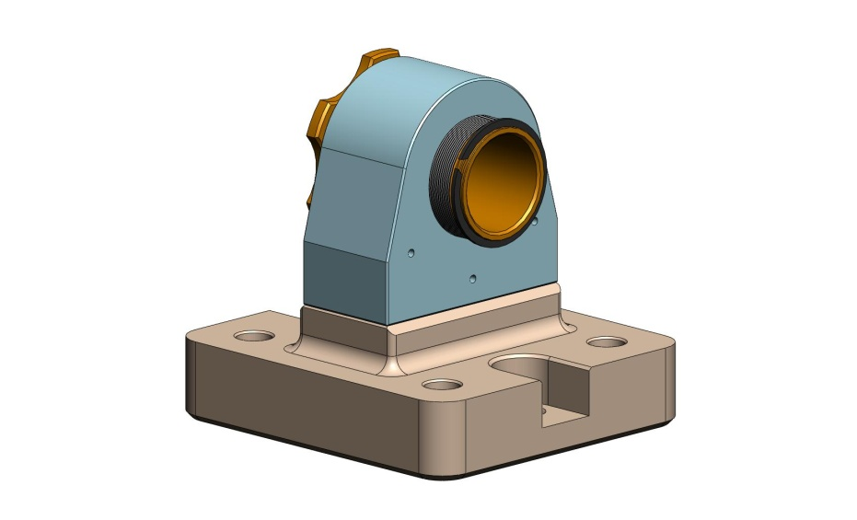
Figure 3.14. Retaining ring in groove on back of Locker Sleeve.

- Insert Locker Spherical Pin (D047935) into Locker Sleeve, as shown in Figure 3.15. Orientation is critical: short end of Pin should stick out of knob end of Sleeve.
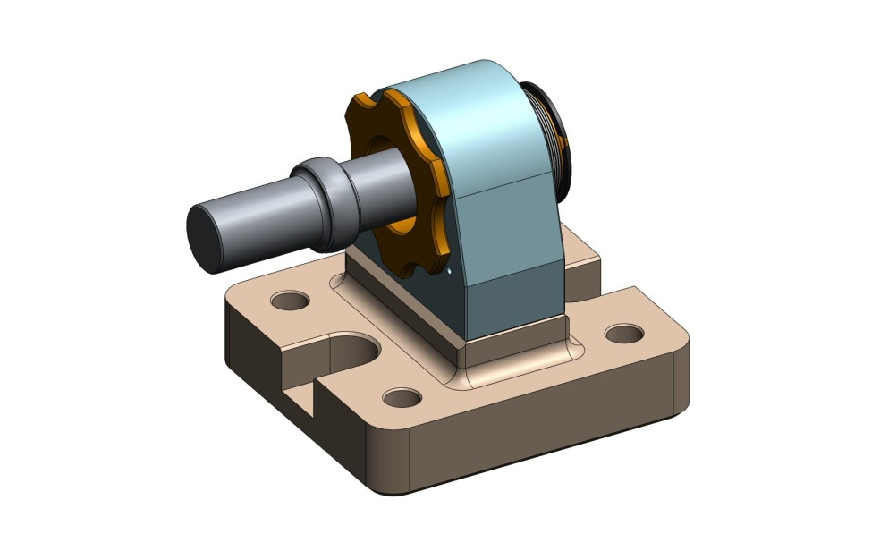
Knob End
Figure 3.15. Locker Spherical Pin being inserted into Locker Sleeve.

- With the Locker Pin Base sitting on a flat surface, pick up the Locker Base/Housing/Sleeve/Spherical Pin, and place the ends of the Pin in the Base’s mating grooves. The knurled end of the Sleeve should face the flat side of the Base, as shown in Figure 3.16.
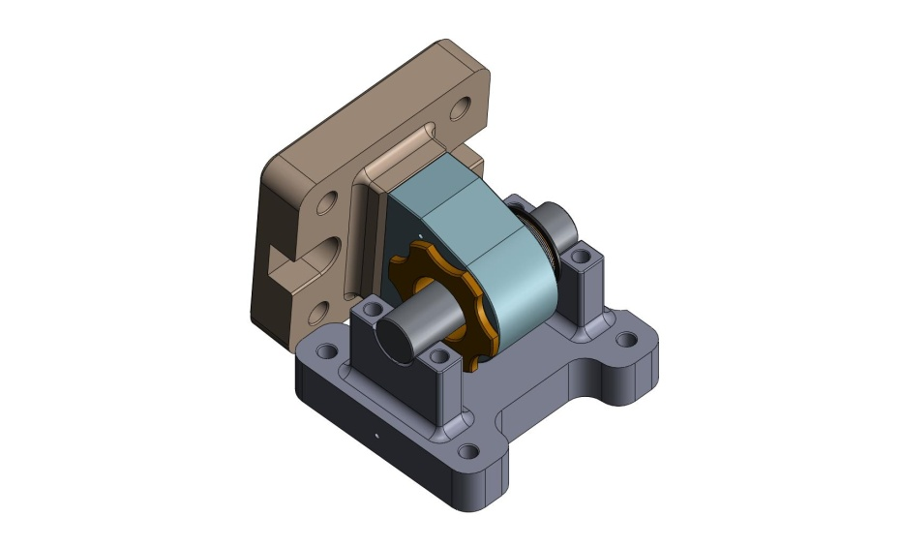
Flat Side
Notched Side
Figure 3.16. Engage two sides of the Locker Assembly by laying the Locker Spherical Pin in the Locker Pin Base. Note the orientation of the Locker Sleeve with respect to the Base.

- Place (2) Locker Pin Caps (D0900635) over the ends of the Locker Spherical Pin, orienting them as shown in Figure 3.17. Start the screws into the Locker Pin Base. Snug, then torque to spec.
Hardware:
(4) 3/8”-16x1.75” SHCS
(4) 3/8” vented washers
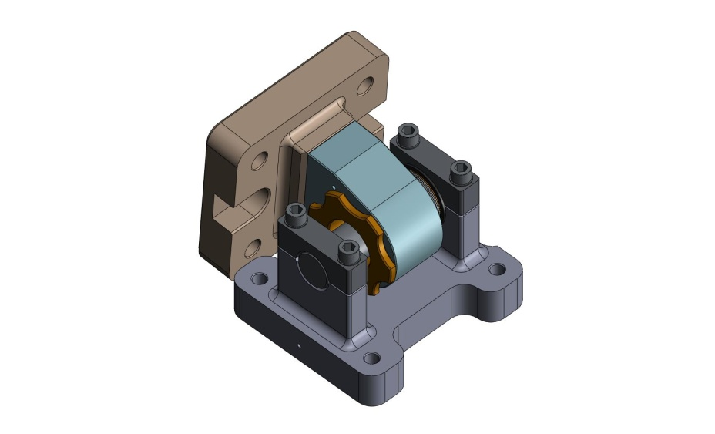
Figure 3.17. Locker Pin Caps clamped over the ends of the Spherical Pin.

- Note: the gaps between the Caps and the Pin Base may not close completely. It is not necessary to control the gaps on either side of the Pin.

- The Locker Assemblies are complete. Set all (6) Lockers to the “locked” position, as shown in Figure 3.18 b, and set aside for later use.
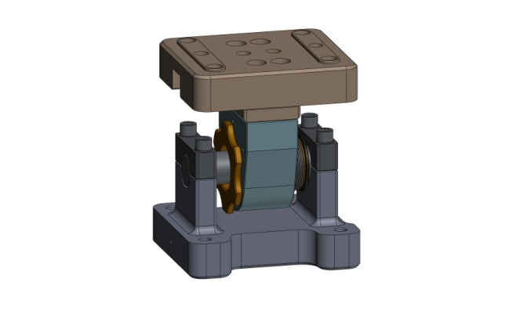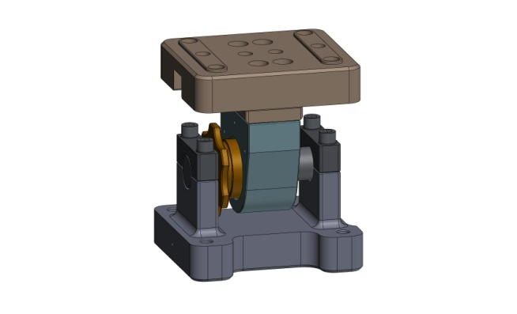
(b)

(a)

Figure 3.18. Locker Assembly in (a) “unlocked” and (b) “locked” positions. To lock the assembly, turn the knob end of the Locker Sleeve counterclockwise, until the retaining ring contacts the back face of the Locker Housing. Note: the Assembly still slides freely when in the locked position.

Assemble (3) Boxwork Assemblies (D071422)
- On a clean, flat surface, arrange the following plates:
  - (3) Rib, Tan, Flexure Cen (D071070)
  - (3) Rib, Rad, Flexure Out 2 (D071069)
  - (3) Rib, Rad, Flexure Out 1 (D071068)
  - (3) Rib, Tan, Flexure Mid (D071071)

the following procedure describes the assembly of one D071422 assembly. This should be repeated for the other two D071422’s, as well:
- With plates standing vertically, butt the Radial Ribs (D071069 and D071068) against either side of the Mid-Tangential Rib (D071071), as shown in Figure 3.19. Make sure pins seat properly into mating holes and slot.
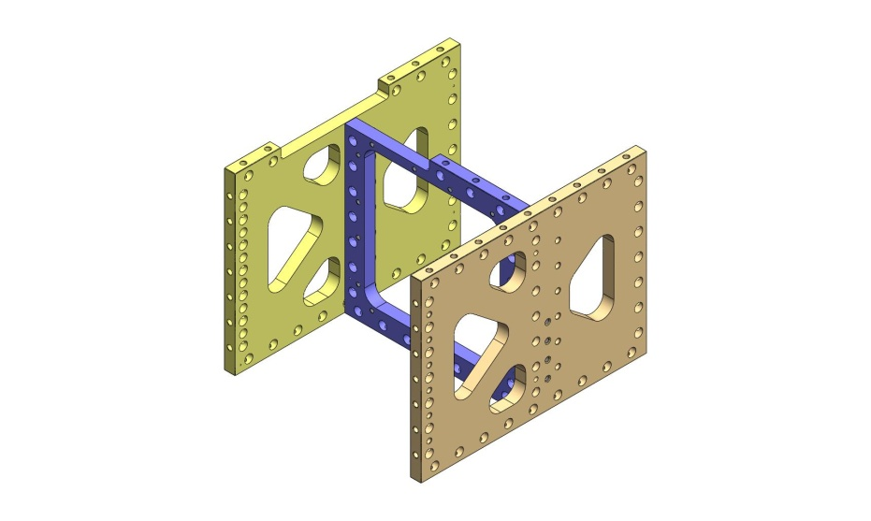
Figure 3.19. Step 1 of Boxwork Assembly. Radial Ribs are placed against Mid-Tangential Ribs.

- Place (14) Type 01 Barrel Nuts (D071250-01) into holes along the sides of the Mid-Tangential Rib (D071071). Flat side of each Nut should face away from its screw, as shown in Figure 3.20. Thread in mating screws. Snug, but don’t torque, yet.
Hardware:
(14) 3/8”-16x1.75” SHCS
(14) 3/8” vented washers
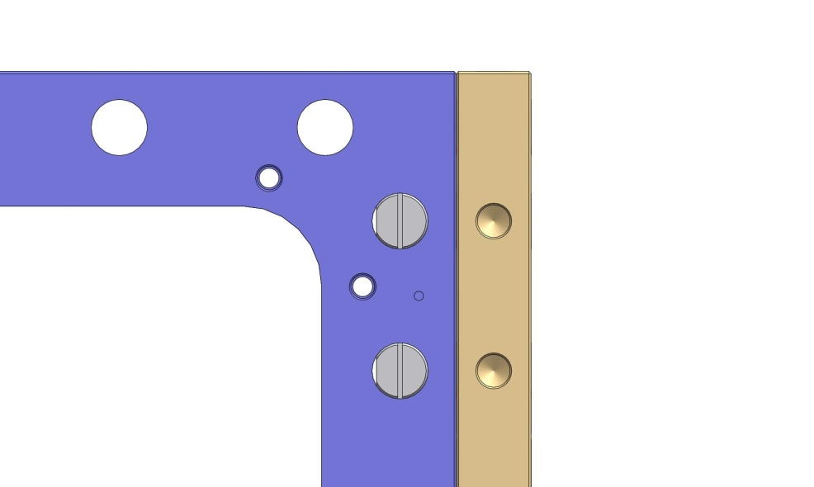
Screws enter this side.
Flats of Barrel Nuts.
Figure 3.20. Preferred orientation of Barrel Nuts. Flat side should always face away from the screw, to minimize stress concentrations.
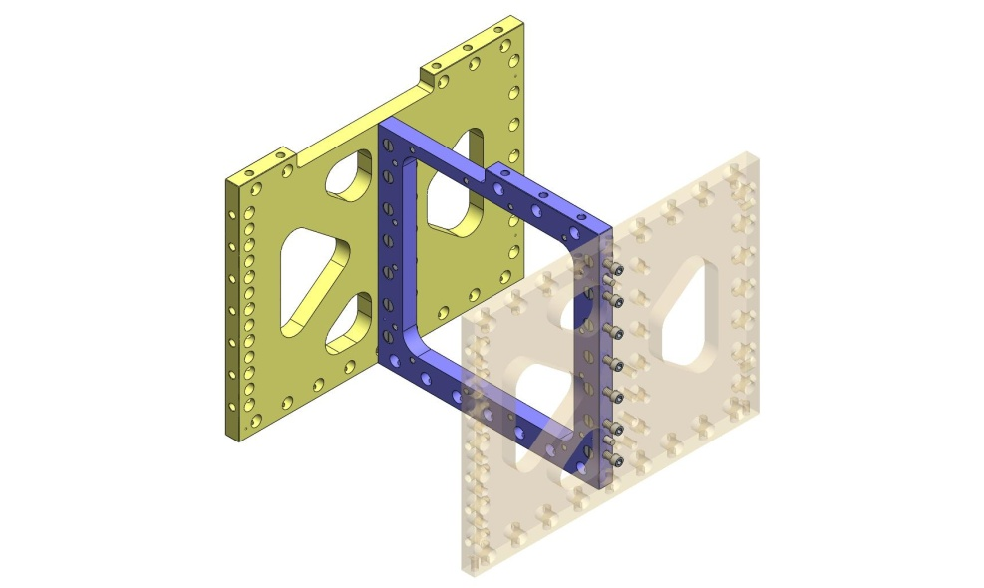
Figure 3.21. Partial assembly of Boxwork, showing screws threaded into Barrel Nuts.

- Push Rib, Tan, Flexure Cen plate (D071070) onto ends of the two Radial Ribs (D071068 and D071069), as shown in Figure 3.22. Make sure pins seat properly into mating holes and slots.
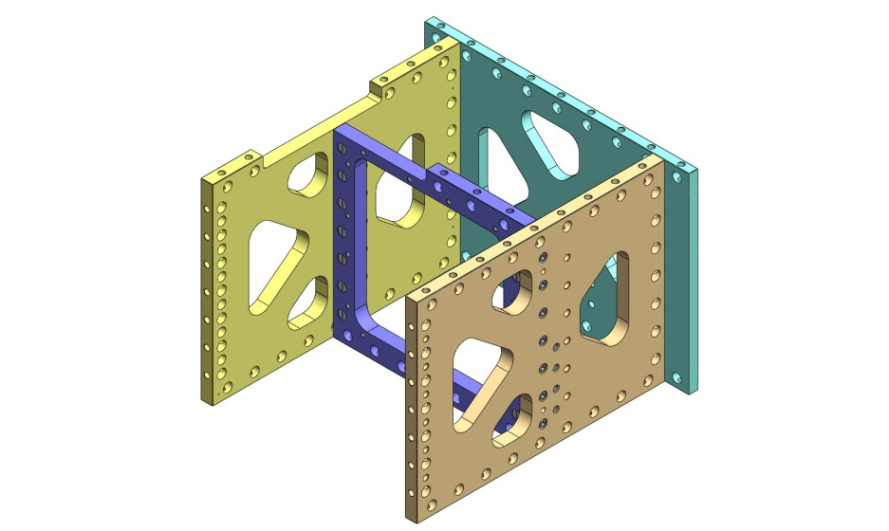
Figure 3.22. Step 2 of Boxwork Assembly. Center-Tangential Rib is placed against the Radial Ribs.

- Place (14) Type 01 Barrel Nuts (D071250 Type 01) into holes along sides of radial plates (D071068 and D071069). Flats should face away from screws. Thread in screws. Snug, but don’t torque, yet.
Hardware:
(14) 3/8”-16x1.75” SHCS
(14) 3/8” vented washers
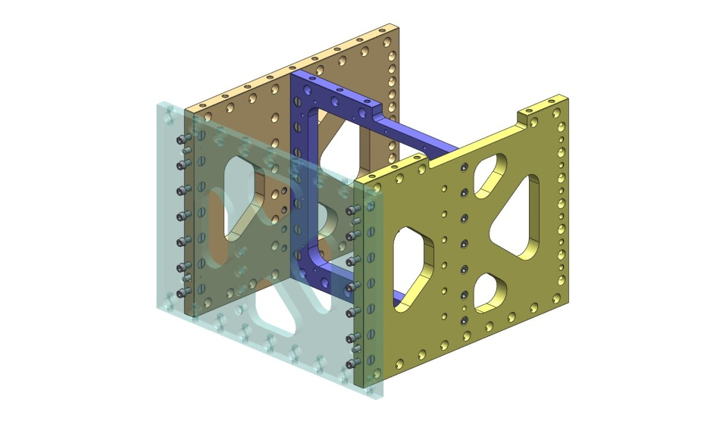
Figure 3.23. Partial assembly of Boxwork, showing screws threaded into Barrel Nuts. Center-Tangential Rib is shown transparent, here.

- Incrementally torque all screws to spec.

- Flip over Boxwork Assembly. Caution: assembly is heavy (92 lbs)! Press (3) 3/8”x.75” pins into bottom of Radial Ribs (D071068 and D071069). Pins should remain .25” proud of the plate surfaces.
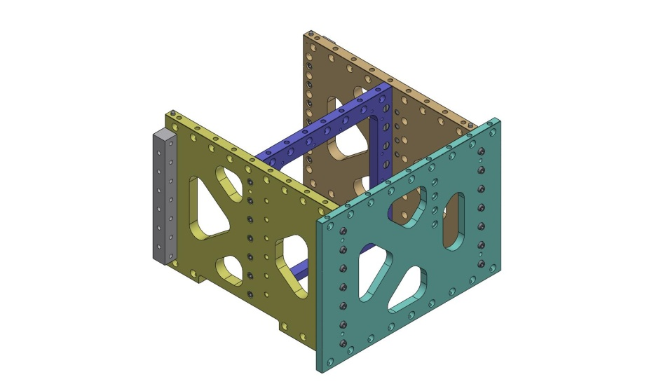
Figure 3.24. Dowel pins pressed into bottom of Boxwork Assembly. After this step, the Boxworks are ready for installation in Stage 1.

- Boxwork Assembly is now complete. Set aside for later use.

Assemble (3) Pitchfork Assemblies (D071423)
- On a clean, flat surface, arrange the following plates:
  - (3) Rib, Tan, GS-13 Mid (D071052)
  - (3) Rib, Tan, GS-13 Cen (D071053)
  - (3) Rib, Rad, GS-13 Mid (D071054)
  - (3) Rib, Rad, GS-13 Out 1 (D071055)
  - (3) Rib, Rad, GS-13 Out 2 (D071056)

the following procedure describes the assembly of one D071423 assembly. This should be repeated for the other two D071423’s, as well:
- Place Mid-Radial Rib (D071054) against Mid-Tangential Rib (D071052), allowing pins to seat properly in hole and slot.
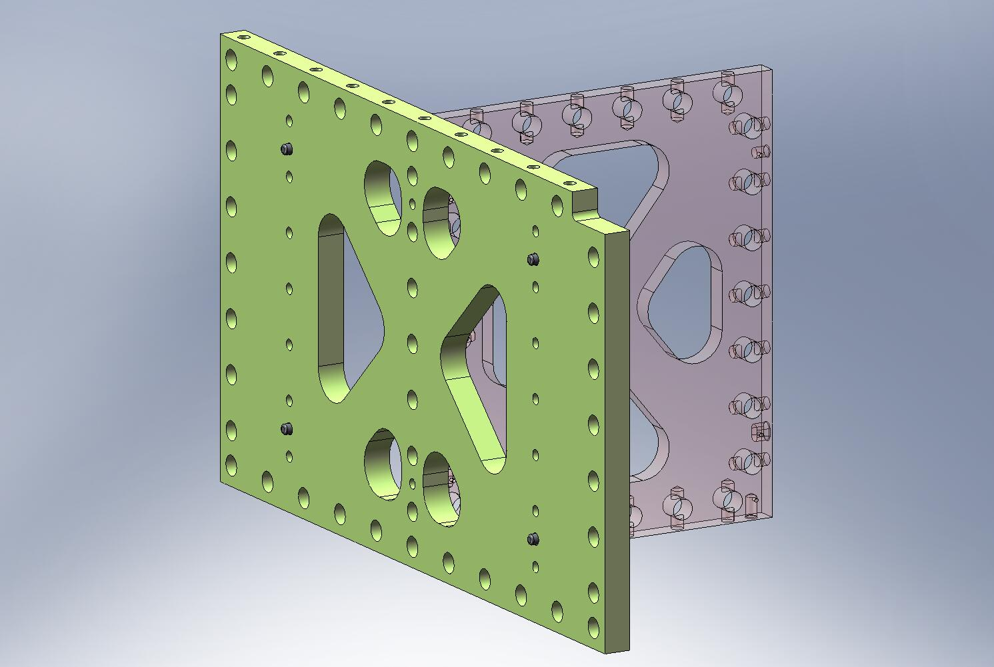
Figure 3.25. Step 1 of Pitchfork Assembly. The Mid-Radial Rib is seated against the Mid-Tangential Rib. Note location of lower dowel pin hole in Mid-Radial Rib.

- Place (7) Type 00 Barrel Nuts (D071250 Type 00) into holes along the side of the Mid-Radial Rib (D071054). Flat side of each Nut should face away from its screw, as shown in Figure 3.26. Thread in mating screws. Torque to final spec.
Hardware:
(7) 3/8”-16x1.75” SHCS
(7) 3/8” vented washers
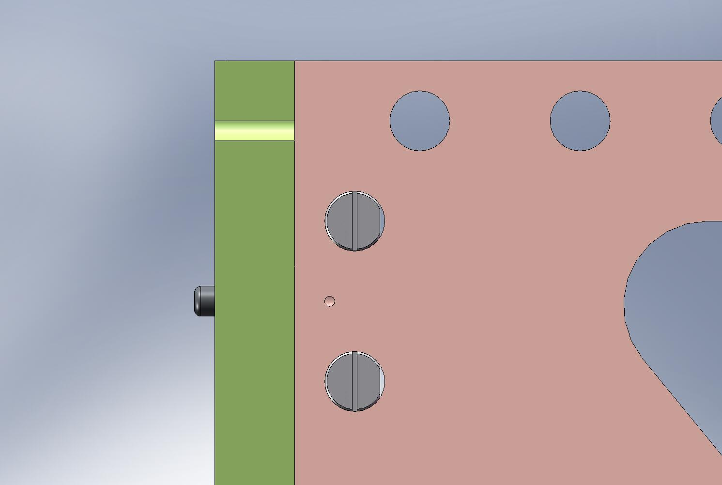
Flats of Barrel Nuts.
Screws enter this side.
Figure 3.26. Preferred orientation of Barrel Nuts. Flat side should always face away from the screw.
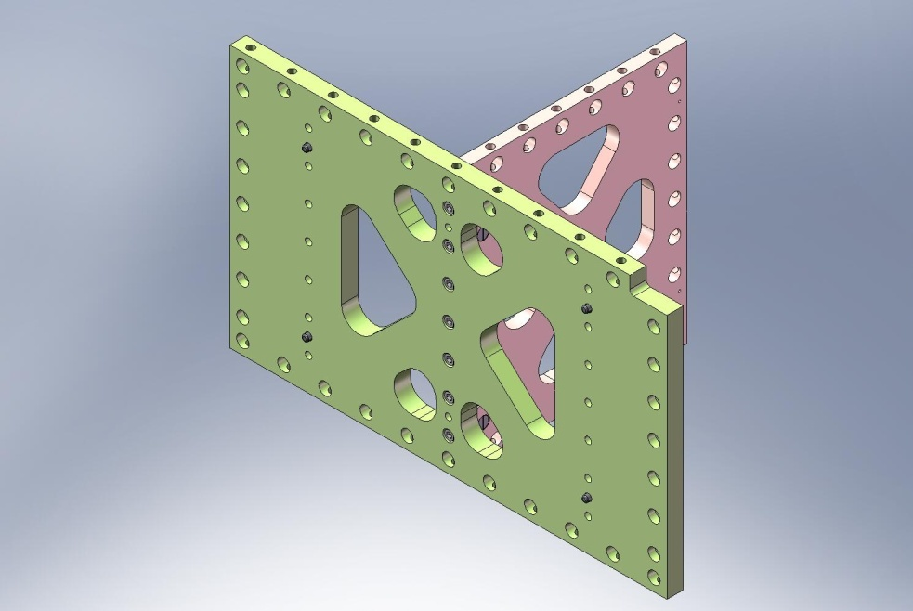
Torque to final spec.
Figure 3.27. Partial assembly of Pitchfork. Screws should be torqued to final spec, before continuing.

- Place Center-Tangential Rib (D071053) against other end of Mid-Radial Rib (D071054), allowing pins to seat properly in hole and slot. Orientation of Center-Tangential Rib does not matter.
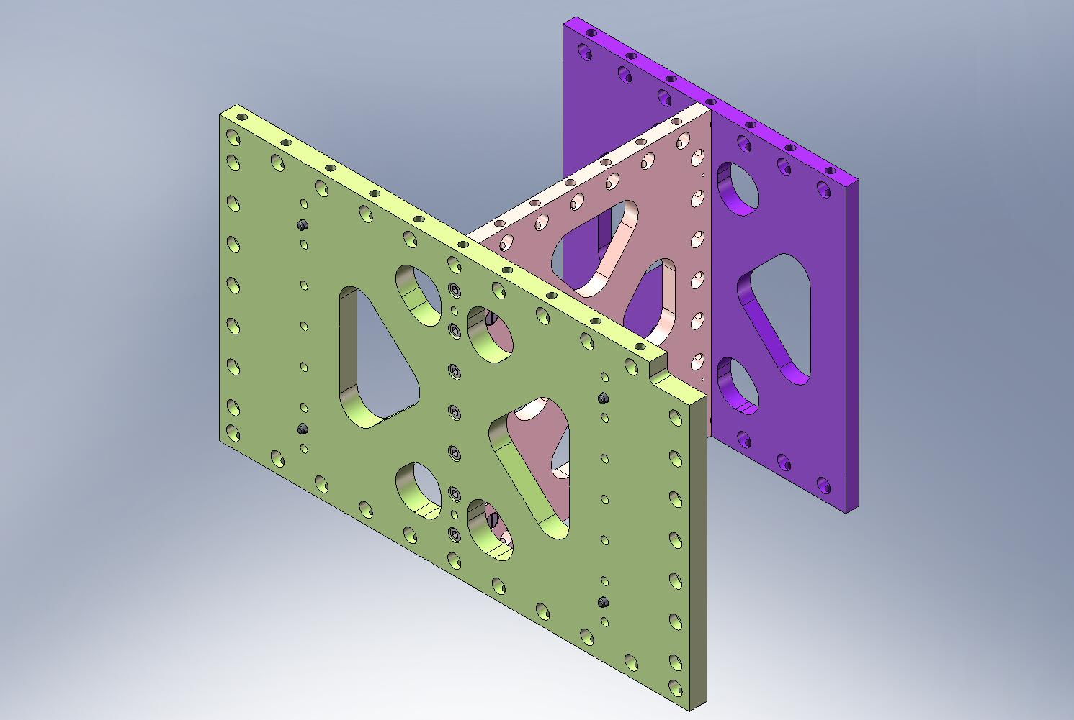
Figure 3.28. Step 2 of Pitchfork Assembly. Center-Tangential Rib is pressed against back end of Mid-Radial Rib.

- Insert (7) Type 00 Barrel Nuts (D071250 Type 00) into holes along the side of the Mid-Radial Rib (D071054). Flats should face away from screws. Thread in screws. Torque to final spec.
Hardware:
(7) 3/8”-16x1.75” SHCS
(7) 3/8” vented washers
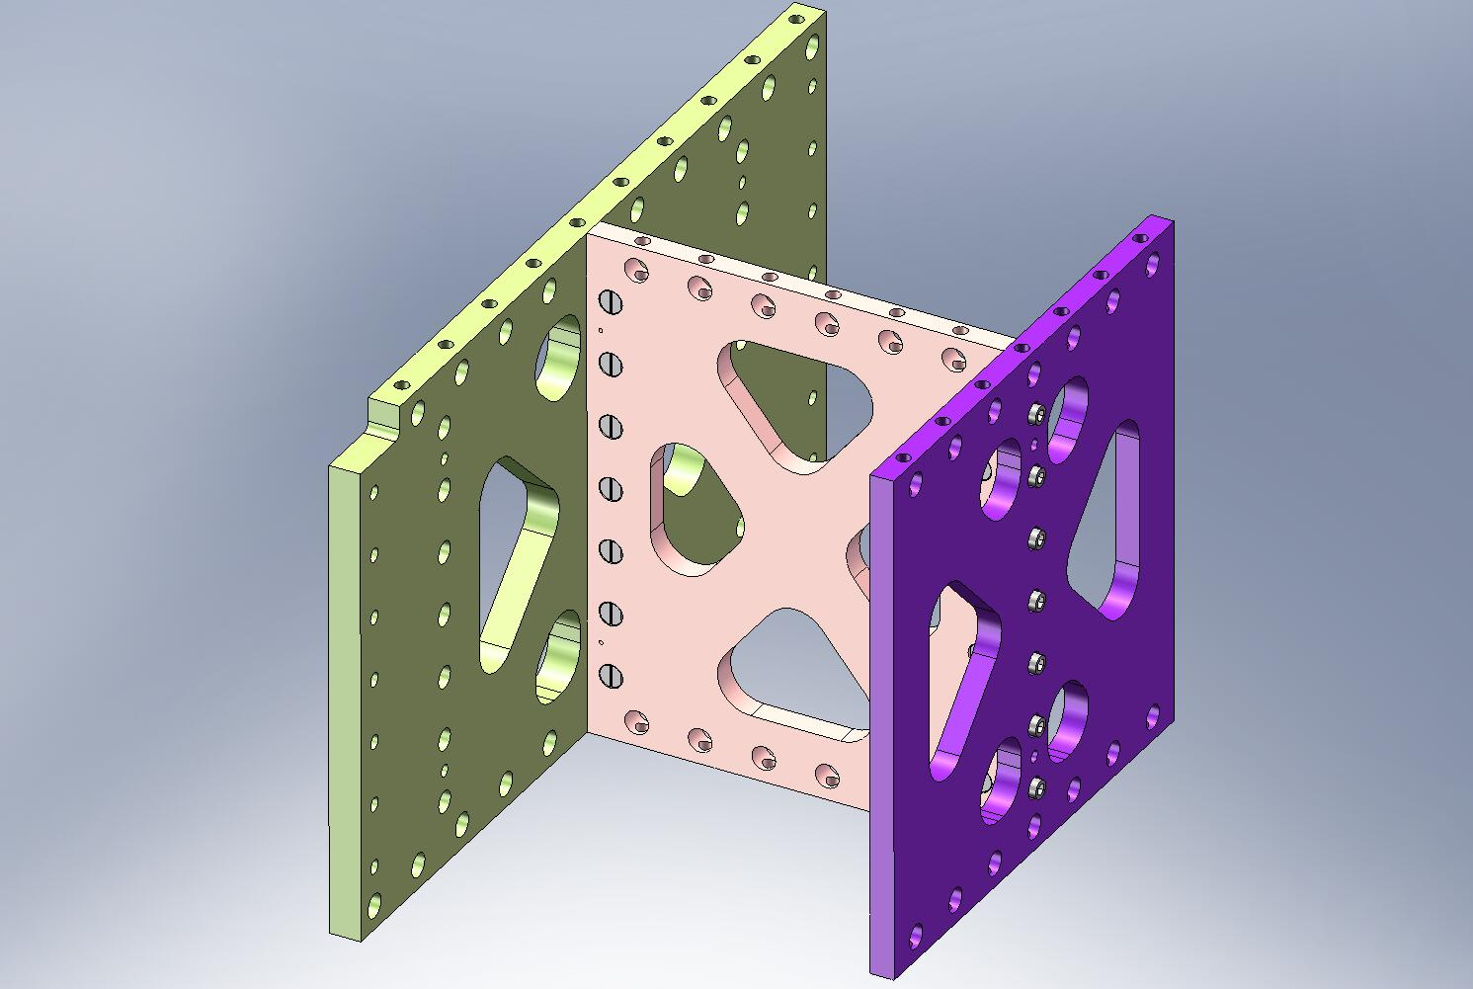
Torque to final spec.
Figure 3.29. Bolt Center-Tangential Rib to Mid-Radial Rib, using Type 00 Barrel Nuts. Torque to final spec.

- Mate GS-13 Out 2 Rib (D071056) against back side of Mid-Tangential Rib (D071052). Pins should seat properly in hole and slot.
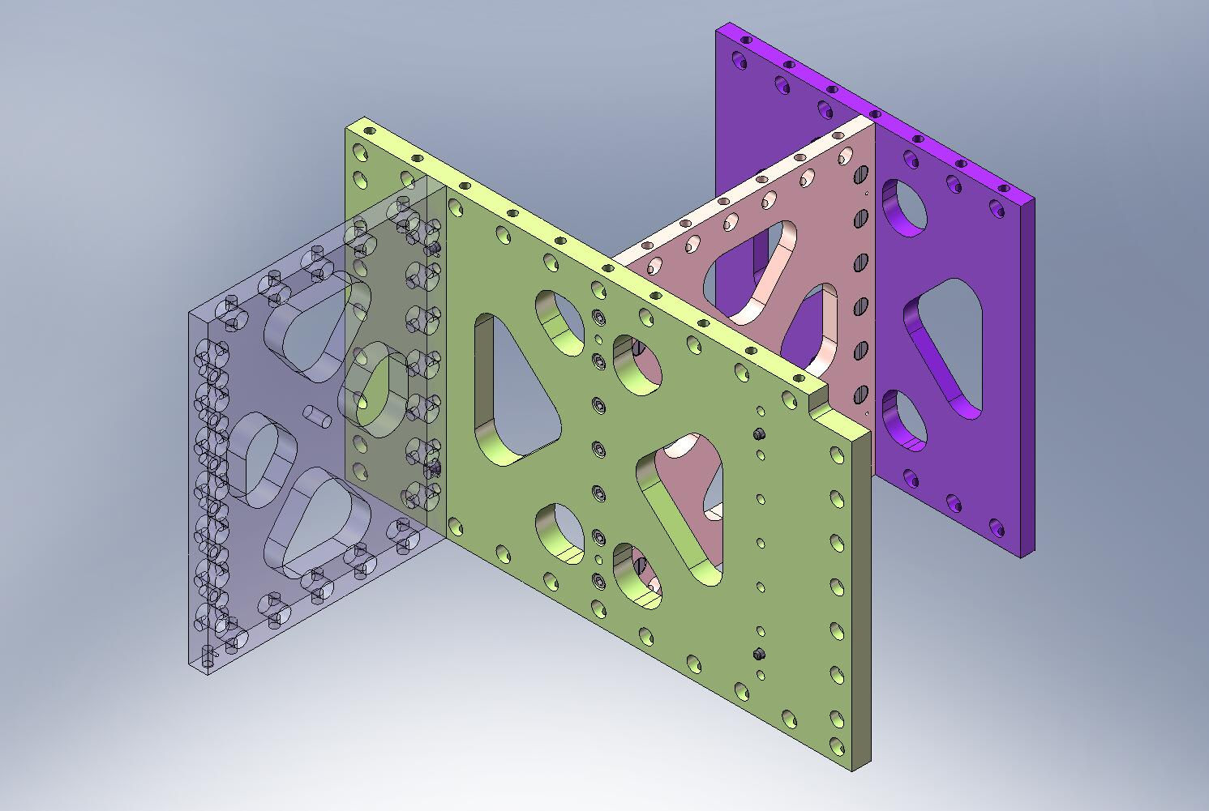
Figure 3.30. Step 3 of Pitchfork Assembly. GS-13 Out 2 Rib mates with dowel pins on back of Mid-Tangential Rib. Note orientation of bottom dowel pin hole in GS-13 Out 2 Rib.

- Insert (7) Type 01 Barrel Nuts (D071250 Type 01) into holes along the side of the GS-13 Out 2 Rib (D071056). Flats should face away from screws. Thread in screws. Torque to final spec.
Hardware:
(7) 3/8”-16x1.75” SHCS
(7) 3/8” vented washers
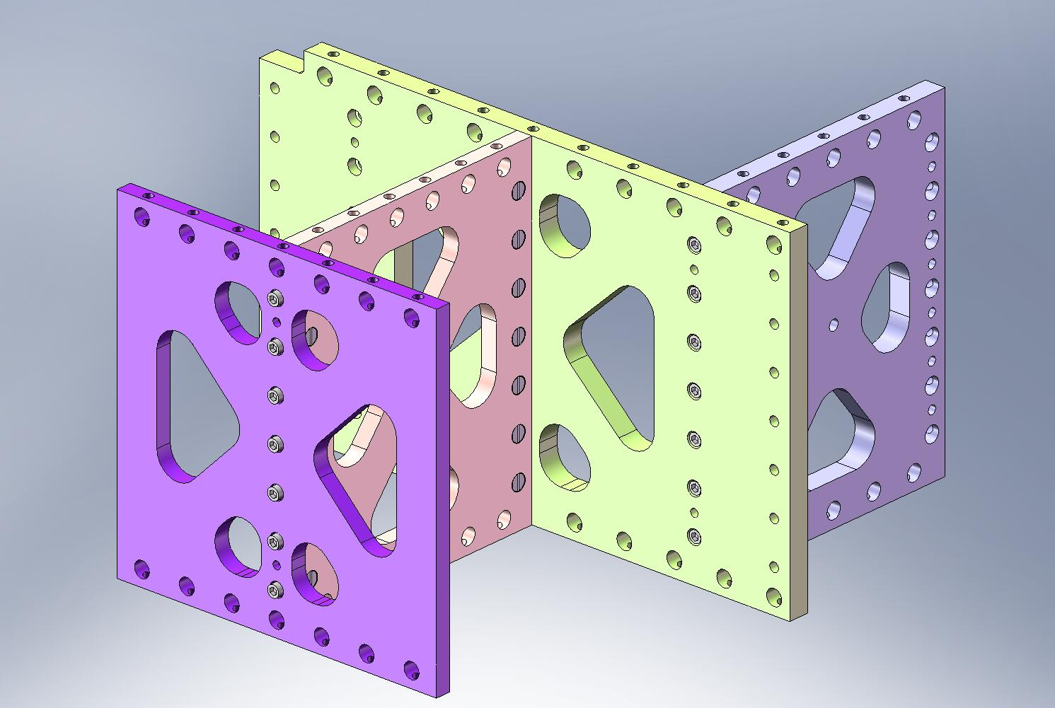
Figure 3.31. Bolt GS-13 Out 2 Rib to Mid-Tangential Rib, using Type 01 Barrel Nuts. Torque to final spec.

- Mate GS-13 Out 1 Rib (D071055) to Mid-Tangential Rib (D071052). Allow pins to seat properly in hole and slot.
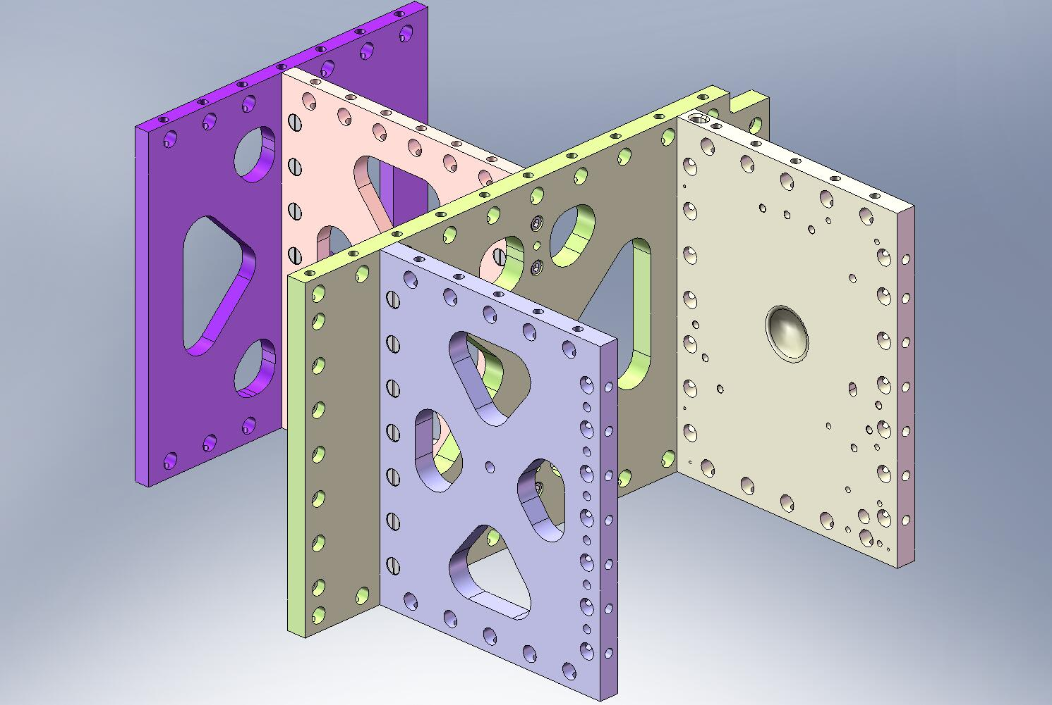
Figure 3.32. Step 4 of Pitchfork Assembly. GS-13 Out 1 Rib mates with Mid-Tangential Rib. Check orientation of Ribs.

- Insert (7) Type 01 Barrel Nuts (D071250 Type 01) into holes along the side of the GS-13 Out 1 Rib (D071055). Flats should face away from screws. Thread in screws. Torque to final spec.
Hardware:
(7) 3/8”-16x1.75” SHCS
(7) 3/8” vented washers
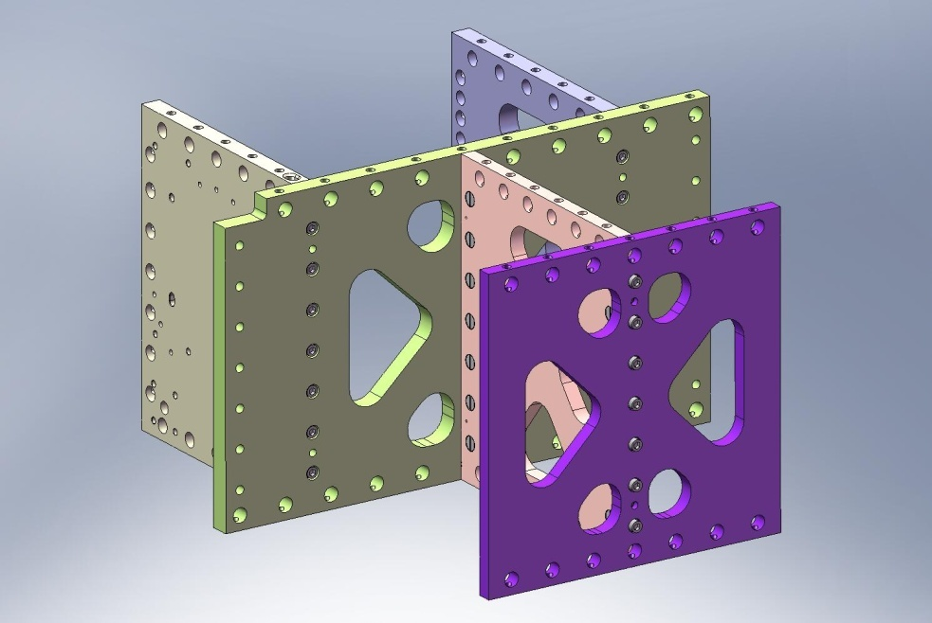
Figure 3.33. Bolt GS-13 Out 1 Rib to Mid-Tangential Rib, using Type 01 Barrel Nuts. Torque to final spec.

- Screw Outer Wall, Bracket 90 (D071061) onto side of GS-13 Out 2 Rib (D071056), in orientation shown in Figure 3.34. Snug screws, but do not torque, yet.
Hardware:
(6) 3/8”-16x1.25” SHCS
(6) 3/8” vented washers
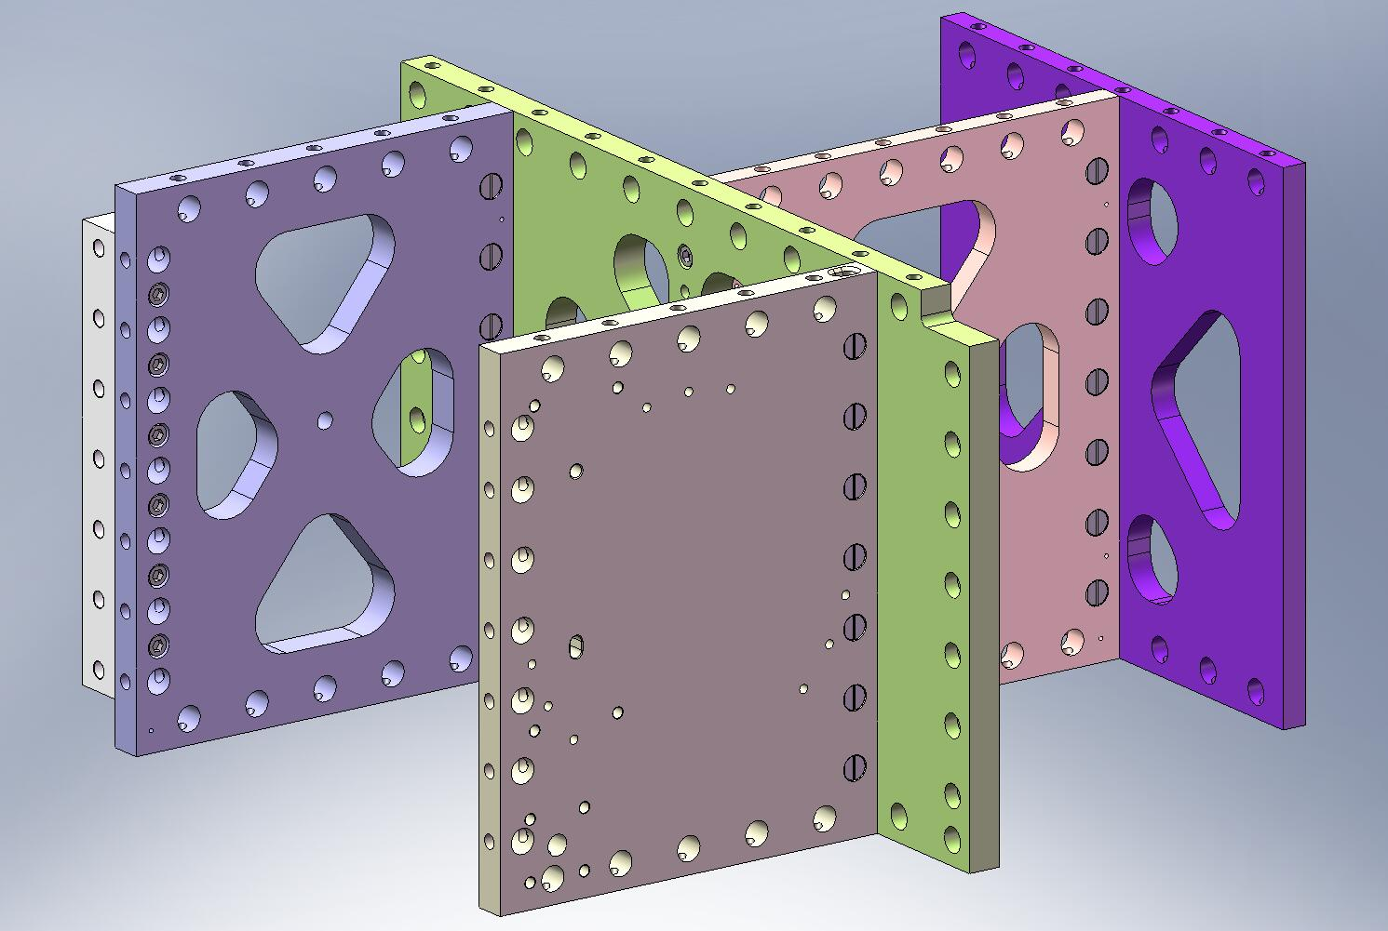
Figure 3.34. 90 Deg Outer Wall Bracket mounted to Pitchfork Assembly. The screws for the Bracket are not torqued until later in the assembly of Stage 1.

- Flip over Pitchfork Assembly. Caution: assembly is heavy (96 lbs)! Press (4) 3/8”x.75” pins into bottom of Radial Ribs (D071068 and D071069). Pins should remain .25” proud of the plate surfaces.
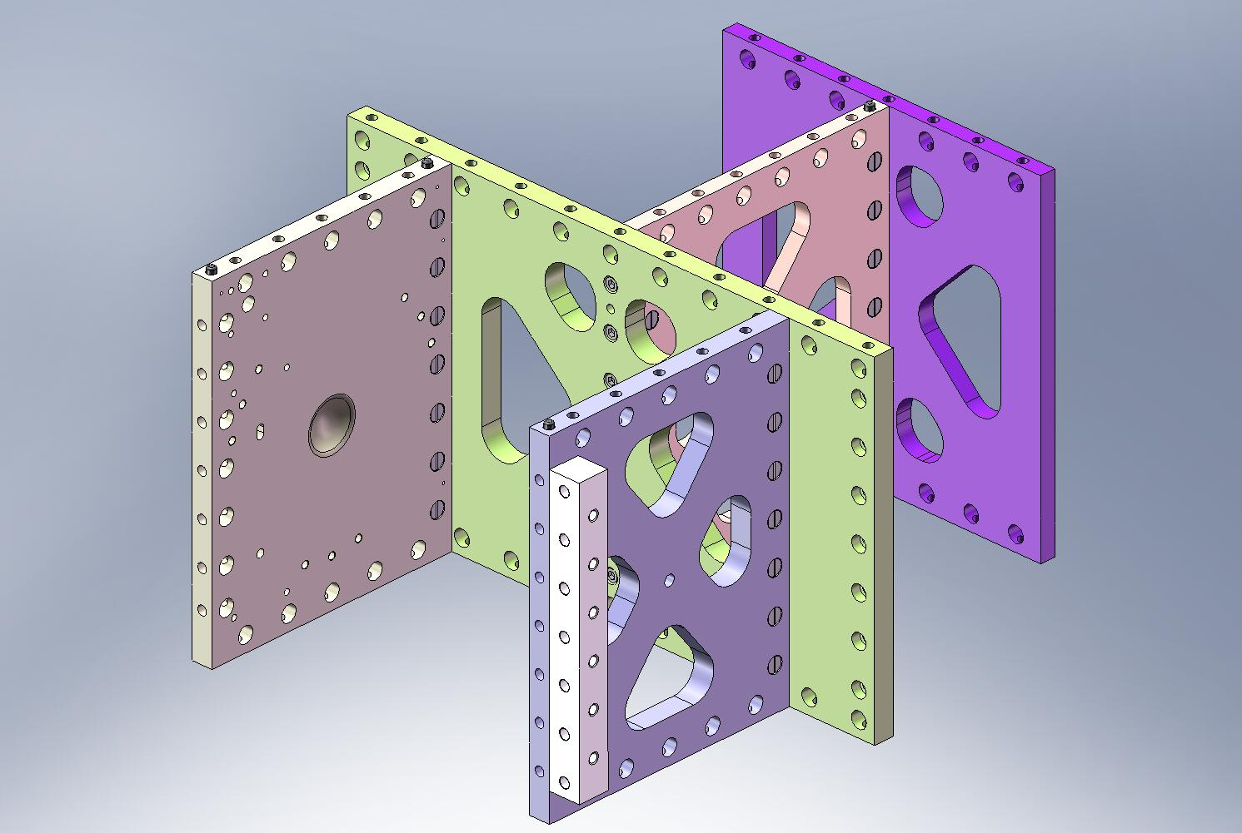
Figure 3.35. Dowel pins pressed into bottom of Pitchfork Assembly. After this step, the Pitchforks are ready for installation in Stage 1.

- Pitchfork Assembly is now complete. Set aside for later use.

Build Up Top of Stage 1 Frame Assembly (D0900154)
- Lower each of (3) Boxwork Assemblies (D071422) onto Stage 1 Floor (D071051). Make sure all (3) pins in bottom of each Boxwork seat properly in their mating holes and slots. Caution: Boxwork Assemblies are heavy (92 lbs)!
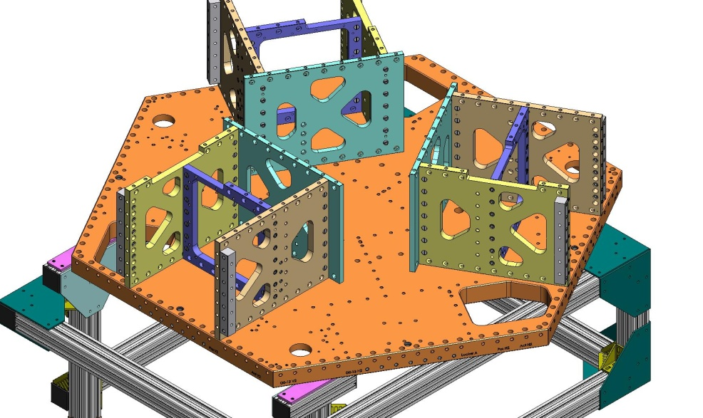
Figure 3.36. Boxworks placed on top surface of Stage 1 Floor.

- Place (75) Type 01 Barrel Nuts (D071250 Type 01) in holes lining the bottom of the Radial and Mid-Tangential Ribs within each Boxwork Assembly. Place (27) Type 00 Barrel Nuts (D071250 Type 00) in holes lining the bottom of the Center-Tangential Ribs. Align flats opposite screws.
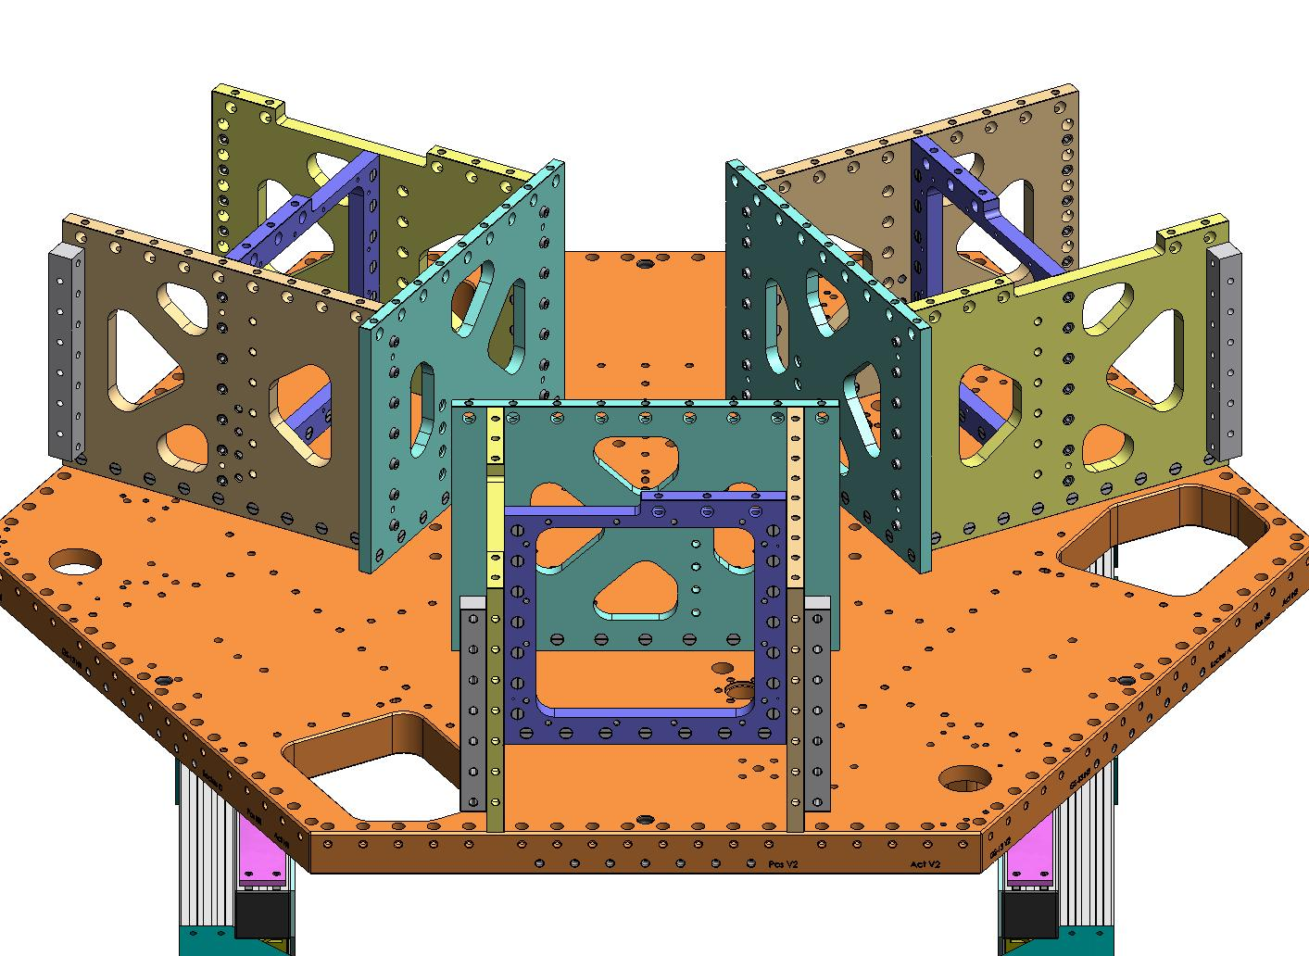
Type 00 Barrel Nuts
Type 01 Barrel Nuts
Figure 3.37. Type 00 (length = 3/4”) Barrel Nuts are used in the Center-Tangential Rib. Type 01 (length = 1”) Barrel Nuts are used in the Radial and Mid-Tangential Ribs.

- Thread screws into Barrel Nuts, from underneath Stage 1 Floor. Snug, but don’t torque, yet.
Hardware:
(102) 3/8”-16x2.0” SHCS
(102) 3/8” vented washers
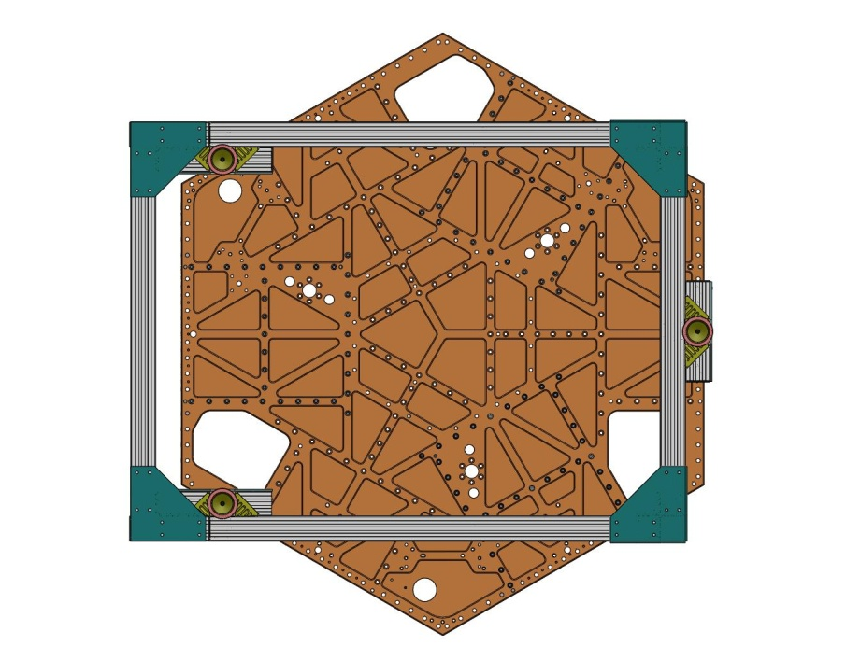
Figure 3.38. Snug (102) screws into Boxwork Barrel Nuts, from underneath Stage 1 Floor.

- Incrementally torque all (102) screws to final spec.

- Lift the Stage 1 Floor and rotate it 60 degrees, as shown in Figure 3.39. This will allow access for bolting on the Pitchfork Assemblies (D071423).
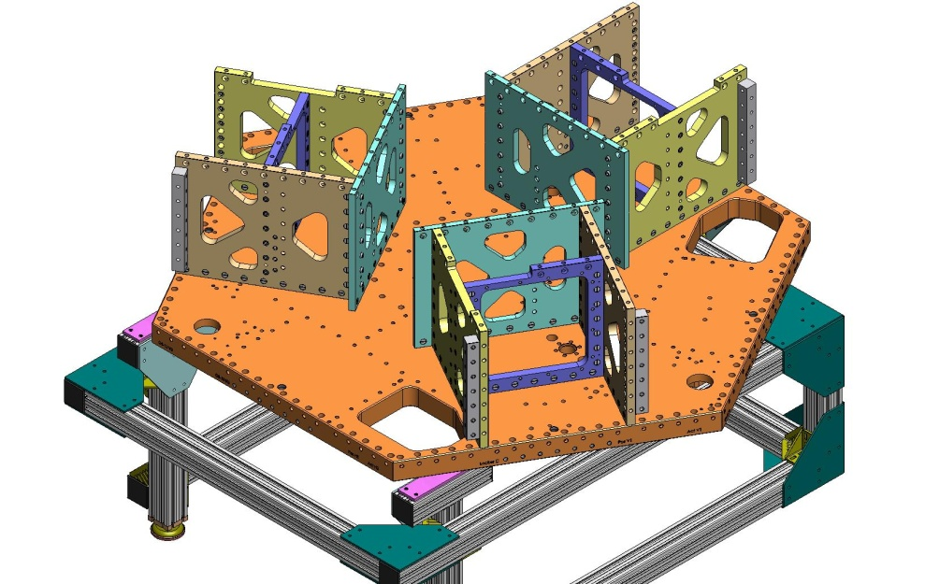
Figure 3.39. Stage 1 Floor must be rotated 60 degrees, to allow access for the Pitchfork Assembly mounting screws.

- Place (3) Flexure Posts (D071074) on top of the Stage 1 Floor. Check that the rim on the bottom of each Post seats properly in the mating counterbore. Start screws from underneath the Floor. Snug, but do not torque.
Hardware:
(18) 3/8”-16x1.75” SHCS
(18) 3/8” vented washers
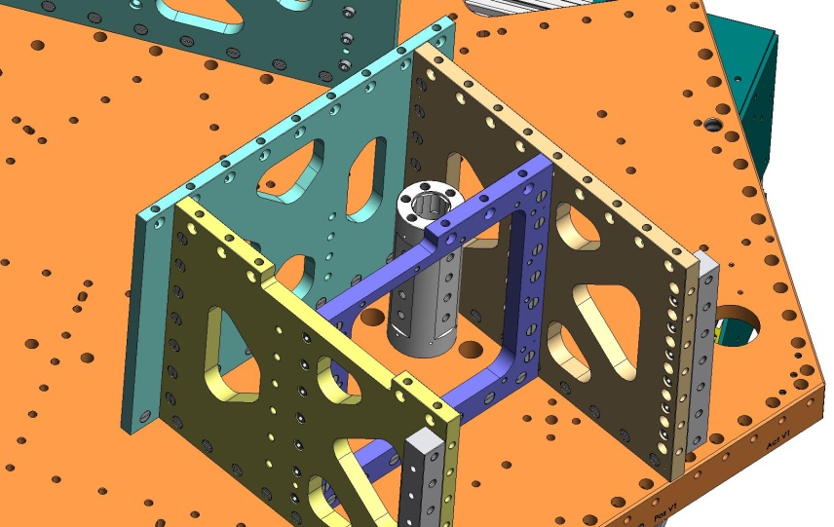
Figure 3.40. (3) Flexure Posts are installed on the Stage 1 Floor. Note the orientation of the flats on the side of the Post.
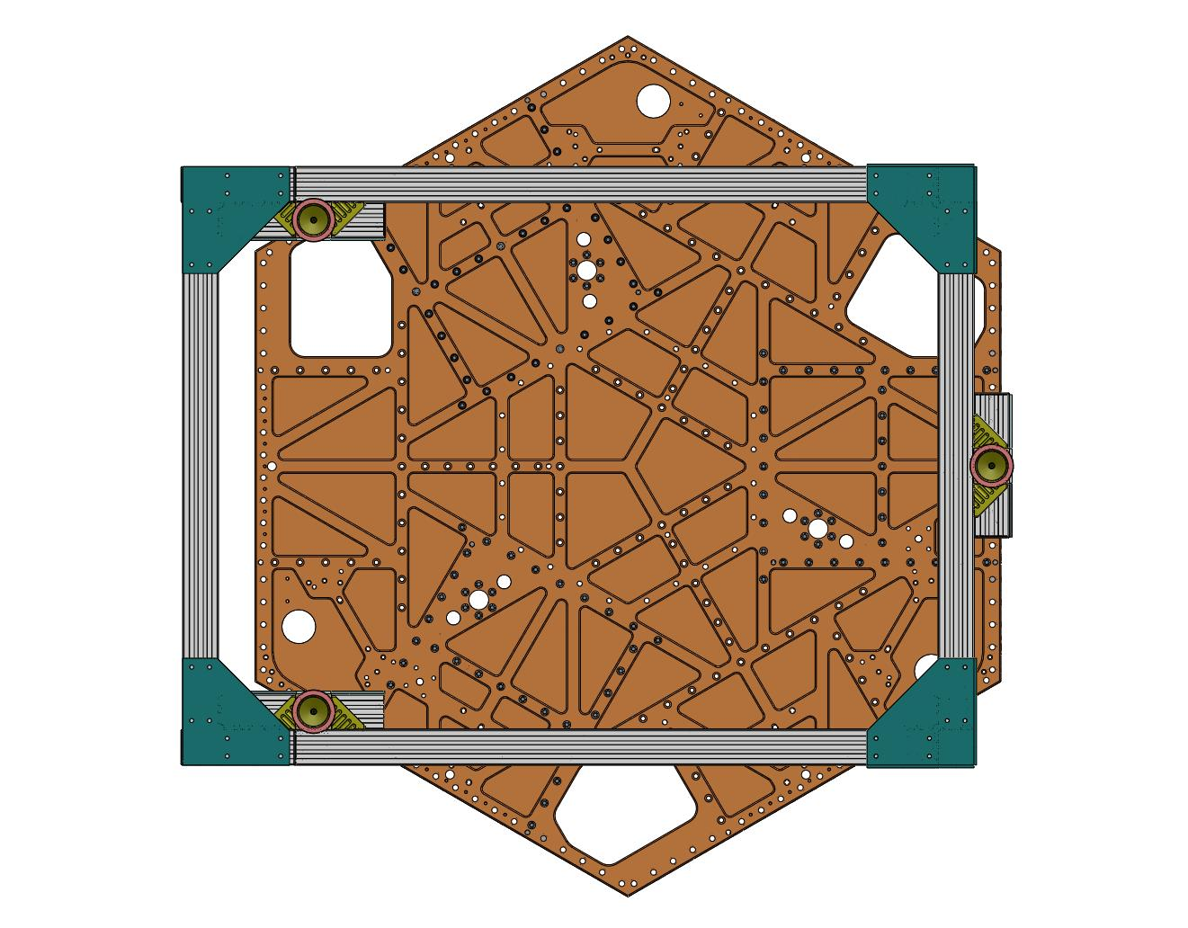
Figure 3.41. Insert screws into bottom of Flexure Posts.

- Place (3) Tangential Flexure Post Brackets (D071076). Start screws into Boxwork Radial Ribs and Flexure Posts. Snug, but don’t torque.
Hardware:
(12) 3/8”-16x1.25” SHCS – into the Boxwork Radial Ribs
(12) 3/8”-16x2.75” SHCS – into the Flexure Posts
(24) 3/8” vented washers
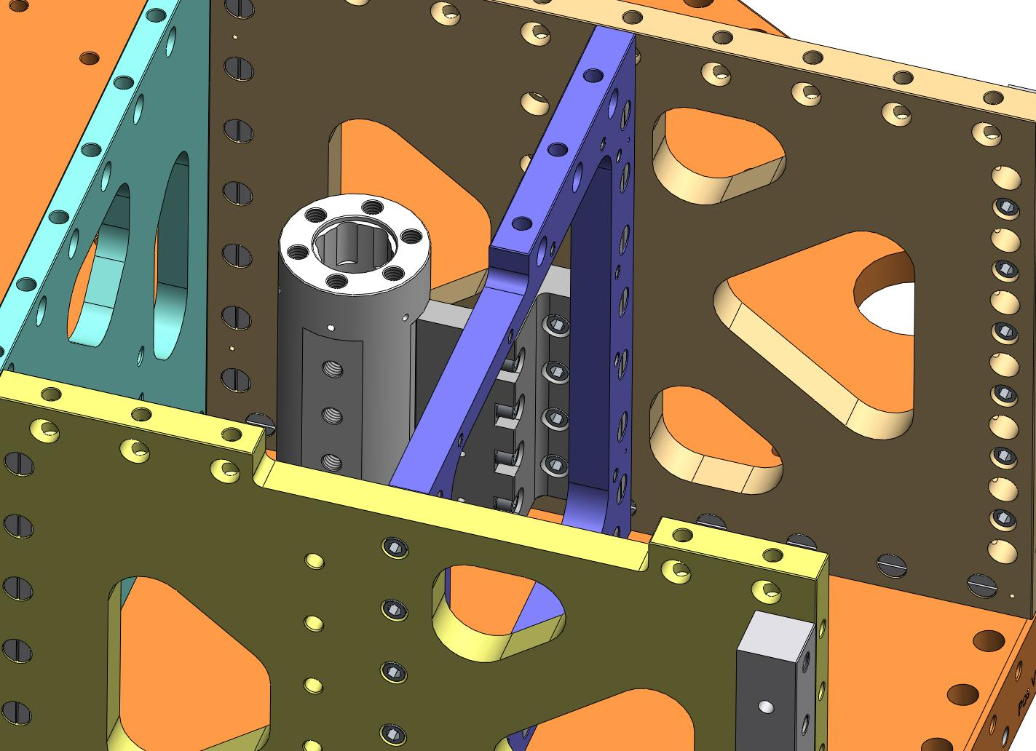
Figure 3.42. Install (3) Tangential Flexure Post Brackets.

- Place (3) Radial Flexure Post Brackets (D071075). Thread screws into Radial Flexure Post Brackets and Flexure Posts. Snug, but don’t torque.
Hardware:
(12) 3/8”-16x1.25” SHCS – for Radial Flexure Post Brackets
(12) 3/8”-16x1.75” SHCS – for Flexure Posts
(24) 3/8” vented washers
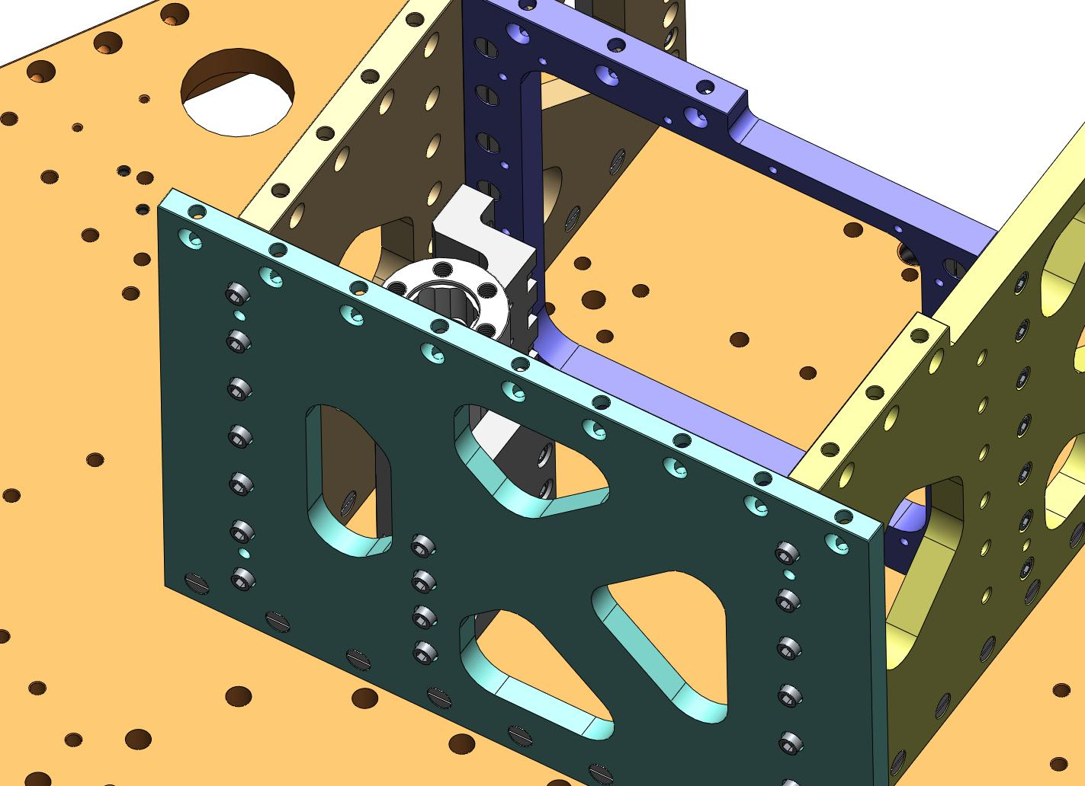
Figure 3.43. Install (3) Radial Flexure Post Brackets. Insert the screws highlighted here.

- Incrementally torque the (3x 6) screws underneath the Flexure Posts to the final spec.
- Hand tighten the (3x 4) screws through the Tangential Flexure Post Brackets, into the Flexure Posts. These will be removed later – do not use torque wrench yet.
- Torque the (3x 4) screws through the Radial Flexure Post Brackets, into the Flexure Posts, to the final spec.
- Hand tighten the (3x 4) screws through the Tangential Flexure Post Brackets, into the Boxwork Radial Ribs. These will be removed later – do not use torque wrench, yet.
- Torque the (3x 4) screws through the Center-Tangential Ribs, into the Radial Flexure Post Brackets, to the final spec.

- Carefully lower all (3) Pitchfork Assemblies onto Stage 1 Floor. Make sure all (4) pins in bottom of each Pitchfork seat properly in their mating holes and slots. Caution: Pitchfork Assemblies are heavy (96 lbs)!
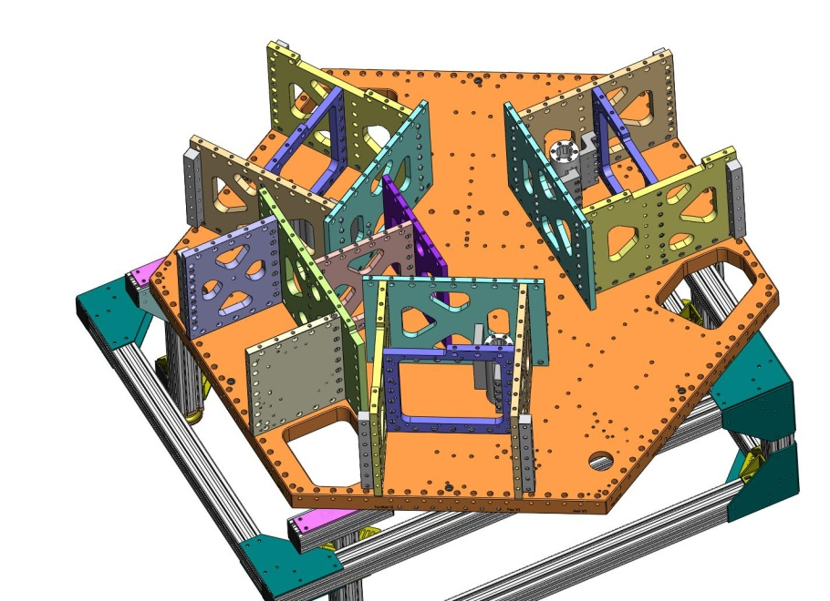
Figure 3.44. View of first Pitchfork Assembly laid on top of Stage 1 Floor. Carefully mate the (4) pins in the Pitchfork Ribs to the holes and slots in the Floor.
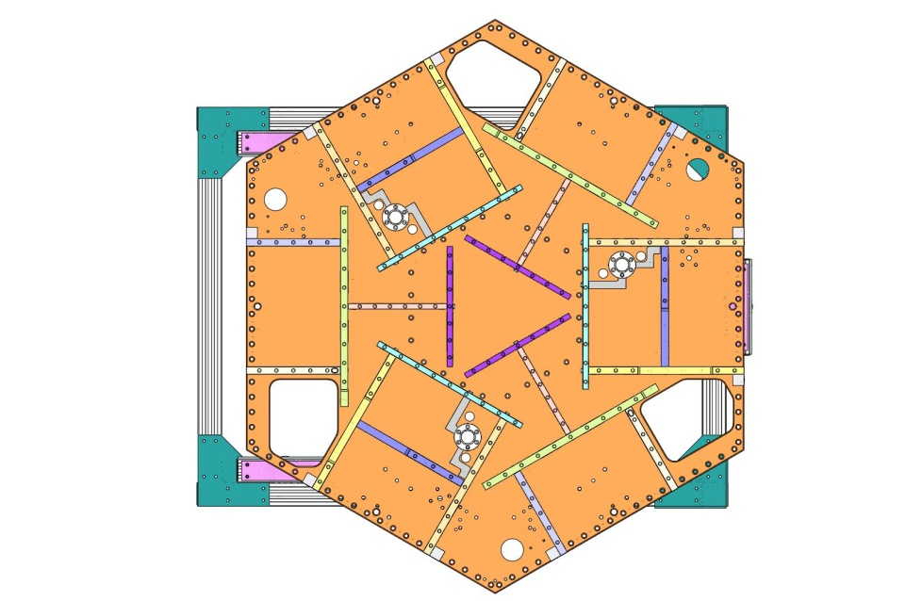
Figure 3.45. Top view of Stage 1 Frame, with Pitchforks and Boxworks in place.

- Place (63) Type 01 Barrel Nuts (D071250-01) in holes lining the bottom of the GS-13 Out Radial and Mid-Tangential Ribs within each Pitchfork Assembly. Place (39) Type 00 Barrel Nuts (D071250-00) in holes lining the bottom of the Mid-Radial and Center-Tangential Ribs. Align flats opposite screws.
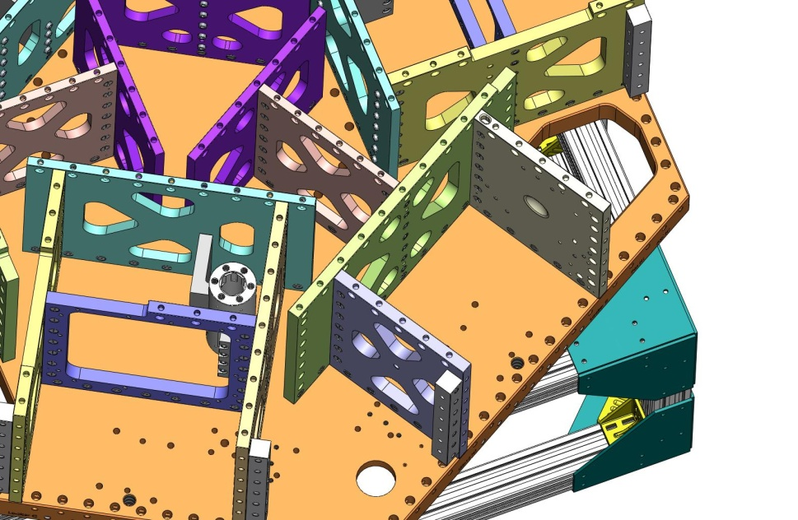
Type 01 Barrel Nuts
Type 00 Barrel Nuts
Figure 3.46. Type 00 (length = 3/4”) Barrel Nuts are used in the Mid-Radial and Center-Tangential Ribs. Type 01 (length = 1”) Barrel Nuts are used in the GS-13 Out Radial and Mid-Tangential Ribs.

- Thread screws into Barrel Nuts, from underneath Stage 1 Floor. Snug, but don’t torque, yet.
Hardware:
(102) 3/8”-16x2.0” SHCS
(102) 3/8” vented washers
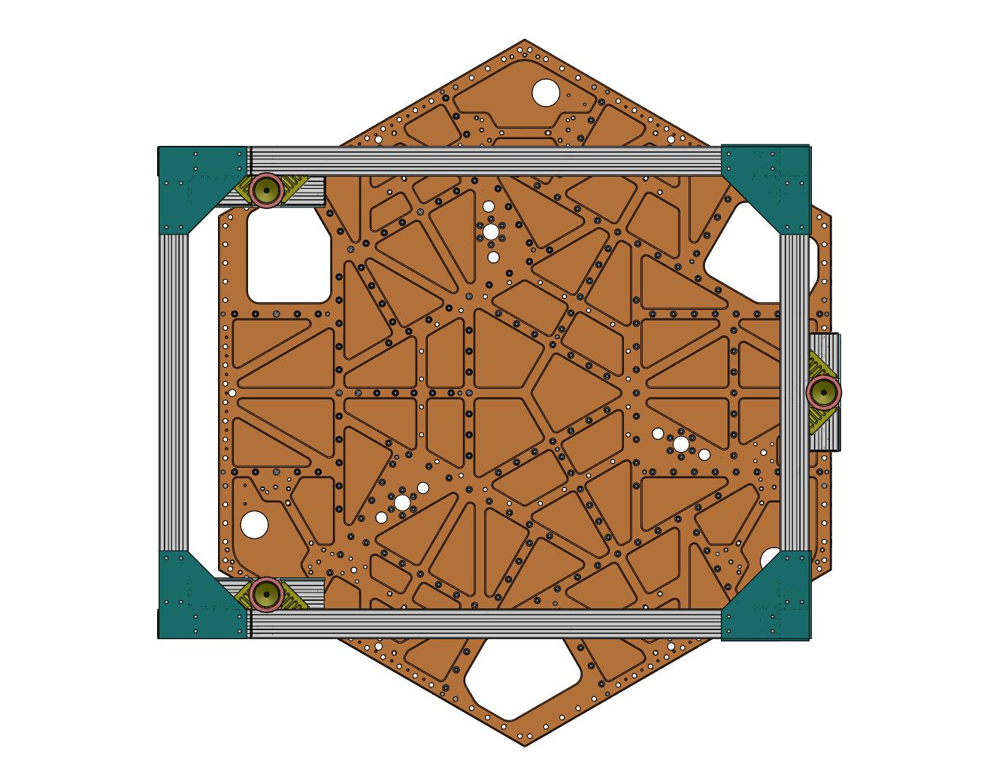
Figure 3.47. Snug (102) screws into Pitchfork Barrel Nuts, from underneath Stage 1 Floor.

- Incrementally torque all (102) screws to final spec.

- Remove the (3) Tangential Flexure Post Brackets, to allow access to the Boxwork Assemblies’ 60 Deg Rib Bracket screws.
- Place (6) 60 Deg Rib Brackets (D071073) between the Boxwork and Pitchfork Assemblies. Start screws. Snug, but do not torque.
Hardware:
(78) 3/8”-16x1.25” SHCS
(78) 3/8” vented washers
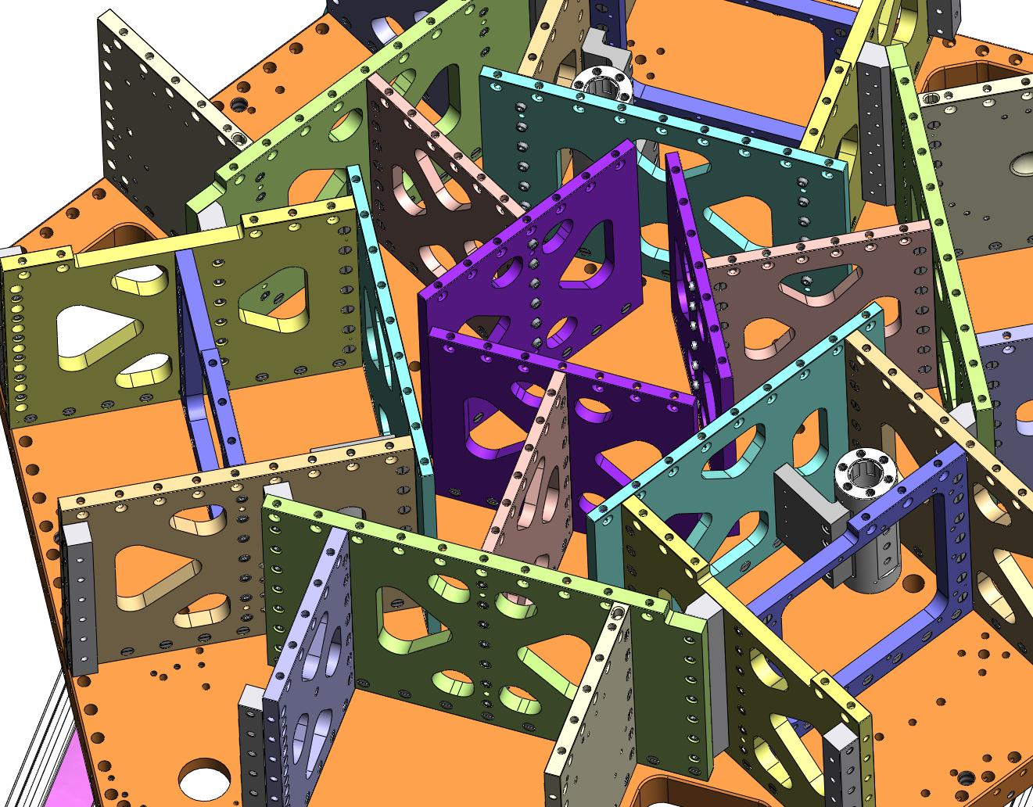
Figure 3.48. Place (6) 60 Deg Rib Brackets between the Boxwork and Pitchfork Assemblies.

- Incrementally torque screws for 60 Deg Rib Brackets to final spec.

- Replace each of the (3) Tangential Flexure Post Brackets. Snug all the screws, then torque to final spec.
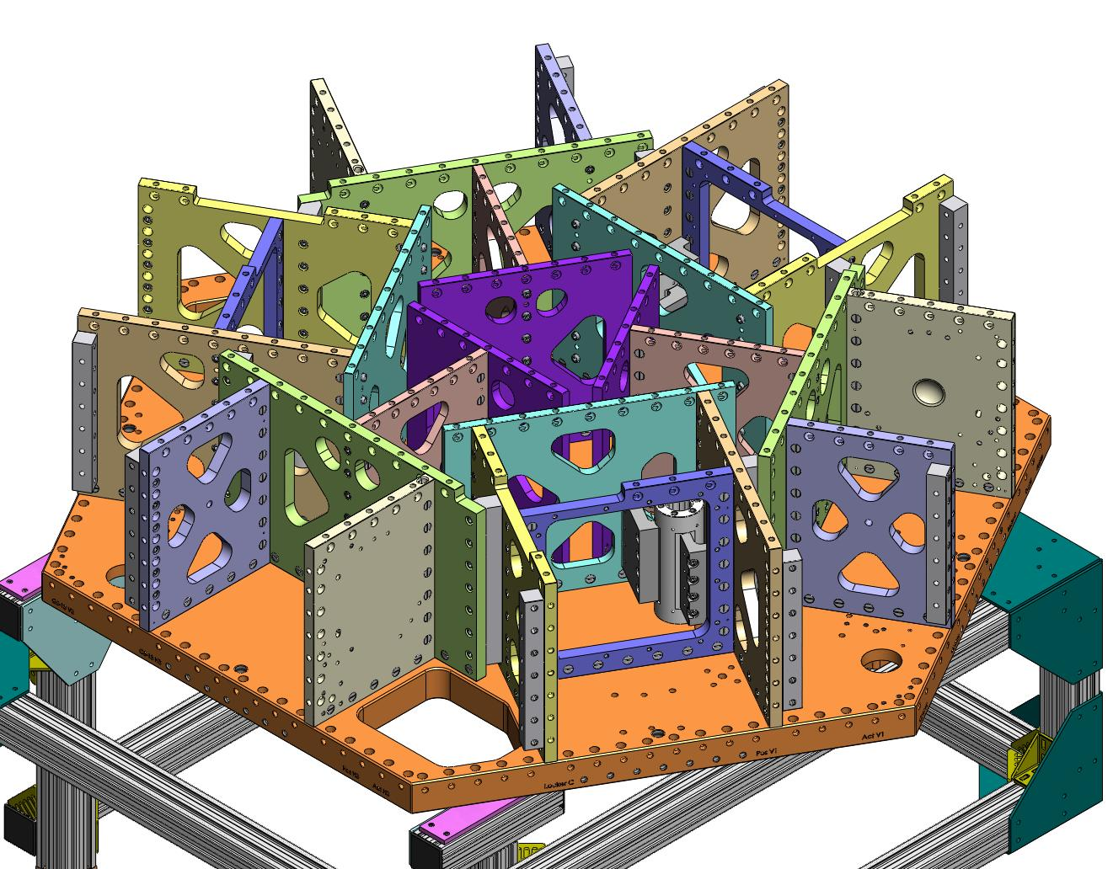
Figure 3.49. Progress of Stage 1 Pre-Assembly, following installation of 60-Degree Brackets and replacement of Tangential Flexure Post Brackets.

Build Keel Assembly (D071424) under Stage 1 Assembly
- Lift the (partially built) Stage 1 Assembly (D0900154) and rotate to the orientation shown in Figure 3.50 and Figure 3.51. This will allow access for bolting on the Locker Assemblies (D071450), later in the procedure.
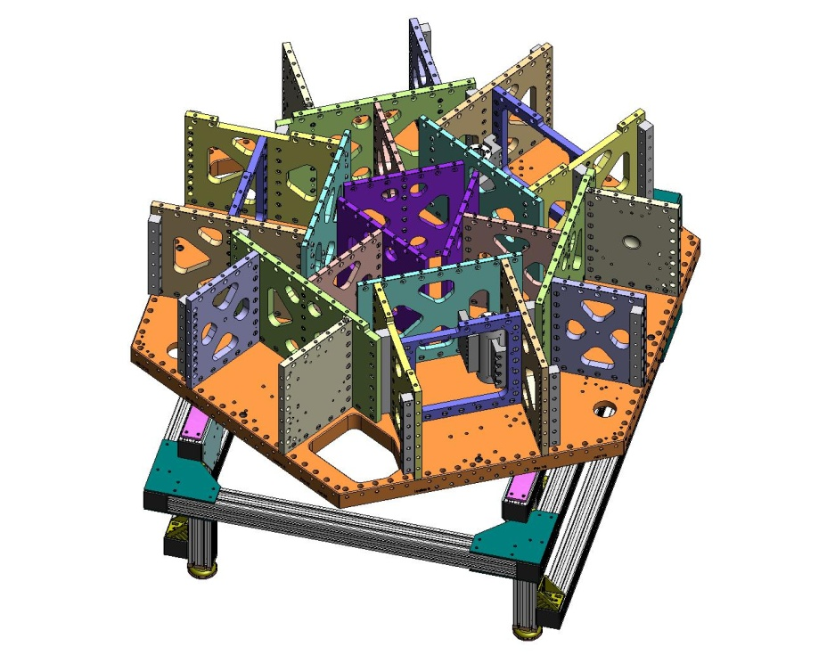
Window for Support Post
Holes for Lockers
Figure 3.50. Rotate Stage 1 Assembly, to the orientation shown here. Note the location of the holes for the Locker Assemblies.
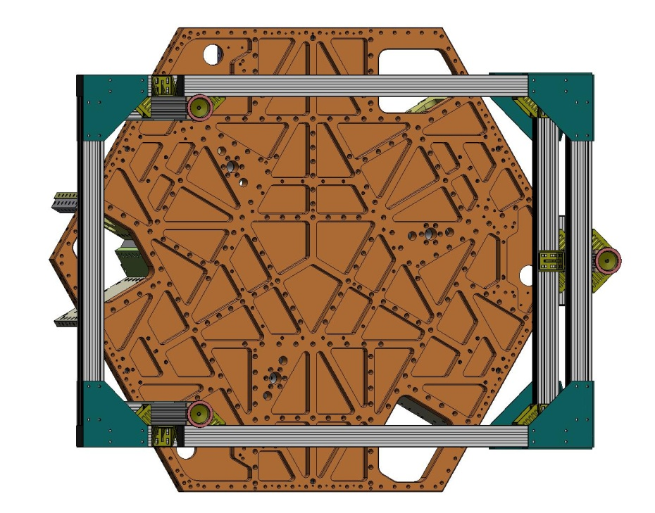
Figure 3.51. Bottom view of the Stage 1 Assembly, after rotation. Note the location of the (4) sets of Locker Assembly mounting holes.

- Drop screws through the top of the Stage 1 Floor, for the Keel Walls.
Hardware:
(24) 3/8”-16x2.0” SHCS
(24) 3/8” vented washers
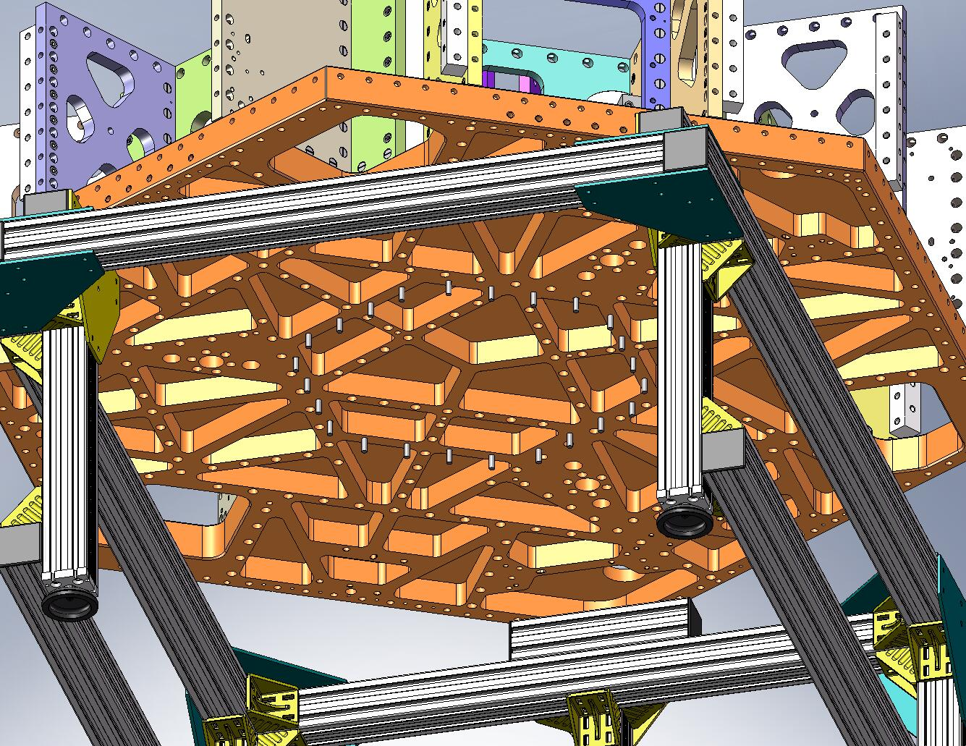
Figure 3.52. Screws hanging from the Stage 1 Floor. These will be used to clamp the Keel Assembly to the Stage 1 Frame.

- Place (4) Type 01 Barrel Nuts (D071250-01) into the holes lining the top of a Keel Wall, as shown in Figure 3.53. The flats should face away from the screw holes.
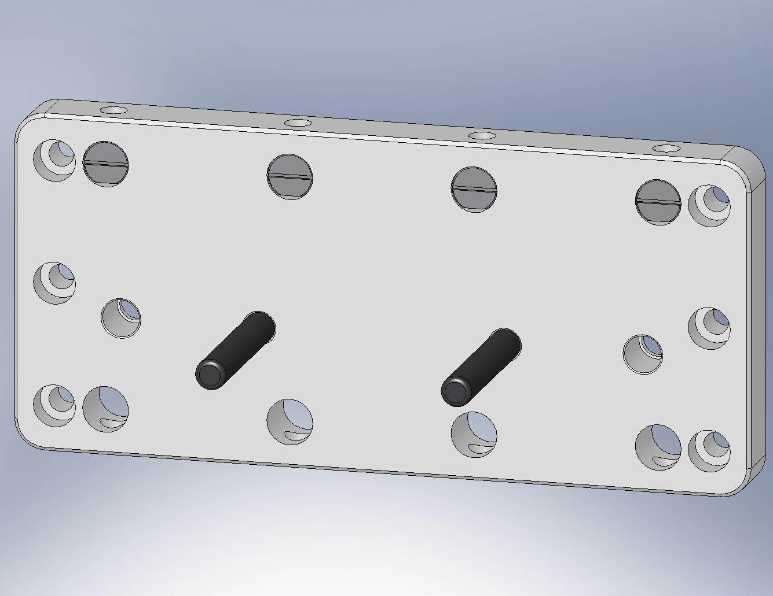
Figure 3.53. Slip in (4) Type 01 Barrel Nuts through the top holes of the Keel Wall. Note the dowel pins are below the mid-plane.

- Lift the Keel Wall against the bottom of the Stage 1 Floor, allowing one line of screws to fit into the top row of holes in the Wall. Start the screws into the Barrel Nuts – requires two people. Snug, but don’t torque, yet.
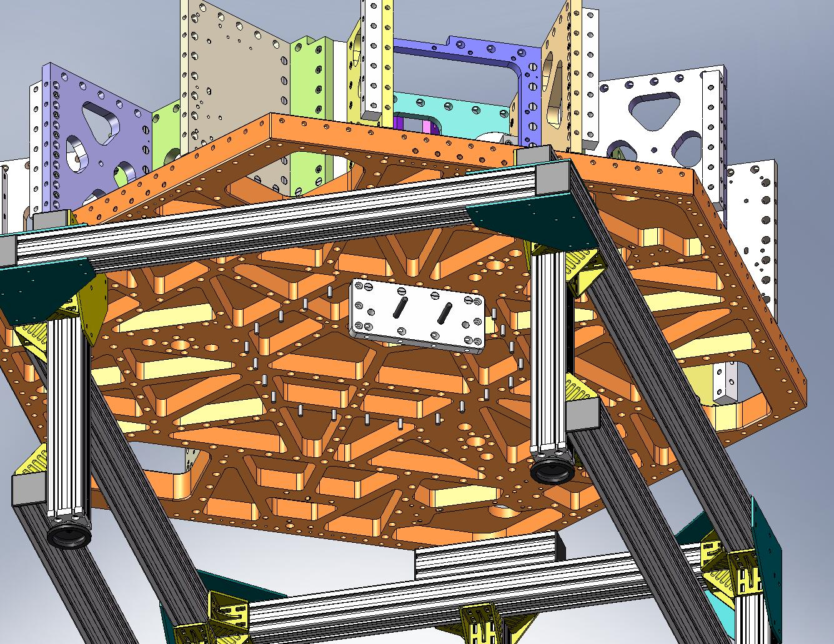
Figure 3.54. Bolt on a single Keel Wall.

- Repeat the last two steps, until all (6) Keel Walls are mounted to Stage 1. All (24) screws should be snug, but not fully torqued, yet.
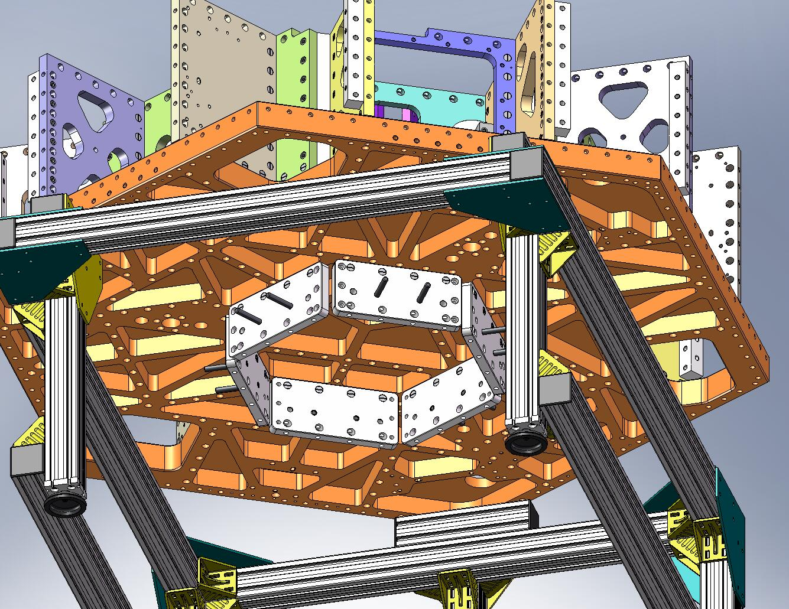
Figure 3.55. All (6) Keel Walls mounted underneath Stage 1.

- Place (6) Type 01 Outer Wall, Bracket 120 (D071060-01) pieces inside the (partially built) Keel. Start screws into all of the Brackets. Snug, but don’t torque, yet.
Hardware:
(36) 3/8”-16x1.25” SHCS
(36) 3/8” vented washers
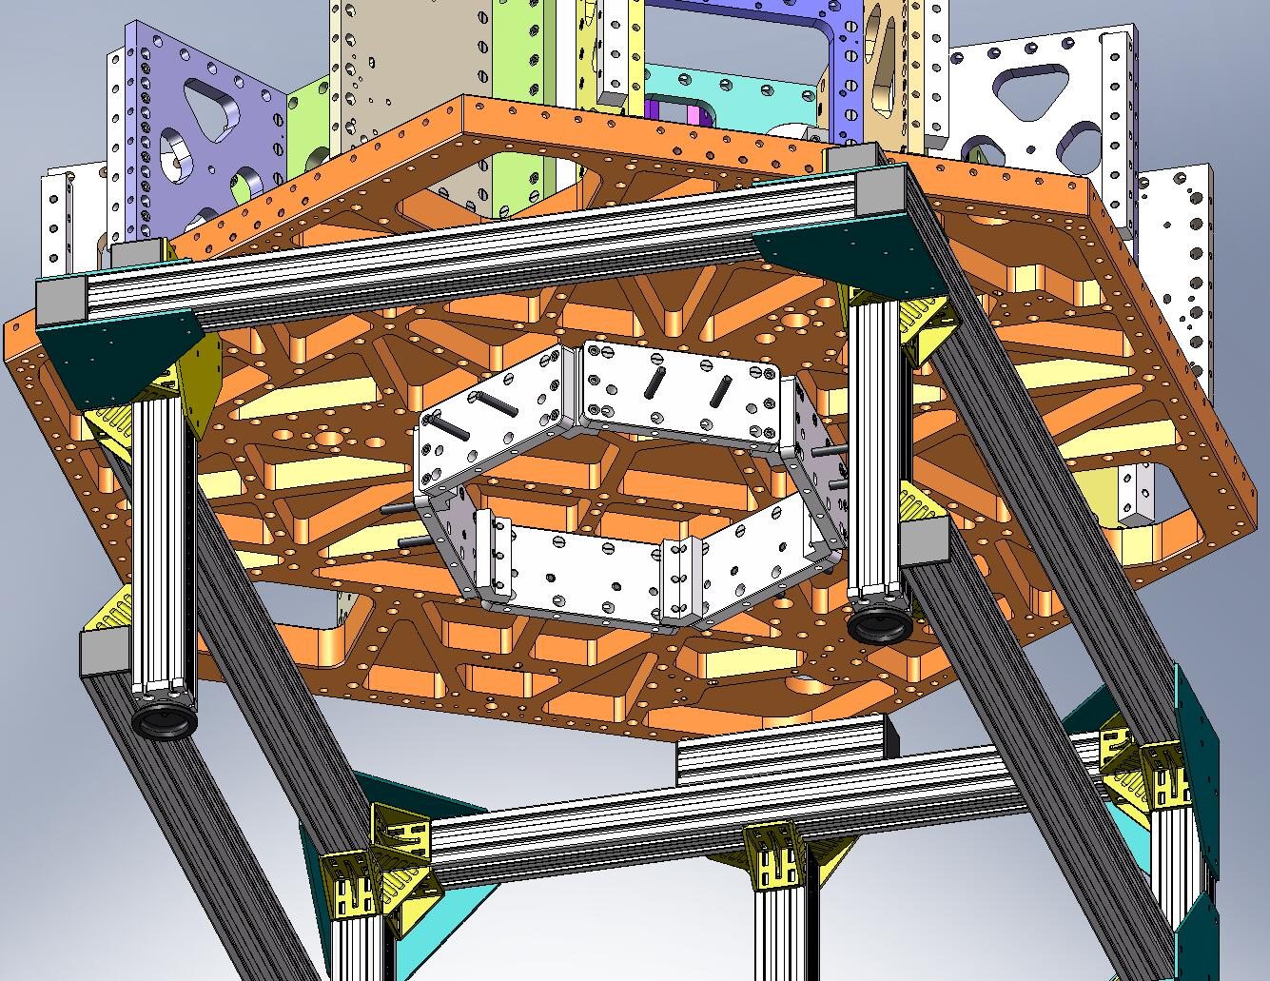
Figure 3.56. 120 Brackets installed inside the Keel. All screws should be snug, so mating surfaces are all in good contact.

- Incrementally torque all (24) screws through the Stage 1 Floor into the Keel Walls.
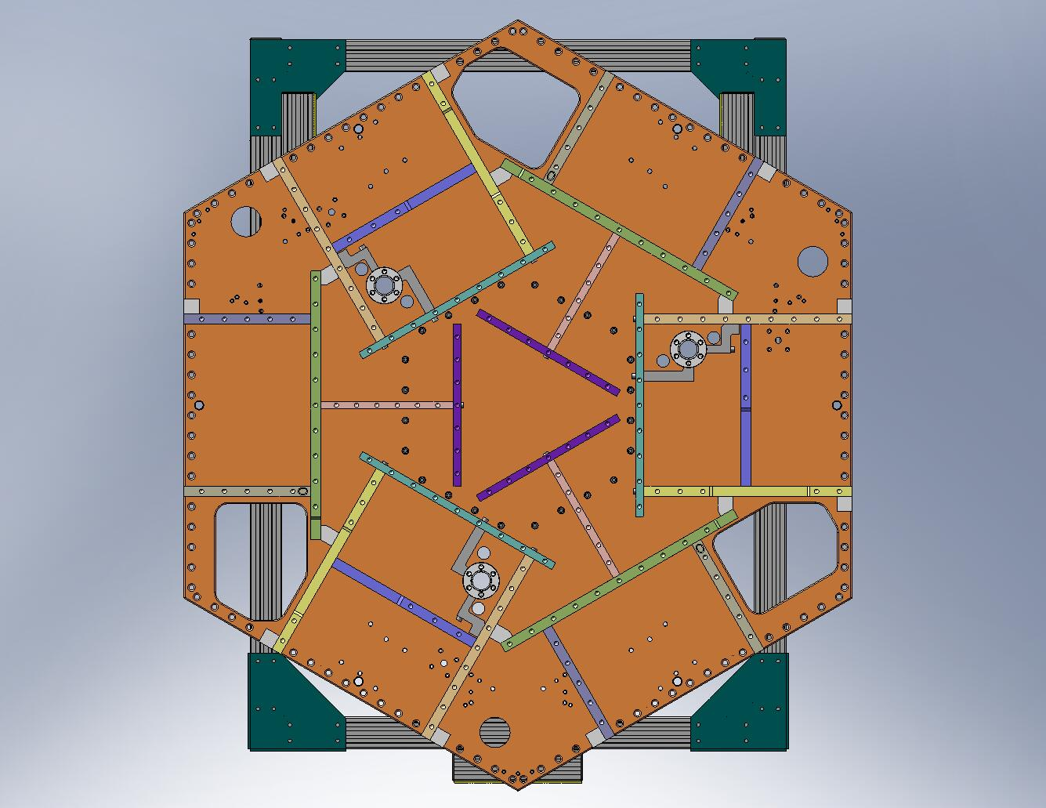
Figure 3.57. Use a wrench extension to torque the Keel Wall mounting screws.

- Incrementally torque all (36) screws for the 120 Brackets to final spec.
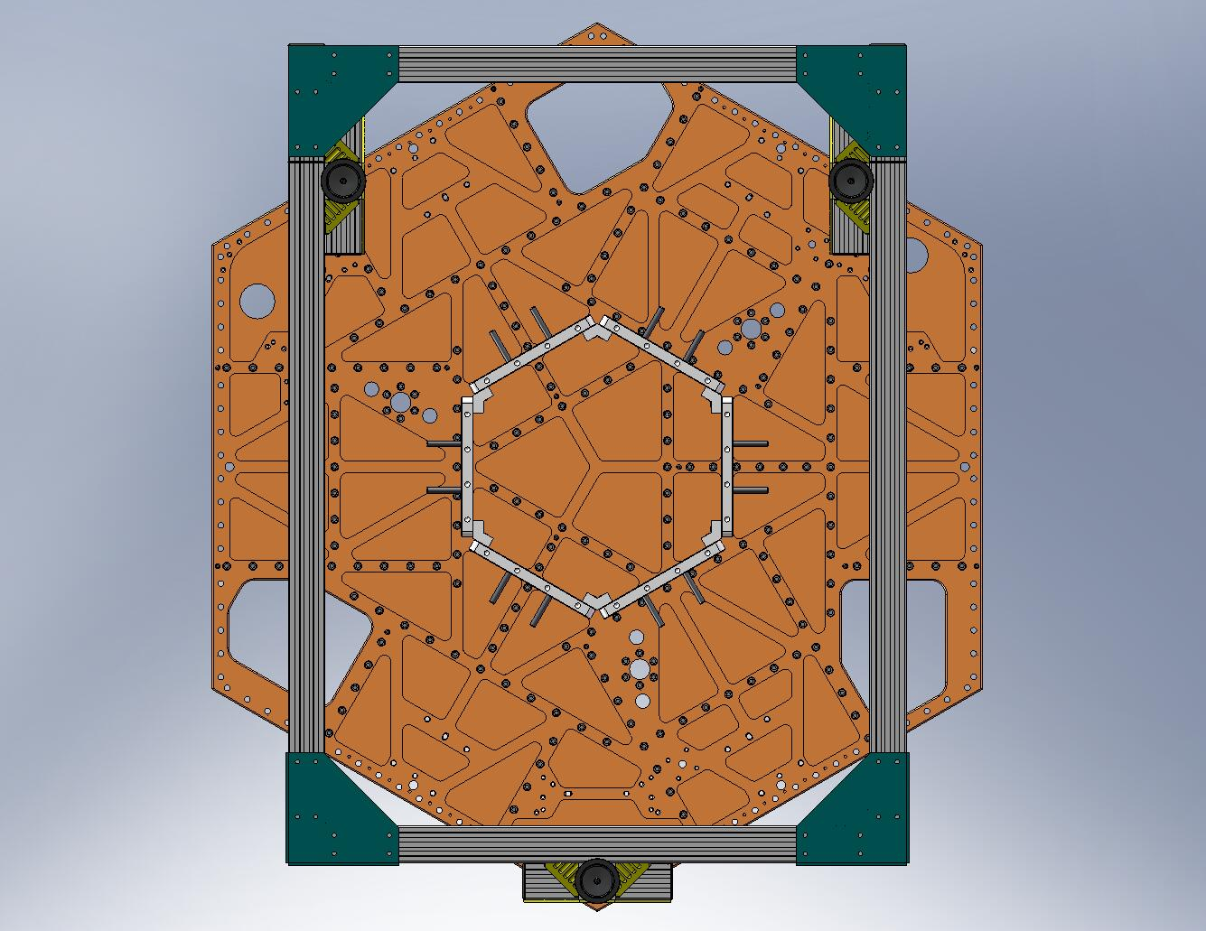
Figure 3.58. Tighten all screws for the 120 Brackets to final torque spec.

- Place (24) Type 01 Barrel Nuts (D071250-01) into the holes lining the bottom of all (6) Keel Walls, as shown in Figure 3.59. The flats should face away from the screw holes.
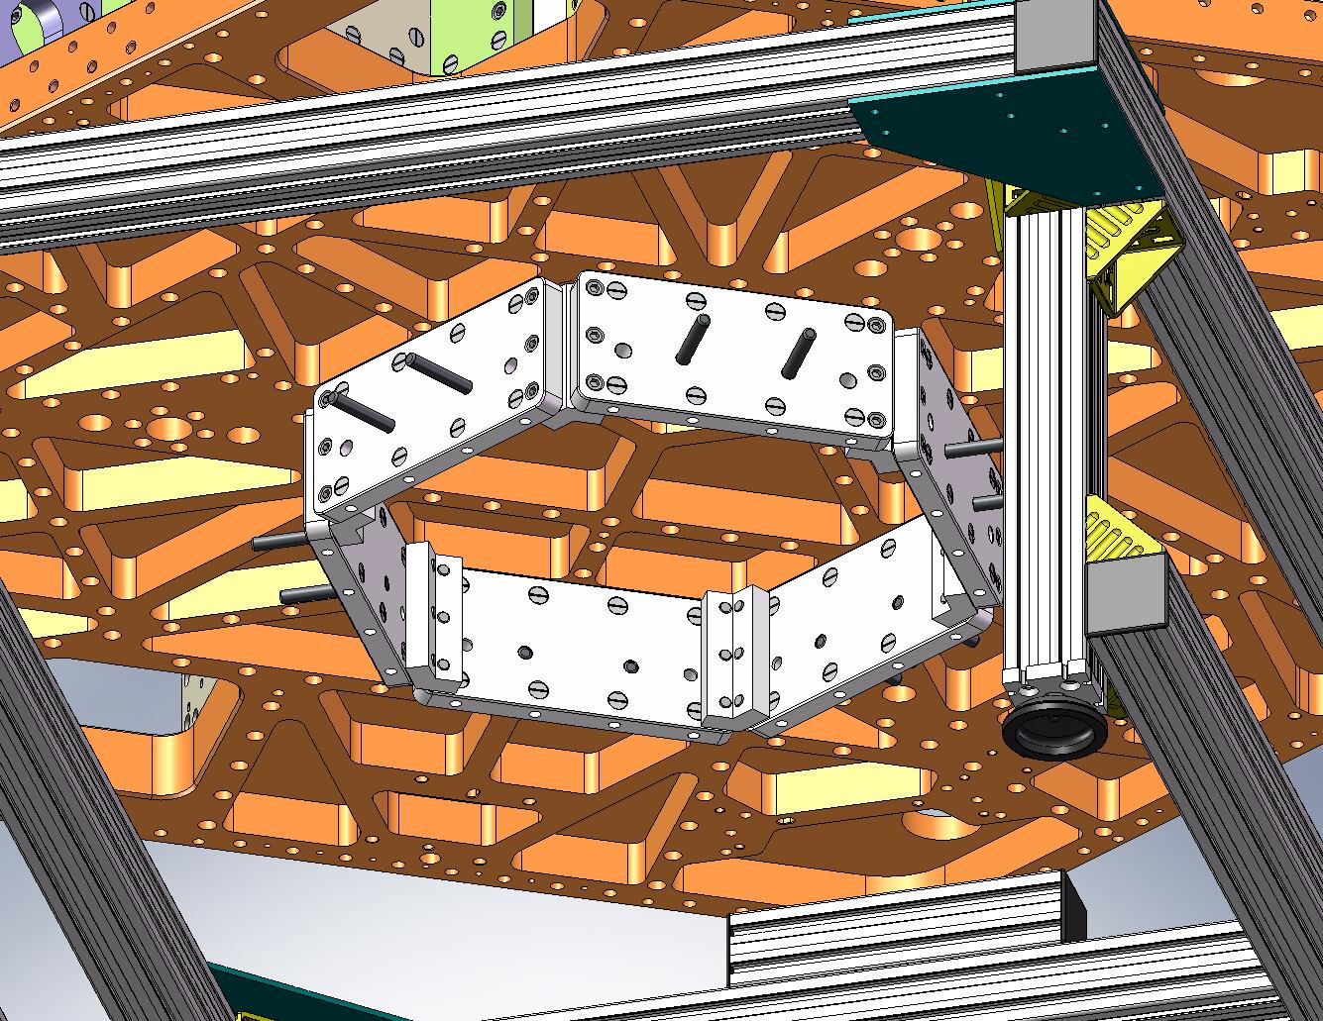
Figure 3.59. (24) Type 01 Barrel Nuts are placed in the holes lining the bottom of the Keel Walls.

- Lift Keel Base (D071065) into position, beneath Stage 1. Start screws through the Base and into the Keel Wall Barrel Nuts. Snug all the screws.
Hardware:
(24) 3/8”-16x1.75” SHCS
(24) 3/8” vented washers
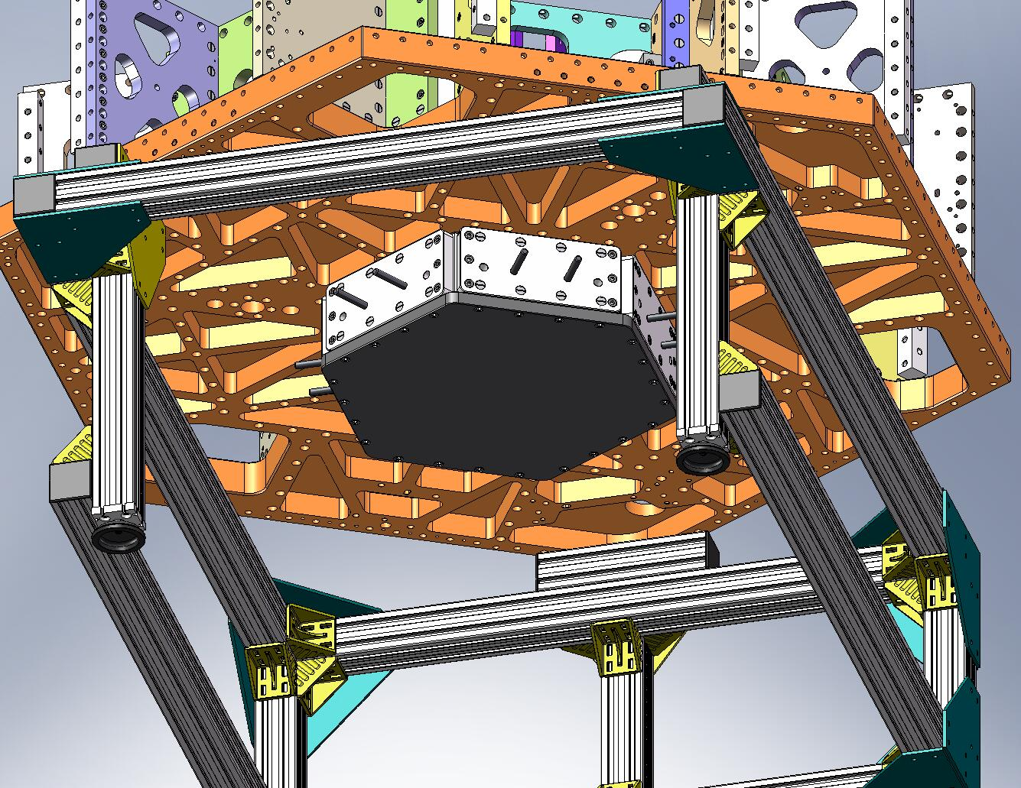
Figure 3.60. Keel Base added to the Keel Assembly.

- Incrementally torque all (24) screws for the Keel Base to final spec. This completes the Keel Assembly (D071424).

Mount (4) Locker Assemblies underneath Stage 1
- Lift each Locker Assembly up against the bottom of the Stage 1 Floor, as shown in Figure 3.61. Make sure that pins seat properly in mating holes and slots. Orientation is important: the knob end of the Locker Sleeves should face outward, to provide access for locking/unlocking. Start screws into the Floor. Snug all (4) screws on each unit, then torque to final spec.
Hardware:
(16) 3/8”-16x2.0” SHCS
(16) 3/8” vented washers
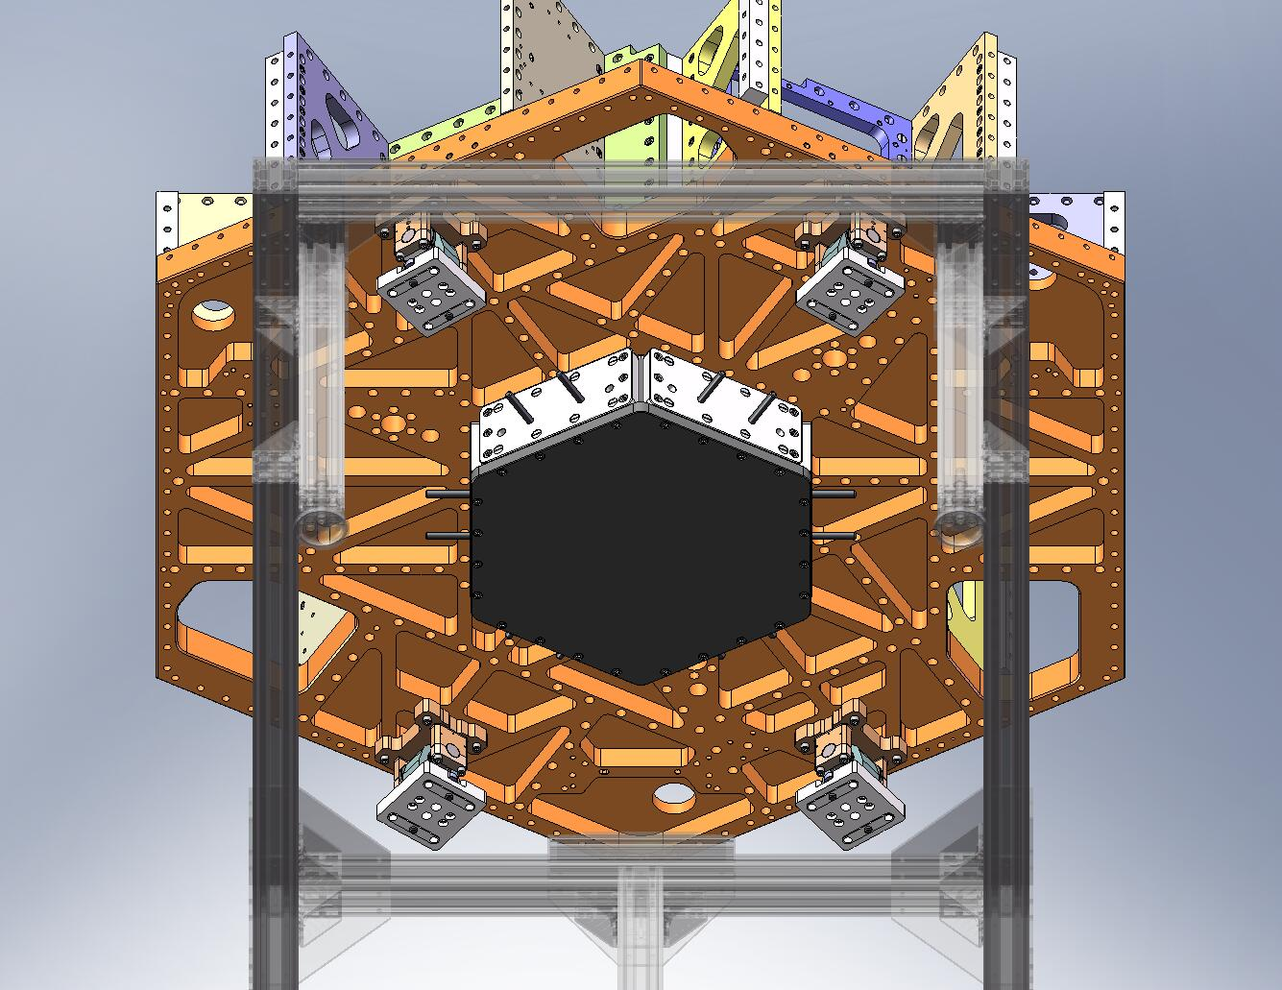
Figure 3.61. Locker Assemblies bolted to bottom of Stage 1 Floor. Knob ends of Locker Sleeves must face outward.

- Assemble temporary pins for locating the Locker Bases to the Stage 0 Base. Clamp a 1/2”-bore shaft collar (McMaster-Carr #9421T700) onto one end of each of (8) 1/2”x2.0” dowel pins (McMaster-Carr #90145A720), as shown in Figure 3.62.
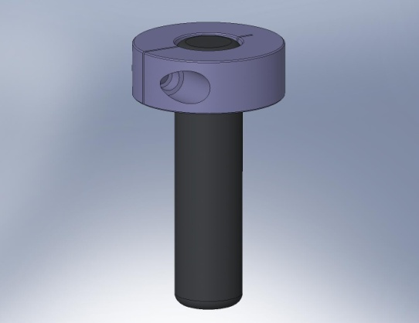
Figure 3.62. Pin used to temporarily locate the Locker Assemblies to the Stage 0 Base. The shaft collar prevents the pin from slipping through the clearance hole in the Locker Base.

- Slip all (8) temporary pins through the oversized 1/2” holes in the Locker Bases, as shown in Figure 3.63.
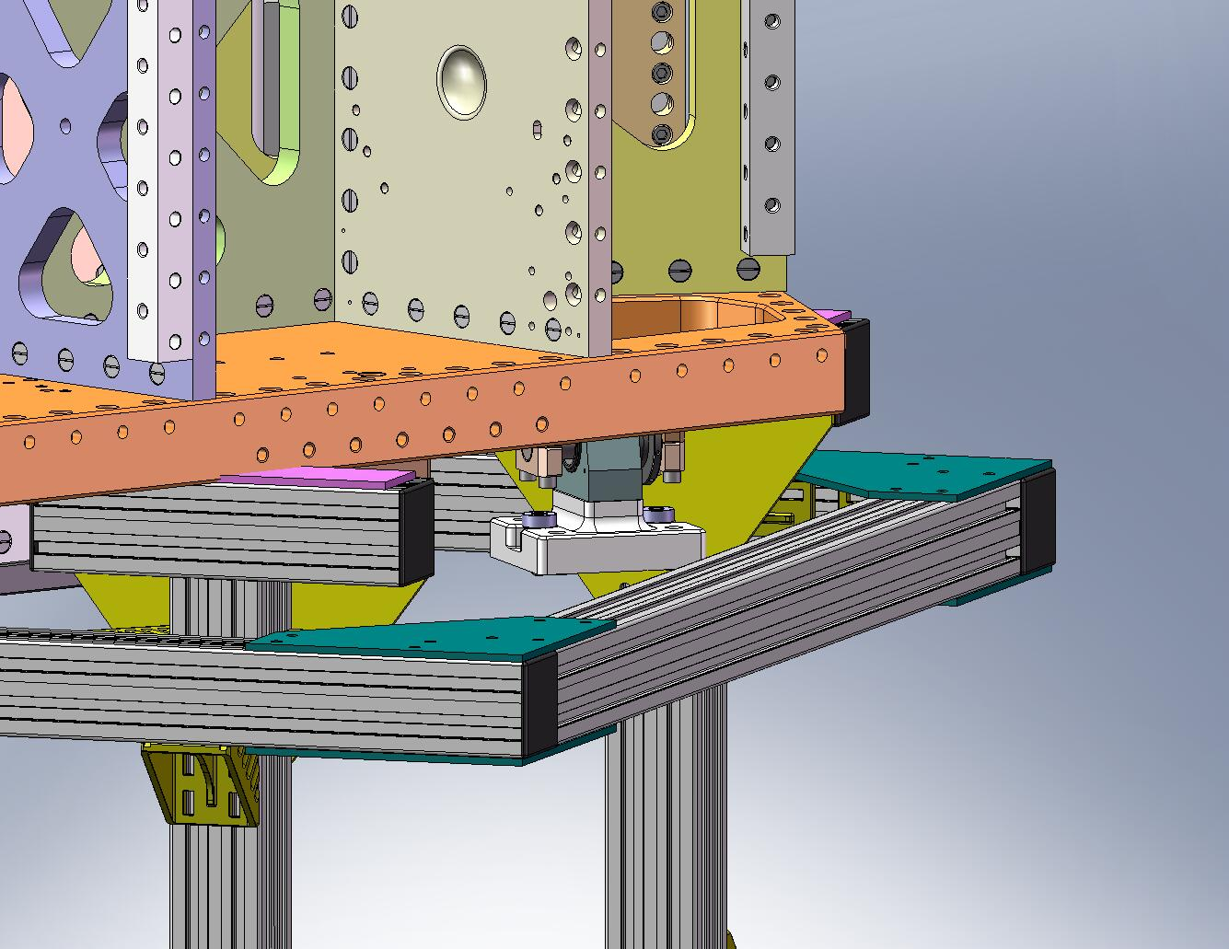
Figure 3.63. Slip (8) pins into the 1/2” holes in the Locker Bases. The shaft collar sits on the surface above the hole counterbore.

Hang Stage 1 from Stage 0
In this section, we couple Stage 1 to Stage 0, via Springs and Flexures.

Prep Work – Assemble (9) Small Panel Outer Walls (D071427)
- Press (2) 1/2”x4.0” dowel pins into each Small Panel Outer Wall (D071059), as shown in Figure 4.1. (If necessary, first heat Wall and cool pins, to reduce interference.)
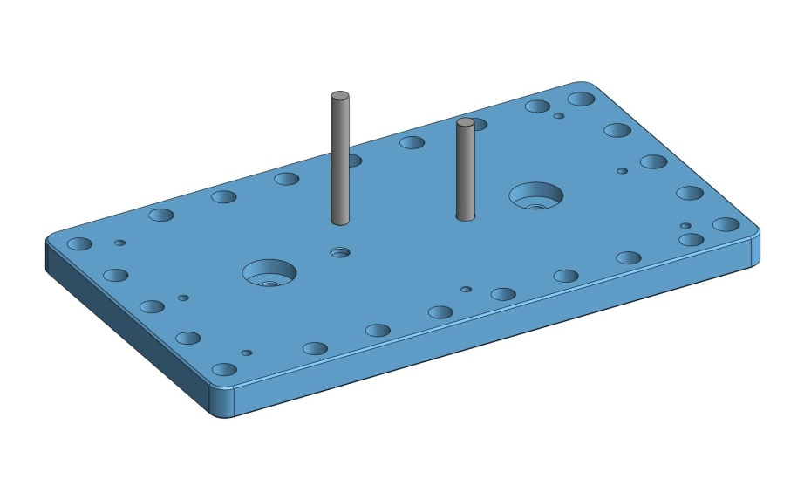
Figure 4.1. Press dowel pins into Small Panel Outer Wall. Note that counterbores all face same direction as pins.

- Insert hex head cap screws, with washer on either side. Tighten to Wall, using D0900204 silver-plated jam nuts on each screw, as shown in Figure 4.2.
Hardware:
(9x 2) 1/2”-13x4.0” full-thread HHCS
(9x 2) 1/2”-13 Ag-plated hex jam nut (D0900204)
(9x 4) 1/2” vented washer
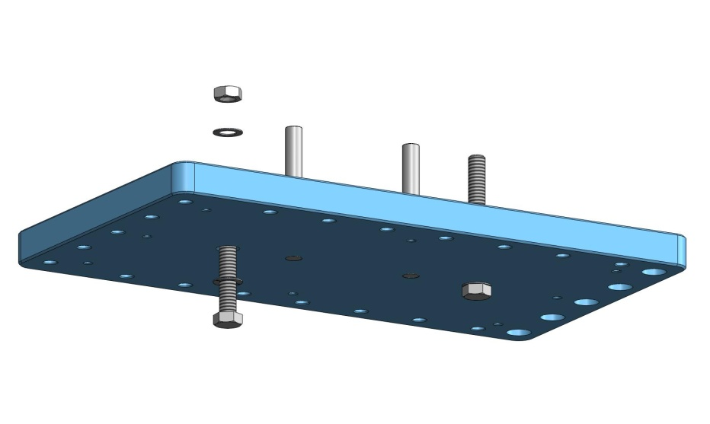
Figure 4.2. Clamp hex head screws to Wall, using silver-plated hex jam nut. Threaded portion should point in same direction as protruding dowel pins.

- Clip E-style retaining rings onto one end of (45) Type 02 Barrel Nuts (D071250-02).
Hardware:
(9x 5) E-style retaining rings
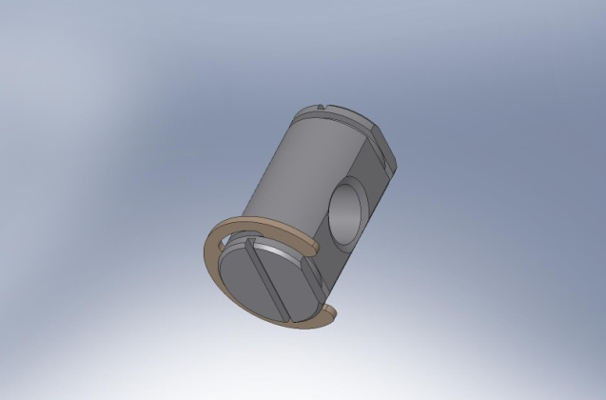
Figure 4.3. Retaining ring clipped into groove on one side of Type 02 Barrel Nut.

- Slip (5) Barrel Nuts through top row of holes in each of the Small Panel Outer Walls. Clip E-style retaining rings onto open end of each Barrel Nut. Turn Nuts so tapped holes line up with screw thru holes, with Nut flat oriented opposite of screw hole.
Hardware:
(9x 5) E-style retaining rings
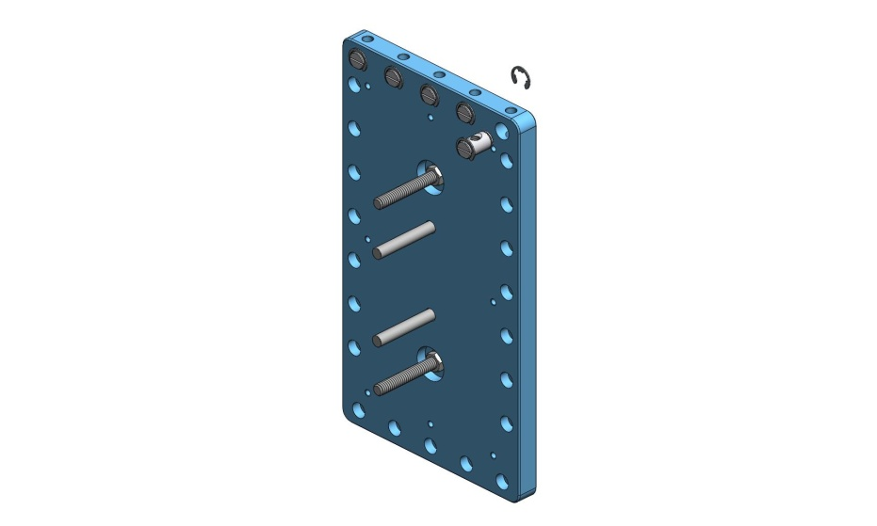
Figure 4.4. Barrel Nuts inserted in top row of holes in Small Panel Outer Wall. Retaining rings hold them in place.

Prep Work – Prepare remaining Outer Walls
- Install Heli-Coils in (3) Horiz GS-13 Outer Walls (D071057).
- Clip E-style retaining rings onto one end of (63) Type 02 Barrel Nuts (D071250-02).
Hardware:
(63) E-style retaining rings
- Slip (13) Barrel Nuts through top row of holes in each of the Horiz GS-13 Outer Walls. Clip E-style retaining rings onto open end of each Barrel Nut. Turn Nuts so tapped holes line up with screw thru holes, with Nut flat oriented opposite of screw hole.
Hardware:
(39) E-style retaining rings
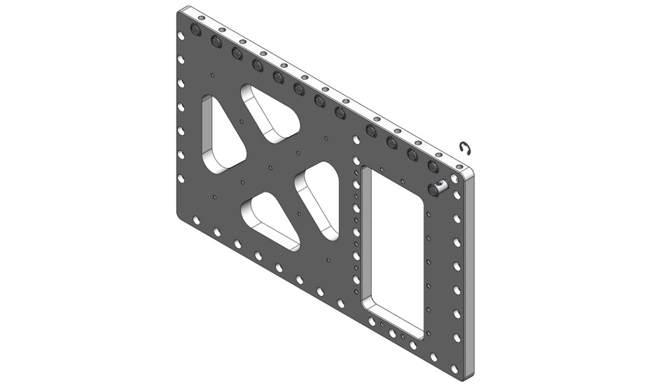
Figure 4.5. Barrel Nuts inserted in top row of holes in Horiz GS-13 Outer Wall.

- Slip (8) Barrel Nuts through top row of holes in each of the Flexure Access Outer Walls (D071058). Clip E-style retaining rings onto open end of each Barrel Nut. Turn Nuts so tapped holes line up with screw thru holes, with Nut flat oriented opposite of screw hole.
Hardware:
(24) E-style retaining rings
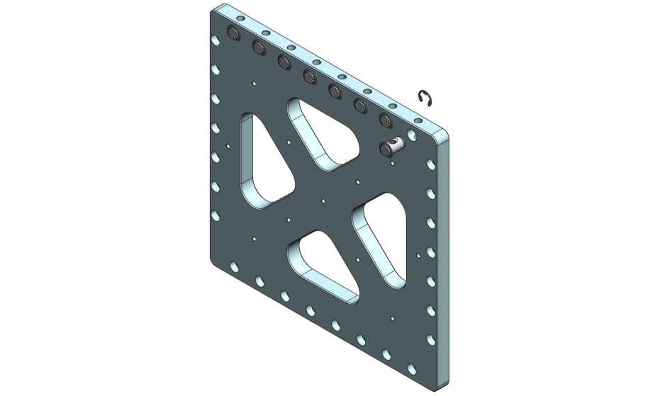
Figure 4.6. Barrel Nuts inserted in top row of holes in Flexure Access Outer Wall.

Prep Work – Prepare (3) Flexure Assemblies (D071431)
- The Flexures are fragile! Before starting this section, check that all (3) are still straight (e.g., by rolling on a surface plate).
the following procedure describes the assembly of one D071431 assembly. This should be repeated for the other two D071431’s, as well:
- Insert Flexure Mount (D071103) through bottom of Flexure Lower Plate (D071105), as shown in Figure 4.7.
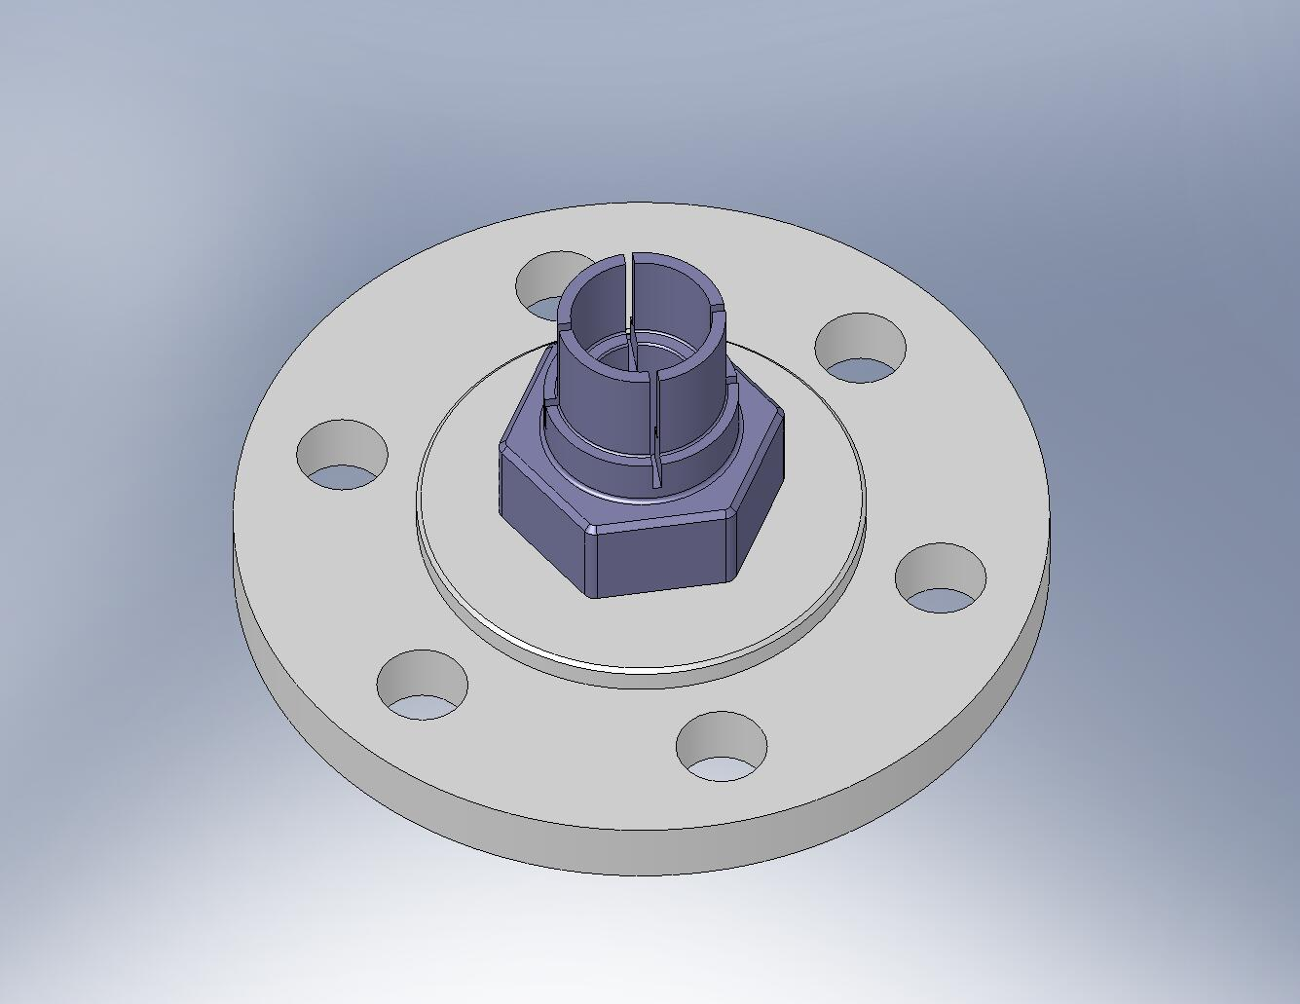
Figure 4.7. Flexure Mount in Flexure Lower Plate. Relative angle between these parts is not important.

- On other side of Flexure Lower Plate, place a washer. Thread D0900206 silver-plated nut onto Flexure Mount. Torque nut to final spec.
Hardware:
(1) 3/4”-10 Ag-plated jam nut (D0900206)
(1) 3/4” washer
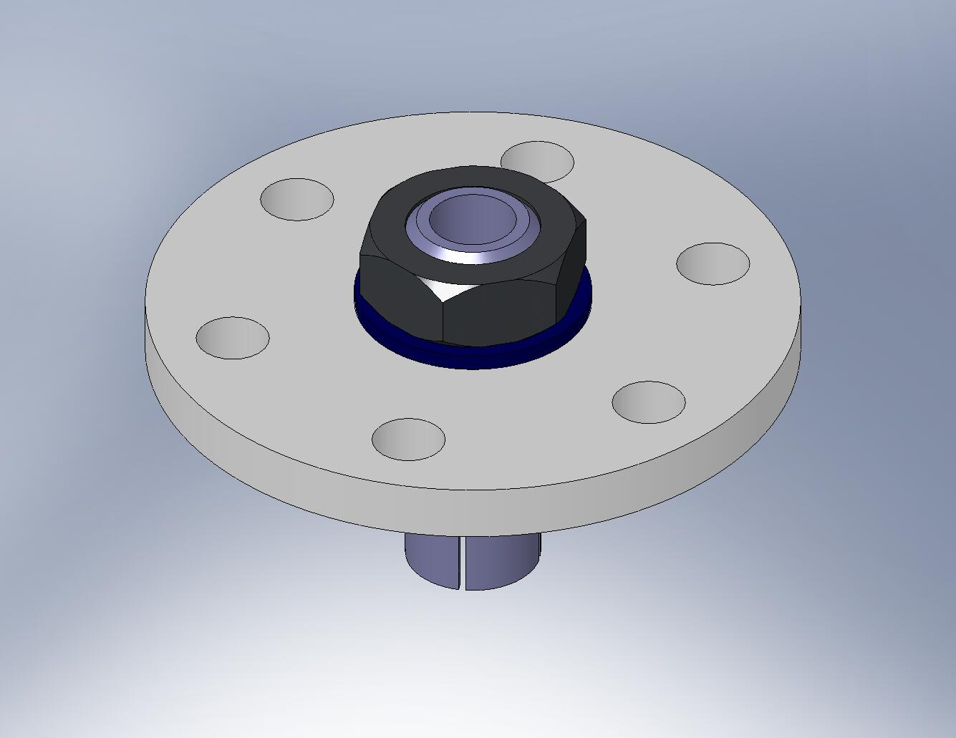
Figure 4.8. Tighten nut against the Flexure Mount. Make sure that the hex flange on the Flexure Mount seats firmly against the bottom surface of the Flexure Lower Plate.

- Insert Flexure (D071102) through Flexure Mount, as shown in Figure 4.9.
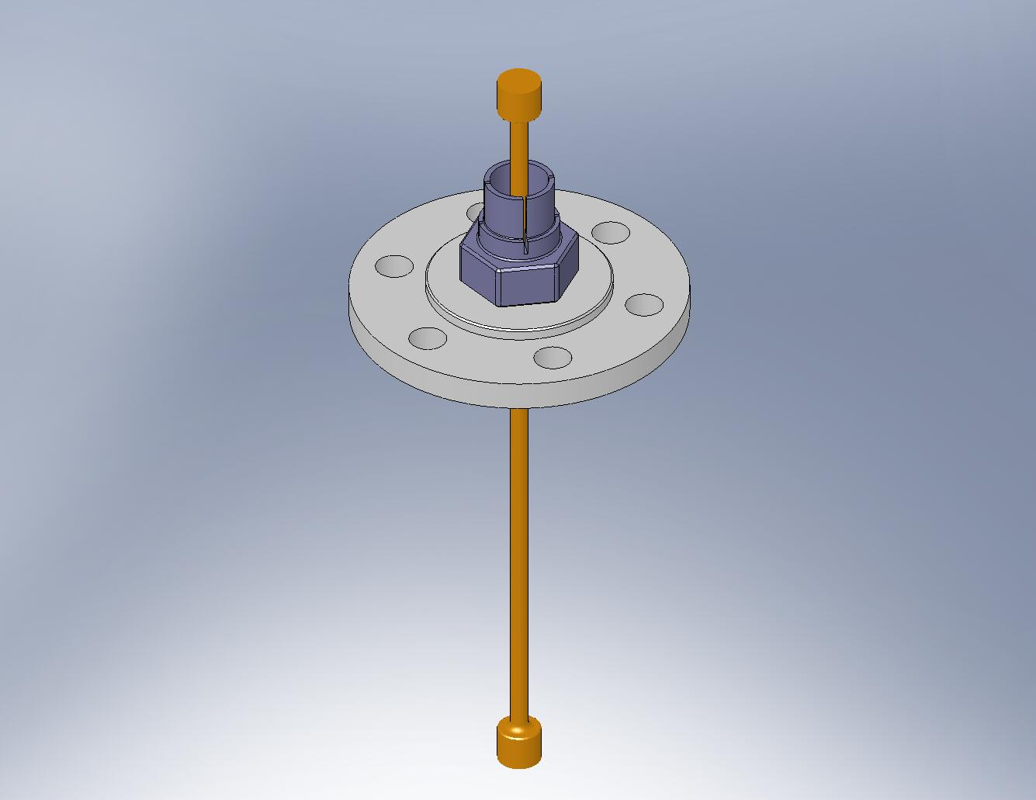
Figure 4.9. Insert Flexure.

- Place (2) Flexure Cups (D071104) inside the Flexure Mount, as shown in Figure 4.10. Try to align the Cups with the grooves in the Mount.
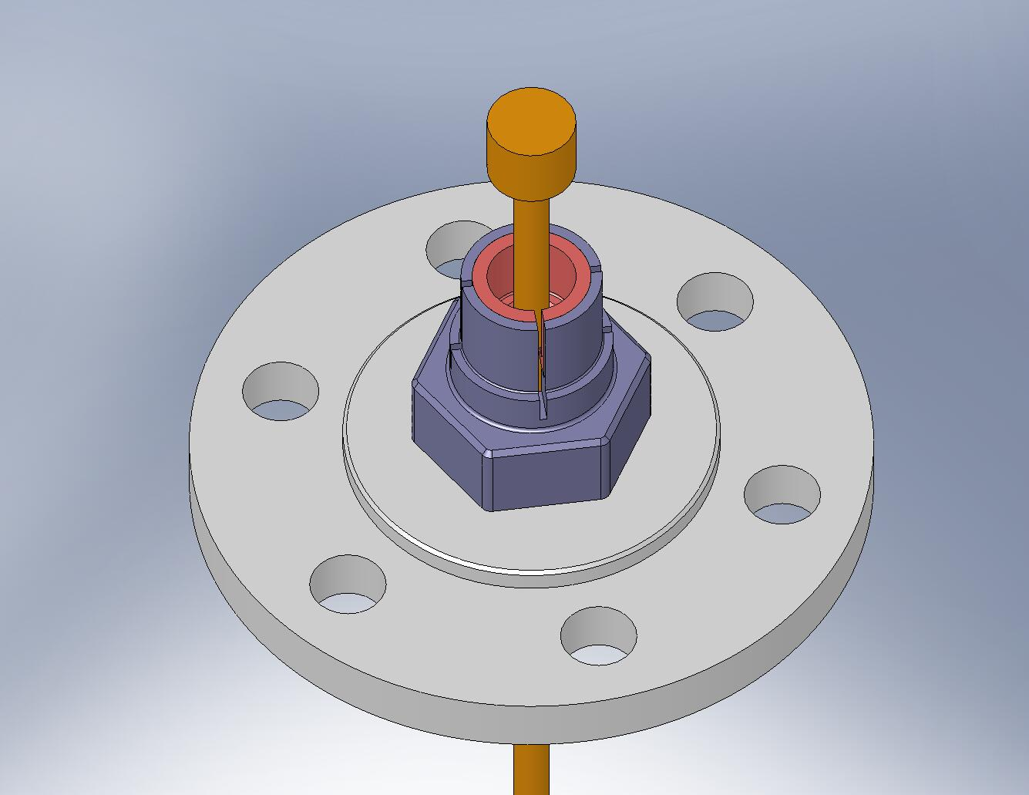
Align sides of Flexure Cups with grooves in Flexure Mount.

Figure 4.10. The Flexure Cups must sit flush inside the Flexure Mount. Next, we will seat the Flexure within the Flexure Cups. These are the most critical joints in the entire assembly!

- Place D0900207 shaft collar with silver-plated screws over the collet end of the Flexure Mount, as shown in Figure 4.11.
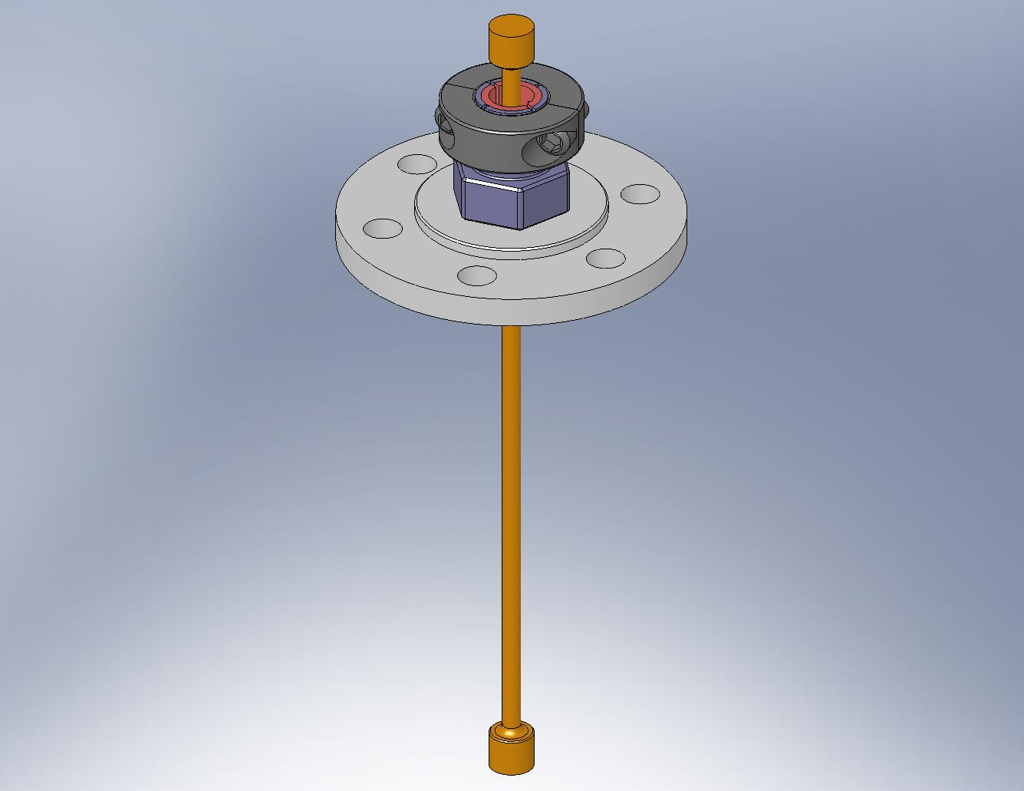
Figure 4.11. Shaft collar must be placed over the end of the Flexure Mount. Do not tighten the screws, yet.

- Hold the D0900206 nut tightly (e.g., using a vice), in the orientation shown in Figure 4.12. Push the head of the Flexure into the Flexure Mount, until the Flexure and Flexure Cups are all fully seated. Partially tighten the shaft collar screws.
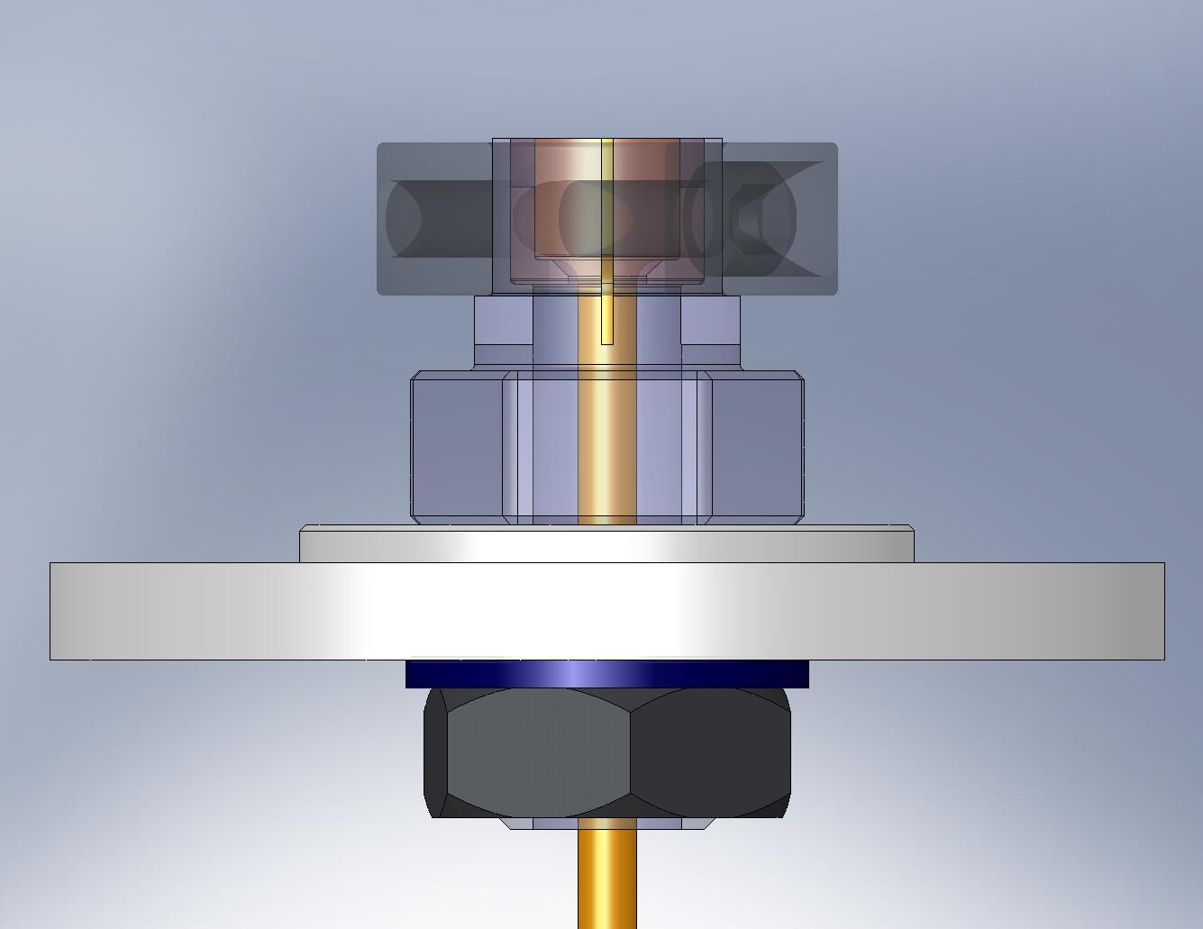
Place nut in vice.

Figure 4.12. Seat the Flexure within the Flexure Mount, then apply a small amount of clamping force from the shaft collar.

- To improve the seating of the Flexure and Flexure Cups within the Flexure Mount, lightly tap the Flexure with a hammer. When you are satisfied that the there is good metal-on-metal contact everywhere, torque the shaft collar screws to final spec.
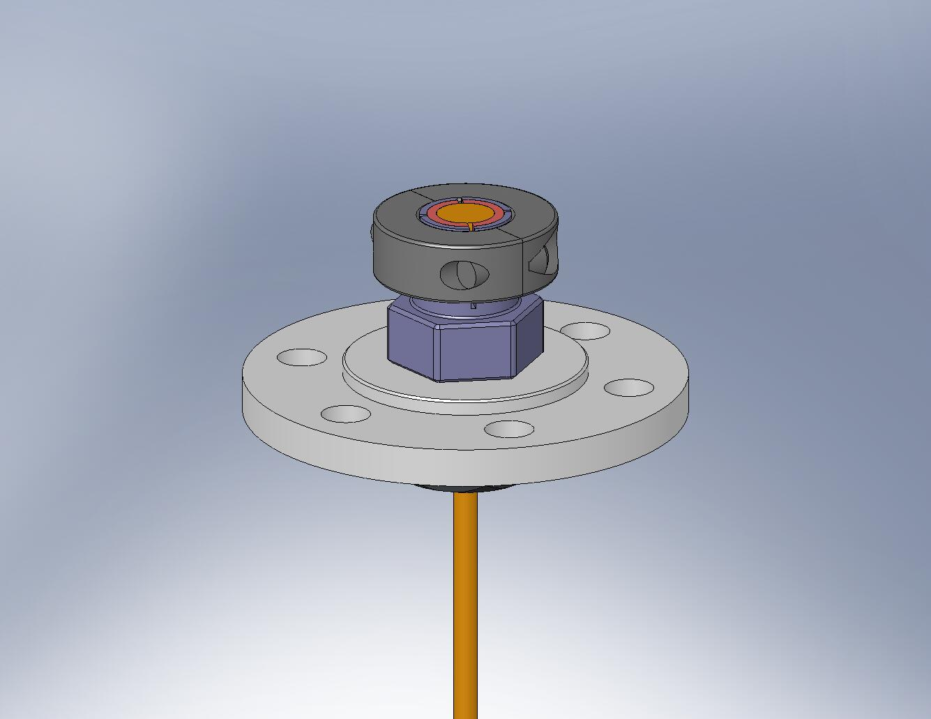
Tap with a hammer, to seat the Flexure.
Figure 4.13. Carefully tap the Flexure into the Flexure Mount, to improve seating.

- Set aside the partially assembled Flexure Assemblies for later use.
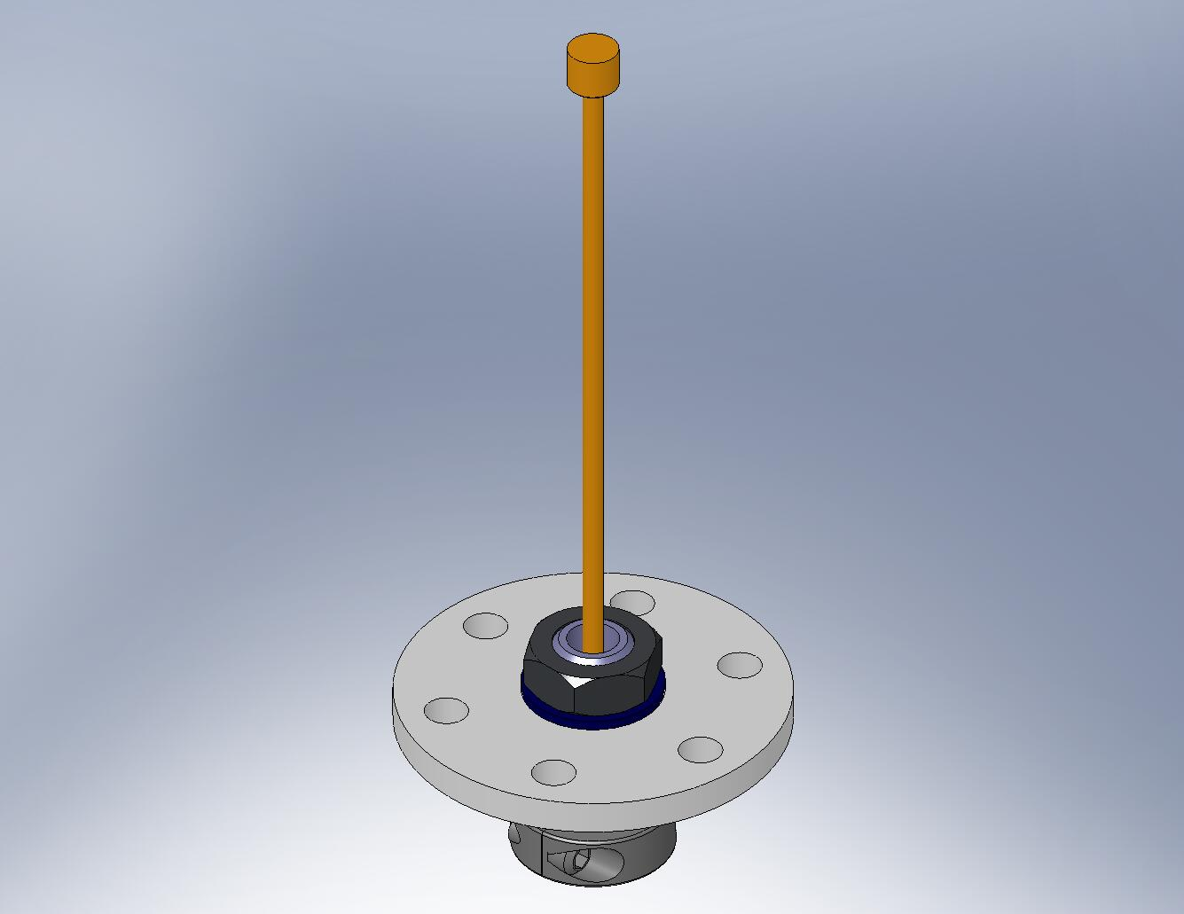
Figure 4.14. The top of the Flexure Assembly will be installed after Stage 1 is placed on Stage 0.

Prep Work – Assemble Actuators (D071442)
- Install Heli-Coils in Actuator parts (D071120, D071121, D071316, and D071317), as specified in their machine drawings.
the following procedure describes the partial assembly of one D071442 assembly, using the Actuator Set-Up Fixture. Repeat the process for all six Actuators. Afterwards, different sets of brackets will be installed for the Horizontal and Vertical Actuator configurations.
- Assemble Actuator Set-Up Fixture (D071497). Refer to Figure 4.15 and Figure 4.16.
Hardware:
(5) 1/4”-20x.875” SHCS
(5) 1/4" vented washers
(2) 3/8”x.75” dowel pins
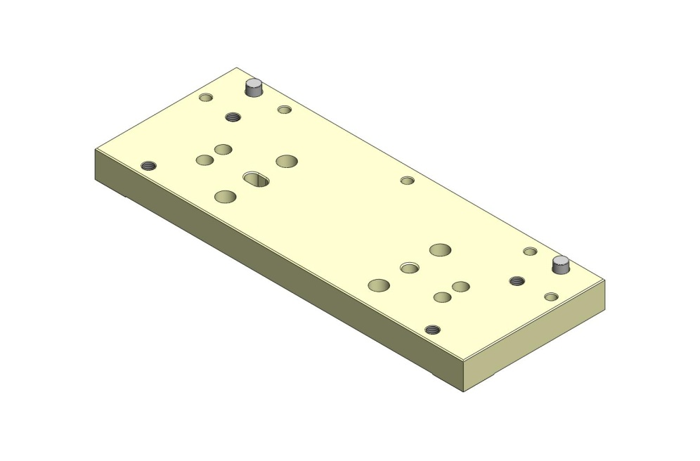
Figure 4.15. Press (2) pins into Set-Up Fixture Plate 2 (D071317).
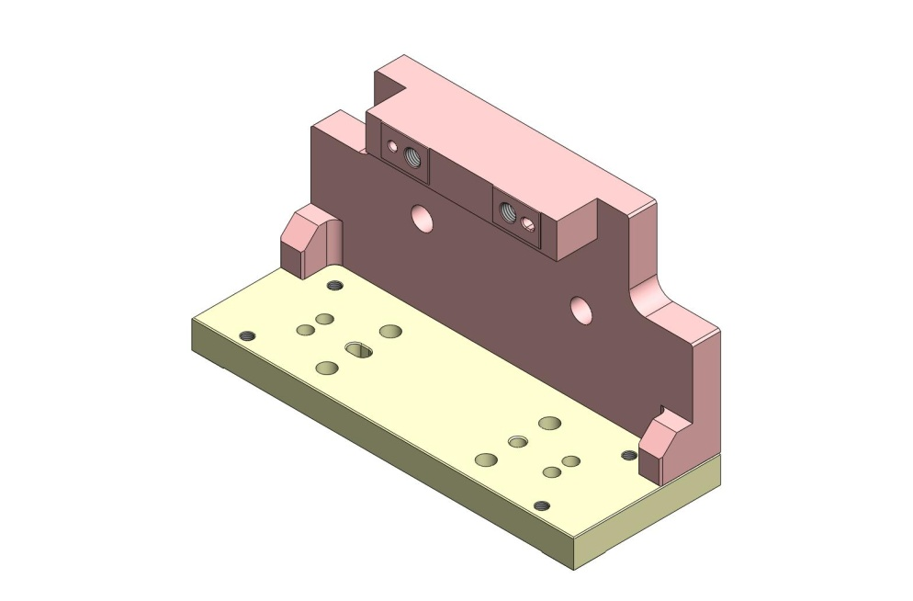
Figure 4.16. Bolt on Set-Up Fixture Plate 1 (D071316).

- Press (2) 3/8”x.75” dowel pins into bottom of Actuator Magnet Mount (D071120). Pins should remain .25” proud of the plate surfaces.
- Thread (4) Captive Screws into the Actuator Magnet Mount, as shown in Figure 4.17. These are later used to mount the Actuator Assemblies to Stage 1, but are also needed to bolt to the Set-Up Fixture.
Hardware:
(4) 1/4”-20x1.5” (1.0” Clear) Captive SHCS (D071136-00)
(4) 1/4" vented washers
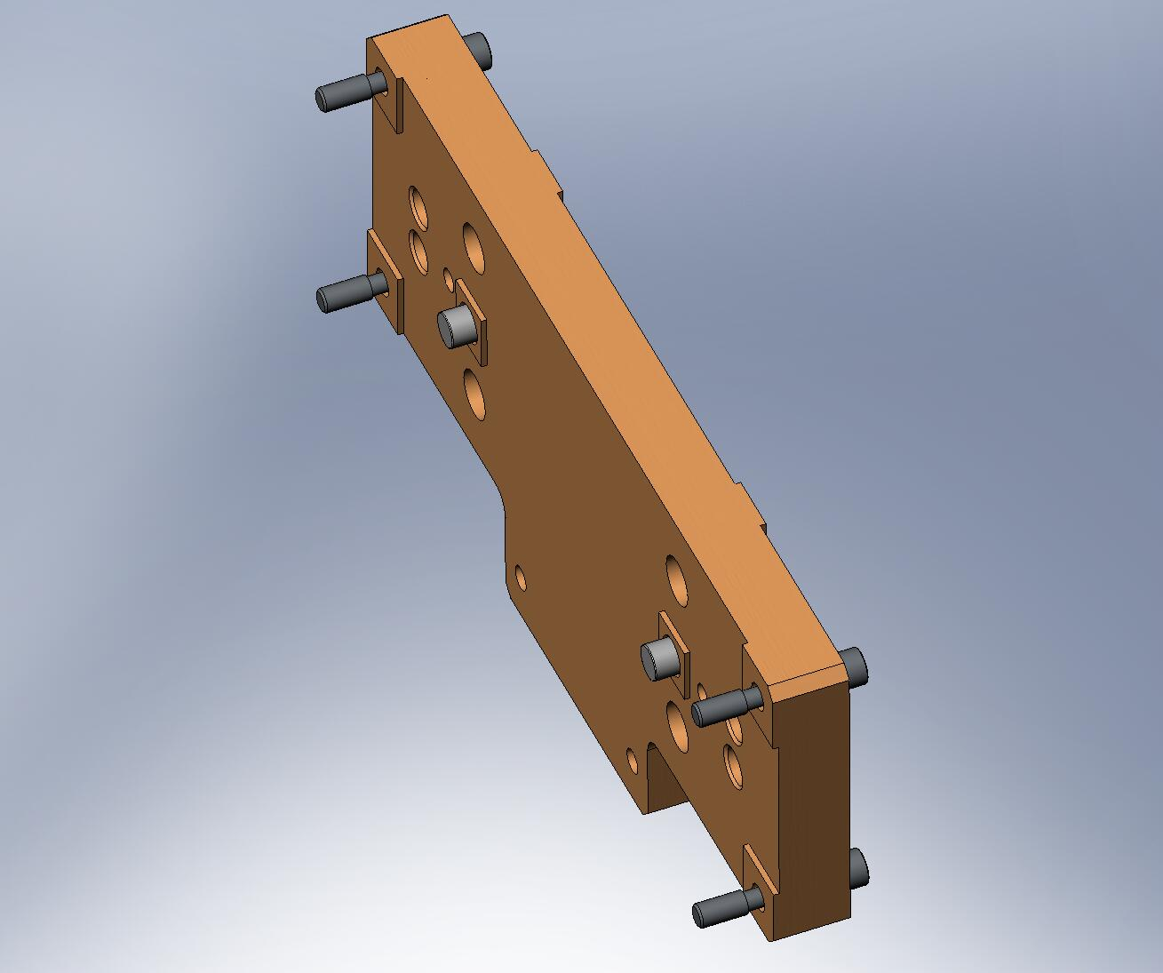
Figure 4.17. Actuator Magnet Mount with Captive Screws and dowel pins installed.

- Prepare PSI Actuator for assembly. Shoulder screws connecting Bobbin to Field Assembly should be installed and tightened, as shown in Figure 4.18.
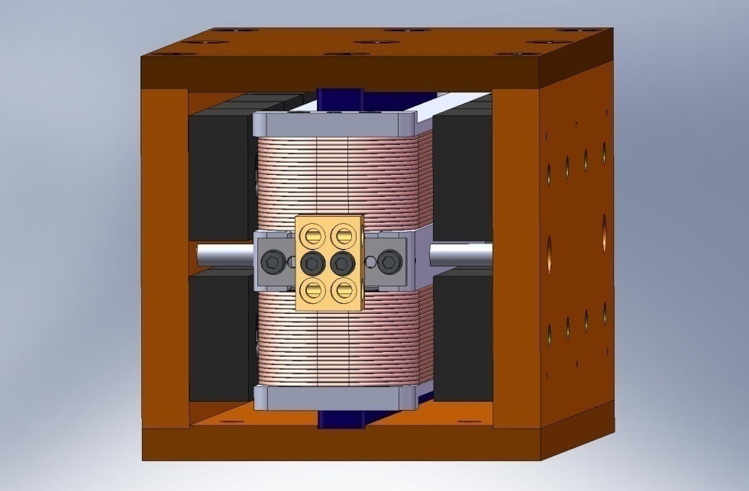
Figure 4.18. (4) shoulder screws are included when the Actuator is shipped, to “lock” the Bobbin to the Field Assembly. Make sure these are tight before proceeding with the rest of the assembly.

- Press (2) 1/8”x.375” dowel pins into the PSI Actuator Bobbins, as shown in Figure 4.19. The pins should remain proud of the Bobbin surface by .195” +.010”/-0. Do not touch the coil wires with these pins! Use care when pressing the pins, to avoid yielding the Aluminum.
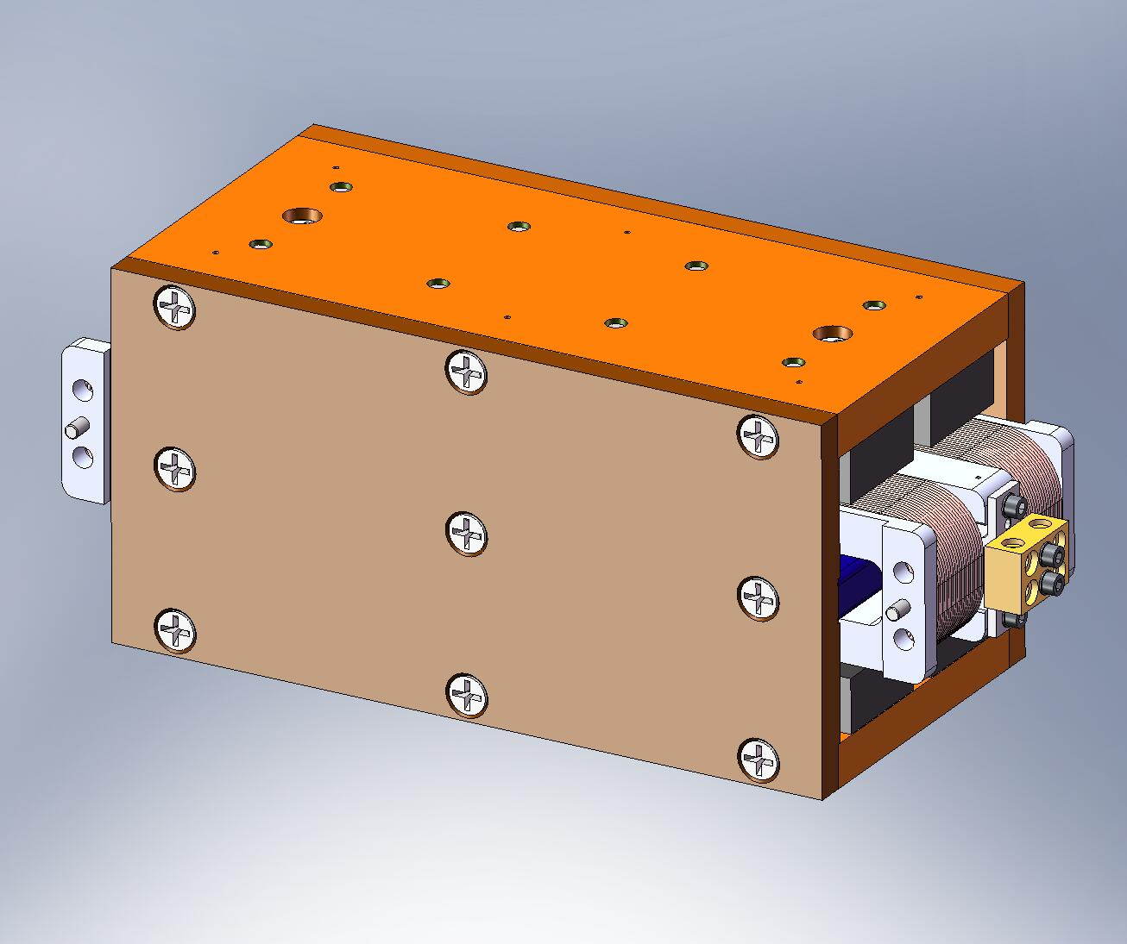
Figure 4.19. Carefully press (2) pins into the Bobbin. Note these pins go into the side opposite the Field Assembly dowel pins (see next step).

- Press (2) 1/8”x.50” dowel pins into the PSI Actuator Field Assembly, as shown in Figure 4.20. These pins should stick out of the Field Assembly’s Bottom Plate by .25”.
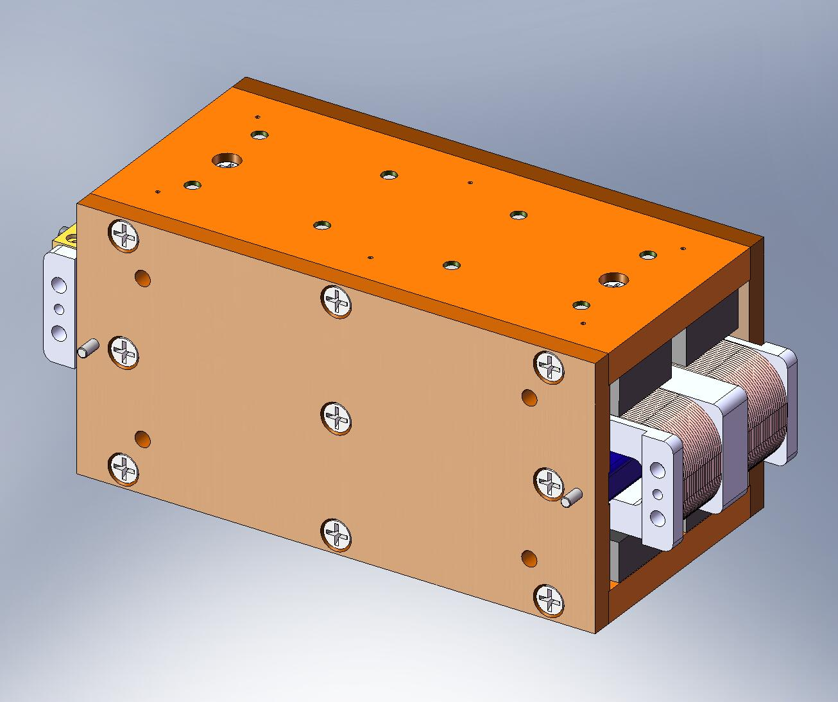
Figure 4.20. Press (2) pins into the Field Assembly.

- Attach Actuator Coil Support (D071121) to pinned-side of Bobbin. Start hardware through Bobbin’s tapped holes. Caution: if screws are longer than specified, they will damage the coil wire! Torque screws to final spec.
Hardware:
(4) #10-32x1.25” SHCS
(4) #10 vented washers
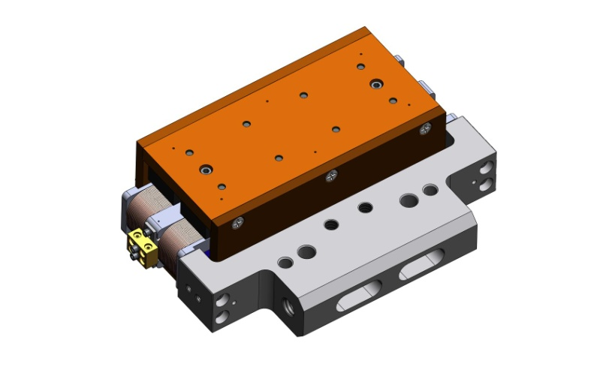
Terminal Block
Heli-Coil Inserts on this Side
Figure 4.21. Bolt Coil Support to Actuator Bobbin. Set orientation as shown above, using locations of Bobbin terminal block and (2) Heli-Coil inserts in Coil Support for reference. Make sure pins in Bobbin mate properly with hole and slot in Coil Support.

- Place (2) Actuator Thermal Bars (D071123) on Coil Support/Actuator Bobbin. Start hardware into both Coil Support and Bobbin. Caution: if screws are longer than specified, they will damage the coil wire! Snug all screws, so each Thermal Bar makes good contact over both of its mating surfaces. Torque to final spec.
Hardware:
(4) #10-32x.25” SHCS – for Bobbin
(4) #10-32x.75” SHCS – for Coil Support
(8) #10 vented washers
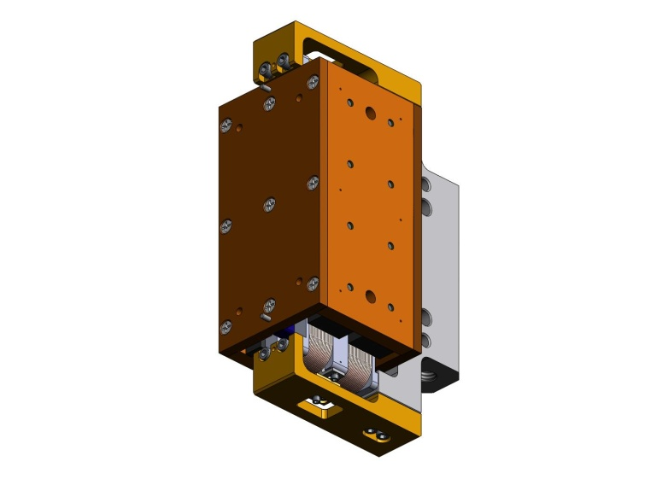
Figure 4.22. Bolt on (2) Thermal Bars. Surfaces must make good contact to properly pull heat out of Bobbin.

- Mate Actuator Magnet Mount to Field Assembly, allowing dowel pins to slip into hole and slot in Actuator Magnet Mount. Proper orientation of parts is shown in Figure 4.23. Start custom silver-plated hardware (D0901100) into tapped holes in Field Assembly. Torque to final spec.
Hardware:
(4) 1/4”-20x.625” Ag-plated SHCS (D0901100)
(4) 1/4" vented washers
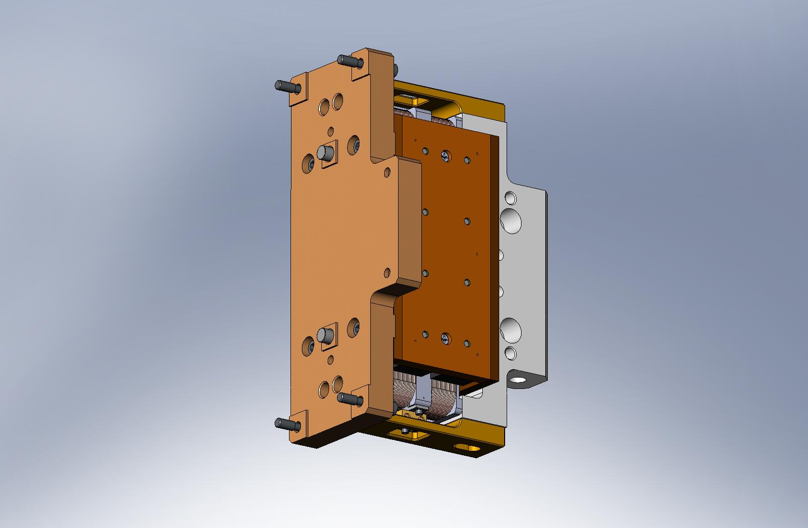
Terminal Block
Tab
Figure 4.23. Actuator Magnet Mount bolted to Field Assembly. Note location of tab on Magnet Mount with respect to Terminal Block on bobbin.

- Hold partially-assembled Actuator horizontal, with the Magnet Mount tab pointing up. Remove (2) shoulder screws from the Field Assembly to the Bobbin. Careful: it is now possible to strike the magnets with the Bobbin. Handle with care!
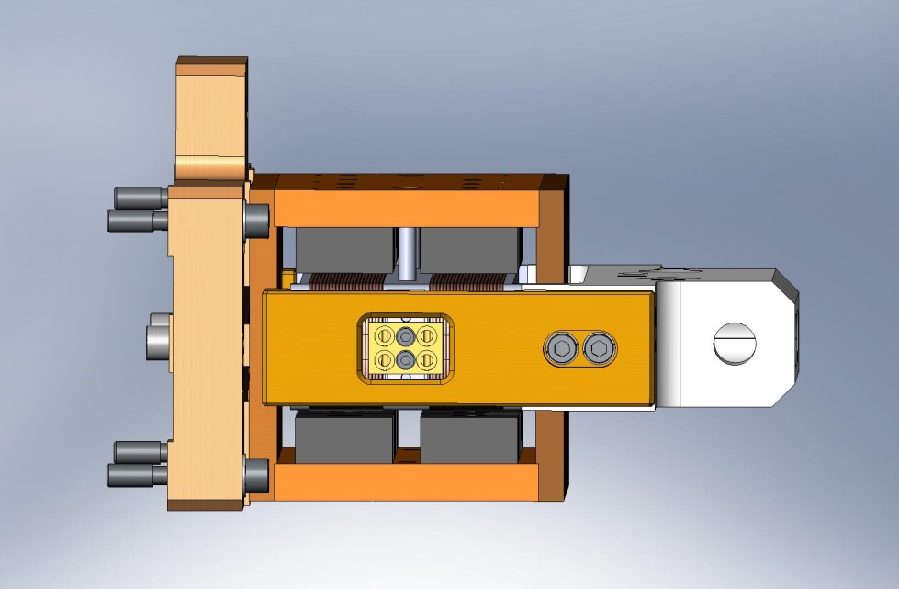
Figure 4.24. Remove the (2) lower shipping screws.

- Install partially-assembled Actuator in the Actuator Set-Up Fixture. Pins in Magnet Mount must fit into hole and slot in Set-Up Fixture Side Plate. Start (4) Captive Screws into Side Plate. Torque to final spec.
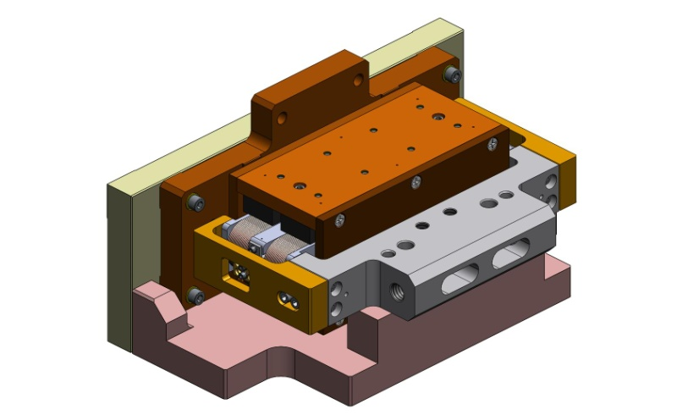
Figure 4.25. Install Actuator in Set-Up Fixture. Field Assembly is now located, to be followed by Bobbin.

- Start screws from Coil Support to Fixture Base Plate. Do not tighten, yet.
Hardware:
(2) 3/8”-16x2.0” SHCS
(2) 3/8" vented washers
- While supporting the Bobbin with your hand, remove the (2) remaining shoulder screws holding the Bobbin to the Field Assembly.
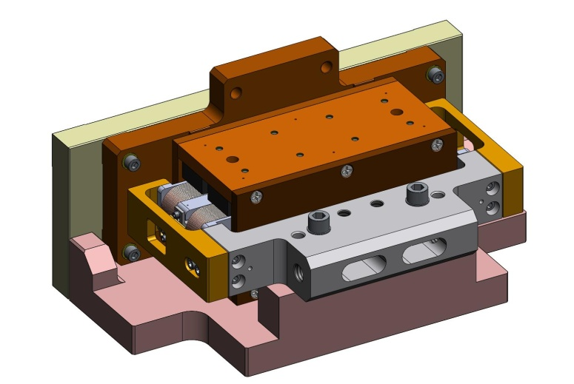
Do not tighten, yet.
Shipping screws removed.

Figure 4.26. Upper (2) shipping screws are removed. Now, the Bobbin is loosely held to the Set-Up Fixture. You may want to insert a Teflon shim between the lower magnets and the Bobbin, to prevent hard contact.

- Slip (2) 1/4”x3.0” dowel pins (McMaster-Carr #90145A553) through Coil Support and into Fixture Base Plate. Now, tighten (2) SHCS from Coil Support to Fixture Base Plate. Torque to final spec.
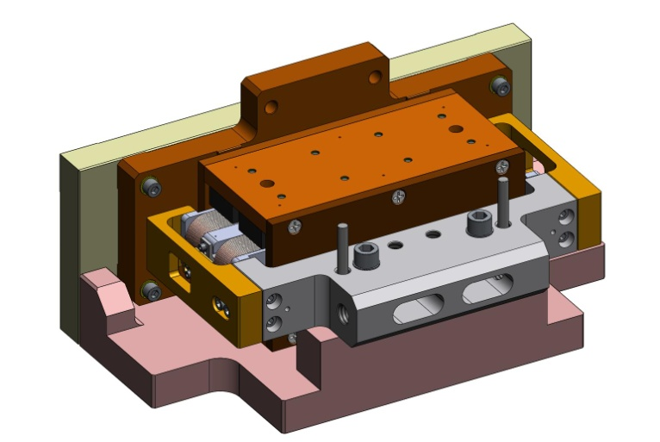
Alignment pins.
Figure 4.27. Install (2) alignment pins, then tighten Coil Support to Fixture. Now, location of Bobbin relative to Field Assembly is fully defined.

- Remove 1/4”x3.0” alignment pins.
- Install Actuator Setup Bar (D071129). Snug hardware connecting Setup Bar to both Actuator Magnet Mount and Coil Support, then torque to final spec.
Hardware:
(2) 1/4”-20x1.25” SHCS – for Actuator Magnet Mount
(2) 1/4”-20x2.25” SHCS – for Actuator Coil Support
(4) 1/4” vented washers
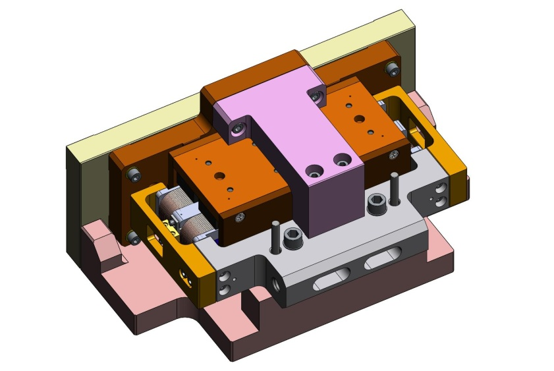
Figure 4.28. Install Setup Bar. Setup Bar is used to lock Bobbin position relative to Field Assembly, until Actuator is installed in HAM ISI.

- Remove screws holding Coil Support to Set-Up Fixture.
- Loosen (4) Captive Screws from Set-Up Fixture. Remove Actuator Assembly from Set-Up Fixture.
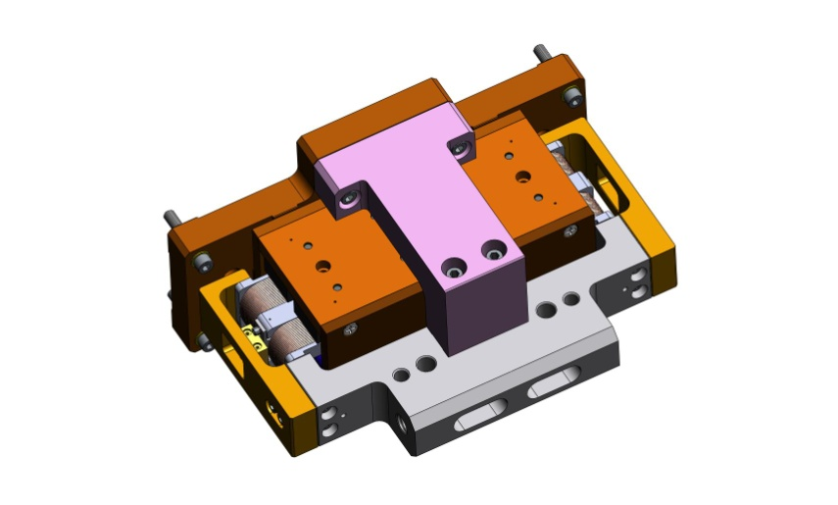
Figure 4.29. Actuator after removal from Set-Up Fixture.

- Slide (2) Actuator Stops (D070534) into Field Assembly, between rows of magnets as shown in Figure 4.30. Start hardware, snug, and torque to final spec.
Hardware:
(4) #8-32x.625” SHCS
(4) #8 vented washers
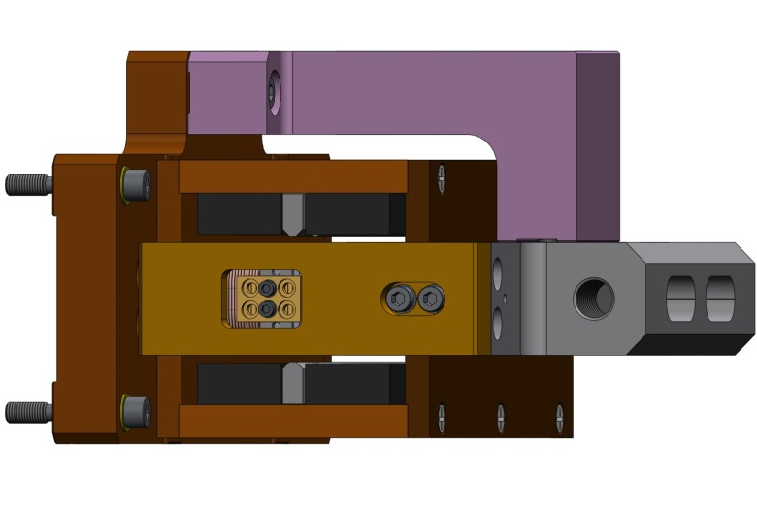
Figure 4.30. Actuator Stops installed. These help prevent “crashes” of Bobbin into magnets during HAM ISI operation.

- Use stacked Teflon shims to check several gaps between Bobbin and Field Assembly. Refer to Sheet 4 of drawing D071442 for nominal gap values. If any measured values are significantly different from values given there, inspect Actuator Assembly for possible machining and/or assembly errors.
- Insert pins from power cable into terminal block. Hand-tighten screws to secure cable. Use multi-meter to check continuity.
- Repeat preceding steps until all (6) Actuator Assemblies are complete.
the following steps complete assembly of (3) Horizontal Actuators:
- Prepare (2) Actuator L-Brackets (Horizontal) (D071132), with the hardware listed below.
Hardware:
(2) 3/8”-16x3.0” SHCS
(4) 3/8” spherical washers, female
(4) 3/8” spherical washers, male
(6) 3/8” fender washers
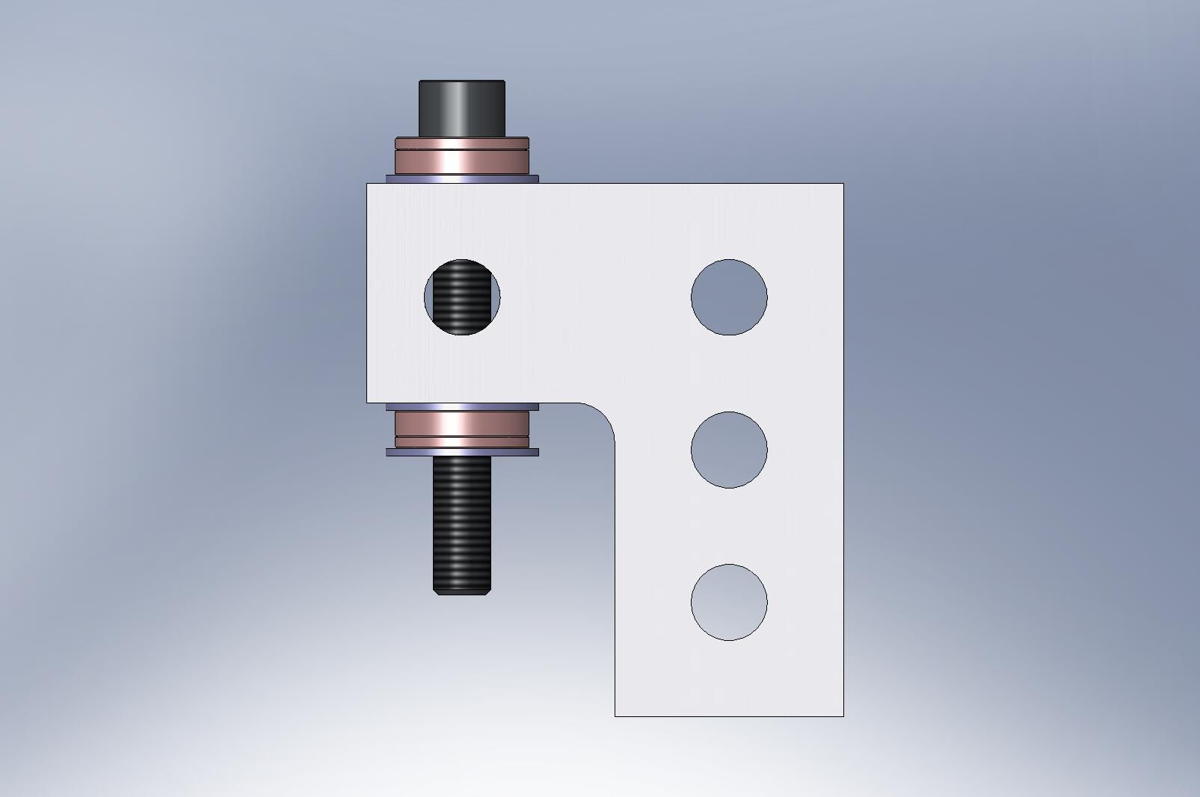
Fender washers
Spherical washers, female
Spherical washers, male
Figure 4.31. Actuator L-Bracket, with screw and washers. Two of these mount to Coil Support on Horizontal Actuator. Spherical washers and loose thru holes compensate for machining and assembly tolerances, when Actuators are installed in HAM ISI.

- Attach both L-Brackets to Actuator Assembly, by threading 3/8”-16x3.0” screws into Coil Support. Finger-tighten screws, so Brackets do not shift easily. Do not torque.
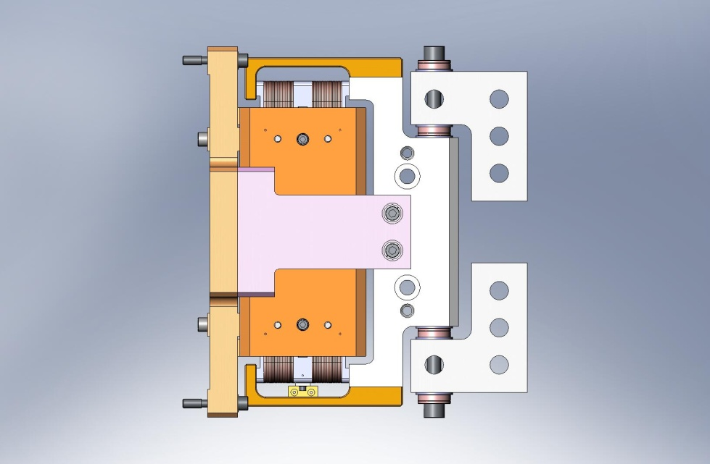
Figure 4.32. Horizontal Actuator, ready for installation in HAM ISI.
- Finish all (3) Horizontal Actuators, and set aside for later use.

the following steps complete assembly of (3) Vertical Actuators:
- Prepare (2) Actuator U-Brackets (Vertical) (D071122), with the hardware listed below.
Hardware:
(2) 3/8”-16x3.0” SHCS
(4) 3/8” spherical washers, female
(4) 3/8” spherical washers, male
(6) 3/8” fender washers
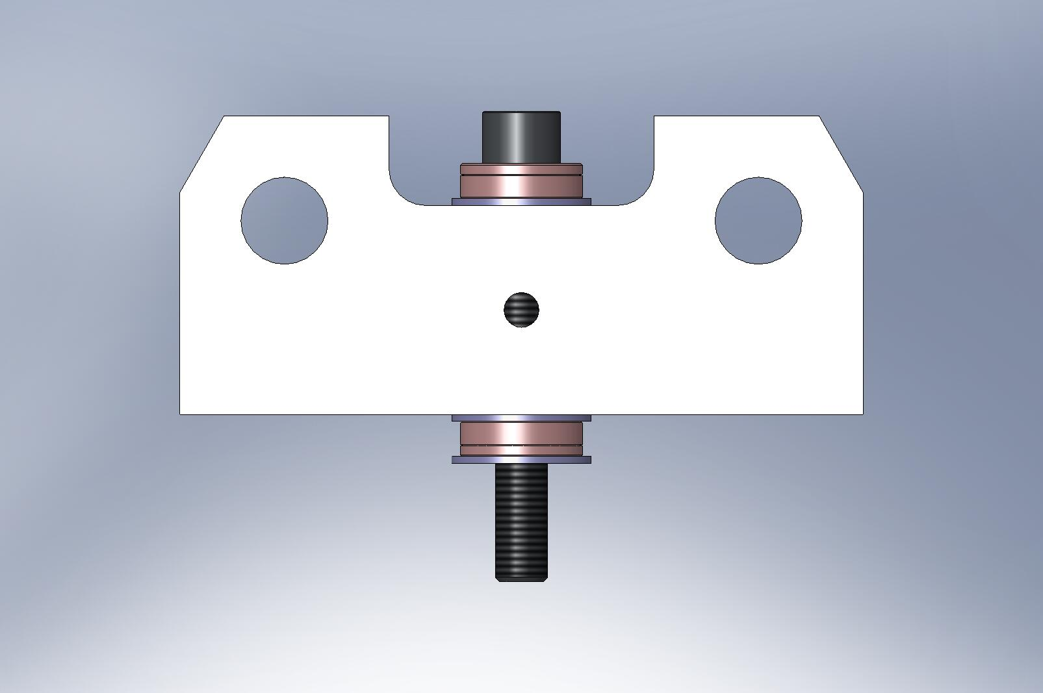
Figure 4.33. Actuator U-Bracket, with screw and washers (refer to Figure 4.31 for more detail). Two of these mount to Coil Support on Vertical Actuator. Spherical washers and loose thru holes compensate for machining and assembly tolerances, when Actuators are installed in HAM ISI.

- Attach both U-Brackets to Actuator Assembly, by threading 3/8”-16x3.0” screws into Coil Support. Finger-tighten screws, so Brackets do not shift easily. Do not torque.
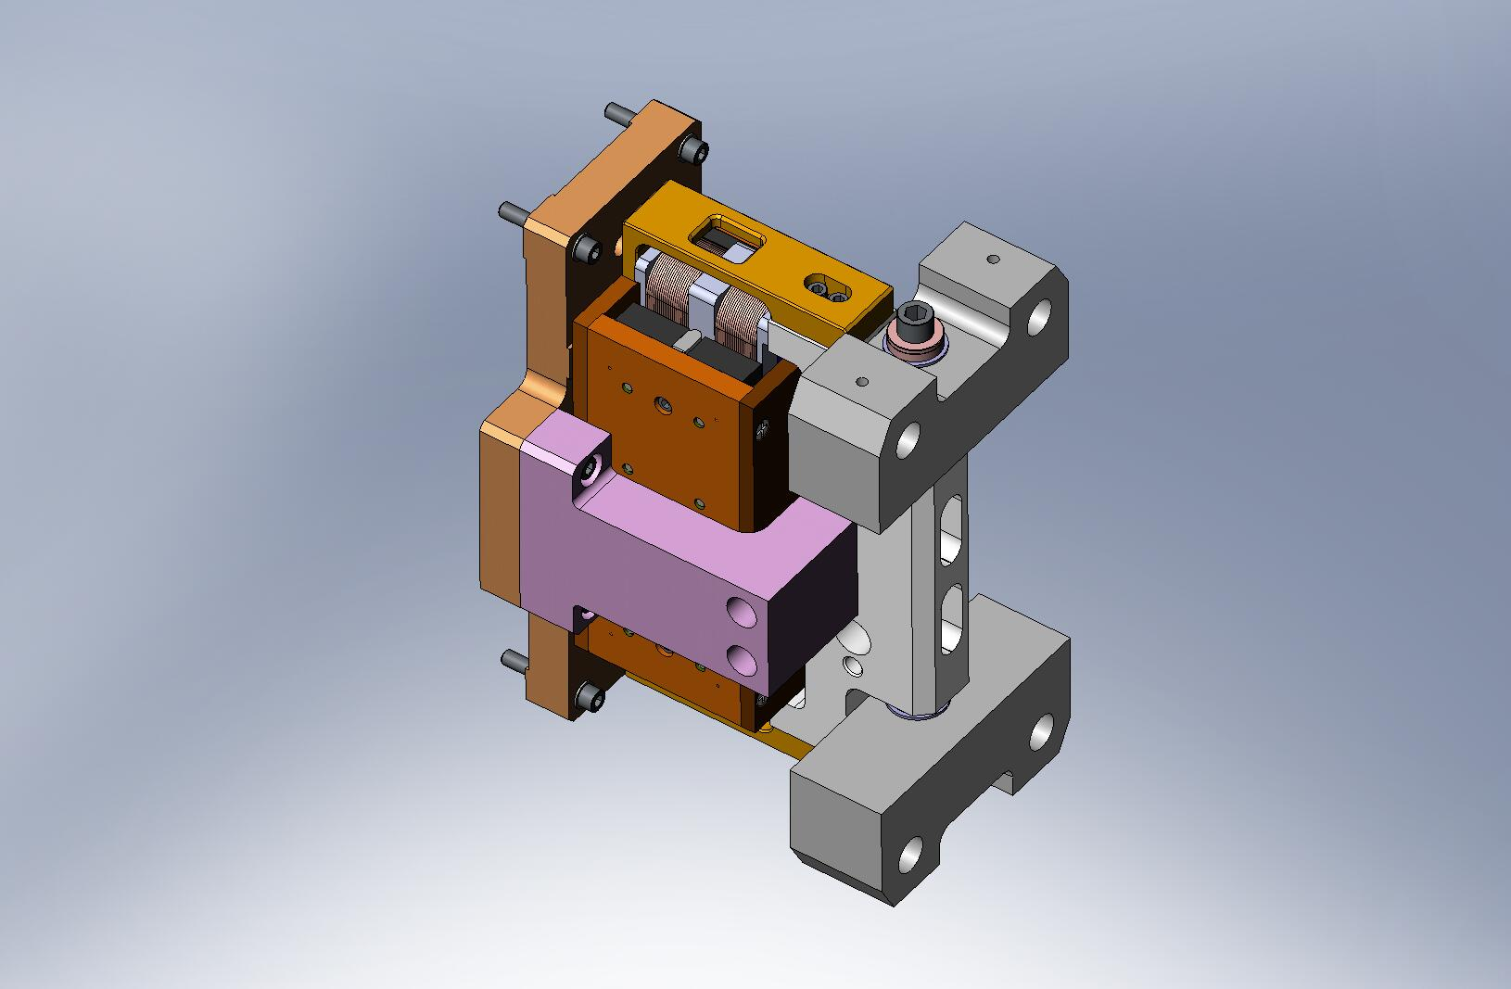
Figure 4.34. Vertical Actuator, ready for installation in HAM ISI.
- Finish all (3) Vertical Actuators, and set aside for later use.

Prep Work – Assemble Sensors (D071463 & D071464)
- Insert Heli-Coils into (6) Sensor Target Body pieces (D071166).
the following procedure describes the assembly of one D071463. Repeat for all (6) Sensor Targets:
- Press Sensor Target Post (D071167) into Sensor Target Body (D071166), until Post comes flush with back face of Body. Note: the Target Body has a slightly over-sized lead-in on one side of the center hole - the Target Post should be inserted from this side.
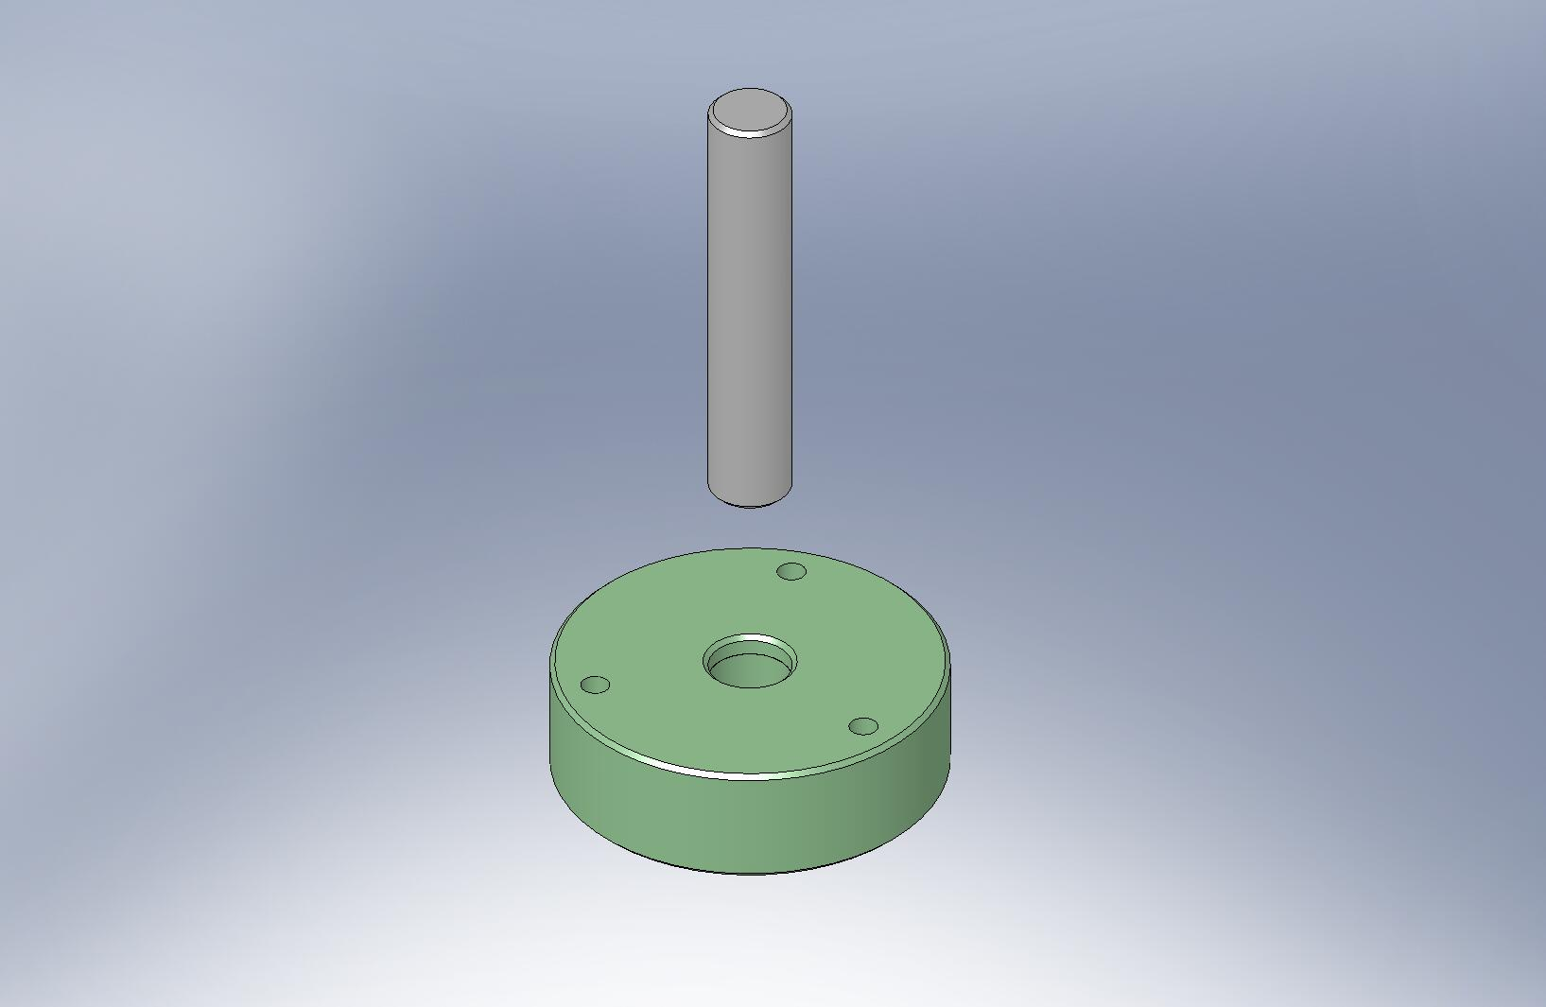
Figure 4.35. Press fit Target Post into Target Body, until the face on the bottom of the Post is flush with the bottom face of the Body.

Caution: surface of Sensor Target (D071165) is delicate. Handle with care!
- Mount Sensor Target to Sensor Target Body. Carefully add hardware, and torque screws to final spec.
Hardware:
(6x 3) #8-32x.50” SHCS
(6x 3) #8 vented washers
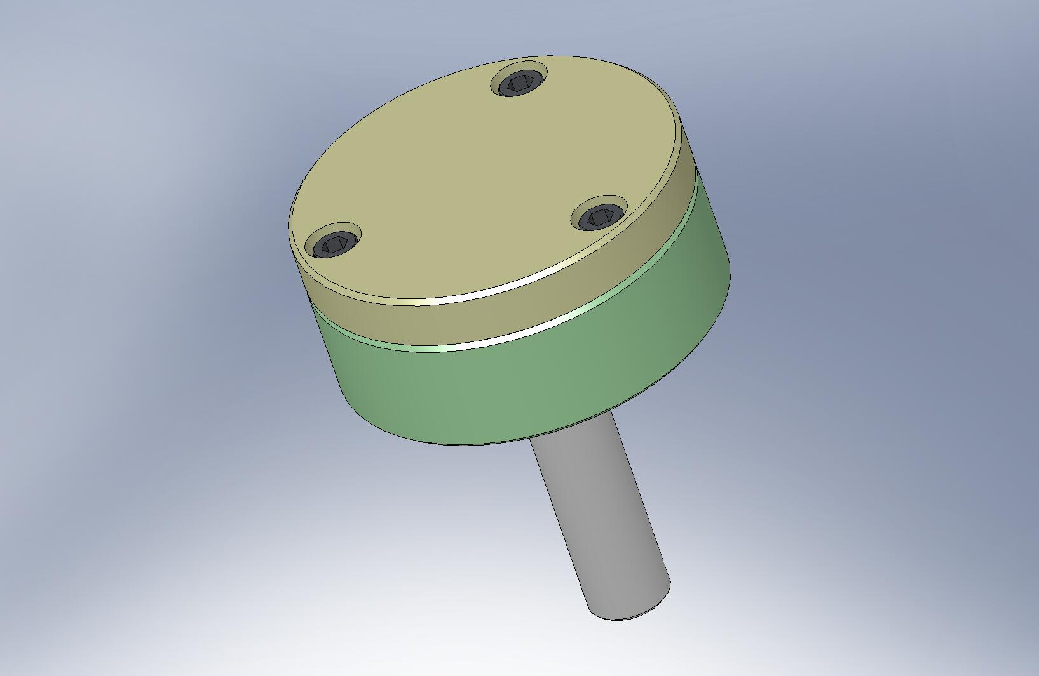
Do not scratch this surface!
Figure 4.36. Screw Sensor Target to top of Sensor Target Body. This is the Position Sensor Target Face Assembly (D071462).

- Slide a D0900208 shaft collar with silver-plated screws over the collet in the Sensor Target Mount (D071160). Next, insert the Sensor Target Face Assembly, as shown in Figure 4.37.
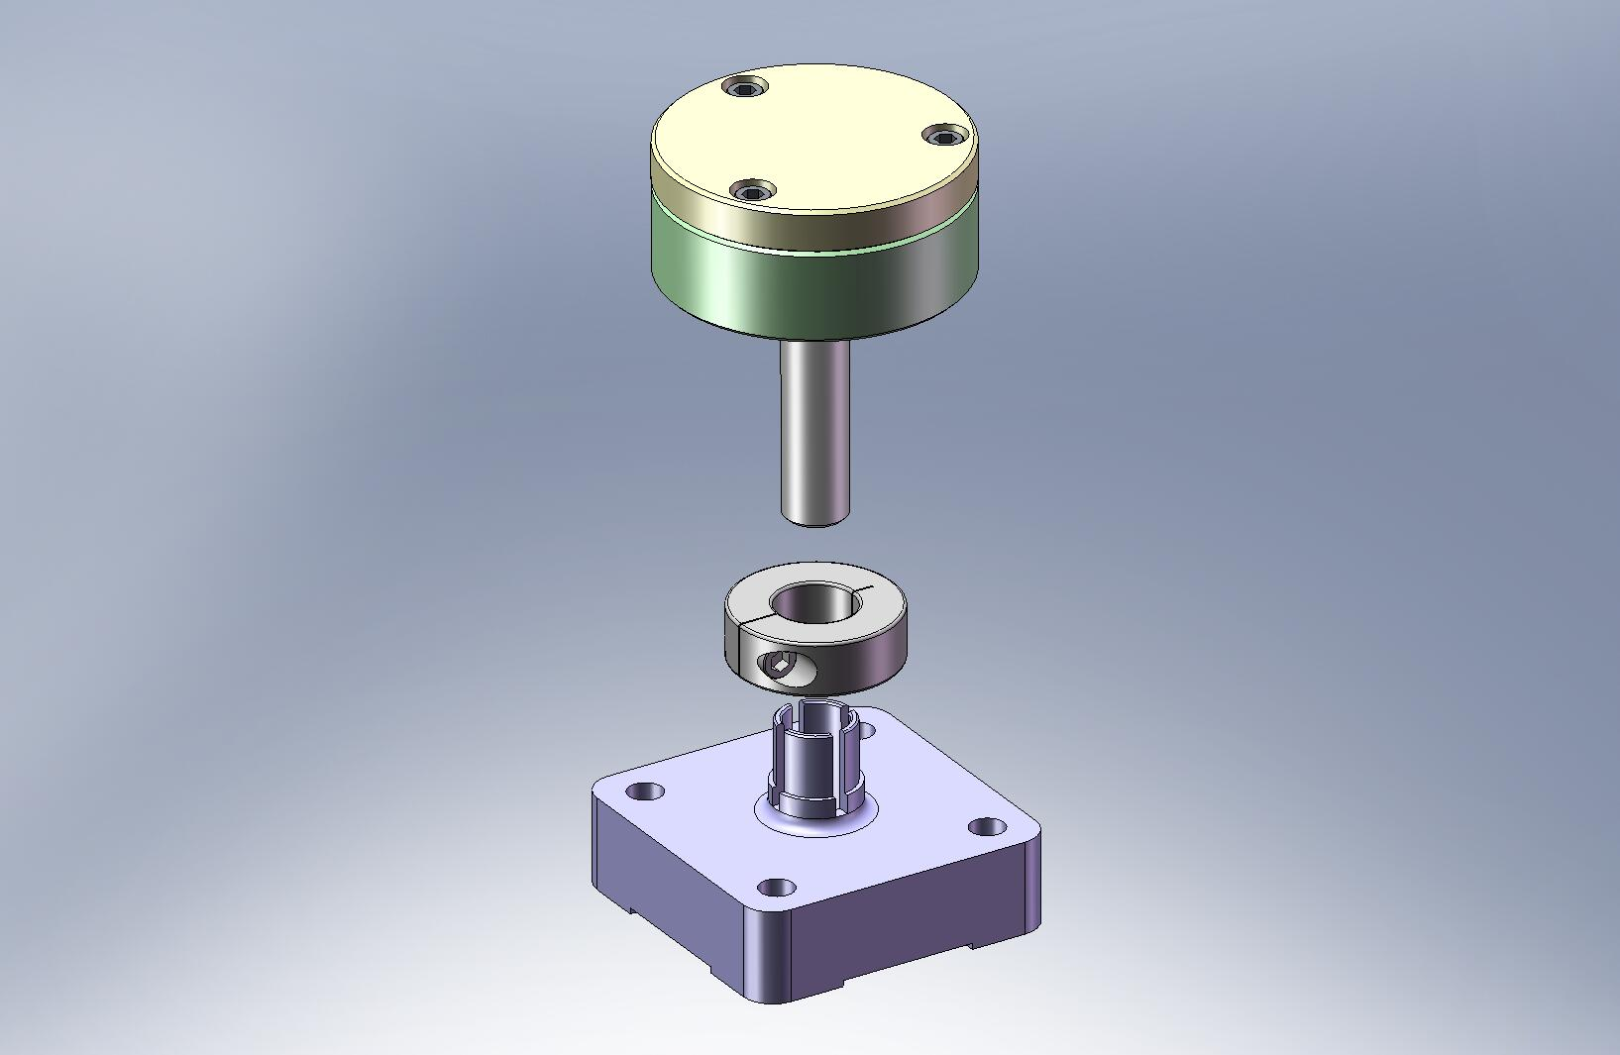
Figure 4.37. Use shaft collar to clamp Sensor Target Face Assembly to Sensor Target Mount.

- Insert Target Face Assembly until bottom of Post is roughly in same plane as bottom of Mount. Tighten shaft collar, so Target Face Assembly does not slide. Store for later installation. Target Face must be protected from accidental damage!
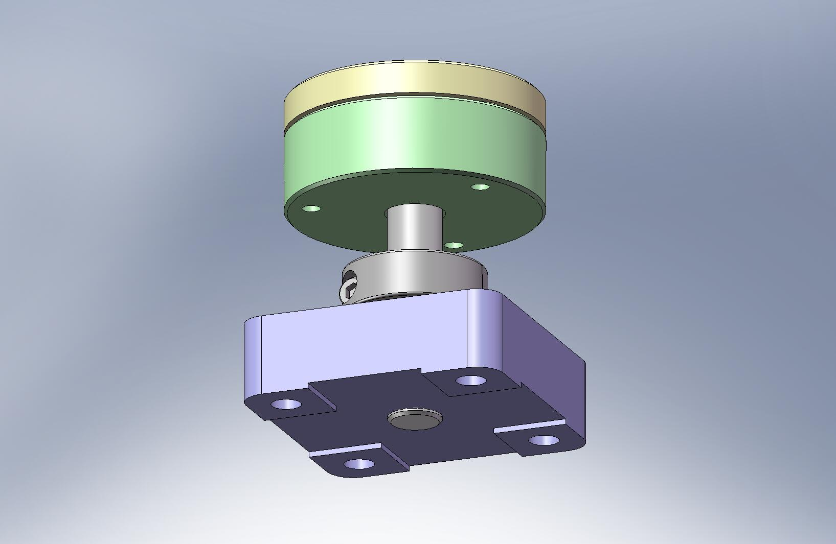
Figure 4.38. Completed Position Sensor Target Assembly.

- Repeat preceding steps for all (6) Position Sensor Target Assemblies.

- Assemble spherical mount, as shown in Figure 4.39 and Figure 4.40. Slide a hex head cap screw through the Sensor Head Base (D071161), Sensor Head Mount (D071163), and Sensor Head Washer (D071162), in that order. Place washers over exposed end of screw, and tighten D0900209 silver-plated nut until assembly is rigid. Repeat for all (6) Position Sensor Assemblies (D071464).
Hardware:
(6x 1) 3/8”-16x2.5” HHCS
(6x 1) 3/8” flat washer
(6x 1) 3/8” curved spring washer
(6x 1) 3/8”-16 Ag-plated jam nut (D0900209)
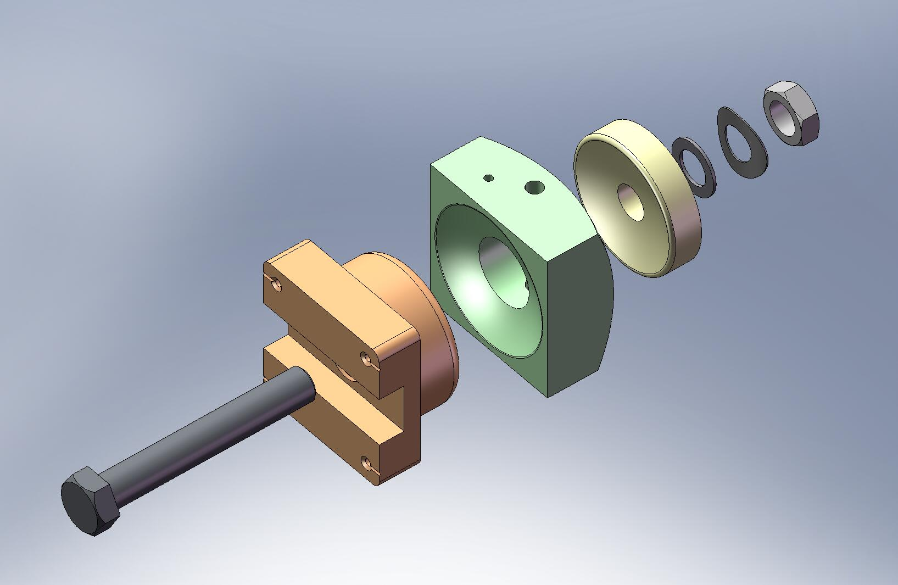
Figure 4.39. Exploded view of sensor spherical mount. This is a sub-assembly of the Position Sensor Assembly (D071464).
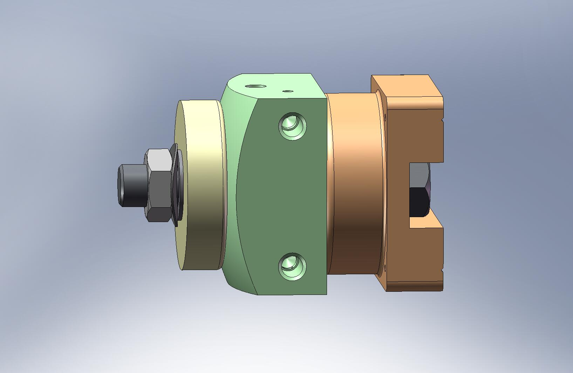
Figure 4.40. Assembled spherical mount. Roughly align Base to Mount, so sides are parallel to one another. Tighten jam nut until assembly is rigid.

- For (3) Horizontal Position Sensor Assemblies, place Horizontal Sensor Head Standoff (D071170) between Sensor Head Mount and Sensor Head Base Plate (D071164), as shown in Figure 4.41. Add screws and torque to final spec.
Hardware:
(3x 2) #10-32x.75” SHCS
(3x 2) #10 vented washer
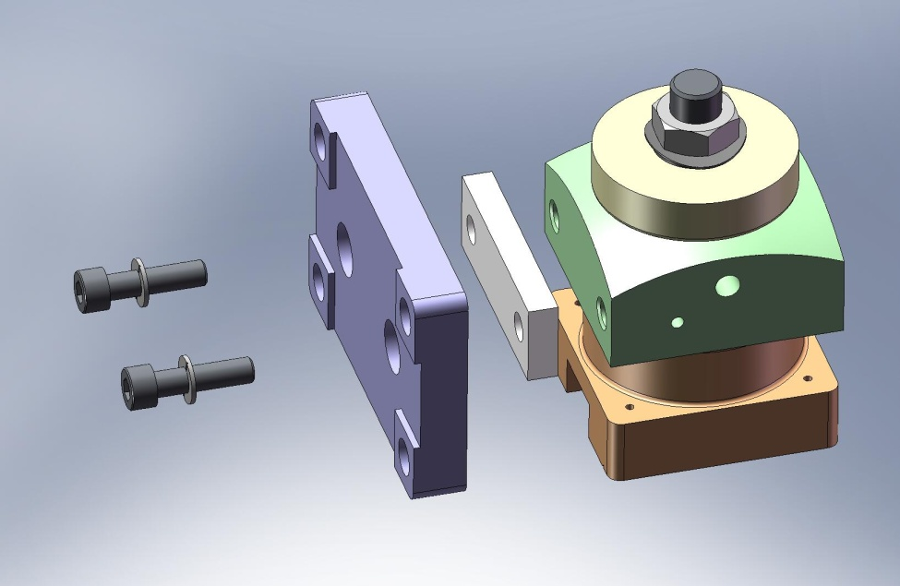
Figure 4.41. Add Standoff and Base Plate, to complete Horizontal Position Sensor Assembly (accept for sensor).

- For each of (3) Vertical Position Sensor Assemblies, attach Vertical Sensor Head Bracket (D071175) to Sensor Head Mount, as shown in Figure 4.42. Add screws and torque to final spec.
Hardware:
(3x 2) #10-32x1.25” SHCS
(3x 2) #10 vented washer
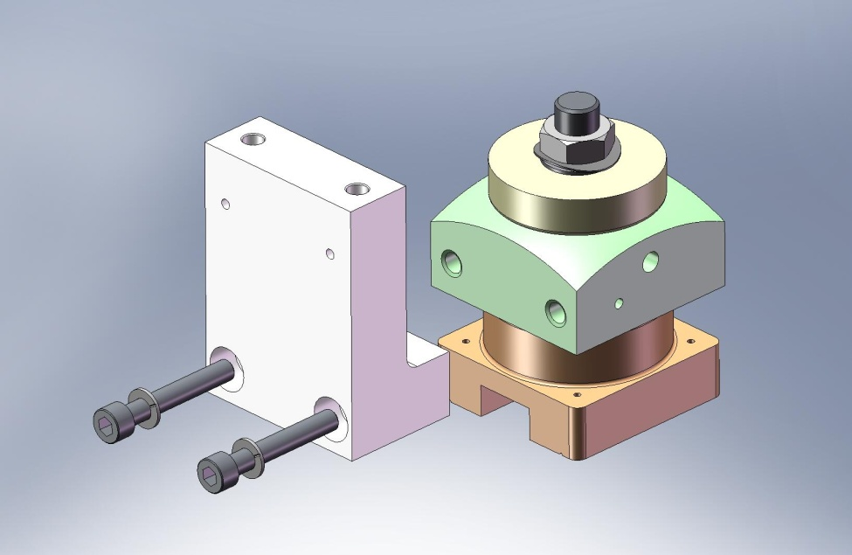
Figure 4.42. Vertical Sensor Head Bracket mounted to Sensor Head Mount.

- Mount Sensor Head Base Plate to Vertical Sensor Head Bracket, as shown in Figure 4.43. Add screws and torque to final spec.
Hardware:
(3x 2) #10-32x.50” SHCS
(3x 2) #10 vented washer
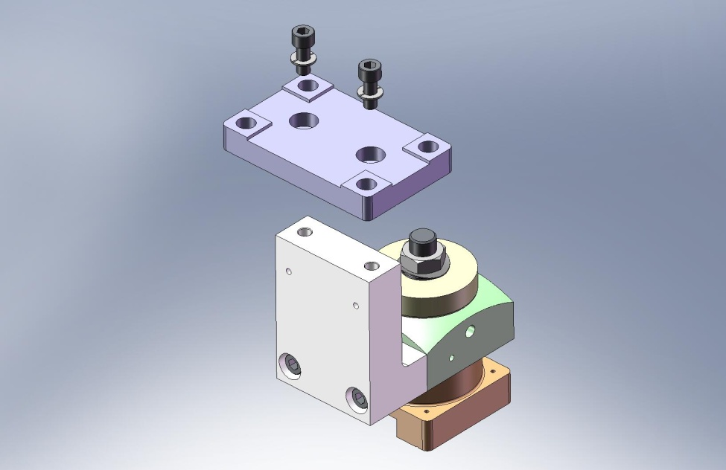
Figure 4.43. Add Base Plate, to complete Vertical Position Sensor Assembly (accept for sensor).

- Mount ADE capacitance sensor to each of the (3) Horizontal and (3) Vertical Position Sensor Assemblies, as shown in Figure 4.44 and Figure 4.45, respectively. Use (2) precision washers under each screw head. The top of each screw should protrude slightly above the sensor face, to prevent crashing the Sensor into the Target (Figure 4.46).
Hardware:
(6x 4) M2-.4x8mm SHCS
(6x 8) precision washer
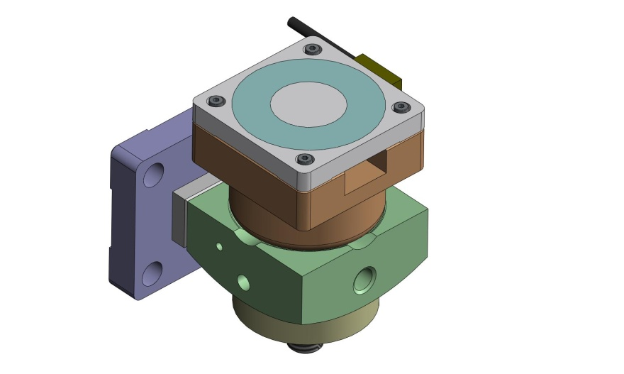
Figure 4.44. ADE sensor mounted in Horizontal Position Sensor Assembly. Note orientation of sensor cable - unlike in the Enhanced LIGO system, the cable now points toward the Support Post when installed.
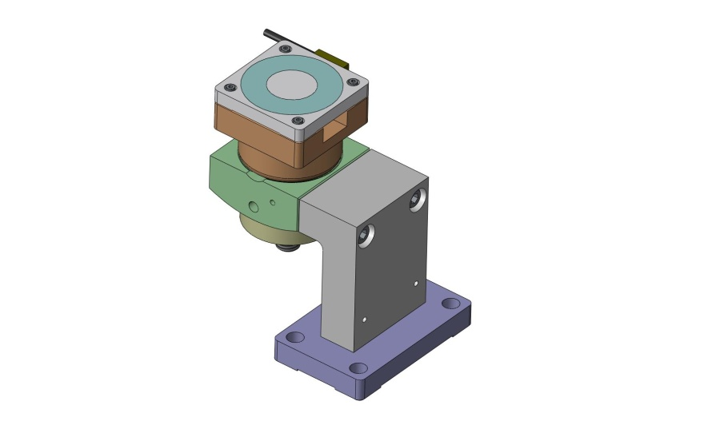
Figure 4.45. ADE sensor mounted in Vertical Position Sensor Assembly. Note orientation of sensor cable.
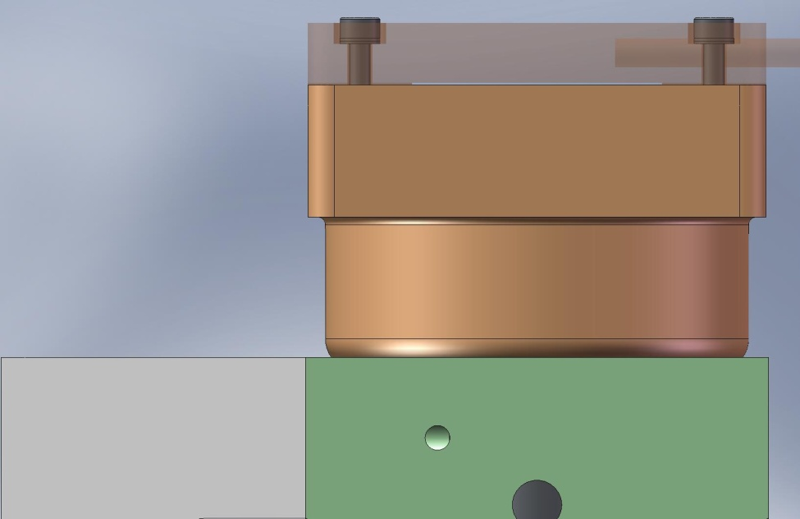
Figure 4.46. Close-up view of ADE sensor mounted to Sensor Head Base. Heads of sensor mounting screws stand approximately .020” proud of sensor face. This prevents contact between center of Sensor Target Face and active area on sensor probe.

- Set aside all (6) Position Sensor Assemblies for later installation. Sensor must be protected from accidental damage!

Prep Work – Finish (6) GS-13 Assemblies (D071470)
- Follow instructions given in separate document for assembly of (6) GS-13 Seismometer Pods (D047810). Of these Pods, (3) should be in the Horizontal configuration (shown in Figure 4.47) and (3) should be in the Vertical configuration (shown in Figure 4.48).
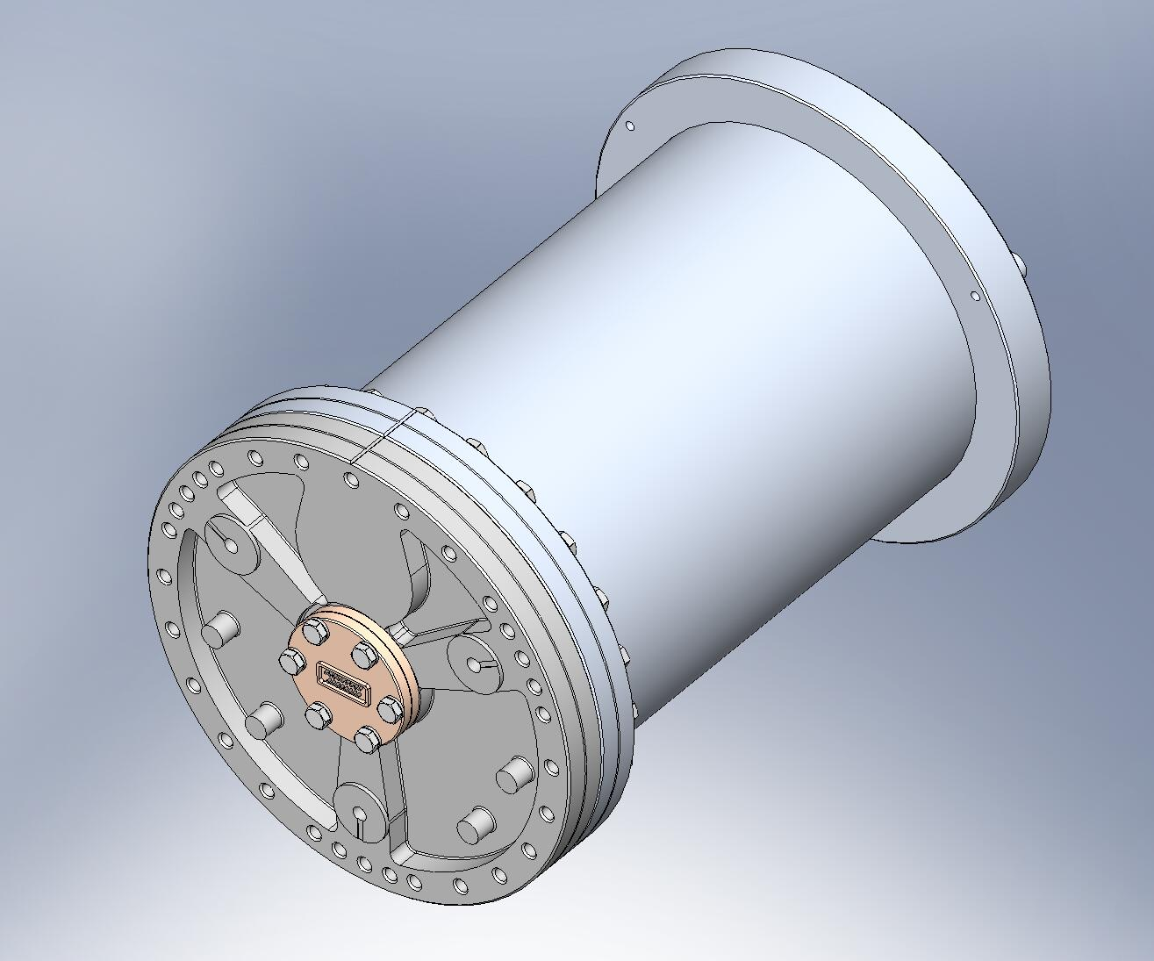
Connector flange.
Figure 4.47. GS-13 Pod, Horizontal configuration. Note centered location of connector flange.
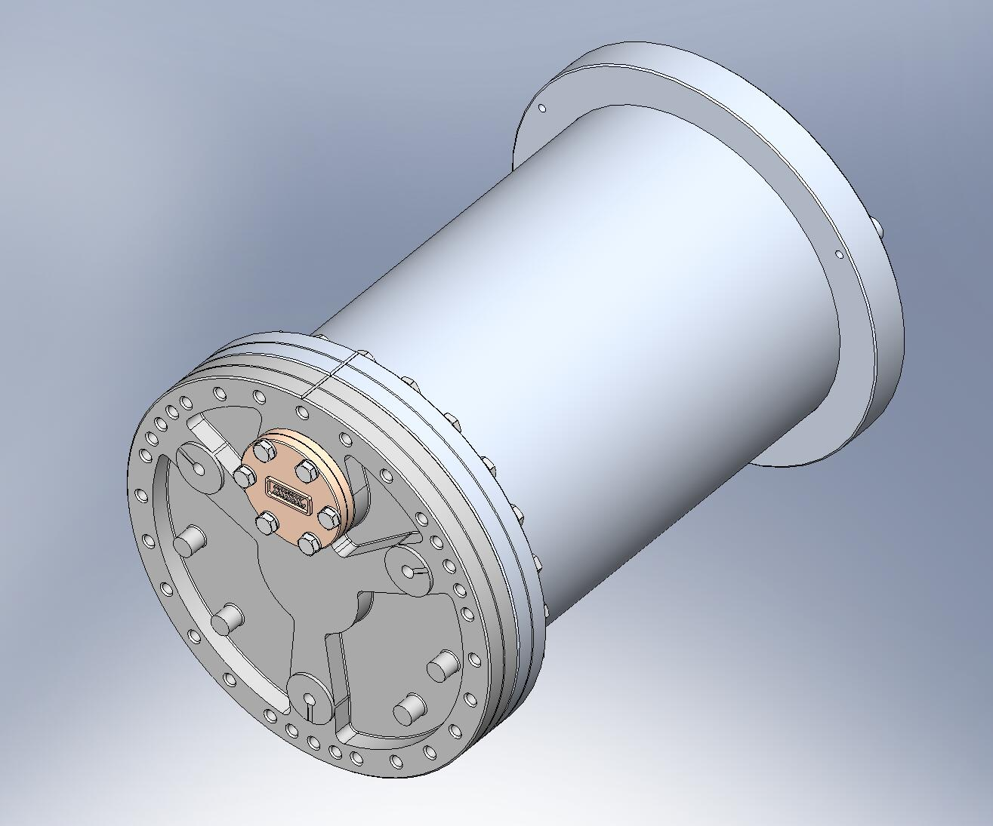
Connector flange.
Figure 4.48. GS-13 Pod, Vertical configuration. Note offset location of connector flange.

- Insert Heli-Coils into (6) GS-13 Adapter Plates (D071180). The (3) Adapter Plates for the Horizontal GS-13s use the offset tapped hole location. The (3) Adapter Plates for the Vertical GS-13s use the symmetric locations.
the remaining steps from this section apply to both the Horizontal and the Vertical configurations:
- Mount GS-13 Adapter Plate to Pod Baseplate (20007813). Cable channel in Adapter Plate must line up with alignment etching on Baseplate (as shown in Figure 4.49). Add vented hardware and torque to final spec.
Hardware:
(6x 6) 5/16”-24x1.5” Ag-plated, vented SHCS
(6x 6) 5/16” vented washer
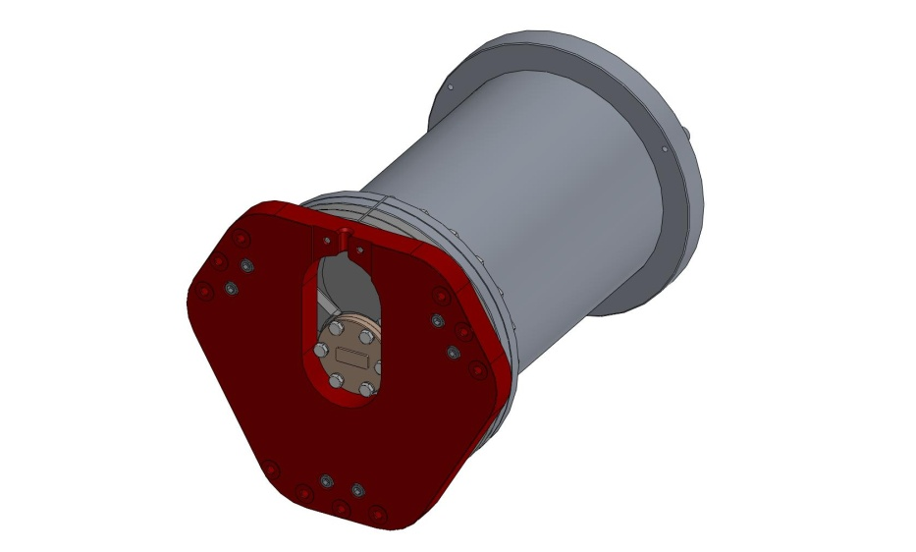
Align cable channel with groove in flange.
Figure 4.49. Adapter Plate bolted onto GS-13 Baseplate. Tapped holes are blind, so vented screws must be used.

- Lift GS-13 and place it vertically on flat surface, with Adapter Plate facing down.
- Place (3) 1/8”-thick spacers on round bosses on back end of GS-13 Pod, then rest GS-13 Stabilizer Assembly (D071471) on top. Weld Nut (D071182) should face up.
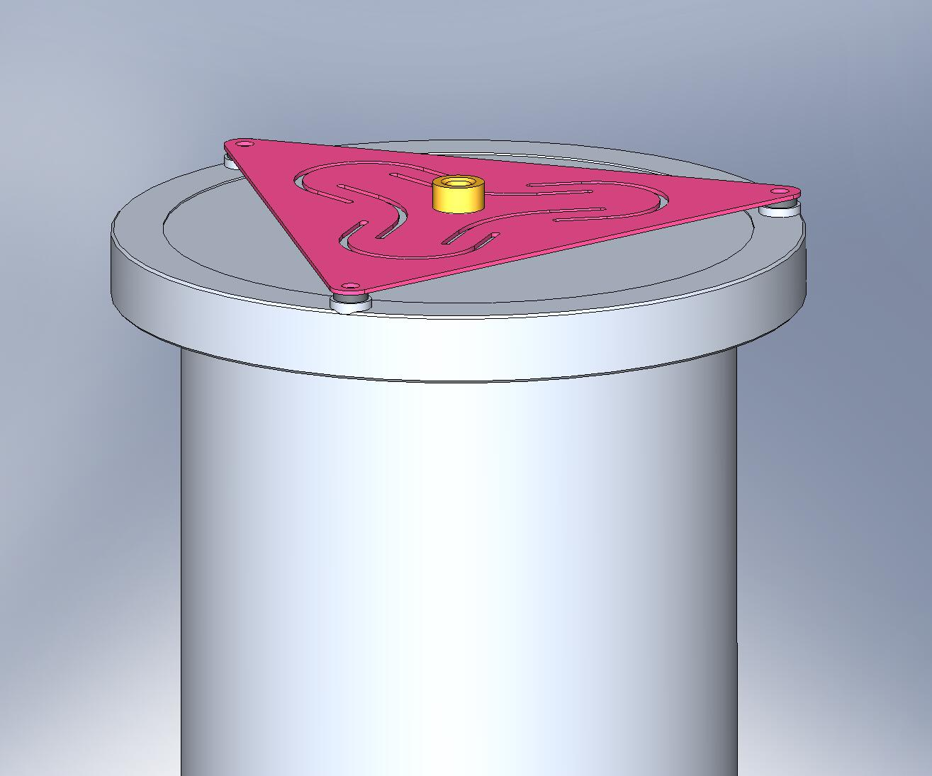
Spacers
Weld Nut
Figure 4.50. Stabilizer Assembly resting on back end of GS-13 Pod.

- Two of the holes under the spacers are tapped. Add hardware to these, and finger tighten.
Hardware:
(6x 2) 1/4”-20x1.0” Ag-plated SHCS
(6x 2) 1/4” vented washer

- Warning: If using A+ cables (D1000227-v11) for the GS-13, the top of the weld nut on this stabilizer assembly (shown in Figure 4.50) will interfere with the walls when installing the GS-13 on the ISI. Instead, do not install the (x3) 1/8” spacers between the pod and the Stabilizer. Then, once the pod is installed on the ISI (after step in Figure 4.128), add one 1/8” thick spacer (or a few washers) between the weld nut and the wall to fill the gap using a long tweezer to hold the spacer in place. More details in sei log 1765.

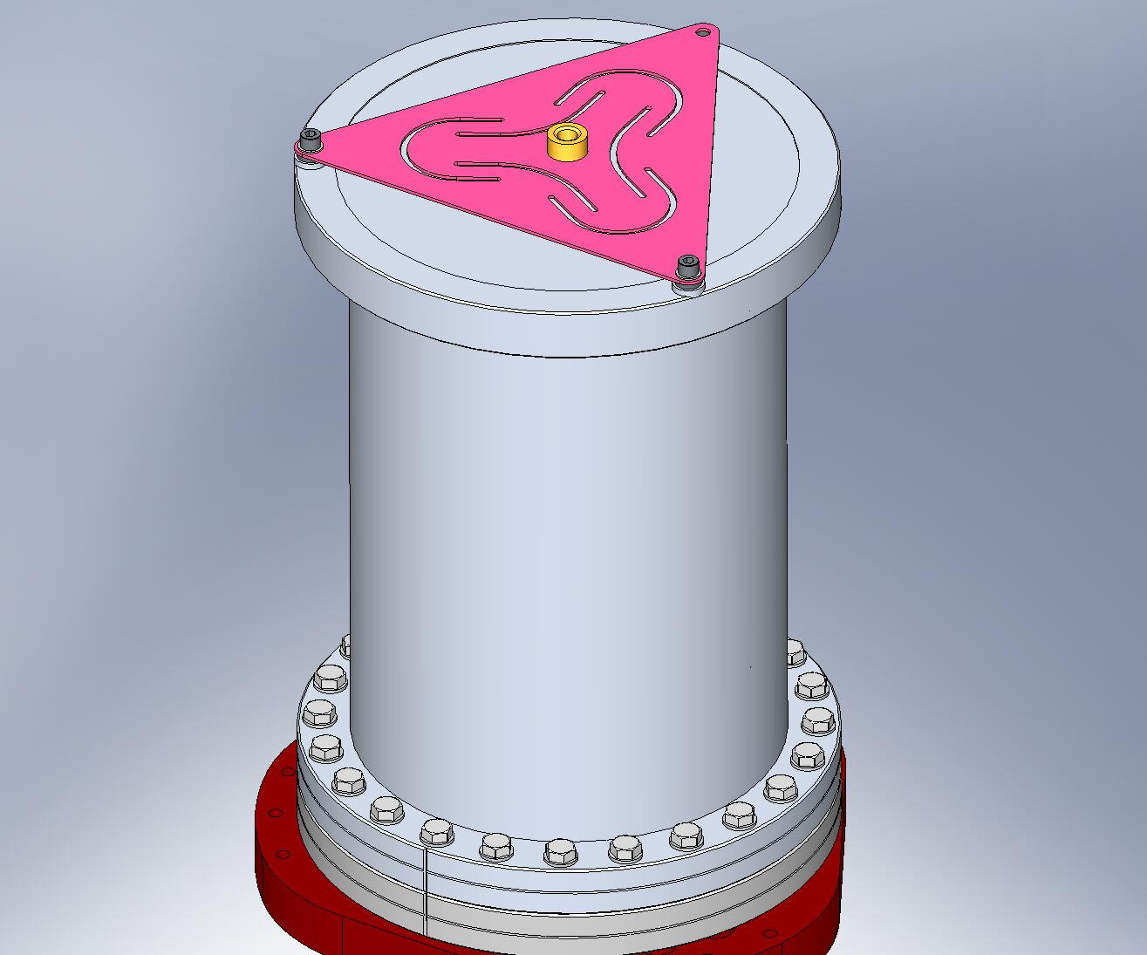
Figure 4.51. Thread (2) screws into tapped holes. Do not torque, yet.

- Insert last screw through Stabilizer and fasten to Pod with hex lock nut. Do not torque nut, yet.
Hardware:
(6x 1) 1/4”-20x1.75” Ag-plated SHCS
(6x 2) 1/4” vented washer
(6x 1) 1/4”-20 hex lock nut
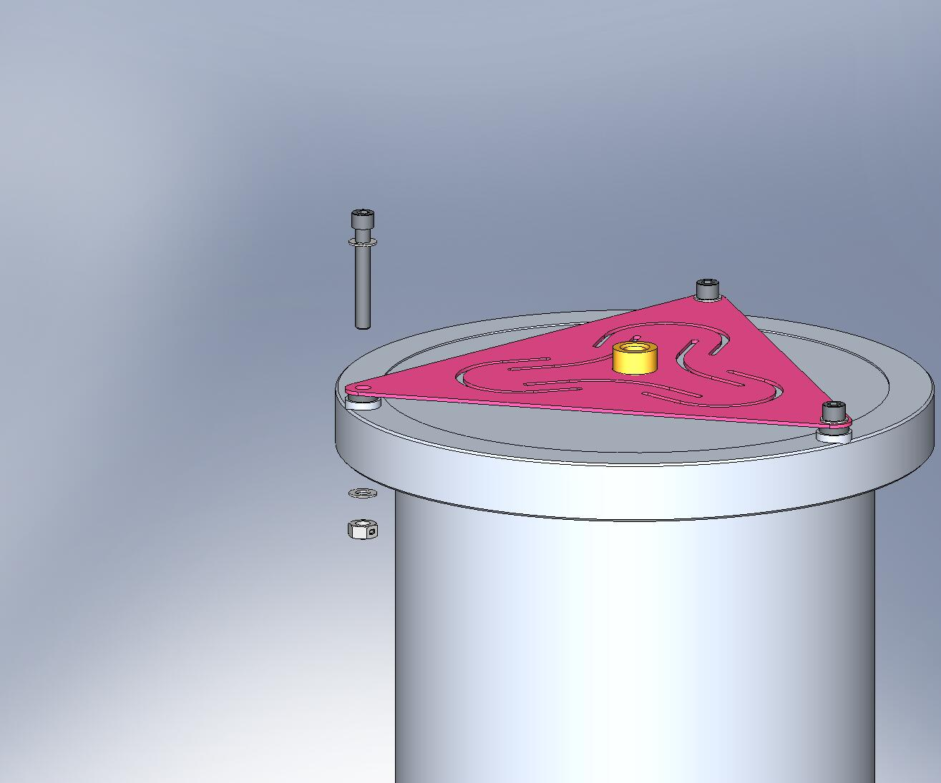
Figure 4.52. Insert screw through Stabilizer and Pod. Fasten onto Pod with hex lock-nut.

- Torque all (3) Stabilizer screws to final spec.
- Thread in (9) Captive Screws through Adapter Plate, as shown in Figure 4.53. Note: Horizontal configuration uses offset screw location, while Vertical configuration uses symmetric locations.
Hardware:
(6x 9) 1/4”-20x1.75” (1.125” Clear) Captive SHCS (D071136-01)
(6x 9) 1/4" vented washers
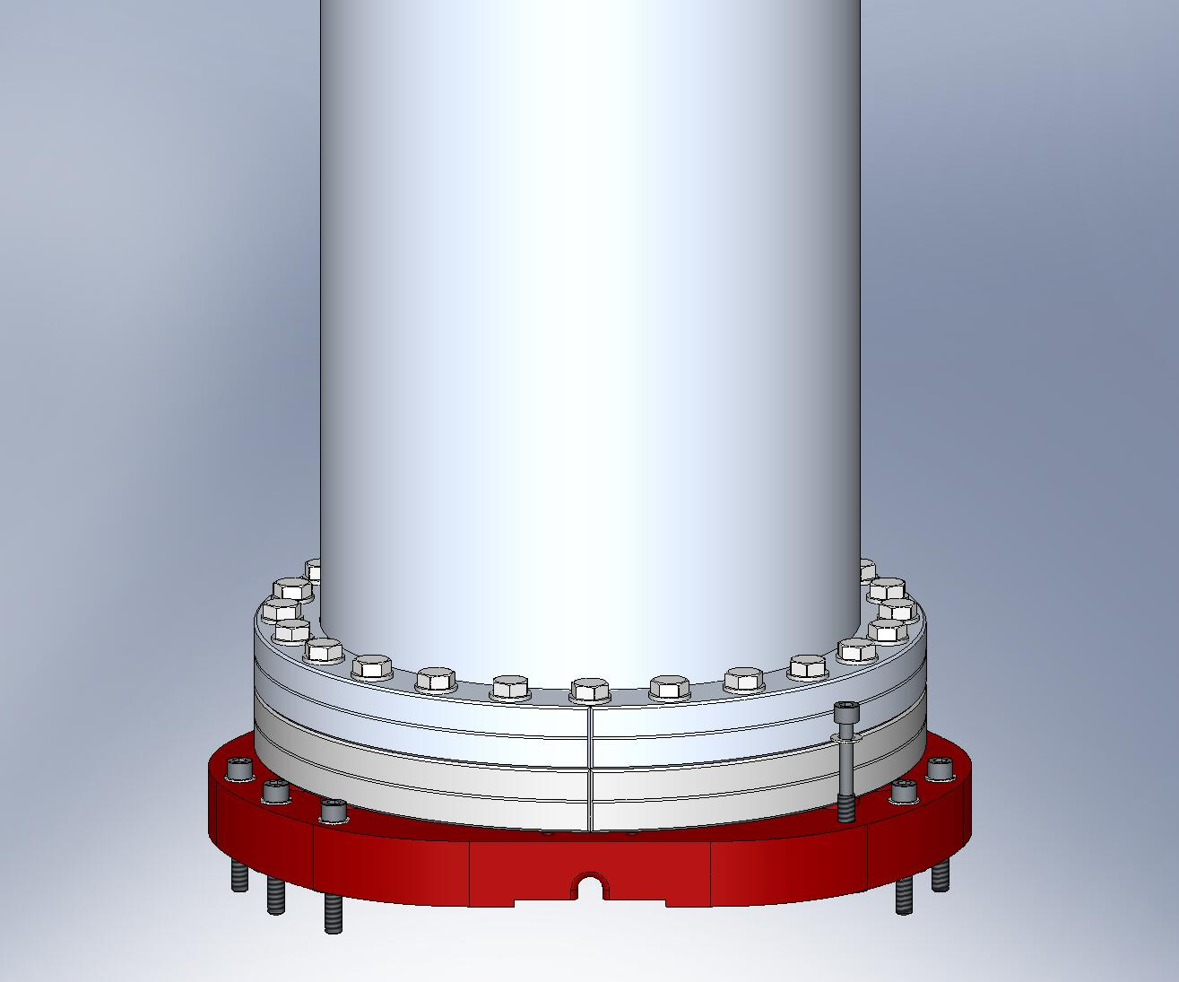
Figure 4.53. Add Captive Screws to Adapter Plate. These screws are used to mount the GS-13s to Stage 1.

- Set aside all (6) GS-13 Assemblies, for later installation. (GS-13 Cable Restraints (D071183) will be added to Horizontal GS-13 Assemblies immediately prior to installation in Stage 1.)

Prep Work – Prepare (3) Spring Pull-Down Tooling Assemblies (D071500)
- Thread ACME hex nut (Dependable ACME, 3/4”-10 Hex 303) onto one end of 3/4”-10x8.0” ACME Screw (D071309), until its top is flush with the end of the Screw. Drill a 1/4” hole through the side of the nut/Screw combination (refer to drawing D071499 for instructions on making the hole). Press 1/4” spring pin into this hole, as shown in Figure 4.54.
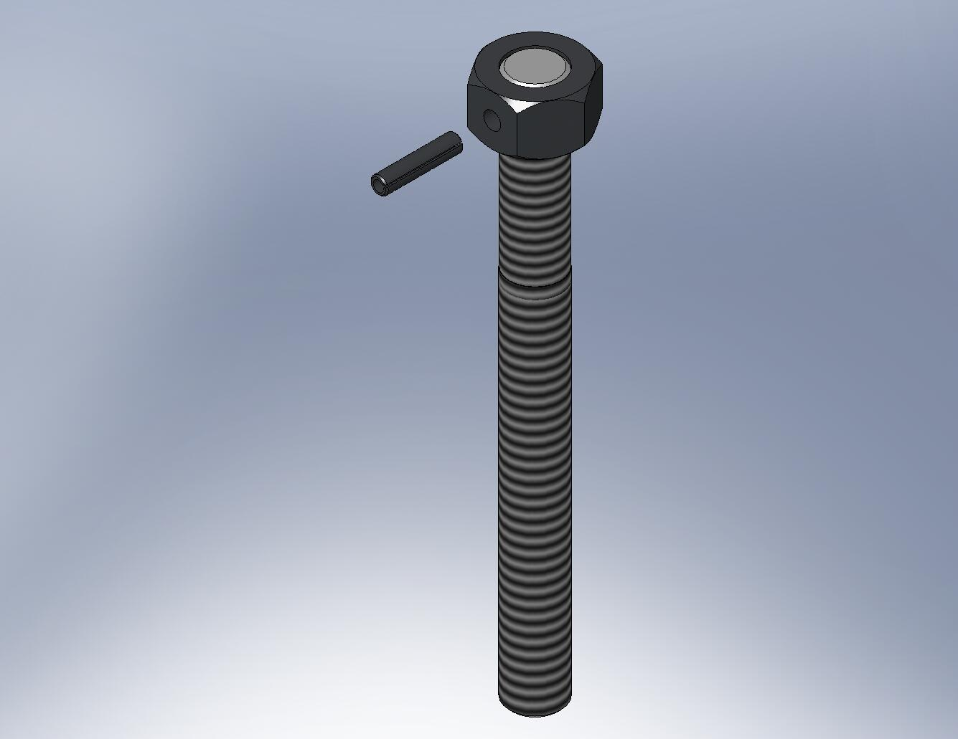
Figure 4.54. After drilling a hole through the ACME Screw and nut, press in the spring pin. The pin transfers torque from the nut to the Screw.

- Insert Heli-Coils into (3) Spring Pull-Down Caps (D071305).
- Press (2) 1/4”x.875” dowel pins into holes in pocket of each of (3) Spring Pull-Down Caps, as shown in Figure 4.55. The pins should stand .375” proud of the pocket’s surface.
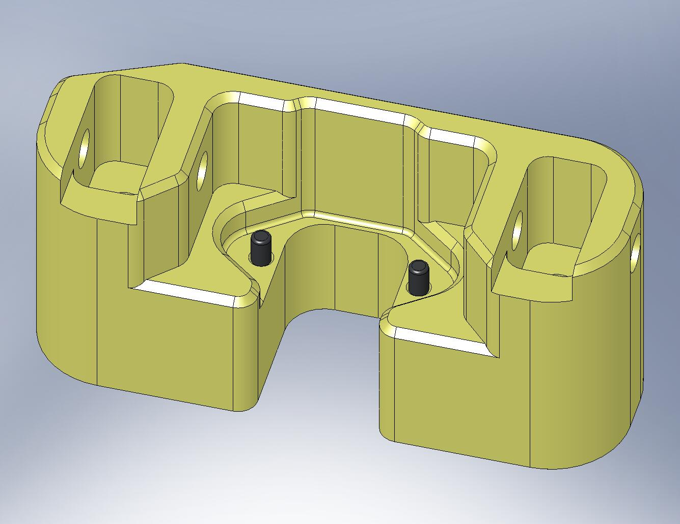
Figure 4.55. Press (2) dowel pins into Spring Pull-Down Cap.

the following procedure describes the assembly of one D071500 assembly. This should be repeated for the other two D071500’s, as well:
- Insert Spring Pull-Down Nut (D071308) through bottom of Spring Pull-Down Base (D071307), as shown in Figure 4.56. Snug all (3) screws, then torque to final spec. Set aside for later use.
Hardware:
(3) 1/4”-20x1.5” SHCS
(3) 1/4” washers
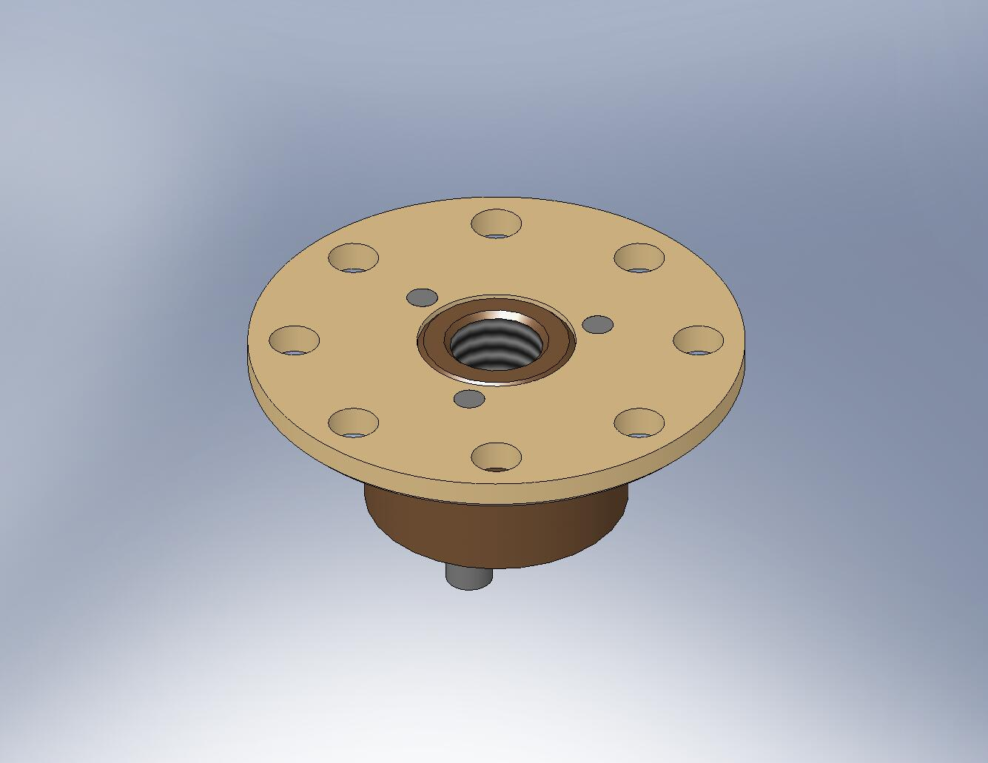
Figure 4.56. Pull-Down Nut bolted onto Pull-Down Base.

- Press combination bearing (INA model NKX25-Z) into Spring Pull-Down Bar (D071306), as shown in Figure 4.57 and Figure 4.58. Note: the bearing must be cleaned to LIGO standards, Class B, before it is installed in this tool. The cleaning process removes all lubrication (requiring temporary disassembly of the bearing) from bearing surfaces. Therefore, the bearing wears quickly when turned under load, and should be replaced when motion begins to feel rough.
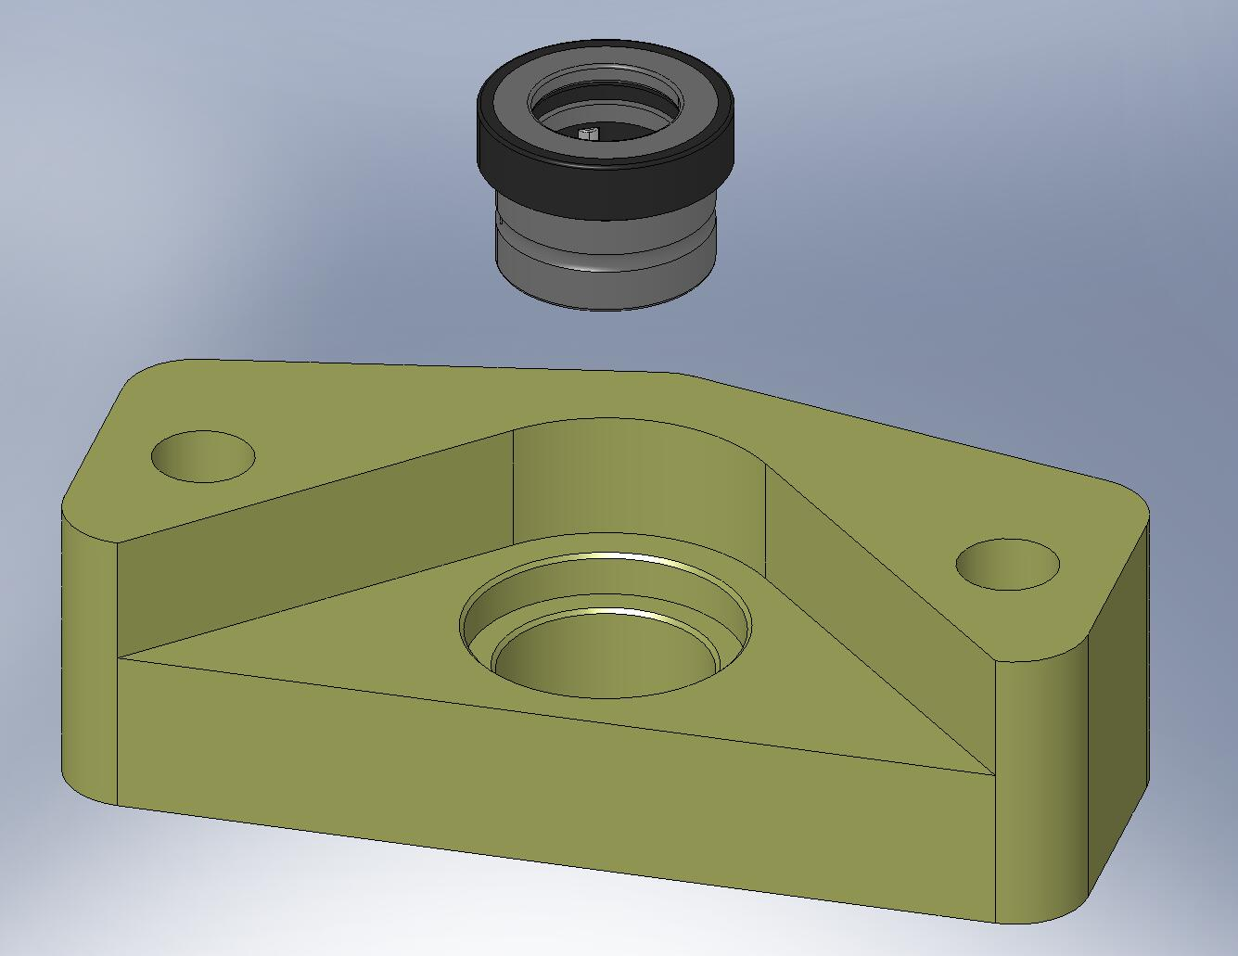
Bearing seats here.
Figure 4.57. Combination bearing (radial + thrust) must be pressed into the Pull-Down Bar. Make sure the force of the press is applied evenly over the bearing’s top surface, and that the bearing seats properly within the Bar.

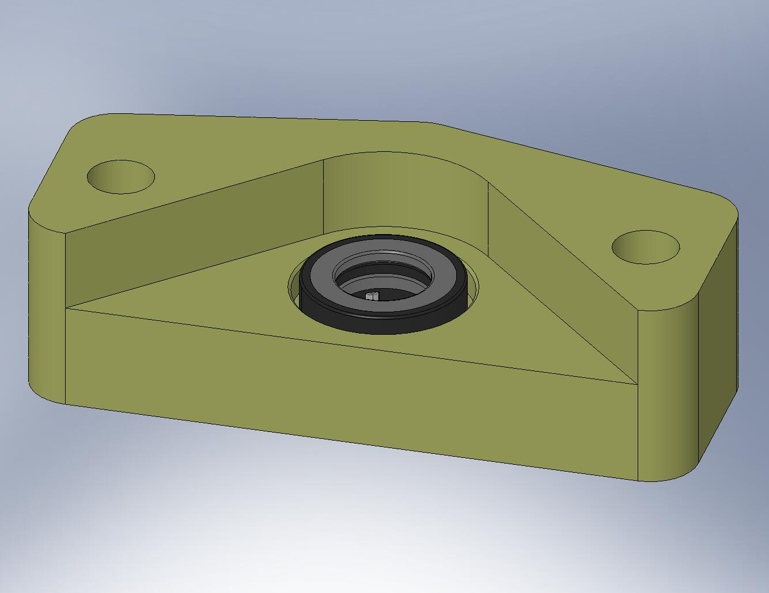
Figure 4.58. The parts should look like this, after the press.

- Insert Spring Pull-Down Conversion Bushing (D071304) through top side of combination bearing, as shown in Figure 4.59. (The Bushing allows us to use the metric bearing with our English ACME Screw.)
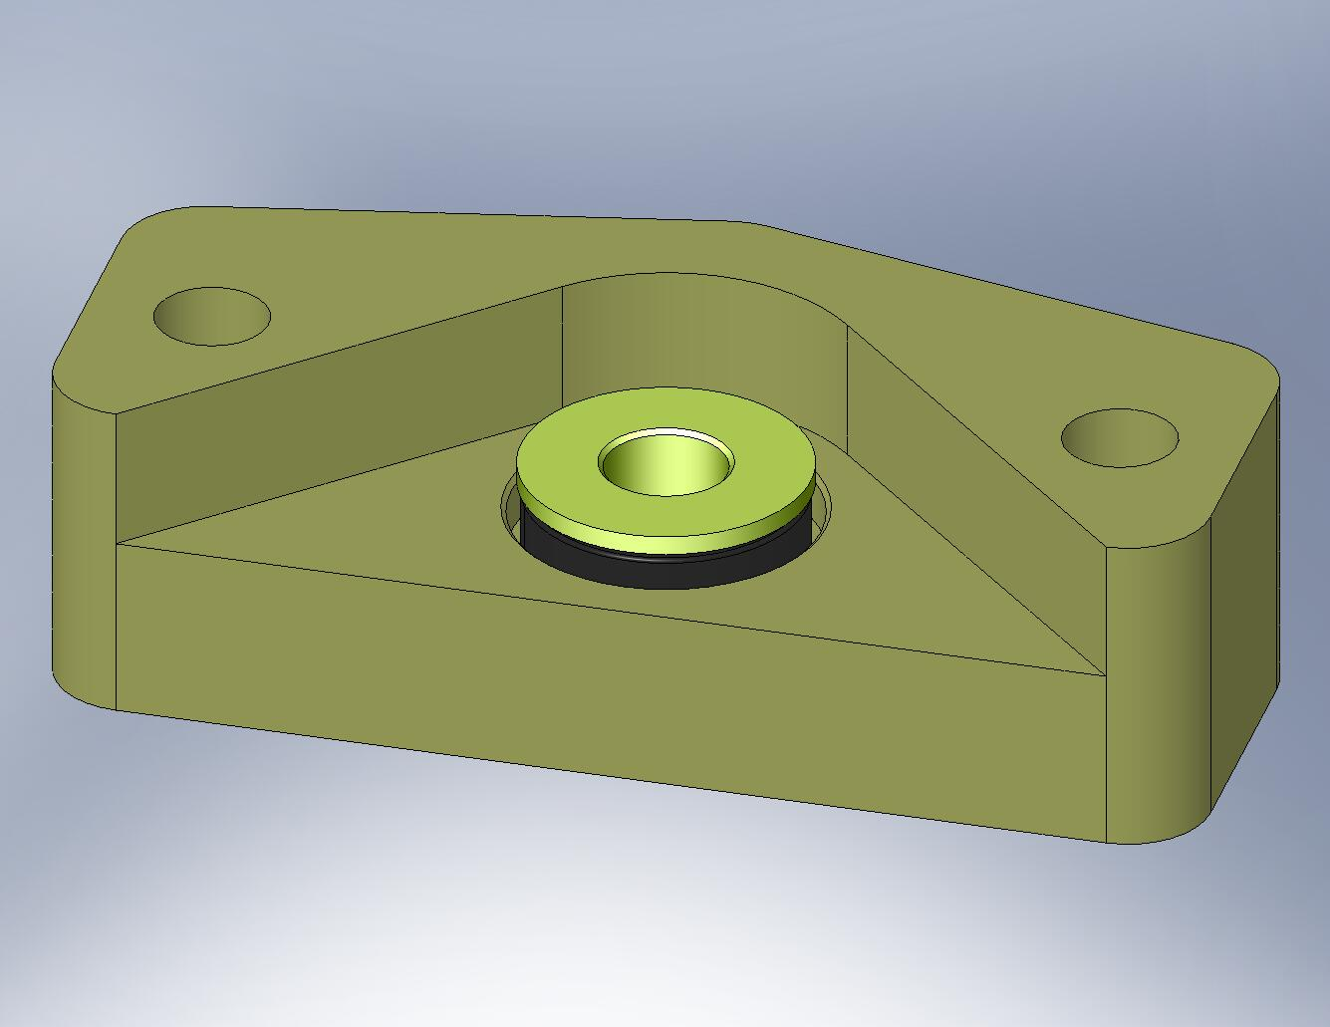
Figure 4.59. Conversion Bushing sitting inside the bearing.

- Place Spring Pull-Down Offset Washer (D071320) over bottom of Conversion Bushing. Clip retaining ring onto the groove in the Bushing.
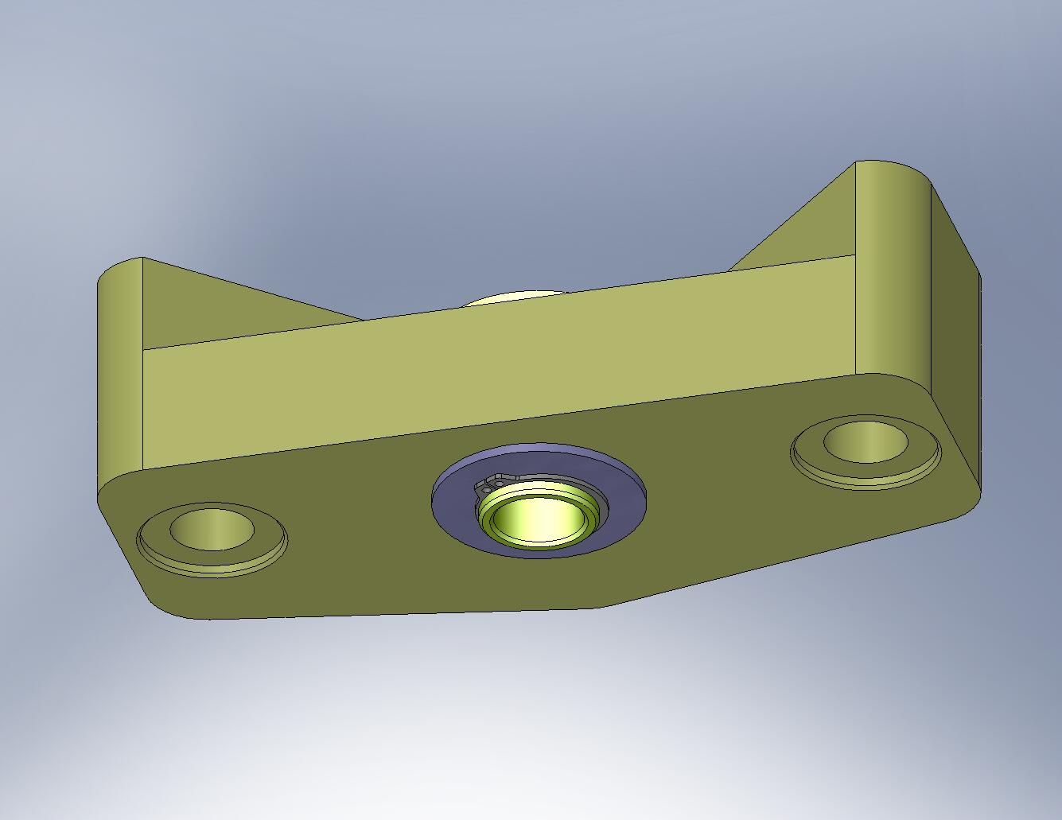
Figure 4.60. The retaining ring and Offset Washer prevent the Conversion Bushing from sliding out of the bearing.

- Drop ACME Screw through top of Conversion Bushing, as shown in Figure 4.61. Slide D0900207 shaft collar with silver-plated screws over ACME Screw, directly below the Bushing. Tighten the collar.
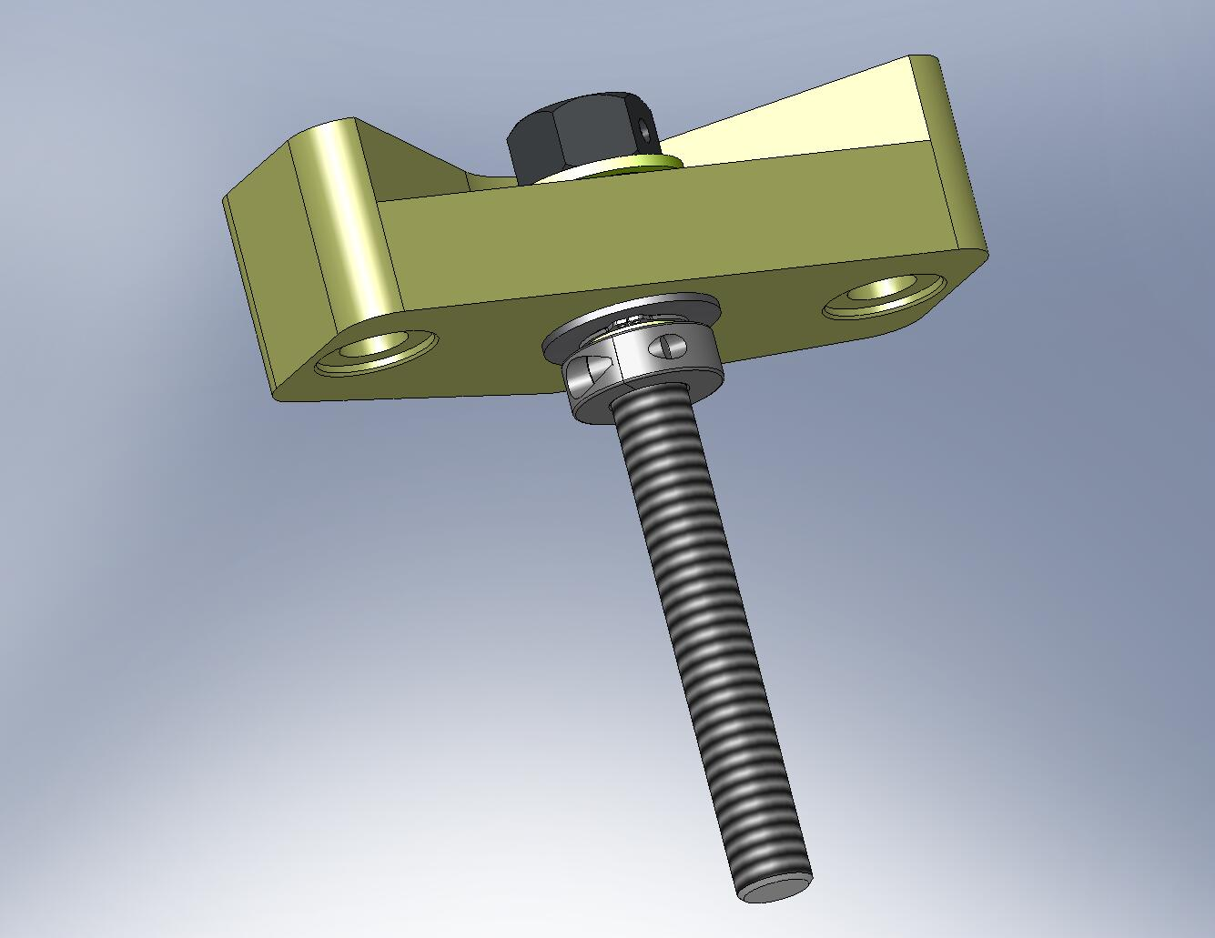
Figure 4.61. ACME Screw placed through the Conversion Bushing. The shaft collar locks the Screw to the Pull-Down Bar.

- Thread ACME Screw into Spring Pull-Down Nut, as shown in Figure 4.62. Set aside.
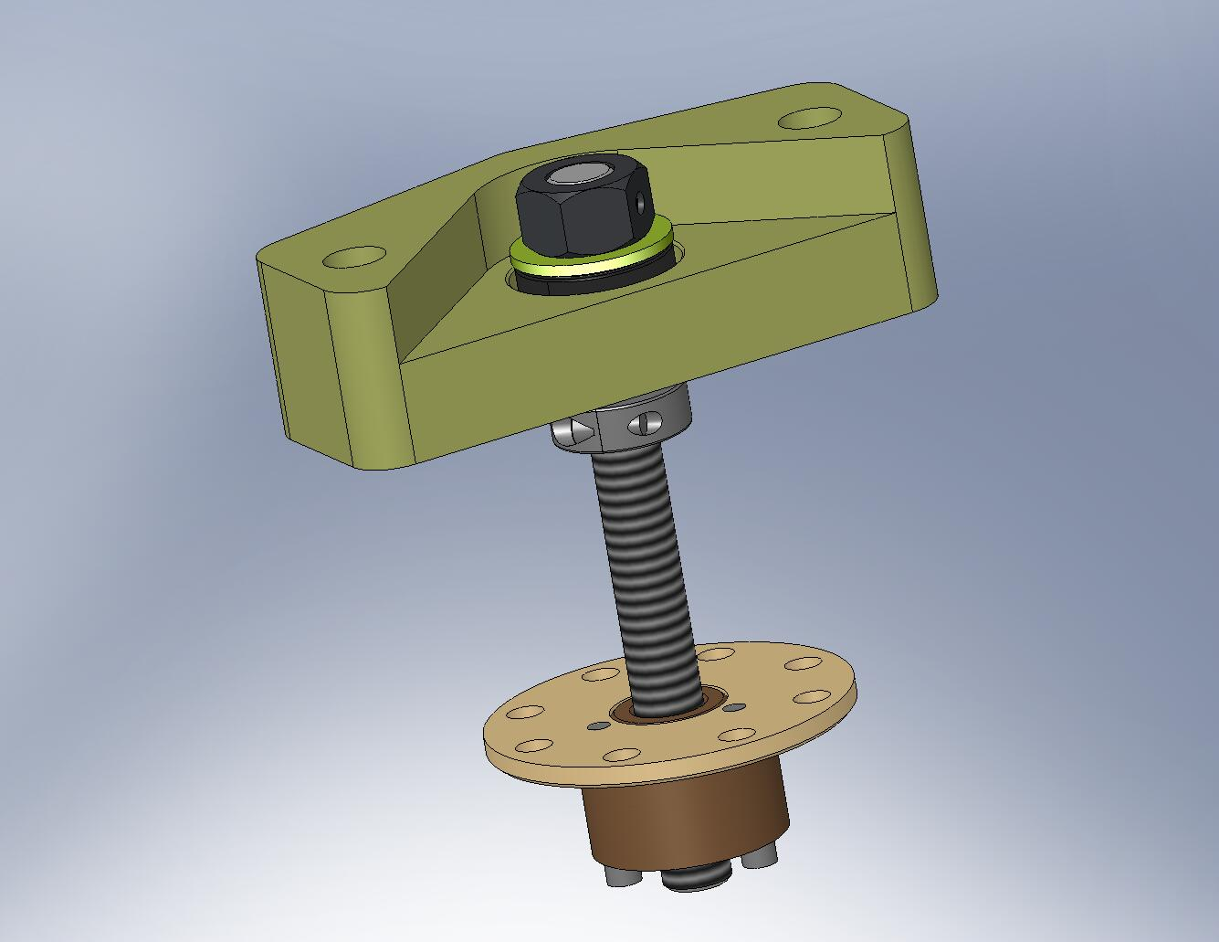
Figure 4.62. Pull-Down Nut threaded onto end of ACME Screw. The bottom part of the Spring Pull-Down Assembly is complete.

- Thread a custom silver-plated 1/2”-20 jam nut (D0901026) onto the short threaded end of each of (2) Spring Pull-Down Pull Rods (D071303), as shown in Figure 4.63.
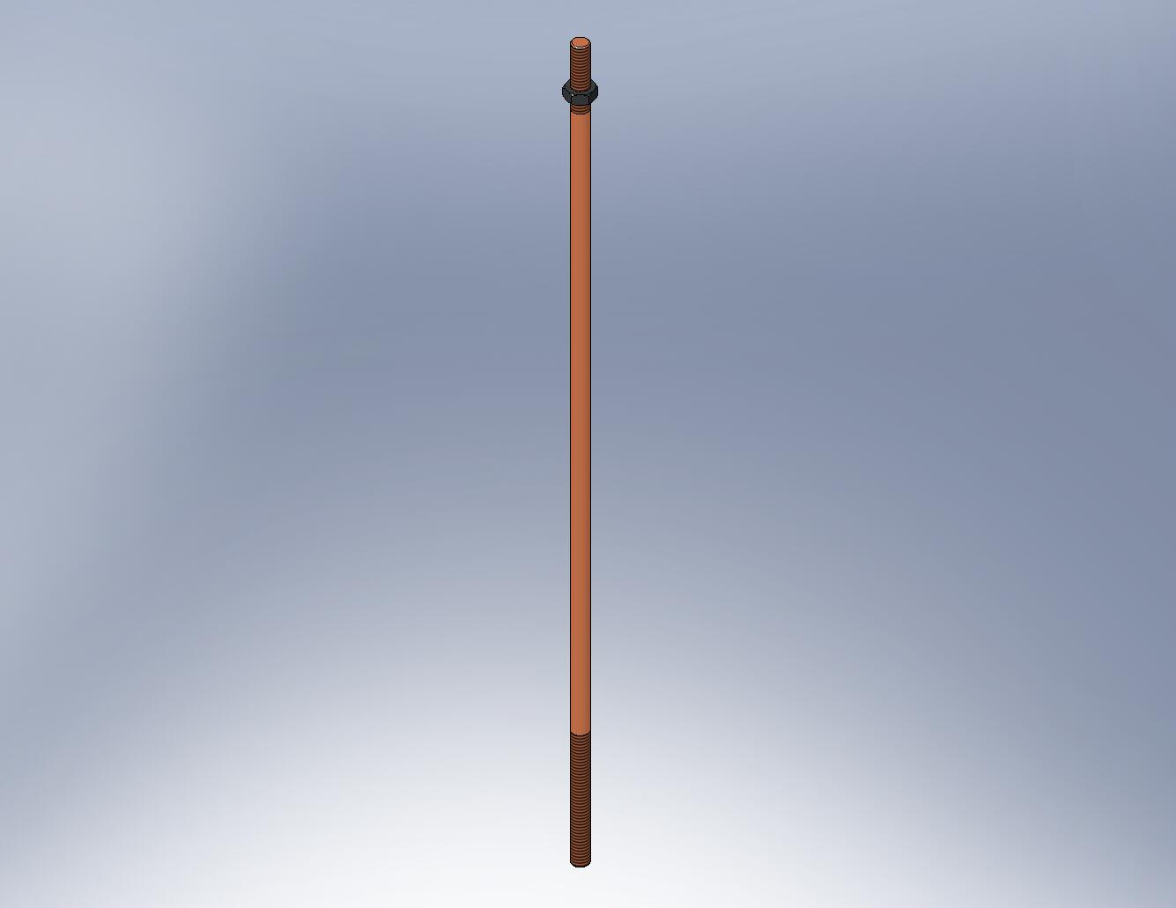
Figure 4.63. Thread the jam nut onto the end of the Pull Rod with 2” of thread.

- Thread a 1/2”-20 ball joint rod end (McMaster-Carr #59915K486) onto the same end of each Pull Rod. Continue screwing the rod end onto the Pull Rod, until it reaches the end of the female thread. Back off a 1/2-turn.
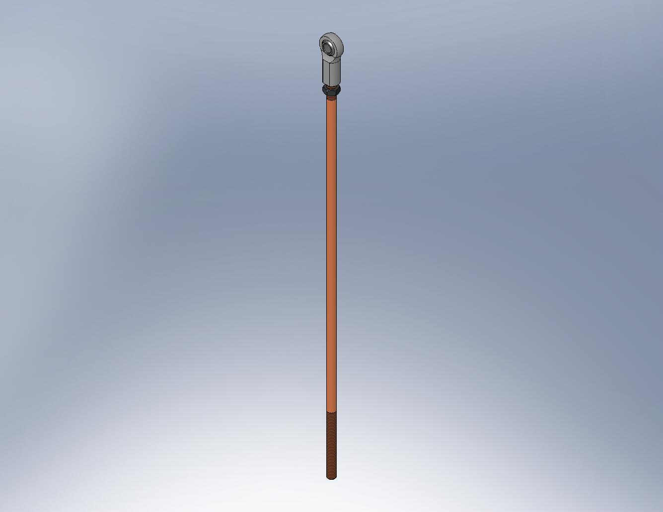
Figure 4.64. The rod end should be fully engaged, minus a 1/2-turn.

- Unscrew the jam nut, until it touches the rod end. Torque the nut against the rod end, using a pair of open-end wrenches. The desired preload is 2x the maximum tensile load the Pull Rod will see – this requires a large torque.
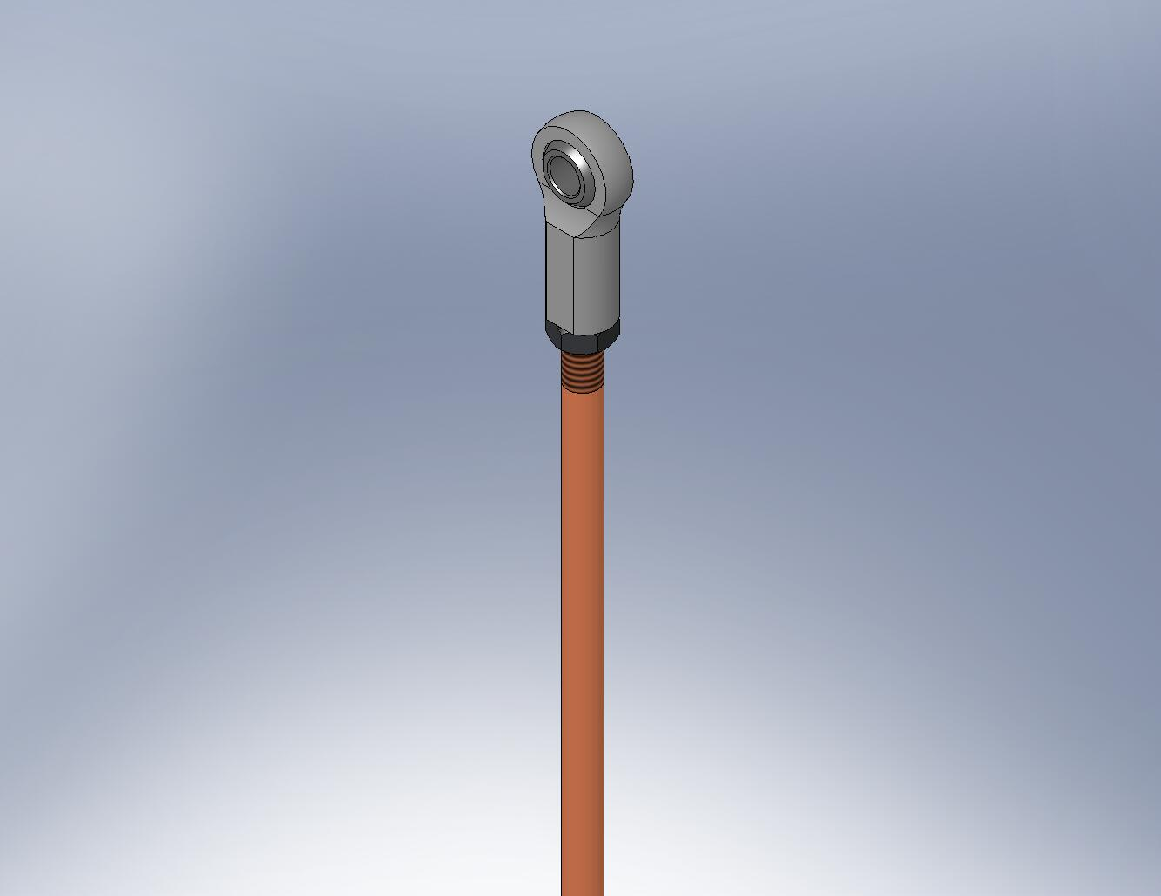
Figure 4.65. Torque the jam nut against the rod end.

- Snap a 1/2” retaining ring (McMaster-Carr #91590A122) on one end of each of (2) 1/2” pivot pins (Misumi #U-SCDG0.50-L2.00), as shown in Figure 4.66.
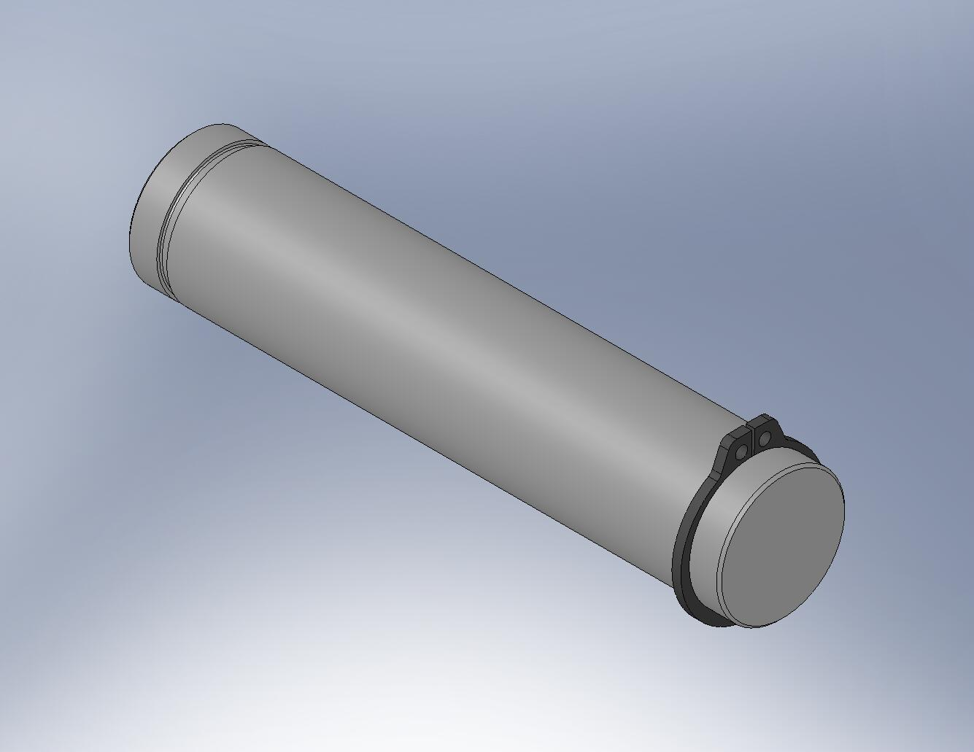
Figure 4.66. Place one retaining ring on each pivot pin now. After inserting through the rod ends, the other end of each pin will get a ring.

- Push each pivot pin through opposite sides of the Pull-Down Cap, as shown in Figure 4.67. Each pin should pass through i) a Spring Pull-Down Rod End Spacer (D071302), ii) a rod end at the end of a Pull Rod, and iii) another Rod End Spacer, before pushing back through the Pull-Down Cap.
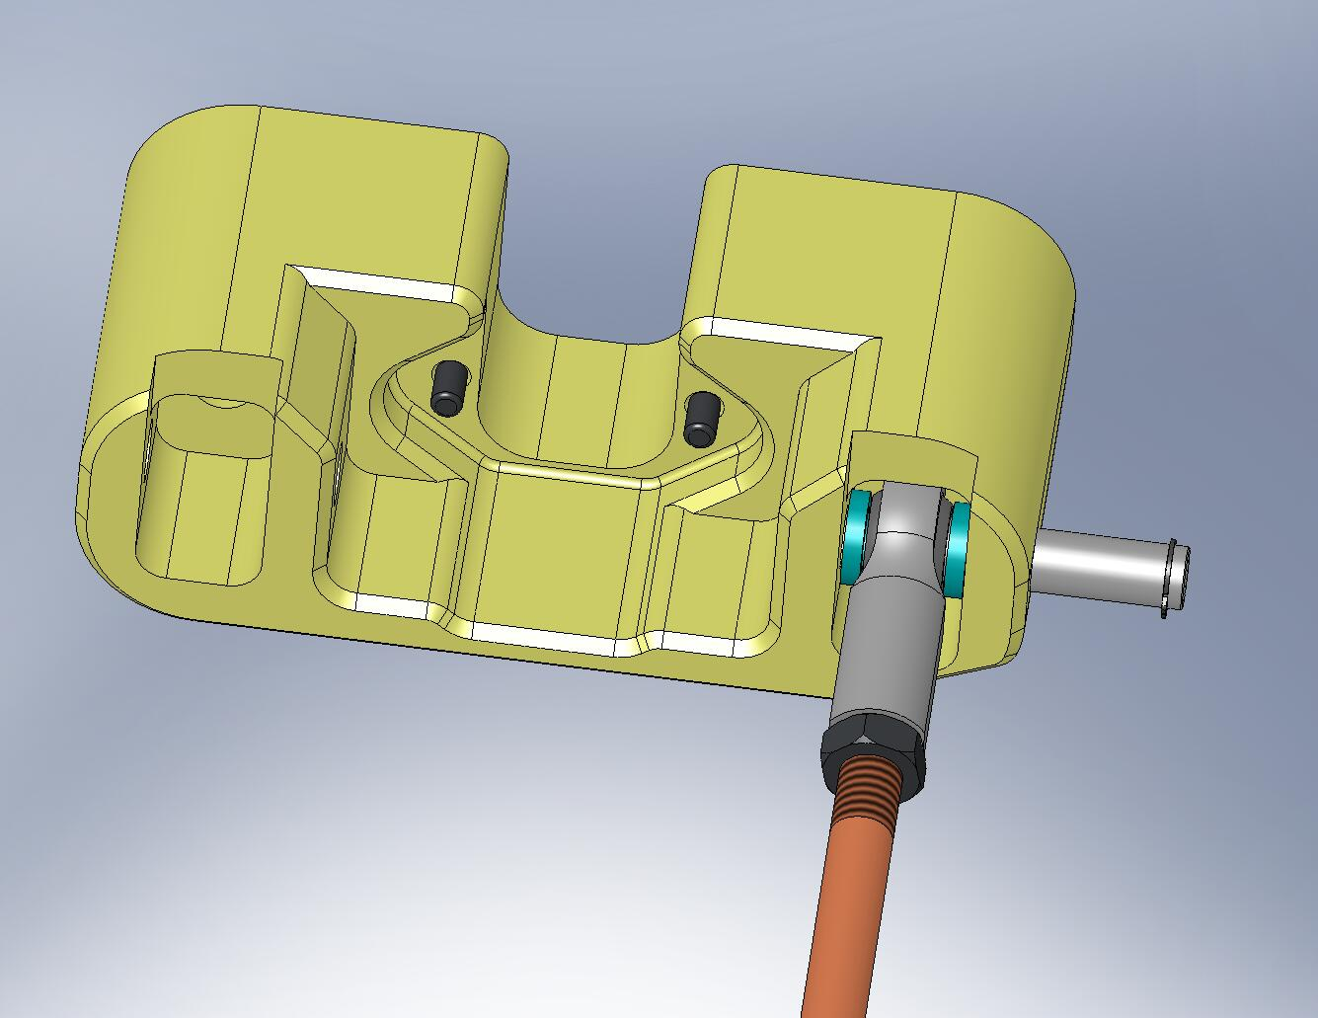
D071302, plastic spacers
Figure 4.67. Pivot pins are pushed through the Pull-Down Cap, passing through the rod ends and spacers.

- Snap 1/2” retaining rings onto the pivot pins, to hold the assembly together.
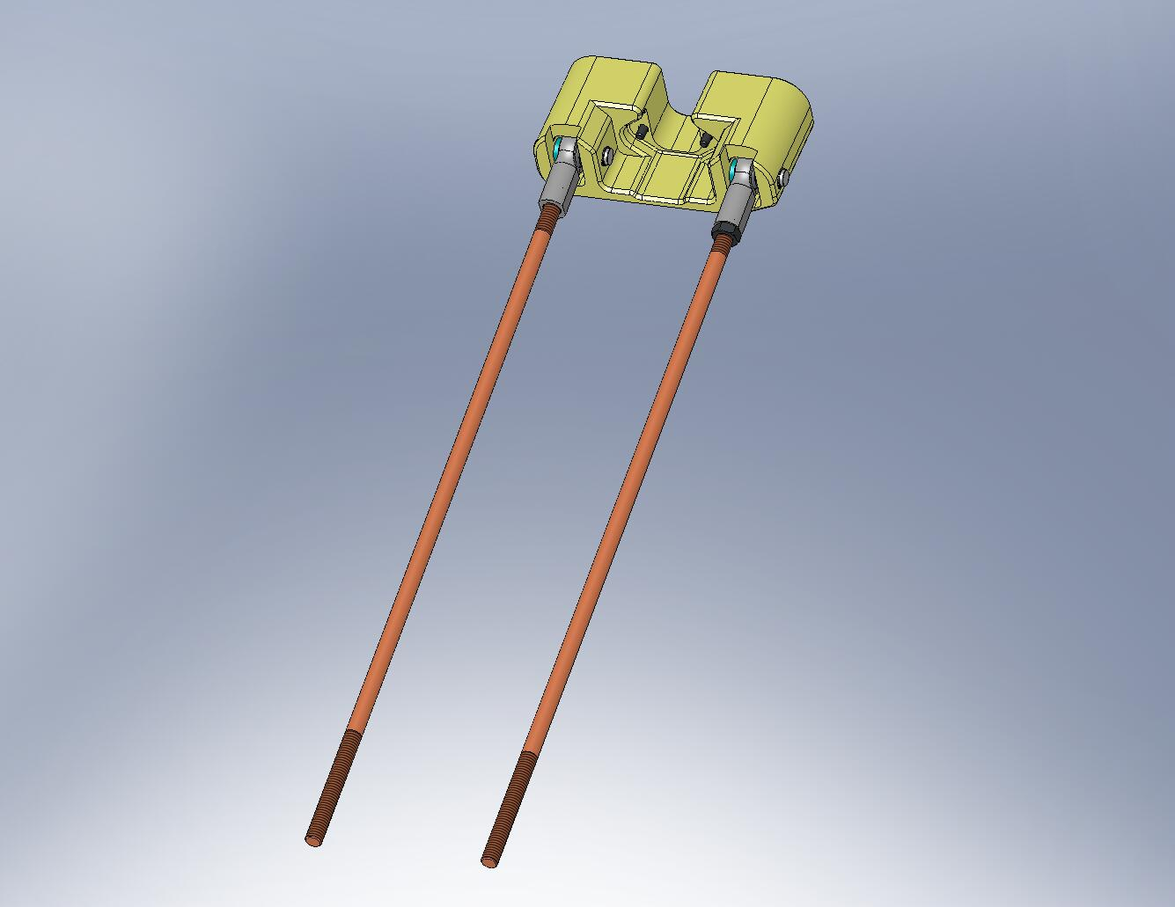
Figure 4.68. After the retaining rings are clamped on, the top part of the Spring Pull-Down Assembly is complete. Set aside for later use.

Prep Work – Assemble Horizontal GS-13 Install Tool (D071496)
- Screw (2) GS-13 Install Slider-Stops (D071310) onto bottom of GS-13 Install Base (D071313). Install hardware and hand-tighten.
Hardware:
(4) 1/4”-20x.50” SHCS
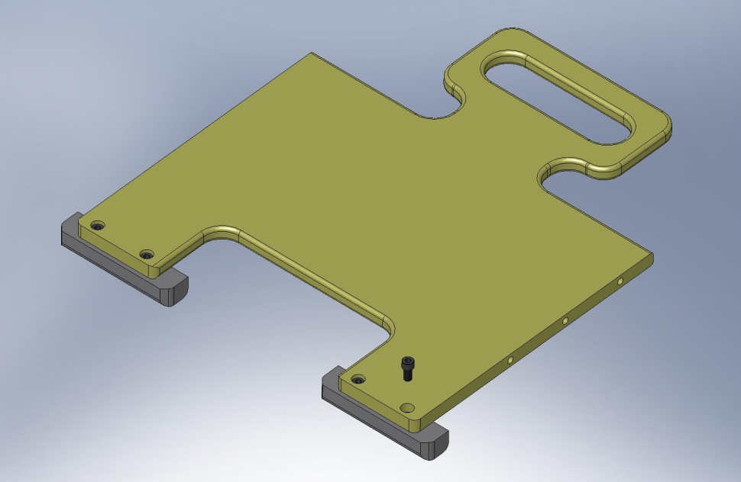
Figure 4.69. Slider-Stops mounted to bottom face of Install Base.

- Attach GS-13 Install Right Rail (D071314) to right side of GS-13 Install Base. Install hardware and hand-tighten.
Hardware:
(3) 1/4”-20x.875” SHCS
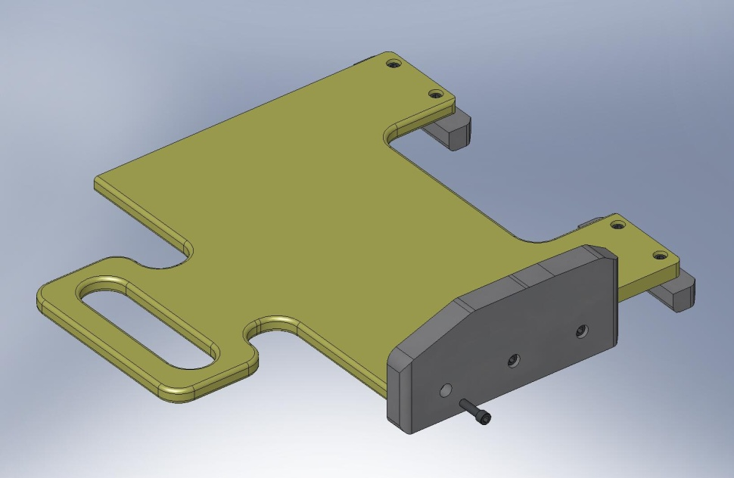
Figure 4.70. Right rail mounted to Install Base.

- Screw GS-13 Install Standoff (D071312) onto outside of GS-13 Install Left Rail (D071311), as shown in Figure 4.71.
Hardware:
(3) 1/4”-20x.50” SHCS
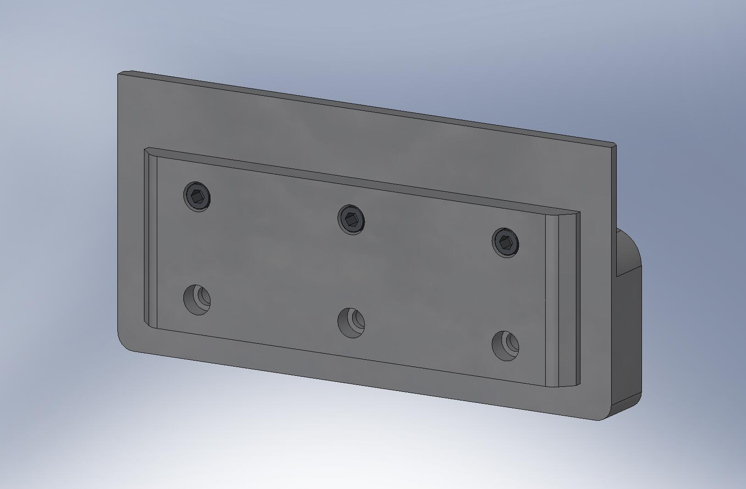
Figure 4.71. Attach Standoff to outside of Left Rail, using top row of screws.

- Attach GS-13 Install Standoff and GS-13 Install Left Rail to left side of GS-13 Install Base.
Hardware:
(3) 1/4”-20x1.25” SHCS
- GS-13 Horizontal Installation Tool is complete. Set aside for later use.
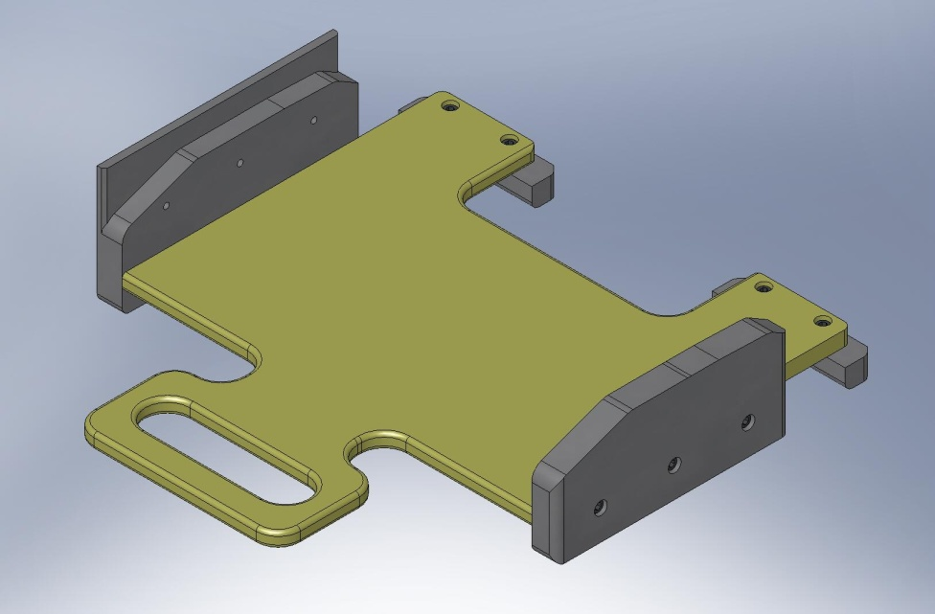
Figure 4.72. Use GS-13 Installation Tool to support Horizontal GS-13’s inside Stage 1. No special tool is needed for Vertical GS-13’s.

Prep Work – Assemble Horizontal GS-13 Shelf (D0900335)
- Place Mounting Bar (D0900337) underneath Plate (D0900336) and thread in screws. Flip on side and push against table, to align side of Bar to side of Plate. Incrementally tighten screws.
Hardware:
(6) 3/8”-16x1.0” SHCS
(6) 3/8” vented washers
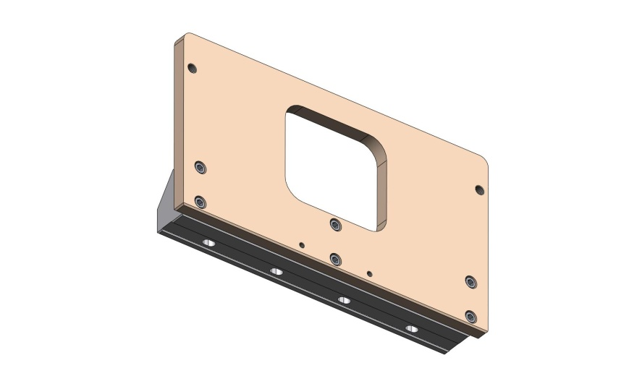
Figure 4.73. Bolt the Mounting Bar underneath the Plate.

- Place Locating Bar (D0900832) on top of Plate. Insert screws and tighten.
Hardware:
(2) 1/4”-20x.75” SHCS
(2) 1/4” vented washers
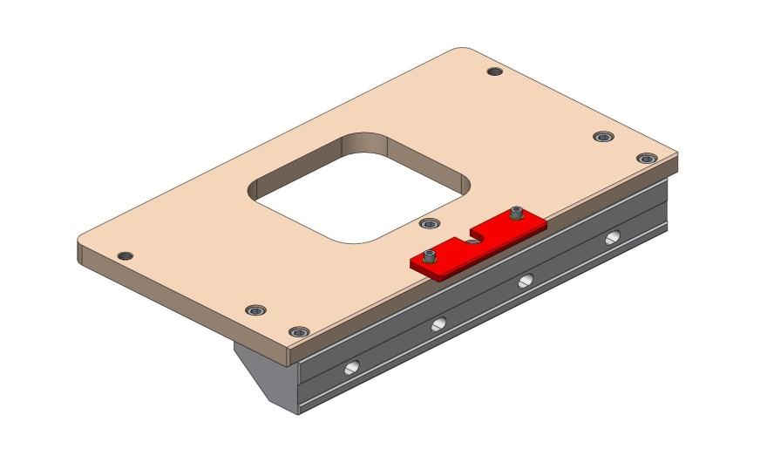
Figure 4.74. A pair of screws hold the Locating Bar on top of the Plate. This Bar helps align the top of the Shelf to the top of the Stage 1 Floor.

- Place (2) Braces (D0900338) on top of Plate. Insert screws and hand tighten.
Hardware:
(2) 3/8”-16x1.0” SHCS
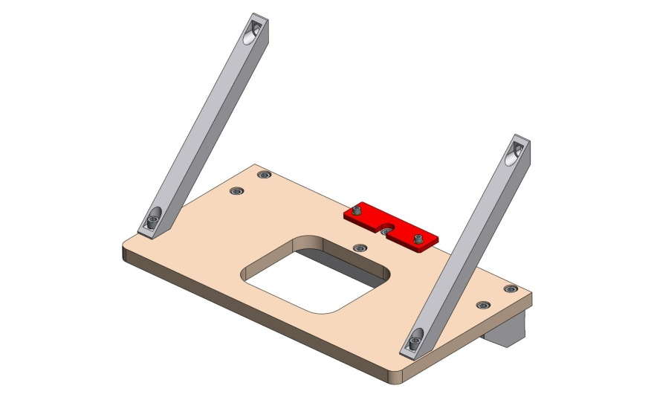
Figure 4.75. Hand-tighten the screws holding the two Braces to the top of the Shelf.

Lower Stage 1 onto Stage 0
- Use overhead crane to lift Stage 1 (D071420) off the Assembly Stand. Move Stage 1 over Stage 0 (D071410), as shown in Figure 4.76.
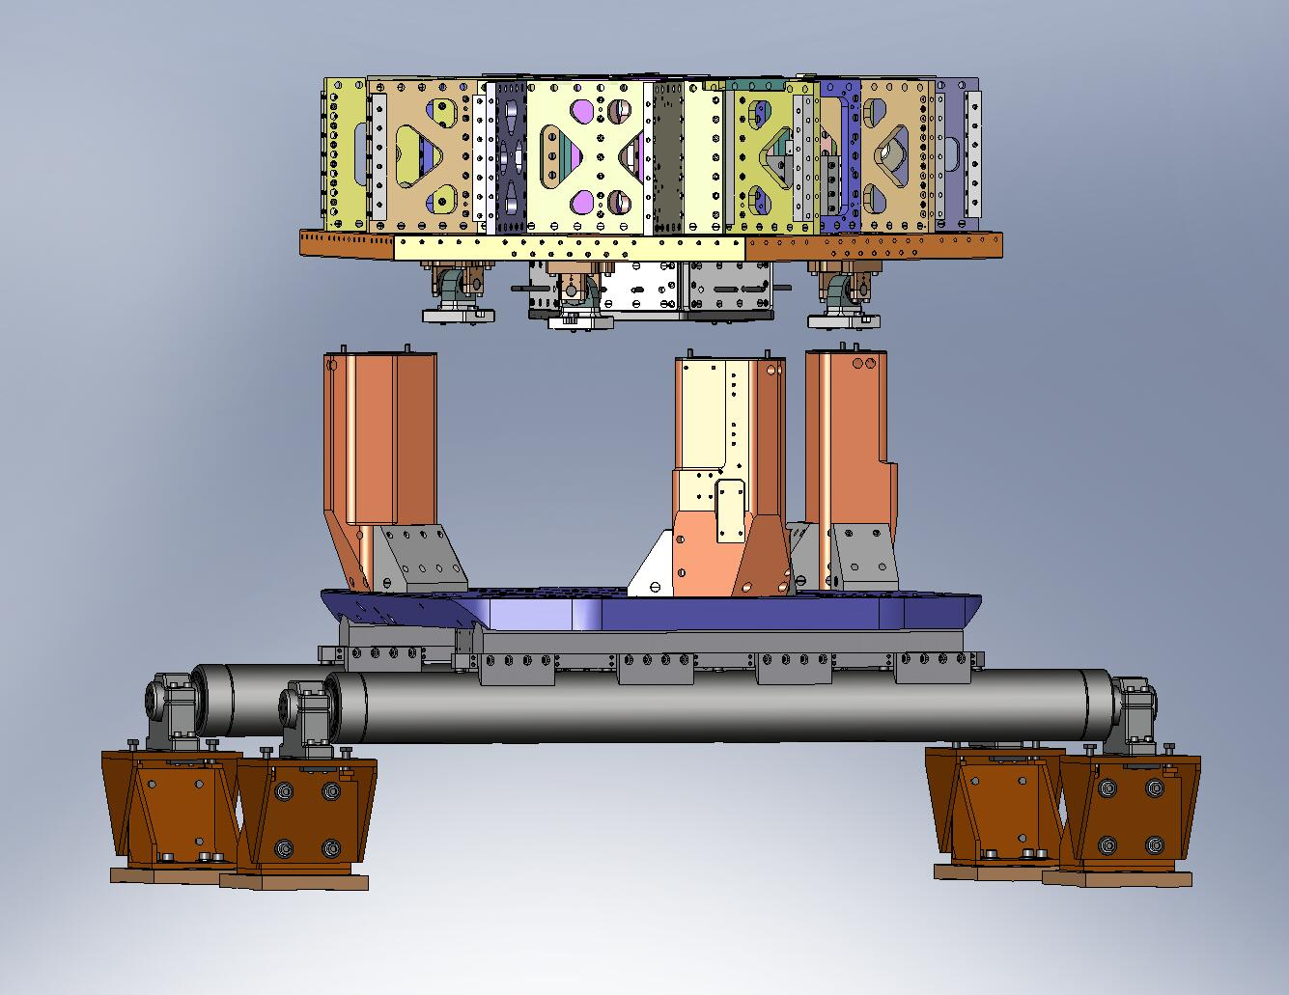
Figure 4.76. Stage 1 positioned over Stage 0 (lifting straps and crane not shown).

- Slowly lower Stage 1. Check clearance between (3) Support Posts (D071002) and the cut-outs in the Stage 1 Floor (D071051). Note: this clearance is nominally just 1/4”.
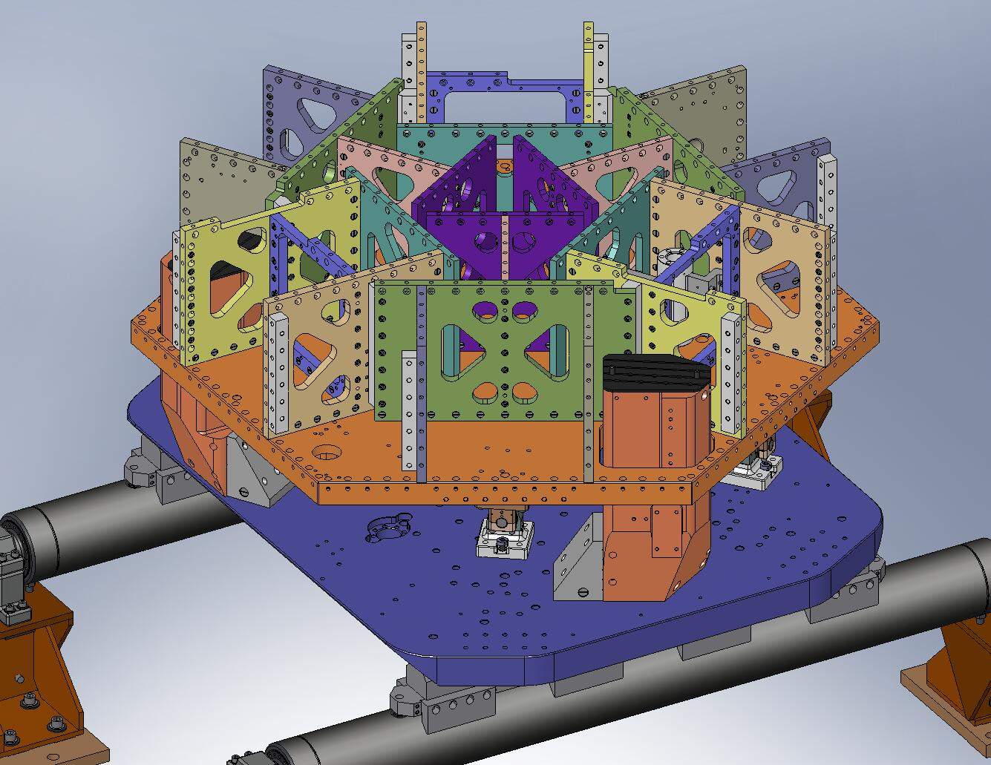
Try to prevent hard contact against the Support Posts.
(3 places)

Figure 4.77. The (3) Support Posts stick through cut-outs in the Stage 1 Floor. When lowering Stage 1 into place, take care to maintain some clearance around each Post.

- Stop lowering Stage 1 when the lowest Locker Base (D071140) is about 1/4” above the Stage 0 Base (D071001), as shown in Figure 4.78. Try to engage the (8) temporary pins in the Locker Bases with the mating holes in the Stage 0 Base, as shown in Figure 4.79.
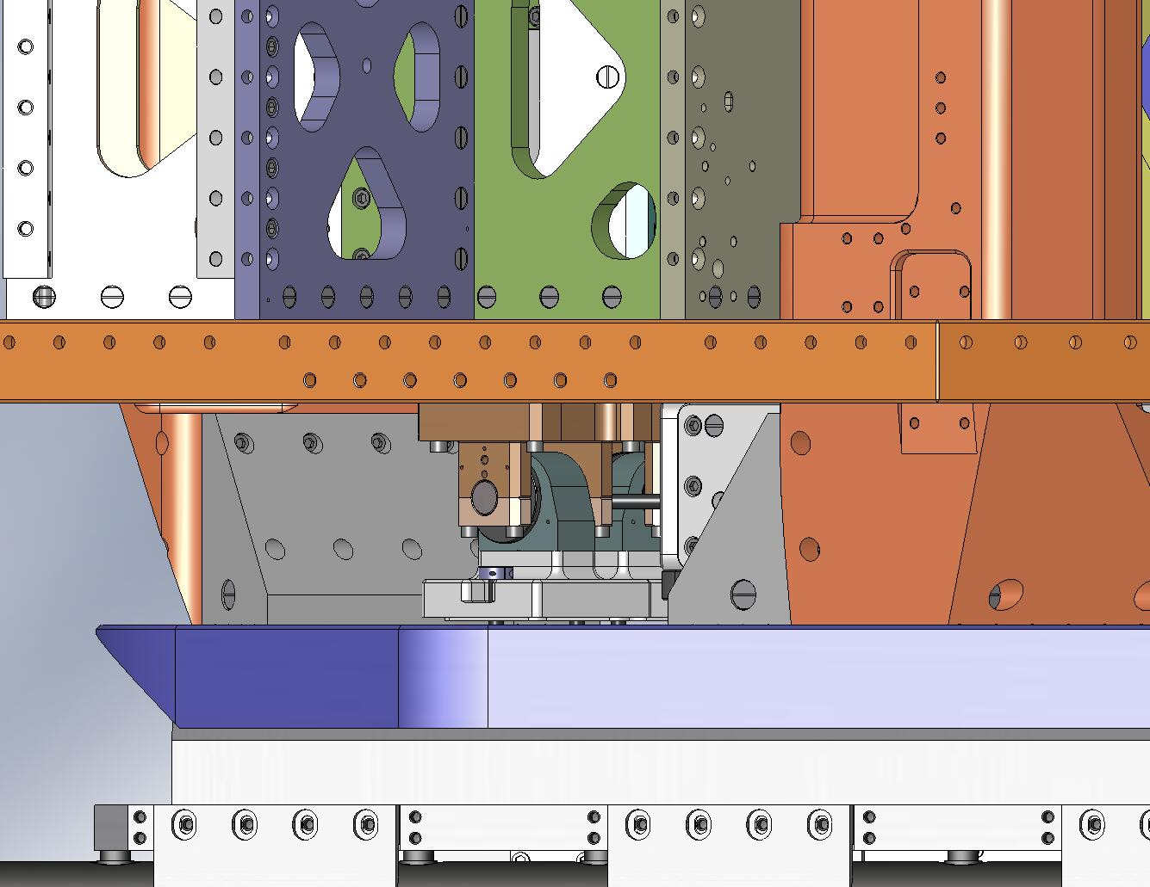
Leave space to slide in the Shims.

Figure 4.78. Lower Stage 1 close to its final position, but leave enough space between the Lockers and Stage 0 to slip in .125” Shims.
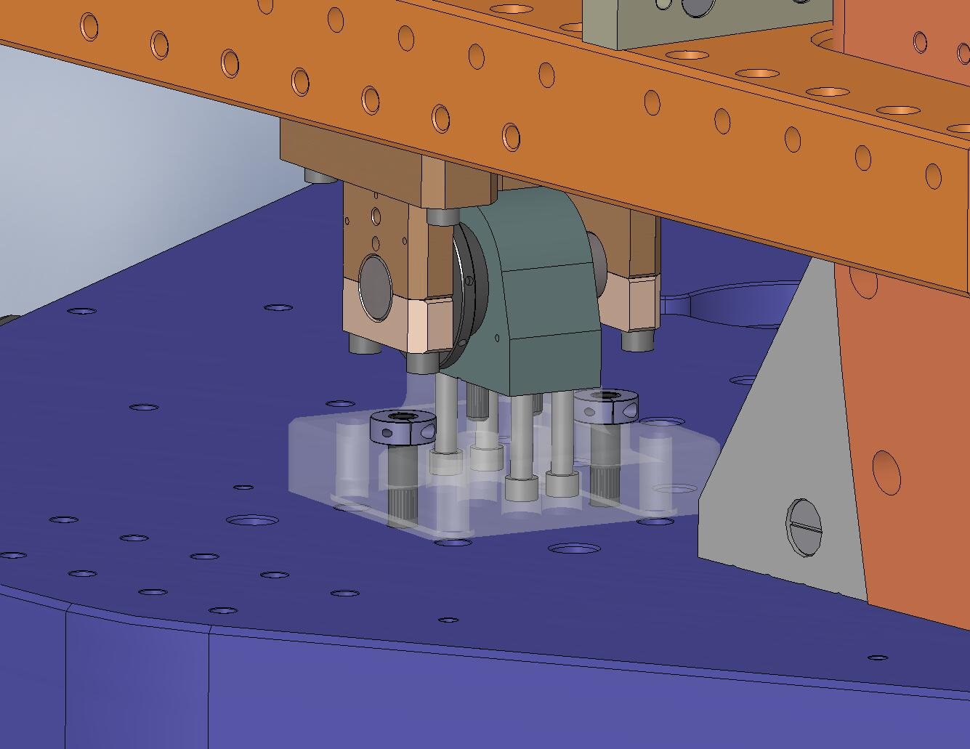
Try to engage these pins in the Stage 0 Base. (4 places)
Figure 4.79. As Stage 1 is lowered, try to engage the temporary pins from the Lockers in the mating holes in Stage 0. Stage 1 will not be parallel to Stage 0 while it’s hanging from the crane, so start with the lowest Locker. It may not be possible to engage all (8) pins, depending on tolerance stack-up.

- Slide (8) .125” Shims (D071141-05) between the Locker Bases and the Stage 0 Base, as shown in Figure 4.80 and Figure 4.81. The Shims should fit closely around the bosses on the bottom of the Locker Bases. Since Stage 1 will not be level to Stage 0 when it’s on the crane, first place the Shims under the lowest Base(s), then carefully lower Stage 1 until all the Shims can be inserted around the bosses.
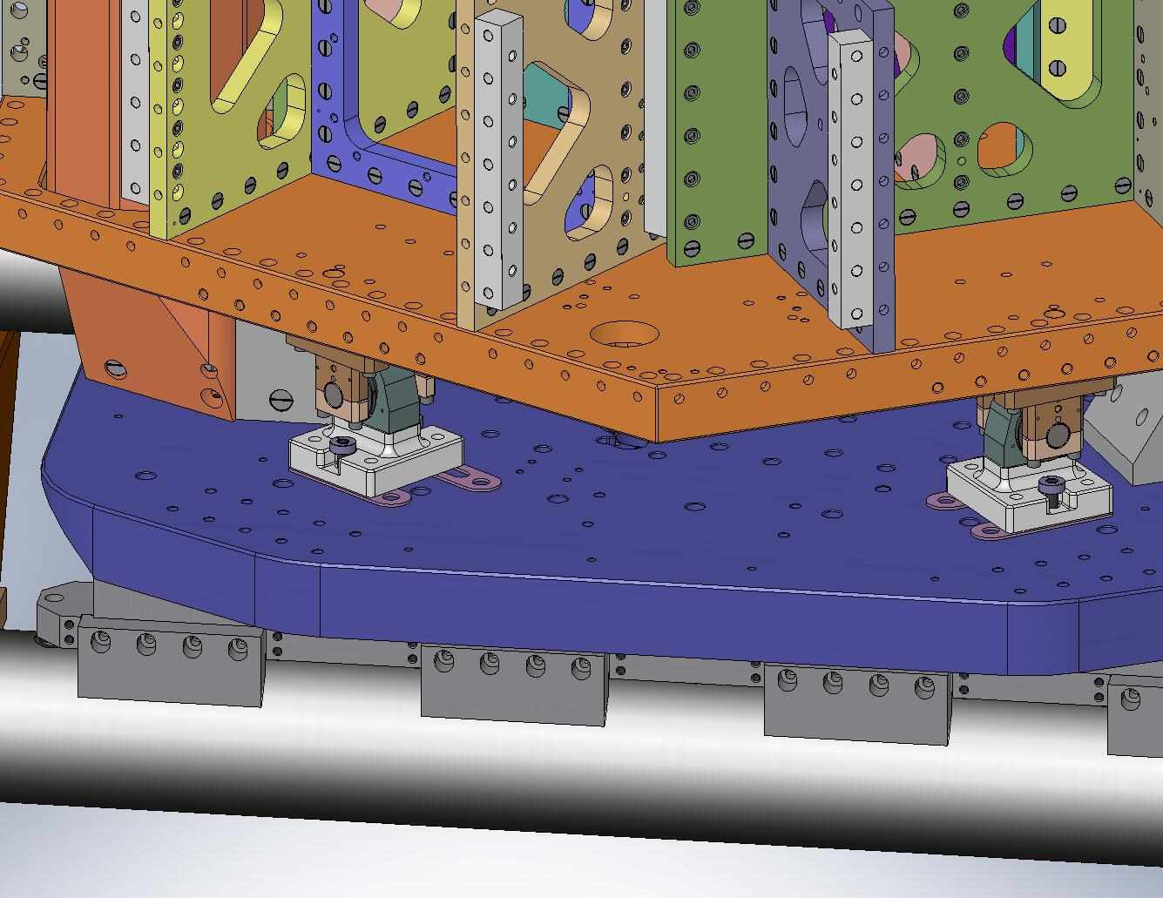
Slide the Shims in.
Figure 4.80. Slide (8) .125” Shims underneath the Locker Bases. Make sure the Shims slide around the bosses on the bottom of the Locker Bases.
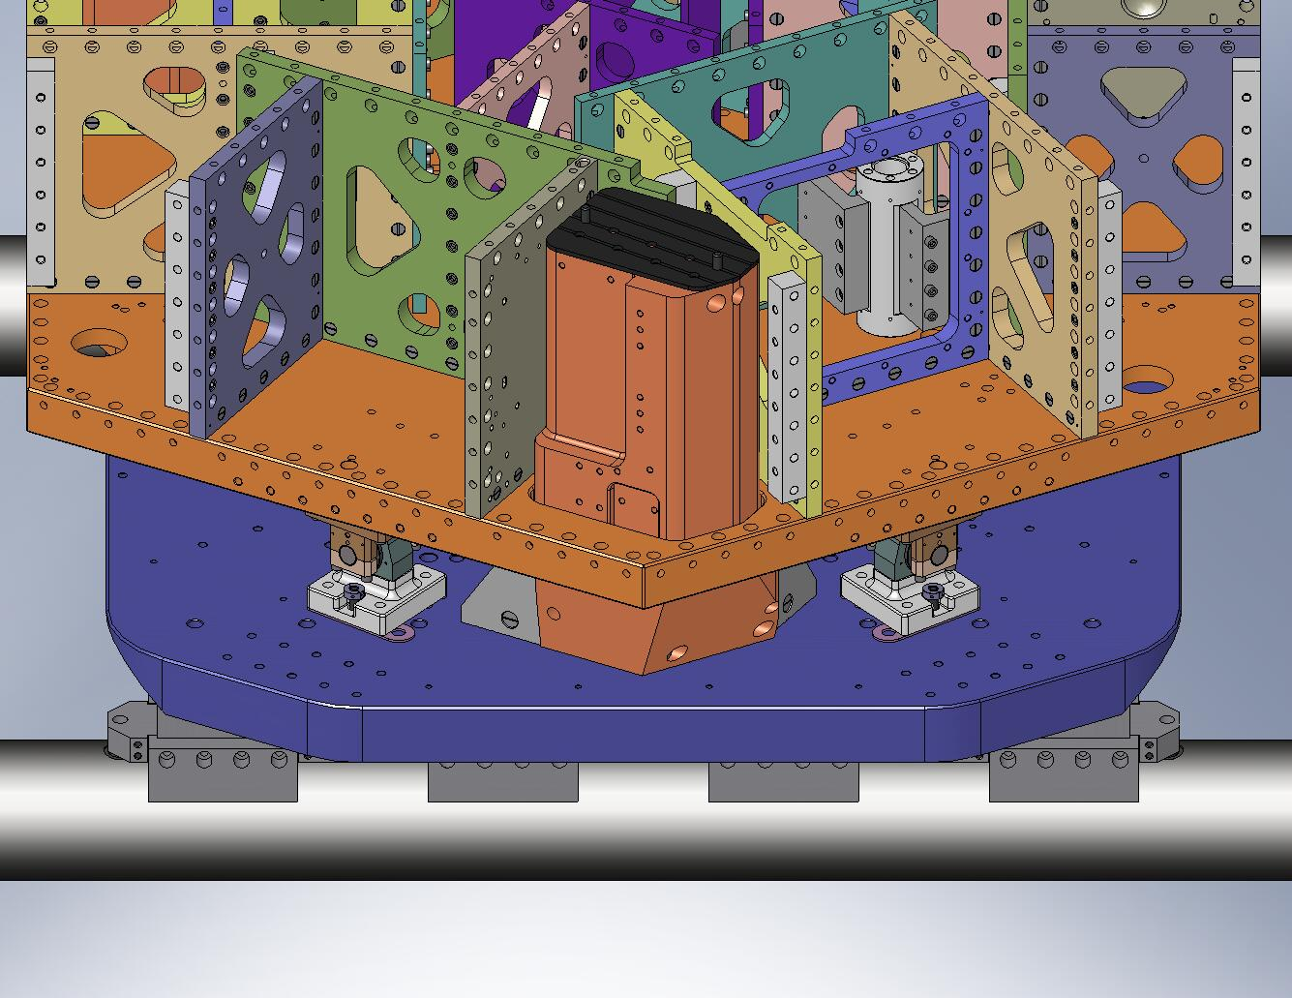
These are mounting holes for Wiring Breadboards.

These Shims must point in the opposite direction.
Figure 4.81. Two of the Shims must be inserted “backwards”, or they will interfere with the Wiring Breadboards, which are installed later.

- Lower Stage 1 until its full weight is supported by Stage 0. Detach the crane.
- Try to slide the Shims under all (4) Locker Bases. Find the Locker with the loosest Shims. Replace these Shims with thicker ones, so they barely slip in.
- Insert screws through the Locker Bases and into the Stage 0 Base. Snug, but don’t torque, yet.
Hardware:
(16) 1/2”-13x2.5” SHCS
(16) 1/2” vented washers
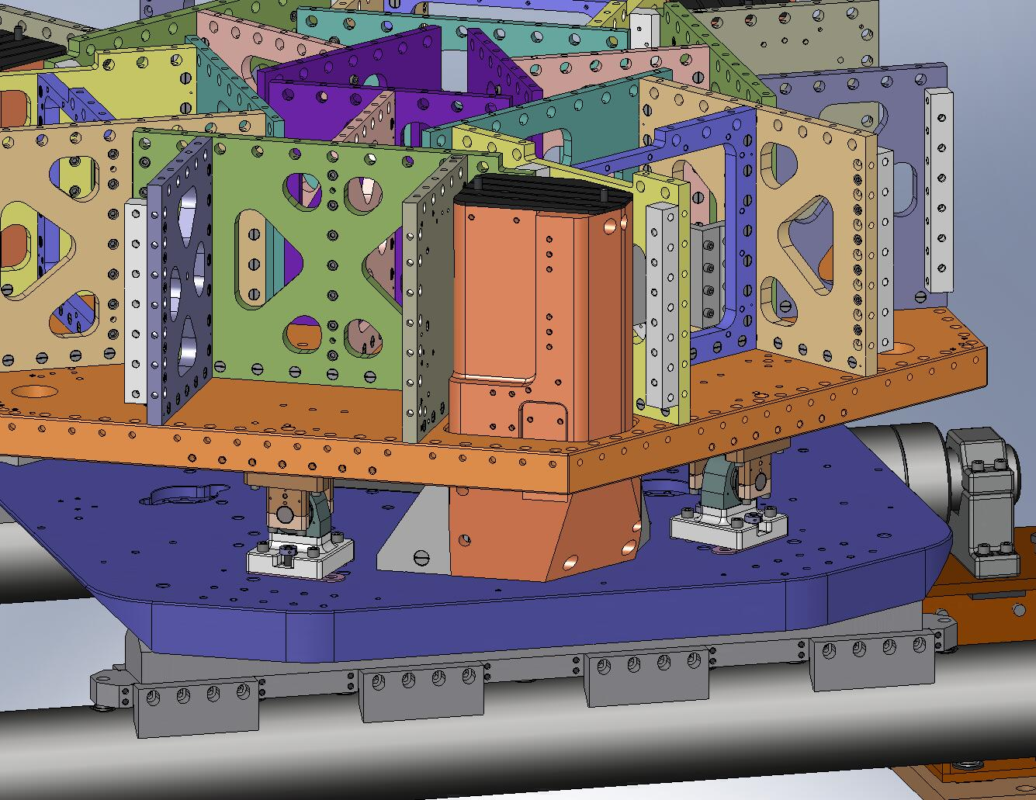
Figure 4.82. Snug the screws holding the Locker Bases to the Stage 0 Base.

- Remove (8) temporary pins from Locker Bases. Now, torque (16) Locker Base screws to final spec.
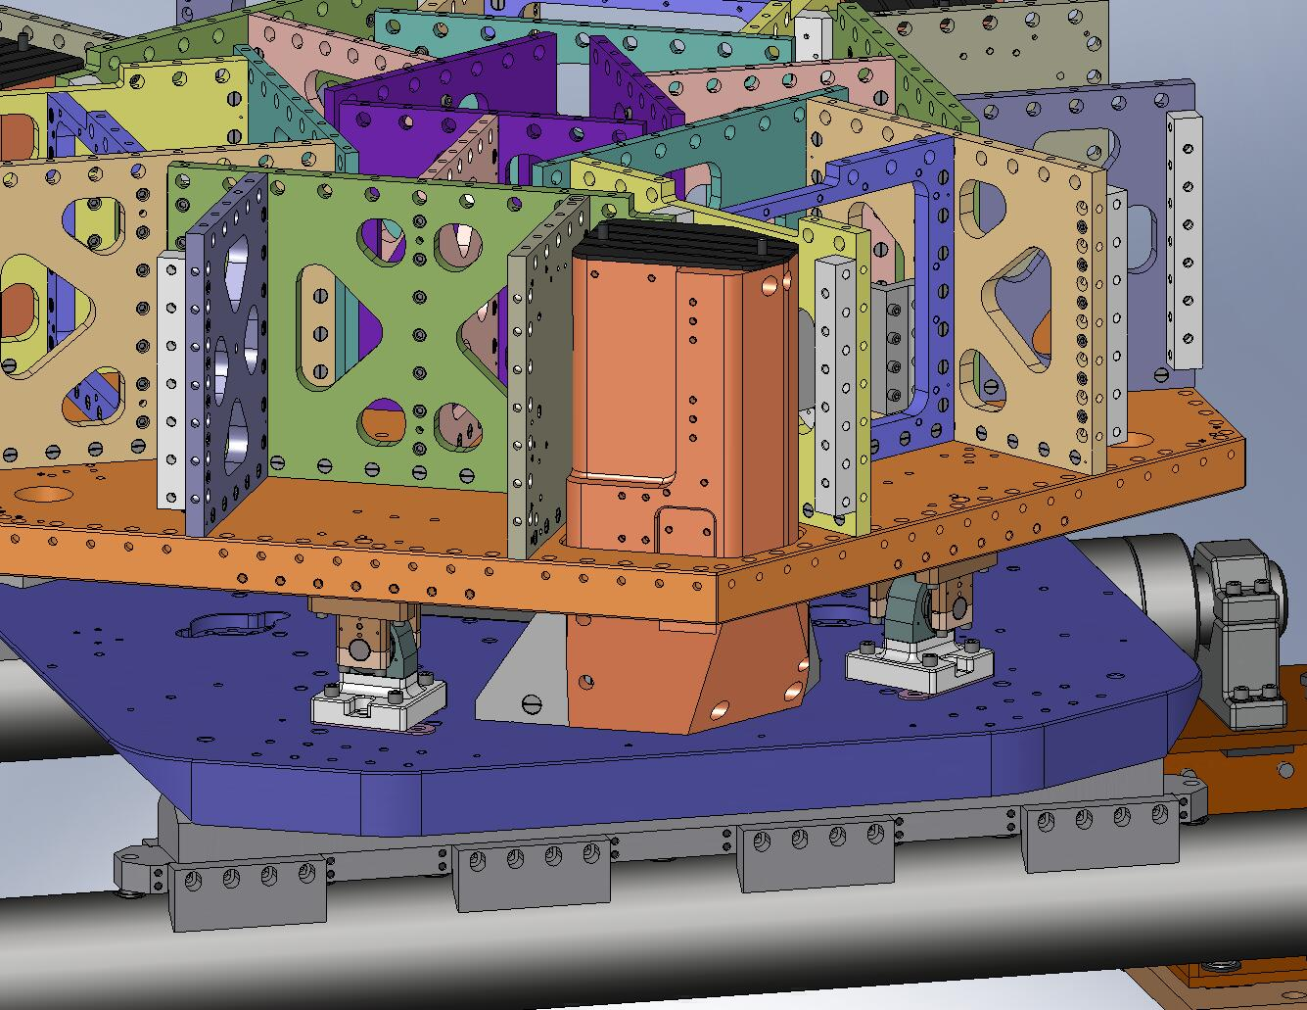
Figure 4.83. Remove (8) pins from the Locker Assemblies, before torquing the mounting screws to final spec.

Attach and Load Springs
- Insert a 3-hole and a 4-hole 1/2”-13 Gang Barrel Nut (D071251-03 and -04, respectively) into each of the Support Posts, as shown in Figure 4.84.
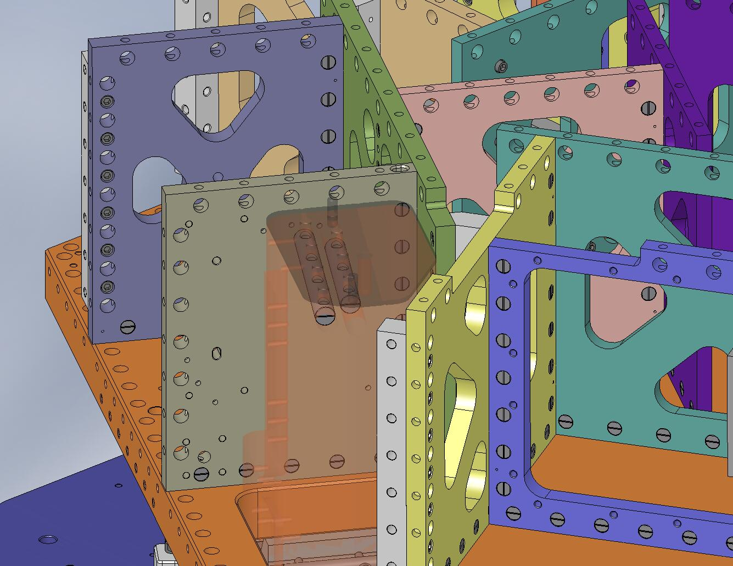
Figure 4.84. Slide (2) large Gang Barrel Nuts into each Support Post. These will capture the mounting screws for the Springs.

- Place a Spring (D071100) on each Support Post, as shown in Figure 4.85. A hole and a slot in each Spring should slip around the dowel pins in the Posts. Start D0900198 silver-plated screws, to keep the Spring from tipping over.
Hardware:
(21) 1/2”-13x3.0” Ag-plated A286 hex bolt (D0900198)
(21) 1/2” vented washer
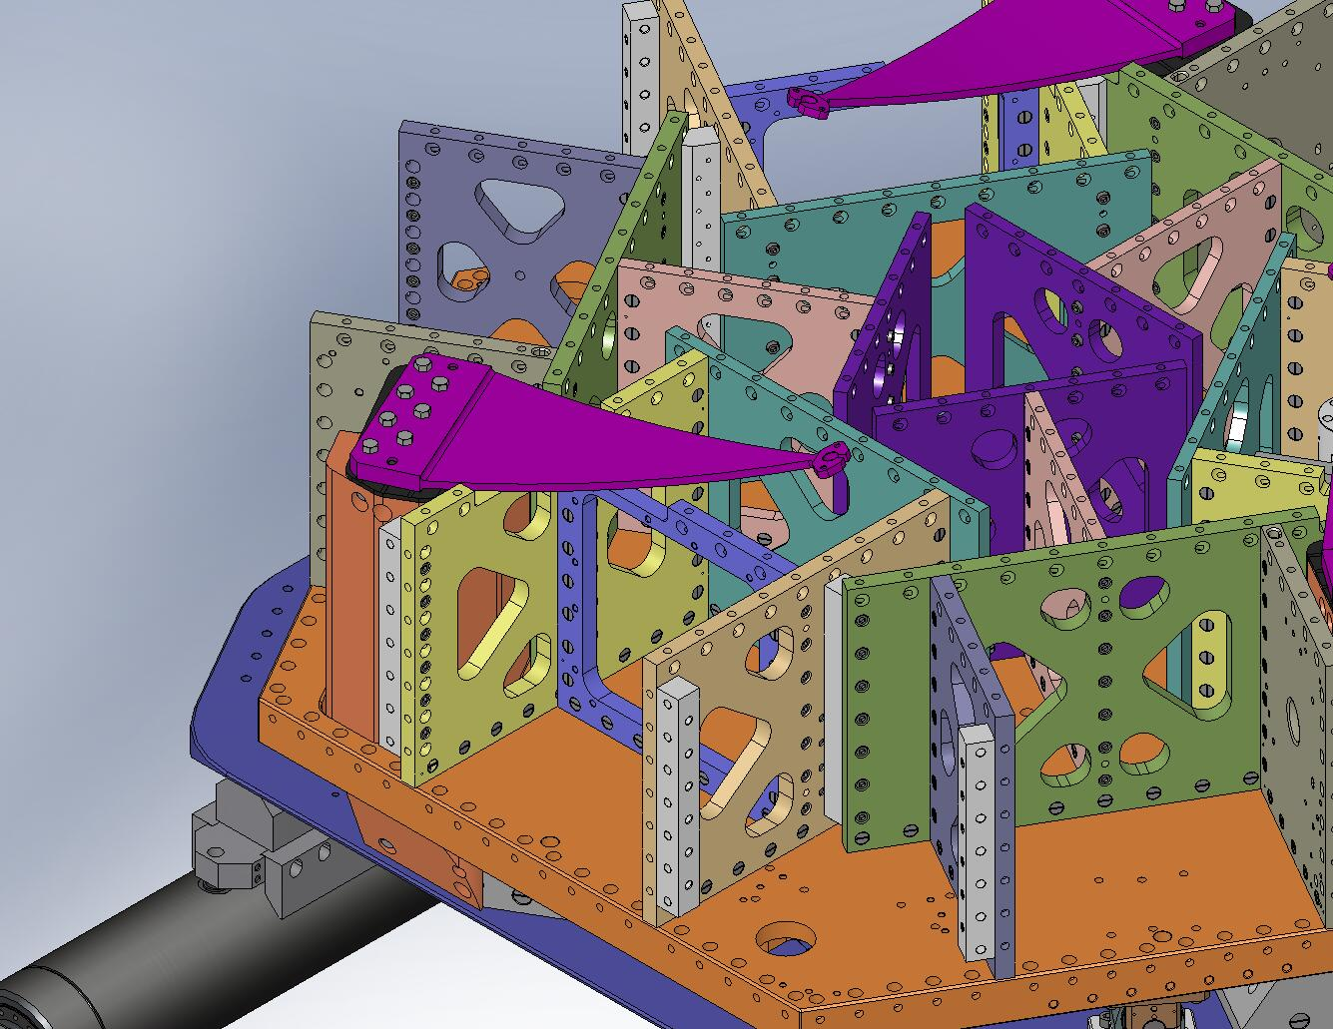
Figure 4.85. A Spring positioned on a Support Post.
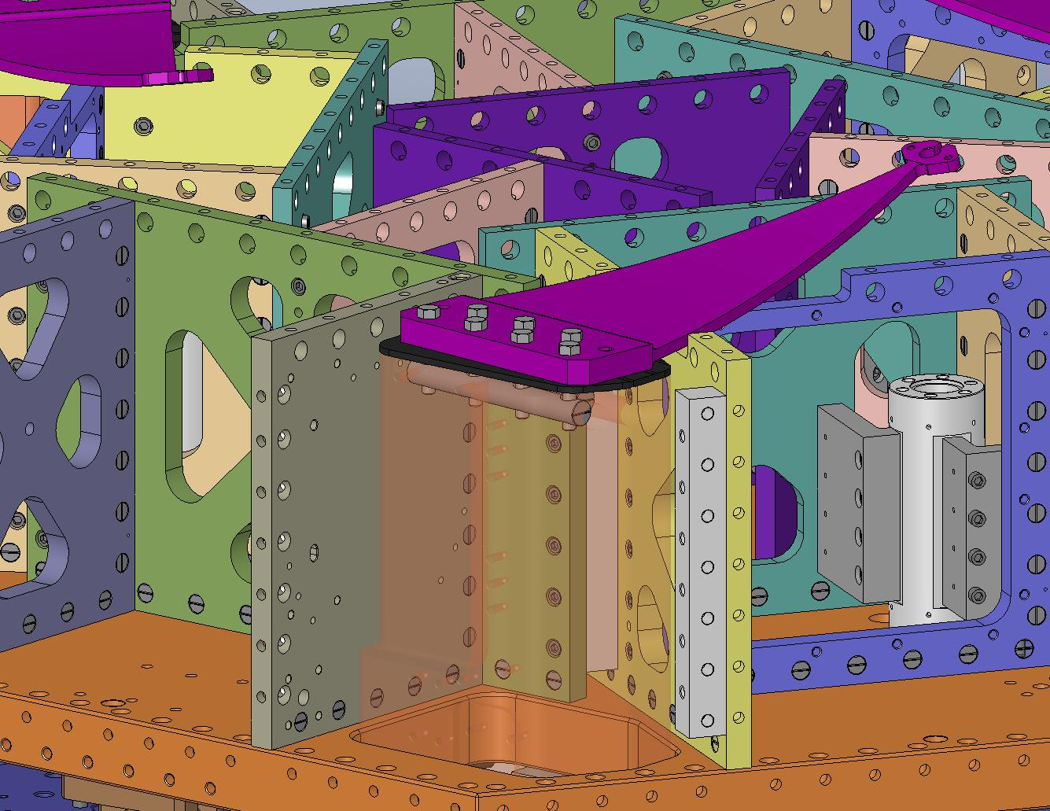
Figure 4.86. High-strength, custom silver-plated hex bolts hold the Springs to the Support Posts (Support Post Caps are sandwiched in between).

- Snug all (7) hex bolts on each Spring, then incrementally torque to spec.
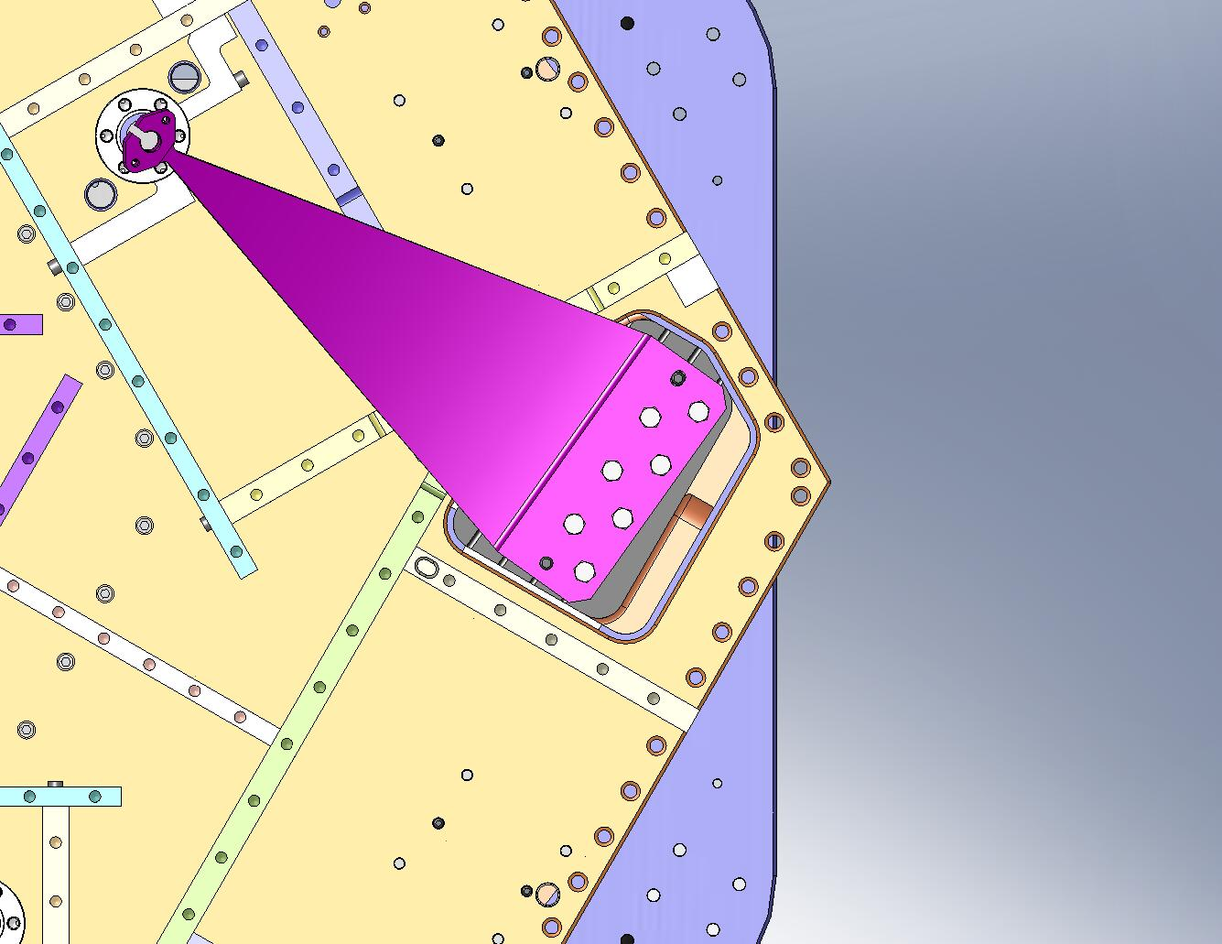
Figure 4.87. A staggered bolt tightening pattern. Use a similar pattern when torquing the Spring bolts.

- Insert (6) Spring Tension Bushings (D071321) in the Stage 1 Floor, on either side of the (3) Flexure Posts.
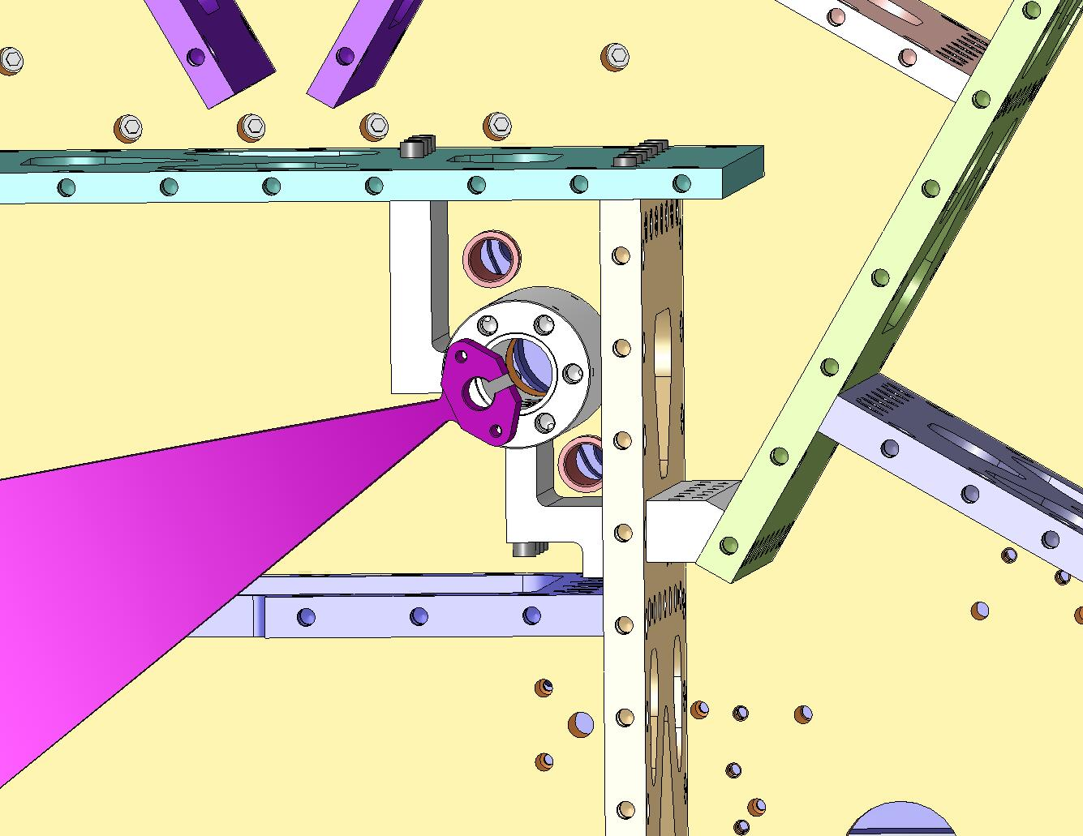
Figure 4.88. These plastic bushings protect the Stage 1 Floor during assembly and use of the Spring Pull-Down Assemblies.

- Slip a D0900206 silver-plated nut and a washer onto all (3) of the Flexure Assemblies (D071431), as shown in Figure 4.89.
Hardware:
(1) 3/4”-10 Ag-plated jam nut (D0900206)
(1) 3/4” washer (McMaster-Carr #98017A220)
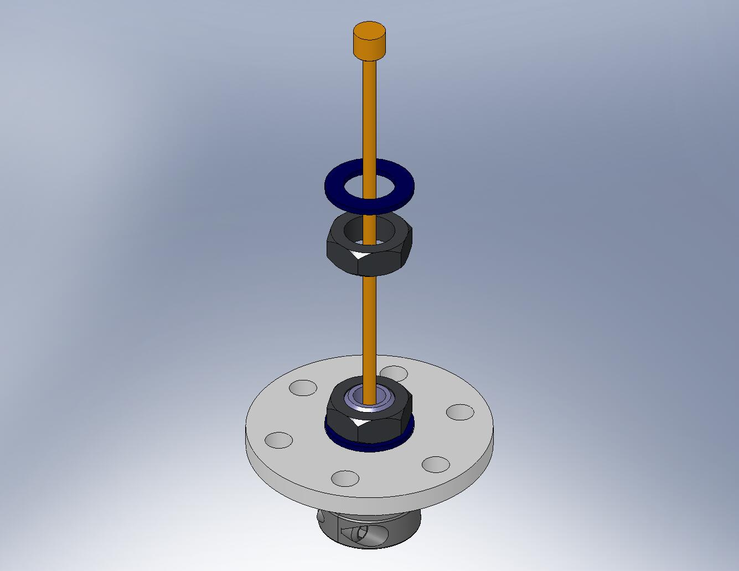
Figure 4.89. The hardware for the top Flexure Mount must go on before the Flexure Assemblies are inserted into the Springs.

- Pass a Flexure Assembly through the slot at the end of one of the Springs, as shown in Figure 4.90.
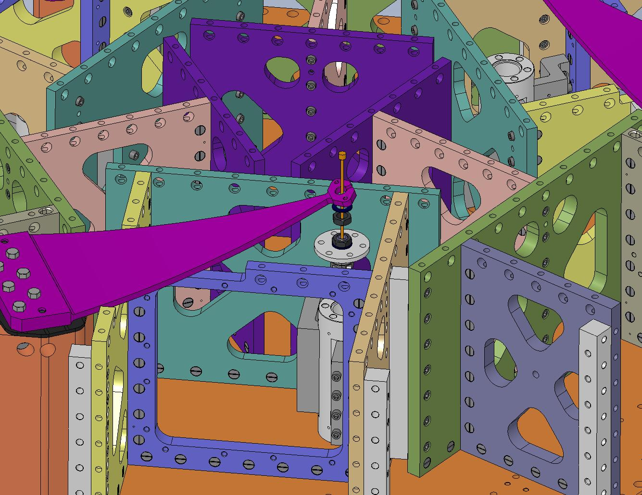
Figure 4.90. Pass the Flexure through the slot at the end of the Spring. Hold it in place during the next few steps.

- Slide a Flexure Mount (D071103) over the top of the Flexure, as shown in Figure 4.91. Seat the Flexure Mount within the mating hole in the Spring.
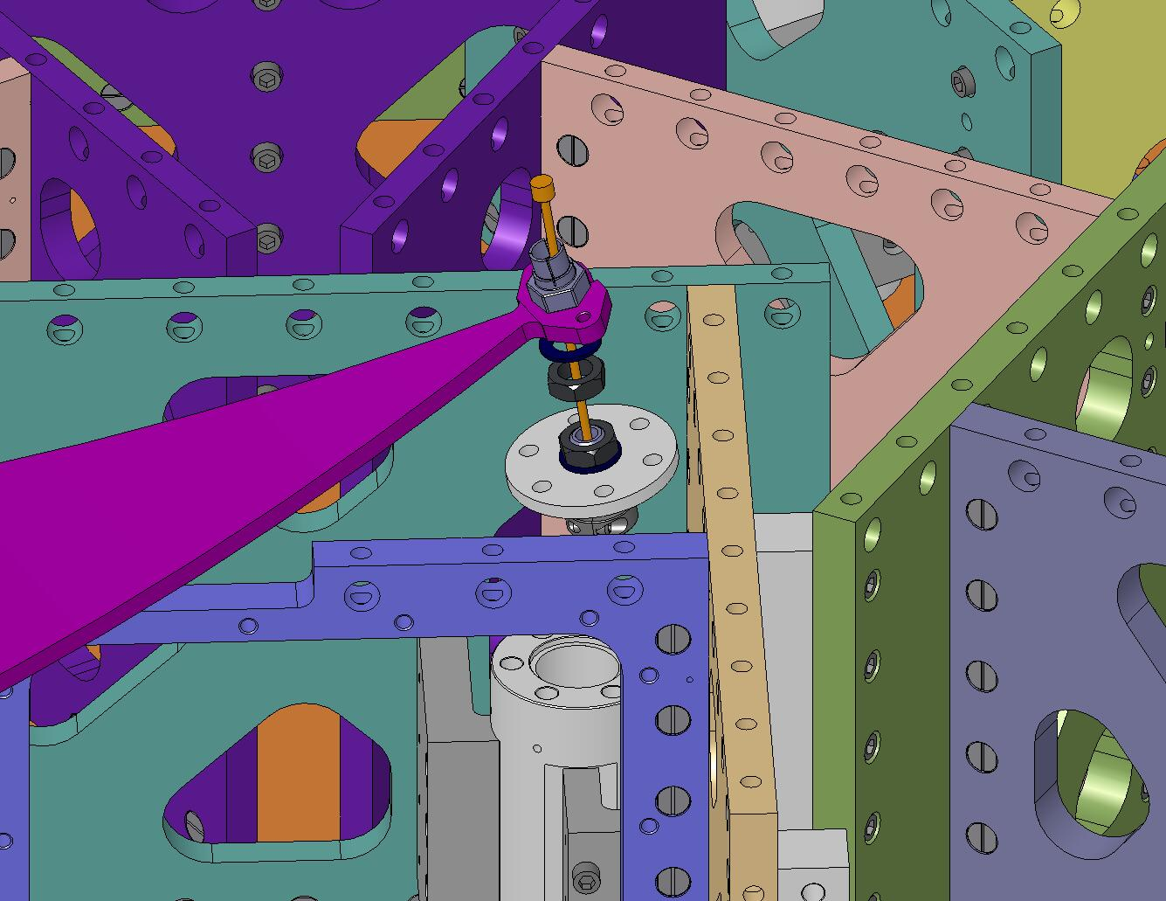
Figure 4.91. Slip a Flexure Mount over the end of the Flexure, then engage it in the Spring.

- Thread the jam nut onto the Flexure Mount, as shown in Figure 4.92. Make sure there is good contact between the Mount’s hex flange and the top of the Spring. Torque the nut to final spec.
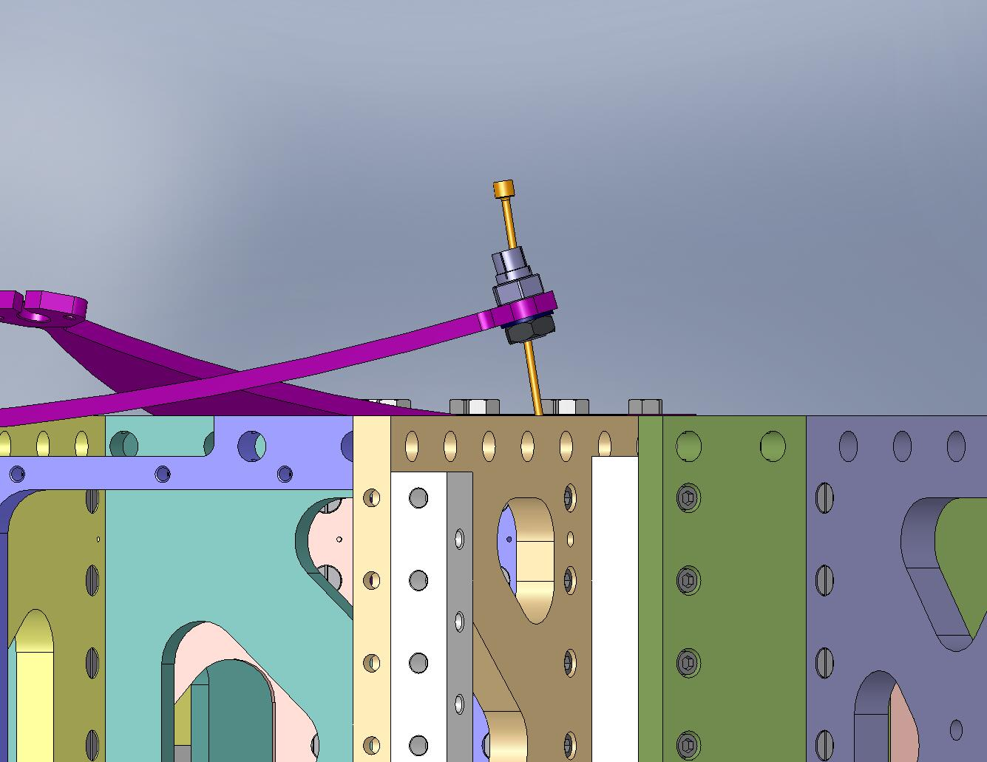
Figure 4.92. Torque the jam nut against the hex flange on the Flexure Mount.

- Place something (e.g., a twisted O-ring) between the top end of the Flexure and the inside of the Flexure Mount, to prevent the Flexure from seating. This reduces the risk of accidentally bending the Flexure when the Springs are loaded.
- Repeat the last few steps with the other (2) Flexure Assemblies.
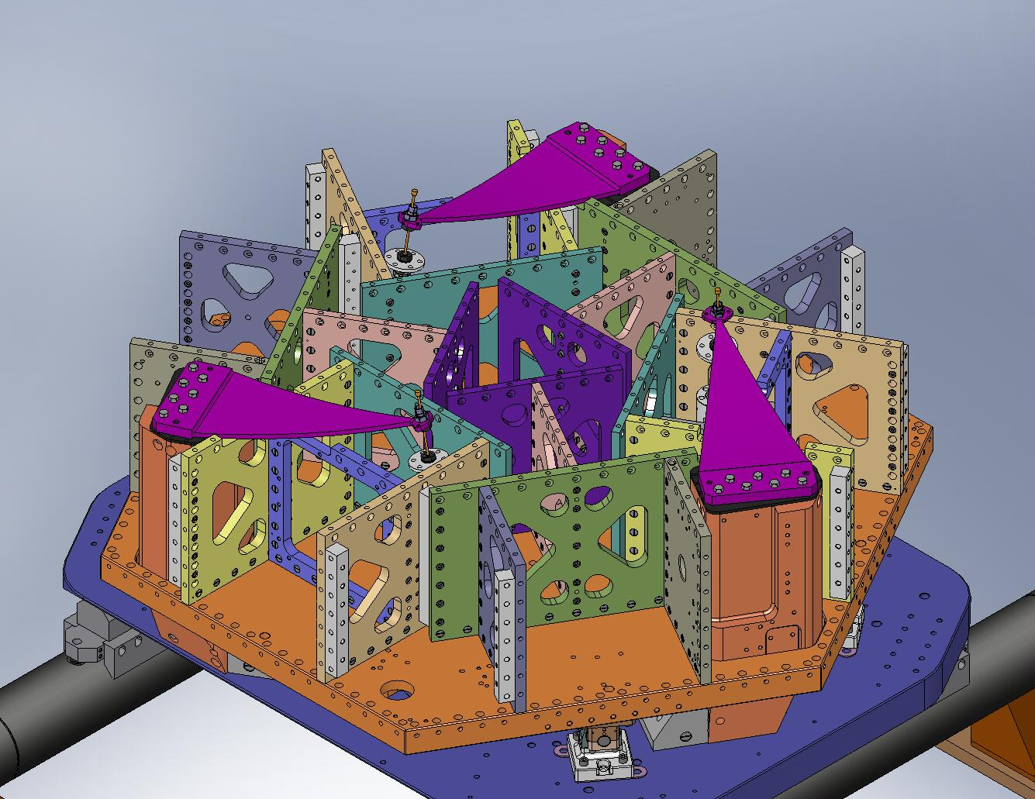
Figure 4.93. Flexure Assemblies temporarily mounted in all (3) Springs. Next, the Springs will be loaded flat.

- Move the (3) bottom parts of the Spring Pull-Down Assemblies (above, Figure 4.62) between Stage 0 and Stage 1. Insert the Spring Pull-Down Bases (D071307) in the (3) matching pockets in the Stage 0 Base, as shown in Figure 4.94.
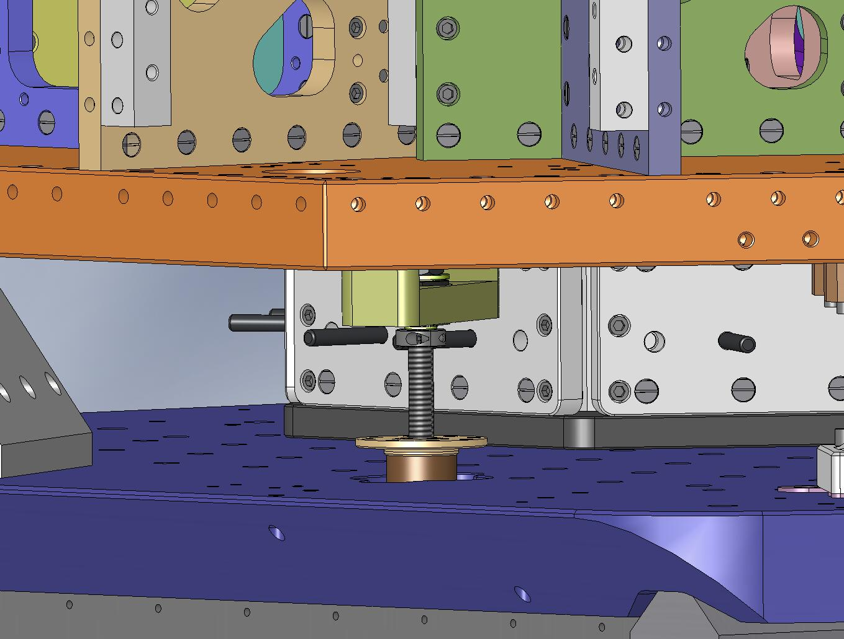
Figure 4.94. The (3) Spring Pull-Down Bases mount inside pockets in the Stage 0 Base.

- Start the screws holding the Pull-Down Bases to the Stage 0 Base. Snug them all, then torque them to final spec.
Hardware:
(24) 3/8"-16x1.25" SHCS
(24) 3/8" vented washers
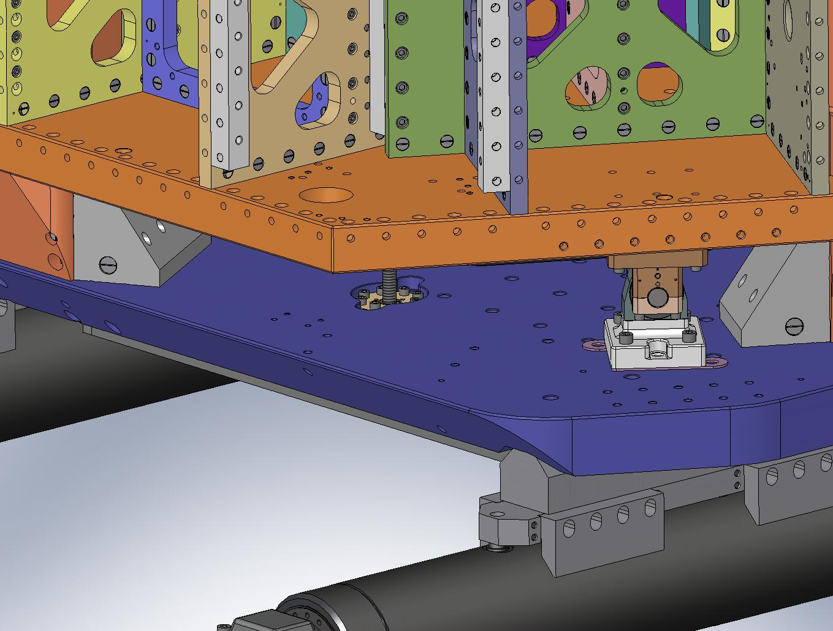
Figure 4.95. Screws holding the bottom of the Spring Pull-Down Tooling to Stage 0.

- Unscrew the ACME Screw (D071309), until the bottom of the shaft collar is 4” above the Pull-Down Base, as shown in Figure 4.96.
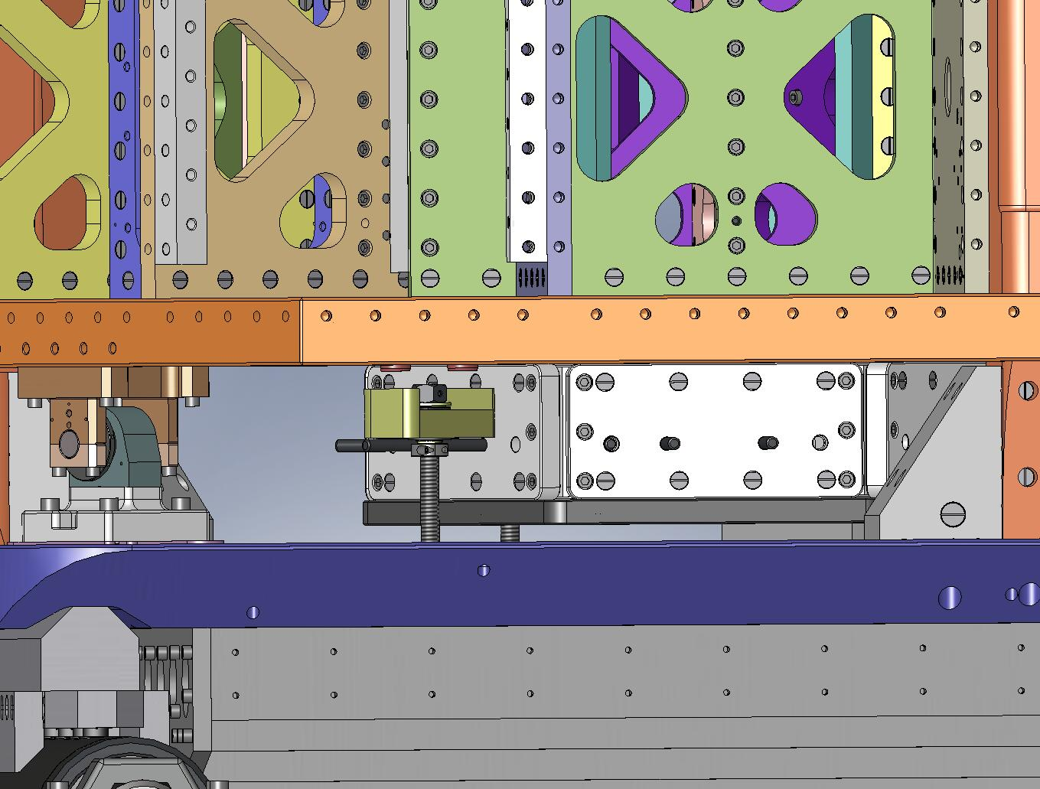
Figure 4.96. Set the starting length for the ACME Screw, leaving 4” between the bottom of the shaft collar and the top of the Pull-Down Base. The Spring Pull-Down Assembly must pull through 3.5” to flatten the Springs. The ACME Screw is not fully engaged in the Pull-Down Nut during the first .5” of travel, but the tension is small over this range.

- Lay the (3) top parts of the Spring Pull-Down Assemblies (above, Figure 4.68) on top of the Springs, as shown in Figure 4.97. Carefully pass the ends of the Pull-Down Rods (D071303) through i) the Spring Tension Bushings in the Stage 1 Floor and ii) the Spring Pull-Down Bars (D071306), as shown in Figure 4.98.
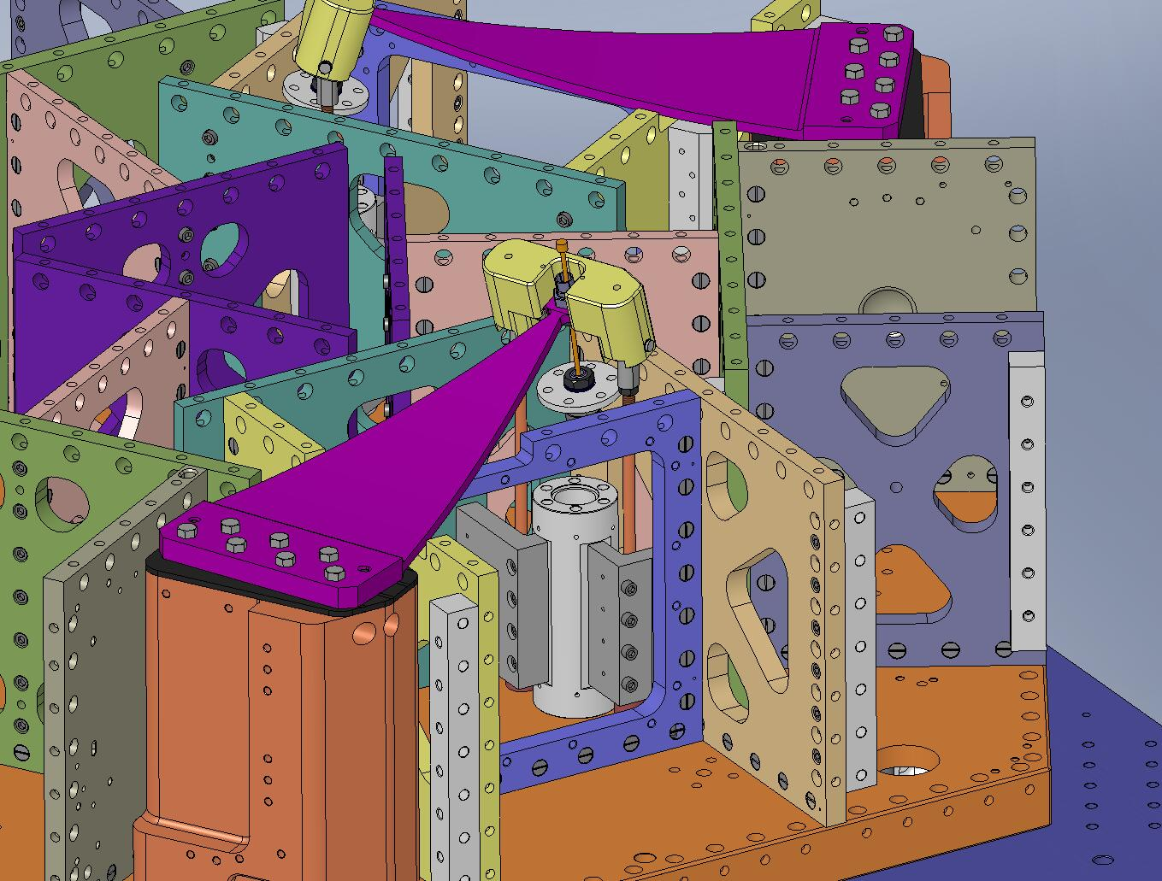
Figure 4.97. Engage the Pull-Down Cap with the end of the Spring. The (2) dowel pins in the Cap should seat in the matching Spring holes.
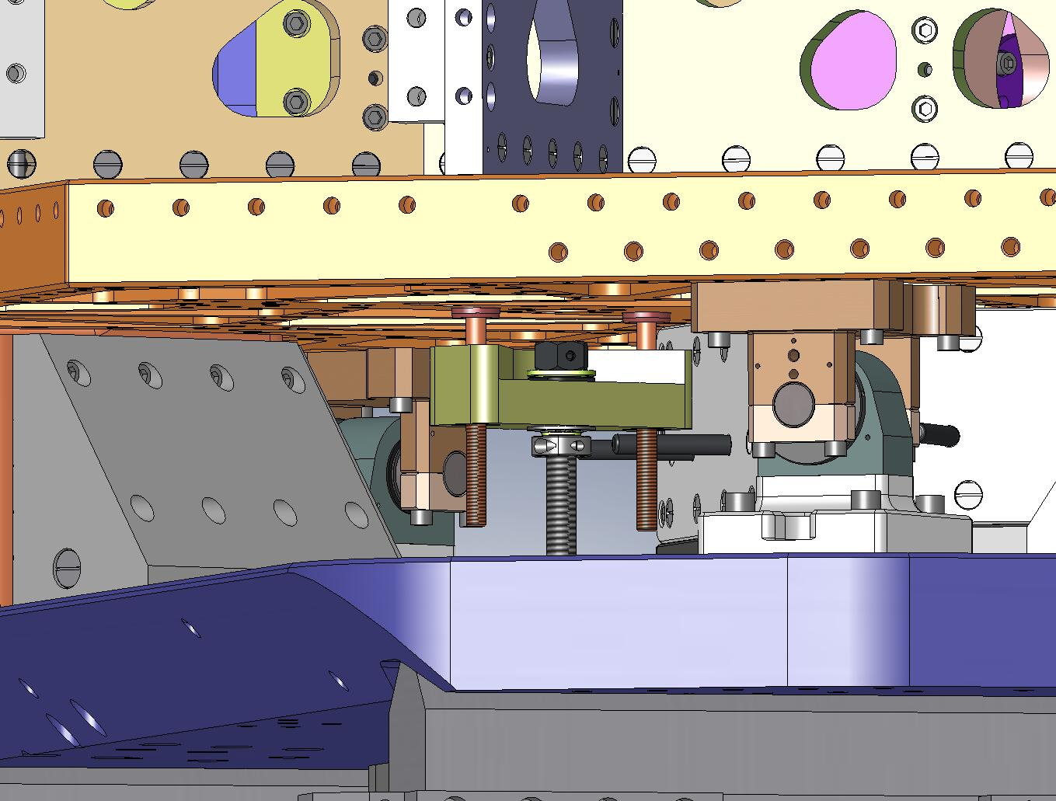
Figure 4.98. Pass the Pull-Down Rods all the way through the holes in the Pull-Down Bar. Note the triangular pocket in the top of the Pull-Down Bar should face to the right – this allows better access for tightening the ACME Screw.

- Place a spherical washer set (McMaster-Carr #91944A470) on each Pull-Down Rod, followed by a custom silver-plated 1/2”-20 coupling nut (D0901023), as shown in Figure 4.99.
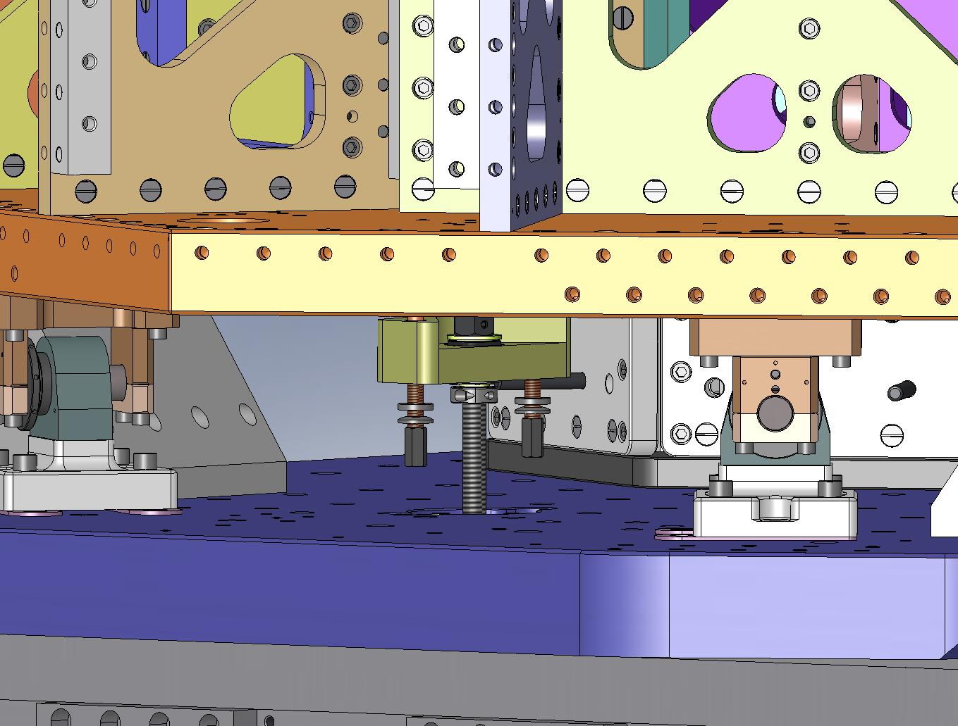
Spherical Washer, Female
Spherical Washer, Male
Ag-Plated Coupling Nut
Figure 4.99. Hardware for the bottom ends of the Pull-Down Rods.

- With the Pull-Down Caps seated flush to the tops of the Springs, tighten the coupling nuts enough to cause a little tension on each Pull-Down Rod. Use equal torque for the (2) coupling nuts on a single Pull-Down Assembly – this is necessary to avoid twisting the Spring during loading.
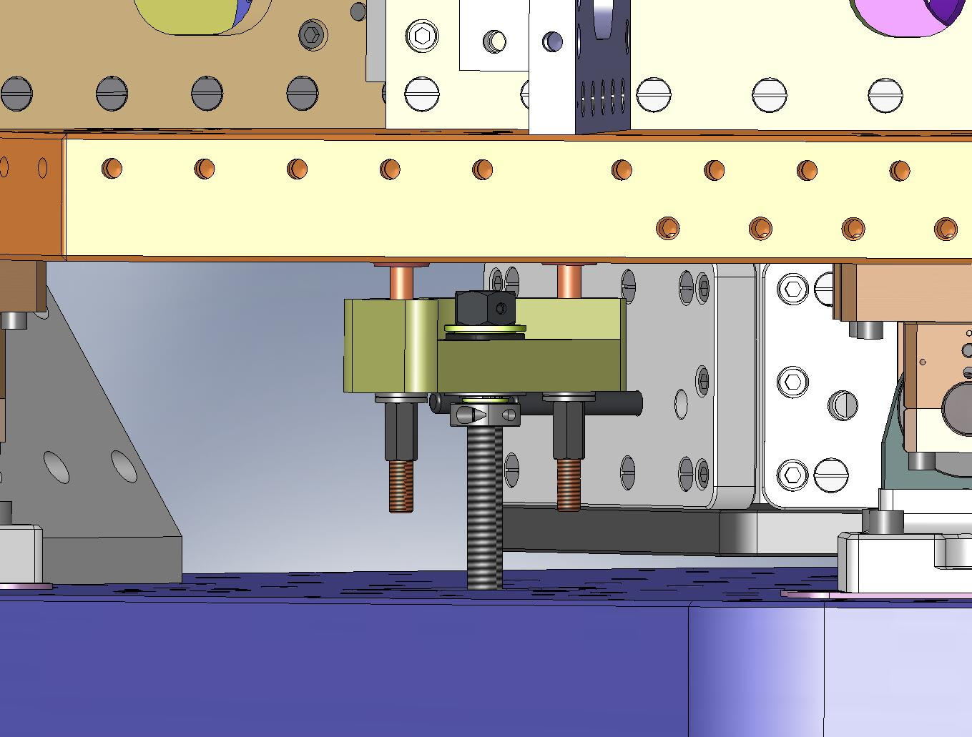
Pull-Down Rods should have equal tension.
Figure 4.100. Carefully tighten the coupling nuts, so both Pull-Down Rods on each Pull-Down Assembly have the same tension.

- Using a ratcheting box wrench, begin tightening all (3) ACME Screws, as shown in Figure 4.101. As the load on each Spring increases, its shape will approach the final, flat profile.
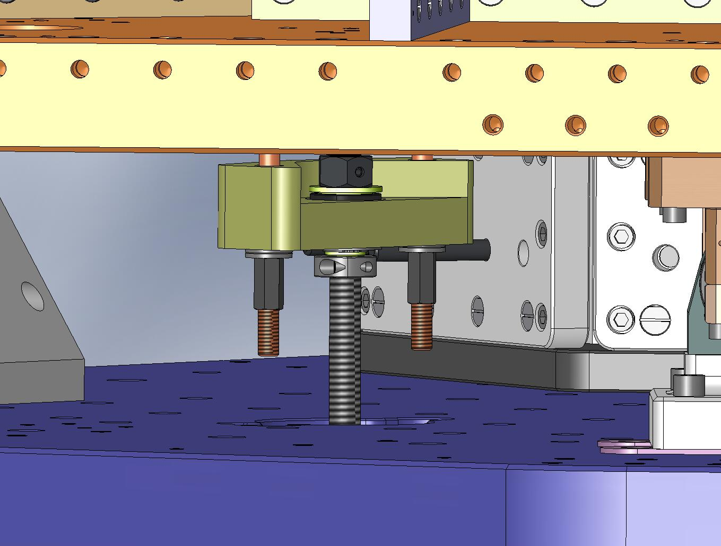
Tightening the Screw tensions the Springs.
Figure 4.101. Load the Springs by tightening the ACME Screws. The Springs may be tightened in any order.

- When loading the Springs, make sure that the Flexure Assemblies do not become wedged against anything on Stage 1.
- As each Spring approaches horizontal, remove the O-ring from its top Flexure Mount, and insert (2) Flexure Cups (D071104), as shown in Figure 4.102. Try to align the Cups with the grooves in the Mount.
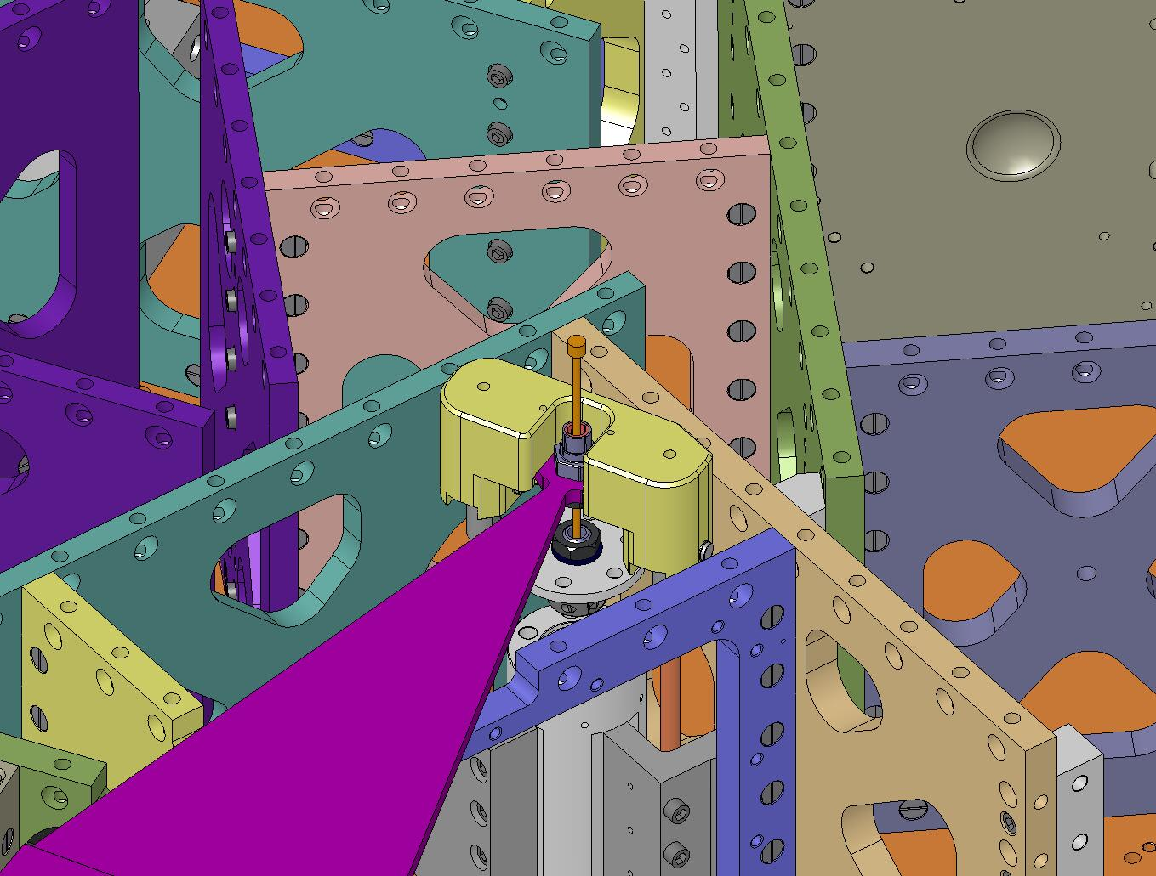
Insert (2) Flexure Cups into each Flexure Mount.
Figure 4.102. Preparing to clamp the Flexure Assemblies to Stage 0 and Stage 1: start by inserting (2) Flexure Cups into each Flexure Mount.

- Place a D0900207 shaft collar with silver-plated screws around the top of each Flexure Mount, as shown in Figure 4.103. Leave the collar loose, so the Flexure can slip in and out of the Flexure Cups without a lot of force.
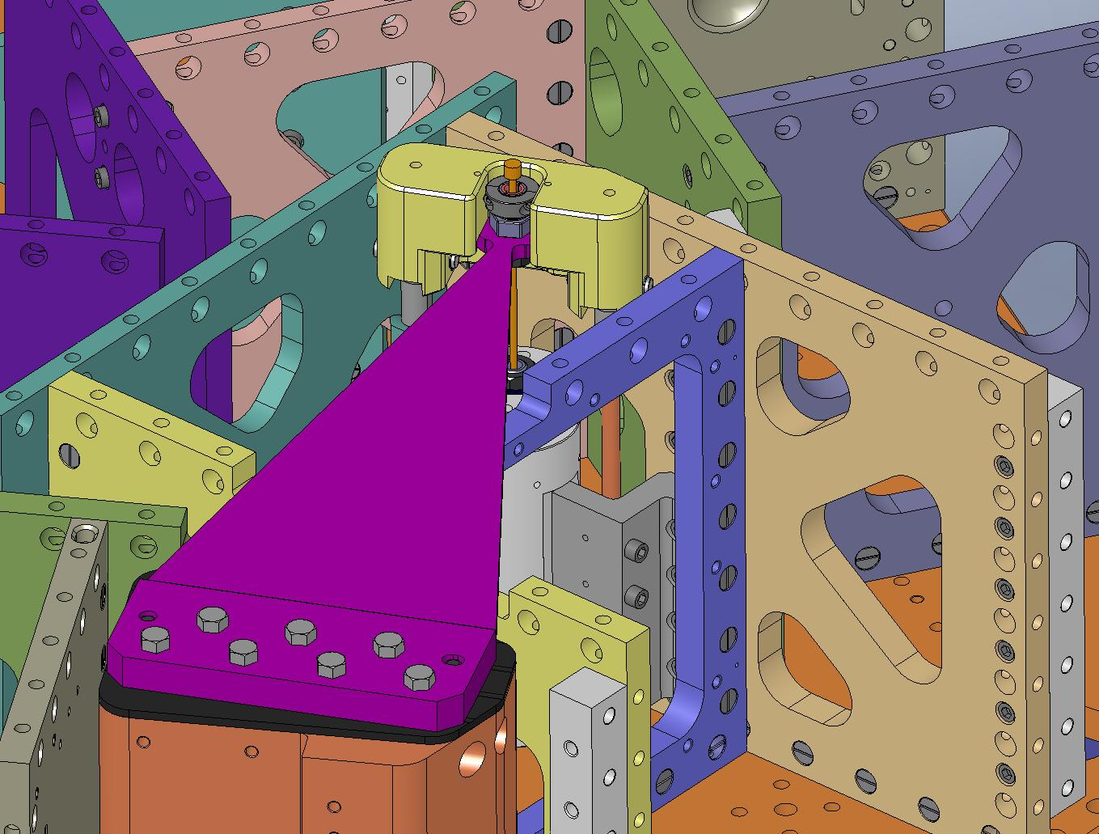
Figure 4.103. Shaft collars will be used to clamp the top of each Flexure to its Flexure Mount. The screw heads must face outward.

- Hold the top ends of the Flexures above the Flexure Cups, while continuing to load each Spring. Place a straightedge on the Spring to check for flatness. Adjust the tension on the Pull-Down Tooling, until the Spring is flat (to within ~.005”-.010”).
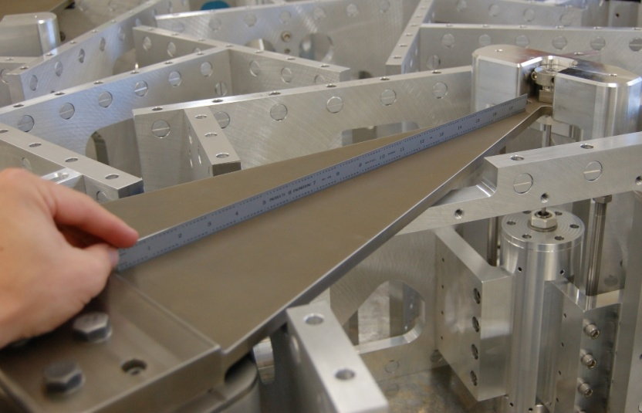
Figure 4.104. Place a straightedge on the Spring, to check the flatness.

- Carefully pull the Flexure into the Flexure Cups. Depending on the height of the Spring tip, either i) the Flexure will seat fully in the Flexure Cups, before the Flexure Lower Plate touches the Flexure Post, or ii) the Flexure Lower Plate will seat first.
- Adjust the Spring tension until you can seat the Flexure Lower Plate, with the top of the Flexure protruding about .005” above the top Flexure Mount, as shown in Figure 4.105.
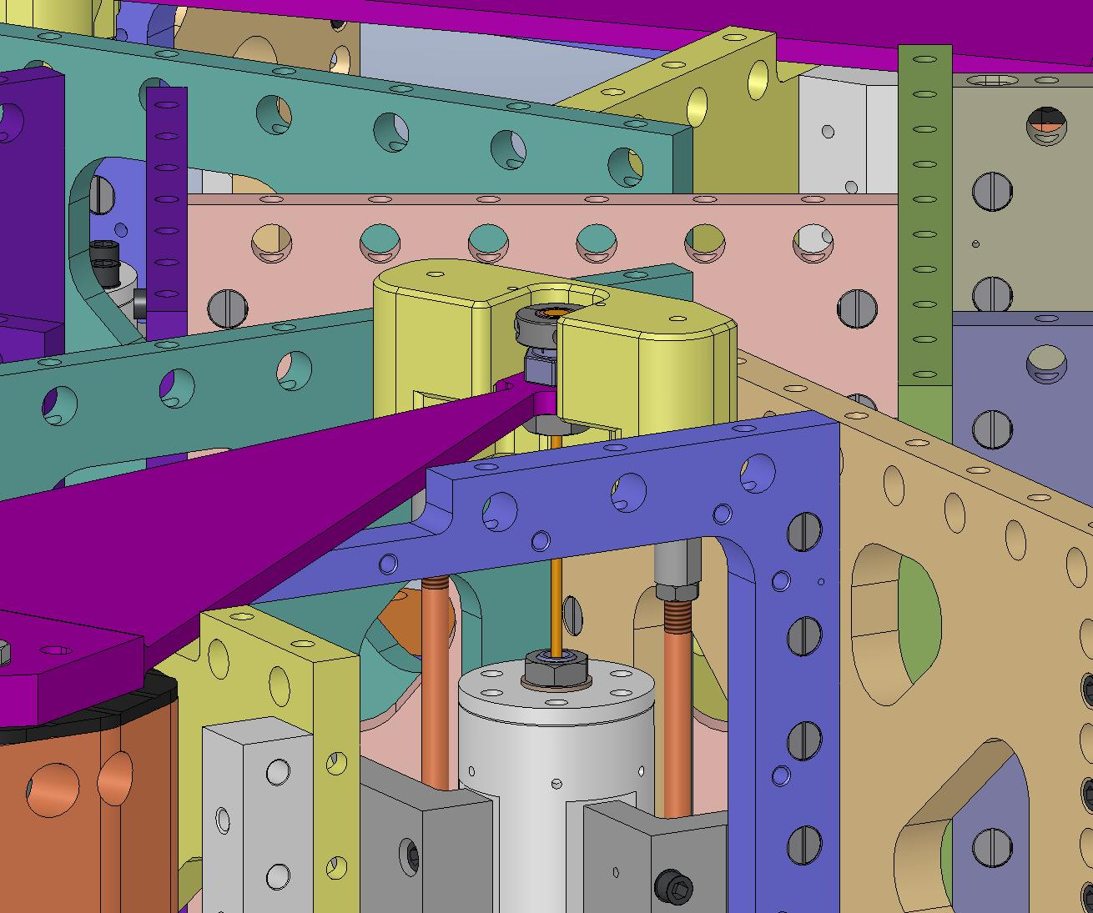
Head of Flexure protrudes ~.005” above top of Flexure Cups.
Flexure Lower Plate seated on Flexure Post.
Figure 4.105. Slightly over-extend Spring, so Flexure Lower Plate seats fully on Flexure Post. There should be a small (internal) gap between Flexure and Flexure Cups.

- Add hardware to Flexure Lower Plate. Snug all screws on a Plate, then torque to final spec, using a staggered pattern.
Hardware:
(24) 3/8"-16x1.0" SHCS
(24) 3/8" vented washers
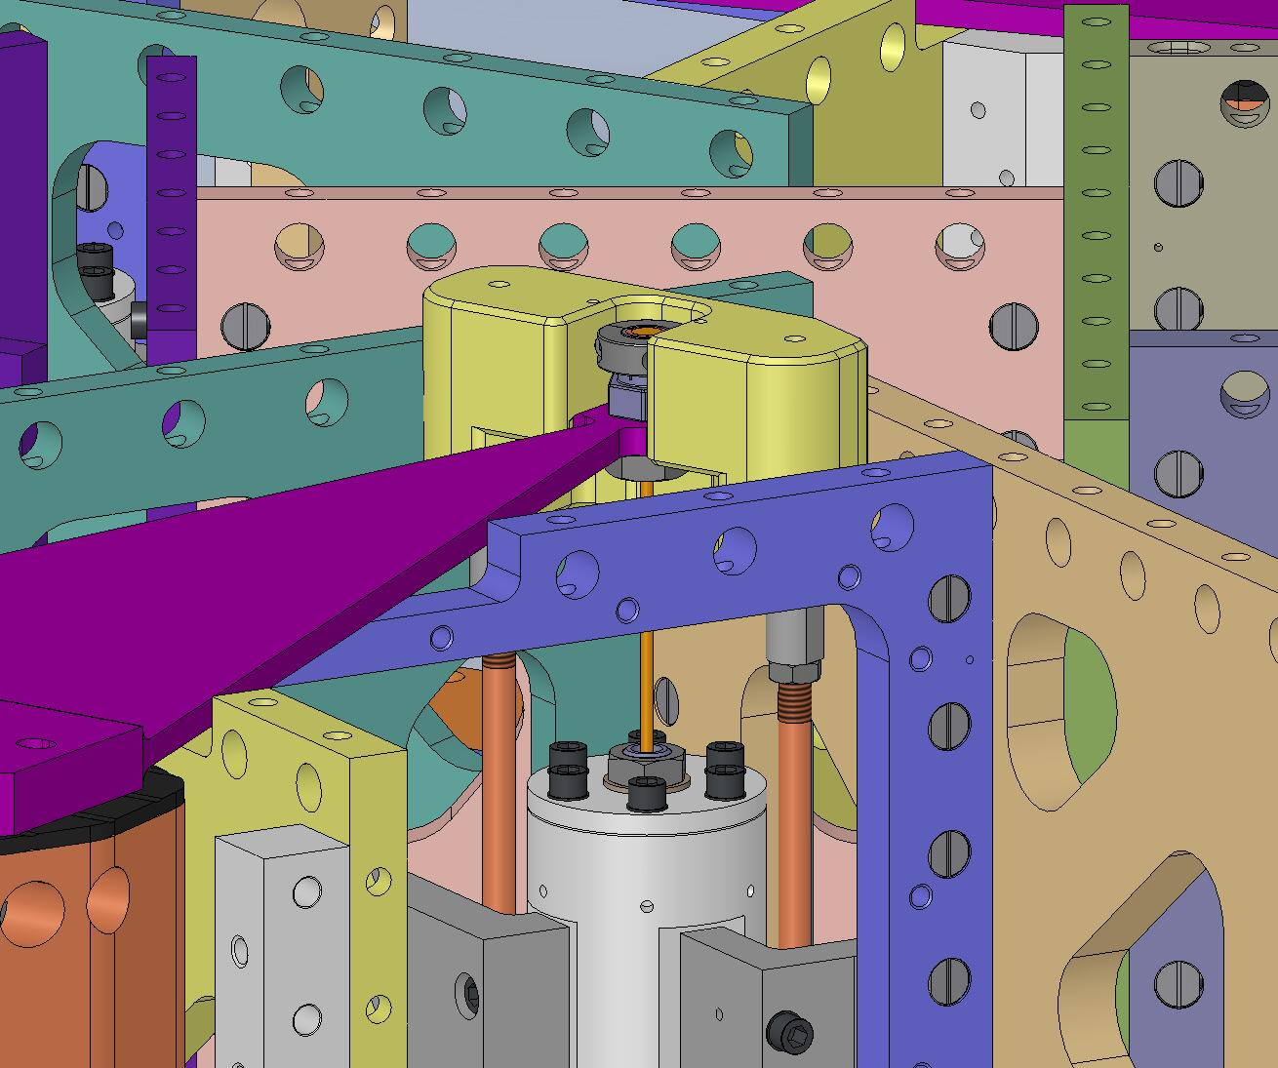
Figure 4.106. Bolt the Flexure Lower Plates to the Flexure Posts.

- Before moving onto next step, all (3) Springs should be loaded and all (3) Flexure Lower Plates should be bolted in.

Mount Optical Table to Stage 1 Assembly
- Bolt (3) Particle Fences (D071009) to the Support Posts, as shown in Figure 4.107. Torque screws to final spec.
Hardware:
(6) 1/4"-20x.75" SHCS
(6) 1/4" vented washers
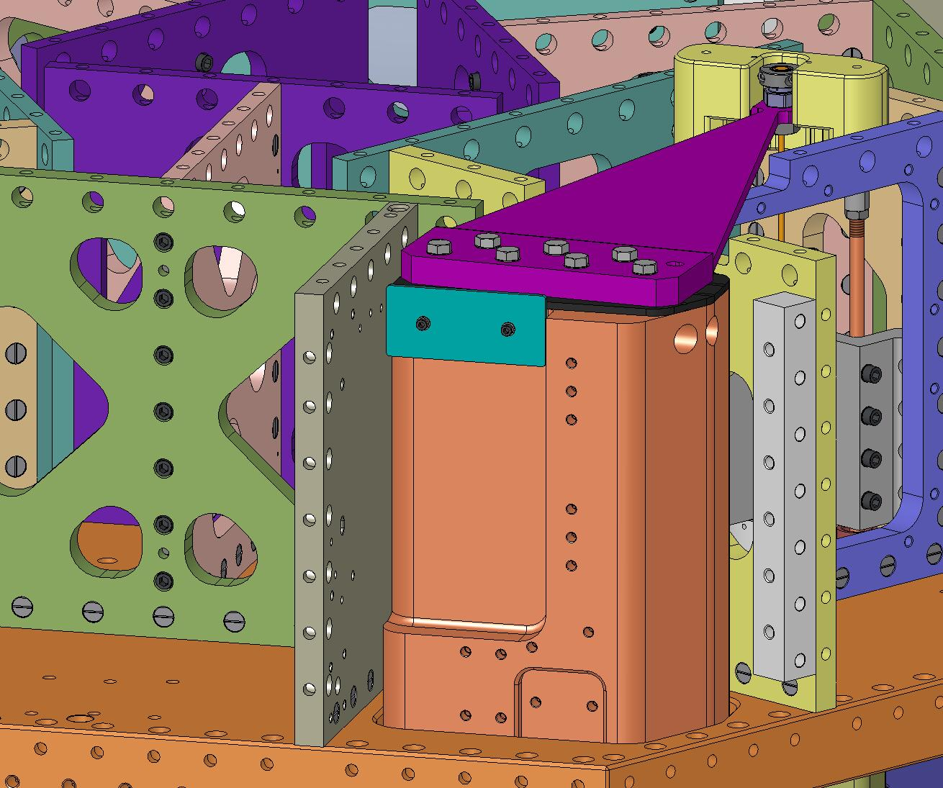
Figure 4.107. Particle Fences are added to prevent debris from Optical Table surface migrating down to Horizontal Actuators.

- Bolt (3) Rib, Tan, Flexure Mid Covers (D071072) to Rib, Tan, Flexure Mid plates (D071071), as shown in Figure 4.108. For each Cover, first snug all screws, then torque to final spec.
Hardware:
(48) 1/4"-20x1.0" SHCS
(48) 1/4" vented washers
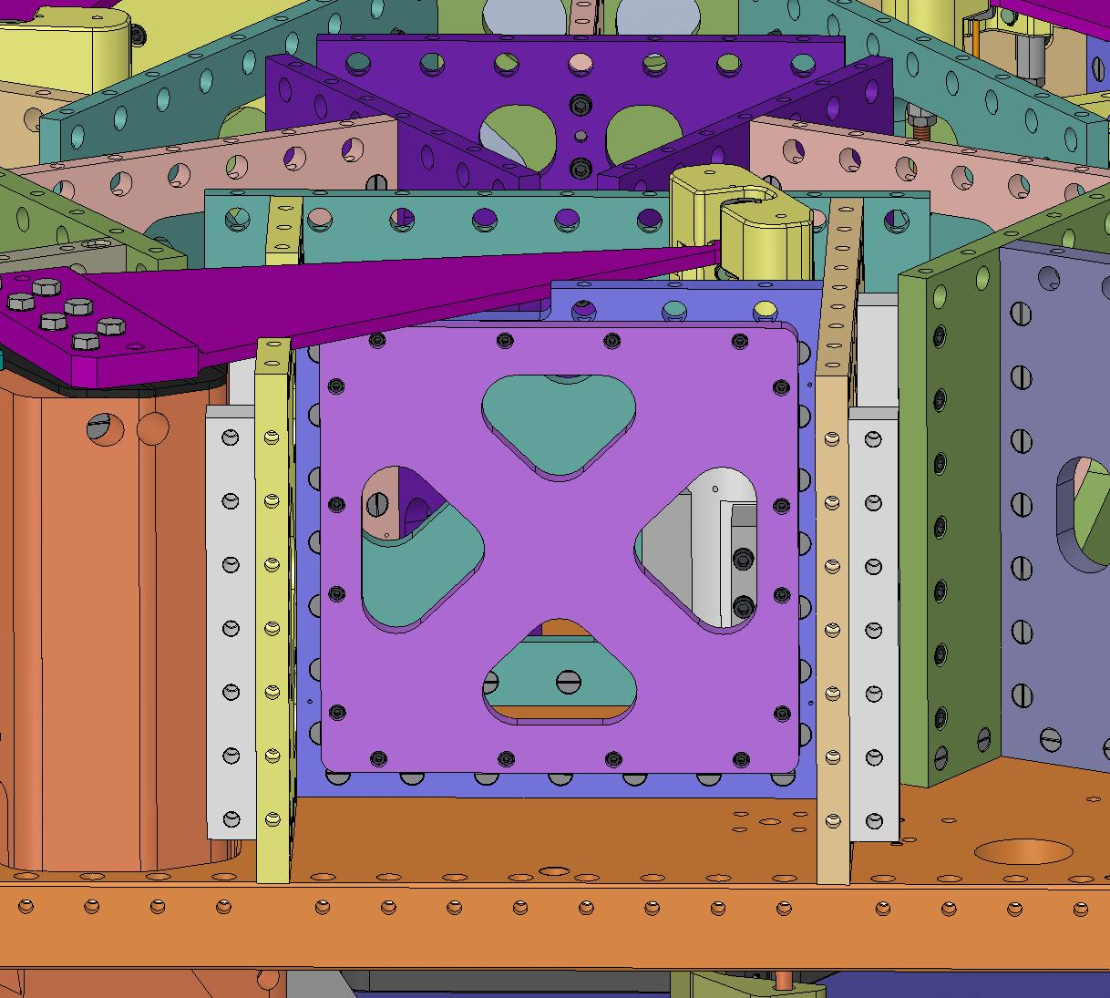
Flexure Cover
Figure 4.108. Orientation of Flexure Mid Cover is not important.

- Place (66) Type 00 Barrel Nuts (D071250-00) and (111) Type 01 Barrel Nuts (D071250-01) in openings along tops of Stage 1 Ribs, as shown in Figure 4.109. Flats should all face down (i.e., away from screws). Check that every tapped hole will be accessible after Optical Table (D071050) is installed.
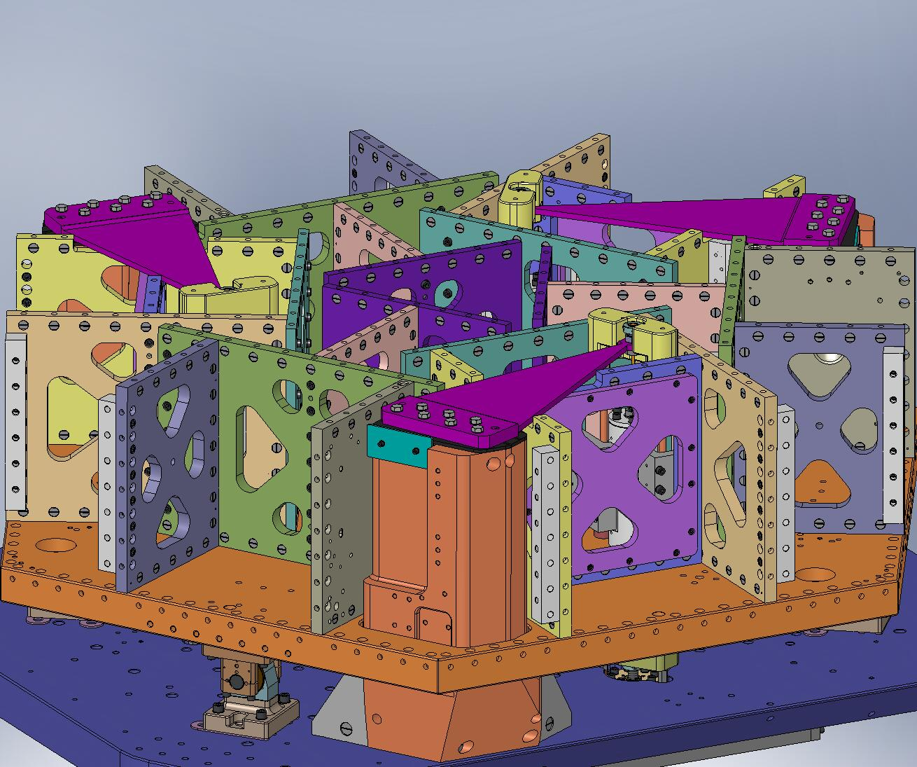
Figure 4.109. Barrel Nuts inserted along top of Stage 1 Ribs. Tapped holes in Nuts must be aligned with thru holes along tops of Ribs (highlighted in red). Refer to Figure 3.37 and Figure 3.46 for detailed identification of which Nut types match with each Rib.

- Top of Optical Table must be handled with care, to keep it free of scratches!
- Install (2) 3/4”-10 lifting eyes into top of Optical Table. Note: Table has (4) tapped holes for lifting – use (2) that are on same mid-line to help maintain balance.
- Lift Optical Table with overhead crane. Position over Stage 1. Orientation is important: vent grooves must run parallel to Support Tubes, while (3) pockets line up with Spring Pull-Down Assemblies.
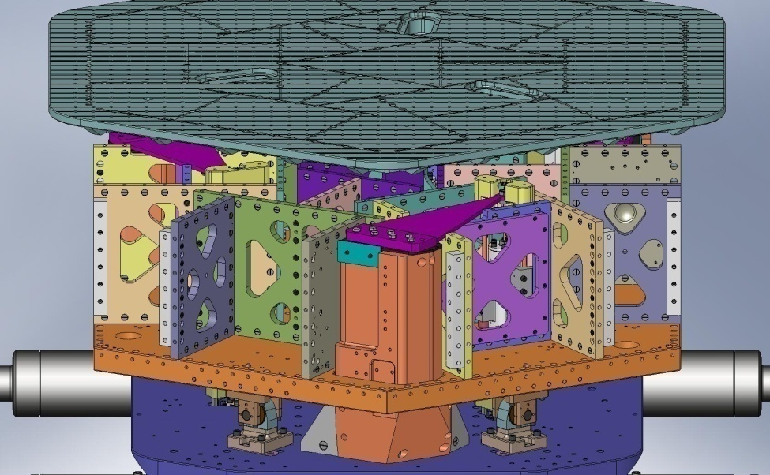
Figure 4.110. Optical Table positioned over Stage 1. Orientation should be set as follows: vent grooves in Table running parallel to Support Tube axes, and (3) oval pockets positioned over (3) Spring Pull-Down Assemblies.

- Place a 1/2” shaft collar on one end of each of (3) 1/2”x12” steel shafts. Leave about 2.75” of the shaft below the collar, and clamp the collar in place. See Figure 4.111.
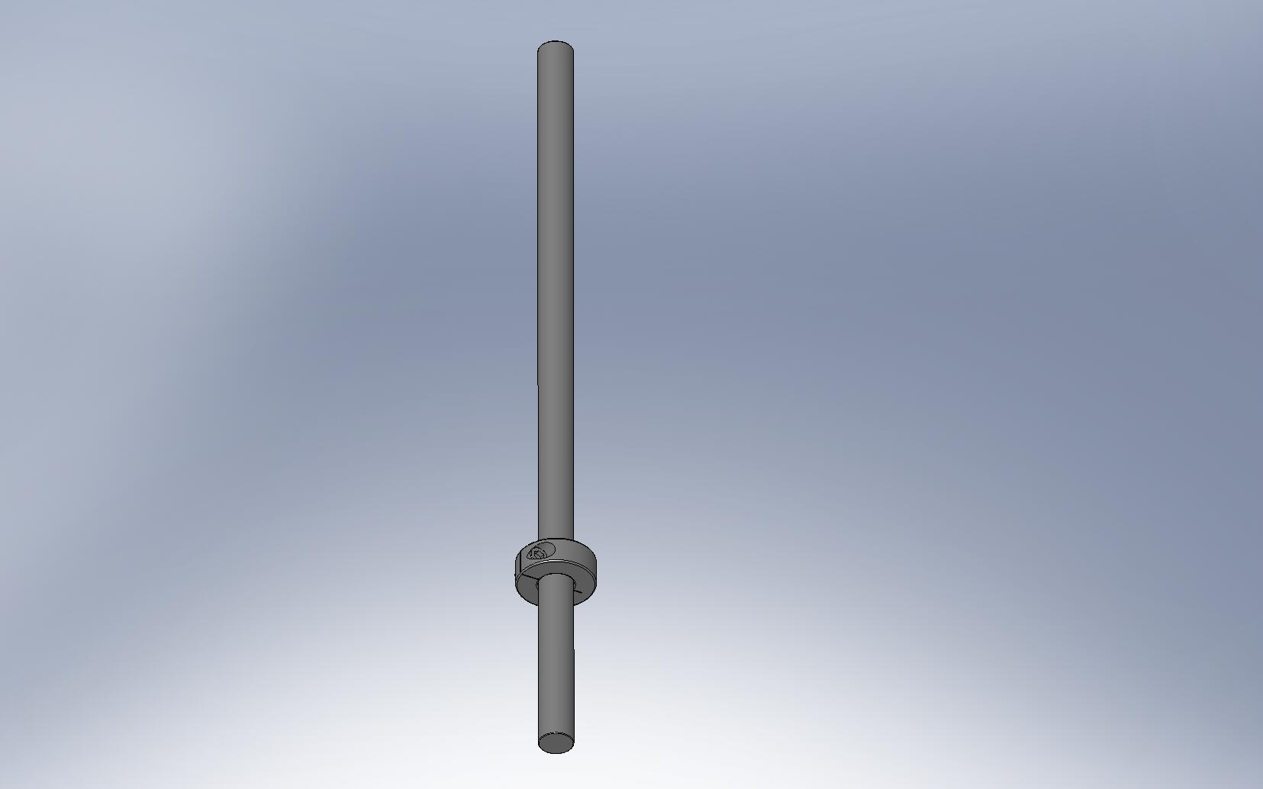
Figure 4.111. Place shaft collars toward the bottom end of (3) 1/2”x12” long dowel pins. These will help orient the Optical Table to the Stage 1 Ribs.

- Drop the 1/2” shafts through the holes in the Optical Table, so approximately .25” stick below the Table’s bottom surface. These will align the Table to the Stage 1 Ribs, by mating with slots in the top of the (3) Rib, Rad, GS-13 Out 1 plates (D071055).
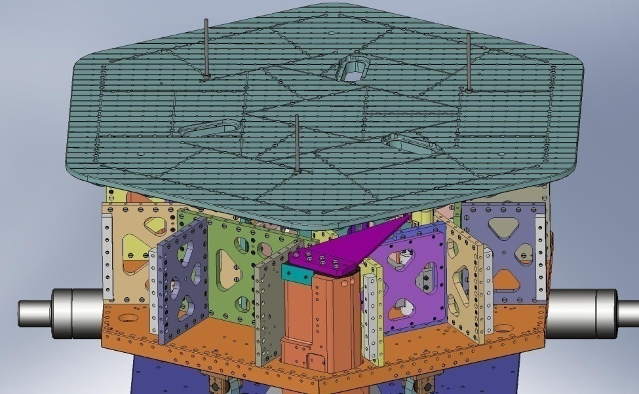
Figure 4.112. Insert (3) long pins into holes in top of Optical Table. These pins will locate to the slots in (3) of the Stage 1 Ribs, as shown in Figure 4.113.
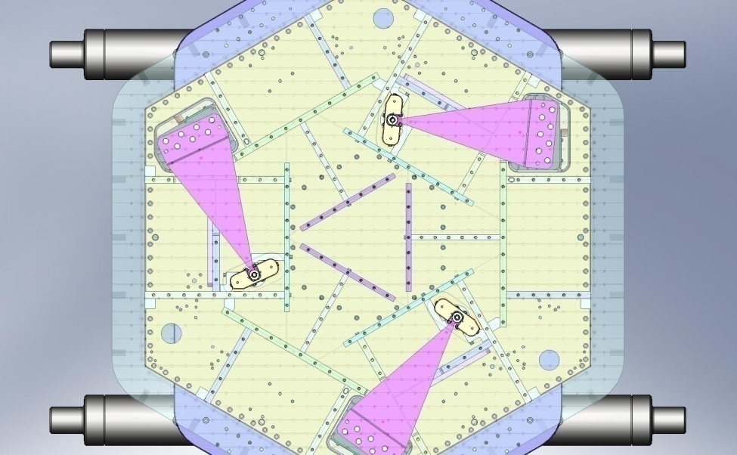
Figure 4.113. View from above ISI, with transparent Optical Table. The (3) slots marked with red circles are alignment slots in the Ribs. When lowering the Optical Table, mate the (3) long pins with these slots.

- Slowly lower the Optical Table, while guiding the 1/2” shafts into the mating slots.
- Once the Table is resting firmly on Stage 1, lower the crane and remove the lifting straps.
- Start all of the screws through the Optical Table. Do not tighten any of them, yet.
Hardware:
(177) 3/8"-16x1.75" SHCS
(177) 3/8" vented washers
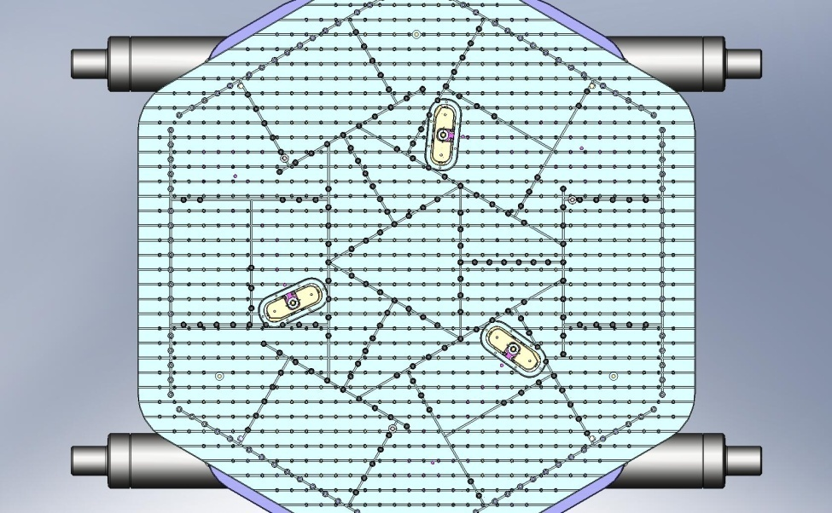
Figure 4.114. With Optical Table resting on Ribs, start (177) screws into Barrel Nuts.

- Tighten several screws near each of the (3) dowel pins. Remove the dowel pins.
- Snug all (177) screws in the Optical Table. After they are all snug, incrementally torque all of the screws to the final spec.

Release Springs
- Before Springs are released, the total load on the Locker Assemblies is Stage 1 mass minus mass of Outer Walls and Sensors/Actuators. Note that at least one of the Lockers could see significantly more than 1/3 of the total load, since the (4) Lockers over-constrain the system.
- Release tension from the (3) Spring Pull-Down Assemblies, evenly. Now, the Springs are pulling up on the Locker Assemblies.
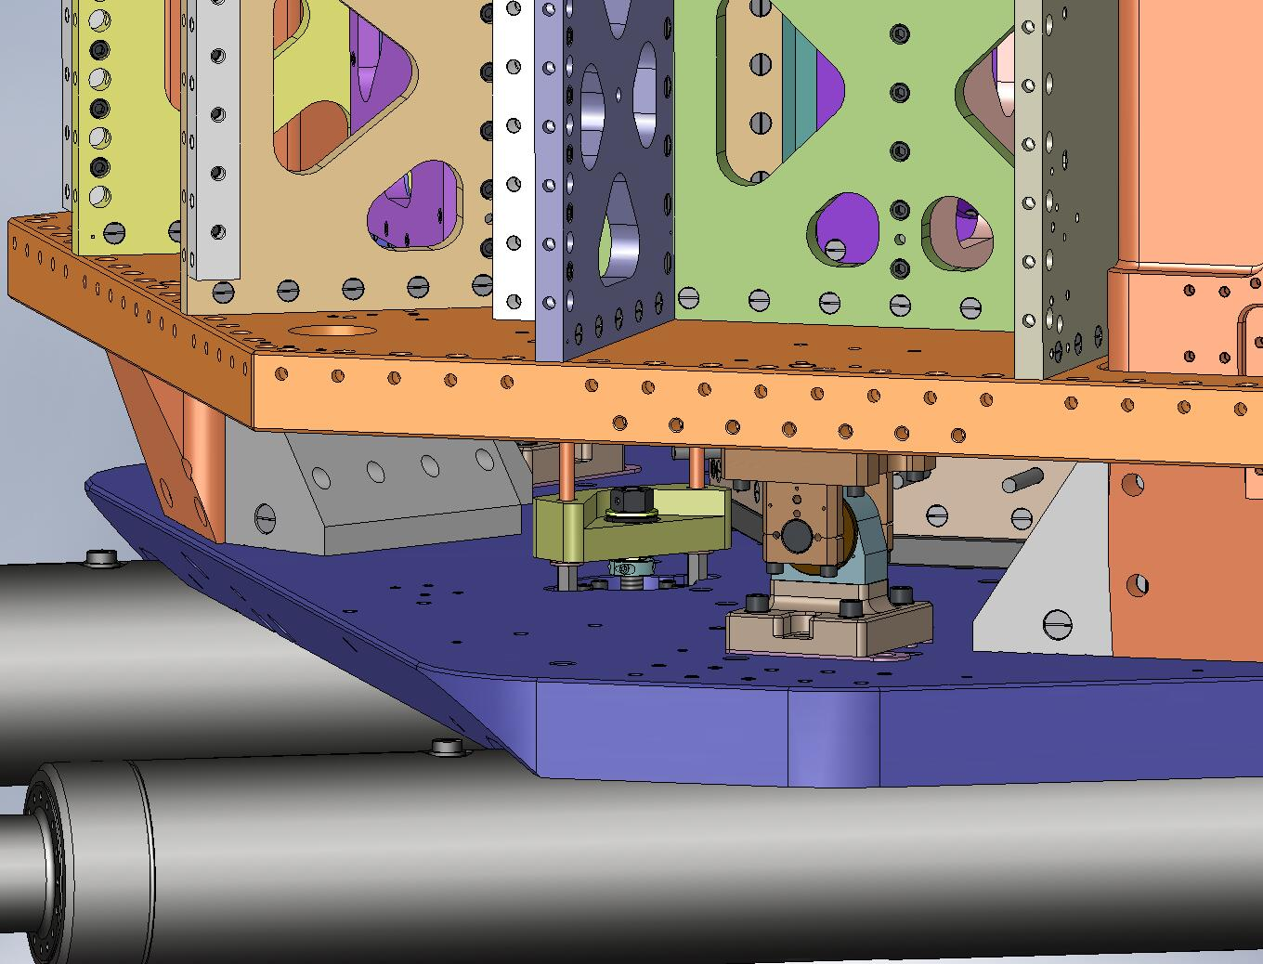
Figure 4.115. Loosen all (3) Spring Pull-Down Assemblies evenly, until the Flexure Assemblies are fully tensioned.

- Torque the silver-plated screws on the (3) shaft collars on the Flexure Mounts, to final spec.
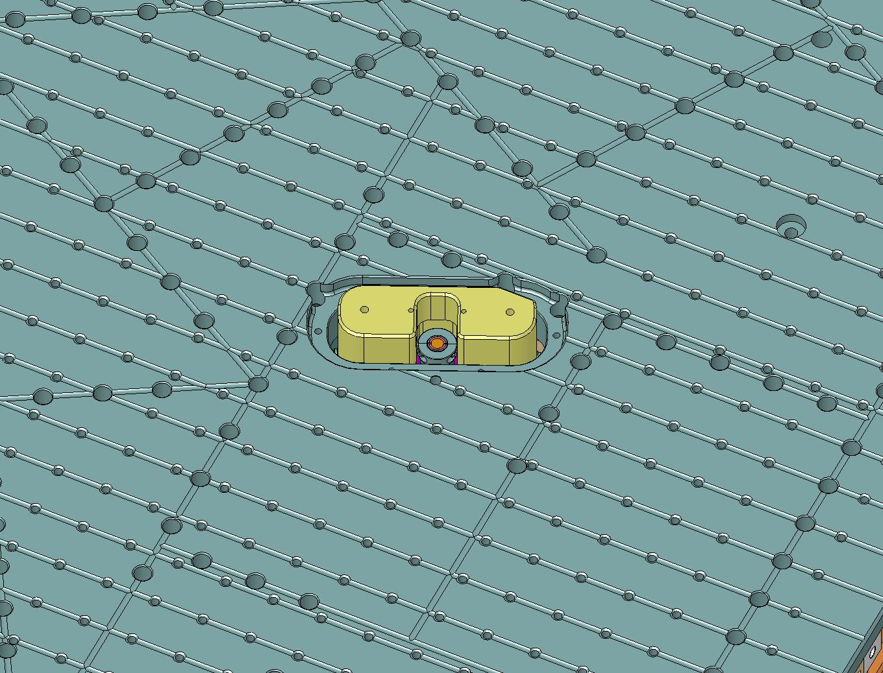
Figure 4.116. Torque the shaft collar screws on all (3) Spring/Flexure Assemblies.

- Unscrew the coupling nuts from the bottom of all (6) Pull-Down Rods. Remove the nuts and the spherical washers above them.
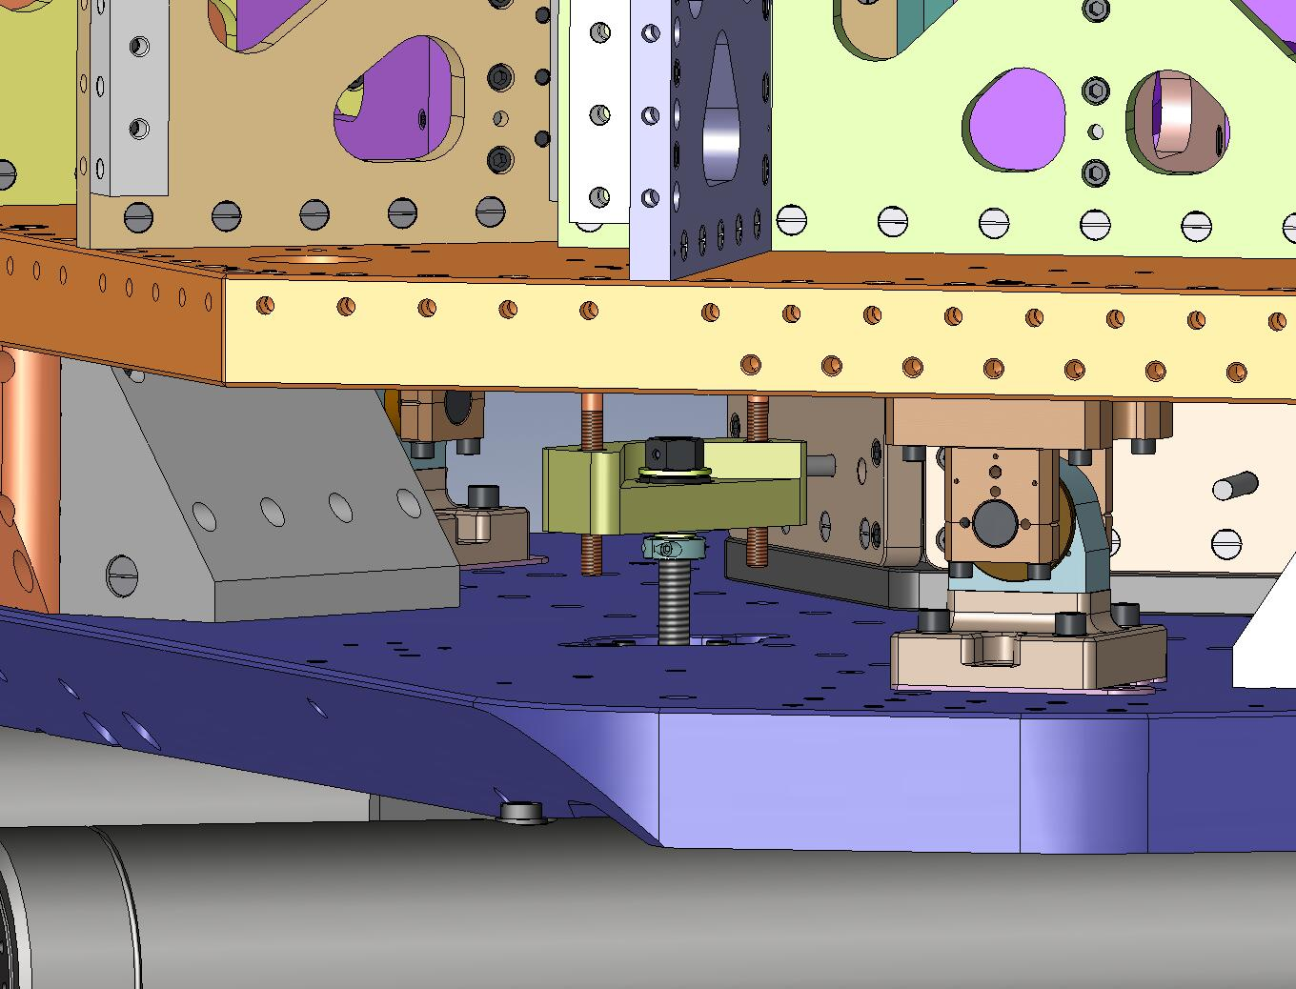
Figure 4.117. Remove the spherical washers and coupling nuts from under the Spring Pull-Down Bar.

- Pull the top part of the (3) Pull-Down Assemblies up through the Optical Table.
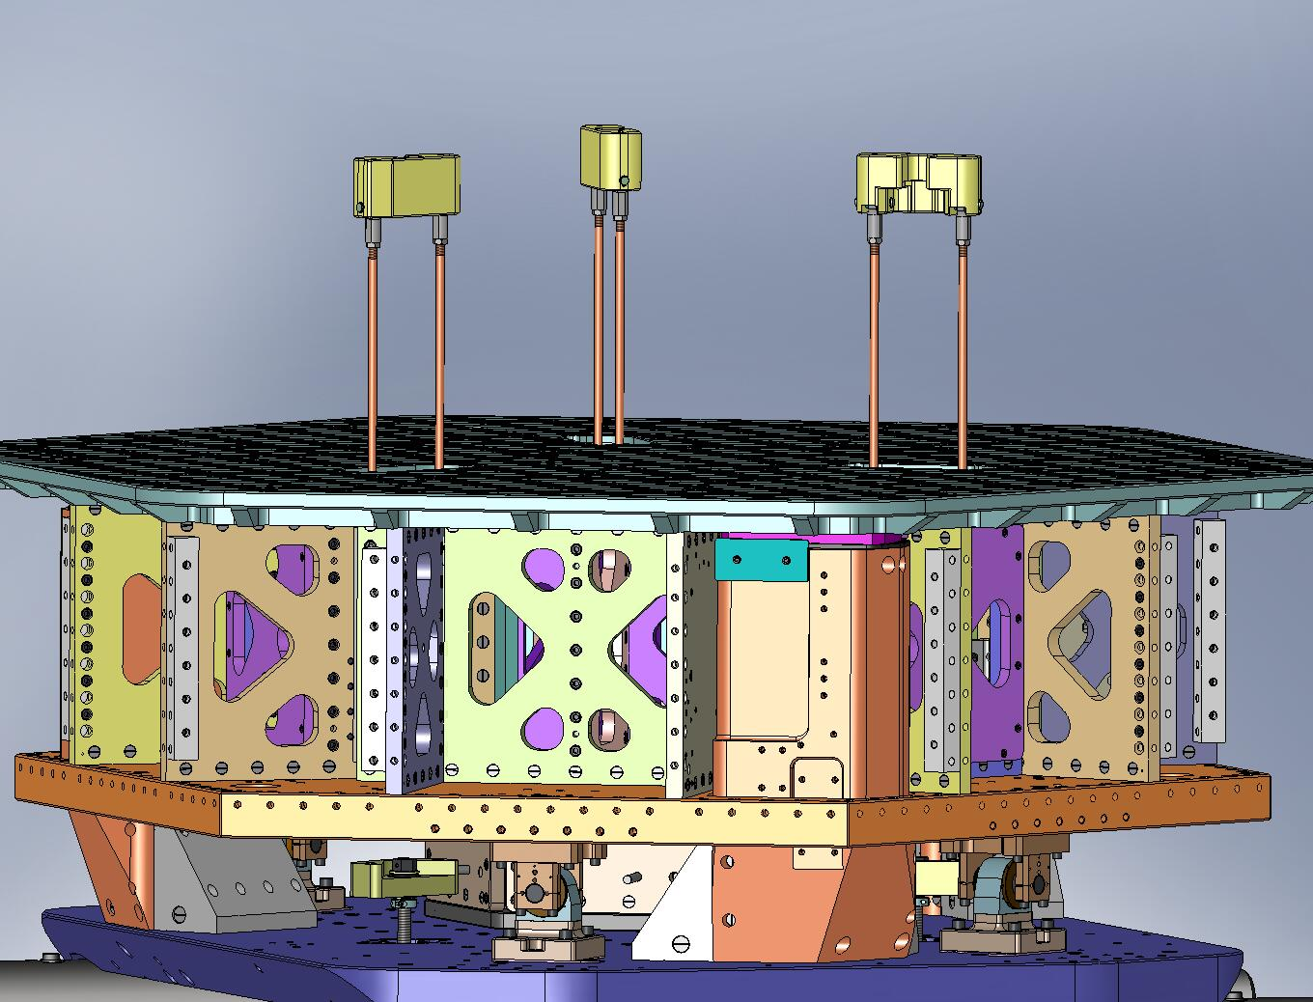
Figure 4.118. Pull out the top part of all (3) Spring Pull-Down Assemblies.

- Remove the (6) Spring Tension Bushings.
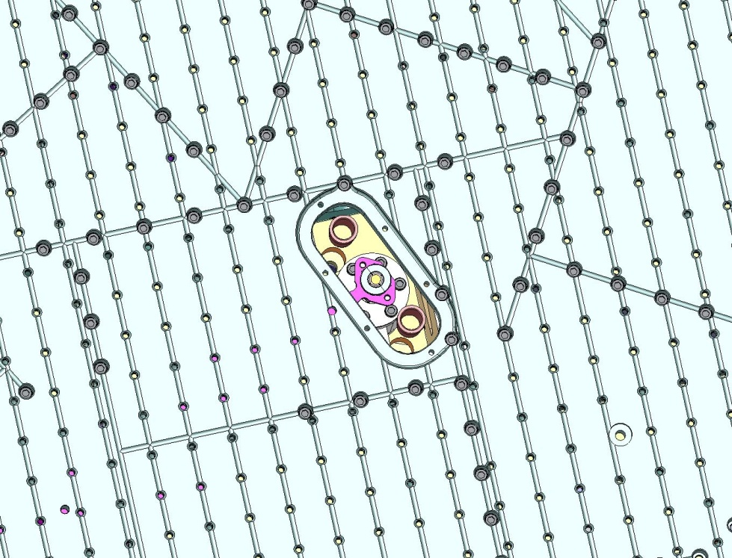
Figure 4.119. Remove the (6) plastic Bushings from the Stage 1 Floor.

- Unscrew the (3) ACME Screws from the Pull-Down Nuts.
- Unscrew the mounting hardware for the (3) Spring Pull-Down Bases, and remove the bottom part of the Spring Pull-Down Assemblies from the ISI. Move to long-term storage, along with top part and hardware. (Note: the Pull-Down Nuts (D071308) are made of 660 Bronze, which is not vacuum compatible – they must be removed from the ISI.)
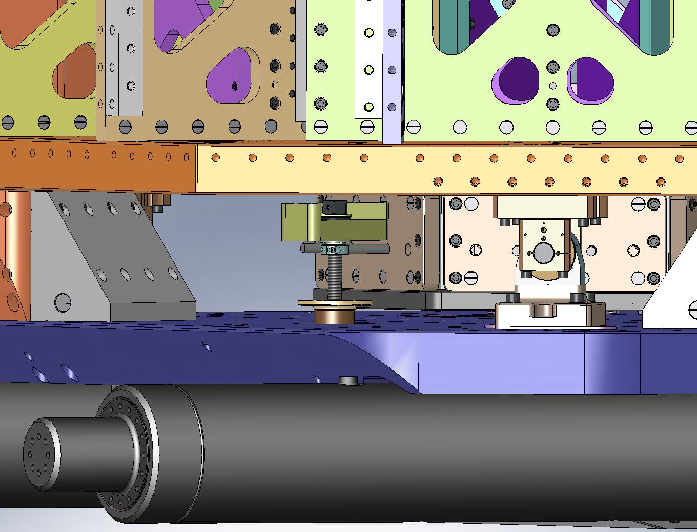
Figure 4.120. Pull out the bottom part of the (3) Pull-Down Assemblies, and store with the rest of the Assemblies.

- Place (3) Spring Hatches (D071067) in the Optical Table, over the Flexure Assemblies.
- Insert the mounting hardware for the Spring Hatches. Torque all the screws to final spec.
Hardware:
(18) 1/4"-20x.625" SHCS
(18) 1/4" vented washers
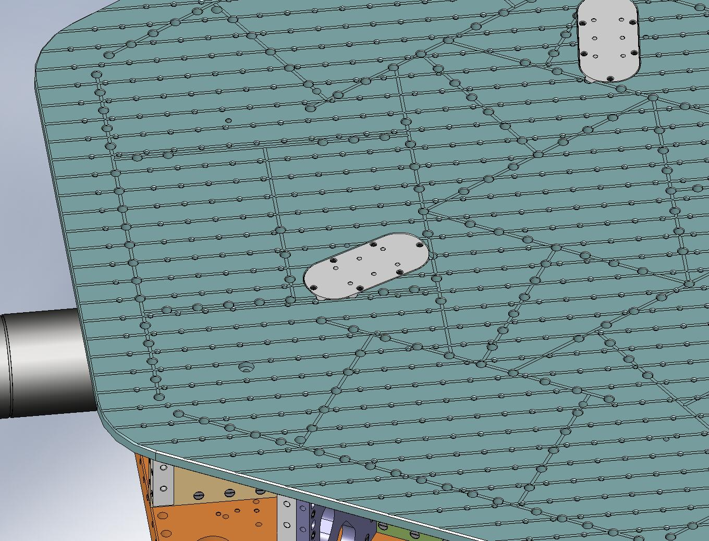
Figure 4.121. Mount (3) Spring Hatches to top of Optical Table.
- Insert (108) Type 01 Barrel Nuts (3/8”-16 x 1.0”) along perimeter of Stage 1 Floor, with flats turned away from screw thru holes.
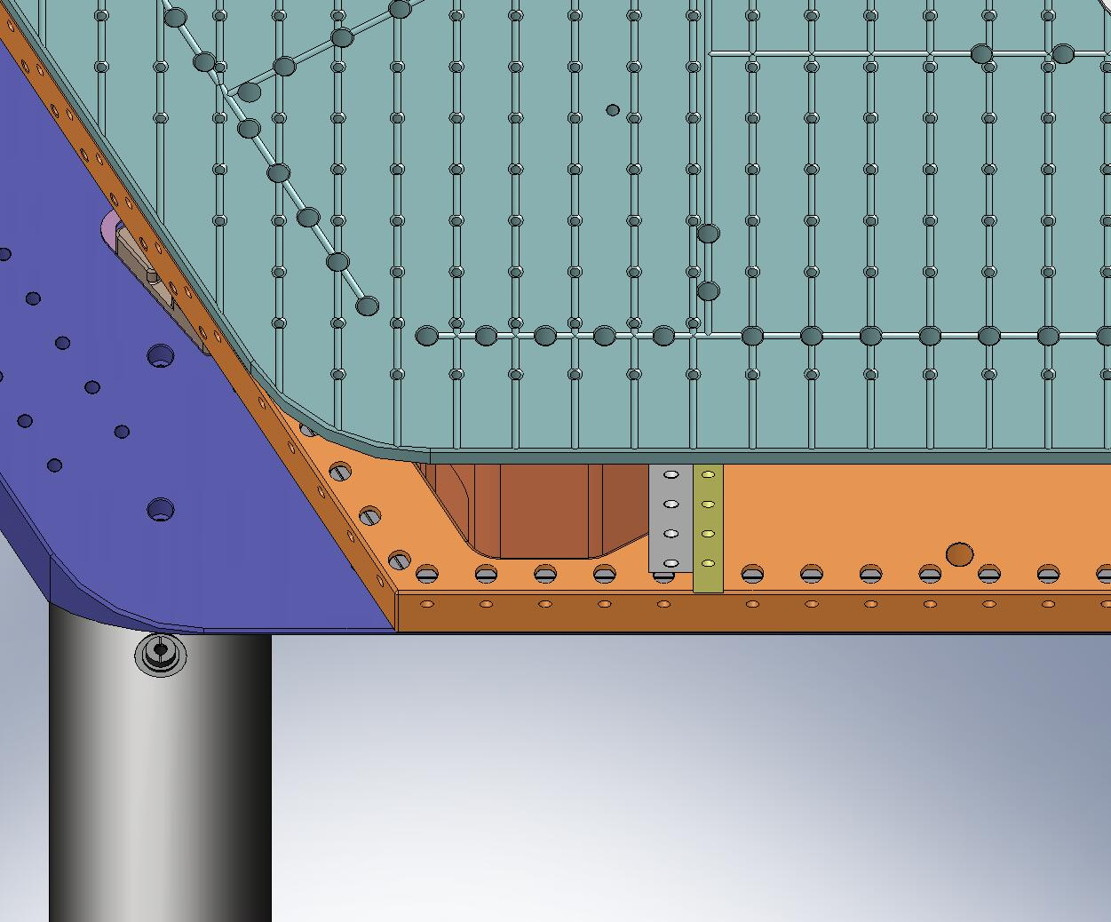
Figure 4.122. Populate Barrel Nut holes around entire perimeter of Stage 1 Floor. Flats on Nuts should face away from screw thru holes.
- Insert (84) Type 01 Barrel Nuts along vertical edges of exposed Boxwork and Pitchfork Ribs. Again, flats on Nuts should face away from screw thru holes.
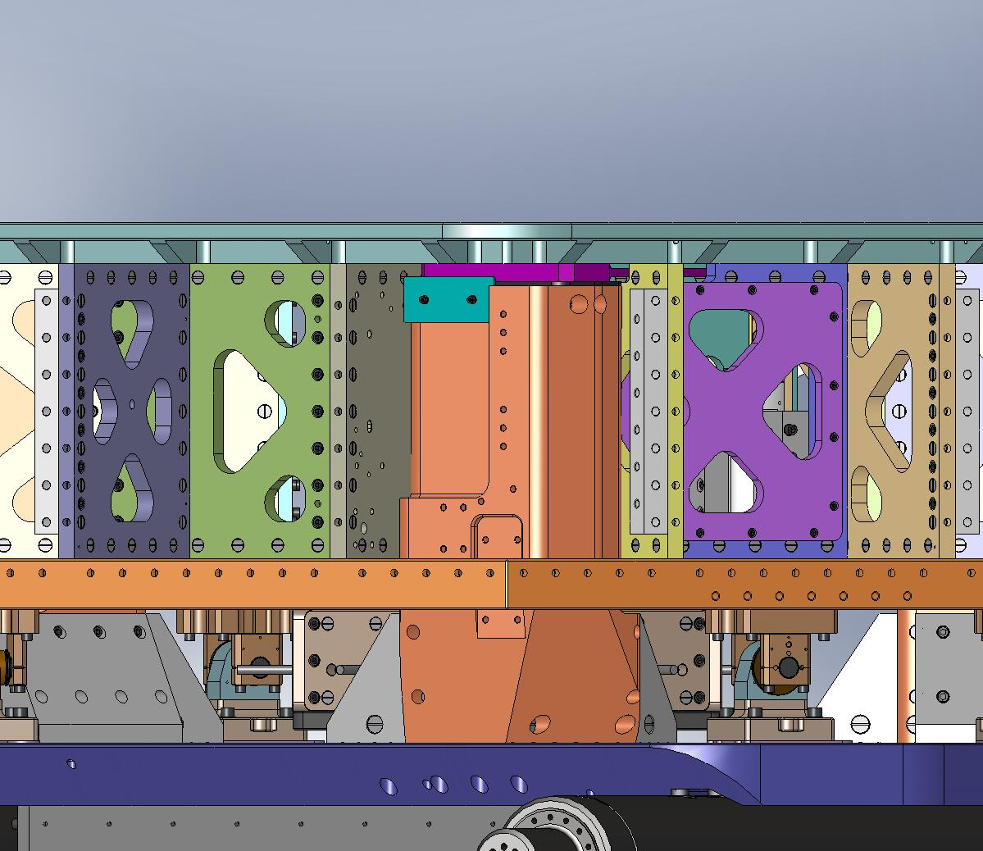
Figure 4.123. Populate Barrel Nuts along exposed edges of Radial Ribs. Flat side of each Nut should face away from screw hole.

Mount Sensors and Actuators
- Plug cable with low-profile, right-angle connector into feedthru connector on Horizontal GS-13.
- Route cable through channel in GS-13 Adapter Plate. Cover with GS-13 Cable Restraint. Add flat head screws and torque to final spec.
Hardware:
(2) #8-32x.375" FHSCS
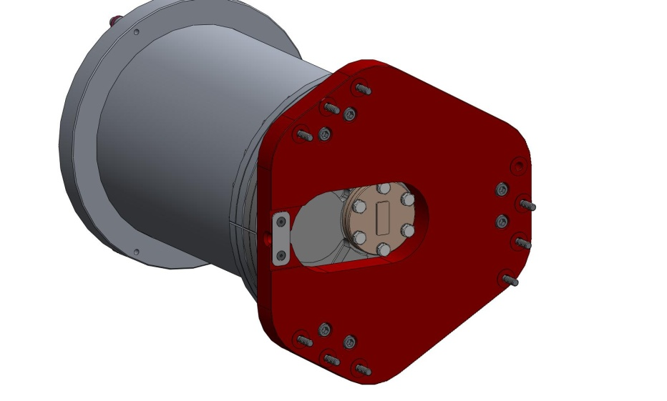
Figure 4.124. Cable Restraint holds cable to Adapter Plate on Horizontal GS-13 Assemblies. (Cable not shown here.)

- Place GS-13 Install Shelf (D0900335) against side of Stage 1 Floor, centered on a Pitchfork Assembly. Let the Locating Bar rest on top of Stage 1 Floor. Insert screws through Mounting Bar (D0900337) and into threaded inserts in Stage 1 Floor. Snug screws.
Hardware:
(4) 3/8"-16x1.5" SHCS
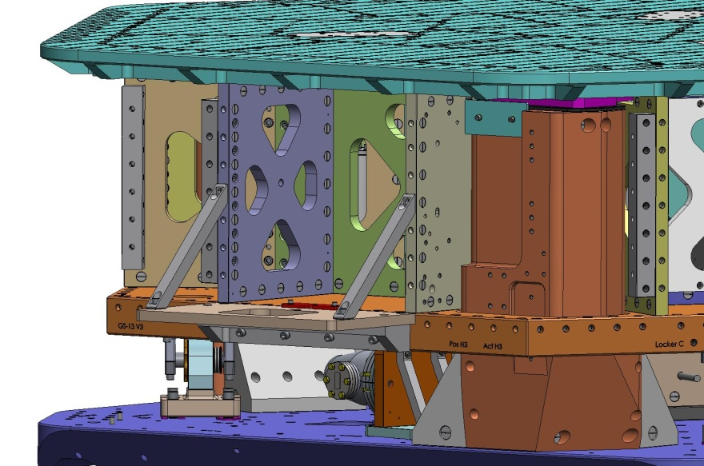
Figure 4.125. Four screws hold the GS-13 Shelf to the side of Stage 1.
- Insert screws through (2) Braces (D0900338) and into Barrel Nuts. Snug screws.
Hardware:
(2) 3/8"-16x1.5" SHCS
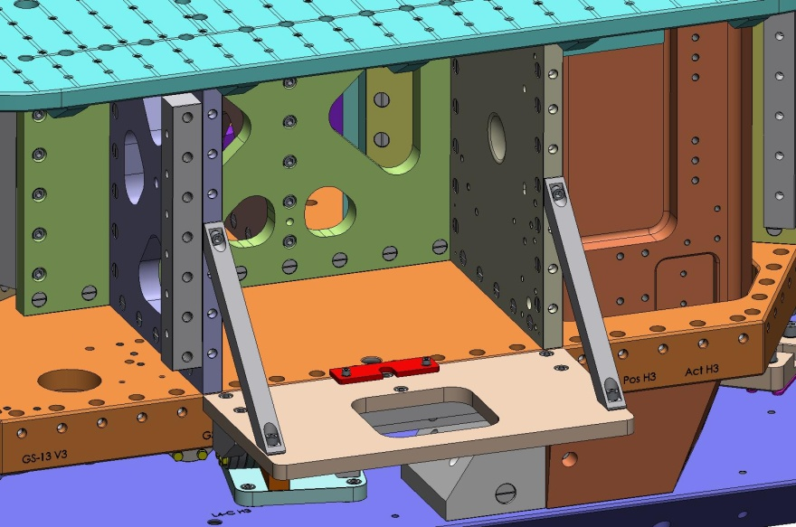
Figure 4.126. Connect 2 Braces to the Pitchfork Ribs, for extra strength.
- Tighten screws connecting the (2) Braces to Shelf Plate (D0900336).
- Place the GS-13 Horizontal Install Tool (D071496) on the GS-13 Install Shelf (see Figure 4.127).
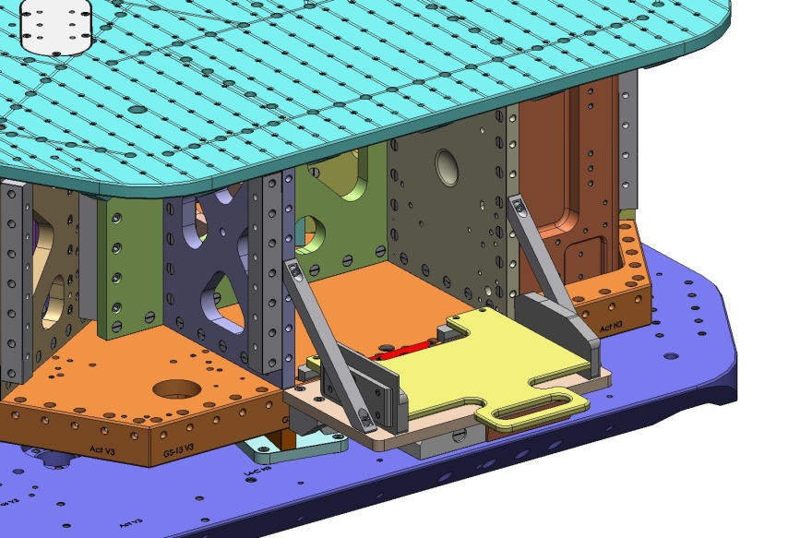
Figure 4.127. Install Sled Tool on Install Shelf, ready for use.
- Pick up a Horizontal GS-13 and carefully place it on the Install Tool. The Adapter Plate should sit on the right side, with the cable channel facing up and away from Stage 1.
- Slide the Install Tool into Stage 1. (The Captive Screws (D071136) must be pushed back into the Adapter Plate (D071180) to pass by the Radial Rib.)
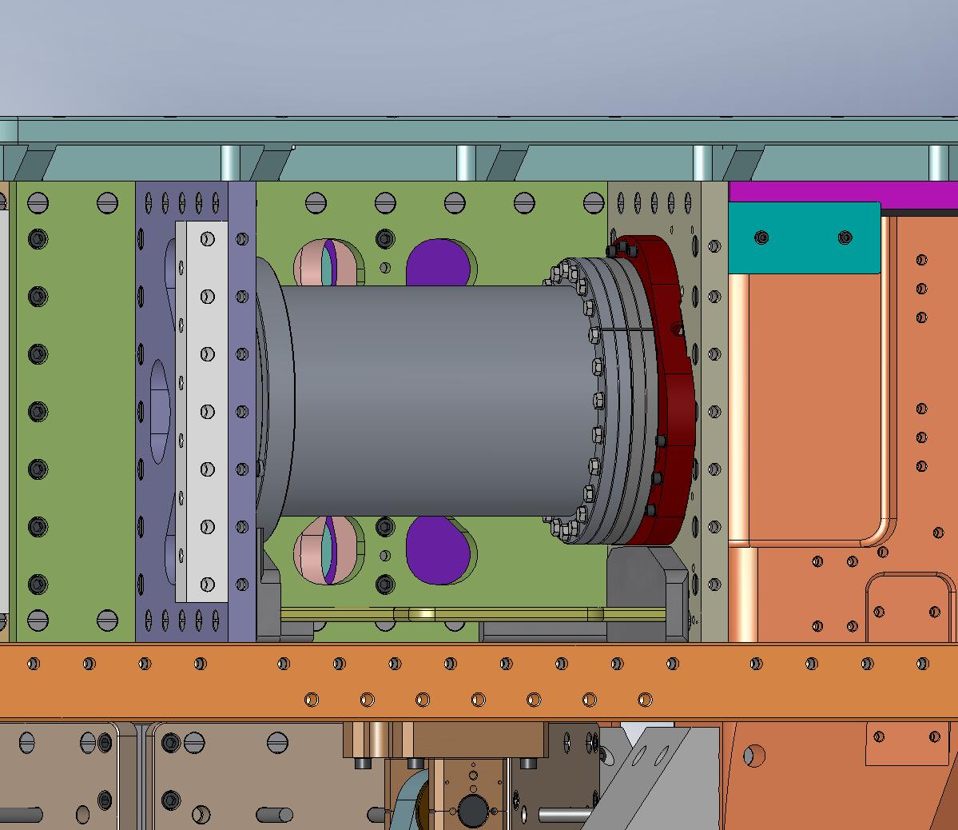
Cable exits here.
Figure 4.128. Horizontal GS-13 mounted to Radial Rib in Pitchfork. The seismometer’s cable should exit from the notch indicated by the arrow.
- Remove the GS-13 Install Shelf.
- Lift GS-13 slightly, to allow (9) Captive Screws to engage into Radial Rib. Snug all (9) Captive Screws, then torque to final spec. (The Install Tool should now be free and can be removed at any time.)
- Thread custom silver-plated screw (D0900201) into Nut (D071182) in Stabilizer flexure. Torque to final spec.
Hardware:
(1) 3/8"-16x1.5" Ag-plated SHCS (D0900201)
(1) 3/8" fender washer

Warning: If using A+ cables (D1000227-v11), see note p89
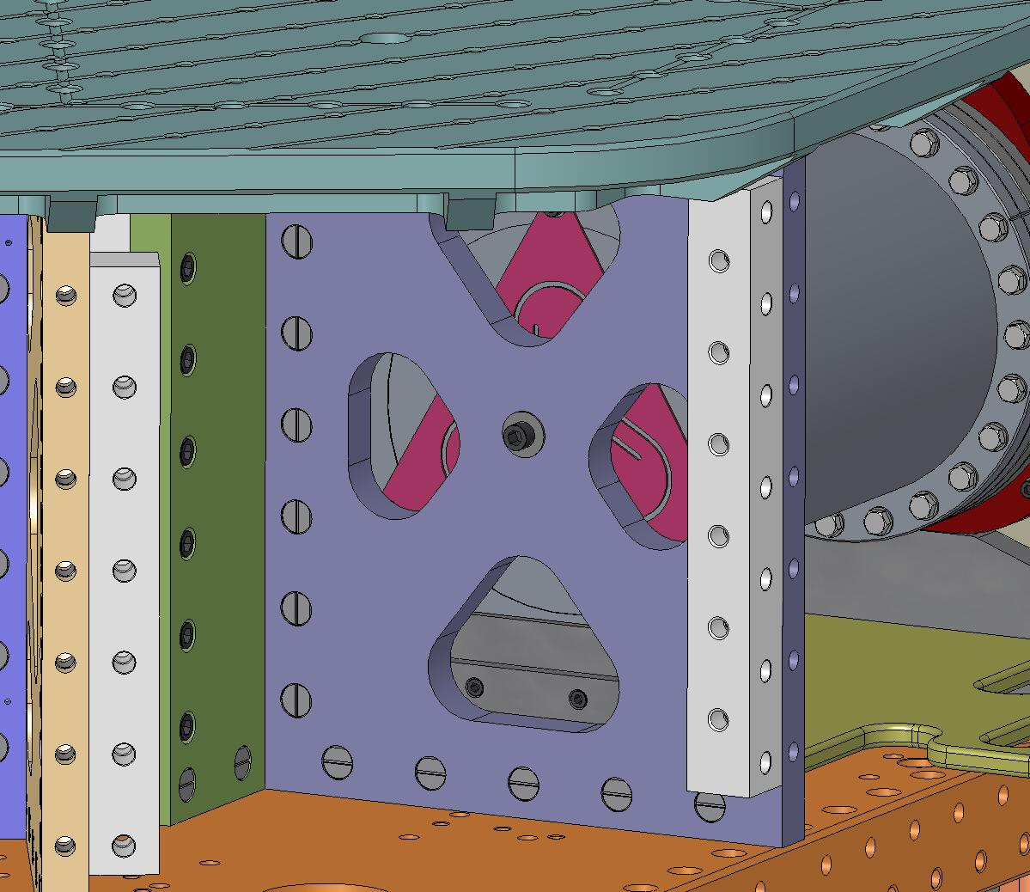
Figure 4.129. Couple the Stabilizer flexure to the other Pitchfork Rib using (1) screw.
- Repeat last (9) steps, to install remaining (2) Horizontal GS-13’s.

- Place Vertical GS-13 at corner of Stage 1 Floor directly to the left of one of the Horizontal GS-13’s. Again, pull Captive Screws into Adapter Plate, to provide adequate clearance. Note the orientation of the Adapter Plate, as shown in Figure 4.130.
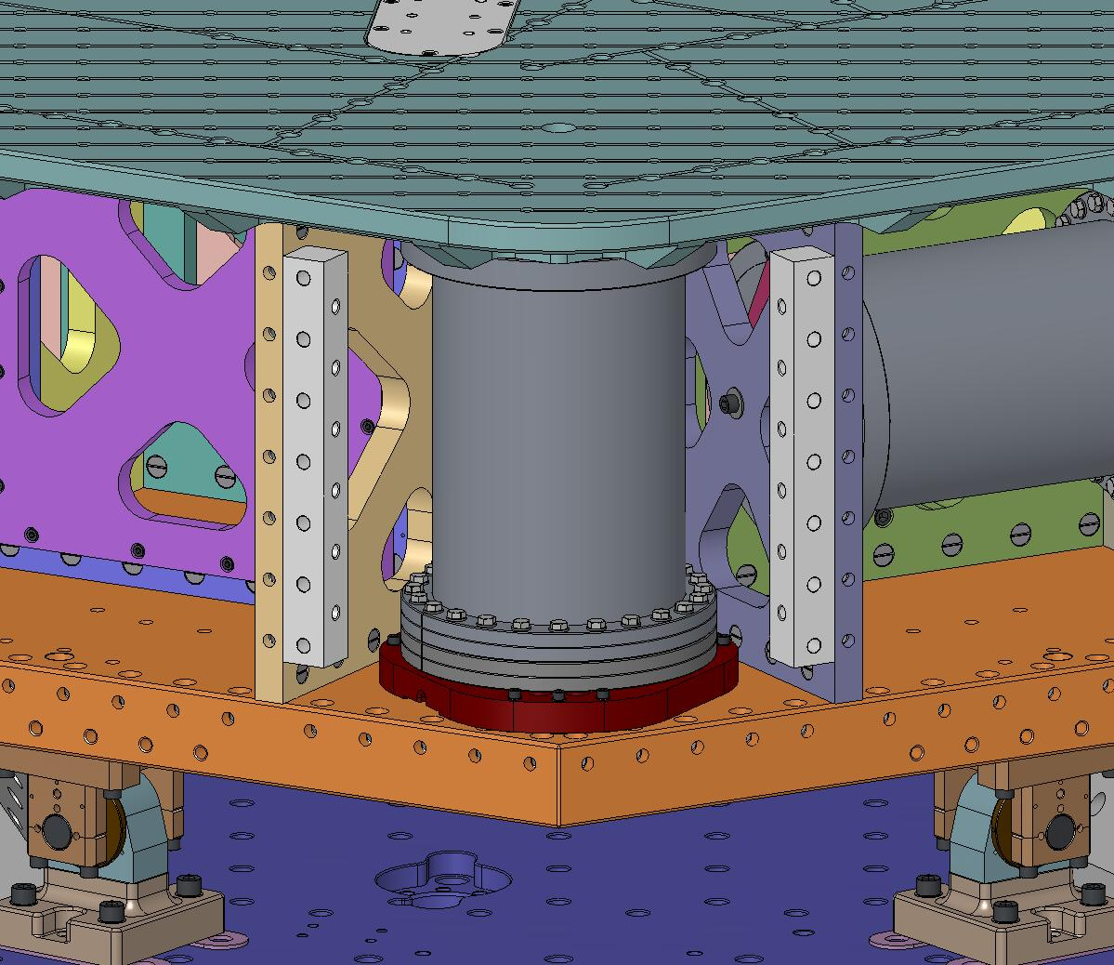
Figure 4.130. Vertical GS-13 placed on Stage 1 Floor. Note location of cable notch, indicated by arrow.
- Snug all (9) Captive Screws, then torque to final spec.
- Thread custom silver-plated screw (D0900202) into Nut (D071182) in Stabilizer flexure. Torque to final spec.
Hardware:
(1) 3/8"-16x2.5" Ag-plated SHCS (D0900202)
(1) 3/8" fender washer
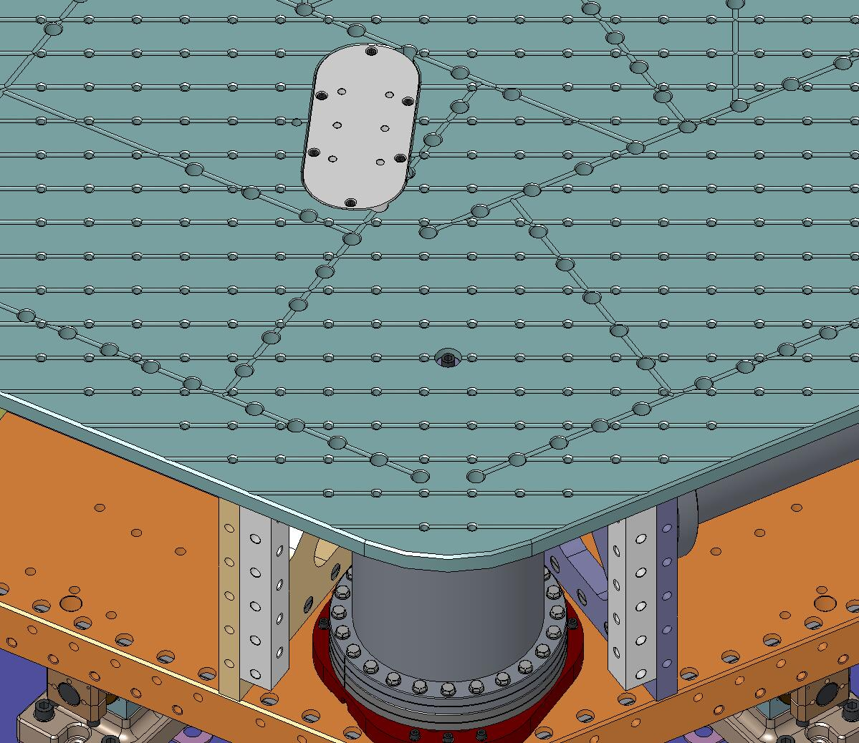
Figure 4.131. Couple the Stabilizer flexure to the Optical Table using (1) screw.
- Repeat last (3) steps, to install remaining (2) Vertical GS-13’s.

- Attach (3) Horizontal Actuators to the Radial Rib opposite the Horizontal GS-13’s. Dowel pins locate the Actuators to the Ribs. Snug (4) Captive Screws, then torque to spec. (Do not remove Setup Bar. Do not bolt to Support Post.)
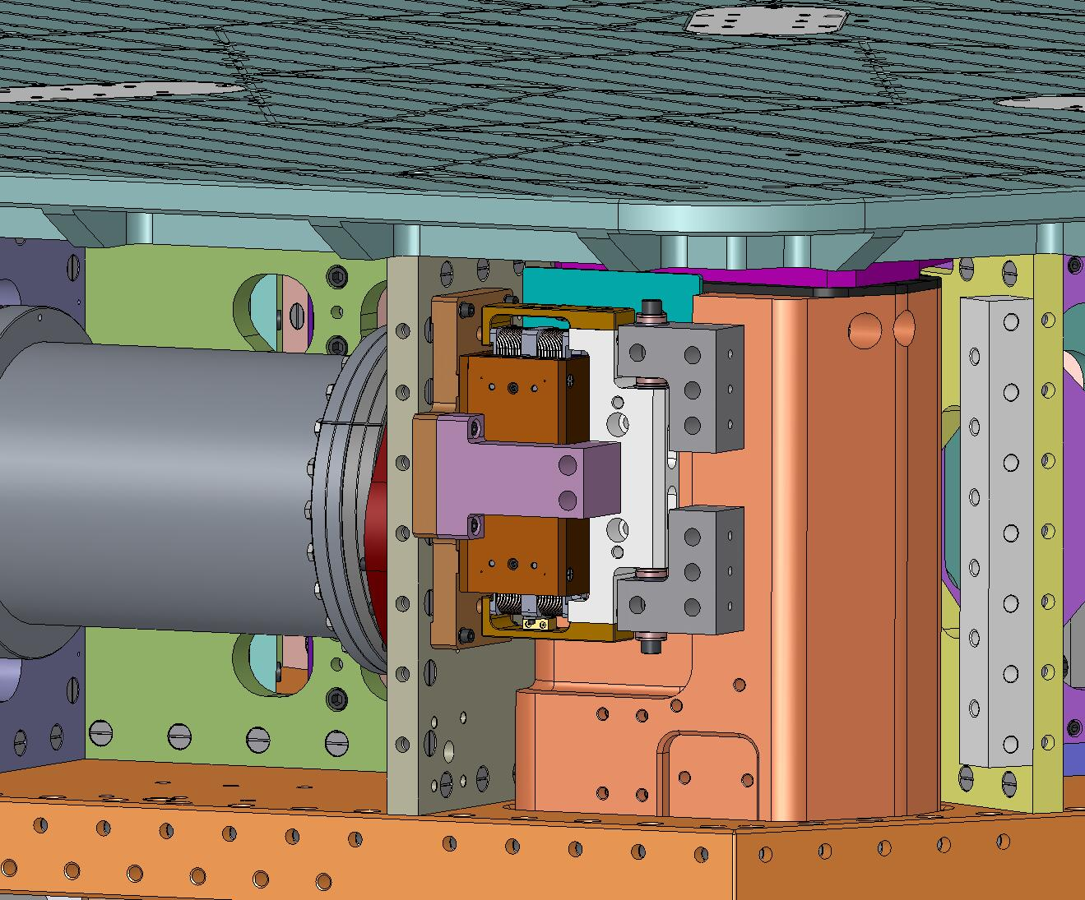
Figure 4.132. Attach Horizontal Actuators to Stage 1. Leave Setup Bar in place.
- Attach (3) Vertical Actuators to bottom of Stage 1 Floor. Dowel pins locate the Actuators to the Floor. Snug (4) Captive Screws, then torque to spec. (Do not remove Setup Bar. Do not bolt to Stage 0 Base.)
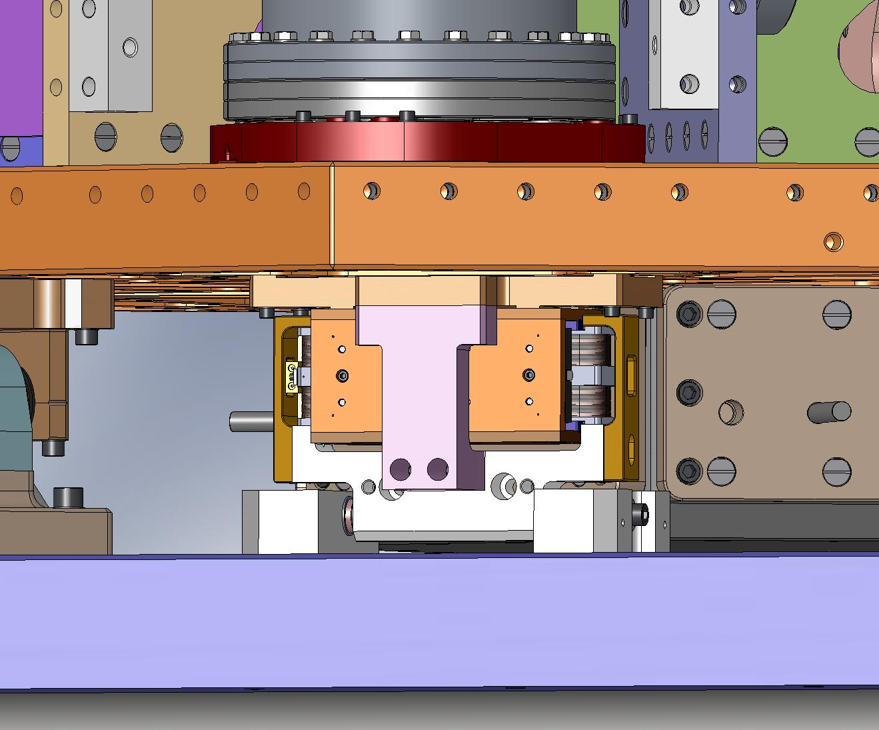
Figure 4.133. Attach Vertical Actuators to Stage 1. Leave Setup Bar in place.

- Bolt (3) Sensor Targets to Radial Rib directly below Horizontal Actuators. Do not scratch diamond-turned target surface! Torque screws to final spec.
Hardware:
(4) 1/4"-20x1.25" SHCS
(4) 1/4” vented washer
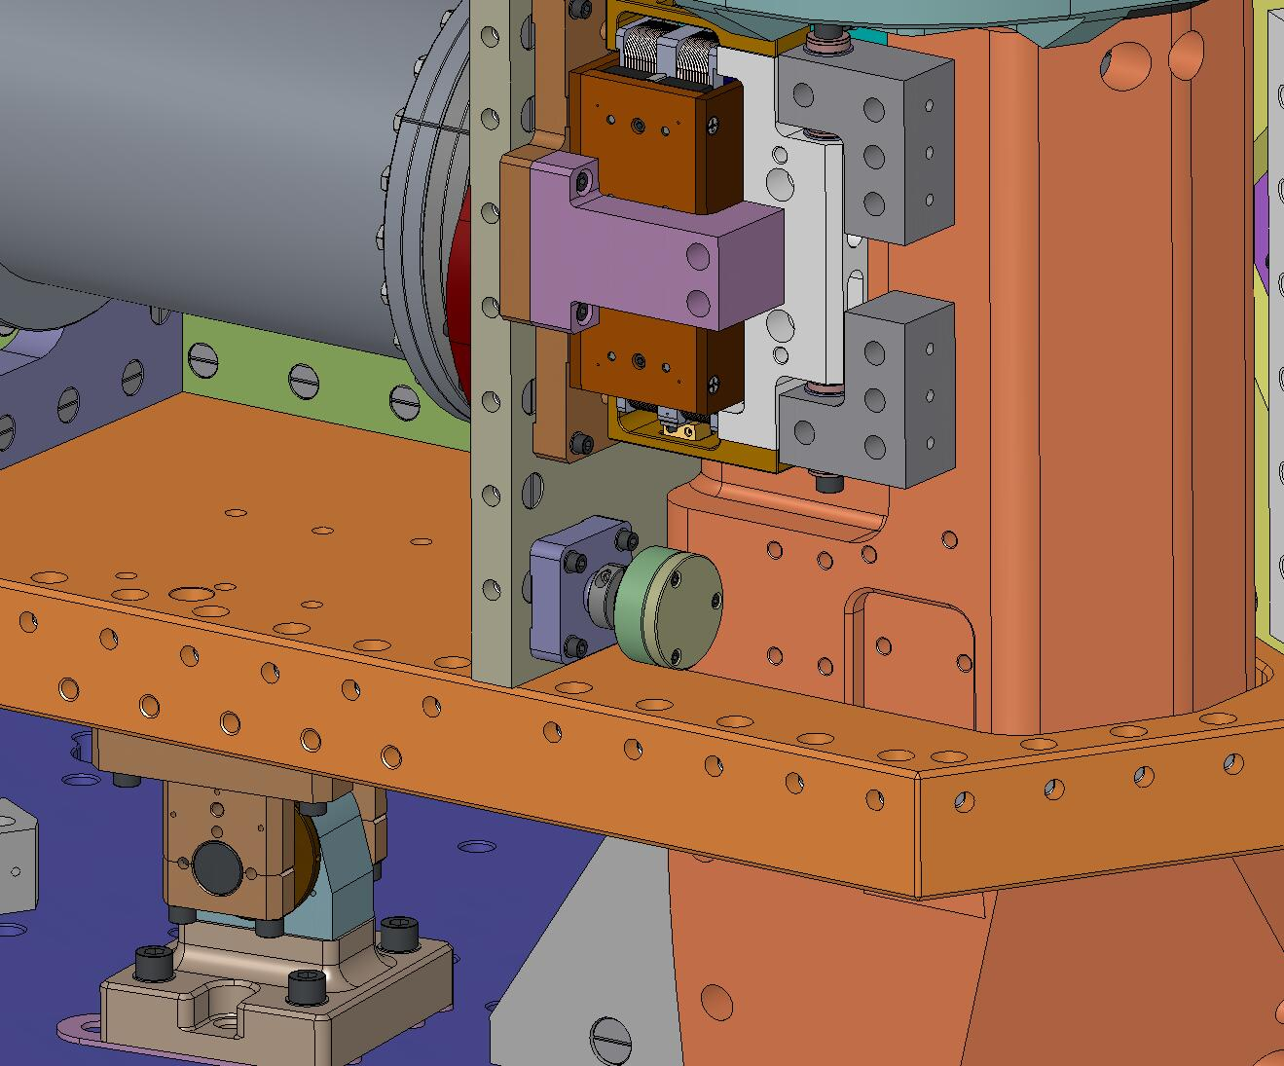
Figure 4.134. Attach Sensor Targets for Horizontal Sensors.

- Loosen collar clamp on Sensor Target collet. Push Target as far in as possible (to maximize gap, when Sensor Probe is installed). Retighten collar clamp.
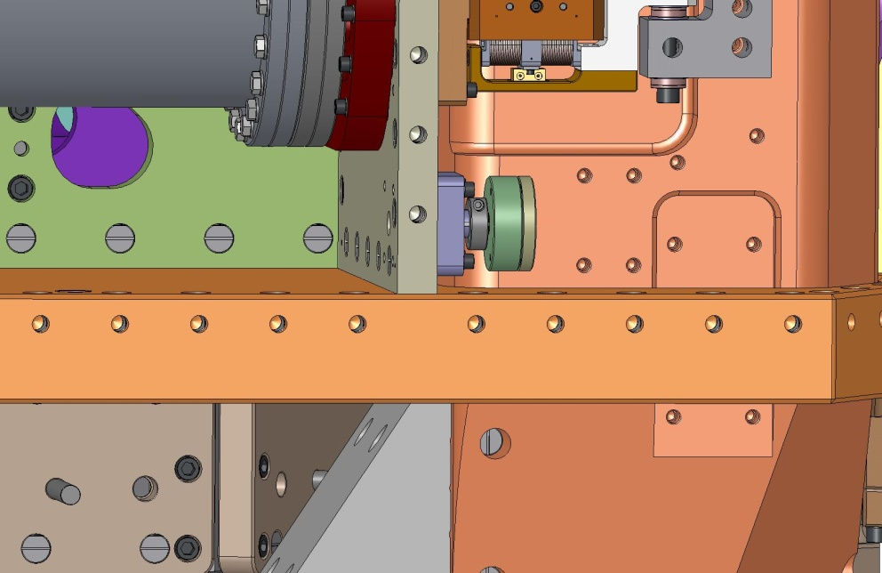
Figure 4.135. Horizontal Sensor Target must be retracted before Sensor Assembly is installed.

- Bolt (3) Sensor Targets to bottom of Stage 1 Floor, next to Vertical Actuators. Do not scratch diamond-turned target surface! Torque screws to final spec.
Hardware:
(4) 1/4"-20x1.25" SHCS
(4) 1/4” vented washer
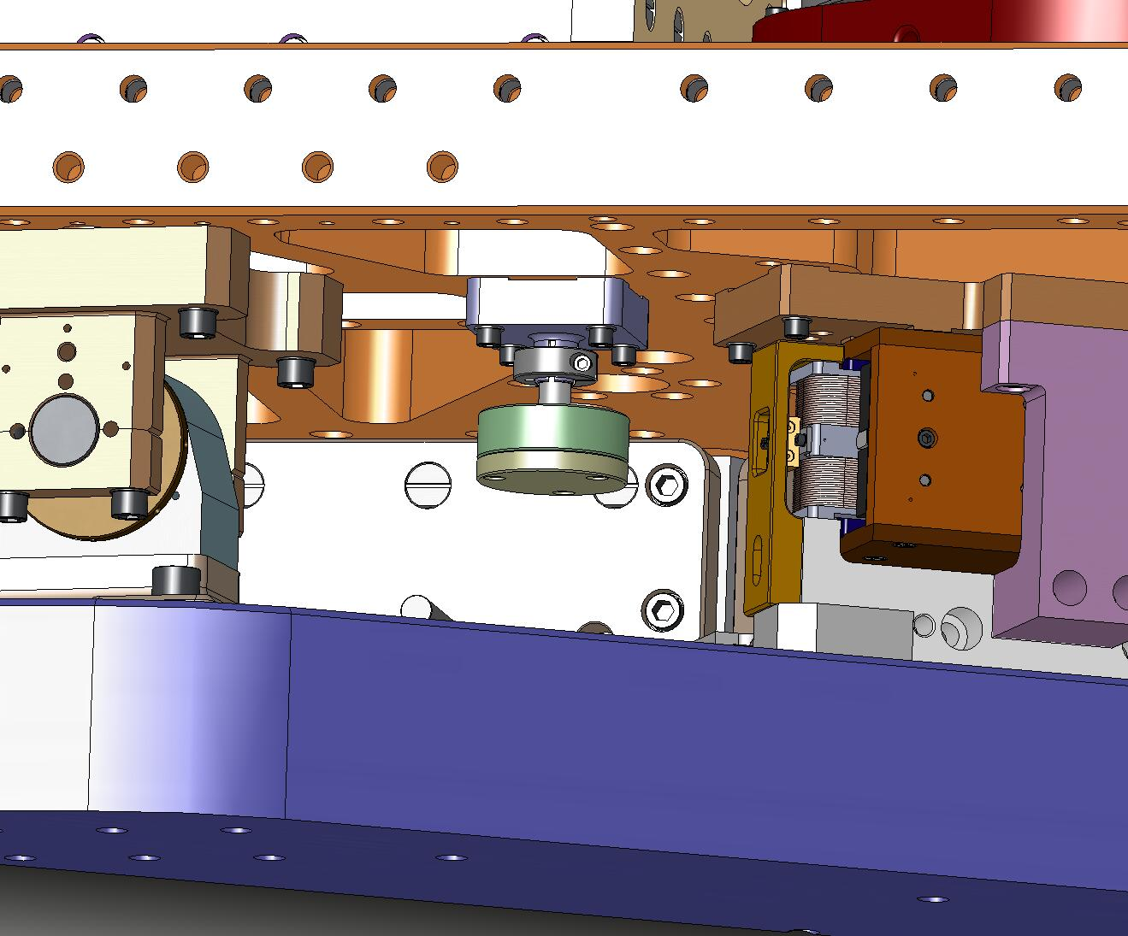
Figure 4.136. Attach Sensor Targets for Vertical Sensors.

- Loosen collar clamp on Sensor Target collet. Push Target as far up as possible (to maximize gap, when Sensor Probe is installed). Retighten collar clamp.
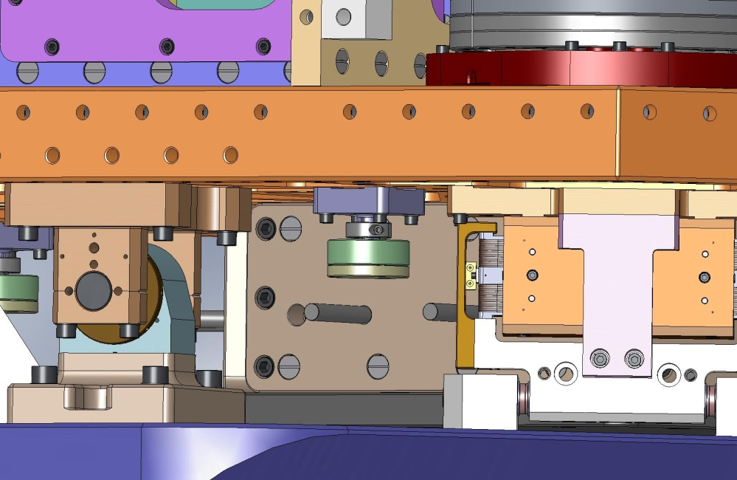
Figure 4.137. Vertical Sensor Target must be retracted before Sensor Assembly is installed.

- Bolt (3) Horizontal Sensor Assemblies to Support Posts. Torque screws to final spec.
Hardware:
(4) 1/4"-20x1.0" SHCS
(4) 1/4” vented washer
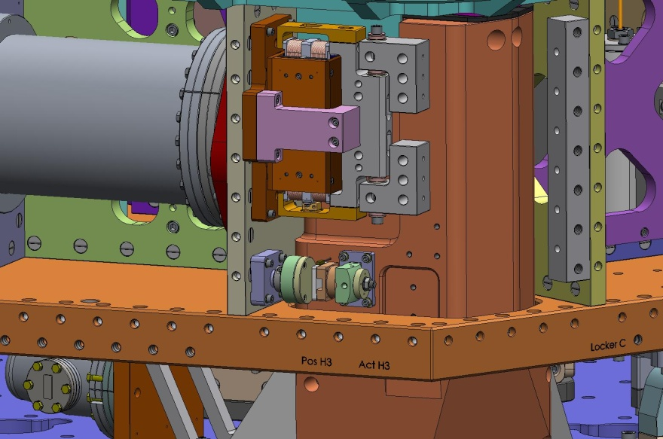
Figure 4.138. Attach Horizontal Sensor Probes.

- Bolt (3) Vertical Sensor Assemblies to Stage 0 Base. Torque screws to final spec.
Hardware:
(4) 1/4"-20x1.0" SHCS
(4) 1/4” vented washer
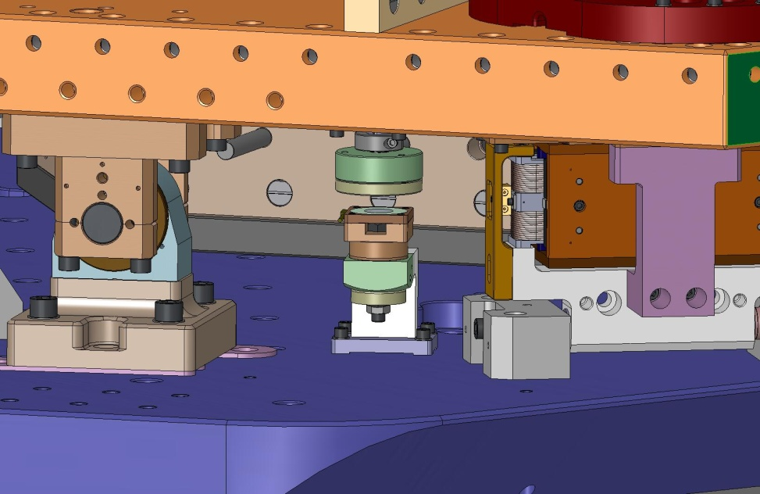
Figure 4.139. Attach Vertical Sensor Probes.

- Place (6) Large Wiring Breadboards (D071255) and (4) Small Wiring Breadboards (D0900312) on the Stage 0 Base. Insert hardware and torque to spec:
Hardware:
(10 x 2) 1/4"-20x.625" SHCS
(10 x 2) 1/4” vented washer
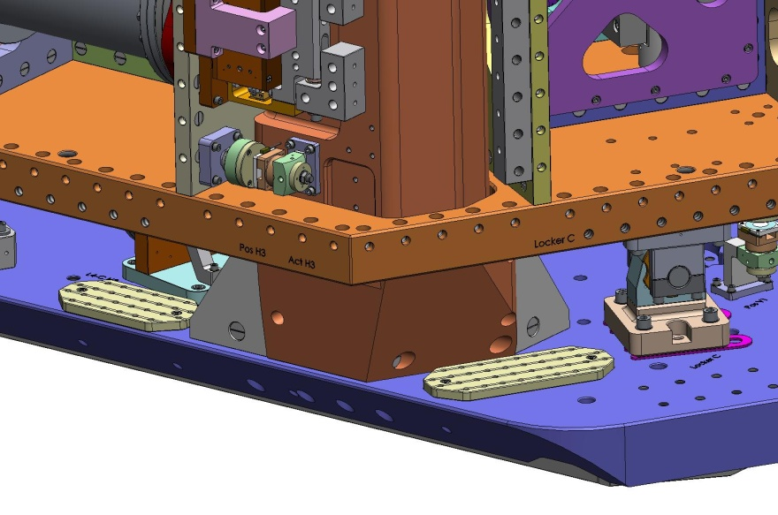
Small Breadboard
Large Breadboard

Figure 4.140. Bolt Wiring Breadboards to top of Stage 0 Base.

- Use 1/4"-20 holes in Breadboards to tie the cables for the actuators and sensors to Stage 0.

Attach Outer Walls
- Place Small Panel Outer Wall against side of Stage 1, covering one of the Vertical GS-13s. Insert screws through Optical Table and screws through bottom row of holes in Outer Wall. Leave screws hand-tight.
Hardware:
(10) 3/8"-16x1.75" SHCS
(10) 3/8” vented washer
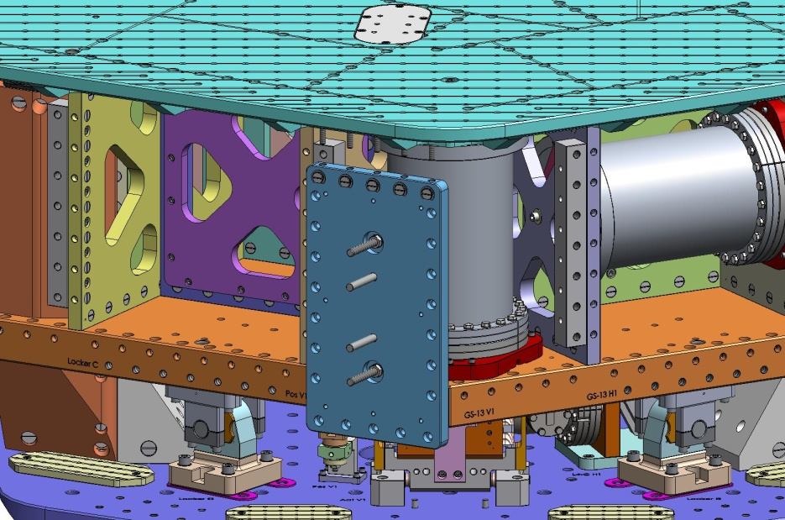
Figure 4.141. Place Small Panel Outer Wall against corner of Stage 1 Floor, in front of Vertical GS-13. Drop screws through Optical Table, and thread into Barrel Nuts.
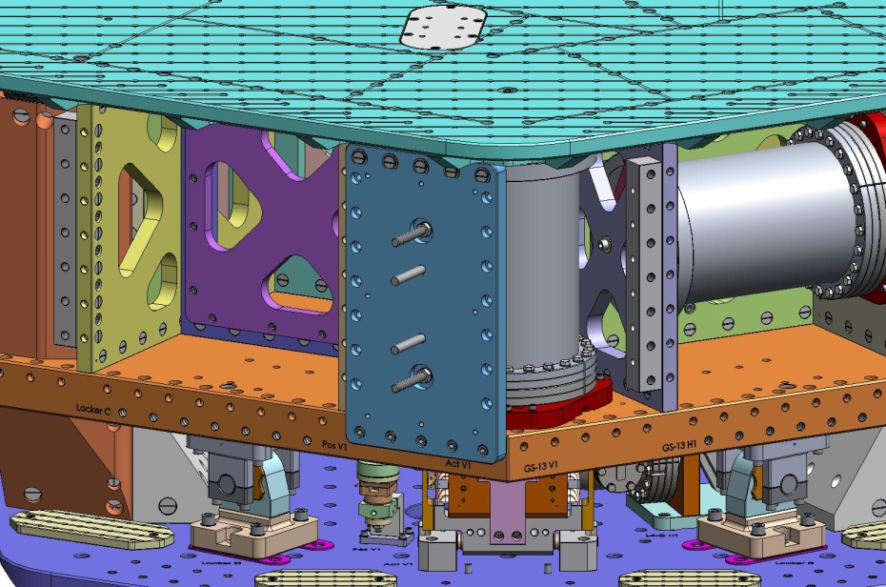
Figure 4.142. Thread screws for bottom row of holes into Stage 1 Floor Barrel Nuts.

- Insert screws through left row of holes in Small Panel Outer Wall. Leave screws hand-tight.
Hardware:
(7) 3/8"-16x1.25" SHCS
(7) 3/8” vented washer
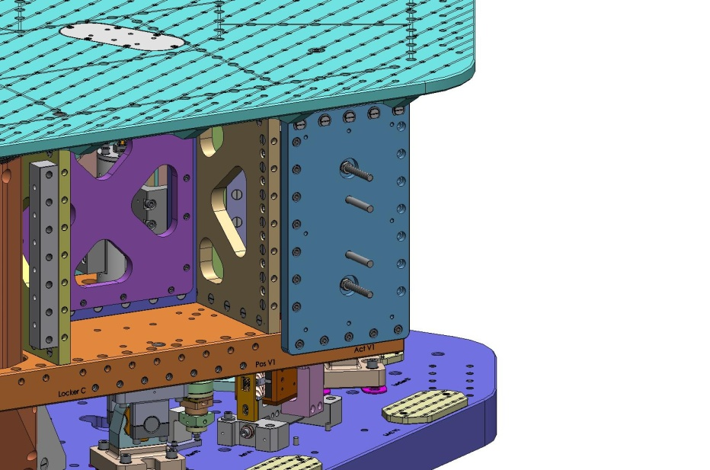
Figure 4.143. Insert screws through left column of holes in Outer Wall, and thread into 90 Degree Bracket.

- Snug screws from Boxwork Radial Rib to Outer Wall Bracket 90.
- Incrementally torque all screws for the Small Panel Outer Wall (including for Bracket 90) to final spec.
- Hold Type 00 Outer Wall 120-Degree Bracket (D071060-00) against back of Small Panel Outer Wall. Start screws. Leave hand-tight.
Hardware:
(7) 3/8"-16x1.25" SHCS
(7) 3/8” vented washer
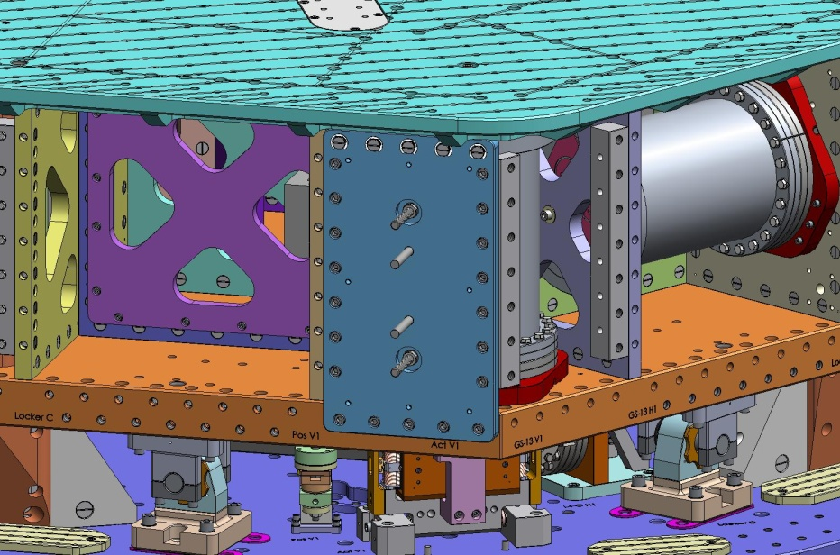
- Place another Small Panel Outer Wall against side of Stage 1, next to the Outer Wall just installed. Insert screws through Optical Table and screws through bottom row of holes in Outer Wall. Leave screws hand-tight.
Hardware:
(10) 3/8"-16x1.75" SHCS
(10) 3/8” vented washer
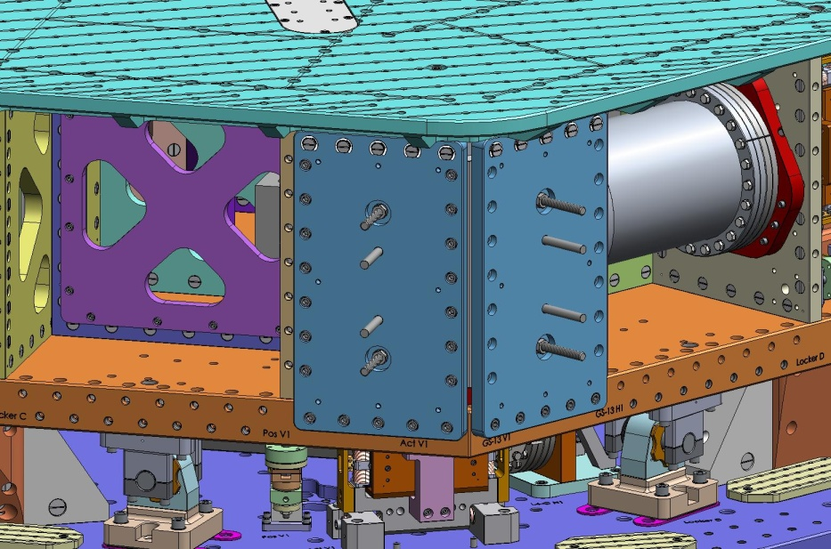
- Insert screws through left and right rows of holes in Outer Wall. Leave screws hand-tight.
Hardware:
(14) 3/8"-16x1.25" SHCS
(14) 3/8” vented washer
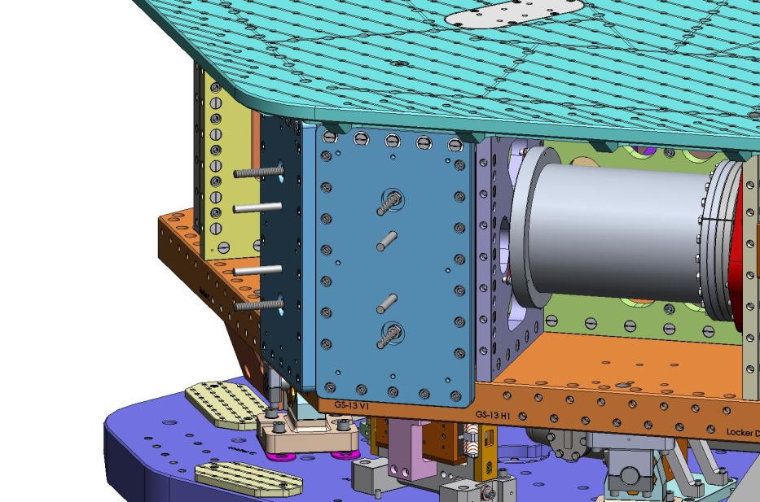
- Snug screws from Pitchfork Radial Rib to Outer Wall Bracket 90.
- Incrementally torque all screws for the Small Panel Outer Wall (including for Bracket 90) to final spec.
- Repeat previous steps to install (2) more pairs of Small Panel Outer Walls over the other (2) Vertical GS-13s.
- Place another Small Panel Outer Wall against Stage 1 Floor, covering one of the Spring Posts. Start screws through Optical Table and screws through bottom row of holes in Outer Wall. Leave screws hand-tight.
Hardware:
(10) 3/8"-16x1.75" SHCS
(10) 3/8” vented washer
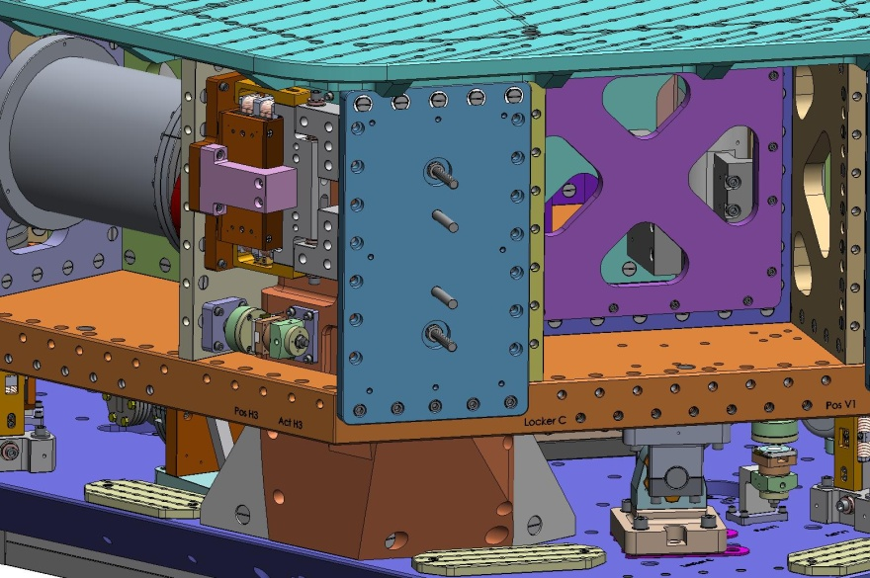
- Insert screws through right row of holes in Small Panel Outer Wall. Leave screws hand-tight.
Hardware:
(7) 3/8"-16x1.25" SHCS
(7) 3/8” vented washer
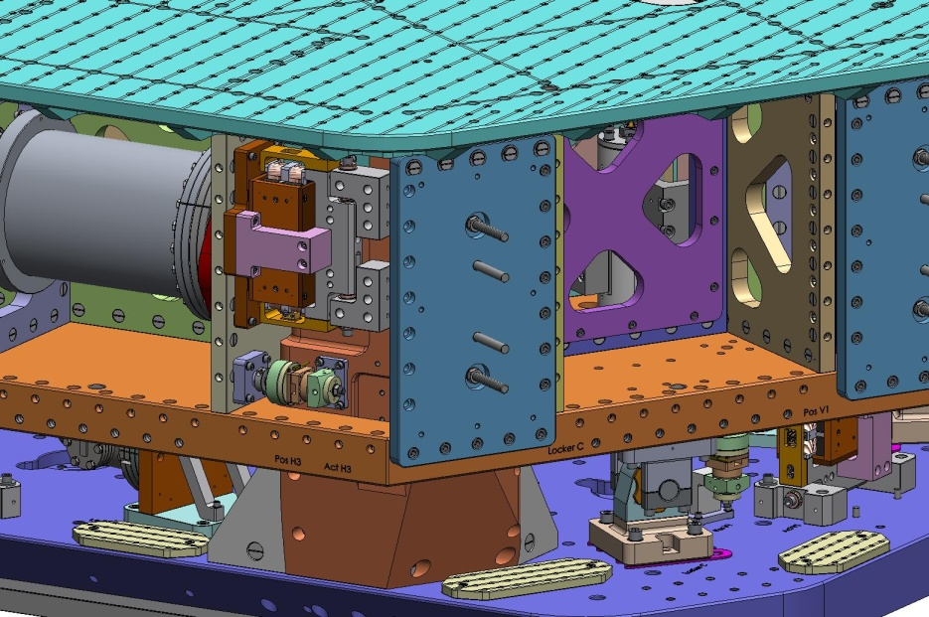
- Snug screws from Pitchfork Radial Rib to Outer Wall Bracket 90.
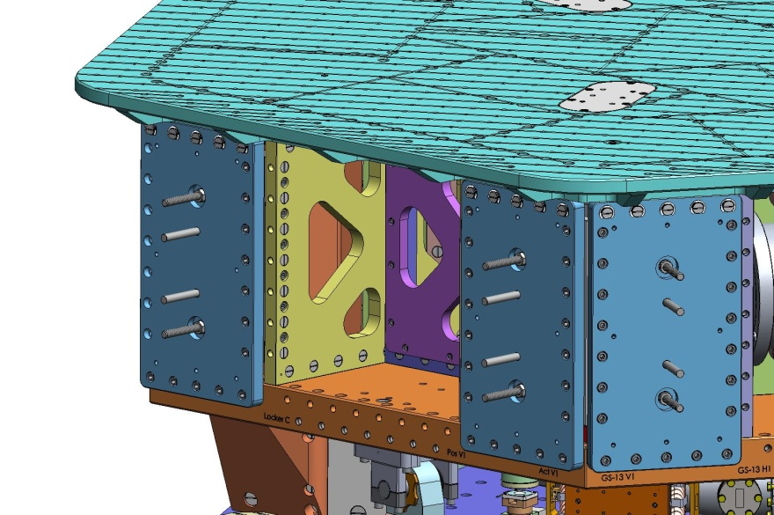
- Incrementally torque all screws for the Small Panel Outer Wall (including for Bracket 90) to final spec.
- Place a Flexure Access Outer Wall against Stage 1 Floor, immediately to the left of one of the Vertical GS-13s. Start screws through Optical Table and screws through bottom row of holes in Outer Wall. Leave screws hand-tight.
Hardware:
(16) 3/8"-16x1.75" SHCS
(16) 3/8” vented washer
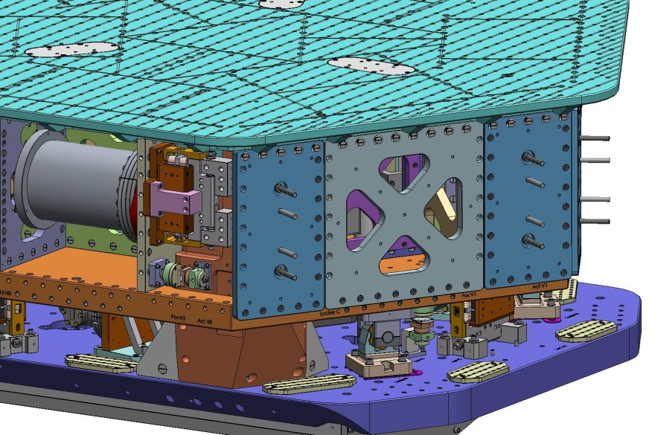
- Start screws through left and right rows of holes in Outer Wall. Snug screws, but do not torque, yet.
Hardware:
(14) 3/8"-16x1.75" SHCS
(14) 3/8” vented washer
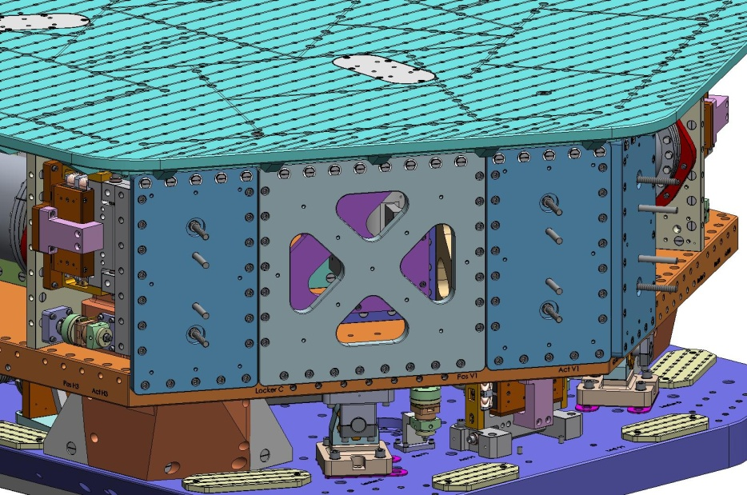
- Incrementally torque all screws for Flexure Access Outer Wall to final spec.
- Repeat previous 3 steps to install (2) remaining Flexure Access Outer Walls.

Release Stage 1
To this point, Stage 1 is held rigidly to Stage 0 via the 4 Locker Assemblies. The 3 Springs require a combined load of 4,350 lbs to remain flat. However, the suspended portion of the HAM ISI - when fully assembled - weighs only 3,030 lbs. Before releasing Stage 1 for the first time, we must add enough ballast to compensate for the missing payload and trim mass.
- Begin adding weight to the Optical Table: place (3) GS-13 Outer Walls (D071057) and (3) Outer Wall Covers (D0900277) on the Table.
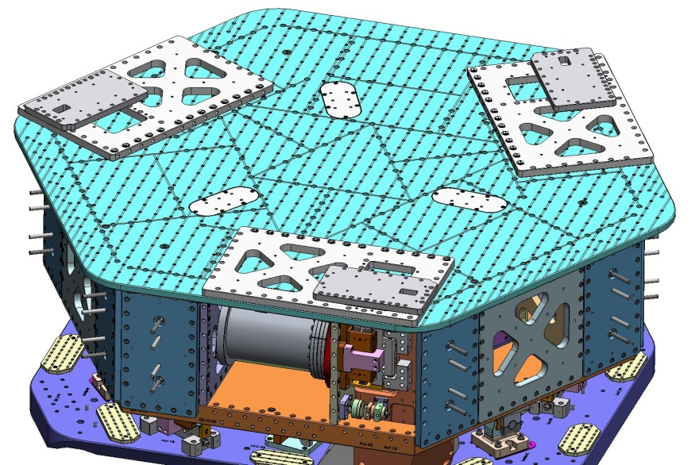
Figure 4.144. Lay GS-13 Outer Walls and Wall Covers on top of Optical Table, preferably above their final locations on Stage 1.

- At this point in the assembly, the approximate weight of Stage 1 (including Actuator Tooling Bars and Brackets) is 3,070 lbs. This leaves 1,280 lbs of additional ballast required before the Lockers can be released.
- Each system has a set of Adjustment Masses (D071200) available for balancing the ISI after the Opto-Mechanical payload is installed. Refer to the Mass Budget Worksheet, HAM ISI, Advanced LIGO (E0900329) to aid in designing the appropriate trim mass configuration for each payload configuration.
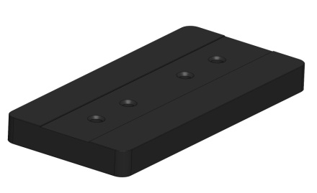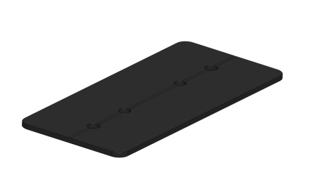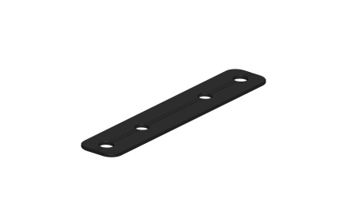
Figure 4.145. 3 (of 7) sizes of Adjustment Mass for the HAM ISI.
- The Adjustment Masses are made in 7 sizes, as follows:
Type | Mass (lbs)
00 | 0.6
01 | 1.1
02 | 2.2
03 | 4.5
04 | 8.2
05 | 16.0
06 | 27.6

- The Adjustment Masses can be bolted to either 1) the Small Panel Outer Walls, or 2) the Keel Walls. In either location, the heaviest masses must be mounted closest to the Wall. Also, each Mass has a vent groove (rectangular for the large ones, rounded for the smaller ones) down the center of one side. This side must face the Wall.
Hardware:
(2) 1/2"-13 Ag-plated Hex Nut (D0900204) - per stack on Small Panel
(2) 1/2" vented washer - per stack on Small Panel
(2) 1/2"-13 HHCS - per stack on Keel Wall
(2) 1/2" vented washer - per stack on Keel Wall
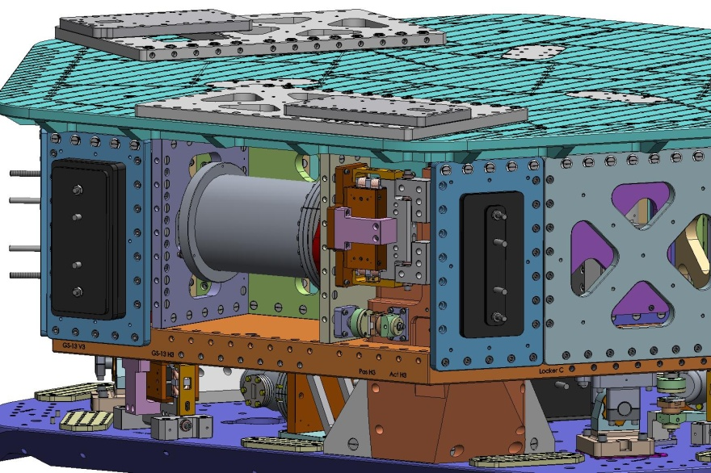
Figure 4.146. Adjustment Mass stacks on Small Panel Outer Walls. These configurations are shown only as examples. Vent grooves in Masses must face the Outer Wall.
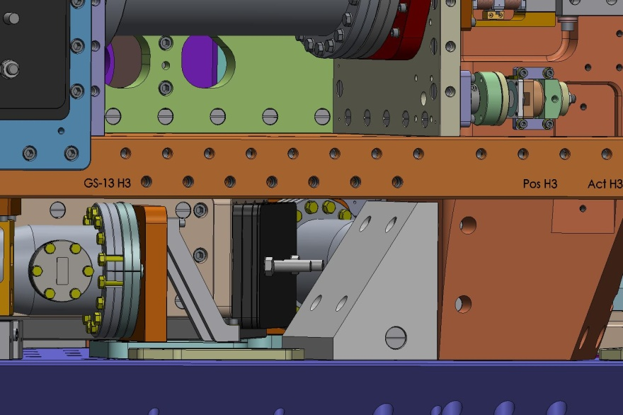
Figure 4.147. Adjustment Mass stack on Keel Wall. This configuration intended only as an example. Vent grooves in Masses must face the Keel Wall.

- Additional dead weight will be needed to balance the Springs. Lay the weight on top of the Optical Table. Distribute the mass evenly, so the center of mass is close to the center of the Table.
- Fasten 4 dial indicators to Stage 0, 1 near each Locker. Orient each indicator horizontally and pick up a point on the side of the Locker Pin Base (make sure the indicator is sufficiently clear of the Locker Sleeve, to reduce risk of accidental bumping).
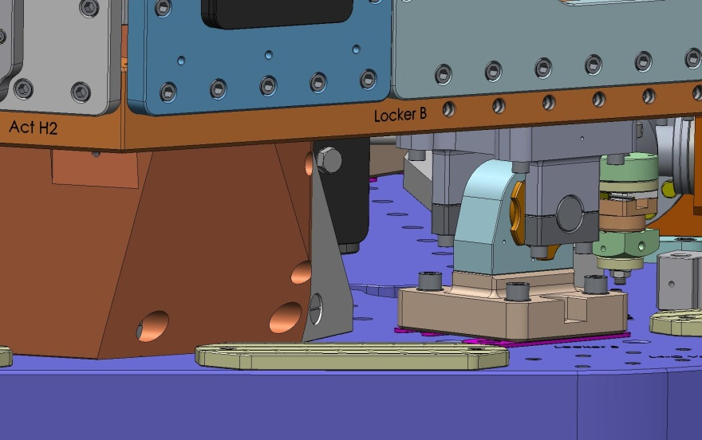
Mount dial indicator to Breadboard.
Pick up point here.
- When the nominal ballast on Stage 1 (Adjustment Masses plus miscellaneous dead weight) is approximately 1,280 lbs, try to un-lock one of the Locker Sleeves (by turning it clock-wise).
- By pushing on Stage 1 and attempting to turn the Locker Sleeves, try to gauge whether the ballast mass on the Stage is too much or too little. Adjust the mass distribution accordingly. If it is still not possible to un-lock any of the Lockers, try loosening the 4 screws holding one of the Locker Sleeve Bases to Stage 0.
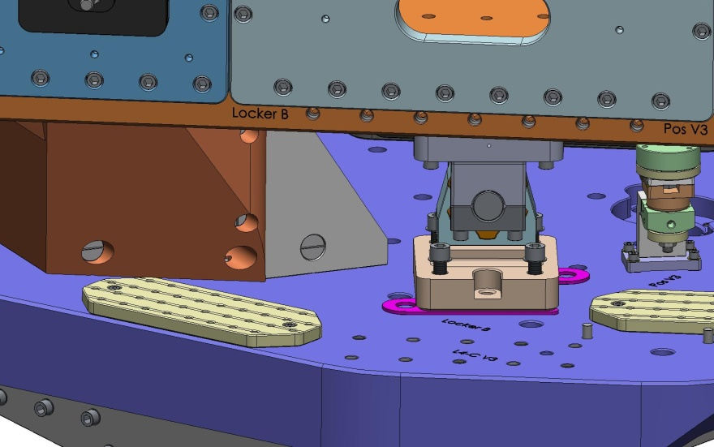
- It should now be possible to un-lock all 4 Locker Assemblies. Stage 1 will shift some amount when the Lockers are released. Record this displacement, as measured by the 4 dial indicators (the Locker Pin must not be in contact with the Locker Sleeve!):
Locker | Displacement (in)
A
B
C
D

- Use a bubble level to measure the deviation from horizontal of the top of the Stage 0 Base (2 orthogonal angle measurements are needed to define the orientation). Use the same level to measure the deviation from horizontal of the top of the Optical Table. Redistribute the ballast mass on Stage 1 until the Optical Table is parallel to Stage 0. Also, add or subtract from the total ballast mass until one of the Locker Spherical Pins can be centered within its Sleeve (there should be .125"-thick Spacers underneath this Locker Sleeve Base, at this time).
Figure 4.148. Use a bubble level to measure deviations from horizontal for both Stage 0 and Stage 1. After un-locking Stage 1, adjust the ballast mass distribution until Stage 0 and Stage 1 are parallel.
- Loosen the screws holding all 4 Locker Sleeve Bases to Stage 0.
- Turn each Locker Sleeve counter-clockwise, to its locked position. This forces the lower half of each Locker Assembly to be centered on its Locker Sleeve Pin.
- We now want to re-fasten the lower half of each Locker Assembly to Stage 0, without moving or distorting Stage 1. Place 4 more dial indicators on Stage 0, again with 1 near each Locker. These indicators should measure vertical displacement of the Stage 1 Floor, next to each Locker.
- One Locker Assembly at a time, adjust the Locker Spacers underneath the Locker Sleeve Base as necessary to keep the Locker Sleeve centered on the Locker Pin. Tighten the 4 screws that connect the Sleeve Base to Stage 0. Check vertical and horizontal displacement as measured by the adjacent dial indicators.
- If the displacements measured are larger than .001", loosen the 4 screws again, and reset the position of the Sleeve Base - replacing the Locker Spacers with different thicknesses as necessary (pairs of Spacers for a Locker must always be the same thickness). Repeat the adjustment and tightening of the screws as necessary until the indicators show less than .001" motion when the screws are tightened.
- When all 4 Lockers have been adjusted, check that all of the mounting screws are torqued to spec.

Set Actuators and Position Sensors
- Place Sensor Alignment Disc (D0900706) over Sensor Target Face. Loosen collar clamp, and slide Target Face toward Sensor Assembly.
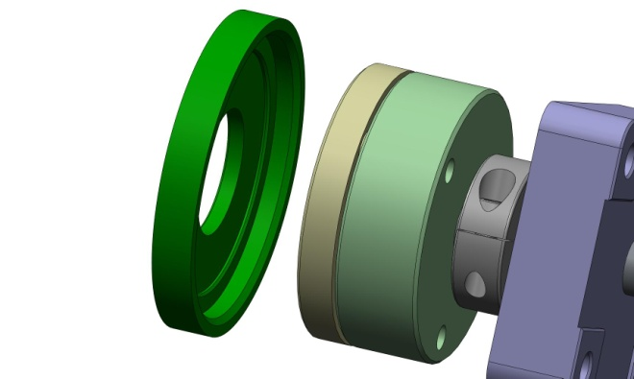

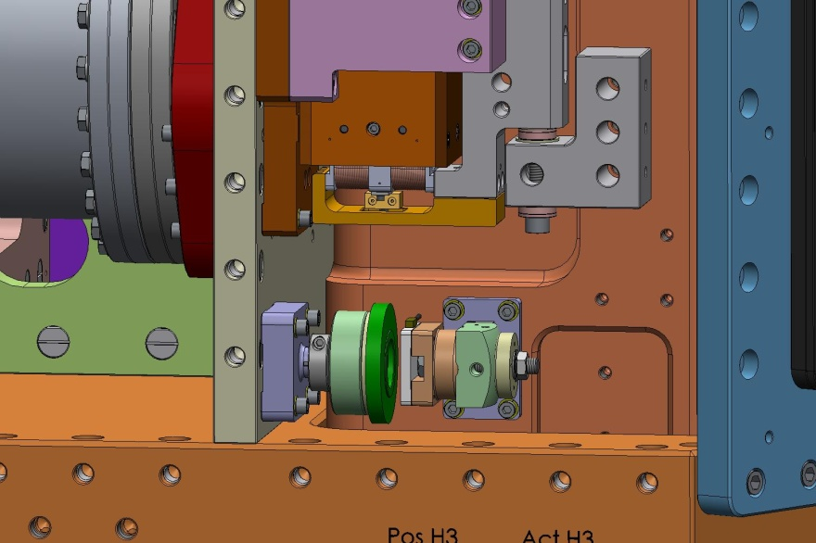
- With the Sensor Alignment Disc pushed tightly against both the sensor Probe and Target, tighten the nut on the Sensor Assembly to lock it in place.
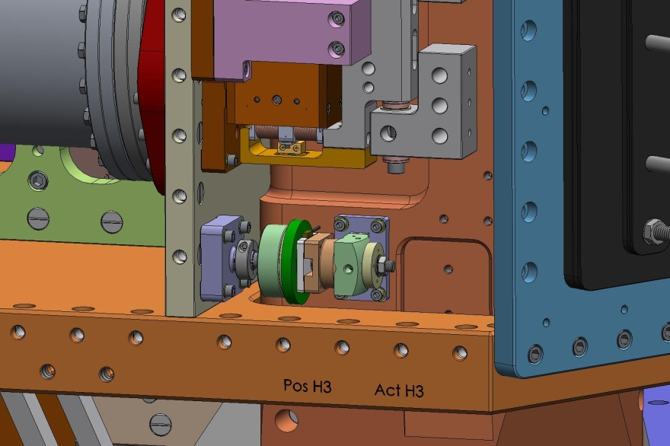

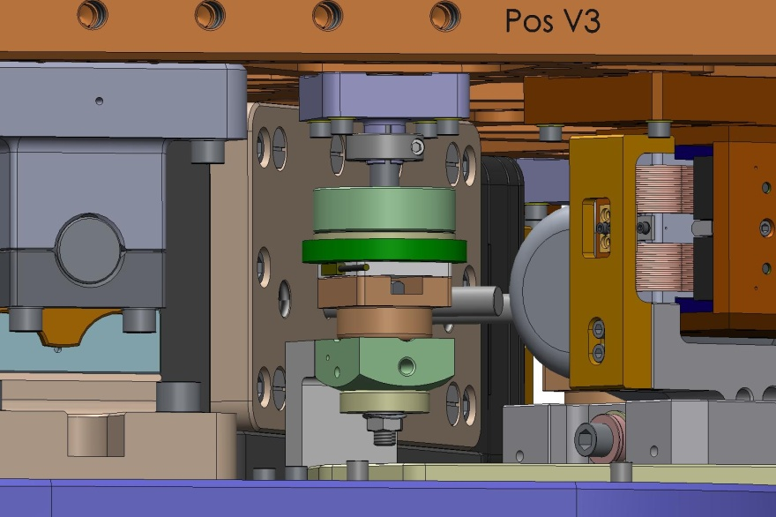
- Slide the Sensor Target Face back, and retighten collar clamp to lock its position. Remove the Alignment Disc.
- Repeat for remaining Sensor Assemblies.
- Bolt coil-side of Actuator Assemblies to Stage 0.
Hardware:
(3x 4) 3/8"-16x2.5" SHCS - Vertical Actuators to Stage 0 Base
(3x 6) 1/4"-20x2.25" SHCS - Horizontal Actuators to Support Posts
(3x 4) 3/8" fender washer (1.0" OD x .12" thickness)
(3x 6) 1/4" fender washer (.88" OD x .06" thickness)
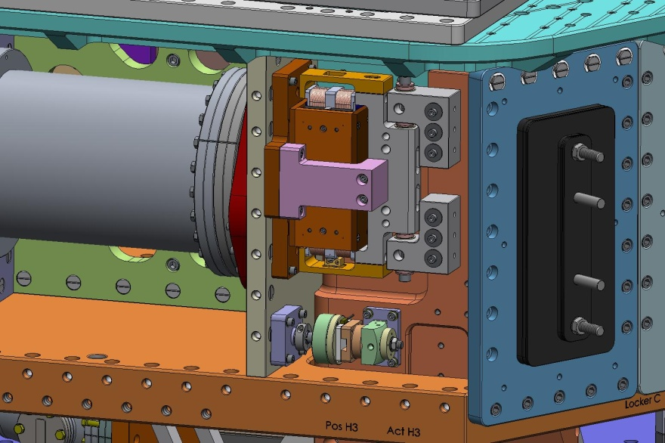

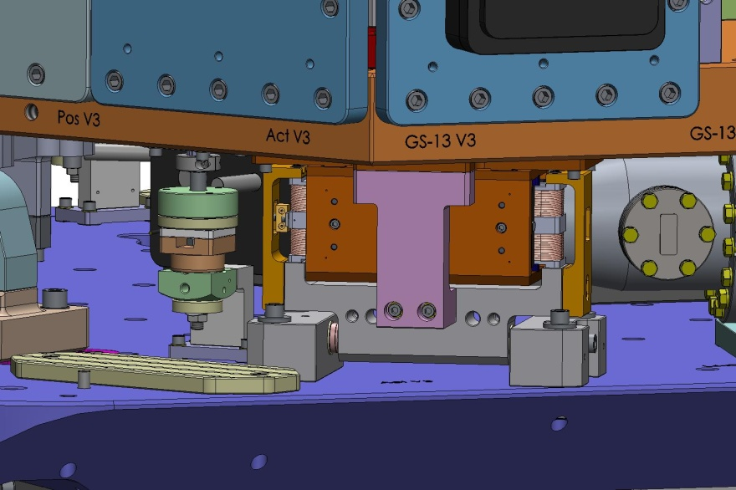
- Tighten screws holding U and L Brackets to Coil Supports. Torque to spec.
- Remove Actuator Set-Up Bars from Actuator Assemblies.
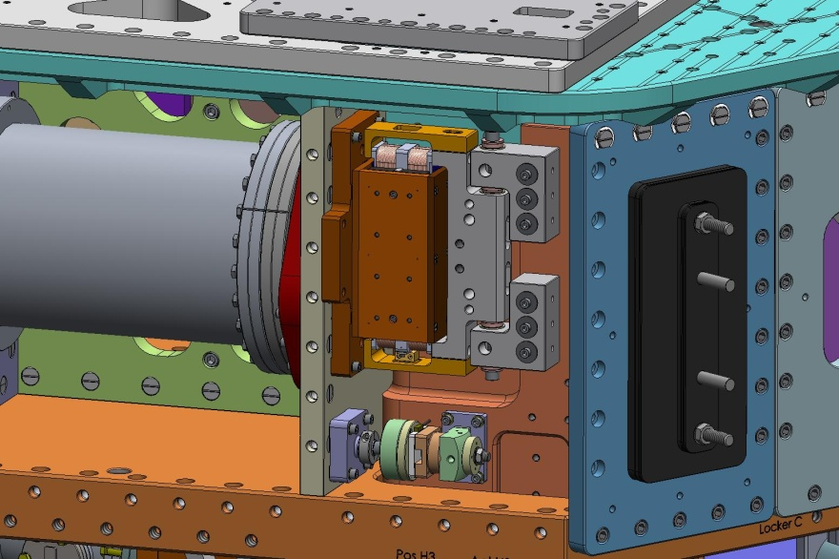

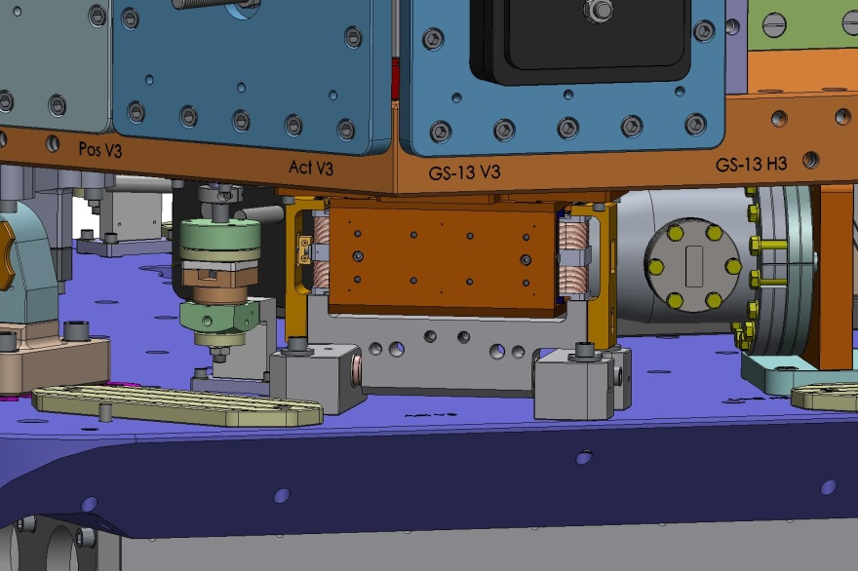

Add Remaining Outer Walls
- Hold Type 00 Outer Wall 120-Degree Bracket (D071060-00) against back of Small Panel Outer Wall. Start screws. Leave hand-tight.
Hardware:
(7) 3/8"-16x1.25" SHCS
(7) 3/8” vented washer
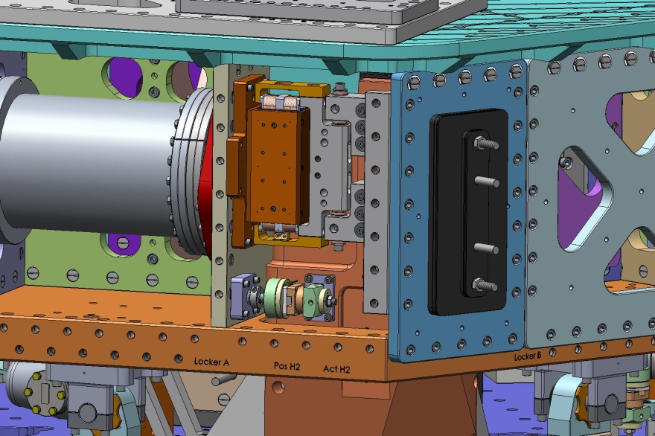
- Place GS-13 Outer Wall against side of Stage 1.
Hardware:
(40) 3/8"-16x1.75" SHCS - through Optical Table, into Pitchfork Barrel Nuts, and into Stage 1 Floor Barrel Nuts
(7) 3/8"-16x1.25" SHCS - into 120 Degree Bracket
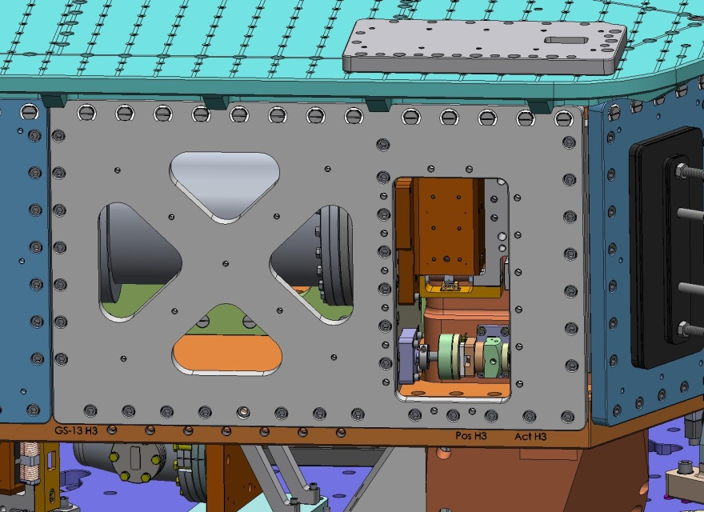
- Add Cover (D0900277) for GS-13 Outer Wall.
Hardware:
(16) 1/4"-20x1.0" SHCS
(16) 1/4" vented washer
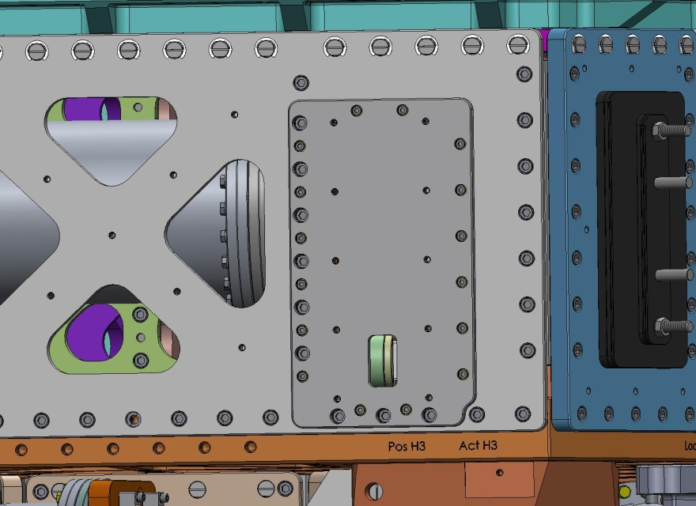
- Repeat for remaining (2) GS-13 Outer Walls and Covers.

Install Vertical L4-Cs
- Need the following:
- (3) Vertical L4-C Pods
- (3x 2) Clamp Caps (D0900705)
- (3x 2) Dog Clamps (D0900310)
- (3x 2) 3/8"-16x3.75" SHCS
- (3x 2) 3/8" fender washers
- Use pairs of dowel pins in Stage 0 Base to reference location of the (3) Vertical L4-Cs. Push the flange of each Pod firmly against the pins. Orient the feedthru connector flange facing away from the center of the ISI. Make sure the mounting pads on the flanges are clear of any holes in the Stage 0 Base.
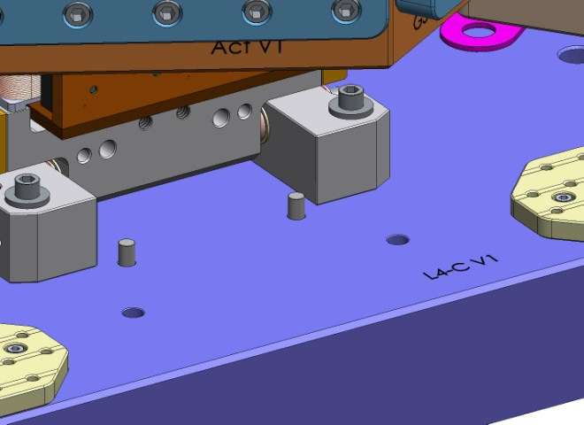

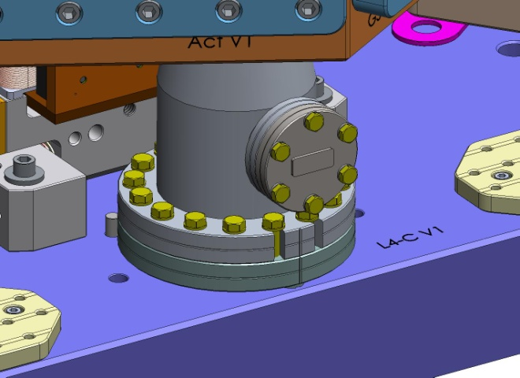

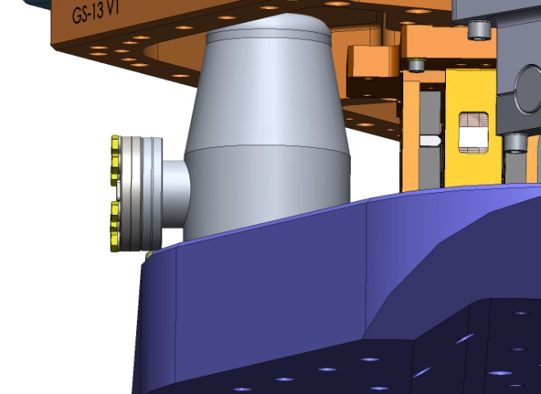

- The Clamp Caps go over hex head screws in the Pod flange. They are interface surfaces for pressing down with the Dog Clamps.
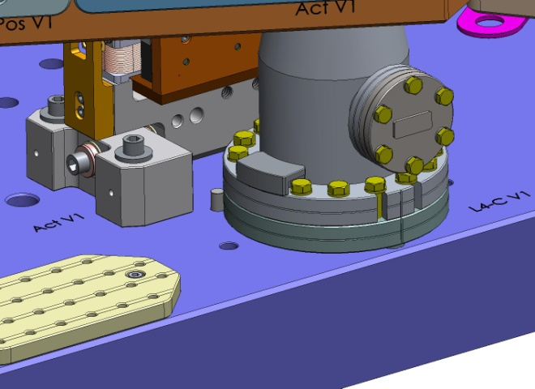
- The pads at the end of the Dog Clamps rest on top of the Clamp Caps.
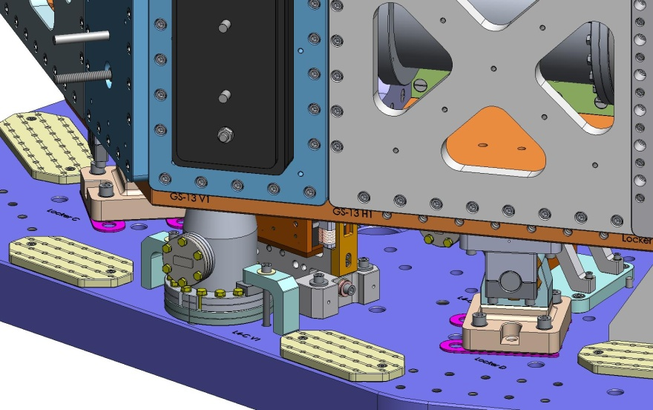

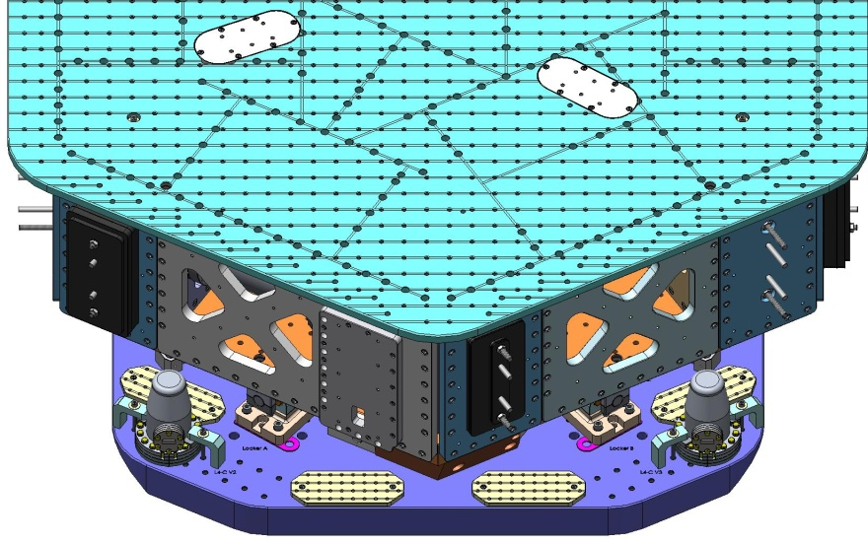

Appendix A. Torque Specifications

Material: Stainless Steel (tensile strength ≥ 70 ksi)
Screw Type: Socket Head Cap Screw (SHCS)
Mfgr./Vendor: McMaster-Carr, or U-C Components
Thread | Torque (in-lbs) | Torque (ft-lbs)
M2-.4mm | 2 | -
#10-32 | 32 | -
1/4”-20 | 75 | 6
5/16”-24 | 142 | 12
3/8”-16 | 236 | 20
3/8”-24 | 259 | 22
1/2”-13 | 517 | 43
1/2”-20 | 541 | 45

Material: Stainless Steel
Screw Type: Socket Head Cap Screw (SHCS)
Mfgr./Vendor: Holo-Krome
Thread | Torque (in-lbs) | Torque (ft-lbs)
#8-32 | 30 | -
#10-32 | 48 | -
1/4”-20 | 100 | 8
3/8”-16 | 329 | 27

Material: Stainless Steel A-286
Screw Type: Hex Head Cap Screw (SHCS)
Mfgr./Vendor: McMaster-Carr
Thread | Torque (in-lbs) | Torque (ft-lbs)
1/2”-13 | 1,320 | 110

Appendix B. Tools List
- English hex wrenches and bits
- hex bit for M2 screws
- ratchet wrench for Spring Pull-Down ACME screw
- torque wrenches
- extensions for torque/ratchet wrenches (e.g., for access to bolts through Stage 1 Floor, into the Keel Assembly)
- depth gage, to measure distance from Optical Table to top of Springs
- install tools for retaining rings (on Locker Sleeve, Type 02 Barrel Nuts)
- shims for checking actuator gaps
- shims for checking Locker gaps
- precision level

