- Loosen the omega-shaped clamps that hold the magnet to the base, remove the small aluminum shims from between the magnet and the magnet base, then re-tighten the large clamps. There are four shims to remove.
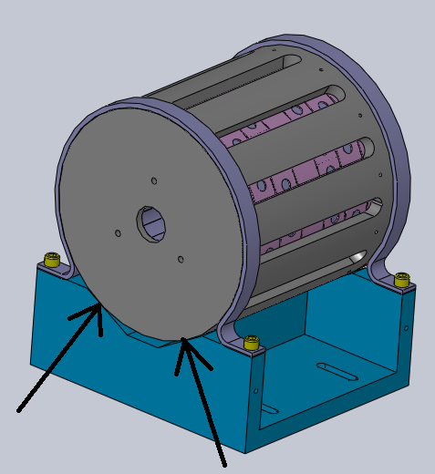

- Get the spacer plate (pictured) and the breadboard to assemble with the magnet assembly.
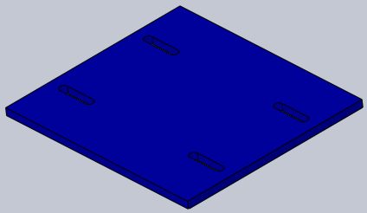

- Attach the magnet assembly and spacer to the breadboard with four ¼-20 x 1” screws and four ¼” washers. Make sure the location of the serial number, the end cap, and the number of holes to the end of the breadboard matches the figure.
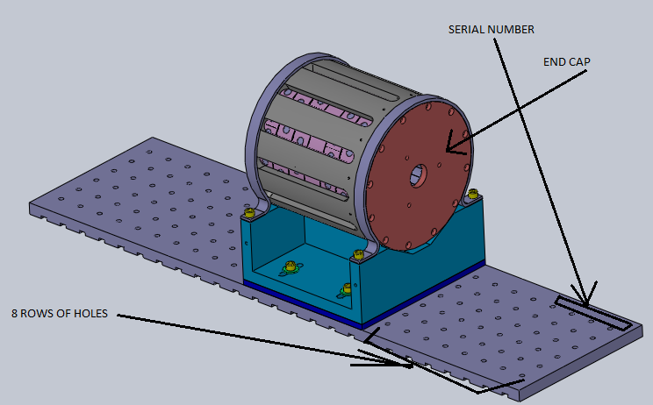

- Attach the post alignment fixtures to the breadboard with two ¼-20x1” screws. Make sure the alignment edges are flush with the breadboard on all faces.
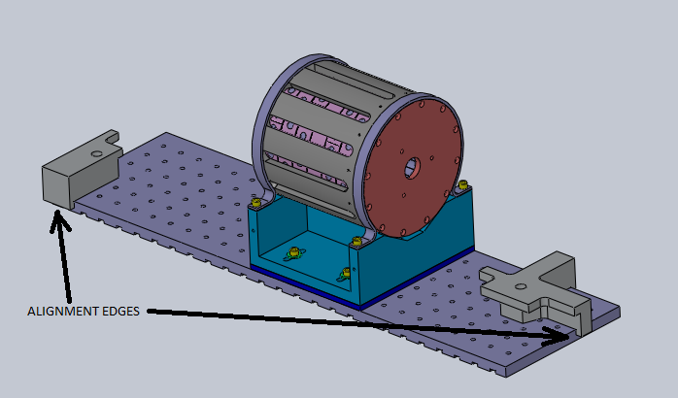
- Take three of the posts with the engraving “L1 HAM2 FI 3.735” and set them on the breadboard so that they are flush against the alignment fixtures.
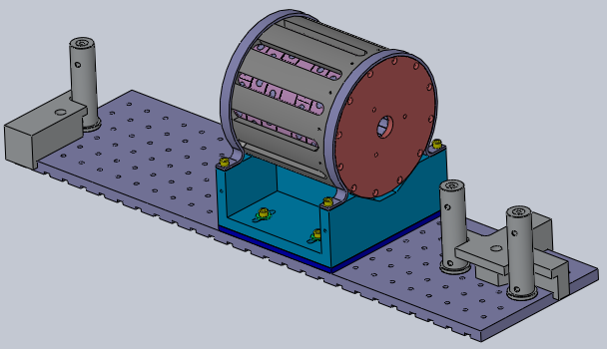
- Get three forks and three ¼-20x5/8” screws and use the forks to clamp the posts to the breadboard. Remove the alignment fixtures when finished.
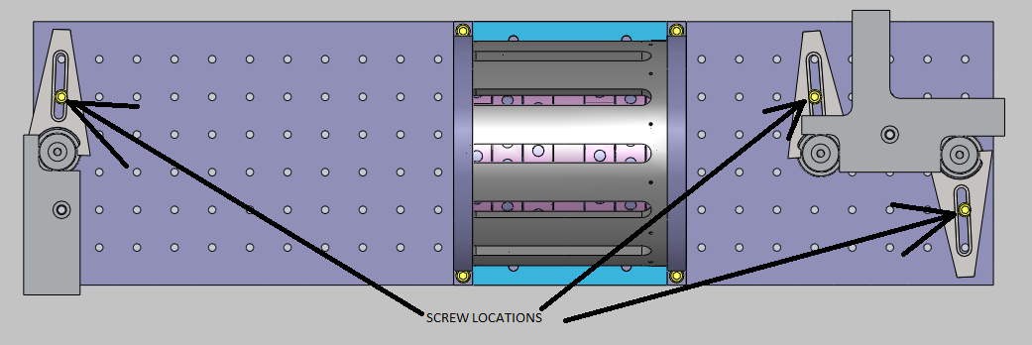
- Assemble the calcite mounts. Set one piece of calcite on a clean-room cloth and set the CWP mount over it. The mount has a threaded hole at the top for a #8-32x3/8” set screw, and a hole in the side for inserting the indium rod.
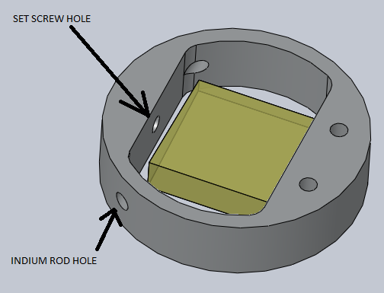

- Insert the indium rod in the side until it goes a few mm past the set screw hole. If it bends under its weight slide it through so it is supported on both ends. Lift the calcite slightly so that it is centered in the mount and tighten the set screw.
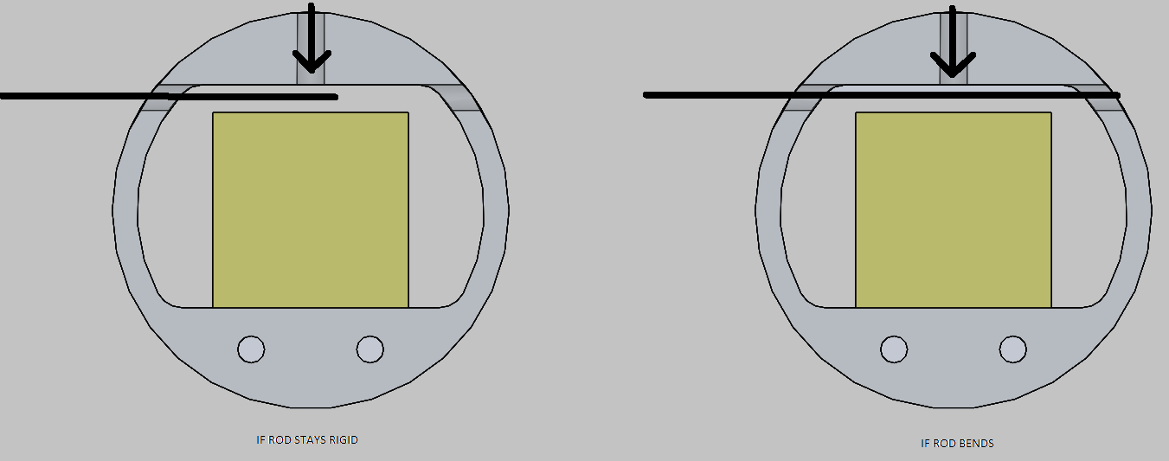
- Once the optic is secure, use an x-acto knife to cut the rod loose and remove the rod.
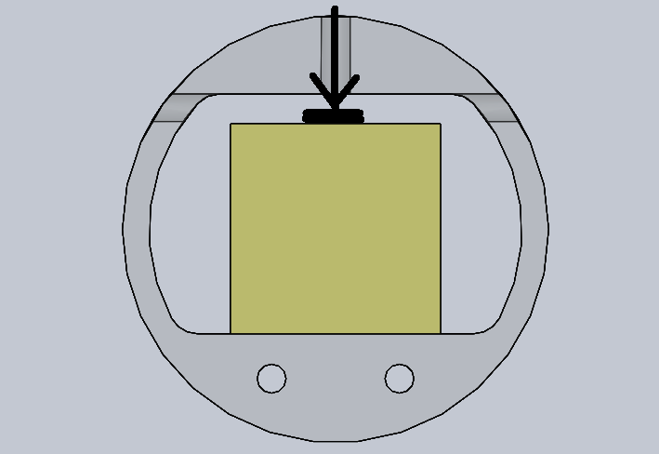

- Repeat to make a second CWP assembly.
- Assemble the HWP and the DKDP in their mounts (procedure the same for both). Set the optic in the optic holder.
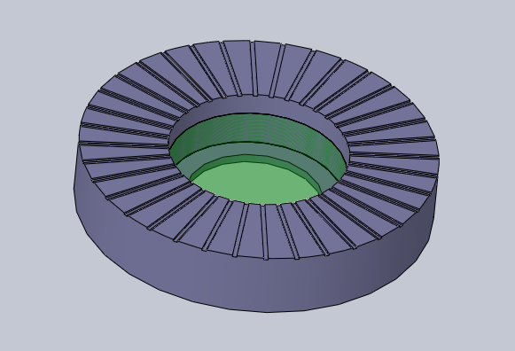
- Cut three strips of indium wire and set them in the near the optic edge as shown.
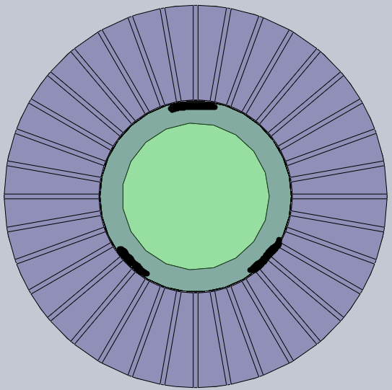
- Screw in the retaining ring with a pair of tweezers or an allen keys, being careful not to slip and scratch the optic, tighten until the optic feels secure. Repeat for the second optic (HWP or DKDP).
