LIGO Laboratory / LIGO Scientific Collaboration

LIGO- LIGO- E0900376-v1 LIGO 25 February 2009

HAM Cross Beams - Modal testing

Fabrice MATICHARD, Andy STEIN

Distribution of this document:
Advanced LIGO Project

This is an internal working note
of the LIGO Laboratory

California Institute of Technology  LIGO Project – MS 18-34  1200 E. California Blvd.  Pasadena, CA 91125  Phone (626) 395-2129  Fax (626) 304-9834  E-mail: info@ligo.caltech.edu | Massachusetts Institute of Technology  LIGO Project – NW22-295  185 Albany St  Cambridge, MA 02139  Phone (617) 253-4824  Fax (617) 253-7014  E-mail: info@ligo.mit.edu
LIGO Hanford Observatory  P.O. Box 1970  Mail Stop S9-02  Richland WA 99352  Phone 509-372-8106  Fax 509-372-8137 | LIGO Livingston Observatory  P.O. Box 940  Livingston, LA 70754  Phone 225-686-3100  Fax 225-686-7189

1. Introduction

This document presents the modal testing done on the new Ham cross beams installed on the HAM-X chamber at LASTI.

Experimental set up:

One cross beam is studied using a 7754 Endevco accelerometer and an impact hammer (BK 8206). The accelerometer mounting is shown on the picture below. Only the vertical accelerometer was used for the measurements presented in this document.

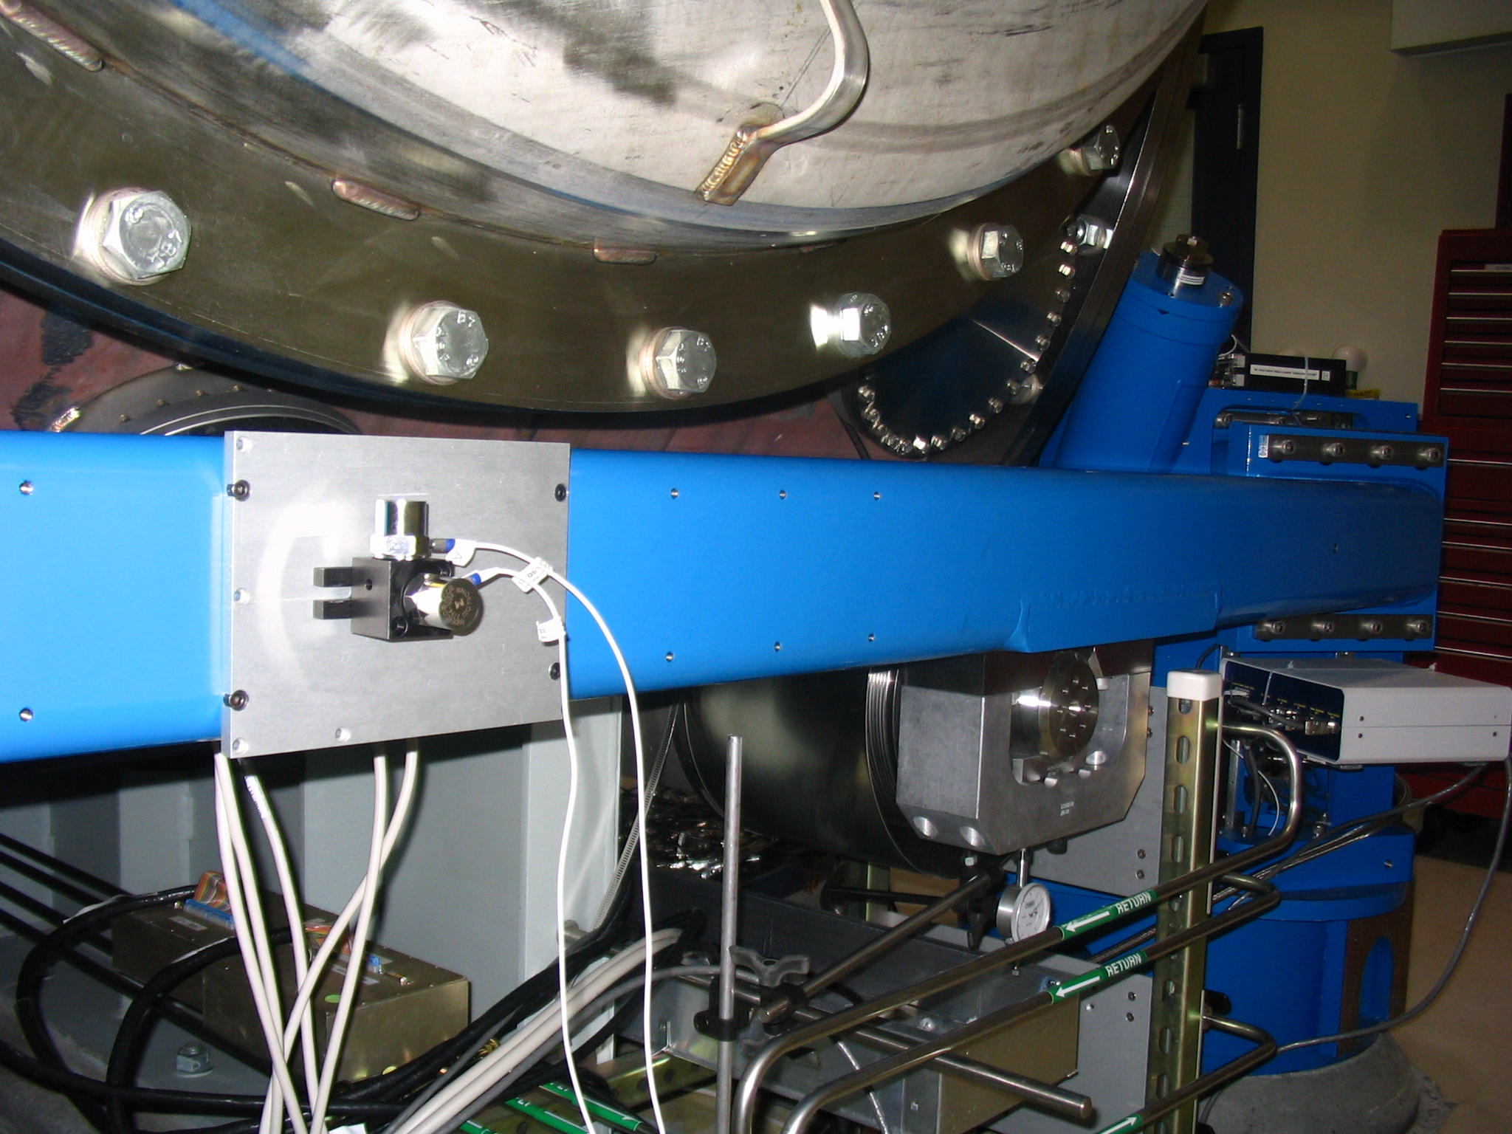

27 points of measurements are used as shown below. Force impact measurements have been done for each point in both X and Z directions.
Y
X
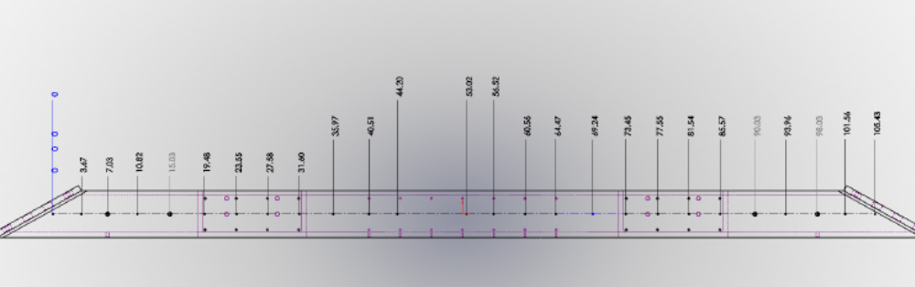
Point 1
Point 27

2. Transfer functions

The plot below shows the transfer functions taken in the Z direction for 10 various points along the beam. The amplitude and phase data quality is good which allows identifying the modal shapes. The phase shift at a given frequency shows that the modes are complex.
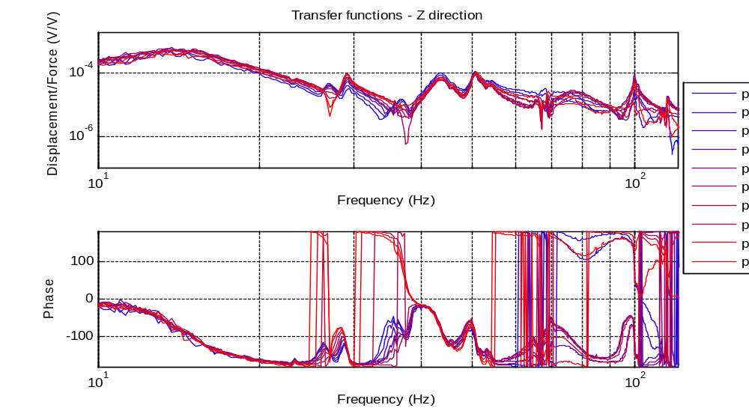
Complex modes
Direction

The plot below is a waterfall. The transfer functions of each point are plotted form left to right with a 0.5Hz increment. This plotting technique usually called waterfall gives a feeling of depth along the waterfall direction. One can see some deformation like shown by the black line (one needs a bit of imagination!)

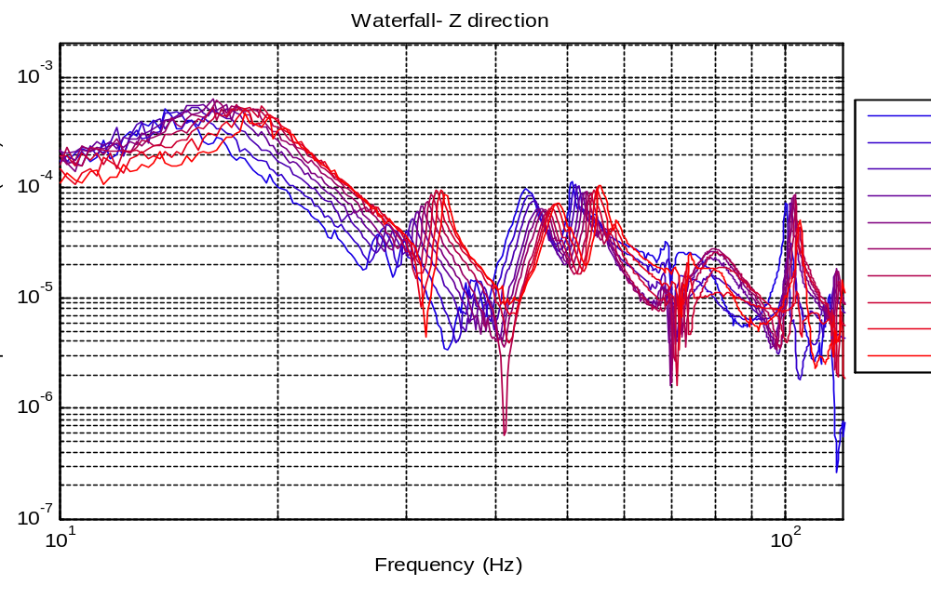
Waterfall
Direction
Approximate
Deformation
3. Modes Inventory

Z - Direction
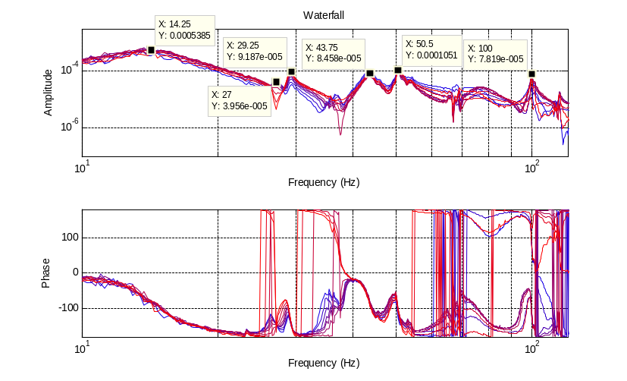

The following resonances have been measures in the Z direction : 14.25Hz ; 27Hz; 29.25 Hz; 43.75 Hz; 50.5 Hz; 100 Hz

X - Direction
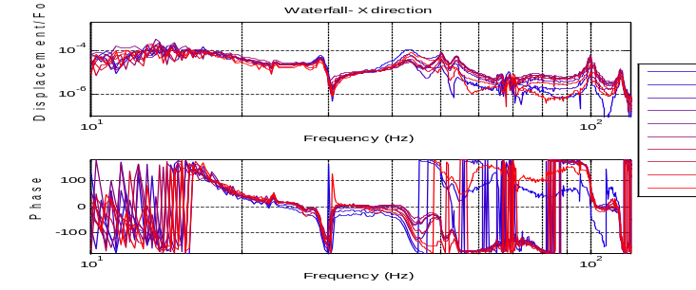

The data quality is poor below 20Hz. The amplitude of motion is however smaller than in the Z-direction.
Y – Direction
Only the two tip points can be measured in the Y-direction (along the neutral axis).
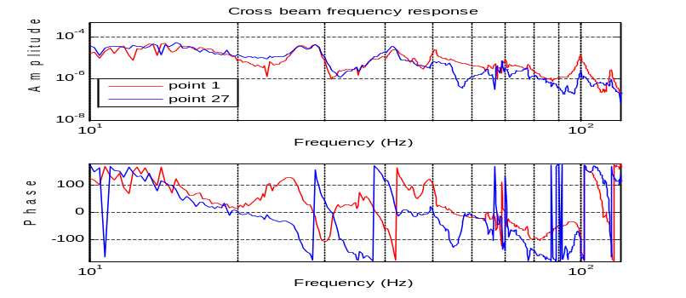
The same modes appear in the X, Y and Z direction.
4. Modes complexity

The plot below compares the real modal shapes at 27Hz with the corresponding complex modal shapes (Operating Deflexion Shape at time t=0). It shows that assuming the mode is real leads to over estimate the deformation. The modes complexity must be taken into account.
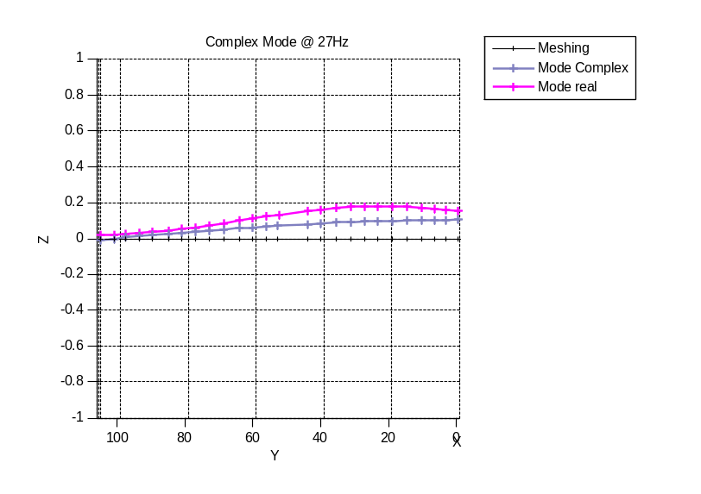

The plots below show that on the other hand the mode at 43.75Hz is mostly real:

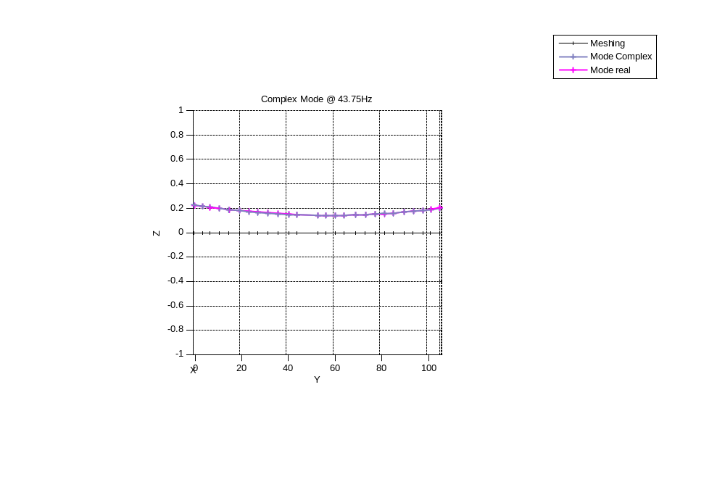
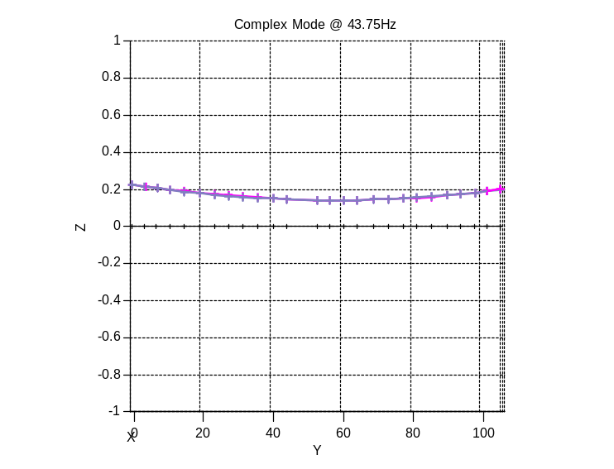
Deflexion Shapes, mode 3 at 29Hz

The plots below show the Operating Deflexion Shape over half a cycle at 29Hz. Each line shows the beam deformation at a given time. The lines in blue shows the response when the mode is assumed real. The minimum and maximum are stationary (black crosses).
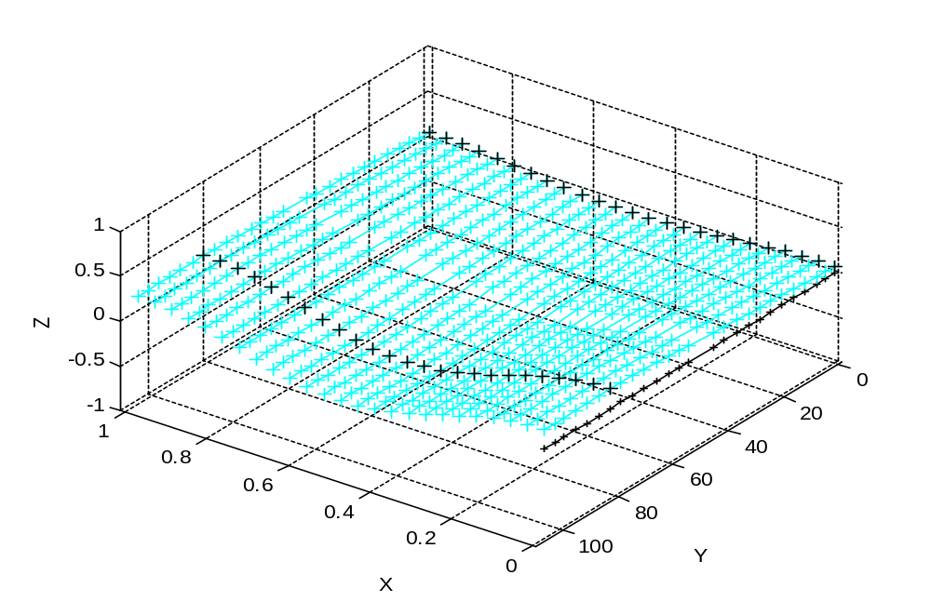
Snap shot @ t=0
Snap shot @ w*t=pi/2
Snap shot @ w*t=pi
Time scale
Z=Vertical displacement
Y=beam neutral axis

The plot below shows the actual response when the complexity is taken into account. The wave propagation effect associated with the mode complexity results in a variation of the points of maximum and minimum of displacements (black and blue crosses respectively).
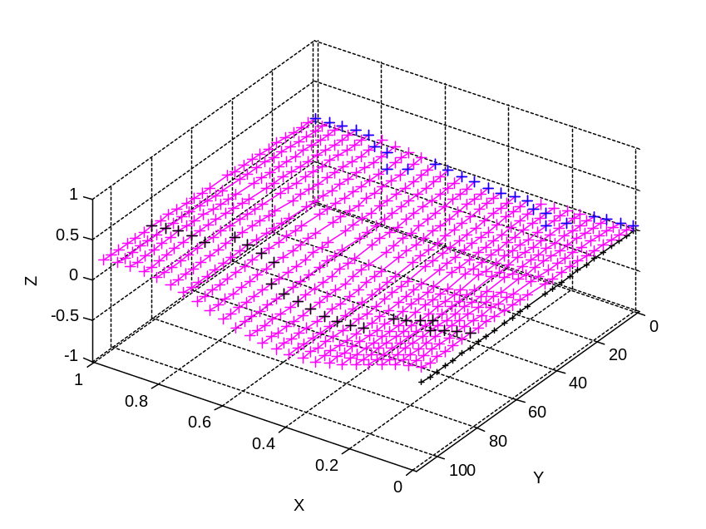
5. Modes shapes and Operating Deflexion Shapes

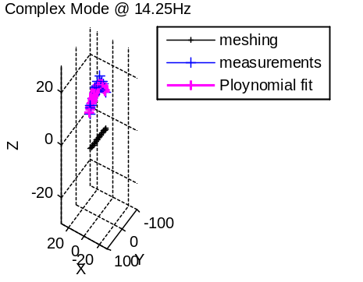
Mode @ 14.25Hz

The table below shows the modal shape at 14.25Hz (complex mode at t=0).

Isometric view  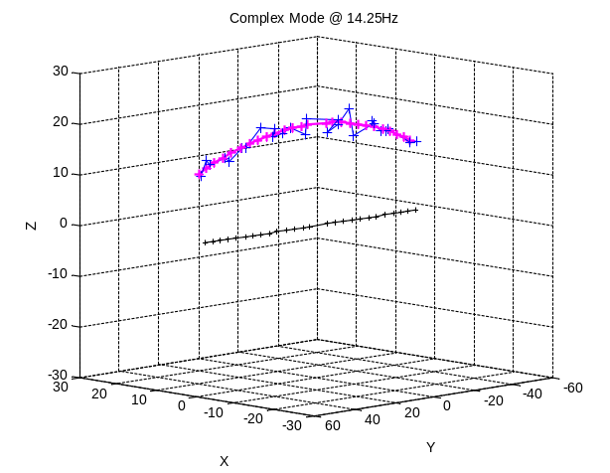 | Top view  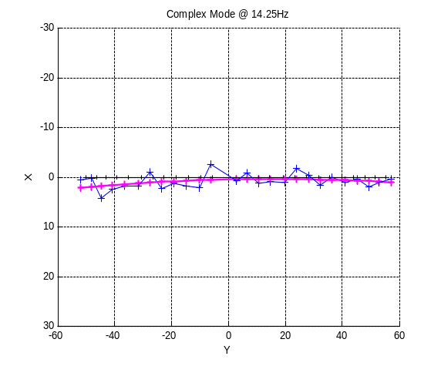
Front view  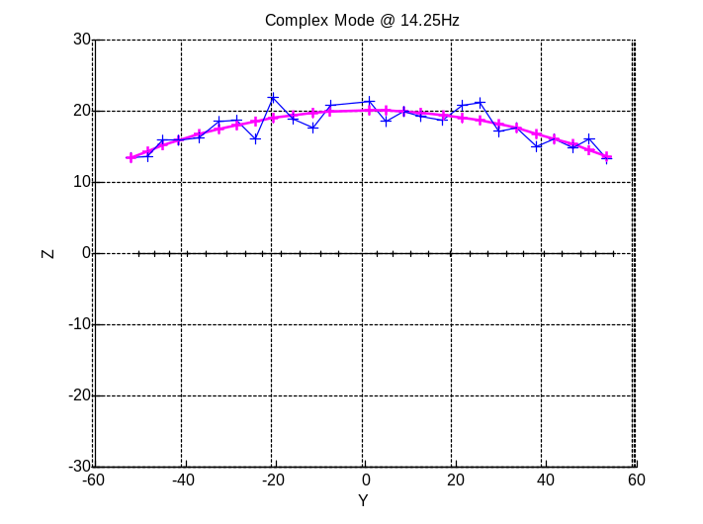  R-B  R-B  D | Side view  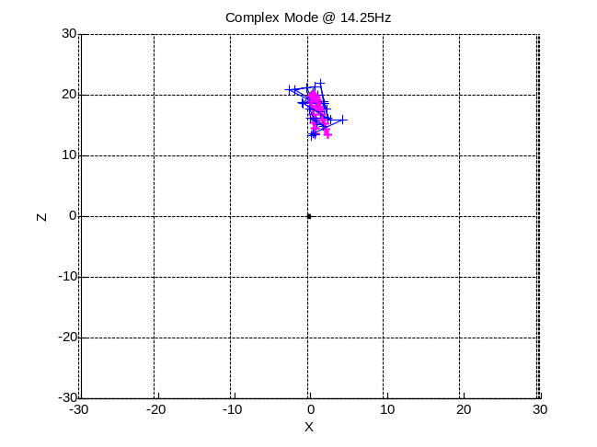

As shown on the front view the first mode is mostly a rigid body (R-B) displacement in the vertical direction. The measurement also shows a part of deformation (D). However the data quality is poor on this mode and the deformation can easily be over estimated.
It is however necessary to plot the ODS over a full cycle to understand the beams behavior at this frequency.
The table below shows the Operating Deflexion Shape (ODS) at 14.25Hz. It’s the complex modes plotted at different times over a full cycle. It shows the actual displacement of the beam for an excitation at 14.25Hz. Each line shows a different time from t=0 (Red line) to 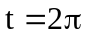(Blue line).

Actual data:  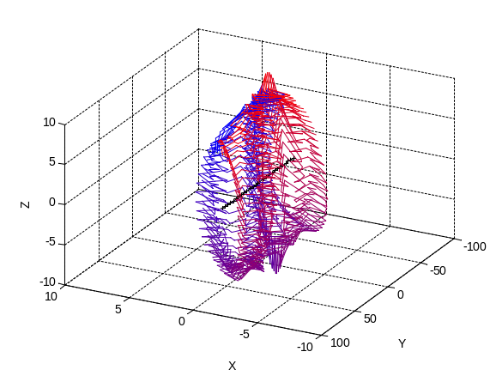 | First order polynomial fit in X and Z:  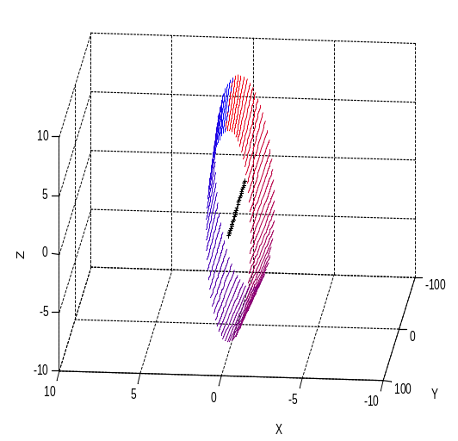
First order polynomial fit in X:  Second order polynomial fit in X:  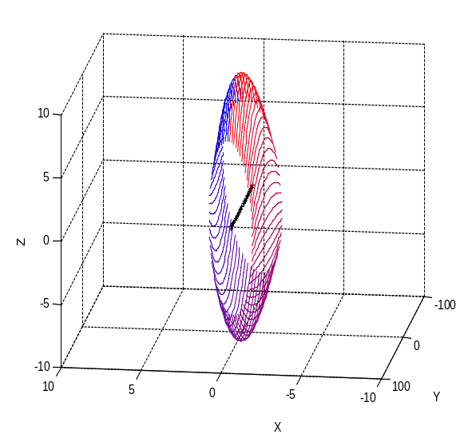 | Second order polynomial fit in X and Z:  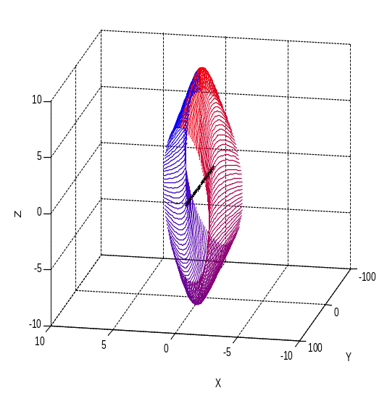

Due to the strong complexity of the modes, the ODS are necessary to understand the actual beam motion. However the modal shapes is helpful to define the good polynomial fitting order. The ODS in the bottom right corner is very likely the best fit of the actual motion.

It shows that the actual motion is mostly a rigid body rotation of the beam around its neutral axis associated with a slight bending deformation.
Mode @ 27Hz

The table below shows the modal shape at 27Hz (complex mode at t=0).

Isometric view  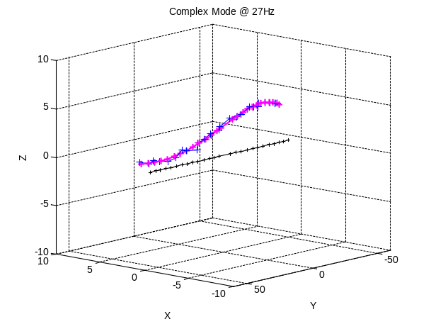 | Top view  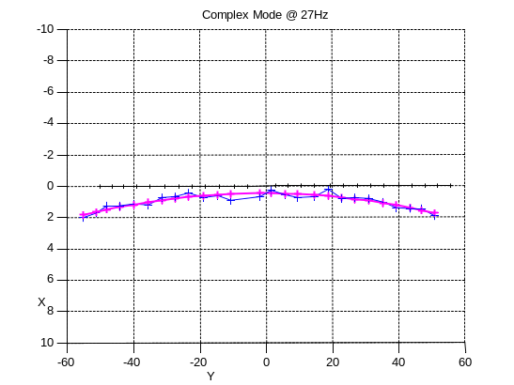
Front view  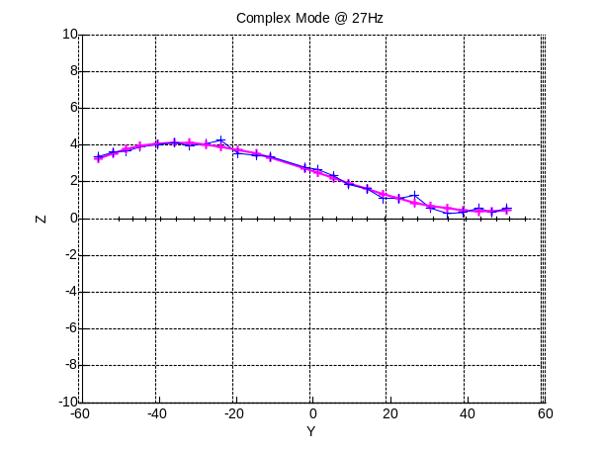 | Side view  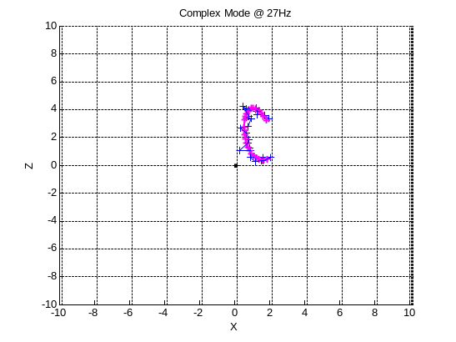

This mode shows bending of the beam. But it is necessary to plot the ODS over a full cycle to understand the beam motion (see next page).
The table below shows the Operating Deflexion Shape (ODS) at 27Hz. It’s the complex modes plotted at different time over a full cycle. It shows the actual displacement of the beam for an excitation at 27Hz. Each line shows a different time from t=0 (Red line) to (Blue line).

The top views are data under different angle of camera. The bottom views are polynomial fit under different angle of camera.

Actual data (half a cycle only for better display):  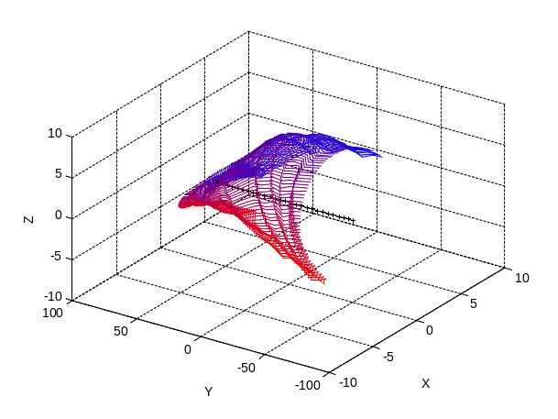 | Actual data (full cycle):  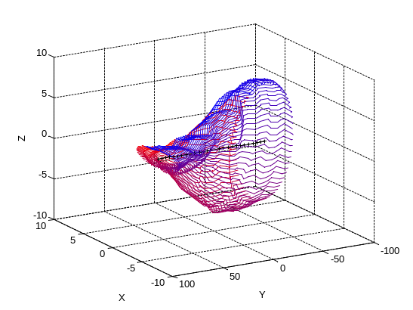
Polynomial fit in X and Z (half a cycle only for better display):  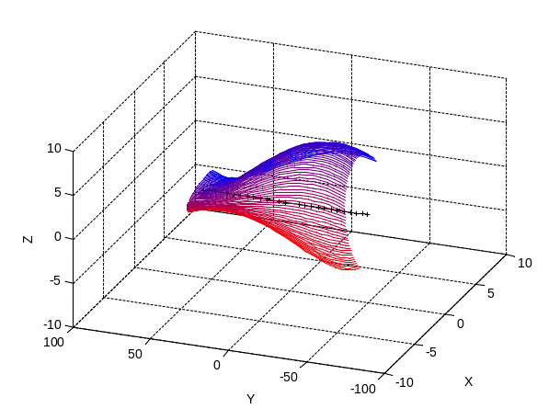 | Polynomial fit in X and Z:  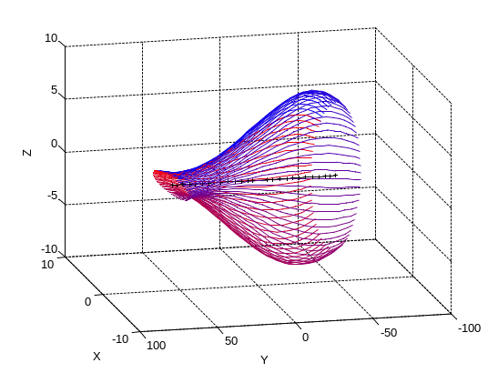

At this frequency, one tip of the beam is moving along a small ellipse and the other tip moves along a large one. The rotation is coupled with a bending of the beam.

Mode @ 29Hz

The table below shows the Operating Deflexion Shape (ODS) at 29Hz.

The top views show the actual data displayed under different angle of camera. The bottom views are polynomial fit displayed under various angles of camera.

At this frequency the other tip of the beam moves along a large ellipse:

Actual data (half a cycle only for better display):  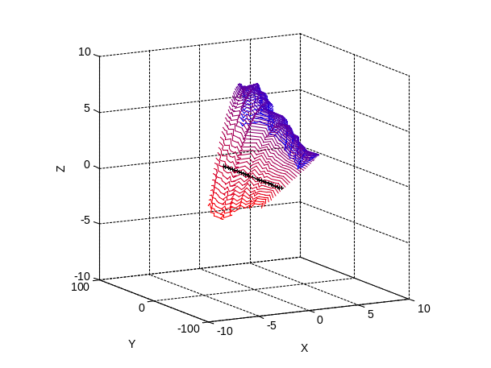 | Actual data (full cycle):  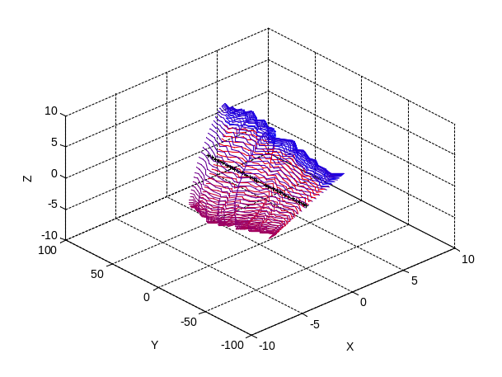
Polynomial fit in X and Z(half a cycle only for better display):  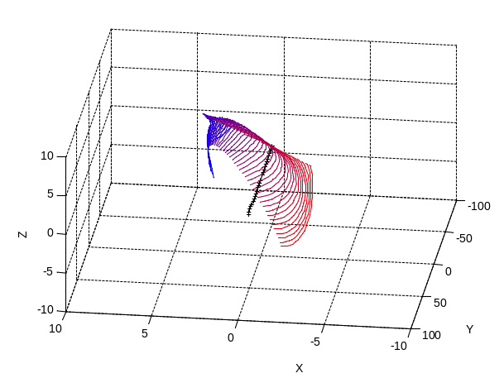 | Polynomial fit in X and Z:  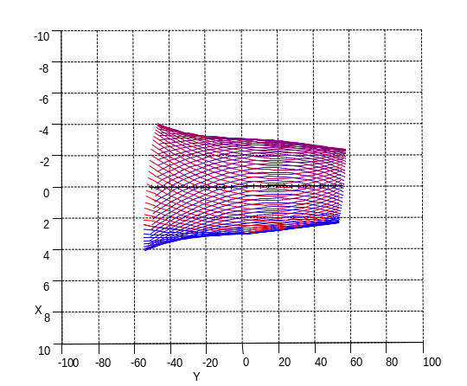

The table below summarizes the modal shapes at higher frequencies (complex mode at t=0).The left column shows the complex mode at t=0 and the polynomial fit. The right column shows the ODS over a full cycle.

Mode 4 at 44Hz  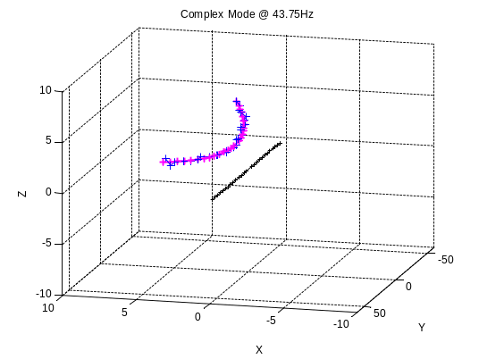 | ODS at 44Hz  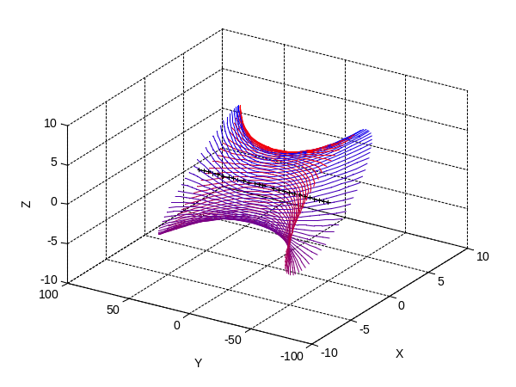
Mode 5 at 50.5Hz  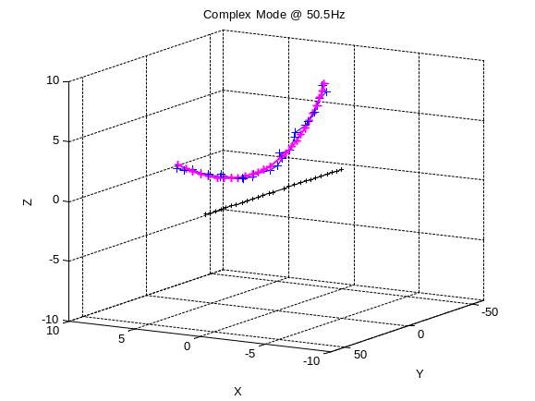 | ODS at 50.5Hz  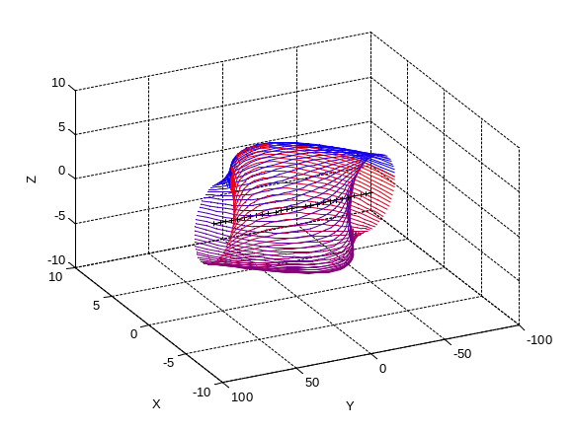
Mode 6 at 100Hz  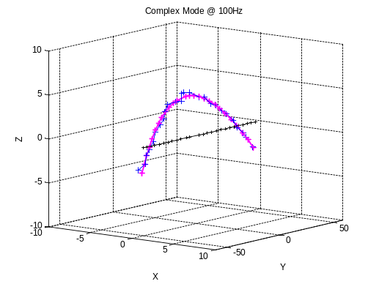 | ODS at 100Hz  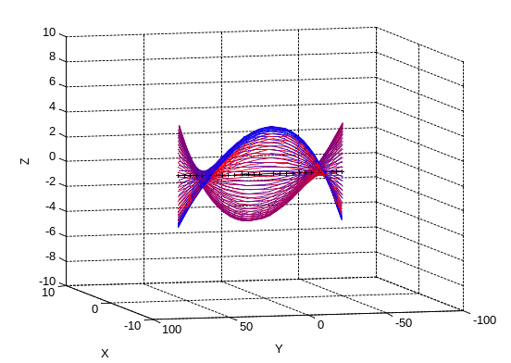
The table below summarizes the modal shapes at higher frequencies (complex mode at t=0).
The left column shows the complex mode at t=0 and the polynomial fit. The right column shows the ODS over a full cycle.
Mode 7 at 115.3Hz  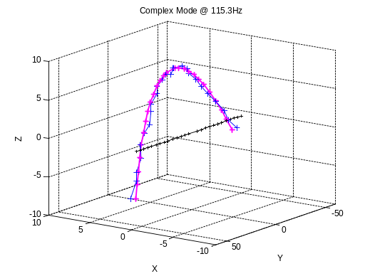 | ODS at 115.3Hz Hz  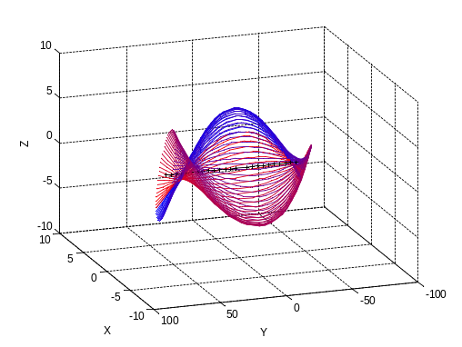
Mode 5 at 160.5Hz  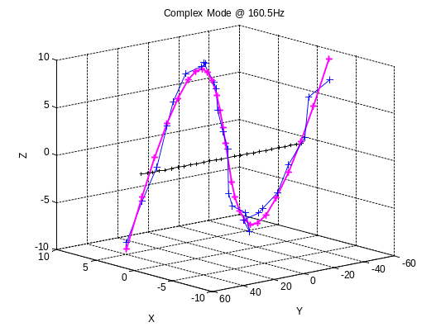 | ODS at160.5Hz  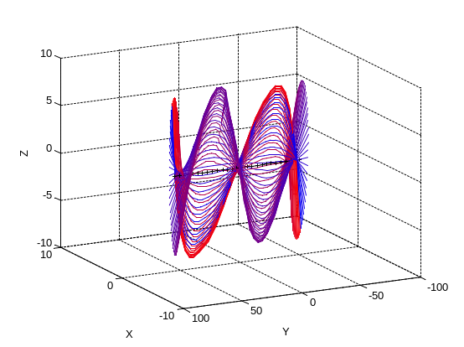
Mode 6 at 162.5Hz  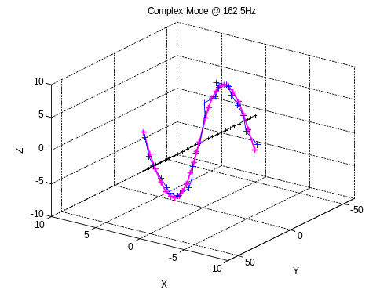 | ODS at 162.5Hz  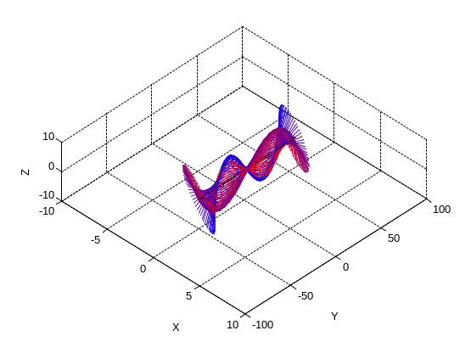

Conclusion:

The modal shapes of the cross beam have been identified. Due to the high local damping in HEPI actuators those modes are strongly complex.
In order to study these complex modes, the Operating Deflexion Shape (ODS) of the beam have been displayed over a full cycle of harmonic excitation.
They show that the first mode at 14.25Hz is mostly a rigid body rotation of the beam around its neutral axis associated with a slight bending deformation.
On the second mode at 27Hz, one tip of the beam is moving along a small ellipse and the other tip moves along a large one. The rotation is coupled with a bending of the beam.
The third mode at 29Hz is almost the symmetric of the mode at 27Hz: the tips moving along a large ellipse at 27Hz moves along a large one at 29Hz, and vice versa.

The higher modes have been identified and are naturally mostly deformation modes of the cross beam.

