Geotech GS-13
Alternative Flexure Installation Instructions

LIGO-T0900583-V1

Geotech GS-13 seismometer beryllium-copper flexure installation instructions as used in aLIGO ISI systems.

Graham Allan
Daniel Clark
Brian Lantz

2009.11.18

Table of Contents
Table of Contents 2
Table of Figures 2
1. Introduction 4
2. Pre-Assembly 4
3. Assembly Procedure 5
4. Installing the preamp board 12
5. Installing the anti-resonant offload spring absorbers 17
6. BeCu flexure installation 19
7. Testing 30
8. Reassembly 34

Table of Figures
Figure 1: Before initial disassembly showing the recommended tools and equipment 5
Figure 2: Close shot of recommended tools 5
Figure 3: Ensure that the GS-13 is locked 6
Figure 4: Turn the GS-13 upside down in preparation for can removal 6
Figure 5: Remove the factory feet and lock ring from the three studs 7
Figure 6: Factory feet removed - these will not be reassembled on the instrument 7
Figure 7: Using the 9/16 combination wrench, loosen the three nuts to about halfway up the stud 8
Figure 8: Slide the aluminum washer cap and rubber grommet up slightly on each stud 8
Figure 9: Push down on the studs while gripping and pulling up on the can until… 9
Figure 10: It slides off the sealing o-ring at the base of the instrument 9
Figure 11: Next remove the nuts, cap washers, and grommets and set them aside for reassembly later 10
Figure 12: Removed hardware for can removal 10
Figure 13: Carefully lift the can off of the instrument 11
Figure 14: GS-13 with can removed 11
Figure 15: Using the P1 screwdriver remove the existing calibration board 12
Figure 16: Pull the board out and make sure that pin 1 is marked on the connector - if not mark it 12
Figure 17: Unplug the connector from the circuit board 13
Figure 18: The LIGO preamp ready to install 13
Figure 19: Plug the connector into the new board observing correct orientation 14
Figure 20: Tuck the wires back in making sure that the wires do not contact offload springs, cantilevers, or flexures 14
Figure 21: Visually ensure the wires are not interfering with the offload springs 15
Figure 22: Attach the circuit board with original screws 15
Figure 23: Turn the GS-13 over and set it on its studs 16
Figure 24: Make sure that all of the jumpers on the board are positioned as shown - in the lower positions 16
Figure 25: Locate the small Viton o-ring on the top of each offload spring (vertical models only) 17
Figure 26: Slip the o-ring around the corner by about 1 cm. 17
Figure 27: Ensure that the spring exits the rod-end that supports it by right angles – if not – rotate it into alignment (this one is not aligned) 18
Figure 28: This one is aligned - repeat for all three offload springs 18
Figure 29: Using the 3/32 hex wrench, remove the screws and plates that hold the lower delta rods in place 19
Figure 30: While supporting the free end remove the other side 19
Figure 31: The removed delta rod, SHCS, and plates (top) will not be reused, the new flexure and 4-40 x 3/8 in. SHCS bottom will be installed 20
Figure 32: Slide the new BeCe flexure in place 20
Figure 33: While holding the end in the correct position tighten the screw 21
Figure 34: Start the screw by about 4 threads 21
Figure 35: Place one clamp on the arm holding the top plate in place 22
Figure 36: Place the second clamp holding the end up against the temporary plate 22
Figure 37: Showing the temporary clamps and plate 23
Figure 38: Attach by tightening the screw 23
Figure 39: Remove the top delta rods 24
Figure 40: Slip the new BeCu flexure in place 24
Figure 41: BeCu flexure partially inserted 25
Figure 42: Lift up the end and start sliding it in place from the back 25
Figure 43: Slightly push the cantilever to the right to help slide the end forward 26
Figure 44: Lift the other end into place 26
Figure 45: Attach both ends 27
Figure 46: This is the trickiest flexure installation 27
Figure 47: Flexure slipped in 28
Figure 48: The flexure will bind up at this point, push the BeCu flexure forward bending the flexure in order to enable it to slip in place 28
Figure 49: Hold it in place and attach with hardware 29
Figure 50: Unlock the proof mass and look at the red indicator - it should fill the center ring completely 29
Figure 51: Remove the outer two jumpers from the pre-amp board 30
Figure 52: Attach the 10X probe and ground clip to the center conductor on each side of the pre-amp 30
Figure 53: Take a ring-down by holding the mass down against its stop and releasing it 31
Figure 54: Typical ring-down. In this case the natural frequency was low 31
Figure 55: To raise the natural frequency loosen the lock collar with the 7/64 hex wrench and turn the knob counterclockwise to increase the frequency 32
Figure 56: Corrected ring-down showing good response 32
Figure 57: Replace the jumpers on the pre-amp board 33
Figure 58: Relock the proof mass 33
Figure 59: Turn the seismometer over 34
Figure 60: Carefully lower the lid over the instrument 34
Figure 61: A fairly large downward force is required to slip the cover over the o-ring 35
Figure 62: Install the grommet, cap, and nut on the studs. Tighten with the 9/16 wrench 35
Figure 63: The correct sequence of installation 36
Figure 64: Installed can 36
Figure 65: Completed GS-13 flexure retrofit ready for podding in aLIGO 37

1. Introduction
The Geotech GS-13 seismometer is supplied to aLIGO with the standard delta-rods. These need to be replaced with the alternative beryllium-copper flexures before being placed inside the GS-13 vacuum pods and placed in service in the aLIGO system. Along with the flexure installation, a new aLIGO pre-amp circuit board must be installed, anti-resonance o-rings slipped in place on the offload springs on the vertical instruments, and the instrument tested.

There are some differences in the horizontal and vertical GS-13 configurations. Namely, the horizontal GS-13 seismometers as used in aLIGO do not have the three offload springs, cantilevers, and supporting flexures. In the case that the instrument being fitted is a horizontal unit the installer may disregard the steps that only pertain to the vertical GS-13.

The following instructions assume that the required flexures and GS-13s have already passed their acceptance tests.

2. Pre-Assembly
The following tools are required for the assembly and testing as described in this document:

- 3 approved top flexures
- 3 approved bottom flexures
- aLIGO pre-amp board
- 12 4-40 x 3/8 in. stainless steel Socket Head Cap Screws (SHCS)
- 9/16 in. combination wrench
- 3/32 hex wrench
- 7/64 hex wrench
- Bottle Loctite 290 green wicking grade threadlocker
- Paint pen or marker
- Screwdriver – P1
- Miniature clamps (we used two plastic tweezers with o-rings and a stainless steel strap)
- Oscilloscope with 10X probe

3. Assembly Procedure
The entire assembly procedure should be done in a relatively clean environment. A cleanroom is not necessary but care should be taken to avoid contamination.
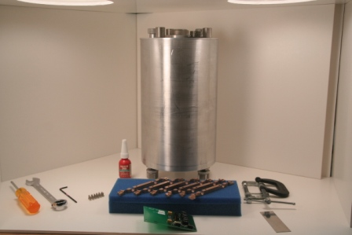
Figure 1: Before initial disassembly showing the recommended tools and equipment

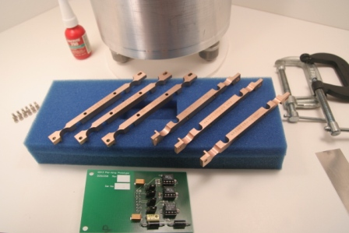

Figure 2: Close shot of recommended tools

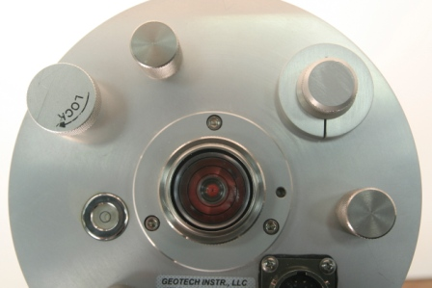

Figure 3: Ensure that the GS-13 is locked

Verify that the proof-mass internal to the GS-13 is locked by both cranking the “LOCK” knob clockwise and the red flower in the center of the view glass fills the view glass to the outer ring.

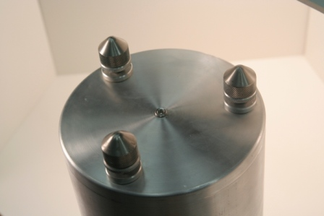

Figure 4: Turn the GS-13 upside down in preparation for can removal

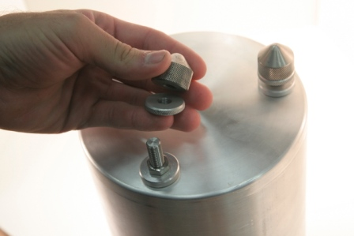

Figure 5: Remove the factory feet and lock ring from the three studs

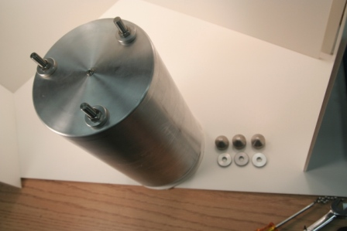

Figure 6: Factory feet removed - these will not be reassembled on the instrument

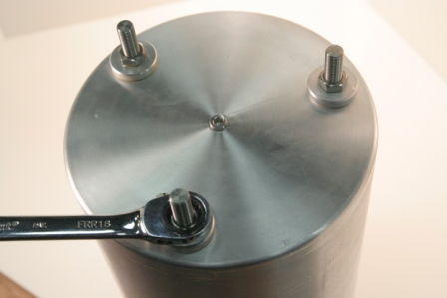

Figure 7: Using the 9/16 combination wrench, loosen the three nuts to about halfway up the stud

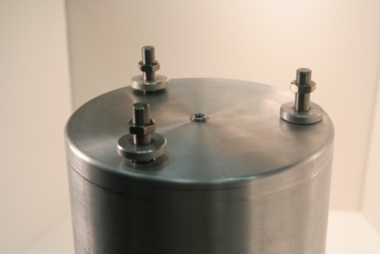

Figure 8: Slide the aluminum washer cap and rubber grommet up slightly on each stud

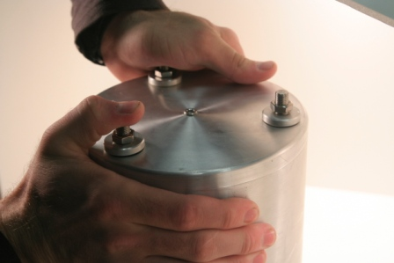

Figure 9: Push down on the studs while gripping and pulling up on the can until…

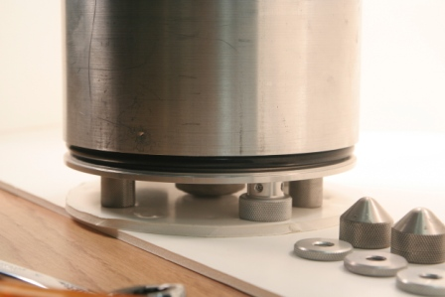

Figure 10: It slides off the sealing o-ring at the base of the instrument

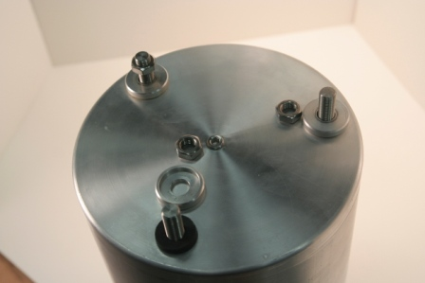

Figure 11: Next remove the nuts, cap washers, and grommets and set them aside for reassembly later

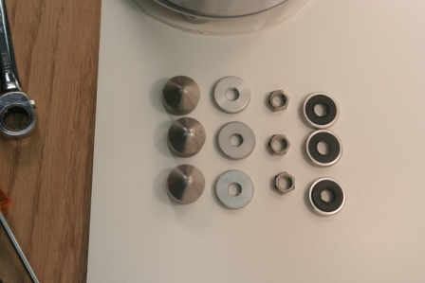

Figure 12: Removed hardware for can removal

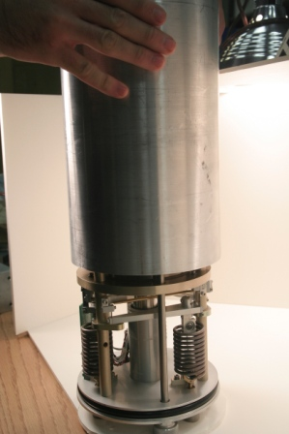

Figure 13: Carefully lift the can off of the instrument

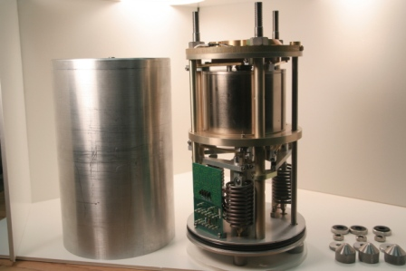

Figure 14: GS-13 with can removed

4. Installing the preamp board
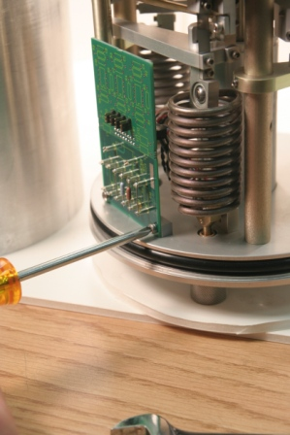

Figure 15: Using the P1 screwdriver remove the existing calibration board

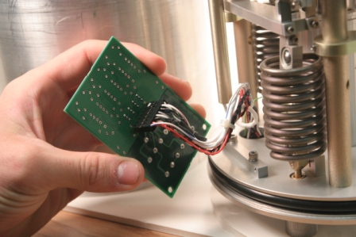

Figure 16: Pull the board out and make sure that pin 1 is marked on the connector - if not mark it

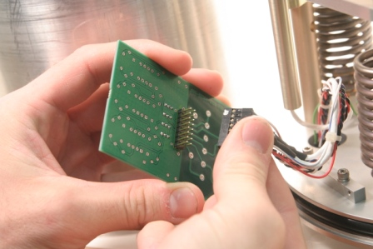

Figure 17: Unplug the connector from the circuit board

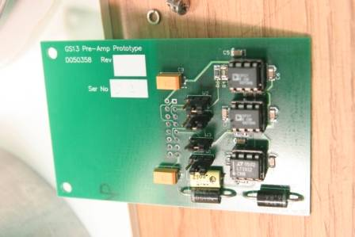

Figure 18: The LIGO preamp ready to install

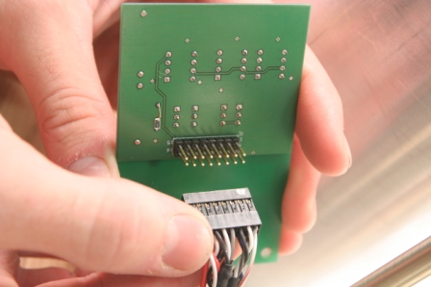

Figure 19: Plug the connector into the new board observing correct orientation

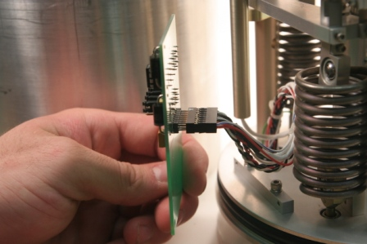

Figure 20: Tuck the wires back in making sure that the wires do not contact offload springs, cantilevers, or flexures

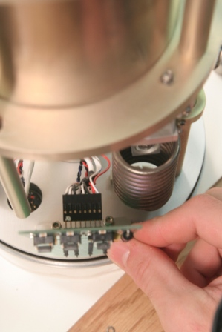

Figure 21: Visually ensure the wires are not interfering with the offload springs

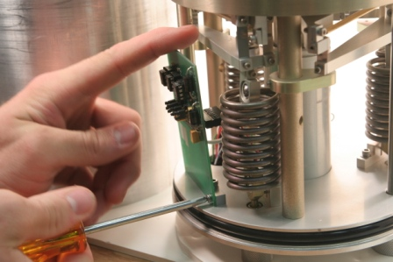

Figure 22: Attach the circuit board with original screws

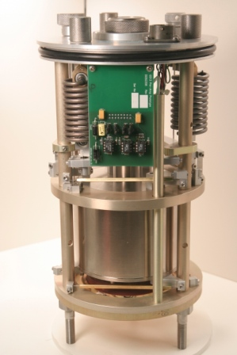

Figure 23: Turn the GS-13 over and set it on its studs

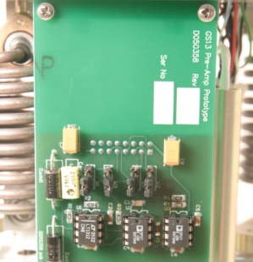

Figure 24: Make sure that all of the jumpers on the board are positioned as shown - in the lower positions

5. Installing the anti-resonant offload spring absorbers
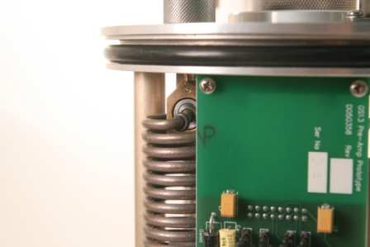

Figure 25: Locate the small Viton o-ring on the top of each offload spring (vertical models only)

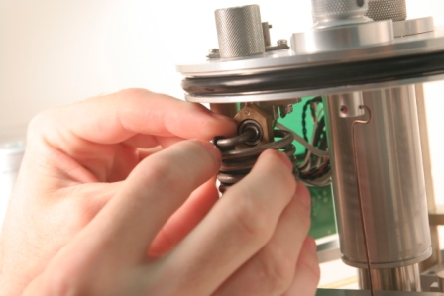

Figure 26: Slip the o-ring around the corner by about 1 cm.

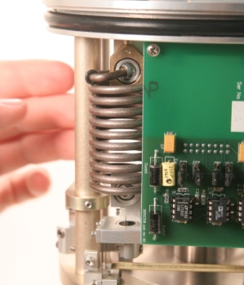

Figure 27: Ensure that the spring exits the rod-end that supports it by right angles – if not – rotate it into alignment (this one is not aligned)

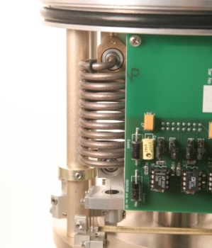

Figure 28: This one is aligned - repeat for all three offload springs

6. BeCu flexure installation
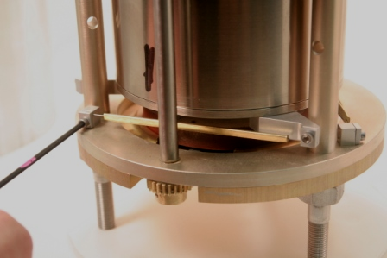

Figure 29: Using the 3/32 hex wrench, remove the screws and plates that hold the lower delta rods in place

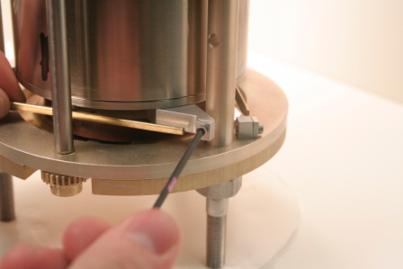

Figure 30: While supporting the free end remove the other side

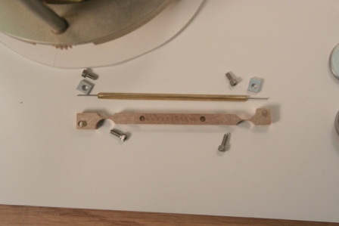

Figure 31: The removed delta rod, SHCS, and plates (top) will not be reused, the new flexure and 4-40 x 3/8 in. SHCS bottom will be installed

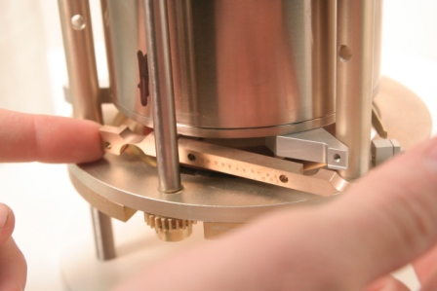

Figure 32: Slide the new BeCe flexure in place

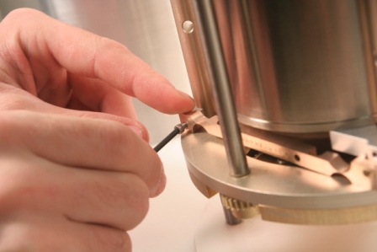

Figure 33: While holding the end in the correct position tighten the screw

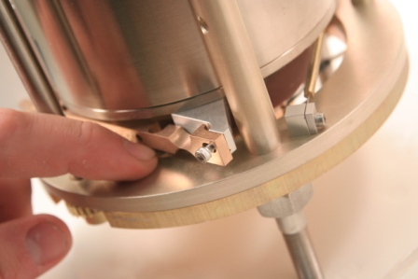

Figure 34: Start the screw by about 4 threads

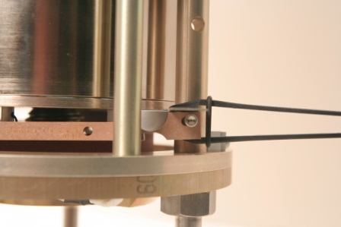

Figure 35: Place one clamp on the arm holding the top plate in place

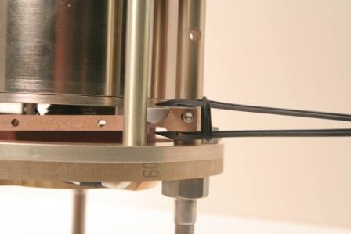

Figure 36: Place the second clamp holding the end up against the temporary plate

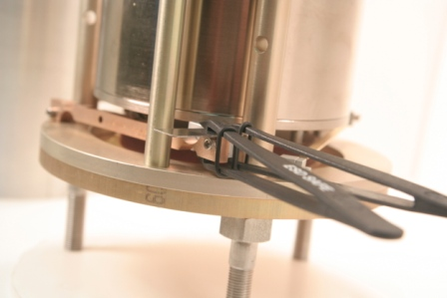

Figure 37: Showing the temporary clamps and plate

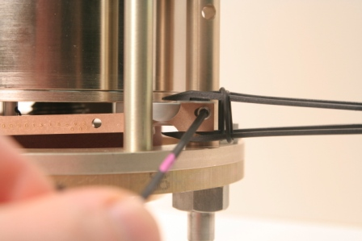

Figure 38: Attach by tightening the screw

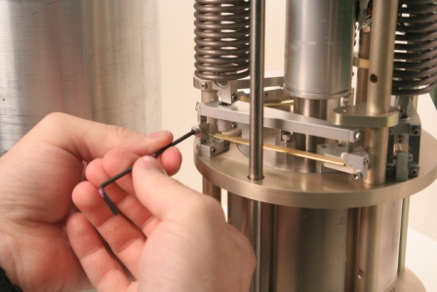

Figure 39: Remove the top delta rods

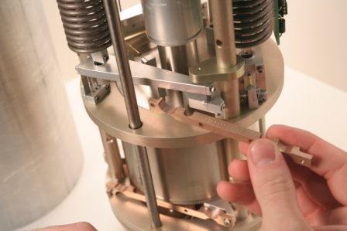

Figure 40: Slip the new BeCu flexure in place

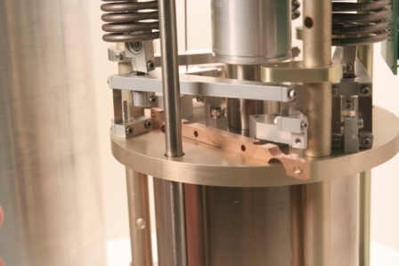

Figure 41: BeCu flexure partially inserted

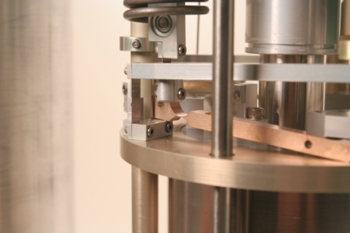

Figure 42: Lift up the end and start sliding it in place from the back

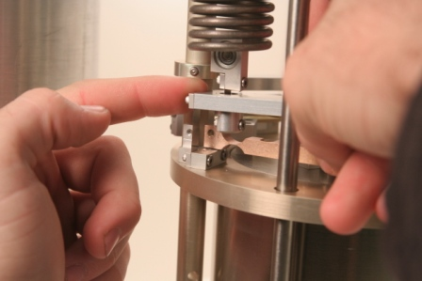

Figure 43: Slightly push the cantilever to the right to help slide the end forward

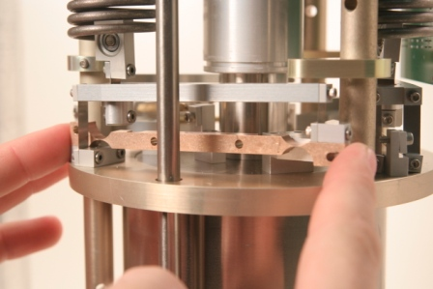

Figure 44: Lift the other end into place

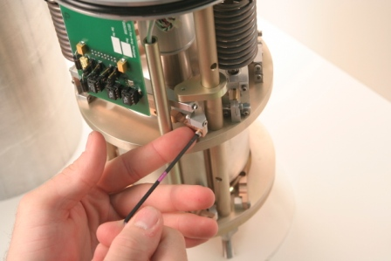

Figure 45: Attach both ends

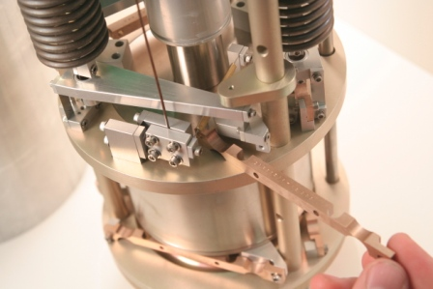

Figure 46: This is the trickiest flexure installation

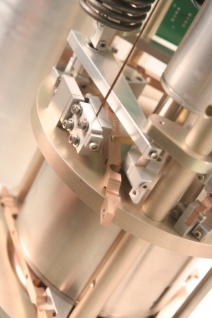

Figure 47: Flexure slipped in

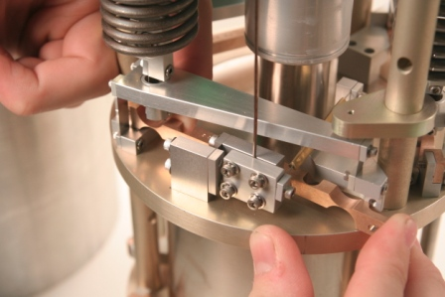

Figure 48: The flexure will bind up at this point, push the BeCu flexure forward bending the flexure in order to enable it to slip in place

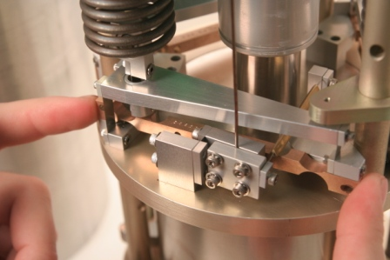

Figure 49: Hold it in place and attach with hardware

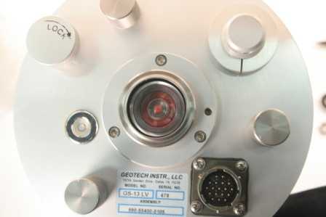

Figure 50: Unlock the proof mass and look at the red indicator - it should fill the center ring completely

If the red indicator is not centered, or not filling completely the center indicator ring, adjust the proof mass offload springs by the three adjustment knobs. Clockwise raises the mass, counterclockwise lowers the mass. Try to turn all three the same amount to fill the indicator evenly.

7. Testing
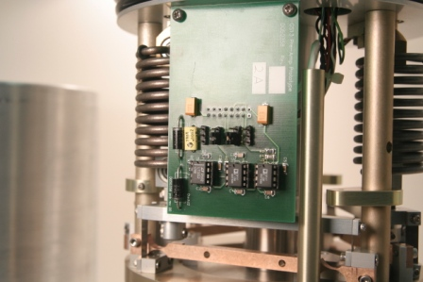

Figure 51: Remove the outer two jumpers from the pre-amp board

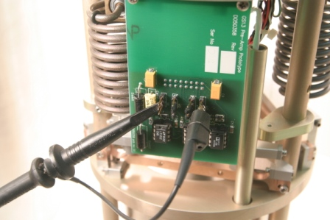

Figure 52: Attach the 10X probe and ground clip to the center conductor on each side of the pre-amp

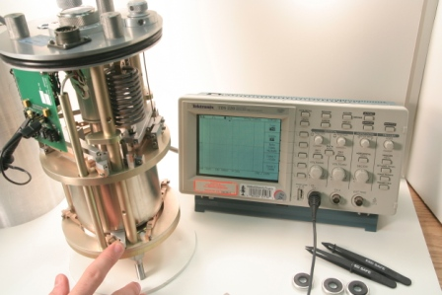

Figure 53: Take a ring-down by holding the mass down against its stop and releasing it

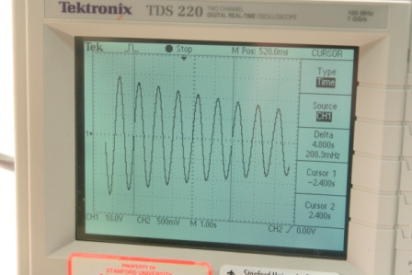

Figure 54: Typical ring-down. In this case the natural frequency was low

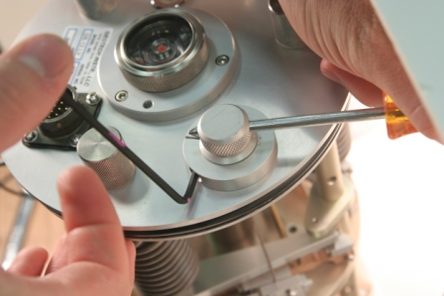

Figure 55: To raise the natural frequency loosen the lock collar with the 7/64 hex wrench and turn the knob counterclockwise to increase the frequency

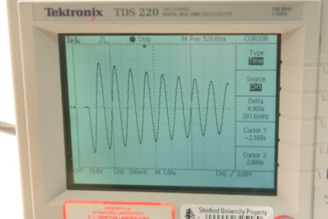

Figure 56: Corrected ring-down showing good response

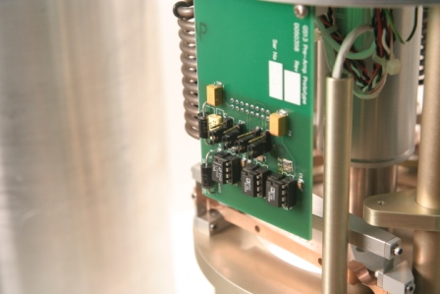

Figure 57: Replace the jumpers on the pre-amp board

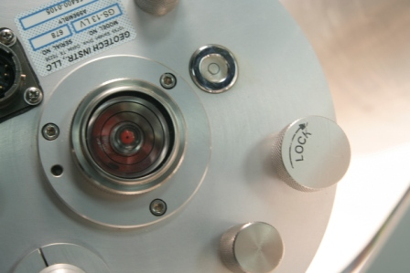

Figure 58: Relock the proof mass

8. Reassembly
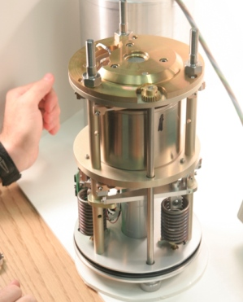

Figure 59: Turn the seismometer over

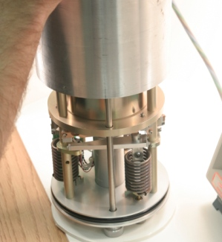

Figure 60: Carefully lower the lid over the instrument

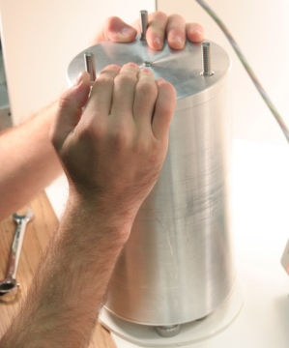

Figure 61: A fairly large downward force is required to slip the cover over the o-ring

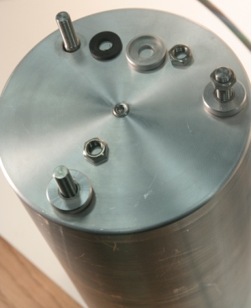

Figure 62: Install the grommet, cap, and nut on the studs. Tighten with the 9/16 wrench

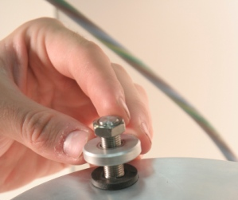

Figure 63: The correct sequence of installation

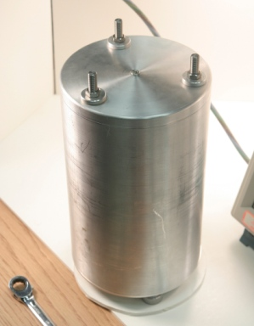

Figure 64: Installed can

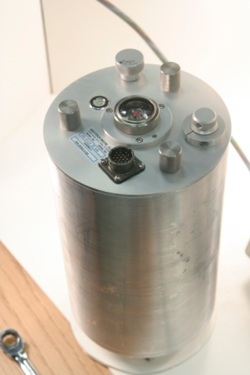

Figure 65: Completed GS-13 flexure retrofit ready for podding in aLIGO

