LIGO Laboratory / LIGO Scientific Collaboration

LIGO-LIGO-T1000095-v1 LIGO 21st February 2010

Parameters and Predicted Mode Frequencies and Transfer Functions for the As-Built HLTS Prototype
Norna A Robertson

Distribution of this document:
LIGO Scientific Collaboration

This is an internal working note
of the LIGO Laboratory.

California Institute of Technology  LIGO Project – MS 18-34  1200 E. California Blvd.  Pasadena, CA 91125  Phone (626) 395-2129  Fax (626) 304-9834  E-mail: info@ligo.caltech.edu | Massachusetts Institute of Technology  LIGO Project – NW22-295  185 Albany St  Cambridge, MA 02139  Phone (617) 253-4824  Fax (617) 253-7014  E-mail: info@ligo.mit.edu
LIGO Hanford Observatory  P.O. Box 159  Richland WA 99352  Phone 509-372-8106  Fax 509-372-8137 | LIGO Livingston Observatory  P.O. Box 940  Livingston, LA 70754  Phone 225-686-3100  Fax 225-686-7189
http://www.ligo.caltech.edu/

Introduction
The purpose of this document is to serve as a record of the parameter set and the expected mode frequencies and transfer functions for the prototype HAM Large Triple Suspension (HLTS) under test at LLO February 2010.

General Description of the HLTS
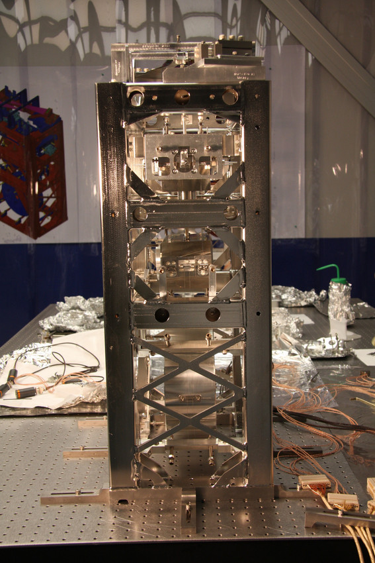
The HLTS is a triple pendulum with two stages of maraging steel blades. Refer to “HAM Small and Large Triple Suspensions - Preliminary Design”, T080187-00-R, for details of the design. Figure 1 shows two views of the prototype which has been assembled at LLO.
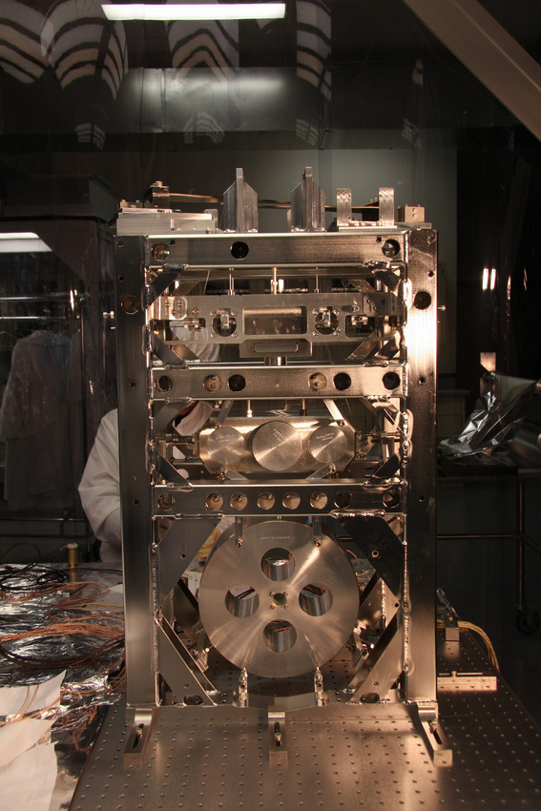
Figure 1. Prototype HLTS at LLO. Left – face on, right – side on.

MATLAB model of the HLTS.
The MATLAB model for the HLTS with parameters as below can be found in T080310-v2. Version v1 at that link gives the model and parameters presented at the Preliminary Design Review. The notes on the DCC entry give information of the changes between the two models.
Units are in SI. Diagrams illustrating the physical dimensions and explanations of other notation used below are given in appendix A.
3.1 Parameter Set.
pend =

m1: 1.1910e+001
I1x: 1.2250e-001
I1y: 1.8130e-002
I1z: 1.2370e-001
m2: 1.2150e+001
I2x: 8.2070e-002
I2y: 1.9960e-002
I2z: 8.1900e-002
tr: 1.3250e-001
m3: 1.2090e+001
I3x: 1.2000e-001
I3y: 6.9900e-002
I3z: 7.0700e-002
l1: 2.0250e-001
l2: 2.0360e-001
l3: 2.5520e-001
nw1: 2
nw2: 4
nw3: 4
r1: 3.0500e-004
r2: 1.7000e-004
r3: 1.3450e-004
Y1: 2.1200e+011
Y2: 2.1200e+011
Y3: 2.1200e+011
l1b: 2.5000e-001
a1b: 6.5000e-002
h1b: 2.3000e-003
ufc1: 2.7000e+000
l2b: 1.2000e-001
a2b: 3.2000e-002
h2b: 1.3000e-003
ufc2: 3.1800e+000
su: 0
si: 3.0000e-002
sl: 5.0000e-003
n0: 7.7000e-002
n1: 1.3000e-001
n2: 7.0000e-002
n3: 1.3750e-001
n4: 1.4050e-001
n5: 1.4050e-001
stage2: 1
d0: 1.0000e-003
d1: 1.0000e-003
d2: 1.0000e-003
d3: 1.0000e-003
d4: 1.0000e-003
ribbon: 0
db: 0
g: 9.8100e+000
kc1: 1.7138e+003
kc2: 2.4253e+003
tl1: 1.9644e-001
tl2: 1.9409e-001
tl3: 2.5720e-001
l_suspoint_to_centreofoptic: 6.4773e-001
l_suspoint_to_bottomofoptic: 7.8023e-001
flex1: 2.7029e-003
flex2: 1.4016e-003
flex3: 1.3556e-003
flex3tr: 1.3556e-003

3.2 Mode Frequencies

In the MATLAB model the longitudinal and pitch modes, and transfer and roll modes, are coupled together. The modes which are more closely associated with longitudinal and transverse motion are italicised below although it should be noted that for longitudinal and pitch the first pair of modes are quite closely coupled and that for transverse/roll all the modes except the highest roll mode are quite closely coupled. This can also be seen in the transfer functions shown in section 3.3. All values in Hz.

longpitch1: [0. 668 0.760 1.58]
longpitch2: [2.33 2.86 4.14]
yaw: [0.986 2.25 3.34]
transroll1: [0.695 1.54 2.37]
transroll2: [2.83 4.70 44.2]
vertical: [1.32 4.53 28.2]

3.3. Transfer Functions
Transfer functions are shown in figures 2 to 7 inclusive for the six degrees of freedom. These are all transfer functions from force or torque acting on the top mass to motion at the top mass. Thes transfer functions can be measured using the BOSEMs. The damping has been turned down so that the modes can be clearly identified. Units are all in SI. The highest vertical and roll modes are very weakly coupled to the top mass and therefore are effectively not visible. The longitudinal direction is the laser beam direction.

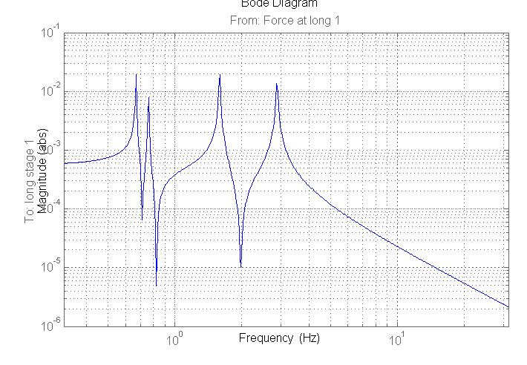

Figure 2: Transfer function for longitudinal: force at top mass to long. displacement of top mass

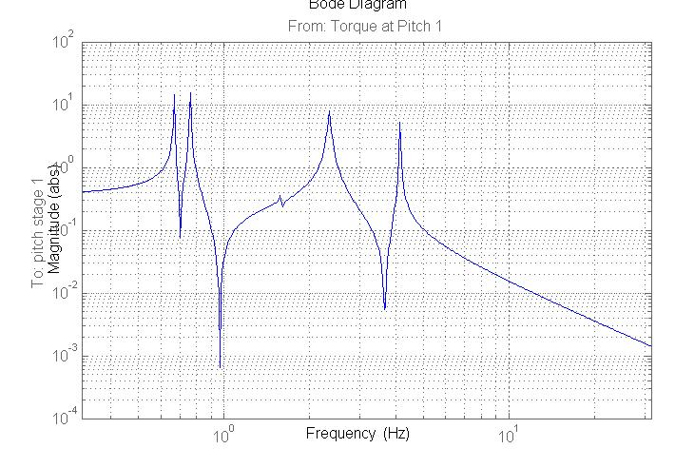

Figure 3: Transfer function for pitch: torque at top mass to pitch of top mass

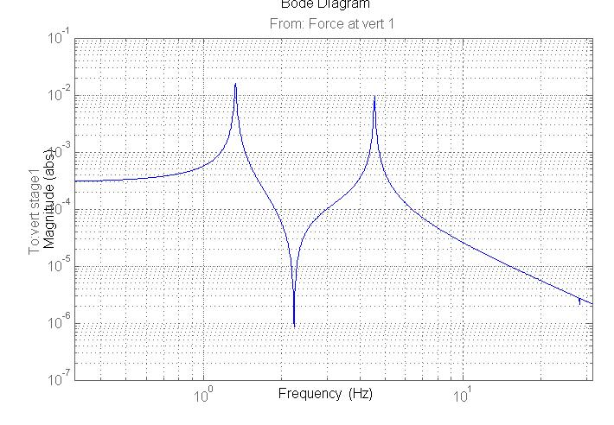

Figure 4: Transfer function for vertical: force at top mass to vertical displacement of top mass

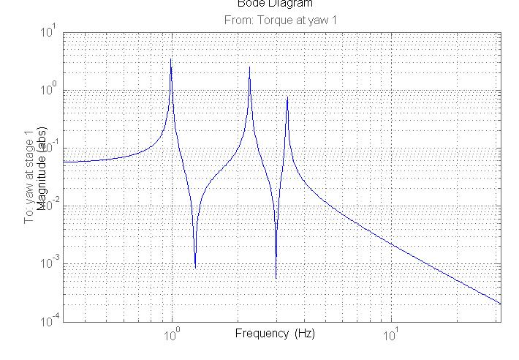

Figure 5: Transfer function for yaw: torque at top mass to yaw of top mass

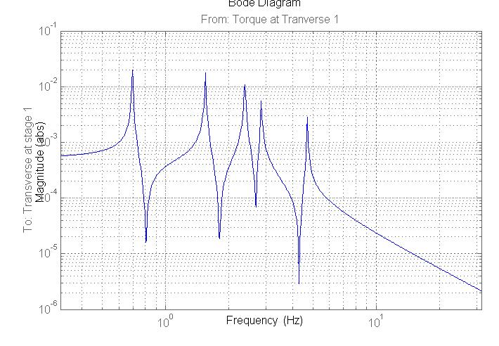

Figure 6: Transfer function for transverse: force at top mass to transverse displacement of top mass
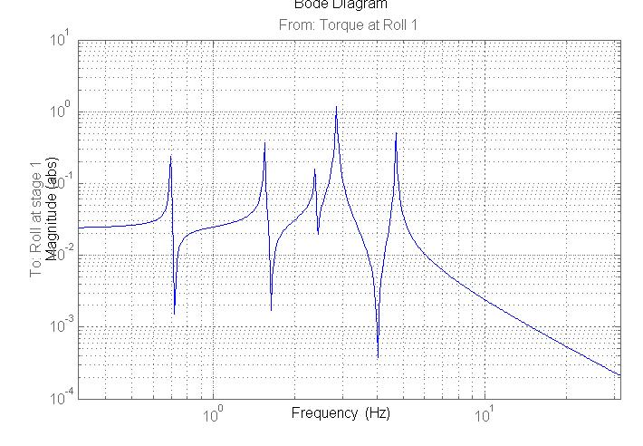

Figure 7: Transfer function for roll: torque at top mass to roll of top mass

Appendix A.

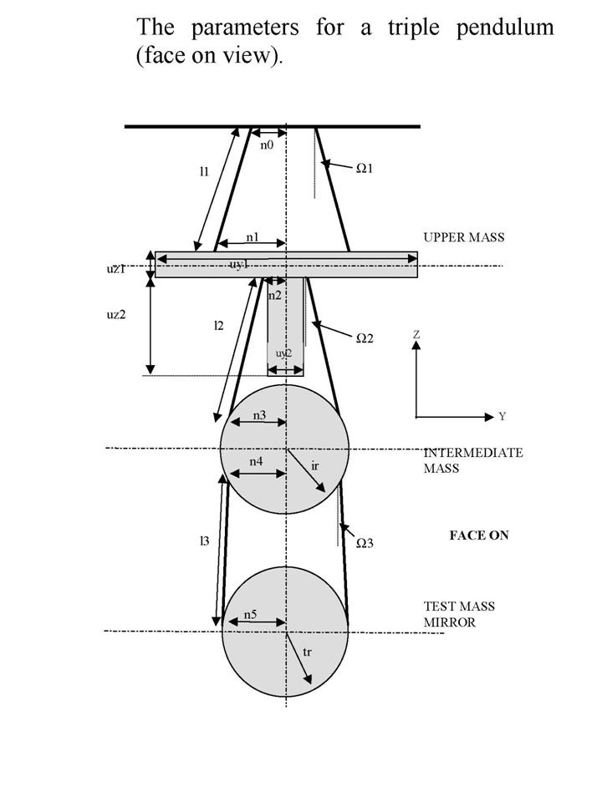

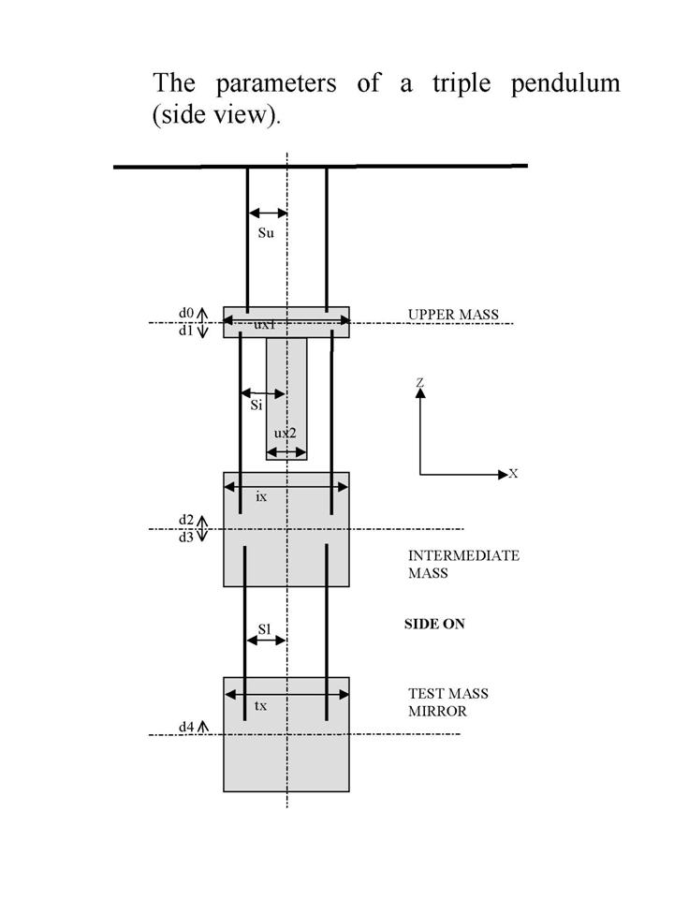

Explanation of parameters listed in section 3 (other than those shown in the diagrams above).
m1, m2, m3: masses from top to bottom
Iix, Iiy, Iiz where i = 1,2,3 from top to bottom mass = moments of inertia as follows
Iix: moment of inertia (transverse roll)
Iiy: moment of inertia (longitudinal pitch)
Iiz: moment of inertia (yaw)
nwi = number of suspension wires at each stage from top to bottom
ri = wire radius from top to bottom
Yi = Young’s modulus of wire/fibre from top to bottom

l1b, a1b, h1b: length, width at root, thickness of top blades
ufc1: uncoupled frequency of top blade with mass immediately below it
l2b etc – same as above for lower blades
stage 2 = 1
If pend.stage2 is defined and non-zero, d0-d4 are interpreted as raw values, i.e., as actual wire breakoff vertical positions
tl1, tl2, tl3: centre to centre vertical separations at each stage - from top suspension point to centre of top mass, centre of top mass to centre of intermediate mass, and centre of intermediate mass to centre of beamsplitter optic respectively
ribbon = 0: round wires/fibres are used (i.e not ribbons)
db = 0: no natural damping included
g: accel. due to gravity
kc1, kc2: blade stiffness (top and bottom respectively)

l_suspoint_to_centreofoptic: length from top suspension point to centre of topic = tl1+tl2+tl3
l_suspoint_to_bottomofoptic: length from top suspension point to bottom of optic

flex1, flex2, flex3: flexure length for wire (top to bottom respectively)
flextr – flexure length for ribbon in transverse/roll direction (same as flex3 if round fibre used)

