*LIGO Laboratory / LIGO Scientific Collaboration*

LIGO-T1000179-v17 *Advanced LIGO* Date:

aLIGO Hartmann Sensor Optical Layouts (H1, L1) Input Test Masses

[see T1100463 and T1100471 for coordinate sources]

Author: Aidan Brooks

Distribution of this document:

LIGO Scientific Collaboration

This is an internal working note

of the LIGO Laboratory.

|  |  |
| --- | --- |
| **California Institute of Technology**  **LIGO Project – MS 18-34**  **1200 E. California Blvd.**  **Pasadena, CA 91125**  Phone (626) 395-2129  Fax (626) 304-9834  E-mail: info@ligo.caltech.edu | **Massachusetts Institute of Technology**  **LIGO Project – NW22-295**  **185 Albany St**  **Cambridge, MA 02139**  Phone (617) 253-4824  Fax (617) 253-7014  E-mail: info@ligo.mit.edu |
| **LIGO Hanford Observatory**  **P.O. Box 159**  **Richland WA 99352**  Phone 509-372-8106  Fax 509-372-8137 | **LIGO Livingston Observatory**  **P.O. Box 940**  **Livingston, LA 70754**  Phone 225-686-3100  Fax 225-686-7189 |

http://www.ligo.caltech.edu/

Table of Contents

1 Introduction 2

1.1 The ITM+CP HWS optical system 3

2 Imaging Solutions (for ITM+CP probe beams) 5

2.1 Relative positions of HAM ISI tables and TCSHT tables 7

2.1.1 HAM4 (H1, L1) 7

2.2 H1/L1: HWSX (nominal) 9

2.3 H1/L1: HWSY (nominal) 9

3 ZEMAX optical layouts 10

3.1 H1/L1 optical layouts (HAM4 & HAM5) 10

4 Optical layout features 15

4.1 Delay line paths. 15

4.2 Imaging optics 15

4.3 Astigmatism 17

4.4 Super-luminescent diode (SLED) source 17

4.4.1 SLED sources 17

4.5 Polarization 17

4.6 Beam Height 17

4.7 Band Pass filter 17

4.8 Beam size and mirror sizes 17

4.9 50/50 Beamsplitter 17

4.10 Periscope 17

4.11 Motorized steering mirrors 17

4.12 Beam Tubes [optional, risk reduction] 18

4.13 Spurious defocus in the probe beam 18

4.14 Diffraction in the HWS probe beam 19

5 Analysis of thermal defocus induced by imaging telescopes 19

6 Full ABCD matrices 20

6.1 H1/L1:HWSX 20

6.2 H1/L1:HWSY 21

# Introduction

The purpose of this document is to record the mode-matching solutions into the interferometer for the ITM+CP aLIGO Hartmann Wavefront Sensor (HWS) probe and secondary beams.

The optical layouts are presented in full in Section 6.

## The ITM+CP HWS optical system

A conceptual layout showing the HWS probe beams coupling into the interferometer and measuring the combined thermal lenses from each ITM and CP pair is illustrated in Figure 1. Probe beams are launched from TCSHT4, *injected* into the interferometer, *retro-reflected* from the ITMs, extracted from the injection points and measured on the Hartmann sensors on TCSHT4. The Y probe beam (green) is injected onto the interferometer axis through SR2. The X probe beam (magenta) is injected into the interferometer off the wedged AR surface of the beamsplitter (BS). A secondary beam (also magneta) is picked off from the X probe beam and spans HAM4 and HAM5. This is to monitor wavefront aberrations induced by displacement between those tables causing defocus in the HWS telescope.

The requirements for the ITM+CP HWS optical system are described in [T1000715](https://dcc.ligo.org/cgi-bin/private/DocDB/ShowDocument?docid=26293) *Requirements for the ITM Hartmann Wavefront Sensor optical layout.* The main optical requirements are summarized below:

1. The ITM must be imaged onto the front surface of the HWS. The tolerance of the imaging should place the conjugate plane of the ITM no further than 1500 mm / ***M***2 = 4.9 mm from the HWS front surface where ***M*** is the magnification.
2. The magnification, ***M***, from the ITM to the HWS should be 1/17.5 ×.
3. The imaging system must span approximately 2.5m from the in-vacuum HAM table to the in-air TCS Hartmann Table (TCSHT).
4. ~~Reflective, not transmissive, optics should be used to avoid specular reflection of any 1064nm light back into the interferometer.~~ On advice from the FDR committee, lenses have been approved for use rather than curved mirrors.
5. The thermally induced defocus, *S*, (where *S* is defined implicitly by the quadratic wavefront equation: *W* = 0.5\**S r2*) should be lower than 7.0 × 10-4 m-1.

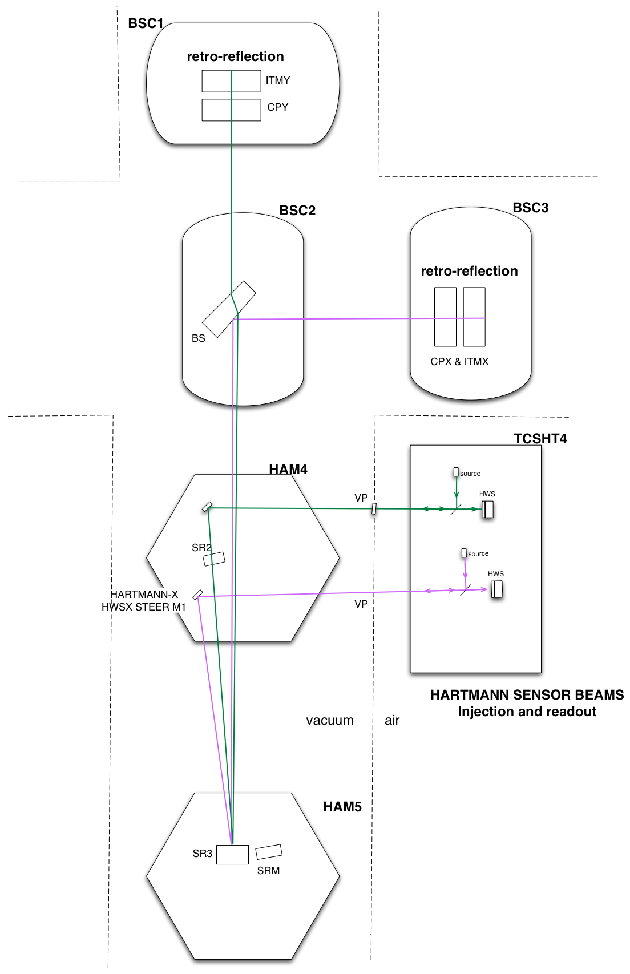

Figure : The H1/L1 Hartman probe beams are injected into the interferometer to measure the thermal lenses in the compensation plates and ITMs.

# Imaging Solutions (for ITM+CP probe beams)

The mode-matching/imaging will be accomplished with a telescope, conceptually illustrated in Figure 2. This telescope is located across HAM4 and TCSHT4 in H1/L1. In this figure the “hand-off plane to imaging telescope” is defined for:

**H1/L1** as:

* SR2_AR for the Y-probe beam (the location of SR2 is shown in Figure 1)
* HARTMANN-X HWS STEER M1 for the X-probe beam (see Figure 1 for location)

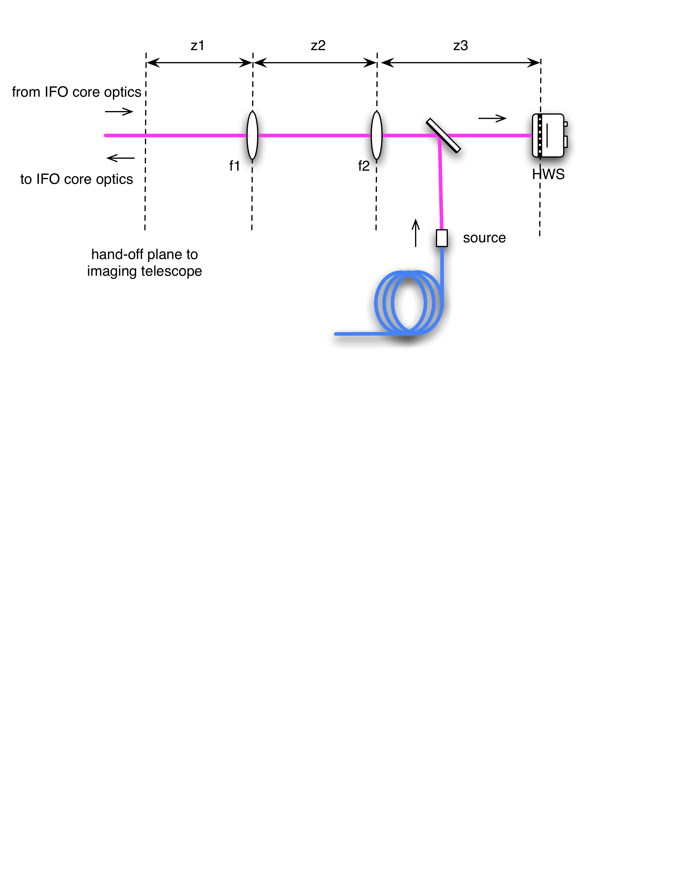

Figure : A schematic of the imaging telescope for the Hartmann sensors.

Requirements 1 (imaging) and 2 (magnification) in [T1000715](https://dcc.ligo.org/cgi-bin/private/DocDB/ShowDocument?docid=26293) constrain 3 of the 5 imaging parameters shown in Figure 2. This was used to solve for z1, z2, and z3 over a discrete 2D parameter space of f1 (VacLens) and f2 (AirLens) (constrained by off-the-shelf lenses from CVI-Melles Griot).

The shortest distance between the in-vacuum optical table (which houses imaging optic f1 (VacLens)) and the exterior optical table (houses imaging optic f2 (AirLens)) is approximately 2.5m, as shown in Figure 3.

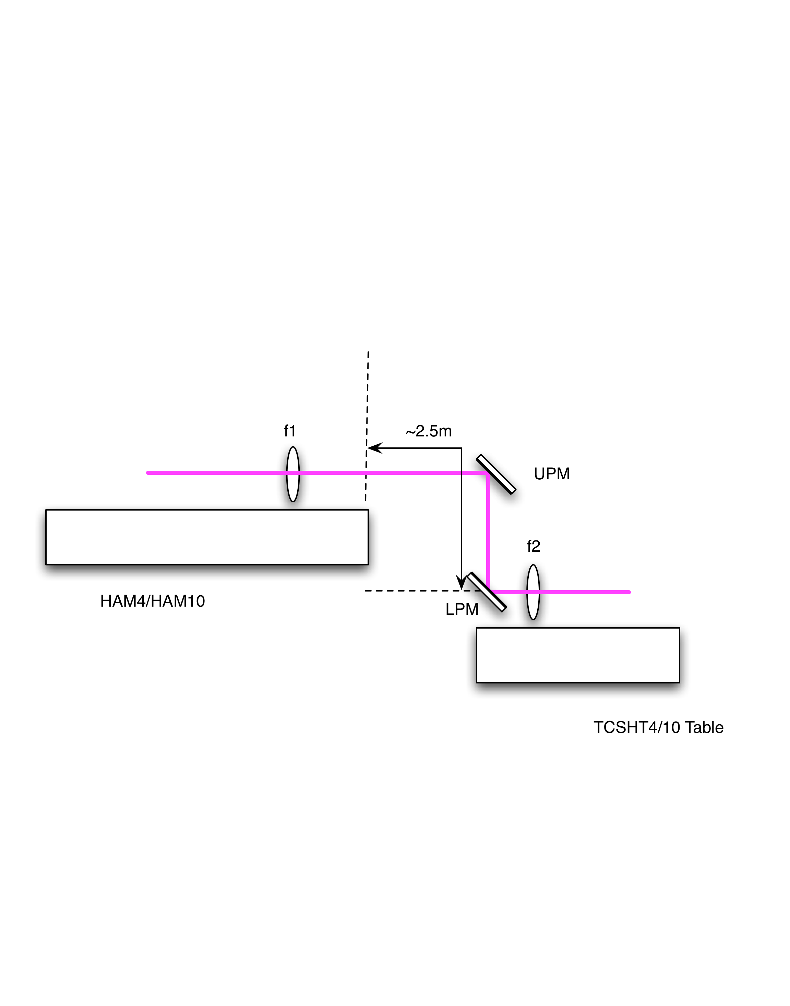

Figure : A side view of the Hartmann imaging telescope located across a HAM table and a TCSHT table. The distance from the edge of the HAM table to the lower periscope mirror (LPM) is approximately 2.5m

Taking into account all the requirements, the allowed regions in f1 (VacLens)-f2 (AirLens) parameter space for H1 and L1 HWSX and HWSY were calculated. Both +ve and –ve magnifications were examined in all cases but those shown are the ones that were judged to be more convenient.

## Relative positions of HAM ISI tables and TCSHT tables

To determine the imaging solutions, we need to know the distances between the tables in the HAM chambers and the in-air tables ([[D1000637 - TCS HWS Optics Table, H1_L1 HAM4]](https://dcc.ligo.org/cgi-bin/private/DocDB/ShowDocument?docid=10232) and [[D1100238 - TCS HWS Optics Table, H2 HAM10]](https://dcc.ligo.org/cgi-bin/private/DocDB/ShowDocument?docid=33261))

### HAM4 (H1, L1)

The position of the HWS table relative to the HAM4 ISI table is shown in Figure 4 and Figure 5.

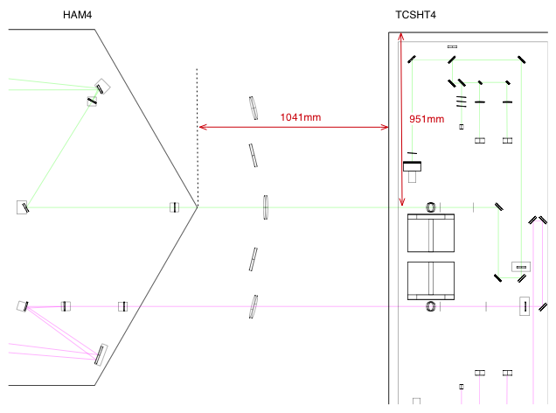

Figure : HAM4 and TCSHT4 Table relative positions - TOP view

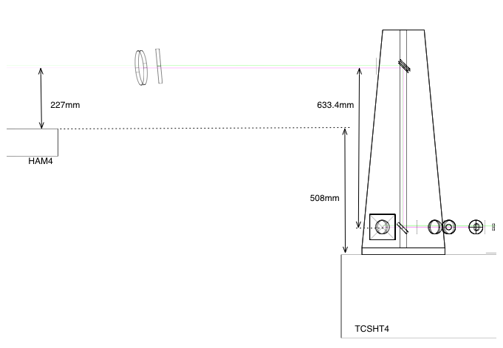

Figure : HAM4 and TCSHT4 table relative positions - SIDE VIEW

## H1/L1: HWSX (nominal)

A search was conducted of the parameter space constrained by the imaging, magnification and defocus requirements. A solution that used conventional radii of curvature mirrors and lying near the defocus minimum was chosen. The Mathematica search of parameter space is attached as supplementary documentation in the DCC entry [T1000179](https://dcc.ligo.org/cgi-bin/private/DocDB/ShowDocument?docid=10643).

Table : Imaging solution for H1/L1 HWSX

|  |  |  |
| --- | --- | --- |
| **H1/L1 - HWSX** | **Value** | **notes** |
| ITMX apparent RoC | 1331.04 m |  |
| ITMX to SR3 | 24.666 m |  |
| SR3 RoC | 36 m |  |
| SR3 to ITMXPO | 15.1375 m |  |
| ITMXPO to F1 (VACLENS): z1= | 2.2578 m |  |
| F1 (VACLENS): f = | -1.6994 m | PLCC-50.8-772.6-UV, f = -1.677 @ 532nm |
| F1 (VACLENS) to F2 (AIRLENS): z2 = | 2.8092 m |  |
| F2 (AIRLENS): f = | 1.6994 m | PLCX-50.8-772.6-UV, f = 1.677 @ 532nm |
| F2 (AIRLENS) to HWS: z3= | 2.7057m |  |

## H1/L1: HWSY (nominal)

Table : Imaging solution for H1/L1 HWSY

|  |  |  |
| --- | --- | --- |
| **H1/L1 - HWSY** | **Value** | **notes** |
| ITMY apparent RoC | 1331.04 m |  |
| ITMY to SR3 | 24.7756 m |  |
| SR3 RoC | 36 m |  |
| SR3 to SR2 distance | 15.4435 m |  |
| SR2 RoC | -6.43 m |  |
| SR2 refractive index at 840nm | 1.445 |  |
| SR2 thickness | 0.075 m |  |
| SR2_AR to F1 (VACLENS): z1= | 3.6716 m |  |
| F1 (VACLENS): f = | 0.7936m | PLCC-50.8-360.6-UV, f = 0.7827 @ 532nm |
| F1 (VACLENS) to F2 (AIRLENS): z2 = | 2.9695 m |  |
| F2 (AIRLENS): f = | 1.134 m | PLCX-50.8-515.1-UV, f = 1.1181 @ 532nm |
| F2 (AIRLENS) to HWS: z3= | 2.2826 m |  |

# ZEMAX optical layouts

The solutions determined in the tables in Section 2 were used to determine the optical layouts for the HWS system. The ZEMAX layouts of the HAM4/HAM10 region are in the DCC under:

* H1: [T1100463](https://dcc.ligo.org/cgi-bin/private/DocDB/ShowDocument?docid=69894)
* L1: [T1100471](https://dcc.ligo.org/cgi-bin/private/DocDB/ShowDocument?docid=70083) (identical to H1 except for the heights of the hand-off optics between the IFO and the HWS optics).

In the discussion below the term *forward-propagating* beam will refer to the HWS probe beam propagating *to* the ITM and the term *backward-propagating* beam will refer to the HWS probe beam once it has retro-reflected from the ITM and is propagating *back* toward the Hartmann sensor.

## H1/L1 optical layouts (HAM4 & HAM5)

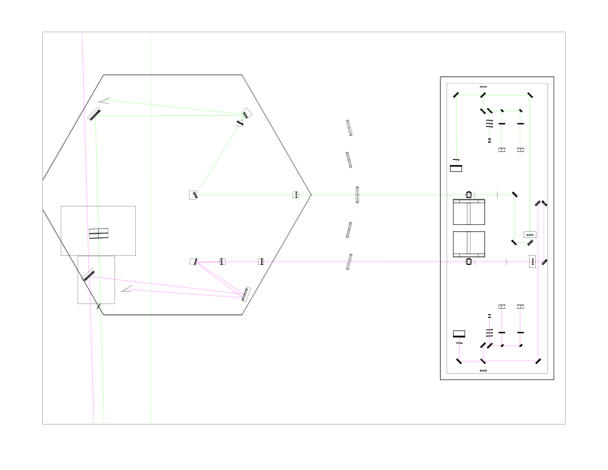

Figure : [H1X, H1Y, L1X, L1Y] ZEMAX model of HAM4 (left) and TCSHT4 (right) table of the Hartmann sensor probe and reference beams on the exterior tables. The three highlighted sections are shown in more detail in the following figures.

Figure 6 shows the region around the HAM4 chamber: the in-vacuum HAM table and the neighbouring TCSHT4 table. All the in-vacuum and in-air Hartmann sensor optics that are directly controlled by the Hartmann sensor system (for H1/L1 ITMs) are housed on these tables. Also shown in HAM4 is the core optic SR2. Additionally,

* Figure 7 shows a zoom of the in-vacuum optical table HAM4,
* Figure 8 shows a zoom of the in-air injection optics for the ITMX HWS,
* Figure 9 shows a zoom of the injection-optics for the ITMY HWS.

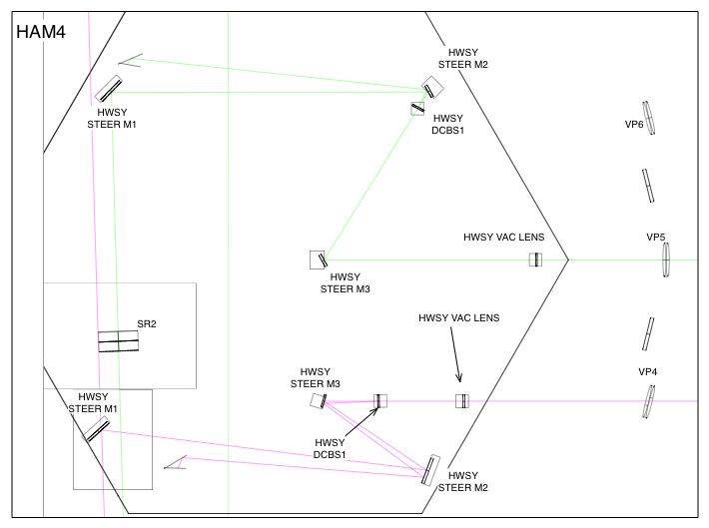

Figure : [ZOOM] HAM4 in-vacuum table. For both HWSX and HWSY the beam is incident close to normal incidence on the first imaging optic inside the vacuum.

HWS ITMY Probe Beam: The (green) forward-propagating beam starts from a source outside the vacuum system, is injected into the vacuum system, through SR2 and onto the interferometer cavity axis. Once on the interferometer axis it propagates to ITMY (illustrated in Figure 1) and retro-reflects from the HR surface of that optic.

The now backward-propagating beam propagates back along the optical axis until, eventually, it reaches SR2 and is transmitted through that optic. From there, it follows the path shown in Figure 7: It is steered by in-vacuum beam steering mirrors HWSY STEER M1-M2. It passes through a lens HWSY VAC LENS and is steered out of the vacuum system by HWSY STEER M3. Additionally, it passes through a dichroic beam splitter, HWSY DCBS1, that reflects 99% of any 1064 nm present on the beam.

HWS ITMX Probe Beam: as with the ITMY probe beam, the forward-propagating ITMX probe beam (magenta) is:

* injected from outside the vacuum system,
* steered to the wedged AR surface of the interferometer beam splitter (not shown in Figure 7, but illustrated schematically in Figure 1).
* The forward-propagating reflection from BS_AR injects the probe beam onto the interferometer optical axis.
* It is then retro-reflected from ITMX HR and propagates back to the beam splitter.
* The backward-propagating reflection of the probe beam from the AR surface of the beam splitter is, technically, the point at which the probe beam is extracted from the interferometer optical axis (again, see Figure 1).
* The beam reflects off SR3 – see Figure 1.
* The backward-propagating beam is collected by the optic HWSX STEER M1, shown in Figure 7 (magenta beam).
* The beam is passed through a dichroic beam splitter, HWSX DCBS1, to strip off 99% of any 1064nm light.
* The beam is passed through an imaging lens HWSX VAC.
* It is then steered out of the vacuum system by the mirrors HWSX STEER M3.

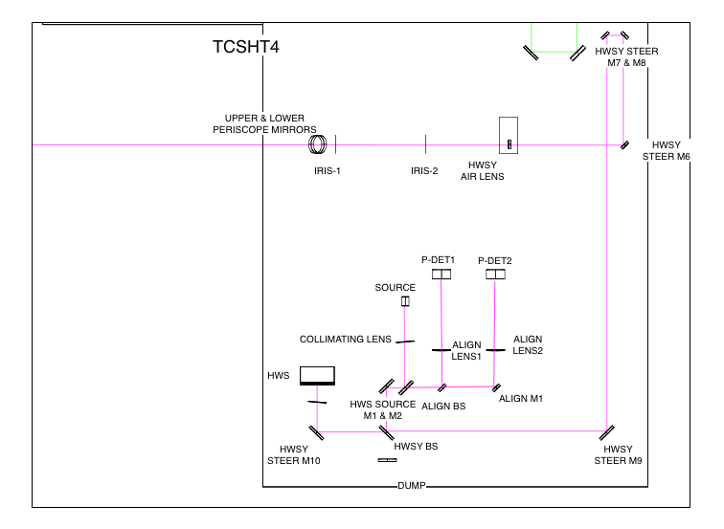

Figure : HWSX imaging optics on the exterior table. The beam propagates from the SOURCE and is reflected off a 50/50 beam splitter. From here the probe beam passes through a delay line that is used to adjust the F2 (AIR LENS)-HWS distance and then passes through F2 (AIR LENS) at close to normal incidence. The beam is then injected into the vacuum system. Periscope is not shown

Figure 8 shows the ITMX probe beam in-air optics. Since the probe beam is injected from this table, retro-reflected from ITMX and then read out again from this table, we can trace the optical axis in either direction. I will continue the convention of following the *backward-propagating* probe beam on the way OUT of the vacuum system.

The backward-propagating HWS ITMX probe beam (magenta) propagates from the vacuum system (from the left) and, via the UPPER AND LOWER PERISCOPE MIRRORS (see Section 4.10), down to the height of the in-air optical table. From here the beam passes through the F2 (AIR LENS). Two of the mirrors around F2 (AIR LENS) will be motorized pico-motor beam steering mirrors – see Section 4.11. The beam is steered through a delay line (formed by HWSX STEER M7 and HWSX STEER M8).

The transmission of the backward-propagating beam through the 50/50 beamsplitter (BS) – see Section 4.9-, passes through a band-pass filter (HWSX BAND PASS – see Section 4.7) and onto the HWS. The HWS is at a conjugate plane of the ITM (see Section 4.2).

The forward-propagating beam, in Figure 8, originates from the end of an optical fiber (LIGHT SOURCE) and is reflected off the main beam splitter BS.

The alignment optics, opto-mechanics and electronics on the exterior table are discussed in more detail in [T1100149](https://dcc.ligo.org/cgi-bin/private/DocDB/ShowDocument?docid=39852) *Initial Alignment of the ITM+CP Hartmann sensor.*

Figure 9 shows the in-air optics for the HWS ITMY probe beam.

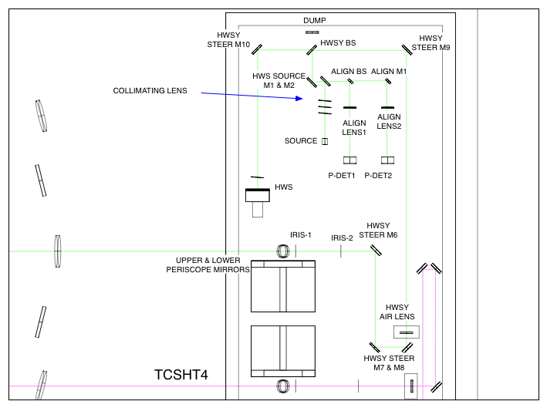

Figure : The HWSY imaging optics and probe on the exterior table. The beam propagation through the optics shown here is largely the same as for HWSX, described in Figure 8.

# Optical layout features

Various features of the optical layouts are described in this Section.

## Delay line paths.

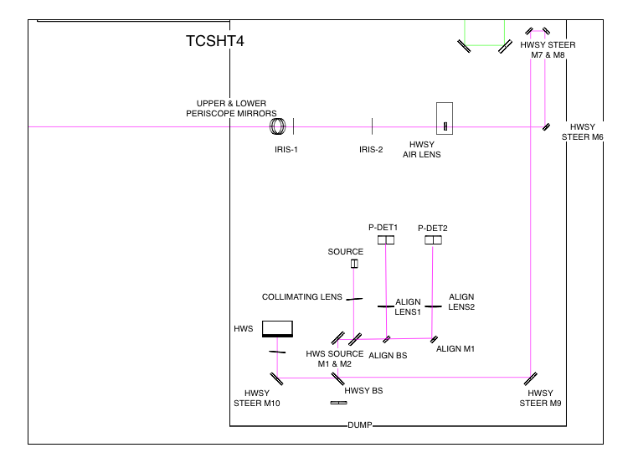

Figure : Example delay line on the probe beam (dark purple) formed by HWSX STEER M7 and HWSX STEER M8.

Delay lines have been added between all the Air Lenses and the Hartmann sensor to allow for the correct distance between the HWS and the Air Lens such that the HWS is at a conjugate plane of the ITM. These delay lines will be for bulk adjustment, not for fine tuning.

## Imaging optics

The imaging optics are simple 2” plano-concave and plano-convex lenses. They are AR coated for around 820 nm.

A scattering analysis is presented in document [[T1100445 - AOS SLC: Signal Recycling Cavity Baffles Final Design]](https://dcc.ligo.org/cgi-bin/private/DocDB/ShowDocument?docid=69211). The results from that document summarizing the “H1 and L1 Hartmann Scatter” are reproduced here:

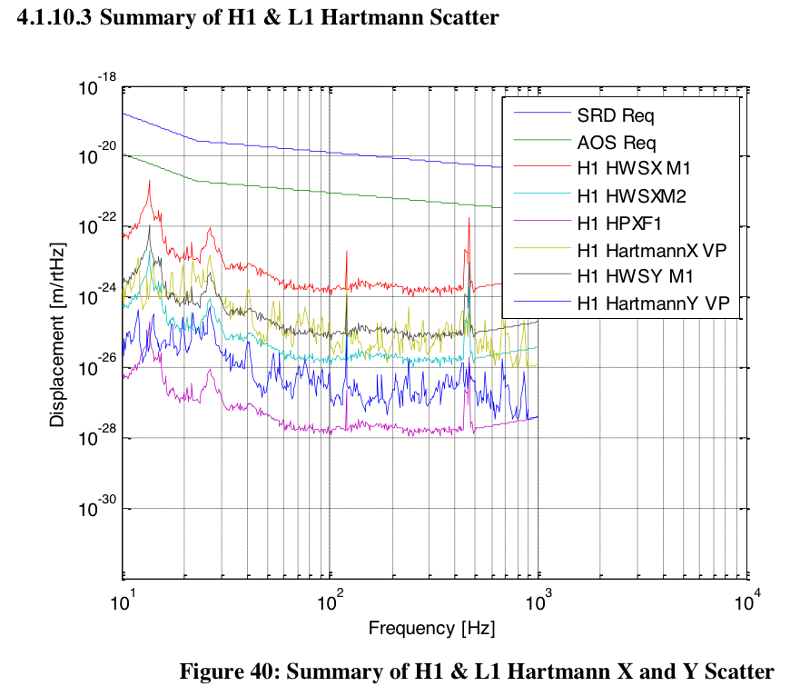

Figure : Summary of H1 and L1 Hartmann X and Y scatter, reproduction of Figure 40 in [[T1100445 - AOS SLC: Signal Recycling Cavity Baffles Final Design]](https://dcc.ligo.org/cgi-bin/private/DocDB/ShowDocument?docid=69211).

## Astigmatism

As we are using lenses in the current design which are close to normal incidence, the astigmatism in the HWS probe beam is negligible.

## Super-luminescent diode (SLED) source

The HWS light source on the table is a short fiber-optic cable (patch-cord) attached to a distant fibre-coupled SLED. The fiber collimator and the optical mount for the source need to be thermally and mechanically stable.

### SLED sources

As indicated in [[T1000682 - Technical Note for the aLIGO TCS Hartmann Sensor Camera and Sources]](https://dcc.ligo.org/cgi-bin/private/DocDB/ShowDocument?docid=25406), there will be one source per HWS used for measurement.

## Polarization

The light from the SLEDs will remain unpolarized in the HWS system. This is a change from previous versions of the optical layout (prior to –v15).

## Beam Height

The beam height on the exterior optical table is 4” everywhere, except for the beam in the periscope and for the non-normal reflections off F2 in H1/L1:HWSY .

## Band Pass filter

The HWS will have a band-pass filter, (790nm ± 10nm) or (840nm ± 10nm) mounted directly in front of it. This will be used filter out ambient light and any residual 1064nm radiation. This will need to be tilted vertically by ~ 10 mrad to prevent any 1064nm reflections back into the signal-recycling cavity

## Beam size and mirror sizes

See [T1000718 - *aLIGO Hartmann Sensor Optics and Opto-Mechanical components (H1, L1, H2) Input Test Masses.*](https://dcc.ligo.org/cgi-bin/private/DocDB/ShowDocument?docid=26296)

## 50/50 Beamsplitter

A 50/50 beamsplitter is used to split the incoming beam from the light source with the return beam from the ITM mirror.

## Periscope

The periscope optics are 2” diameter mirrors.

## Motorized steering mirrors

The HAM-ISIs and core optics can all move, rotate and affect the alignment of the HWS probe beam – by a maximum amount of approximately 1mrad. To compensate for this there will be two motorized steering mirrors (with picomotor drives) in the HWS optical layout that can be used to periodically adjust the alignment of the HWS optical path without entering the optical table (on time scales of greater than 10-100s).

Near the viewport, axis alignment errors of greater than ±7 mrad[1] (±3.5 mrad on the steering optics) or on the forward-propagating beam will cause the backward-propagating beam from the ITM to be completely clipped by internal apertures in the optical beam path. The target for the alignment precision should be < 20× the maximum axis error, or less than ±0.35mrad.

The pico-motor mirrors (New Focus 8816) have an angular resolution of 0.7 μradians and a range of around 70 mrad. The optimum locations for the motorized mirrors on the in-air table is TBD.

## Beam Tubes [optional, risk reduction]

If necessary, the Hartmann beams can be enclosed in beam tubes to reduce the effect of air currents on the wavefront.

The HWS enclosures [[D1102033 - aLIGO TCS H1-L1 Viewport and Table Enclosure Assembly]](https://dcc.ligo.org/cgi-bin/private/DocDB/ShowDocument?docid=73822) should serve to sufficiently reduce the integrate air-currents over the HWS beam (when the HEPA filters on the enclosure are not running).

## Spurious defocus in the probe beam

This is discussed in greater detail in [[T1000722 - Hartmann Wavefront Sensor: Defocus defined and maximum acceptable defocus error]](https://dcc.ligo.org/cgi-bin/private/DocDB/ShowDocument?docid=26364). As defined in that document, the maximum acceptable defocus at the HWS, *Sε-HWS*, where defocus is implied implicitly by the quadratic wavefront error, *W = 0.5 S r2*, is



It is important to note, however, that the defocus, or quadratic change in the probe beam wavefront, at the Hartmann sensor will be dependent on the length change of the telescope, formed by SR2 and SR3, between HAM4 and HAM5. This length will change as the HAM ISIs and HEPIs move and also due to thermal expansion of the slab separating these two chambers. As such, as part of installation it will be necessary to calibrate and remove the effective defocus seen at the Hartmann sensor induced by motion of HEPI and ISI.



In this equation, *dS\** indicates the spurious defocus in the probe beam at the HWS induced by HEPI and ISI motion.

For reference, a . The maximum spurious defocus that can be tolerated in the HWS is ~7.4 x 10-4 m-1. Therefore, the maximum displacement that can be tolerated between the HAM chambers, without requiring any compensation of this effect in the Hartmann sensor analysis, is approximately 390 μm (see [T1000715](https://dcc.ligo.org/cgi-bin/private/DocDB/ShowDocument?docid=26293)). The maximum motion expected from HEPI is of the order of 1mm. As a result, we will need to incorporate the signals from HEPI and ISI into the analysis of the Hartmann sensor signal.

## Diffraction in the HWS probe beam

Diffraction in the HWS probe beam is discussed in [[T1100549 - Diffraction in the aLIGO ITM HWS probe beams]](https://dcc.ligo.org/cgi-bin/private/DocDB/ShowDocument?docid=74167).

# Analysis of thermal defocus induced by imaging telescopes

The following table examines each telescope within the HWS optical layout and determined the temperature change necessary in that telescope to induce a change of defocus of 7 × 10-4m-1 at the HWS by thermal expansion of the telescope. Note that the thermal expansion of the optics is not included as the relative size of this effect is given by the ratio of thermal expansion of the optics (~5E-7 K-1) to the thermal expansion of the material separating the optics (~1E5 K-1).

Table : Maximum acceptable change in temperature based on thermal defocus in each component of the imaging telescopes.

|  |  |  |  |
| --- | --- | --- | --- |
| **Optical Path** |  | **dS/dT @ HWS** | **Maximum acceptable Δ*T*** |
| **H1/L1:ITMX (~ H2:ITMY)** | | |  |
| SR3 to F1 |  | 4.3 × 10-4 m­-1 K-1 | 1.6 K |
| F1 to F2 |  | 1.9 × 10-5 m­-1 K-1 | 35 K |
| F2 to HWS |  | 5.0 × 10-6 m­-1 K-1 | 140 K |
| **H1/L1:ITMY (~ H2:ITMX)** | | |  |
| SR3 to SR2 |  | 3.6 × 10-4 m­-1 K-1 | 2.0 K |
| SR2 to F1 |  | 1.9 × 10-4 m­-1 K-1 | 3.7 K |
| F1 to F2 |  | 1.1 × 10-4 m­-1 K-1 | 6.4 K |
| F2 to HWS |  | 2.3 × 10-5 m­-1 K-1 | 30K |

# Full ABCD matrices

## H1/L1:HWSX [see T1300437, T1300439]

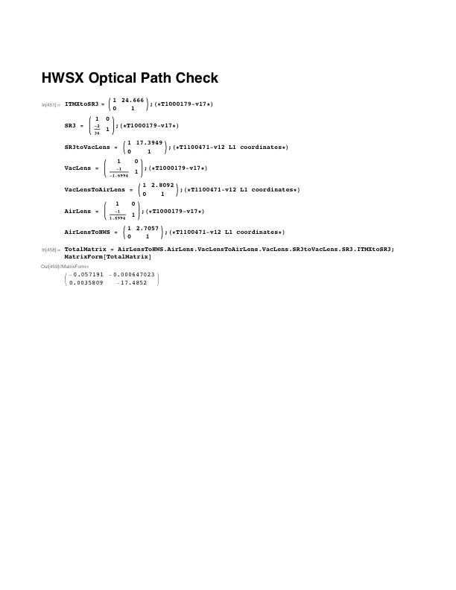

Figure : T1300437 - L1 HWSX ABCD matrix calculation

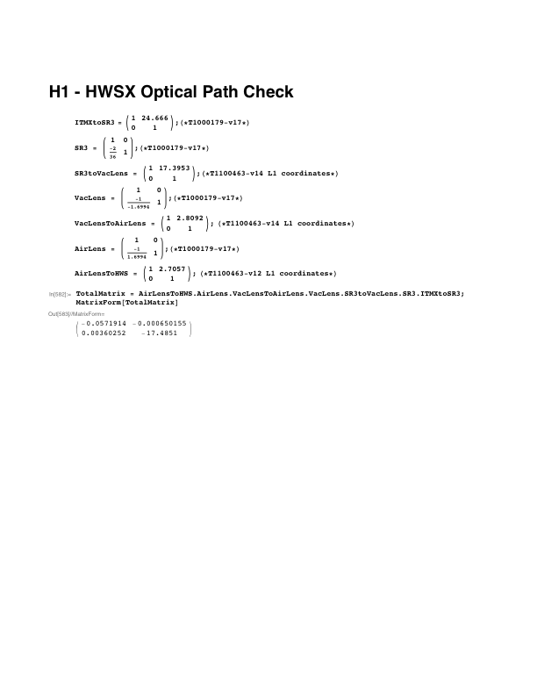

Figure : T1300439 - H1 HWSX ABCD matrix calculation

## H1/L1:HWSY [see T1300438, T1300440]

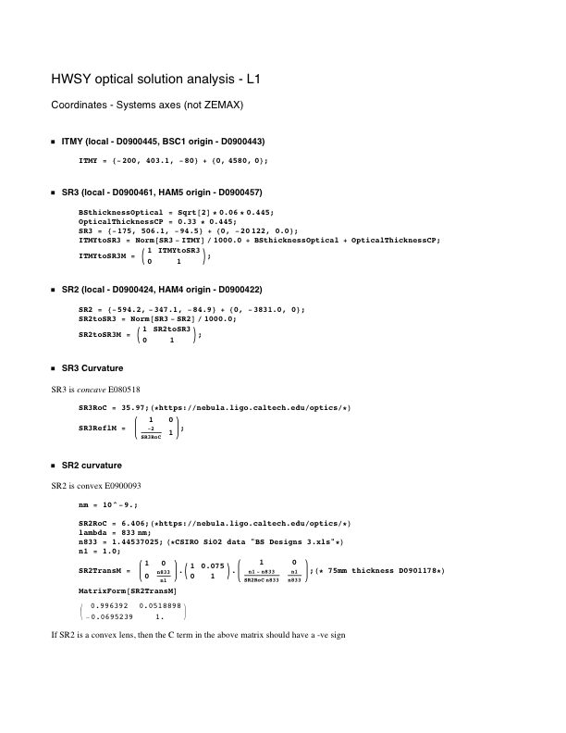

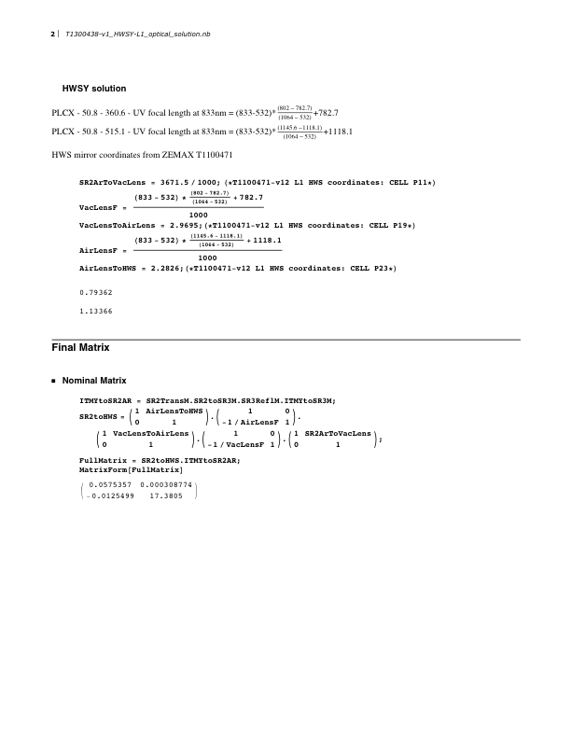

Figure : T1300438 - L1 HWSY ABCD matrix calculation

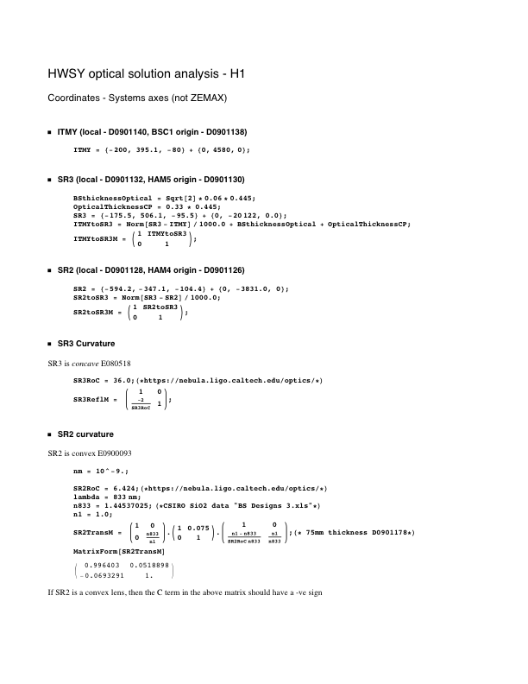

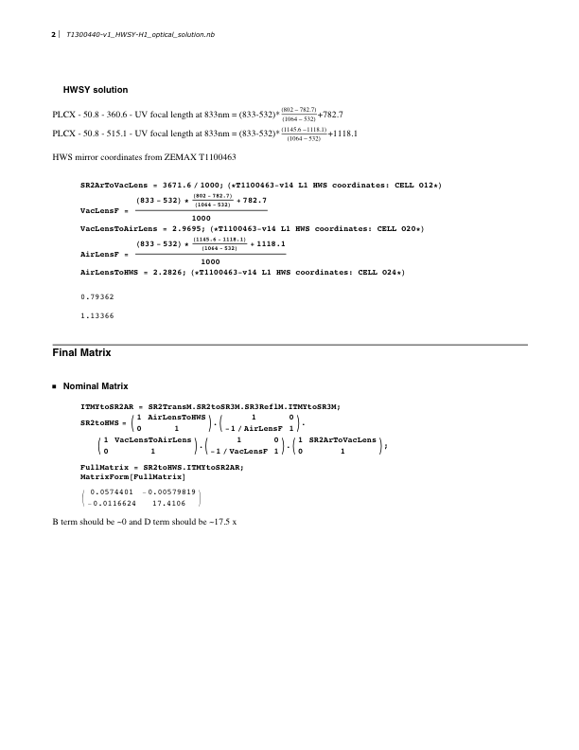

Figure : T1300440 - H1 HWSY ABCD calculation

1. This is a relatively easy calculation. If we assume that the size of the limiting aperture inside the vacuum system is ±1”, we ignore the intervening lenses as they are low power, and we assume there is distance between the last beam steering mirror and the aperture is 3.5m, then we find a maximum tolerable axis error of ~ ±7 mrad, or ±3.5 mrad on the beam steering mirror.