*LIGO Laboratory / LIGO Scientific Collaboration*

LIGO- T1000219-v2 *LIGO* April 30th 2010

**Test mass optical levers preliminary design**

Richard Abbott, Erik Black, Tara Celermsongsak, Craig Conley, Vladimir Dergarchev,

Doug Cook, Riccardo DeSalvo, Andrea Lottarini, Gerardo Moreno, Mohana Mageswaran,

Christopher Murphy, Rick Savage, Robert Schofield, Michael Smith, Cheryl Vorvick,

Hiro Yamamoto

Distribution of this document:

LIGO Scientific Collaboration

This is an internal working note

of the LIGO Laboratory.

|  |  |
| --- | --- |
| **California Institute of Technology**  **LIGO Project – MS 18-34**  **1200 E. California Blvd.**  **Pasadena, CA 91125**  Phone (626) 395-2129  Fax (626) 304-9834  E-mail: info@ligo.caltech.edu | **Massachusetts Institute of Technology**  **LIGO Project – NW22-295**  **185 Albany St**  **Cambridge, MA 02139**  Phone (617) 253-4824  Fax (617) 253-7014  E-mail: info@ligo.mit.edu |
| **LIGO Hanford Observatory**  **P.O. Box 1970**  **Richland WA 99352**  Phone 509-372-8106  Fax 509-372-8137 | **LIGO Livingston Observatory**  **P.O. Box 940**  **Livingston, LA 70754**  Phone 225-686-3100  Fax 225-686-7189 |

http://www.ligo.caltech.edu/

**Summary**

The Advanced LIGO optical levers will comprise Super-luminescent LEDs coupled with monomode angle-cut fibers to telescope launchers mounted on Opto-Sigma lockable goniometer pitch-yaw stages bolted to pyramidal, folded-sheet, welded stainless steel pylons that are bolted to base-plates that are grouted to the LVEA floor.

The Test mass optical lever launcher telescopes will be a 50 mm diameter telescopes, able to generate 1 to 2 mm light spot on 1 cm2 quadrant photo diodes up to 66 m away. The optical levers main beam impinges almost perpendicularly and hits the center of each test mass. The quadrant photo-detector receivers are mounted on remote-controlled X-Y micrometric translation stages that are also mounted on similarly designed pyramidal pylons. The X-Y translation stages are used to null the quadrant photo-detector signal where maximum sensitivity to displacement occurs and several causes of noise cancel out. The optical levers deliver analog quadrant photo diode signals to the controls and data acquisition system.

The beam launcher telescopes for the test masses are designed to include a beam splitter to generate auxiliary, paraxial beams that are sensed by two or three auxiliary CCD sensors mounted next to the quadrant photo diode. These beams are intended to monitor the test Radius of Curvature changes due to thermal lensing. This option will be implemented on a risk reduction basis only. The End test mass receiver piers are shared with the receiver boxes for the Photon Calibrator subsystem.

**Requirements**

The alignment requirements for the optical levers are summarized in table 1 and detailed in LIGO-T0900174 and references therein. More detail is presented in the conceptual design is LIGO-T1000048-v4.

The optical lever signals will be used to pre-align the interferometer. During the aLIGO commissioning phase, and possibly during acquisition, the signal will be used also to damp test mass oscillations, and to keep the mirrors aligned during lock acquisition, until the interferometric (wavefront) angular feedback signals can take over. For this the four analogue signals of each quadrant photodiode will be provided to the control system.

The accepted alignment resolution requirement from the Ad-LIGO optical levers is ±0.7 microradian, to be maintained for up to 100 minutes, with a dynamic range of 0.2 milliradian.

Table 1: Required angular sensitivity for the test mass individual mirrors, physical and physical parameters of individual Optical levers. The arm length given is the one between the monitored mirror and the detection photo diode, the beam travels twice that distance from the launcher telescope to the detection diode.

|  |  |  |  |  |  |  |  |  |  |
| --- | --- | --- | --- | --- | --- | --- | --- | --- | --- |
| Optics element | Requirement Straight/ /Folded interferometer [mradian] | Arm-length (straight/ folded) [m] | Required spatial resolution  [mm] | Required Spotsize (2w, max.) [mm] | Launching Telescope diameter [mm] | Launching/ Detection height [m] | Dynamic range [mm]/ [mradian] | Expected sensitivity /stability  [nrad] / [mrad] | Incidence angle [degrees] |
| ITM | 2.56/2.54 | 33.1/ 28.2 | 89 | 4 | 40 | 1.1 / 2.4 | ±7/200 | 1.3/ 1 | 1.8-1.3 |
| ETM | 2.3/2.28 | 5.7/3.3 | 14/7 | 2 | 40 | 1.1 / 2.4 | ±5/330 | 3.5/ 1 | 6.8-8.4 |

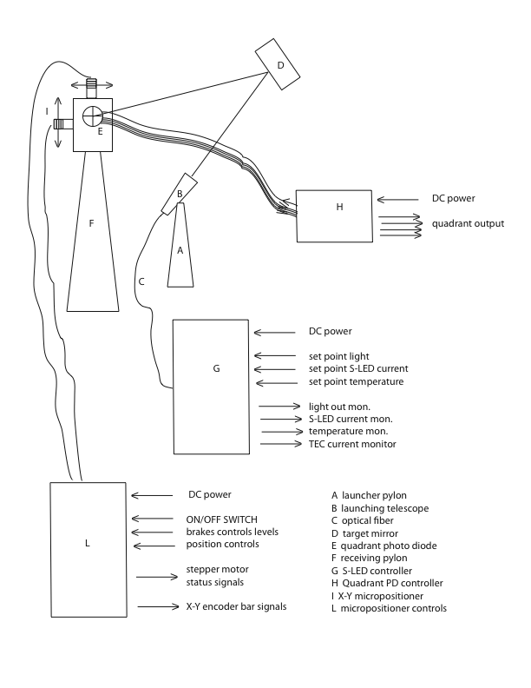

Figure 1: Optical lever block diagram.

S-LED controls and read-back will be handled via Epics. Stepper motor controls will be manually controls by means of a portable controller. The pre-amplified analog signals from the quadrant photo diodes are delivered to the data acquisition system and processed (amplifying, whitening,. . .) in the controls subsystem.

**Choices made and their rationale**

A block diagram of one of the proposed optical levers is given in figure 1. The light produced on a super-luminescent LED is carried by a single mode fibers to a launching telescope, reflects on the monitored optics, and is collected on a quadrant photo diode detector.

Tests performed in the conceptual design phase [T0900651, T1000070, T1000096, T1000112, T1000113, T0900477] demonstrated the importance of using angle cut fibers, super-luminescent LED instead of lasers, and to maintain the optical spot as close as possible to the quadrant photo-diode center; the problems of vignetting and Airy rings were studied as well, and drove the requirements on the launching telescope size and pointing mechanisms.

The optical levers will use Super-luminescent Light Emitting Diodes (figure 2). An initial test with a QPhotonics, QSDM series diode (with declared lifetime at nominal power of better than 100,000 hours i.e. 11 years) failed the declared standard by a large amount (decay time ~1 month). QPhotonics then indicated that the declared lifetime was intended for different models (InP), that the bad result was a spurious one, but had no data to offer for the AsGa models. A replacement Qphotonics diode failed as well. Additionally during tests in Australia on two Qphotonics Super-luminescent Light Emitting Diodes, one died.

Alternative Super-luminescent Light Emitting Diodes were found with Exalos and Superlum. Both companies provided us with proper lifetime charts. The accelerated lifetime test data provided by the vendors were performed over tens of Super-luminescent Light Emitting Diodes and spanning over 10 to 20,000 hours with no failure. The test results provided from both companies are compatible with a lifetime in excess of 100,000 hours. The S-LED offered are otherwise equivalent to those previously procured from Qphotonics.

We chose Superlum <http://www.superlumdiodes.com> (keeping Exalos as a good backup) because of requirements from the Hartman sensors. The Hartman sensor requires higher power, and Superlum has higher power models in catalog. Additionally Superlum has been in business withS-LED for longer time and has a large customer base in navigation (which require >100,000 hours lifetime) and ophthalmology. Additionally Superlum offers an integrated power supply/driver/S-LED unit that suits well our needs. We ordered a integrated DC powered driver/S-LED control unit (SLD-381-MP-DBUT-SM-PD-FC/APC with PCB Driver PILOT-4 sandwich assembly, see figure 2 and <http://www.superlumdiodes.com/pilots.htm> ) for electromagnetic noise and stability evaluation. It will be monitored and controlled under epics remote control.

The presently used fiber pigtailed lasers, although scheduled to be phased out due to unwanted interference patterns at the focused spot level and to lifetime issues, remain as a viable and easily interchangeable alternative.

Super-luminescent Light Emitting Diodes exist in several wavelengths, the same available with the previously used solid-state diode lasers (they use the same lasing structure without beam defining mirrors). Several considerations point towards the 840nm wavelength (this wavelength is used in ophthalmology and navigation, it is the best known in terms of stability and lifetime), which is not visible but is detected with optimal sensitivity by the photodiode and CCD cameras.

The evaluation of the 840 nm diode effectiveness taking into account the mirror spectral reflectivity is shown in figure 2 using the spectral emission of a 3 mW SLM381 S-LED emitter. The current output of figure 2, has still to be divided by four to account for the beam splitting of the radius of curvature monitoring system, i.e. 53mA for the ITM and 57mA for the ETM.

This current on a 200 kOhm transimpedance preamplifier yields ~10V when the light spot was concentrated on a single quadrant.

The launching telescopes will be rigid Galilean collimating telescopes (Thorlabs BE20M-B - 20X Galilean Beam Expander, AR Coating: 650-1050 nm) mounted on a manual, micrometric movement, lockable pitch-yaw mechanism.

The beam of the Test mass optical levers will hit directly the center of the test mass and return to the quadrant photo diodes without further reflections.

The centering of the optical lever spot on the quadrant photo diodes will be done manually by means of the pitch-yaw micrometric stages, and then locking it. A visible low power S-LED will be used during alignment, until the optical lever box is sealed, then the light source is swapped to the IR source. This is mainly for ease of alignment but also for safety reasons. The IR light has an added safety risk due to the lack of eye blink protection. The nominally 3 mW beam is potentially dangerous. Several factors make its use safe.

At launching the beam is ~3 cm diameter, so diffused as not to be dangerous. The beam is split at the telescope level into less than 0.75 mW beams by the test mass radius of curvature monitoring system. Even if this system was not implemented, the beam becomes focused to a potentially dangerous level only near the location of the quadrant photo diode. By that point, because of the 10% reflectivity from the test masses the residual beam power exiting the vacuum chamber is only 0.3 mW, an intrinsically safe level. Nevertheless, and because other optical levers elsewhere may not be so strongly attenuated at the mirror reflection, for added safety, it is required that the IR light source is used only after coarse alignment, with protection boxes sealed.

Note that the beam transmitted by the test masses carries 90% of the power and becomes potentially dangerous at 20 to 50 m behind the test mass (for the H1 interferometer ITM case where the focus is 38 m from the test masses, shorter distances for the beams of the other test masses). By then the beam should be scattered by the beam pipe walls. It will be still required not to have optical levers on while accessing the vacuum chambers, or at least to switch them to visible light so that to have eye blink protection. Interlocks will be required.

The launcher telescope will be bench focused (by means of a CCD camera) with caustic at 840 nm on the quadrant photodiode. A simple pointing telescope (a camera zoom) rigidly mounted on the side of the launching telescope, and bench aligned with the launcher telescope, will be used to pre-align the launcher to the center of each test mass. The pointing telescope (which would have the quadruple pendulum mechanical frame in its field of view) allows pointing to the center of the test mass without accessing the vacuum to place a target in front of the test mass. This alignment precision is sufficient to center the exit viewport. Eliminating the necessity to access the vacuum chambers minimizes pollution risks. Fine alignment on to the quadrant photo diode will be done with a temporary visible Super-luminescent Light Emitting Diode or laser light, then switching the light source (at the end of the fiber) to the 840 nm one after alignment. The optics of the alignment telescope and its CCD camera will be chosen for sensitivity also to 1064 nm, so that these telescopes will remain as scattered light monitoring throughout the lifetime of A-LIGO

For beam alignment of the launching telescope to the test mass we adopted OPTOSIGMA pitch/yaw stage assembly comprising a 70mm goniometer (GOHT-70A70) on a 120 mm worm gear rotation stage (S120/TVL360). The stage includes a custom, double locking mechanism on both axis to guarantee the required rigidity and long term stability.

The beam spot will be readout by a Hamamatsu S5981 quadrant photo diode with local trans-impedance preamplifier [LIGO-D0902824]. This diode has a noise performance 10 times better than the quadrant photo diodes previously used in LIGO.

The optical lever angular reconstruction has been shown to have less systematics, less noise and higher sensitivity when the light spot is centered on the quadrant photodiodes. The light spot size on the photodiode will be focused to the minimal achievable size (the BE20M-B, 50 mm diameter telescope is capable to generate ~2 millimeter FWHM spot (s =0.8 mm) at 6.6 to 76 meter) to maximize sensitivity. Figure 3 illustrates the measured light spot as the telescope is focused. The light spot was found to be practically free of Airy rings.

A small spot will reduce the optical dynamic range over which good position reconstruction can be achieved to a few mm. To recover linearity and dynamic range it is necessary to be able to track the light spot with the quadrant photo diode. The fine centering of the light spot on the quadrant photo diode is achieved with a remotely controlled X-Y micrometric table [Sigma Koki SGSP series]. Its ±25mm range will allow 0.66 mrad dynamic range, better than the required 0.2 mrad even including an initial misalignment of the beam spot on the quadrant photodiode of 12 mm. The initial misalignment can be manually adjusted by means of slots on the stage’s mount. To positively track long-term beam wandering, the table will be provided with a absolute position Mitutoyo digimatic scale readout. Normally-locked electromagnetic brakes on the X-Y stage will guarantee stability in absence of power. The normal status of the stages will be unpowered with locked brakes. Movement and readout of the stages will be done with a portable controller unit for the A-LIGO startup. Remote control from the LIGO control room can be implemented at a later time, if found necessary.

There is no practical limitation on the length of the fiber feeding the light to the launching telescope. Similarly the signal cabling after the trans-impedance amplifiers can be long if necessary, and the X-Y stage cabling length has no practical limitation.

The cables for each optical lever station will be routed to a convenient location in the LVEA still to be defined by the electronics group.

All the optical lever electronics, which includes the superluminescent photodiode and its power supply as well as the whitening filters and amplifiers, and stepper motor controls will be housed in that location.

The electronics specifications and interface with data acquisition and controls are specified in T1000132.

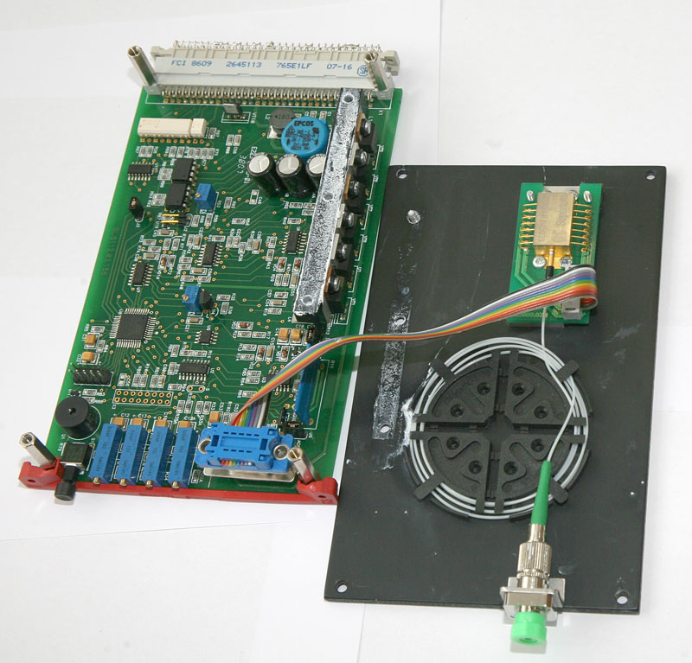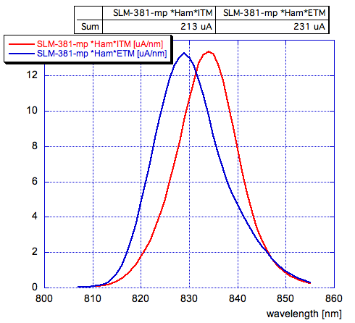

Figure 2 Top: Photo of Superlum integrated S-LED and remote controlled driver.

Bottom: Spectral emission of a SLM-381-mp S-LED convoluted with the Hamamatsu photodiode spectral response, and the ITM and ETM spectral reflectivity. The numbers in the box are the integrated current expected from the photo diode.

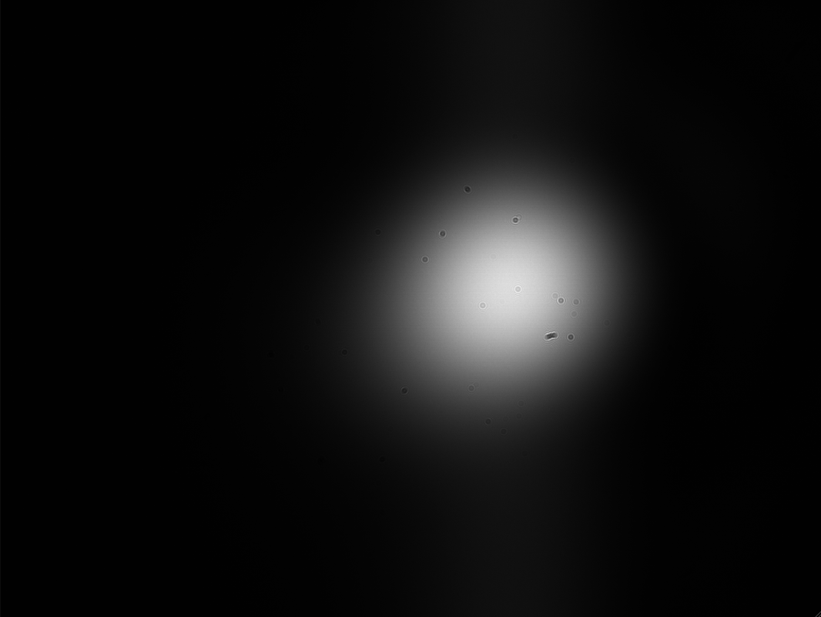

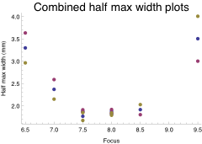

Figure 3. Top: image of the light spot on a CCD at focus=”8”. The spot profile is close to Gaussian and is virtually free of Airy rings.

Bottom: Full width at half maximum of the beam spot generated at 75 m in air by the BEx20 telescope as a function of position of its focus ring, the units in the horizontal axis are 1/10 of a turn of the focusing ring. The telescope will be bench pre-focused and locked.

**Choice, cost and declared delivery time for significant components to be procured**

Superlum S-LED plus driver combined unit, 5V power, remote controls, $2,100

Delivery time 6 weeks aro

PYLON quoted $4,500 for a midsize unit; our engineering evaluation amounts to $3,000 for the launcher pylons, and $12,500 for the receiver pylon

Delivery quoted 3-4 weeks aro (1-2 unit). Estimated 4-6 weeks for larger parts, plus 2-3 units per week for larger numbers of units.

Telescope Thorlabs BE20M-B - 20X Galilean Beam Expander, AR Coating: 650-1050 nm

Catalog item Availability off the shelf,

Telescope $ 700

Pre-collimator $ 300

Pitch/yaw stage assembly

GOHT-70A70: 70mm goniometer with 70mm height / worm gear rotation: S120/TVL360/MICRMTR with additional locking mechanism to 70mm goniometer.

Modified catalog item availability 3 WEEKS ARO $ 2,065.00

Pointing zoom telescope and CCD camera, estimated $1,500 off the shelf.

Hamamatsu S5981 quadrant photo diode Catalog item Availability off the shelf, $75

Preamplifier, 100$

X-Y dual axis motorized stage assembly SGSP33 OPTOSIGMA P/N: 100226DD03 with additional electromagnetic brakes on each axis and MITUTOYO DIGIMATIC scale

Modified catalog item availability 7 WEEKS ARO. $8,460.00

Fibers, Cables patch panels, connections $2,500

SLED unit $2,100

Pylons $15,500

Telescope $1,000

Pointing mechanics $2,100

Pointing telescope $1,500

Quadrant photo detector assembly $500

X-Y micrometric stage $8,500

Fibers, cables, $2,500

Contingency, 30% $11,000

Total per test mass $44,000

4 test masses x 3 interferometers $528,000

**Pylon structure.**

The pylons supporting both launcher and receivers will be a light and rigid, triangular-base, pyramidal structures made of folded and welded stainless steel sheet metal (figure 4, 5 and 6).

The pyramid’s laser cut, stainless steel sheet panels, will be windowed to eliminate drum mode excitations. All sheet metal plates will be properly damped with soft rubber adhesive foils to kill all resonances. All Internal cross beams will be provided with a full-length, 90o stiffening folded lip. The mating edge of each panel will also be provided with a 30o stiffening folded lip to stiffen the welds.

The bottom of the pyramid will be welded to a 20 mm thick stainless steel plate, bolted to a separate base plate, solidly grouted to ground.

The rigidity of the mounting to ground will be achieved by grouting the base plate to ground with expansive concrete.

A 20 mm thick platform will be welded at the top of the pylon with the proper orientation and threaded holes to mount the pitch yaw mechanism or quad diode translation stage.

The test mass receiver pylons will be approximately 2 m tall and the launcher pylons about 60 cm tall. The implementation plan in the end stations is shown in figure 7, 8 and 9. The implementation plan in the corner station is shown in figure 10 and 11.

Figure 12 shows more detail of the launcher pylon.

Figure 13 shows more detail of the receiver pylon.

The fiber between the super-luminescent Light Emitting Diode and the launcher telescope will be tubed for protection and vibration damped near the launching telescope.

The receiver pylons in the end station are shared with the photon drive system. The photon drive receiver will be housed on a small breadboard at half height of the pylon. In the corner station, the breadboard may be used by the final folding mirror of the Thermal Compensation System.

The center of weight of the pylons remains well within the footprint, thus not generating safety (tipping) concerns when not bolted to ground. Suitable hooking points are provided for craning.

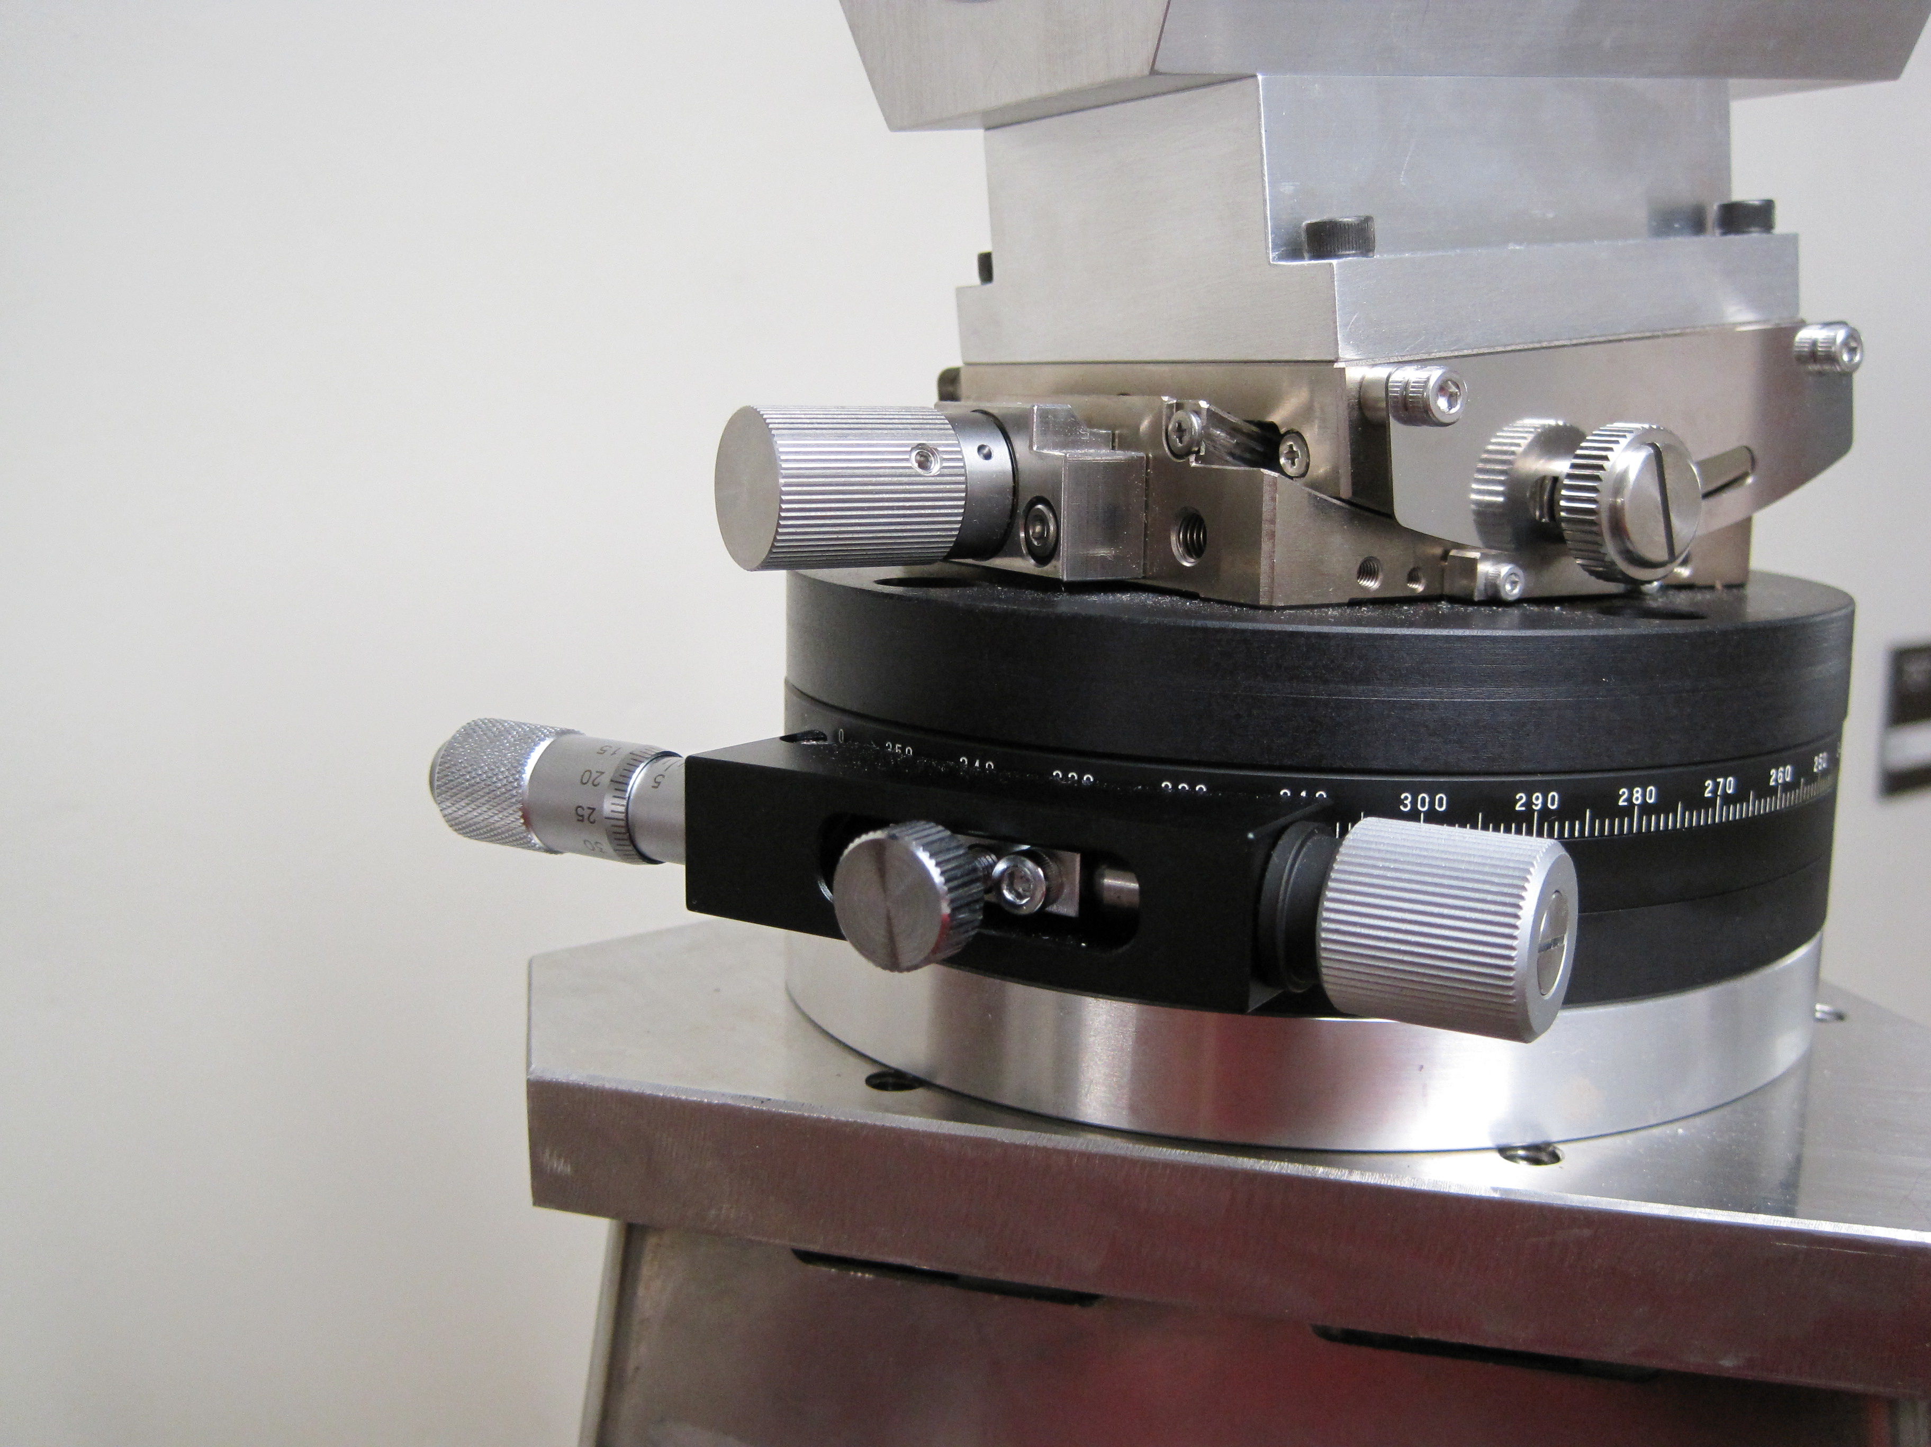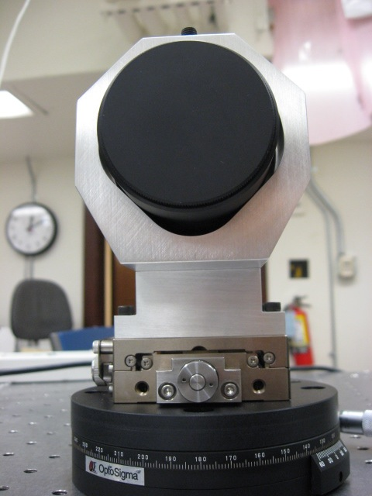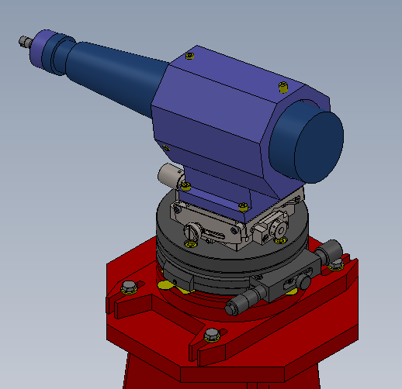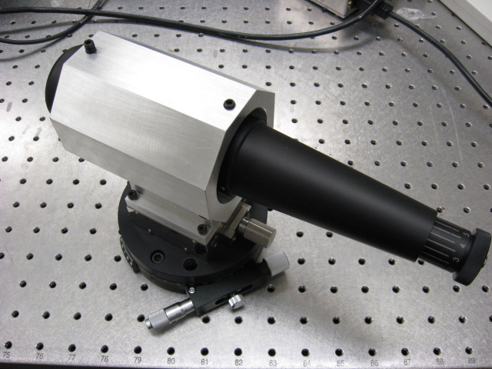

Figure 4. Fifty mm diameter test mass telescope launcher on its Opto-Sigma yaw-tilt micrometric pointing mechanism; note, the locking mechanisms is still one sided in these photos.

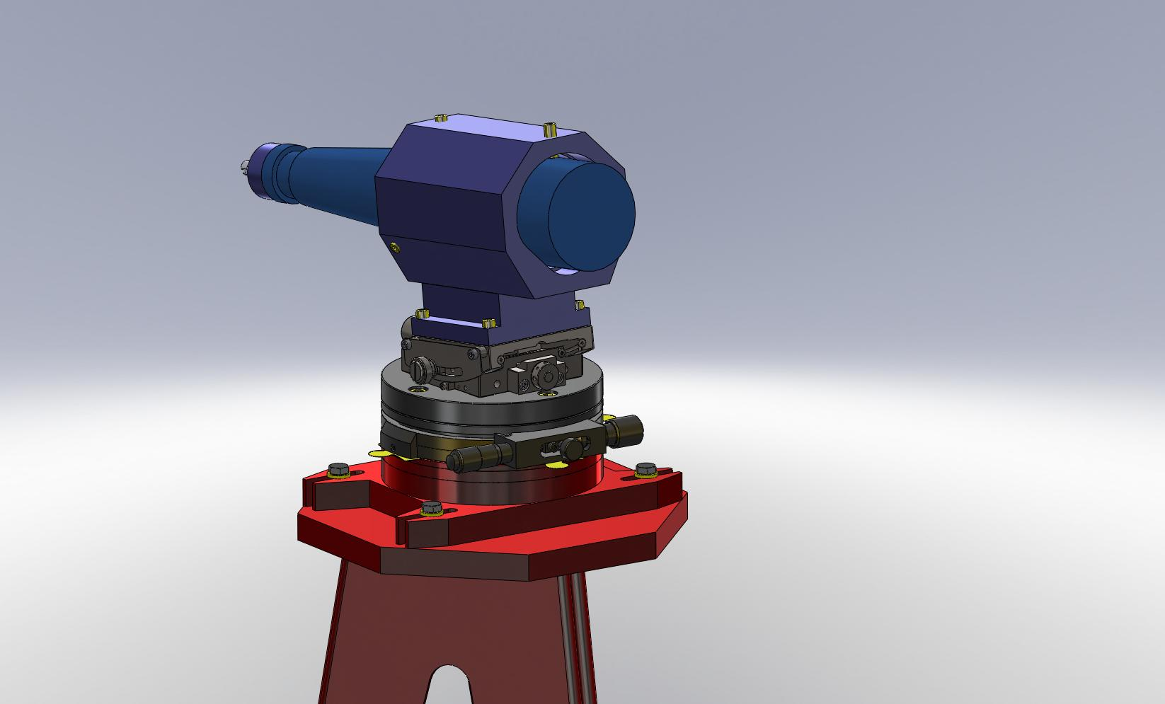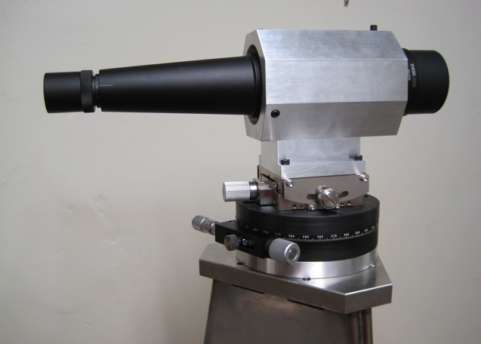

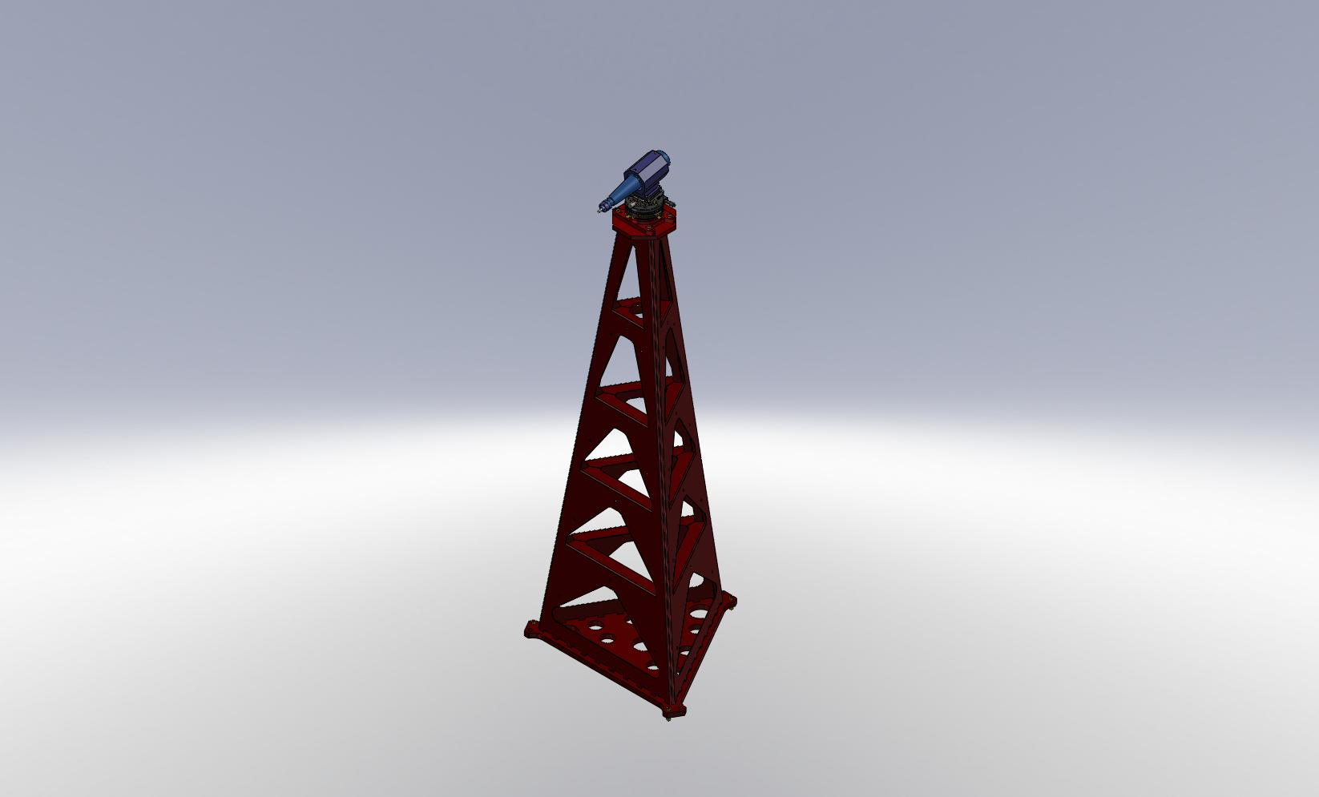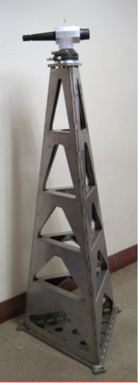

Figure 5. Schematic design of a light pylon to carry the optical lever launching and receiving optics and of a launching telescope to be mounted on top of the pylon. The pylon is made with sheet metal laser cut, bent and stitch welded. The thicker base plate would be bolted to a second plate grouted to ground for maximal stiffness; the grouted plate is provided with large holes to allow the grout to mushroom through, expand and lock the structure to ground.

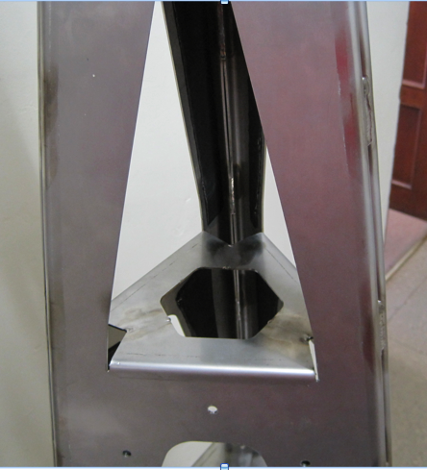

Figure 6. Detail of pylon’s folding and welding structure, the folded lips of all windows are welded together for added stiffness. The edges of the three separate panels are folded at 30o angle, then stitch welded forming three very strong ribs along the pyramid sides. Note the black vibration damping adhesive tape near the folded ribs that damps resonances on all surfaces.

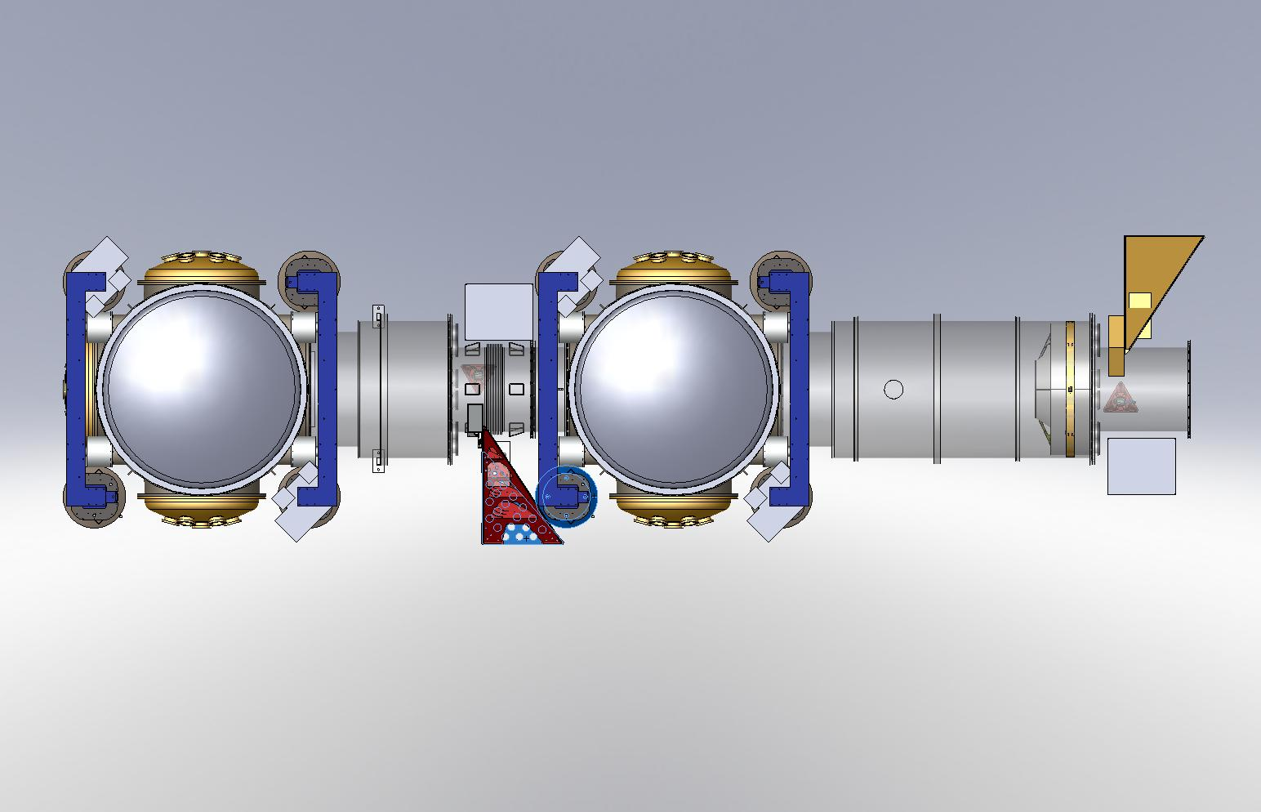

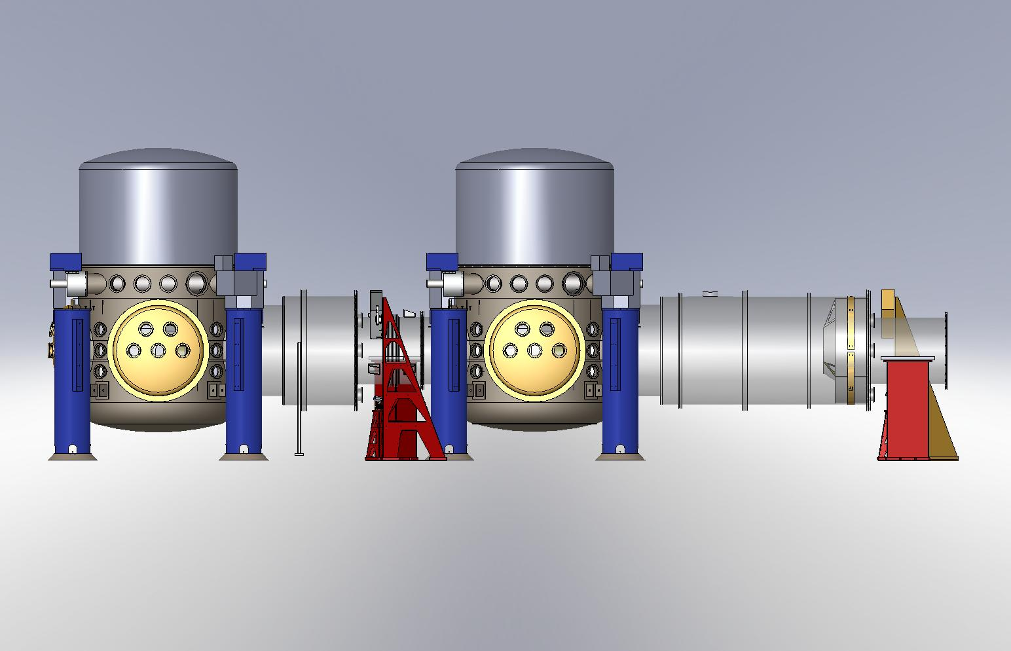

Figure 7. Endstation: Layout for the optical lever and photon calibration pylons, red is for the optical levers of H1, yellow is for the optical levers of H2, pink is the launcher of the photon calibration.

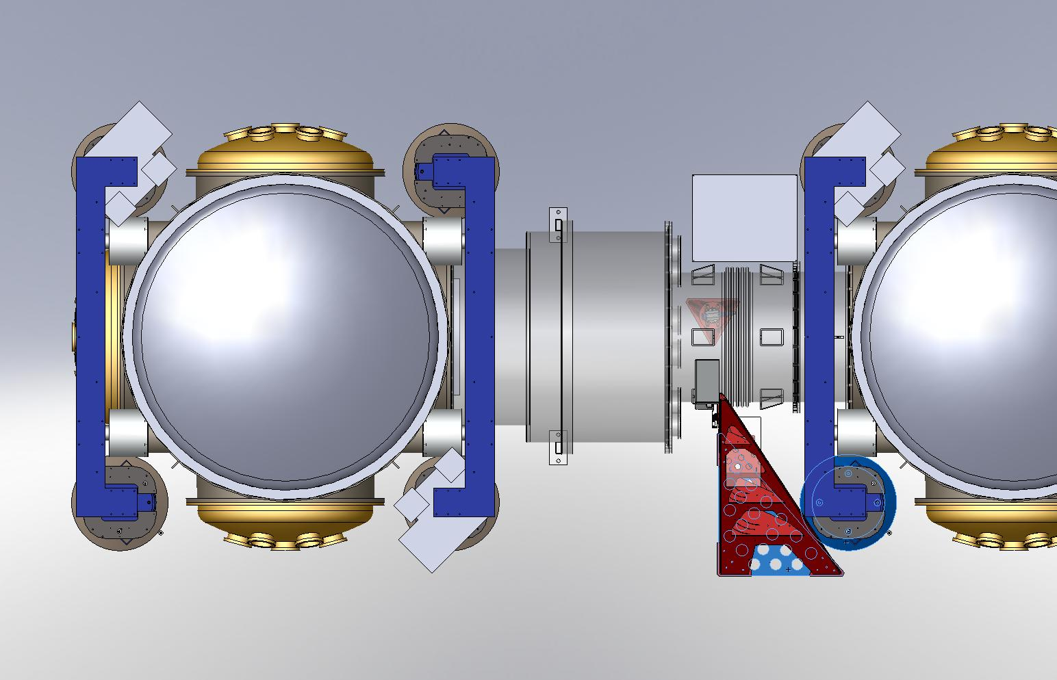

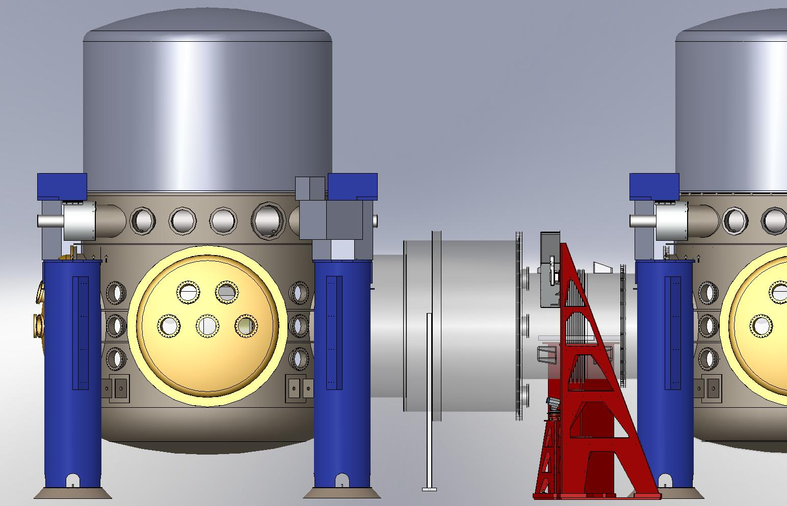

Figure 8. Endstation top and side view of the H1 optical lever pylons.

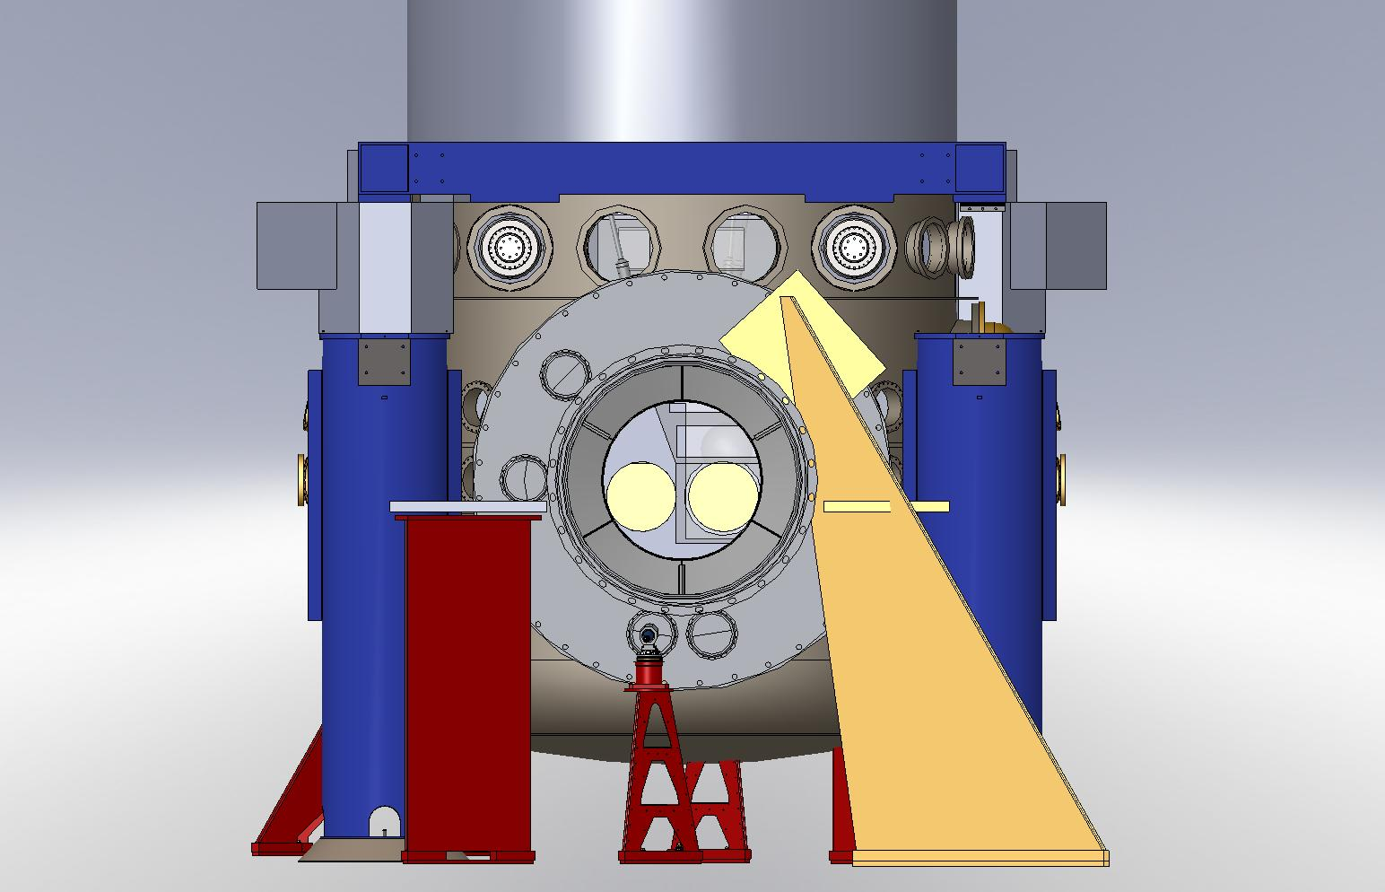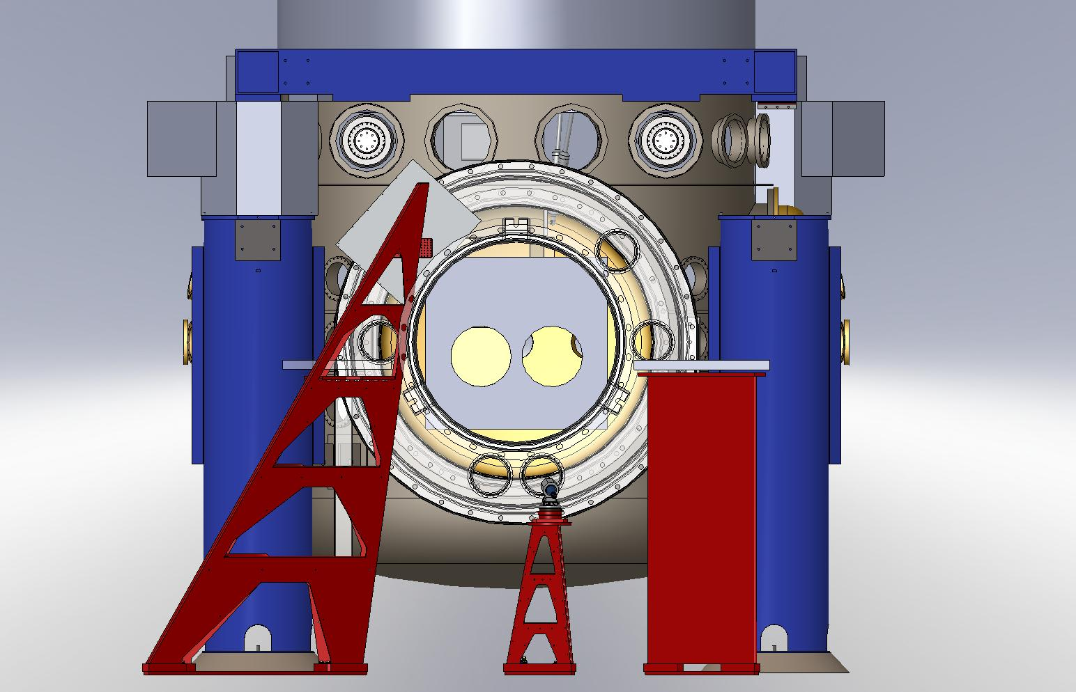

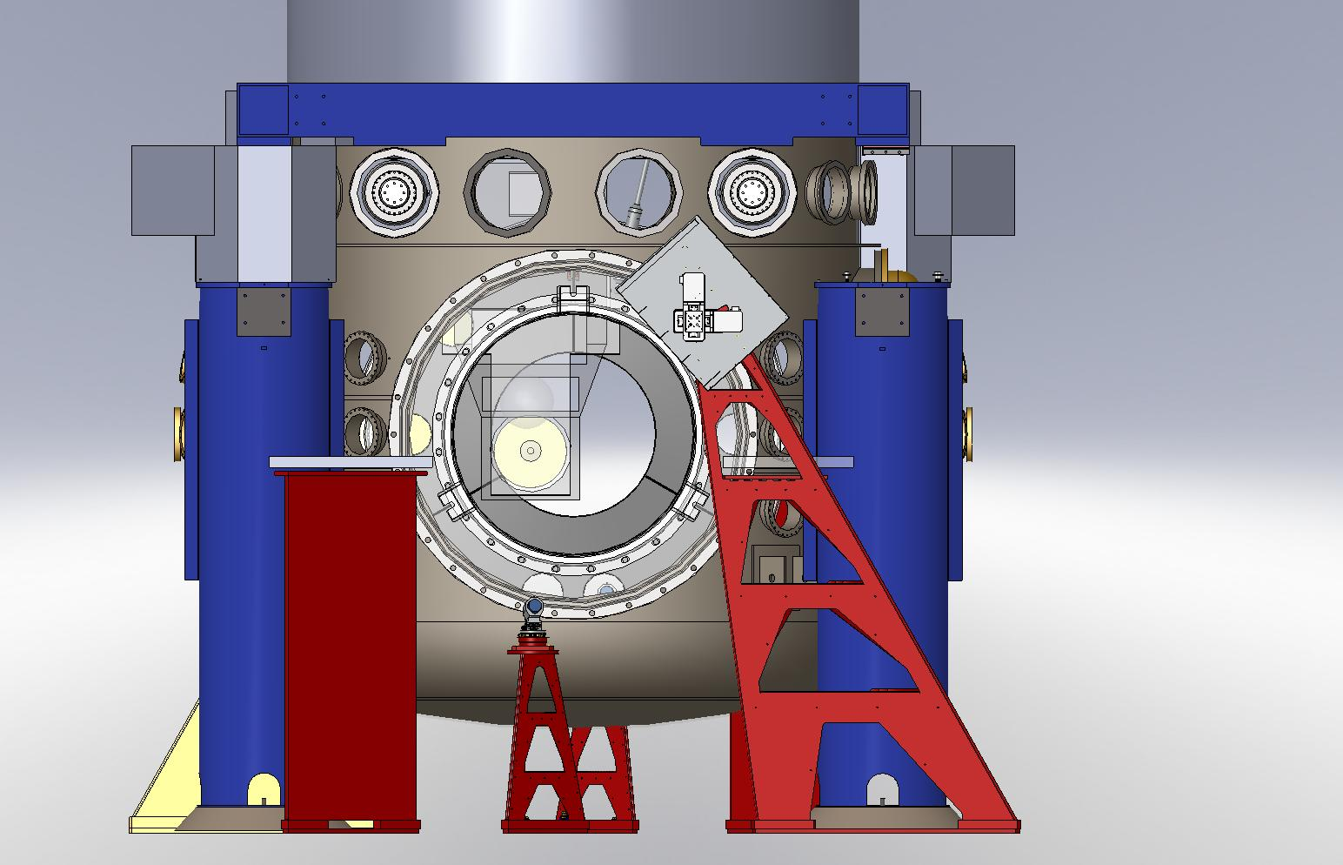

Figure 9. Endstation: top left back, view of the H1 optical lever and photon calibrator pylons. Top right, back view of the H2 optical lever and photon calibrator pylons. Bottom left, front view of the H1 optical lever and photon calibrator pylons.

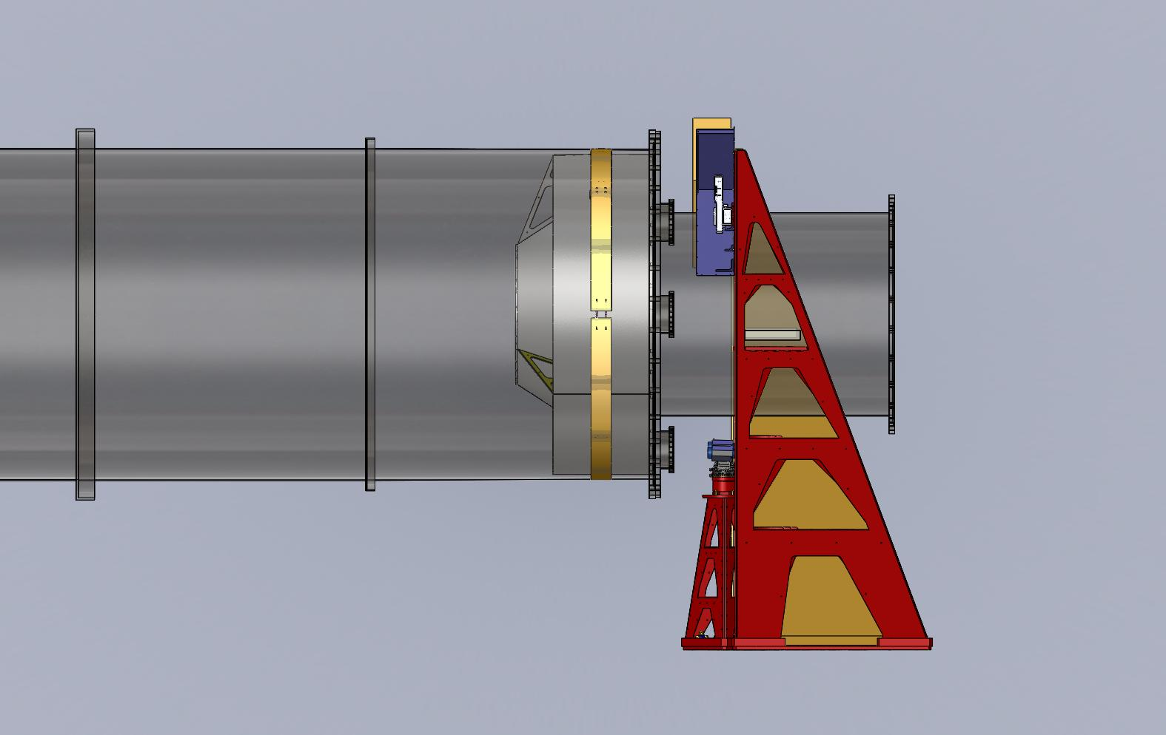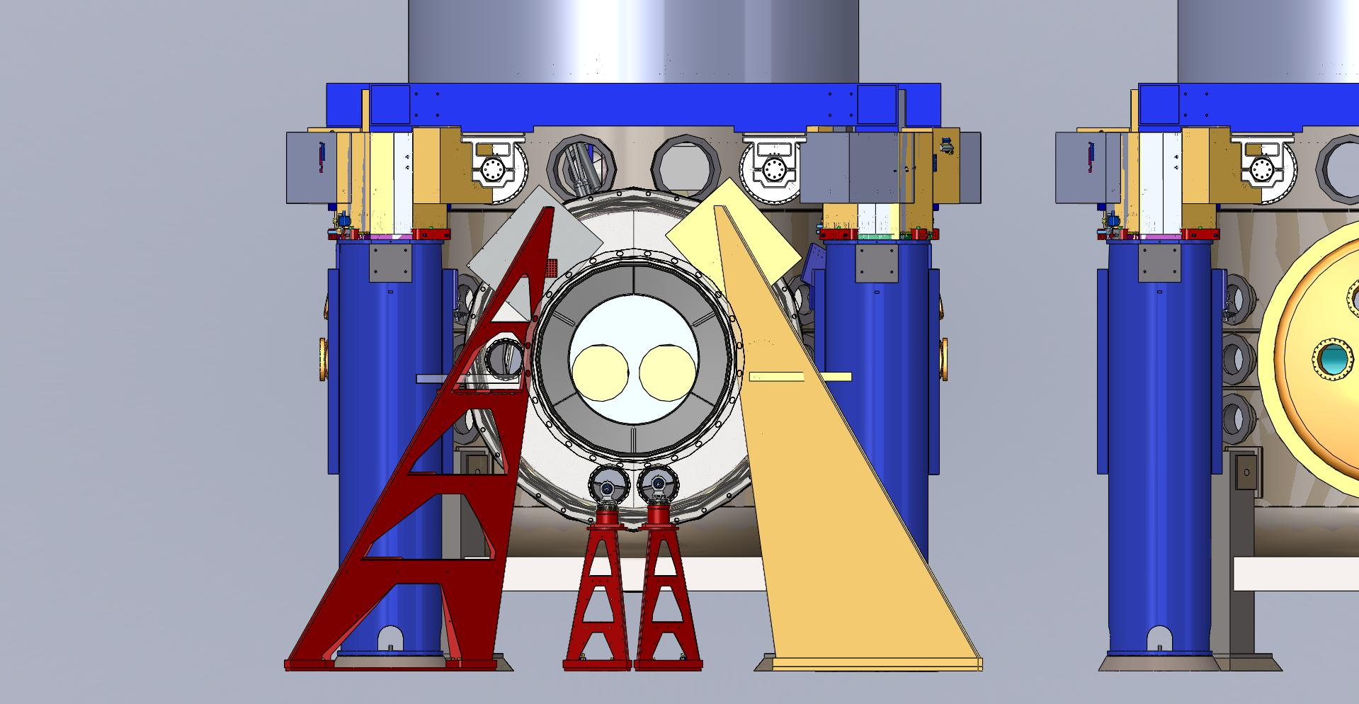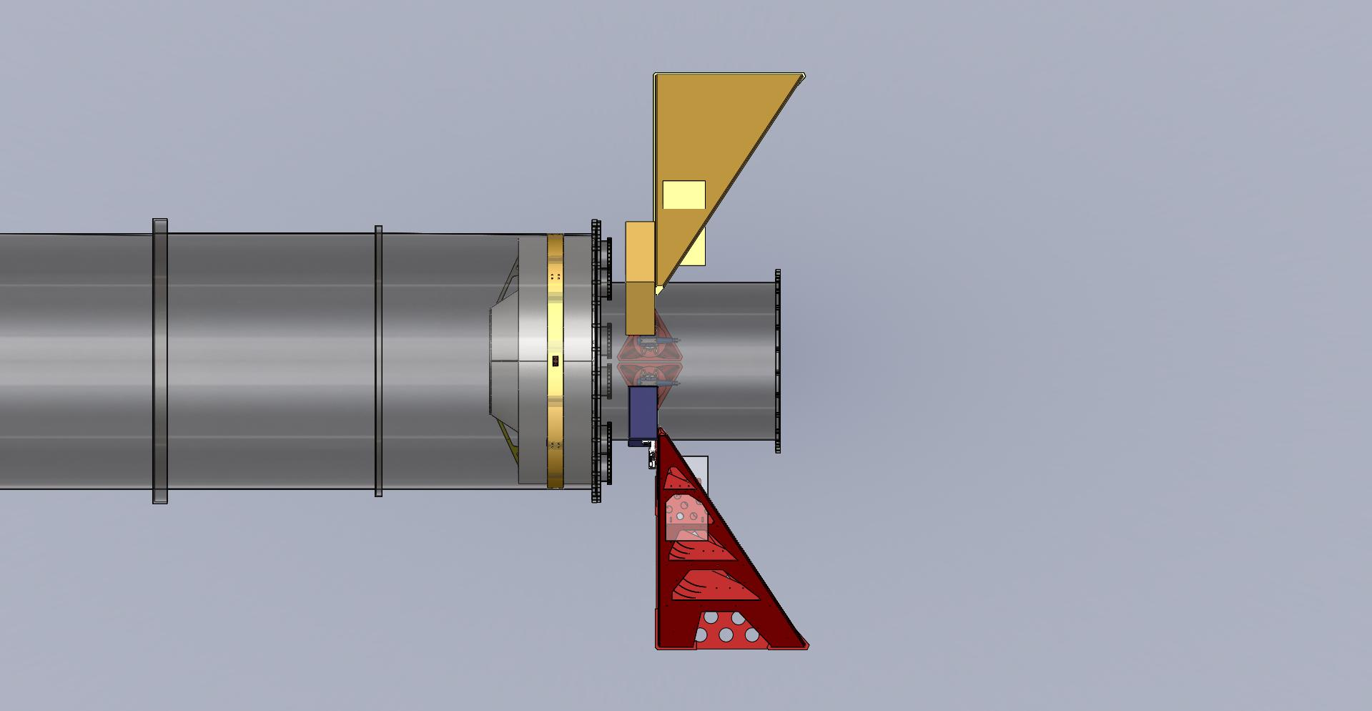

Figure 10. Corner station: top left back, side view of the optical lever pylons. Top right, back view of the optical lever pylons. Bottom left, top view of the optical lever pylons.

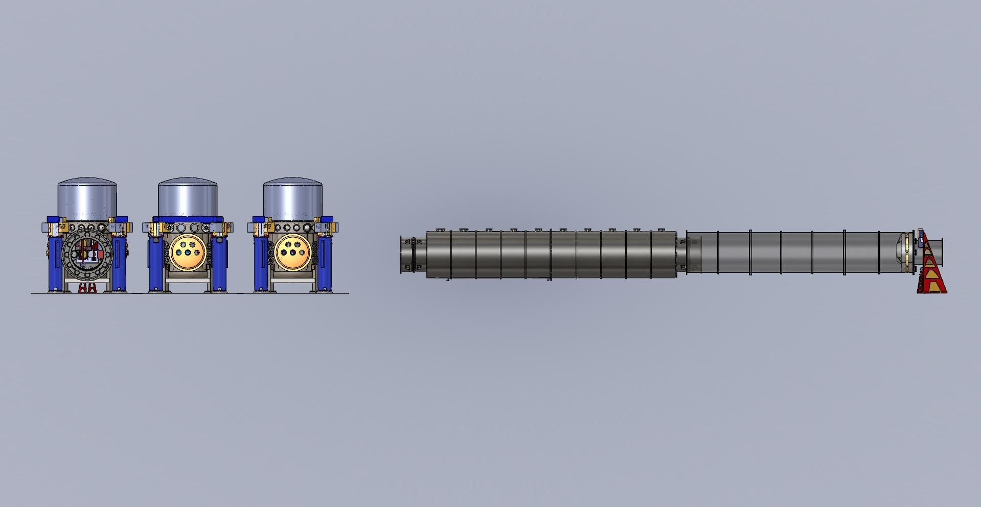

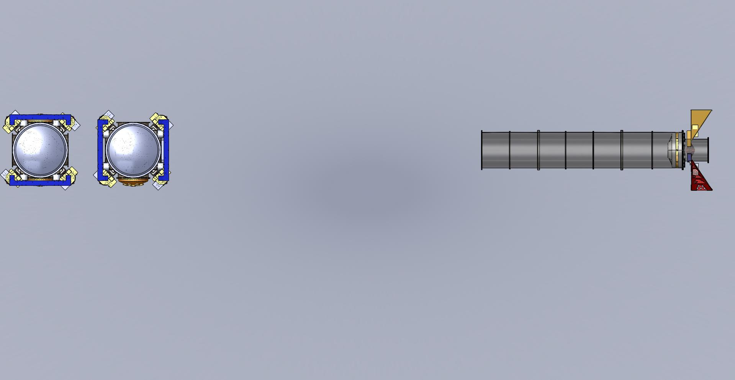

Figure 11. Corner station: top side view of the optical lever pylons. Bottom, top view of the optical lever pylons.

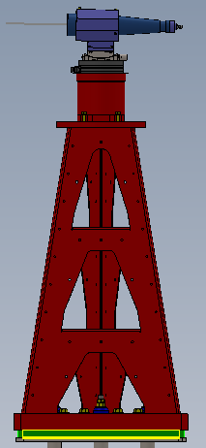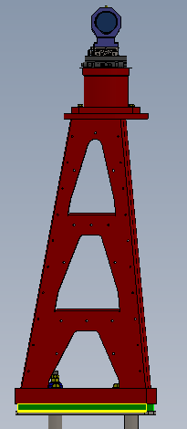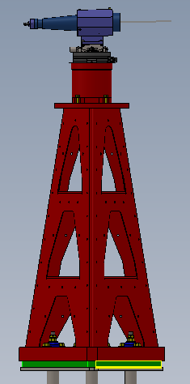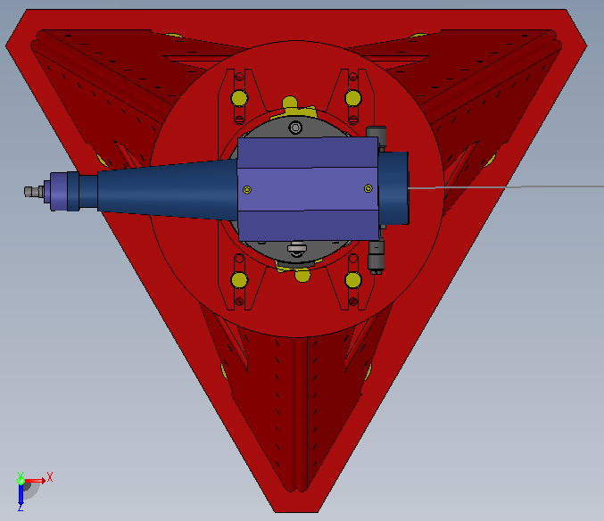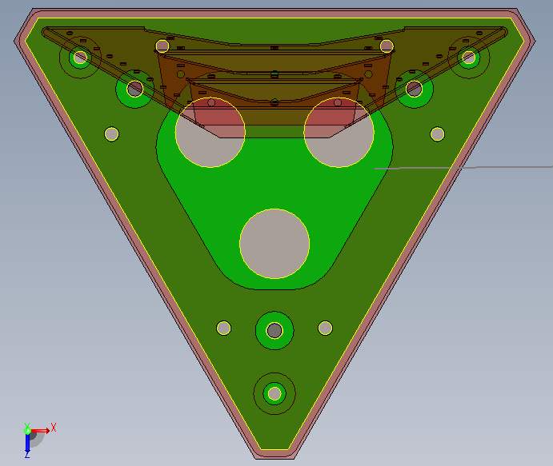

Figure 12. Model of the receiver pylon, the pylon structure (red) is bolted to a base-plate (green) provided with three threaded holes for leveling screws and through holes for pre-anchoring. The base plate is then grouted to the ground. The launcher telescope (blue), is manually pointed to the center of the test mass with the help of a pointer telescope (not shown).

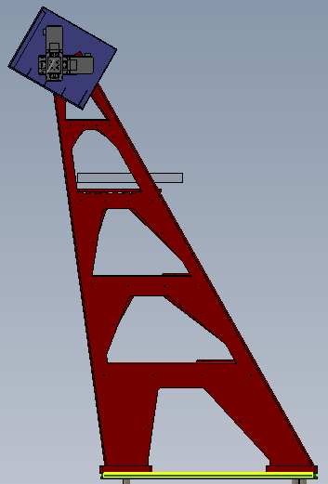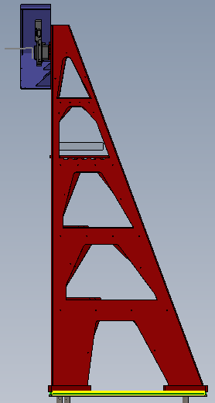

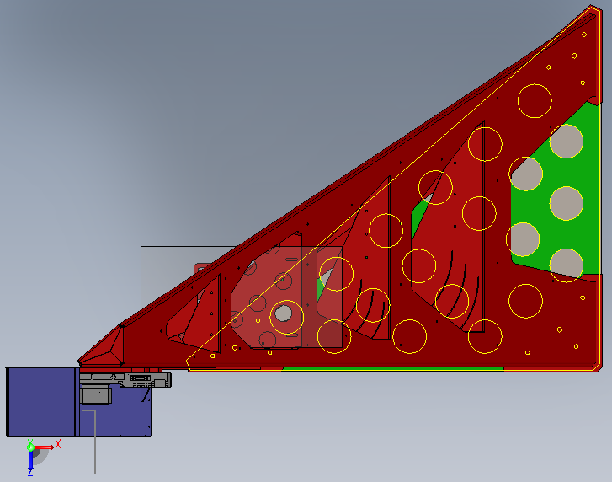

Figure 13. Model of the receiver pylon, the pylon structure is bolted to a base-plate (yellow and green), which is bolted and grouted to the ground. The base plate is provided with large holes for best grout anchoring. The square triangle footprint is chosen to avoid interference with the existing BSC pier in the end station. The tilt is to reach over the vacuum tube. The (grey) X-Y micrometric stage is mounted inside a protection box (blue). It will carry a 150x150 mm breadboard (not shown) supporting the quadrant photo diodes and the optional CCD for the auxiliary beams to monitor the test mass radius of curvature.

**Coupling through the viewports**

To reduce air turbulence between the launching telescope and the vacuum optical port and stray ambient light on the detection diodes a metal box will cover the launch telescope and a short, soft rubber bellow will connect the box to the viewport flange. The boxes will be sturdy enough to provide protection in the case of window implosion. They will be light tight, vibration damped and thermally isolated. This will provide protection from light exposure during operation. If IR light will be chosen for the optical levers, low power visible sources will be used during implementation and maintenance.

We expect to use AR coated viewport for the receiver end, and wedged windows (with AR coatings) for the test mass launcher end, where the wedged window will be required to eliminate interference with the three split beams for test mass radius of curvature monitoring.

The viewports will be provided for the injection and collection of the Optical Lever laser beams by the AOS team in accordance to LIGO safety specifications.

**Test mass radius of curvature monitoring system**

The test mass radius of curvature monitoring system is an optional design developed on a risk reduction basis

The design of the launching telescope and of the breadboard supporting the quadrant photodiode, as well as the beam routing (point of injection and of egress in the viewports), is designed to allow implementation of this system. In particular the telescope is provided with a holder ring housing a wedge, coated with 50% reflectivity on both sides. The wedge angle (see table) is designed to generate 45 mm separation between the primary beam (on the quadrant photodiode), and the secondary and the tertiary beams. These beams will be collected on CCD cameras mounted on the same breadboard of the quadrant photodiodes and readout at low repetition rate.

Wedge angle of the beam splitters of the test mass radius of curvature monitoring system.

H1 ITM   0.013 deg 0.78 min

H1 ETM   0.078 deg 4.68 min

H2 ITM   0.016 deg 0.96 min

H2 ETM   0.140 deg 8.40 min

Appendix 1: **Assembly procedure for optical levers.**

The following procedure should be intended repeated for each of the optical levers, 11 (13) per interferometer, and for each pylon (4+4 per test mass, 2+2 per recycling mirror, 4 per HAMs)

**Preliminaries**

The pylons must be received, inspected for damage and cleanliness.

All components and materials must be received inventoried and ready.

The pylon footprint area must be previously marked and cleared of piping and cablings, the epoxy paint or vinyl floor tiles scraped off if present.

**Locate the positioning and drill holes in conctere.**

Two days, three people (one mechanical, one masonry).

**Position and grout the pylons in place.**

Two days, four people (one mechanical, one masonry).

The base plates are detachable from the pylon but the grouting must be performed with the pylon attached to ensure proper positioning (the clearance against the vacuum pipe is tight, alignment to the viewport must be guaranteed).

To do this three pushing screws and three pulling rods fastened to the concrete floor are foreseen. A temporary jig (a rubber flange cover with marking indicating the input and output points of the beam) fastening to the viewport will be needed for sufficiently accurate positioning.

The grout will be held in place by a temporary dam.

Note no different estimation is made for different pylons.

Launching pylons and HAM optical lever pylons are small, can be manhandled and may be implemented faster.

The test mass and recycling pylons are tall, heavy, and cantilevered (always center of mass within footing though), and need to be handled with a crane and moved slowly to insure personnel and equipment safety. May take longer than a day, especially for the first ones.

One can expect that the first pylon of each kind will take longer even for the small pylons (to improve tooling, sequence, et c.)

Note: The grout congeals within a day but hardens slowly. The legal term for concrete structures is three weeks, but, because of the anchoring bolts, a week of hardening is deemed sufficient before applying forces to the pylon.

The receiving pylons are more than 3 m tall and cantilevered. Ideally nobody should lean on the pylons even during commissioning. It must be assumed that in case of danger a person must be able to hang to it with all of his weight and inertia, without damage.

This sets the requirements for the long hardening time before installation.

If necessary for other operations (cabling, piping), after a couple of days of hardening the pylon can be unbolted and stored elsewhere.

**External mounting the launching-receiving optics.**

Two days, four people (one mechanical and one electronics person).

The launching telescope will be bench pre-focussed to the required distance, and the pointing telescope (where present) pre-aligned parallel to the launching telescope.

The launching telescope assembly will be pre-positioned on the pylon, the fiber routed and connected to the light source.

A visible light source will be used during alignment, even if an IR source is chosen for operation.

The receiving quadrant photo diode and the micrometric X-Y table will be installed.

All connections to EPICS (switches, Super-luminescent Light Emitting Diodes, cooling controls and read-back, position controls, readout channels et c.) and power (+/- 15V, +/-24V) will be made.

All possible EPICS functionalities will be tested.

The light source will be tested and setup.

The quadrant photodiode and acquisition chain will be tested with the help of temporary masks and fibers from the Super-luminescent Light Emitting Diodes.

Most of the functionality testing can be done in situ with launching telescope and quadrant photo diodes disconnected from the pylons, while the grout hardens

**Final alignment of the optical levers.**

Two days, four people, one in bunny suit where needed.

The pylons need to be in place or re-positioned.

The viewports need to be in place.

The vacuum chambers need to be in vented mode to guarantee safety from implosion and accessible where needed.

The pointing telescope will be used to point the launching telescope on the center of the test mass or recycling mirror. The alignment will be done with respect to marks on the quad or triple pendulum frame. Ambient light will be provided through the receiving viewport for the pre-alignment of the test mass optical lever with the pointing telescope.

For the HAM case a person aligning the back-reflection mirror will be necessary in the vacuum chamber.

The beam splitter and folding mirror cases are intermediate; a person in the vacuum chamber may or may not be necessary.

Proper communication between people inside and outside is necessary.

One person controls the alignment of the launching telescope (pre focused to the correct throw length), one person tracks the beam in the vacuum chamber, perform the mirror alignment in the case of the HAM optical table optical lever, one person at the controls check the proper alignment of the received signal.

The beam splitter and folding mirrors are a special case, as they involve an in-vacuum periscope and both launching and receiving from the existing blue pier and through the same viewport.

Installation in such cramped and difficult location will likely take more than a day each.

**Safety case and safety duct installation, final commissioning.**

Two persons one day.

The safety case of both launcher telescope and receiving quadrant photo diode, and the duct (and guillotine protection) between the case and the viewport is installed and the full functionality tested.

After the protection boxes are closed, the visible light source is replaced with the IR one if needed.

Appendix 2: **Optical lever footprints**.

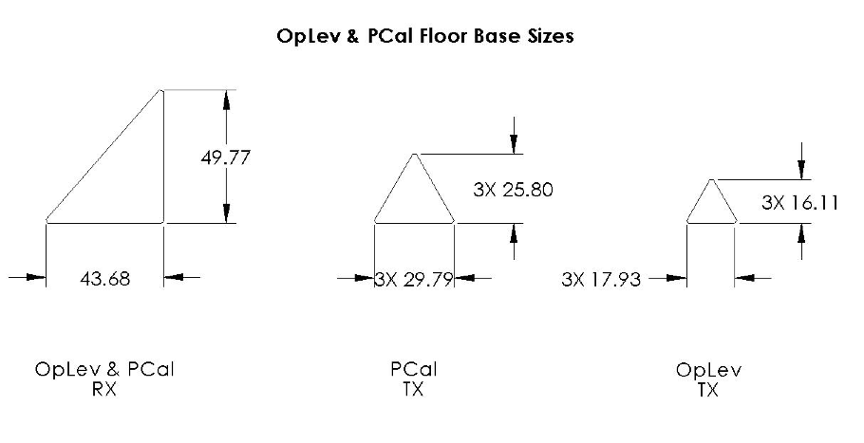

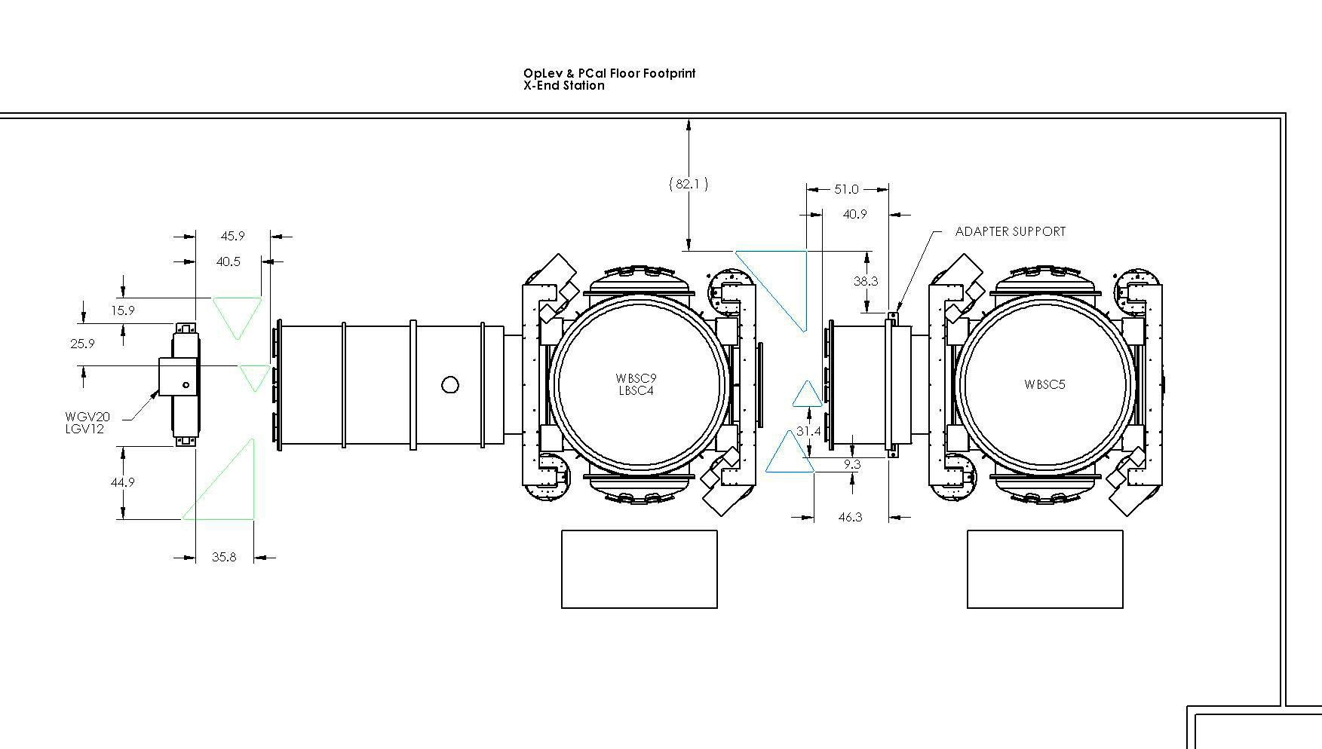

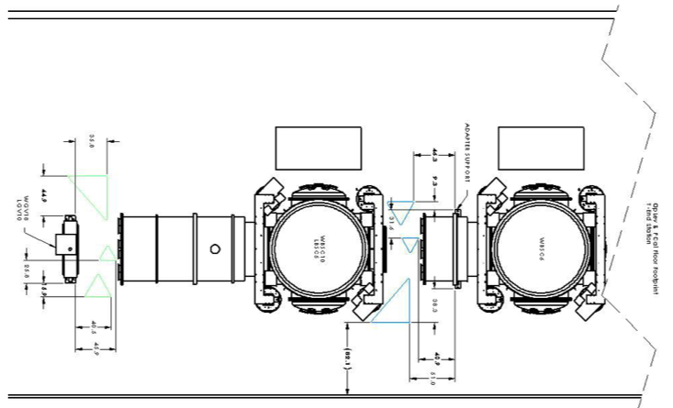

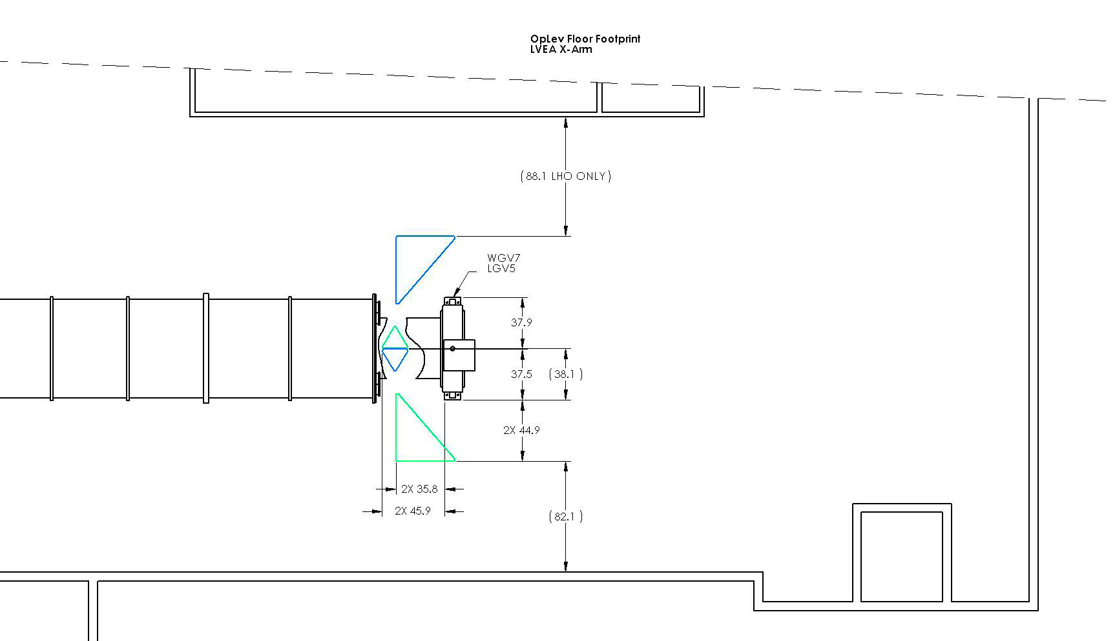

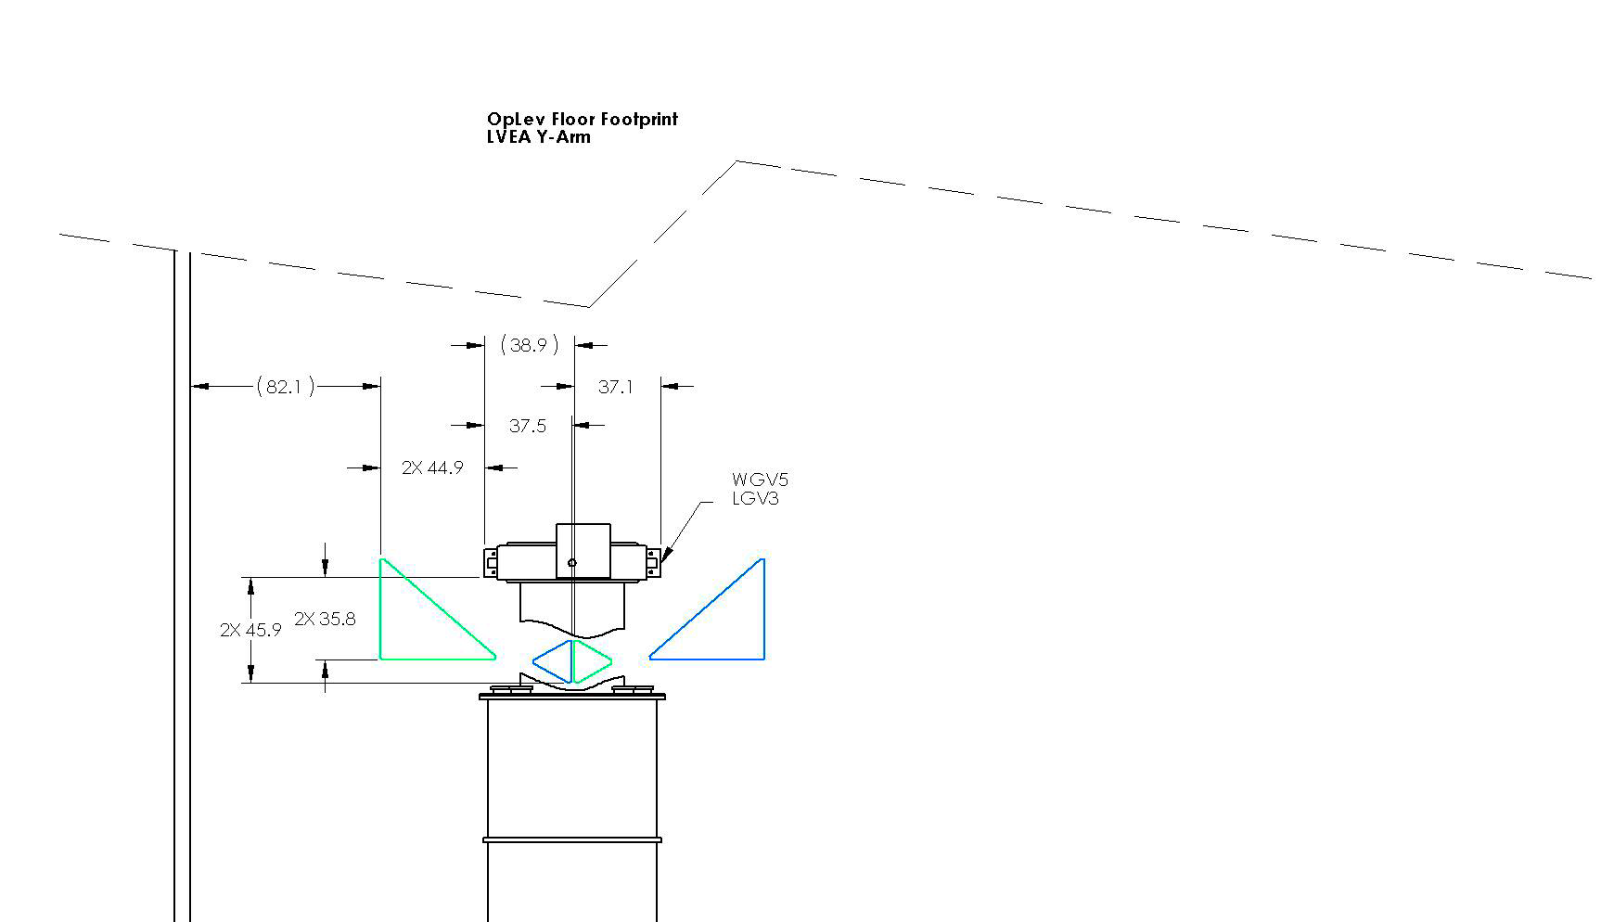

Appendix 3: **Preliminary Design Review Checklist**

System Design Requirements, especially any changes or refinements from DRR

Interactively agreed with M. Landry

Preliminary Design Document, summarizing the design and pointing to other documents

This document

Justification that the design can satisfy the functional and performance requirements

First chapter of this document

􀂄 Subsystem block and functional diagrams

See figure 1

􀂄 Equipment layouts

Appendix 2

􀂄 Document tree and preliminary drawings

Documents listed in this document

􀂄 Modeling, test, and simulation data

Not applicable

􀂄 Thermal and/or mechanical stress aspects

Not applicable

􀂄 Vacuum aspects

Not applicable (Only in Beam splitter/folding mirrors)

􀂄 Material considerations and selection

Choices made and their rationale chapter in this document

􀂄 Environmental controls and thermal design aspects

Not applicable

􀂄 Software and computational design aspects

Not applicable

􀂄 Power distribution and grounding

Not applicable

􀂄 Electromagnetic compatibility considerations

S-LED drivers being tested. Stepper motor drivers are normally off, not applicable.

􀂄 Fault Detection, Isolation, & Recovery strategy

Entire S-LED unit replaced at the breakout point if S-LED was to fail or become noisy.

Resolution to action items from DRR

Interactively resolved with M. Landry

Interface control documents

Ground occupancy (appendix 2 of this document) provided to sites for clearing needed space. Detailed absolute positioning document being prepared. Necessary real estate cleaning and reservation operations agreed during a walkout with J. Worden and R. Wooley.

Relevant RODA changes and actions completed

In progress, will finalize when the balance of optical levers will be developed.

Instrumentation, control, diagnostics design approach

Described in this document

Fabrication and manufacturing considerations

Pylon structure chapter of this document.

Instrumentation, control, diagnostics design approach

Discussion of component choice in this document

Preliminary reliability/availability issues

Identified lifetime choice in early S-LED choice, btained satisfactory lifetime data from the main provider and from a backup provider

Assembly procedure

Bench tuning of telescopes as tested in figure 2.

Installation and integration plan

Appendix 1 of this document

Environment, safety, and health issues

􀂄 Mitigation of personnel and equipment safety hazards; refined Hazard Analysis

Discussion of stray beams inside vacuum, and procedure described when accessing

􀂄 Reflected in equipment design and procedures for use

See discussion on page 6, agreed on necessary actions with Safety officers, no other danger identified.

Human resource needs, cost and schedule

Any long-lead procurements

No relevant ones. See cost and procurement table

Technical, cost & schedule risks and planned mitigation

No relevant concern identified

Test plan overview

Planned tests or identification of data to be analyzed to verify performance

􀂄 In prototyping phase

completed, new S-LED to be verified, relying on manufacturer’s data.

􀂄 In production/installation/integration phase

Described telescope tuning, check of S-LED noise level and stability

Identification of testing resources

􀂄 The test equipment required for each test adequately identified

No special equipment required.

􀂄 Organizations/individuals to perform each test identified

No special needs identified.

􀂄 QA involvement

S-LED lifetime and stability.

Test and evaluation schedule, prototype and production

Revised Failure Modes and Effects Analysis (FMEA) (bottom-up approach based on design)

Not required

Risk Registry items discussed

No risks identified

Lessons learned documented, circulated

None

Problems and concerns

None