LIGO Laboratory / LIGO Scientific Collaboration

LIGO-T1000319-v1 LIGO 20th June 2010

Note on Choice of Lowest Stage Wire Radius for Quad Reaction Chain

Norna A Robertson

Distribution of this document:
LIGO Scientific Collaboration

This is an internal working note
of the LIGO Laboratory.

California Institute of Technology  LIGO Project – MS 18-34  1200 E. California Blvd.  Pasadena, CA 91125  Phone (626) 395-2129  Fax (626) 304-9834  E-mail: info@ligo.caltech.edu | Massachusetts Institute of Technology  LIGO Project – NW22-295  185 Albany St  Cambridge, MA 02139  Phone (617) 253-4824  Fax (617) 253-7014  E-mail: info@ligo.mit.edu
LIGO Hanford Observatory  P.O. Box 159  Richland WA 99352  Phone 509-372-8106  Fax 509-372-8137 | LIGO Livingston Observatory  P.O. Box 940  Livingston, LA 70754  Phone 225-686-3100  Fax 225-686-7189
http://www.ligo.caltech.edu/

Introduction
The purpose of this document is to capture the final design choice for the wire radius for the final stage of the reaction chains for the ETM and ITM suspensions.

Background
The choice of wire radii for Advanced LIGO suspensions has in general been made by using a nominal value for tensile strength for music wire of 2000 MPa and using a safety factor of ~3. We note that the minimum tensile strength as per ASTM A-228M-07 is ~2000 MPa for wire of diameter ~1.5 mm, radius 0.75 mm, and gradually increases for smaller diameters (see T0900502). The range of wire radii for a quad is from ~0.5 mm at the top to ~ 0.23 mm at the bottom and for these values the minimum tensile strength is of order 2400 to 2600 MPa, so we have in fact a safety factor closer to 4.
The quadruple pendulums are all assembled firstly with metal masses and wires at every stage. Thus we have to specify a wire radius for the bottom stage of the main chain, though this gets replaced eventually by the silica fibres when the monolithic suspension is installed. This wire is chosen using the criteria above (stress of ~1/3 of 2000 MPa) applied to a 40 kg mass and the resulting value is 0.457 mm diameter, 0.2285 mm radius, ref D060516-v2. However the bottom mass of the reaction chain is lighter, 26 kg in the case of the end reaction mass for the ETM, and 20 kg for the newly proposed thinner compensator plate in the reaction chain of the ITM. If one follows the same criteria for choosing those wires, the wires for suspending those masses would be thinner than for the main chain, and indeed different for the two types of reaction chain. We had originally proposed to use thinner wire for the reaction chain – see T060283-02. However for simplicity of assembly we are now proposing that the same wire diameter is used for all chains at the final stage of the quad suspensions, regardless of the final mass. We review the implications of this decision in section 4.
Note that choice of wire diameters at upper stages is not affected by any difference in the lowest mass since we keep the overall mass the same by increasing the penultimate mass as necessary.

Parameters varied for this study.
We have looked at the effect of different wire diameters using the latest published quad MATLAB model from Mark Barton, ref T1000263-v1, which is the current baseline model of the quad suspension main chain. To used this model for looking at the reaction chain we require to change several of the parameters
1) Material (Young’s modulus) and radius of the bottom wire.
2) Masses and moments of inertia for the penultimate and bottom mass.
3) The effective d values at the ends of the lowest wire, to simulate keeping the physical d values (i.e. positions of attachment point for the break off prisms or clamps) the same. The effective d values will change with wire diameter since they include the wire flexure lengths, and the code is currently written so that if a wire is changed, the physical d is changed to keep the effective d constant. Thus is we want to keep the physical ds constant (corresponding to the production as-built values) we need to change the effective ds in the code.

The appendix (section 6) lists the various parameter sets used in this investigation.
Note that the parameters are only an approximation to the production values. For example we have modeled the penultimate reaction masses as right circular cylinders and in reality they are more complicated. Also no wedges are included for the ERM or CP. But the values are close enough to draw conclusions about the changes which occur when different radii of wire are used at the final stage.

Observations regarding effect of wire radius
The major effects seen when the wire radius of the final stage in the reaction chain is changed is that:
i) With increasing wire radius, the highest two pitch modes are raised and the pitch isolation is slightly decreased (by less than factor of two at 10 Hz for the wire radii considered). See figure 1.
ii) With increasing wire radius, the highest vertical and roll modes are increased, see figures 2 and 3.
For the ERM with r = 0.2285 mm (default value), highest vertical mode = 18.3 Hz and highest roll mode = 26.1 Hz
For the ERM with r = 0.175 mm (thinner wire), highest vertical mode = 14.4 Hz and highest roll mode = 20.5 Hz
For the thinner CP with r = 0.2285 mm (default value), highest vertical mode = 19.8 Hz and highest roll mode = 28.2 Hz
Other modes and transfer functions are essentially unchanged.

Conclusions
The isolation required in the reaction chain of the quad is modest compared to the main chain – see for example T060043-00-K. Thus the small decrease in pitch isolation when using thicker wire is not significant. We have no requirement on the frequencies of the highest vertical and roll modes for the reaction chains. These peaks will only weakly couple into the main chain and will have much lower Qs than the main chain which contains silica fibres. We can see no adverse effect in their being at slightly higher frequencies due to the use of thicker wire. The frequencies are similar to those from other wire suspensions (HLTS and HSTS) and are all below 30 Hz.
The advantage of using the same wire, r = 0.2285 mm, is that is simplifies the assembly process for the quadruple suspensions. Having only one set of four wire sizes for the quad for both main and reaction chains makes keeping track of which wire goes where a simpler process. In addition this choice of wire is what has been assumed in the design of parts by the RAL group. Thus in conclusion we propose to use the same lowest wire radius, namely r = 0.2285 mm (diameter = 0.457 mm) for all quad suspension chains regardless of the mass of the bottom stage.

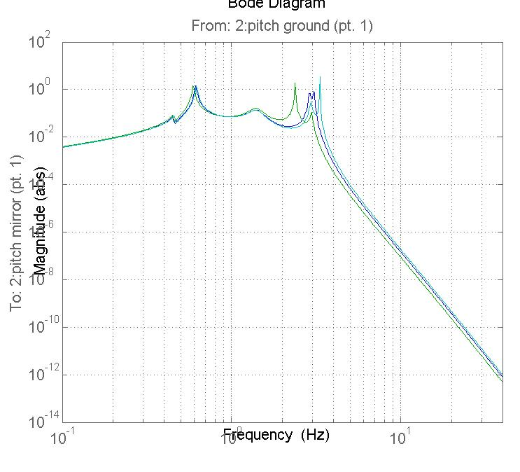

Figure 1. Pitch transfer functions for ERM chain (green and blue) and for thin CP chain (turquoise). Green : r3 = 0.2285 mm. Blue: r3 = 0.175 mm. Turquoise: r3 = 0.2285 mm.

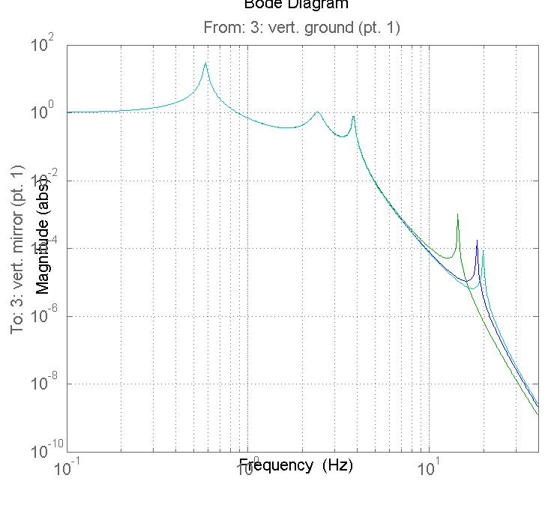

Figure 2. Vertical transfer functions for ERM chain (green and blue) and for thin CP chain (turquoise). Green : r3 = 0.2285 mm. Blue: r3 = 0.175 mm. Turquoise: r3 = 0.2285 mm.

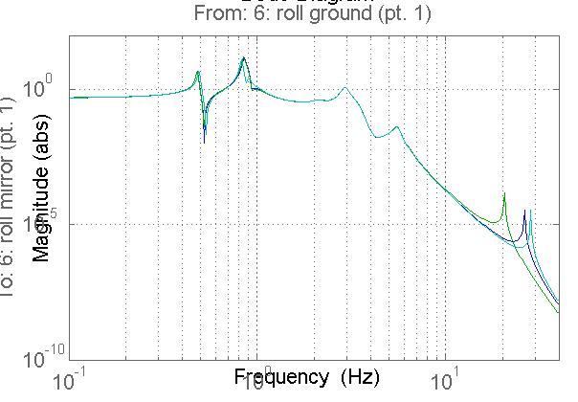
Figure 3. Roll transfer functions for ERM chain (green and blue) and for thin CP chain (turquoise). Green : r3 = 0.2285 mm. Blue: r3 = 0.175 mm. Turquoise: r3 = 0.2285 mm.

Appendix

Default parameters in T1000263 (set for noise prototype with silica fibres in final stage)

pend =

stage2: 1
ribbon: 0
g: 9.8100
nx: 0.1300
ny: 0.5000
nz: 0.0840
denn: 4000
mn: 22.1100
Inx: 0.4558
Iny: 0.0712
Inz: 0.4547
ux: 0.1300
uy: 0.5000
uz: 0.0840
den1: 4000
m1: 21.0110
I1x: 0.5174
I1y: 0.0598
I1z: 0.5205
ix: 0.2000
ir: 0.1700
if: 0.0950
den2: 2200
m2: 39.5696
I2x: 0.5666
I2y: 0.4204
I2z: 0.4101
tx: 0.2000
tr: 0.1700
tf: 0.0950
den3: 2200
m3: 39.5696
I3x: 0.5666
I3y: 0.4204
I3z: 0.4101
nwn: 2
nw1: 4
nw2: 4
nw3: 4
bd: 0
rn: 5.2000e-004
r1: 3.5000e-004
r2: 3.1000e-004
r3: 4.0000e-004
r3n: 4.0000e-004
r3m: 2.0000e-004
nl: 0.0150
Yn: 2.1200e+011
Y1: 2.1200e+011
Y2: 2.1200e+011
Y3: 7.2000e+010
twistlength: 0
d3tr: 1.0000e-003
d4tr: 1.0000e-003
sn: 0
su: 0.0030
si: 0.0030
sl: 0.0150
nn0: 0.2500
nn1: 0.0900
n0: 0.2000
n1: 0.0600
n2: 0.1400
n3: 0.1762
n4: 0.1712
n5: 0.1712
ln: 0.4486
l1: 0.3090
l2: 0.3327
l3: 0.6077
dm: -0.0031
dn: 0.0032
d0: -0.0017
d1: 0.0031
d2: 0.0072
d3: -0.0029
d4: -0.0029
mn3: 122.2602
m13: 100.1502
m23: 79.1392
tlnspec: 0.4160
tl1spec: 0.2770
tl2spec: 0.3410
tl3spec: 0.6020
kxn: 100000
kx1: 100000
kx2: 80000
dmspec: 1.0000e-003
dnspec: 1.0000e-003
d0spec: 1.0000e-003
d1spec: 1.0000e-003
d2spec: 0.0100
d3spec: 1.0000e-003
d4spec: 1.0000e-003
kcn: 1.6111e+003
kc1: 1.8114e+003
kc2: 2.6347e+003
kw3n: 4.8255e+006
kw3m: 3.1322e+004
kw3: 3.0921e+004
tln: 0.4160
tl1: 0.2770
tl2: 0.3410
tl3: 0.6020
Mn1: 5.7425e-014
M11: 1.1786e-014
M21: 7.2533e-015
M31: 2.0106e-014
M32: 2.0106e-014
flexn: 0.0041
flex1: 0.0027
flex2: 0.0028
flex3: 0.0039
ufcn: 1.9213
ufc1: 2.0899
ufc2: 1.8366
kwn: 4.0148e+005
kw1: 5.2808e+005
kw2: 3.8475e+005
l_suspoint_to_centreofoptic: 1.6360
l_suspoint_to_bottomofoptic: 1.8060
flex3tr: 0.0039
longpitch1: [0.4332 0.5193 0.9870 1.2331]
longpitch2: [1.5674 2.0072 2.9454 3.4189]
yaw: [0.5981 1.3452 2.4083 3.0462]
transroll1: [0.4625 0.8615 1.0442 2.1240]
transroll2: [2.6925 3.3254 5.0994 12.8743]
vertical: [0.5815 2.3386 3.7604 9.0024]

Note that sum of test mass (m3) and penultimate mass (m2 ) = 2 x 39.57 = 79.14 kg

A.1 End Reaction Mass
ERM mass (m3) = 25.97 kg (340 mm diameter by 130 mm thick silica)
Thus penultimate mass (m2) = 79.14 – 26.0 = 53.14 kg
m2 has been approximated below by a cylinder of same dimensions as the ERM and fictitious density, as given below.
ix: 0.1300
ir: 0.1700
den2: 4502
m2: 53.1369
I2x: 0.7678
I2y: 0.4587
I2z: 0.4587
tx: 0.1300
tr: 0.1700
den3: 2200
m3: 25.9665
I3x: 0.3752
I3y: 0.2242
I3z: 0.2242

Complete baseline parameter set is as below. Note that d3 and d4 are -1.0 mm, which are physical break-off values as noted by Joe Odell in email to NAR 28 May 2010, and taken from D060338-v1. These values are held constant in subsequent analyses.
r3 is set at 0.2285 mm, default value.

pend =

stage2: 1
ribbon: 0
g: 9.8100
nx: 0.1300
ny: 0.5000
nz: 0.0840
denn: 4000
mn: 22.1100
Inx: 0.4558
Iny: 0.0712
Inz: 0.4547
ux: 0.1300
uy: 0.5000
uz: 0.0840
den1: 4000
m1: 21.0110
I1x: 0.5174
I1y: 0.0598
I1z: 0.5205
ix: 0.1300
ir: 0.1700
if: 0.0950
den2: 4502
m2: 53.1369
I2x: 0.7678
I2y: 0.4587
I2z: 0.4587
tx: 0.1300
tr: 0.1700
tf: 0.0950
den3: 2200
m3: 25.9665
I3x: 0.3752
I3y: 0.2242
I3z: 0.2242
nwn: 2
nw1: 4
nw2: 4
nw3: 4
bd: 0
rn: 5.2000e-004
r1: 3.5000e-004
r2: 3.1000e-004
r3: 2.2850e-004
r3n: 2.2850e-004
r3m: 2.2850e-004
nl: 0.0150
Yn: 2.1200e+011
Y1: 2.1200e+011
Y2: 2.1200e+011
Y3: 2.1200e+011
twistlength: 0
d3tr: 1.0000e-003
d4tr: 1.0000e-003
sn: 0
su: 0.0030
si: 0.0030
sl: 0.0150
nn0: 0.2500
nn1: 0.0900
n0: 0.2000
n1: 0.0600
n2: 0.1400
n3: 0.1762
n4: 0.1712
n5: 0.1712
ln: 0.4486
l1: 0.3090
l2: 0.3327
l3: 0.6041
dm: -0.0031
dn: 0.0032
d0: -0.0017
d1: 0.0031
d2: 0.0072
d3: -0.0010
d4: -0.0010
mn3: 122.2245
m13: 100.1145
m23: 79.1035
tlnspec: 0.4160
tl1spec: 0.2770
tl2spec: 0.3410
tl3spec: 0.6020
kxn: 100000
kx1: 100000
kx2: 80000
dmspec: 1.0000e-003
dnspec: 1.0000e-003
d0spec: 1.0000e-003
d1spec: 1.0000e-003
d2spec: 0.0100
d3spec: 0.0016
d4spec: 0.0016
kcn: 1.6111e+003
kc1: 1.8114e+003
kc2: 2.6347e+003
kw3n: 4.6366e+006
kw3m: 1.2115e+005
kw3: 1.1514e+005
tln: 0.4160
tl1: 0.2770
tl2: 0.3410
tl3: 0.6020
Mn1: 5.7425e-014
M11: 1.1786e-014
M21: 7.2533e-015
M31: 2.1411e-015
M32: 2.1411e-015
flexn: 0.0041
flex1: 0.0027
flex2: 0.0028
flex3: 0.0027
ufcn: 1.9213
ufc1: 2.0899
ufc2: 1.5849
kwn: 4.0147e+005
kw1: 5.2808e+005
kw2: 3.8475e+005
l_suspoint_to_centreofoptic: 1.6360
l_suspoint_to_bottomofoptic: 1.8060
flex3tr: 0.0027
longpitch1: [0.4505 0.6128 0.8590 1.3716]
longpitch2: [1.9256 2.8707 3.0690 3.4091]
yaw: [0.6532 1.3450 2.3237 2.9966]
transroll1: [0.4804 0.8508 0.9096 2.0566]
transroll2: [2.7038 3.3251 5.0981 26.0771]
vertical: [0.5825 2.3494 3.7765 18.3095]

Parameter set for thinner wire (as highlighted)
pend =

stage2: 1
ribbon: 0
g: 9.8100
nx: 0.1300
ny: 0.5000
nz: 0.0840
denn: 4000
mn: 22.1100
Inx: 0.4558
Iny: 0.0712
Inz: 0.4547
ux: 0.1300
uy: 0.5000
uz: 0.0840
den1: 4000
m1: 21.0110
I1x: 0.5174
I1y: 0.0598
I1z: 0.5205
ix: 0.1300
ir: 0.1700
if: 0.0950
den2: 4502
m2: 53.1369
I2x: 0.7678
I2y: 0.4587
I2z: 0.4587
tx: 0.1300
tr: 0.1700
tf: 0.0950
den3: 2200
m3: 25.9665
I3x: 0.3752
I3y: 0.2242
I3z: 0.2242
nwn: 2
nw1: 4
nw2: 4
nw3: 4
bd: 0
rn: 5.2000e-004
r1: 3.5000e-004
r2: 3.1000e-004
r3: 1.7500e-004
r3n: 0.0022
r3m: 1.7500e-004
nl: 0.0150
Yn: 2.1200e+011
Y1: 2.1200e+011
Y2: 2.1200e+011
Y3: 2.1200e+011
twistlength: 0
d3tr: 1.0000e-003
d4tr: 1.0000e-003
sn: 0
su: 0.0030
si: 0.0030
sl: 0.0150
nn0: 0.2500
nn1: 0.0900
n0: 0.2000
n1: 0.0600
n2: 0.1400
n3: 0.1762
n4: 0.1712
n5: 0.1712
ln: 0.4486
l1: 0.3090
l2: 0.3327
l3: 0.6040
dm: -0.0031
dn: 0.0032
d0: -0.0017
d1: 0.0031
d2: 0.0072
d3: -0.0010
d4: -0.0010
mn3: 122.2245
m13: 100.1145
m23: 79.1035
tlnspec: 0.4160
tl1spec: 0.2770
tl2spec: 0.3410
tl3spec: 0.6020
kxn: 100000
kx1: 100000
kx2: 80000
dmspec: 1.0000e-003
dnspec: 1.0000e-003
d0spec: 1.0000e-003
d1spec: 1.0000e-003
d2spec: 0.0100
d3spec: 5.6000e-004
d4spec: 5.6000e-004
kcn: 1.6111e+003
kc1: 1.8114e+003
kc2: 2.6347e+003
kw3n: 4.2009e+008
kw3m: 7.1067e+004
kw3: 7.1043e+004
tln: 0.4160
tl1: 0.2770
tl2: 0.3410
tl3: 0.6020
Mn1: 5.7425e-014
M11: 1.1786e-014
M21: 7.2533e-015
M31: 7.3662e-016
M32: 7.3662e-016
flexn: 0.0041
flex1: 0.0027
flex2: 0.0028
flex3: 0.0016
ufcn: 1.9213
ufc1: 2.0899
ufc2: 1.5849
kwn: 4.0147e+005
kw1: 5.2808e+005
kw2: 3.8475e+005
l_suspoint_to_centreofoptic: 1.6360
l_suspoint_to_bottomofoptic: 1.8060
flex3tr: 0.0016
longpitch1: [0.4504 0.5930 0.8582 1.3646]
longpitch2: [1.9244 2.3692 2.9517 3.4088]
yaw: [0.6531 1.3431 2.3233 2.9965]
transroll1: [0.4803 0.8448 0.9095 2.0566]
transroll2: [2.7021 3.3241 5.0981 20.5003]
vertical: [0.5825 2.3485 3.7753 14.3941]

A.2 Compensator plate (thin version)
CP mass (m3 below) = 20.0 kg (340 mm diameter by 100 mm thick silica)
Thus penultimate mass (m2 below) = 79.14 – 20.0 = 59.14 kg
m2 has been approximated below by a cylinder of same dimensions as the ERM (and the original CP) and fictitious density, as given below.
ix: 0.1300
ir: 0.1700
den2: 5011
m2: 59.1447
I2x: 0.8546
I2y: 0.5106
I2z: 0.5106
tx: 0.1000
tr: 0.1700
den3: 2200
m3: 19.9742
I3x: 0.2886
I3y: 0.1610
I3z: 0.1610

Complete parameter set is as below. Note that d3 and d4 are -1.0 mm, which are physical break-off values as noted by Joe Odell in email to NAR 28 May 2010, and taken from D060338-v1. These values are held constant.
r3 is set at 0.2285 mm, default value.
pend =

stage2: 1
ribbon: 0
g: 9.8100
nx: 0.1300
ny: 0.5000
nz: 0.0840
denn: 4000
mn: 22.1100
Inx: 0.4558
Iny: 0.0712
Inz: 0.4547
ux: 0.1300
uy: 0.5000
uz: 0.0840
den1: 4000
m1: 21.0110
I1x: 0.5174
I1y: 0.0598
I1z: 0.5205
ix: 0.1300
ir: 0.1700
if: 0.0950
den2: 5011
m2: 59.1447
I2x: 0.8546
I2y: 0.5106
I2z: 0.5106
tx: 0.1000
tr: 0.1700
tf: 0.0950
den3: 2200
m3: 19.9742
I3x: 0.2886
I3y: 0.1610
I3z: 0.1610
nwn: 2
nw1: 4
nw2: 4
nw3: 4
bd: 0
rn: 5.2000e-004
r1: 3.5000e-004
r2: 3.1000e-004
r3: 2.2850e-004
r3n: 2.2850e-004
r3m: 2.2850e-004
nl: 0.0150
Yn: 2.1200e+011
Y1: 2.1200e+011
Y2: 2.1200e+011
Y3: 2.1200e+011
twistlength: 0
d3tr: 1.0000e-003
d4tr: 1.0000e-003
sn: 0
su: 0.0030
si: 0.0030
sl: 0.0150
nn0: 0.2500
nn1: 0.0900
n0: 0.2000
n1: 0.0600
n2: 0.1400
n3: 0.1762
n4: 0.1712
n5: 0.1712
ln: 0.4486
l1: 0.3090
l2: 0.3327
l3: 0.6041
dm: -0.0031
dn: 0.0032
d0: -0.0017
d1: 0.0031
d2: 0.0072
d3: -0.0010
d4: -0.0010
mn3: 122.2399
m13: 100.1299
m23: 79.1189
tlnspec: 0.4160
tl1spec: 0.2770
tl2spec: 0.3410
tl3spec: 0.6020
kxn: 100000
kx1: 100000
kx2: 80000
dmspec: 1.0000e-003
dnspec: 1.0000e-003
d0spec: 1.0000e-003
d1spec: 1.0000e-003
d2spec: 0.0100
d3spec: 0.0020
d4spec: 0.0020
kcn: 1.6111e+003
kc1: 1.8114e+003
kc2: 2.6347e+003
kw3n: 4.6366e+006
kw3m: 1.2115e+005
kw3: 1.1513e+005
tln: 0.4160
tl1: 0.2770
tl2: 0.3410
tl3: 0.6020
Mn1: 5.7425e-014
M11: 1.1786e-014
M21: 7.2533e-015
M31: 2.1411e-015
M32: 2.1411e-015
flexn: 0.0041
flex1: 0.0027
flex2: 0.0028
flex3: 0.0030
ufcn: 1.9213
ufc1: 2.0899
ufc2: 1.5023
kwn: 4.0147e+005
kw1: 5.2808e+005
kw2: 3.8475e+005
l_suspoint_to_centreofoptic: 1.6360
l_suspoint_to_bottomofoptic: 1.8060
flex3tr: 0.0030
longpitch1: [0.4589 0.6188 0.8090 1.3760]
longpitch2: [1.9046 2.9211 3.3219 3.4078]
yaw: [0.6655 1.3437 2.2629 2.9686]
transroll1: [0.4906 0.8249 0.8796 2.0383]
transroll2: [2.7045 3.3232 5.0981 28.1695]
vertical: [0.5825 2.3499 3.7772 19.7787]

