LIGO Laboratory / LIGO Scientific Collaboration

LIGO- E1000309 LIGO July 12th, 2011

aLIGO HAM-ISI, Pre-integration Testing procedure,
Phase I (post-assembly, before storage)
E1000309 – V9

Ben Abbott, Eric Allwine, Corey Gray, Celine Ramet, Michael Vargas
Vincent Lhuillier, Fabrice Matichard, Hugh Radkins, Jim Warner, Richard Mittleman

Distribution of this document:
Advanced LIGO Project

This is an internal working note
of the LIGO Laboratory

California Institute of Technology  LIGO Project – MS 18-34  1200 E. California Blvd.  Pasadena, CA 91125  Phone (626) 395-2129  Fax (626) 304-9834  E-mail: info@ligo.caltech.edu | Massachusetts Institute of Technology  LIGO Project – NW22-295  185 Albany St  Cambridge, MA 02139  Phone (617) 253-4824  Fax (617) 253-7014  E-mail: info@ligo.mit.edu
LIGO Hanford Observatory  P.O. Box 1970  Mail Stop S9-02  Richland WA 99352  Phone 509-372-8106  Fax 509-372-8137 | LIGO Livingston Observatory  P.O. Box 940  Livingston, LA 70754  Phone 225-686-3100  Fax 225-686-7189

Table of contents:

Introduction 4
I. Pre-Assembly Testing 5
▪ Step 1: Position Sensors 5
▪ Step 2: GS13 7
▪ Step 3: Actuators 7
II. Tests to be performed during assembly 8
▪ Step 1: Inventory (E1000052) 8
▪ Step 2: Check torques on all bolts 8
▪ Step 3: Check gaps under Support Posts 9
▪ Step 4: Pitchfork/Boxwork flatness before Optical Table install 10
▪ Step 5: Blade spring profile 11
▪ Step 6: Gap checks on actuators-after installation on Stage 1 12
▪ Step 7: Check level of Stage 0 13
▪ Step 8: Check level of Stage 1 Optical Table 14
▪ Step 9: Mass budget 15
▪ Step 10: Shim thickness 17
▪ Step 11: Lockers adjustment 17
III. Tests to be performed after assembly 19
▪ MEDM set-up for testing 19
▪ Step 1 - Electronics Inventory 20
▪ Step 2 - Set up sensors gap 21
▪ Step 3 - Measure the Sensor gap 23
▪ Step 4 - Check Sensor gaps after the platform release 24
▪ Step 5 – Performance of the limiter 25
▪ Step 5.1 - Test Nº1 - Push “in the general coordinates” 25
▪ Step 5.2 - Test Nº2 – Push “locally” 26
▪ Step 6 - Position Sensors unlocked/locked Power Spectrum 27
▪ Step 7 - GS13 power spectrum -tabled tilted 29
▪ Step 8- GS13 pressure readout 31
▪ Step 9 - Coil Driver, cabling and resistance check 32
▪ Step 10 - Actuators Sign and range of motion (Local drive) 34
▪ Step 11 - Vertical Sensor Calibration 35
▪ Step 12 - Vertical Spring Constant 37
▪ Step 13 - Static Testing (Tests in the local basis) 38
▪ Step 14 - Linearity test 40
▪ Step 15 - Cartesian Basis Static Testing 42
▪ Step 16- Frequency response 44
▪ Step 16.1 - Local to local measurements 47
▪ Step 16.2 - Cartesian to Cartesian measurements 48
▪ Step 17 - Transfer function comparison with Reference 51
▪ Step 17.1 - Local to local - Comparison with Reference 51
▪ Step 17.2 - Cartesian to Cartesian - Comparison with Reference 51
▪ Step 18 - Lower Zero Moment Plane 53
▪ Step 19 - Damping loops 55
▪ Step 19.1 - Transfer functions - Simulation 55
▪ Step 19.2 - Powerspectra – Experimental 57
Appendix A: Dial indicators location 59
Appendix B: Sensor calibration 61
Appendix C: SVN arborescence 62
Appendix D: Matrices 63

Introduction

The HAM-ISI testing will be made in three phase:
1) HAM-ISI, Pre-integration Testing, Phase I (post-assembly, before storage)
2) HAM-ISI, Pre-integration Testing, Phase II : Final tests done after storage and before insertion
3) HAM-ISI, Integration Phase Testing: Procedure and results related to the commissioning in the chamber.

This document describes the test to be done on the HAM-ISI Pre-integration Testing, Phase I. All the units have to be tested per this procedure prior storage. Due to the several procedure releases, each
Test reports must mentioned the procedure version used during testing.

Tests reports and results for each unit, including the data (one test report per HAM-ISI):
- E1000310, aLIGO HAM-ISI, Pre-integration Test Report, Phase I, LHO Unit #1.
- E1000311, aLIGO HAM-ISI, Pre-integration Test Report, Phase I, LHO Unit #2.
- E1000312, aLIGO HAM-ISI, Pre-integration Test Report, Phase I, LHO Unit #3.
- E1000313, aLIGO HAM-ISI, Pre-integration Test Report, Phase I, LHO Unit #4.
- E1000314, aLIGO HAM-ISI, Pre-integration Test Report, Phase I, LHO Unit #5.
- E1000323, aLIGO HAM-ISI, Pre-integration Test Report, Phase I, LHO Unit #6.
- E1000324, aLIGO HAM-ISI, Pre-integration Test Report, Phase I, LHO Unit #7.
- E1000325, aLIGO HAM-ISI, Pre-integration Test Report, Phase I, LLO Unit #1.
- E1000326, aLIGO HAM-ISI, Pre-integration Test Report, Phase I, LLO Unit #2.
- E1000327, aLIGO HAM-ISI, Pre-integration Test Report, Phase I, LLO Unit #3.
- E1000328, aLIGO HAM-ISI, Pre-integration Test Report, Phase I, LLO Unit #4.
- E1000329, aLIGO HAM-ISI, Pre-integration Test Report, Phase I, LLO Unit #5.
- E1000330, aLIGO HAM-ISI, Pre-integration Test Report, Phase I, LLO Unit #6.
- E1000331, aLIGO HAM-ISI, Pre-integration Test Report, Phase I, LLO Unit #7.

SVN
- Excell spreadsheet (.xls)
- SVN Masses distribution scheme (ppt)

DCC documents
- E1000300 HAM-ISI LLO test stand software check
- E1000052 aLIGO HAM-ISI Assembly Serial Number Registration
- T1100261 aLIGO SEI Testing, HAM-ISI, Weight Recording Example
- E1100427 aLIGO SEI Testing, HAM-ISI, Results Compilations

Notes:
- Useful information such as sign conventions or calibration numbers are highlighted in green.
- This is a living document. If you modifications or corrections are needed, they should be carried on, provided that their validity is checked.

Pre-Assembly Testing

Step 1: Position Sensors

Set up the offset on the jig. The test jig is shown on the picture below. Shim washers are used to set up the gap between the position sensor and the jig. A caliper is used to measure the jig cutout depth and the shims thickness.

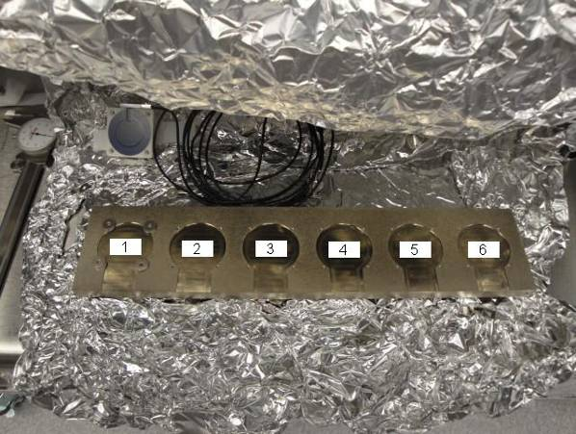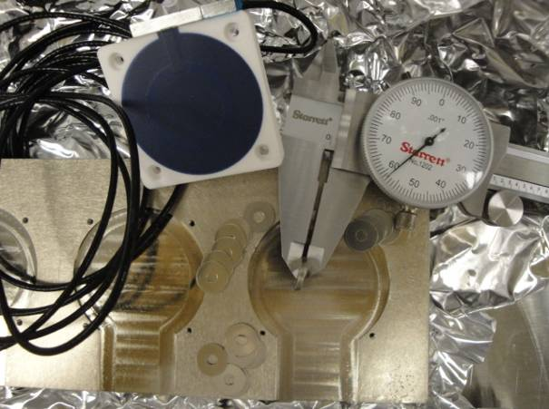

6 shims are measured at 0.058”. The cutout in the jig is 0.030” deep. The sensor extends out approximately 0.007” away from the surface where the shims are placed. So the gap is set up to be 0.081" nominal.
0.058"
Position sensors and shim washers prior installation:

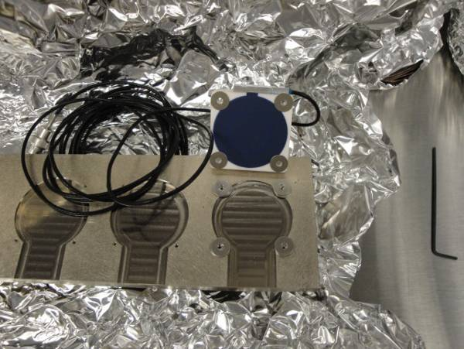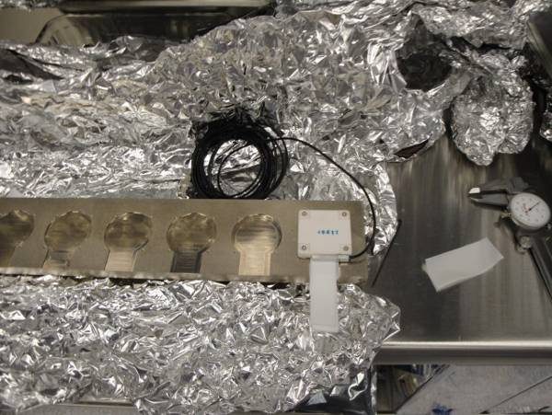

The displacement sensor mounted on the 6th spot of the test jig. Use teflon shims to check the gap:

1- Zeroing the offset of capacitive position sensors:
The range of the zeroing potentiometer is estimated to be + 5.5V and – 5.5V with a +-0.2V uncertainty from the differential outputs on the back of the satellite box. The counterclockwise rotation of the potentiometer was the direction most of the time it was turned when adjusted. So if the voltage read negative then the potentiometer was turned counterclockwise until the voltage was at about +-0.01V. Fill the table below.

S/N sensor | S/N board | ADE Gap Standoff(mm) | Location on the Jig | Gap Standoff on Jig(mm/in) | Voltage before zeroing | Voltage after zeroing. Prebake | Voltage after zeroing. Post bake
Table – Zeroing the offset of capacitive position sensors

The back panel reads 0.508V/0.001"

2- Measure power spectrum of the capacitive position sensor (V1/H1, V2/H2 and V3/H3) before baking.

Acceptance Criteria:
- Power spectrum magnitudes must be lower than:
  - 9.e-10 m/√Hz at 0.1Hz
  - 6.e-10 m/√Hz at 1Hz

The tests report must contain:
- The table “Zeroing the offset of capacitive position sensors”
- Capacitive position sensors powerspectra
- Issues/difficulties/comments regarding this test
- Recall of the acceptance criteria
- Test results (Passed: Failed: ).””

Step 2: GS13
All the data related to GS-13 post podding testing can be found in the SVN at : SeismicSVN\seismic\Common\Data\aLIGO_GS13_TestData\PostMod_TestResults_PDFs.

E1000058 spreadsheet provides the status of each individual GS-13 at LLO site during aLIGO HAM assembly

Acceptance Criteria:
- GS13 should have been already tested. GS-13 Inspection/Pod Assembly (D047810). Checklist is defined in F090070-v6

The tests report must contain:
- Test results (Passed: Failed: ).””

Step 3: Actuators
Actuator data can be found at: T0900564. Actuator inventory is made at Section II – Step 1.

Acceptance Criteria:
- Actuators were previously tested and results are reported in T900564.

The tests report must contain:
- Test results (Passed: Failed: ).””

Tests to be performed during assembly

Step 1: Inventory (E1000052)

DCC/Vendor number | Part name | Configuration | S/N | S/N | S/N
D071001 | Stage 0 base
D071051 | Stage 1 base
D071050 | Optical table
D071002 | Spring Post
D071100 | Spring
D071102 | Flexure
ADE | Position sensor | Horizontal
ADE | Position sensor | Vertical
D047812 | GS-13 pod | Horizontal
D047812 | GS-13 pod | Vertical
D047823 | L4C pod | Horizontal
D047823 | L4C pod | Vertical
D0902749 | Actuator | Horizontal
D0902749 | Actuator | Vertical

Step 2: Check torques on all bolts

Procedure to follow for this test:
After any bolt or bolt pattern is torque, check the torque by reapplying the torque wrench to the bolt. For bolt patterns, torque the whole group to final spec, then start the pattern over again. The wrench should trip, and then the bolt should start moving.

Acceptance Criteria:
- All bolts should trip the wrench, and start moving immediately after. If any bolts in a pattern move before torque is reached, recheck after all bolts are brought to spec.

The tests report must contain:
- Test result (Passed: Failed: ).””

Step 3: Check gaps under Support Posts

Procedure to follow for this test:
Try to push a 0.001 inch shim between the Support Post, Gussets and Stage 0 along the edges shown below.
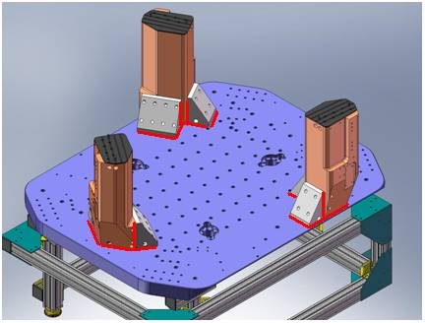
Figure - Showing edges that need checked on support posts and gussets

Acceptance Criteria:
- A 0.001 inch shim cannot be passed freely through any connection to Stage 0 or between post and gussets. If shim can pass through, loosen all constraining bolts, and then retighten iteratively from the center of the part to the edges. Retest.

The tests report must contain:
- Test result (Passed: Failed: ).””

Step 4: Pitchfork/Boxwork flatness before Optical Table install

Procedure to follow for this test:
- Lay a straight-edge on edge across top edge of each subassembly where wall pieces intersect
- Try to insert shims between parts

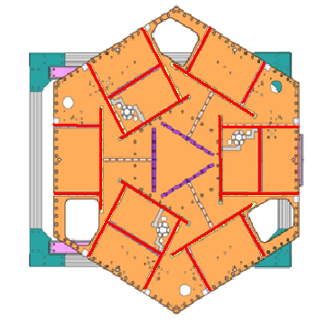
Figure - Showings that need check on Boxworks and Pitchforks

Acceptance Criteria:
- Shim inserted won’t pass between parts.

The tests report must contain:
- Test result (Passed: Failed: ).””

Step 5: Blade spring profile
Procedure to follow for this test:
1- Measure the blade profile with a plunge tip, or a depth gauge.

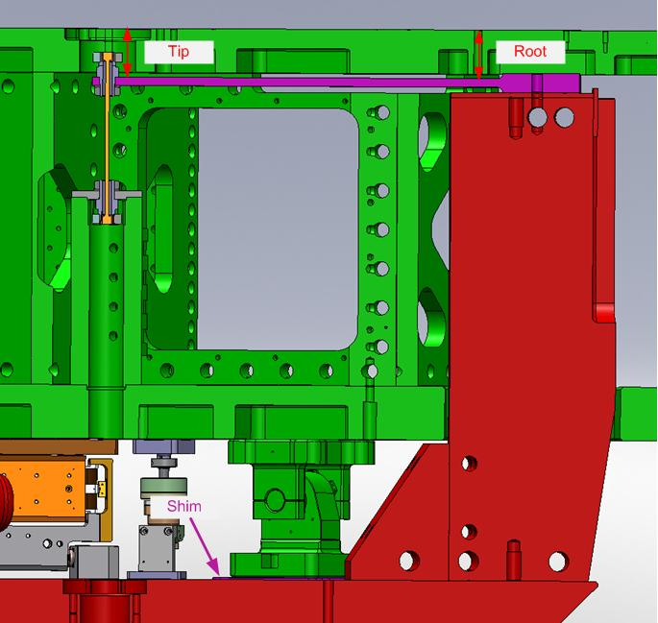

2- Fill the table below (nominal, if the distance is measured directly, is .149")

Blade # | Base (") | Tip(") | Flatness (mils)
1
2
3
Table – Blades profile

Note: Measurement is height below Optical Table top surface to contact the Spring below. Weight of the plunge micrometer is observed to lower the Stage1 by up to 0.002” which should reduce the Root number making the Spring Tip higher.

Note that the tip measurement should be constant and that root value can be impacted by shims change.

Acceptance Criteria:
- Blades must be flat within 0.015" inches.

The tests report must contain:
- The table “Blades’ profile”
- Issues/difficulties/comments regarding this test
- Test result (Passed: Failed: ).””

Step 6: Gap checks on actuators-after installation on Stage 1

Procedure to follow for this test:
After assembly use sized Teflon shims to measure gaps between stops and coils. Starting with 0.080”, adjust the stack height until the Teflon shims just barely pass freely between the coils and stops. Record the results
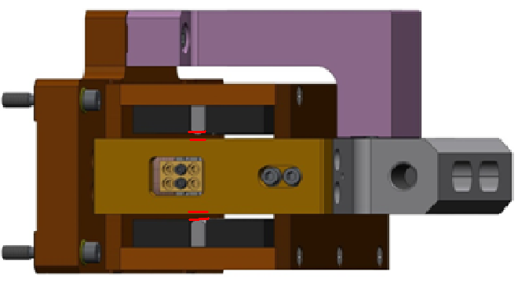
Figure - Showing gaps that need to be checked on actuators.

Issues/difficulties/comments regarding this test:

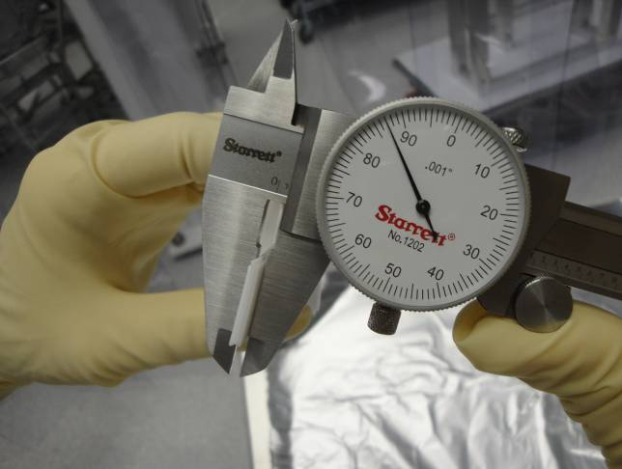
Figure - Stack of Teflon shims being measured for gap check of actuators.

Acceptance Criteria
- Gaps must be within 0.010” of design value (0.080”)

The tests report must contain:
- Test result (Passed: Failed: ).””

Step 7: Check level of Stage 0
Optical Level measurement of Stage 0 at large (12 - 15) number of points.

Procedure to follow for this test:
- Set up the Optical Level so that it has a good view of Stage 0.
- Ensure that the instrument is set up level and stable.
- Looking through the optical level record the height on the target (LHO’s shown below) of different points as evenly spaced as possible around Stage 0. It will be necessary to move the optical level to cover the whole assembly.
- After each move, check the heights of at least 2 previously measured points to control for the change in height at the new position. More overlap of measured points is better.

Note: The desired precision of these measurements is finer than that offered by most rulers, so it will be necessary to estimate from the optical level’s reticule relative to a convenient mark on the ruler.
Acceptance Criteria
- The maximum angle of the table with the horizontal mustn’t exceed ~100µrad

The tests report must contain:
- A schematic showing the measurements
- Tilt computation
- Issues/difficulties/comments regarding this test
- Test result (Passed: Failed: ).

Step 8: Check level of Stage 1 Optical Table
Optical Level measurement of Stage 1 at large (12 - 15) number of points.

Procedure to follow for this test:
- Same procedure as Stage 0

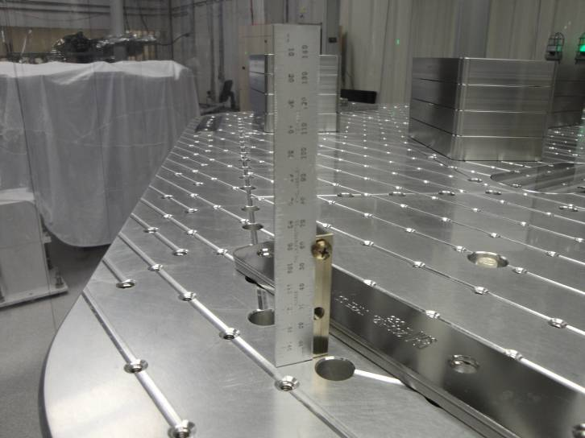
Figure – Checking level of stage 1 optical table

Acceptance Criteria
- The maximum angle of the table with the horizontal mustn’t exceed ~100µrad

The tests report must contain:
- A schematic showing the measurements
- Tilt computation
- Issues/difficulties/comments regarding this test
- Test result (Passed: Failed: ).

Step 9: Mass budget

Procedure to follow for this test:
- Record the amount of mass used for each location (Optical table, walls, keel) and report in a table like the following ones

 |  | Mass
 | Type | 00 | 01 | 02 | 03 | 04 | 05 | 06
 | Weight | 0.6 | 1.1 | 2.2 | 4.5 | 7.9 | 15.6 | 27.2 | lbs | kgs
Location | w1
Location | w2
Location | w3
Location | w4
Location | w5
Location | w6
Location | w7
Location | w8
Location | w9
Location | k1
Location | k2
Location | k3
Location | k4
Location | k5
Location | k6
Table – Wall masses and Keel masses distribution

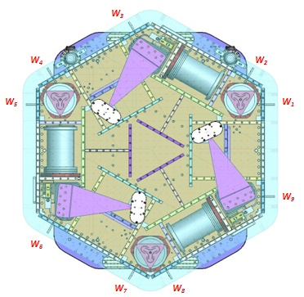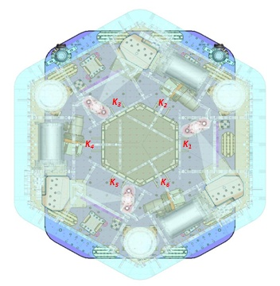
Figure – Keel Masses and Wall masses location

- Draw a map of masses distribution (a template can be found in on the SVN at /optseisvn/seismic/HAM-ISI/X1/Data/Unit_1/Report_Spreadsheets/
Masses_on_optic_table.pptx)
- Take a picture of the optic table
Here is an example with the HAM-ISI-LLO – unit#1
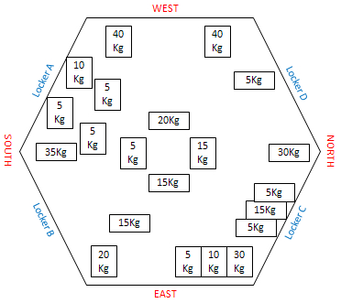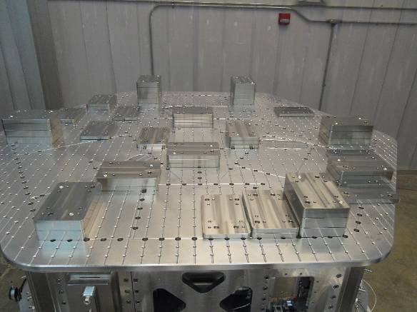

Figure - Masses distribution

 | Side | Keel | Optical  Table | Total
Weight (kg)
Torque x at O (N.m)
Torque y at O (N.m)
Table - Masses distribution (can be computed using T1100261)

Acceptance Criteria
The Mass budget must be
- 579.1 Kg (cf E1100427)+/-25Kg (5%)

The tests report must contain:
- The table “Masses distributions”
- The table “Wall masses and Keel masses distributions”
- Map or table of the mass location on the optic table
- Picture of the optic table
- Torque estimation
- Issues/difficulties/comments regarding this test
- Test result (Passed: Failed: ).

Step 10: Shim thickness
- Report the shim thickness of each lockers
Lockers | Shim thickness (mil)
A
B
C
D
Table – Shims Thickness
The tests report must contain:
- The table “Shim thickness”
- Issues/difficulties/comments regarding this test
- Test result (Passed: Failed: ).

Step 11: Lockers adjustment
The figure below presents location (more details in appendix 2) of dial indicators (yellow) and lockers (blues dots and blue lines). Vertical Dial indicator read negative for increasing height of Optical Table. Horizontal dial indicators depend on location. Lockers A & C read negative for +RZ rotation of Stage 1 relative to Stage 0. B & D read positive for +RZ rotation. When locking and unlocking the table, try to lock and unlock always the same way. For instance, lock ABCD and unlock DCBA.
Before the test, make sure that all masses are bolted to the optic table.
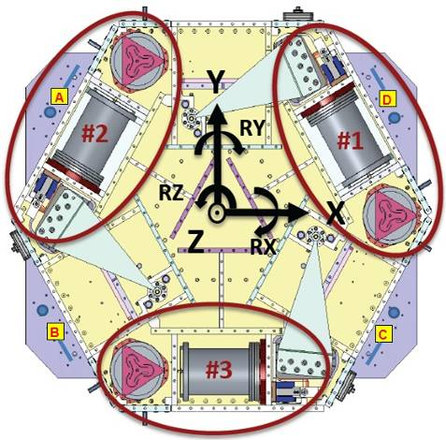
Figure - Top view of the HAM-ISI

Procedure to follow for this test:

Once the table is locked, dial indicators are set to zero and the table is released. In the table below reports the dial indicators evolution when unlocking the table. We consider the table centered when the difference doesn’t exceed 0.002”.

D.I at Lockers | Dial indicators V | Dial indicators H
A
B
C
D
Table – Dial indicators read-out (table locked-unlocked)

Acceptance Criteria
- Vertical and horizontal displacement near the lockers must be lower than 2 mils (0.002”)

The tests report must contain:
- The table “Dial indicators read-out (table locked-unlocked)”
- Issues/difficulties/comments regarding this test
- Test result (Passed: Failed: ).

Tests to be performed after assembly
This section describes the tests performed to check and validate the subassemblies and overall assembly good functioning. From step 8, data collected, Matlab scripts and figures, documentation have to be posted on the local copy of the SVN. Appendix 4 describes the path used to store data. X1 and X1 are respectively the Hanford and the Livingston test stand. In this procedure document, an example is given for the test realized on HAM-ISI-LHO-Unit1. SVN information that refers to sites, units and dates are colored in red (Scripts, data and figures names). Black is used for generic name.
It is good practice to run a "svn update" in all folders before starting work and finish the day with a "svn commit"!

MEDM set-up for testing

MEDM
- In MEDM open G1ISIHAM_HAM_OVERVIEW.adl at the following location : /rtcds/geo/g1/medm/g1isiham/G1ISIHAM_HAM_OVERVIEW.adl
- Edit the watchdog values with the parameters in the table below or upload with HAM_ISI_X1_Populate_All_Matrices.m

Upload Watchdog limit values
Watchdog values, base change matrices can be uploaded with: HAM_ISI_X1_Populate_All_Matrices.m in the SVN at ~/seisvn/seismic/HAM-ISI/X1/Scripts/

For testing, GS13 watchdog are set to 40000.

Watchdog | Limit (counts) | Safe Limit (counts)
STS | 20000 | 30000
GS13 | 40000 | 30000
CPS | 20000 | 30000
Actuators | 20000 | 30000
Table - Watchdogs set-up

Unless otherwise specified, all tests should be done without the dial indicators on.

Step 1 - Electronics Inventory
Write down serial number of coil driver, Anti aliasing chassis, Anti image chassis and interface chassis used for this test are listed below:

Hardware | LIGO reference | S/N
Coil driver | D0902744
Anti Image filter | D070081
Anti aliasing filter | D1000269
Interface chassis | D1000067
Table - Inventory electronics

Acceptance Criteria
- Inventory is complete

The tests report must contain:
- The table “Inventory electronics”
- Issues/difficulties/comments regarding this test
- Test result (Passed: Failed: ).

Step 2 - Set up sensors gap
During this step, sensors gap are adjusted.

Procedure to follow for this test:
- Lock the table
- Add 10 Kg masses at each corner (A, B, C ,D ,E, F)

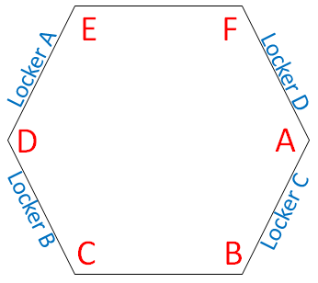
Figure – Corners location

- Pull up the capacitive position sensors (CPS) signals in a data viewer window
- Adjust the displacement sensor target position so that the collocated DISP channels readout fewer than 400 counts on Dataviewer (a bit less than .0005”).
- Lock the target
- Write down the mean values and standard deviation in the table below

Matlab script:
A matlab function called “Offset_STD_CPS_HAM_ISI.m” can be executed to get offsets and standard deviations of the CPS sensors. This function is located in the SVN at:
seisvn/seismic/HAM-ISI/X1/Scripts/Data_Collection/.

It computes the offset/STD at the execution time. The function waits for about 40 s before getting the results (30s are required before accessing the data from the frame builder). Column 1 of the table “Offset_STD_CPS” reports the offsets, column 2 reports the Standard deviations. Lines are the sensors (H1, H2, H3, V1, V2 and V3). The result table “Offset_STD_CPS” can be copied and pasted in the test report as it is. This function doesn’t save any .mat file.
Note that if results return artificial '0' counts on the last channels, you need to increase the allowed time in the “Offset_STD_CPS_HAM_ISI.m” script.
Notes:
- Before starting the gap set up, the targets are typically far from their target and consequently out of range. The signal should be +32000 counts. However, when the ADC saturates it can go to 0. The bottom line is that a 0 count signal doesn’t mean that the sensor is broken.
- When the target to sensor gaps gets larger, the MEDM count value increases (maximum gap is positive). When the target to sensor gaps gets smaller, the MEDM count value decreases (minimum gap is negative).

Table locked | ADE boxes on |  | ADE boxes on/off
Sensors | Offset (Mean) | Std deviation | Offset (Mean) | Std deviation
H1
H2
H3
V1
V2
V3
Table – Capacitive position sensor readout after gap set-up

Acceptance criteria:

- All mean values must be lower than 400 cts (a bit less than .0005”).
- All standard deviations below 5 counts.
- No cross talk

The tests report must contain:
- The table “Capacitive position sensors readout after gap set-up”
- Issues/difficulties/comments regarding this test
- Test result (Passed: Failed: ).

Step 3 - Measure the Sensor gap
The test verifies that sensors gap measured on the Jig doesn’t change after the assembly.

Procedure to follow for this test:
- Measure the gaps between probes and targets using Teflon shims on the Jig and once sensors have been installed on the table. Try to measure the gap at the edge of the sensor to avoid scratches on the target.
- Fill the table below.

Sensors | Gap measured on the Jig | Gap measured on the table | % of change | Offset sensors (counts)
H1
H2
H3
V1
V2
V3
Table - Measured sensors gap

Acceptance criteria:

Sensors gap measured on the jig and on the optic table must be:
- 0.080” +/-0.005”

The tests report must contain:
- The table “Measured sensors gap”
- Issues/difficulties/comments regarding this test
- Test result (Passed: Failed: ).

Step 4 - Check Sensor gaps after the platform release
During this test, the motion of the table between the locked and the unlocked position without dial indicators is evaluated.

Procedure to follow for this test:
- Remove dial indicators
- Pull up the CPS signals in a data viewer window or Matlab
- Lock the table
- Write down CPS mean values in the table below or use the Offset_STD_CPS_HAM_ISI.m matlab script
- Unlocked the table
- Write down CPS mean values in the table below or use the Offset_STD_CPS_HAM_ISI.m matlab scripts

 | Table locked |  | Table unlocked
Sensors | Offset (Mean) | Std deviation | Offset (Mean) | Diff unlocked - locked
H1
H2
H3
V1
V2
V3
Table – Sensors readout before and after optic table release

Acceptance criteria:

- Absolute values of the difference between the unlocked and the locked table must be below:
  - 1600 cts for horizontal sensors (~0.002”)
  - 1600 cts for vertical sensors (~0.002”)
- Considering the acceptance criteria of step 4, all mean values must be lower than
  - 2000 cts for horizontal sensors (~0.0025”)
  - 2000 cts for vertical sensors (~0.0025”)

The tests report must contain:
- The table “Sensors readout before and after optic table release”
- Issues/difficulties/comments regarding this test
- Test result (Passed: Failed: ).

Step 5 – Performance of the limiter
The two following tests enable to verify three points:
- Sensors signs
- Sensors range of measurement
- To double check the optical table range of motion

Step 5.1 - Test Nº1 - Push “in the general coordinates”
This test requires two persons in the clean room and one person in front of the computer.

Procedure to follow for this test:
- Unlock the optic table
- The two operator in the clean room push simultaneously on the optic table in the direction +Z or -Z or +RZ or -RZ until the table touches the lockers
- The operator in front of dataviewer write down the sensors readout when the table touches the lockers or runs the Offset_STD_CPS_HAM_ISI.m matlab script
- Report the sensor readout in the table “Optic table range of motion”

Vertical displacement sensors:
At each corner, push down gently (uniformly) on the optic table and watch the response in dataviewer. While pushing up/down, you have to make sure that the table is not rotating. All sensors should respond with the same sign. When the table is going down (-Z), the gap between the probe and the sensor decreases. Consequently vertical sensor readout is going in the negative direction. Push up/down until the optic table is in contact with the locker. Report the MEDM count values in the table below.
Horizontal displacement sensors:
At each corner, push the structure tangentially at the plane of the sensors in one direction. While rotating, you have to make sure that the table is not going up/down. All sensors should respond with the same sign. When the table is turning -RZ or clockwise (viewed from top), the gap between the probe and the sensor decreases. Consequently, horizontal sensor readout is going in the positive direction. Rotate until the optic table touches the locker. Report the MEDM count values in the table below.
 | CPS read out |  | Calculated after calibration
Sensors | UP (Counts) | Down (Counts) | UP (mil) | Down (mil)
V1
V2
V3
 | CPS read out |  | Calculated after calibration
Sensors | CW(-RZ) | CCW (+RZ) | CW (mil) | CCW (mil)
H1
H2
H3
Table - Optic table range of motion

Step 5.2 - Test Nº2 – Push “locally”
The main thing here is we want to make sure our Actuators & Sensors have zero chance of ever contacting (the lockers should always limit the Actuators/Sensors from closing their gaps).

Procedure to follow for this test:
- Apply manually a force collinear to the sensor axis you are testing (+ and - directions)
- For displacement sensors check
  - Move the table such that the target is as close as you can get it to the Sensor Head. This motion is monitored visually in dataviewer and Sensor counts are recorded.
  - Move the table such that the target is as far as you can get it to the Sensor Head. This motion is monitored visually in dataviewer and Sensor counts are recorded.
- For the Actuators, check all possible contacts point was a little tough. One person watches the Actuator while two people move the table in every direction possible. If there is no contact give the Actuator a positive “X”/PASS.

Displacement sensors and actuator gap check:

 | Push in positive direction  sensor readout (count) | Push in negative direction  Sensor readout (count) | Railing | Actuator Gap Check
H1
H2
H3
V1
V2
V3
Table - Sensors and Actuators gap check

Acceptance criteria:
- The vertical sensor readout be positive when the optic table is pushed in the +Z direction
- The horizontal sensor readout be negative when the optic table is pushed in the +RZ direction
- Step 7.1
  - Absolutes value of all estimated motions must be higher than 16000counts (~0.020”)
- Step 7.2
  - No contact point on sensors
  - Absolute value of sensor read out must be higher than 16000counts (~0.020”)
  - No contact point on actuators

The tests report must contain:
- The table “Optic table range of motion”
- The table “Sensors and actuators gap check”
- Issues/difficulties/comments regarding this test
- Test result (Passed: Failed: ).

Step 6 - Position Sensors unlocked/locked Power Spectrum
The following test verifies the functioning of Capacitive Position Sensors as well as the existence of crosstalk between sensors satellite boxes. The Pre-filter inputs channels (for example G1:ISI-HAM_DISPPF_H1_IN1_DAQ - G1:ISI-HAM_GEOPF_H1_IN1_DAQ) are recorded for these measurements. This test is performed with the table locked and unlocked.
At the same time, functioning of GS13 geophones is verified once they have been installed in the HAM-ISI. To perform this test, powerspectra are measured in different configurations (table locked and unlocked

1- Power spectra measurements are performed via Matlab with the following parameters:
- BW = 0.02Hz
- Averages = 50
- Overlap = 50%

2- The testing configurations are the followings:
- Satellite boxes 1 and 2 powered ON and synchronized
  - Table locked with an additional mass of 6x10 Kg on the top of the optic table
  - Table unlocked

Matlab script
A Matlab function is used to plot and calibrate the power spectra of the CPS and the geophones when the table is unlocked and locked. Powerspectra of the GS13 are reported in Step 9.1.
Follow the steps below:
- Write down the GPS Time when the table is unlocked and wait for 45 minutes
- Lock the table, write down the GPS Time and wait for 45 minutes
- Open the script Powerspectra_Measurements_Locked_Unlocked_HAM_ISI.m located in the SVN at seisvn/seismic/HAM-ISI/X1/Scripts/Data_Collection/.
- Edit GPS_TIME (unlocked, locked configuration), edit the location where the figures and the data will be saved (Save_Figure_Path and Save_Data_Path), Edit autosave_plot to 1.
- Run the script and paste the figure in report

Issues/difficulties/comments regarding this test: Capacitive sensors use electric field for sensing. When multiple, independent capacitive sensors are used simultaneously, the electric field from one probe may be trying to add charge to the target, while another sensor is trying to remove charge. This conflicting interaction with the target will create errors in the sensors’ outputs. This problem is easily solved by synchronizing the sensors. Synchronization sets the drive signal of all sensors to the same phase so that all probes are adding or removing charge simultaneously and the interference is eliminated. Interferences between ADE boxes can be roughly estimated by measuring standard deviation when one out of two satellite boxes is off.

Example of SVN path with HAM-ISI-LLO-Unit-1

Matlab
Data files in SVN at:
seisvn/seismic/HAM-ISI/X1/Data/Unit_1/ Powerspecta/Undamped
- LHO_HAM_ISI_Unit_1_Calibrated_PSD_CPS_GS13_Unlocked_Locked_YYYY_MM_DD.mat

Figures in SVN at:
seisvn/seismic/HAM-ISI/X1/Data/Unit_1/Figures/Powerspectra/Undamped
LHO_HAM_ISI_Unit_1_Calibrated_PSD_CPS_GS13_Unlocked_Locked_YYYY_MM_DD.fig

Acceptance criteria:
- No cross talk (peaks at low frequencies + harmonics on measurements)
- Magnitudes of power spectra must be between requirement curves such as in the following figures (dashed lines)

Sensors | ISI state | Frequency (Hz) | 2x10⁻² | 1x10⁻¹ | 1 | 10 | 20 | 100 | 1000
GS-13 | Table locked | Max | 3x10⁻¹ | 3x10⁻⁴ | 3x10⁻⁷ | 10⁻⁷ |  | 10⁻¹¹ | 10⁻¹⁴
GS-13 | Table locked | Min | 3x10⁻⁴ | 3x10⁻⁷ | 3x10⁻¹⁰ | 10⁻¹² |  | 10⁻¹⁴ | 10⁻¹⁷
GS-13 | Table unlocked | Max | 1 | 3x10⁻³ | 10⁻⁵ | 10⁻⁹ |  | 10⁻¹¹ | 10⁻¹⁴
GS-13 | Table unlocked | Min | 10⁻⁴ | 3x10⁻⁷ | 10⁻⁹ | 10⁻¹³ |  | 10⁻¹⁵ | 10⁻¹⁸
CPS | Table locked | Max | 2*10⁻⁷ | 2x10⁻⁸ | 10⁻⁸ | 5x10⁻⁸ | 2x10⁻⁷ | 5x10⁻⁹ | 10⁻⁹
CPS | Table locked | Min | 5x10⁻⁹ | 2x10⁻⁹ | 8x10⁻¹⁰ | 5x10⁻¹⁰ |  | 10⁻¹⁰ | 5x10⁻¹¹
CPS | Table unlocked | Max | 2x10⁻⁶ | 8x10⁻⁷ | 8x10⁻⁷ | 5x10⁻⁸ | 2x10⁻⁷ | 2x10⁻⁸ | 10⁻⁹
CPS | Table unlocked | Min | 10⁻⁷ | 5x10⁻⁸ | 8x10⁻⁹ | 5x10⁻¹⁰ |  | 2x10⁻¹⁰ | 10⁻¹⁰
Table - Step 6 -Normal conditions-Sensors powerspectra requirements

The tests report must contain:
- The calibrated powerspectra of capacitive position sensors
- SVN paths of
  - Data files (with date label)
  - Figures
- Issues/difficulties/comments regarding this test
- Test result (Passed: Failed: ).

Step 7 - GS13 power spectrum -tabled tilted
Functioning of the GS-13s in the full range of motion of the ISI is tested hereafter. Each corner of the table are successively grounded, and we measure power spectra in these various tilts positions. The Pre-filter output channels (for example G1:ISI-HAM_GEOPF_H1_IN1_DAQ) are recorded for these measurements.

1- This measurement is performed via Matlab with the following parameters:
- BW = 0.5Hz
- Averages = 50
- Overlap = 50%

2- The testing configurations are the followings:
- Table unlocked with a mass of 10 Kg at one corner of the optic table (1 mass at the time).

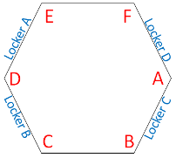
Figure – Corners location

Matlab
A Matlab function is used to plot the power spectra of the Geophones when the table is tilted.
Follow the steps below:
- Write down the GPS Time after placing the Mass at one corner.
- Wait for 120s.
- Proceed for every corner.
- Open the script Powersprectra_Measurements_Tilted_HAM_ISI.m located in the SVN at seisvn/seismic/HAM-ISI/X1/Scripts/Data_Collection/.
- Edit the GPS time for the different masses location and run the scripts. Edit the location where the figures and the data will be saved (Save_Figure_Path and Save_Data_Path), Edit autosave plot to 1)
- Run the script and paste the figure in the report

Matlab
Data files in SVN at:
seisvn/seismic/HAM-ISI/X1/Data/Unit_1/ Powerspectra/Undamped
- LHO_HAM_ISI_Unit_1_Calibrated_PSD_CPS_GS13_Tilted_YYYY_MM_DD.mat

Figures in SVN at:
seisvn/seismic/HAM-ISI/X1/Data/Unit_1/Figures/Powerspectra/Undamped
- LHO_HAM_ISI_Unit_1_Calibrated_PSD_CPS_GS13_Tilted_YYYY_MM_DD.fig

Acceptance criteria:
- With table unlocked and tilted, magnitudes of power spectra must be lower than:

Sensor | ISI State | Frequency | 5x10⁻¹ Hz | 1 | 10 | 100 | 1000
GS-13 | Table Tilted | Max | 2x10⁻⁻⁵ | 2x10⁻⁻⁶ | 8x10⁻⁸ | 4x10⁻¹¹ | 3x10⁻¹⁴
GS-13 | Table Tilted | Min | 10⁻⁸ | 10⁻⁹ | 2x10⁻¹¹ | 10⁻¹⁴ | 10⁻¹⁷
Table - Table Tilted- Sensors powerspectra requirements

The tests report must contain:
- The calibrated powerspectra of geophones
  - When the table is locked
  - When the table is unlocked
  - When the table is unlocked with a mass at one corner (A, B, C, D, E, F)
- SVN paths of
  - Data files (with date label)
  - Script file use for calibration (with date-label)
  - Figures
- Issues/difficulties/comments regarding this test
4- Test result (Passed: Failed: )
.

Step 8- GS13 pressure readout
During this test, the pressure sensors of the 6 GS13s is checked using a Matlab function gs13PressTest. These plots should be as long as possible (i.e. as long as the ISI is connected to the test stand)

The function is called as follows

gs13Presstest(GPS starting time, Measure duration given in seconds,
{'G1:ISI-HAM_PRESSMON_GEO_H1_IN1_DAQ.mean';
'G1:ISI-HAM_PRESSMON_GEO_H2_IN1_DAQ.mean';
'G1:ISI-HAM_PRESSMON_GEO_H3_IN1_DAQ.mean';
'G1:ISI-HAM_PRESSMON_GEO_V1_IN1_DAQ.mean';
'G1:ISI-HAM_PRESSMON_GEO_V2_IN1_DAQ.mean'
'G1:ISI-HAM_PRESSMON_GEO_V3_IN1_DAQ.mean'},Boolean indicating whether the plot should be saved or not)

Acceptance criteria:

- The pressure on all channels must be 25000 counts +/- 3000 counts
- All channels must follow comparable trend

The tests report must contain:
- The plot
- Test result (Passed: Failed: ).

Step 9 - Coil Driver, cabling and resistance check
Before driving actuators, a few tests have to be carried out to check for shorts.

On the actuator cable (vacuum side of the feedthrough)
The actuator cable is a three pin cables. All three pins are connected to a voltage drive, even though only two pins are used to drive actuators.
Pins are connected such as:
- Pin #1 (left pin in view below) is neutral return
- Pin #2 (middle pin) is the drive pin
- Pin #3 (right pin) is shield ground.

Make sure the shield ground is not connected to the middle pin of the plug. If not, swap middle pin with pin #3.

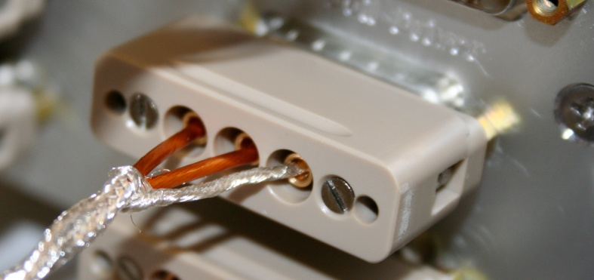
Figure – Actuator cable plugged on the feedthrough

Procedure to follow for this test:
- Turn coil Driver (D0902744) OFF
- Disconnect the actuator cable at the back side of the coil driver
- Measure the resistance between the side pins and the middle pin of the actuator cable
- Turn D0902744 ON and make sure all LEDs on the front panel are green
- Measure the coil driver output for a 1000 counts offset drive (if no voltage, check the anti-image pin)
- Reconnect actuator cable to the coil driver

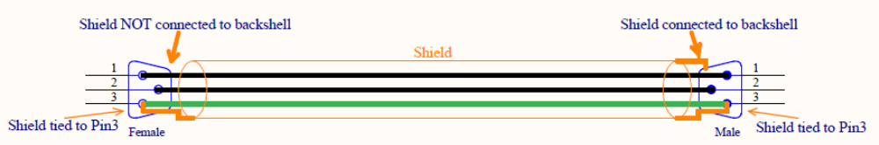
Figure – Actuator cable between feedthrough and test rack

Actuator | V1 |  | H1 |  | V2
Coil driver
Anti image pin # | 1 |  | 2 |  | 3
Cable #
Resistance  (Ohm) | P1 - P2 | P2 - P3 | P1 - P2 | P2 - P3 | P1 - P2 | P2 - P3
MEDM offset  (1000 counts) | Measurement P2 (-) ; P1&P3 (+) |  | Measurement P2 (-) ; P1&P3 (+) |  | Measurement P2 (-) ; P1&P3 (+)
Actuator | H2 |  | V3 |  | H3
Coil driver
Anti image pin # | 4 |  | 5 |  | 6
Cable #
Resistance  (Ohm) | P1 - P2 | P2 - P3 | P1 - P2 | P2 - P3 | P1 - P2 | P2 - P3
MEDM offset  (1000 counts) | Measurement P2 (-) ; P1&P3 (+) |  | Measurement P2 (-) ; P1&P3 (+) |  | Measurement P2 (-) ; P1&P3 (+)
Table - Actuators resistance check

Acceptance criteria:

- The measured resistance between the middle pin and one side pin must be 6.5 +/-1 ohms
- Actuator neutral pins must be connected on pin #1 (left side pin of the plug)
- Actuator drive pins must be connected on pin #2 (middle pin of the plug)
- Actuator ground shield pins must be connected on pin #3 (right pin of the plug)
- All LEDs on the coil driver front panel must be green

The tests report must contain:
- The table “Actuators resistance check”
- Issues/difficulties/comments regarding this test
- Test result (Passed: Failed: ).

Step 10 - Actuators Sign and range of motion (Local drive)
In this step, actuators signs are verified and the range of motion is measured when the table is moved by actuators.

In this step, the range of motion of the optic table is checked when applying a local drive on actuators.

Matlab
A Matlab function is used to execute the “Range of motion – Local drive test”
Follow the steps below:
- Open the Matlab script Range_Motion_HAM_ISI.m located in the SVN at seisvn/seismic/HAM-ISI/X1/Scripts/Data_Collection/
- Edit the data name (LHO_HAM_ISI_Unit_1_Range_Of_Motion_Date), edit the path (seisvn/seismic/HAM-ISI/X1/Data/Unit_1/Static_Tests)
- Copy and paste the table in the test report as it is

Range_Motion_HAM_ISI.m drives a +/-30000 counts offset in a single actuator and get the Local CPS readouts.

 | Negative drive | Positive drive
H1 readout (count)
H2 readout (count)
H3 readout (count)
V1 readout (count)
V2 readout (count)
V3 readout (count)
Table - Range of motion - Local drive

Acceptance criteria:

- Main couplings sensors readout must be at least 16000 counts (~0.02”)
- A positive offset drive on one actuator must give positive sensor readout on the collocated sensor. Signs will also be tested when measuring local to local transfer functions.

Note that if a positive offset drive does not give a positive sensor offset, this can be corrected as follows
  - turn D0902744 OFF, swap pin #1 (not the shield ground) with the middle pin (pin #2) on the accuglass cable
  - Turn D0902744 ON
  - Retest

The tests report must contain:
- The table “Range of motion-Local drive”
- Issues/difficulties/comments regarding this test
- Test result (Passed: Failed: ).

Step 11 - Vertical Sensor Calibration
During this test, the vertical sensitivity of the position sensors is measured.

Procedure to follow for this test:
- Install exclusively vertical dial indicators as described in appendix and set to zero when the table is unlocked
- Set actuators watchdog to 25000counts
- In the Isolation filters bank
  - Set the gain to 0 on Z direction
  - Set the ramp time to 20s
  - Set a 10000 counts offset on Z direction
  - Change the gain to 6
- When driving, make sure there is no contact between the table and the lockers. If the table is touching, reduce offset.
- Write down dial indicators and position sensors mean values
- Drive a negative offset on all vertical actuators (make sure there is no contact between the table and the lockers)
- Write down dial indicators and position sensors mean value
- Compute sensitivity using ADC calibration:
2¹⁵ Count/20V = 32768 Count/20 V = 1638 Count/Volt
- Reset the actuators watchdog at 20000counts

D.I at Lockers | D.I readout with for  a negative drive | D.I readout without any drive | D.I readout with for  a positive drive
A
B
C
D
Average
Sensors | Read out (Counts) | Readout (Counts) | Readout (Counts) | Difference (Counts)
V1
V2
V3
 |  |  | Average
Table - Calibration of capacitive position sensors

Vertical sensitivity: / = count/mil
or count/mil * 1/ 1638V/count = V/mil
or 25400nm/mil * 1/ mil/count = nm/count
Nominal Calibration

CPS Sensitivity: 20V/0.039" = 20V/39mils = 0.513V/mil

Calibration in counts: 2¹⁵ / 20 * 20/39 = 840 count/mil
or 25400 nm/mil * 1/840 mil/count = 30.2nm/count

Change = (Calibration measured-840)/840=%

Acceptance criteria:

- Deviation from nominal value < 2%. Nominal value is 840 count/mil.

The tests report must contain:
- The table “Calibration of capacitive position sensors”
- Fill vertical sensibility values
- Issues/difficulties/comments regarding this test
- Test result (Passed: Failed: ).

Step 12 - Vertical Spring Constant
This test verifies the vertical spring constant. The procedure is detailed below:
- Remove dial indicators
- Write down initial position of the unlocked table given by position sensors
- Place calibrated weights (3 x 2Kg) at various positions on Stage. The masses must be placed at equal radii from the center of Stage 1, at symmetric angles around the table. If possible, use the hatches as reference points. (A,B,C)
- Measure displacements with position sensors after loading a total of 6 Kg. Make sure the optic table is not touching the lockers
- Repeat the measurement after swapping masses (A,B,C=>B,C,A=>C,A,B)
- After averaging, fill the table below
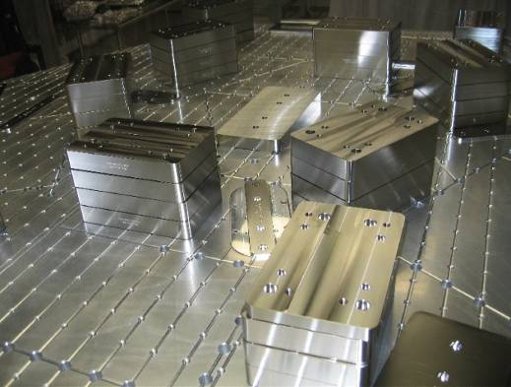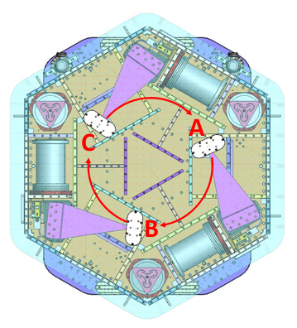
Figure – Vertical spring constant measurement – Hatches as reference points

Results presented below are obtained after the initial sensors calibration.

Sensors | Mean diff counts | Mean diff m | K (N/m) | Error with average
V1
V2
V3
 |  | Average (N/m)
 |  | Total Stiffness (N/m)

Table - Vertical spring constant

Acceptance criteria:
- +/-2 % of 2.4704e5 N/m (i.e. between 2.421e5 and 2.520e5 N/m)
- +/- 5% of variation between each spring and the average

The tests report must contain:
- The table “Vertical spring constant”
- Issues/difficulties/comments regarding this test
- Test result (Passed: Failed: ).

Step 13 - Static Testing (Tests in the local basis)
This test verifies three points:
- Actuators-sensors readout chains
- Static main coupling and cross coupling
- Actuator power (driving signal and actuator response)

Matlab
A Matlab function is used to execute the “Static Testing (Tests in the local basis)”
Follow the steps below:
- Open the Matlab script Sensor_Readout_Local_Drive_MEDM_HAM_ISI.m located in the SVN at seisvn/seismic/HAM-ISI/X1/Scripts/Data_Collection/
- Edit the data name (LHO_HAM_ISI_Unit_1_Offset_Local_Drive_Date), edit the path (seisvn/seismic/HAM-ISI/X1/Data/Unit_1/Static_Tests)
- Copy and paste the table in the test report as it is

Sensor_Readout_Local_Drive_MEDM_HAM_ISI.m drives a 1000 counts positive offset on the local actuators and reads all the CPS sensors.

Vertical actuators
A positive offset drive on one vertical actuator creates a positive offset readout on the collocated sensor and a negative offsets readout on other vertical sensors. For a 1000 counts positive offset drive on vertical actuators, the collocated sensor readout should be about 1400 counts.

Horizontal actuators
A positive offset on one horizontal actuator drive creates a positive offset readout on every horizontal sensor. For a 1000 counts positive offset on horizontal actuators, the collocated sensor readout should be about 2000 counts and about 1250 counts on the other horizontal sensors.

 |  | Sensors (counts)
 |  | H1 | H2 |  | H3 |  | V1 |  | V2 |  | V3
Actuators  (1000 counts) | H1
Actuators  (1000 counts) | H2
Actuators  (1000 counts) | H3
Actuators  (1000 counts) | V1
Actuators  (1000 counts) | V2
Actuators  (1000 counts) | V3
 | Main coupling
 | Important cross coupling

Table - Main and cross coupling - Static

Acceptance criteria:

- Vertical
For a +1000 count offset drive on vertical actuators
  - Collocated sensors must be 1400 counts +/- 10%

- Horizontal
For a +1000 count offset drive on horizontal actuators
  - Collocated sensors must be 2000 counts +/- 10%
  - Non-collocated horizontal sensors must be 1250 counts +/-10%

The tests report must contain:
- The table “Main and cross coupling -Static”
- Issues/difficulties/comments regarding this test
- Test result (Passed: Failed: ).

Step 14 - Linearity test
The linearity of the triplet Actuators-HAM-sensors is evaluated during the following test.

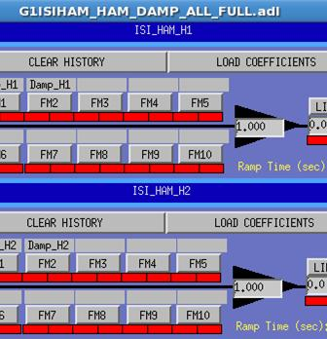
Figure – State of the damp MEDM screen- All gains must be set to 1!

Matlab
A Matlab function is used to execute the “Linearity Test”
Follow the steps below:
- Open the Matlab script Linearity_Test_Awgstream_HAM_ISI.m located in the SVN at seisvn/seismic/HAM-ISI/X1/Scripts/Data_Collection/
- Edit the data name (LHO_HAM_ISI_Unit_1_Linearity_Test_Date), edit the data path (seisvn/seismic/HAM-ISI/X1/Data/Unit_1/Linearity_Test) and the figure path
- Copy and paste the table Slopes_Offset in the test report as it is
- Paste the figure in the report

Linearity_Test_Awgstream_HAM_ISI.m performs the linearity Test. It plots the linearity test and computes the slopes)
Plot_linearity_Test.m (This script enables to replot the linearity test)

Report slopes in this table

 | Slope | Offset | Average slope | Variation from  average(%)
H1
H2
H3
V1
V2
V3
Table - Slopes and offset of the triplet Actuators - HAM-ISI - Sensors

Acceptance criteria:

- Horizontal and vertical slopes of the triplet actuators x HAM-ISI x sensors: Average slope +/- 1%

The tests report must contain:
- The table “Linearity of the triplet Actuators – HAM – ISI - Sensors”
- The table “Slopes and offsett of the triplet Actuators – HAM – ISI - Sensors”
- Figures that shows linearity on vertical and horizontal axis
- Issues/difficulties/comments regarding this test
- Test result (Passed: Failed: ).

Step 15 - Cartesian Basis Static Testing
During this step, change of basis matrices uploaded prior to start testing are checked. These matrices are given in Appendix D and can be loaded with HAM_ISI_X1_Populate_All_Matrices.m in the SVN at :
~/seisvn/seismic/HAM-ISI/Common/Basis_Change_Matrices/

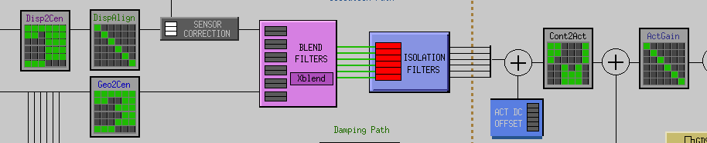
Figure – Matrices are filled

The electronic compensation filters and matrices defined in Appendix D should be on at this point!

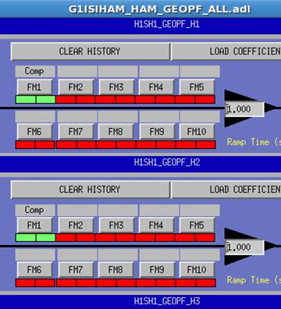
Figure – State of the Geophone readout MEDM screen: compensation filters need to be ON!

DISP2CEN and CONT2ACT signs are checked through a static test. GEO2CEN sign is later tested with a transfer functions measurements.

Test conditions
- Once populated, test the matrices by performing the following test
  - Drive a 1000 counts positive offset in one direction by using the isolation filter bank (MEDM – ISI_HAM_CONT_Direction)
  - Write down CPS readout (relative) in the table below
  - Write down sensor readout in the general direction in the table below
  - Compare signs with reference table

Matlab
A Matlab function is used to execute the “Static Testing (Tests in the Cartesian basis)”
Follow the steps below:
- Open the Matlab script Sensor_Readout_Cartesian_Drive_MEDM_HAM_ISI.m located in the SVN at seisvn/seismic/HAM-ISI/X1/Scripts/Data_Collection/
- Edit the data name (LHO_HAM-ISI_Unit_1_Cartesian_Drive_Date), edit the path (seisvn/seismic/HAM-ISI/X1/Data/Unit_1/Static_Tests)
- Copy and paste the table in the test report as it is

Sensor_Readout_Offset_Cartesian_Drive_MEDM_HAM_ISI.m drives a 1000 counts positive offset on the local actuators and reads all the CPS sensors.

 | 1000 counts Drive | X Drive | Y Drive | Z Drive | Rx Drive | Ry Drive | Rz Drive
Sensors readout  (count) | H1
Sensors readout  (count) | H2
Sensors readout  (count) | H3
Sensors readout  (count) | V1
Sensors readout  (count) | V2
Sensors readout  (count) | V3
Sensors readout  (count) | Direction read out
Table - Tests in the general coordinate basis

 |  | X Drive | Y Drive | Z Drive | Rx Drive | Ry Drive | Rz Drive
Sensors readout  (count) | H1 | + | - |  |  |  | -
Sensors readout  (count) | H2 | + | + |  |  |  | -
Sensors readout  (count) | H3 | - | 0 |  |  |  | -
Sensors readout  (count) | V1 |  |  | + | - | -
Sensors readout  (count) | V2 |  |  | + | + | +
Sensors readout  (count) | V3 |  |  | + | - | +
Sensors readout  (count) | Direction read out | + | + | + | + | + | +

Table – Reference table

Acceptance criteria:

For a positive drive in the Cartesian basis:
- Local sensor readout must have the same sign that the reference table (CONT2ACT check)
- Cartesian sensors read out must be positive (DISP2CEN check) in the drive direction

The tests report must contain:
- The table “Tests in the general coordinate basis”
- If signs issues – report CONTACT and DISP2CEN used for this test
- Issues/difficulties/comments regarding this test
- Test result (Passed: Failed: ).

Step 16- Frequency response
Transfer functions are measured via Matlab and awgstream. Measurements are launched with Run_Exc_Batch_X1_HAM_ISI and processed with Run_Get_Batch_X1_HAM_ISI. Run_Exc_Batch_X1_HAM_ISI calls Run_TF_L2L_XX or Run_TF_C2C_XX functions to start excitations. It creates the excitation file and the batch_file. The batch file is an “exchange file” that is read by Run_Get_Batch_X1_HAM_ISI. It carries general information such as data locations, data names, response channels, etc… The excitation file contains more specific data such as the excitation signals, GPS start time, frequency resolution, etc… Transfer functions are computed by Run_Get_Batch_X1_HAM_ISI and results are saved in structure file (1 per section).

In Run_Exc_Batch_X1_HAM_ISI and Run_Get_Batch_X1_HAM_ISI, locations of the data and the batch file (current + archive) have to be specified. Site, Unit, State (Undamped, Damped, Isolated …) must be edited. Date is automatically added.

Note 1: The batch_file is erased at every new set of measurements. If the batch file has been overwritten, Run_get_batch_retrieve can be used to compute transfer functions. In that case, the batch_file_archive name must be edited in Run_get_batch_retrieve.

Note 2: The identification scripts calls the Schroeder phase scripts that are common to every subsystem (BSC-ISI, HAM-ISI, HEPI-BSC, HEPI-HAM). These scripts are located at the top of the SVN arborescence (svncommon/seisvn/seismic/Common/MatlabTools/Schroeder_Phase_Scripts)

Scripts used at LASTI to measure transfer functions are located in the SVN at:
seisvn/seismic/HAM-ISI/X1/Scripts/Data_Collection
- Run_Exc_Batch_X1_HAM_ISI.m
- Run_Get_Batch_X1_HAM_ISI.m
- Run_Get_Batch_Retrieve_X1_HAM_ISI.m
- Run_TF_L2L_10mHz_100mHz.m
- Run_TF_L2L_100mHz_1Hz.m
- Run_TF_L2L_1Hz_10Hz.m
- Run_TF_L2L_10Hz_100Hz.m
- Run_TF_L2L_100Hz_1000Hz.m
- HAM_ISI_ exc_chan_list.m
- HAM_ISI_ resp_chan_list.m

Batch_file location is specific for each Unit.
For instance, /seisvn/seismic/HAM-ISI/X1/Data/Transfer_Functions/Measurements and the archived batch file at /seisvn/seismic/HAM-ISI/X1/Data/Transfer_Functions/Measurements/Batch_file-Archive

Local to local and Cartesian to Cartesian transfer functions are measured between 0.05Hz and 800Hz (4 sections: 50mHz to 500mHz; 500mHz to 5Hz; 5Hz to 200Hz; 200mHz to 800Hz).

Batch Files are located in SVN at:
seisvn/seismic/HAM-ISI/X1/Data/Unit_1/Transfer_Functions/Measurements/

Run_Exc_bactch.m calls Data collection script files to start excitation.

Data collection script files in the SVN at:
seisvn/seismic/HAM-ISI/X1/Scripts/Data_Collection
- Run_TF_L2L_50mHz_500mHz.m
- Run_TF_L2L_500mHz_5Hz.m
- Run_TF_L2L_5mHz_200Hz.m
- Run_TF_L2L_200Hz_800Hz.m
- Run_TF_C2C_50mHz_500mHz.m
- Run_TF_C2C_500mHz_5Hz.m
- Run_TF_C2C_5mHz_200Hz.m
- Run_TF_C2C_200Hz_800Hz.m
- Run_TF_C2C_10mHz_100mHz_LZMP.m

Depending on the type of measurements, the excitation list and the response channels list defer. Several channel lists have been defined.

Excitation channels and response channels list in the SVN at:
seisvn/seismic/HAM-ISI/X1/Scripts/Schroeder_Phase_Scripts
- HAM_ISI_exc_chan_list.m (Drive_List=1 for local to local - Drive_List=2 for Cartesian to Cartesian – Type=3 for LZMP)
- HAM_ISI_resp_chan_list.m (Channels_List=1 for local to local – Channels_List =2 Cartesian to Cartesian)

The table below presents the convention chosen for the excitation channels lists (type 1, 2, 3)

 | # | 1 | 2 | 3 | 4 | 5 | 6
type = 1 | Actuator | H1 | H2 | H3 | V1 | V2 | V3
type = 2 | Actuator | X | Y | RZ | Z | RX | RY
type = 3 | Actuator | X | Y
Table – Excitation list

The table below presents the convention chosen for the response channels lists (type 1, 2)

 | # | 1 | 2 | 3 | 4 | 5 | 6 | 7 | 8 | 9 | 10 | 11 | 12
resplist = 1 | Actuator | CPS  H1 | CPS  H2 | CPS  H3 | CPS  V1 | CPS  V2 | CPS  V3 | GS13  H1 | GS13  H2 | GS13  H3 | GS13  V1 | GS13  V2 | GS13  V3
resplist = 2 | Actuator | CPS  X | CPS  Y | CPS  RZ | CPS  Z | CPS  RX | CPS  RY | GS13  X | GS13  Y | GS13  RZ | GS13  Z | GS13  RX | GS13  RY
Table – Response channel list

Parameters to define before starting measurements
- Define/Check autosave path (X1 or X1) in Run_Exc_Batch_X1_HAM_ISI.m and Run_Get_Batch_X1_HAM_ISI.m
- Define/Check autosave name in Data collection scripts
- Add/Edit comments (date - configuration – Number of repetitions)
- Folders in which the data are stored must be created.

How to use Run_Exc_Batch_X1_HAM_ISI.m and Run_Exc_Batch_X1_HAM_ISI.m?
- Open one matlab session and run “Run_Exc_Batch_X1_HAM_ISI.m”. This script creates a batch_file (in Data/Transfer Functions), start excitations and store excitation files stored in Data/Transfer Functions/Measurements/Subfolder (Subfolder can be Undamped, Damping, Isolation, Super Sensors)
- Run_Get_Batch_X1_HAM_ISI reads the batch file and computes transfer functions section by section and stored results in one of the subfolder mentioned above.
- Once Run_Exc_Batch_X1_HAM_ISI is done and Run_Get_Batch_X1_HAM_ISI is waiting for new results, kill Run_Exc_Batch_X1_HAM_ISI.m with a “Ctrl + C” in Matlab command window.
- The number of repetition for measurement is defined in Run_Exc_Batch_X1_HAM_ISI.m Quick tests with 1 or 2 repetitions are advised before running the whole measurement.

How to get the transfer functions?
- Each data folders mentioned above must contain one script file that processes the data (concatenate 4 sections and plot transfer functions and/or compute LZMP). Use the one from previous unit
- Date label the script file use to process data
- In the script files, edit title, input/output (last line) data. Two variables that can be edited:
  - plot_with_HAM6 = 0 (to display measurements without HAM6) or 1 (to display measurements with HAM6)
  - Automatic_plot_saving = 0 (save nothing) or 1 (to automatically save figures in the appropriated figure folder
- Run it. (to save figures automatically, every scripts must be run from the folder in which they are located (Data/Transfer_Functions/Undamped))
- Main results of the measurement are stored in a .mat files

.mat files contain:
- Transfer functions and coherences are stored in a 3D matrix (sensor, actuator, frequency)
- Saturation section by section

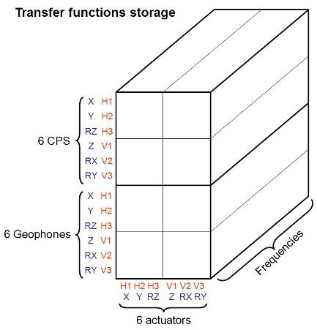
Figure – Transfer functions storage

Step 16.1 - Local to local measurements
The table below summarizes the data acquisition parameters used for the local to local measurements. The advised number of repetitions is 90 but for quick measurements 30 repetitions are sufficient (at night in LHO).

Run # | 1 | 2 | 3 | 4
Fmin | 0.05 Hz | 0.5 Hz | 5 Hz | 200
Fmax | 0.5 Hz | 5 Hz | 200 Hz | 800
F Res | 0.05Hz | 0.05 Hz | 0.1 Hz | 0.1
N rep | 30 - 90 | 30 - 90 | 30 - 90 | 30 - 90
H1 Drive Amp | 550 Cts | 100 Cts | 6000 Cts | 7000 Cts
H2 Drive Amp | 550 Cts | 100 Cts | 6000 Cts | 7000 Cts
H3 Drive Amp | 550 Cts | 100 Cts | 6000 Cts | 7000 Cts
V1 Drive Amp | 550 Cts | 50 Cts | 6000 Cts | 7000 Cts
V2 Drive Amp | 550 Cts | 50 Cts | 6000 Cts | 7000 Cts
V2 Drive Amp | 550 Cts | 50 Cts | 6000 Cts | 7000 Cts
Est Duration | 70 - 210mn | 60 - 180mn | 40 - 120mn | 40 - 120mn
Table - Measurement parameters – Local to local

Data collection script files are in the SVN at:
seisvn/seismic/HAM-ISI/X1/Scripts/Data_Collection
- Run_TF_L2L_50mHz_500mHz.m
- Run_TF_L2L_500mHz_5Hz.m
- Run_TF_L2L_5mHz_200Hz.m
- Run_TF_L2L_200Hz_800Hz.m

Procedure to follow for this test:
- Run Run_Exc_Batch_X1_HAM_ISI.m (Define the number of repetitions) and Run_Get_Batch_X1_HAM_ISI.m
- Date label the script file use to process data and place into the data folder
- In the script file, edit title, input/output data.

Example of SVN path with HAM-ISI-LLO-Unit-1
Data files measurement of local to local transfer functions in SVN at:
seisvn/seismic/HAM-ISI/X1/Data/Unit_1/Transfer_Functions/Measurements/Undamped/
- LHO_HAM_ISI_Unit_1_Data_TF_L2L_50mHz_500mHz_DATE.mat
- LHO_HAM_ISI_Unit_1_Data_TF_L2L_500mHz_5Hz_DATE.mat
- LHO_HAM_ISI_Unit_1_Data_TF_L2L_5_200Hz_DATE.mat
- LHO_HAM_ISI_Unit_1_Data_TF_L2L_200_800Hz_DATE.mat

Script file for processing and plotting local to local transfer functions in SVN at:
seisvn/seismic/HAM-ISI/X1/Data/Unit_1/Transfer_Functions/Measurements/Undamped/
- Plot_LHO_HAM_ISI_Unit_1_TF_L2L_DATE.m (set plot_with_HAM6 to 0)

Figures of local to local transfer functions in SVN at:
seisvn/seismic/HAMISI/X1/Data/Unit_1/Figures/Transfer_Functions/Measurements/Undamped/
- LHO_HAM_ISI_ Unit_1_TF_L2L_H_CPS_50mHz_800Hz _ DATE.fig
- LHO_HAM_ISI_ Unit_1_TF_L2L_V_CPS _50mHz_800Hz _DATE.fig
- LHO_HAM_ISI_ Unit_1_TF_L2L_H_GS13_50mHz_800Hz _DATE.fig
- LHO_HAM_ISI_ Unit_1_TF_L2L_V_GS13_50mHz_800Hz _DATE.fig

Measured of local to local transfer functions in the SVN at:
seisvn/seismic/HAM-ISI/X1/Data/Unit_1/Transfer_Functions/Measurements/Undamped/
- LHO_HAM_ISI_Unit_1_Data_TF_L2L_50mHz_800Hz _DATE.mat

Step 16.2 - Cartesian to Cartesian measurements
The table below summarizes the data acquisition parameters used for the Cartesian to Cartesian. The advised number of repetitions is 90 but for quick measurements 30 repetitions are sufficient (at night in LHO).

Run # | 1 | 2 | 2 | 3
Fmin | 0.05 Hz | 0.5 Hz | 5 Hz | 200
Fmax | 5 Hz | 5 Hz | 200 Hz | 800
F Res | 0.05 Hz | 0.05 Hz | 0.1 Hz | 0.1
N rep | 30 - 90 | 30 - 90 | 30 - 90 | 30 - 90
X Drive Amp | 550 Cts | 75 Cts | 6000 Cts | 7000 Cts
Y Drive Amp | 550Cts | 75 Cts | 6000 Cts | 7000 Cts
RZ Drive Amp | 550 Cts | 35 Cts | 6000 Cts | 7000 Cts
Z Drive Amp | 550 Cts | 75 Cts | 6000 Cts | 7000 Cts
RX Drive Amp | 550 Cts | 20 Cts | 6000 Cts | 7000 Cts
RY Drive Amp | 550 Cts | 20 Cts | 6000 Cts | 7000 Cts
Est Duration | 70 - 210mn | 60 - 180mn | 40 - 120mn | 40 - 120mn
Table - Measurement parameters – Cartesian to Cartesian

Procedure to follow for this test:
- Run Run_Exc_batch and Run_Get_batch
- Date label the script file use to process data and place into the data folder
- In the script file, edit title, input/output data.

Example of SVN path with HAM-ISI-LHO-Unit-1
Data collection script files in SVN at:
seisvn/seismic/HAM-ISI/X1/Scripts/Data_Collection
- Run_TF_C2C_50mHz_500mHz.m
- Run_TF_C2C_500mHz_5Hz.m
- Run_TF_C2C_5mHz_200Hz.m
- Run_TF_C2C_200Hz_800Hz.m

Data files of cartesian to cartesian measurement transfer functions in SVN at:
seisvn/seismic/HAM-ISI/X1/Data/Unit_1/Transfer_Functions/Measurements/Undamped
- LHO_HAM_ISI_Unit_1_Data_TF_C2C_50mHz_500mHz_DATE.mat
- LHO_HAM_ISI_Unit_1_Data_TF_C2C_500mHz_5Hz_DATE.mat
- LHO_HAM_ISI_Unit_1_Data_TF_C2C_5_200Hz_DATE.mat
- LHO_HAM_ISI_Unit_1_Data_TF_C2C_200_800Hz_DATE.mat

Script file for processing and plotting cartesian to cartesian transfer functions in SVN at:
seisvn/seismic/HAM-ISI/X1/Data/Unit_1/Transfer_Functions/Measurements/Undamped
- Plot_ LHO_HAM_ISI_Unit_1_TF_C2C_DATE.m

Figures of Cartesian to Cartesian transfer functions in SVN at:
seisvn/seismic/HAMISI/X1/Data/Unit_1/Figures/Transfer_Functions/Measurements
- LHO_HAM_ISI_ Unit_1_TF_C2C_X_Y_RZ_CPS_50mHz_800Hz_DATE.fig
- LHO_HAM_ISI_ Unit_1_TF_C2C_X_Y_RZ_GS13_50mHz_800Hz_DATE.fig
- LHO_HAM_ISI_ Unit_1_TF_C2C_Z_RX_RY_CPS_50mHz_800Hz_DATE.fig
- LHO_HAM_ISI_ Unit_1_TF_C2C_Z_RX_RY_GS13_50mHz_800Hz_DATE.fig

Measured Cartesian to Cartesian transfer functions in the SVN at:
seisvn/seismic/HAM-ISI/X1/Data/Unit_1/Transfer_Functions/Measurements/Undamped
- LHO_HAM_ISI_Unit_1_Data_TF_C2C _50mHz_800Hz_DATE.mat

Acceptance criteria:

- Local to local measurements
  - On CPS, the phase must be 0º at DC
  - On Geophones, the phase must be -90º at DC
  - Identical shape in each corner
- Cartesian to Cartesian measurements
  - On CPS, the phase must be 0º at DC
  - On Geophones, the phase must be -90º at DC
  - Identical shape X/Y and RX/RY

The tests report must contain:
- Figures of local to local measurements
  - Local to local vertical position sensors transfer functions
  - Local to local horizontal position sensors transfer functions
  - Local to local vertical geophones transfer functions
  - Local to local horizontal geophones transfer functions
- Path in SVN of local to local measurements
  - Data (4 sections)
  - Scripts used for processing
  - Figures
  - Data storage (concatenate)
- Figures of Cartesian to cartesian measurements
  - Cartesian to Cartesian vertical position sensors transfer functions
  - Cartesian to Cartesian horizontal position sensors transfer functions
  - Cartesian to Cartesian vertical geophones transfer functions
  - Cartesian to Cartesian horizontal geophones transfer functions
- Path in SVN of Cartesian to Cartesian measurements
  - Data (4 sections)
  - Scripts used for processing
  - Figures
  - Data storage (concatenate)
- Issues/difficulties/comments regarding this test
- Test result (Passed: Failed: ).

Step 17 - Transfer function comparison with Reference
Procedure to follow for this test:
In this test, we only run the same plotting scripts as in the previous step
- Plot_ LHO_HAM_ISI_Unit_1_TF_L2L_DATE.m
- Plot_ LHO_HAM_ISI_Unit_1_TF_C2C_DATE.m
editing them on line 19 Plot_with_REF=1;

Add the following paths to Matlab before starting:
- seisvn/seismic/HAM-ISI/Common/MatlabTools
- seisvn/seismic/HAM-ISI/Common/MatlabTools/Plot_Functions_HAM_ISI

NB: starting May 2011, the reference to compare the transfer functions against is LHO Unit #2
This will re-plot the same data as the previous step, with the reference results, and compare the main resonances.

Reference main results (3D matrix format) are located in the SVN at:
/svn/seismic/HAM-ISI/X1/Data/Old_Unit_2/Transfer_functions/Local_to_local/
- Local_2_Local_LHO_HAM-ISI-Unit_2_2010_09_16.mat
/svn/seismic/HAM-ISI/X1/Data/Old_Unit_2/Transfer_functions/Cartesian_to_cartesian/
- Cartesian_2_Cartesian_LHO_HAM-ISI-Unit_2_2010_08_28.mat

Step 17.1 - Local to local - Comparison with Reference

Example of SVN path with HAM-ISI-LHO-Unit-1
Script files for processing and plotting transfer functions are located in the SVN at:
seisvn/seismic/HAM-ISI/X1/Data/Unit_1/Transfer_Functions/Measurements/Undamped/
- Plot_LHO_HAM_ISI_Unit_1_TF_L2L_DATE.m (with plot_with_HAM6 set to 1)

The tests report must contain:
- Figures of local to local measurements
  - Local to local vertical position sensors transfer functions
  - Local to local horizontal position sensors transfer functions
  - Local to local vertical geophones transfer functions
  - Local to local horizontal geophones transfer functions
- Path in SVN of local to local measurements
  - Figures
- Report main differences with Reference
- Issues/difficulties/comments regarding this test

Step 17.2 - Cartesian to Cartesian - Comparison with Reference

Example of SVN path with HAM-ISI-LHO-Unit-1
Script files for processing and plotting transfer functions are located in the SVN at:
seisvn/seismic/HAM-ISI/X1/Data/Unit_1/Transfer_Functions/Measurements/Undamped/
- Plot_LHO_HAM_ISI_Unit_1_TF_C2C_DATE.m (with plot_with_HAM6 set to 1)

Acceptance criteria:

- No difference with the reference transfer functions (SVN)
  - Phase – less than 10º - In Phase – Out of Phase
  - Damping (fit by eye with Reference transfer functions)
  - DC gain
  - Eigen frequencies shift less than 10%

The tests report must contain:
- Figures of local to local measurements
  - Cartesian to Cartesian vertical position sensors transfer functions
  - Cartesian to Cartesian horizontal position sensors transfer functions
  - Cartesian to Cartesian vertical geophones transfer functions
  - Cartesian to Cartesian horizontal geophones transfer functions
- Path in SVN of Cartesian to Cartesian measurements
  - Figures
- Report the main differences with Reference
- Issues/difficulties/comments regarding this test
- Test result (Passed: Failed: ).

Step 18 - Lower Zero Moment Plane
This test aims at measuring the distance between the horizontal actuator plane and the lower zero moment plane. That distance is calculated from Cartesian to Cartesian transfer functions measured at low frequencies between 10mHz and 100mHz.
Procedure to follow for this test:
- Run Run_Exc_Batch_X1_HAM_ISI.m and Run_Get_Batch_X1_HAM_ISI.m
to lunch to LZMP measurements with Run_TF_C2C_10mHz_100mHz_LZMP.m
- Date label the script file use to process data
- In the script file, edit title, input/output data.

Data collection script files used for this measurement is located in the SVN at:
seisvn/seismic/HAM-ISI/X1/Scripts/Data_Collection
- Run _TF_C2C_10mHz_100mHz_LZMP.m

Example of SVN path with HAM-ISI-LHO-Unit-1
Data files in SVN at:
seisvn/seismic/HAM-ISI/X1/Data/Unit_1/Transfer_Functions/Undamped
- LHO_HAM_ISI_Unit_1_Data_TF_C2C_10mHz_100mHz_LZMP_DATE.mat

Scripts files for processing and plotting in SVN at:
seisvn/seismic/HAM-ISI/X1/Data/Unit_1/Transfer_Functions/Undamped
- Plot_LHO_HAM_ISI_Unit_1_TF_C2C_10mHz_100mHz_LZMP_DATE.m

Figures in SVN at:
seisvn/seismic/HAM-ISI/X1/Data/Unit_1/Figures/Transfer_Functions/Undamped
- LHO_HAM_ISI_Unit_1_LZMP_DATE.fig

To compute the LZMP, use the spring constants from Final Review Document defined in
“Nov 13, 2007 LIGO+HPD eLog entry 287”
The table below summarizes the data acquisition parameters used for the Cartesian to Cartesian. The advised number of repetitions is 200 but for quick measurements 100 repetitions are sufficient.

Run # | 1
Fmin | 0.01 Hz
Fmax | 0.1 Hz
F Res | 0.01 Hz
N rep | 100 - 200
X Drive Amp | 4000Cts
Y Drive Amp | 4000Cts
Est Duration | mm
Table - Measurement parameters – Cartesian to Cartesian
Report the LZMP offsets in the table
X offset (mm)
Y offset (mm)
Table – Offset of the Lower Zero Moment Plane

Acceptance criteria:
- X offset must be less than 2 mm
- Y offset must be less than 2 mm

The tests report must contain:
- Figure of Cartesian to Cartesian measurements (X to X, Y to Y, X to RY, Y to RX)
- Path in SVN of Cartesian to Cartesian measurements
  - Data
  - Scripts used for processing
  - Figures
- The Table “Offset of the lower zero moment plan”
- Issues/difficulties/comments regarding this test
- Test result (Passed: Failed: ).

Step 19 - Damping loops
In this step, HAM6 damping loops are implemented. First, damping performances are evaluated in simulation. Second, Damping loops are implemented and performance is experimentally measured.

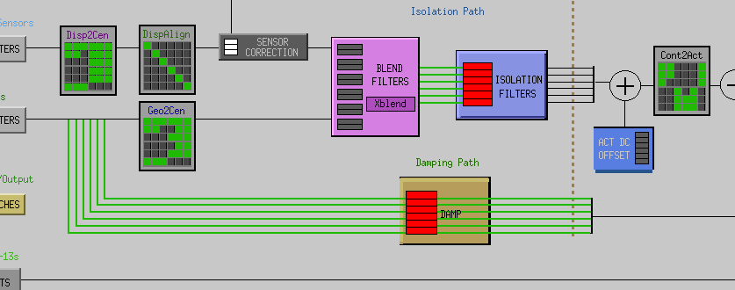
Figure – Turn damping loops on!

Note that usually a gain of -1 is necessary for stable damping loops!

Step 19.1 - Transfer functions - Simulation

Continuous HAM6 filters are located in the SVN at:
/optseisvn/seismic/HAM-ISI/Common/HAM6_Main_Results
- HAM6_LLO_Damping_Filters.mat

Procedure to follow for this test:
- Open the script file LHO_HAM_ISI_Unit_1_Damping_TF_DATE) in /seismic/HAM-ISI/X1/Data/Unit_1/Transfer_Functions/Simulations/Damping
- Date label the script file
- In the script file, edit title, input/output data
- Run it
This script creates a .mat files in which the plant, open loops, closed loops, suppression are stored in 3D matrices. This script also plots figures that present the plant, controller, open loop, closed loop and sensitivity of vertical and horizontal damping loops.
On figures that show the three vertical or horizontal damping loops on the same plot, the line style code is:
- H1/V1 are plotted in solid line
- H2/V2 are plotted in dash line
- H3/V3 are plotted in dash-dot line

The following plots are presented using the convention below:

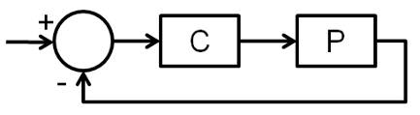
Figure – Feedback loop

Example of SVN path with HAM-ISI-LHO-Unit-1

Scripts files used to evaluate damping loops performance from measurementsare located in SVN at:
/ seismic/HAM-ISI/X1/Data/Unit_1/Transfer_Functions/Simulations
LHO_HAM_ISI_Unit_1_Damping_TF_DATE.m

Save file is located in the SVN at:
/seismic/HAM-ISI/X1/Data/Unit_1/Transfer_Functions/Simulations
- LHO_HAM_ISI_Unit_1_Damping_TF_DATE.mat

Figures in SVN at:
seismic/HAM-ISI/X1/Data/Unit_1/Figures/Damping_Loops
- LHO_HAM_ISI_Unit_1_Damping_TF_ Horizontals_DATE.fig
- LHO_HAM_ISI_Unit_1_Damping_TF_ Verticals_DATE.fig

Acceptance criteria:

- HAM6 damping loops must implemented and stable with
  - Phase margin must be at least 45º
  - Gain margin must be at least 20dB

The tests report must contain:
- Figures Damping loop (horizontal and vertical filters)
- Path in SVN of Cartesian to Cartesian measurements
  - Data
  - Scripts used for processing
  - Figures
- Issues/difficulties/comments regarding this test
- Test result (Passed: Failed: ).

Step 19.2 - Powerspectra – Experimental
Once the stability has been verified in simulation, the HAM6 digital damping filters can be loaded in the MEDM filter bank. The filter file “G1ISIHAM.txt” is located in /opt/rtcds/geo/g1/chans. Don’t forget to create back-up files if you modify digital filters. Filters have to be reloaded in the MEDM filter ban by pressing load coefficients.

Matlab
A first Matlab function is used to plot the power spectra of the Geophones when the table is in the undamped and the damped position. A second Matlab function is used to compare the experimental and the simulated suppression

Follow the steps below:
- Write down the GPS Time once the table is undamped.
- Wait for 35 minutes or reuse the GPS time of Step 8 if you can still access the data in the frame builder
- Proceed for every corner.
- Open the script Powersprectra_Measurement_HAM_ISI_Undamped_Damped.m located in the SVN at seisvn/seismic/HAM-ISI/X1/Scripts/Data_Collection/.
- Edit the GPS time for the two different configurations and run the script. Edit autosave plot to 1)
- Paste the figures in the report
- Open the script LHO_HAM_ISI_Unit_1_Damping_Powerspectra_DATE.m located in the SVN at seisvn/seismic/HAM-ISI/X1/Data/Unit_1/Powerspectra/Damping/
- Edit figure title, unit ID, date, input data (Simulated transfer functions, ) and run the script. Edit autosave plot to 1)
- Run the script and paste the figures in the report

Example of SVN path with HAM-ISI-LHO-Unit-1

Filters used by Damping loops in SVN at:
seisvn/seismic/HAM-ISI/X1/Data/Unit_1/
- G1ISIHAM_LHO_Unit_1_DATE.txt (digitalized filters copied and rename to G1ISIHAM.txt in /opt/rtcds/geo/g1/chans)
- HAM6_LHO_Damping_Filters.mat (continuous filters)

Scripts files for processing and plotting in SVN at:
seisvn/seismic/HAM-ISI/X1/Scripts/Data_Collection
Powerspectra_Measurement_HAM_ISI_Undamped_Damped.m

seisvn/seismic/HAM-ISI/X1/Data/Unit_1/ Powerspectra/Damping/
LHO_HAM_ISI_Unit_3_Damping_Powerspectra_DATE.m

Data files in SVN at:
seisvn/seismic/HAM-ISI/X1/Data/Unit_1/ Powerspectra/Damping/
LHO_HAM_ISI_Unit_1_Calibrated_PSD_CPS_GS13_Undamped_Damped_DATE.mat

Figures in SVN at:
seisvn/seismic/HAM-ISI/X1/Data/Unit_1/Figures/ Powerspectra/Damping/
- LHO_HAM_ISI_Unit_1_Calibrated_PSD_GS13_Undamped_Damped_DATE.fig
- LHO_HAM_ISI_Unit_1_Suppression_Exp_vs_Sim_DATE.fig

Acceptance criteria:

- HAM6 damping loop must stable when all damping loops are engaged
- Similar damping effect than in simulated plots

The testing document must contain:
- Figures of Dampimg loops controller (vertical and horizontal)
- Figures of suppression Measurement vs simulation vs HAM6
- Path in SVN of Cartesian to Cartesian measurements
  - Data
  - Scripts used for processing
  - Figures
- Issues/difficulties/comments regarding this test
- Test result (Passed: Failed: ).

Appendix A: Dial indicators location

In order to ensure repeatable measurements from one unit to another, dial indicators have to be installed properly in the right locations. This section describes how to do it.

Dial indicators are used to monitor actual table motions & offer a back-up position measurement to the Capacitive Position Sensors. Breadboards on Stage 0 are used to mount the dial indicators. Dial indicators should resolve to at least 0.001”. Try to avoid using complicated or long mounting hardware; we do not want to have the Dial Indicator mounted on a long post and possibly being easily “bump-able”.

We have chosen to use horizontal & vertical dial indicators near each of our four Lockers. The vertical dial indicator registers on a bottom surface of Stage 1. The horizontal dial indicator registers on one of the radial surfaces on the Top Mount of the Locker.

Dial indicators should be pulled away from the ISI system when one wants to take noise measurements.

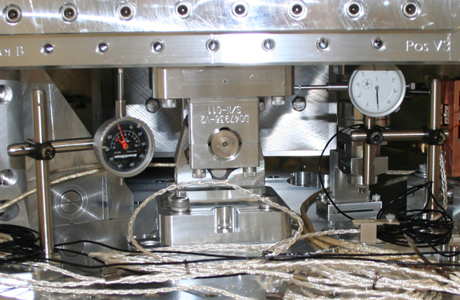
Figure - Vertical & Horizontal dial indicators installed near locker B

Dial indicators positions are presented in the figure below (blues dots and blue lines). Horizontal dial indicators A & C read negative for CCW rotation of Stage1 wrt Stage 0 whereas B & D read negative for CW rotation.

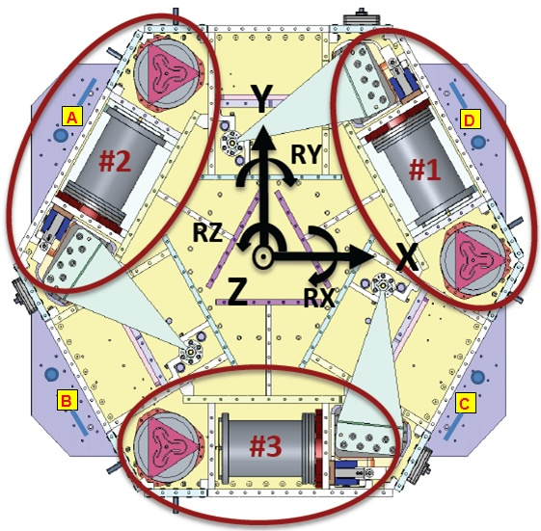
Figure - Top view of the HAM-ISI

Appendix B: Sensor calibration

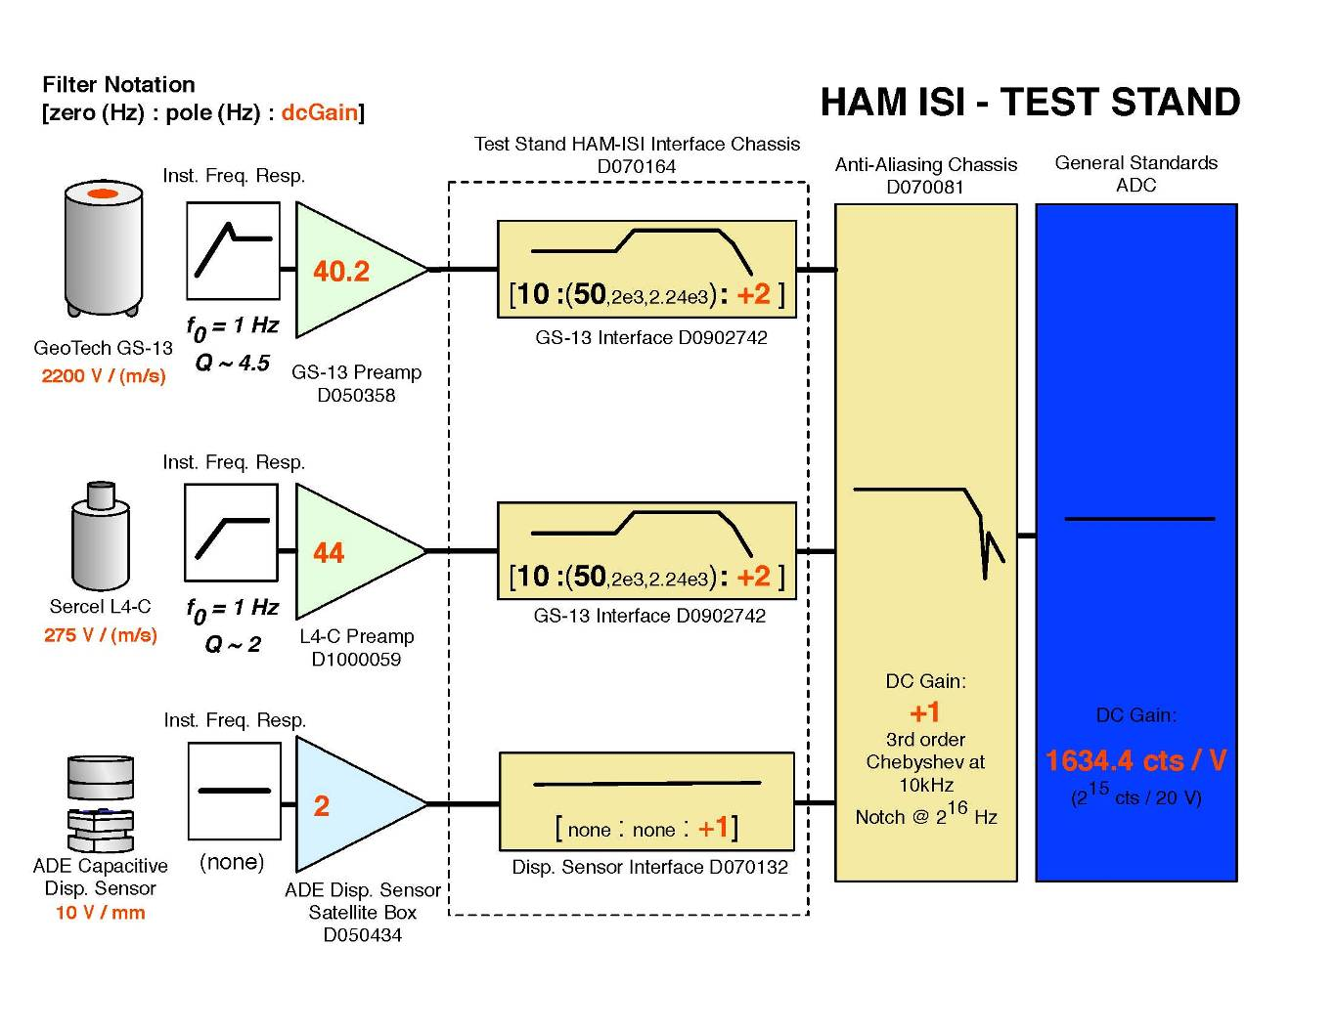

Appendix C: SVN arborescence

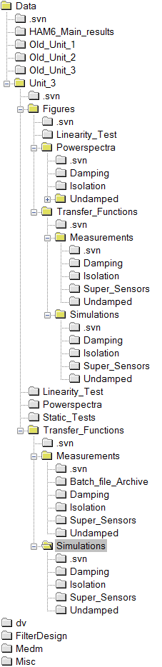
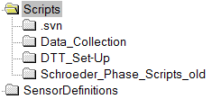
Figure - SVN arborescence

Appendix D: Matrices

- GEO2CEN : from local to Cartesian (GS13 Geophones)
- DISP2CEN : from local to Cartesian (Capacitive displacement sensors)
- CONT2ACT : from cartesian to local (Actuators)

For example, CONT2ACT matrix is the following matrix
 | X | Y | Z | RX | RY | RZ
H1 | 0.333 | -0.577 | 0 | 0 | 0 | -0.431
H2 | 0.333 | 0.577 | 0 | 0 | 0 | -0.431
H3 | -0.667 | 0 | 0 | 0 | 0 | -0.431
V1 | 0 | 0 | 0.333 | 0 | -0.937 | 0
V2 | 0 | 0 | 0.333 | 0.812 | 0.469 | 0
V3 | 0 | 0 | 0.333 | -0.812 | 0.469 | 0

with Local_vector = CONT2ACT x Cartesian_vector

DISP2CEN is the following matrix
 | H1 | H2 | H3 | V1 | V2 | V3
X | 0.333 | 0.333 | -0.667 | -0.194 | 0.049 | 0.145
Y | -0.577 | 0.577 | 0 | 0.056 | -0.196 | 0.140
Z | 0 | 0 | 0 | 0.333 | 0.333 | 0.333
RX | 0 | 0 | 0 | -0.273 | 0.961 | -0.688
RY | 0 | 0 | 0 | -0.952 | 0.240 | 0.712
RZ | -0.422 | -0.422 | -0.422 | 0 | 0 | 0

with Cartesian_vector = DISP2CEN x Local_vector

