LIGO Laboratory / LIGO Scientific Collaboration

LIGO- E1000312 LIGO October 11, 2010

aLIGO HAM-ISI, Pre integration Test report, Phase 1,
LHO Unit #3
E1000312 – V1

Eric Allwine, Hugh Radkins, Corey Gray, Jeffrey Garcia, Fabrice Matichard, Vincent Lhuillier

Distribution of this document:
Advanced LIGO Project

This is an internal working note
of the LIGO Laboratory

California Institute of Technology  LIGO Project – MS 18-34  1200 E. California Blvd.  Pasadena, CA 91125  Phone (626) 395-2129  Fax (626) 304-9834  E-mail: info@ligo.caltech.edu | Massachusetts Institute of Technology  LIGO Project – NW22-295  185 Albany St  Cambridge, MA 02139  Phone (617) 253-4824  Fax (617) 253-7014  E-mail: info@ligo.mit.edu
LIGO Hanford Observatory  P.O. Box 1970  Mail Stop S9-02  Richland WA 99352  Phone 509-372-8106  Fax 509-372-8137 | LIGO Livingston Observatory  P.O. Box 940  Livingston, LA 70754  Phone 225-686-3100  Fax 225-686-7189

.
Table of contents:

Introduction 3
I. Pre-Assembly Testing 4
▪ Step 1: Position Sensors 4
▪ Step 2: GS13 5
▪ Step 3: Actuators 5
II. Tests to be performed during assembly 6
▪ Step 1: Check torques on all bolts 6
▪ Step 2: Check gaps under Support Posts 6
▪ Step 3: Pitchfork/Boxwork flatness before Optical Table install 6
▪ Step 4: Blade spring profile 6
▪ Step 5: Gap checks on actuators 7
▪ Step 6: Check level of Stage 0 7
▪ Step 7: Mass budget 7
▪ Step 8: Lockers adjustment 9
III. Tests to be performed after assembly 10
▪ Step 1 - Actuators Inventory 10
▪ Step 2 - Sensors Inventory 10
▪ Step 3 - Electronics Inventory 11
▪ Step 4 - Set up sensors gap 11
▪ Step 5 - Measure the Sensor gap 12
▪ Step 6 - Check Sensor gaps after the platform release 12
▪ Step 7 - Check range of motion (hand pushing) 13
o Step 7.1 – Test Nº1 – Push up and down 13
o Step 7.2 – Test Nº2 – Push “sideways” 13
▪ Step 8 - Capacitive position sensor Power Spectrum 14
▪ Step 9 - GS13 power spectrums 15
o Step 9.1 –Table locked and unlocked (free) 15
o Step 9.2 – Table tilted 15
▪ Step 10 - Coil Driver, cabling and resistance check 17
▪ Step 11 - Actuators Sign and range of motion (Local drive) 17
o Step 11.1 - Actuators sign 17
o Step 11.2 - Range of motion - Local drive 18
▪ Step 12 - Vertical Sensor Calibration 18
▪ Step 13 - Vertical Spring Constant 19
▪ Step 14 - Static Testing (Tests in the local basis) 19
▪ Step 15 - Linearity test 20
▪ Step 16 – Static tests in the general coordinate basis 21
▪ Step 17 - Frequency response 21
o Step 17.1 - Local to local measurements 21
o Step 17.2 - Cartesian to Cartesian measurements 23
▪ Step 18 - Transfer function comparison 24
o Step 18.1 - Local to local - Comparison with HAM6 24
o Step 18.2 - Cartesian to Cartesian - Comparison with HAM6 25
▪ Step 19 - Lower Zero Moment Plane 27
▪ Step 20 - Damping loops 28
o Step 20.1 - Transfer functions - Simulation 28
o Step 20.2 - Powerspectrum – Experimental 29
IV. Testing Summary 31

Introduction

This document presents the tests performed to characterize and validate the “HAM-ISI LHO Unit #3”.

In the first section, Pre-Assembly Testing, we summarize the measurements done on the capacitive position sensors, GS13 seismometers and actuators prior the beginning of the assembly.

In the second section, we present the results of the Tests to be performed during assembly. It includes subassemblies flatness check, the blade spring profile, the leveling of stage 0 and the lockers adjustments.

In the third section we present the Tests to be performed after assembly. These tests allow to check step by step the overall assembly. Transfer functions are measured and damping loops are implemented

Section four summarizes major issues during testing.
The procedure document used to perform this test is:
- E1000309 –V4 - aLIGO HAM-ISI, Pre-Integration Testing Procedure, Phase I (post assembly, before storage)
Other useful information can be found in:
- E1000300 - HAM-ISI LLO test stand: software and electronic check

Problems encountered during transfer function measurements have not been investigated due to the possible disassembly of HAM-ISI LHO Unit #3.

Pre-Assembly Testing

Step 1: Position Sensors
Note: The back panel reads 0.508V/0.001"
S/N sensor | S/N board | ADE Gap Standoff(mm) | Location on the Jig | Gap Standoff on Jig(mm/in) | Voltage before zeroing | Voltage after zeroing. Prebake | Voltage after zeroing. Post bake
11988 | 11846 | NR | 1 | 2.007mm/0.079" | -1 | 0.02 | -4.9
12004 | 11836 | NR | 1 | 2.007mm/0.079" | NR | 0.01 | -5
11989 | 11842 | NR | 1 | 2.007mm/0.079" | -1 | 0.01 | -4.7
11997 | 11829 | NR | 1 | 2.007mm/0.079" | -1 | 0.01 | -4.9
12036 | 11867 | NR | 1 | 2.057mm/0.081" | NR | 0.01 | -4.7
12030 | 11893 | NR | 1 | 2.057mm/0.081" | NR | 0.01 | -5.2

NR: not recorded

Sensors noise spectra measured before baking:
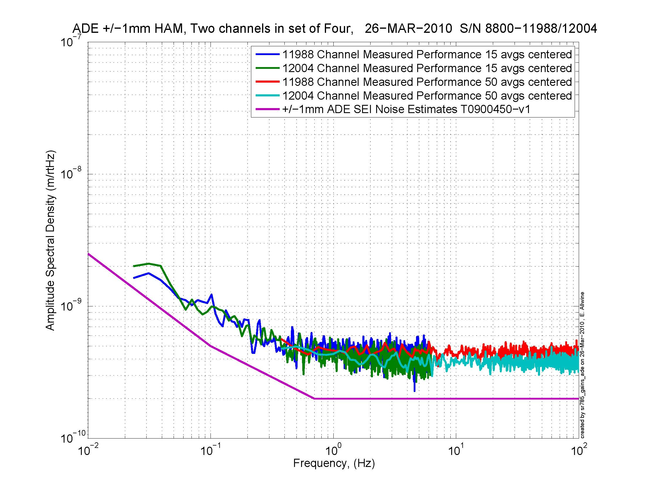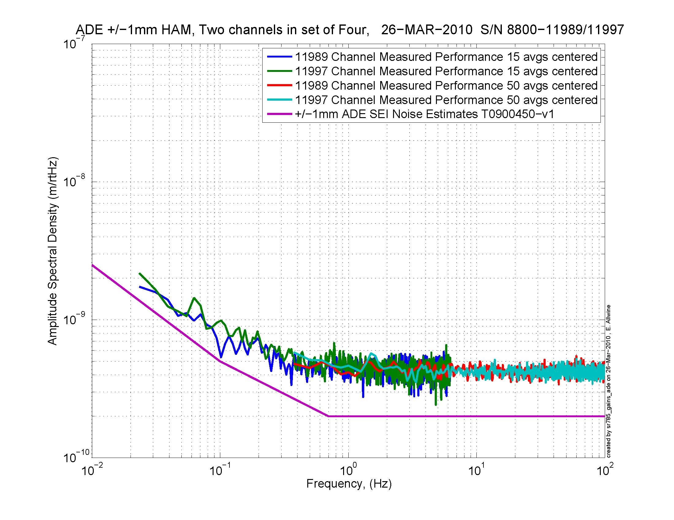
Figure - H1 and V1 sensor noise Figure - H2 and V2 sensor noise
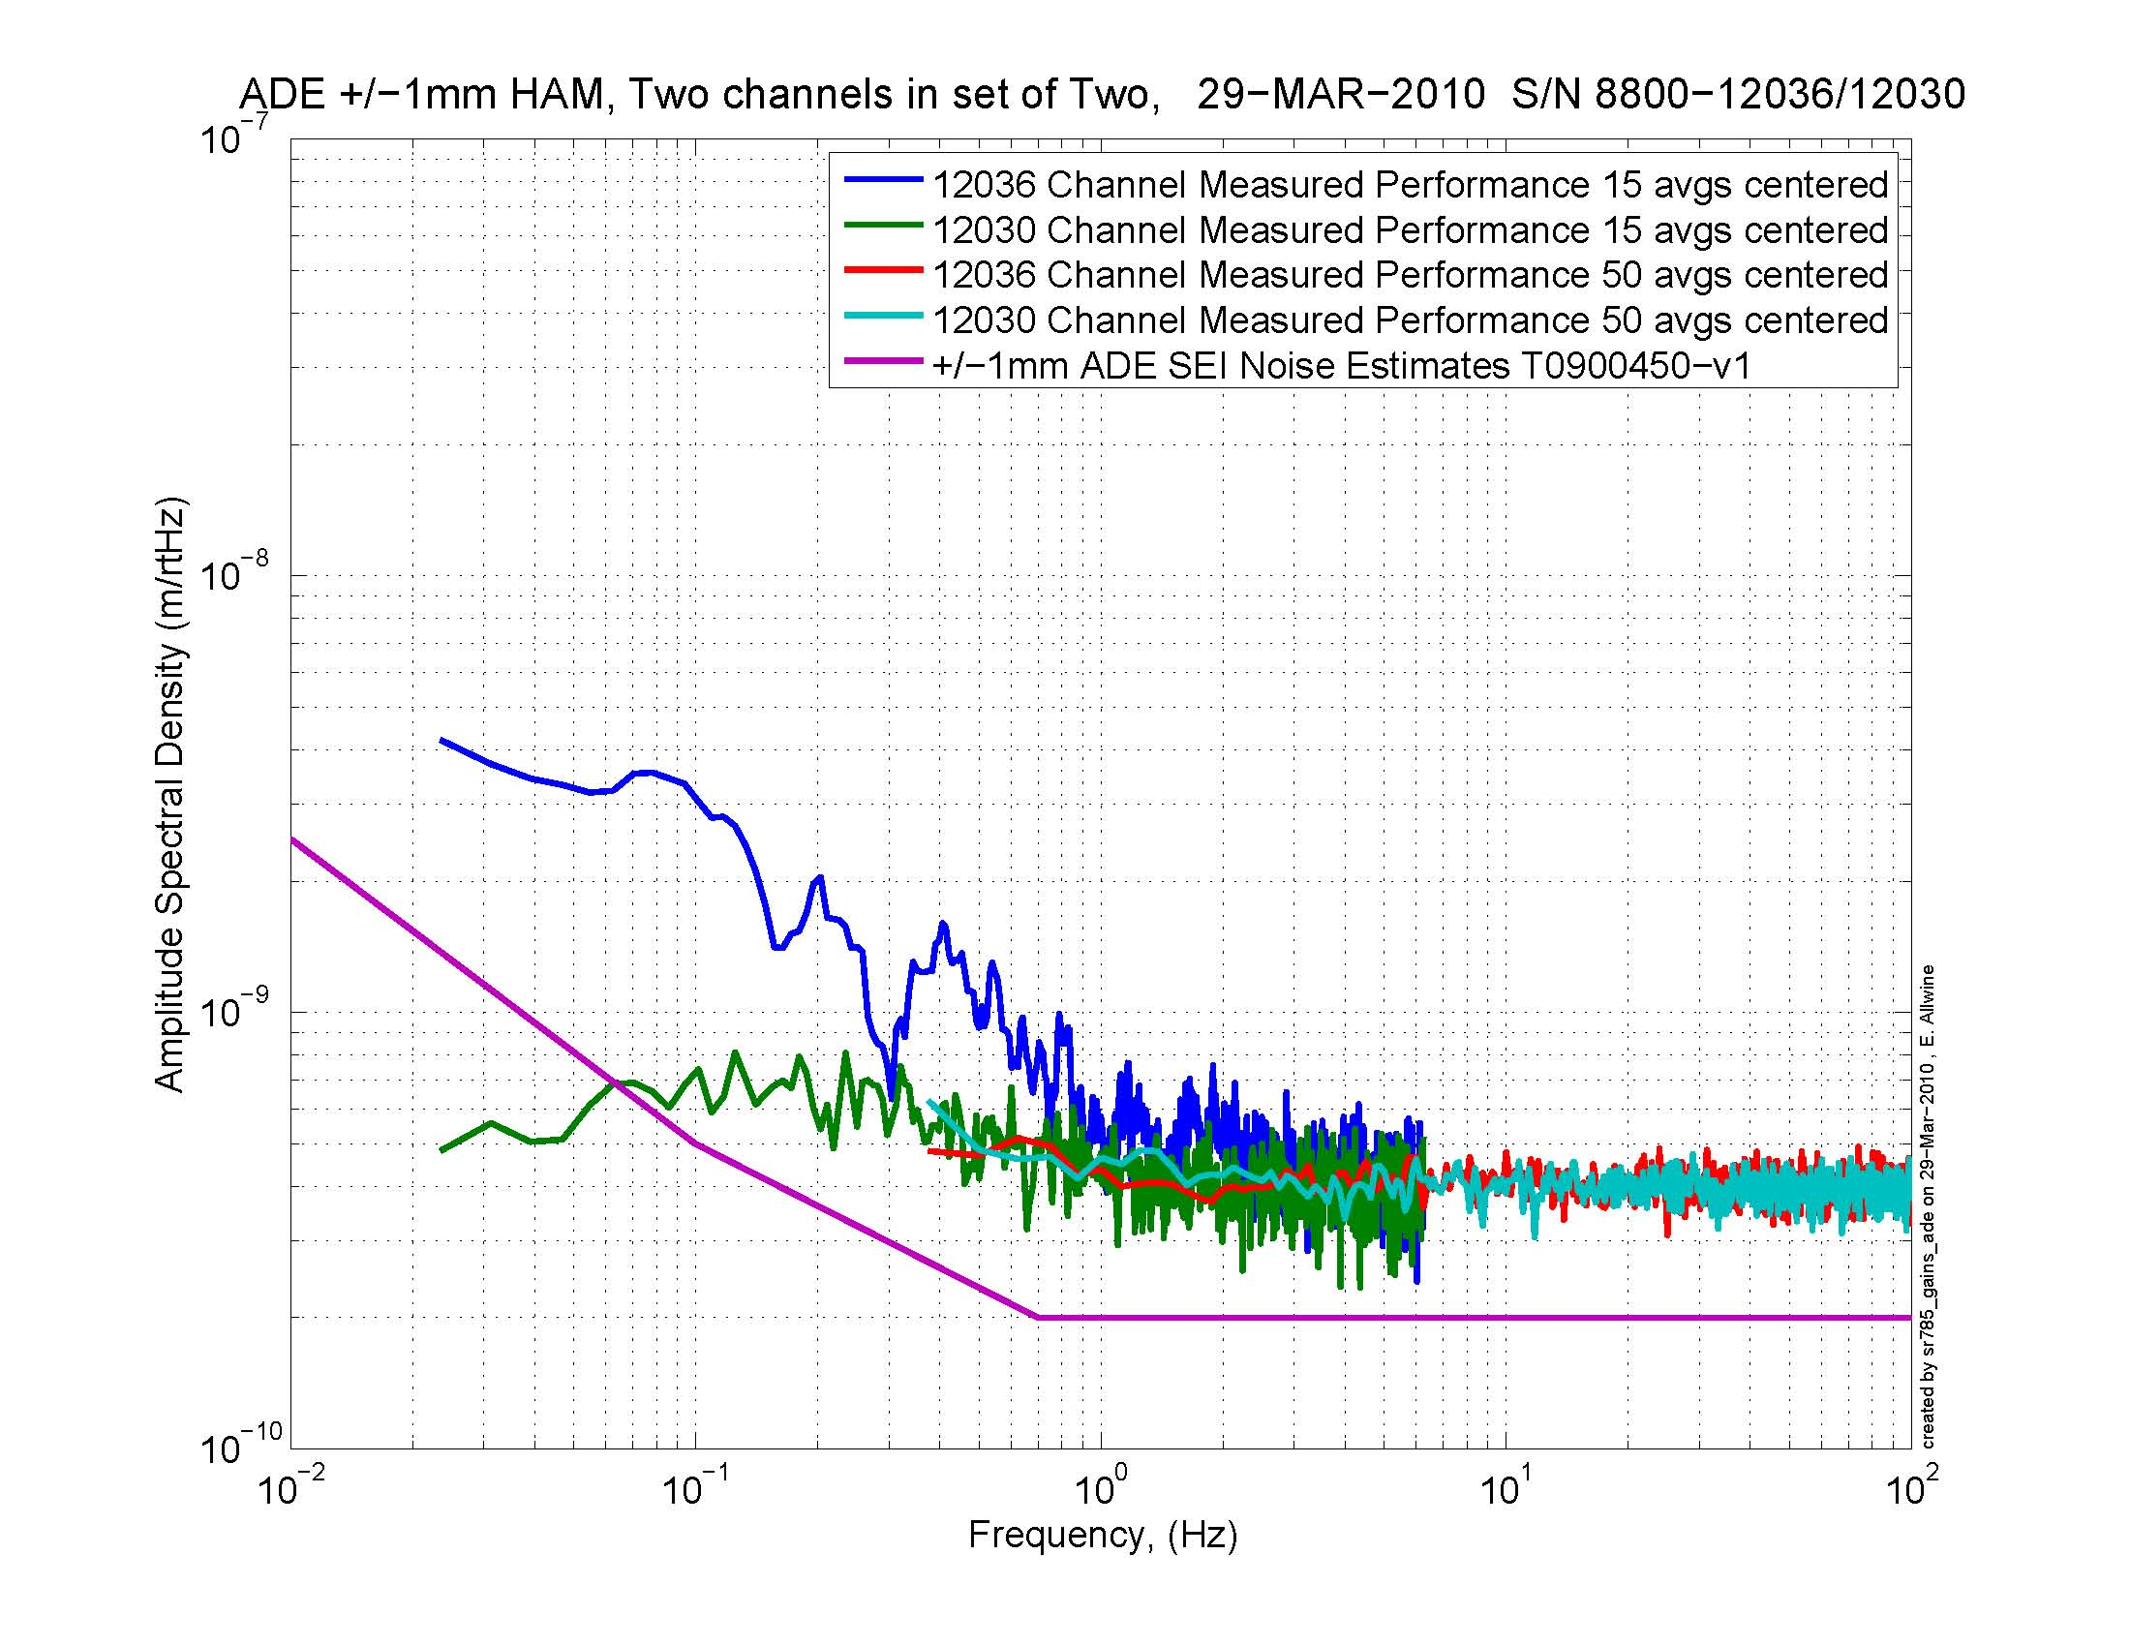
Figure - H3 and V3 sensor noise

Acceptance Criteria:
- Power spectrum magnitudes must be lower than:
  - 9.e-9 m/√Hz at 0.1Hz
  - 6.e-9 m/√Hz at 1Hz

Issues/difficulties/comments regarding this test: Values of sensor gaps and zeroing were not recorded. Waived for this unit.

Test result: Passed: X Failed: .

Step 2: GS13

All the data related to GS-13 post podding testing can be found in the SVN at : SeismicSVN\seismic\Common\Data\aLIGO_GS13_TestData\PostMod_TestResults_PDFs.
E1000058 spreadsheet provides the status of each individual GS-13 at LLO site during aLIGO HAM assembly

Acceptance Criteria:
- GS13 should have been already tested. GS-13 Inspection/Pod Assembly (D047810). Checklist is defined in F090070-v6

Test result: Passed: X Failed: .

Step 3: Actuators

Actuator data can be found at: T0900564. Actuator inventory is made at Section II – Step 1.

Acceptance Criteria:
- Actuators were previously tested and results are reported in T900564.

Test result: Passed: X Failed: .

Tests to be performed during assembly

Step 1: Check torques on all bolts

Acceptance Criteria:
- All bolts should trip the wrench, and start moving immediately after. If any bolts in a pattern move before torque is reached, recheck after all bolts are brought to spec.

Test result: Passed: X Failed: .

Step 2: Check gaps under Support Posts

Acceptance Criteria:
- The test is passed if: a 0.001 inch shim cannot be passed freely through any connection to Stage 0 or between post and gussets. If shim can pass through, loosen all constraining bolts, and then retighten iteratively from the center of the part to the edges. Retest.

Test result: Passed: X Failed: .

Step 3: Pitchfork/Boxwork flatness before Optical Table install

Acceptance Criteria:
- Shim inserted won’t pass between parts.

Test result: Passed: X Failed: .

Step 4: Blade spring profile

Blade # | Base (") | Tip(") | Flatness (mils)
1 | 0.378 | 0.375 | 0.003
2 | 0.383 | 0.384 | 0.001
3 | 0.38 | 0.376 | 0.004
Table 1 - Blade profile

Acceptance Criteria
- Blades must be flat within 0.020" inches.

Test result: Passed: X Failed: .

Step 5: Gap checks on actuators

Acceptance Criteria
- Gaps must be within 0.010” of design (i.e. 0.090” and .070” pass, but 0.095” and 0.065” doesn’t).

Test result: Passed: X Failed: .

Step 6: Check level of Stage 0

Acceptance Criteria To be defined.

Test result: Passed: X Failed: .

Step 7: Mass budget

Optical Mass (Kg) | Wall Mass (Kg) | Keel Mass (Kg) | Total Mass (Kg)
305.00 | 173.58 | 89.65 | 568.23
Table - Masses distribution

The total weight is 568.23Kg.

To do
Figure - Masses distribution

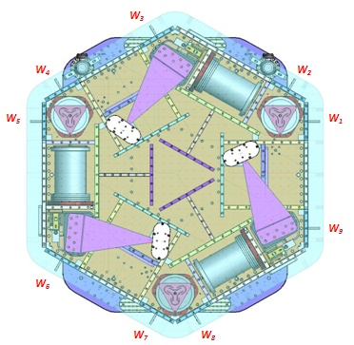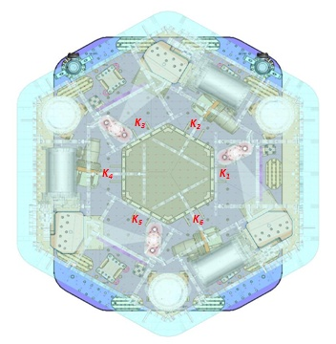
Figure – Keel Masses and Wall masses location

 |  | Mass
 | Type | 00 | 01 | 02 | 03 | 04 | 05 | 06
 | Weight | 0.246 | 0.512 | 0.992 | 2.052 | 3.558 | 7.028 | 12.268 | Kg
Location | w1 |  | 1 |  | 1 |  | 1 | 1 | 21.9
Location | w2 | 1 |  |  | 1 | 1 |  | 1 | 18.1
Location | w3 |  |  |  | 1 | 1 |  | 1 | 17.9
Location | w4 |  | 1 |  | 1 |  | 1 | 1 | 21.9
Location | w5 | 1 |  |  | 1 | 1 |  | 1 | 18.1
Location | w6 |  |  |  | 1 | 1 |  | 1 | 17.9
Location | w7 |  | 1 |  | 1 |  | 1 | 1 | 21.9
Location | w8 | 1 |  |  | 1 | 1 |  | 1 | 18.1
Location | w9 |  |  |  | 1 | 1 |  | 1 | 17.9
 |  | 3 | 3 | 0 | 8 | 6 | 3 | 9 | 173.6
Location | k1 |  |  |  |  |  | 2 |  | 14.1
Location | k2 |  |  |  |  | 1 |  | 1 | 15.8
Location | k3 |  |  |  |  |  | 2 |  | 14.1
Location | k4 |  |  |  |  | 1 |  | 1 | 15.8
Location | k5 |  |  |  |  |  | 2 |  | 14.1
Location | k6 |  |  |  |  | 1 |  | 1 | 15.8
 |  | 0 | 0 | 0 | 0 | 3 | 6 | 3 | 89.6
Table – Wall masses and Keel masses distribution

Shims Thickness
Lockers | Shim thickness (mil)
A | 130
B | 128
C | 120
D | 122
Table – Shims Thickness

Acceptance Criteria
The Mass budget must be
- 596.7Kg +/-25Kg (4%)

Test result: Passed: Failed: .

Step 8: Lockers adjustment

D.I at Lockers | Dial indicators V | Dial indicators H
A | 1 | 0
B | 0 | 0
C | -1 | 0
D | 0 | 0
Table – Dial indicators read-out
Issues/difficulties encountered during this test :

Acceptance Criteria
- Vertical and horizontal displacement near the lockers must be lower than 2 mils

Test result: Passed: X Failed: .

Tests to be performed after assembly

Step 1 - Actuators Inventory

Actuator | Actuator S/N
H1 | 42-L042
H2 | 61-L053
H3 | 63-L057
V1 | 60-L039
V2 | 44-L036
V3 | 59-L033
Table - Actuators' inventory

Issues/difficulties/comments regarding this test: Horizontal actuators S/N missing

Test result: Passed: X Failed: .

Step 2 - Sensors Inventory

Sensor | CPS S/N | Mount S/N | ADE board serial #
H1 | 11988 | 10 | 11846
H2 | 11989 | 58 | 11842
H3 | 12036 | 80 | 11867
V1 | 12004 | 55 | 11836
V2 | 11997 | 73 | 11829
V3 | 12030 | 81 | 11893
Table - Capacitive position sensors' inventory

Geophones GS13 | Serial Number | POD | Adaptor
H1 | 799 | 58 | 32
H2 | 803 | 13 | 42
H3 | 805 | 68 | 33
V1 | 701 | 40 | 40
V2 | 695 | 49 | 41
V3 | 705 | 59 | 37
Table - Geophones' inventory

Issues/difficulties/comments regarding this test:

Test result: Passed: X Failed: .

Step 3 - Electronics Inventory
Write down serial number of coil driver, Anti aliasing chassis, Anti image chassis and interface chassis used for this test are listed below:

Hardware | Ligo reference | S/N
Coil driver | D0902744 | S1000266
Coil driver | D0902744 | S1000269
Anti Image filter | D070081 | S1000250
Anti aliasing filter | D1000269 | S1000247
Anti aliasing filter | D1000269 | S1000246
Interface chassis | D1000067 | S1000270
Interface chassis | D1000067 | S1000271
Interface chassis | D1000067 | S1000272

Table - Inventory electronics

Issues/difficulties/comments regarding this test:

Test result: Passed: X Failed: .

Step 4 - Set up sensors gap

 | 10 Kg masses at each corners |  | No mass
Table locked | ADE boxes on |  | ADE boxes on
Sensors | Offset (Mean) | Std deviation | Offset (Mean) | Std deviation
H1 | -764.2 | 0.9 | -606.8 | 1.0
H2 | -703.6 | 0.8 | -516.2 | 0.8
H3 | 580.4 | 1.0 | 479.0 | 0.9
V1 | 307.1 | 0.7 | 415.7 | 0.7
V2 | 143.2 | 1.1 | 279.7 | 1.1
V3 | 123.3 | 1.3 | 317.6 | 0.8
Table - Set-up sensors gap

Issues/difficulties/comments regarding this test: HAM-ISI – LHO unit#3 uses synchronized satellite boxes

Acceptance criteria:

- All mean values must be lower than 400 cts (a bit less than .0005”).
- All standard deviations below 5 counts.

Test result: Passed: Failed: .

Step 5 - Measure the Sensor gap

Sensors | Gap measured on the Jig | Gap measured on the table | % of change | Offset sensors (counts)
H1 | 80 | 80 | 0 | -606.8
H2 | 80 | 80 | 0 | -516.2
H3 | 80 | 80 | 0 | 479.0
V1 | 80 | 80 | 0 | 415.7
V2 | 80 | 80 | 0 | 279.7
V3 | 80 | 80 | 0 | 317.6
Table - Sensors gap

Issues/difficulties/comments regarding this test: No information of gaps measured on the Jig.

Acceptance criteria:

- Change of gaps lower than 2% (reference is the gap measured on the Jig)

Test result: Passed: X Failed: .

Step 6 - Check Sensor gaps after the platform release
 | Table locked |  | Table unlocked
Sensors | Offset (Mean) | Std deviation | Offset (Mean) | STD | Diff
H1 | -558.0 | 1.3 | 98.0 | 3.8 | 656.0
H2 | -575.9 | 1.2 | -31.5 | 3.2 | 544.4
H3 | 501.4 | 1.3 | 427.6 | 4.0 | -73.8
V1 | 422.2 | 0.9 | -179.7 | 3.3 | -602.0
V2 | 327.3 | 1.8 | 1008.9 | 8.4 | 681.6
V3 | 262.9 | 1.9 | -314.5 | 5.8 | -577.5
Table – Sensor gaps after platform release

Issues/difficulties/comments regarding this test:

Acceptance criteria:

- Absolute values of the difference between the unlocked and the locked table must be below:
  - 1600 cts for horizontal sensors (~0.002”)
  - 1600 cts for vertical sensors (~0.002”)
- Considering the acceptance criteria of step 4, all mean values must be lower than
  - 2000 cts for horizontal sensors (~0.0025”)
  - 2000 cts for vertical sensors (~0.0025”)

Test result: Passed: X Failed: .

Step 7 - Check range of motion (hand pushing)

Step 7.1 – Test Nº1 – Push up and down

 | CPS read out |  | Calculated after calibration
Sensors | UP (Counts) | Down (Counts) | UP (mil) | Down (mil)
V1 | 20450 | -19000 | 24.5 | -22.8
V2 | 20500 | -18250 | 24.6 | -21.9
V3 | 20500 | -20500 | 24.6 | -24.6
 | CPS read out |  | Calculated after calibration
Sensors | CW(-RZ) | CCW (+RZ) | CW (mil) | CCW (mil)
H1 | 20100 | -21500 | 24.1 | -25.8
H2 | 21500 | -21500 | 25.8 | -25.8
H3 | 23000 | -21500 | 27.5 | -25.8
Table - Optic table range of motion

Issues/difficulties/comments regarding this test: the results indicate that all displacement sensor signals have the same sign all the way through the read chain.

Step 7.2 – Test Nº2 – Push “sideways”

Displacement sensors and actuator gap check:

 | Push in positive direction | Push in negative direction | Railing | Actuator Gap Check
H1 | 22600 | -23550 |  | X
H2 | 23000 | -25300 |  | X
H3 | 25700 | -25000 |  | X
V1 | 21100 | -19900 |  | X
V2 | 32768 | -32680 | X | X
V3 | 22500 | -24000 |  | X
Table - Sensor and Actuator gap check

Acceptance criteria:
- The vertical sensor readout be positive when the optic table is pushed in the +Z direction
- The horizontal sensor readout be negative when the optic table is pushed in the +RZ direction
- Step 7.1
  - Absolutes value of all estimated motions must be higher than 16000counts (~0.020”)
- Step 7.2
  - No contact point on sensors
  - Absolute value of sensor read out must be higher than 16000counts (~0.020”)
  - No contact point on actuators

Test result: Passed: X Failed: .

Step 8 - Capacitive position sensor Power Spectrum

Data files in SVN at:
/opt/svncommon/seisvn/seismic/HAM-ISI/X1/Data/Unit_3/ Powerspectrum_Undamped
- Power_spectrum_table_locked_ADE_Sync_10_10_08.xml
- Power_spectrum_table_unlocked_ADE_Sync_10_10_08.xml
- Power_spectrum_table_locked_ADE_Sync_10_10_07.txt
- Power_spectrum_table_unlocked_ADE_Sync_10_10_07.txt

Scripts files for processing and plotting in SVN at:
/opt/svncommon/seisvn/seismic/HAM-ISI/X1/Data/Unit_3/ Powerspectrum_Undamped
- PSD_CPS_GS13_lock_unlock_HAM_ISI_LHO_unit_3_2010_10_07.m

Figures in SVN at:
/opt/svncommon/seisvn/seismic/HAM-ISI/X1/Data/Unit_3/Figures/Powerspectrum_GS13_CPS
- Calibrated_CPS_Powerspectrum_Locked_Unlocked.fig

CPS calibration:
The CPS power spectrums are calibrated by using a sensitivity of 30.2nm/count.

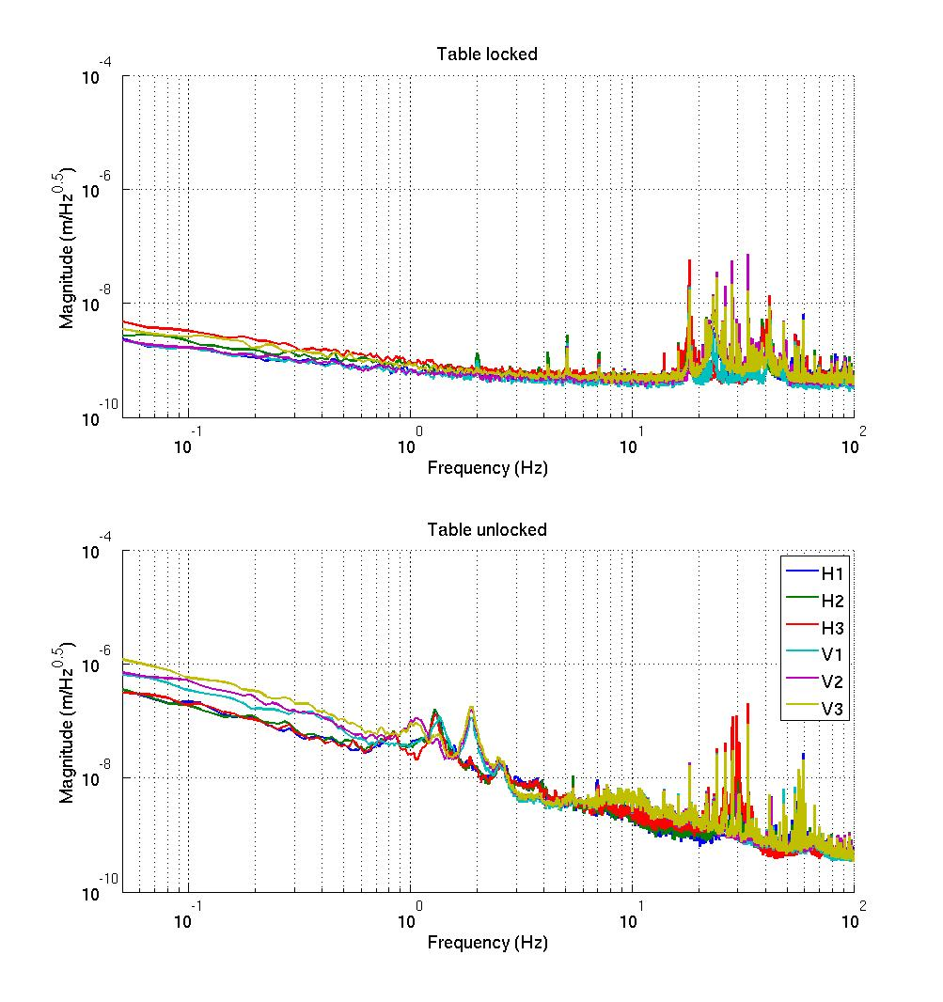
Figure - Calibrated CPS power spectrum

Acceptance criteria:
- No cross talk (peaks at low frequencies + harmonics on measurements)
- Magnitude of power spectrums must be lower than

 | Locked |  | Unlocked
 | at 0.1Hz | at 1Hz | at 0.1Hz | at 1Hz
Horizontal | 1.00E-07 | 2.00E-08 | 5.00E-07 | 8.00E-08
Vertical | 4.00E-07 | 5.00E-08 | 8.00E-07 | 4.00E-07

Test result: Passed: X Failed: .

Step 9 - GS13 power spectrums

Step 9.1 –Table locked and unlocked (free)

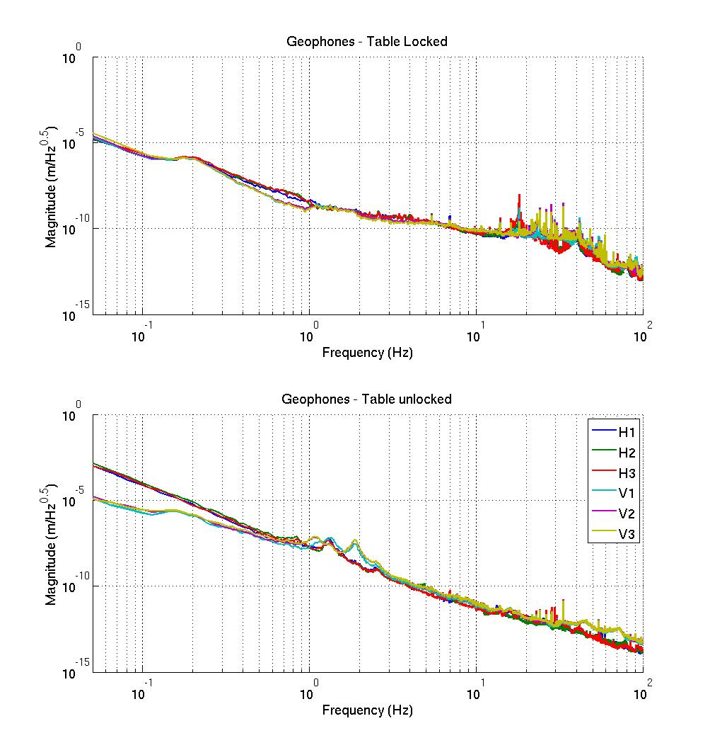
Figure – Power spectrum Calibrated GS13

Step 9.2 – Table tilted
The figure below presents the GS13 powerspectrum when the table is unlocked and loaded with a 20Kg mass at one of its corner.

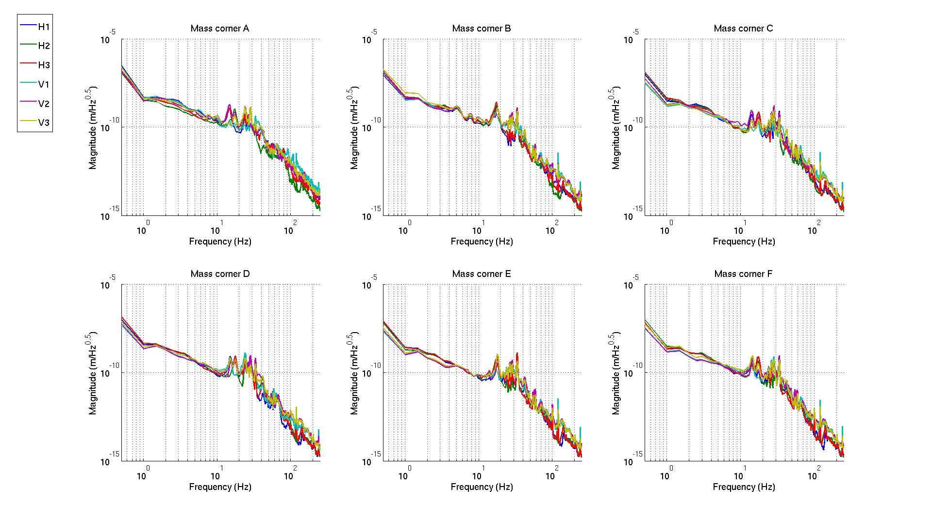
Figure – Power spectrum Calibrated GS13 with mass at corner

Data files in SVN at:
opt//svncommon/seisvn/seismic/HAM-ISI/X1/Data/Unit_3/ Powerspectrum_Undamped
- Power_spectrum_table_locked_ADE_Sync_10_10_08.xml
- Power_spectrum_table_unlocked_ADE_Sync_10_10_08.xml
- Power_spectrum_table_locked_ADE_Sync_10_10_07.txt
- Power_spectrum_table_unlocked_ADE_Sync_10_10_07.txt
- Power_spectrum_table_unlocked_Mass_corner_A_ADE_Sync_10_10_07_V2.xml
- Power_spectrum_table_unlocked_Mass_corner_B_ADE_Sync_10_10_07_V2.xml
- Power_spectrum_table_unlocked_Mass_corner_C_ADE_Sync_10_10_07_V2.xml
- Power_spectrum_table_unlocked_Mass_corner_D_ADE_Sync_10_10_07_V2.xml
- Power_spectrum_table_unlocked_Mass_corner_E_ADE_Sync_10_10_07_V2.xml
- Power_spectrum_table_unlocked_Mass_corner_F_ADE_Sync_10_10_07_V2.xml
- Power_spectrum_table_unlocked_Mass_corner_A_ADE_Sync_10_10_07_V2.txt
- Power_spectrum_table_unlocked_Mass_corner_B_ADE_Sync_10_10_07_V2.txt
- Power_spectrum_table_unlocked_Mass_corner_C_ADE_Sync_10_10_07_V2.txt
- Power_spectrum_table_unlocked_Mass_corner_D_ADE_Sync_10_10_07_V2.txt
- Power_spectrum_table_unlocked_Mass_corner_E_ADE_Sync_10_10_07_V2.txt
- Power_spectrum_table_unlocked_Mass_corner_F_ADE_Sync_10_10_07_V2.txt

Scripts files for processing and plotting in SVN at:
opt/svncommon/seisvn/seismic/HAM-ISI/X1/Data/Unit_3/ Powerspectrum_Undamped
- PSD_CPS_GS13_Lock_Unlock_HAM_ISI_LHO_Unit_3_2010_10_07.m

Figures in SVN at:
opt/svncommon/seisvn/seismic/HAM-ISI/X1/Data/Unit_3/Figures/Powerspectrum_GS13_CPS
- Calibrated_Geophones_Powerspectrum_Locked_Unlocked.fig
- Calibrated_Geophones_Powerspectrum_with_20Kg_Mass_at_one corner.fig

Acceptance criteria:
- With table locked, magnitudes of power spectra must be lower than:
 | Table locked
 | at 0.1Hz | at 1Hz | at 10Hz
H & V Geophones | 8.E-05 | 3.E-08 | 2.E-10

- With table unlocked, magnitudes of power spectra must be lower than:
 | Table unlocked
 | at 0.1Hz | at 1Hz | at 10Hz
Horizontal Geophones | 3.E-04 | 1.E-07 | 1.E-11
Vertical Geophones | 5.E-05 | 1.E-07 | 1.E-11

- With table unlocked and tilted, magnitudes of power spectra must be lower than:
 | Table unlocked (tilted with masses)
 | at 0.1Hz | at 1Hz | at 10Hz
H & V Geophones | 8.E-05 | 3.E-08 | 2.E-10

Test result: Passed: X Failed: .

Step 10 - Coil Driver, cabling and resistance check

Actuator | V1 |  | H1 |  | V2
Coil driver | S1000266 - Coarse 1 OUT |  | S1000266 - Fine 1 OUT |  | S1000266 - Fine 2 OUT
Cable # | 25 |  | 26 |  | 27
Resistance  (Ohm) | P1 - P2 | P2 - P3 | P1 - P2 | P2 - P3 | P1 - P2 | P2 - P3
Resistance  (Ohm) | 6.5 | O.L (infinity) | 6.5 | O.L (infinity) |  | O.L (infinity)
  6.5
MEDM offset  (1000 counts) | Measurement P2 (-) ; P1&P3 (+) |  | Measurement P2 (-) ; P1&P3 (+) |  | Measurement P2 (-) ; P1&P3 (+)
MEDM offset  (1000 counts) | 0.303 V |  | 0.306 V |  | 0.305 V
Actuator | H2 |  | V3 |  | H3
Coil driver | S1000266 - Coarse 2 OUT |  | S1000267 - Coarse 1 OUT |  | S1000267 - Fine 1 OUT
Cable # | 28 |  | 29 |  | 30
Resistance  (Ohm) | P1 - P2 | P2 - P3 | P1 - P2 | P2 - P3 | P1 - P2 | P2 - P3
Resistance  (Ohm) | 6.5 | O.L (infinity) | 6.5 | O.L (infinity) | 6.5 | O.L (infinity)
MEDM offset  (1000 counts) | Measurement P2 (-) ; P1&P3 (+) |  | Measurement P2 (-) ; P1&P3 (+) |  | Measurement P2 (-) ; P1&P3 (+)
MEDM offset  (1000 counts) | 0.307 V |  | 0.298 V |  | 0.301 V
Table - Actuators resistance check

Issues/difficulties/comments regarding this test:

Acceptance criteria:

- The measured resistance between the middle pin and one side pin must be 6.5 +/-1 ohms
- Actuator neutral pins must be connected on pin #1 (left side pin of the plug)
- Actuator drive pins must be connected on pin #2 (middle pin of the plug)
- Actuator ground shield pins must be connected on pin #3 (right pin of the plug)
- All LEDs on the coil driver front panel must be green

Test result: Passed: X Failed: .

Step 11 - Actuators Sign and range of motion (Local drive)

Step 11.1 - Actuators sign

Acceptance criteria: A positive offset drive on one actuator must give positive sensor readout on the collocated sensor. Signs will also be tested when measuring local to local transfer functions.

Test result: Passed: X Failed: .

Step 11.2 - Range of motion - Local drive

 | Negative push | Positive push
H1 | -24207 | 23825
H2 | -25031 | 23209
H3 | -24216 | 25252
V1 | -19040 | 27519
V2 | -25095 | 22519
V3 | -22470 | 21292
Table - Range of motion - Local drive

Issues/difficulties/comments regarding this test:
Acceptance criteria:
- Main couplings read out must be at least +/-16000 counts (~0.002”)
- Signs of actuators drive and sensors read out have to be the same

Test result: Passed: X Failed: .

Step 12 - Vertical Sensor Calibration

Lockers | D.I readout with for  a negative drive | D.I readout without any drive | D.I readout with for  a positive drive
A | -19 | 0 | 19
B | -19 | 0 | 19
C | -19 | 0 | 19
D | -19.5 | 0 | 19
Average | -19.125 | 0 | 19 | 38.1
Sensors | Counts | Counts | Counts | Difference (Counts)
V1 | -15405 | 687.4 | 16464 | 31869
V2 | -14575 | 1244.5 | 17432 | 32007
V3 | -16268 | -304.9 | 15351 | 31619
 |  |  | Average | 31832
Table - Calibration of capacitive position sensors

Vertical sensitivity: 31832/38.1 = 834.9 count/mil
or 834.9 count/mil * 1/1638 V/count = 0.510V/mil
or 25400nm/mil * 1/834.9 mil/count = 30.42 nm/count

Difference with Nominal sensitivity = (834.9-840)/840=-0.60%

Issues/difficulties/comments regarding this test:

Acceptance criteria: Deviation from nominal value < 2%. Nominal value is 840 count/mil.
Test result: Passed: X Failed: .

Step 13 - Vertical Spring Constant

Sensors | Mean diff counts | Mean diff m | K (N/m)
V1 | 8436 | 2.55E-04 | 7.85E+04
V2 | 8007 | 2.42E-04 | 8.27E+04
V3 | 7837 | 2.37E-04 | 8.45E+04
 |  | Average (N/m) | 2.46E+05
Table - Vertical spring constant

The measured vertical stiffness is 2.46e5N/m. The nominal vertical spring constant is 2.428e5N/m. The measured error on the vertical stiffness is 1.24%.

Issues/difficulties/comments regarding this test:

Acceptance criteria:

- Spring constant is within +/- 10/-1% of 2.428e5 N/m (HPD FEA Results).

Test result: Passed: X Failed: .

Step 14 - Static Testing (Tests in the local basis)
 |  | Sensors (counts)
 |  | H1 | H2 | H3 | V1 | V2 | V3
Actuators  (1000 counts) | H1 | 2081 | 1289 | 1301 | 5 | -3 | 6
Actuators  (1000 counts) | H2 | 1286 | 2049 | 1291 | -9 | -1 | 4
Actuators  (1000 counts) | H3 | 1306 | 1291 | 2078 | 17 | -8 | 12
Actuators  (1000 counts) | V1 | 194 | 184 | -380 | 1467 | -26 | -613
Actuators  (1000 counts) | V2 | -376 | 192 | 195 | -626 | 1479 | -25
Actuators  (1000 counts) | V3 | 206 | -368 | 199 | -11 | -634 | 1465
 | Main coupling
 | Important cross coupling

Table - Main and cross coupling

Issues/difficulties/comments regarding this test:

Acceptance criteria:
- Vertical
For a +1000 count offset drive on vertical actuators
  - Collocated sensors must be 1400 counts +/- 10%
- Horizontal
For a +1000 count offset drive on horizontal actuators
  - Collocated sensors must be 2000 counts +/- 10%
  - Non-collocated horizontal sensors must be 1250 counts +/-10%

Test result: Passed: X Failed: .

Step 15 - Linearity test

 | Slope | Offset | Average slope | Variation from  average(%)
H1 | 2.081 | 108 | 2.0860 | -0.25
H2 | 2.079 | -35 | 2.0860 | -0.32
H3 | 2.098 | 437 | 2.0860 | 0.57
V1 | 1.478 | -151 | 1.4674 | 0.71
V2 | 1.473 | 1003 | 1.4674 | 0.40
V3 | 1.451 | -280 | 1.4674 | -1.11
Table - Slopes and offset of the triplet Actuators - HAM-ISI - Sensors

Data files in SVN at:
/opt/svncommon/seisvn/seismic/HAM-ISI/X1/Data/Unit_3/Linearity_test
- Linearity_test_2010_10_07.mat
- Slope_Offset_Linearity_test_2010_10_07.mat

Scripts files for processing and plotting in SVN at:
/opt/svncommon/seisvn/seismic/HAM-ISI/X1/Data/Unit_3/Linearity_test
- Plot_linearity_test_2010_10_07.m

Figures in SVN at:
/opt/svncommon/seisvn/seismic/HAM-ISI/X1/Data/Unit_3/Figures/Linearity_test
- Linearity_test.fig

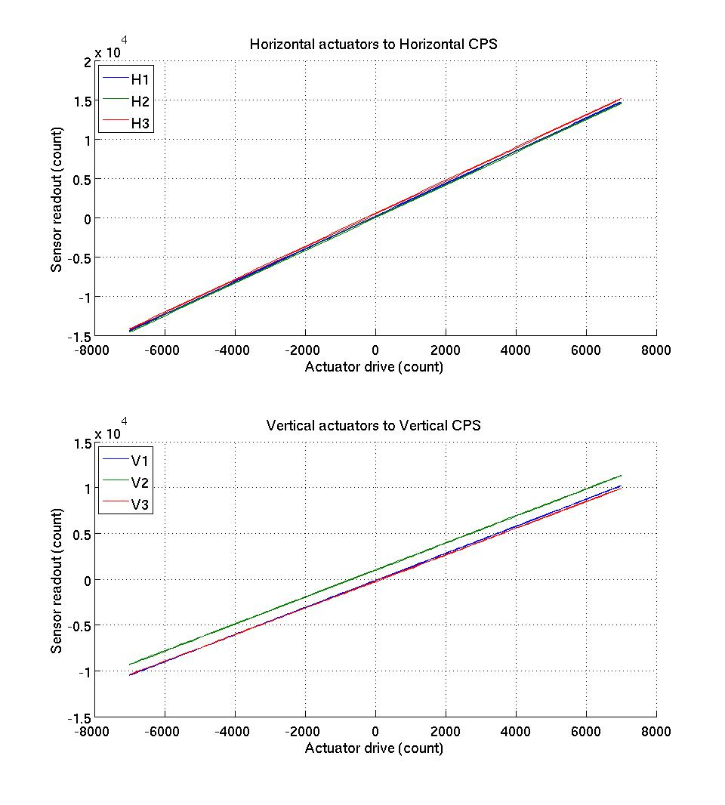
Figure - Horizontal and vertical actuators x HAM-ISI x sensors

Issues/difficulties/comments regarding this test:

Acceptance criteria:

- Horizontal and vertical slopes of the triplet actuators x HAM-ISI x sensors: Average slope +/- 3%.

Test result: Passed: X Failed: .

Step 16 – Static tests in the general coordinate basis

 | 1000 counts Drive | X Drive | Y Drive | Z Drive | Rx Drive | Ry Drive | Rz Drive
Sensors readout  (count) | H1 | 260 | -460 | 2 | -460 | -269 | -2002
Sensors readout  (count) | H2 | 251 | 436 | 7 | 450 | -257 | -2008
Sensors readout  (count) | H3 | -522 | 3 | -1 | 5 | 541 | -2013
Sensors readout  (count) | V1 | 9 | -9 | 280 | -488 | -1692 | 5
Sensors readout  (count) | V2 | -20 | 6 | 262 | 1695 | 423 | -12
Sensors readout  (count) | V3 | 5 | 18 | 252 | -1177 | 1237 | -2
Sensors readout  (count) | Direction read out | 516 | 517 | 265 | 2572 | 2593 | 2542

Table - Tests in the general coordinate basis

Issues/difficulties/comments regarding this test:

Acceptance criteria:
For a positive drive in the Cartesian basis:
- Local sensor readout must have the same sign that the reference table (CONT2ACT check)
- Cartesian sensors read out must be positive (DISP2CEN check) in the drive direction

Test result: Passed: X Failed: .

Step 17 - Frequency response
Compensation filters of the new GS13 interface chassis are located in the geophone pre-filters bank. Powerspectra were measured with masses on the optic table not bolted.

Step 17.1 - Local to local measurements
Local to local transfer functions have been measured with 90 repetitions.
Data collection script files:
opt/svncommon/seisvn/seismic/HAM-ISI/X1/Scripts/Data_Collection
- Run_L2L_50mHz_500mHz.m
- Run_L2L_500mHz_5Hz.m
- Run_L2L_5mHz_200Hz.m
- Run_L2L_200Hz_800Hz.m

Data files in SVN at:
/opt/svncommon/seisvn/seismic/HAM-ISI/X1/Data/Unit_3/Transfer_functions/Local_to_local
- Data_L2L_50mHz_500mHz_20100916-105204.mat
- Data_L2L_500mHz_5Hz_20101014-121533.mat
- Data_L2L_5_200Hz_20101014-104200.mat
- Data_L2L_200_800Hz_20101014-090827.mat
Scripts files for processing and plotting in SVN at:
opt/svncommon/seisvn/seismic/HAM-ISI/X1/Data/Unit_3/Transfer_functions/Local_to_local
- Plot_TF_Local_to_Local_2010_10_14.m
Figures in SVN at:
opt/svncommon/seisvn/seismic/HAMISI/X2/Data/Unit_3/Figures/Transfer_functions/Local_to_Local
- TF_Horizontal_CPS.fig
- TF_Vertical_CPS.fig
- TF_Horizontal_Geophone.fig
- TF_Vertical_Geophone.fig
Storage of measured transfer functions in the SVN at:
opt/svncommon/seisvn/seismic/HAM-ISI/X2/Data/Unit_1/Transfer_functions/Local_to_local
- Local_2_Local_LHO_HAM-ISI-Unit_3_2010_10_14.mat

The local to local transfer functions are presented below.

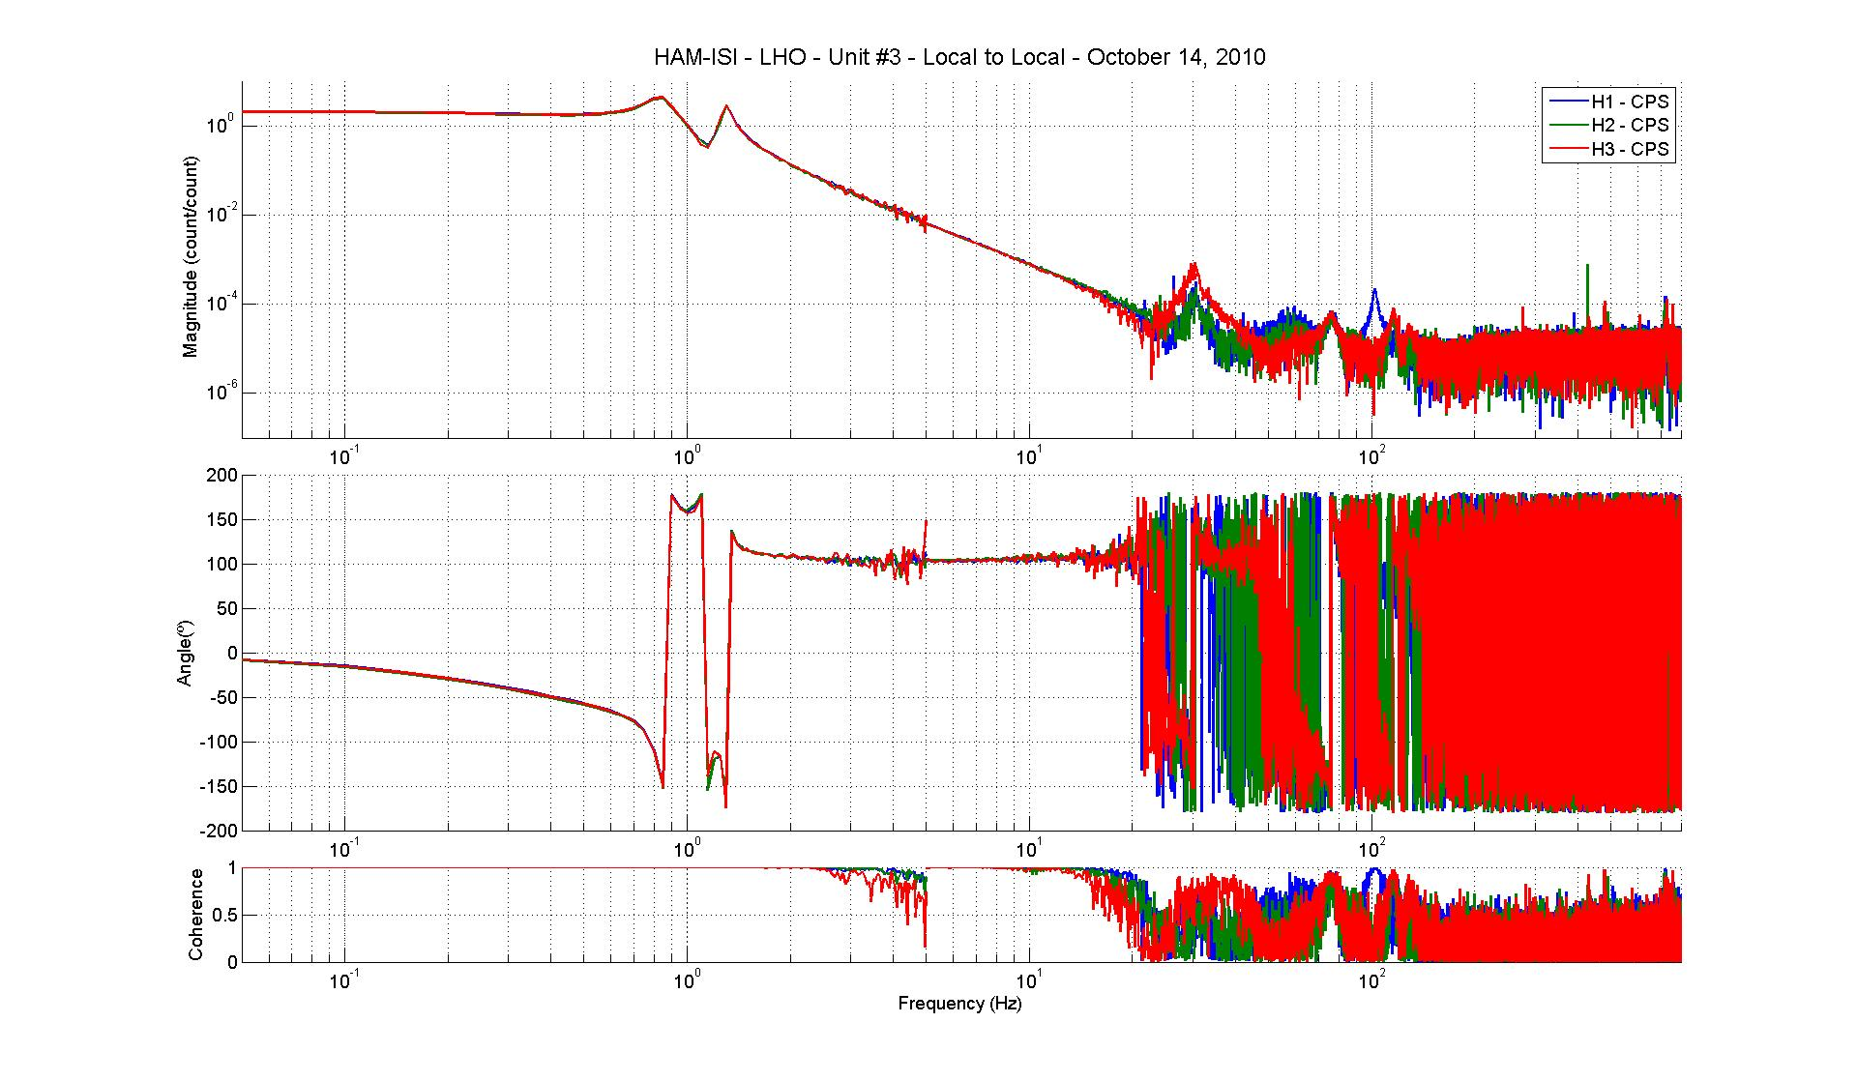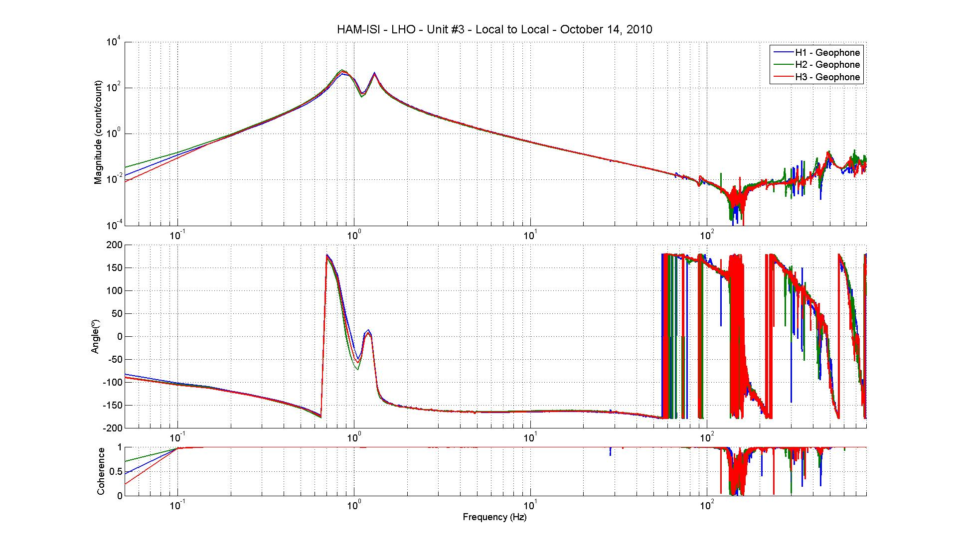
Figure - Local to Local Measurements – Horizontal sensors
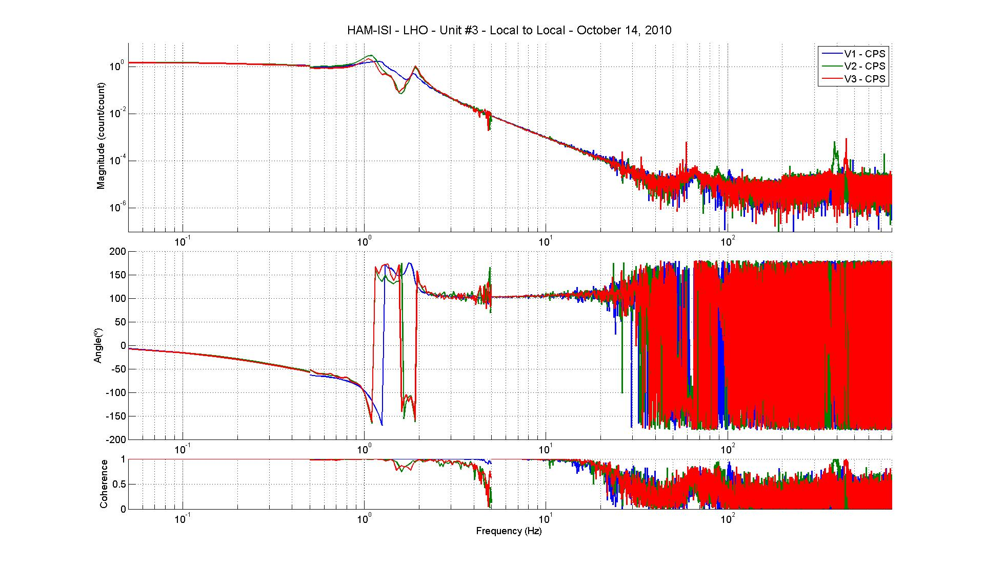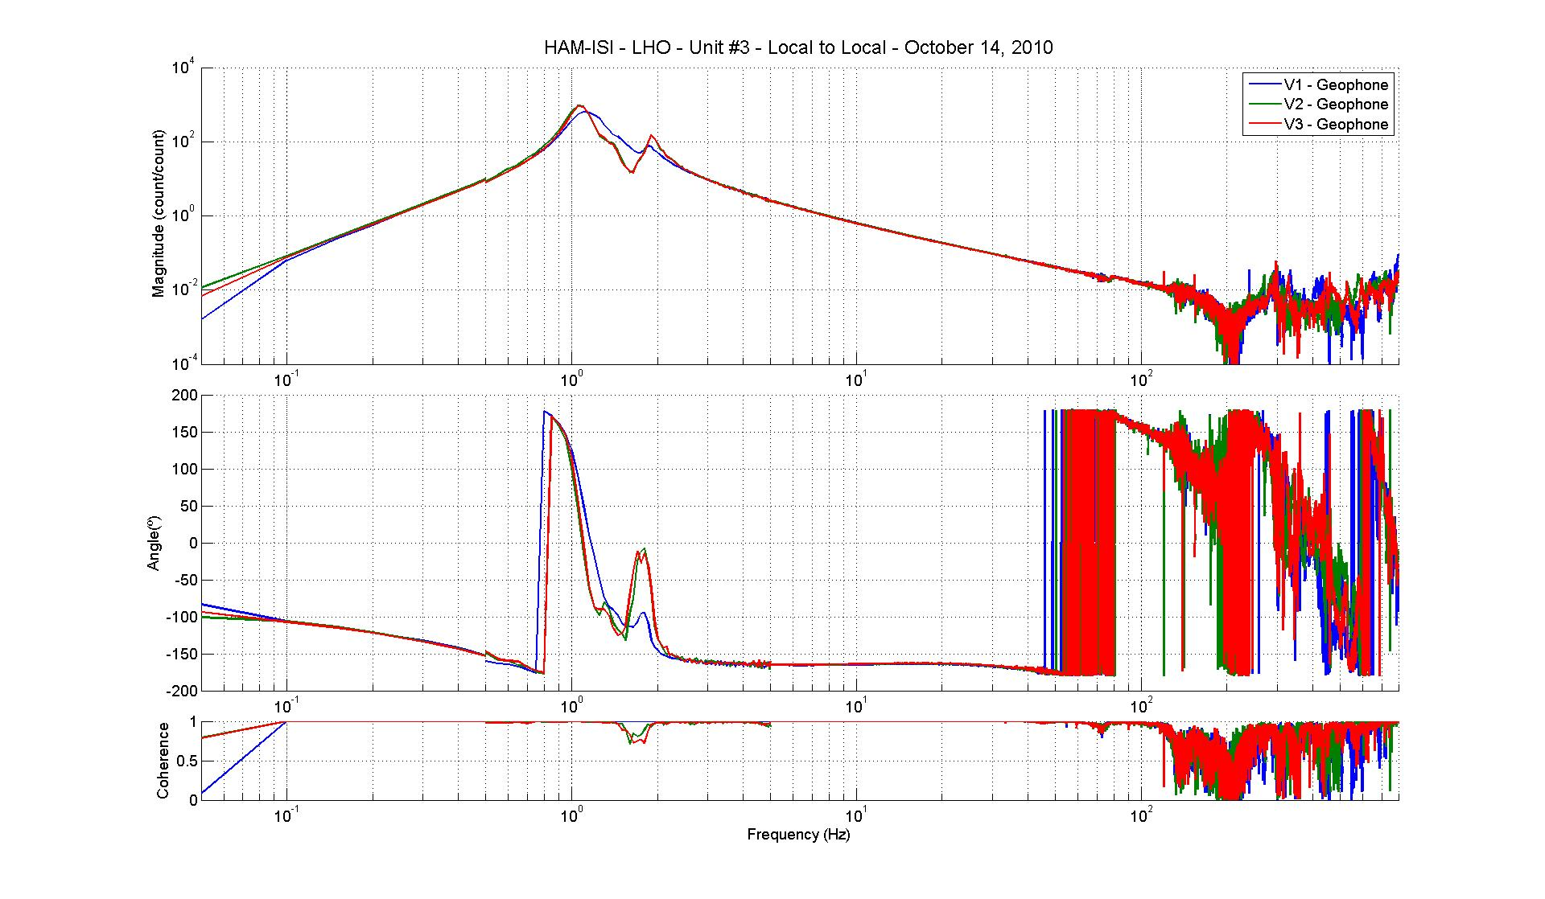
Figure - Local to Local Measurements – Vertical sensors

Issues/difficulties/comments regarding this test: Vertical transfer functions shows an extra resonance between 1Hz and 2Hz

Step 17.2 - Cartesian to Cartesian measurements
Cartesian to Cartesian transfer functions have been measured with 90 repetitions.
Data files in SVN at:
opt/svncommon/seisvn/seismic/HAM-ISI/X1/Data/Unit_3/Transfer_functions/Cartesian_to_cartesian
- Data_Cart2Cart_50mHz_500mHz_20101022-182142.mat
- Data_Cart2Cart_500mHz_5Hz_20101022-151609.mat
- Data_Cart2Cart_5_200Hz_20101022-134236.mat
- Data_Cart2Cart_200_800Hz_20101022-120902.mat

Scripts files for processing and plotting in SVN at:
opt/svncommon/seisvn/seismic/HAM-ISI/X1/Data/Unit_3/Transfer_functions/Cartesian_to_cartesian
- Plot_TF_Cartesian_to_Cartesian_2010_10_23.m

Figures in SVN at:
opt/svncommon/seisvn/seismic/HAMISI/X1/Data/Unit_3/Figures/Transfer_functions/ Cartesian_to_cartesian
- TF_X_Y_RZ_CPS.fig
- TF_X_Y_RZ_Geophone.fig
- TF_Z_RX_RY_CPS.fig
- TF_Z_RX_RY_Geophone.fig

Storage of measured transfer functions in the SVN at:
/svncommon/seisvn/seismic/HAM-ISI/X1/Data/Unit_3/Transfer_functions/Cartesian_to_Cartesian
- Cartesian_2_Cartesian_LHO_HAM-ISI-Unit_3_2010_10_23.mat

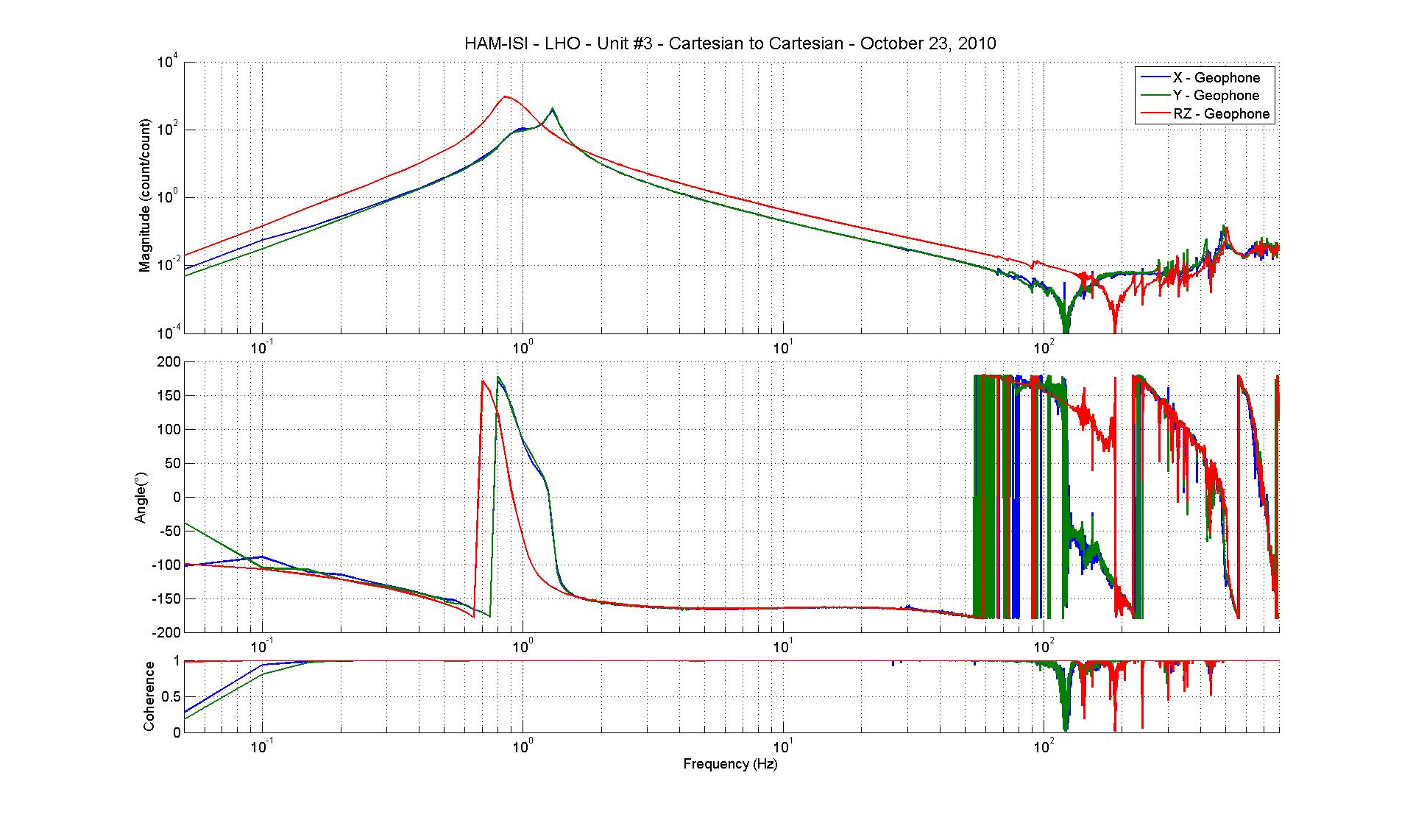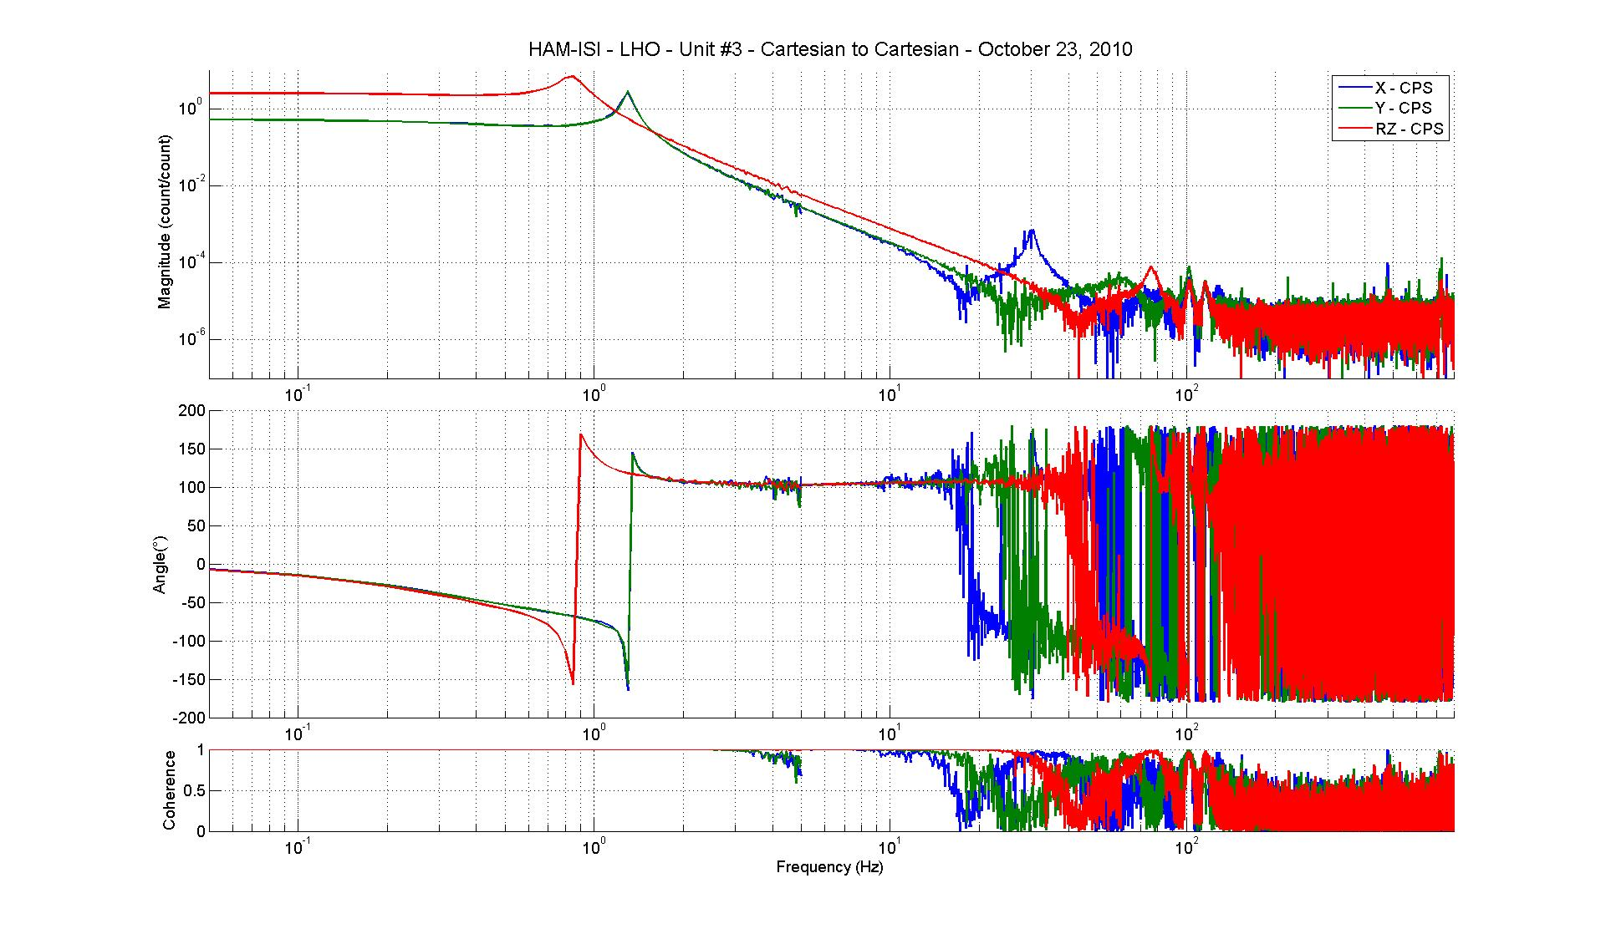
Figure - Cartesian to Cartesian measurements – X, Y, RZ directions

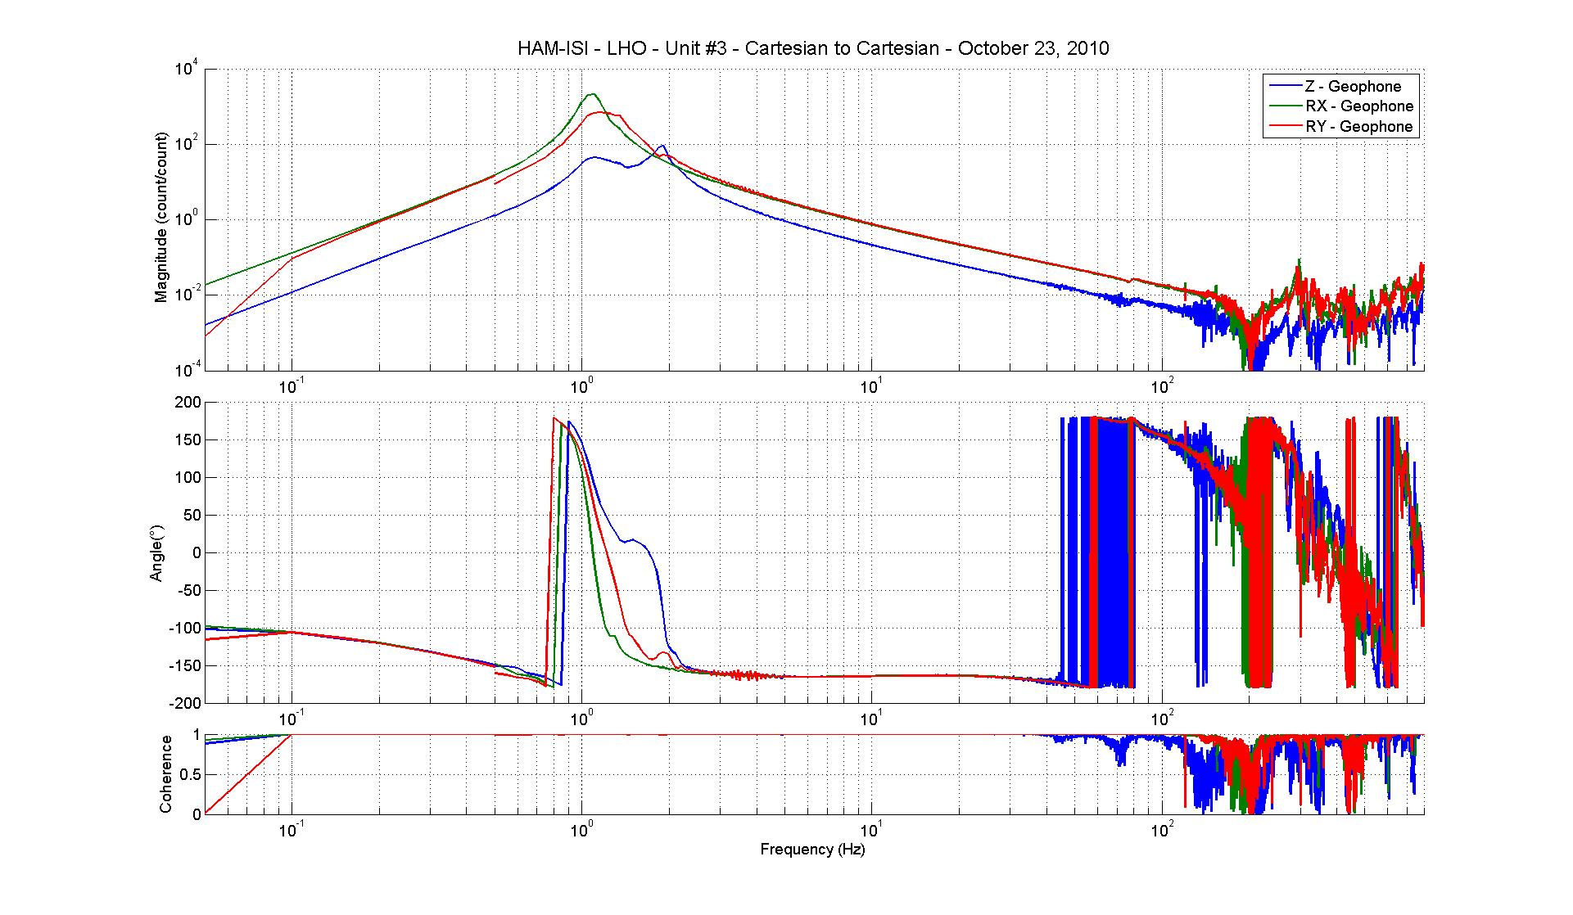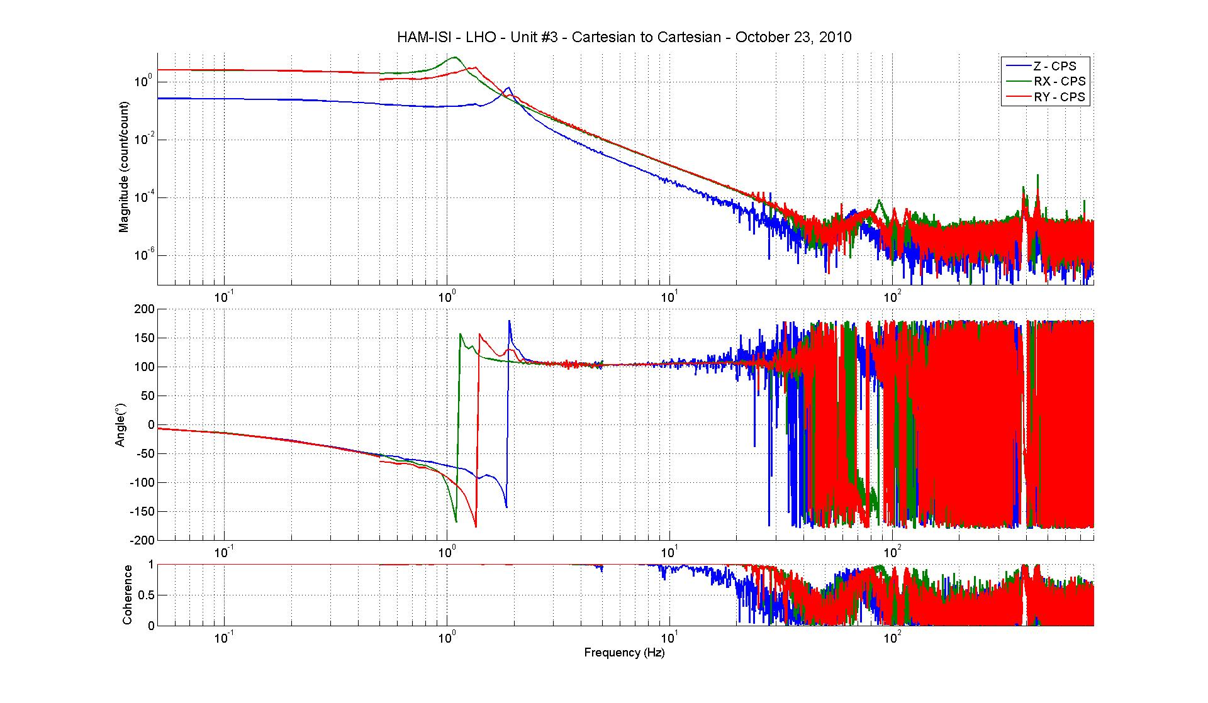
Figure - Cartesian to Cartesian measurements – Z, RX, RY directions

Issues/difficulties/comments regarding this test:

Acceptance criteria:

- Local to local measurement
  - On CPS, the phase must be 0º at DC
  - On Geophones, the phase must be -90º at DC
  - Modal to modal measurement
  - On CPS, the phase must be 0º at DC
  - On Geophones, the phase must be -90º at DC

Test result: Passed: Failed: X .

Step 18 - Transfer function comparison

Step 18.1 - Local to local - Comparison with HAM6

Scripts files for processing and plotting in SVN at:
opt/svncommon/seisvn/seismic/HAM-ISI/X1/Data/Unit_3/Transfer_functions/Local_to_local
- Plot_TF_Local_to_Local_2010_10_14.m

Local to local figures in SVN at:
/svncommon/seisvn/seismic/HAM-ISI/X1/Data/Unit_3/Figures/Transfer_functions/Local_to_Local
- TF_Horizontal_CPS_vs_HAM6.fig
- TF_Vertical_CPS_vs_HAM6.fig
- TF_Horizontal_Geophone_vs_HAM6.fig
- TF_Vertical_Geophone_vs_HAM6.fig

GS13, Local to local measurement

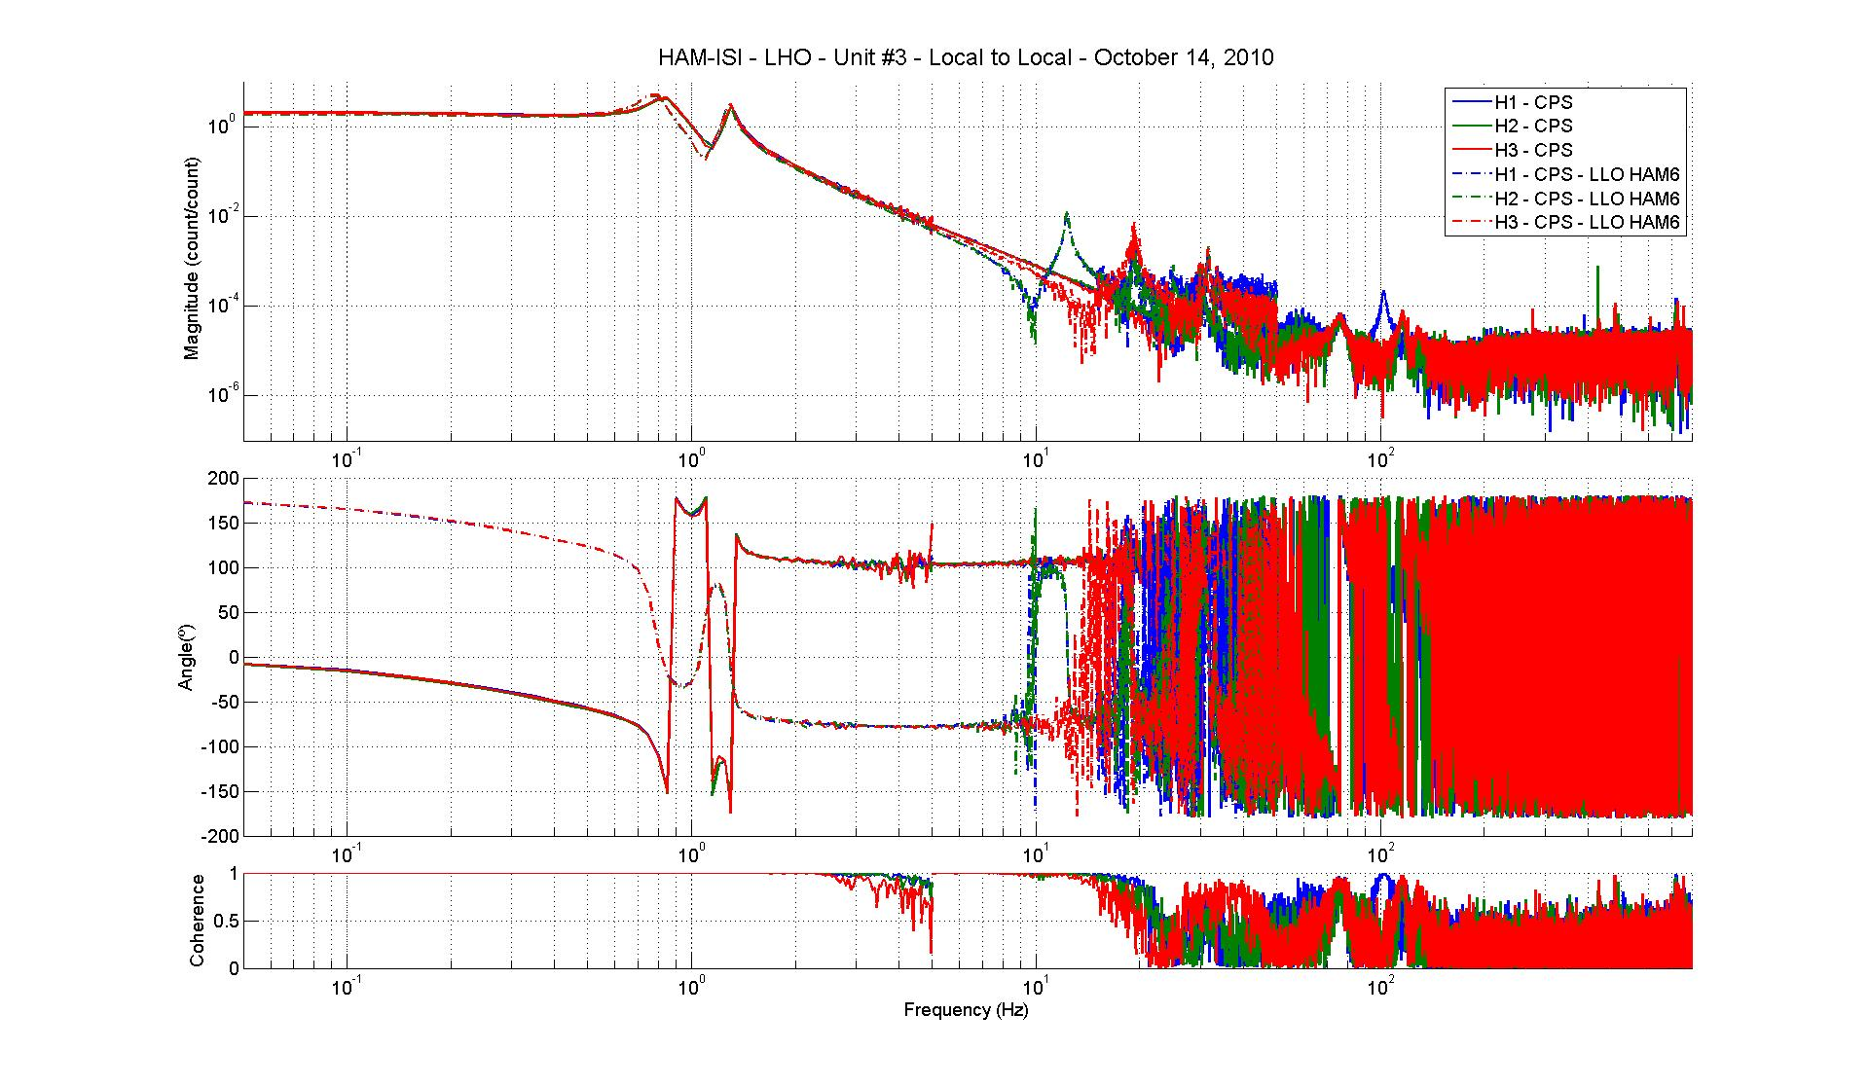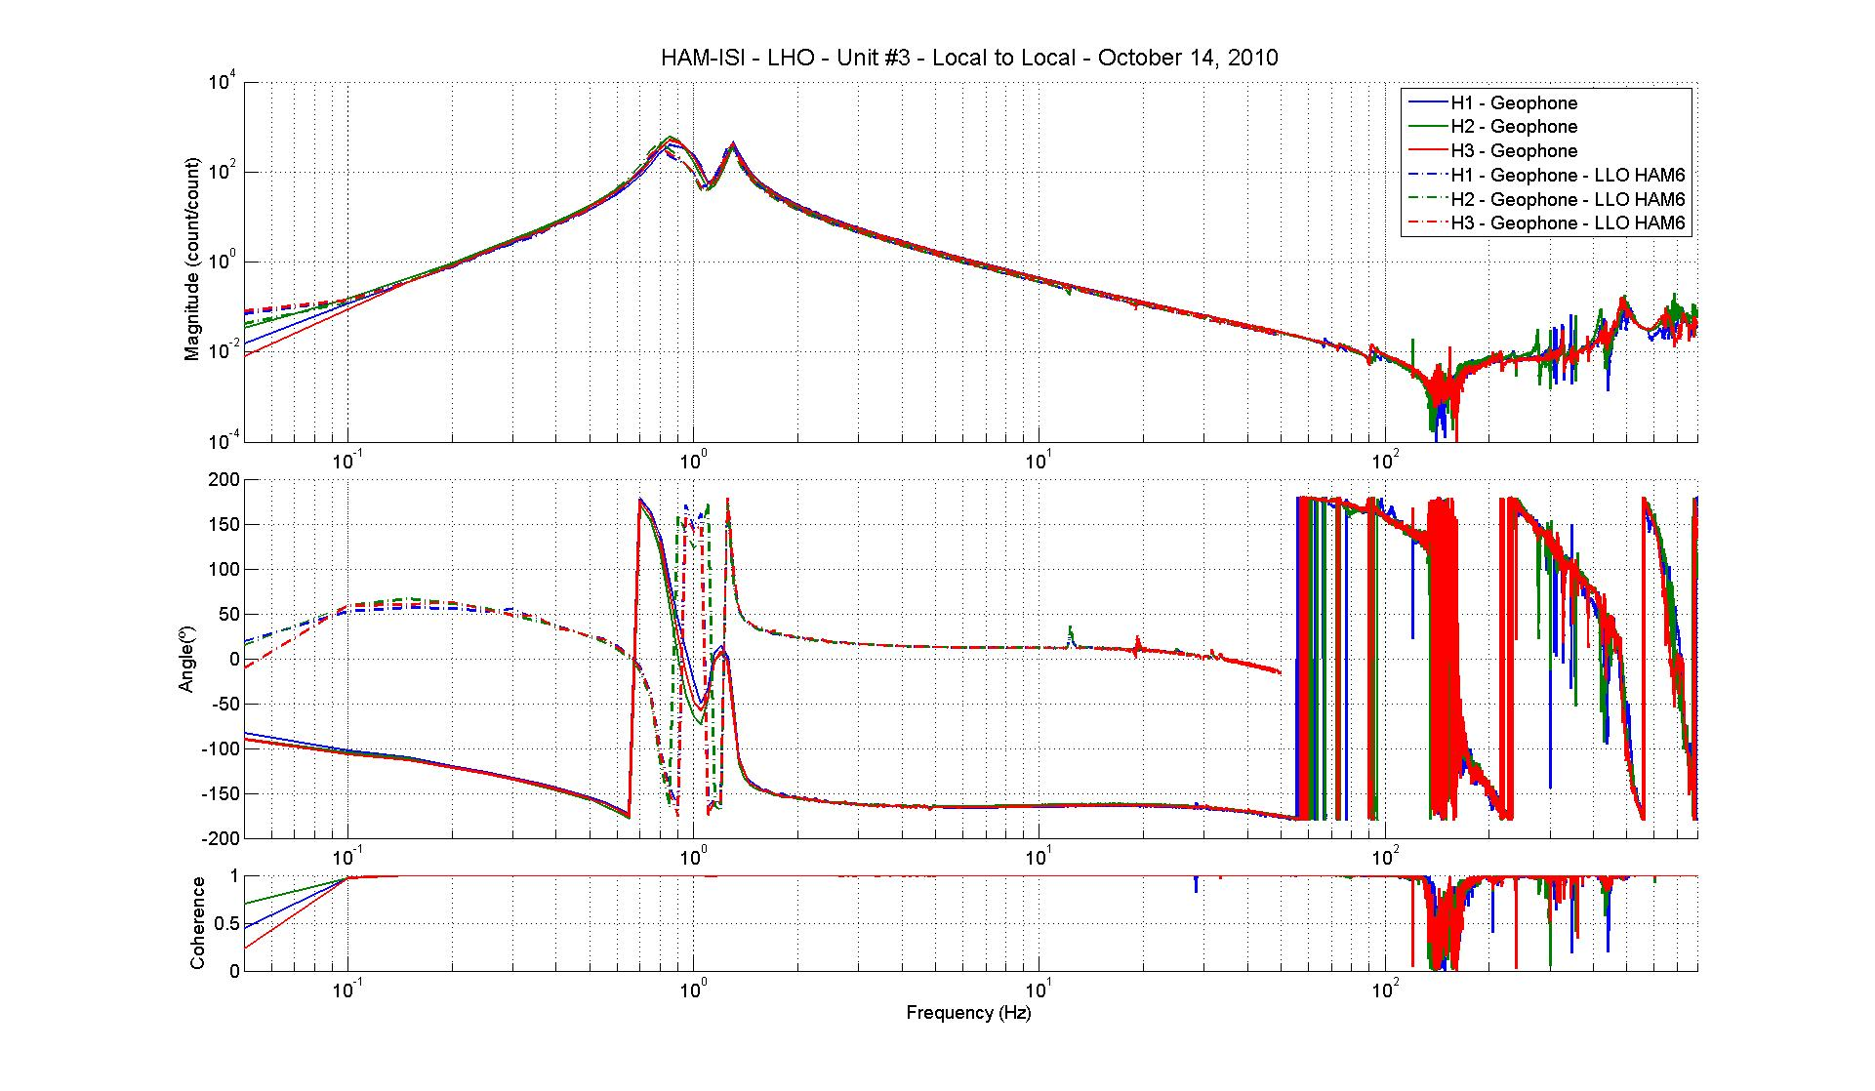
Figure - Local to local measurements comparison with HAM6 – GS13

CPS, Local to local measurement, Undamped
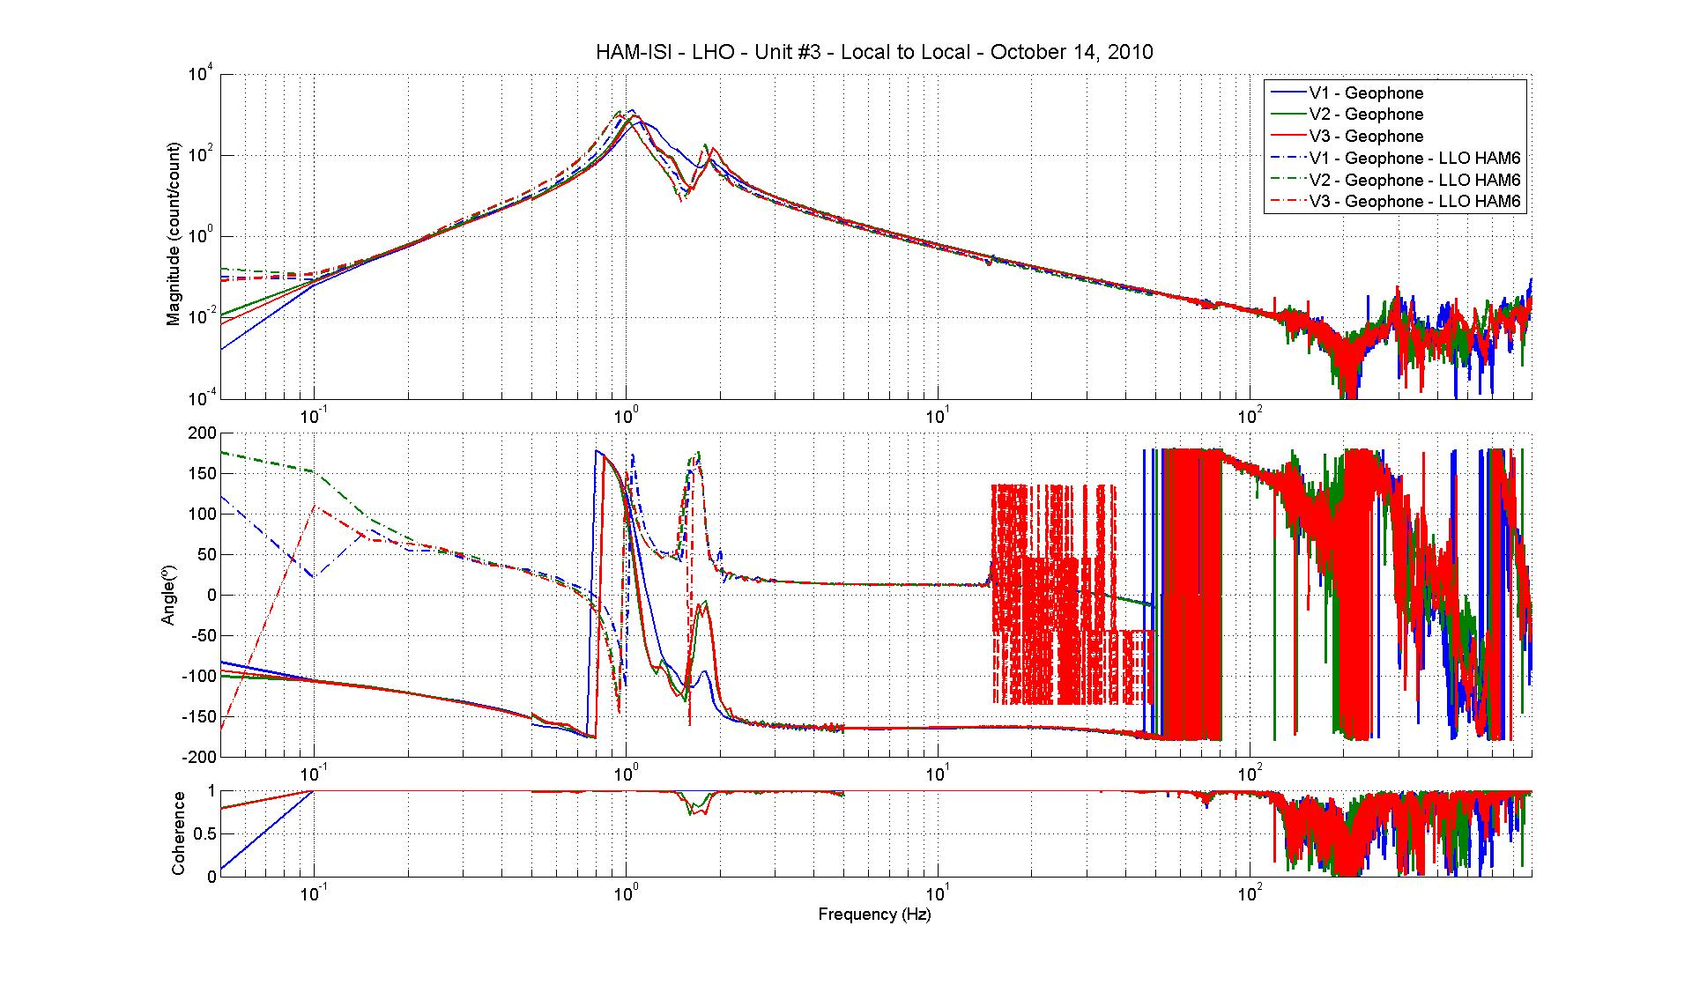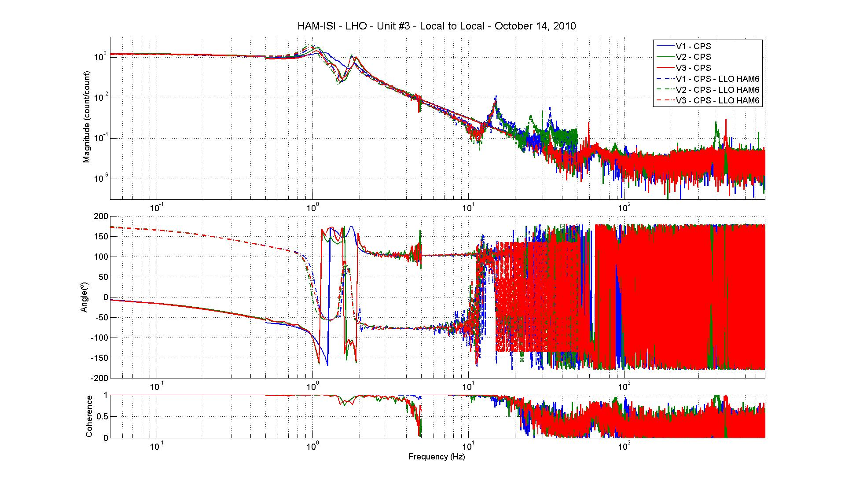
Figure - Local to local measurements comparison – Position sensors

Difference with HAM6:

- Sign difference on CPS and Geophones.
- Transfer functions don’t have the same shape

Step 18.2 - Cartesian to Cartesian - Comparison with HAM6
Scripts files for processing and plotting in SVN at:
opt/svncommon/seisvn/seismic/HAM-ISI/X1/Data/Unit_3/Transfer_functions/Cartesian_to_cartesian
- Plot_TF_Cartesian_to_Cartesian_2010_10_23.m
Cartesian to Cartesian figures in SVN at :
/svncommon/seisvn/seismic/HAM-ISI/X1/Data/Unit_3/Transfer_functions/Cartesian_to_Cartesian
- TF_X_Y_RZ_CPS_vs_HAM6.fig
- TF_Z_RX_RY_CPS_vs_HAM6.fig
- TF_X_Y_RZ_Geophone_vs_HAM6.fig
- TF_Z_RX_RY_Geophone_vs_HAM6.fig

GS13, Cartesian to Cartesian measurement, Undamped

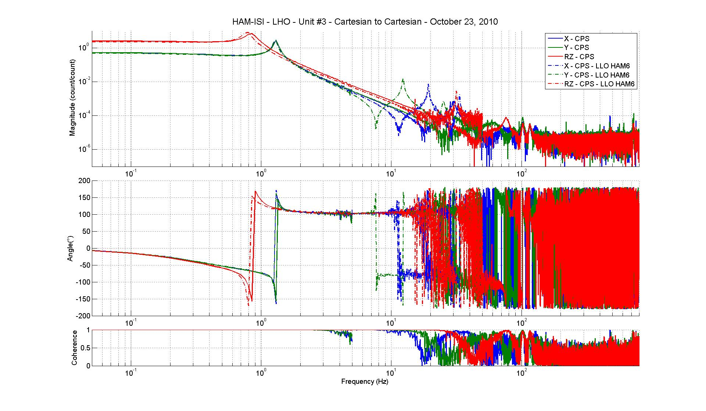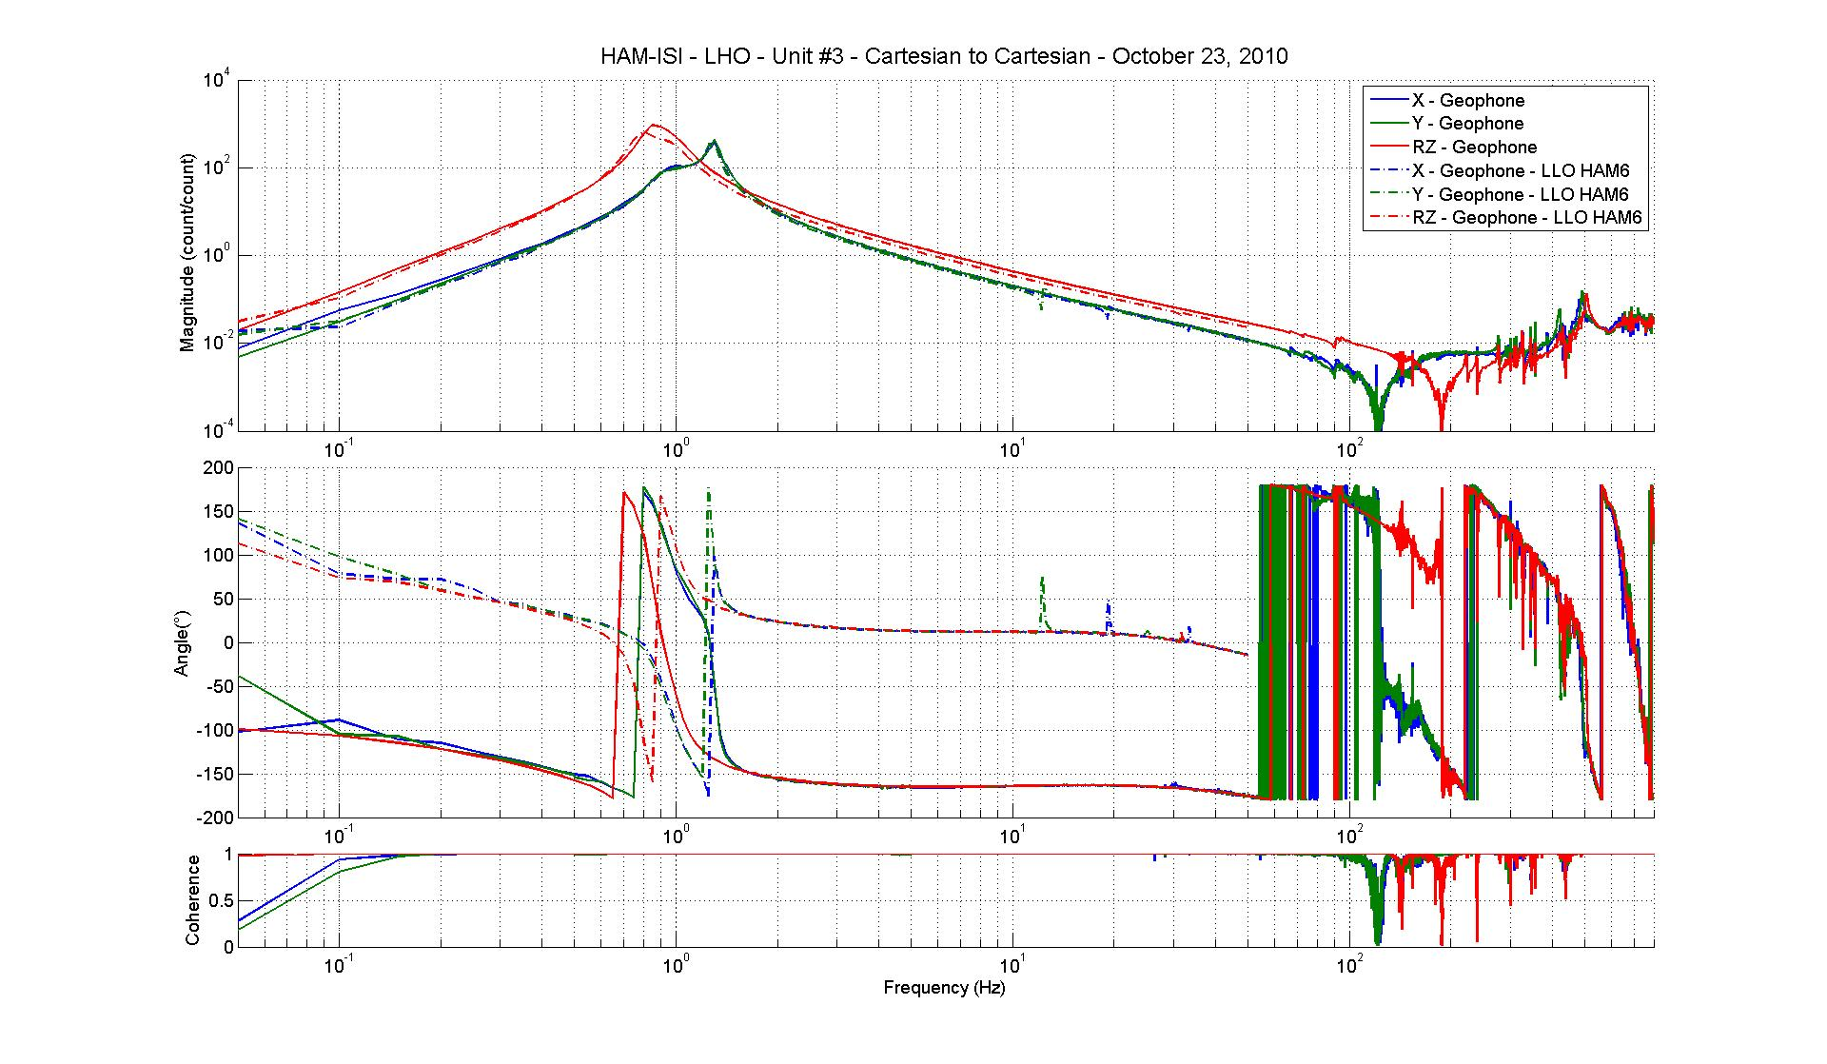
Figure - Cartesian to Cartesian measurements comparison with HAM6 – GS13

CPS, Cartesian to Cartesian measurement, Undamped

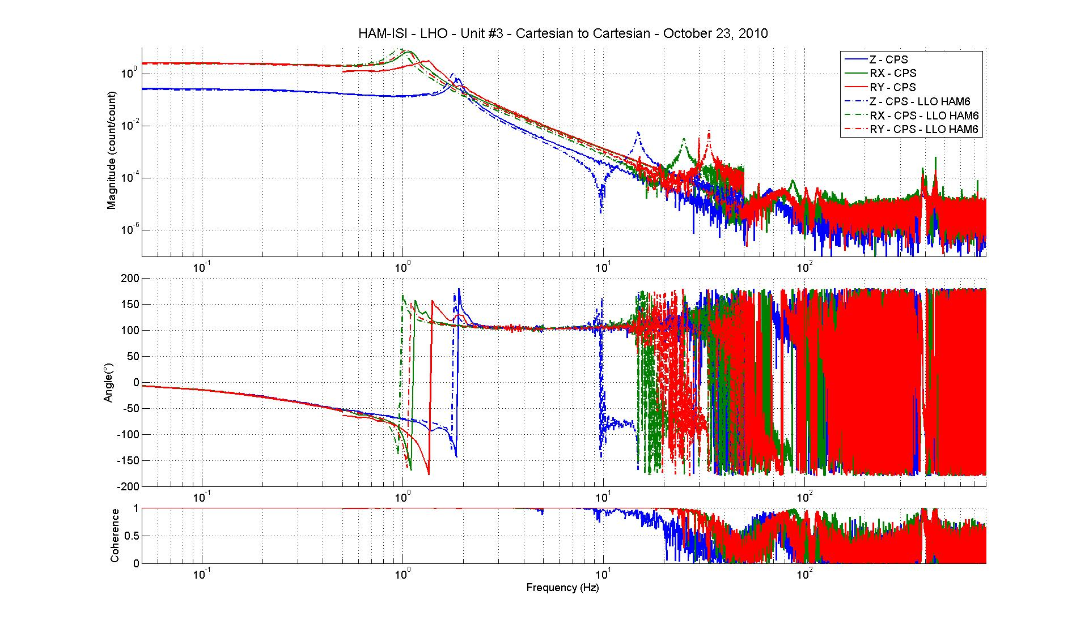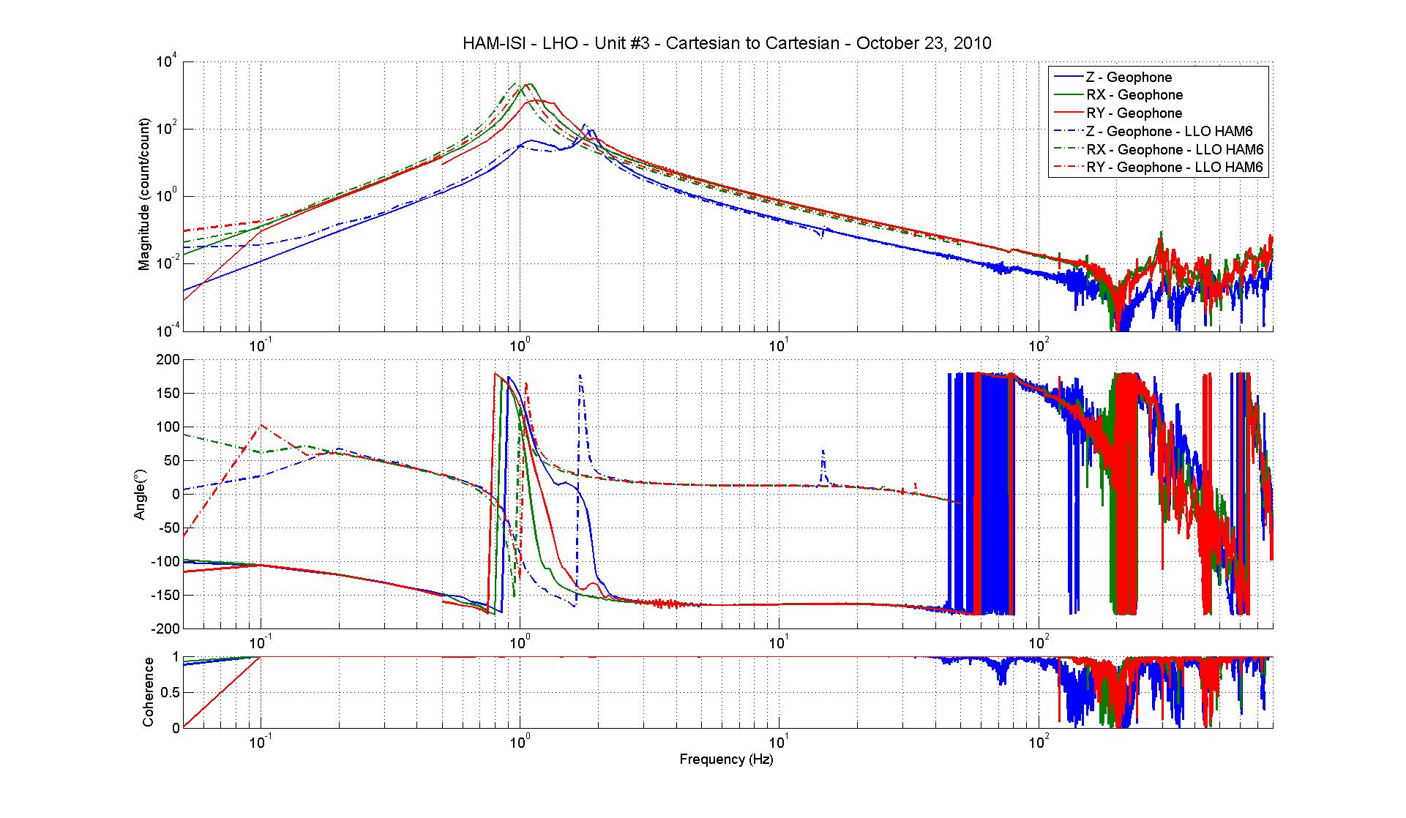
Figure - Cartesian to Cartesian measurements comparison – Position sensors

Difference with HAM6:

- Resonance at 1 Hz is slightly higher than HAM6
- Sign difference on CPS and Geophones
- Transfer function don’t have the same shape

Acceptance criteria:

- No difference with the reference transfer functions (SVN)
  - Phase – less than 10º - In Phase – Out of Phase
  - Damping (fit by eye with the reference transfer functions)
  - DC gain
  - Eigen frequencies shift less than 5%

Test result: Passed: Failed: X .

Step 19 - Lower Zero Moment Plane
Data collection script files:
opt/svncommon/seisvn/seismic/HAM-ISI/X1/Scripts/Data_Collection
- Run_Cart2Cart_10mHz_100mHz.m
Data files in SVN at:
opt/svncommon/seisvn/seismic/HAM-ISI/X1/Data/Unit_3/Transfer_functions/LZMP
- Data_LZMP_Cart2Cart_10mHz_100mHz_20101021-014251.mat
Scripts files for processing and plotting in SVN at:
opt/svncommon/seisvn/seismic/HAM-ISI/X1/Data/Unit_3/Transfer_functions/LZMP
- LZMP_2010_10_21.m
Figures in SVN at:
opt/svncommon/seisvn/seismic/HAM-ISI/X1/Data/Unit_3/Figures/Transfer_functions/LZMP
- LZMP.fig
X & Y offsets:
X offset (mm) | 1.77
Y offset (mm) | 0.37
Table – Offset of the Lower Zero Moment Plane
The results from two measurements are presented on the figure below:

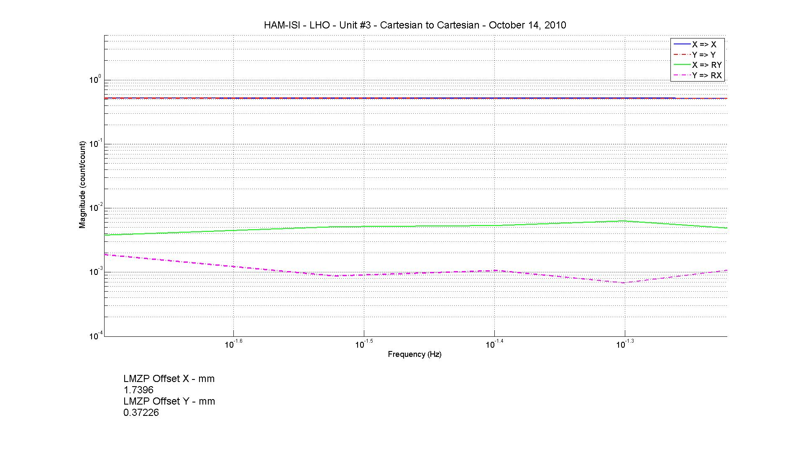
Figure - Lower Zero moment plane – Main and cross couplings at low frequency

Acceptance criteria:

- X offset must be less than 1 mm
- Y offset must be less than 1mm

Test result: Passed: Failed: X .

Step 20 - Damping loops
Filters used by Damping loops in SVN at:
/opt/svncommon/seisvn/seismic/HAM-ISI/X1/FilterDesign/Unit_2/txt_file
- G1ISIHAM_Back_up_2010_09_01.txt (digitalized filters copied and rename to G1ISIHAM.txt in /opt/rtcds/geo/g1/chans)

Step 20.1 - Transfer functions - Simulation
Scripts files for processing and plotting in SVN at:
/opt/svncommon/seisvn/seismic/HAM-ISI/X1/Data/Unit_3/Damping_Loops/Transfer_functions_simulation
- HAM_ISI_LHO_Unit_3_Damping_TF_2010_10_24.m
Figures in SVN at:
/svncommon/seisvn/seismic/HAM-ISI/X2/Data/Unit_3/Figures/Damping_Loops
- Damping_LOOP_H1_H2_H3.fig
- Damping_LOOP_V1_V2_V3.fig

Results are saved in SVN at:
/opt/svncommon/seisvn/seismic/HAM-ISI/X1/Data/Unit_3/Damping_Loops/Transfer_functions_simulation
- Damping_loop_transfer_functions_HAM-ISI-LHO-unit3_2010_10_24.mat
The following figures present the plant, controller, open loop, closed loop and sensitivity of vertical and horizontal damping loops. H1/V1 are plotted in solid line, H2/V2 are plotted in dash line, H3/V3 are plotted in dash-dot line.
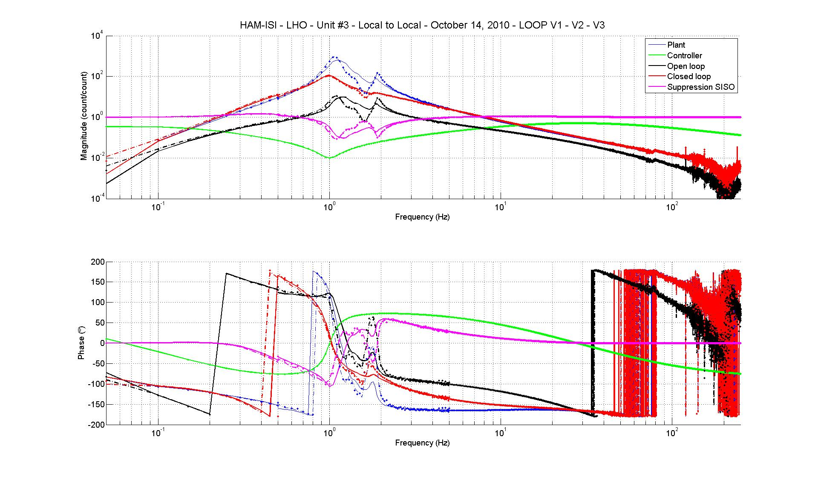
Figure - Vertical damping loops - Simulation

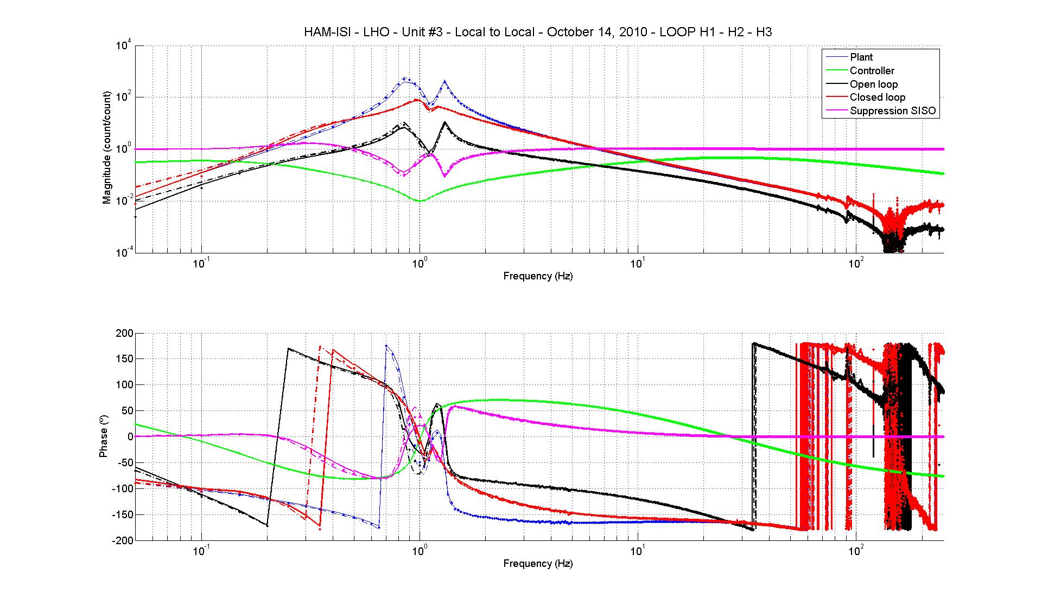
Figure – Horizontal damping loops - Simulation

Step 20.2 - Powerspectrum – Experimental

Data files in SVN at:
/opt/svncommon/seisvn/seismic/HAM-ISI/X1/Data/Unit_3/Damping_Loops/
Powerspectrum_experimental
- Powerspectrum_experimental_Damping_OFF_10_10_11.xml
- Powerspectrum_experimental_Damping_OFF_10_10_11.txt
- Powerspectrum_experimental_Damping_ON_10_10_11.xml
- Powerspectrum_experimental_Damping_ON_10_10_11.txt
Scripts files for processing and plotting in SVN at:
/opt/svncommon/seisvn/seismic/HAM-ISI/X1/Data/Unit_3/Damping_Loops/
DTT_Powerspectrum_experimental
- HAM_ISI_LHO_Unit_3_Damping_Powerspectrum_2010_10_14.m
Figures in SVN at:
/svncommon/seisvn/seismic/HAM-ISI/X1/Data/Unit_3/Figures/Damping_Loops
- Damping_LOOP_GEO_Powerspectrum.fig
- Simulation_vs_experimental_Suppression.fig

Powerspectrum:
The figure below shows power spectrum of Geophones when there when there is no damping loop and when all damping loops are engaged.
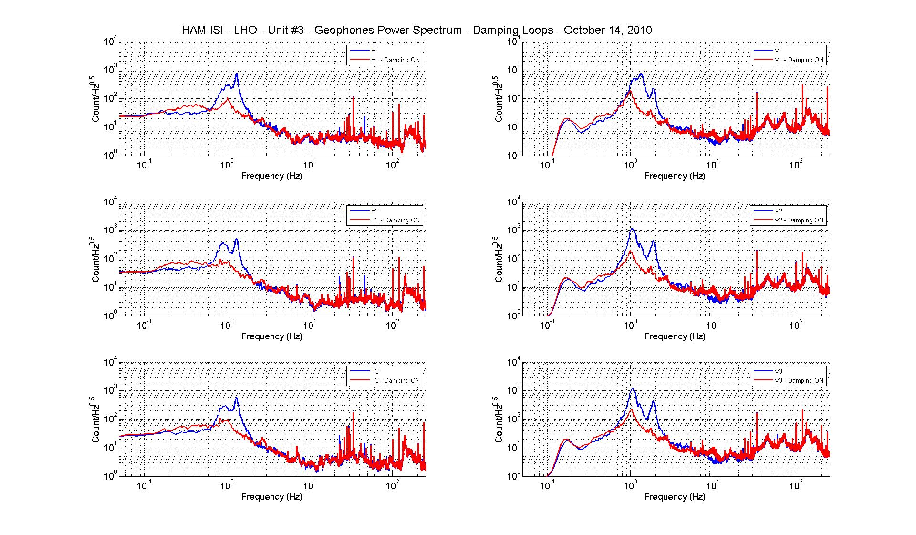
Figure – Horizontal (left) and vertical (right) damping loops - Experimental

Sensitivity:
The figure below compare the sensitivity ('Undamped/Damped') of LLO HAM (Aug 2008) and LHO Unit 2. Performances are very similar, which confirms that we can use the damping loop as they are (modulo electronics change compensation). The plot also shows that the measured performance matches with the prediction.
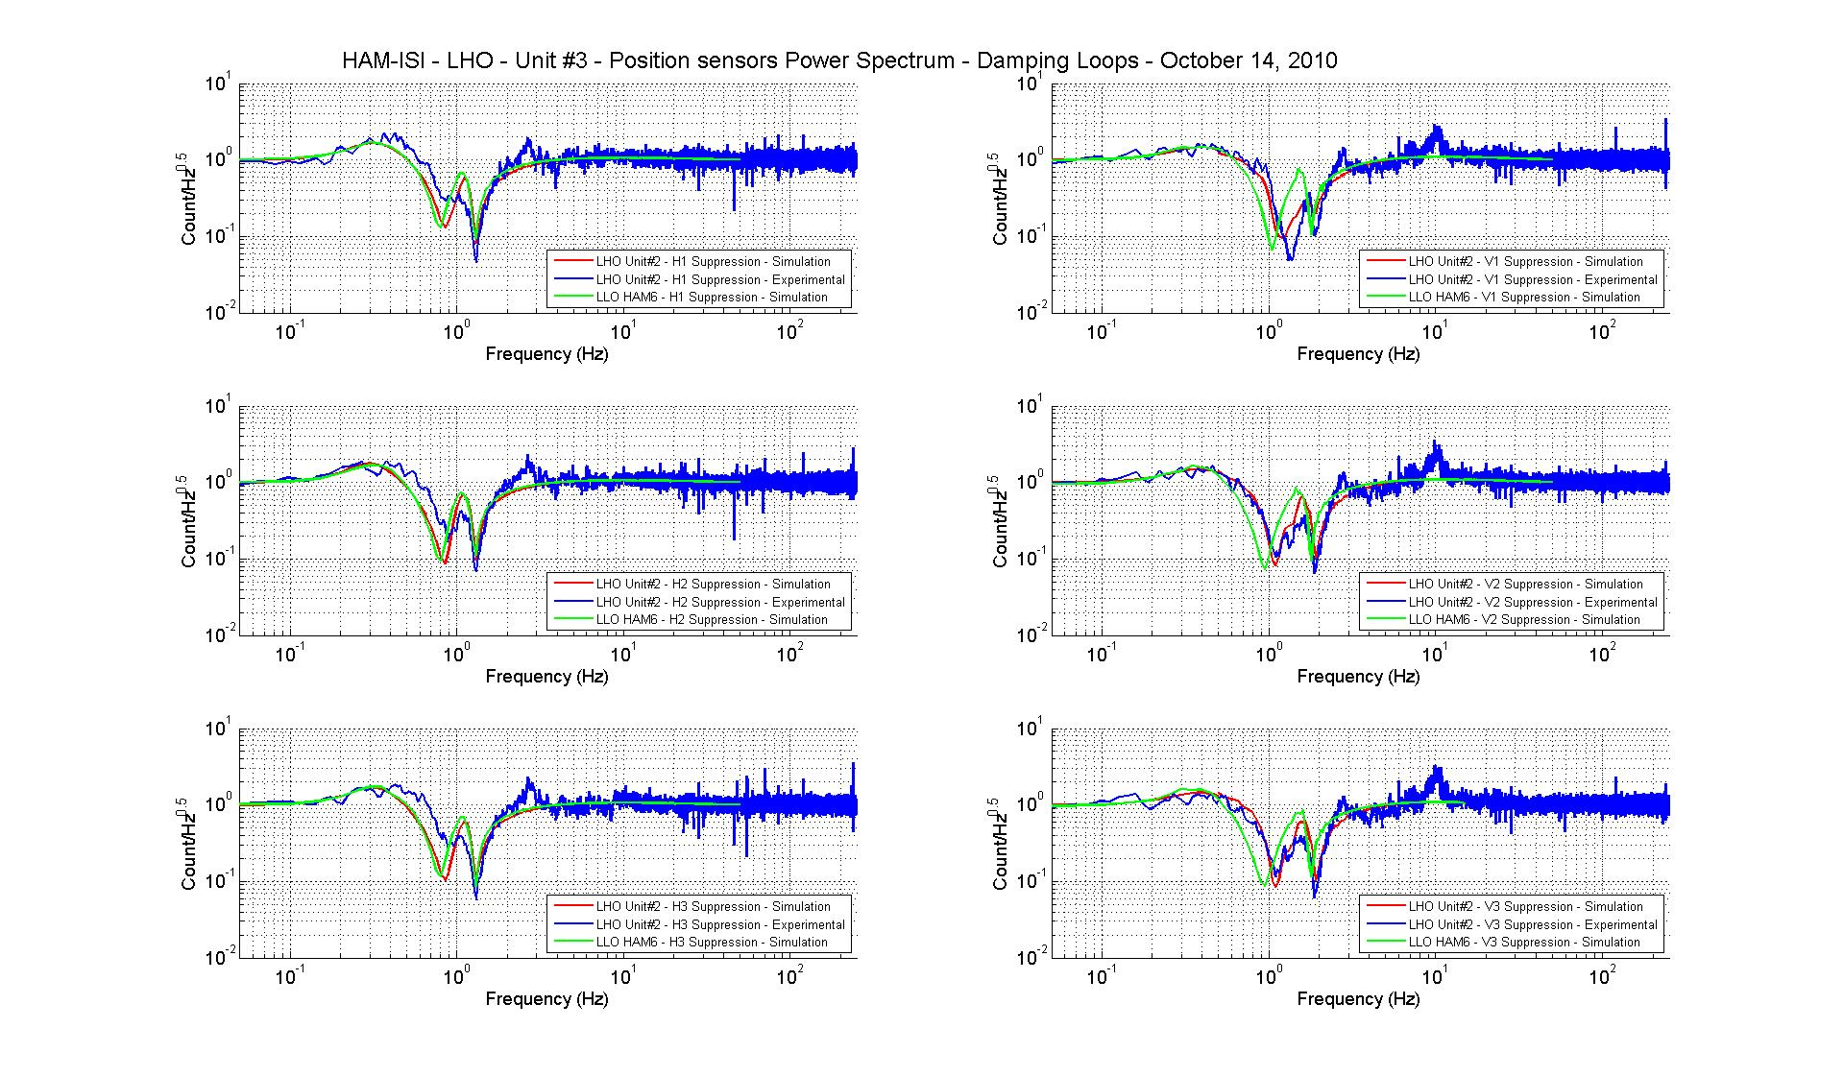
Figure - Damping loop sensitivity

Acceptance criteria:
- Ham 6 damping loop must implemented and stable with
  - Phase margin must be at least 45º
  - Gain margin must be at least 20dB

Test result: Passed: X Failed: .

Testing Summary
Problems encountered during transfer function measurements have not been investigated due to the possible disassembly of HAM-ISI LHO Unit #3.

