LIGO Laboratory / LIGO Scientific Collaboration

LIGO- E1000312 LIGO January, 2011

aLIGO HAM-ISI, Pre-integration Test Report, Phase I,
LHO Unit 3 – HAM10 (post-assembly, before storage, after replacement of faulty parts)
E1000312 – V4

Eric Allwine, Hugh Radkins, Corey Gray, Fabrice Matichard,
Vincent Lhuillier, Hugo Paris

Distribution of this document:
Advanced LIGO Project

This is an internal working note
of the LIGO Laboratory

California Institute of Technology  LIGO Project – MS 18-34  1200 E. California Blvd.  Pasadena, CA 91125  Phone (626) 395-2129  Fax (626) 304-9834  E-mail: info@ligo.caltech.edu | Massachusetts Institute of Technology  LIGO Project – NW22-295  185 Albany St  Cambridge, MA 02139  Phone (617) 253-4824  Fax (617) 253-7014  E-mail: info@ligo.mit.edu
LIGO Hanford Observatory  P.O. Box 1970  Mail Stop S9-02  Richland WA 99352  Phone 509-372-8106  Fax 509-372-8137 | LIGO Livingston Observatory  P.O. Box 940  Livingston, LA 70754  Phone 225-686-3100  Fax 225-686-7189

Table of contents:
Introduction 2
I. Pre-Assembly Testing 3
▪ Step 1: Position Sensors 3
▪ Step 2: GS13 4
▪ Step 3: Actuators 5
▪ Capacitive Position Sensor noise investigaion 6
II. Tests to be performed during assembly 9
▪ Step 1: Parts Inventory (E1000052) 9
▪ Step 2: Check torques on all bolts 10
▪ Step 3: Check gaps under Support Posts 10
▪ Step 4: Pitchfork/Boxwork flatness before Optical Table install 11
▪ Step 5: Blade spring profile 12
▪ Step 6: Gap checks on actuators-after installation on Stage 1 13
▪ Step 7: Check level of Stage 0 14
▪ Step 8: Check level of Stage 1 Optical Table 15
▪ Step 9: Mass budget 16
▪ Step 10: Shim thickness 18
III. Tests to be performed after assembly 19
▪ Step 1 - Electronics Inventory 19
▪ Step 2 - Set up sensors gap 19
▪ Step 3 - Measure the Sensor gap 20
▪ Step 4 - Check Sensor gaps after the platform release 20
▪ Step 5 – Performance of the limiter 21
▪ Step 5.1 - Test Nº1 - Push “in the general coordinates” 21
▪ Step 5.2 - Test Nº2 – Push “locally” 21
▪ Step 6 - Position Sensors unlocked/locked Power Spectrum 22
▪ Step 7 - GS13 power spectrum -tabled tilted 24
▪ Step 8- GS13 pressure readout 25
▪ Step 9 - Coil Driver, cabling and resistance check 25
▪ Step 10 - Actuators Sign and range of motion (Local drive) 26
▪ Step 11 - Vertical Sensor Calibration 27
▪ Step 12 - Vertical Spring Constant 28
▪ Step 13 - Static Testing (Tests in the local basis) 28
▪ Step 14 - Linearity test 29
▪ Step 15 - Cartesian Basis Static Testing 30
▪ Step 16- Frequency response 31
▪ Step 16.1 - Local to local measurements 31
▪ Step 16.2 - Cartesian to Cartesian measurements 35
▪ Step 17 - Transfer function comparison with Reference 37
▪ Step 17.1 - Local to local - Comparison with Reference 37
▪ Step 17.2 - Cartesian to Cartesian - Comparison with Reference 39
▪ Step 18 - Lower Zero Moment Plane 44
IV. HAM-ISI Unit #3 testing summary 46
▪ List of tests that failed and don’t need to be redone: 46
▪ Tests that failed and need to be done during phase II 46
▪ List of test that were skipped and that we will not do because they are not essential 46
▪ List of test that were skipped and need to be done during phase II: 46

Introduction
HAM-ISI Unit #3 (HAM10) was built and tested in October 2010. Since then, it has been disassembled and reassembled due to faulty parts that needed to be replaced. The replacement of these parts implied the need of going through the testing process again, which has been performed early December 2011, and is presented here.
Final GS13 were not available during tests. Test GS13 were used instead. They will be replaced before the in-vacuum installation.
Stage-0 L4Cs were not installed during tests.
The procedure document used to perform this test is:
- E1000309–V9 - aLIGO HAM-ISI, Pre-Integration Testing Procedure, Phase I (post assembly, before storage)
The report done prior to HAM-ISI Unit #3 disassembly/reassembly is posted under V1:
- E1000312_aLIGO_SEI_Testing_Report_HAM-ISI_LHO_Unit_3_V1
Other useful information can be found in:
- E1000300 - HAM-ISI LLO test stand: software and electronic check

Remark regarding SVN paths:
Units used to be called per the order of assembly (i.e. LHO HAM-ISI Unit #3, for the third unit assembled at LHO).
Since we are re-doing the testing of these LHO HAM-ISI units and we now know in which chamber they will be used (Unit #3 will go in HAM10), we have created folders in the SVN named after the chamber:
seismic/HAM-ISI/X1/HAM10/
All the data related to the Phase I testing of this unit is stored in this folder and sub-folders. The data name and exact location of each test result is specified all along the document.

Pre-Assembly Testing

Step 1: Position Sensors
Note: The back panel reads 0.508V/0.001"
S/N sensor | S/N board | ADE Gap Standoff(mm) | Location on the Jig | Gap Standoff on Jig(mm/in) | Voltage before zeroing | Voltage after zeroing. Prebake | Voltage after zeroing. Post bake
11988 | 11846 | NR | 1 | 2.007mm/0.079" | -1 | 0.02 | NR
12004 | 11836 | NR | 1 | 2.007mm/0.079" | NR | 0.01 | NR
11989 | 11842 | NR | 1 | 2.007mm/0.079" | -1 | 0.01 | NR
11997 | 11829 | NR | 1 | 2.007mm/0.079" | -1 | 0.01 | NR
12029 | 11885 | NR | 1 | 2.057mm/0.081" | NR | 0.01 | NR
12040 | 11876 | NR | 1 | 2.057mm/0.081" | NR | 0.01 | NR

NR: not recorded

Sensors noise spectra measured before baking, and before shielding per procedure T1000636:
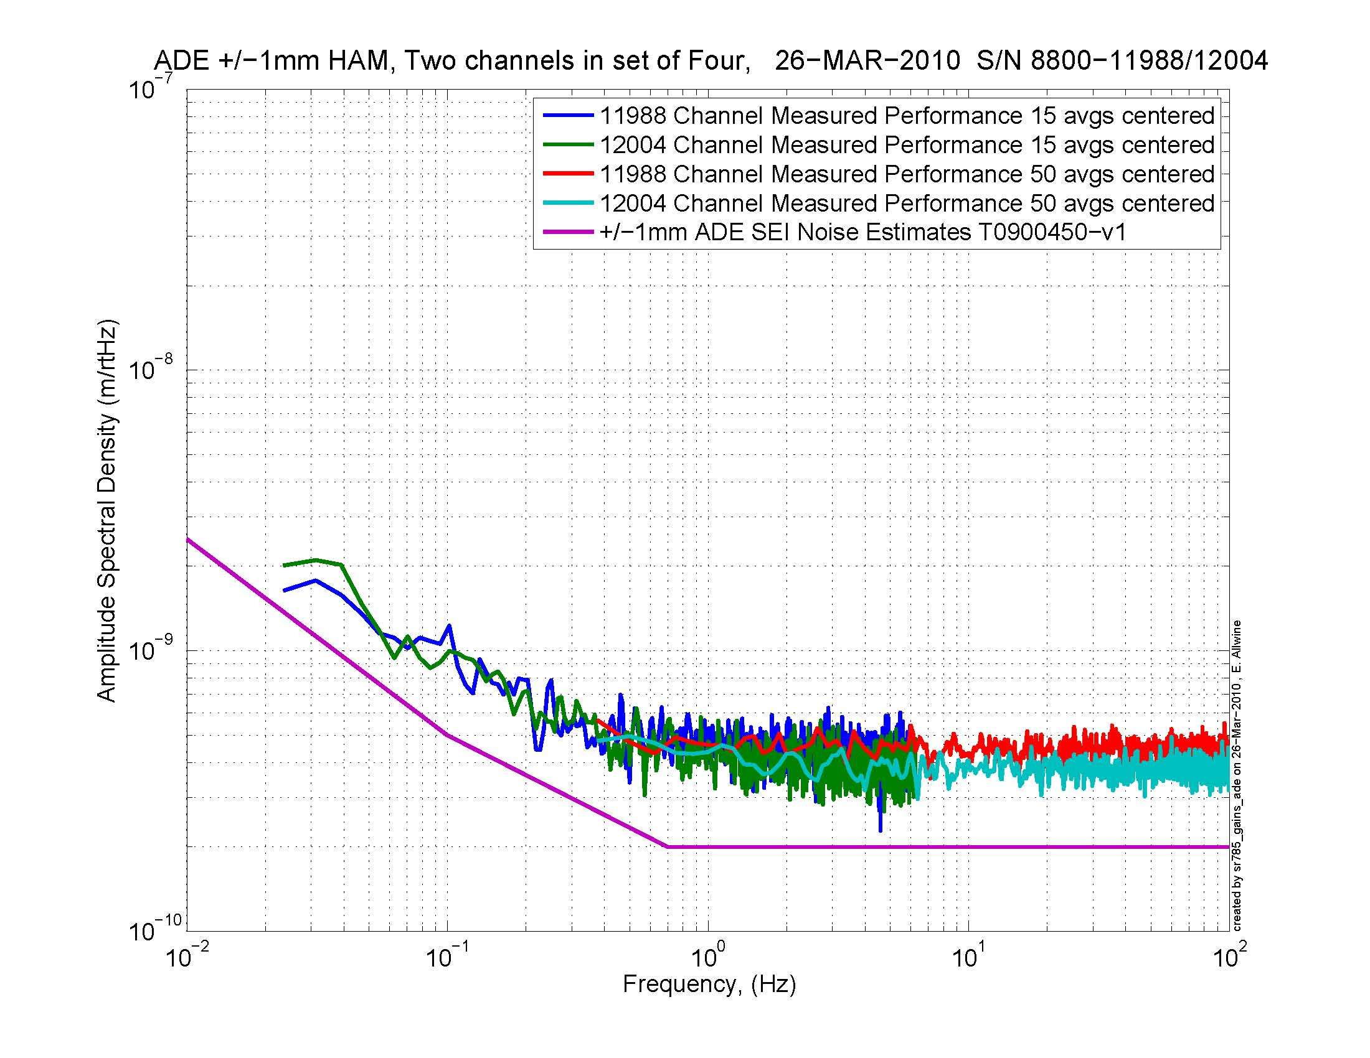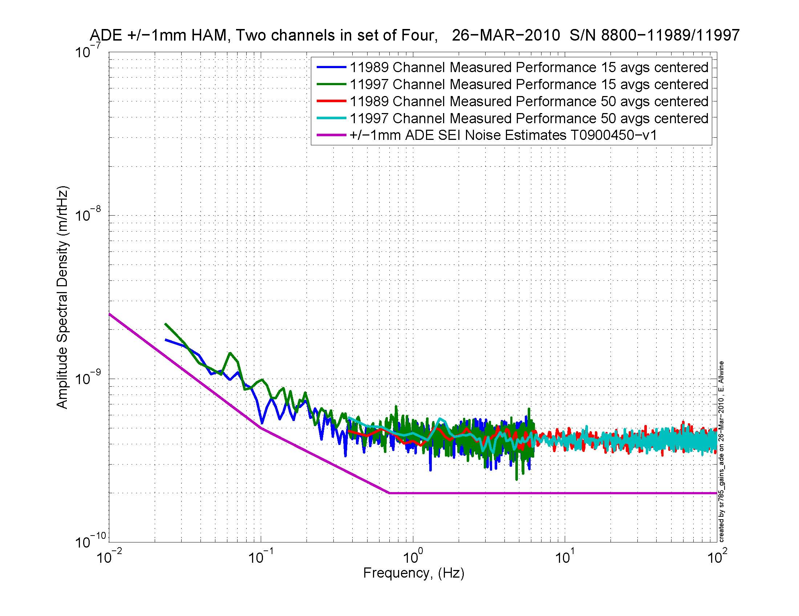
Figure - H1 and V1 sensor noise Figure - H2 and V2 sensor noise

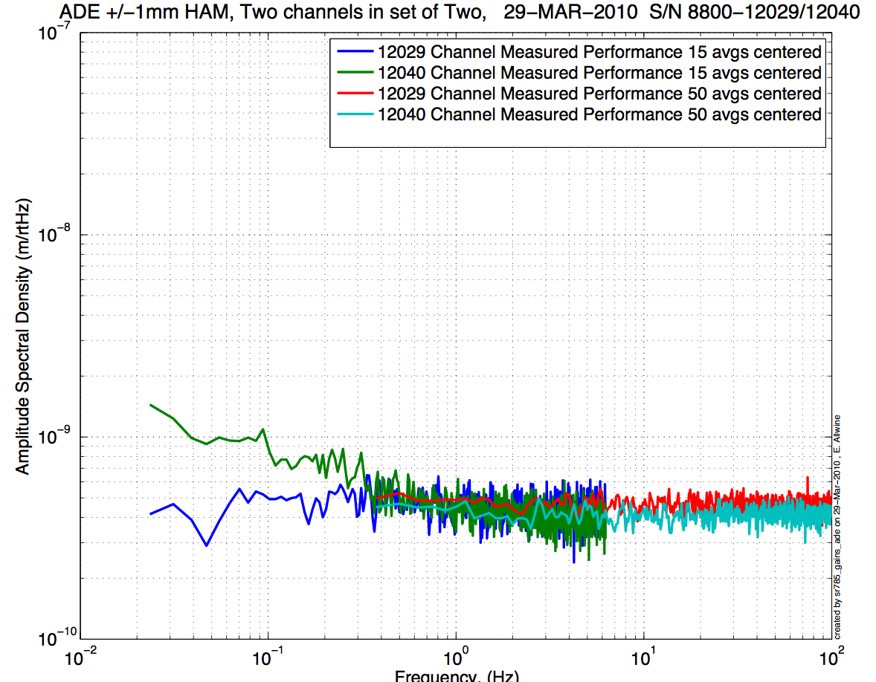
Figure - H3 and V3 sensor noise

Issues/difficulties/comments regarding this test:
- Values of sensor gaps and zeroing were not recorded. Waived for this unit.
- BNC feedthrough connectors have been diagnosed defective and replaced. Voltage after zeroing post brake was not recorded since then. Previous results can still be found in DCC document E100237-V2, Capacitive Position Sensor Testing.

Acceptance Criteria:
- Power spectrum magnitudes must be lower than:
  - 9.e-10 m/√Hz at 0.1Hz
  - 6.e-10 m/√Hz at 1Hz

Test result: Passed: X Failed: .

Step 2: GS13
All the data related to GS-13 post podding testing can be found in the SVN at: SeismicSVN\seismic\Common\Data\aLIGO_GS13_TestData_LHO\
aLIGO GS13 Testing page is E1100367. It contains links to:
- LIGO-E1000058: aLIGO GS-13 Status Chart
- LIGO-E1100393: aLIGO GS-13 as received testing results
- LIGO-E1100394: aLIGO GS-13 prior shipping testing results
- LIGO-E1100395: aLIGO GS-13 Post Modification testing results
- LIGO-F0900070: GS-13 Inspection Checklist

Issues/difficulties/comments regarding this test:
Temporary test GS13 mounted. They are not referenced in the post-podding testing spreadsheet (E1000058-V39). However they have already been successfully used for the 3 previous HAM-ISI testings.

Several issues were encountered and summarized in:
- Vincent Lhuillier, alog #1801: Detection of a malfunctioning horizontal GS13 and description of it symptoms.
- Greg Grabeel, alog #1832: Repairing the horizontal GS13. It seems that the instrument was tilted inside its pod by whether a loose jam nut or an insufficiently tightened crossbar.

Geophones installed in this unit have been used for 3 previous HAM-ISI tests.

Acceptance Criteria:
- GS13 have been already tested at LLO. GS-13 Inspection/Pod Assembly is described in document D047810. Checklist is defined in F090070-v6
- After reception the geophones at LHO ASDs of the geophones must confirm that they are still functioning after shipping.

Test result: Passed: Failed: X .

These pods will be replaced prior insertion.

Step 3: Actuators
Actuator data can be found at: T0900564-V2. Actuator inventory is made at Section II – Step 1.

Actuator Serial #: L036  Operator Name: Gordon, Matt  Date: 9/23/2009 Time: 5:54 PM  Actuator Coil Resistance: 6.33 Ohms, PASS Ambient Temperature: 71.8 F  Hi Pot Test Results: 1000 MOhms, PASS  X Travel Limit (inches): 0.531  Y Travel Limit (inches): 0.205  Z Travel Limit (inches): 0.508 | Actuator Serial #: L053  Operator Name: Gordon, Matt  Date: 9/24/2009 Time: 4:23 PM  Actuator Coil Resistance: 6.36 Ohms, PASS Ambient Temperature: 76.0 F  Hi Pot Test Results: 1000 MOhms, PASS  X Travel Limit (inches): 0.527  Y Travel Limit (inches): 0.205  Z Travel Limit (inches): 0.501
Actuator Serial #: L039  Operator Name: Gordon, Matt  Date: 9/24/2009 Time: 5:00 PM  Actuator Coil Resistance: 6.33 Ohms, PASS Ambient Temperature: 75.8 F  Hi Pot Test Results: 1000 MOhms, PASS  X Travel Limit (inches): 0.525  Y Travel Limit (inches): 0.205  Z Travel Limit (inches): 0.506 | Ac Actuator Serial #: L042  Operator Name: Gordon, Matt  Date: 9/24/2009 Time: 4:39 PM  Actuator Coil Resistance: 6.34 Ohms, PASS Ambient Temperature: 76.1 F  Hi Pot Test Results: 1000 MOhms, PASS  X Travel Limit (inches): 0.526  Y Travel Limit (inches): 0.205  Z Travel Limit (inches): 0.502
Actuator Serial #: L033  Operator Name: Gordon, Matt  Date: 9/23/2009 Time: 2:41 PM  Actuator Coil Resistance: 6.42 Ohms, PASS Ambient Temperature: 74.7 F  Hi Pot Test Results: 1000 MOhms, PASS  X Travel Limit (inches): 0.523  Y Travel Limit (inches): 0.205  Z Travel Limit (inches): 0.506 | Actuator Serial #: L057  Operator Name: Gordon, Matt  Date: 9/23/2009 Time: 6:23 PM  Actuator Coil Resistance: 6.37 Ohms, PASS Ambient Temperature: 71.8 F  Hi Pot Test Results: 1000 MOhms, PASS  X Travel Limit (inches): 0.530  Y Travel Limit (inches): 0.205  Z Travel Limit (inches): 0.503

Issues/difficulties/comments regarding this test:
- Inventory was done after assembly. Vertical actuators serial numbers were not visible then.
- Vertical actuators’ serial numbers come from the previous report (E1000312-V1).

Acceptance Criteria:
- Actuators were previously tested and results are reported in T0900564-V2.

Test result: Passed: X Failed: .

Capacitive Position Sensor noise investigaion

Subject of investigation:
After measuring few amplitude spectral densities of CPS and GS13 on the HAM-ISI, we were surprised by the high density of narrow peaks between 10Hz and 100Hz (cf figure ASD CPS on locked HAM-ISI). Since these peaks are less visible on GS13 spectra (cf step 6, GS13 ASD figure), we thought that electronic noise could create the high Q peaks on the CPSs. Since measurements are taken with the HAM-ISI in the so-called “locked” position, we should not see any stage 0 to stage 1 relative motion. Hence, we got concerned by the grounding of the new shielding installed on the CPS cables.

Data in SVN at:
/opt/svncommon/seisvn/seismic/HAM-ISI/X1/HAM10/Data/Spectra/Undamped/
- LHO_ISI_HAM10_ASD_m_CPS_T240_L4C_GS13_Locked_vs_Unlocked_2011_12_14.mat

Figures in SVN at:
/opt/svncommon/seisvn/seismic/HAM-ISI/X1/HAM10/Data/Figures/Spectra/Undamped
- LHO_ISI_HAM10_ASD_m_CPS_Locked_Zoom_2011_12_14.fig

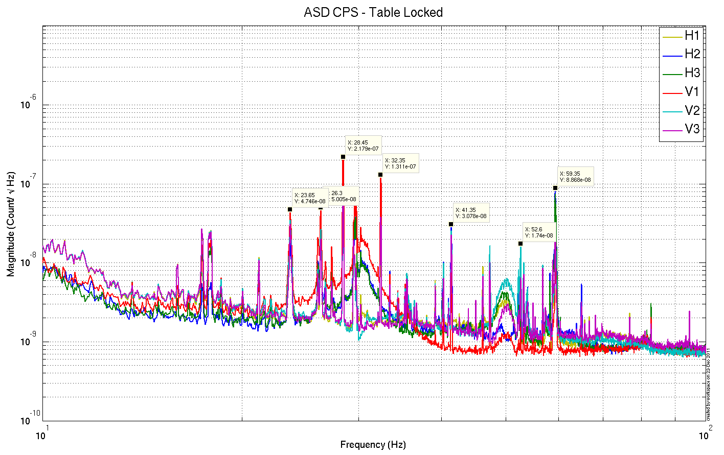
Figure –ASD CPS on locked HAM-ISIs

Extra tests:
We took measurements in different configurations to find the source of the peaks:
- CPS spectra fans ON vs fans OFF: We only saw minor differences
- Spectra of a locked CPS using the jig in several configurations:
  - Shield not connected to the ground
  - Shield connected to the ground

The two spectra (shield not grounded, and shield grounded) are identical and without any features in the 10-100Hz bandwidth (Noise floor at 5e-10 m/sqrt Hz). It confirms that CPSs are not picking up electric noise but are actually seeing a real motion.

The figure below is the calibrated ASD of the CPS on the jig.

- 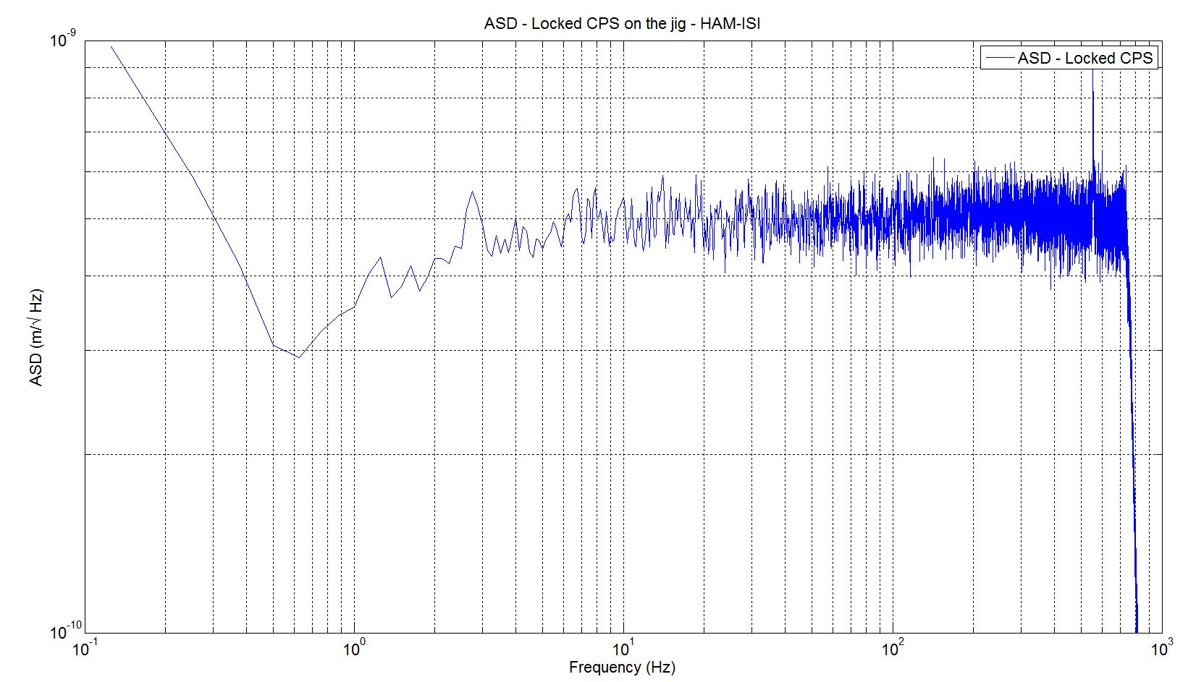
Figure –ASD locked CPS on the jig

Ground motion measurement
A L4C was set on the ground to confirm that the peaks seen on HAM-ISI CPS ASD, in the so-called “locked” position, comes from ground motion itself. Due to the passive isolation provided by the ISI above 1Hz, amplitudes of the narrow peaks (probably motors) are reduced on GS13 (in the unlocked and the so-called locked configurations).

Narrow peaks agree with ASD of CPS in “locked configuration”

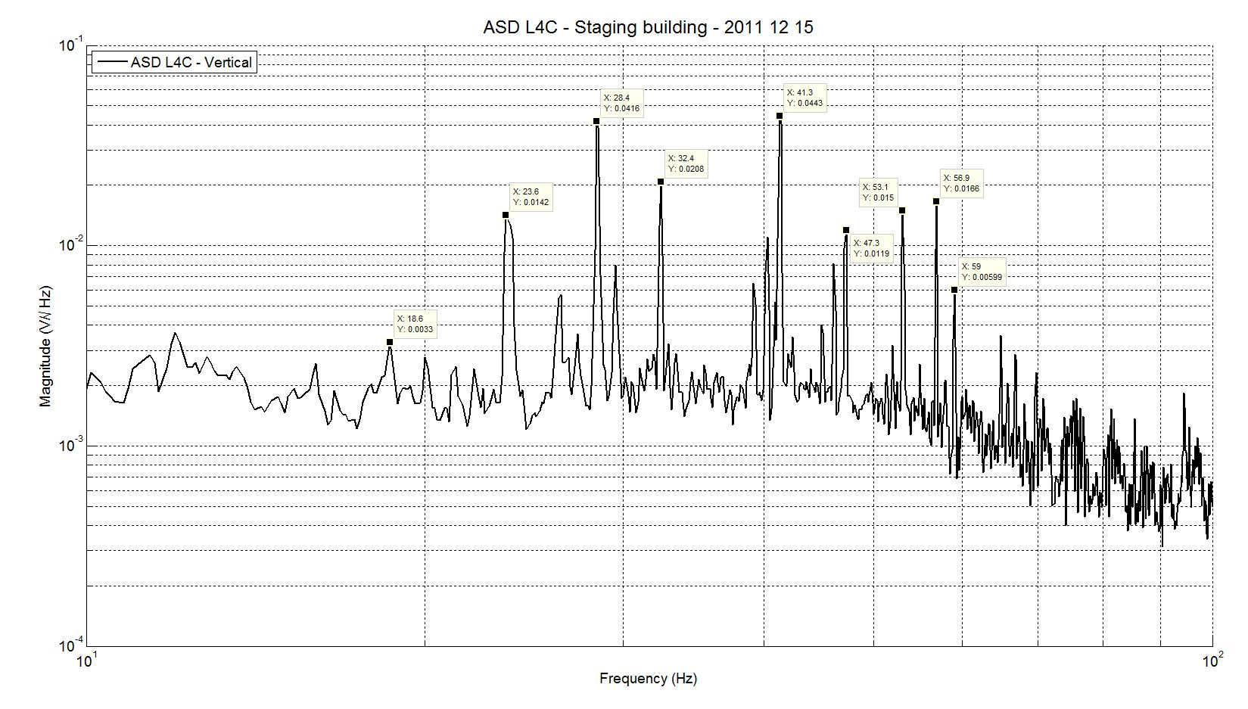
Figure – ASD of L4C on the ground in LHO staging building

Conclusions regarding this test:
This last measurement confirms that the peaks seen on the ASD of the CPS when the HAM-ISI is locked are due to ground motion.

Tests to be performed during assembly

Step 1: Parts Inventory (E1000052)
DCC Number | Part name | Configuration | Corner 1 S/N | Corner 2 S/N | Corner 3 S/N
D071001 | Stage 0 base | NA | 008
D071051 | Stage 1 base | NA | 008
D071050 | Optical table | NA | 7
D071002 | Spring Post | NA | 036 | 440 | 030
D071100 | Spring | NA | NR | NR | NR
D071102 | Flexure | NA | NR | NR | NR
ADE | Position sensor | Horizontal | 11988 master 0 | 11989  slave 180 | 12029  slave 0
 |  | Vertical | 12004  slave 180 | 11997  salve 0 | 12040 slave 180
D047812 | GS-13 pod | Horizontal | 058 | 013 | 068
 |  | Vertical | 049 | 040 | 059
D047823 | L4C pod | Horizontal | NA | NA | NA
 |  | Vertical | NA | NA | NA
D0902749 | Actuator | Horizontal | L053 | L057 | L042
 |  | Vertical | L036 | L039 | L033
Table – Parts inventory

Cable Connects |  | Cable S/N
Part Name | Configuration | Corner 1 | Corner 2 | Corner 3
GS13 | Horizontal | S1106672 | S1106661  S1104679 | S1104776  S1104673
GS13 | Vertical
L4C | Horizontal | NA | NA | NA
L4C | Vertical | NA | NA | NA
Actuator | Horizontal | S1104491 | S1104766 | S1104769
 | Vertical | S1104488 | S1104482 | S1104755
Table – Cables inventory

NR: Not recorded; NA: Not applicable
Stricken-out S/N are cables that were discarded after failure.
Highlighted S/N are supposed S/N. They need to be checked at the beginning of the chamber-side testing.

Issues/difficulties/comments regarding this test:
Inventory was done after assembly. Some serial numbers were not visible then: flexure rod and spring. GS13 have been identified after removal.

This unit should have L4C pods but those were not ready at the time. They will be added before the in-vacuum installation.

The serial numbers given for GS13 are correspond to test versions of the sensor. They will be replaced as soon as the definitive GS13 are shipped.

ADE board serial # differ due to disassembly/reassembly.

Step 2: Check torques on all bolts

Acceptance Criteria:
- All bolts should trip the wrench, and start moving immediately after. If any bolts in a pattern move before torque is reached, recheck after all bolts are brought to spec.

Test result: Passed: X Failed: .

Step 3: Check gaps under Support Posts
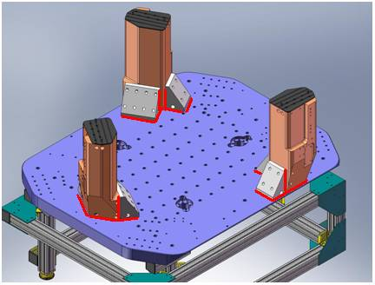
Figure - Showing edges that need checked on support posts and gussets

Acceptance Criteria:
- A 0.001 inch shim cannot be passed freely through any connection to Stage 0 or between post and gussets. If shim can pass through, loosen all constraining bolts, and then retighten iteratively from the center of the part to the edges. Retest.

Test result: Passed: X Failed: .

Step 4: Pitchfork/Boxwork flatness before Optical Table install
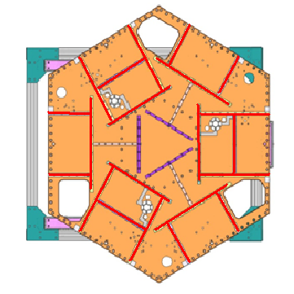
Figure – Showing what needs to be checked on Boxworks and Pitchforks

Acceptance Criteria:
- Shim inserted won’t pass between parts.

Test result: Passed: X Failed: .

Step 5: Blade spring profile
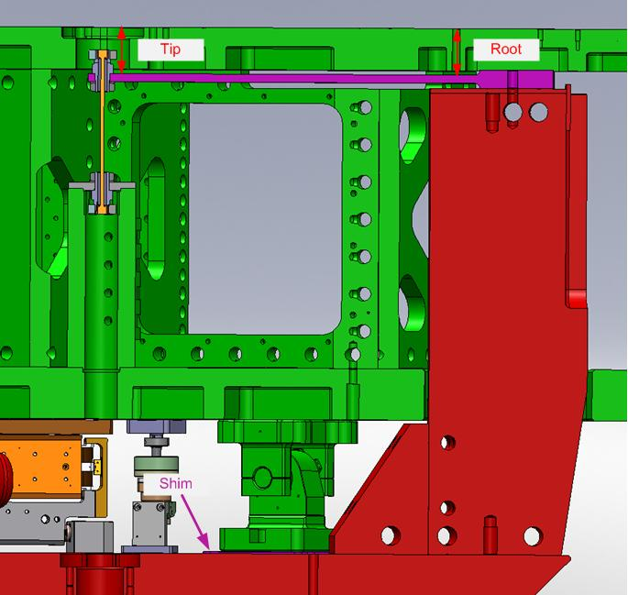
figure – Blade spring profile measurement points

Blade # | Base (") | Tip(") | Flatness (mils)
1 | 0.384 | 0.377 | 0.007
2 | 0.387 | 0.385 | 0.002
3 | 0.381 | 0.3785 | 0.0025

Table 1 - Blade profile

Acceptance Criteria:
- Blades must be flat within 0.015" inches.

Test result: Passed: X Failed: .

Step 6: Gap checks on actuators-after installation on Stage 1
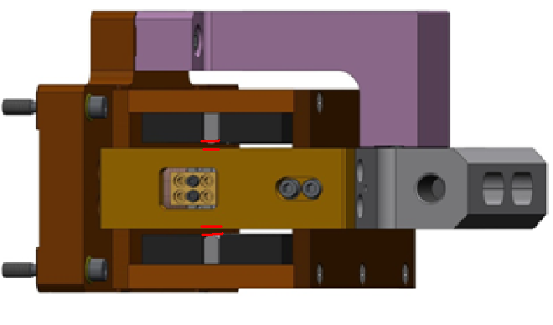
Figure - Showing gaps that need to be checked on actuators.

Issues/difficulties/comments regarding this test:
Test hasn’t been performed since previous testing of this unit.

Acceptance Criteria
- Gaps must be within 0.010” of design (i.e. 0.090” and .070” pass, but 0.095” and 0.065” doesn’t).

Test result: Passed: X Failed: .

Step 7: Check level of Stage 0
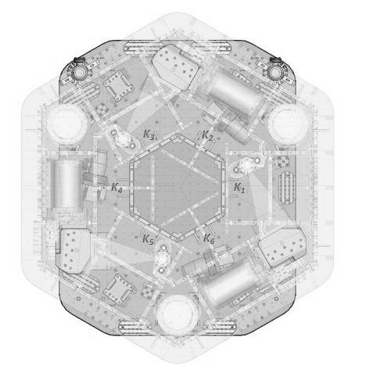
5”
CORNER 1
0”
0”
0”
2.5”
4”
4”
-3”
-3”
Flexion of Stage-0
Figure – Level measured on Stage 0

Issues/difficulties/comments regarding this test:
Stage 0 appears to be flexing along the median line which is facing corner 1.

Max angle=(0.005)/(72/2)= 141µrad

Acceptance Criteria
- The maximum angle of the table with the horizontal mustn’t exceed ~100µrad

Test result: Passed: Failed: X .

Note:
This test doesn't meet our stringent requirement, however this leveling value is sufficient for all the tests being performed.

Step 8: Check level of Stage 1 Optical Table

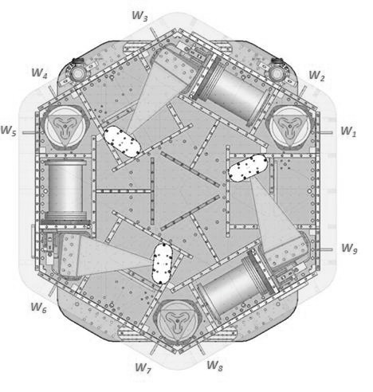
1”
2”
10”
15”
10”
0”
CORNER 1

Figure – Level measured on Stage 1
Issues/difficulties/comments regarding this test:
The optical table appears tilted with corner 1 the lower point.

Max angle = (0.014)/85.59 = 164 µrad
Max angle stage 0 inclination removed from recorded values = (0.014-0.005)/85.59 = 105 µrad

Acceptance Criteria
- The maximum angle of the table with the horizontal mustn’t exceed ~100µrad

Test result: Passed: Failed: X .

Note:
This test doesn't meet our stringent requirement, however this leveling value is sufficient for all the tests being performed.

Step 9: Mass budget

 | 00 | 01 | 02 | 03 | 04 | 05 | 06
 | 0.6 | 1.1 | 2.2 | 4.5 | 7.9 | 15.6 | 27.2 | lbs | kgs
w9 | 1 |  |  | 1 | 1 |  | 1 | 40.2 | 18.23
w1 |  | 1 |  | 1 | 1 |  | 1 | 40.7 | 18.46
w2 |  |  |  | 1 |  | 1 | 1 | 47.3 | 21.45
w3 | 1 |  |  | 1 | 1 |  | 1 | 40.2 | 18.23
w4 |  | 1 |  | 1 | 1 |  | 1 | 40.7 | 18.46
w5 |  |  |  | 1 |  | 1 | 1 | 47.3 | 21.45
w6 |  | 1 |  | 1 | 1 |  | 1 | 40.7 | 18.46
w7 |  | 1 |  | 1 | 1 |  | 1 | 40.7 | 18.46
w8 |  |  |  | 1 |  | 1 | 1 | 47.3 | 21.45
Side Masses Total | 2 | 4 | 0 | 9 | 6 | 3 | 9 | 385.1 | 174.68
Table – Wall masses distribution

 | 00 | 01 | 02 | 03 | 04 | 05 | 06
 | 0.6 | 1.1 | 2.2 | 4.5 | 7.9 | 15.6 | 27.2 | lbs | kgs
k1 |  |  |  |  | 1 |  | 1 | 35.1 | 15.92
k2 |  |  |  |  |  | 2 |  | 31.2 | 14.15
k3 |  |  |  |  | 1 |  | 1 | 35.1 | 15.92
k4 |  |  |  |  |  | 2 |  | 31.2 | 14.15
k5 |  |  |  |  | 1 |  | 1 | 35.1 | 15.92
k6 |  |  |  |  |  | 2 |  | 31.2 | 14.15
Keel Masses Total | 0 | 0 | 0 | 0 | 3 | 6 | 3 | 198.9 | 90.22
Table – Keel masses distribution

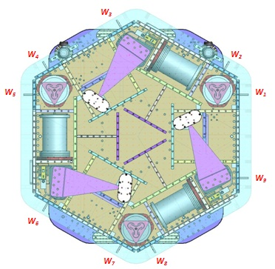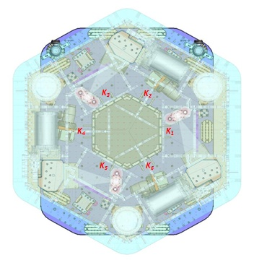
Figure – Wall Masses(W) and Keel masses (K) location. South of picture = corner 1

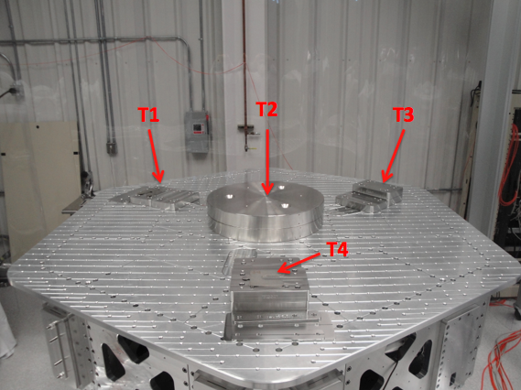
Figure – Optical table masses distribution

 | Mass (kg)
T1 | 22.31
T2 | 211.37
T3 | 30.00
T4 | 31.77
Total | 295.46
Table – Optic table masses distribution

 | Side | Keel | Top | Total
Weigh (kg) | 174.68 | 90.22 | 295.46 | 560.35
Table – Mass budget sum up

Issues/difficulties/comments regarding this test:
- T2 masses evaluated at nominal value: 233lbs each. Gauge not available for measurement yet.
- The previous version of this report (E1000312-V1) featured a total mass of 568.23kgs.
- Side masses total was 1.1 kg lower.
- Keel masses total was 0.57 kg lower.
- Top masses total was 9.54 kg higher.
…which makes the new mass budget 7.88kg lighter than during the first series of tests prior disassembly/re-assembly.

Acceptance Criteria
The Mass budget must be
- 579.1 Kg (cf E1100427)+/-25Kg (5%)

Test result: Passed: X Failed: .

Step 10: Shim thickness

Lockers | Shim thickness (mils)
A | 130
B | 128
C | 121
D | 127
Table – Shims Thickness

Issues/difficulties/comments regarding this test:
Shims could be used to adjust stage-1 level previously measured out of spec.

Acceptance Criteria
- The shim thickness should be 125 mils +/-5

Test result: Passed: X Failed: .

Tests to be performed after assembly

Step 1 - Electronics Inventory

Hardware | LIGO reference | S/N
Coil driver | D0902744 | S1000266
 |  | S1000269
Anti Image filter | D070081 | S1000250
Anti aliasing filter | D1000269 | S1102694
 |  | S1102679
Interface chassis | D1000067 | 1102223
 |  | 1102224
 |  | 1102214
Table - Inventory electronics

Acceptance Criteria
- Inventory is complete
Test result: Passed: X Failed: .

Step 2 - Set up sensors gap

 | 10 Kg masses at each corners |  | Locked /no mass |  | Unlocked /no mass
Table locked | ADE boxes on |  | ADE boxes on |  | ADE boxes on
Sensors | Offset (Mean) | Std deviation | Offset (Mean) | Std deviation | Offset (Mean) | Std deviation
H1 | -500.33 | 8.82 | -377.58 | 15.81 | -98.63 | 52.75
H2 | -3.51 | 9.43 | -161.00 | 13.90 | 240.42 | 46.43
H3 | -188.21 | 8.01 | -296.29 | 26.04 | -181.82 | 94.86
V1 | -167.76 | 6.61 | 219.86 | 18.72 | -284.90 | 28.06
V2 | -348.55 | 9.18 | 66.61 | 16.21 | -26.16 | 21.86
V3 | -122.92 | 6.09 | 134.64 | 16.19 | 96.82 | 31.93
Capacitive position sensor readout after gap set-up

Issues/difficulties/comments regarding this test:
High standard deviation required to do extra test on the jig (see below)

Acceptance criteria:
- All mean values must be lower than 400 cts (a bit less than .0005”).
- All standard deviations below 5 counts.
- No cross talk

Test result: Passed: Failed: X .

Failed because of standard deviation but a CPS set on a jig was measured and gave 4.3 counts, which is within specs. Hence, the high standard deviations measured are correlated to the 10Hz-100Hz peaks observed on the locked/unlocked GS13 and CPS ASDs. As shown earlier, these peaks are caused by ground motion. Hence, high standard deviations should not be associated with sensor noise.

Step 3 - Measure the Sensor gap
Issues/difficulties/comments regarding this test:
Measured in the previous version of this report (E1000312-V1, p11) .Waived to avoid scratching targets.

Acceptance criteria:
Sensors gap measured on the jig and on the optic table must be:
- 0.080” +/-0.002”

Test result: Passed: Failed: X .

Step 4 - Check Sensor gaps after the platform release

 | Locked /no mass |  | Unlocked /no mass
Table locked | ADE boxes on |  | ADE boxes on
Sensors | Offset (Mean) | Std deviation | Offset (Mean) | Std deviation | difference
H1 | -377.58 | 15.81 | -98.63 | 52.75 | 278.95
H2 | -161.00 | 13.90 | 240.42 | 46.43 | 401.41
H3 | -296.29 | 26.04 | -181.82 | 94.86 | 114.47
V1 | 219.86 | 18.72 | -284.90 | 28.06 | -504.77
V2 | 66.61 | 16.21 | -26.16 | 21.86 | -92.77
V3 | 134.64 | 16.19 | 96.82 | 31.93 | -37.82
Table – Sensor gaps after platform release

Acceptance criteria:

- Absolute values of the difference between the unlocked and the locked table must be below:
  - 1600 cts for horizontal sensors (~0.002”)
  - 1600 cts for vertical sensors (~0.002”)
- Considering the acceptance criteria of step 4, all mean values must be lower than
  - 2000 cts for horizontal sensors (~0.0025”)
  - 2000 cts for vertical sensors (~0.0025”)

Test result: Passed: X Failed: .

Step 5 – Performance of the limiter

Step 5.1 - Test Nº1 - Push “in the general coordinates”

Pushing Z,-Z | CPS read out |  | Calculated after calibration
Sensors | UP (Counts) | Down (Counts) | UP (mil) | Down (mil) | ROM (Counts)
V1 | 21100 | -19500 | 25.2 | -23.3 | 40600
V2 | 20900 | -19750 | 24.9 | -23.6 | 40650
V3 | 20900 | -19350 | 24.9 | -23.1 | 40250
Pushing RZ, -RZ | CPS read out |  | Calculated after calibration
Sensors | CCW (+RZ) | CW(-RZ) | CW (mil) | CCW (mil) | ROM (Counts)
H1 | -21400 | 21020 | -25.5 | 25.1 | 42420
H2 | -22800 | 22550 | -27.2 | 26.9 | 45350
H3 | -22500 | 20750 | -26.9 | 24.8 | 43250
Table - Optic table range of motion
ROM: Range Of Motion

Step 5.2 - Test Nº2 – Push “locally”

Pushing Locally | Push in positive direction | Push in negative direction | Railing | Actuator Gap Check | ROM (Counts)
H1 | -24650 | 24900 |  | x | 49550
H2 | -25250 | 23950 |  | x | 49200
H3 | -24600 | 24950 |  | x | 49550
V1 | 21150 | -19850 |  | x | 41000
V2 | 32000 | -32000 |  | x | 64000
V3 | 21000 | -20000 |  | x | 41000
Table - Optic table range of motion

Acceptance criteria:
- The vertical sensor readout must be positive when the optic table is pushed in the +Z direction
- The horizontal sensor readout must be negative when the optic table is pushed in the +RZ direction
- Step 5.1
  - Absolutes value of all estimated motions must be higher than 16000counts (~0.020”)
- Step 5.2
  - No contact point on sensors
  - Absolute value of sensor read out must be higher than 16000counts (~0.020”)
  - No contact point on actuators

Test result: Passed: X Failed: .

Step 6 - Position Sensors unlocked/locked Power Spectrum

Scripts files for processing and plotting in SVN at:
/opt/svncommon/seisvn/seismic/HAM-ISI/Common/Testing_Functions_HAM_ISI/
- ASD_Measurements_Locked_Unlocked_HAM_ISI.m

Data in SVN at:
/opt/svncommon/seisvn/seismic/HAM-ISI/X1/HAM10/Data/Spectra/Undamped/
- LHO_ISI_HAM10_ASD_m_CPS_T240_L4C_GS13_Locked_vs_Unlocked_2011_12_14.mat

Figures in SVN at:
/opt/svncommon/seisvn/seismic/HAM-ISI/X1/HAM10/Data/Figures/Spectra/Undamped
- LHO_ISI_HAM10_ASD__m_GS13_Requirements_Locked_vs_Unlocked_2011_12_14.fig
- LHO_ISI_HAM10_ASD__m_CPS_Requirements_Locked_vs_Unlocked_2011_12_14.fig
- LHO_ISI_HAM10_ASD__m_GS13_Locked_vs_Unlocked_2011_12_14.fig
- LHO_ISI_HAM10_ASD__m_CPS_Locked_vs_Unlocked_2011_12_14.fig
- LHO_ISI_HAM10_ASD__CT_GS13_Locked_vs_Unlocked_2011_12_14.fig
- LHO_ISI_HAM10_ASD__CT_CPS_Locked_vs_Unlocked_2011_12_14.fig
- LHO_ISI_HAM10_ASD_m_CPS_Locked_Zoom_2011_12_14.fig

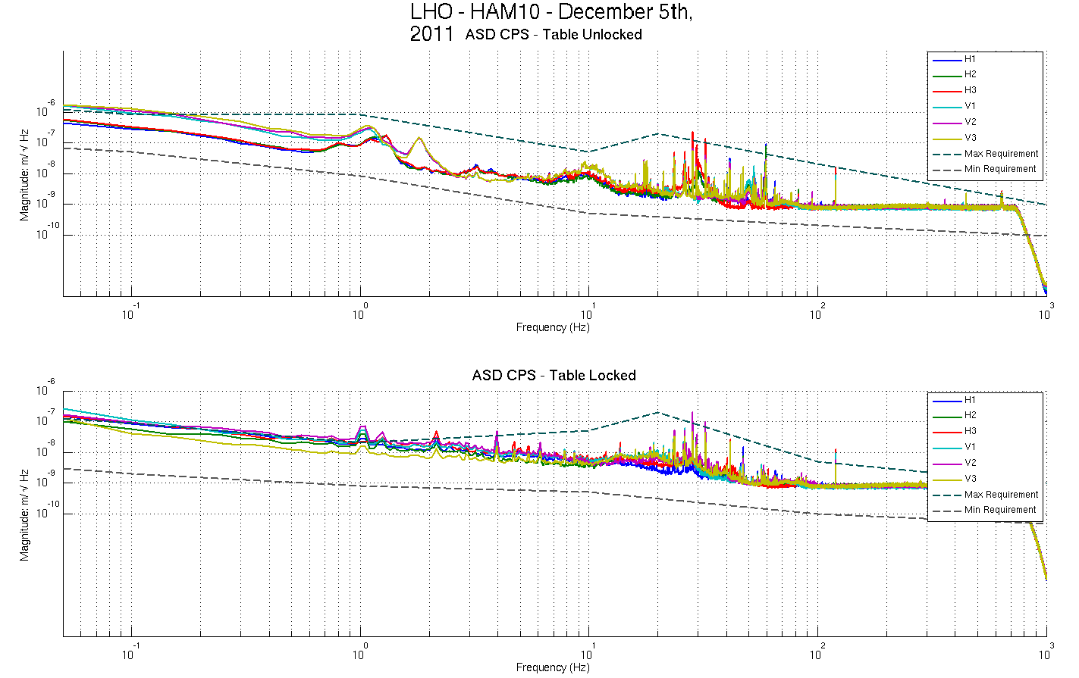
Figure - Calibrated CPS power spectrum

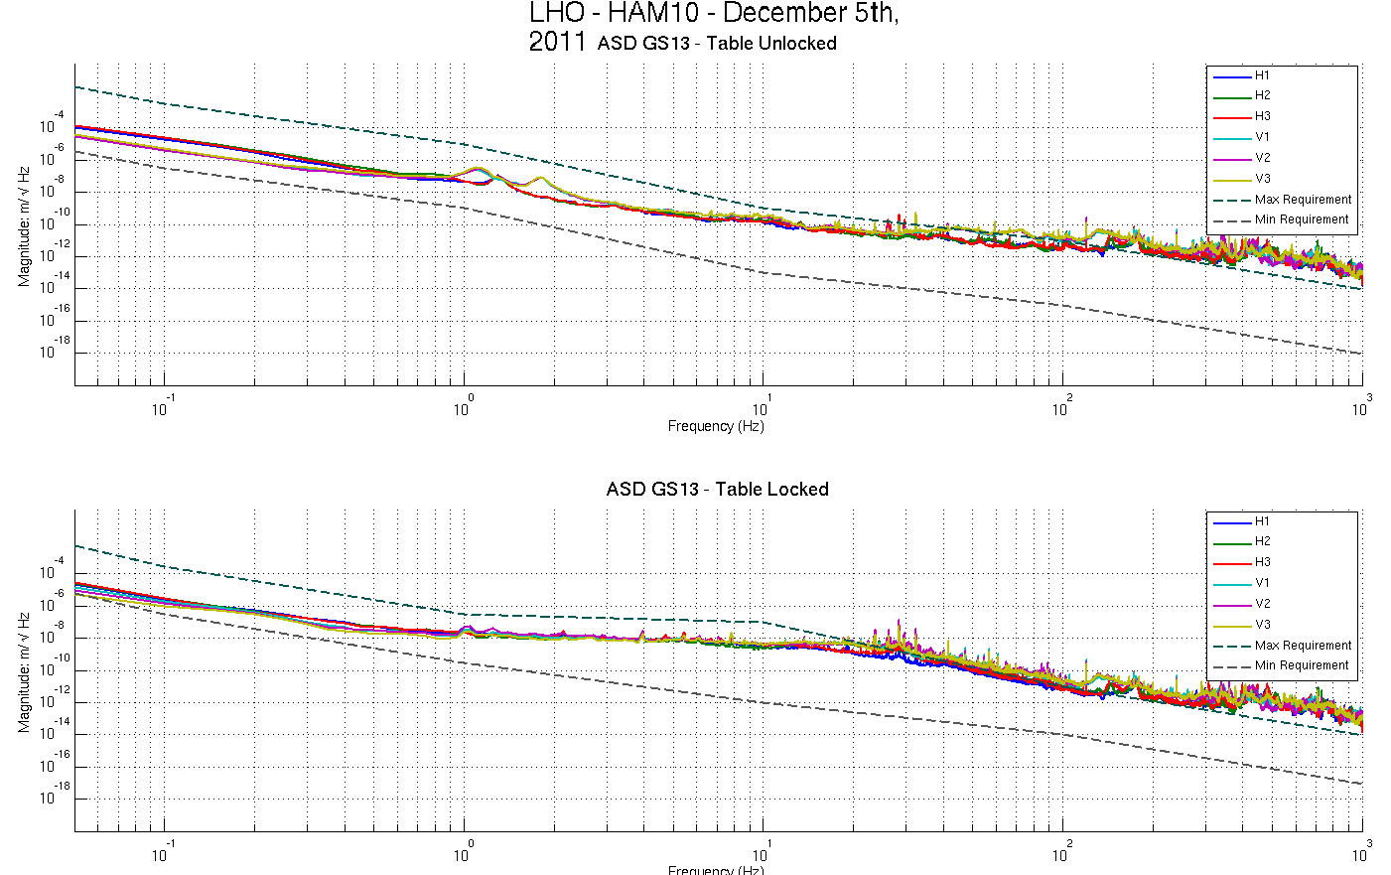
Figure – Power spectrum Calibrated GS13

Issues/difficulties/comments regarding this test:
10Hz-100Hz peaks investigated above in Part 1, last step: capacitive position sensor investigation.

Acceptance criteria:
- No cross talk (peaks at low frequencies + harmonics on measurements)
- Magnitudes of power spectra must be between requirement curves

Test result: Passed: X Failed: .

Step 7 - GS13 power spectrum -tabled tilted

Scripts files for processing and plotting in SVN at:
/opt/svncommon/seisvn/seismic/HAM-ISI/Common/Testing_Functions_HAM_ISI/
- ASD_Measurements_Stages_Tilted_HAM_ISI.m

Figures in SVN at:
/opt/svncommon/seisvn/seismic/HAM-ISI/X1/HAM10/Data/Figures/Spectra/Undamped
- LHO_ISI_HAM10_m_PSD_GS13_Tilted_ 2011_12_06.fig
- LHO_ISI_HAM10_CT_PSD_GS13_Tilted_ 2011_12_06.fig

The figure below presents the GS13 power spectrum when the table is unlocked and loaded with a 10Kg mass at each of its corner.

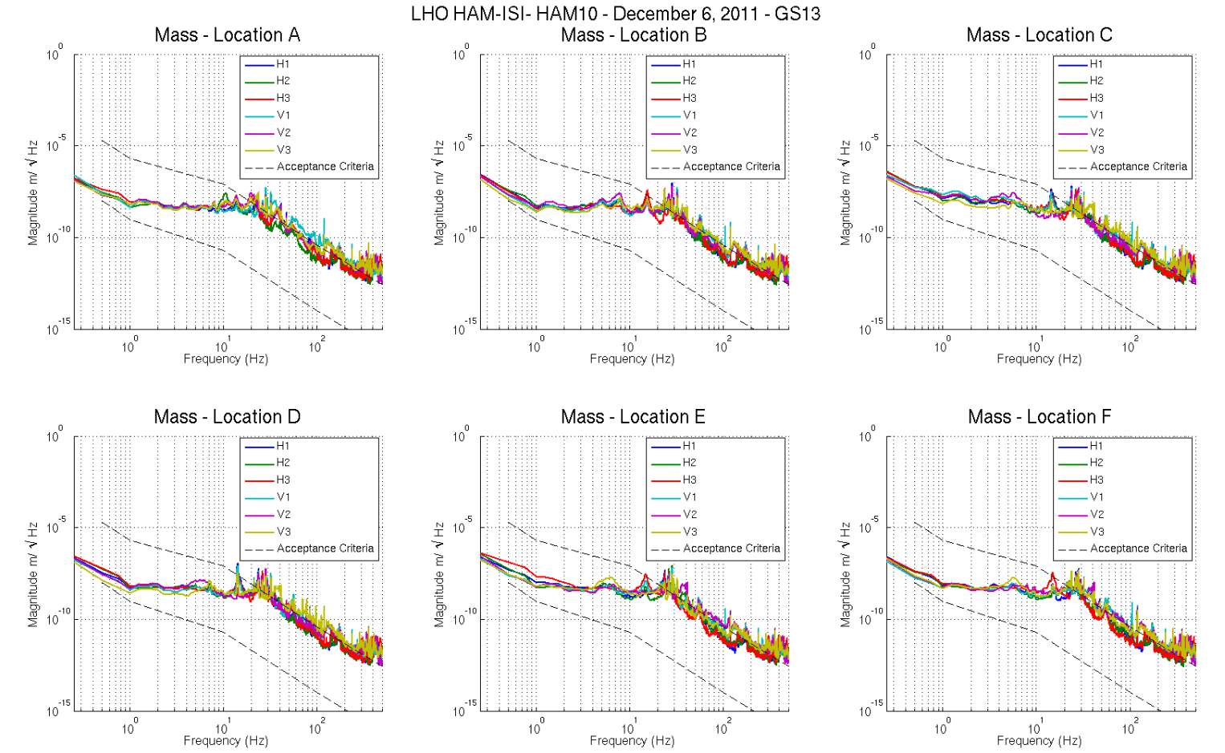
Figure – Power spectrum Calibrated GS13 with mass at corners A to F

Issues/difficulties/comments regarding this test:
Test GS13 are used, so borderline values are acceptable.

Acceptance criteria:
- With table unlocked and tilted, magnitudes of power spectra must be fully included within requirement curves.

Test result: Passed: X Failed: .

Step 8- GS13 pressure readout

Test GS13 used. Step to be performed o the final GS13s

Step 9 - Coil Driver, cabling and resistance check

Actuator | V1 |  | H1 |  | V2
Coil driver | S1000266 - Coarse 2 |  | S1000266 - Coarse 1 |  | S1000269 - Coarse 2
Cable # | S1104488 |  | S1104491 |  | S1104482
Resistance  (Ohm) | P1 - P2 | P2 - P3 | P1 - P2 | P2 - P3 | P1 - P2 | P2 - P3
 | O.L (infinity) | 6.7 | O.L (infinity) | 6.7 | O.L (infinity) | 6.7
MEDM offset  (1000 counts) | Measurement P2 (+) ; P1&P3 (-) |  | Measurement P2 (+) ; P1&P3 (-) |  | Measurement P2 (+) ; P1&P3 (-)
 | 0.303V |  | 0.299V |  | 0.299V
Actuator | H2 |  | V3 |  | H3
Coil driver | S1000269 - Coarse 1 |  | S1102692 - Coarse 2 |  | S1102692 - Coarse 1
Cable # | S1104766 |  | S1104755 |  | S1104769
Resistance  (Ohm) | P1 - P2 | P2 - P3 | P1 - P2 | P2 - P3 | P1 - P2 | P2 - P3
 | O.L (infinity) | 6.6 | O.L (infinity) | 6.8 | O.L (infinity) | 6.8
MEDM offset  (1000 counts) | Measurement P2 (+) ; P1&P3 (-) |  | Measurement P2 (+) ; P1&P3 (-) |  | Measurement P2 (+) ; P1&P3 (-)
 | 0.297V |  | 0.306V |  | 0.3V
Table - Actuators resistance check

Issues/difficulties/comments regarding this test:
Voltages measured from Pin #1 (-) to pin #2 (+) with compensation filters engaged.

Acceptance criteria:
- The measured resistance between the middle pin and one side pin must be 6.5 +/-1 ohms
- Actuator neutral pins must be connected on pin #1 (left side pin of the plug)
- Actuator drive pins must be connected on pin #2 (middle pin of the plug)
- Actuator ground shield pins must be connected on pin #3 (right pin of the plug)
- All LEDs on the coil driver front panel must be green

Test result: Passed: X Failed: .

Step 10 - Actuators Sign and range of motion (Local drive)

 | Negative drive | No Drive | Positive drive | ROM (Counts)
H1 readout (count) | -24556 | -194 | 23770 | 48326
H2 readout (count) | -24400 | 368 | 23750 | 48150
H3 readout (count) | -24860 | -63 | 24375 | 49235
V1 readout (count) | -19195 | -445 | 20330 | 39526
V2 readout (count) | -26044 | 212 | 26435 | 52479
V3 readout (count) | -21303 | 58 | 22458 | 43761
Table - Range of motion - Local drive

Acceptance criteria:
- Main couplings sensors readout must be at least 16000 counts (~0.02”)
- A positive offset drive on one actuator must give positive sensor readout on the collocated sensor. Signs will also be tested when measuring local to local transfer functions.

Test result: Passed: X Failed: .

Step 11 - Vertical Sensor Calibration

Lockers | D.I readout with for  a negative drive | D.I readout without any drive | D.I readout with for  a positive drive
A | 18.80 | 0.00 | -18.00
B | 18.00 | 0.00 | -18.00
C | 16.50 | 0.00 | -16.50
D | 17.30 | 0.00 | -17.20
Average | 17.65 | 0.00 | -17.43
Sensors | Counts | Counts | Counts | Difference
V1 | -15186.26 | -112.32 | 15052.02 | 30238.28
V2 | -14101.07 | 778.67 | 15608.16 | 29709.23
V3 | -13685.56 | 304.07 | 14526.27 | 28211.83
Vertical Sensibility
837.82 | Count/mil
0.51 | V/mil
30.32 | nm/count
-0.26 | % from nominal value (840nm/count)

Table - Calibration of capacitive position sensors

Acceptance criteria:

- Deviation from nominal value < 2%. Nominal value is 840 count/mil.

Test result: Passed: X Failed: .

Step 12 - Vertical Spring Constant

Results presented below are obtained after the initial sensors calibration.

Sensors | Mean diff counts | Mean diff m | K (N/m) | Error with average
V1 | -8086 | -2.44E-04 | 8.03E+04 | -1.35%
V2 | -8004 | -2.42E-04 | 8.12E+04 | -0.34%
V3 | -7843 | -2.37E-04 | 8.28E+04 | 1.70%
 |  | Average (N/m) | 2.44E+05
 |  | Total Stiffness (N/m) | 2.47E+05
Table - Vertical spring constant

Acceptance criteria:
- +/-2 % of 2.4704e5 N/m (i.e. between 2.421e5 and 2.520e5 N/m)
- +/- 5% of variation between each spring and the average

The measured error on the vertical stiffness is -1.09 %

Test result: Passed: X Failed:

Step 13 - Static Testing (Tests in the local basis)

 | Sensors (counts)
 | H1 | H2 | H3 | V1 | V2 | V3
H1 | 2011 | 1231 | 1215 | -5 | 16 | 6
H2 | 1208 | 1973 | 1206 | -22 | 12 | 40
H3 | 1226 | 1202 | 1968 | -4 | -3 | 43
V1 | 142 | 149 | -387 | 1386 | 27 | -556
V2 | -388 | 154 | 133 | -594 | 1418 | 14
V3 | 141 | -373 | 153 | -58 | -591 | 1441

Table - Main couplings and cross couplings
Acceptance criteria:
- Vertical
For a +1000 count offset drive on vertical actuators
  - Collocated sensors must be 1400 counts +/- 10%

- Horizontal
For a +1000 count offset drive on horizontal actuators
  - Collocated sensors must be 2000 counts +/- 10%
  - Non-collocated horizontal sensors must be 1250 counts +/-10%

Test result: Passed: X Failed: .

Step 14 - Linearity test

 | Slope | Offset | Average slope | Variation from  average(%)
H1 | 2.11 | -22.86 | 2.09 | 1.09
H2 | 2.08 | 475.60 |  | -0.34
H3 | 2.08 | -119.54 |  | -0.75
V1 | 1.49 | 146.15 | 1.46 | 2.02
V2 | 1.47 | 238.46 |  | 0.44
V3 | 1.43 | 51.40 |  | -2.46
Table - Slopes and offset of the triplet ‘Actuators - HAM-ISI – Sensors’

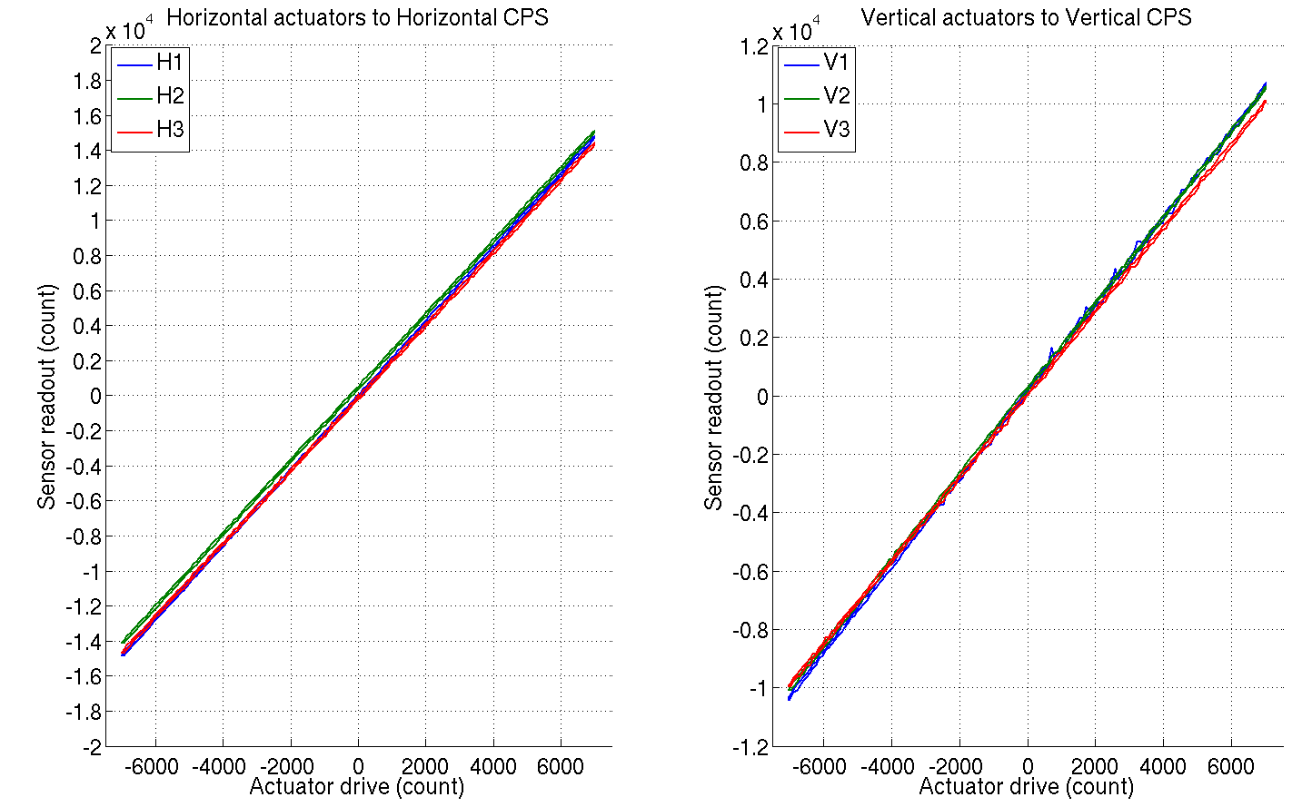
Figure - Linearity test on the triplet ‘actuators - HAM-ISI – sensors’
in both Horizontal and vertical directions

Issues/difficulties/comments regarding this test:
- A cable was rubbing initially and caused V1 and V3 to be 5% off average.
- No cable rubbing anymore. Still, we observe 2% off average for these sensors.
- Cables lengths vary from one corner to another. They are:
  - Corner 1: 26ft
  - Corner 2: 42ft
  - Corner 3: 48ft
…which corresponds to a 0.1ohm resistance difference between the longest and the shortest cable. A 0.1 Ohm resistance difference would induce a 1.5% voltage drop on actuators of 6.5 Ohm resistance. Hence, having out of spec variations from average slopes, in linearity tests, can be associated with inhomogeneous cable length, as long as difference with requirements remains under 1.5%.

Acceptance criteria:
- Horizontal and vertical slopes of the triplet actuators x HAM-ISI x sensors: Average slope +/- 1%

Test result: Passed: Failed: X .

IComment: we’ll check it is within tolerance when we’ll use the final field cables.

Step 15 - Cartesian Basis Static Testing

1000 counts Drive | H1 | H2 | H3 | V1 | V2 | V3 | Direction read out
X Drive | 271.3 | 270.6 | -507.7 | -0.8 | 3.9 | -9.8 | 520.0
Y Drive | -471.0 | 444.6 | -10.4 | -9.6 | 12.4 | 8.7 | 526.0
Z Drive | 1.7 | 4.7 | -20.2 | 265.9 | 304.8 | 247.1 | 274.3
Rx Drive | -439.1 | 470.4 | 8.6 | -472.9 | 1680.6 | -1211.1 | 2549.3
Ry Drive | -254.0 | -245.9 | 551.0 | -1709.3 | 448.3 | 1250.6 | 2613.8
Rz Drive | -2024.6 | -2007.5 | -2022.4 | -2.4 | 14.7 | -10.8 | 2551.5
Table – Static testing: Drive in the Cartesian basis, response in the Local basis

1000 counts Drive | X | Y | RZ | Z | RX | RY
X Drive | 520.0 | -1.7 | -8.0 | -36.3 | -22.8 | -17.9
Y Drive | 0.3 | 526.0 | -1.9 | -15.8 | 7.6 | 13.1
Z Drive | 3.0 | 3.4 | 274.3 | -14.2 | 2.8 | -6.1
Rx Drive | 8.6 | 4.9 | 7.3 | 2549.3 | 8.8 | -15.8
Ry Drive | -10.6 | 0.2 | -17.5 | -2.6 | 2613.8 | -23.6
Rz Drive | 2.0 | 0.3 | -8.3 | -7.0 | 11.8 | 2551.5
Table – Static testing: Drive in the Cartesian basis, response in the Cartesian basis

Issues/difficulties/comments regarding this test:
Tables reviewed as new display (drive in lines, response in columns) required transposition.

1000 counts Drive | H1 | H2 | H3 | V1 | V2 | V3 | Direction read out
X Drive | + | + | - |  |  |  | +
Y Drive | - | + | 0 |  |  |  | +
Z Drive |  |  |  | + | + | + | +
Rx Drive |  |  |  | - | + | - | +
Ry Drive |  |  |  | - | + | + | +
Rz Drive | - | - | - |  |  |  | +
Table – Cartesian static testing reference table

Acceptance criteria:
For a positive drive in the Cartesian basis:
- Local sensor readout must have the same sign that the reference table (CONT2ACT check)
- Cartesian sensors read out must be positive (DISP2CEN check) in the drive direction

Test result: Passed: X Failed: .

Step 16- Frequency response

Step 16.1 - Local to local measurements

FREQ. RANGE |  |  | DRIVE |  | MEAS. TIME
Min | Max | Freq. Res. (Hz) | H | V | Time for 1 Rep. (s) | Number of Reps | Time (min)
0.01 | 0.1 | 0.01 | 10500.0 | 10500.0 | 620.0 | 10.0 | 103.3
0.1 | 0.5 | 0.02 | 600.0 | 600.0 | 320.0 | 30.0 | 160.0
0.5 | 5 | 0.025 | 35.0 | 35.0 | 260.0 | 55.0 | 238.3
5 | 100 | 0.1 | 300.0 | 300.0 | 80.0 | 50.0 | 66.7
100 | 1000 | 0.2 | 135.0 | 135.0 | 50.0 | 150.0 | 125.0
 |  |  |  |  | Total Meas. time(h) |  | 11.6
Table – Transfer function settings, by frequency band

Data files in SVN at:
/opt/svncommon/seisvn/seismic/HAM-ISI/X1/HAM10/Data/Transfer_Functions/Measurements/
Undamped/
- LHO_ISI_HAM10_Data_TF_L2L_10mHz_100mHz_20111210-021010.mat
- LHO_ISI_HAM10_Data_TF_L2L_100mHz_500mHz_20111209-232830.mat
- LHO_ISI_HAM10_Data_TF_L2L_500mHz_5Hz_20111212-175710.mat
- LHO_ISI_HAM10_Data_TF_L2L_5Hz_100Hz_20111209-184516.mat
- LHO_ISI_HAM10_Data_TF_L2L_100Hz_1000Hz_20111209-172743.mat
Data collection script files:
opt/svncommon/seisvn/seismic/HAM-ISI/Common//Transfer_Function_Scripts/
- Run_TF_L2L_10mHz_100mHz.m
- Run_TF_L2L_100mHz_500mHz.m
- Run_TF_L2L_500mHz_5Hz.m
- Run_TF_L2L_5Hz_100Hz.m
- Run_TF_L2L_100Hz_1000Hz.m
Scripts files for processing and plotting in SVN at:
/opt/svncommon/seisvn/seismic/HAM-ISI/X1/HAM10/Scripts/Control_Scripts/
- Step_1_Plot_TF_L2L_HAM_Testing.m
Figures in SVN at:
opt/svncommon/seisvn/seismic/HAM-ISI/X1/HAM10/Data/ Figures/Transfer_Functions/Measurements/Undamped/
- LHO_ISI_HAM10_TF_L2L_Raw_from_ACT_to_CPS_2011_12_12.fig
- LHO_ISI_HAM10_TF_L2L_Raw_from_ACT_to_GS13_2011_12_12.fig
Storage of measured transfer functions in the SVN at:
opt/svncommon/seisvn/seismic/HAM-ISI/X1/HAM10/Data/Transfer_functions/ Simulations/
Undamped/
- LHO_ ISI_HAM10_ TF_L2L_RAW_2011_12_12.mat

The local to local transfer functions are presented below.

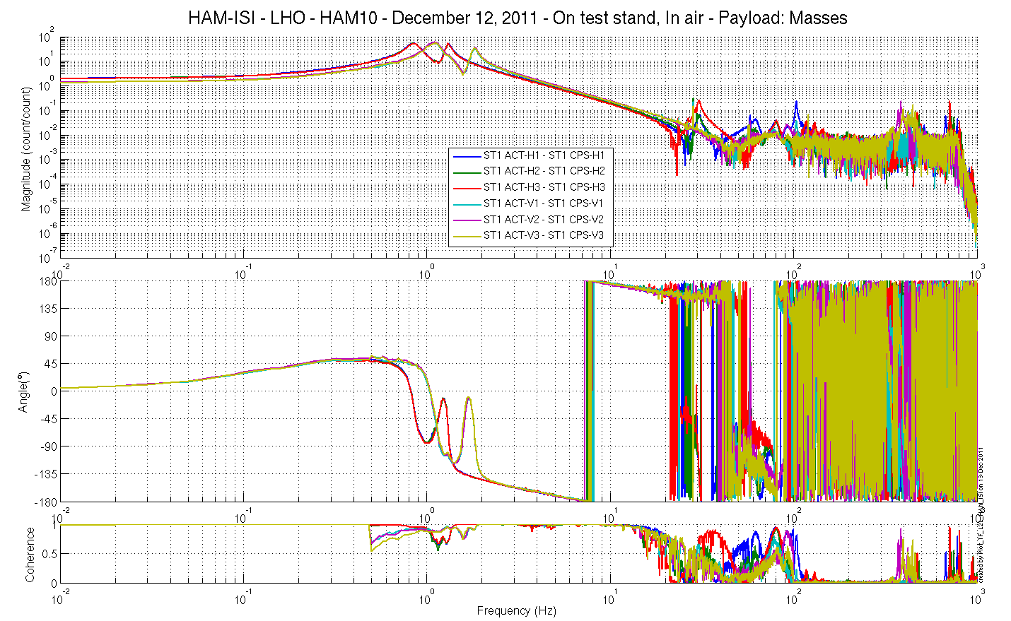
Figure - Local to Local Measurements – Capacitive sensors

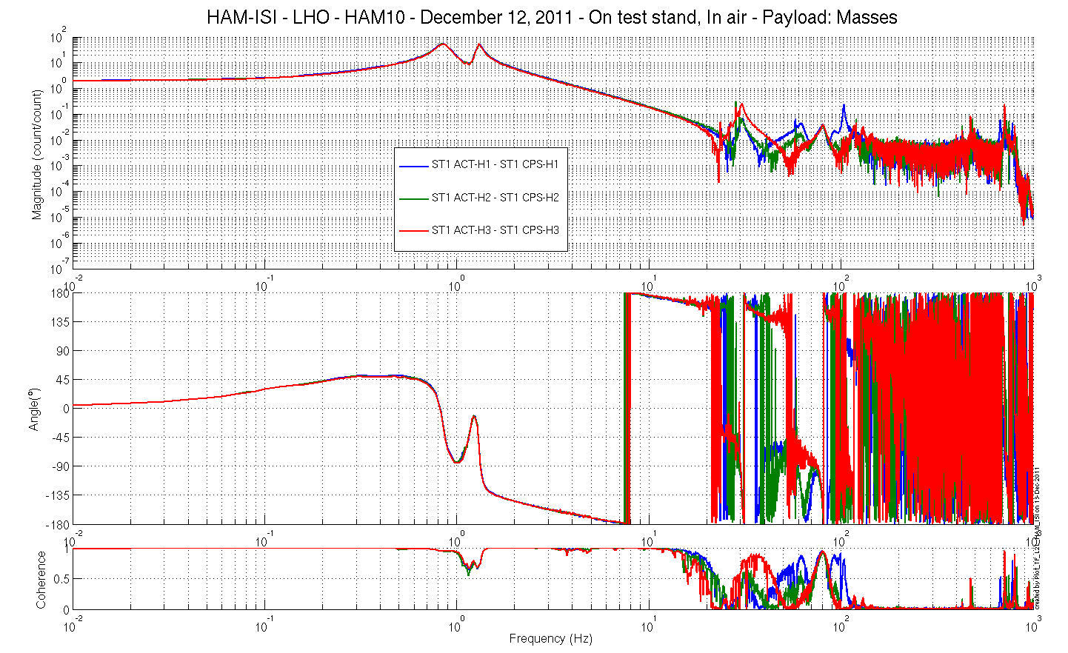
Figure - Local to Local Measurements – Capacitive sensors
Horizontal motion
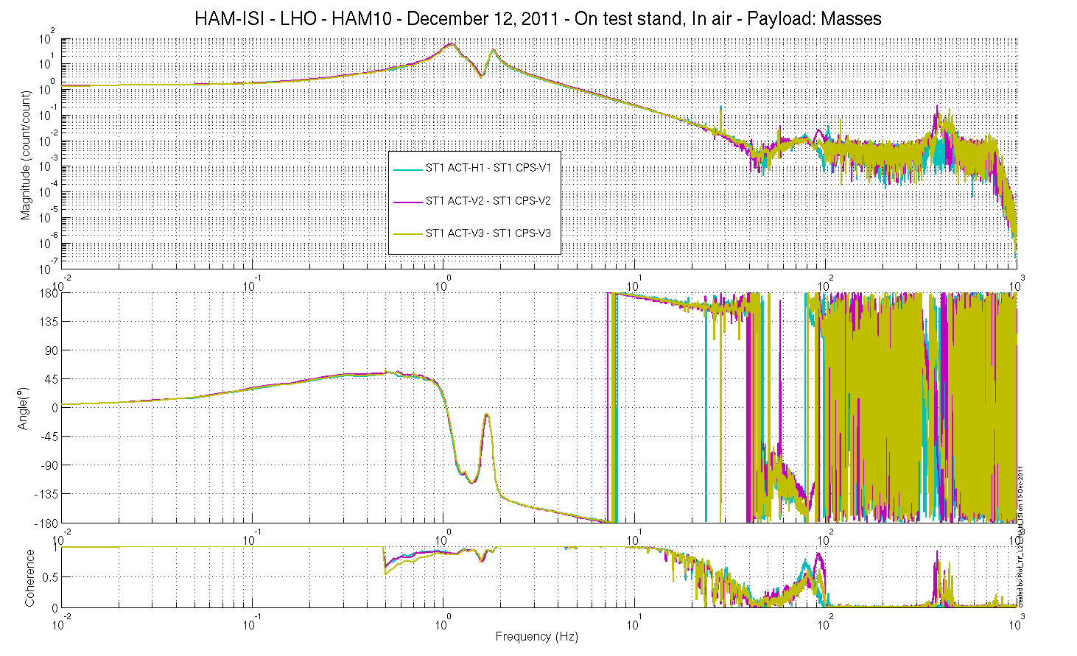Figure - Local to Local Measurements – Capacitive sensors
Vertical motion

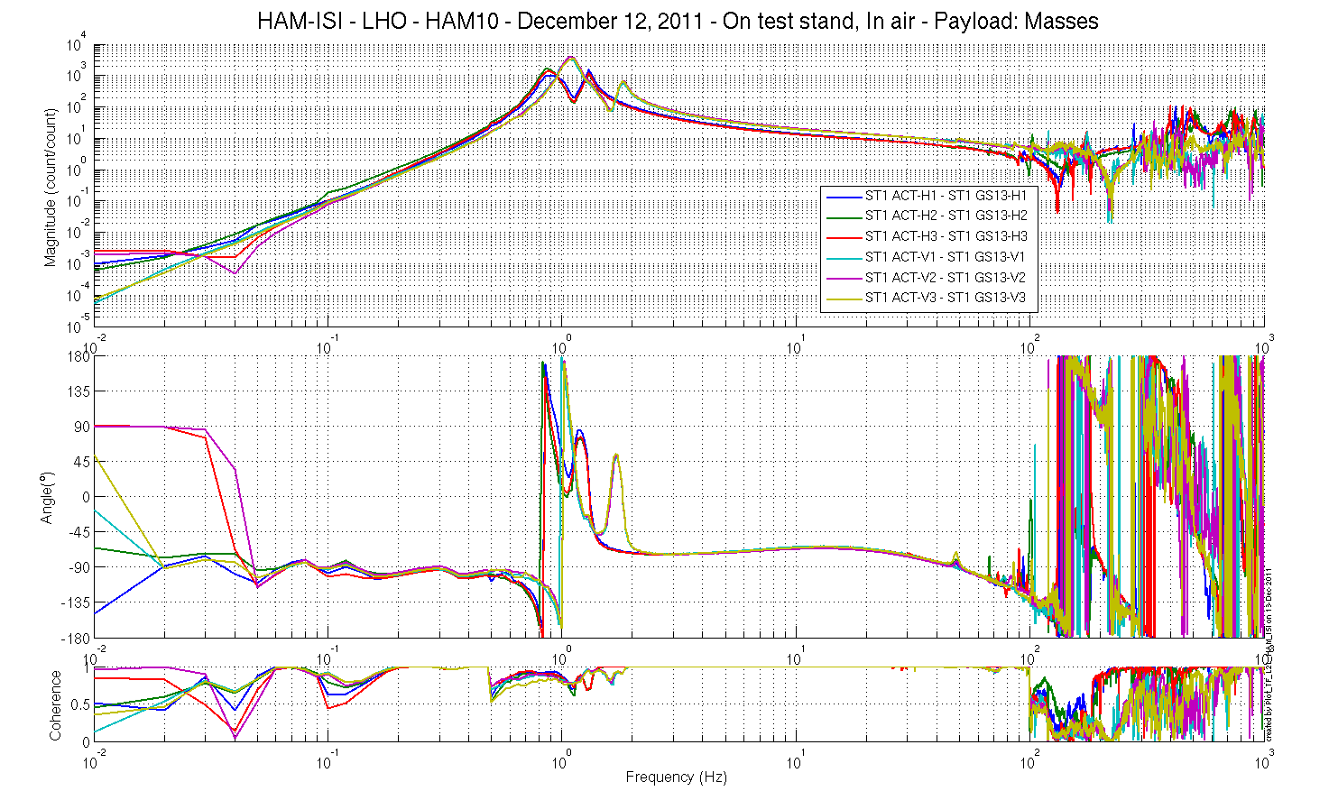
Figure - Local to Local Measurements – Inertial sensors

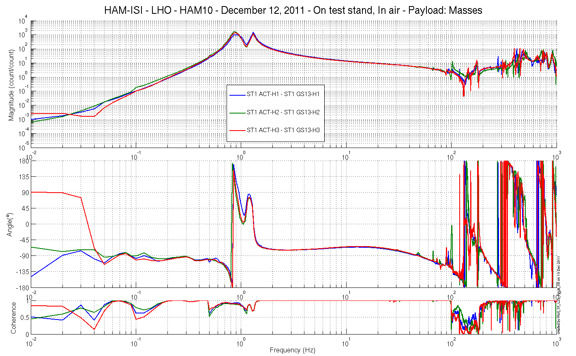
Figure - Local to Local Measurements – Inertial sensors
Horizontal motion
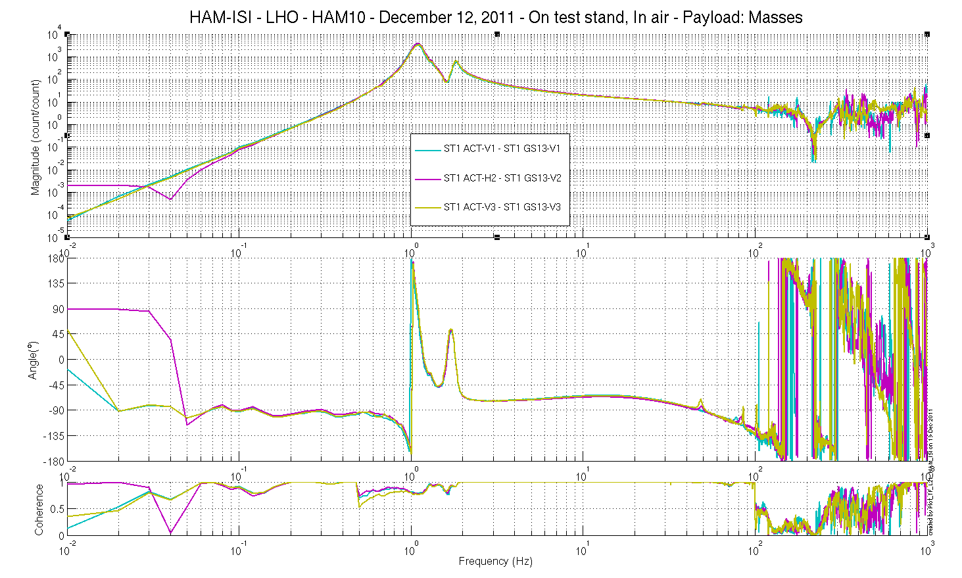
Figure - Local to Local Measurements – Inertial sensors
Vertical motion

Step 16.2 - Cartesian to Cartesian measurements

FREQ. RANGE |  |  | DRIVE |  |  |  |  |  | MEAS. TIME
Min | Max | Freq. Res. (Hz) | X | Y | RZ | Z | RX | RY | Time for 1 Rep. (s) | Number of Reps | Time (min)
0.01 | 0.1 | 0.01 | 7000 | 7000 | 7000 | 7000 | 7000 | 7000 | 620.0 | 10.0 | 103.3
0.1 | 0.5 | 0.02 | 740 | 740 | 740 | 740 | 740 | 740 | 320.0 | 30.0 | 160.0
0.5 | 5 | 0.025 | 30 | 30 | 35 | 45 | 12 | 12 | 260.0 | 55.0 | 238.3
5 | 100 | 0.1 | 680 | 680 | 450 | 1200 | 560 | 450 | 80.0 | 50.0 | 66.7
100 | 1000 | 0.2 | 300 | 300 | 360 | 525 | 225 | 200 | 50.0 | 150.0 | 125.0
 |  |  |  |  |  |  |  |  | Total Meas. time(h) |  | 11.6
Table – Transfer function settings, by frequency band

Data files in SVN at:
/opt/svncommon/seisvn/seismic/HAM-ISI/X1/HAM10/Data/Transfer_Functions/Measurements/
Undamped/
- LHO_ISI_HAM10_Data_TF_C2C_10mHz_100mHz_20111217-044713.mat
- LHO_ISI_HAM10_Data_TF_C2C_100mHz_500mHz_20111217-020534.mat
- LHO_ISI_HAM10_Data_TF_C2C_500mHz_5Hz_20111219-114314.mat
- LHO_ISI_HAM10_Data_TF_C2C_5Hz_100Hz_20111216-212221.mat
- LHO_ISI_HAM10_Data_TF_C2C_100Hz_1000Hz_20111216-200448.mat
Data collection script files:
opt/svncommon/seisvn/seismic/HAM-ISI/Common//Transfer_Function_Scripts/
- Run_TF_C2C_10mHz_100mHz.m
- Run_TF_C2C_100mHz_500mHz.m
- Run_TF_C2C _500mHz_5Hz.m
- Run_TF_C2C _5Hz_100Hz.m
- Run_TF_C2C _100Hz_1000Hz.m
Scripts files for processing and plotting in SVN at:
/opt/svncommon/seisvn/seismic/HAM-ISI/X1/HAM10/Scripts/Control_Scripts/
- Step_1_Plot_TF_L2L_HAM_Testing.m
Figures in SVN at:
opt/svncommon/seisvn/seismic/HAM-ISI/X1/HAM10/Data/ Figures/Transfer_Functions/Measurements/Undamped/
- LHO_ISI_HAM10_TF_C2C_Raw_from_ACT_to_GS13_2011_12_19.fig
- LHO_ISI_HAM10_TF_C2C_Raw_from_ACT_to_GS13_2011_12_19.fig
Storage of measured transfer functions in the SVN at:
opt/svncommon/seisvn/seismic/HAM-ISI/X1/HAM10/Data/Transfer_functions/ Simulations/
Undamped/
- LHO_ ISI_HAM10_ TF_C2C_RAW_2011_12_19.mat

The Cartesian to Cartesian transfer functions are presented below:

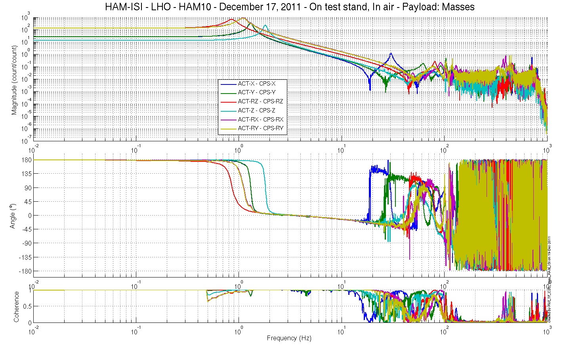
Figure – Cartesian to Cartesian Measurements – Capacitive sensors

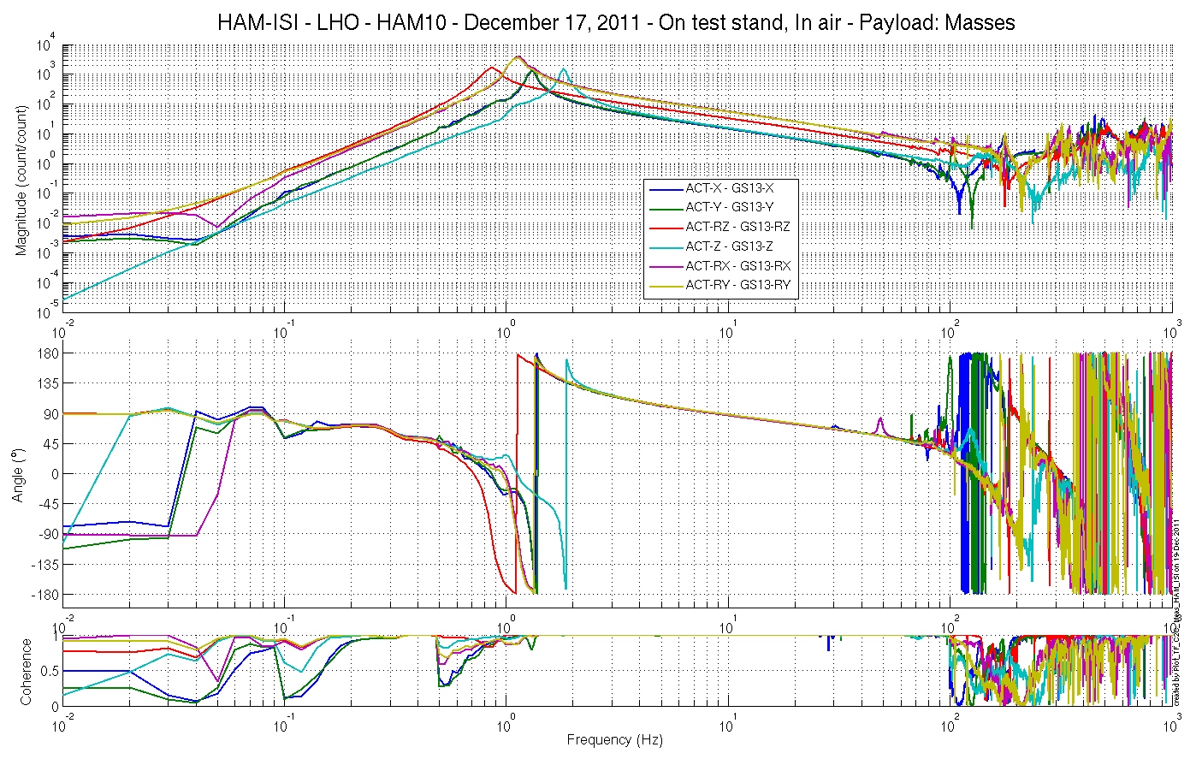
Figure – Cartesian to Cartesian Measurements – Inertial sensors

Issues/difficulties/comments regarding this test:
Damp gain set on -1 during measurements causing phase not starting at 0 degrees.

Acceptance criteria:

- Local to local measurements
  - On CPS, the phase must be 0º at DC
  - On Geophones, the phase must be -90º at DC
  - Identical shape in each corner
- Cartesian to Cartesian measurements
  - On CPS, the phase must be 0º at DC
  - On Geophones, the phase must be -90º at DC
  - Identical shape X/Y and RX/RY

Test result: Passed: X Failed: .

Step 17 - Transfer function comparison with Reference

Step 17.1 - Local to local - Comparison with Reference

This unit is compared to LLO HAM 6. Furthermore, units of a given site will be compared with the unit that has been tested the most recently on the site.

Scripts files for processing and plotting in SVN at:
/opt/svncommon/seisvn/seismic/HAM-ISI/X1/HAM10/Scripts/Control_Scripts/
- Step_1_Plot_TF_L2L_HAM_Testing.m
/opt/svncommon/seisvn/seismic/HAM-ISI/X1/HAM10/Misc/
- Plot_TF_L2L_HAM_Testing_With_HAM6_Reference.m

Local to local figures in SVN at:
opt/svncommon/seisvn/seismic/HAM-ISI/X1/HAM10/Data/ Figures/Transfer_Functions/Measurements/Undamped/
- LHO_ISI_HAM10_TF_L2L_Raw_from_ACT_V_to_CPS_V_vs_HAM6_2011_12_12.fig
- LHO_ISI_HAM10_TF_L2L_Raw_from_ACT_H_to_CPS_H_vs_HAM6_2011_12_12.fig
- LHO_ISI_HAM10_TF_L2L_Raw_from_ACT_V_to_GS13_V_vs_HAM6_2011_12_12.fig
- LHO_ISI_HAM10_TF_L2L_Raw_from_ACT_H_to_GS13_H_vs_HAM6_2011_12_12.fig

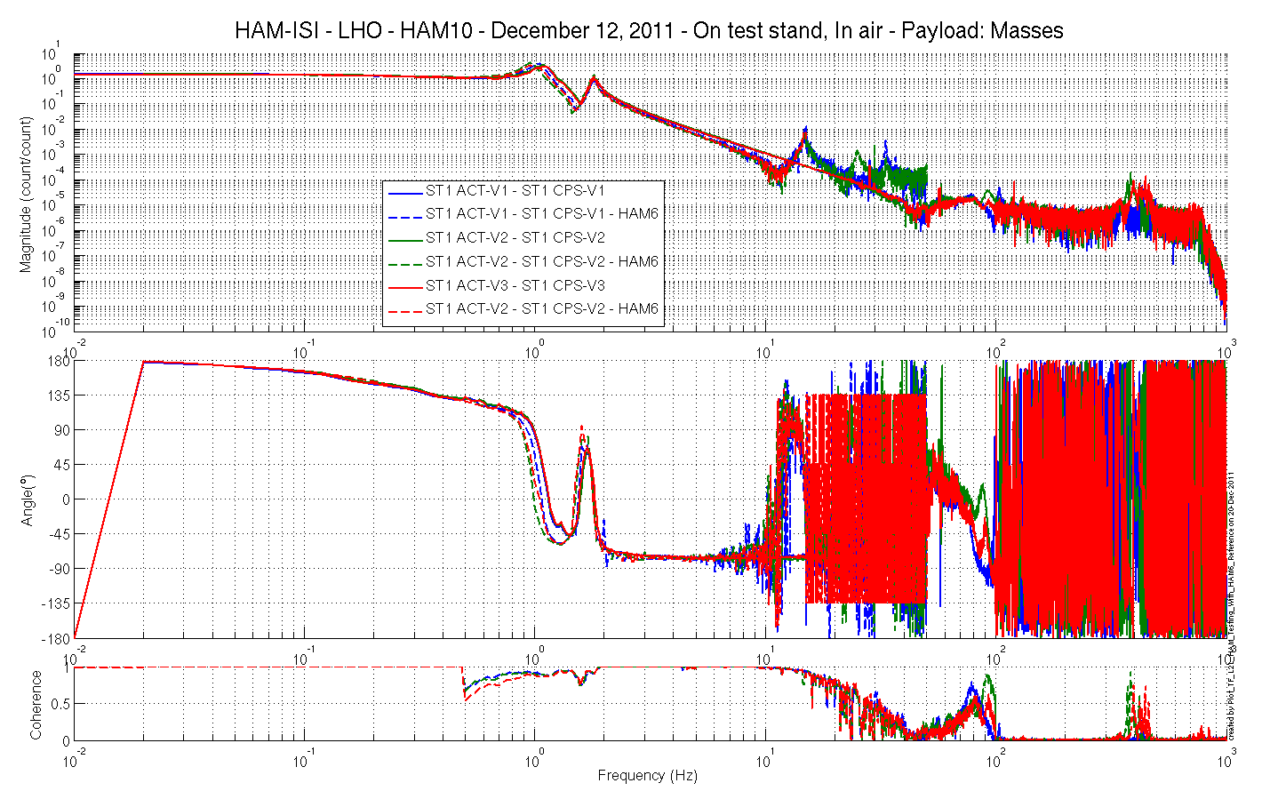
Figure – Local to Local measurements, comparison with HAM6 reference – Capacitive Position Sensors
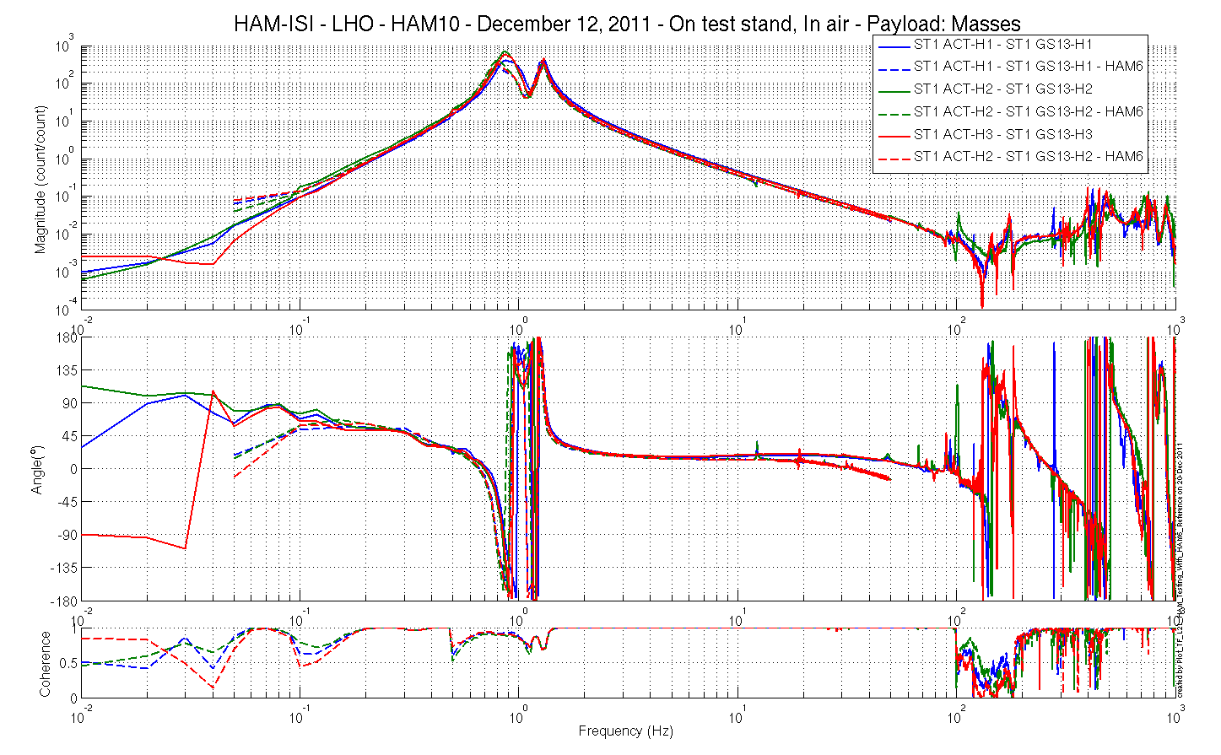 Figure – Local to Local measurements, comparison with HAM6 reference – Inertial sensors

Step 17.2 - Cartesian to Cartesian - Comparison with Reference

Scripts files for processing and plotting in SVN at:
/opt/svncommon/seisvn/seismic/HAM-ISI/X1/HAM10/Scripts/Control_Scripts/
- Step_3_Plot_TF_C2C_HAM_Testing.m
/opt/svncommon/seisvn/seismic/HAM-ISI/X1/HAM10/Misc/
- Plot_TF_C2C_HAM_Testing_With_HAM6_Reference.m

Cartesian to Cartesian figures in SVN at:
opt/svncommon/seisvn/seismic/HAM-ISI/X1/HAM10/Data/ Figures/Transfer_Functions/Measurements/Undamped/
- LHO_ISI_HAM10_TF_C2C_Raw_from_ACT_H_to_GS13_H_vs_HAM6_2011_12_19.fig
- LHO_ISI_HAM10_TF_C2C_Raw_from_ACT_H_to_GS13_V_vs_HAM6_2011_12_19.fig
- LHO_ISI_HAM10_TF_C2C_Raw_from_ACT_H_to_CPS_H_vs_HAM6_2011_12_19.fig
- LHO_ISI_HAM10_TF_C2C_Raw_from_ACT_H_to_CPS_V_vs_HAM6_2011_12_19.fig

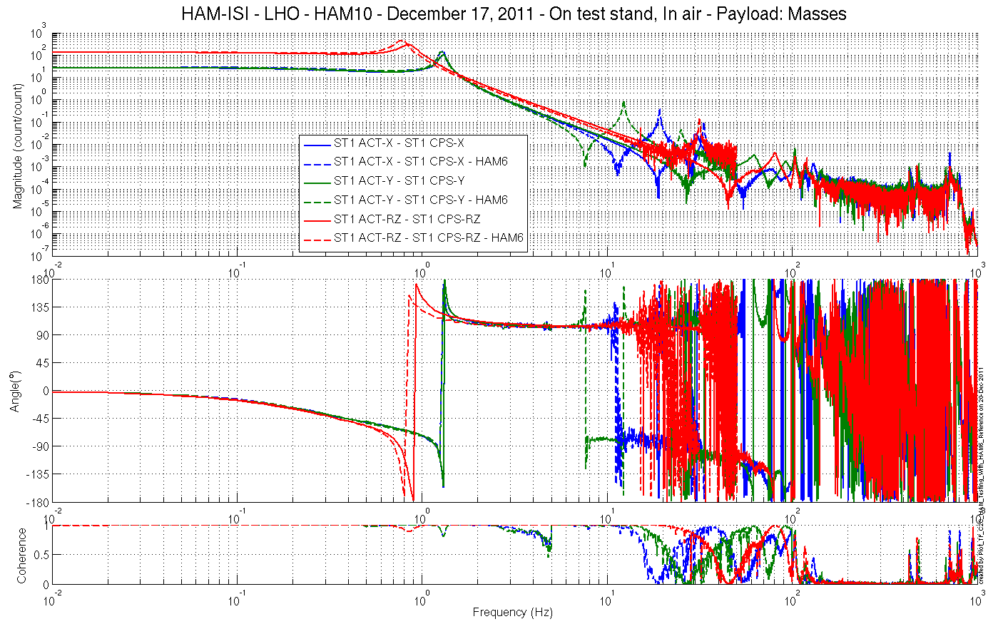
Figure – Cartesian to Cartesian measurements, comparison with HAM6 reference – Capacitive Position Sensors
Horizontal motion

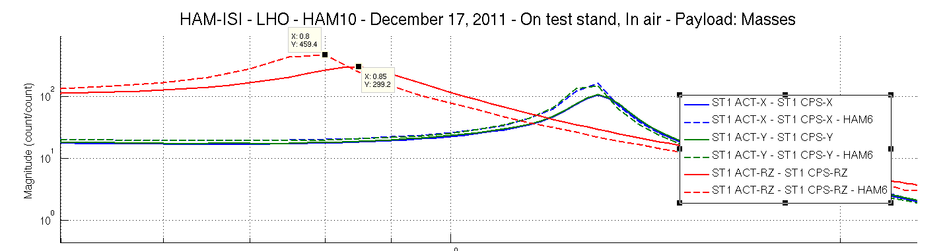
Figure – Cartesian to Cartesian measurements, comparison with HAM6 reference – Capacitive Position Sensors
Horizontal motion-Zoomed on a resonance

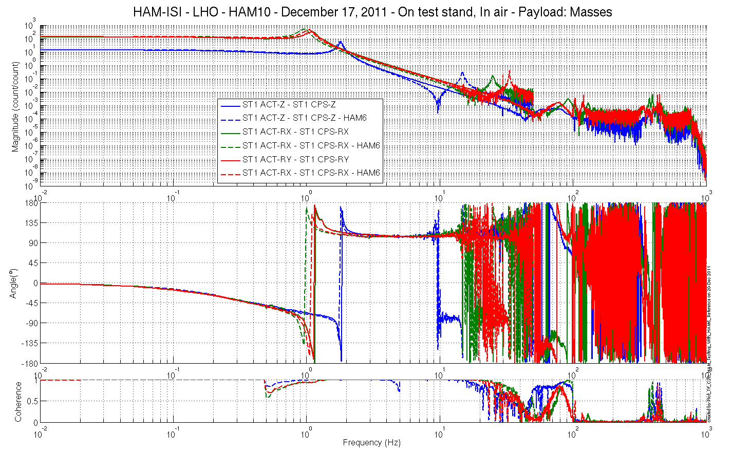
Figure – Cartesian to Cartesian measurements, comparison with HAM6 reference – Capacitive Position Sensors
Vertical motion

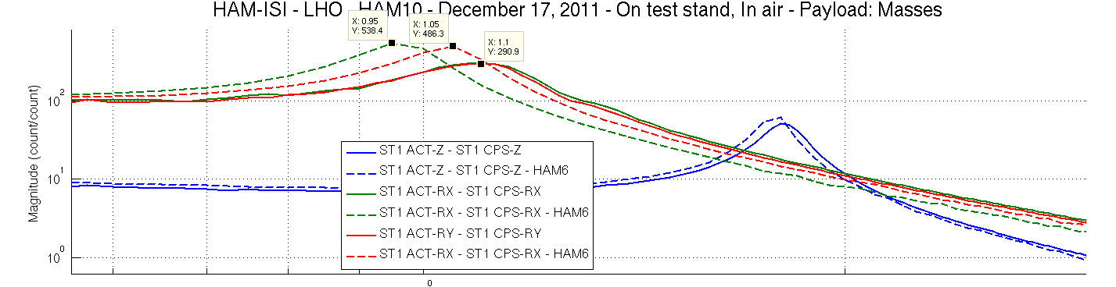
Figure – Cartesian to Cartesian measurements, comparison with HAM6 reference – Inertial Sensors
Vertical motion-Zoomed on a resonance
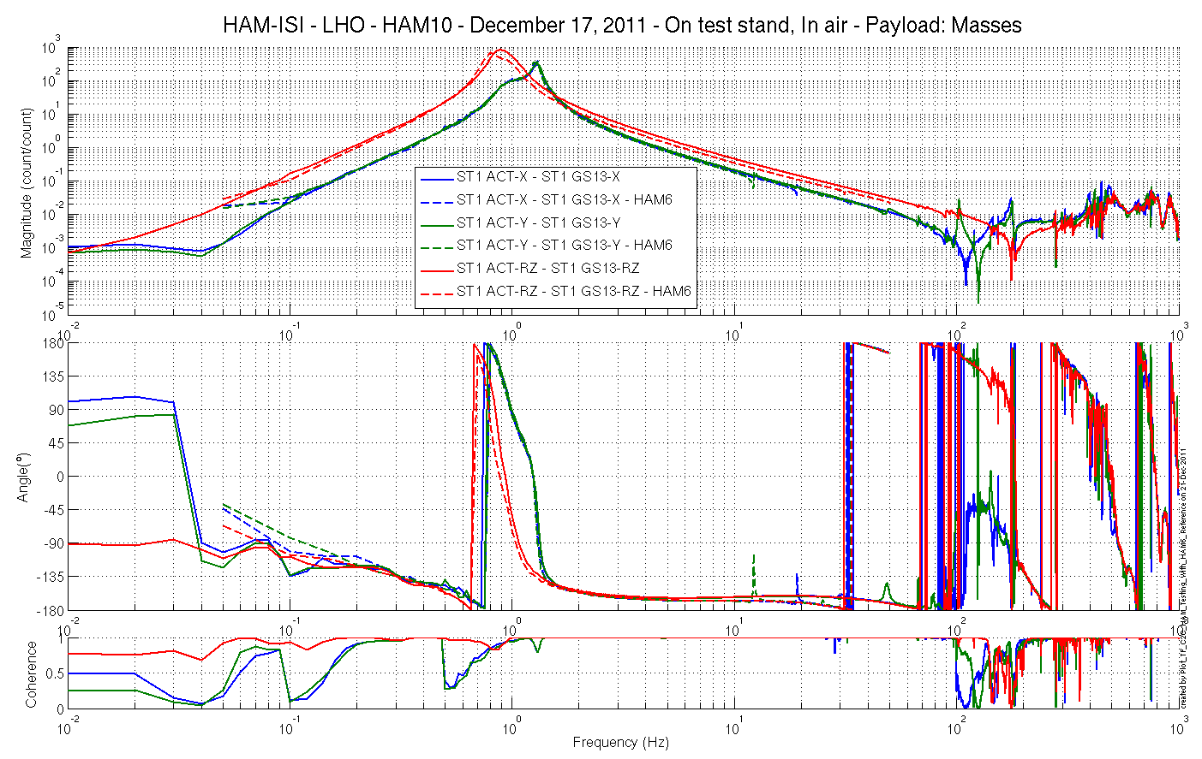
Figure – Cartesian to Cartesian measurements, comparison with HAM6 reference – Inertial Sensors
Horizontal motion

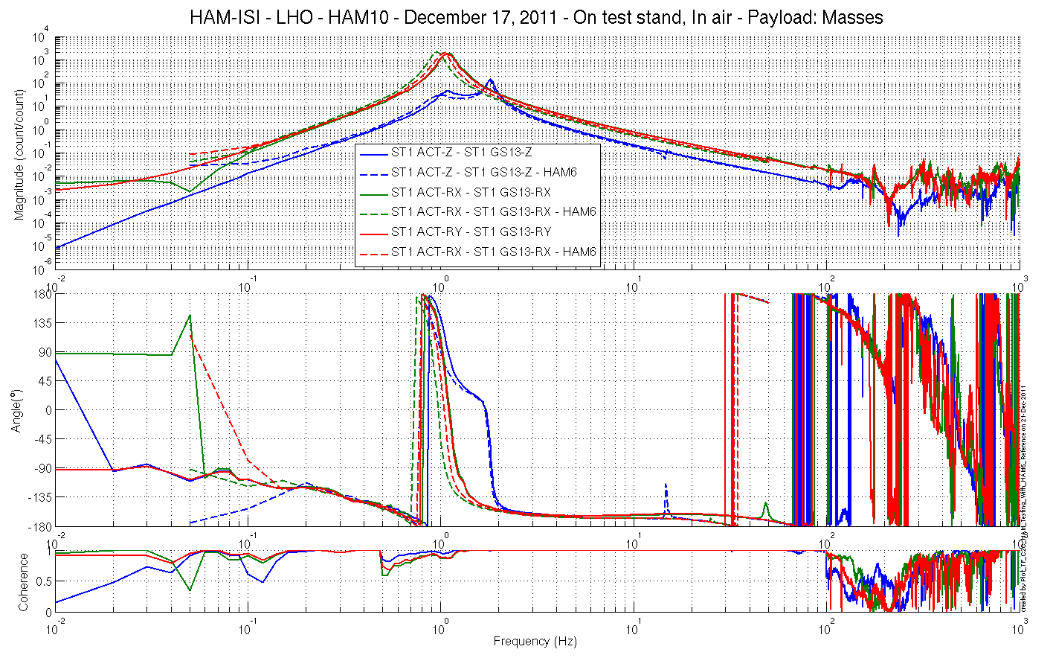
Figure – Cartesian to Cartesian measurements, comparison with HAM6 reference – Inertial Sensors
Vertical motion

Cartesian to Cartesian measurement configuration:
- CPS Calibration filter: ON, but with bad gain (old version)
- GS13 Calibration filter: ON
- GS13 Gain filter: ON
- GS13 De-whitening filter: ON
- Actuators Compensation filter: ON
- ISI_HAM10_Damp channels’ gain set on -1 during measurements.

“Post-processing”:
- De-whitening filters cancelled on GS13 measurements.
- Idealization filters cancelled on GS13 Cartesian TF.
- Actuators’ compensation filter cancelled on measurement.
- Gain applied on HAM6 CPS to adjust curves amplitudes for comparison.

Issues/difficulties/comments regarding this test:
- More than 10% out of phase for vertical (Z, RX, RY) geophones. However, test geophones are used.
- Plotting functions put in temporary folder.

Acceptance criteria:
- No difference with the reference transfer functions (SVN)
  - Phase – less than 10º - In Phase – Out of Phase
  - Damping (fit by eye with Reference transfer functions)
  - DC gain
  - Eigen frequencies shift less than 10%

Test result: Passed: X Failed: .

Step 18 - Lower Zero Moment Plane
Data collection script files:
opt/svncommon/seisvn/seismic/HAM-ISI/Common/Transfer_Function_Scripts/
- Run_TF_C2C_10mHz_100mHz_LZMP_HAM_ISI.m
Data files in SVN at:
opt/svncommon/seisvn/seismic/HAM-ISI/X1/HAM10/Data/Transfer_Functions/Measurements/
Undamped/
- LHO_ISI_HAM10_Data_TF_C2C_10mHz_100mHz_LZMP_20111219-170245.mat
Scripts files for processing and plotting in SVN at:
opt/svncommon/seisvn/seismic/HAM-ISI/Common/Testing_Functions_HAM_ISI/
- LZMP_HAM_ISI.m

Figures in SVN at:
opt/svncommon/seisvn/seismic/HAM-ISI/X1/HAM10/Data/ Figures/Transfer_Functions/
Measurements/Undamped/
- LHO_ISI_HAM10_LZMP.fig

X & Y offsets:
X offset (mm) | 1.19
Y offset (mm) | 1.52
Table – Offset of the Lower Zero Moment Plane

Issues/difficulties/comments regarding this test:
Increasing the number of averages from 200 to 300 did not affect results.
The results from two measurements are presented on the figure below:
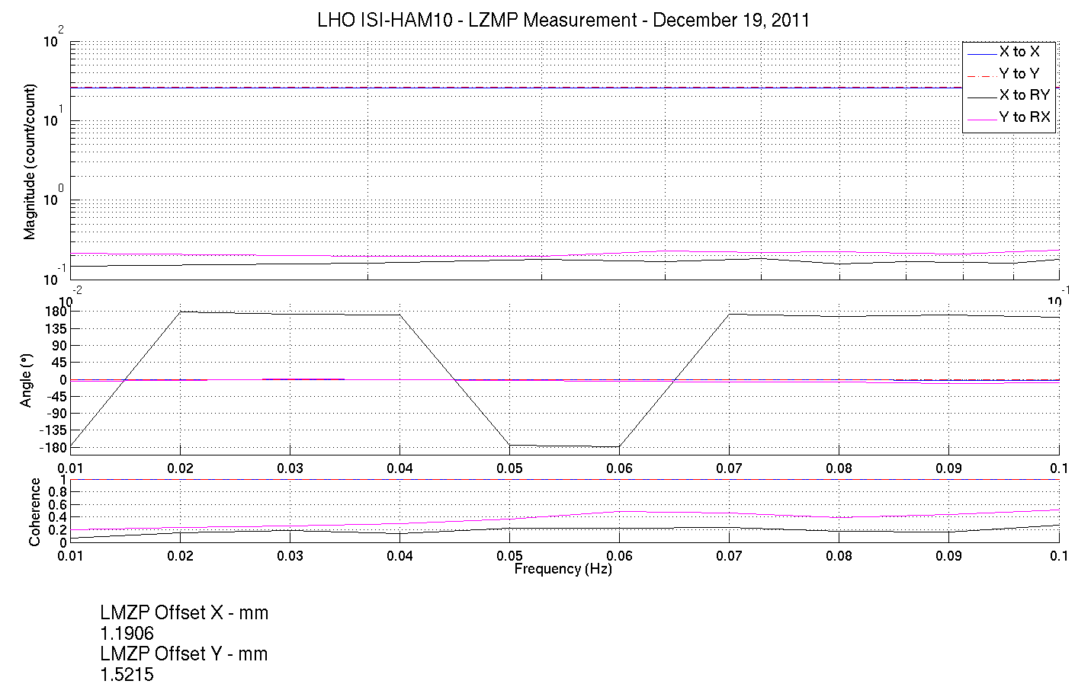
Figure - Lower Zero Moment Plane – Main and cross couplings at low frequency

Issues/difficulties/comments regarding this test
Run_Get_Batch.m needed a minor update in order to process large amounts of data.

Acceptance criteria:
- X offset must be less than 2 mm
- Y offset must be less than 2 mm

Test result: Passed: X Failed: .

HAM-ISI Unit #3 testing summary

HAM-ISI unit #3 was built and tested in October 2010. Faulty part replacement implied the need of disassembling and reassembling the unit. Once reassembled, the unit had to be re-tested. Tests presented here were performed between November 15th and December 23rd 2011. Tests were performed in accordance with E1000309-V9 procedure.

Particularities:
Test versions of the GS13 were used. Permanent GS13 will replace them as soon as received.
L4Cs were not installed for this first phase of testing.

Evolution from previous testing:
Mass budget is now lower of 7.88kg. That can be due to the blades leveling or in accuracy in our estimates of the balancing masses. That’s within tolerance, so it’s not a problem.

Complementary inquiries:
CPS shielding efficiency was investigated due to the high density of narrow peaks observed on their ASDs. Inquiry was performed and proved that the peaks were caused by the spectral characteristics of ground motion.

FAILED AND WAIVED TESTS

List of tests that failed and don’t need to be redone:
Step II.7: Level of stage 0 was slightly out of requirements, but good enough for this phase of testing.
Step II.8: Same comments for the leveling of stage 1 (was out of spec because stage 0 was not leveled)
Step III.2: Excessive standard deviation associated to ground motion. Sensor noise is acceptable.
Step III.7: ASDs with table tilted are borderline. However the geophones will be replaced.

Tests that failed and need to be done during phase II
Step I.2: Test GS13 will be replaced with permanent ones. S/N should be recorded then.
Step III.14: Deviation from average slope out of spec. However this is associated with cable length. Make sure that linearity test results correlate with the final filed cables.

List of test that were skipped and that we will not do because they are not essential
Step III.3: Sensor gap measurement with a jig. Waved to avoid scratching targets. Distance between sensor and target has also been checked during the assembly while adjusting target distance.

List of test that were skipped and need to be done during phase II:
Step III.19: Damping loops
Step III.19.1: Transfer functions – Simulation
Step III.19.2: Powerspectra – Experimental

