LIGO Laboratory / LIGO Scientific Collaboration

LIGO- E1000314 LIGO May 23rd, 2012

aLIGO HAM-ISI, Pre-integration Test Report, Phase I,
LHO Unit #5 (post-assembly, before storage)
E1000314 – V3

Hugo Paris, Fabrice Matichard, Vincent Lhuillier
Hugh Radkins, Jim Warner, Robinson Mitchel, Corey Gray, Gregory Grabeel, Eric Allwine

Distribution of this document:
Advanced LIGO Project

This is an internal working note
of the LIGO Laboratory

California Institute of Technology  LIGO Project – MS 18-34  1200 E. California Blvd.  Pasadena, CA 91125  Phone (626) 395-2129  Fax (626) 304-9834  E-mail: info@ligo.caltech.edu | Massachusetts Institute of Technology  LIGO Project – NW22-295  185 Albany St  Cambridge, MA 02139  Phone (617) 253-4824  Fax (617) 253-7014  E-mail: info@ligo.mit.edu
LIGO Hanford Observatory  P.O. Box 1970  Mail Stop S9-02  Richland WA 99352  Phone 509-372-8106  Fax 509-372-8137 | LIGO Livingston Observatory  P.O. Box 940  Livingston, LA 70754  Phone 225-686-3100  Fax 225-686-7189

Table of contents:
Introduction 4
I. Pre-Assembly Testing 5
▪ Step 1: Position Sensors 5
▪ Step 2: GS13 testing prior to shippement 7
▪ Step 2.1 – Horizontal GS-13s 8
▪ Step 2.2 – Vertical GS-13s 9
▪ Step 3: Actuators 11
▪ Step 5 – Seismometer inspection after shipping 12
II. Tests to be performed during assembly 13
▪ Step 1: Parts Inventory (E1000052) 13
▪ Step 2: Check torques on all bolts 14
▪ Step 3: Check gaps under Support Posts 14
▪ Step 4: Pitchfork/Boxwork flatness before Optical Table install 14
▪ Step 5: Blade spring profile 15
▪ Step 6: Gap checks on actuators-after installation on Stage 1 16
▪ Step 7: Check level of Stage 0 17
▪ Step 8: Check level of Stage 1 Optical Table 18
▪ Step 9: Mass budget 19
▪ Step 10: Shim thickness 21
▪ Step 11: Lockers adjustment 21
III. Tests to be performed after assembly 22
▪ Step 1 - Electronics Inventory 22
▪ Step 2 - Set up sensors gap 22
▪ Step 3 - Measure the Sensor gap 23
▪ Step 4 - Check Sensor gaps after the platform release 23
▪ Step 5 – Performance of the limiter 24
▪ Step 5.1 - Test Nº1 - Pushing “in the general coordinates” 24
▪ Step 5.2 - Test Nº2 – Pushing “locally” 24
▪ Step 6 - Position Sensors unlocked/locked Power Spectra 26
▪ Step 7 - GS13 power spectra -tabled tilted 28
▪ Step 8- GS13 pressure readout 29
▪ Step 9 - Coil Driver, cabling and resistance check 30
▪ Step 10 - Actuators Sign and range of motion (Local drive) 31
▪ Step 11 - Vertical Sensor Calibration 32
▪ Step 12 - Vertical Spring Constant 33
▪ Step 13 - Static Testing (Tests in the local basis) 33
▪ Step 14 - Linearity test 34
▪ Step 15 - Cartesian Basis Static Testing 35
▪ Step 16- Frequency response 36
▪ Step 16.1 - Local to local measurements 36
▪ Step 16.2 – GS13 Response extraction 38
▪ Step 16.3 GS13 response fitting 41
▪ 16.4 Symmetrization Filters 44
▪ Step 16.4 - Cartesian to Cartesian TF computation 46
▪ Step 17 - Transfer function comparison with Reference 48
▪ Step 17.1 - Local to local - Comparison with Reference 48
▪ Step 17.2 - Cartesian to Cartesian - Comparison with Reference 51
▪ Step 18 - Lower Zero Moment Plane 54
▪ Step 19 - Damping loops 55
▪ Step 19.1 – Simulation of damping performance - TF 55
▪ Step 19.2 – Experiemental evaluation of damping performance - Spectra 57
IV. HAM-ISI Unit #5 testing summary 59
▪ List of tests that failed and don’t need to be redone: 59
▪ Tests that failed and need to be done during phase II 59
▪ List of test that were skipped and that we will not do because they are not essential 59

Introduction
HAM-ISI Unit #5 was assembled during April 2012. The testing of this Unit is presented here. It started on May 2nd 2012 and lasted until May 8th 2012 with the testing horizontal GS13s.
These Horizontal GS13s featured non-consistent behavior after reception at LHO. Investigation has been performed at LLO for instruments featuring the same symptoms (LLO aLog 2909). It revealed that the screws of some flexures were not correctly torqued anymore and that they needed lock tight in order to remain secured during shipping. Hence, the horizontal GS13s initially used for testing were considered as “testing instruments”. They were removed from the assembly at the end of the assembly validation, to be replaced with production pods. Tests involving GS13s were performed with the new set of production pods between May 21st and May 24th 2012.
Stage-0 L4Cs and their brackets were not installed during tests.
The procedure document used to perform these tests is:
- E1000309–V12 - aLIGO HAM-ISI, Pre-Integration Testing Procedure, Phase I (post assembly, before storage)
Other useful information can be found in:
- E1000300 - HAM-ISI LLO test stand: software and electronic check

Remark regarding SVN paths:
Units need to be tested under a folder that matches medm channels’ names. Since MEDM channels’ names all refer to HAMX during this phase of testing, units are all tested under:
/SeiSVN/seismic/HAM-ISI/X1/HAMX/
Once a unit is tested, a folder called after its order of assembly is created. For Unit #5, the name of this folder will be:
/SeiSVN/seismic/HAM-ISI/X1/Unit_5/
Test data is then moved from HAMX testing folder to this final folder. All the data related to the Phase I testing of this unit is then stored in this folder. The data set names, the location of the test results, and the locations of the programs used to obtain them are specified along this document.
Even if they are tested under HAMX, units are called per their order of assembly in programs, figures and data files.

Pre-Assembly Testing

Step 1: Position Sensors
S/N sensor | S/N board | ADE Gap Standoff (mm) | Location on the Jig | Gap Standoff on Jig (mm/in) | Voltage before zeroing | Voltage after zeroing. Prebake | Voltage after zeroing. Post bake
12007 | 11887 | NR | NR | ~2.057 | 0.6 | ~.01 | x
11983 | 11853 | NR | NR | ~2.057 | x | ~.01 | x
12022 | 11869 | NR | NR | ~2.057 | x | ~.01 | x
12006 | 11901 | NR | NR | ~2.057 | x | ~.01 | x
12035 | 11888 | NR | NR | 2.032mm/0.080" | **-1 | *.01 | -4.88
12027 | 11883 | NR | NR | 2.032mm/0.080" | **-1 | *.01 | -4.82

*: Not recorded, estimation
**: The sign was not recorded, but probably is in negative volts
NR: Not recorded
Note: The back panel reads 0.508V/0.001"

Sensors noise spectra measured before baking E1000257, and before shielding per procedure T1000636:

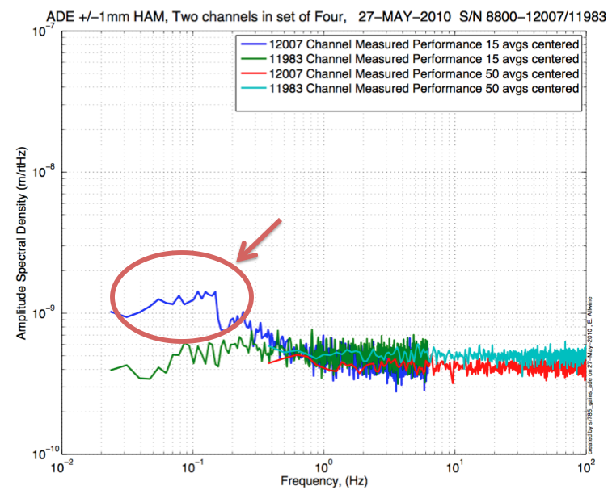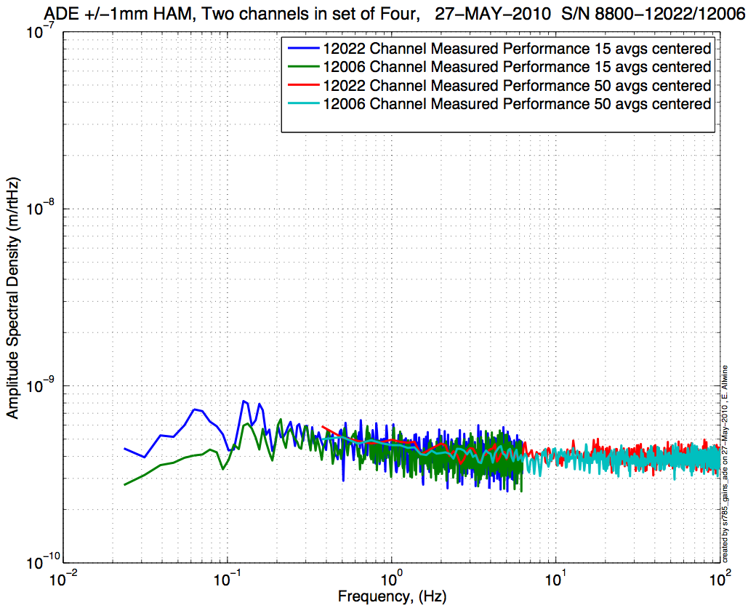
Figure - H1 and V1 sensor noise Figure - H2 and V2 sensor noise
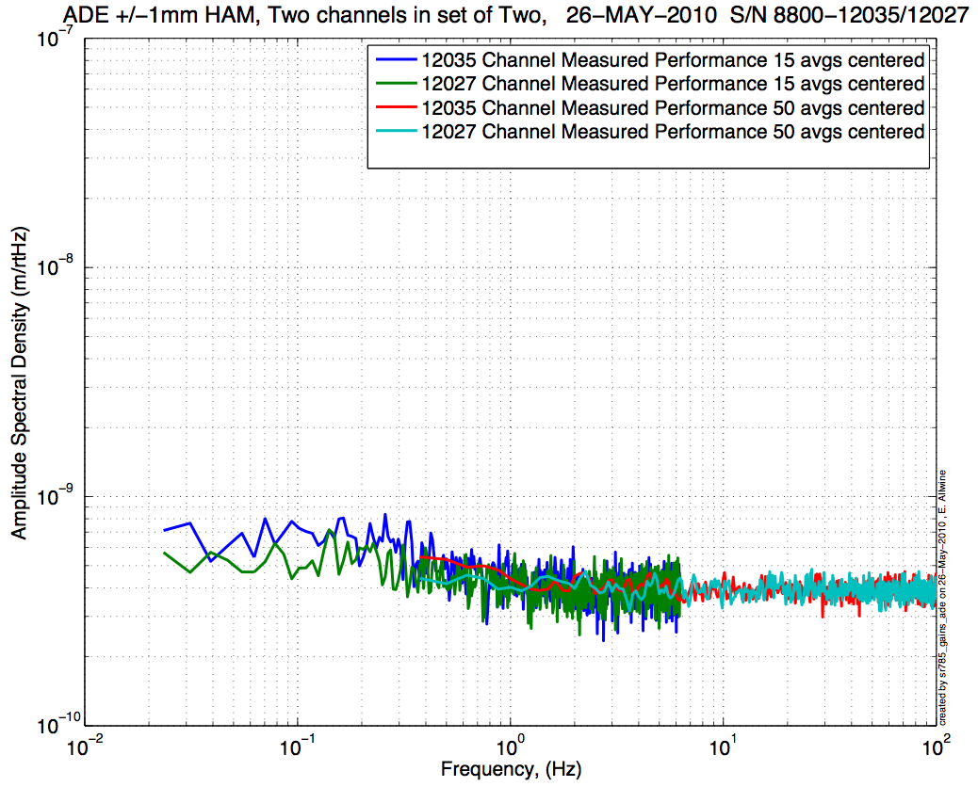
Figure - H3 and V3 sensor noise

Issues/difficulties/comments regarding this test:
- CPS # 12007 (H1) is slightly out of requirements at 0.1 Hz

Acceptance Criteria:
- Power spectrum magnitudes must be lower than:
  - 9.e-10 m/√Hz at 0.1Hz
  - 6.e-10 m/√Hz at 1Hz

Test result: Passed: Failed: X .

Note: Failed on H1 at 0.1Hz. Its spectrum is however very close from our requirement.

Step 2: GS13 testing prior to shippement
Data related to GS-13 post podding testing can be found in the SVN at: \SeismicSVN\seismic\Common\Data\aLIGO_GS13_TestData\PostMod_TestResults_PDFs.
Power spectra measured at reception, after shipment from LLO, can be found at
\SeismicSVN\ seismic\Common\Data\aLIGO_GS13_TestData_LHO\
aLIGO GS13 Testing page is E1100367. It contains links to:
- LIGO-E1000058: aLIGO GS-13 Status Chart
- LIGO-24: aLIGO GS-13 as received testing results
- LIGO-E1100394: aLIGO GS-13 prior shipping testing results
- LIGO-E1100395: aLIGO GS-13 Post Modification testing results
- LIGO-F0900070: GS-13 Inspection Checklist

 |  | Corner 1 | Corner 2 | Corner 3
V | Pod | 74 | 72 | 4
 | Instrument | 687 | 733 | 691
H | Pod | 13 | 38 | 71
 | Instrument | 820 | 829 | 843
Table- GS13 instrument and Pod S/Ns

Step 2.1 – Horizontal GS-13s
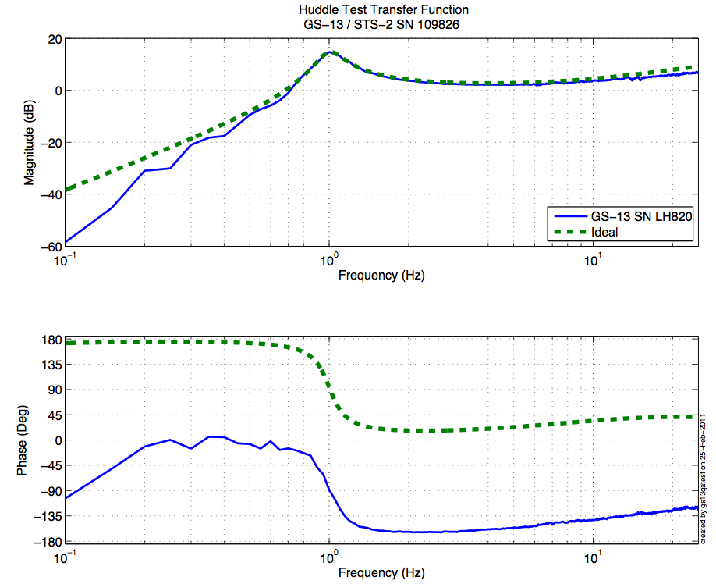
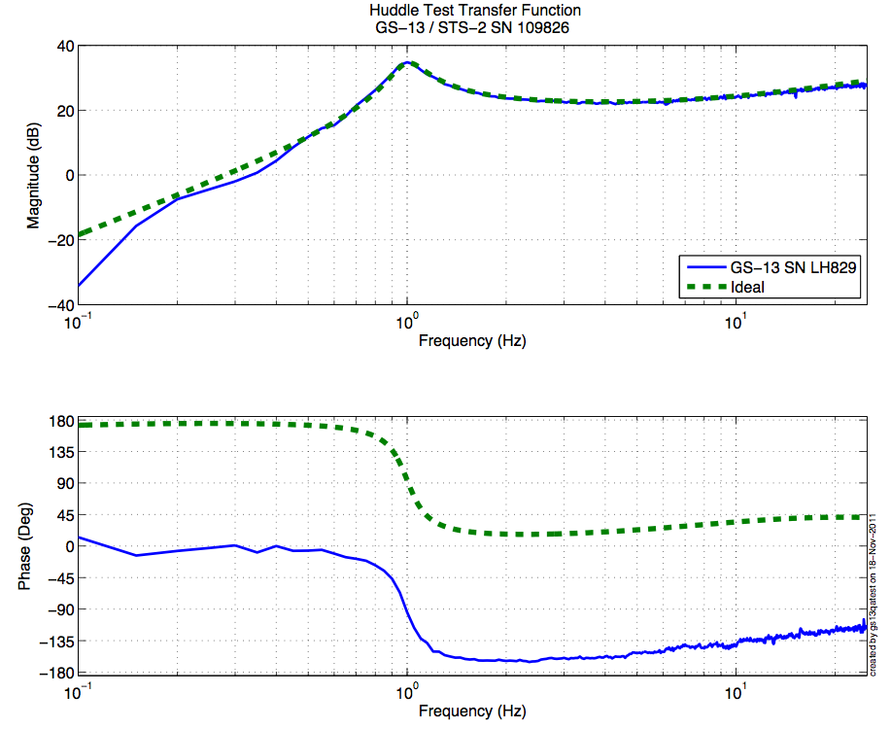
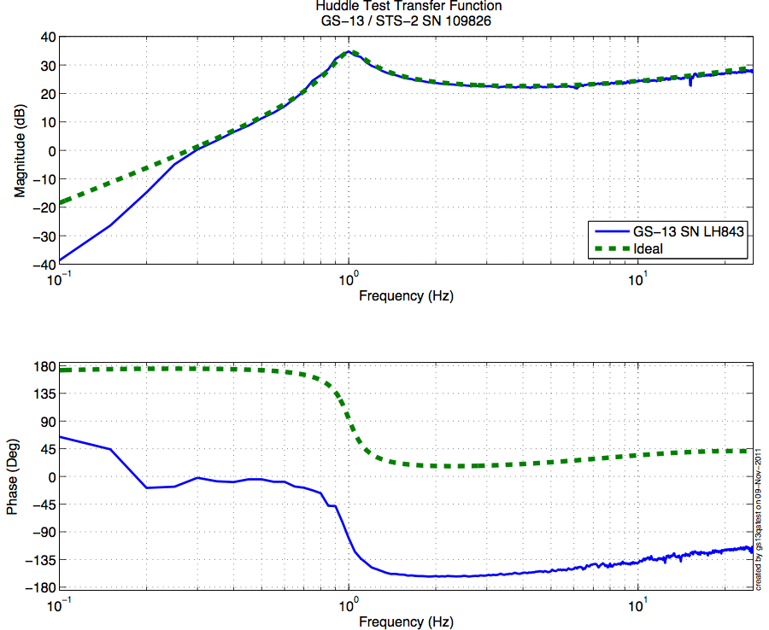
Figure - Huddle testing of Horizontal GS-13 820(H1), 829(H2), and 843(H3) after aLIGO modifications

Step 2.2 – Vertical GS-13s
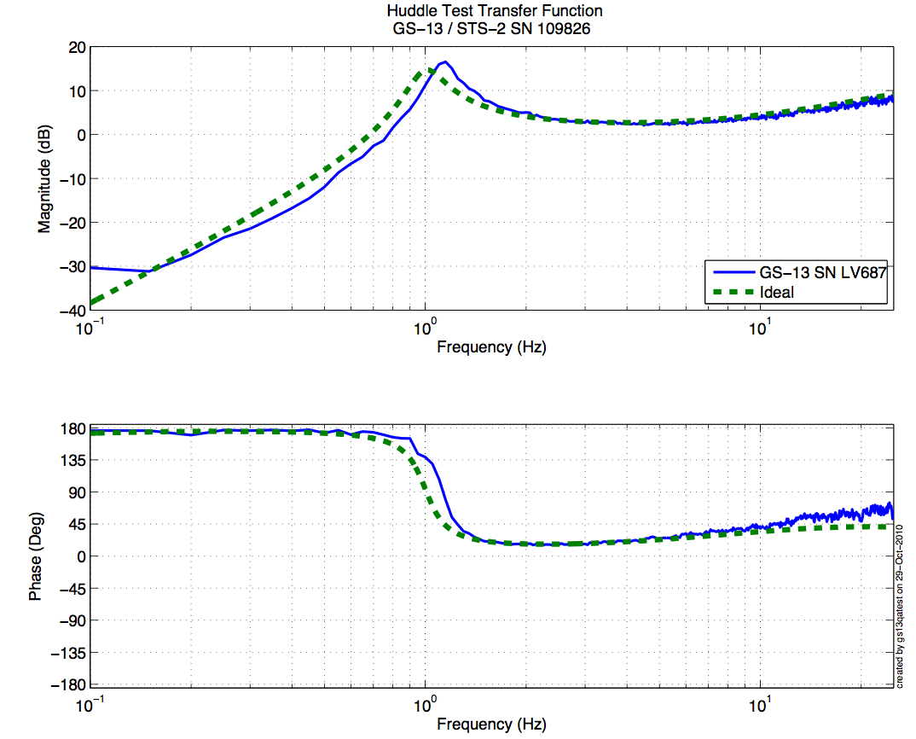
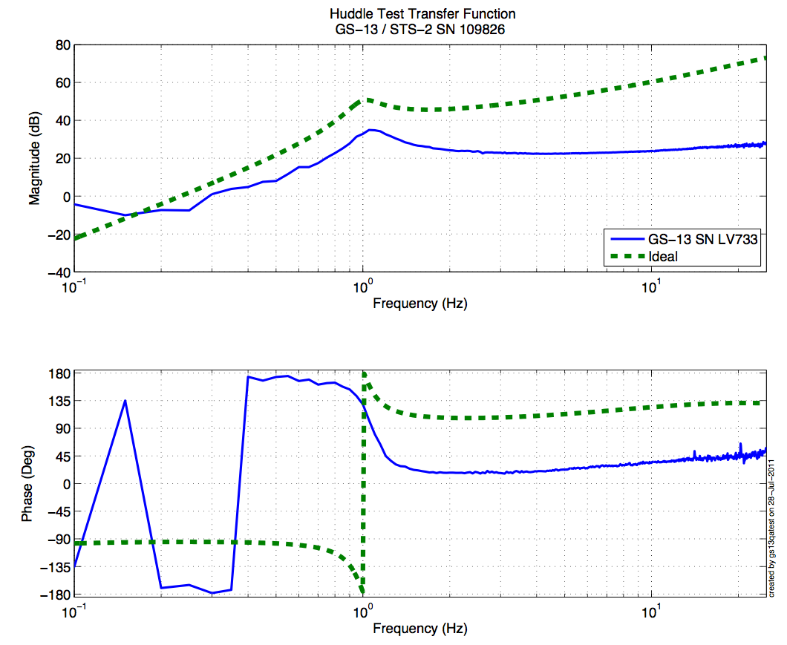
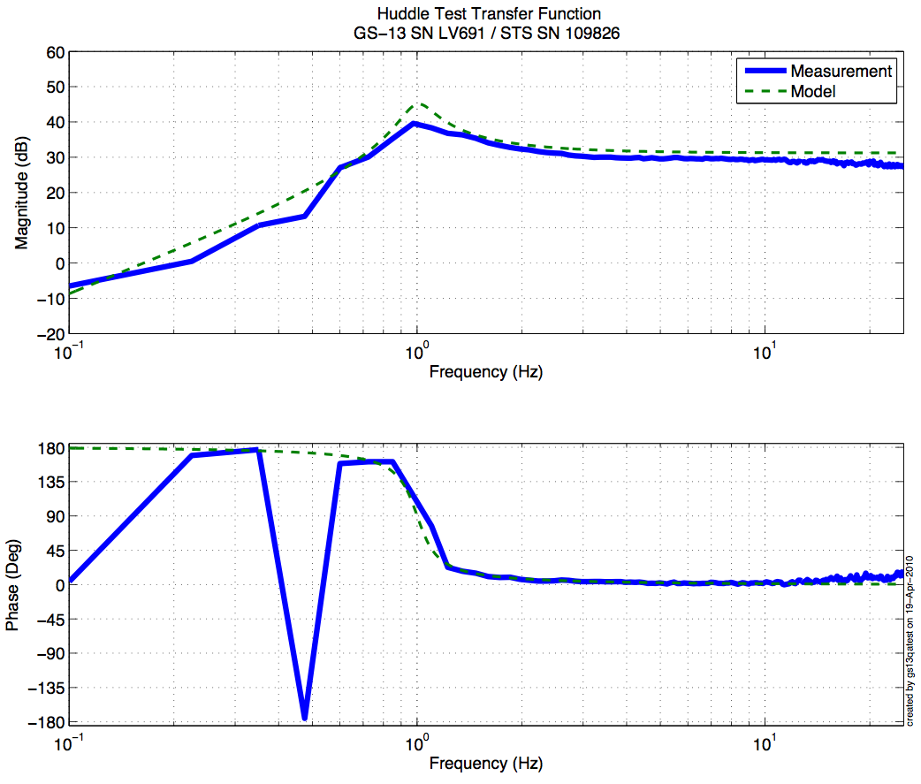
Figure - Huddle testing of Vertical GS-13 687(V1), 733(V2), and 691(V3) after aLIGO modifications
Driven testing
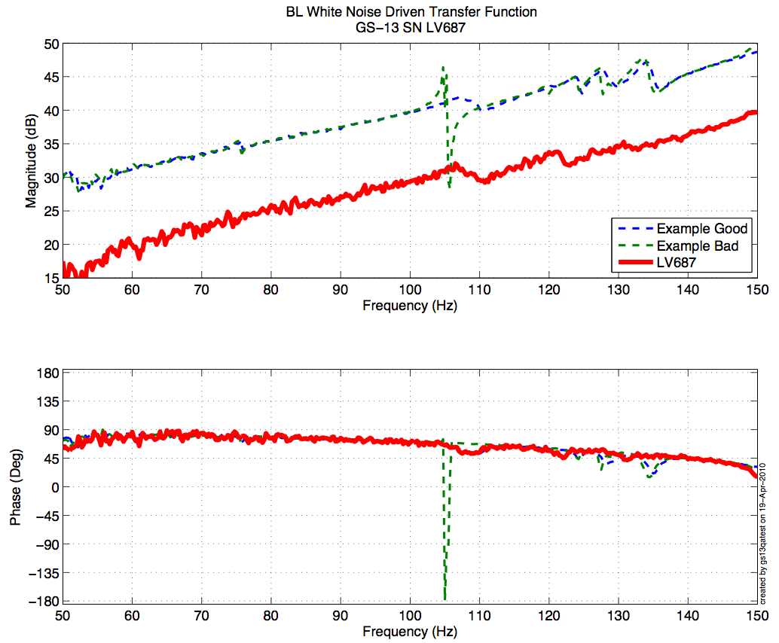
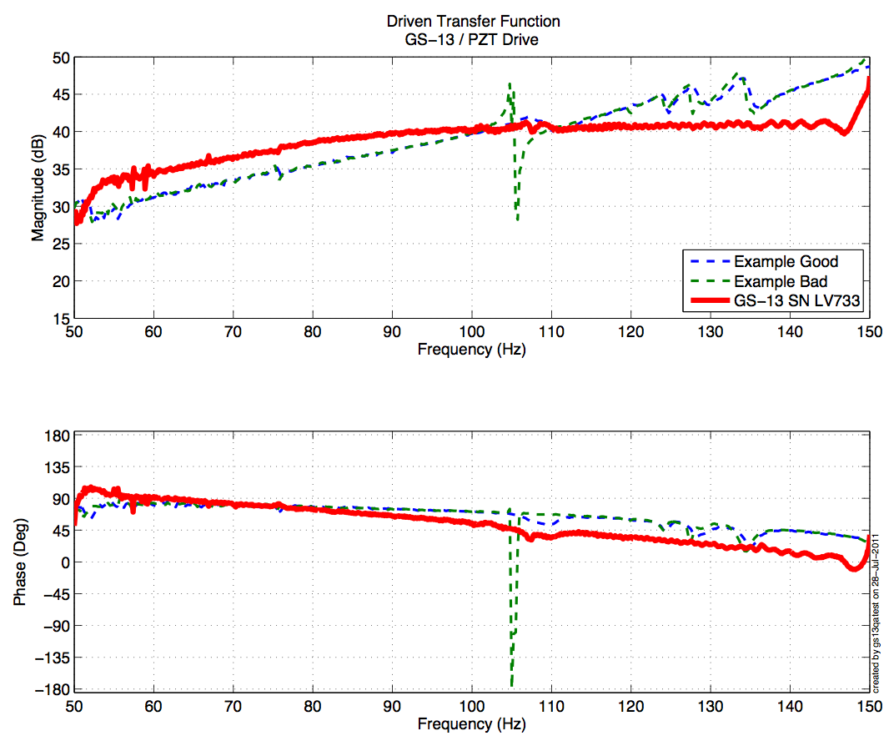
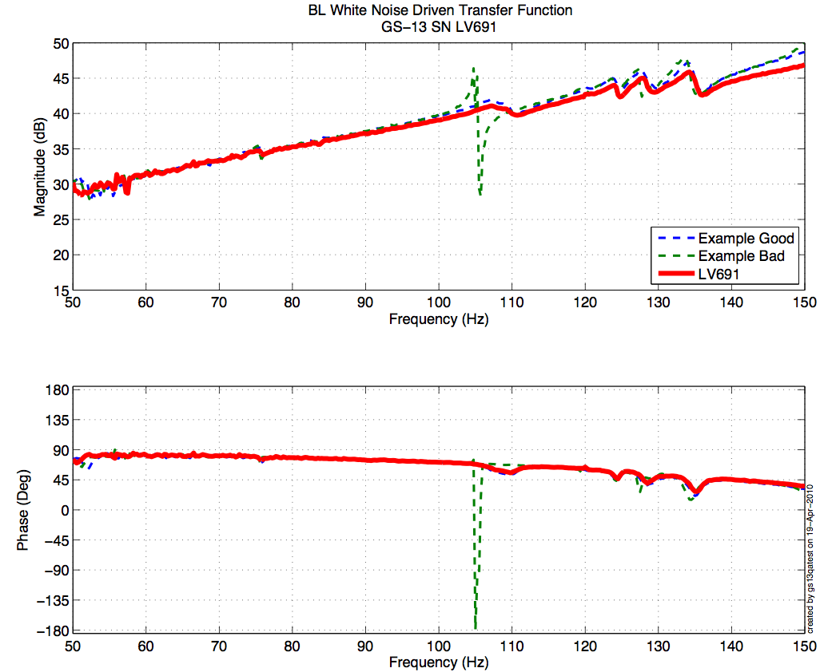

Figure - Driven testing of Vertical GS-13 687(V1), 733(V2), and 691(V3) after aLIGO modifications

Acceptance Criteria:
- GS13 have already been tested at LLO. GS13 Inspection/Pod Assembly is described in document D047810. Checklist is defined in F090070-v6

Test result: Passed: X Failed: .

Step 3: Actuators
Actuator data can be found at: T0900564-V2. Actuator inventory is made at Section II – Step 1.

Actuator Serial #: L105  Operator Name: Gordon, Matt  Date: 1/30/2010 Time: 11:00 AM  Actuator Coil Resistance: 6.42 Ohms, PASS Ambient Temperature: 65.5 F  Hi Pot Test Results: 1000 MOhms, PASS  X Travel Limit (inches): 0.528  Y Travel Limit (inches): 0.205  Z Travel Limit (inches): 0.501 | Actuator Serial #: L023  Operator Name: Smith, Lane  Date: 8/12/2009 Time: 9:26 AM  Actuator Coil Resistance: 6.42 Ohms, PASS Ambient Temperature: 68.8 F  Hi Pot Test Results: 1000 MOhms, PASS  X Travel Limit (inches): 0.518  Y Travel Limit (inches): 0.205  Z Travel Limit (inches): 0.478
Actuator Serial #: L098  Operator Name: Gordon, Matt  Date: 1/30/2010 Time: 12:14 PM  Actuator Coil Resistance: 6.34 Ohms, PASS Ambient Temperature: 65.2 F  Hi Pot Test Results: 1000 MOhms, PASS  X Travel Limit (inches): 0.534  Y Travel Limit (inches): 0.206  Z Travel Limit (inches): 0.505 | Actuator Serial #: L115  Operator Name: Gordon, Matt  Date: 1/29/2010 Time: 4:19 PM  Actuator Coil Resistance: 6.35 Ohms, PASS Ambient Temperature: 71.3 F  Hi Pot Test Results: 1000 MOhms, PASS  X Travel Limit (inches): 0.540  Y Travel Limit (inches): 0.205  Z Travel Limit (inches): 0.505
Actuator Serial #: L116  Operator Name: Gordon, Matt  Date: 1/29/2010 Time: 3:50 PM  Actuator Coil Resistance: 6.35 Ohms, PASS Ambient Temperature: 71.3 F  Hi Pot Test Results: 1000 MOhms, PASS  X Travel Limit (inches): 0.526  Y Travel Limit (inches): 0.205  Z Travel Limit (inches): 0.506 | Actuator Serial #: L117  Operator Name: Gordon, Matt  Date: 1/29/2010 Time: 3:32 PM  Actuator Coil Resistance: 6.4033 Ohms, PASS Ambient Temperature: 71.3 F  Hi Pot Test Results: 1000 MOhms, PASS  X Travel Limit (inches): 0.536  Y Travel Limit (inches): 0.206  Z Travel Limit (inches): 0.507

TBC: To Be Completed once horizontal actuators’ S/N are retrieved (GS13 door opened)

Issues/difficulties/comments regarding this test:
- Actuators S/Ns were recorded after assembly.

Acceptance Criteria:
- Actuators were previously tested and results are reported in T0900564-V2.

Test result: Passed: X Failed: .

Step 5 – Seismometer inspection after shipping
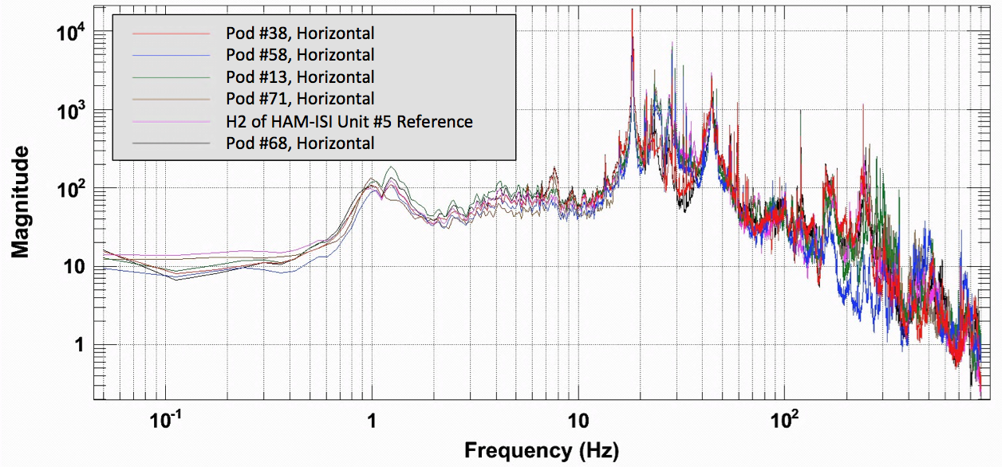
Figure – Horizontal Geophones (H1=13 H2=38, H3=71) inspection after reception at LHO

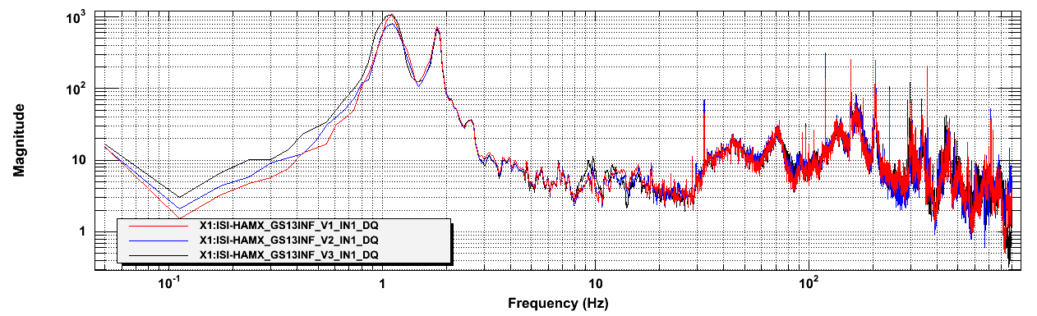 Figure – Vertical Geophones inspection after reception at LHO

Results saved under the SVN at:
/SeiSVN/seismic/Common/Data/aLIGO_GS13_TestData_LHO/

Acceptance Criteria:
- Geophones must have been tested after reception the geophones at LHO
- ASDs of the geophones must confirm that they are still functioning after shipping.
- Results must be available in the SVN

Test result: Passed: X Failed: .

Note:
Horizontal GS13s have locktight on their flexure’s screws.

Tests to be performed during assembly

Step 1: Parts Inventory (E1000052)
DCC Number | Part name | Configuration | Corner 1 S/N | Corner 2 S/N | Corner 3 S/N
D071001 | Stage 0 base | NA | 10
D071051 | Stage 1 base | NA | 12
D071050 | Optical table | NA | 11
D071002 | Spring Post | NA | 2 | 3 | 8
D071100 | Spring | NA | 38 | 13 | 29
D071102 | Flexure | NA | 2 | 4 | 14
ADE | Position sensor | Horizontal | 12007 Master 0 | 12022 S1ave 180 | 12035 Slave 0
 |  | Vertical | 11983 Slave 180 | 12006 Slave 0 | 12027 Slave 180
D047812 | GS-13 pod | Horizontal | 13 | 38 | 71
 |  | Vertical | 74 | 72 | 4
D047823 | L4C pod | Horizontal | NA | NA | NA
 |  | Vertical | NA | NA | NA
D0902749 | Actuator | Horizontal | 23 | 115 | 117
 |  | Vertical | 105 | 98 | 116
Table – Parts inventory

Cable Connects |  | Cable S/N
Part Name | Configuration | Corner 1 | Corner 2 | Corner 3
GS13 | Horizontal | S1106664 | S1106659 | S1104712
 | Vertical
L4C | Horizontal | NA | NA | NA
 | Vertical | NA | NA | NA
Actuator | Horizontal | S1104492 | S1104756 | S1106678
 | Vertical | S1106679 | S1104490 | S1105207
Table – Cables inventory

NA: Not applicable

Step 2: Check torques on all bolts
Acceptance Criteria:
- All bolts should trip the wrench, and start moving immediately after. If any bolts in a pattern move before torque is reached, recheck after all bolts are brought to spec.

Test result: Passed: X Failed: .

Step 3: Check gaps under Support Posts
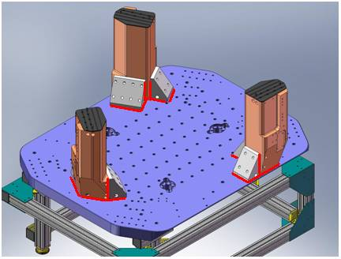
Figure - Showing edges that need checked on support posts and gussets

Acceptance Criteria:
- A 0.001 inch shim cannot be passed freely through any connection to Stage 0 or between post and gussets. If shim can pass through, loosen all constraining bolts, and then retighten iteratively from the center of the part to the edges. Retest.
Test result: Passed: X Failed: .

Step 4: Pitchfork/Boxwork flatness before Optical Table install
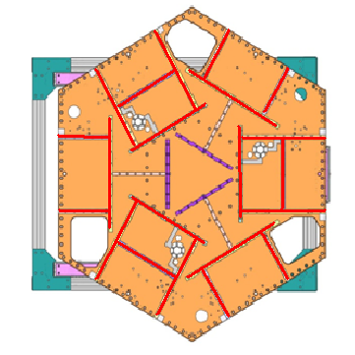
Figure – Showing what needs to be checked on Boxworks and Pitchforks

Acceptance Criteria:
- Shim inserted won’t pass between parts.
Test result: Passed: X Failed: .

Step 5: Blade spring profile

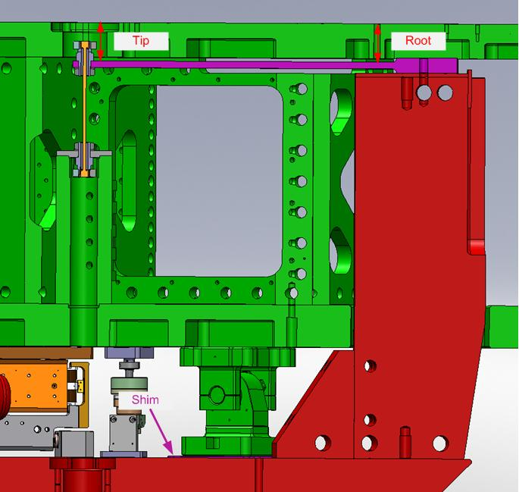
figure – Blade spring profile measurement points

Blade # | Root (Mils) | Tip(Mils) | Flatness (mils)
1 | 611.5 | 624 | 12.5
2 | 608.5 | 620 | 11.5
3 | 612 | 622 | 10
Table - Blade profile

Acceptance Criteria:
- Blades must be flat within 0.015" inches.

Note that the tip measurement should be constant and that root value can be impacted by shims change.

Test result: Passed: X Failed: .

Step 6: Gap checks on actuators-after installation on Stage 1

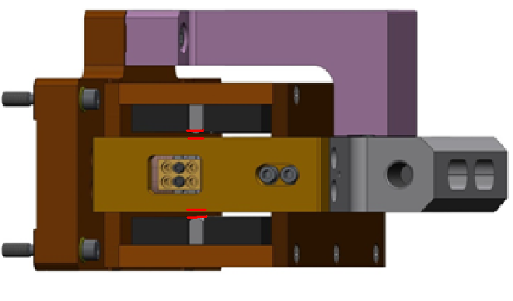
Figure - Showing gaps that need to be checked on actuators.

Issues/difficulties/comments regarding this test:
Since layers of shims are difficult to use accurately, a Go (70mils shim set) vs. No Go (90 mils shim set) technique was used for this test. To pass the test an actuator gap has to allow the 70mils shim set to be inserted and refuse the 90mils shim set.
The gaps on the backside of horizontal actuators are hard to access.

Acceptance Criteria
- Gaps must be within 0.010” of design (i.e. 0.090” and .070” pass, but 0.095” and 0.065” doesn’t).

Test result: Passed: X Failed: .

Step 7: Check level of Stage 0

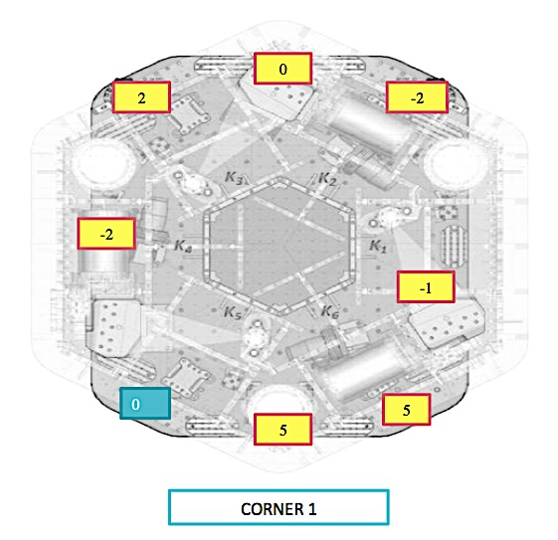
Figure – Level measured on Stage 0

Issues/difficulties/comments regarding this test:
The accuracy of the measurement limited by the measurement tool: optical level + ruler on a block. The ruler only has 1/100” graduations. Values are deduced from the relative distance to graduations. The uncertainty is about 1mil.
Max angle is calculated between the opposite points that have the most different level.
Max angle=0.007/72 (± 0.001/72) = 97.2 (±13.8) µrad

Acceptance Criteria
- The maximum angle of the table with the horizontal mustn’t exceed ~100µrad

Test result: Passed: X Failed: .

Note:
This test is borderline to our stringent requirement, however this leveling value is sufficient for all the tests being performed.

Step 8: Check level of Stage 1 Optical Table

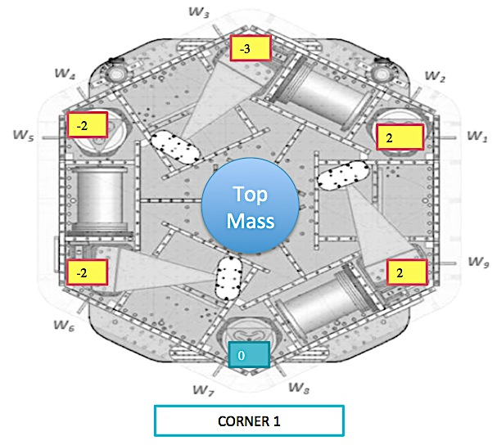
Figure – Level measured on Stage 1

Issues/difficulties/comments regarding this test:
The accuracy of the measurement is limited by the measurement tool: optical level + ruler on a block. The ruler only has 1/100” graduations. Values are deduced from the relative distance to graduations. The uncertainty is about 1mil.
Max angle is calculated between the opposite points that have the most different level.
Max angle = 0.004/86 (± 0.001/86) = 47.5 (± 11.7) µrad

Acceptance Criteria
- The maximum angle of the table with the horizontal mustn’t exceed ~100µrad

Test result: Passed: X Failed: .

Step 9: Mass budget
 | 00 | 01 | 02 | 03 | 04 | 05 | 06
 | 0.6 | 1.1 | 2.2 | 4.5 | 7.9 | 15.6 | 27.2 | lbs | kgs
W9 | 1 | 2 |  |  |  |  |  | 2.8 | 1.27
W1 |  |  |  | 1 |  |  | 1 | 31.7 | 14.38
W2 |  |  | 1 | 1 |  |  | 1 | 33.9 | 15.38
W3 | 2 | 2 |  |  |  |  |  | 3.4 | 1.54
W4 |  | 1 |  |  |  |  | 1 | 28.3 | 12.84
W5 |  |  |  | 1 |  |  | 1 | 31.7 | 14.38
W6 | 1 |  |  |  |  |  |  | 0.6 | 0.27
W7 |  |  |  | 2 |  |  | 1 | 36.2 | 16.42
W8 | 1 |  |  |  |  |  | 1 | 27.8 | 12.61
Side Masses Total | 5 | 5 | 1 | 5 | 0 | 0 | 6 | 196.4 | 89.09
Table – Wall masses distribution

 | 00 | 01 | 02 | 03 | 04 | 05 | 06
 | 0.6 | 1.1 | 2.2 | 4.5 | 7.9 | 15.6 | 27.2 | lbs | kgs
K1 |  |  |  |  | 1 |  | 1 | 35.1 | 15.92
K2 |  |  |  |  |  | 2 |  | 31.2 | 14.15
K3 |  |  |  |  | 1 |  | 1 | 35.1 | 15.92
K4 |  |  |  |  |  | 2 |  | 31.2 | 14.15
K5 |  |  |  |  | 1 |  | 1 | 35.1 | 15.92
K6 |  |  |  |  |  | 2 |  | 31.2 | 14.15
Keel Masses Total | 0 | 0 | 0 | 0 | 3 | 6 | 3 | 198.9 | 90.22
Table – Keel masses distribution

 | Mass (kg)
t1 | 40.00
t2 | 280.79
t3 | 35.00
t4 | 30.00
Total | 385.79
Table – Optic table masses distribution

 | Side | Keel | Top | Total
Weigh (kg) | 89.09 | 90.22 | 385.79 | 565.10
Table – Mass budget sum up

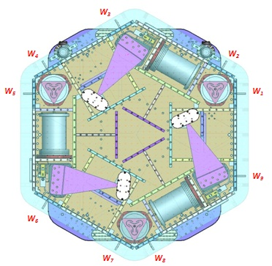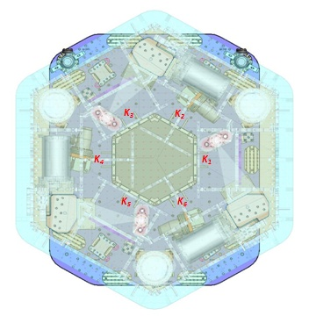
Figure – Wall Masses (W) and Keel masses (K) location. South of picture = corner 1

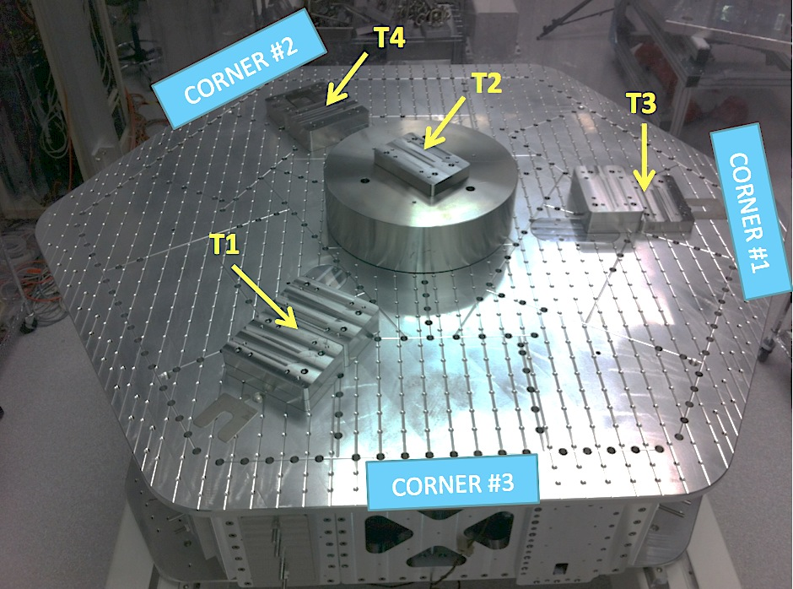
Picture – Optic table masses distribution

Issues/difficulties/comments regarding this test:
- T2’s big mass evaluated at nominal value: 270.79lbs. Gauge not available for measurement.
- A few shims were used for balancing. Their weight is negligible in comparison with the mass budget. Hence their weight is not reported in the mass budget.

Acceptance Criteria
The Mass budget must be
- 579.1 Kg (cf. E1100427)+/-25Kg (5%)

Test result: Passed: X Failed: .

Step 10: Shim thickness

Lockers | Shim thickness (mils)
A | 120
B | 120
C | 121
D | 122
Table – Shims Thickness

Acceptance Criteria
- The shim thickness should be 125 mils +/-5

Test result: Passed: X Failed: .

Step 11: Lockers adjustment

D.I. at Locker | Vertical D.I. | Horizontal D.I.
A | 1 | 0
B | 0.8 | -0.6
C | 0.5 | 0.2
D | 1.2 | 0
Table – Dial indicators read-out (in thousands of an inch)

Acceptance Criteria
- Vertical and horizontal displacement near the lockers must be lower than 2 mils (0.002”)

Test result: Passed: X Failed:

Tests to be performed after assembly

Step 1 - Electronics Inventory
Hardware | LIGO reference | S/N
Coil driver | D0902744 | S1000266
 |  | S1000269
Anti Image filter | D070081 | S1000250
Anti aliasing filter | D1000269 | S1102694
 |  | S1102679
Interface chassis | D1000067 | 1102223
 |  | 1102224
 |  | 1102214
Table - Inventory electronics

Step 2 - Set up sensors gap
 | Locked, 10 Kg masses at each corners
Table locked | ADE boxes on
Sensors | Offset (Mean) | Std deviation
H1 | -349.90 | 6.69
H2 | 10.84 | 6.49
H3 | 360.82 | 6.95
V1 | -221.90 | 7.10
V2 | -822.97 | 8.87
V3 | -539.05 | 11.92
Capacitive position sensor readout after gap set-up

Acceptance criteria:
- All mean values must be lower than +/-400 cts (a bit less than .0005”).
- All standard deviations below 20 counts.
- No cross talk

Test result: Passed: Failed: X .

Note: Failed because of standard deviation. However, a CPS was set on a test-jig and featured 4.3 counts of standard deviation, which is within specs. Hence, the high standard deviation observed is correlated to the 10Hz-100Hz peaks observed on the locked/unlocked GS13 and CPS ASDs. As shown in SEI Logbook entry #15, these peaks are caused by ground motion. Hence, high standard deviations should not be associated with sensor noise.
Note: Vertical CPSs are out of requirement when the ISI is unlocked. This little issue will be solved when the balancing was perfected for the next steps of testing.

Step 3 - Measure the Sensor gap
Issues/difficulties/comments regarding this test:
Measured in the previous step. Waived to avoid scratching targets.

Test result: Passed: Failed: . Waived: X_

Step 4 - Check Sensor gaps after the platform release
 | Table locked |  | Table unlocked
Sensors | Mean | Std Deviation | Mean | Std Deviation | Difference
H1 | -250.23 | 8.98 | -130.32 | 24.21 | 119.91
H2 | 100.34 | 7.15 | 144.23 | 18.61 | 43.89
H3 | 135.28 | 7.49 | -425.38 | 30.98 | 560.66
V1 | -125.67 | 9.33 | 439.86 | 22.21 | 565.53
V2 | -777.05 | 17.66 | 151.37 | 23.91 | 928.42
V3 | -279.89 | 13.21 | -395.83 | 26.57 | 115.94
Table – Sensor gaps after platform release

Acceptance criteria:

- Absolute values of the difference between the unlocked and the locked table must be below:
  - 1600 cts for horizontal sensors (~0.002”)
  - 1600 cts for vertical sensors (~0.002”)
- All mean values must be lower than:
  - 2000 cts for horizontal sensors (~0.0025”)
  - 2000 cts for vertical sensors (~0.0025”)

Test result: Passed: X Failed: .

Step 5 – Performance of the limiter

Step 5.1 - Test Nº1 - Pushing “in the general coordinates”
Pushing Z,-Z | CPS read out |  | Calculated after calibration |  | ROM
Sensors | UP (Counts) | Down (Counts) | UP (mil) | Down (mil)
V1 | 20600 | -19200 | 24.8 | -23.1 | 39800
V2 | 17400 | -19600 | 20.9 | -23.6 | 37000
V3 | 19800 | -21030 | 23.8 | -25.3 | 40830
Pushing RZ, -RZ | CPS read out |  | Calculated after calibration |  | ROM
Sensors | CCW (+RZ) | CW(-RZ) | CW (mil) | CCW (mil)
H1 | -22000 | 22000 | -26.4 | 26.4 | 44000
H2 | -19000 | 20000 | -22.8 | 24.0 | 39000
H3 | -22000 | 23000 | -26.4 | 27.6 | 45000
Table - Optic table range of motion

Step 5.2 - Test Nº2 – Pushing “locally”
Pushing Locally | Push in positive direction | Push in negative direction | Railing | Actuator Gap Check | ROM
H1 | -23000 | 22300 |  | X | 45300
H2 | -22400 | 21700 |  | X | 44100
H3 | -21900 | 23300 |  | X | 45200
V1 | 20300 | -20100 |  | X | 40400
V2 | 32000 | -32000 | X | X | 64000
V3 | 25000 | -26000 |  | X | 51000
Table - Optic table range of motion

Issues/difficulties encountered during this test:
- Contact points are difficult to check on vertical actuators.
- V2 was railing when pushing locally on V3.
- Horixontal motion (Rz) was computed in mils from the vertical CPS calibration.

Acceptance criteria:
- The vertical sensor readout must be positive when the optic table is pushed in the +Z direction
- The horizontal sensor readout must be negative when the optic table is pushed in the +RZ direction
- Step 5.1
  - Absolutes value of all estimated motions must be higher than 16000counts (~0.020”)
- Step 5.2
  - No contact point on sensors
  - Absolute value of sensor read out must be higher than 16000counts (~0.020”)
  - No contact point on actuators

Test result: Passed: X Failed: .

Step 6 - Position Sensors unlocked/locked Power Spectra
Locked/Unlocked Power Spectra are presented below.

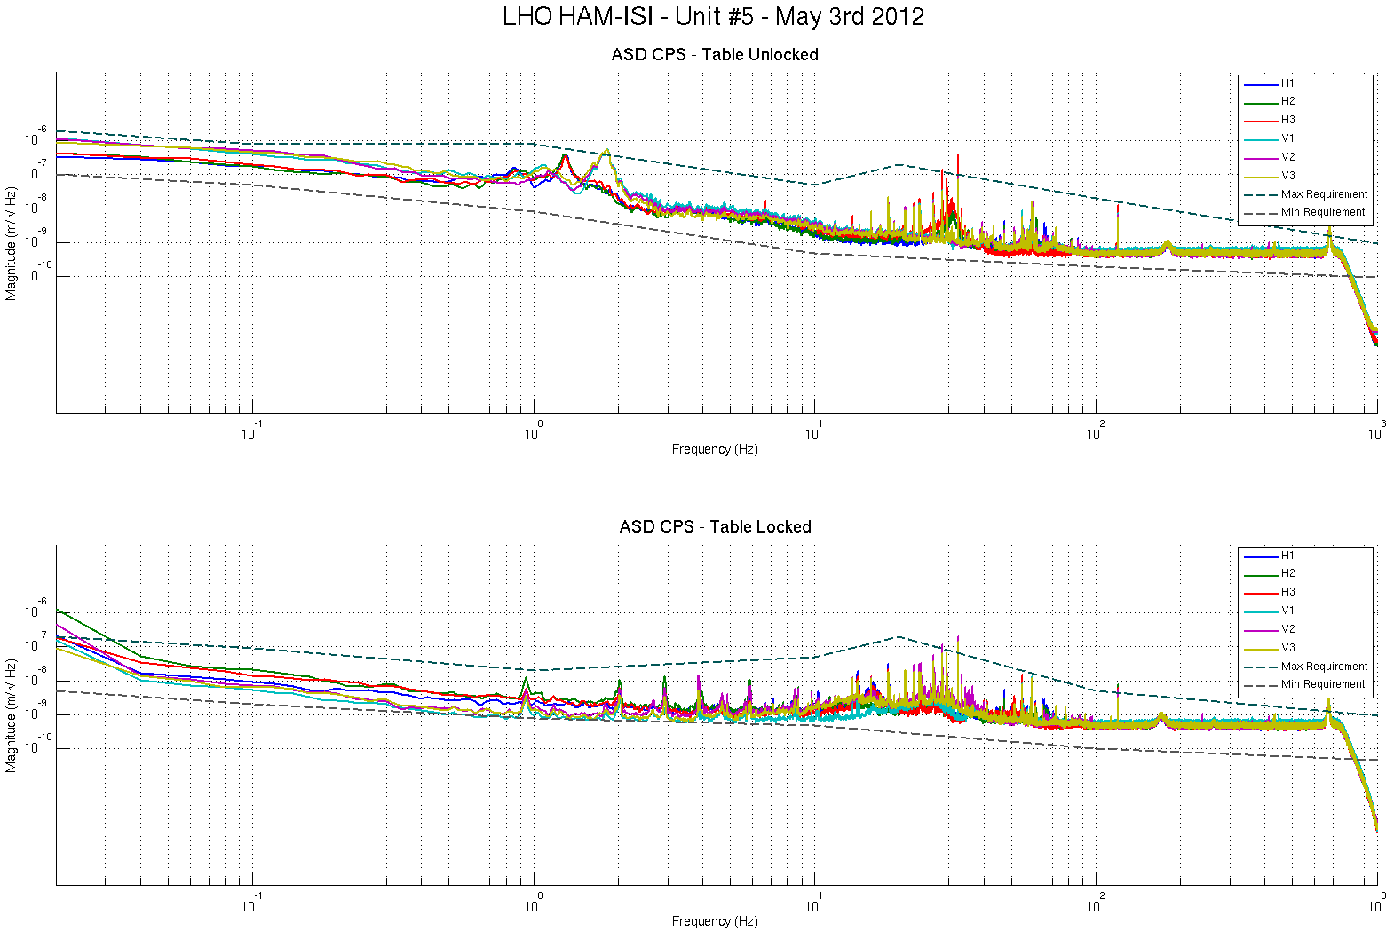
Figure - Calibrated CPS power spectra

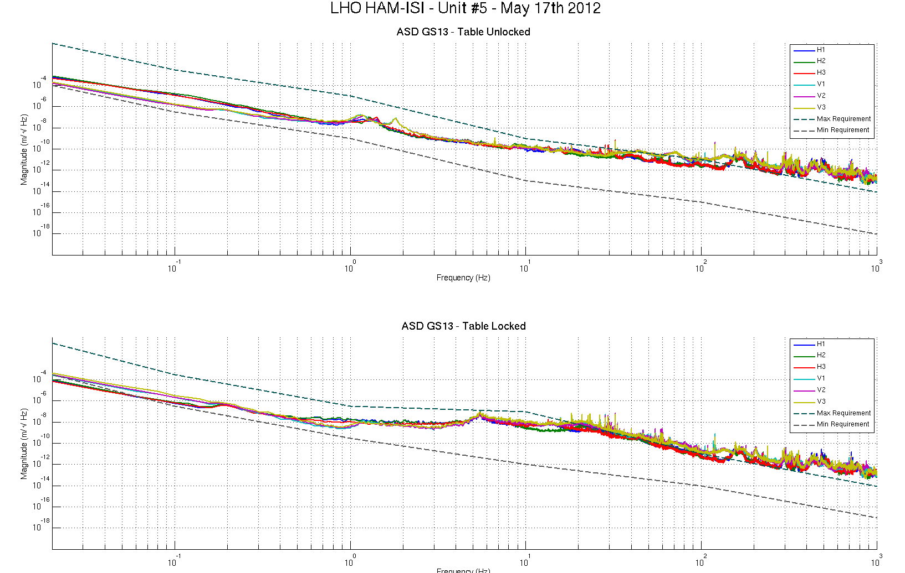
Figure – Calibrated GS13 Power spectra

Scripts files for processing and plotting in SVN at:
/SeiSVN/seismic/HAM-ISI/Common/Testing_Functions_HAM_ISI/
- ASD_Measurements_Locked_Unlocked_HAM_ISI.m

Data in SVN at:
SeiSVN/seismic/ HAM-ISI/X1/HAMX/Data/Spectra/Undamped/
- LHO_ISI_UNIT_5_ASD_m_CPS_T240_L4C_GS13_Locked_vs_Unlocked_2012_05_17.mat

Figures in SVN at:
/SeiSVN/seismic/HAM-ISI/X1/HAMX/Data/Figures/Spectra/Undamped
- LHO_ISI_UNIT_5_PSD_m_GS13_Locked_vs_Unlocked_2012_05_17.fig
- LHO_ISI_UNIT_5_PSD_m_CPS_ Locked_vs_Unlocked_2012_05_17.fig

Issues/difficulties/comments regarding this test:
- 10Hz-100Hz peaks were investigated for the testing phase I of Unit #3, and reported in Part 1, last step: Capacitive Position Sensor Investigation, of the related report (Document #E1000312-v3)

Acceptance criteria:
- No cross talk (peaks at low frequencies + harmonics on measurements)
- Magnitudes of power spectra must be between requirement curves

Test result: Passed: X Failed: .

Note:
When a seismometer fails, its low frequency response is affected. Spectra are within requirements in low frequency. The production GS13s installed on this unit are functional.

Step 7 - GS13 power spectra -tabled tilted
GS13 spectra when the table is tilted are presented below.

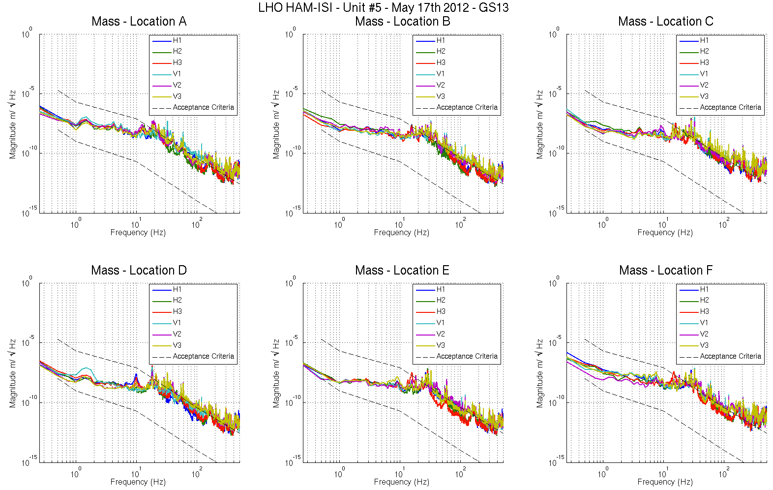
Figure – Power spectrum Calibrated GS13 with mass at corners A to F

Scripts files for processing and plotting in SVN at:
SeiSVN/seismic/HAM-ISI/Common/Testing_Functions_HAM_ISI/
- ASD_Measurements_Stages_Tilted_HAM_ISI.m
Data in SVN at:
SeiSVN/seismic/ HAM-ISI/X1/HAMX/Data/Spectra/Undamped/
- LHO_ISI_UNIT_5_ASD_m_GS13_Stage_Tilted_2012_05_17.mat
Figures in SVN at:
SeiSVN/seismic/HAM-ISI/X1/HAMX/Data/Figures/Spectra/Undamped
- LHO_ISI_UNIT_5_m_PSD_GS13_Tilted_2012_05_17.fig

Acceptance criteria:
- With table unlocked and tilted, magnitudes of power spectra must be fully included within requirement curves.

Test result: Passed: X Failed: .
Note:
When a seismometer fails, its low frequency response is affected. Spectra are within requirements in low frequency. The production GS13s installed on this unit are functional.

Step 8- GS13 pressure readout

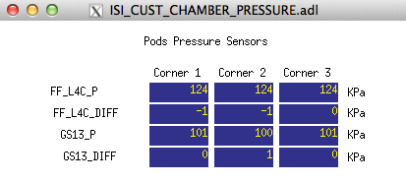
Figure – Pressure Readouts

Acceptance criteria:
- The pressure on GS13_P channels must be 102KPa +/-8 KPa (25000 counts +/- 3000 counts)
- GS13_P must vary the same way in each corner and GS13_DIFF must be constant (channels follow comparable trend)

Test result: Passed: X Failed: .

Note: There is no L4C on this Unit. The values read on the FF_L4C_P channels are suspicious. These channels display 30KPa when GS13 interface-chassis are OFF, and 124KPa when GS13 interface chassis are ON.

Step 9 - Coil Driver, cabling and resistance check
Actuator | V1 |  | H1 |  | V2
Coil driver | S1000266 - Coarse 2 |  | S1000266 - Coarse 1 |  | S1000269 - Coarse 2
Cable # | S1106679 |  | S1104492 |  | S1104490
Resistance | P1 - P2 | P2 - P3 | P1 - P2 | P2 - P3 | P1 - P2 | P2 - P3
(Ohm) | O.L (infinity) | 6.5 | O.L (infinity) | 6.5 | O.L (infinity) | 6.5
MEDM offset | Measurement P2 (+) ; P1&P3 (-) |  | Measurement P2 (+) ; P1&P3 (-) |  | Measurement P2 (+) ; P1&P3 (-)
(1000 counts) | 0.3070V |  | 0.3117V |  | 0.3115V
Actuator | H2 |  | V3 |  | H3
Coil driver | S1000269 - Coarse 1 |  | S1102692 - Coarse 2 |  | S1102692 - Coarse 1
Cable # | S1104756 |  | S1105207 |  | S1106678
Resistance | P1 - P2 | P2 - P3 | P1 - P2 | P2 - P3 | P1 - P2 | P2 - P3
(Ohm) | O.L (infinity) | 6.5 | O.L (infinity) | 6.5 | O.L (infinity) | 6.5
MEDM offset | Measurement P2 (+) ; P1&P3 (-) |  | Measurement P2 (+) ; P1&P3 (-) |  | Measurement P2 (+) ; P1&P3 (-)
(1000 counts) | 0.3138V |  | 0.3044V |  | 0.3106V
Table - Actuators resistance check

Issues/difficulties/comments regarding this test:
- Voltages measured from Pin #2 (+) to pin #3 (-) with compensation filters engaged.
- Resistances are given +/-0.2V

Acceptance criteria:
- The measured resistance between the middle pin and one side pin must be 6.5 +/-1 ohms
- Actuator neutral pins must be connected on pin #3 (left side pin of the plug)
- Actuator drive pins must be connected on pin #2 (middle pin of the plug)
- Actuator ground shield pins must be connected on pin #1 (right pin of the plug)
- All LEDs on the coil driver front panel must be green

Test result: Passed: X Failed: .

Step 10 - Actuators Sign and range of motion (Local drive)

 | Negative drive | No Drive | Positive drive | ROM (Counts)
H1 readout (count) | -24394 | -147 | 23977 | 48371
H2 readout (count) | -24102 | 124 | 23981 | 48083
H3 readout (count) | -24270 | -424 | 25092 | 49362
V1 readout (count) | -19143 | 462 | 20146 | 39289
V2 readout (count) | -26064 | 184 | 26109 | 52173
V3 readout (count) | -23320 | -360 | 20977 | 44297
Table - Range of motion - Local drive

Issues/difficulties/comments regarding this test:
- Compensation filters are ON.
- Symmetrization filters are OFF

Acceptance criteria:
- Main couplings sensors readout must be at least 16000 counts (~0.02”)
- A positive offset drive on one actuator must give positive sensor readout on the collocated sensor. Signs will also be tested when measuring local-to-local transfer functions.

Test result: Passed: X Failed: .

Step 11 - Vertical Sensor Calibration

Lockers | D.I readout with for  a negative drive | D.I readout without any drive | D.I readout with for  a positive drive
A | -18.90 | 0.00 | 19.50
B | -19.10 | 0.00 | 19.10
C | -18.90 | 0.00 | 19.10
D | -18.50 | 0.00 | 19.00
Average | -18.85 | 0.00 | 19.18
Sensors | Counts | Counts | Counts | Difference
V1 | -14971.00 | 362.81 | 16410.00 | 31381.00
V2 | -15149.00 | 770.03 | 16463.00 | 31612.00
V3 | -15919.00 | -117.31 | 15999.00 | 31918.00
Vertical Sensibility
832.01 | Count/mil
0.51 | V/mil
30.53 | nm/count
-0.95 | % from ref (840count/mil)
Table - Calibration of capacitive position sensors

Acceptance criteria:

- Deviation from nominal value < 2%. Nominal value is 840 count/mil.

Test result: Passed: X Failed: .

Step 12 - Vertical Spring Constant

Results presented below are obtained after the initial sensors calibration.

Sensors | Mean diff counts | Mean diff m | K (N/m) | Error with average
V1 | -8323 | -2.541E-04 | 78805 | -2.65%
V2 | -8039 | -2.454E-04 | 81592 | 0.79%
V3 | -7954 | -2.428E-04 | 82457 | 1.86%
 |  | Average (N/m) | 242854
 |  |  | -1.69 | % variation from nominal
Table - Vertical spring constant

Acceptance criteria:
- +/-2 % of 2.4704e5 N/m (i.e. between 2.421e5 and 2.520e5 N/m)
- +/- 5% of variation between each spring and the average

Test result: Passed: X Failed:

Step 13 - Static Testing (Tests in the local basis)
 | Sensors (counts)
 | H1 | H2 | H3 | V1 | V2 | V3
H1 | 2099 | 1309 | 1296 | -23 | -17 | 14
H2 | 1292 | 2064 | 1293 | 17 | -24 | -16
H3 | 1260 | 1261 | 2001 | 5 | -25 | -11
V1 | 196 | 190 | -392 | 1506 | -55 | -630
V2 | -378 | 186 | 187 | -648 | 1453 | -33
V3 | 193 | -381 | 201 | -71 | -648 | 1451
Table - Main couplings and cross couplings

Acceptance criteria:
- Vertical
For a +1000 count offset drive on vertical actuators
  - Collocated sensors must be 1400 counts +/- 10%

- Horizontal
For a +1000 count offset drive on horizontal actuators
  - Collocated sensors must be 2000 counts +/- 10%
  - Non-collocated horizontal sensors must be 1250 counts +/-10%

Test result: Passed: X Failed: .

Step 14 - Linearity test
 | Slope | Offset | Average slope | Variation from  average(%)
H1 | 2.1037 | -193.1119 | 2.06 | 2.04
H2 | 2.0597 | 93.2935 |  | -0.09
H3 | 2.0215 | -461.5963 |  | -1.95
V1 | 1.5042 | 492.2323 | 1.47 | 2.08
V2 | 1.4634 | 218.1938 |  | -0.69
V3 | 1.453 | -322.766 |  | -1.39
Table - Slopes and offset of the triplet ‘Actuators - HAM-ISI – Sensors’

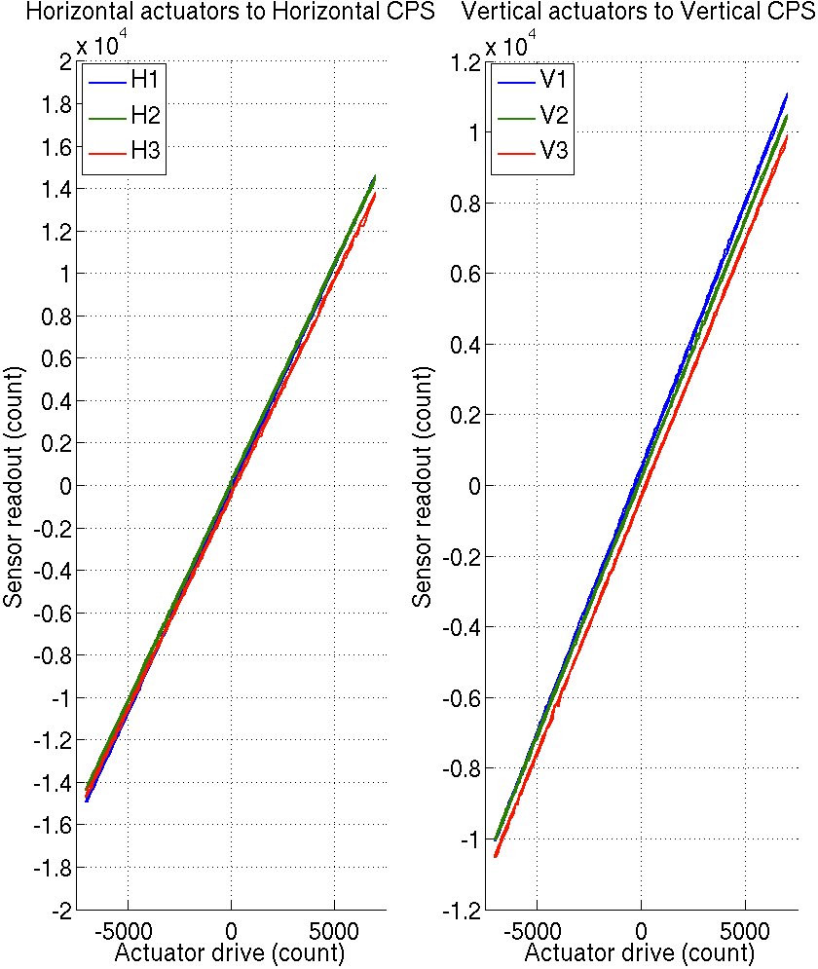
Figure - Linearity test on the triplet ‘actuators - HAM-ISI – sensors’
in both Horizontal and vertical directions

Issues/difficulties encountered during this test:
- H1, H3 and V1 do not meet our requirements.
- The tendencies on linearity test slopes seem to match the tendencies on cable resistance (coildriver to feedthrough section). Cable resistance, which is proportional to cable length, would then be a possible explanation for the linearity results obtained.

Acceptance criteria:
- Horizontal and vertical slopes of the triplet actuators x HAM-ISI x sensors: Average slope +/- 1.5%
Test result: Passed: Failed: X .

Note: we will check that these values are within tolerance when we’ll use the final field cables.

Step 15 - Cartesian Basis Static Testing
1000 counts Drive | H1 | H2 | H3 | V1 | V2 | V3 | Direction read out
X Drive | 285.10 | 272.52 | -463.91 | -17.34 | -30.18 | -22.76 | 506.38
Y Drive | -461.20 | 418.89 | -15.08 | 6.68 | -32.85 | -18.13 | 525.64
Z Drive | -5.47 | -6.26 | -1.06 | 272.07 | 256.14 | 242.21 | 266.38
Rx Drive | -452.02 | 447.27 | 12.34 | -485.66 | 1673.81 | -1216.00 | 2584.48
Ry Drive | -279.17 | -271.21 | 549.72 | -1724.15 | 399.50 | 1241.35 | 2631.81
Rz Drive | -1998.09 | -2000.19 | -1995.12 | -3.80 | -34.73 | -31.69 | 2524.51
1000 counts Drive | H1 | H2 | H3 | V1 | V2 | V3 | Direction read out
X Drive | + | + | - |  |  |  | +
Y Drive | - | + | 0 |  |  |  | +
Z Drive |  |  |  | + | + | + | +
Rx Drive |  |  |  | - | + | - | +
Ry Drive |  |  |  | - | + | + | +
Rz Drive | - | - | - |  |  |  | +
1000 counts Drive | X | Y | Z | RX | RY | RZ | Direction read out
X Drive | 506.38 | 0.63 | 2.17 | 3.61 | 9.78 | -40.31 | 506.38
Y Drive | -6.97 | 525.64 | 1.05 | 6.06 | 14.93 | 15.09 | 525.64
Z Drive | -0.45 | 2.12 | 266.38 | 36.92 | -15.86 | -2.81 | 266.38
Rx Drive | 12.63 | 2.26 | 3.78 | 2584.48 | 4.73 | -1.47 | 2584.48
Ry Drive | -1.83 | 7.32 | -5.54 | 30.44 | 2631.81 | -4.58 | 2631.81
Rz Drive | 1.48 | 11.88 | 3.36 | 2.66 | -8.44 | 2524.51 | 2524.51
Table – Cartesian static testing reference table

Acceptance criteria:
For a positive drive in the Cartesian basis:
- Local sensor readout must have the same sign that the reference table
- Cartesian sensors read out must be positive in the drive direction

Test result: Passed: X Failed: .

Step 16- Frequency response

Step 16.1 - Local to local measurements
FREQ. RANGE |  |  | DRIVE |  | MEAS. TIME
Min | Max | Freq. Res. (Hz) | H | V | Time for 1 Rep. (s) | Number of Reps | Estimated duration (min)
0.01 | 0.1 | 0.01 | 3500 | 3500 | 620 | 10 | 103.3
0.1 | 0.5 | 0.02 | 420 | 420 | 320 | 30 | 160
0.5 | 5 | 0.025 | 24.5 | 24.5 | 260 | 55 | 238.3
5 | 200 | 0.1 | 140 | 140 | 80 | 50 | 66.7
200 | 1000 | 0.2 | 140 | 140 | 50 | 150 | 125
 |  |  |  |  | Estimated Measurement Time (h) |  | 11.6
Table – Transfer function settings, by frequency band

Data collection script files:
/SeiSVN/seismic/HAM-ISI/Common//Transfer_Function_Scripts/
- Run_TF_L2L_10mHz_100mHz.m
- Run_TF_L2L_100mHz_500mHz.m
- Run_TF_L2L_500mHz_5Hz.m
- Run_TF_L2L_5Hz_100Hz.m
- Run_TF_L2L_100Hz_1000Hz.m

Data files in SVN at:
/SeiSVN/seismic/HAM-ISI/X1/HAMX/Data/Transfer_Functions/Measurements/Undamped/
- LHO_ISI_HAM_Unit_5_Data_TF_L2L_10mHz_100mHz_20120522-011123.mat
- LHO_ISI_HAM_Unit_5_Data_TF_L2L_100mHz_500mHz_20120521-222957.mat
- LHO_ISI_HAM_Unit_5_Data_TF_L2L_500mHz_5Hz_20120521-184031.mat
- LHO_ISI_HAM_Unit_5_Data_TF_L2L_5Hz_200Hz_20120521-174707.mat
- LHO_ISI_HAM_Unit_5_Data_TF_L2L_200Hz_1000Hz_20120521-162943.mat
Scripts files for processing and plotting in SVN at:
/SeiSVN/seismic/HAM-ISI/X1/HAMX/Scripts/Control_Scripts/
- Step_1_TF_Loc_to_Loc_X1_ISI_HAMX

Figures in SVN at:
/SeiSVN/seismic/HAM-ISI/X1/HAMX/Data/ Figures/Transfer_Functions/Measurements/Undamped/
- X1_ISI_HAMX_TF_L2L_Raw_from_ACT_to_CPS_2012_05_22.fig
- X1_ISI_HAMX_TF_L2L_Raw_from_ACT_to_GS13_2012_05_22.fig

Storage of measured transfer functions in the SVN at:
/SeiSVN/seismic/HAM-ISI/X1/HAMX/Data/Transfer_functions/ Simulations/Undamped/
- LHO_ISI_Unit_5_TF_L2L_Raw_2012_05_22.mat

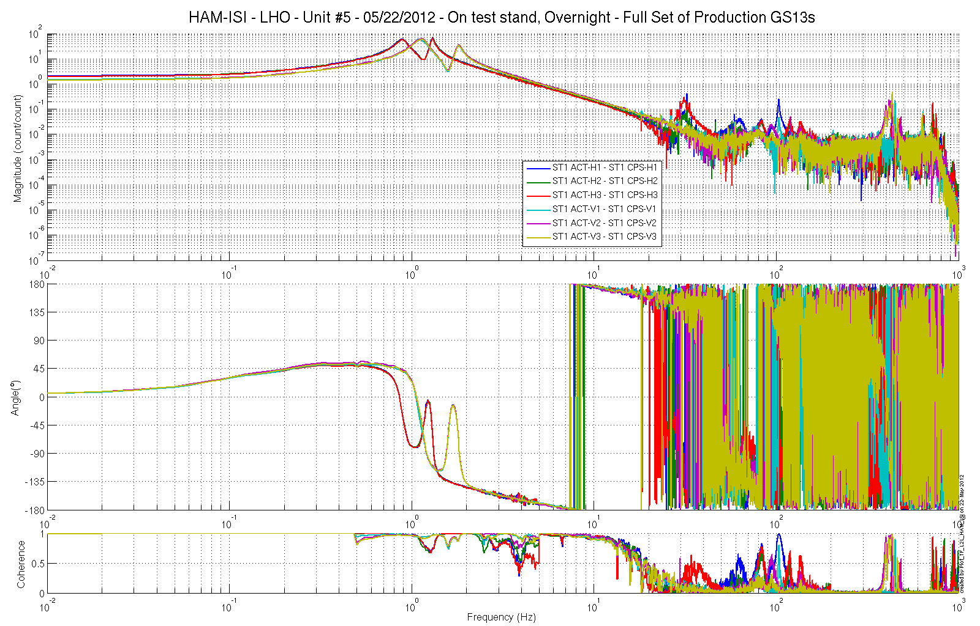
Figure - local-to-Local Measurements – Capacitive sensors

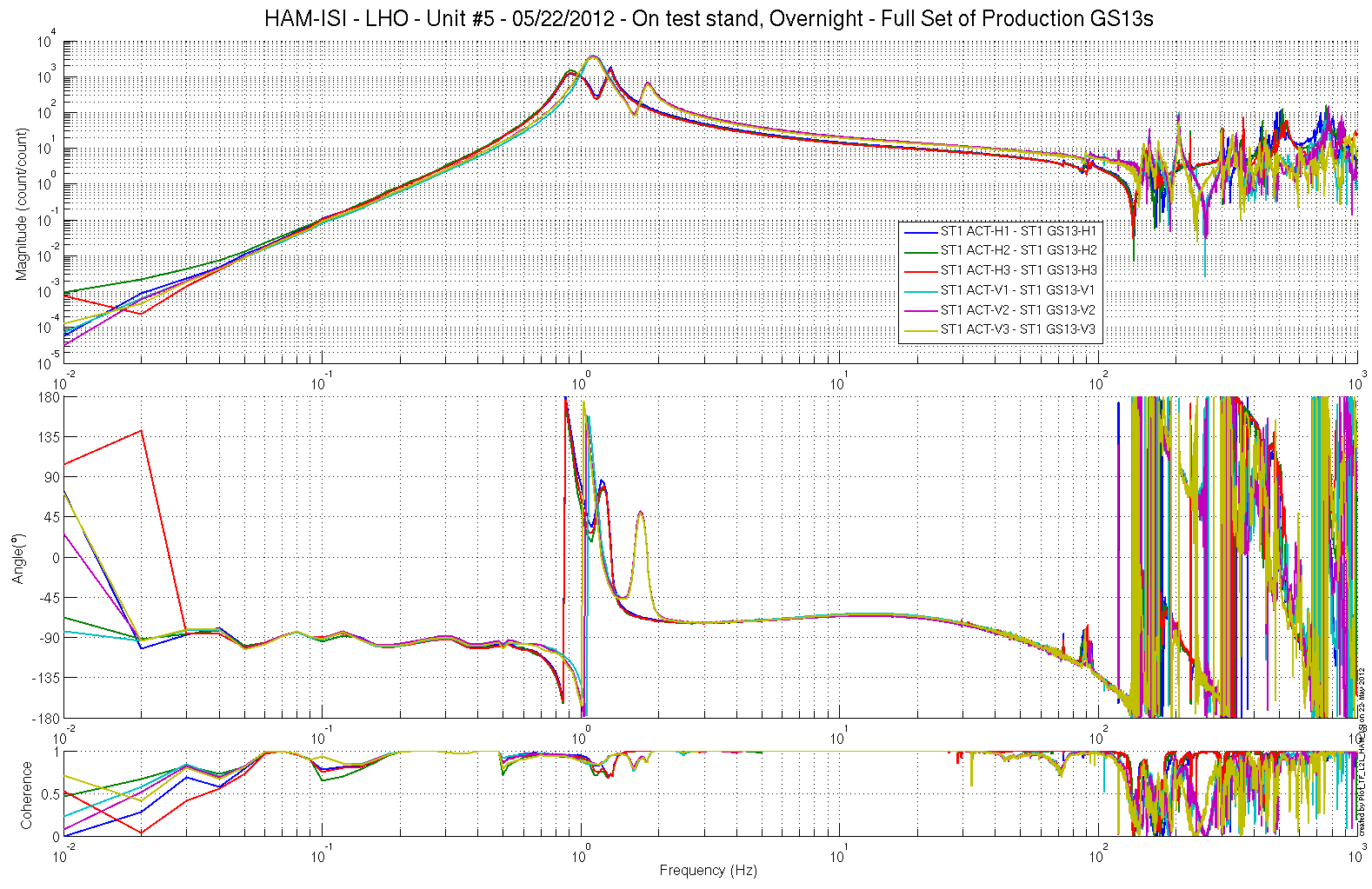
Figure - local-to-Local Measurements – Inertial sensors

Step 16.2 – GS13 Response extraction
Plots for the extracted responses are presented below.
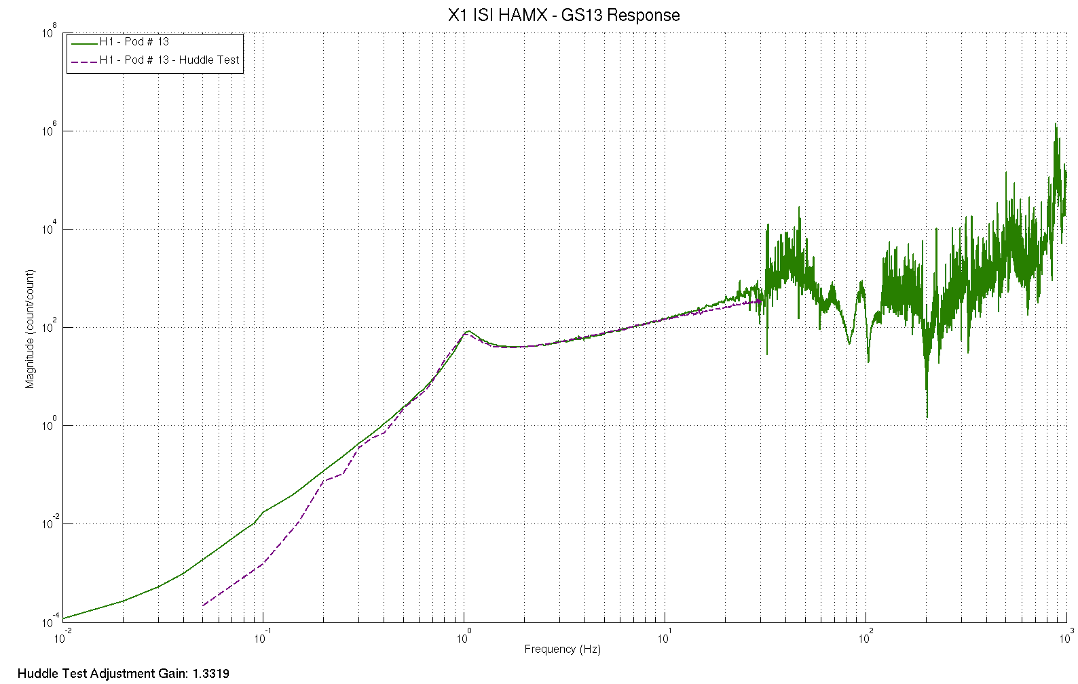
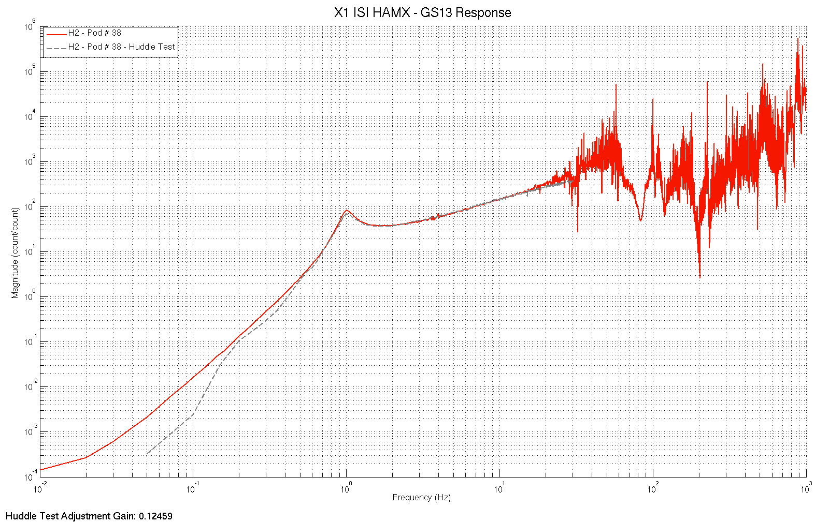
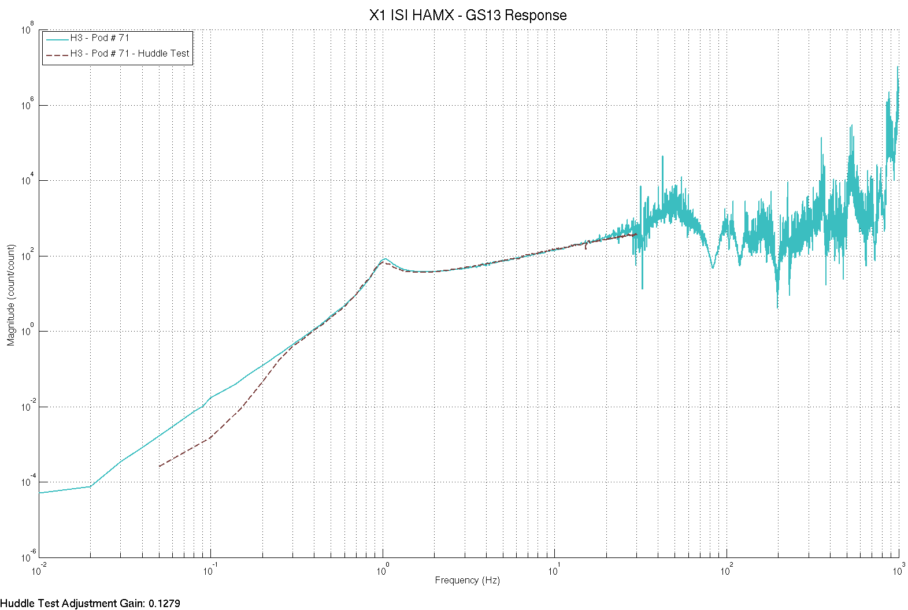
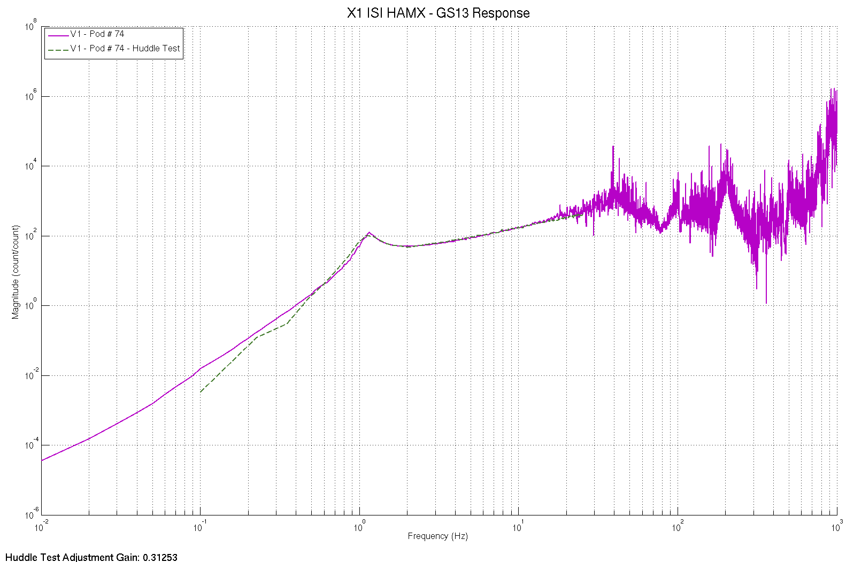
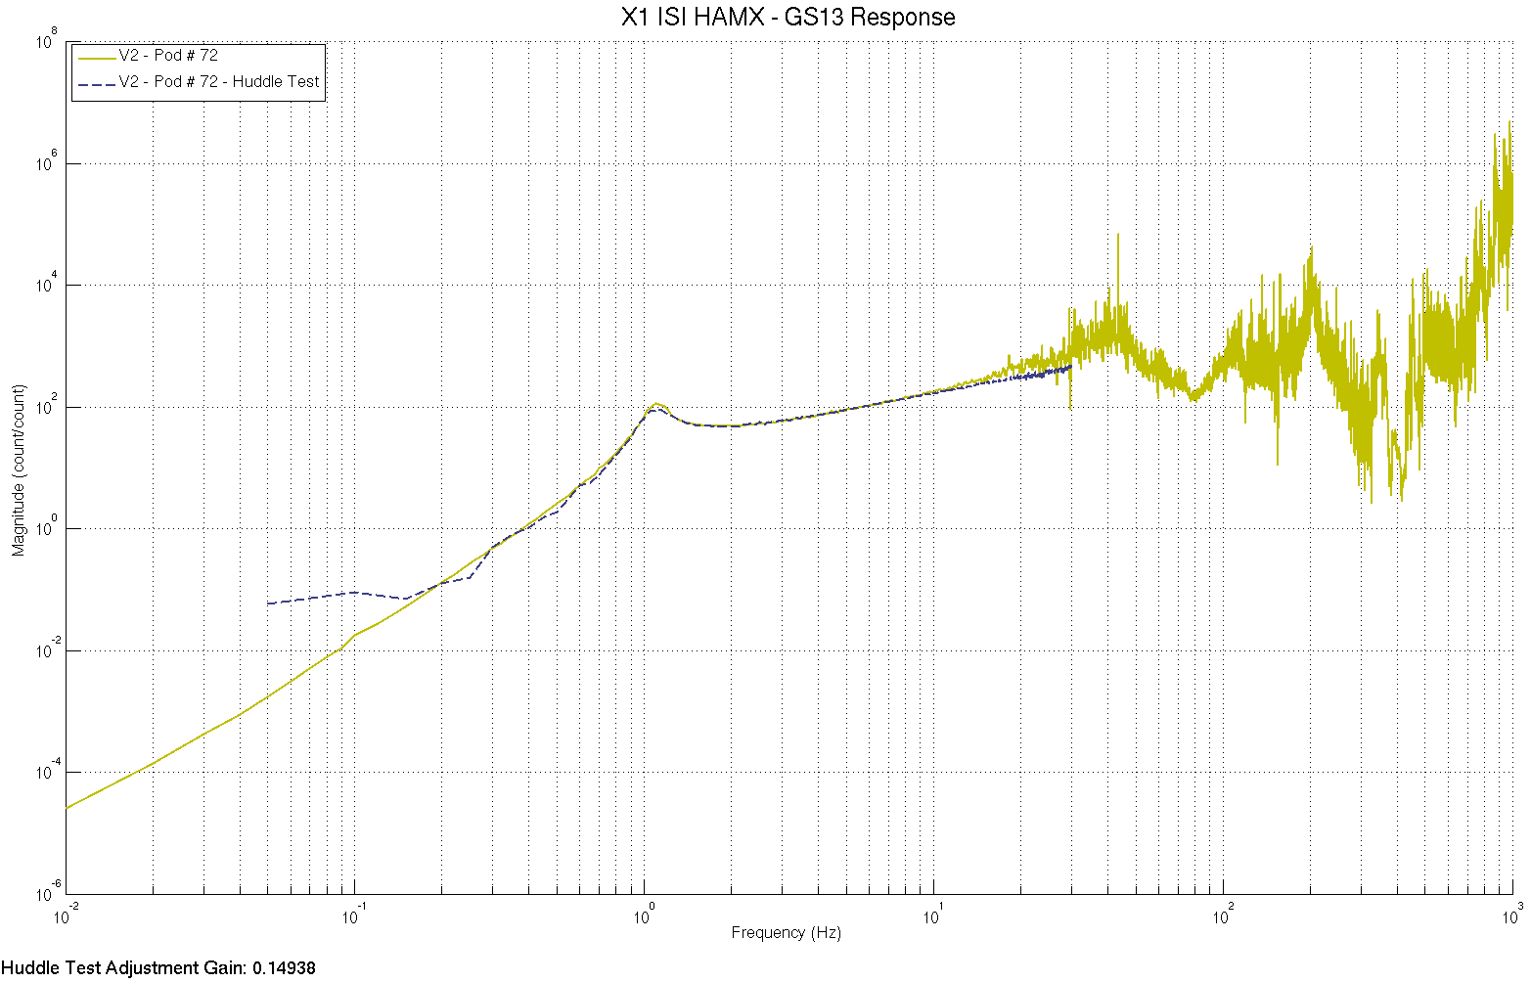
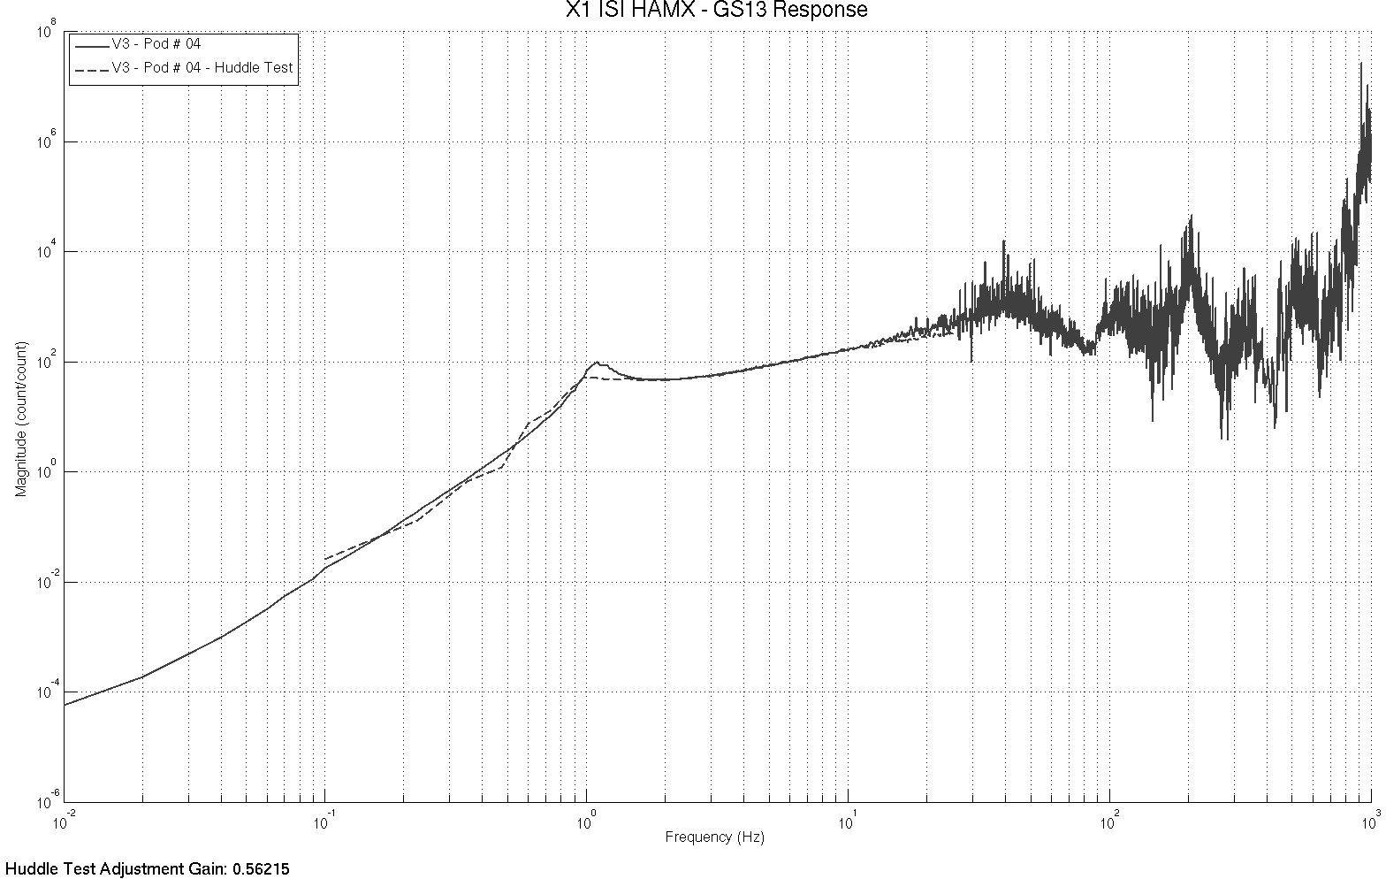

figure – GS13 extracted responses VS Huddle test responses

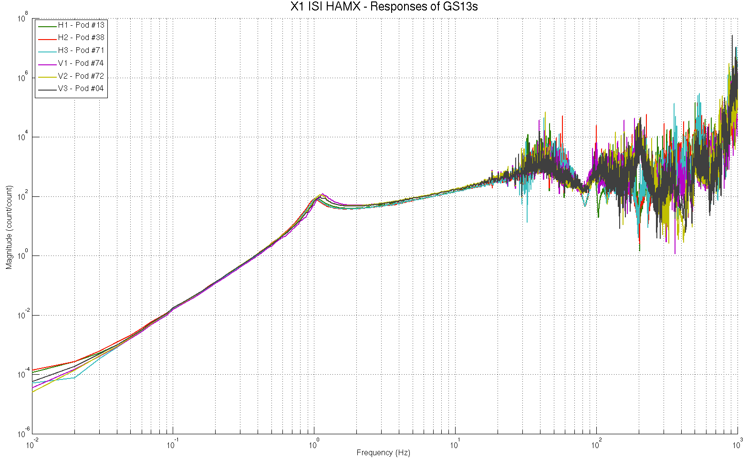
figure – Extracted GS13 responses comparison

Issues/difficulties encountered during this test:
- The Electronics and/or Digital filters used for the initial huddle testing seem to have varied along the huddle testing campaign. Gains vary from one sensor to another. Resonance frequencies are, however, unaffected which allow us to analyze their evolution.
- Lots of pods have encountered rework since the huddle testing campaign. The rework operations, such as flexure replacement or preamplifier replacement, did most likely affect the frequency responses of the instruments. Hence, these modifications would be a good explanation for the resonance frequency shifts observed between the huddle test and the extracted response of some pods.

GS13 response extraction plots under the SVN at:
/SeiSVN/seismic/HAM-ISI/X1/HAMX/Data/Figures/Instrument_Responses/GS13/
- X1_ISI_HAMX_Fitted_Responses_Comparison.fig
- X1_ISI_HAMX_GS13_H1_Pod_13_Extracted_Response_VS_Huddle.fig
- X1_ISI_HAMX_GS13_H2_Pod_38_Extracted_Response_VS_Huddle.fig
- X1_ISI_HAMX_GS13_H3_Pod_71_Extracted_Response_VS_Huddle.fig
- X1_ISI_HAMX_GS13_V1_Pod_74_Extracted_Response_VS_Huddle.fig
- X1_ISI_HAMX_GS13_V2_Pod_72_Extracted_Response_VS_Huddle.fig
- X1_ISI_HAMX_GS13_V3_Pod_04_Extracted_Response_VS_Huddle.fig

Acceptance criteria:
- The resonance frequency shift between the initial huddle test measurement and the extracted response must be lower than 15%

Test result: Passed: X Failed: .

Step 16.3 GS13 response fitting
Fitted responses for the GS13s are presented below.

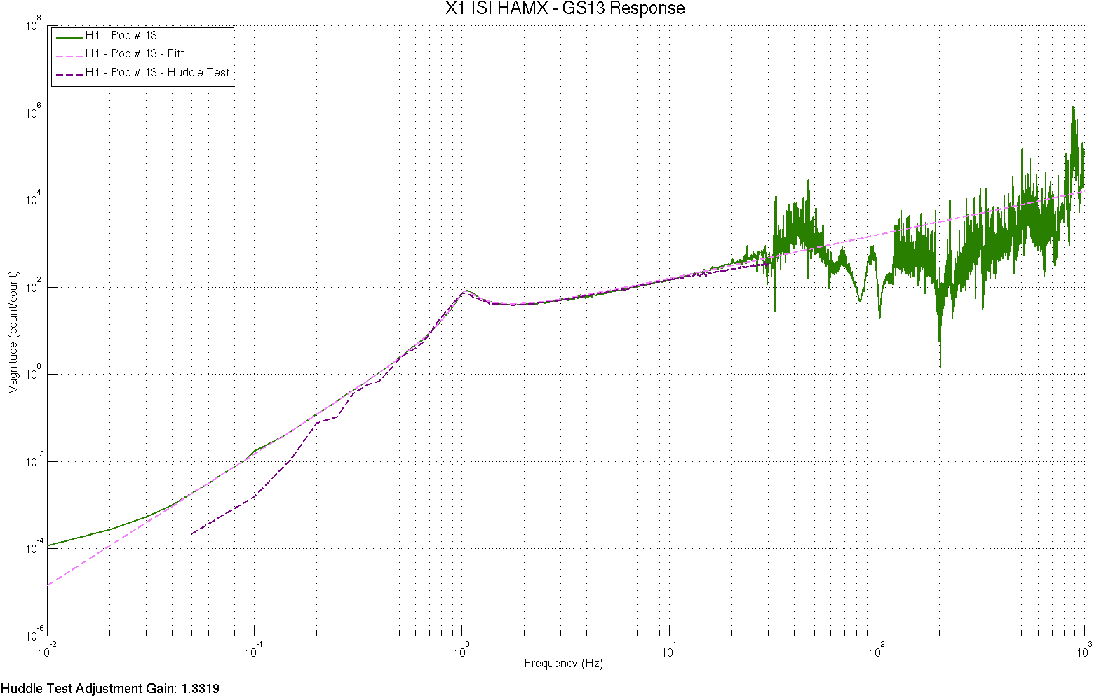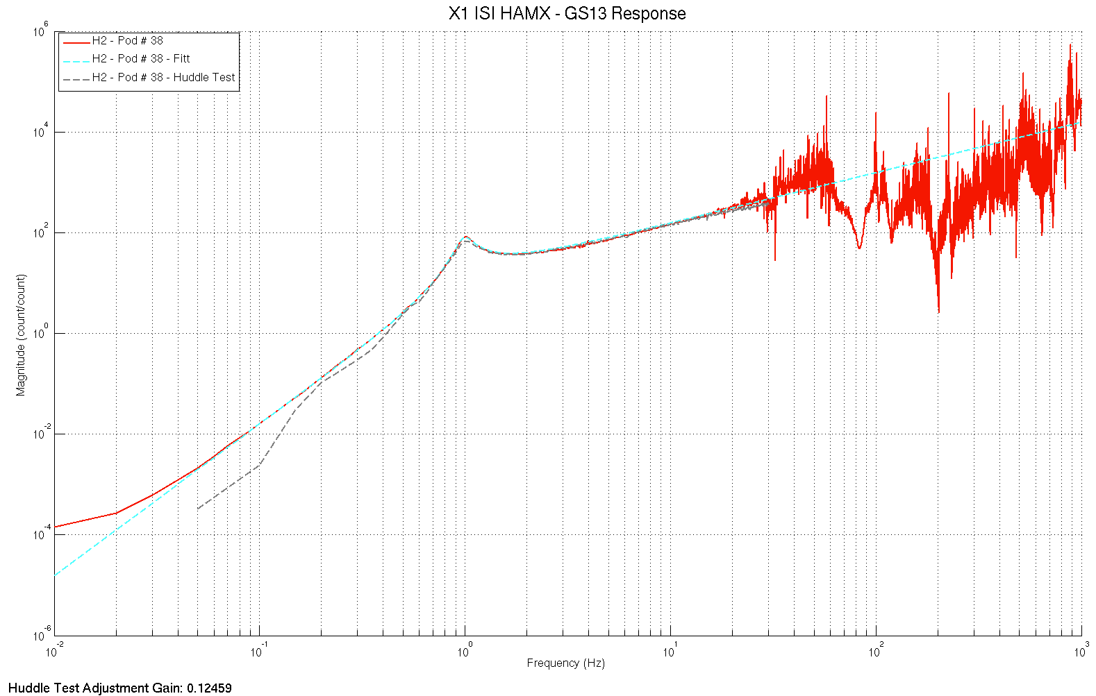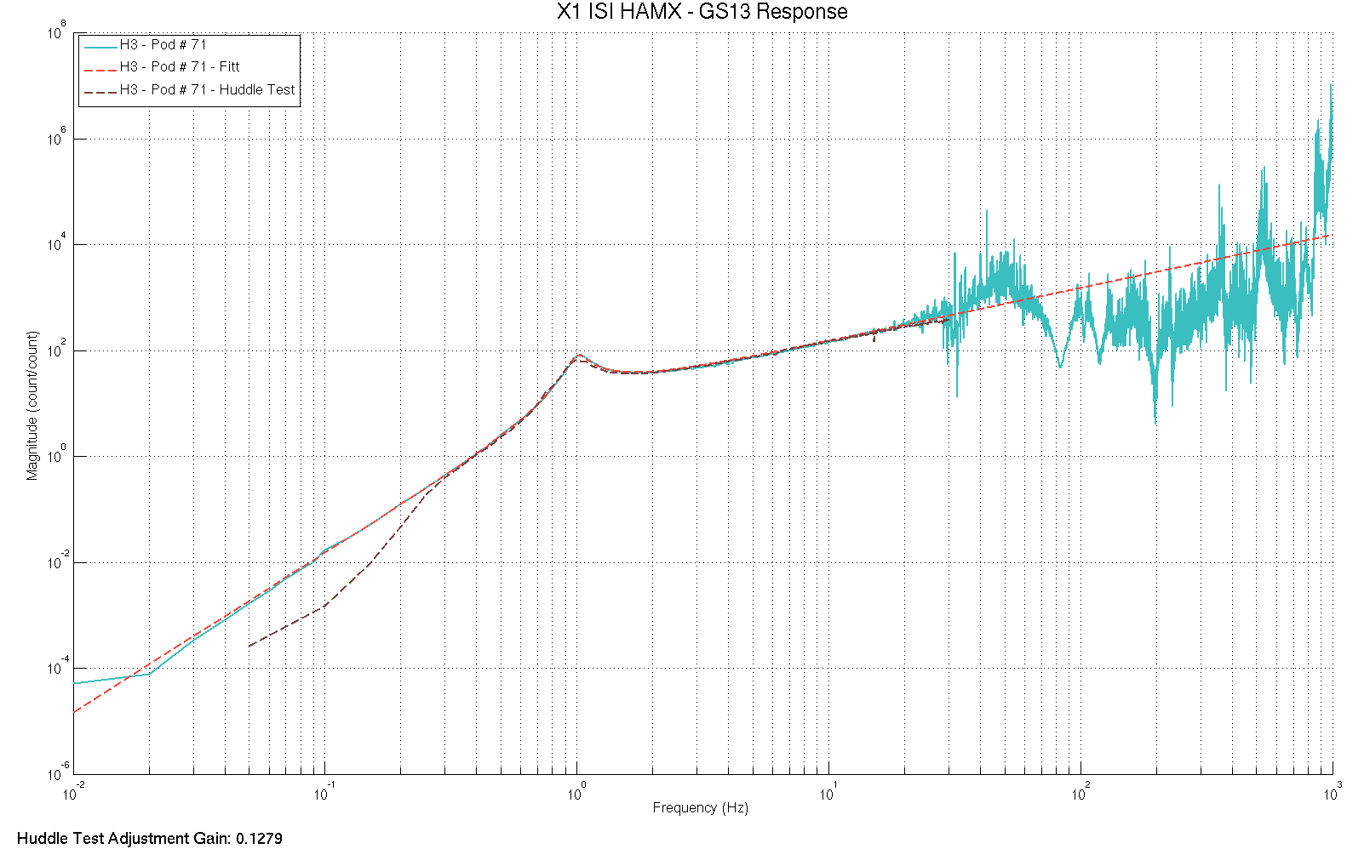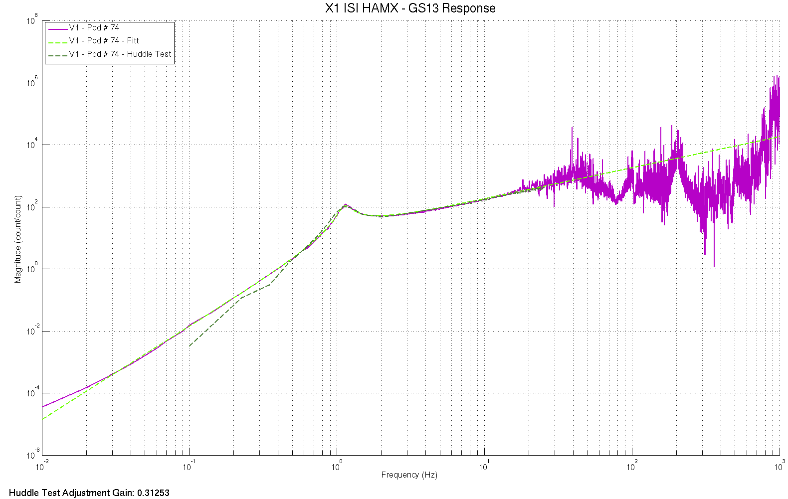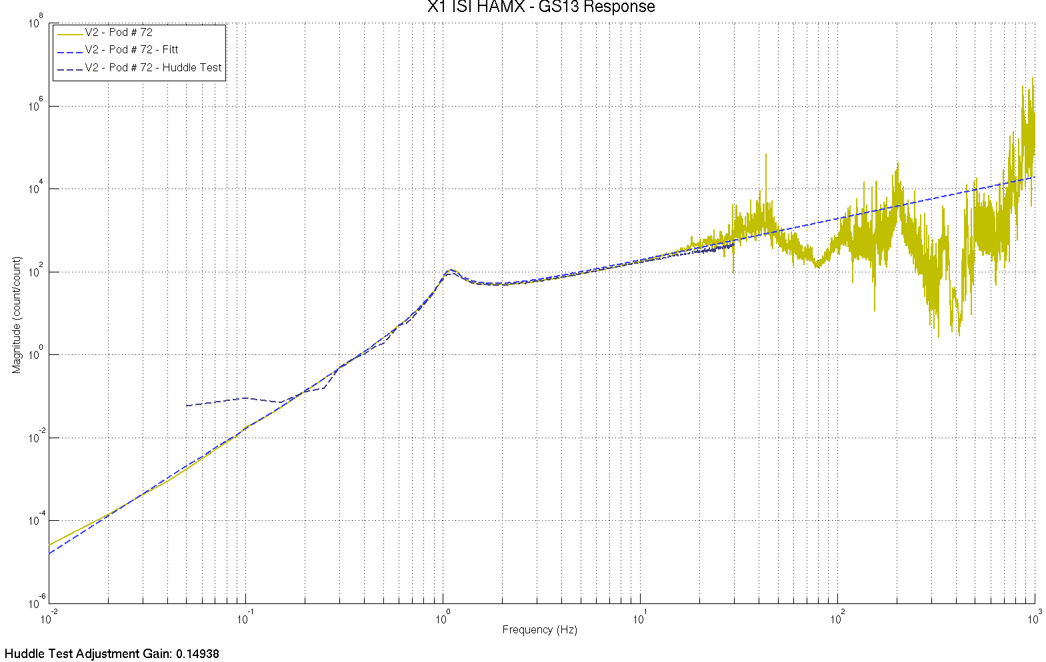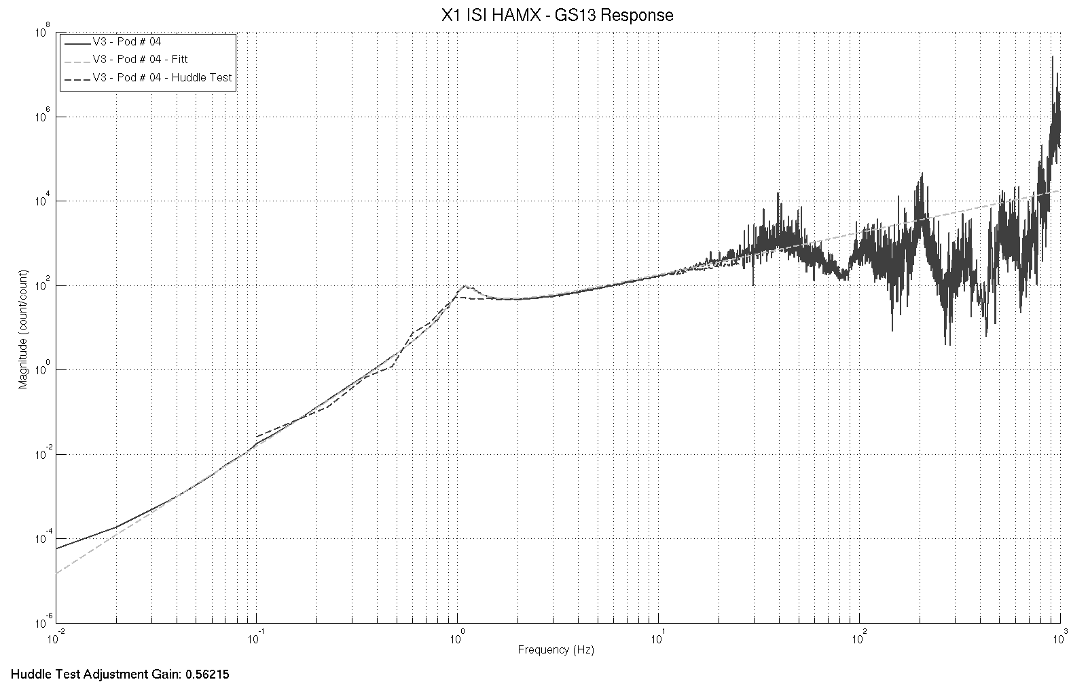
figure – Fitted responses of the GS13s

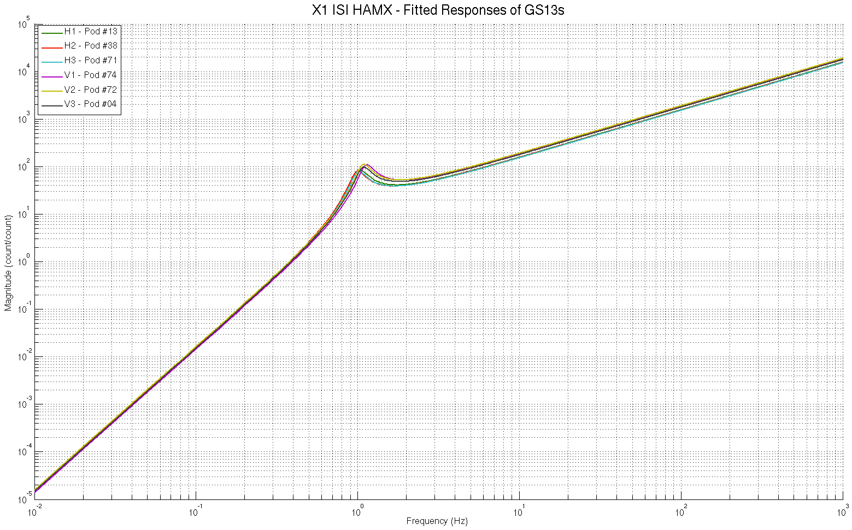
figure – Comparison of the fitted responses for the GS13s

GS13 response fitting plots under the SVN at:
/SeiSVN/seismic/HAM-ISI/X1/HAMX/Data/Figures/Instrument_Responses/GS13/
- X1_ISI_HAMX_Fitted_Responses_Comparison.fig
- X1_ISI_HAMX_GS13_H1_Pod_84_Extracted_Response_VS_Fitt_VS_Huddle.fig
- X1_ISI_HAMX_GS13_H2_Pod_20_Extracted_Response_VS_Fitt_VS_Huddle.fig
- X1_ISI_HAMX_GS13_H3_Pod_37_Extracted_Response_VS_Fitt_VS_Huddle.fig
- X1_ISI_HAMX_GS13_V1_Pod_74_Extracted_Response_VS_Fitt_VS_Huddle.fig
- X1_ISI_HAMX_GS13_V2_Pod_72_Extracted_Response_VS_Fitt_VS_Huddle.fig
- X1_ISI_HAMX_GS13_V3_Pod_04_Extracted_Response_VS_Fitt_VS_Huddle.fig

Acceptance criteria:
- The resonance frequency difference between the extracted response and the fitted response must be less than 5%
- The amplitude shift between the extracted response and the fitted response must be less than 10% between 0.1Hz and 100Hz.

Test result: Passed: X Failed: .

16.4 Symmetrization Filters
Symmetrized Local to Local TFs are presented below.

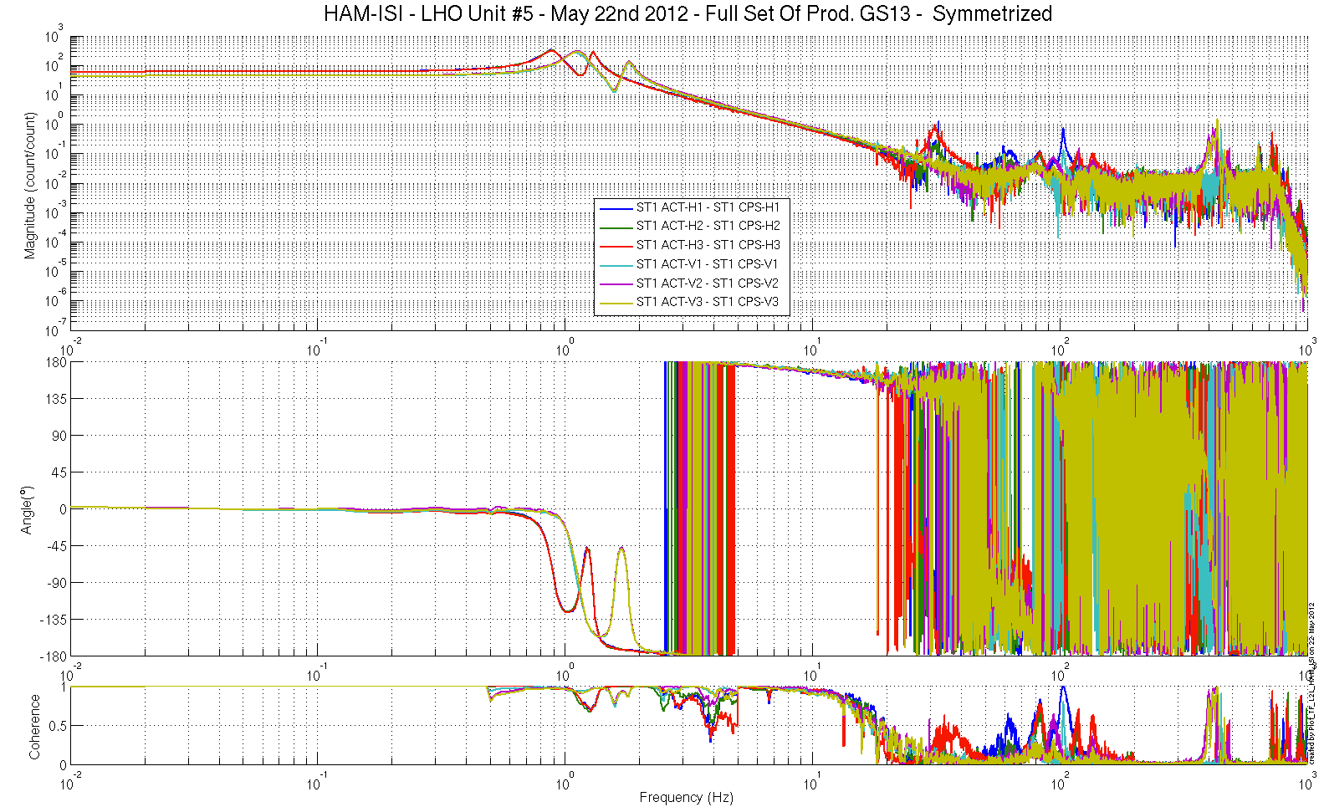
figure – Symmetrized L2L – Computed TFs – Capacitive sensors

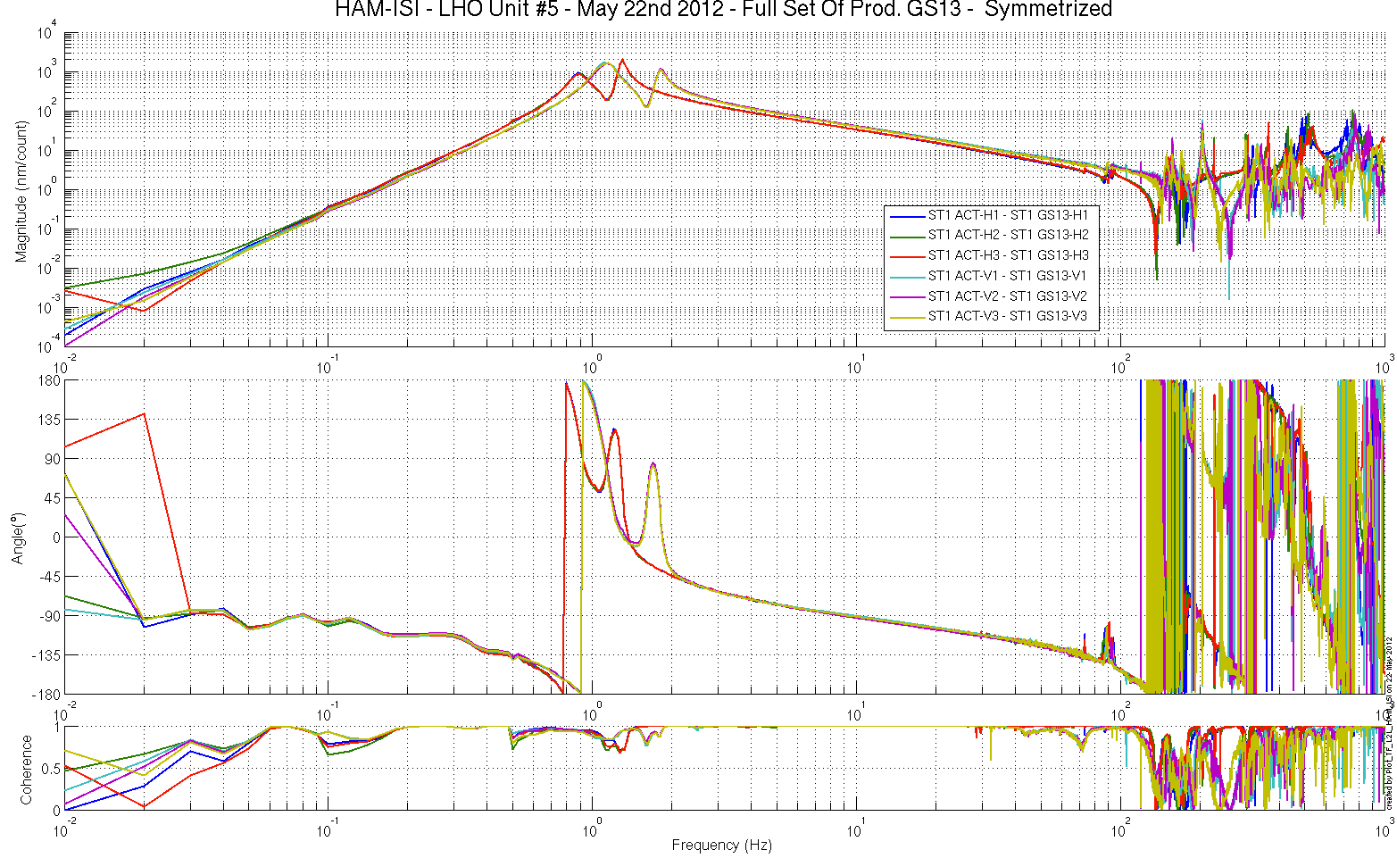
figure – Symmetrized L2L – Computed TFs – Innertial sensors
Symmetrization filters under the SVN at:
/SeiSVN/seismic/HAM-ISI/X1/HAMX/Filters/
- X1_ISI_HAMX_Filters_20120522-134354.mat

Symmetrized L2L TFs under the SVN at:
/SeiSVN/seismic/HAM-ISI/X1/HAMX/Data/Figures/Transfer_Functions/Simulations/Undamped/
- X1_ISI_HAMX_TF_L2L_Symmetrized_from_ACT_to_GS13_2012_05_22
- X1_ISI_HAMX_TF_L2L_Symmetrized_from_ACT_to_CPS_2012_05_22

Test result: Passed: X Failed: .

Step 16.4 - Cartesian to Cartesian TF computation
Scripts files for processing and plotting in SVN at:
/SeiSVN/seismic/HAM-ISI/X1/HAMX/Scripts/Control_Scripts/
- Step_3_TF_Cart_to_Cart_X1_ISI_HAMX.m
Figures in SVN at:
/SeiSVN/seismic/HAM-ISI/X1/HAMX/Data/ Figures/Transfer_Functions/Simulations/Undamped/
- X1_ISI_HAMX_TF_C2C_Symmetrized_from_ACT_to_CPS_2012_05_22.fig
- X1_ISI_HAMX_TF_C2C_Symmetrized_from_ACT_to_GS13_2012_05_22.fig
Storage of measured transfer functions in the SVN at:
/SeiSVN/seismic/HAM-ISI/X1/HAMX/Data/Transfer_functions/Simulations/Undamped/
- X1_ISI_HAMX_TF_C2C_Raw_2012_05_22.mat

The Cartesian to Cartesian transfer functions are presented below:

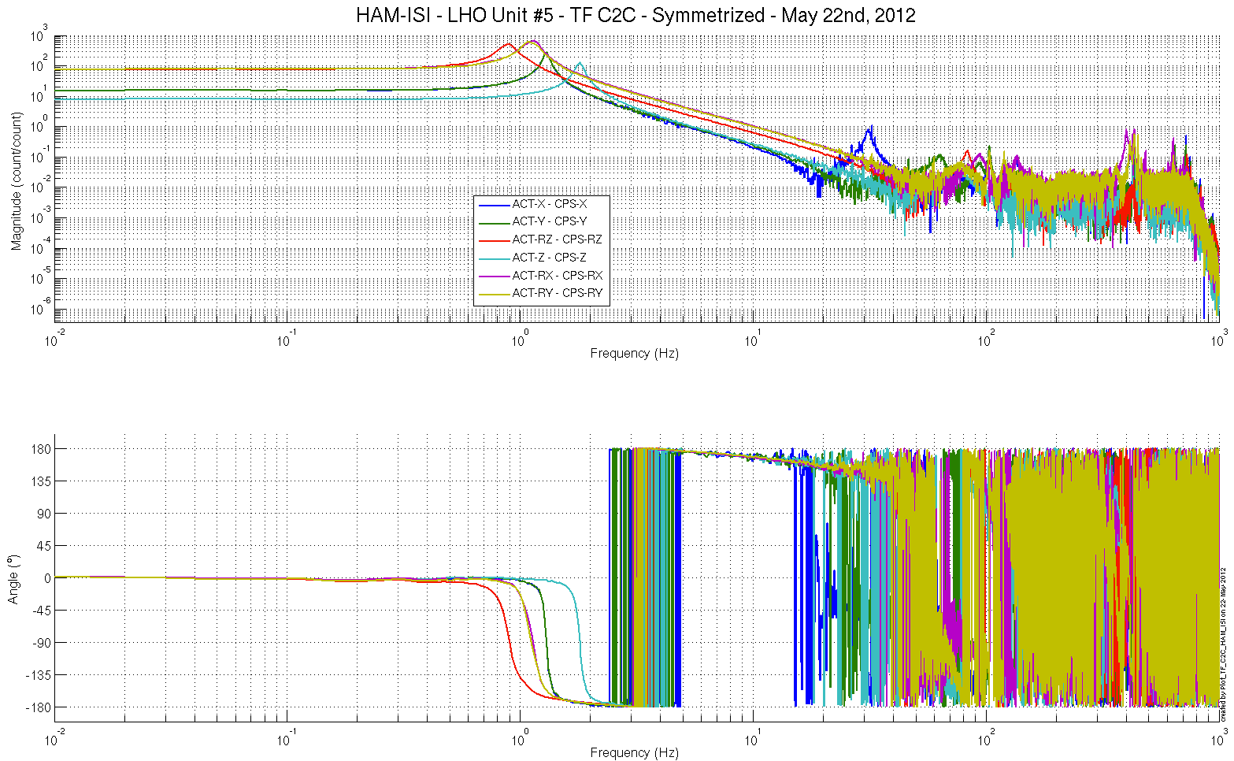
Figure – Cartesian to Cartesian – computed - Capacitive sensors

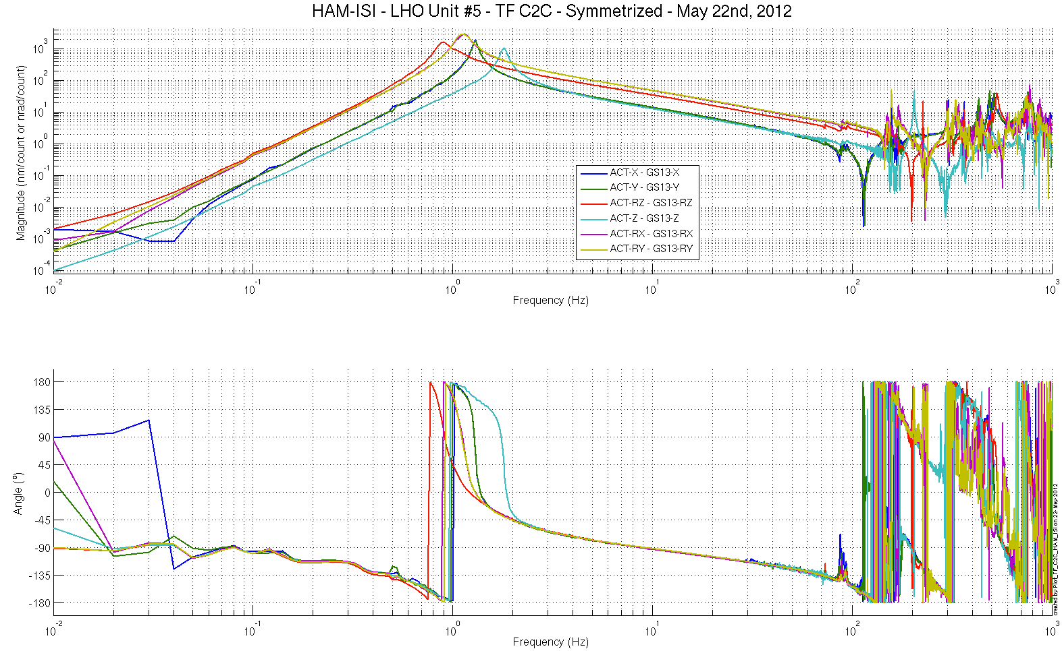
Figure – Cartesian to Cartesian - computed - Inertial sensors

Acceptance criteria:
- Local to local measurements
  - On CPS, the phase must be 0º at DC
  - On Geophones, the phase must be -90º at DC
  - Identical shape in each corner
- Cartesian to Cartesian measurements
  - On CPS, the phase must be 0º at DC
  - On Geophones, the phase must be -90º at DC
  - Identical shape X/Y and RX/RY

Test result: Passed: X Failed: .

Step 17 - Transfer function comparison with Reference

Step 17.1 - Local to local - Comparison with Reference
Scripts files for processing and plotting in SVN at:
/SeiSVN/seismic/HAM-ISI/X1/HAMX/Scripts/Control_Scripts/
- Step_1_Plot_TF_L2L_HAM_Testing.m
/SeiSVN/seismic/HAM-ISI/Common/Testing_Functions_HAM_ISI/
- Step_1_TF_Loc_to_Loc_X1_ISI_HAMX

Local to local comparison figures in SVN at:
/SeiSVN/seismic/ HAM-ISI/X1/HAMX/Data/ Figures/Transfer_Functions/Measurements/Comparisons/L2L/
- X1_ISI_HAMX_TF_L2L_Raw_from_ACT_H_to_CPS_H_vs_UNIT_1_2012_02_02_With_3_Washers_Under_Top_Mass.fig
- X1_ISI_HAMX_TF_L2L_Raw_from_ACT_H_to_CPS_H_vs_UNIT_1_2012_02_02_With_3_Washers_Under_Top_Mass.pdf
- X1_ISI_HAMX_TF_L2L_Raw_from_ACT_H_to_GS13_H_vs_UNIT_1_2012_02_02_With_3_Washers_Under_Top_Mass.fig
- X1_ISI_HAMX_TF_L2L_Raw_from_ACT_H_to_GS13_H_vs_UNIT_1_2012_02_02_With_3_Washers_Under_Top_Mass.pdf
- X1_ISI_HAMX_TF_L2L_Raw_from_ACT_V_to_CPS_V_vs_UNIT_1_2012_02_02_With_3_Washers_Under_Top_Mass.fig

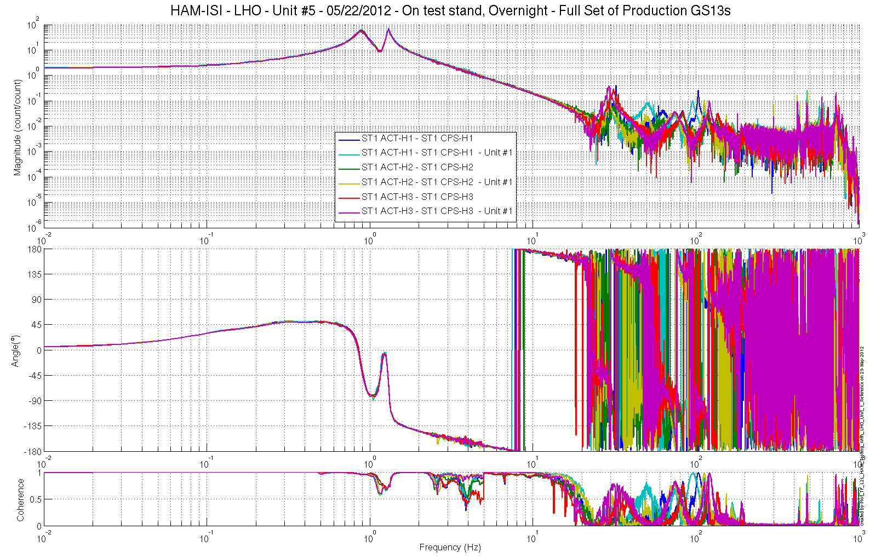
Figure – local-to-Local measurements, comparison with Unit #1 reference
Capacitive Position Sensors - Horizontal motion
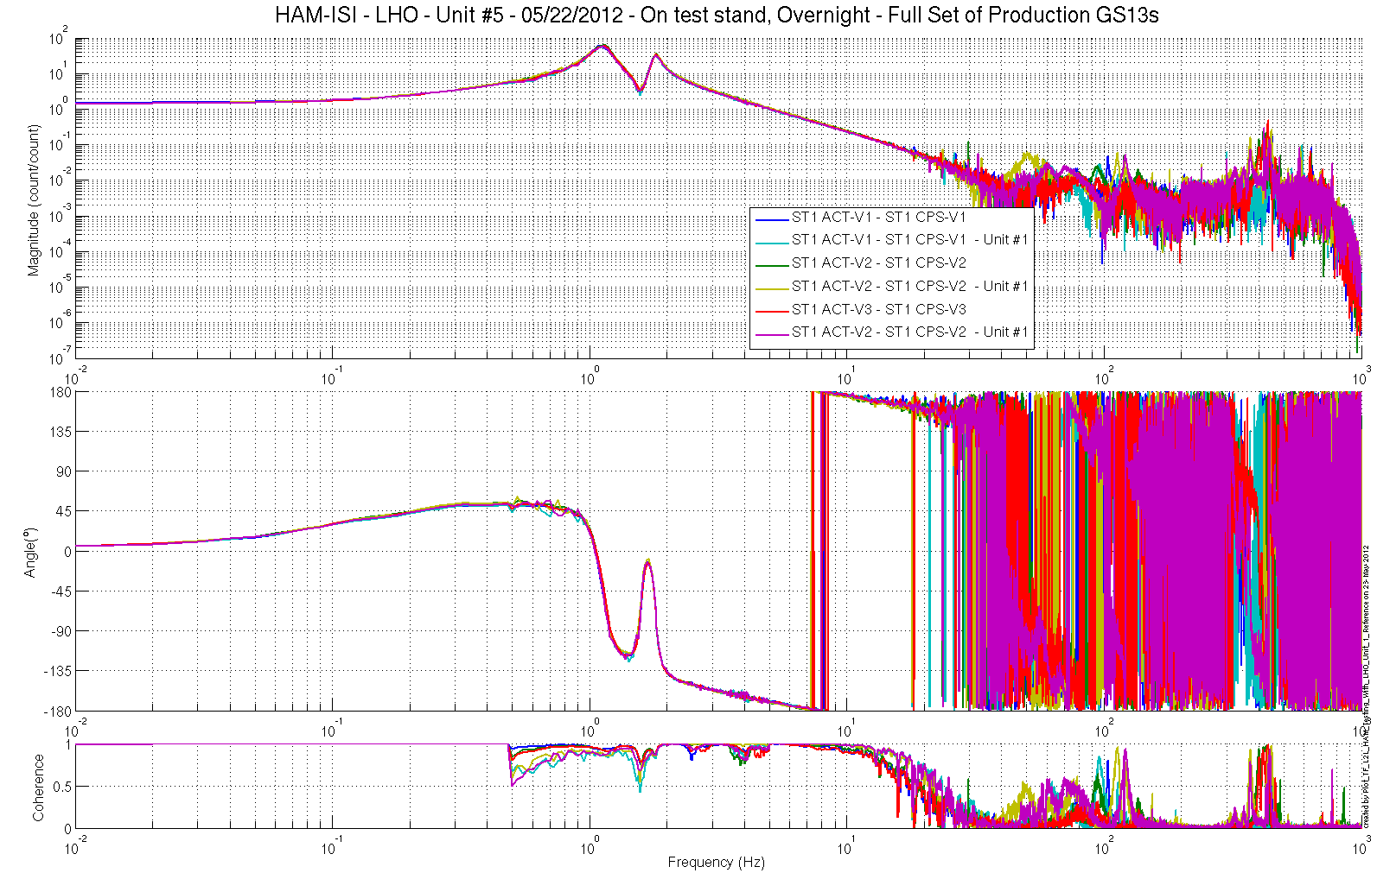
Figure – local-to-Local measurements, comparison with Unit #1 reference
Capacitive Position Sensors - Vertical motion

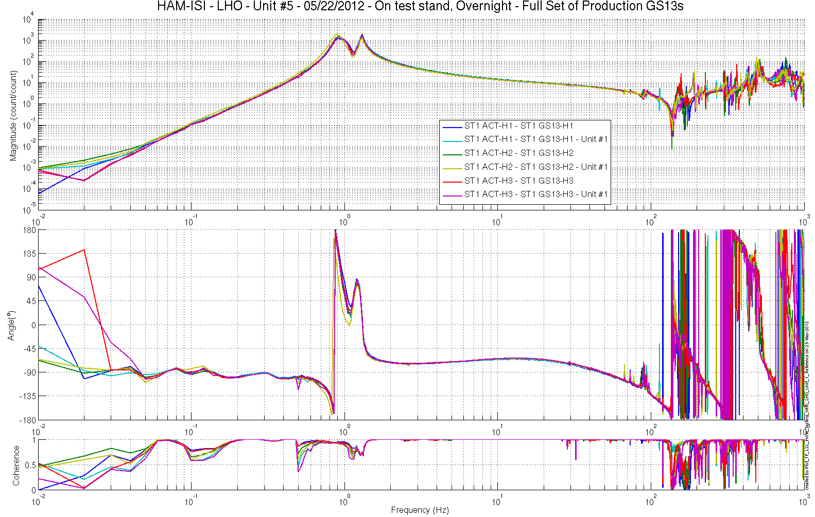
Figure – local-to-Local measurements, comparison with Unit #1 reference
Inertial Sensors - Horizontal motion
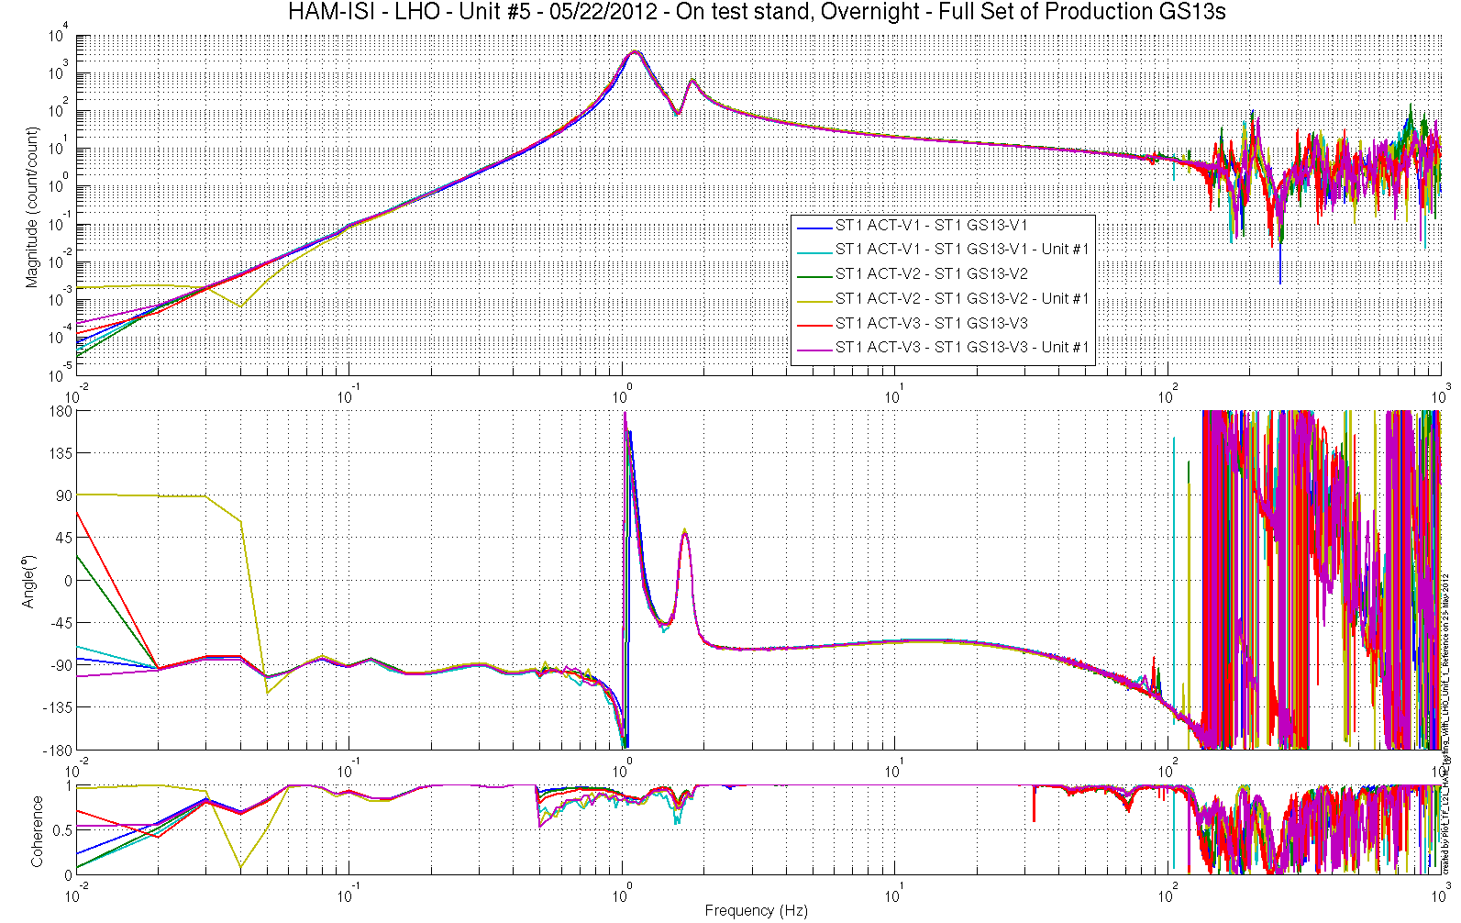
Figure – local-to-Local measurements, comparison with Unit #1 reference
Inertial Sensors - Vertical motion

Acceptance criteria:
No difference with the reference transfer functions (Unit #1)
  - Phase – less than 10º - In Phase – Out of Phase
  - Damping (fit by eye with Reference transfer functions)
  - DC gain
  - Eigen frequencies shift less than 10%

Test result: Passed: X Failed: .

Step 17.2 - Cartesian to Cartesian - Comparison with Reference

Scripts files for processing and plotting in SVN at:
/SeiSVN/seismic/HAM-ISI/X1/HAMX/Scripts/Control_Scripts/
- Step_3_TF_Cart_to_Cart_M1_ISI_HAMX.m
/SeiSVN/seismic/HAM-ISI/Common/Testing_Functions_HAM_ISI/
- Plot_TF_C2C_HAM_Testing_With_LHO_Unit_1_Reference.m

Cartesian to Cartesian figures in SVN at:
/SeiSVN/seismic/ HAM-ISI/X1/HAMX/Data/ Figures/Transfer_Functions/Measurements/Comparisons/C2C/
- X1_ISI_HAMX_TF_C2C_Raw_from_ACT_H_to_CPS_H_Symmetrized_vs_Unit_1_2012_04_04.fig X1_ISI_HAMX_TF_C2C_Raw_from_ACT_V_to_CPS_V_Symmetrized_vs_Unit_1_2012_04_04.fig
- X1_ISI_HAMX_TF_C2C_Raw_from_ACT_H_to_GS13_H_Symmetrized_vs_Unit_1_2012_04_04.fig X1_ISI_HAMX_TF_C2C_Raw_from_ACT_V_to_GS13_V_Symmetrized_vs_Unit_1_2012_04_04.fig

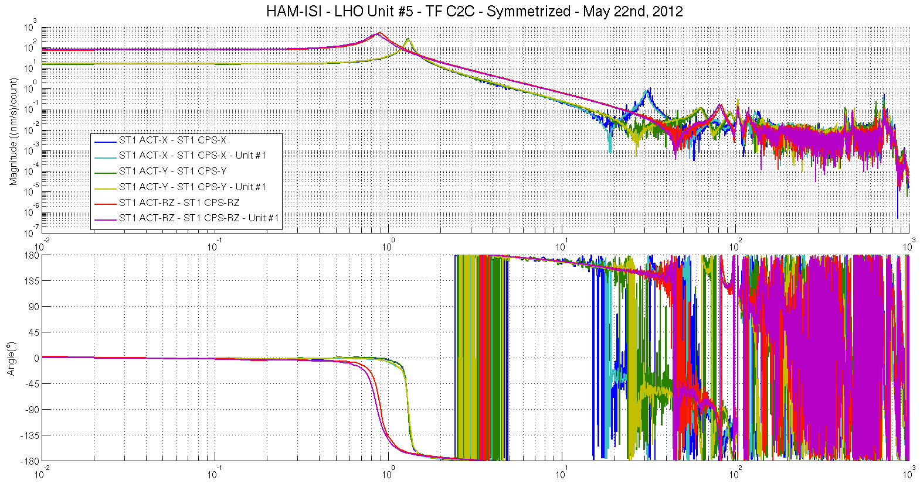
Figure – Cartesian to Cartesian measurements, comparison with Unit #1 reference
Capacitive Position Sensors - Horizontal motion

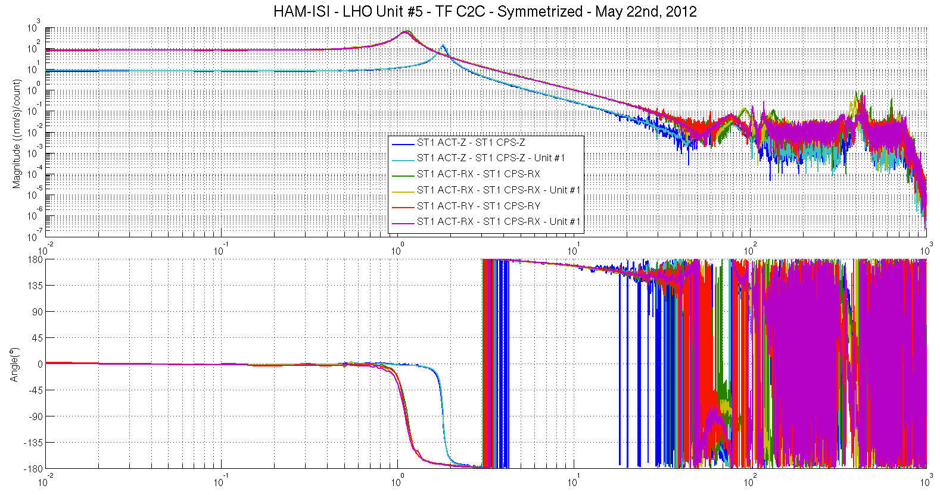
Figure – Cartesian to Cartesian measurements, comparison with Unit #1 reference
Capacitive Position Sensors - Vertical motion

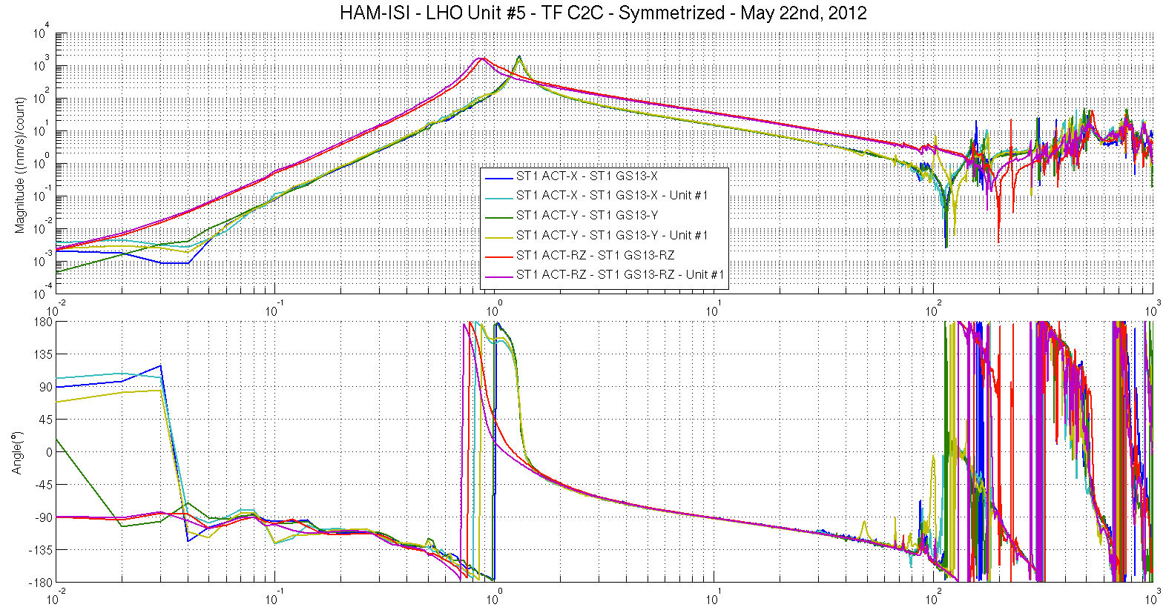
Figure – Cartesian to Cartesian measurements, comparison with Unit #1 reference – Inertial Sensors
Horizontal motion

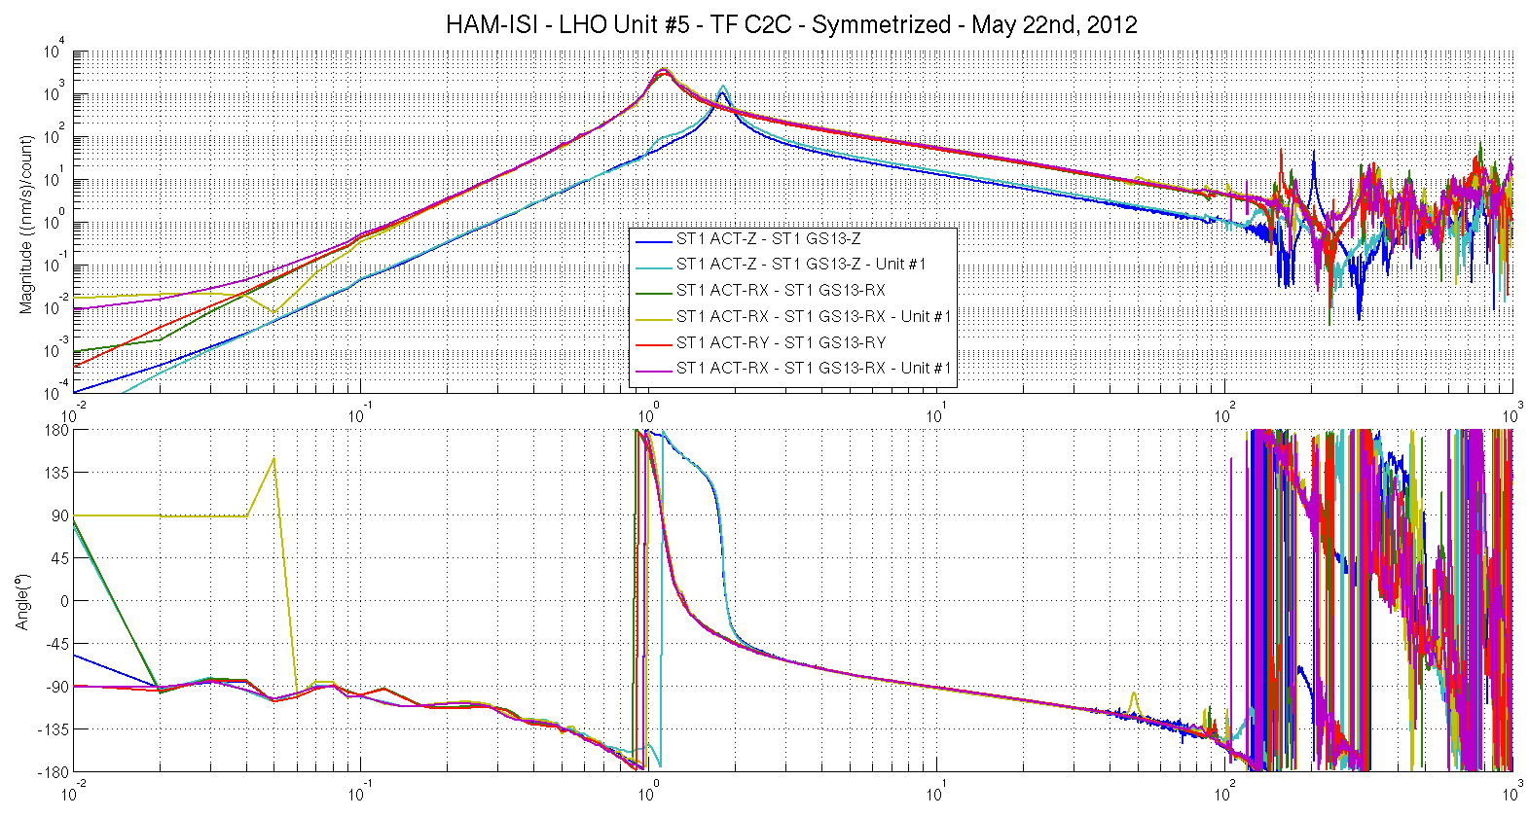
Figure – Cartesian to Cartesian measurements, comparison with Unit #1 reference
Inertial Sensors - Vertical motion

Issues/difficulties encountered during this test:
Unit #5’s Cartesian-TFs were simulated. Coherence is not available.

Acceptance criteria:
- No difference with the reference transfer functions (SVN)
  - Phase – less than 10º - In Phase – Out of Phase
  - Damping (fit by eye with Reference transfer functions)
  - DC gain
  - Eigen frequencies shift less than 10%

Test result: Passed: X Failed: .

Note:
Phase shifts on GS13s, that are not observed on CPSs, can be associated to the difference in response between the GS13s.

Step 18 - Lower Zero Moment Plane

Data collection script files:
/SeiSVN/seismic/HAM-ISI/Common/Transfer_Function_Scripts/
- Run_TF_C2C_10mHz_100mHz_LZMP_HAM_ISI.m
Data files in SVN at:
/SeiSVN/seismic/HAM-ISI/X1/HAMX/Data/Transfer_Functions/Measurements/Undamped/
- LHO_ISI_HAM_Unit_5_Data_TF_C2C_10mHz_100mHz_LZMP_20120523-163904.mat
Scripts files for processing and plotting in SVN at:
/SeiSVN/seismic/HAM-ISI/Common/Testing_Functions_HAM_ISI/
- LZMP_HAM_ISI.m

Figures in SVN at:
/SeiSVN/seismic/HAM-ISI/X1/HAMX/Data/ Figures/Transfer_Functions/Measurements/Undamped/
- LHO_ISI_UNIT_5_LZMP_20120523.fig

The result of the measurement performed is presented below. Symmetrization filters are engaged. Measurement was performed over 46h (800 averages), during the weekend.

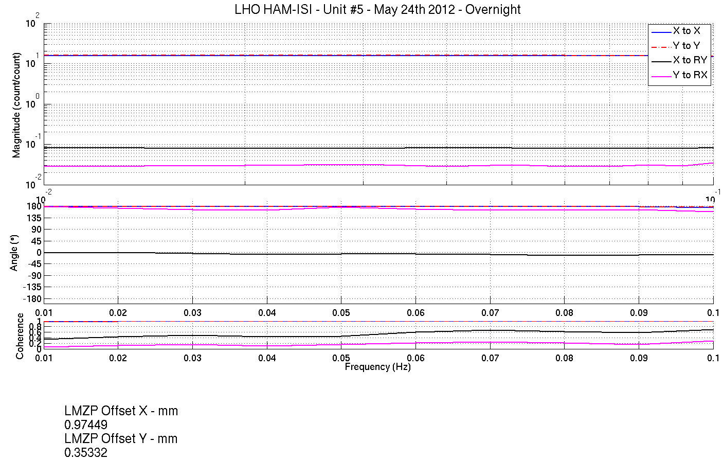
Figure - Lower Zero Moment Plane – Main and cross couplings at low frequency

Acceptance criteria:
- X offset must be less than 2 mm
- Y offset must be less than 2 mm

Test result: Passed: X Failed: .

Step 19 - Damping loops
In this step, HAM6 damping loops are implemented. First, damping performances are evaluated in simulation. Second, Damping loops are implemented and performance is experimentally measured.

Step 19.1 – Simulation of damping performance - TF
Continuous HAM6 filters are located in the SVN at:
/SeiSVN/seismic/HAM-ISI/Common/HAM6_Main_Results/
- HAM6_LLO_Damping_Filters.mat

Scripts files used to evaluate damping loops performance from measurementsare located in SVN at:
/SeiSVN/seismic/HAM-ISI/X1/HAMX/Scripts/Control_Scripts/
- Step_4_Damping_Filters_X1_ISI_HAMX.m

TF Data file is located in the SVN at:
/seismic/HAM-ISI/X2/Data/Unit_2/Transfer_Functions/Simulations/Damping/
- X1_ISI_HAMX_TF_C2C_Damped_2012_05_22.mat

Figures in SVN at:
/SeiSVN/seismic/HAM-ISI/X1/HAMX/Data/Figures/Transfer_Functions/Simulations/Damped/
- X1_ISI_HAMX_Damping_TF_MIMO_ST1_ACT_RX_to_ST1_GS13_RX_2012_05_22.fig
- X1_ISI_HAMX_Damping_TF_MIMO_ST1_ACT_RY_to_ST1_GS13_RY_2012_05_22.fig
- X1_ISI_HAMX_Damping_TF_MIMO_ST1_ACT_RZ_to_ST1_GS13_RZ_2012_05_22.fig
- X1_ISI_HAMX_Damping_TF_MIMO_ST1_ACT_X_to_ST1_GS13_X_2012_05_22.fig
- X1_ISI_HAMX_Damping_TF_MIMO_ST1_ACT_Y_to_ST1_GS13_Y_2012_05_22.fig
- X1_ISI_HAMX_Damping_TF_MIMO_ST1_ACT_Z_to_ST1_GS13_Z_2012_05_22.fig
- X1_ISI_HAMX_TF_Damped_SISO_ACT_RX_to_GS13_RX_2012_05_22.fig
- X1_ISI_HAMX_TF_Damped_SISO_ACT_RY_to_GS13_RY_2012_05_22.fig
- X1_ISI_HAMX_TF_Damped_SISO_ACT_RZ_to_GS13_RZ_2012_05_22.fig
- X1_ISI_HAMX_TF_Damped_SISO_ACT_X_to_GS13_X_2012_05_22.fig
- X1_ISI_HAMX_TF_Damped_SISO_ACT_Y_to_GS13_Y_2012_05_22.fig
- X1_ISI_HAMX_TF_Damped_SISO_ACT_Z_to_GS13_Z_2012_05_22.fig

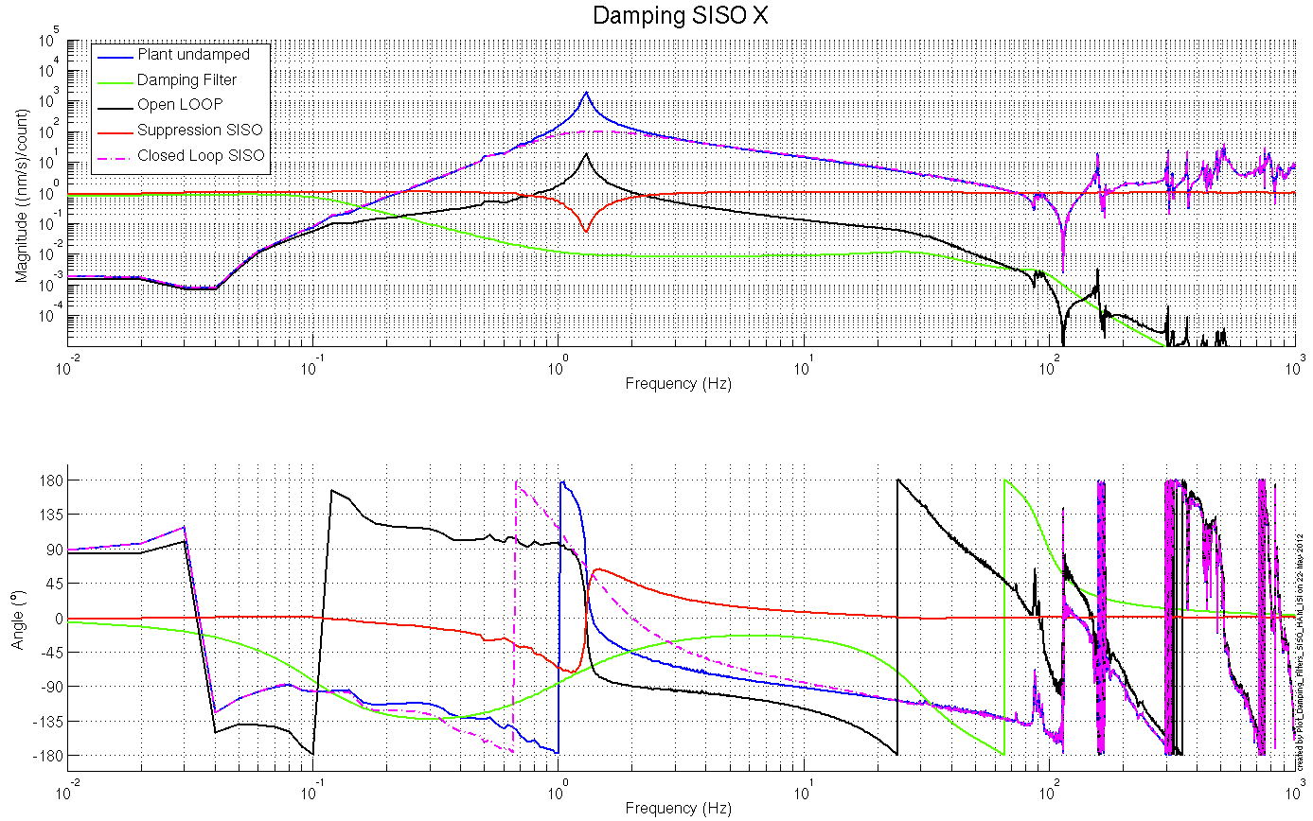

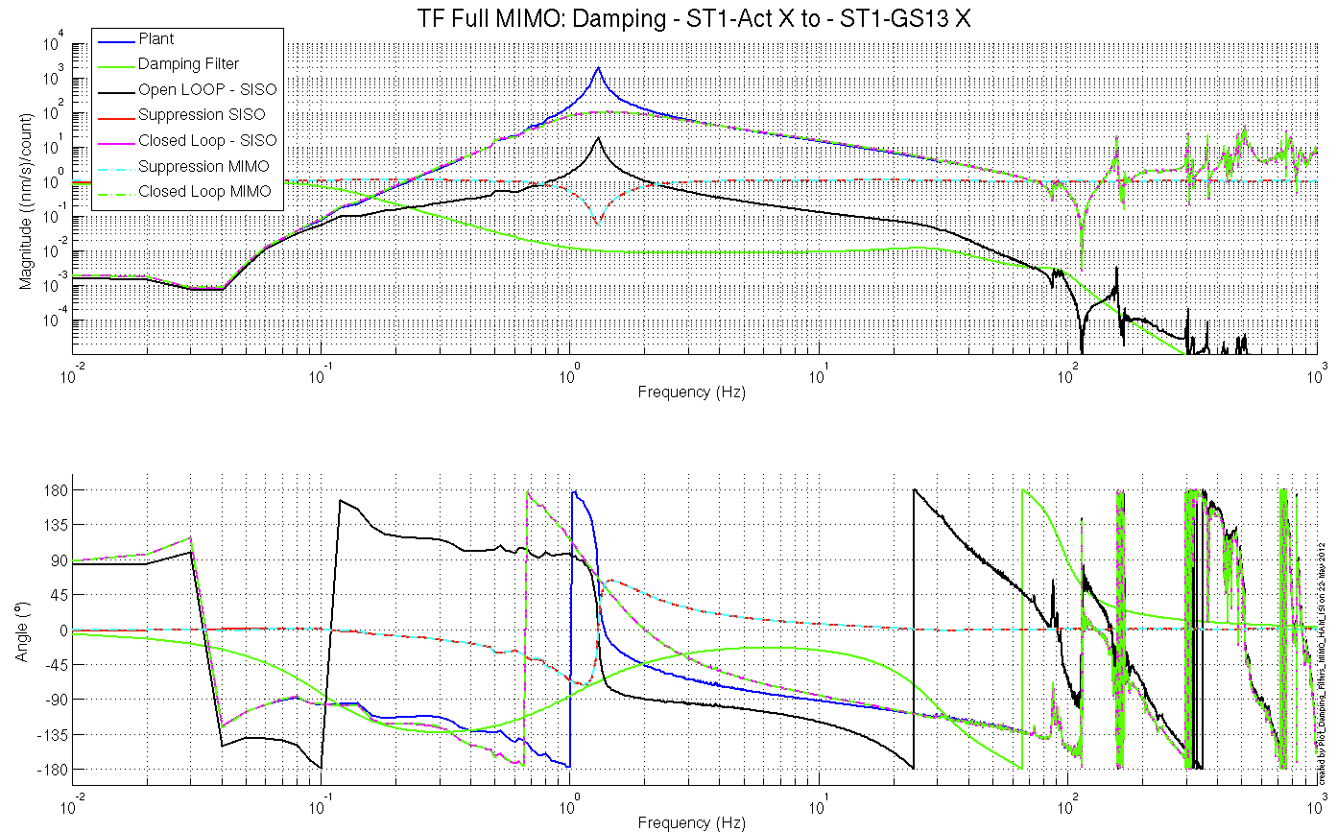
Figure – Simulated damping performances – X axis

Acceptance criteria:

- HAM6 damping loops must implemented and stable with
  - Phase margin must be at least 45º
  - Gain margin must be at least 20dB

Test result: Passed: X Failed: .

Step 19.2 – Experiemental evaluation of damping performance - Spectra

Scripts files for taking data and plotting in SVN at:
/SeiSVN/seismic/HAM-ISI/X1/Scripts/Data_Collection/
- Master_TEST_X1_ISI_Unit_5.m (lines 99 to 114)

Data files in SVN at:
/SeiSVN/seismic/HAM-ISI/X1/HAMX/Data/Spectra/Damped/
- LHO_ISI_UNIT_5_ASD_m_CPS_GS13_Undamped_vs_Damped_ 2012_05_07_103121.mat
Figures in SVN at:
/SeiSVN/seismic/HAM-ISI/X1/HAMX/Data/Figures/Spectra/Damped/
- LHO_ISI_UNIT_5_ASD_CT_CPS_CART_Undamped_vs_Damped 2012_05_22_142540.fig
- LHO_ISI_UNIT_5_ASD_CT_GS13_CART_Undamped_vs_Damped2012_05_22_142540.fig
- LHO_ISI_UNIT_5_ASD_m_CPS_CART_Undamped_vs_Damped2012_05_22_142540.fig
- LHO_ISI_UNIT_5_ASD_m_GS13_CART_Undamped_vs_Damped2012_05_22_142540.fig
- LLO_HAM_ISI_Unit_5_Calibrated_PSD_CPS_Undamped_Damped2012_05_22_142540.fig

Issues/difficulties encountered during this test:
Like for Unit #2 and 4, damping was slightly overestimated along Z-axis.

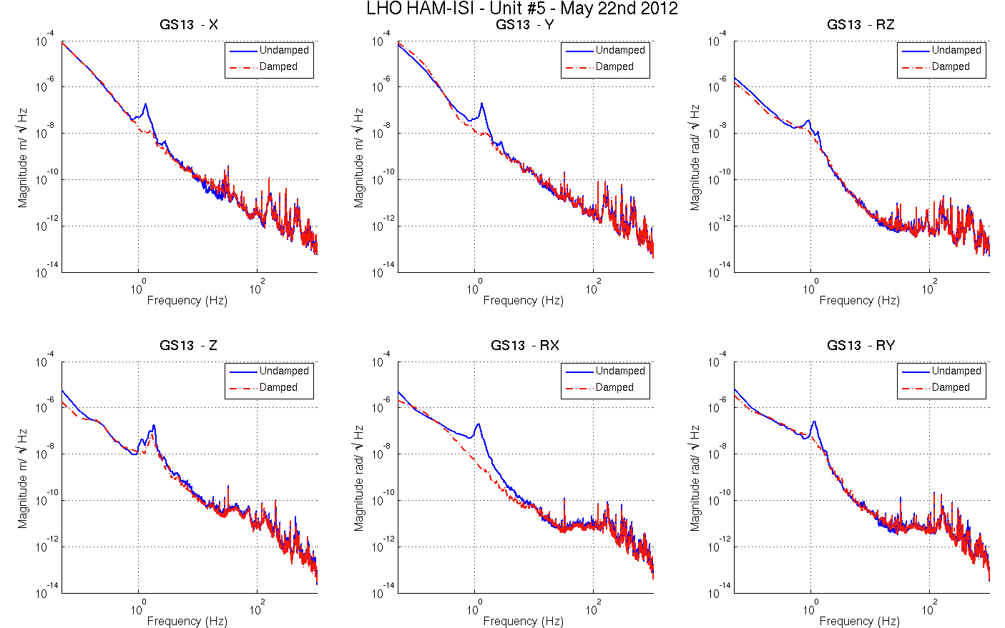
Figure - Damped/Undamped GS-13 Power Spectra comparison

Acceptance criteria:

- HAM6 damping loop must stable when all damping loops are engaged
- Similar damping effect than in simulated plots

Test result: Passed: X Failed: .

Generic control scripts were updated after testing was performed. This should only impact the experimental evaluation of damping loops’ performances.

HAM-ISI Unit #5 testing summary
HAM-ISI Unit #5 was assembled during April 2012. The testing of this Unit is presented here. It started on May 2nd 2012 and lasted until May 8th 2012 with the testing horizontal GS13s.
These Horizontal GS13s featured non-consistent behavior after reception at LHO. Investigation has been performed at LLO for instruments featuring the same symptoms (LLO aLog 2909). It revealed that the screws of some flexures were not correctly torqued anymore and that they needed lock tight in order to remain secured during shipping. Hence, the horizontal GS13s initially used for testing were considered as “testing instruments”. They were removed from the assembly at the end of the assembly validation, to be replaced with production pods. Tests involving GS13s were performed with the new set of production pods between May 21st and May 24th 2012.
Particularities:
- Full set of production GS13s
- No L4Cs
- No L4C brackets

FAILED AND WAIVED TESTS

List of tests that failed and don’t need to be redone:
Step I.1: Failed on CPS-H1 at 0.1Hz. Its spectrum is however very close from our requirement.
Step III.2: Excessive standard deviation on CPSs is associated to ground motion (SEI logbook, entry #15). Sensor noise is acceptable.

Tests that failed and need to be done during phase II
Step III.14: Actuators appear to be linear on measurements. However, deviation from average slope is out of spec. It seems to correlate with cable+actuator resistance measurements. Make sure that linearity test results correlate with the final field cables.
This scale factor, which varies from an actuation point to another, could be corrected with an adjustment gain applied on the excitation signal sent to the actuators.
Step 19.2: The implementation method for the damping loops was updated since testing. Damping loops’ experimental performance need to be re-evaluated. However, this test is not mandatory for the assembly validation and is just performed as a preparation for further commissioning.

List of test that were skipped and that we will not do because they are not essential
Step III.3: Sensor gap measurement with a jig. Waved to avoid scratching targets. Distance between sensor and target has also been checked during the assembly while adjusting target distance.

