LIGO Laboratory / LIGO Scientific Collaboration

LIGO- E1000325 LIGO August 16, 2010

aLIGO HAM-ISI, Pre integration Test report, Phase 1,
LLO Unit #1

Celine Ramet, Michael Vargas, Richard Mittleman, Fabrice Matichard, Vincent Lhuillier

Distribution of this document:
Advanced LIGO Project

This is an internal working note
of the LIGO Laboratory

California Institute of Technology  LIGO Project – MS 18-34  1200 E. California Blvd.  Pasadena, CA 91125  Phone (626) 395-2129  Fax (626) 304-9834  E-mail: info@ligo.caltech.edu | Massachusetts Institute of Technology  LIGO Project – NW22-295  185 Albany St  Cambridge, MA 02139  Phone (617) 253-4824  Fax (617) 253-7014  E-mail: info@ligo.mit.edu
LIGO Hanford Observatory  P.O. Box 1970  Mail Stop S9-02  Richland WA 99352  Phone 509-372-8106  Fax 509-372-8137 | LIGO Livingston Observatory  P.O. Box 940  Livingston, LA 70754  Phone 225-686-3100  Fax 225-686-7189

.
Table of contents:

Introduction 3
I. Pre-Assembly Testing 4
▪ Step 1: Position Sensors 4
▪ Step 2: GS13 5
▪ Step 3: Actuators 5
II. Tests to be performed during assembly 6
▪ Step 1: Check torques on all bolts 6
▪ Step 2: Check gaps under Support Posts 6
▪ Step 3: Pitchfork/Boxwork flatness before Optical Table install 6
▪ Step 4: Blade spring profile 6
▪ Step 5: Gap checks on actuators 7
▪ Step 6: Check level of Stage 0 7
▪ Step 7: Mass budget 7
▪ Step 8: Lockers adjustment 9
III. Tests to be performed after assembly 10
▪ Step 1 - Actuators Inventory 10
▪ Step 2 - Sensors Inventory 10
▪ Step 3 - Electronics Inventory 11
▪ Step 4 - Set up sensors gap 11
▪ Step 5 - Measure the Sensor gap 12
▪ Step 6 - Check Sensor gaps after the platform release 12
▪ Step 7 - Check range of motion (hand pushing) 13
o Step 7.1 – Test Nº1 13
o Step 7.2 – Test Nº2 13
▪ Step 8 - Capacitive position sensor Power Spectrum 14
▪ Step 9 - GS13 power spectrum 15
▪ Step 10 - Coil Driver, cabling and resistance check 17
▪ Step 11 - Actuators Sign and range of motion (Local drive) 17
o Step 11.1 - Actuators sign 17
o Step 11.2 - Range of motion - Local drive 17
▪ Step 12 - Vertical Sensor Calibration 17
▪ Step 13 - Vertical Spring Constant 18
▪ Step 14 - Static Testing (Tests in the local basis) 19
▪ Step 15 - Linearity test (might not be necessary) 20
▪ Step 16 - Tests in the general coordinate basis 21
▪ Step 17 - Frequency response 22
o Step 17.1 - Local to local measurements 22
o Step 17.2 - Cartesian to Cartesian measurements 23
▪ Step 18 - Transfer function comparison 25
o Step 18.1 - Local to local - Comparison with HAM6 25
o Step 18.2 - Cartesian toCartesian - Comparison with HAM6 26
▪ Step 19 - Lower Zero Moment Plan 27
▪ Step 20 - Damping loops 28
o Step 20.1 - Transfer functions - Simulation 28
o Step 20.2 - Powerspectrum – Experimental 29
IV. Testing Summary 31

Introduction

This document presents the tests performed to characterize and validate the “HAM-ISI LLO Unit #1”. This unit is the first unit assembled for aLIGO at LLO.
The procedure document used to perform this test is:
- E1000309 - aLIGO HAM-ISI, Pre-Integration Testing Procedure, Phase I (post assembly, before storage)
Other useful information can be found in:
- E1000300 - HAM-ISI LLO test stand: software and electronic check
-

Pre-Assembly Testing

Step 1: Position Sensors

Note: The back panel reads 0.508V/0.001"

S/N sensor | S/N board | ADE Gap Standoff(mm) | Location on the Jig | Gap Standoff on Jig(mm/in) | Voltage before zeroing | Voltage after zeroing. Prebake | Voltage after zeroing. Post bake
12000 | 12000 | NR | NR | NR | NR | NR | NR
12001 | 12001 | NR | NR | NR | NR | NR | NR
12067 | 12067 | NR | NR | NR | NR | NR | NR
11985 | 11985 | NR | NR | NR | NR | NR | NR
11923 | 11992 | NR | NR | NR | NR | NR | NR
12066 | 12066 | NR | NR | NR | NR | NR | NR

NR: not recorded

Will be measured for the next units.

Sensors noise spectra measured before baking:

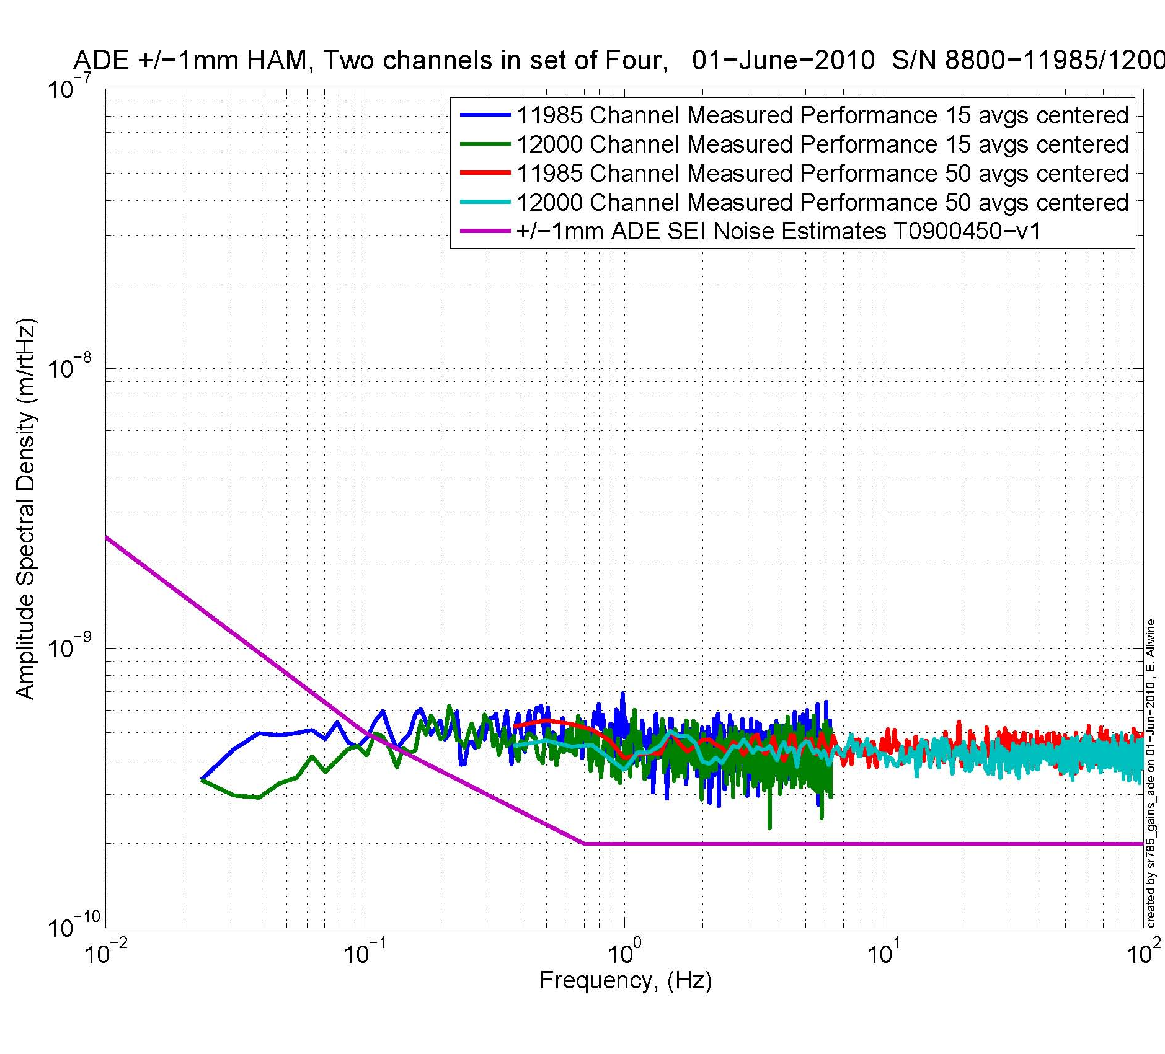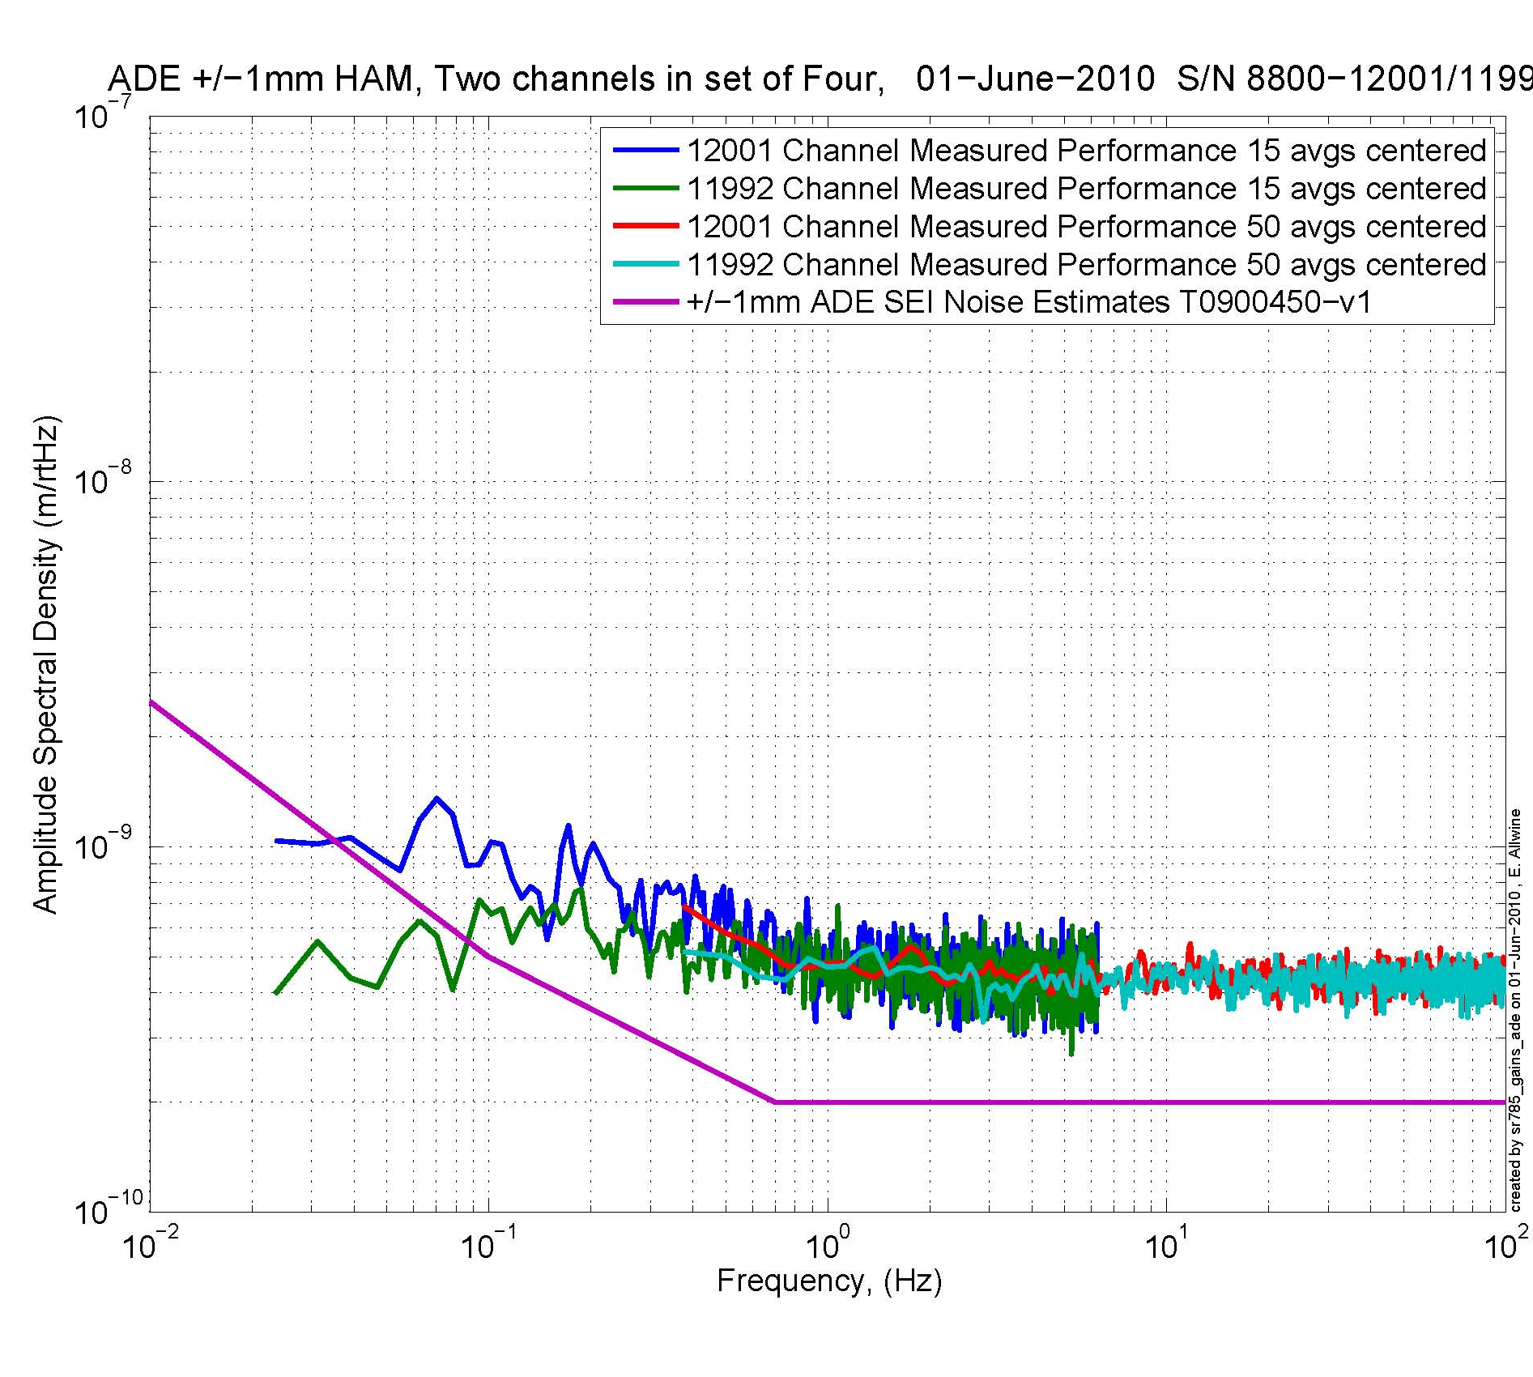
Figure - H1 and V1 sensor noise Figure - H2 and V2 sensor noise

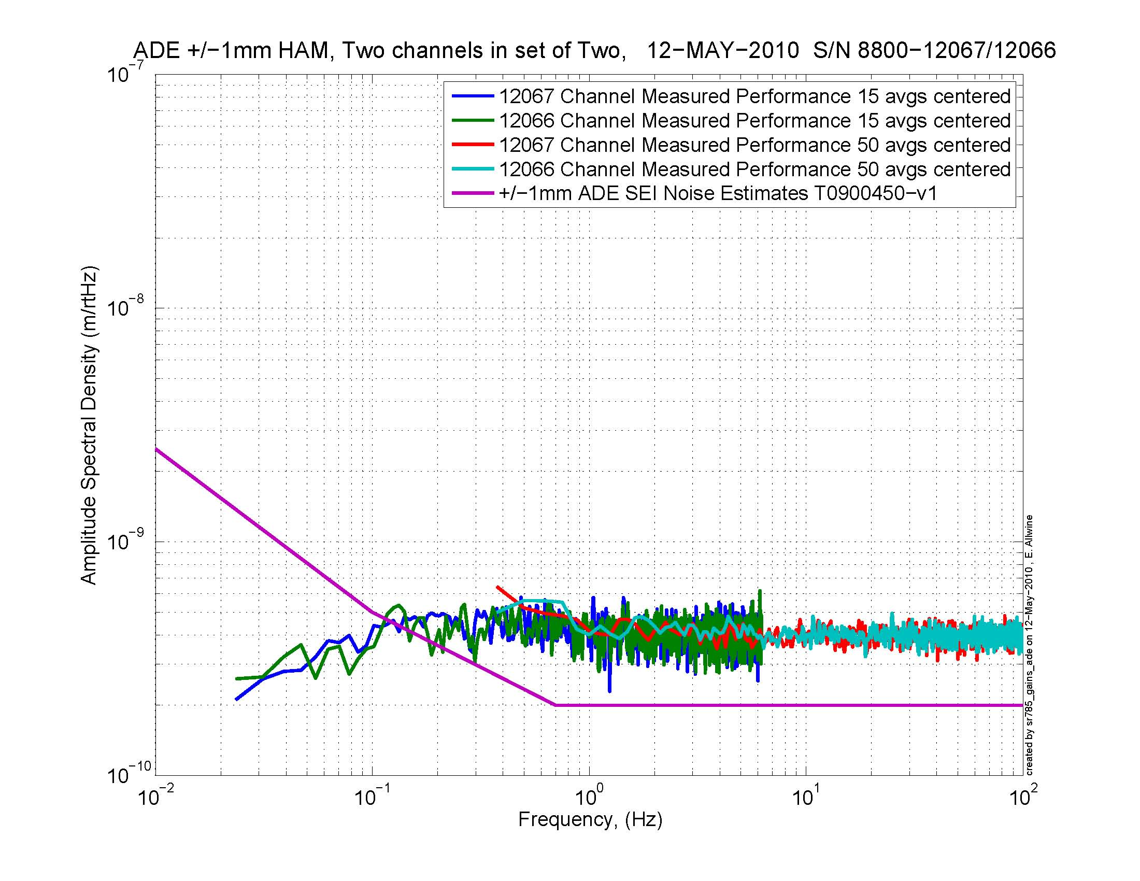
Figure - H3 and V3 sensor noise

Acceptance Criteria: To be defined.

Issues/difficulties/comments regarding this test: Values of sensor gaps and zeroing were nor recorded. Waived for this unit.

Test result: Passed: X Failed: .

Step 2: GS13

All the data related to GS-13 post podding testing can be found in the SVN at : SeismicSVN\seismic\Common\Data\aLIGO_GS13_TestData\PostMod_TestResults_PDFs.

E1000058 spreadsheet provides the status of each individual GS-13 at LLO site during aLIGO HAM assembly

Acceptance Criteria: To be defined.

Test result: Passed: Failed: .

Step 3: Actuators

Actuator data can be found at: T0900564. Actuator inventory is made at Section II – Step 1.

Acceptance Criteria: To be defined.

Test result: Passed: Failed: .

Tests to be performed during assembly

Step 1: Check torques on all bolts

Acceptance Criteria:
- All bolts should trip the wrench, and start moving immediately after. If any bolts in a pattern move before torque is reached, recheck after all bolts are brought to spec.

Test result: Passed: X Failed: .

Step 2: Check gaps under Support Posts

Acceptance Criteria:
- The test is passed if: a 0.001 inch shim cannot be passed freely through any connection to Stage 0 or between post and gussets. If shim can pass through, loosen all constraining bolts, and then retighten iteratively from the center of the part to the edges. Retest.

Test result: Passed: X Failed: .

Step 3: Pitchfork/Boxwork flatness before Optical Table install

Acceptance Criteria:
- Shim inserted won’t pass between parts.

Test result: Passed: X Failed: .

Step 4: Blade spring profile

Test Results, August 5, 2010:
 | Base (") | Tip(") | Flatness (mils)
Spring 1 | 0.5115 | 0.49375 | 17.75
Spring 2 | 0.502 | 0.48875 | 13.25
Spring 3 | 0.501 | 0.4875 | 13.5

Acceptance Criteria
- Blades must be flat within 0.020" inches. To be approved

Test result: Passed: Failed: .

Step 5: Gap checks on actuators

Acceptance Criteria
- Gaps must be within 0.010” of design (i.e. 0.090” and .070” pass, but 0.095” and 0.065” doesn’t).

Test result: Passed: X Failed: .

Step 6: Check level of Stage 0

Acceptance Criteria To be defined.

Test result: Passed: Failed: .

Step 7: Mass budget

Optical Mass (Kg) | Wall Mass (Kg) | Keel Mass (Kg) | Total Mass (Kg)
325.00 | 164.02 | 90.08 | 579.10
Table - Masses distribution

The total weight is 579.1Kg.

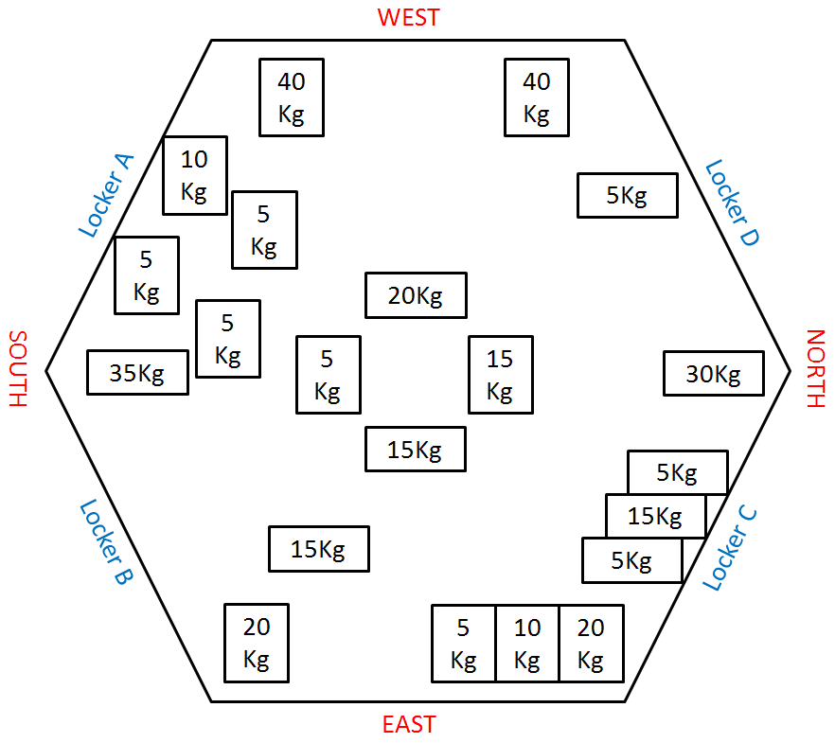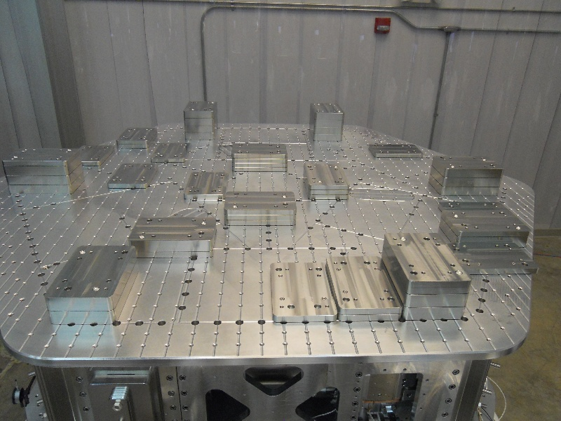

Figure - Masses distribution

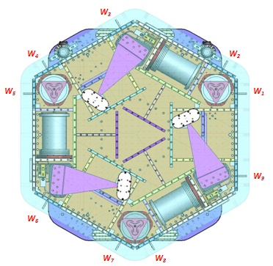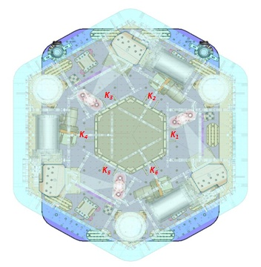
Figure – Keel Masses and Wall masses location

 |  | Mass
 | Type | 00 | 01 | 02 | 03 | 04 | 05 | 06
 | Weight | 0.6 | 1.1 | 2.2 | 4.5 | 7.9 | 15.6 | 27.2 | lbs | kgs
Location | w1 |  |  |  | 1 | 1 |  | 1 | 39.6 | 18.0
Location | w2 | 0 | 0 | 1 | 1 |  | 2 |  | 37.9 | 17.2
Location | w3 | 0 | 1 | 1 | 1 | 2 | 1 |  | 39.2 | 17.8
Location | w4 |  | 1 | 1 | 1 | 1 | 2 | 0 | 46.9 | 21.3
Location | w5 | 0 | 3 | 1 | 1 | 2 | 1 |  | 41.4 | 18.8
Location | w6 | 0 | 1 | 1 | 1 | 0 | 2 | 0 | 39 | 17.7
Location | w7 |  |  |  | 1 | 1 |  | 1 | 39.6 | 18.0
Location | w8 | 0 | 1 | 1 | 1 | 0 | 2 |  | 39 | 17.7
Location | w9 | 0 | 1 | 1 | 1 |  | 2 | 0 | 39 | 17.7
 |  | 0 | 7 | 6 | 8 | 7 | 10 | 2 | 361.6 | 164.0
Location | k1 |  |  |  |  | 1 |  | 1 | 35.1 | 15.9
Location | k2 | 1 | 1 | 1 |  |  |  | 1 | 31.1 | 14.1
Location | k3 |  |  |  |  | 1 |  | 1 | 35.1 | 15.9
Location | k4 | 1 | 1 | 1 |  |  |  | 1 | 31.1 | 14.1
Location | k5 |  |  |  |  | 1 |  | 1 | 35.1 | 15.9
Location | k6 | 1 | 1 | 1 |  |  |  | 1 | 31.1 | 14.1
 |  | 3 | 3 | 3 | 0 | 3 | 0 | 6 | 198.6 | 90.1
Table – Wall masses and Keel masses distribution

Locker shim thickness indicated in mils.

Lockers | Shim thickness (mil)
A
B
C
D

Table – Shims Thicness

Acceptance Criteria
- The total weight must be Kg +/- Kg

Test result: Passed: Failed: .

Step 8: Lockers adjustment

D.I at Lockers | Dial indicators V | Dial indicators H
A | 0.5 | 1
B | 0 | -1
C | 1 | 1
D | 1 | -1.5
Table – Dial indicators read-out
Issues/difficulties encountered during this test : This test has been performed three times due to important variation of the plant with time. On initial measurements, measured variations between locked and unlocked configuration were around 3 mils on horizontal D.I and 1 mil on vertical D.I. We saw that one actuator cable was touching stage 1. After clamping the cable properly to stage 0 to avoid contact with stage 1, variations between locked and unlocked configurations fall to 1 mil on vertical dial indicators and 1.5 mil on horizontal dial indicators (table above).

Acceptance Criteria
- Vertical and horizontal displacement near the lockers must be lower than 2 mils

Test result: Passed: Failed: .

Tests to be performed after assembly

Step 1 - Actuators Inventory

Actuator | Actuator S/N
H1
H2
H3
V1 | 147
V2 | 74
V3 | 95
Table - Actuators' inventory

Issues/difficulties/comments regarding this test: Horizontal actuators S/N missing

Acceptance Criteria: all S/N must be recorded.
Test result: Passed: Failed: X .

Step 2 - Sensors Inventory

Sensor | CPS S/N | Mount S/N | ADE board serial #
H1 | 12000 |  | 8800-12000
H2 | 12001 |  | 8800-12001
H3 | 12067 |  | 8800-12067
V1 | 11985 |  | 8800-11985
V2 | 11992 |  | 8800-11992
V3 | 12066 |  | 8800-12066
Table - Capacitive position sensors' inventory

Geophones GS13 | Serial Number | POD
H1 | 785 | 57
H2 | 789 | 47
H3 | 797 | 52
V1 | 682 | 6
V2 | 691 | 4
V3 | 707 | 1
Table - Geophones' inventory

Issues/difficulties/comments regarding this test:

Test result: Passed: Failed: X .

Step 3 - Electronics Inventory
Write down serial number of coil driver, Anti aliasing chassis, Anti image chassis and interface chassis used for this test are listed below:

Hardware | LIGO reference | S/N
Coil driver | D0902744 | S1000317
Coil driver | D0902744 | S1000316
Anti Image filter | D070081 | S1000251
Anti aliasing filter | D1000269 | S1000244
Anti aliasing filter | D1000269 | S1000298
Interface chassis | D1000067 | S1000311
Interface chassis | D1000067 | S1000312
Interface chassis | D1000067 | S1000314
Table - Inventory electronics

Issues/difficulties/comments regarding this test:

Test result: Passed: Failed: .

Step 4 - Set up sensors gap

Table locked | ADE boxes on |  | ADE boxes on/off
Sensors | Offset (Mean) | Std deviation | Offset (Mean) | Std deviation
H1 | 180 | 3.7 | 181 | 3.4
H2 | 155 | 4.8 | -155 | 3.9
H3 | -28 | 3.7
V1 | -329 | 3.1 | -329 | 3.2
V2 | -390 | 4.1 | -391 | 4.2
V3 | 144 | 2.8
Table - Set-up sensors gap

Issues/difficulties/comments regarding this test: HAM-ISI – LLO unit#1 uses synchronized satellite boxes

Acceptance criteria:

- All mean values must be lower than 400 cts (a bit less than .0005”).
- All standard deviations below 5 counts.

Test result: Passed: Failed: .

Step 5 - Measure the Sensor gap

Sensors | Gap measured on the Jig | Gap measured on the table | % of change | Offset sensors (counts)
H1 |  | 0.085'' |  | 106
H2 |  | 0.08'' |  | -298
H3 |  | 0.085'' |  | 373
V1 |  | 0.085'' |  | 441
V2 |  | 0.085'' |  | 165
V3 |  | 0.085'' |  | -252
Table - Sensors gap

Issues/difficulties/comments regarding this test: No information of gaps measured on the Jig

Acceptance criteria:

- Change of gaps lower than 2% (reference is the gap measured on the Jig)

Test result: Passed: Failed: .

Step 6 - Check Sensor gaps after the platform release

 | Table locked |  | Table unlocked
Sensors | Offset (Mean) | Std deviation | Offset (Mean) | Diff unlocked - locked
H1 | -63 | 4.0 | 1658 | 1721
H2 | -19 | 4.0 | 1408 | 1427
H3 | 158 | 3.0 | 1849 | 1691
V1 | -278 | 3.0 | -1028 | -750
V2 | -379 | 4.0 | -771 | -392
V3 | 129 | 3.0 | -505 | -634
Table – Sensor gaps after platform release

Issues/difficulties/comments regarding this test:

Acceptance criteria:

- Absolute values of the difference between the unlocked and the locked table must be below:
  - 1600 cts for horizontal sensors (~0.002”)
  - 1600 cts for vertical sensors (~0.002”)
- Considering the acceptance criteria of step 4, all mean values must be lower than
  - 2000 cts for horizontal sensors (~0.0025”)
  - 2000 cts for vertical sensors (~0.0025”)

Test result: Passed: Failed: .

Step 7 - Check range of motion (hand pushing)

Step 7.1 – Test Nº1

 | CPS read out |  | Calculated after calibration
Sensors | UP (Counts) | Down (Counts) | UP (mil) | Down (mil)
V1 | 20634 | -19404 | 24.6 | -23.1
V2 | 20165 | -20185 | 24.0 | -24.0
V3 | 20482 | -18891 | 24.4 | -22.5
 | CPS read out |  | Calculated after calibration
Sensors | CW(-RZ) | CCW (+RZ) | CW (mil) | CCW (mil)
H1 | 23340 | -22750 | 27.8 | -27.1
H2 | 20600 | -20750 | 24.5 | -24.7
H3 | 21000 | 20940 | 25.0 | 24.9
Table - Optic table range of motion

Issues/difficulties/comments regarding this test: the results indicate that all displacement sensor signals have the same sign all the way through the read chain.

Step 7.2 – Test Nº2

Displacement sensors and actuator gap check:

 | Push in positive direction | Push in negative direction | Railing | Actuator Gap Check
H1 | 23973 | -24453 |  | X
H2 | 23636 | -24425 |  | X
H3 | 24861 | -24552 |  | X
V1 | 19800 | -17583 |  | X
V2 | 32767 | -32768 | X | X
V3 | 18664 | -19104 |  | X

Table - Sensor and Actuator gap check

Acceptance criteria:
- The vertical sensor readout be positive when the optic table is pushed in the +Z direction
- The horizontal sensor readout be negative when the optic table is pushed in the +RZ direction
- Step 7.1
  - Absolutes value of all estimated motions must be higher than 16000counts (~0.020”)
- Step 7.2
  - No contact point on sensors
  - Absolute value of sensor read out must be higher than 16000counts (~0.020”)
  - No contact point on actuators

Test result: Passed: Failed: .

Step 8 - Capacitive position sensor Power Spectrum

Data files in SVN at:
/svncommon/seisvn/seismic/HAM-ISI/X2/Data/Unit_1/DTT_Powerspectrum_Undamped
- Power_spectrum_table_locked_ADE_Sync_072910_N2.xml
- Power_spectrum_table_unlocked_ADE_Sync_072910.xml
- Power_spectrum_table_locked_ADE_Sync_072910_N2.txt
- Power_spectrum_table_unlocked_ADE_Sync_072910.txt

Scripts files for processing and plotting in SVN at:
/svncommon/seisvn/seismic/HAM-ISI/X2/Data/Unit_1/DTT_Powerspectrum_Undamped
- PSD_GS13_lock_unlock_HAM_ISI_LLO_unit_1_2010_08_05.m

Figures in SVN at:
/svncommon/seisvn/seismic/HAM-ISI/X2/Data/Unit_1/Figures/Powerspectrum_GS13_CPS
- Calibrated_CPS_Powerspectrum_when_Locked_Unlocked.fig

CPS calibration:
The CPS power spectrums are calibrated by using a sensitivity of 30.2nm/count.
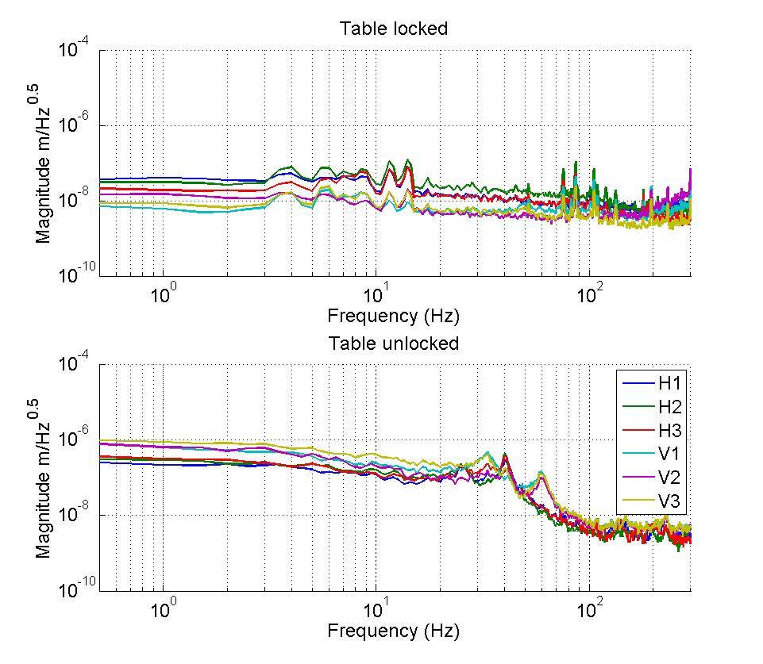
Figure - Calibrated CPS power spectrum

Acceptance criteria:
- No cross talk (peaks at low frequencies + harmonics on measurements)
- Magnitude of power spectrums must be
  - Less than 5e-10m/√Hz at 0.1Hz
  - Less than 5e-10m/√Hz at 1Hz
  - Less than 5e-10m/√Hz at 10Hz

Test result: Passed: Failed: .

Step 9 - GS13 power spectrum
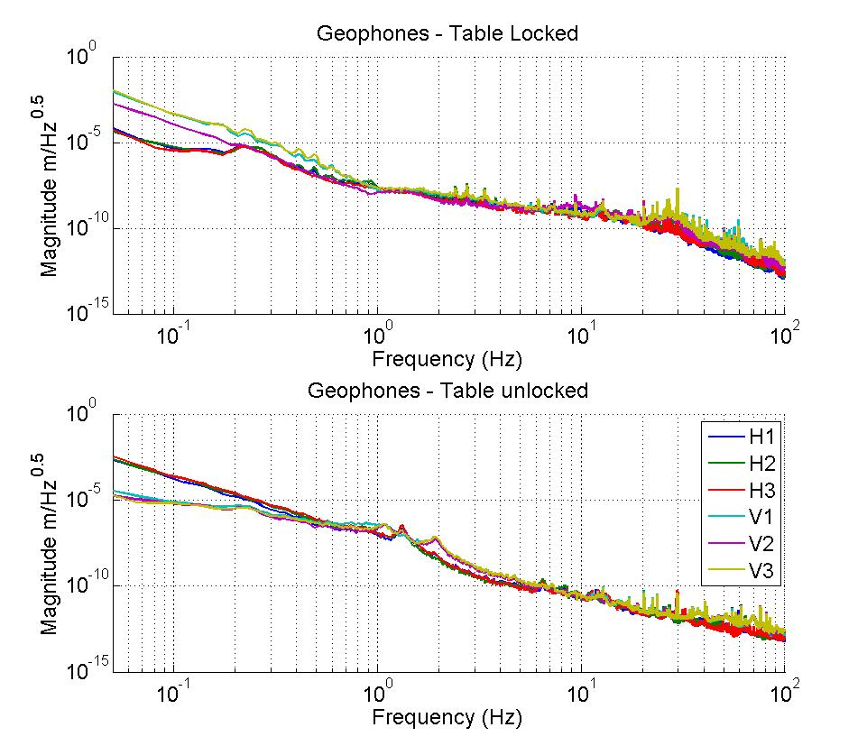
Figure – Power spectrum Calibrated GS13 with mass at corner

The figure below presents the GS13 powerspectrum when the table is unlocked and loaded with a 20Kg mass at one of its corner.

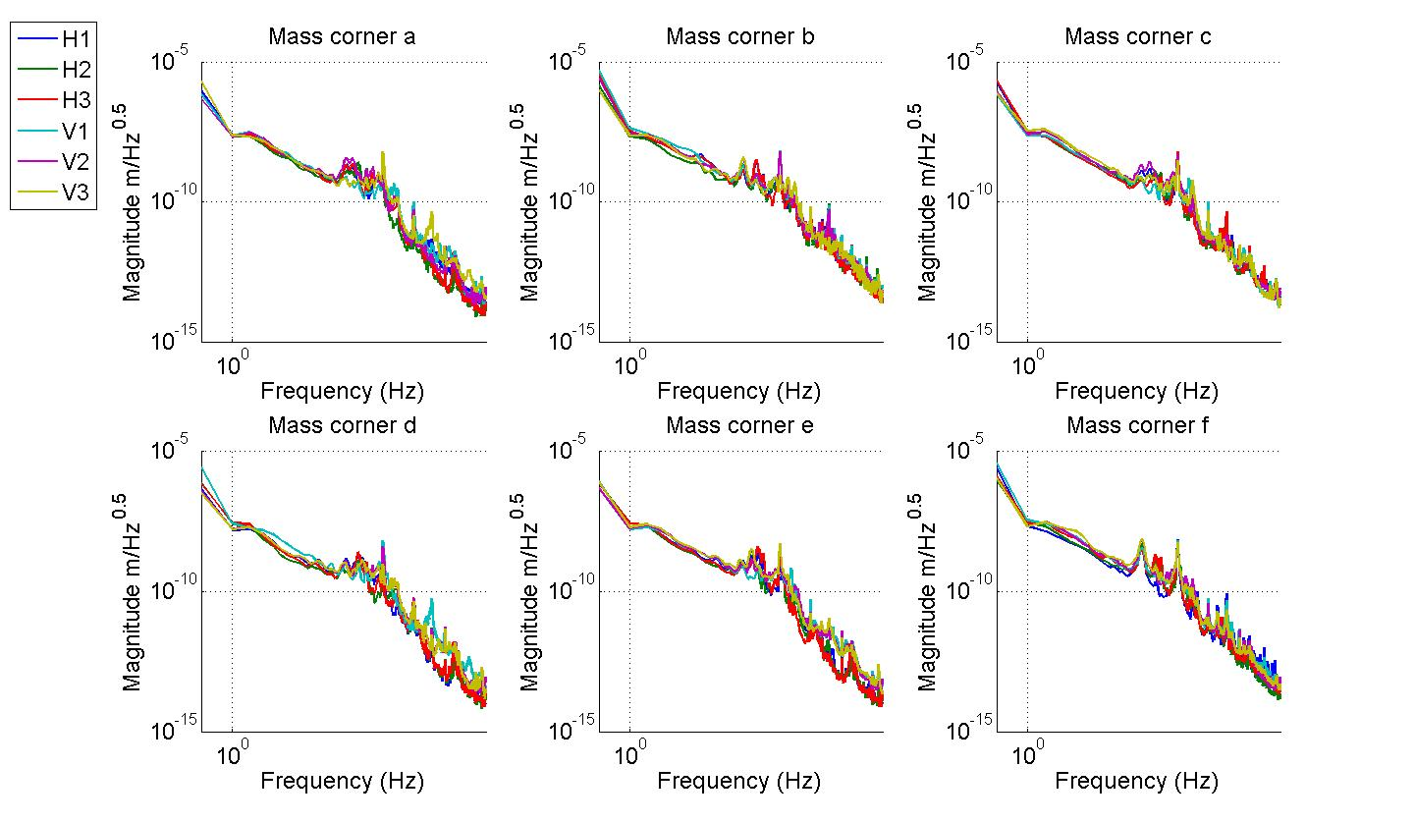
Figure – Power spectrum Calibrated GS13 with mass at corner

Data files in SVN at:
/svncommon/seisvn/seismic/HAM-ISI/X2/Data/Unit_1/DTT_Powerspectrum_Undamped
- Power_spectrum_table_locked_ADE_Sync_072910_N2.xml
- Power_spectrum_table_unlocked_ADE_Sync_072910.xml
- Power_spectrum_table_locked_ADE_Sync_072910_N2.txt
- Power_spectrum_table_unlocked_ADE_Sync_072910.txt
- Gs13_test_corner_a_loaded_072910.txt / Gs13_test_corner_a_loaded_072910.xml
- Gs13_test_corner_b_loaded_072910.txt / Gs13_test_corner_b_loaded_072910.xml
- Gs13_test_corner_c_loaded_072910.txt / Gs13_test_corner_c_loaded_072910.xml
- Gs13_test_corner_d_loaded_072910.txt / Gs13_test_corner_d_loaded_072910.xml
- Gs13_test_corner_e_loaded_072910.txt / Gs13_test_corner_e_loaded_072910.xml
- Gs13_test_corner_f_loaded_072910.txt / Gs13_test_corner_f_loaded_072910.xml

Scripts files for processing and plotting in SVN at:
/svncommon/seisvn/seismic/HAM-ISI/X2/Data/Unit_1/DTT_Powerspectrum_Undamped
- PSD_GS13_lock_unlock_HAM_ISI_LLO_unit_1_2010_08_05.m

Figures in SVN at:
/svncommon/seisvn/seismic/HAM-ISI/X2/Data/Unit_1/Figures/Powerspectrum_GS13_CPS
- Calibrated_Geophones_Powerspectrum_when_table_locked_Unlocked.fig
- Calibrated_Geophones_Powerspectrum_with_20Kg_mass_at_one corner.fig

Acceptance criteria:
- Table locked
  - Less than xx at 0.1Hz
  - Less than xx at 1Hz
  - Less than xx at 10Hz
- Table unlocked (no tilt)
  - Less than xx at 0.1Hz
  - Less than xx at 1Hz
  - Less than xx at 10Hz
- Table unlocked (tilt Rx & Ry)
  - Less than xx at 0.1Hz
  - Less than xx at 1Hz
  - Less than xx at 10Hz
Test result: Passed: Failed: X .

Step 10 - Coil Driver, cabling and resistance check

Actuator | V1 |  | H1 |  | V2
Coil driver | S1000316 – Coarse 1 OUT |  | S1000316 – Fine 1 OUT |  | S1000317 – Fine 2 OUT
Anti image pin # | 1 |  | 2 |  | 3
Cable # | 28 |  | 25 |  | 30
Resistance  (Ohm) | P1 - P2 | P2 - P3 | P1 - P2 | P2 - P3 | P1 - P2 | P2 - P3
Resistance  (Ohm) | 6.4 | O.L (infinity) | 6.4 | O.L (infinity) | 6.3 | O.L (infinity)
MEDM offset  (1000 counts) | Volt out: P2 (-) ; P1&P3 (+) |  | Volt out: P2 (-) ; P1&P3 (+) |  | Volt out: P2 (-) ; P1&P3 (+)
Actuator | H2 |  | V3 |  | H3
Coil driver | S1000317 – Coarse 2 OUT |  | S1000317 – Coarse 1 OUT |  | S1000317 – Fine 1 OUT
Anti image pin # | 4 |  | 5 |  | 6
Cable # | 29 |  | 26 |  | 27
Resistance  (Ohm) | P1 - P2 | P2 - P3 | P1 - P2 | P2 - P3 | P1 - P2 | P2 - P3
Resistance  (Ohm) | 6.3 | O.L (infinity) | 6.3 | O.L (infinity) | 6.4 | O.L (infinity)
MEDM offset  (1000 counts) | Volt out: P2 (-) ; P1&P3 (+) |  | Volt out: P2 (-) ; P1&P3 (+) |  | Volt out: P2 (-) ; P1&P3 (+)
Table - Actuators resistance check

Issues/difficulties/comments regarding this test: During testing, we had to check anti-image pins due to a no actuator drive.

Acceptance criteria:

- The measured resistance between the middle pin and one side pin must be 6.5 +/-1 ohms
- Actuator neutral pins must be connected on pin #1 (left side pin of the plug)
- Actuator drive pins must be connected on pin #2 (middle pin of the plug)
- Actuator ground shield pins must be connected on pin #3 (right pin of the plug)
- All LEDs on the coil driver front panel must be green

Test result: Passed: Failed: .

Step 11 - Actuators Sign and range of motion (Local drive)

Step 11.1 - Actuators sign
Acceptance criteria: A positive offset drive on one actuator must give positive sensor readout on the collocated sensor. Signs will also be tested when measuring local to local transfer functions.
Test result: Passed: X Failed: .

Step 11.2 - Range of motion - Local drive

 | Positive and negative offset Drive(+/-30000 counts)
 | V1 | V2 | V3 | H1 | H2 | H3
V1 readout (counts) |  |  |  | X | X | X
V2 readout (counts) |  |  |  | X | X | X
V3 readout (counts) |  |  |  | X | X | X
H1 readout (counts) | X | X | X
H2 readout (counts) | X | X | X
H3 readout (counts) | X | X | X
Table - Range of motion - Local drive

Issues/difficulties/comments regarding this test: No time to perform that test
Acceptance criteria:
- Main couplings read out must be at least 16000 counts (~0.002”)
- Signs of actuators drive and sensors read out have to be the same

Test result: Passed: Failed: X .

Step 12 - Vertical Sensor Calibration

D.I at Lockers | D.I readout with for  a negative drive | D.I readout without any drive | D.I readout with for  a positive drive
A | -19 | 0 | 20
B | -19 | 0 | 19
C | -18.5 | 0 | 19
D | -18 | 0 | 19
Average | -18.625 | 0 | 19.3 | 37.9
Sensors | Read out (Counts) | Readout (Counts) | Readout (Counts) | Difference (Counts)
V1 | -16223 | -500 | 14749 | 30972
V2 | -16125 | -8 | 15987 | 32112
V3 | -17814 | -1625 | 14525 | 32339
 |  |  | Average | 31808
Table - Calibration of capacitive position sensors

Vertical sensitivity: 31808/37.9 = 839.8 count/mil
or 839.8 count/mil * 1/1638 V/count = 0.513V/mil
or 25400nm/mil * 1/839.8 mil/count = 30.24 nm/count

Difference with Nominal sensitivity = (839.8-840)/840=-0.02%

Issues/difficulties/comments regarding this test:

Acceptance criteria: Deviation from nominal value < 2%. Nominal value is 840 count/mil.
Test result: Passed: Failed: .

Step 13 - Vertical Spring Constant

Sensors | Mean diff counts | Mean diff m | K (N/m)
V1 | 7800.25 | 2.36E-04 | 8.30E+04
V2 | 7711.5 | 2.33E-04 | 8.40E+04
V3 | 7881.5 | 2.38E-04 | 8.22E+04
 |  | Average (N/m) | 2.49E+05
Table - Vertical spring constant

The measured vertical stiffness is 2.491e5N/m. The nominal vertical spring constant is 2.428e5N/m. The measured error on the vertical stiffness is 2.62%.

Issues/difficulties/comments regarding this test:

Acceptance criteria:

- Spring constant is within +/- 10/-1% of 2.41e4 N/m (HPD FEA Results).

Test result: Passed: Failed: .

Step 14 - Static Testing (Tests in the local basis)

 |  | Sensors (counts)
 |  | H1 | H2 |  | H3 |  | V1 |  | V2 |  | V3
Actuators  (1000 counts) | H1 | 2019.5 | 1277.5 |  | 1239 |  | -1 |  | 21.5 |  | -46.5
Actuators  (1000 counts) | H2 | 1264.5 | 2031.5 |  | 1238 |  | 2 |  | 12.5 |  | -13.5
Actuators  (1000 counts) | H3 | 1235.5 | 1238.5 |  | 1958 |  | 21 |  | 5.5 |  | -0.5
Actuators  (1000 counts) | V1 | 230 | 210 |  | -337 |  | 1411 |  | -35 |  | -579
Actuators  (1000 counts) | V2 | -327 | 196 |  | 177 |  | -589 |  | 1371 |  | 26
Actuators  (1000 counts) | V3 | 154 | -374 |  | 192 |  | -68 |  | 813 |  | 1443
 | Main coupling
 | Important cross coupling

Table - Main and cross coupling

Issues/difficulties/comments regarding this test:

Acceptance criteria:
- Vertical
For a +1000 count offset drive on vertical actuators
  - Collocated sensors must be 1400 counts +/- 10%
- Horizontal
For a +1000 count offset drive on horizontal actuators
  - Collocated sensors must be 2000 counts +/- 10%
  - Non-collocated horizontal sensors must be 1250 counts +/-10%

Test result: Passed: Failed: .

Step 15 - Linearity test (might not be necessary)

 |  | Sensors (counts)
 |  | V1/V1 | V2/V2 | V3/V3 | H1/H1 | H2/H2 | H3/H3
Actuators  (counts) | -7000
Actuators  (counts) | -3000
Actuators  (counts) | -1000
Actuators  (counts) | -300
Actuators  (counts) | 0
Actuators  (counts) | 300
Actuators  (counts) | 1000
Actuators  (counts) | 3000
Actuators  (counts) | 7000
Table - Linearity test of the triplet Actuators – HAM-ISI – Sensors

 | Slope | Offset
H1
H2
H3
V1
V2
V3
Table - Slopes and offset of the triplet Actuators - HAM-ISI - Sensors

Linearity tests plots

Add figure
Figure - Horizontal actuators x HAM-ISI x sensors

Add figure
Figure - Vertical actuators x HAM-ISI x sensors

Issues/difficulties/comments regarding this test: No time to perform that test

Acceptance criteria:

- Horizontal and vertical slopes of the triplet actuators x HAM-ISI x sensors: Average slope +/- 3%.

Test result: Passed: Failed: .

Step 16 - Tests in the general coordinate basis

1000 counts Drive | X Drive | Y Drive | Z Drive | Rx Drive | Ry Drive | Rz Drive
H1 | 265 | -459 | 12 | -447 | -266 | -1996
H2 | 243 | 410 | -7 | 454 | -265 | -1988
H3 | -513 | -9 | 11 | -5 | 534 | -1961
V1 | 12 | 17 | 267 | 2943 | -1638 | 27
V2 | 1 | 10 | 271 | 1706 | 423 | 28
V3 | 21 | 9 | 290 | -1220 | 1287 | 22
Direction read out | -512 | -514 | -230 | -2595 | -2582 | -2514
Table - Tests in the general coordinate basis

Issues/difficulties/comments regarding this test: CPS Modal readout read negative when drive a positive offset. Actuator matrix signs is good (comparison with reference table). For example, a positive drive on Z gives a positive readout on vertical sensors (local basis) but a negative readout in the “reconstructed Cartesian basis sensors”. Consequently sign of the CONT2ACT matrix is right and sign of the DISP2CEN matrix is wrong. Cartesian to Cartesian transfer functions (step 17) also show the sign issue on DISP2CEN matrix.

DISP2CEN is (the bad one – Used for this test)
 | X | Y | Z | RX | RY | RZ
H1 | -0.333 | 0.577 | 0 | 0 | 0 | 0.431
H2 | -0.333 | -0.577 | 0 | 0 | 0 | 0.431
H3 | 0.667 | 0 | 0 | 0 | 0 | 0.431
V1 | 0 | 0 | -0.333 | 0 | 0.937 | 0
V2 | 0 | 0 | -0.333 | -0.812 | -0.469 | 0
V3 | 0 | 0 | -0.333 | 0.812 | -0.469 | 0
with Cartesian_vector = DISP2CEN x Local_vector

For the next unit, DISP2CEN matrix sign is modified such that a physical displacement in the positive direction gives a positive readout on “Cartesian sensors”.

DISP2CEN has been corrected for the next unit. New DISP2CEN is
 | H1 | H2 | H3 | V1 | V2 | V3
X | 0.333 | 0.333 | -0.667 | -0.194 | 0.049 | 0.145
Y | -0.577 | 0.577 | 0 | 0.056 | -0.196 | 0.140
Z | 0 | 0 | 0 | 0.333 | 0.333 | 0.333
RX | 0 | 0 | 0 | -0.273 | 0.961 | -0.688
RY | 0 | 0 | 0 | -0.952 | 0.240 | 0.712
RZ | -0.422 | -0.422 | -0.422 | 0 | 0 | 0

Acceptance criteria:

For a positive drive in the Cartesian basis:
- Local sensor readout must have the same sign that the reference table (CONT2ACT check)
- Cartesian sensors read out must be positive (DISP2CEN check) in the drive direction

Test result: Passed: Failed: .

Step 17 - Frequency response

Step 17.1 - Local to local measurements
Local to local transfer functions have been measured with 90 repetitions.
Data files in SVN at:
/svncommon/seisvn/seismic/HAM-ISI/X2/Data/Unit_1/Transfer_functions/Local_to_local
- Data_L2L_50mHz_500mHz_20100802-221530.mat
- Data_L2L_500mHz_5Hz_20100805-104653.mat
- Data_L2L_5_200Hz_20100731-184659.mat
- Data_L2L_200_800Hz_20100731-171336.mat
Data collection script files:
/svncommon/seisvn/seismic/HAM-ISI/X2/Scripts/Data_Collection
- Run_L2L_50mHz_500mHz.m
- Run_L2L_500mHz_5Hz.m
- Run_L2L_5mHz_200Hz.m
- Run_L2L_200Hz_800Hz.m
Scripts files for processing and plotting in SVN at:
/svncommon/seisvn/seismic/HAM-ISI/X2/Data/Unit_1/Transfer_functions/Local_to_local
- Plot_TF_Local_to_Local_2010_08_05.m
Figures in SVN at:
/svncommon/seisvn/seismic/HAMISI/X2/Data/Unit_1/Figures/Transfer_functions/Local_to_Local
- TF_H_CPS.fig
- TF_V_CPS.fig
- TF_H_Geophone.fig
- TF_V_Geophone.fig
Storage of measured transfer functions in the SVN at:
/svncommon/seisvn/seismic/HAM-ISI/X2/Data/Unit_1/Transfer_functions/Local_to_local
- Local_2_Local_LLO_HAM-ISI-Unit_1_2010_08_05.mat

The local to local transfer functions are presented below.

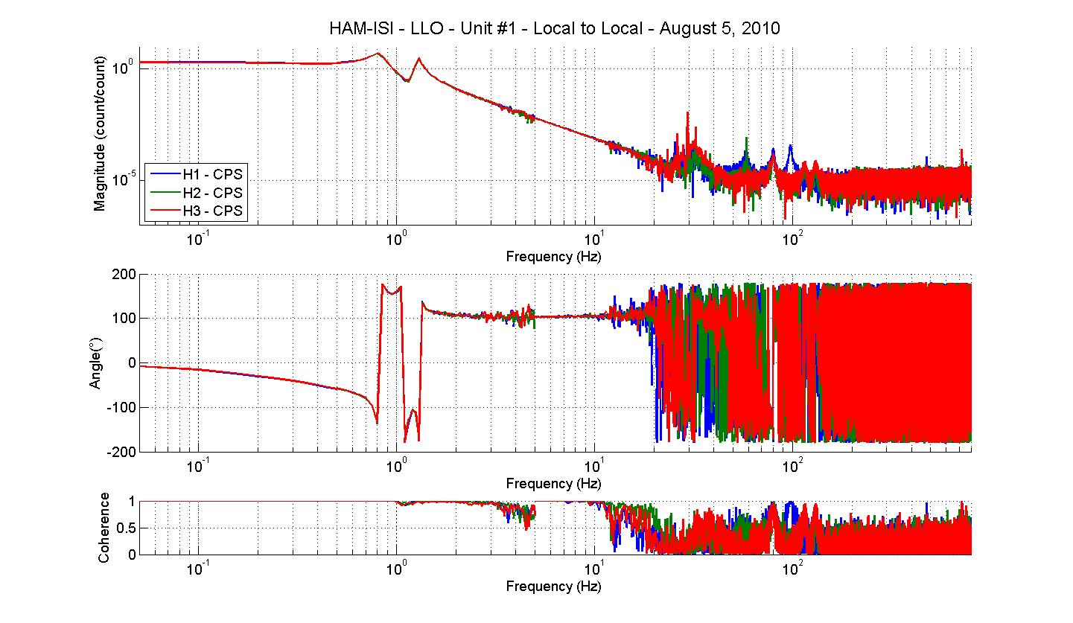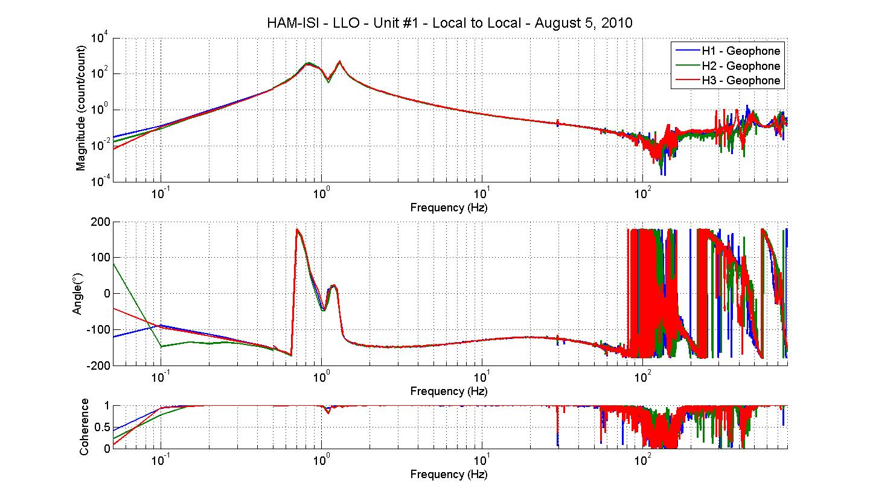
Figure - Local to Local Measurements

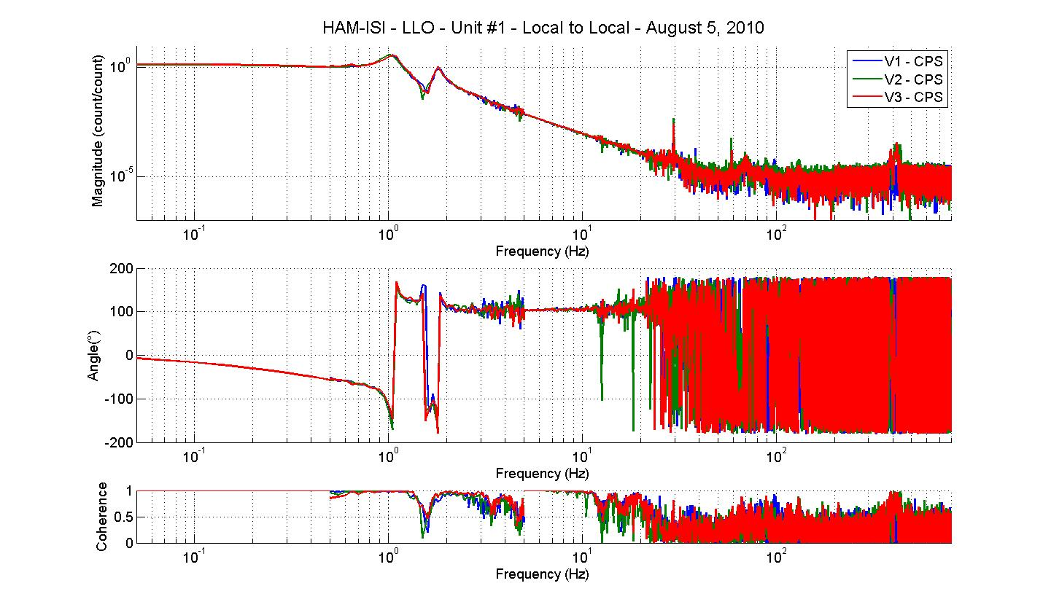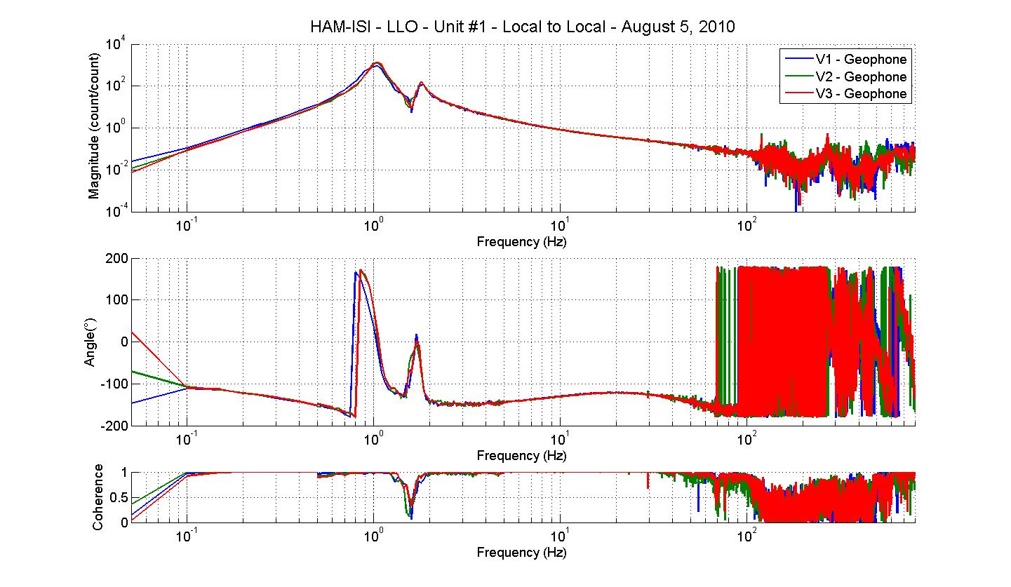
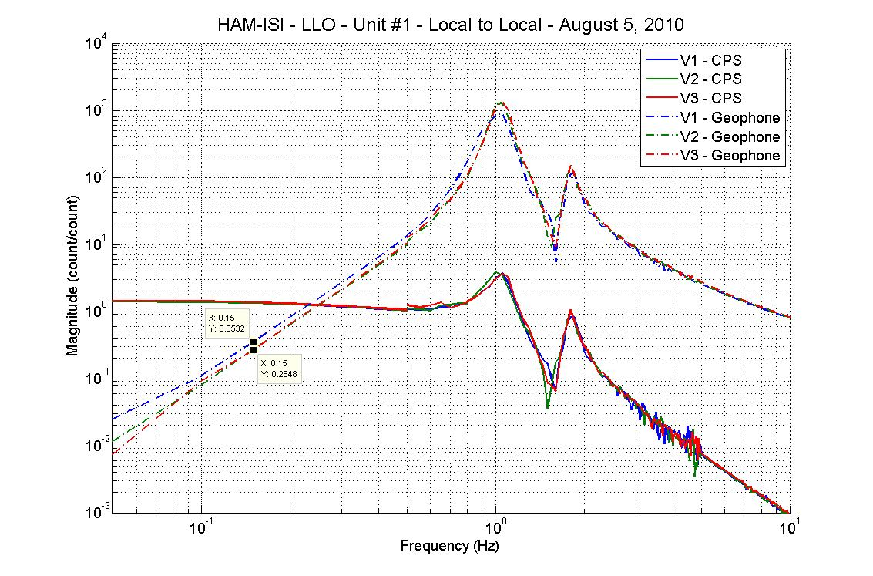
Figure - Local to Local Measurements – Vertical sensors

Issues/difficulties/comments regarding this test:
- Even with 90 repetitions, coherence falls to 0.85 at 500mHz – 800mHz (section 2) on vertical sensors (Geophones and CPS).
- Below 1 Hz, GS13 transfer function from actuator V1 to geophone V1 is higher than the other transfer functions (V2, V3) by respectively 25%. The Q at 1 Hz is also lower. These differences are not noticed on the CPS transfer functions.

Step 17.2 - Cartesian to Cartesian measurements
Cartesian to Cartesian transfer functions have been measured with 90 repetitions.
Data files in SVN at:
/svncommon/seisvn/seismic/HAM-ISI/X2/Data/Unit_1/Transfer_functions/Cartesian_to_cartesian
- Data_M2M_50mHz_500mHz_20100805-062421.mat
- Data_M2M_500mHz_5Hz_20100805-031900.mat
- Data_M2M_5_200Hz_20100805-014539.mat
- Data_M2M_200_800Hz_20100805-001218.mat

Scripts files for processing and plotting in SVN at:
/svncommon/seisvn/seismic/HAM-ISI/X2/Data/Unit_1/Transfer_functions/Cartesian_to_cartesian
- Plot_TF_cartesian_to_cartesian_2010_08_05.m

Figures in SVN at:
/svncommon/seisvn/seismic/HAMISI/X2/Data/Unit_1/Figures/Transfer_functions/ Cartesian_to_cartesian
- TF_X_Y_RZ_CPS.fig
- TF_X_Y_RZ_Geophone.fig
- TF_Z_RX_RY_CPS.fig
- TF_Z_RX_RY_Geophone.fig

Storage of measured transfer functions in the SVN at:
/svncommon/seisvn/seismic/HAM-ISI/X2/Data/Unit_1/Transfer_functions/Cartesian_to_Cartesian
- Cartesian_2_Cartesian_LLO_HAM-ISI-Unit_1_2010_08_05.mat

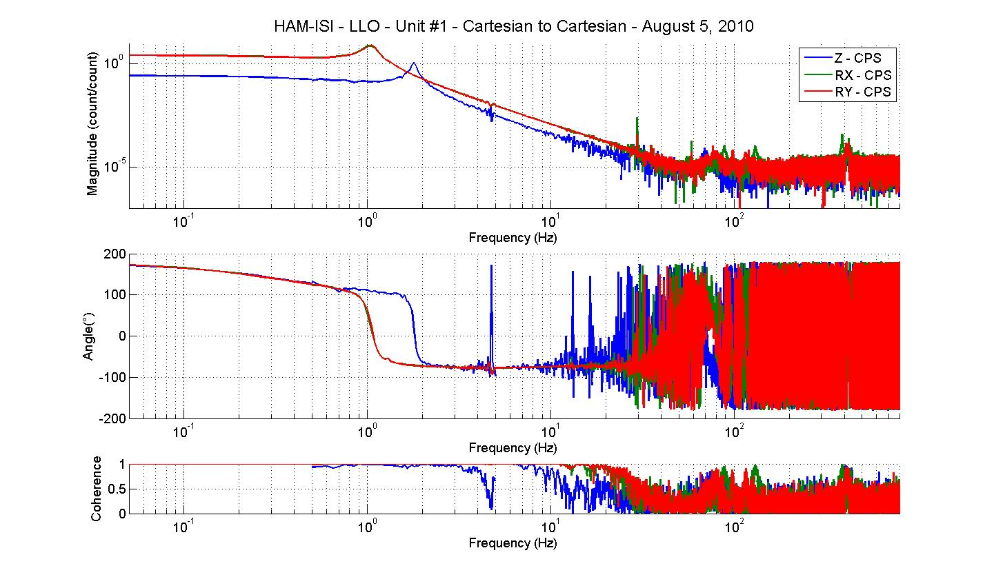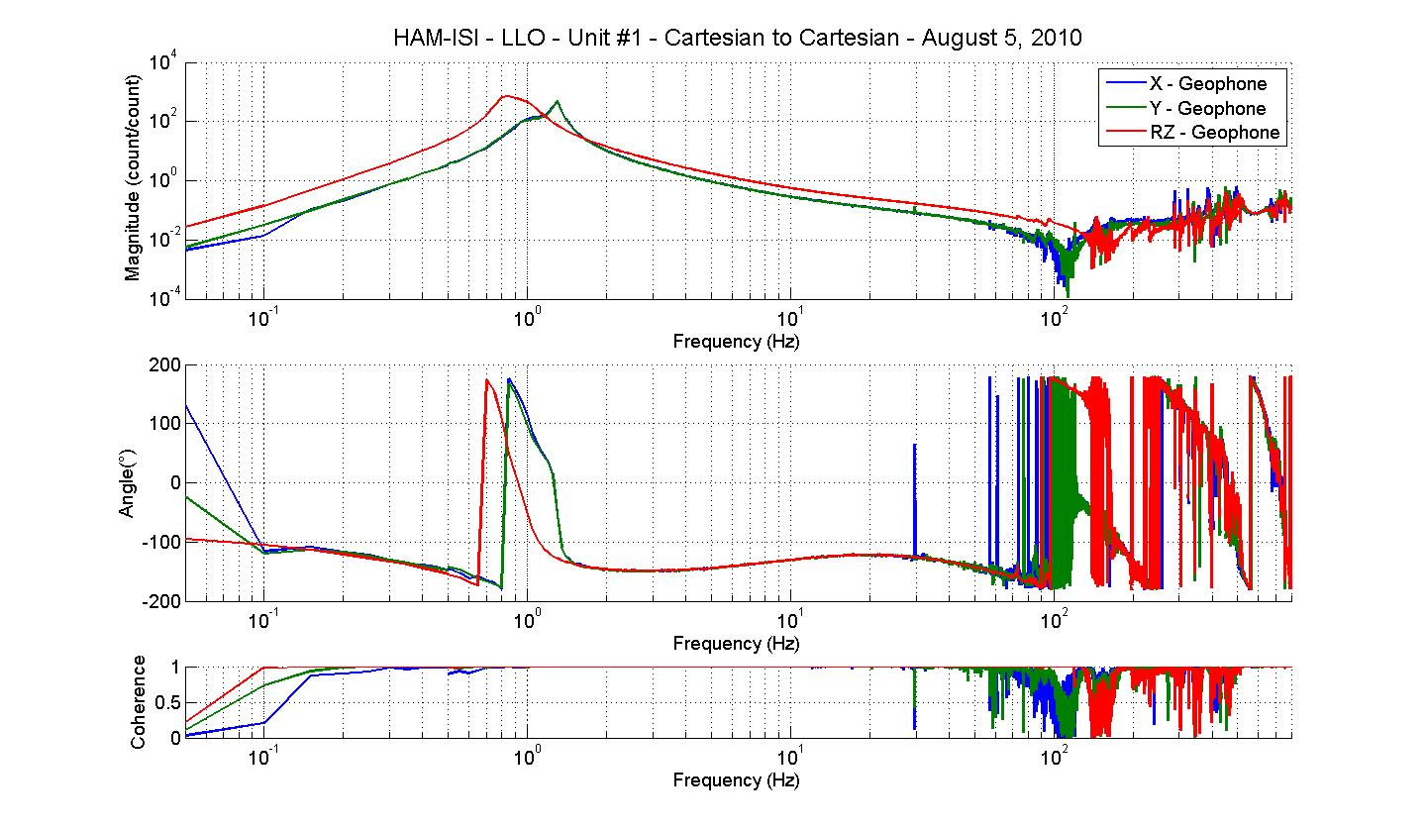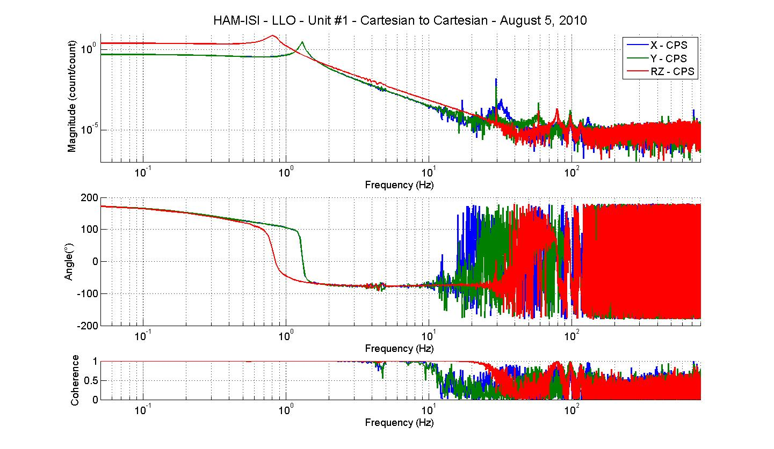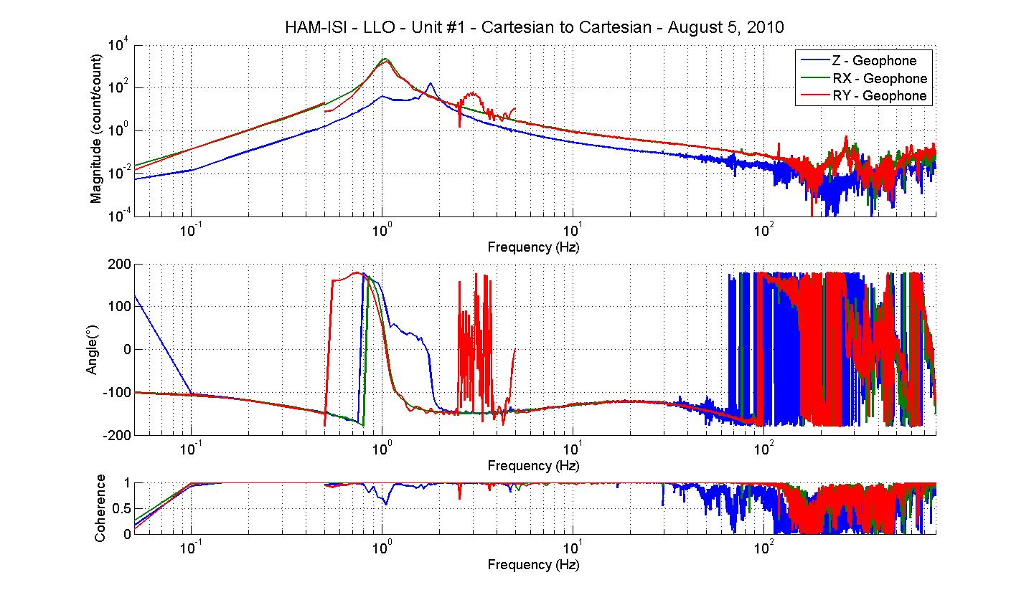
Figure - Modal to modal measurements

Issues/difficulties/comments regarding this test: During testing, we overdrove RY creating saturation in section 2 (500mHz to 5Hz). We used a wrong DISP2CEN matrix as mentioned at step 17.

Acceptance criteria:

- Local to local measurement
  - On CPS, the phase must be 0º at DC
  - On Geophones, the phase must be -90º at DC
- Modal to modal measurement
  - On CPS, the phase must be 0º at DC
  - On Geophones, the phase must be -90º at DC

Test result: Passed: Failed: .

Step 18 - Transfer function comparison

Step 18.1 - Local to local - Comparison with HAM6

Scripts files for processing and plotting in SVN at:
/svncommon/seisvn/seismic/HAM-ISI/X2/Data/Unit_1/Transfer_functions/Local_to_local
- Plot_TF_local_to_local_2010_08_05.m

Local to local figures in SVN at:
/svncommon/seisvn/seismic/HAM-ISI/X2/Data/Unit_1/Figures/Transfer_functions/Local_to_Local
- TF_H_CPS_vs_HAM6.fig
- TF_V_CPS_vs_HAM6.fig
- TF_H_Geophone_vs_HAM6.fig
- TF_V_Geophone_vs_HAM6.fig

GS13, Local to local measurement

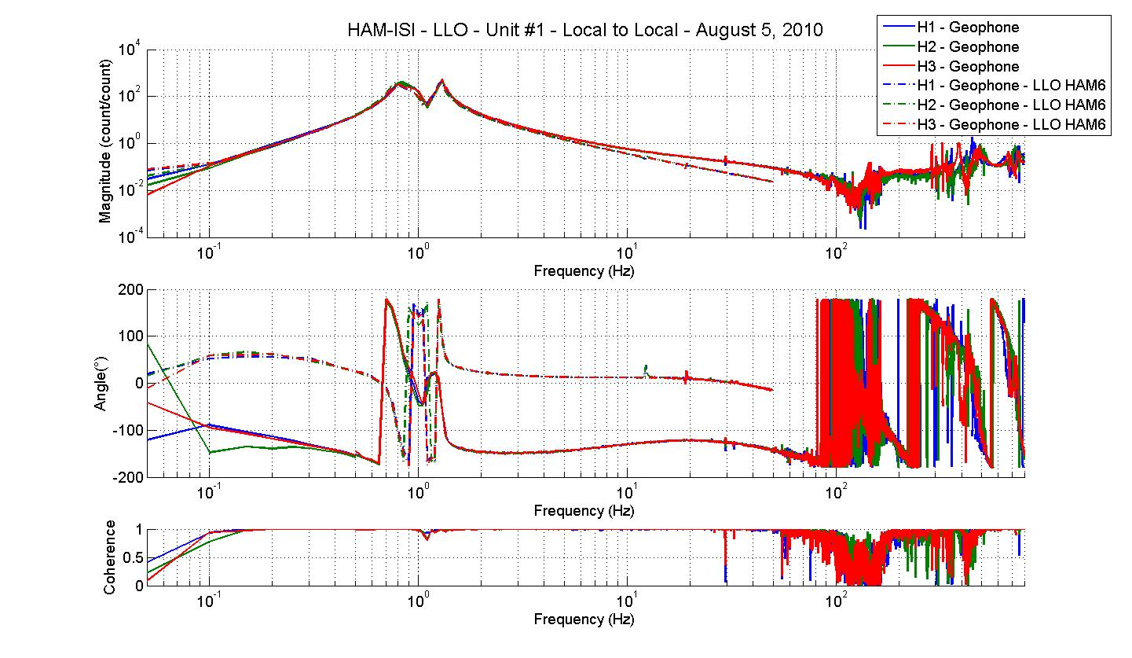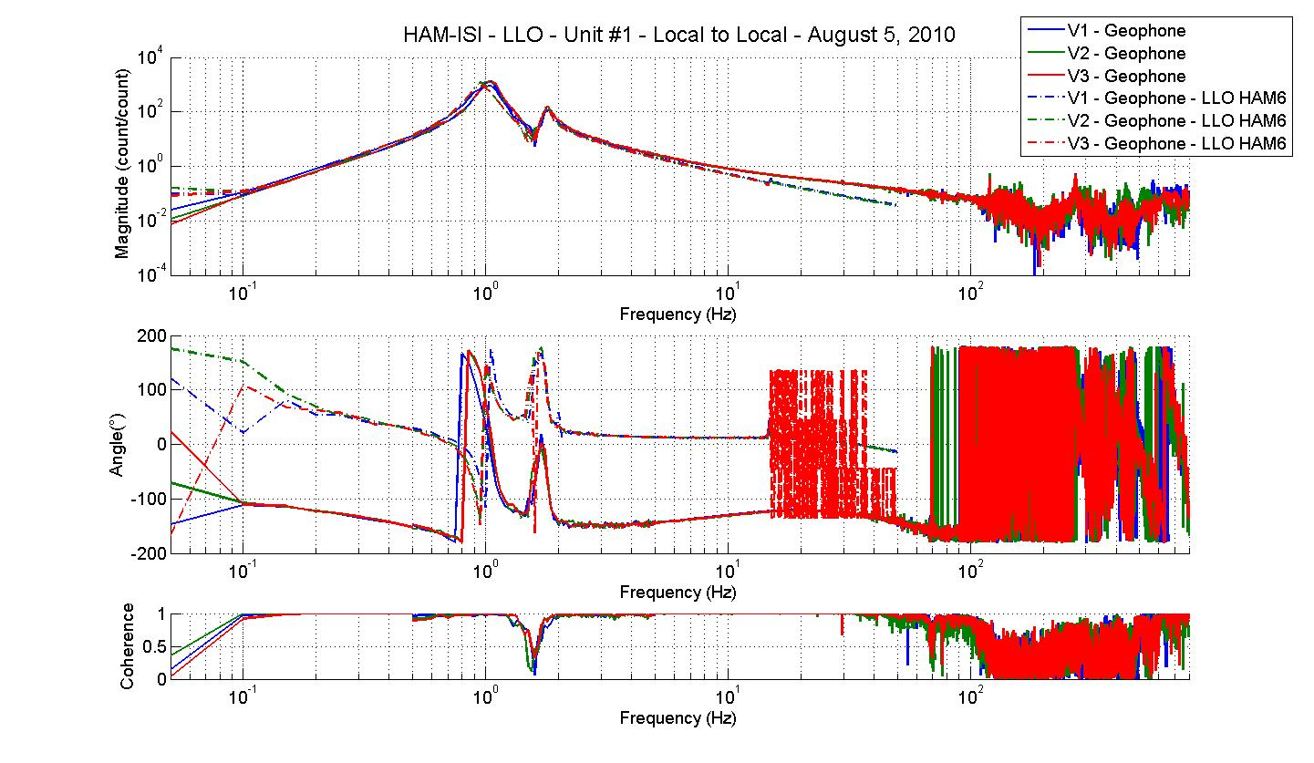
Figure - Local to local measurements comparison with HAM6 – GS13

CPS, Local to local measurement, Undamped
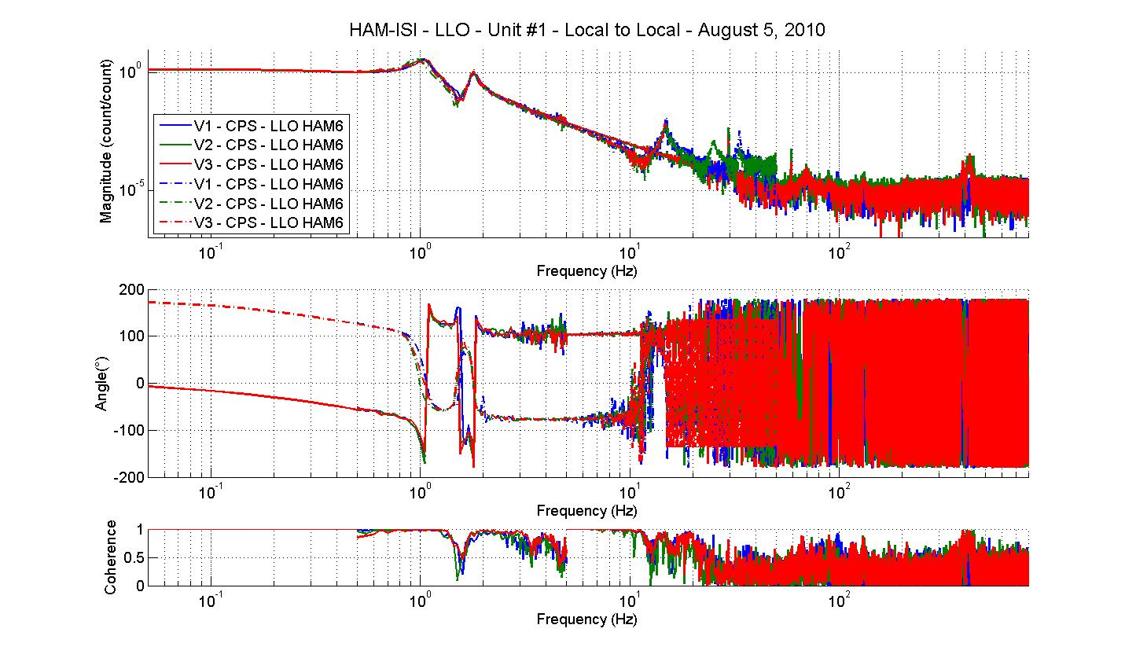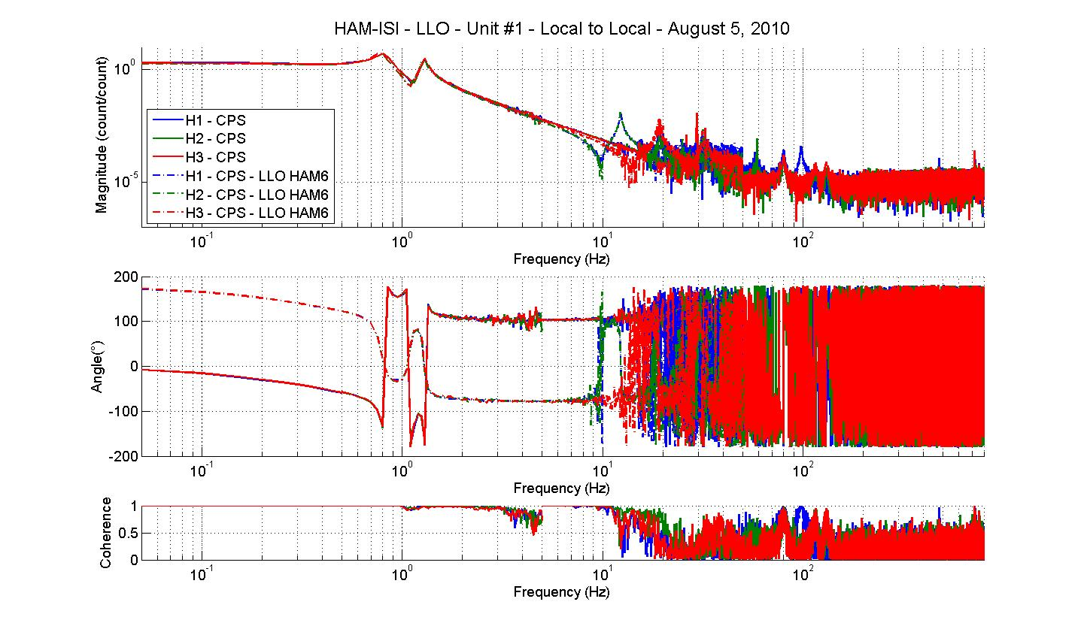
Figure - Local to local measurements comparison – Position sensors

Difference with HAM6:

- Sign difference on CPS and Geophones.
- Change of the GS13 interface chassis (1 zero at 10Hz and 1 pole at 50Hz)

Step 18.2 - Cartesian toCartesian - Comparison with HAM6
Scripts files for processing and plotting in SVN at:
/svncommon/seisvn/seismic/HAM-ISI/X2/Data/Unit_1/Transfer_functions/Cartesian_to_cartesian
- Plot_TF_cartesian_to_cartesian_2010_08_05.m
Cartesian to Cartesian figures in SVN at :
/svncommon/seisvn/seismic/HAM-ISI/X2/Data/Unit_1/Transfer_functions/Cartesian_to_cartesian
- TF_X_Y_RZ_CPS_vs_HAM6.fig
- TF_Z_RX_RY_CPS_vs_HAM6.fig
- TF_X_Y_RZ_Geophone_vs_HAM6.fig
- TF_Z_RX_RY_Geophone_vs_HAM6.fig
GS13, Cartesian to Cartesian measurement, Undamped

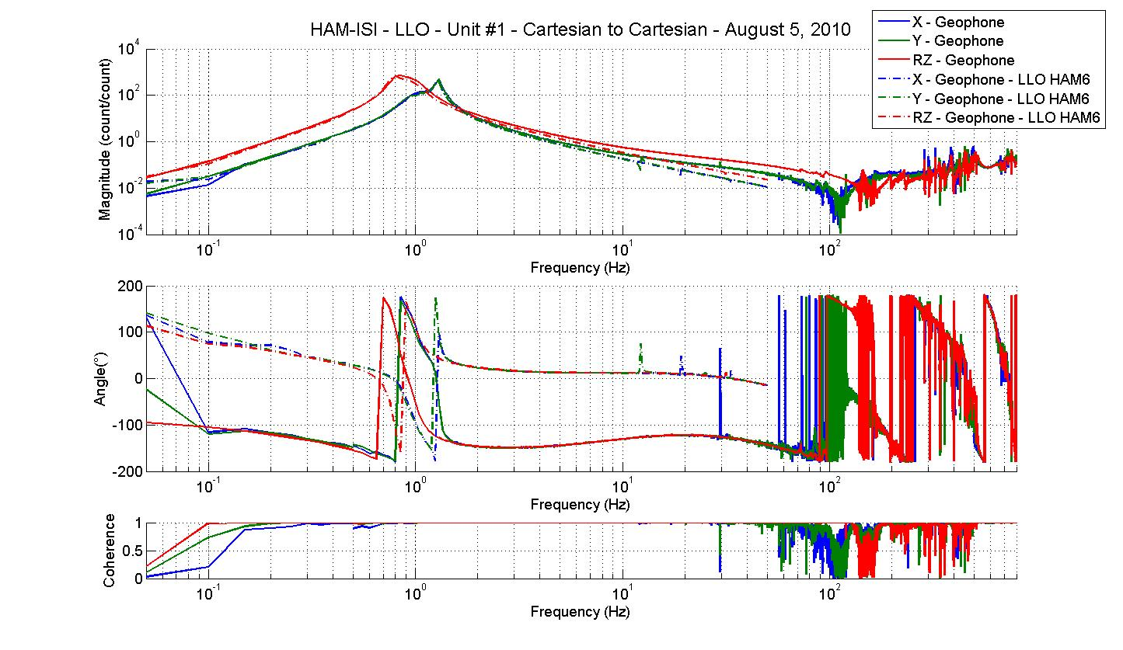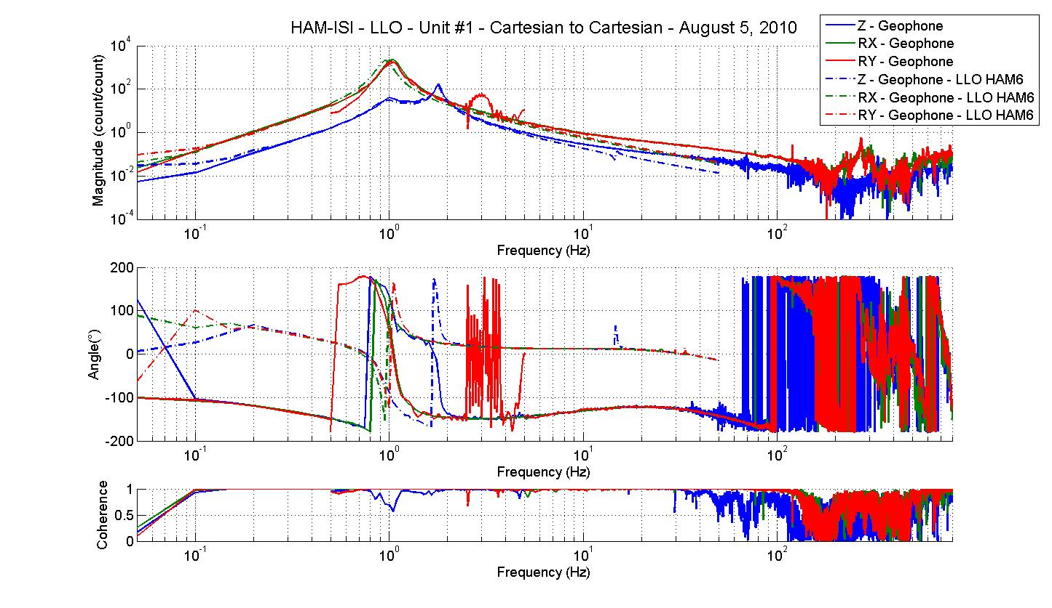
Figure - Cartesian to Cartesian measurements comparison with HAM6 – GS13

CPS, Cartesian to Cartesian measurement, Undamped

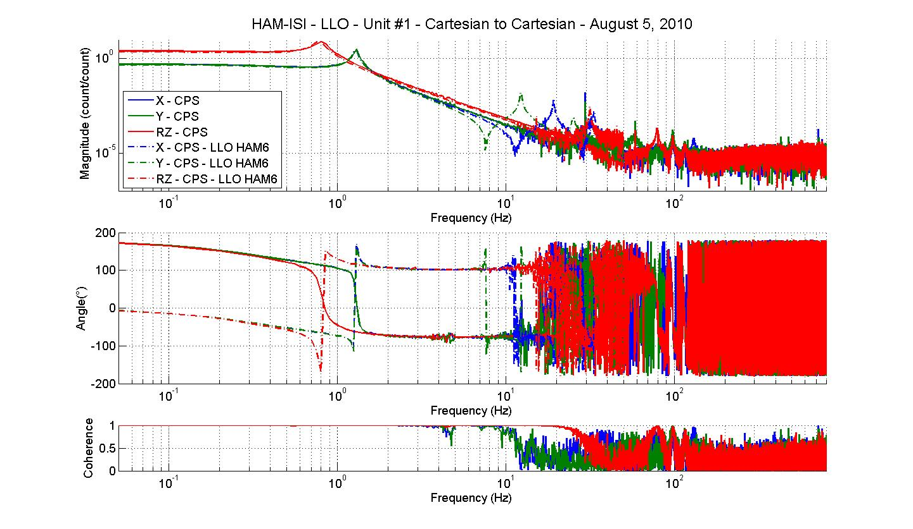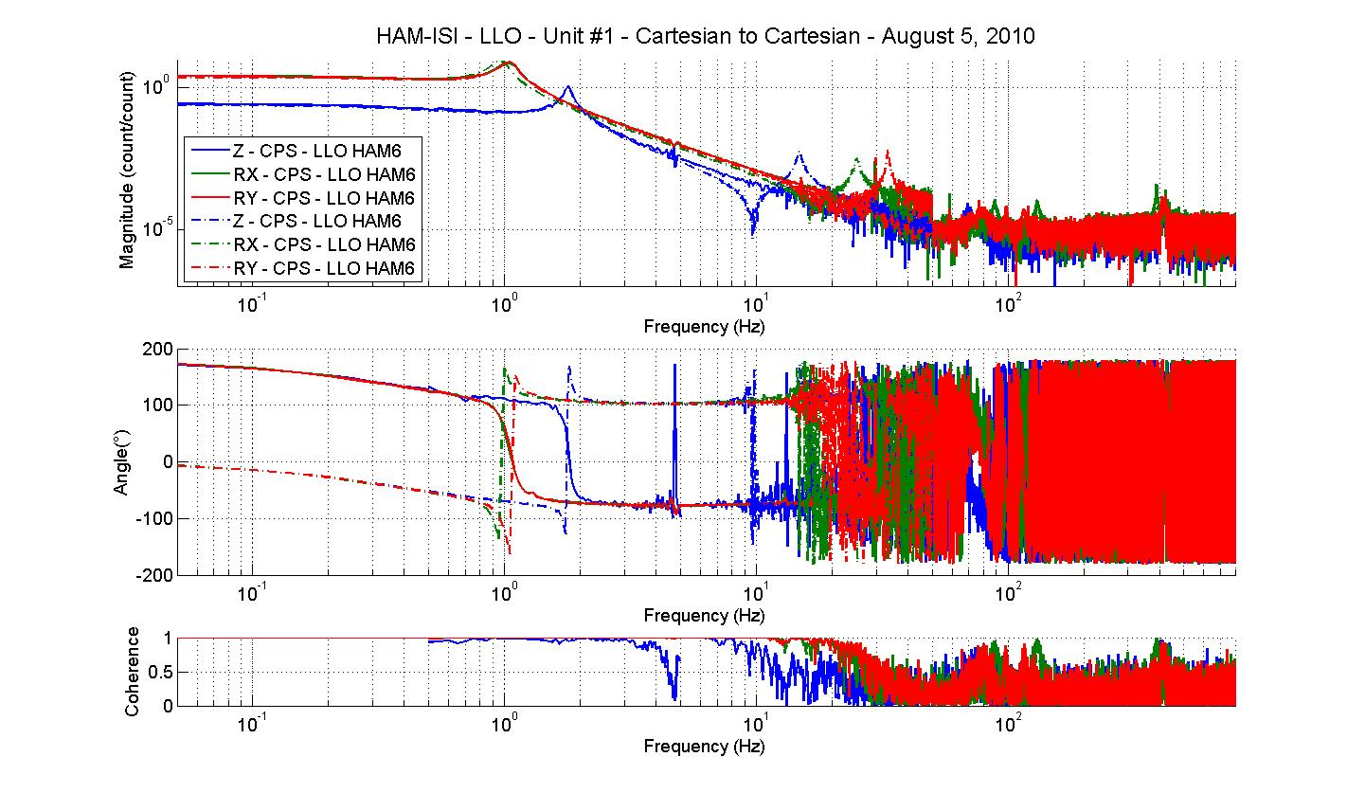
Figure - Cartesian to Cartesian measurements comparison – Position sensors

Difference with HAM6:

- Resonnance at 1 Hz (RX and RY) is slightly higher than HAM6
- Sign difference on CPS and Geophones
- Change of the GS13 interface chassis (1 zero at 10Hz and 1 pole at 50Hz)

Acceptance criteria:

- No difference with the reference transfer functions (SVN)
  - Phase – less than 10º - In Phase – Out of Phase
  - Damping (fit by eye with the reference transfer functions)
  - DC gain
  - Eigen frequencies shift less than 5%

Test result: Passed: Failed: .

Step 19 - Lower Zero Moment Plan
Data collection script files:
/svncommon/seisvn/seismic/HAM-ISI/X2/Scripts/Data_Collection
- Run_Cart2Cart_10mHz_100mHz.m
Data files in SVN at:
/svncommon/seisvn/seismic/HAM-ISI/X2/Data/Unit_1/Transfer_functions/LZMP
- Data_M2M_10mHz_100mHz_20100805-121423.mat
Scripts files for processing and plotting in SVN at:
/svncommon/seisvn/seismic/HAM-ISI/X2/Data/Unit_1/Transfer_functions/LZMP
- LZMP_2010_08_05.m
Figures in SVN at:
/svncommon/seisvn/seismic/HAM-ISI/X2/Data/Unit_1/Figures/Transfer_functions/LZMP
- LZMP.fig
X & Y offsets:
X offset (mm) | 0.16
Y offset (mm) | 0.19
Table – Offset of the Lower Zero Moment Plane
The results from two measurements are presented on the figure below:

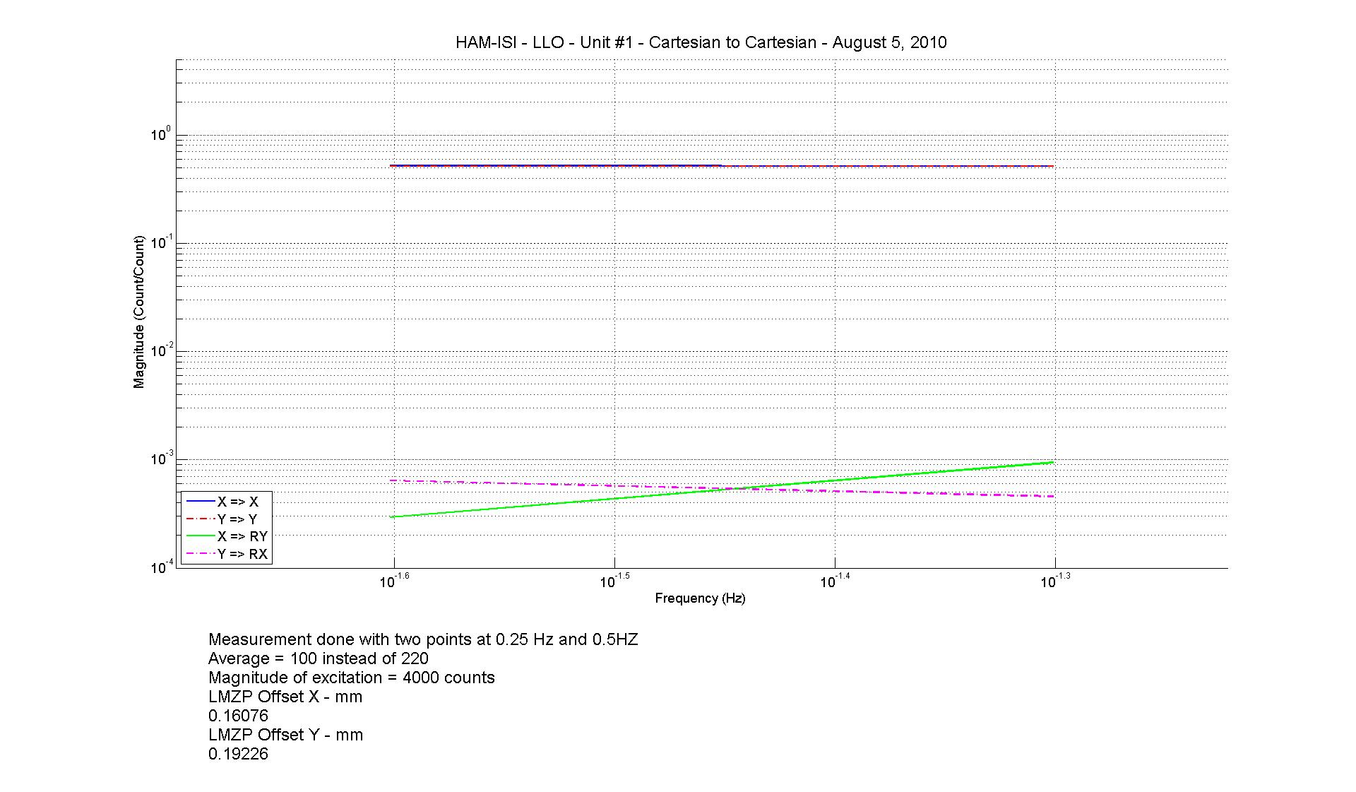
Figure - Lower Zero moment plane – Main and cross coupling at low frequency

Acceptance criteria:
- Vertical offset must be less than mm
- Horizontal offset must be less than mm

Test result: Passed: Failed: .

Step 20 - Damping loops
Filters used by Damping loops in SVN at:
/svncommon/seisvn/seismic/HAM-ISI/X2/Scripts/Damping_Loops
- G1ISIHAM_LLO_Unit_1_2010_08_10.txt (digitalized filters copied and rename to G1ISIHAM.txt in /opt/rtcds/geo/g1/chans)
Scripts files for processing and plotting in SVN at:
/svncommon/seisvn/seismic/HAM-ISI/X2/Data/Unit_1/
Damping_Loops_DTT_Powerspectrum_Transfer_functions
- HAM_ISI_LLO_unit1_Control_unlocked_no_damping_damping_100803.m
Data files in SVN at:
/svncommon/seisvn/seismic/HAM-ISI/X2/Data/Unit_1/
Damping_Loops_DTT_Powerspectrum_Transfer_functions
- Powerspectrum_table_unlocked_no_damping_damping.txt
Figures in SVN at:
/svncommon/seisvn/seismic/HAM-ISI/X2/Data/Unit_1/Figures/Damping_Loops
- Damping_LOOP_GEO_Powerspectrum.fig
- Damping_LOOP_H1_H2_H3.fig
- Damping_LOOP_V1_V2_V3.fig
- Simulation_vs_experimental_Suppression.fig

Step 20.1 - Transfer functions - Simulation
The following figures present the plant, controller, open loop, closed loop and sensitivity of vertical and horizontal damping loops. H1/V1 are plotted in solid line, H2/V2 are plotted in dash line, H3/V3 are plotted in dash-dot line.
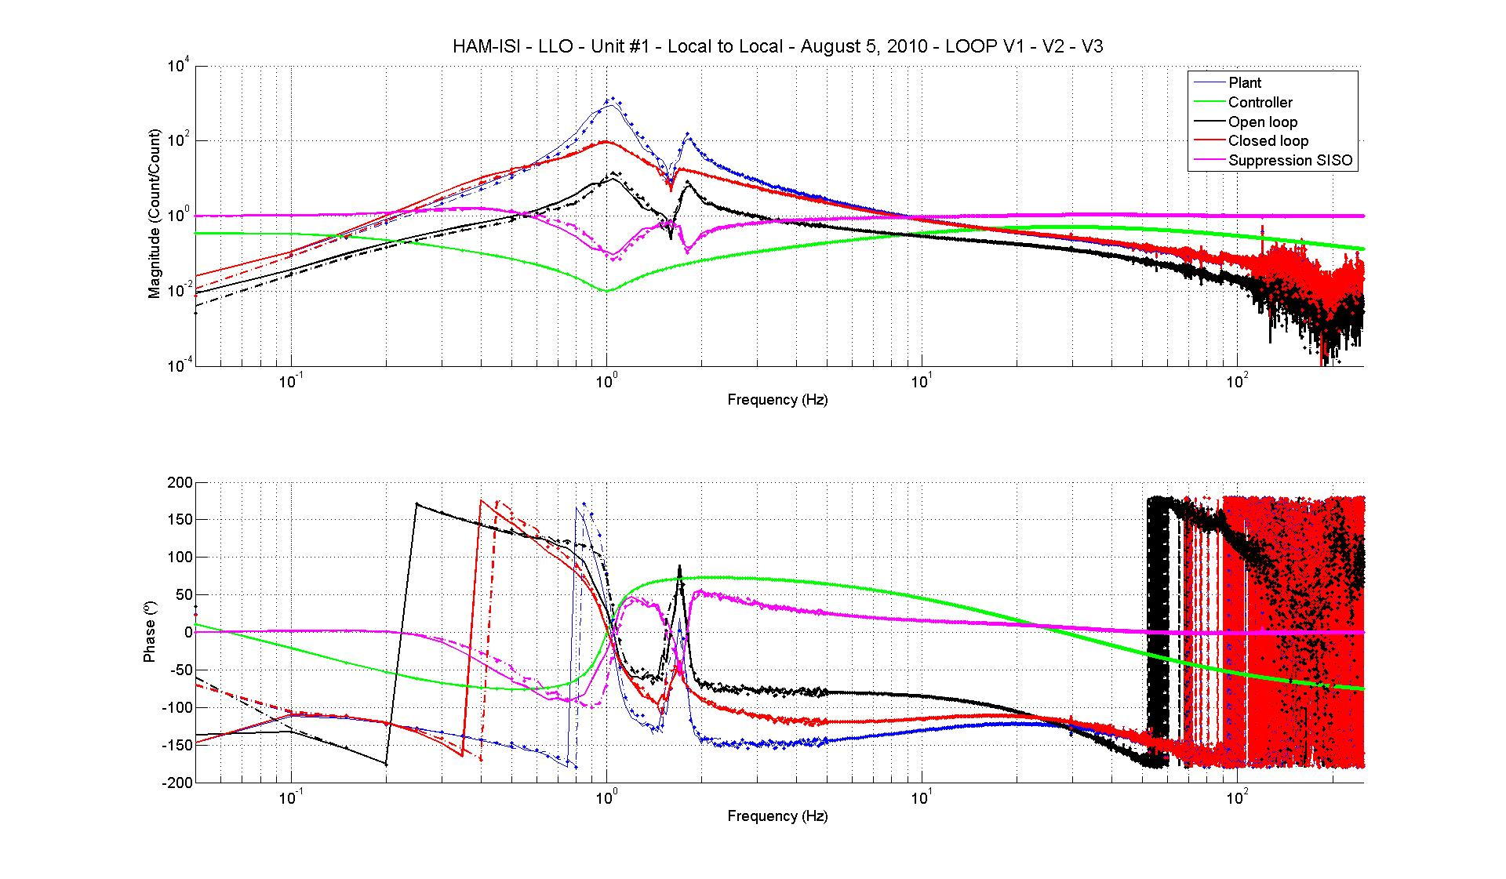
Figure - Vertical damping loops - Simulation
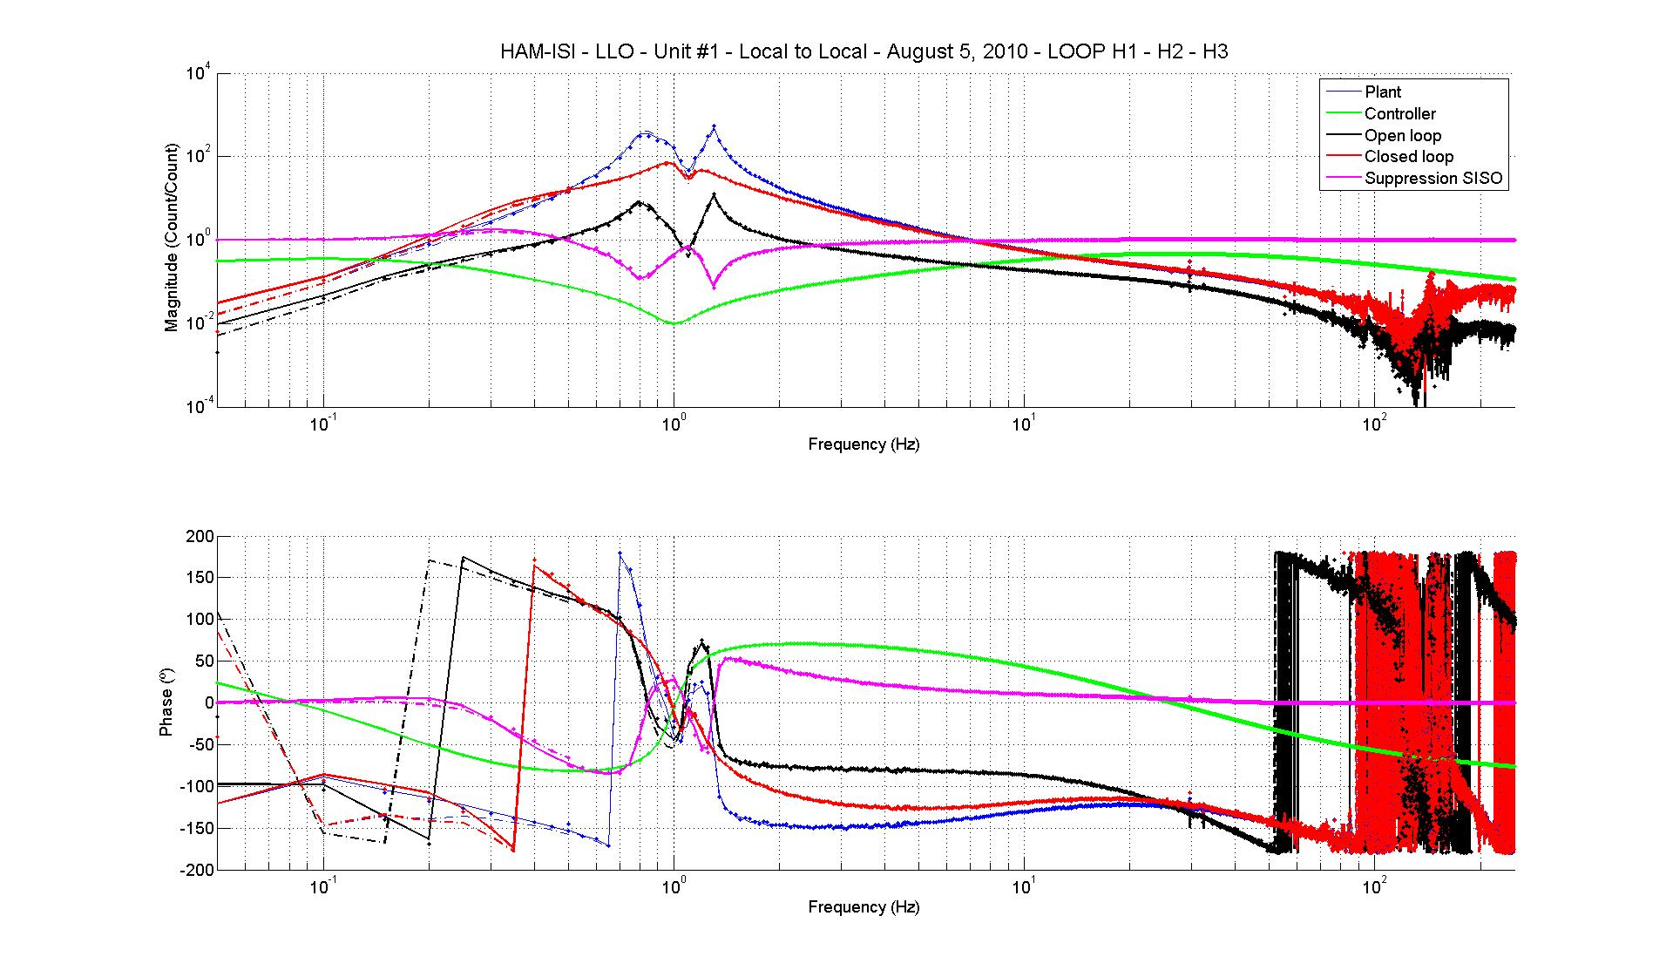
Figure – Horizontal damping loops - Simulation

Step 20.2 - Powerspectrum – Experimental
Powerspectrum:
The figure below shows power spectrum of Geophones when there when there is no damping loop and when all damping loops are engaged.

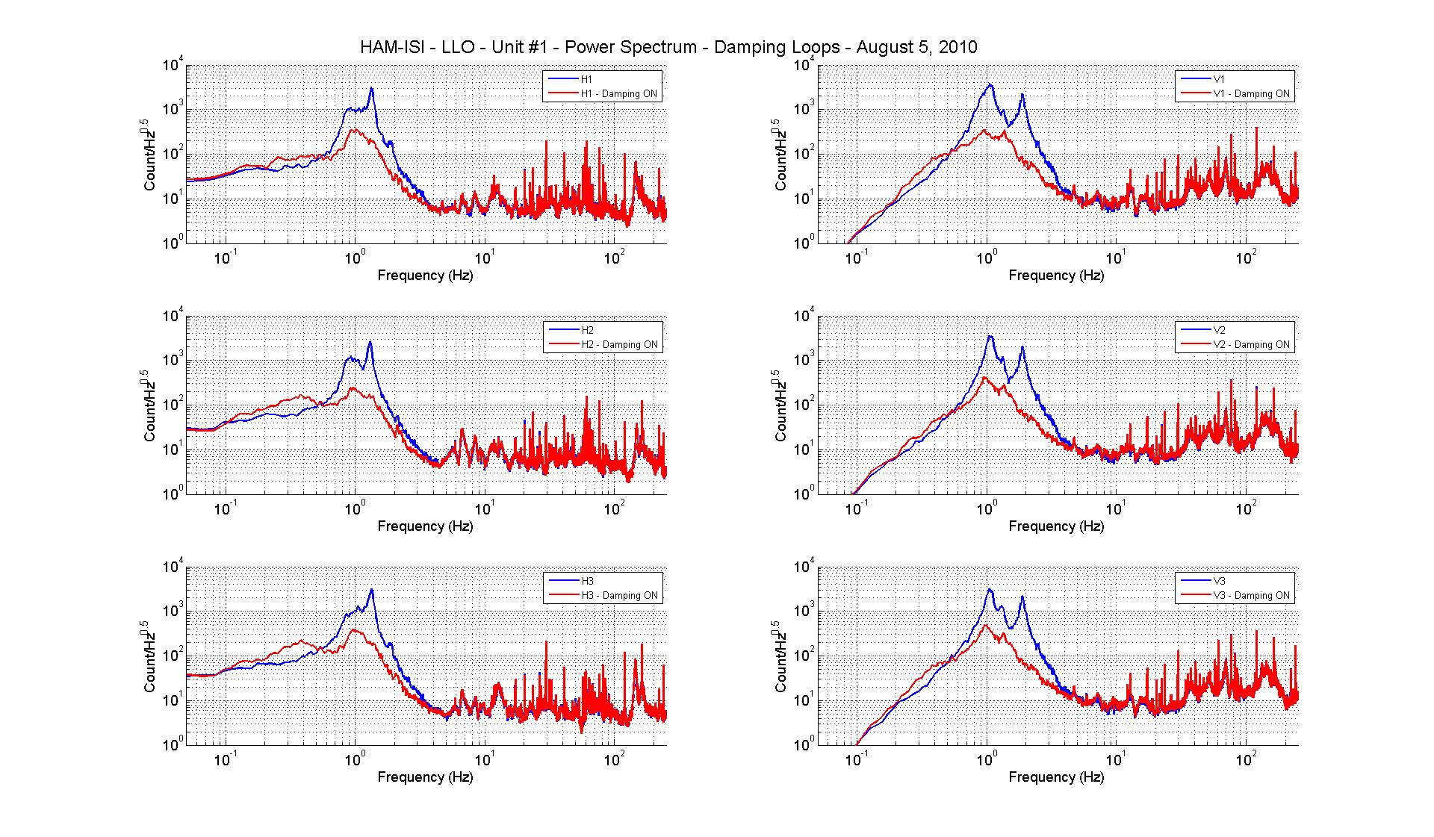
Figure – Horizontal (left) and vertical (right) damping loops - Experimental

Sensitivity:
The figure below compare the sensitivity ('Undamped/'Damped') of LLO HAM (Aug 2008) and LLO Unit 1. Performances are very similar, which confirms that we can use the damping loop as they are (modulo electronics change compensation). The plot also shows that the measured performance matches with the prediction.
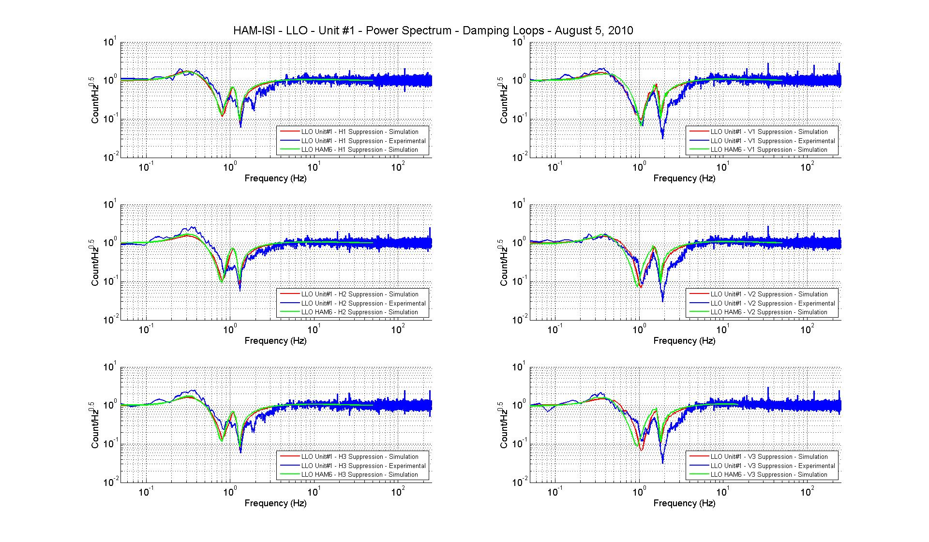
Figure - Damping loop sensitivity

Acceptance criteria:

- Ham 6 damping loop must implemented and stable with
  - Phase margin must be at least 45º
  - Gain margin must be at least 20dB

Test result: Passed: Failed: .

Testing Summary

