LIGO Laboratory / LIGO Scientific Collaboration

LIGO- E1000327 LIGO April 19th, 2011

aLIGO HAM-ISI, Pre integration Test report, Phase 1,
LLO Unit #3
E1000327 – V4

Joe Hanson, Adrien Le Roux, Michael Vargas, Céline Ramet, Vincent Lhuillier

Distribution of this document:
Advanced LIGO Project

This is an internal working note
of the LIGO Laboratory

California Institute of Technology  LIGO Project – MS 18-34  1200 E. California Blvd.  Pasadena, CA 91125  Phone (626) 395-2129  Fax (626) 304-9834  E-mail: info@ligo.caltech.edu | Massachusetts Institute of Technology  LIGO Project – NW22-295  185 Albany St  Cambridge, MA 02139  Phone (617) 253-4824  Fax (617) 253-7014  E-mail: info@ligo.mit.edu
LIGO Hanford Observatory  P.O. Box 1970  Mail Stop S9-02  Richland WA 99352  Phone 509-372-8106  Fax 509-372-8137 | LIGO Livingston Observatory  P.O. Box 940  Livingston, LA 70754  Phone 225-686-3100  Fax 225-686-7189

.
Table of contents:

Introduction 3
I. Pre-Assembly Testing 4
▪ Step 1: Position Sensors 4
▪ Step 2: GS13 5
o Step 2.1 – Horizontal GS-13s 6
o Step 2.2 – Vertical GS-13s 7
▪ Step 3: Actuators 9
II. Tests to be performed during assembly 10
▪ Step 1: Check torques on all bolts 10
▪ Step 2: Check gaps under Support Posts 10
▪ Step 3: Pitchfork/Boxwork flatness before Optical Table install 10
▪ Step 4: Blade spring profile 10
▪ Step 5: Gap checks on actuators 11
▪ Step 6: Check level of Stage 1 optical table 11
▪ Step 7: Mass budget 12
▪ Step 8: Lockers adjustment 14
III. Tests to be performed after assembly 15
▪ Step 1 - Actuators Inventory 15
▪ Step 2 - Sensors Inventory 15
▪ Step 3 - Electronics Inventory 16
▪ Step 4 - Set up sensors gap 16
▪ Step 5 - Measure the Sensor gap 17
▪ Step 6 - Check Sensor gaps after the platform release 17
▪ Step 7 - Check range of motion (hand pushing) 18
o Step 7.1 – Test Nº1 18
o Step 7.2 – Test Nº2 18
▪ Step 8 - Capacitive position sensor Power Spectrum 19
▪ Step 9 - GS13 power spectrums 20
o Step 9.1 –Table locked and unlocked (free) 20
o Step 9.2 – Table tilted 21
▪ Step 10 - Coil Driver, cabling and resistance check 23
▪ Step 11 - Actuators Sign and range of motion (Local drive) 24
o Step 11.1 - Actuators sign 24
o Step 11.2 - Range of motion - Local drive 24
▪ Step 12 - Vertical Sensor Calibration 25
▪ Step 13 - Vertical Spring Constant 26
▪ Step 14 - Static Testing (Tests in the local basis) 27
▪ Step 15 - Linearity test 28
▪ Step 16 – Static tests in the general coordinate basis 30
▪ Step 17 - Frequency response 30
o Step 17.1 - Local to local measurements 30
o Step 17.2 - Cartesian to Cartesian measurements 33
▪ Step 18 - Transfer function comparison 36
o Step 18.1 - Local to local - Comparison with HAM6 36
o Step 18.2 - Cartesian to Cartesian - Comparison with HAM6 39
▪ Step 19 - Lower Zero Moment Plane 43
▪ Step 20 - Damping loops 44
o Step 20.1 - Transfer functions - Simulation 44
o Step 20.2 - Powerspectrum – Experimental 44

Introduction

This document presents the tests performed to characterize and validate the “HAM-ISI LLO Unit #3”. This unit is the 3rd unit assembled for aLIGO at LLO.
The procedure document used to perform this test is:
- E1000309 -V5 - aLIGO HAM-ISI, Pre-Integration Testing Procedure, Phase I (post assembly, before storage)
Other useful information can be found in:
- E1000300 - HAM-ISI LLO test stand: software and electronic check

Pre-Assembly Testing

Step 1: Position Sensors

Note: The back panel reads 0.508V/0.001"

S/N sensor | S/N board | ADE Gap Standoff(mm) | Location on the Jig | Gap Standoff on Jig(mm/in) | Voltage before zeroing | Voltage after zeroing. Prebake | Voltage after zeroing. Post bake
12057 | NR | NR | NR | NR | NR | NR | NR
12026 | NR | NR | NR | NR | NR | NR | NR
12013 | NR | NR | NR | NR | NR | NR | NR
12059 | NR | NR | NR | NR | NR | NR | NR
12056 | NR | NR | NR | NR | NR | NR | NR
12083 | NR | NR | NR | NR | NR | NR | NR

NR: not recorded

Will be measured for the next units.

Sensors noise spectra measured before baking:

Figure - H1 and V1 sensor noise | 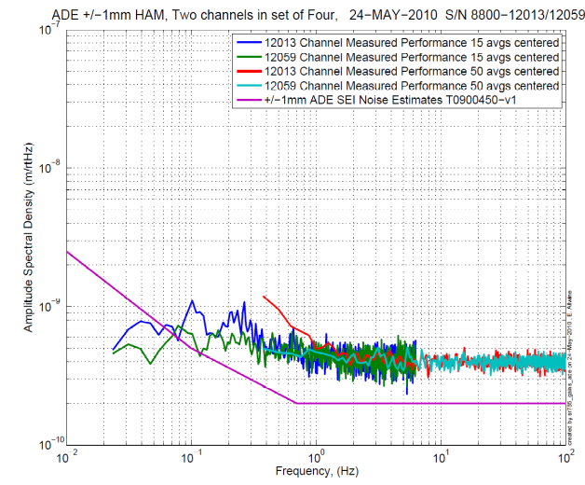  Figure - H2 and V2 sensor noise

Figure - H3 and V3 sensor noise

Acceptance Criteria:
- Power spectrum magnitudes must be lower than:
  - 9.e-10 m/√Hz at 0.1Hz
  - 6.e-10 m/√Hz at 1Hz

Issues/difficulties/comments regarding this test: Values of sensor gaps and zeroing were not recorded. Waived for this unit.
12013 (used for H2) is noisier than other sensors, still passes.

Test result: Passed: X Failed: .

Step 2: GS13

All the data related to GS-13 post podding testing can be found in the SVN at : SeismicSVN\seismic\Common\Data\aLIGO_GS13_TestData\PostMod_TestResults_PDFs.
E1000058 spreadsheet provides the status of each individual GS-13 at LLO site during aLIGO HAM assembly

Data files in SVN at:
/opt/svncommon/seisvn/seismic/Common/Data/aLIGO_GS13_TestData/PostMod_TestResults_RawASCII

Scripts files for processing and plotting in SVN at:
/opt/svncommon/seisvn/seismic/Common/MatlabTools
- gs13qatest.m

Figures in SVN at:
/opt/svncommon/seisvn/seismic/Common/Data/aLIGO_GS13_TestData/PostMod_TestResults_PDFs

Step 2.1 – Horizontal GS-13s

Huddle testing

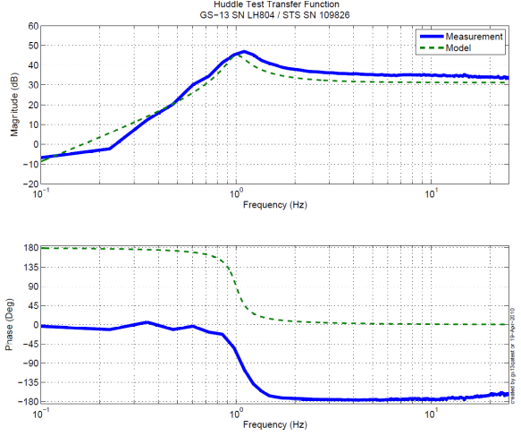

Figure - Huddle testing of Horiz GS-13 804,795, and 792 after aLIGO modifications

Step 2.2 – Vertical GS-13s

Huddle testing

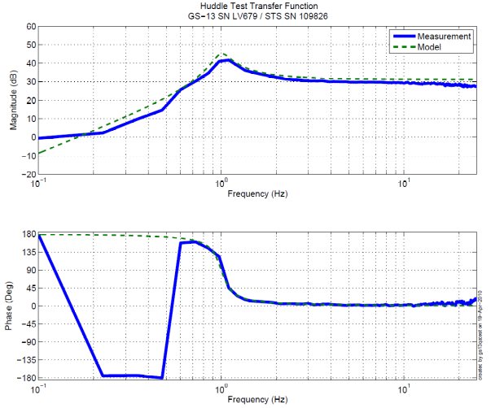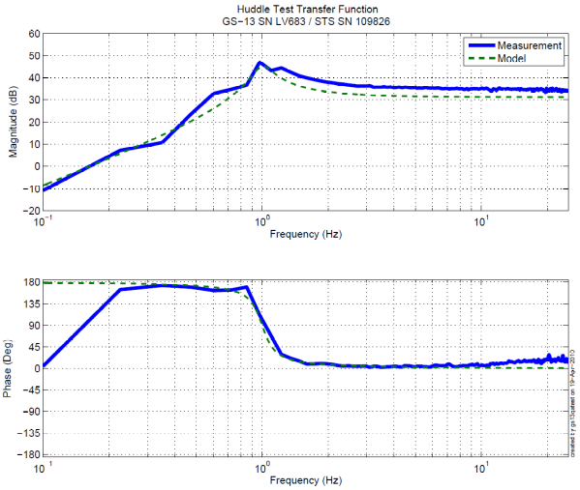
Figure - Huddle testing of Vert GS-13 679,683 and 699 after aLIGO modifications
Driven testing
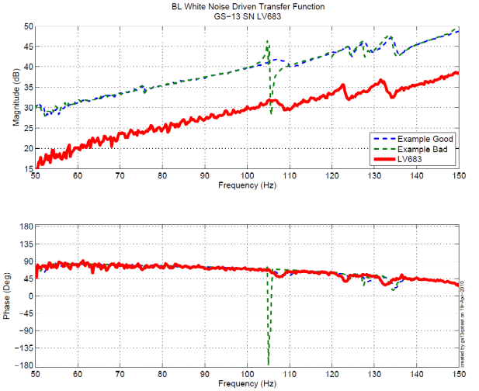
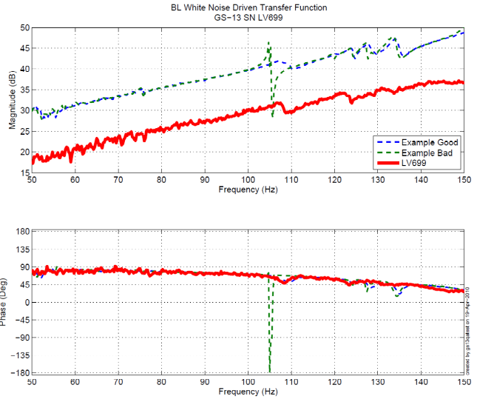
Figure - Driven Transfer Function of Vert GS-13 679,683 and 699 after aLIGO modifications

Acceptance Criteria:
- GS13 should have been already modified and tested. GS-13 Inspection/Pod Assembly (D047810). Checklist is defined in F090070-v6
- Resonant frequency at 1 Hz (huddle testing)
- No spring resonance on vertical driven tests

Test result: Passed: X Failed: .

Step 3: Actuators

Actuator data can be found at: T0900564. Actuator inventory is made at Section II – Step 1.

Actuator Serial #: L087  Operator Name: Gordon, Matt  Date: 11/22/2009 Time: 11:48 AM  Actuator Coil Resistance: 6.28 Ohms, PASS  Ambient Temperature: 71.1 F  Hi Pot Test Results: 1000 MOhms, PASS  X Travel Limit (inches): 0.526  Y Travel Limit (inches): 0.205  Z Travel Limit (inches): 0.508 | Actuator Serial #: L088  Operator Name: Gordon, Matt  Date: 11/21/2009 Time: 4:48 PM  Actuator Coil Resistance: 6.31 Ohms, PASS  Ambient Temperature: 70.0 F  Hi Pot Test Results: 1000 MOhms, PASS  X Travel Limit (inches): 0.530  Y Travel Limit (inches): 0.206  Z Travel Limit (inches): 0.506
Actuator Serial #: L096  Operator Name: Gordon, Matt  Date: 11/23/2009 Time: 3:50 PM  Actuator Coil Resistance: 6.26 Ohms, PASS  Ambient Temperature: 71.1 F  Hi Pot Test Results: 1000 MOhms, PASS  X Travel Limit (inches): 0.530  Y Travel Limit (inches): 0.206  Z Travel Limit (inches): 0.509 | Actuator Serial #: L134  Operator Name: Gordon, Matt  Date: 4/12/2010 Time: 3:25 PM  Actuator Coil Resistance: 6.34 Ohms, PASS  Ambient Temperature: 73.3 F  Hi Pot Test Results: 1000 MOhms, PASS  X Travel Limit (inches): 0.536  Y Travel Limit (inches): 0.205  Z Travel Limit (inches): 0.506
Actuator Serial #: L137  Operator Name: Gordon, Matt  Date: 4/12/2010 Time: 4:19 PM  Actuator Coil Resistance: 6.42 Ohms, PASS  Ambient Temperature: 73.3 F  Hi Pot Test Results: 1000 MOhms, PASS  X Travel Limit (inches): 0.530  Y Travel Limit (inches): 0.206  Z Travel Limit (inches): 0.501 | Actuator Serial #: L145  Operator Name: Gordon, Matt  Date: 4/13/2010 Time: 11:44 AM  Actuator Coil Resistance: 6.45 Ohms, PASS  Ambient Temperature: 73.1 F  Hi Pot Test Results: 1000 MOhms, PASS  X Travel Limit (inches): 0.526  Y Travel Limit (inches): 0.205  Z Travel Limit (inches): 0.506
Table 1 Extract of T0900564-testing at Qinetiq

Acceptance Criteria:
- Actuators were previously tested and results are reported in T900564.

Test result: Passed: X Failed: .

Tests to be performed during assembly

Step 1: Check torques on all bolts

Acceptance Criteria:
- All bolts should trip the wrench, and start moving immediately after. If any bolts in a pattern move before torque is reached, recheck after all bolts are brought to spec.

Test result: Passed: X Failed: .

Step 2: Check gaps under Support Posts

Acceptance Criteria:
- The test is passed if: a 0.001 inch shim cannot be passed freely through any connection to Stage 0 or between post and gussets. If shim can pass through, loosen all constraining bolts, and then retighten iteratively from the center of the part to the edges. Retest.

Test result: Passed: X Failed: .

Step 3: Pitchfork/Boxwork flatness before Optical Table install

Acceptance Criteria:
- Shim inserted won’t pass between parts.

Test result: Passed: X Failed: .

Step 4: Blade spring profile

Blade # | Base (") | Tip(") | Flatness (mils)
1 | .495 | .491 | +4
2 | .501 | .489 | +12
3 | .498 | .490 | +8
Table 2 - Blade profile

Acceptance Criteria
- Blades must be flat within 0.020" inches.

Test result: Passed: X Failed: .

Issues/difficulties/comments regarding this test:
Passed on first try. No adjustment necessary.

Step 5: Gap checks on actuators
Actuator | Front Gap (1/1000") | Back Gap (1/1000")
V1 | 80 | 90
V2 | 90 | 75
V3 | 95/85 | 65/80
H1 | 85
H2 | 80
H3 | 80

Acceptance Criteria
- Gaps must be within 0.010” of design (i.e. 0.090” and .070” pass, but 0.095” and 0.065” doesn’t).

Test result: Passed: Failed: X .

Step 6: Check level of Stage 1 optical table

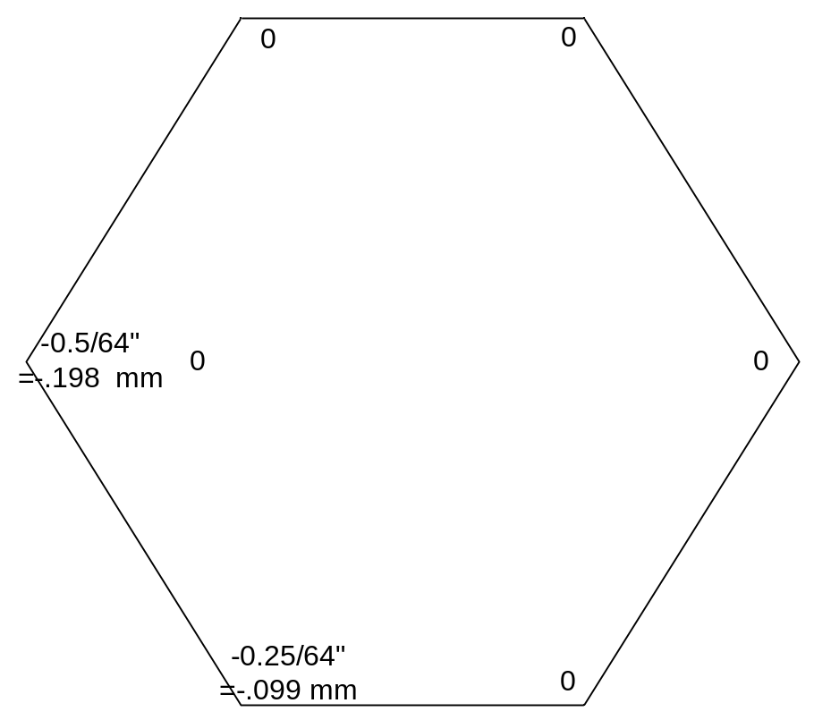

Max angle=(.5/64)/85.59= 91 urad
Acceptance Criteria 100 urad.
Test result: Passed: X Failed: .

Step 7: Mass budget
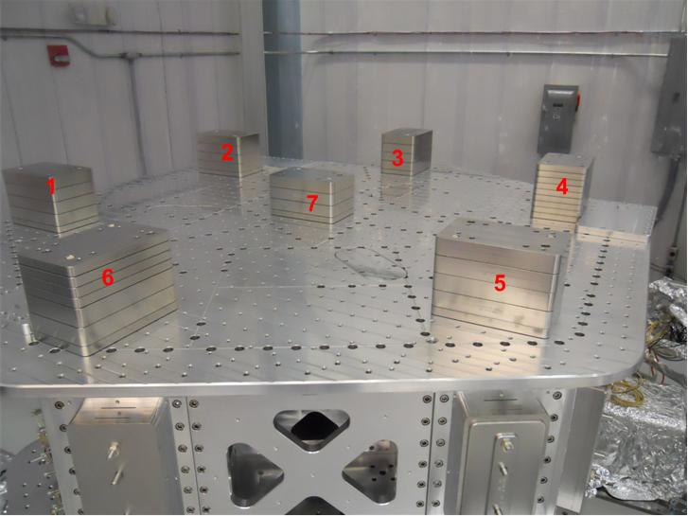
Figure - Optical table masses distribution

 | Mass (kg)
t1 | 45.00
t2 | 45.00
t3 | 45.00
t4 | 45.00
t5 | 45.00
t6 | 45.00
t7 | 35.00
total | 305.00
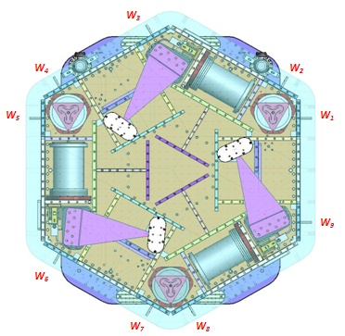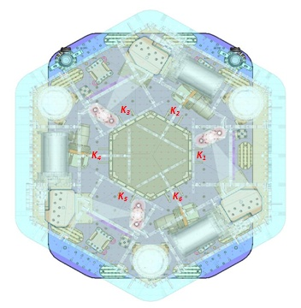
Figure – Keel Masses and Wall masses location

 | 00 | 01 | 02 | 03 | 04 | 05 | 06
 | 0.6 | 1.1 | 2.2 | 4.5 | 7.9 | 15.6 | 27.2 | lbs | kgs
w9 |  |  |  |  |  | 1 | 1 | 42.8 | 19.41
w1 | 1 |  |  |  |  | 1 | 1 | 43.4 | 19.69
w2 |  |  |  |  |  | 1 | 1 | 42.8 | 19.41
w3 |  |  |  |  |  | 1 | 1 | 42.8 | 19.41
w4 |  | 1 |  | 1 |  | 1 | 1 | 48.4 | 21.95
w5 |  | 1 |  |  |  | 1 | 1 | 43.9 | 19.91
w6 | 2 |  |  |  |  | 1 | 1 | 44 | 19.96
w7 |  |  |  |  |  | 1 | 1 | 42.8 | 19.41
w8 |  |  |  |  |  | 1 | 1 | 42.8 | 19.41
Side Masses Total | 3 | 2 | 0 | 1 | 0 | 9 | 9 | 393.7 | 178.58
Table – Wall masses distribution

 | 00 | 01 | 02 | 03 | 04 | 05 | 06
 | 0.6 | 1.1 | 2.2 | 4.5 | 7.9 | 15.6 | 27.2 | lbs | kgs
k1 |  |  |  |  | 1 |  | 1 | 35.1 | 15.92
k2 | 1 | 1 | 1 |  |  |  | 1 | 31.1 | 14.11
k3 |  |  |  |  | 1 |  | 1 | 35.1 | 15.92
k4 | 1 | 1 | 1 |  |  |  | 1 | 31.1 | 14.11
k5 |  |  |  |  | 1 |  | 1 | 35.1 | 15.92
k6 | 1 | 1 | 1 |  |  |  | 1 | 31.1 | 14.11
 | 3 | 3 | 3 | 0 | 3 | 0 | 6 | 198.6 | 90.08
Table – Keel masses distribution

Lockers | Shim thickness (mil)
A | 125
B | 125
C | 125
D | 125
Table – Shims Thickness

 | Side | Keel | Top | Total
Weigh (kg) | 178.58 | 90.08 | 305.00 | 573.66
Table - Masses distribution

Acceptance Criteria
The Mass budget must be
- 596.7Kg +/-25Kg (4%)

Test result: Passed: X Failed: .

Step 8: Lockers adjustment

D.I at Lockers | Dial indicators V | Dial indicators H
A | 0.5 | -1
B | 2 | 0
C | .25 | 0
D | -1.5 | -1.5
Table – Dial indicators read-out (in thousands of an inch)
Issues/difficulties encountered during this test :

Acceptance Criteria
- Vertical and horizontal displacement near the lockers must be lower than 2 mils

Test result: Passed: X Failed: .

Tests to be performed after assembly

Step 1 - Actuators Inventory

Actuator | Actuator S/N
H1 | L 145
H2 | L 088
H3 | L 134
V1 | L 096
V2 | L 137
V3 | L 087
Table - Actuators' inventory

Issues/difficulties/comments regarding this test:

Test result: Passed: X Failed: .

Step 2 - Sensors Inventory

Sensor | CPS S/N | ADE board serial #
H1 | 12057
H2 | 12013
H3 | 12056
V1 | 12026
V2 | 12059
V3 | 12083
Table - Capacitive position sensors' inventory

Geophones GS13 | Serial Number | POD
H1 | 792/809 | 66/46
H2 | 804 | 26
H3 | 795 | 92
V1 | 699 | 56
V2 | 679 | 2
V3 | 683 | 60
Table - Geophones' inventory (cf E1000058)

Issues/difficulties/comments regarding this test:
Vertical GS-13 are staying on this unit, whereas horizontals are gotten off to test Unit #2

Test result: Passed: X Failed: .

Step 3 - Electronics Inventory
Write down serial number of coil driver, Anti aliasing chassis, Anti image chassis and interface chassis used for this test are listed below:

Hardware | Ligo reference | S/N
Coil driver | D0902744 | S1000317
Coil driver | D0902744 | S1000316
Anti Image filter | D070081 | S1000251
Anti aliasing filter | D1000269 | S1000244
Anti aliasing filter | D1000269 | S1000245
Interface chassis | D1000067 | S1000311
Interface chassis | D1000067 | S1000312
Interface chassis | D1000067 | S1000314
Table - Inventory electronics

Issues/difficulties/comments regarding this test:
We had to change one Anti aliasing filter prior to start testing on this unit.

Test result: Passed: X Failed: .

Step 4 - Set up sensors gap
 | 10 Kg masses at each corners |  | No mass
Table locked | ADE boxes on |  | ADE boxes on
Sensors | Offset (Mean) | Std deviation | Offset (Mean) | Std deviation
H1 | -36.967 | 1.2 | -109.44 | 1.5
H2 | 254.8 | 1.1 | 243.71 | 0.8
H3 | -23.343 | 0.7 | -91.761 | 1.1
V1 | -264.62 | 0.6 | -52.461 | 1.6
V2 | -148.73 | 1.8 | 24.719 | 1.5
V3 | 196.35 | 1.4 | 296.66 | 1.2
Table - Set-up sensors gap

Issues/difficulties/comments regarding this test: HAM-ISI – LLO unit#3 uses synchronized satellite boxes

Acceptance criteria:

- All mean values must be lower than 400 cts (a bit less than .0005”).
- All standard deviations below 5 counts.

Test result: Passed: X Failed: .

Step 5 - Measure the Sensor gap

Sensors | Gap measured on the Jig | Gap measured on the table
H1 | NR | 0.080"
H2 | NR | 0.085"
H3 | NR | 0.085"
V1 | NR | 0.085"
V2 | NR | 0.085"
V3 | NR | 0.085"
Table - Sensors gap

Issues/difficulties/comments regarding this test: No information of gaps measured on the Jig. Difficult to measure without scratching the target.

Acceptance criteria:

- Change of gaps lower than 2% (reference is the gap measured on the Jig)

Test result: Passed: X Failed: .

Step 6 - Check Sensor gaps after the platform release
 | Table locked |  | Table unlocked
Sensors | Offset (Mean) | Std deviation | Offset (Mean) | Difference
H1 | -274.44 | 0.83234 | 664.2 | 938.64
H2 | -43.197 | 0.75333 | -327.25 | -284.053
H3 | 159.76 | 0.74358 | -561.14 | -720.9
V1 | -296.64 | 1.0669 | 583.93 | 880.57
V2 | 245.48 | 1.4453 | 495.1 | 249.62
`V3 | -362.15 | 1.627 | -1144.2 | -782.05
Table – Sensor gaps after platform release

Issues/difficulties/comments regarding this test:

Acceptance criteria:

- Absolute values of the difference between the unlocked and the locked table must be below:
  - 1600 cts for horizontal sensors (~0.002”)
  - 1600 cts for vertical sensors (~0.002”)
- Considering the acceptance criteria of step 4, all mean values must be lower than
  - 2000 cts for horizontal sensors (~0.0025”)
  - 2000 cts for vertical sensors (~0.0025”)

Test result: Passed: X Failed: .

Step 7 - Check range of motion (hand pushing)

Step 7.1 – Test Nº1

 | CPS read out |  | Calculated after calibration
Sensors | UP (Counts) | Down (Counts) | UP (mil) | Down (mil)
V1 | 20269 | -20331 | 24.0 | -24.1
V2 | 20234 | -20363 | 23.9 | -24.1
V3 | 19885 | -19746 | 23.5 | -23.4
 | CPS read out |  | Calculated after calibration
Sensors | CW(-RZ) | CCW (+RZ) | CW (mil) | CCW (mil)
H1 | 18281 | -22331 | 21.6 | -26.4
H2 | 24413 | -19937 | 28.9 | -23.6
H3 | 18099 | -22126 | 21.4 | -26.2

Table - Optic table range of motion

Issues/difficulties/comments regarding this test: the results indicate that all displacement sensor signals have the same sign all the way through the read chain.

Step 7.2 – Test Nº2

Displacement sensors and actuator gap check:
 | Push in positive direction | Push in negative direction | Railing | Actuator Gap Check
H1 | 20691 | -26431 |  | X
H2 | 24701 | -24100 |  | X
H3 | 25028 | -22929 |  | X
V1 | 19785 | -20422 |  | X
V2 | 31629 | -32519 |  | X
V3 | 19762 | -21787 |  | X
Table - Sensor and Actuator gap check

Acceptance criteria:
- The vertical sensor readout be positive when the optic table is pushed in the +Z direction
- The horizontal sensor readout be negative when the optic table is pushed in the +RZ direction
- Step 7.1
  - Absolutes value of all estimated motions must be higher than 16000counts (~0.020”)
- Step 7.2
  - No contact point on sensors
  - Absolute value of sensor read out must be higher than 16000counts (~0.020”)
  - No contact point on actuators

Test result: Passed: X Failed: .

Step 8 - Capacitive position sensor Power Spectrum

Data files in SVN at:
/opt/svncommon/seisvn/seismic/HAM-ISI/X2/Data/Unit_3/Powerspectra/Undamped
- LLO_HAM_ISI_Unit_3_Calibrated_PSD_CPS_GS13_Unlocked_Locked_2011-03-25.mat

Scripts files for processing and plotting in SVN at:
/opt/svncommon/seisvn/seismic/HAM-ISI/X2/Data/Unit_3/Powerspectra/Undamped
- Powerspectra_Measurement_HAM_ISI_Locked_Unlocked.m

Figures in SVN at:
/opt/svncommon/seisvn/seismic/HAM-ISI/X2/Data/Unit_3/Figures/Powerspectra/Undamped
LLO_HAM_Unit_3_Calibrated_PSD_CPS_Unlocked_Locked_2011-03-25.pdf

CPS calibration:
The CPS power spectrums are calibrated by using a sensitivity of 30.2 nm/count.
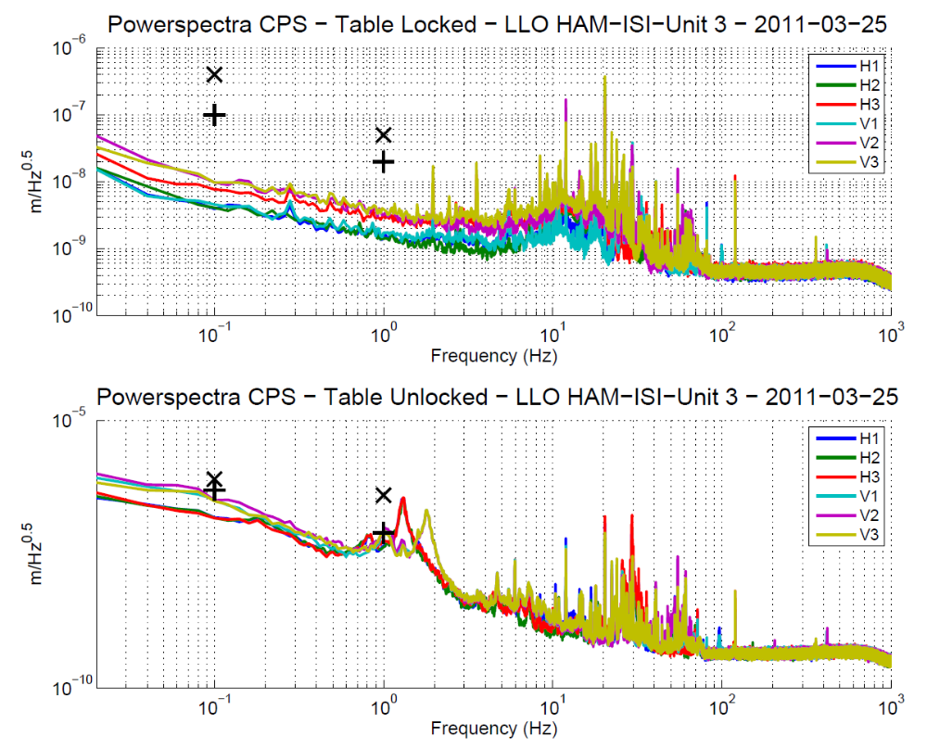
Figure - Calibrated CPS power spectrum
(+ signs are Horizontal requirements, x signs are Vertical requirements)

Acceptance criteria:
- No cross talk (peaks at low frequencies + harmonics on measurements)
- Magnitude of power spectrums must be lower than

 | Locked |  | Unlocked
 | at 0.1Hz | at 1Hz | at 0.1Hz | at 1Hz
Horizontal | 1.00E-07 | 2.00E-08 | 5.00E-07 | 8.00E-08
Vertical | 4.00E-07 | 5.00E-08 | 8.00E-07 | 4.00E-07

Test result: Passed: X Failed: .

Step 9 - GS13 power spectrums

Step 9.1 –Table locked and unlocked (free)
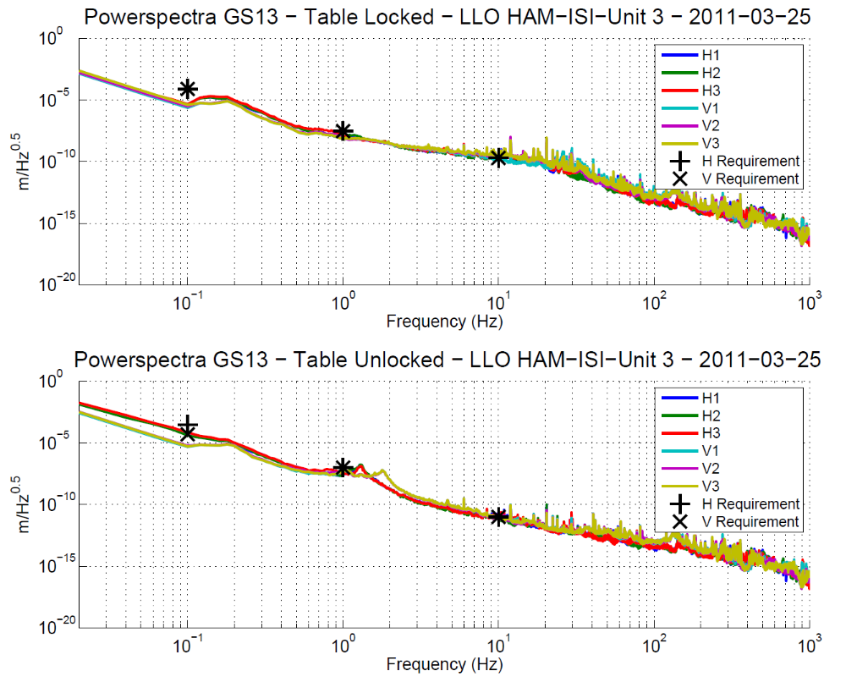
Figure – Power spectrum Calibrated GS13

Step 9.2 – Table tilted
The figure below presents the GS13 power spectrum when the table is unlocked and loaded with a 20Kg mass at one of its corner.
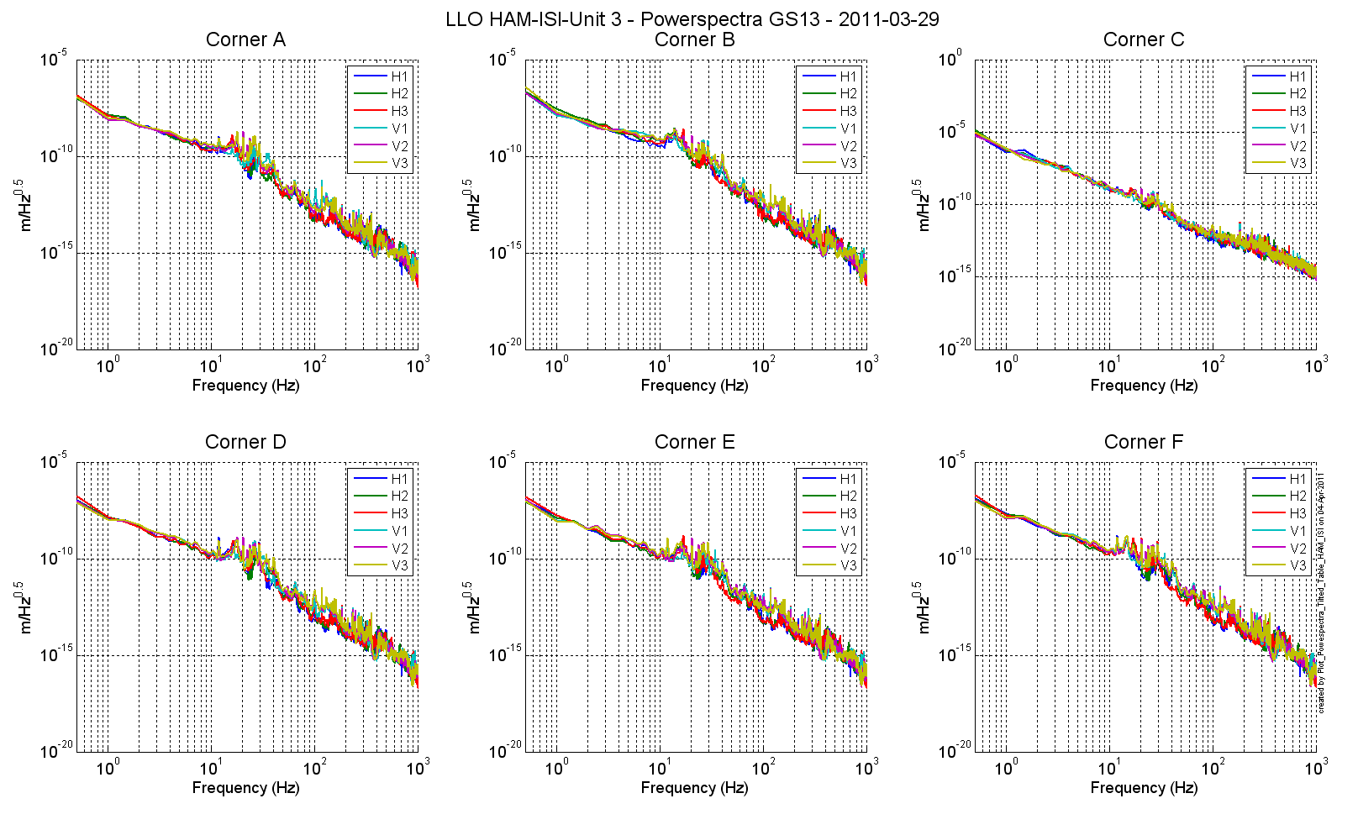
Figure – Power spectrum Calibrated GS13 with mass at corner

Data files in SVN at:
/opt/svncommon/seisvn/seismic/HAM-ISI/X2/Data/Unit_3/ Powerspectra/Undamped
- LLO_HAM_ISI_Unit_3_Calibrated_PSD_CPS_GS13_Unlocked_Locked_2011-03-25.mat
- LLO_HAM_ISI_Unit_3_Calibrated_PSD_GS13_Table_Tilted_2011-03-29.mat

Scripts files for taking and processing the data, and plotting it in SVN at:
/opt/svncommon/seisvn/seismic/HAM-ISI/X2/Scripts/Data_collection/Old_Scripts
- Powerspectra_Measurement_HAM_ISI_Locked_Unlocked.m
/opt/svncommon/seisvn/seismic/HAM-ISI/X2/Scripts/Data_collection/
- Powerspectra_Measurements_Tilted_HAM_ISI.m

Figures in SVN at:
opt/svncommon/seisvn/seismic/HAM-ISI/X2/Data/Unit_3/Figures/ Powerspectra/Undamped
- LLO_HAM_Unit_3_Calibrated_PSD_GS13_Unlocked_Locked_2011-03-25.pdf
- LLO_HAM_ISI_Unit_3_Calibrated_PSD_GS13_Table_Tilted_2011-03-29.pdf

Acceptance criteria:
- With table locked, magnitudes of power spectra must be lower than:
 | Table locked
 | at 0.1Hz | at 1Hz | at 10Hz
H & V Geophones | 8.E-05 | 3.E-08 | 2.E-10

- With table unlocked, magnitudes of power spectra must be lower than:
 | Table unlocked
 | at 0.1Hz | at 1Hz | at 10Hz
Horizontal Geophones | 3.E-04 | 1.E-07 | 1.E-11
Vertical Geophones | 5.E-05 | 1.E-07 | 1.E-11

- With table unlocked and tilted, magnitudes of power spectra must be lower than:
 | Table unlocked (tilted with masses)
 | at 0.1Hz | at 1Hz | at 10Hz
H & V Geophones | 8.E-05 | 3.E-08 | 2.E-10

Test result: Passed: X Failed: .

Step 10 - Coil Driver, cabling and resistance check
Actuator | V1 |  | H1 |  | V2
Coil driver | S1000317 - Coarse 1 |  | S1000317 - Fine 1 |  | S1000317 - Fine 2
Anti image pin #
Cable # | 28 |  | 25 |  | 30
Resistance  (Ohm) | P1 - P2 | P2 - P3 | P1 - P2 | P2 - P3 | P1 - P2 | P2 - P3
Resistance  (Ohm) | 6.3 | O.L (infinity) | 6.5 | O.L (infinity) | 6.4 | O.L (infinity)
MEDM offset  (1000 counts) | Measurement P2 (-) ; P1&P3 (+) |  | Measurement P2 (-) ; P1&P3 (+) |  | Measurement P2 (-) ; P1&P3 (+)
MEDM offset  (1000 counts) | 0.3 |  | 0.303 |  | 0.3
Actuator | H2 |  | V3 |  | H3
Coil driver | S1000317 - Coarse 2 |  | S1000316 - Coarse 1 |  | S1000316 - Fine 1
Anti image pin #
Cable # | 29 |  | 26 |  | 27
Resistance  (Ohm) | P1 - P2 | P2 - P3 | P1 - P2 | P2 - P3 | P1 - P2 | P2 - P3
Resistance  (Ohm) | 6.4 | O.L (infinity) | 6.4 | O.L (infinity) | 6.3 | O.L (infinity)
MEDM offset  (1000 counts) | Measurement P2 (-) ; P1&P3 (+) |  | Measurement P2 (-) ; P1&P3 (+) |  | Measurement P2 (-) ; P1&P3 (+)
MEDM offset  (1000 counts) | 0.303 |  | 0.296 |  | 0.298

Table - Actuators resistance check

Issues/difficulties/comments regarding this test:

Acceptance criteria:

- The measured resistance between the middle pin and one side pin must be 6.5 +/-1 ohms
- Actuator neutral pins must be connected on pin #1 (left side pin of the plug)
- Actuator drive pins must be connected on pin #2 (middle pin of the plug)
- Actuator ground shield pins must be connected on pin #3 (right pin of the plug)
- All LEDs on the coil driver front panel must be green

Test result: Passed: X Failed: .

Step 11 - Actuators Sign and range of motion (Local drive)

Step 11.1 - Actuators sign

Acceptance criteria: A positive offset drive on one actuator must give positive sensor readout on the collocated sensor. Signs will also be tested when measuring local to local transfer functions.

Test result: Passed: X Failed: .

Step 11.2 - Range of motion - Local drive
 | Positive and negative offset Drive(+/-30000 counts)
 | V1 | V2 | V3 | H1 | H2 | H3
V1 readout (counts) | -24840 |  |  | X | X | X
V1 readout (counts) | 23704 |  |  | X | X | X
V2 readout (counts) |  | -23504 |  | X | X | X
V2 readout (counts) |  | 24473 |  | X | X | X
V3 readout (counts) |  |  | -25079 | X | X | X
V3 readout (counts) |  |  | 24232 | X | X | X
H1 readout (counts) | X | X | X | -19988
 |  |  |  | 19535
H2 readout (counts) | X | X | X |  | -25296
 |  |  |  |  | 27191
H3 readout (counts) | X | X | X |  |  | -22424
 |  |  |  |  |  | 21599

Table - Range of motion - Local drive

Data files in SVN at:
/opt/svncommon/seisvn/seismic/HAM-ISI/X2/Data/Unit_3/Static_Tests
- LLO_HAM-ISI_Unit_3_Range_Of_Motion_20110329.mat

Scripts files for taking and processing the data, and plotting it in SVN at:
/opt/svncommon/seisvn/seismic/HAM-ISI/X2/Scripts/Data_collection
- Range_Motion_HAM_ISI.m

Issues/difficulties/comments regarding this test:
Acceptance criteria:
- Main couplings read out must be at least +/-16000 counts (~0.020”)
- Signs of actuators drive and sensors read out have to be the same

Test result: Passed: X Failed: .

Step 12 - Vertical Sensor Calibration
Lockers | D.I readout for  a negative drive | D.I readout without any drive | D.I readout for positive drive
A | 19 | 0 | -19
B | 19.25 | 0 | -19
C | 18.5 | 0 | -19
D | 19 | 0 | -19
Average | 18.9375 | 0 | -19 | -37.9
Sensors | Counts | Counts | Counts | Difference (Counts)
V1 | -15407 | 703 | 16730 | -32137
V2 | -15595 | 551 | 16437 | -32032
V3 | -17675 | -1772 | 14357 | -32032
 |  |  | Average | -32067
Table - Calibration of capacitive position sensors

Vertical sensitivity: 32067/37.91 = 845.3 count/mil
or 845.3 count/mil * 1/1638 V/count = 0.516V/mil
or 25400nm/mil * 1/845.3 mil/count = 30.05 nm/count

Difference with Nominal sensitivity = (845.3-840)/840=-0.63%

Issues/difficulties/comments regarding this test:

Acceptance criteria: Deviation from nominal value < 2%. Nominal value is 840 count/mil.

Test result: Passed: X Failed: .

Step 13 - Vertical Spring Constant
Sensors | Mean diff counts | Mean diff m | K (N/m)
V1 | 7370 | 2.23E-04 | 8.81E+04
V2 | 7538 | 2.28E-04 | 8.62E+04
V3 | 8553 | 2.58E-04 | 7.60E+04
 |  | Average (N/m) | 2.50E+05
Table - Vertical spring constant

The measured vertical stiffness is 2.503e5N/m. The nominal vertical spring constant is 2.428e5N/m. The measured error on the vertical stiffness is 3.10%.

Issues/difficulties/comments regarding this test:

Acceptance criteria:

- Spring constant is within +10% -1% of 2.428e5 N/m (HPD FEA Results).

Test result: Passed: X Failed: .

Step 14 - Static Testing (Tests in the local basis)

 |  | H1 | H2 | H3 | V1 | V2 | V3
Actuators  (1000 counts) | H1 | 1967.669 | 1210.834 | 1224.792 | -3.392 | 12.744 | -33.92
Actuators  (1000 counts) | H2 | 1207.9290 | 2017.293 | 1256.419 | 11.939 | 21.785 | -21.05
Actuators  (1000 counts) | H3 | 1224.299 | 1259.544 | 2015.90 | 37.030 | 16.072 | -30.849
Actuators  (1000 counts) | V1 | 201.7530 | 172.320 | -313.735 | 1415.569 | -43.636 | -546.33
Actuators  (1000 counts) | V2 | -276.287 | 261.940 | 230.952 | -554.369 | 1437.609 | -44.9600
Actuators  (1000 counts) | V3 | 159.632 | -385.887 | 142.389 | 44.354 | -612.036 | 1403.714

Table - Main and cross coupling
Data files in SVN at:
/opt/svncommon/seisvn/seismic/HAM-ISI/X2/Data/Unit_3/Static_Tests
- LLO_HAM_ISI_Unit_3_Sensor_Readout_Local_20110331.mat

Scripts files for taking data in SVN at:
/opt/svncommon/seisvn/seismic/HAM-ISI/X2/Scripts/Data_Collection
- Sensor_Readout_Local_Drive_MEDM_HAM_ISI.m

Issues/difficulties/comments regarding this test:

Acceptance criteria:
- Vertical
For a +1000 count offset drive on vertical actuators
  - Collocated sensors must be 1400 counts +/- 10%
- Horizontal
For a +1000 count offset drive on horizontal actuators
  - Collocated sensors must be 2000 counts +/- 10%
  - Non-collocated horizontal sensors must be 1250 counts +/-10%

Test result: Passed: X Failed: .

Step 15 - Linearity test

 | Slope | Offset | Average slope | Variation from  average(%)
H1 | 2.077 | 127.6 | 2.0845 | -0.37
H2 | 2.102 | -763 | 2.0845 | 0.83
H3 | 2.075 | -711 | 2.0845 | -0.46
V1 | 1.498 | -282 | 1.4872 | 0.74
V2 | 1.479 | 368.3 | 1.4872 | -0.53
V3 | 1.484 | -1024 | 1.4872 | -0.20
Table - Slopes and offset of the triplet Actuators - HAM-ISI - Sensors

Scripts files for taking data in SVN at:
/opt/svncommon/seisvn/seismic/HAM-ISI/X2/Scripts/Data_Collection
- Linearity_Test_Awgstream_HAM_ISI.m

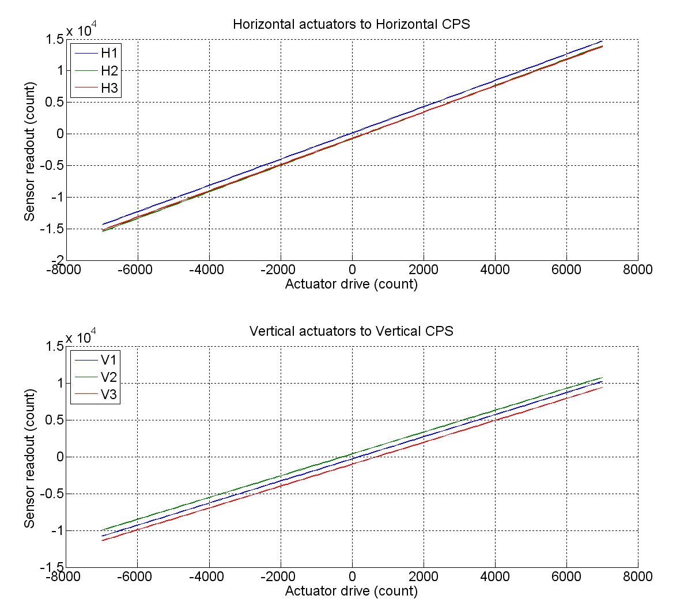
Figure - Horizontal and vertical actuators x HAM-ISI x sensors

Data files in SVN at:
/opt/svncommon/seisvn/seismic/HAM-ISI/X2/Data/Unit_3/Linearity_test
- LLO_HAM_ISI_Unit_3_Linearity_test_20110407.mat

Figures in SVN at:
/opt/svncommon/seisvn/seismic/HAM-ISI/X2/Data/Unit_3/Figures/Linearity_test
- LLO_HAM_ISI_Unit_3_Linearity_test_20110407.fig
LLO_HAM_ISI_Unit_3_Linearity_test_20110407.pdf

Issues/difficulties/comments regarding this test:

Acceptance criteria:

- Horizontal and vertical slopes of the triplet actuators x HAM-ISI x sensors: Average slope +/- 3%.

Test result: Passed: X Failed: .

Step 16 – Static tests in the general coordinate basis
 | 1000 counts drive | X Drive | Y Drive | Z Drive | Rx Drive | Ry Drive | Rz Drive
Sensors readout  (count) | H1 | 263.528 | -390.4432 | 39.232 | -351.599 | -234.314 | -1870.593
Sensors readout  (count) | H2 | 232.73 | 510.05 | 51.46 | 511.84 | -214.09 | -1926.44
Sensors readout  (count) | H3 | -492.32 | 23.53 | 10.56 | 70.06 | 532.44 | -1901.82
Sensors readout  (count) | V1 | -5.871 | 6.292 | 248.899 | -510.236 | -1619.426 | 11.019
Sensors readout  (count) | V2 | -21.28 | -33.566 | 239.421 | 1633.514 | 398.43 | -57.855
Sensors readout  (count) | V3 | 2.8 | -18.2 | 270.36 | -1169.8 | 1208.911 | 29.8
Sensors readout  (count) | Direction read out | 492.38 | 524.71 | 256.965 | 2516.66 | 2506.73 | 2404.763
Table - Tests in the general coordinate basis

Issues/difficulties/comments regarding this test:

Acceptance criteria:
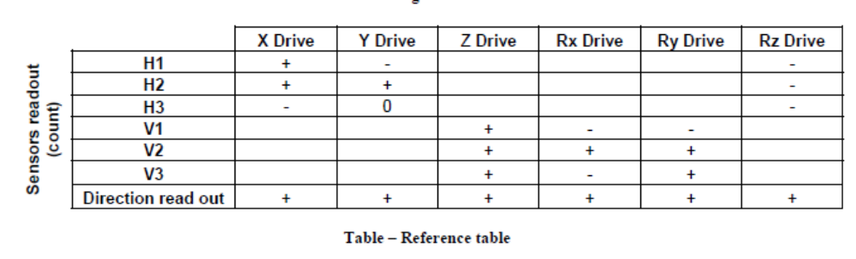
For a positive drive in the Cartesian basis:
- Local sensor readout must have the same sign that the reference table (CONT2ACT check)
- Cartesian sensors read out must be positive (DISP2CEN check) in the drive direction

Test result: Passed: X Failed: .

Step 17 - Frequency response
Compensation filters of the new GS13 interface chassis are located in the geophone pre-filters bank. Powerspectra were measured with masses on the optic table not bolted.

Step 17.1 - Local to local measurements
Local to local transfer functions have been measured with 90 repetitions.
Data files in SVN at:
/opt/svncommon/seisvn/seismic/HAM-ISI/X2/Data/Unit_3/Transfer_Functions/Measurements/
Undamped/
- LLO_HAM_ISI_Unit_3_Data_TF_L2L_50mHz_500mHz_20110406-181629.mat
- LLO_HAM_ISI_Unit_3_Data_TF_L2L_500mHz_5Hz_20110406-151108.mat
- LLO_HAM_ISI_Unit_3_Data_TF_L2L_200Hz_800Hz_20110406-120426.mat
- LLO_HAM_ISI_Unit_3_Data_TF_L2L_5Hz_200Hz_20110406-133747.mat

Data collection script files:
opt/svncommon/seisvn/seismic/HAM-ISI/X2/Scripts/Data_Collection
- Run_TF_L2L_50mHz_500mHz.m
- Run_TF_L2L_500mHz_5Hz.m
- Run_TF_L2L_5mHz_200Hz.m
- Run_TF_L2L_200Hz_800Hz.m
Scripts files for processing and plotting in SVN at:
/opt/svncommon/seisvn/seismic/HAM-ISI/X2/Data/Unit_3/Transfer_Functions/Measurements/
Undamped/
- Plot_LLO_HAM_ISI_Unit_3_TF_L2L_2011_04_06.m
Figures in SVN at:
opt/svncommon/seisvn/seismic/HAMISI/X2/Data/Unit_3/Figures/Transfer_Functions/Measurements/
Undamped/
- LLO_HAM_ISI_Unit_3_TF_L2L_H_CPS_50mHz_800Hz_2011_04_06.fig
- LLO_HAM_ISI_Unit_3_TF_L2L_V_CPS_50mHz_800Hz_2011_04_06.fig
- LLO_HAM_ISI_Unit_3_TF_L2L_H_GS13_50mHz_800Hz_2011_04_06.fig
- LLO_HAM_ISI_Unit_3_TF_L2L_V_GS13_50mHz_800Hz_2011_04_06.fig
Storage of measured transfer functions in the SVN at:
opt/svncommon/seisvn/seismic/HAM-ISI/X2/Data/Unit_3/Transfer_functions/ Measurements/
Undamped/
- LLO_HAM_ISI_Unit_3_Data_TF_L2L_2011_04_06.mat

The local to local transfer functions are presented below.

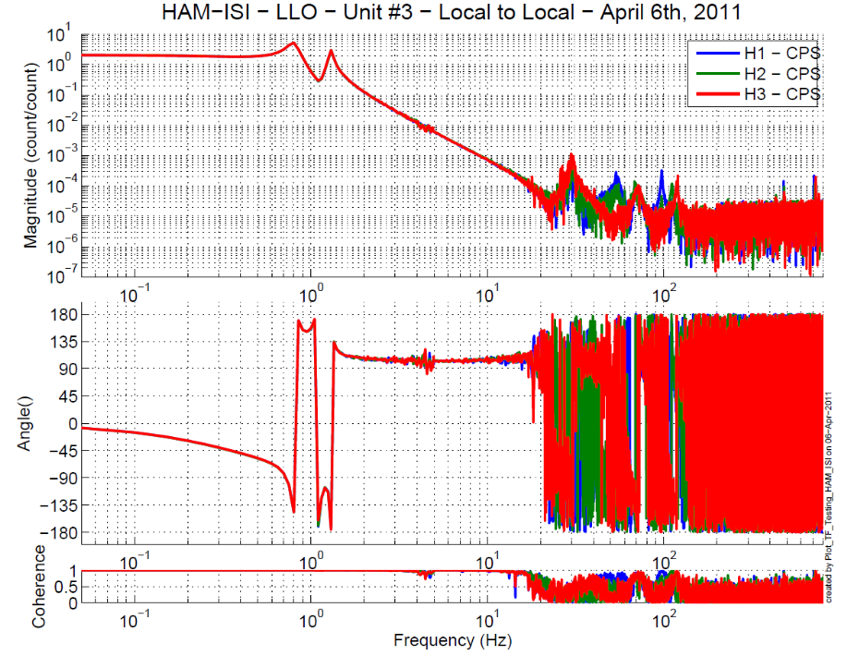
Figure - Local to Local Measurements – Horizontal capacitive sensors
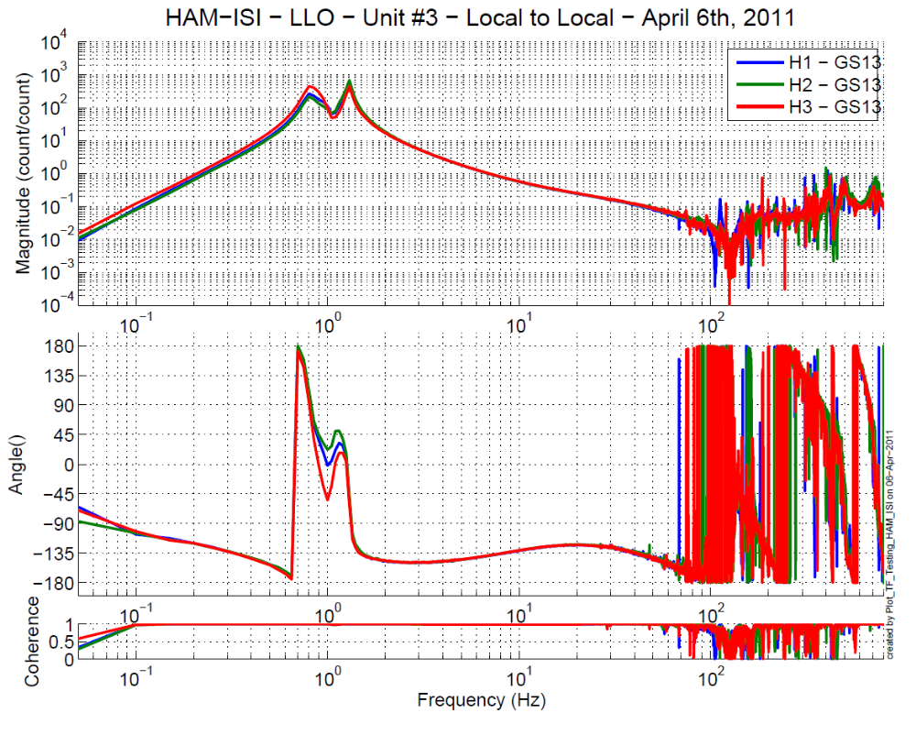
Figure - Local to Local Measurements – Horizontal inertial sensors

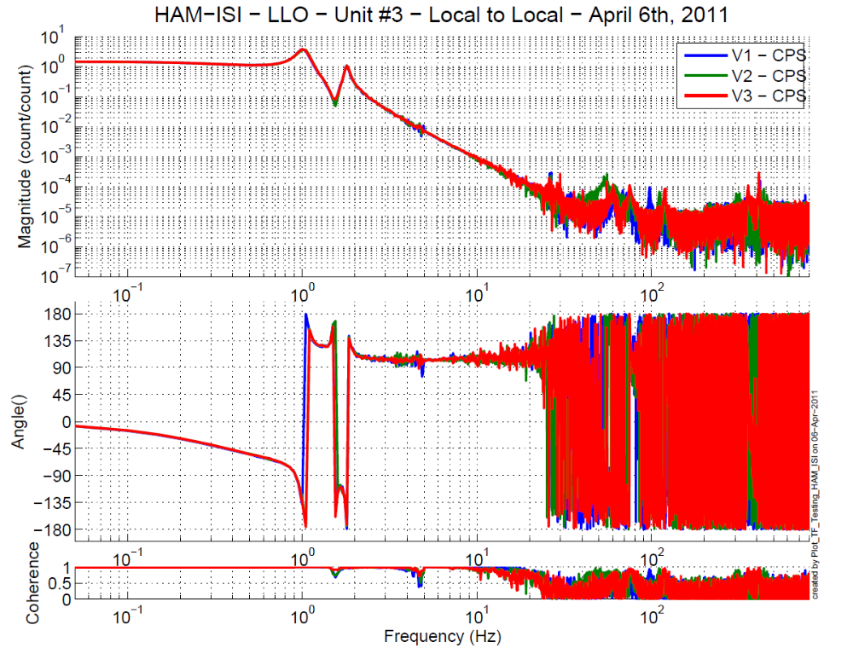
Figure - Local to Local Measurements – Vertical capacitive sensors
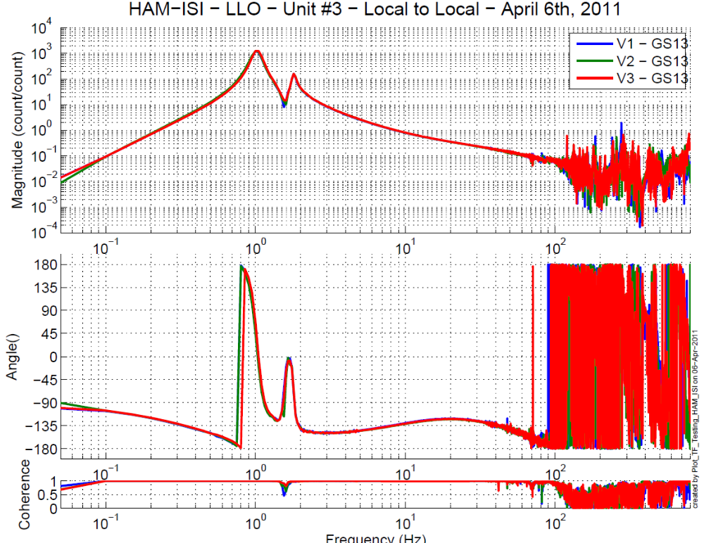
Figure - Local to Local Measurements – Vertical inertial sensors

Issues/difficulties/comments regarding this test:
Cables contacting Stage 1 and Stage 0 created issues in the .5 to 5 Hz.
At low frequencies, the horizontal GS-13s present some differences.

Step 17.2 - Cartesian to Cartesian measurements
Cartesian to Cartesian transfer functions have been measured with 90 repetitions.
Data files in SVN at:
opt/svncommon/seisvn/seismic/HAM-ISI/X2/Data/Unit_3/Transfer_Functions/Measurements/
Undamped/
- LLO_HAM_ISI_Unit_3_Data_TF_C2C_50mHz_500mHz_20110405-215335.mat
- LLO_HAM_ISI_Unit_3_Data_TF_C2C_500mHz_5Hz_20110405-184814.mat
- LLO_HAM_ISI_Unit_3_Data_TF_C2C_5Hz_200Hz_20110405-171453.mat
- LLO_HAM_ISI_Unit_3_Data_TF_C2C_200Hz_800Hz_20110405-154132.mat

Scripts files for processing and plotting in SVN at:
opt/svncommon/seisvn/seismic/HAM-ISI/X2/Data/Unit_3/Transfer_Functions/Measurements/
Undamped/
- Plot_LLO_HAM_ISI_Unit_3_TF_C2C_2011_04_06.m

Figures in SVN at:
opt/svncommon/seisvn/seismic/HAM-ISI/X2/Data/Unit_3/Figures/Transfer_Functions/
Measurements/Undamped/
- LLO_HAM_ISI_Unit_3_TF_C2C_X_Y_RZ_CPS_50mHz_800Hz_2011_04_05.fig
- LLO_HAM_ISI_Unit_3_TF_C2C_X_Y_RZ_GS13_50mHz_800Hz_2011_04_05.fig
- LLO_HAM_ISI_Unit_3_TF_C2C_Z_RX_RY_CPS_50mHz_800Hz_2011_04_05.fig
- LLO_HAM_ISI_Unit_3_TF_C2C_Z_RX_RY_GS13_50mHz_800Hz_2011_04_05.fig

Storage of measured transfer functions in the SVN at:
/svncommon/seisvn/seismic/HAM-ISI/X2/Data/Unit_3/Transfer_functions/Cartesian_to_Cartesian
- LLO_HAM_ISI_Unit_3_Data_TF_C2C_2011_04_05

Figure - Cartesian to Cartesian CPS measurements – X, Y, RZ directions

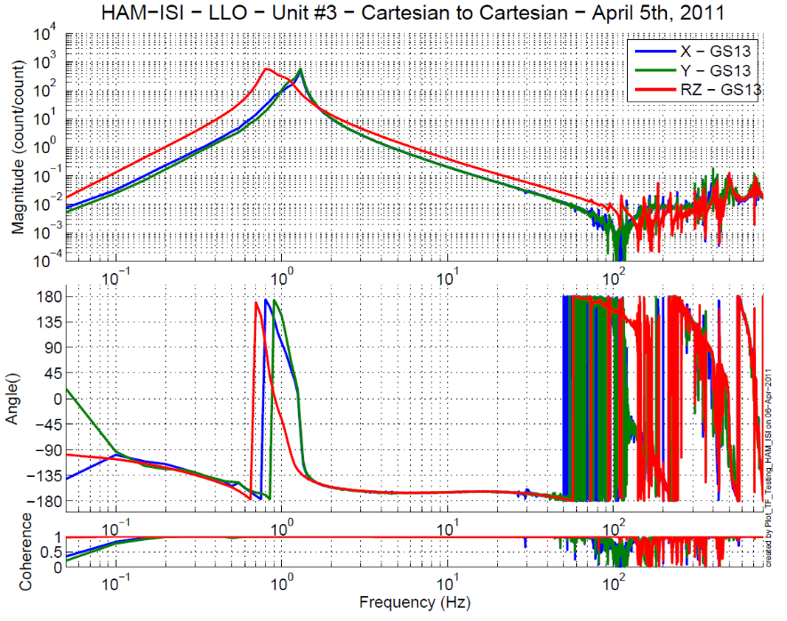
Figure - Cartesian to Cartesian GS-13 measurements – X, Y, RZ directions

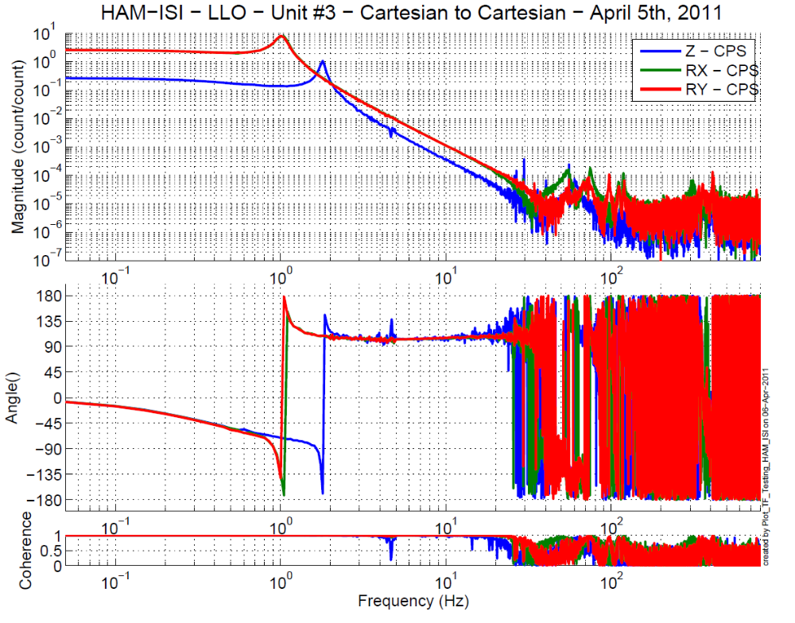
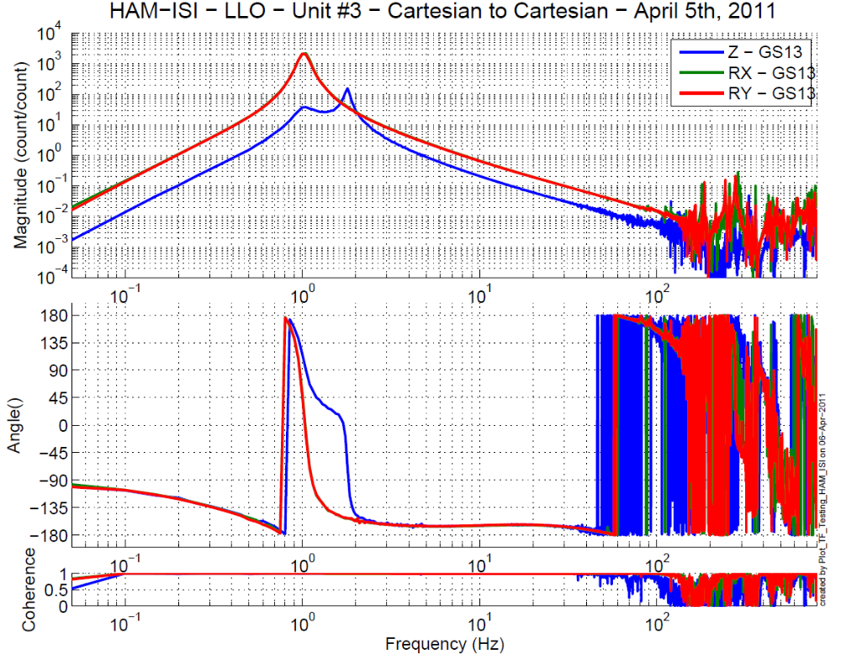
Figure - Cartesian to Cartesian measurements – Z, RX, RY directions

Issues/difficulties/comments regarding this test:

Acceptance criteria:

- Local to local measurement
  - On CPS, the phase must be 0º at DC
  - On Geophones, the phase must be -90º at DC
- Cartesian to cartesian measurement
  - On CPS, the phase must be 0º at DC
  - On Geophones, the phase must be -90º at DC

Test result: Passed: X Failed: .

Step 18 - Transfer function comparison

Step 18.1 - Local to local - Comparison with HAM6

Scripts files for processing and plotting in SVN at:
/opt/svncommon/seisvn/seismic/HAM-ISI/X2/Data/Unit_3/Transfer_Functions/Measurements/
Undamped/
- Plot_LLO_HAM_ISI_Unit_3_TF_L2L_2011_04_06.m

Local to local figures in SVN at:
/svncommon/seisvn/seismic/HAM-ISI/X2/Data/Unit_3/Figures/Transfer_Functions/Measurements/
- LLO_HAM_ISI_Unit_3_TF_L2L_H_CPS_50mHz_800Hz_wHAM6_2011_04_06.fig
- LLO_HAM_ISI_Unit_3_TF_L2L_V_CPS_50mHz_800Hz_wHAM6_2011_04_06.fig
- LLO_HAM_ISI_Unit_3_TF_L2L_H_GS13_50mHz_800Hz_wHAM6_2011_04_06.fig
- LLO_HAM_ISI_Unit_3_TF_L2L_V_GS13_50mHz_800Hz_wHAM6_2011_04_06.fig
GS13, Local to local measurement

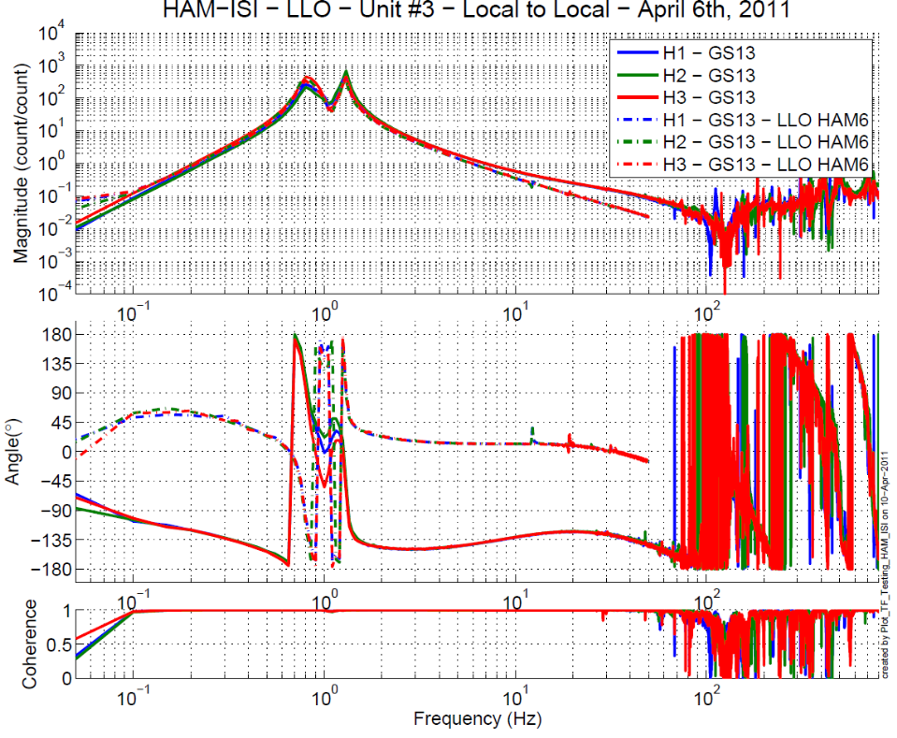
Figure - Local to local measurements comparison with HAM6 – Horizontal GS13

Figure - Local to local measurements comparison with HAM6 – Vertical GS13
CPS, Local to local measurement, Undamped
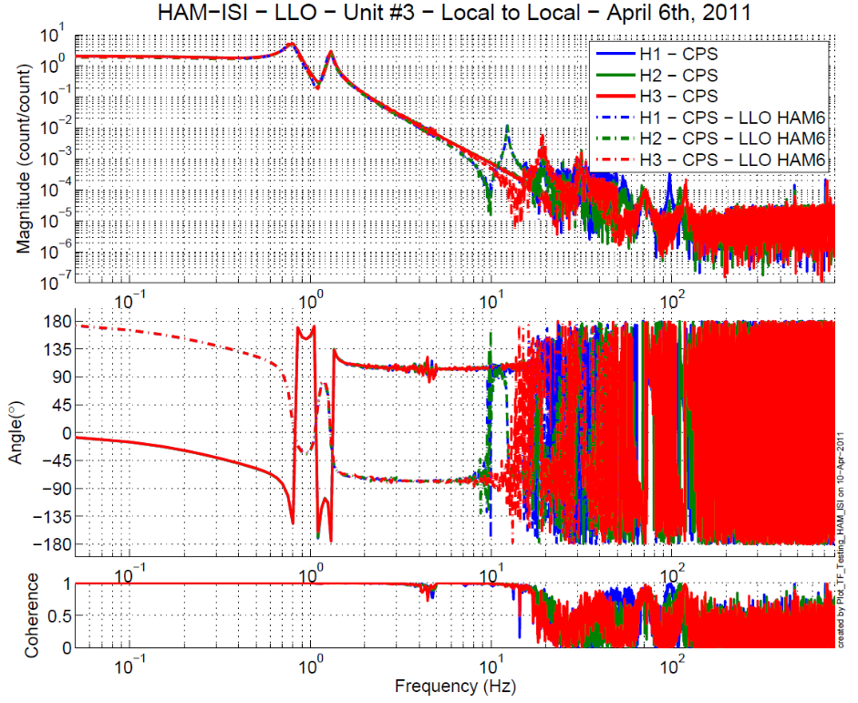
Figure - Local to local measurements comparison – Horizontal Position sensors

Figure - Local to local measurements comparison – Horizontal Position sensors

Difference with HAM6:

- Sign difference on CPS and Geophones.

Step 18.2 - Cartesian to Cartesian - Comparison with HAM6
Scripts files for processing and plotting in SVN at:
opt/svncommon/seisvn/seismic/HAM-ISI/X2/Data/Unit_3/Transfer_Functions/Measurements/
Undamped/
- Plot_LLO_HAM_ISI_Unit_3_TF_C2C_2011_04_06.m
Cartesian to Cartesian figures in SVN at :
/svncommon/seisvn/seismic/HAM-ISI/X2/Data/Unit_3/Transfer_functions/Cartesian_to_Cartesian
- LLO_HAM_ISI_Unit_3_TF_C2C_X_Y_RZ_CPS_50mHz_800Hz_wHAM6_2011_04_05.fig
- LLO_HAM_ISI_Unit_3_TF_C2C_Z_RX_RY_CPS_50mHz_800Hz_wHAM6_2011_04_05.fig
- LLO_HAM_ISI_Unit_3_TF_C2C_X_Y_RZ_GS13_50mHz_800Hz_wHAM6_2011_04_05.fig
- LLO_HAM_ISI_Unit_3_TF_C2C_Z_RX_RY_GS13_50mHz_800Hz_wHAM6_2011_04_05.fig
GS13, Cartesian to Cartesian measurement, Undamped

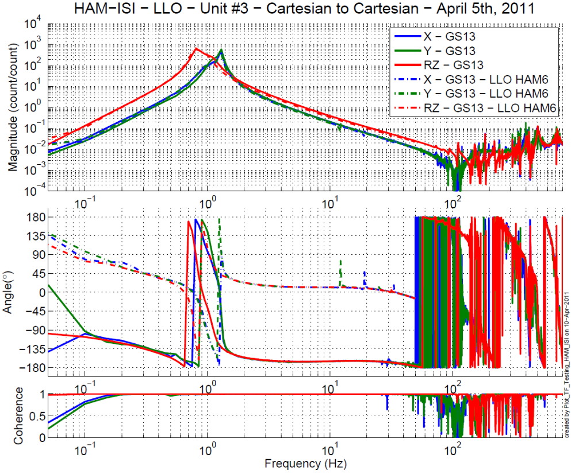

Figure - Cartesian to Cartesian measurements comparison with HAM6 – Horiz GS13

Figure - Cartesian to Cartesian measurements comparison with HAM6 – Vertical GS13

CPS, Cartesian to Cartesian measurement, Undamped

Figure - Cartesian to Cartesian measurements comparison – Horizontal Position sensors

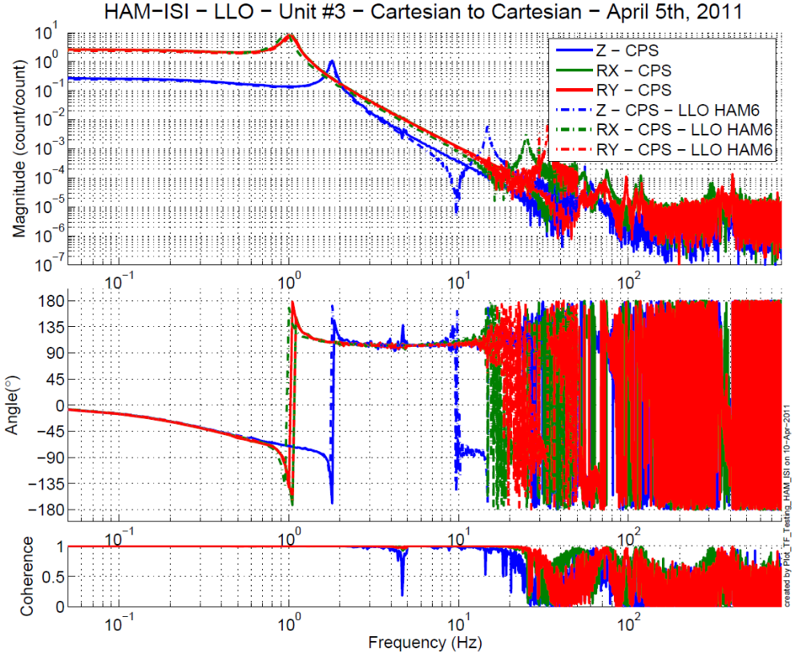
Figure - Cartesian to Cartesian measurements comparison – Vertical Position sensors
Difference with HAM6:

- Resonance at 1 Hz is slightly higher than HAM6
- Sign difference on Geophones

Acceptance criteria:

- No difference with the reference transfer functions (SVN)
  - Phase – less than 10º - In Phase – Out of Phase
  - Damping (fit by eye with the reference transfer functions)
  - DC gain
  - Eigen frequencies shift less than 5%

Test result: Passed: X Failed: .

Step 19 - Lower Zero Moment Plane
Data collection script files:
opt/svncommon/seisvn/seismic/HAM-ISI/X2/Scripts/Data_Collection
- Run_Cart2Cart_10mHz_100mHz.m
Data files in SVN at:
opt/svncommon/seisvn/seismic/HAM-ISI/X2/Data/Unit_3/Transfer_Functions/Measurements/
Undamped/
- LZMP_LLO_HAM-ISI-Unit_3_2011_04_06.mat
Scripts files for processing and plotting in SVN at:
opt/svncommon/seisvn/seismic/HAM-ISI/X2/Data/Unit_3/Transfer_Functions/Measurements/
Undamped/
- LZMP_2011_04_06.m
Figures in SVN at:
opt/svncommon/seisvn/seismic/HAM-ISI/X2/Data/Unit_3/Figures/Transfer_Functions/
Measurements/Undamped/
- LZMP.fig
X & Y offsets:
X offset (mm) | 0.399
Y offset (mm) | 0.738
Table – Offset of the Lower Zero Moment Plane
The results from two measurements are presented on the figure below:
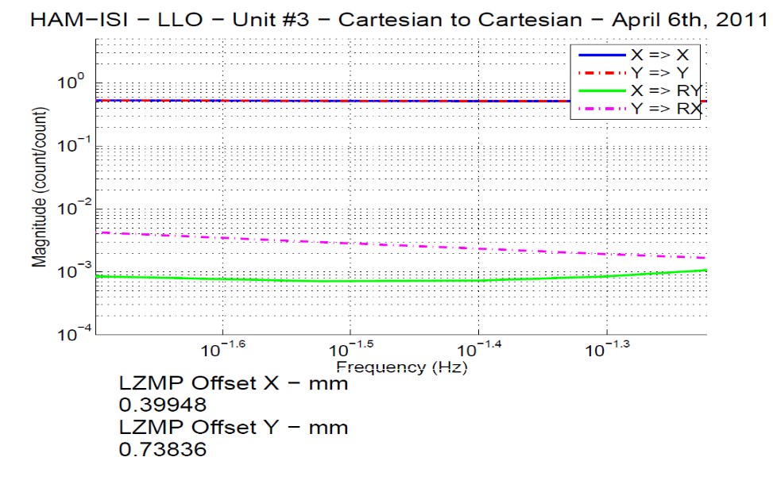
Figure - Lower Zero moment plane – Main and cross couplings at low frequency

Acceptance criteria:
- X offset must be less than 1 mm
- Y offset must be less than 1mm

Test result: Passed: X Failed: .

Step 20 - Damping loops
Filters used by Damping loops in SVN at:
/opt/svncommon/seisvn/seismic/HAM-ISI/X1/FilterDesign/Unit_3/txt_file
- G1ISIHAM_Back_up_2010_09_01.txt (digitalized filters copied and rename to G1ISIHAM.txt in /opt/rtcds/geo/g1/chans)

Step 20.1 - Transfer functions - Simulation
Scripts files for processing and plotting in SVN at:
/opt/svncommon/seisvn/seismic/HAM-ISI/X2/Data/Unit_3/Transfer_Functions/Simulation/Damping
- HAM_ISI_LLO_Unit_3_Damping_TF_2011_04_18.m
Figures in SVN at:
/svncommon/seisvn/seismic/HAM-ISI/X2/Data/Unit_3/Transfer_Functions/Simulations/
Damping/
- Damping_LOOP_H1_H2_H3.fig
- Damping_LOOP_V1_V2_V3.fig

Results are saved in SVN at:
/opt/svncommon/seisvn/seismic/HAM-ISI/X2/Data/Unit_3/Transfer_Functions/Simulations/
Damping/
The following figures present the plant, controller, open loop, closed loop and sensitivity of vertical and horizontal damping loops. H1 (respectively V1) are plotted in solid line, H2 (respectively V2) are plotted in dash line, H3 (respectively V3) are plotted in dash-dot line.

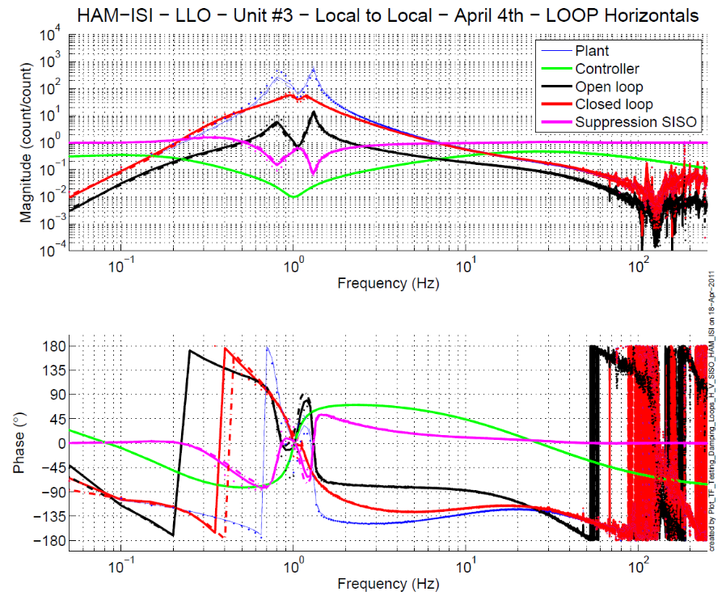
Figure - Horizontal damping loops - Simulation

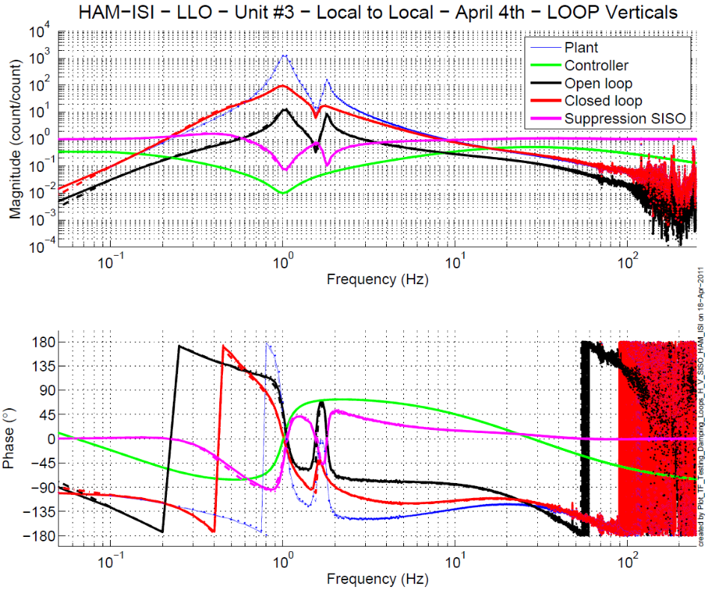
Figure - Vertical damping loops - Simulation

Step 20.2 - Powerspectrum – Experimental

Data files in SVN at:
/opt/svncommon/seisvn/seismic/HAM-ISI/X2/Data/Unit_3/Powerspectra/Damping/
Scripts files for taking data and plotting in SVN at:
/opt/svncommon/seisvn/seismic/HAM-ISI/X2/Scripts/Data_Collection/
- Powerspectra_Measurements_Undamped_Damped_HAM_ISI.m
Figures in SVN at:
/svncommon/seisvn/seismic/HAM-ISI/X2/Data/Unit_3/Figures/Powerspectra/Damping/
- LLO_HAM_ISI_Unit_3_Calibrated_PSD_CPS_Undamped_Damped_2011_04_08.fig
- Simulation_vs_experimental_Suppression.fig

Powerspectrum:
The figure below shows power spectrum of Geophones when there when there is no damping loop and when all damping loops are engaged.
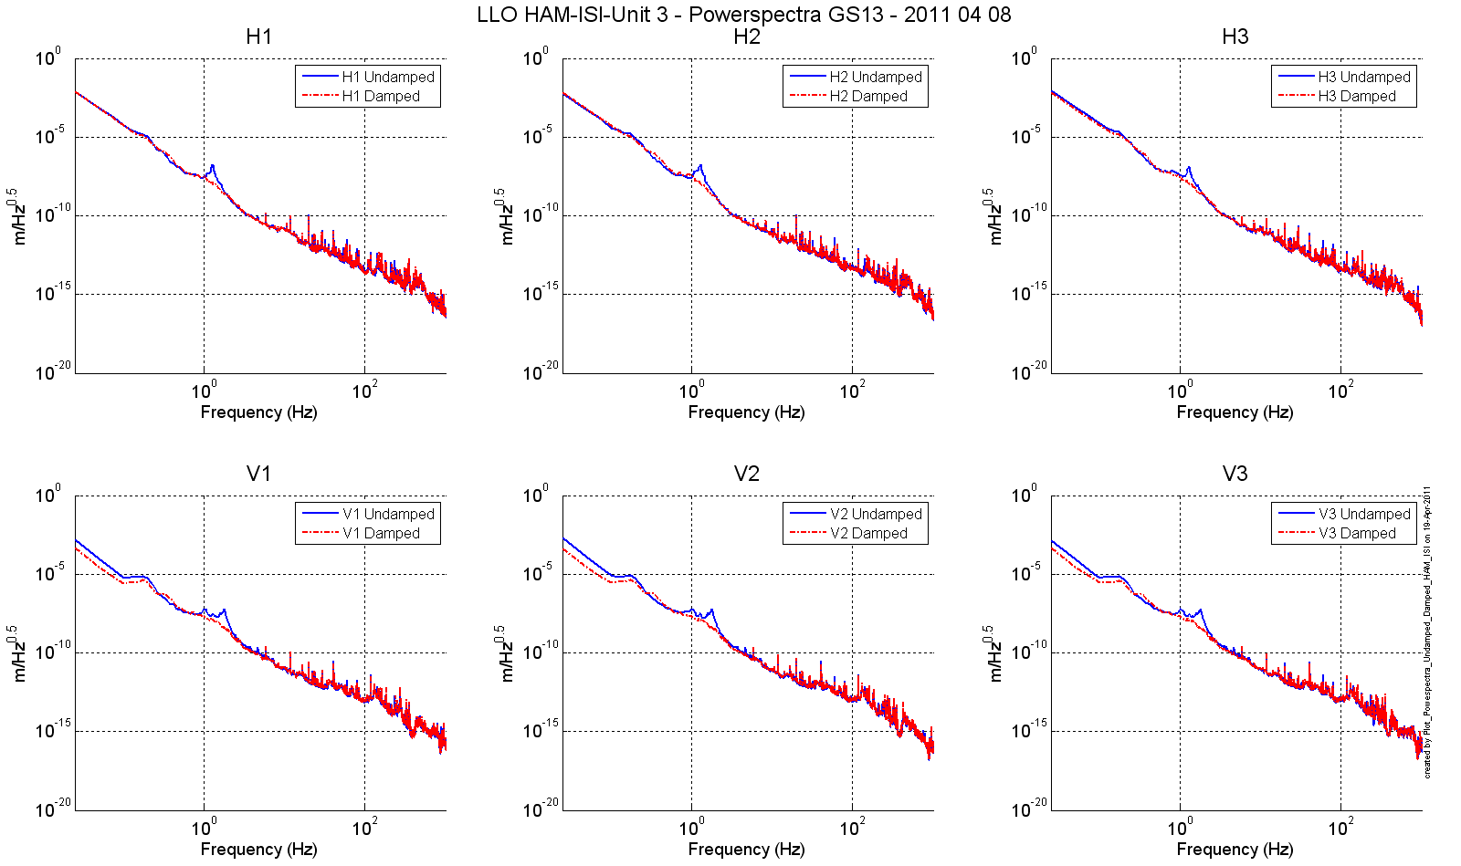
Figure – Horizontal (top) and vertical (bottom) damping loops - Experimental

Sensitivity:
The figure below compare the sensitivity ('Undamped/Damped') of LLO HAM (Aug 2008) and LHO Unit 2. Performances are very similar, which confirms that we can use the damping loop as they are (modulo electronics change compensation). The plot also shows that the measured performance matches with the prediction.

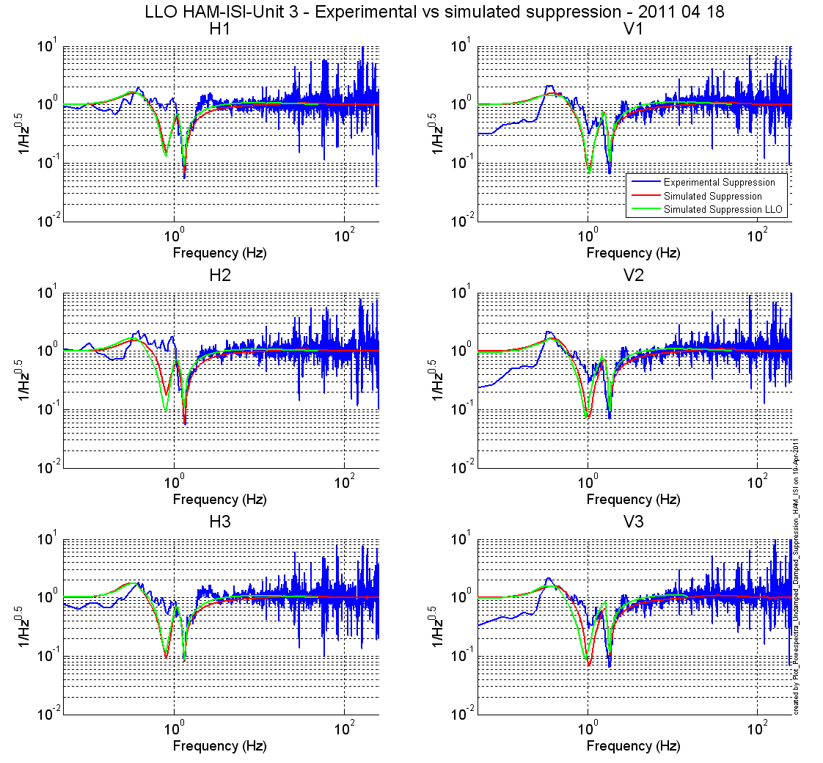
Figure – Horizontal (left) and vertical (right) damping loops - Experimental

Acceptance criteria:
- Ham 6 damping loop must implemented and stable with
  - Phase margin must be at least 45º
  - Gain margin must be at least 20dB

Test result: Passed: X Failed: .

