LIGO Laboratory / LIGO Scientific Collaboration

LIGO- E1000328 LIGO July 28th, 2011

aLIGO HAM-ISI, Pre-integration Testing Unit # 4,
Phase I (post-assembly, before storage)
E1000328 – V1

Joe Hanson, Celine Ramet, Michael Vargas, Adrien Le Roux

Distribution of this document:
Advanced LIGO Project

This is an internal working note
of the LIGO Laboratory

California Institute of Technology  LIGO Project – MS 18-34  1200 E. California Blvd.  Pasadena, CA 91125  Phone (626) 395-2129  Fax (626) 304-9834  E-mail: info@ligo.caltech.edu | Massachusetts Institute of Technology  LIGO Project – NW22-295  185 Albany St  Cambridge, MA 02139  Phone (617) 253-4824  Fax (617) 253-7014  E-mail: info@ligo.mit.edu
LIGO Hanford Observatory  P.O. Box 1970  Mail Stop S9-02  Richland WA 99352  Phone 509-372-8106  Fax 509-372-8137 | LIGO Livingston Observatory  P.O. Box 940  Livingston, LA 70754  Phone 225-686-3100  Fax 225-686-7189

Table of contents:

Introduction 4
I. Pre-Assembly Testing 5
▪ Step 1: Position Sensors 5
▪ Step 2: GS13 7
▪ Step 2.1 – Horizontal GS-13s 7
▪ Step 2.2 – Vertical GS-13s 8
▪ Step 3: Actuators 10
II. Tests to be performed during assembly 11
▪ Step 1: Inventory (E1000052) 11
▪ Step 2: Check torques on all bolts 11
▪ Step 3: Check gaps under Support Posts 11
▪ Step 4: Pitchfork/Boxwork flatness before Optical Table install 12
▪ Step 5: Blade spring profile 12
▪ Step 6: Gap checks on actuators-after installation on Stage 1 13
▪ Step 7: Check level of Stage 0 13
▪ Step 8: Check level of Stage 1 Optical Table 14
▪ Step 9: Mass budget 15
▪ Step 10: Shim thickness 17
▪ Step 11: Lockers adjustment 17
III. Tests to be performed after assembly 18
▪ Step 1 - Electronics Inventory 18
▪ Step 2 - Set up sensors gap 18
▪ Step 3 - Measure the Sensor gap 19
▪ Step 4 - Check Sensor gaps after the platform release 19
▪ Step 5 – Performance of the limiter 20
▪ Step 5.1 - Test Nº1 - Push “in the general coordinates” 20
▪ Step 5.2 - Test Nº2 – Push “locally” 20
▪ Step 6 - Position Sensors unlocked/locked Power Spectrum 21
▪ Step 7 - GS13 power spectrum -tabled tilted 23
▪ Step 8- GS13 pressure readout 25
▪ Step 9 - Coil Driver, cabling and resistance check 26
▪ Step 10 - Actuators Sign and range of motion (Local drive) 27
▪ Step 11 - Vertical Sensor Calibration 28
▪ Step 12 - Vertical Spring Constant 29
▪ Step 13 - Static Testing (Tests in the local basis) 29
▪ Step 14 - Linearity test 31
▪ Step 15 - Cartesian Basis Static Testing 33
▪ Step 16- Frequency response 34
▪ Step 16.1 - Local to local measurements 34
▪ Step 16.2 - Cartesian to Cartesian measurements 37
▪ Step 17 - Transfer function comparison with Reference 41
▪ Step 17.1 - Local to local - Comparison with Reference 41
o Step 17.2 - Cartesian to Cartesian - Comparison with Reference 44
▪ Step 18 - Lower Zero Moment Plane 48
▪ Step 19 - Damping loops 50
▪ Step 19.1 - Transfer functions - Simulation 50
▪ Step 19.2 - Powerspectra – Experimental 53
Conclusion 1

Introduction
This Unit#4 has been built between May and July 2011, and was tested immediately afterward.
The procedure document used to perform this test is:
- E1000309–V9 - aLIGO HAM-ISI, Pre-Integration Testing Procedure, Phase I (post assembly, before storage)
Other useful information can be found in:
- E1000300 - HAM-ISI LLO test stand: software and electronic check

Pre-Assembly Testing

Step 1: Position Sensors

Note: The back panel reads 0.508V/0.001"

S/N sensor | S/N board | ADE Gap Standoff(mm) | Location on the Jig | Gap Standoff on Jig(mm/in) | Voltage before zeroing | Voltage after zeroing. Prebake | Voltage after zeroing. Post bake
12064 | NR | NR | NR | NR | NR | NR | NR
12073 | NR | NR | NR | NR | NR | NR | NR
12076 | NR | NR | NR | NR | NR | NR | NR
12082 | NR | NR | NR | NR | NR | NR | NR
12024 | NR | NR | NR | NR | NR | NR | NR
11996 | NR | NR | NR | NR | NR | NR | NR

NR: not recorded

Will be measured for the next units.

Sensors noise spectra measured before baking:

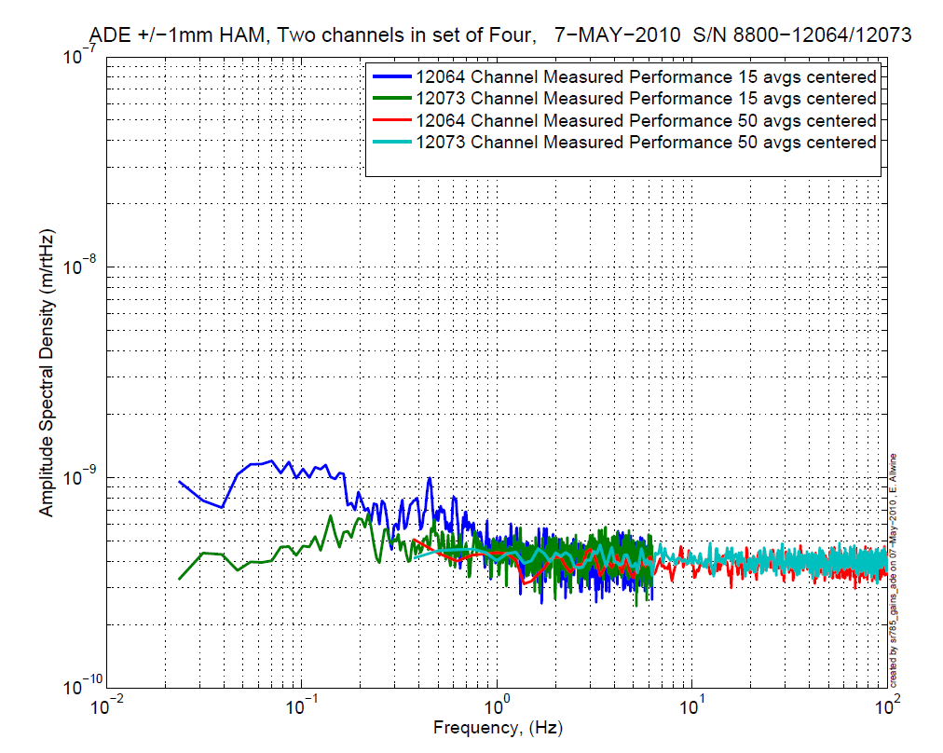  Figure - H1 and V1 sensor noise | 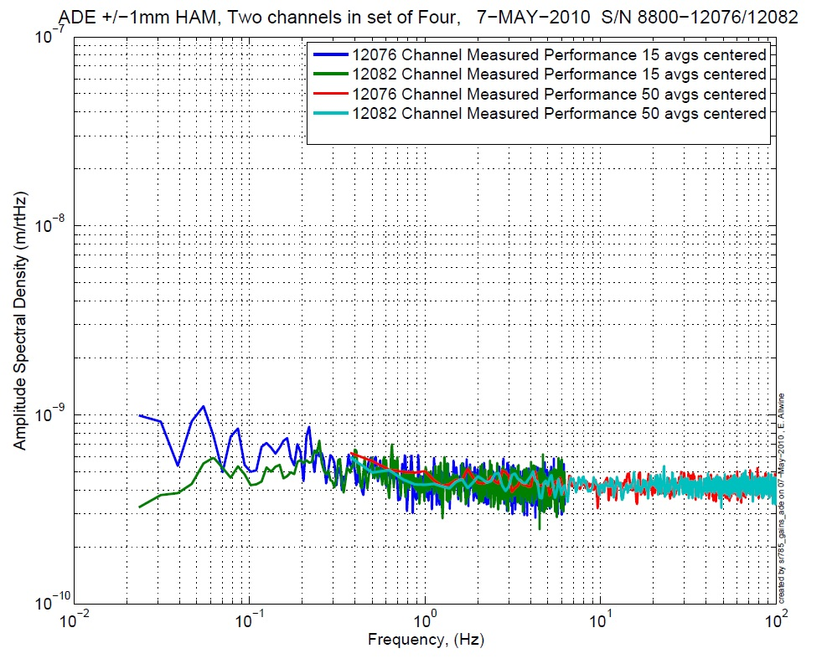  Figure - H2 and V2 sensor noise

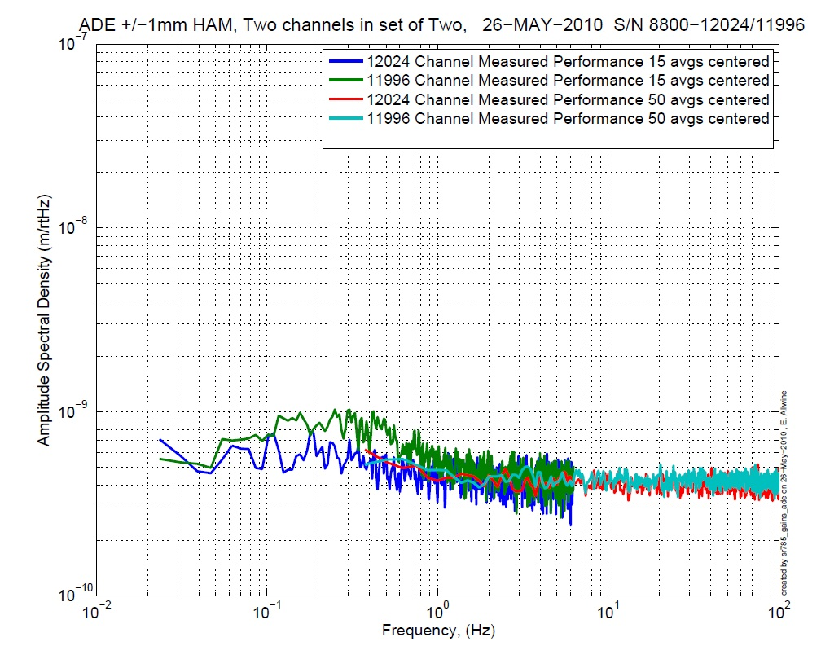
Figure - H3 and V3 sensor noise

Acceptance Criteria:
- Power spectrum magnitudes must be lower than:
  - 9.e-10 m/√Hz at 0.1Hz
  - 6.e-10 m/√Hz at 1Hz

Issues/difficulties/comments regarding this test: Values of sensor gaps and zeroing were not recorded. 12064 doesn’t meet the requirements by a little at 0.1Hz, but we still decided to go on with this sensor.

Test result: Passed: Failed: X .

Step 2: GS13

All the data related to GS-13 post podding testing can be found in the SVN at : SeismicSVN\seismic\Common\Data\aLIGO_GS13_TestData\PostMod_TestResults_PDFs.
E1000058 spreadsheet provides the status of each individual GS-13 at LLO site during aLIGO HAM assembly

Data files in SVN at:
/opt/svncommon/seisvn/seismic/Common/Data/aLIGO_GS13_TestData/PostMod_TestResults_RawASCII

Scripts files for processing and plotting in SVN at:
/opt/svncommon/seisvn/seismic/Common/MatlabTools
- gs13qatest.m

Figures in SVN at:
/opt/svncommon/seisvn/seismic/Common/Data/aLIGO_GS13_TestData/PostMod_TestResults_PDFs

Step 2.1 – Horizontal GS-13s

Huddle testing
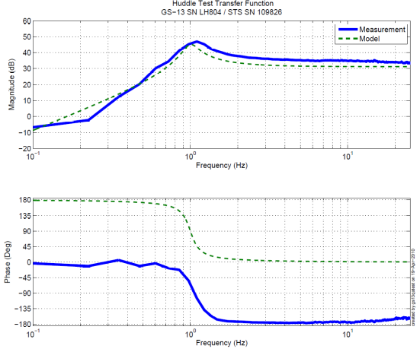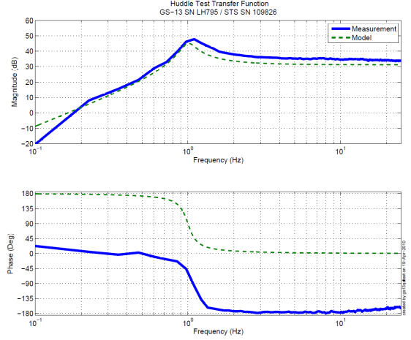
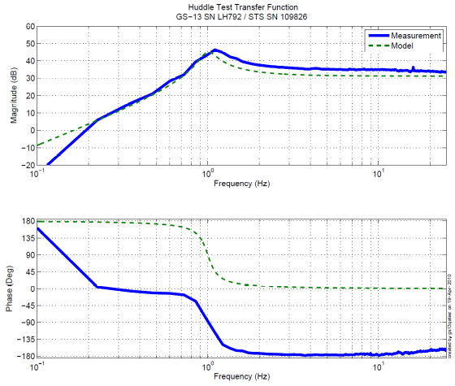
Figure - Huddle testing of Horiz GS-13 804,795, and 792 after aLIGO modifications

Step 2.2 – Vertical GS-13s

Huddle testing

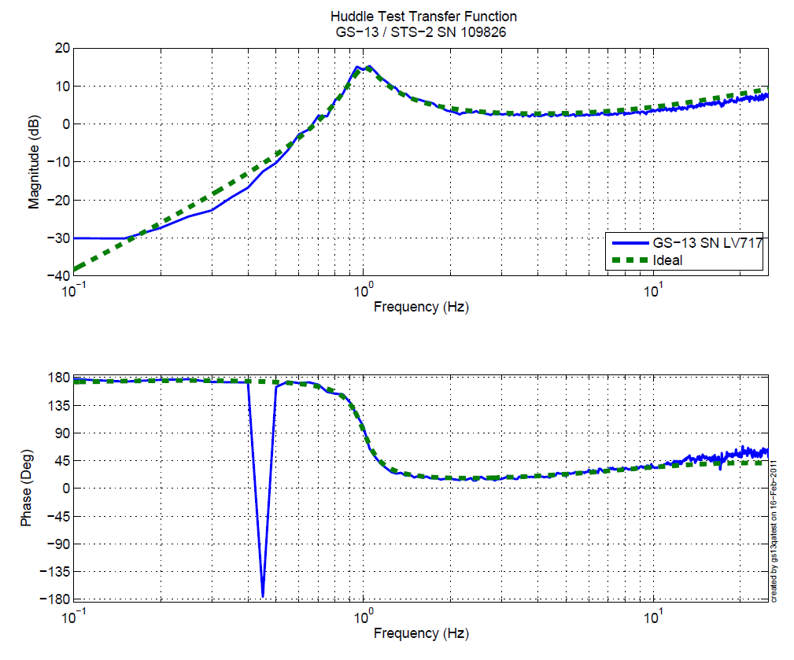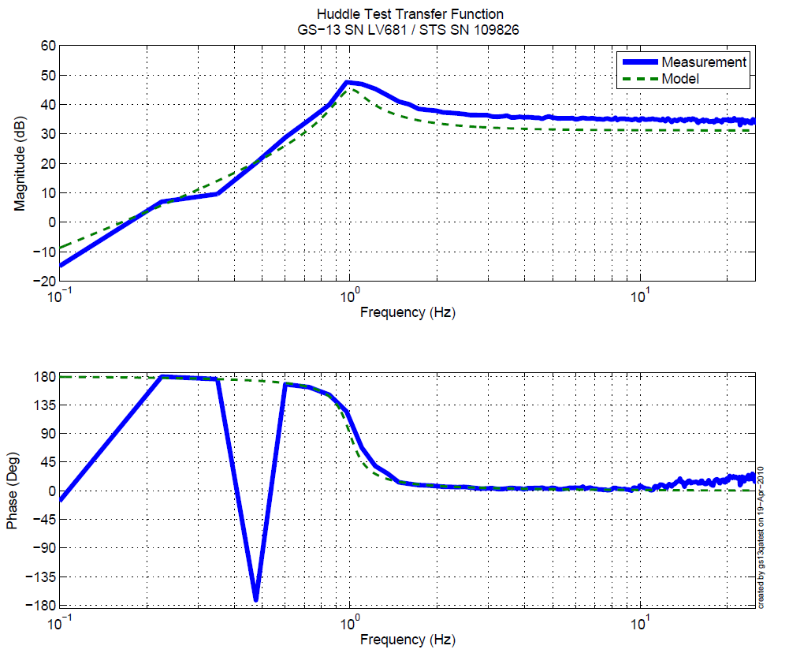
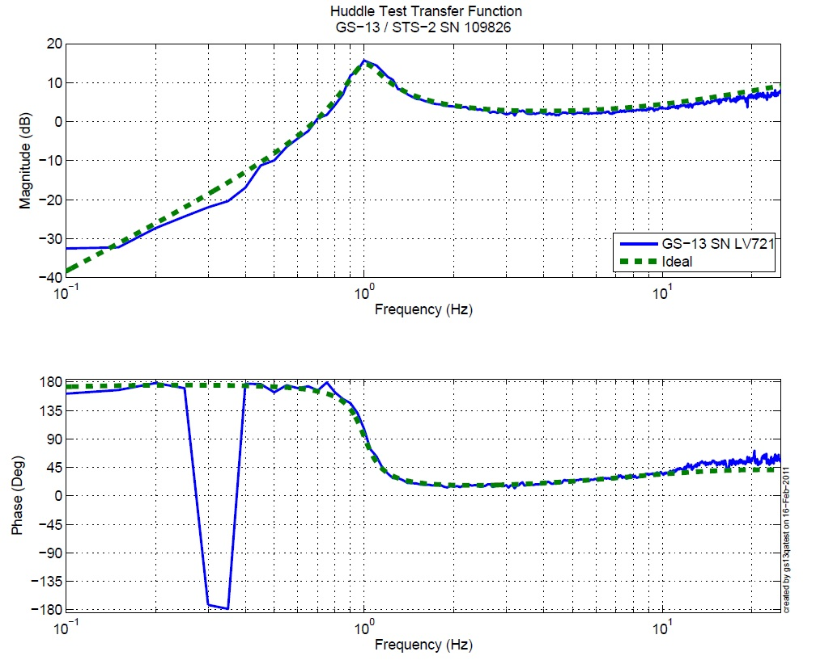
Figure - Huddle testing of Vert GS-13 717, 681 and 721 after aLIGO modifications
Driven testing
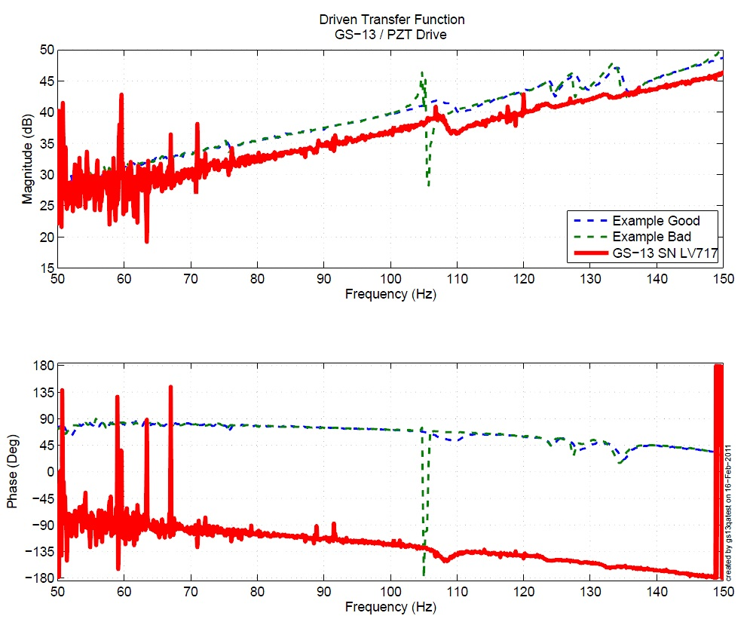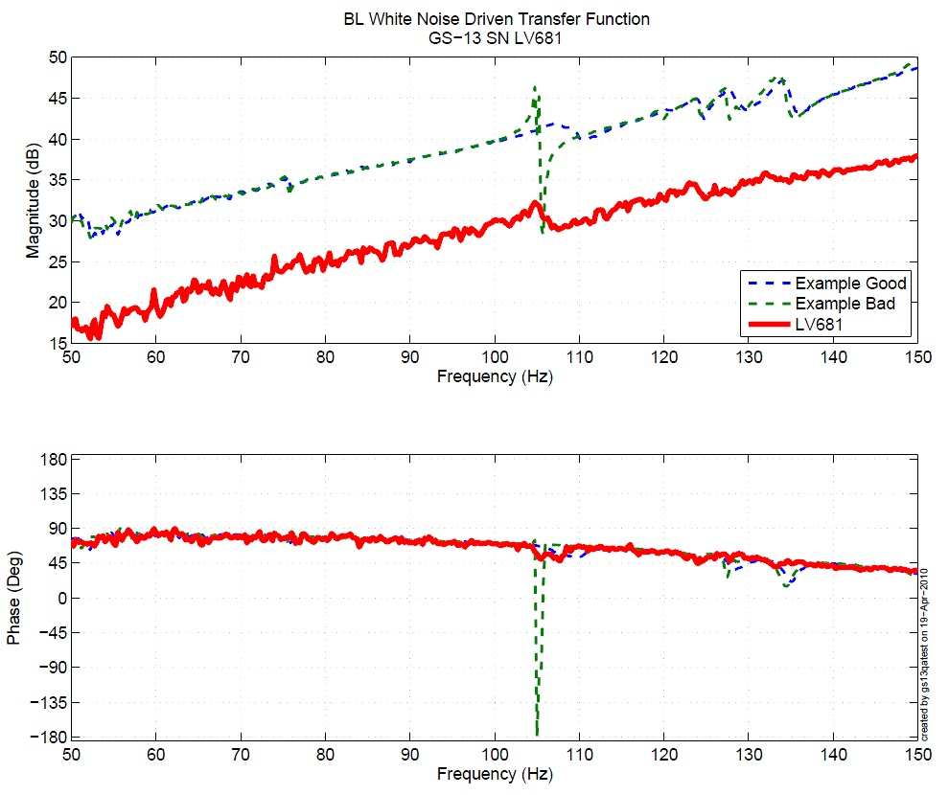
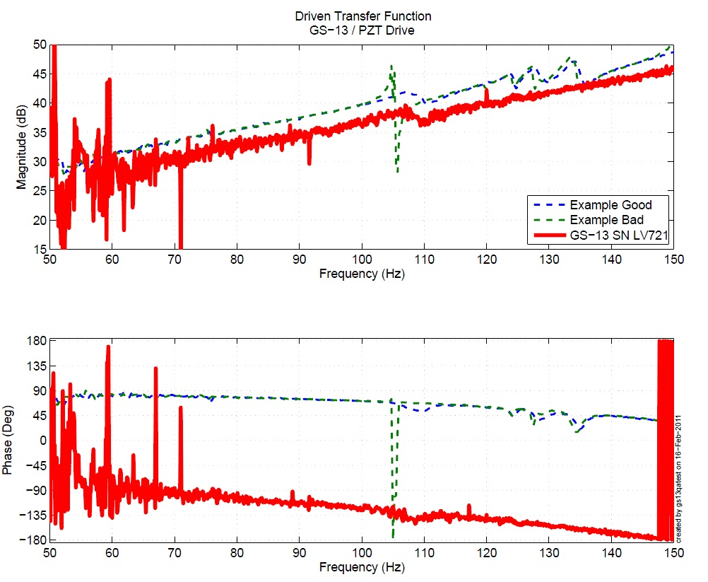
Figure - Driven Transfer Function of Vert GS-13 717, 681 and 721 after aLIGO modifications

Acceptance Criteria:
- GS13 should have been already modified and tested. GS-13 Inspection/Pod Assembly (D047810). Checklist is defined in F090070-v6
- Resonant frequency at 1 Hz (huddle testing)
- No spring resonance on vertical driven tests

Test result: Passed: X Failed: .

Step 3: Actuators
Actuator data can be found at: T0900564. Actuator inventory is made at Section II – Step 1.

Actuator Serial #: L066  Operator Name: Gordon, Matt  Date: 11/22/2009 Time: 2:43 PM  Actuator Coil Resistance: 6.31 Ohms, PASS  Ambient Temperature: 71.1 F  Hi Pot Test Results: 1000 MOhms, PASS  X Travel Limit (inches): 0.523  Y Travel Limit (inches): 0.205  Z Travel Limit (inches): 0.508 | Actuator Serial #: L079  Operator Name: Gordon, Matt  Date: 11/22/2009 Time: 12:11 PM  Actuator Coil Resistance: 6.35 Ohms, PASS  Ambient Temperature: 71.5 F  Hi Pot Test Results: 1000 MOhms, PASS  X Travel Limit (inches): 0.529  Y Travel Limit (inches): 0.205  Z Travel Limit (inches): 0.506
Actuator Serial #: L158  Operator Name: Gordon, Matt  Date: 4/13/2010 Time: 6:04 PM  Actuator Coil Resistance: 6.42 Ohms, PASS  Ambient Temperature: 73.3 F  Hi Pot Test Results: 1000 MOhms, PASS  X Travel Limit (inches): 0.531  Y Travel Limit (inches): 0.205  Z Travel Limit (inches): 0.504 | Actuator Serial #: L149  Operator Name: Gordon, Matt  Date: 4/13/2010 Time: 1:52 PM  Actuator Coil Resistance: 6.41 Ohms, PASS  Ambient Temperature: 72.9 F  Hi Pot Test Results: 1000 MOhms, PASS  X Travel Limit (inches): 0.531  Y Travel Limit (inches): 0.205  Z Travel Limit (inches): 0.507
Actuator Serial #: L140  Operator Name: Gordon, Matt  Date: 4/13/2010 Time: 8:20 AM  Actuator Coil Resistance: 6.38 Ohms, PASS  Ambient Temperature: 73.3 F  Hi Pot Test Results: 1000 MOhms, PASS  X Travel Limit (inches): 0.528  Y Travel Limit (inches): 0.206  Z Travel Limit (inches): 0.505 | Actuator Serial #: L159  Operator Name: Gordon, Matt  Date: 4/13/2010 Time: 5:48 PM  Actuator Coil Resistance: 6.37 Ohms, PASS  Ambient Temperature: 73.3 F  Hi Pot Test Results: 1000 MOhms, PASS  X Travel Limit (inches): 0.533  Y Travel Limit (inches): 0.206  Z Travel Limit (inches): 0.506

Acceptance Criteria:
- Actuators were previously tested and results are reported in T900564.

The tests report must contain:
- Test results (Passed: X Failed: ).””

Tests to be performed during assembly

Step 1: Inventory (E1000052)

DCC/Vendor number | Part name | Configuration | S/N | S/N | S/N
D071001 | Stage 0 base |  | 5
D071051 | Stage 1 base |  | 6
D071050 | Optical table |  | 13
D071002 | Spring Post |  | 41 | 40 | 35
D071100 | Spring |  | 36 | 31 | 32
D071102 | Flexure |  | 8 | 5 | 36
ADE | Position sensor | Horizontal | 12064 | 12076 | 12024
ADE | Position sensor | Vertical | 12073 | 12082 | 11996
D047812 | GS-13 pod | Horizontal | 92 | 26 | 45
D047812 | GS-13 pod | Vertical | 80 | 64 | 15
D047823 | L4C pod | Horizontal
D047823 | L4C pod | Vertical
D0902749 | Actuator | Horizontal | L066 | L158 | L140
D0902749 | Actuator | Vertical | L079 | L149 | L159

Note that L4C pods will be installed on this unit but were not ready at the time of testing.

Step 2: Check torques on all bolts

Acceptance Criteria:
- All bolts should trip the wrench, and start moving immediately after. If any bolts in a pattern move before torque is reached, recheck after all bolts are brought to spec.

Test result: Passed: X Failed: .

Step 3: Check gaps under Support Posts

Acceptance Criteria:
- A 0.001 inch shim cannot be passed freely through any connection to Stage 0 or between post and gussets. If shim can pass through, loosen all constraining bolts, and then retighten iteratively from the center of the part to the edges. Retest.
Test result: Passed: X Failed: .

Step 4: Pitchfork/Boxwork flatness before Optical Table install

Acceptance Criteria:
- Shim inserted won’t pass between parts.

Test result: Passed: X Failed: .

Step 5: Blade spring profile

Blade # | Base (") | Tip(") | Flatness (mils)
1 | 0.510 | 0.494 | + 16
2 | 0.509 | 0.496 | + 13
3 | 0.498 | 0.493 | + 5

Table 1 - Blade profile

Issues/difficulties encountered during this test
Multiple iterations of shims were tried, and unless we use shims thinner 120 mils, we are confident that we can not provide better blade spring profile while keeping the optical table level.

Acceptance Criteria:
- Blades must be flat within 0.015" inches.

Test result: Passed: Failed: X .

Step 6: Gap checks on actuators-after installation on Stage 1

Actuator | Front Gap (1/1000") | Back Gap (1/1000")
H1 | 0.085 | 0.080
H2 | 0.080 | 0.090
H3 | 0.080 | 0.090
V1 | 0.080 | 0.085
V2 | 0.080 | 0.085
V3 | 0.090 | 0.090

Acceptance Criteria
- Gaps must be within 0.010” of design (i.e. 0.090” and .070” pass, but 0.095” and 0.065” doesn’t).

Test result: Passed: X Failed: .

Step 7: Check level of Stage 0

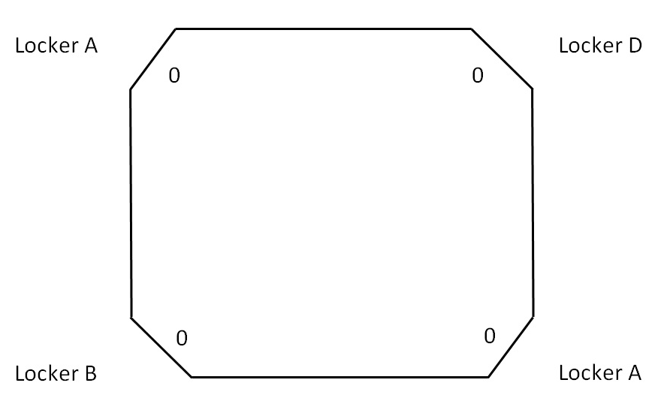
Locker C
Locker C
0
0
0
1/256”

1/256”

Max angle=(1/256)/78.97"= 49.5 urad

Acceptance Criteria
- The maximum angle of the table with the horizontal mustn’t exceed ~100µrad

Test result: Passed: X Failed: .

Step 8: Check level of Stage 1 Optical Table
Optical Level measurement of Stage 1 at large (12 - 15) number of points.

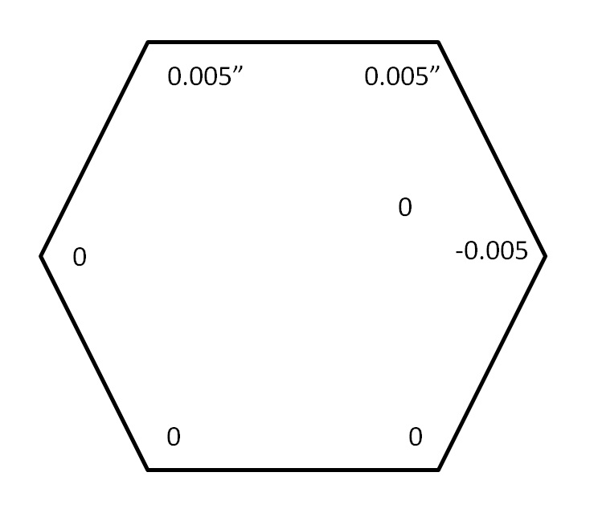

Max angle = (0.005)/85.59= 58 urad

Acceptance Criteria
- The maximum angle of the table with the horizontal mustn’t exceed ~100µrad

Test result: Passed: X Failed: .

Step 9: Mass budget

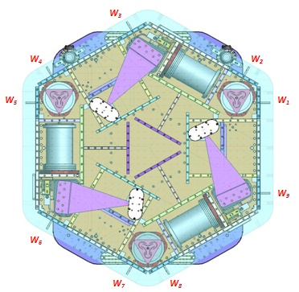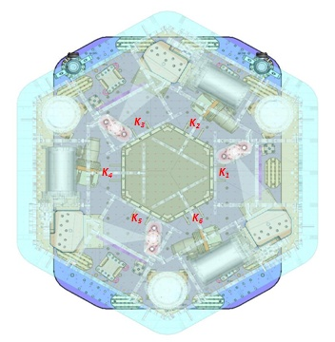
Figure – Keel Masses and Wall masses location

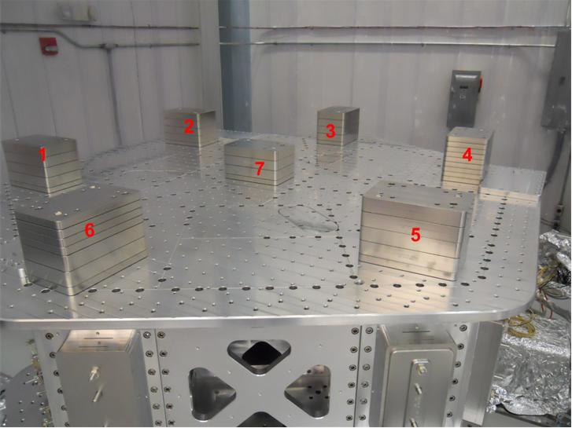
Figure - Optical table masses distribution

 | Mass (kg)
t1 | 45.00
t2 | 45.00
t3 | 45.00
t4 | 45.00
t5 | 45.00
t6 | 45.00
t7 | 35.00
total | 305.00

 |  | 00 | 01 | 02 | 03 | 04 | 05 | 06
 |  | 0.6 | 1.1 | 2.2 | 4.5 | 7.9 | 15.6 | 27.2 | lbs | kgs
w9 |  | 1 |  |  |  |  | 1 | 1 | 43.4 | 19.69
w1 |  |  |  |  |  |  | 1 | 1 | 42.8 | 19.41
w2 |  |  |  |  |  |  | 1 | 1 | 42.8 | 19.41
w3 |  | 1 |  |  |  |  | 1 | 1 | 43.4 | 19.69
w4 |  | 1 |  |  |  |  | 1 | 1 | 43.4 | 19.69
w5 |  |  |  |  | 1 |  | 1 | 1 | 47.3 | 21.45
w6 |  |  |  | 1 |  |  | 1 | 1 | 45 | 20.41
w7 |  |  |  |  |  |  | 1 | 1 | 42.8 | 19.41
w8 |  |  |  |  |  |  | 1 | 1 | 42.8 | 19.41
Side Masses Total |  | 3 | 0 | 1 | 1 | 0 | 9 | 9 | 393.7 | 178.58
Table – Wall masses distribution

 | 00 | 01 | 02 | 03 | 04 | 05 | 06
 | 0.6 | 1.1 | 2.2 | 4.5 | 7.9 | 15.6 | 27.2 | lbs | kgs
k1 |  |  |  |  | 1 |  | 1 | 35.1 | 15.92
k2 | 1 | 1 | 1 |  |  |  | 1 | 31.1 | 14.11
k3 |  |  |  |  | 1 |  | 1 | 35.1 | 15.92
k4 | 1 | 1 | 1 |  |  |  | 1 | 31.1 | 14.11
k5 |  |  |  |  | 1 |  | 1 | 35.1 | 15.92
k6 | 1 | 1 | 1 |  |  |  | 1 | 31.1 | 14.11
 | 3 | 3 | 3 | 0 | 3 | 0 | 6 | 198.6 | 90.08

 | Side | Keel | Top | Total
Weigh (kg) | 178.58 | 90.08 | 305.00 | 573.66
Torque x at O (N.m) | -4.58 | 0.00 | -8.72 | -13.31
Torque y at O (N.m) | -24.53 | 5.26 | 11.21 | -8.06
Table - Masses distribution (computed using T1100261)

Acceptance Criteria
The Mass budget must be
- 579.1 Kg (cf E1100427)+/-25Kg (5%)

Test result: Passed: X Failed: .

Step 10: Shim thickness

Lockers | Shim thickness (mils)
A | 122
B | 122
C | 122
D | 120
Table – Shims Thickness

Acceptance Criteria
- Inventory is complete

Test result: Passed: X Failed: .

Step 11: Lockers adjustment

D.I at Lockers | Dial indicators V | Dial indicators H
A | 1.5 | 1
B | 2 | 0.5
C | -1 | 0
D | -1 | -1
Table – Dial indicators read-out (in thousands of an inch)
Issues/difficulties encountered during this test :
We believe that we could have brought the level a touch better (mostly for lockers A & B in the vertical directions) but that would have required to have weights smaller than D071250-type 0 or to place them somewhere where they could not be bolted. At this stage of the testing, we judged that it was not necessary.

Acceptance Criteria
- Vertical and horizontal displacement near the lockers must be lower than 2 mils (0.002”)

Test result: Passed: X Failed: .

Tests to be performed after assembly

Step 1 - Electronics Inventory

Hardware | LIGO reference | S/N
Coil driver | D0902744 | S1000317
Coil driver | D0902744 | S1000316
Anti Image filter | D070081 | S1000251
Anti aliasing filter | D1000269 | S1000244
Anti aliasing filter | D1000269 | S1000245
Interface chassis | D1000067 | S1000311
Interface chassis | D1000067 | S1000312
Interface chassis | D1000067 | S1000314
Table - Inventory electronics

Acceptance Criteria
- Inventory is complete
Test result: Passed: X Failed: .

Step 2 - Set up sensors gap

 | 10 Kg masses at each corners |  | No mass |  | No mass
Table locked | ADE boxes on |  | ADE boxes on |  | ADE boxes off
Sensors | Offset (Mean) | Std deviation | Offset (Mean) | Std deviation | Offset (Mean) | Std deviation
H1 | -188.55 | 0.92636 | -87.125 | 1.243 | -150.29 | 1.32
H2 | 108.83 | 1.6874 | 77.64 | 1.463 | 26.07 | 1.39
H3 | 14.526 | 0.70896 | 137.45 | 1.2642 | 52.696 | 0.32
V1 | -26.081 | 0.69054 | 268.82 | 1.9254 | 209.42 | 1.66
V2 | -118.62 | 1.6893 | 290.01 | 2.2444 | 240.25 | 1.88
V3 | 36.343 | 2.5092 | 54.525 | 1.5449 | 55.115 | 0.25
Capacitive position sensor readout after gap set-up

Issues/difficulties/comments regarding this test: HAM-ISI – LLO unit# 4 uses synchronized satellite boxes

Acceptance criteria:

- All mean values must be lower than 400 cts (a bit less than .0005”).
- All standard deviations below 5 counts.
- No cross talk

Test result: Passed: X Failed: .

Step 3 - Measure the Sensor gap

Sensors | Gap measured on the Jig | Gap measured on the table
H1 | NR | 0.080"
H2 | NR | 0.080"
H3 | NR | 0.080"
V1 | NR | 0.080"
V2 | NR | 0.082"
V3 | NR | 0.080"

Acceptance criteria:

Sensors gap measured on the jig and on the optic table must be:
- 0.080” +/-0.002”

Test result: Passed: X Failed: .

Step 4 - Check Sensor gaps after the platform release

 | Table locked |  | Table unlocked
Sensors | Offset (Mean) | Std deviation | Offset (Mean) | Difference
H1 | -87.125 | 1.243 | 86.78 | 173.902
H2 | 77.64 | 1.463 | 689.43 | 611.79
H3 | 137.45 | 1.2642 | -376.73 | 514.18
V1 | 268.82 | 1.9254 | 233.45 | 35.37
V2 | 290.01 | 2.2444 | 154.79 | 135.22
`V3 | 54.525 | 1.5449 | -1661.00 | 1715.525
Table – Sensor gaps after platform release

Acceptance criteria:

- Absolute values of the difference between the unlocked and the locked table must be below:
  - 1600 cts for horizontal sensors (~0.002”)
  - 1600 cts for vertical sensors (~0.002”)
- Considering the acceptance criteria of step 4, all mean values must be lower than
  - 2000 cts for horizontal sensors (~0.0025”)
  - 2000 cts for vertical sensors (~0.0025”)

Comments:

The difference between Table locked and unlocked for V3 is really high compared to the others, but still meet the second acceptance criteria. Note that is consistent with having locker B indicating the table going high when the table is released.

Test result: Passed: X Failed: .

Step 5 – Performance of the limiter

Step 5.1 - Test Nº1 - Push “in the general coordinates”

 | CPS read out |  | Calculated after calibration
Sensors | UP (Counts) | Down (Counts) | UP (mil) | Down (mil)
V1 | 20250 | -19254 | 24.1 | -22.9
V2 | 17805 | -19764 | 21.2 | -23.5
V3 | 17568 | -19388 | 20.9 | -23.1
 | CPS read out |  | Calculated after calibration
Sensors | CW(-RZ) | CCW (+RZ) | CW (mil) | CCW (mil)
H1 | 20466 | -24195 | 24.3 | -28.8
H2 | 21367 | -18019 | 25.4 | -21.4
H3 | 21746 | -19875 | 25.9 | -23.6
Table - Optic table range of motion

Step 5.2 - Test Nº2 – Push “locally”

 | Push in positive direction | Push in negative direction | Railing | Actuator Gap Check
H1 | 23339 | -21943 |  | X
H2 | 23413 | -20089 |  | X
H3 | 24904 | -23328 |  | X
V1 | 21262 | -18718 |  | X
V2 | 32767 | -32768 | X | X
V3 | 23716 | -24914 |  | X
Table - Optic table range of motion

Acceptance criteria:
- The vertical sensor readout must be positive when the optic table is pushed in the +Z direction
- The horizontal sensor readout must be negative when the optic table is pushed in the +RZ direction
- Step 5.1
  - Absolutes value of all estimated motions must be higher than 16000counts (~0.020”)
- Step 5.2
  - No contact point on sensors
  - Absolute value of sensor read out must be higher than 16000counts (~0.020”)
  - No contact point on actuators

Test result: Passed: X Failed: .

Step 6 - Position Sensors unlocked/locked Power Spectrum
Data files in SVN at:
/opt/svncommon/seisvn/seismic/HAM-ISI/X2/Data/Unit_4/ Powerspectra/Undamped
- LLO_HAM_ISI_Unit_4_Calibrated_PSD_CPS_GS13_Unlocked_Locked_2011_07_26.mat
- LLO_HAM_ISI_Unit_4_Calibrated_PSD_GS13_Table_Tilted_2011_07_25.mat

Scripts files for processing and plotting in SVN at:
/opt/svncommon/seisvn/seismic/HAM-ISI/X2/Scripts/Data_collection/
- Powerspectra_Measurements_Locked_Unlocked_HAM_ISI.m
- - Powerspectra_Measurements_Tilted_HAM_ISI.m

Figures in SVN at:
/opt/svncommon/seisvn/seismic/HAM-ISI/X2/Data/Unit_4/Figures/Powerspectra/Undamped
- LLO_HAM_ISI_Unit_4_Calibrated_PSD_CPS_Unlocked_Locked_2011_07_26.mat
- LLO_HAM_ISI_Unit_4_Calibrated_PSD_GS13_Unlocked_Locked_2011_07_26.mat

CPS calibration:
The CPS power spectrums are calibrated by using a sensitivity of 30.2 nm/count.

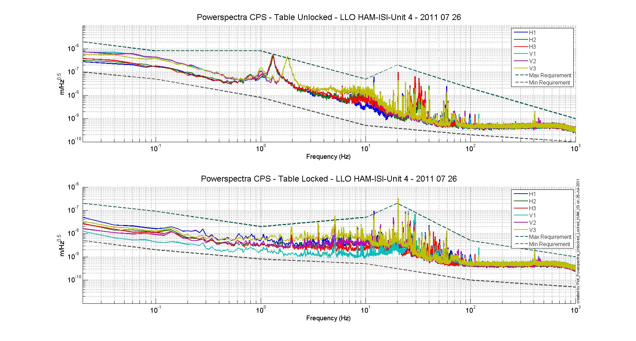
Figure - Calibrated CPS power spectrum

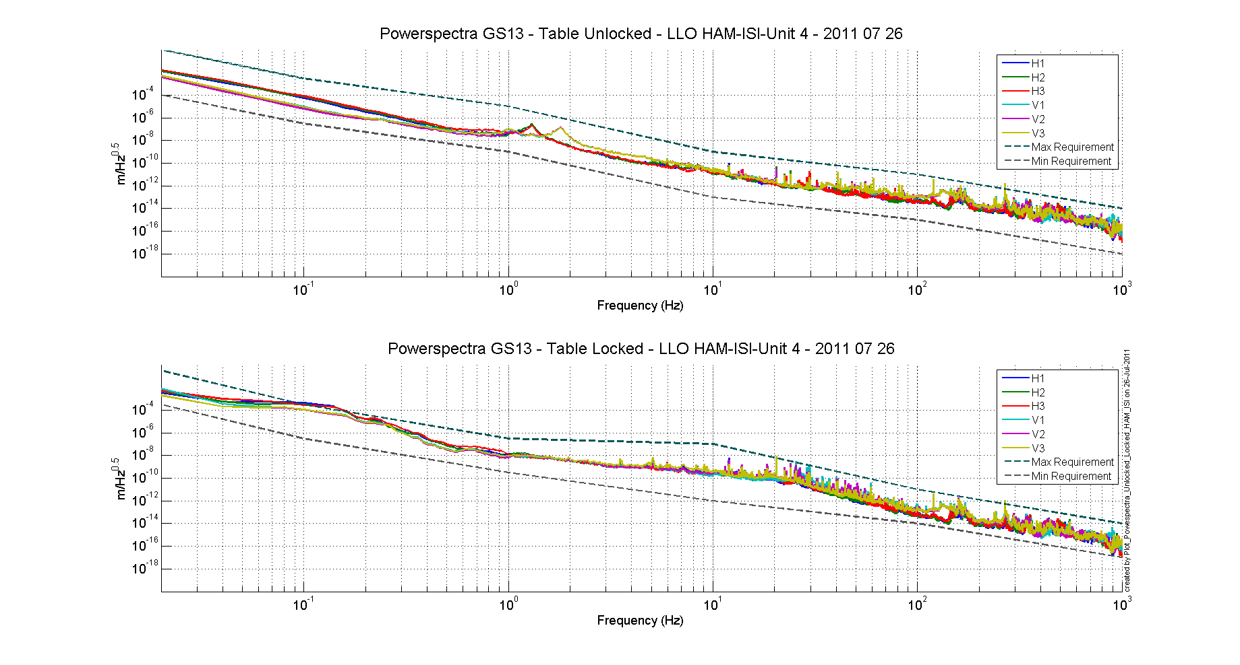
Figure – Power spectrum Calibrated GS13

Acceptance criteria:
- No cross talk (peaks at low frequencies + harmonics on measurements)
- Magnitudes of power spectra must be between requirement curves such as in the following figures (dashed lines)-Note that those are given as indication of what we've achieved in the past with precedent units, not absolute criteria.

Sensors | ISI state | Frequency (Hz) | 2x10⁻² | 1x10⁻¹ | 1 | 10 | 20 | 100 | 1000
GS-13 | Table locked | Max | 3x10⁻¹ | 3x10⁻⁴ | 3x10⁻⁷ | 10⁻⁷ |  | 10⁻¹¹ | 10⁻¹⁴
GS-13 | Table locked | Min | 3x10⁻⁴ | 3x10⁻⁷ | 3x10⁻¹⁰ | 10⁻¹² |  | 10⁻¹⁴ | 10⁻¹⁷
GS-13 | Table unlocked | Max | 1 | 3x10⁻³ | 10⁻⁵ | 10⁻⁹ |  | 10⁻¹¹ | 10⁻¹⁴
GS-13 | Table unlocked | Min | 10⁻⁴ | 3x10⁻⁷ | 10⁻⁹ | 10⁻¹³ |  | 10⁻¹⁵ | 10⁻¹⁸
CPS | Table locked | Max | 2*10⁻⁷ | 2x10⁻⁸ | 10⁻⁸ | 5x10⁻⁸ | 2x10⁻⁷ | 5x10⁻⁹ | 10⁻⁹
CPS | Table locked | Min | 5x10⁻⁹ | 2x10⁻⁹ | 8x10⁻¹⁰ | 5x10⁻¹⁰ |  | 10⁻¹⁰ | 5x10⁻¹¹
CPS | Table unlocked | Max | 2x10⁻⁶ | 8x10⁻⁷ | 8x10⁻⁷ | 5x10⁻⁸ | 2x10⁻⁷ | 2x10⁻⁸ | 10⁻⁹
CPS | Table unlocked | Min | 10⁻⁷ | 5x10⁻⁸ | 8x10⁻⁹ | 5x10⁻¹⁰ |  | 2x10⁻¹⁰ | 10⁻¹⁰
Table - Step 6 -Normal conditions-Sensors power spectra requirements

Issues/difficulties encountered during this test
Those measurements were taken during the day while normal assembly activities were going on in the area. The minor overshoot over the requirements don't seem consequent enough to fail this test.

Test result: Passed: X Failed: .

Step 7 - GS13 power spectrum -tabled tilted
The figure below presents the GS13 power spectrum when the table is unlocked and loaded with a 20Kg mass at one of its corner.

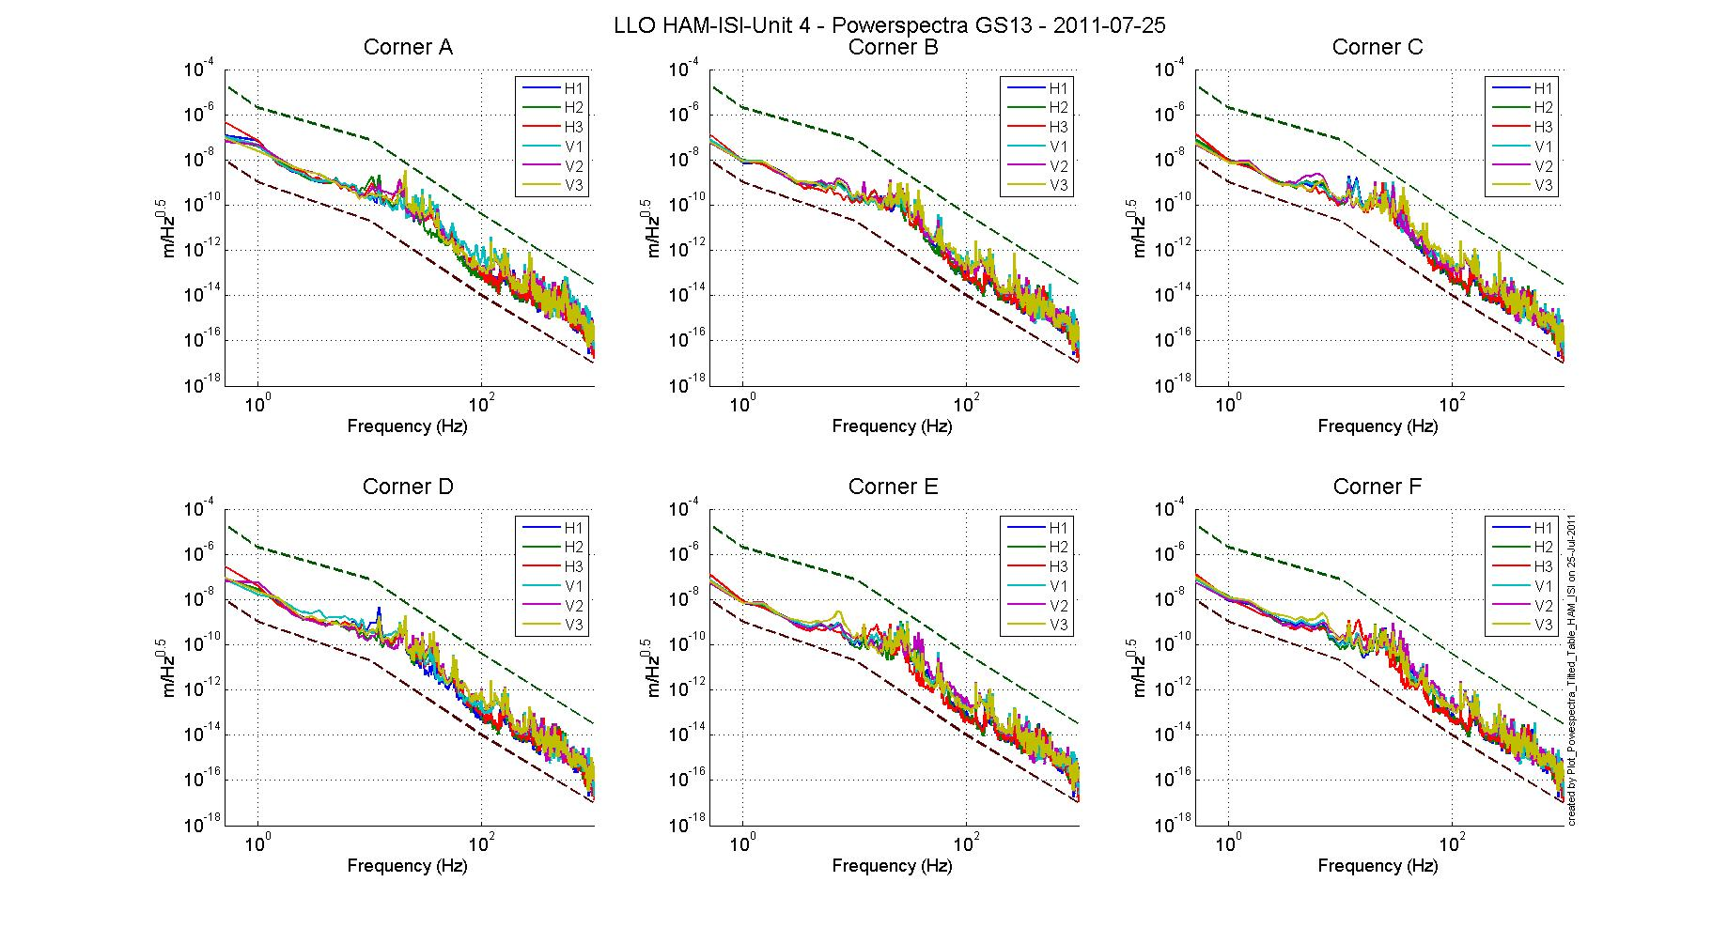
Figure – Power spectrum Calibrated GS13 with mass at corner

Data files in SVN at:
/opt/svncommon/seisvn/seismic/HAM-ISI/X2/Data/Unit_4/ Powerspectra/Undamped
- LLO_HAM_ISI_Unit_4_Calibrated_PSD_CPS_Unlocked_Locked_2011_07_26.mat
- LLO_HAM_ISI_Unit_4_Calibrated_PSD_GS13_Unlocked_Locked_2011_07_26.mat

Scripts files for taking and processing the data, and plotting it in SVN at:
/opt/svncommon/seisvn/seismic/HAM-ISI/X2/Scripts/Data_collection/
- Powerspectra_Measurements_Tilted_HAM_ISI.m

Figures in SVN at:
opt/svncommon/seisvn/seismic/HAM-ISI/X2/Data/Unit_4/Figures/ Powerspectra/Undamped
- LLO_HAM_ISI_Unit_4_Calibrated_PSD_GS13_Table_Tilted_2011_07_25
Acceptance criteria:
- With table unlocked and tilted, magnitudes of power spectra must be fully included within:

Sensor | ISI State | Frequency | 5x10⁻¹ Hz | 1 | 10 | 100 | 1000
GS-13 | Table Tilted | Max | 2x10⁻⁻⁵ | 2x10⁻⁻⁶ | 8x10⁻⁸ | 4x10⁻¹¹ | 3x10⁻¹⁴
GS-13 | Table Tilted | Min | 10⁻⁸ | 10⁻⁹ | 2x10⁻¹¹ | 10⁻¹⁴ | 10⁻¹⁷
Table - Table Tilted- Sensors power spectra requirements

Test result: Passed: X Failed: .

Step 8- GS13 pressure readout
Scripts files for taking and processing the data, and plotting it in SVN at: seismicSVN/Common/MatlabTools
- gs13Presstest.m

Figures in SVN at:
- seismicSVN/Common/Data/Pressure_Plots/Pressure_072011_to_072711_H1H2H3V1V2V3.pdf

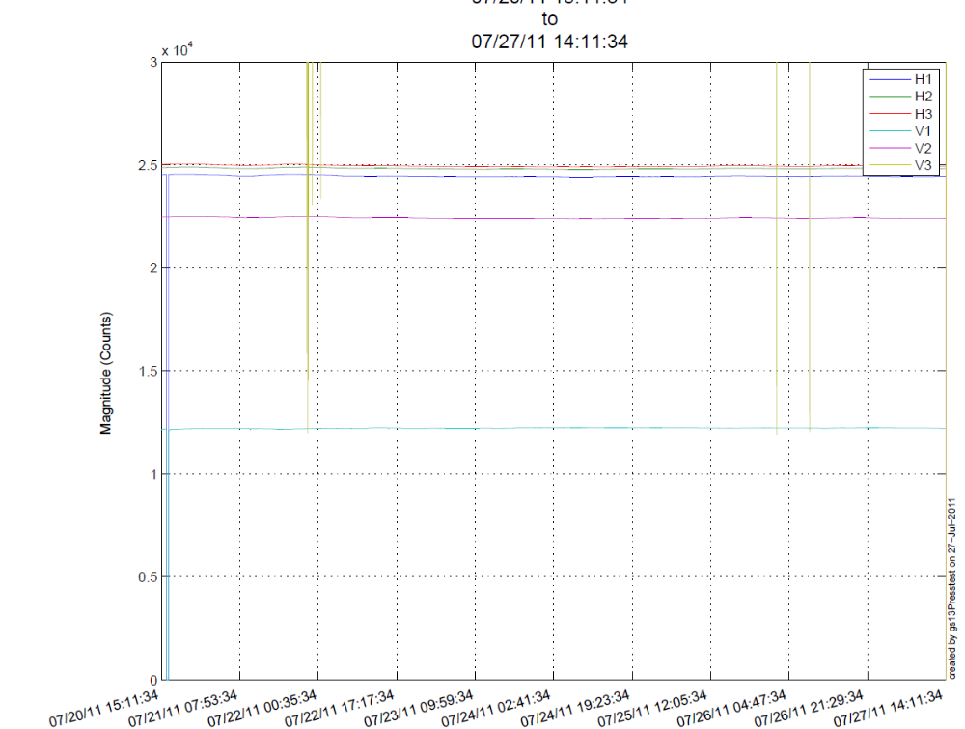
Figure – Pressure Plots
Issues/difficulties/comments regarding this test
We know that the drop to 0 at the end of the plot is due to issues with getdata.
We can notice issues with V1(value about 1/2 of what's expected) and V3 (saturating). However we were able to assess using dataviewer that the pressure sensors in the GS-13 pods V1 and V3 are ok, the read-out of those is damaged.

Acceptance criteria:
- The pressure on all channels must be 25000 counts +/- 3000 counts
- All channels must follow comparable trend

Test result: Passed: X Failed: .

Step 9 - Coil Driver, cabling and resistance check

Actuator | V1 |  | H1 |  | V2
Coil driver | S1000317 - Coarse 1 |  | S1000317 - Fine 1 |  | S1000317 - Fine 2
Anti image pin #
Cable # | 28 |  | 25 |  | 30
Resistance  (Ohm) | P1 - P2 | P2 - P3 | P1 - P2 | P2 - P3 | P1 - P2 | P2 - P3
Resistance  (Ohm) | 6.3 | O.L (infinity) | 6.5 | O.L (infinity) | 6.4 | O.L (infinity)
MEDM offset  (1000 counts) | Measurement P2 (-) ; P1&P3 (+) |  | Measurement P2 (-) ; P1&P3 (+) |  | Measurement P2 (-) ; P1&P3 (+)
MEDM offset  (1000 counts) | 0.3 |  | 0.301 |  | 0.3
Actuator | H2 |  | V3 |  | H3
Coil driver | S1000317 - Coarse 2 |  | S1000316 - Coarse 1 |  | S1000316 - Fine 1
Anti image pin #
Cable # | 29 |  | 26 |  | 27
Resistance  (Ohm) | P1 - P2 | P2 - P3 | P1 - P2 | P2 - P3 | P1 - P2 | P2 - P3
Resistance  (Ohm) | 6.4 | O.L (infinity) | 6.4 | O.L (infinity) | 6.3 | O.L (infinity)
MEDM offset  (1000 counts) | Measurement P2 (-) ; P1&P3 (+) |  | Measurement P2 (-) ; P1&P3 (+) |  | Measurement P2 (-) ; P1&P3 (+)
MEDM offset  (1000 counts) | 0.304 |  | 0.296 |  | 0.299
Table - Actuators resistance check

Acceptance criteria:

- The measured resistance between the middle pin and one side pin must be 6.5 +/-1 ohms
- Actuator neutral pins must be connected on pin #1 (left side pin of the plug)
- Actuator drive pins must be connected on pin #2 (middle pin of the plug)
- Actuator ground shield pins must be connected on pin #3 (right pin of the plug)
- All LEDs on the coil driver front panel must be green

The tests report must contain:
- The table “Actuators resistance check”
- Issues/difficulties/comments regarding this test
- Test result (Passed: X Failed: ).

Step 10 - Actuators Sign and range of motion (Local drive)

 | Negative drive | Positive drive
H1 readout (count) | -24456 | 24319
H2 readout (count) | -24056 | 24028
H3 readout (count) | -25048 | 25158
V1 readout (count) | -19090 | 20454
V2 readout (count) | -24938 | 27149
V3 readout (count) | -22392 | 21583
Table - Range of motion - Local drive

Data files in SVN at:
/opt/svncommon/seisvn/seismic/HAM-ISI/X2/Data/Unit_4/Static_Tests
- LLO_HAM-ISI_Unit_4_Range_Of_Motion_0721201120110721.mat

Scripts files for taking and processing the data, and plotting it in SVN at:
/opt/svncommon/seisvn/seismic/HAM-ISI/X2/Scripts/Data_collection
- Range_Motion_HAM_ISI.m

Acceptance criteria:
- Main couplings sensors readout must be at least 16000 counts (~0.02”)
- A positive offset drive on one actuator must give positive sensor readout on the collocated sensor. Signs will also be tested when measuring local to local transfer functions.

Test result: Passed: X Failed: .

Step 11 - Vertical Sensor Calibration

Lockers | D.I readout for  a negative drive | D.I readout without any drive | D.I readout for positive drive
A | 18.75 | 0 | -19
B | 18.5 | 0 | -19
C | 19.5 | 0 | -19
D | 19.5 | 0 | -19.5
Average | 19.0625 | 0 | -19.125 | 38.2
Sensors | Counts | Counts | Counts | Difference (Counts)
V1 | -15515 | 183.12 | 16717 | 32232
V2 | -15913 | 172.73 | 16217 | 32130
V3 | -17390 | -1902.5 | 13893 | 31283
 |  |  | Average | 31881.66667
Table - Calibration of capacitive position sensors

Vertical sensitivity: 31881.66667/38.2 = 834.9 count/mil
or 834.9 count/mil * 1/1638 V/count = 0.510V/mil
or 25400nm/mil * 1/845.3 mil/count = 30.42 nm/count

Nominal Calibration

CPS Sensitivity: 20V/0.039" = 20V/39mils = 0.513V/mil

Calibration in counts: 2¹⁵ / 20 * 20/39 = 840 count/mil
or 25400 nm/mil * 1/840 mil/count = 30.2nm/count

Difference with Nominal sensitivity = (840-834.9)/840=-0.61%

Acceptance criteria:

- Deviation from nominal value < 2%. Nominal value is 840 count/mil.

Test result: Passed: X Failed: .

Step 12 - Vertical Spring Constant

Results presented below are obtained after the initial sensors calibration.

Sensors | Mean diff counts | Mean diff m | K (N/m) | Error with average
V1 | 7911 | 2.39E-04 | 8.21E+04 | -9.25E-01
V2 | 7868 | 2.38E-04 | 8.26E+04 | -3.81E-01
V3 | 7737 | 2.34E-04 | 8.40E+04 | 1.31E+00
 |  | Average (N/m) | 8.34E+04
 |  | Total Stiffness (N/m) | 2.49E+05
Table - Vertical spring constant

Acceptance criteria:
- +/-2 % of 2.4704e5 N/m (i.e. between 2.421e5 and 2.520e5 N/m)
- +/- 5% of variation between each spring and the average

The measured error on the vertical stiffness is 0.66%

Test result: Passed: X Failed:

Step 13 - Static Testing (Tests in the local basis)

 |  | H1 | H2 | H3 | V1 | V2 | V3
Actuators  (1000 counts) | H1 | 2041 | 1300.4 | 1266 | -42.04 | 35.29 | -49.01
Actuators  (1000 counts) | H2 | 1253.4 | 2049.1 | 1263.9 | -52.74 | 32.19 | -40.61
Actuators  (1000 counts) | H3 | 1258.8 | 1292.7 | 2066.6 | -50.94 | 37.29 | -36.51
Actuators  (1000 counts) | V1 | 179.8 | 193.34 | -373.72 | 1417.9 | -16.91 | -659.51
Actuators  (1000 counts) | V2 | -325.2 | 194.6 | 207.96 | -564.24 | 1396.6 | 10.79
Actuators  (1000 counts) | V3 | 156.73 | -370.07 | 185.84 | -78.54 | -584.31 | 1423.6

Table - Main and cross coupling
Data files in SVN at:
/opt/svncommon/seisvn/seismic/HAM-ISI/X2/Data/Unit_4/Static_Tests
- LLO_HAM_ISI_Unit_4_Sensor_Readout_Local_20110721.mat

Scripts files for taking data in SVN at:
/opt/svncommon/seisvn/seismic/HAM-ISI/X2/Scripts/Data_Collection
- Sensor_Readout_Local_Drive_MEDM_HAM_ISI.m
Issues/difficulties/comments regarding this test:

Acceptance criteria:

- Vertical
For a +1000 count offset drive on vertical actuators
  - Collocated sensors must be 1400 counts +/- 10%

- Horizontal
For a +1000 count offset drive on horizontal actuators
  - Collocated sensors must be 2000 counts +/- 10%
  - Non-collocated horizontal sensors must be 1250 counts +/-10%

Test result: Passed: X Failed: .

Step 14 - Linearity test

 | Slope | Offset | Average slope | Variation from  average (%)
H1 | 2.103 | -199.1607 | 2.0952 | 0.38
H2 | 2.071 | 537.8538 | 2.0952 | -1.14
H3 | 2.111 | -634.8164 | 2.0952 | 0.76
V1 | 1.489 | 442.7404 | 1.4734 | 1.06
V2 | 1.472 | 104.35 | 1.4734 | -0.07
V3 | 1.459 | -1746.1 | 1.4734 | -0.98
Table - Slopes and offset of the triplet Actuators - HAM-ISI - Sensors

Scripts files for taking data in SVN at:
/opt/svncommon/seisvn/seismic/HAM-ISI/X2/Scripts/Data_Collection
- Linearity_Test_Awgstream_HAM_ISI.m

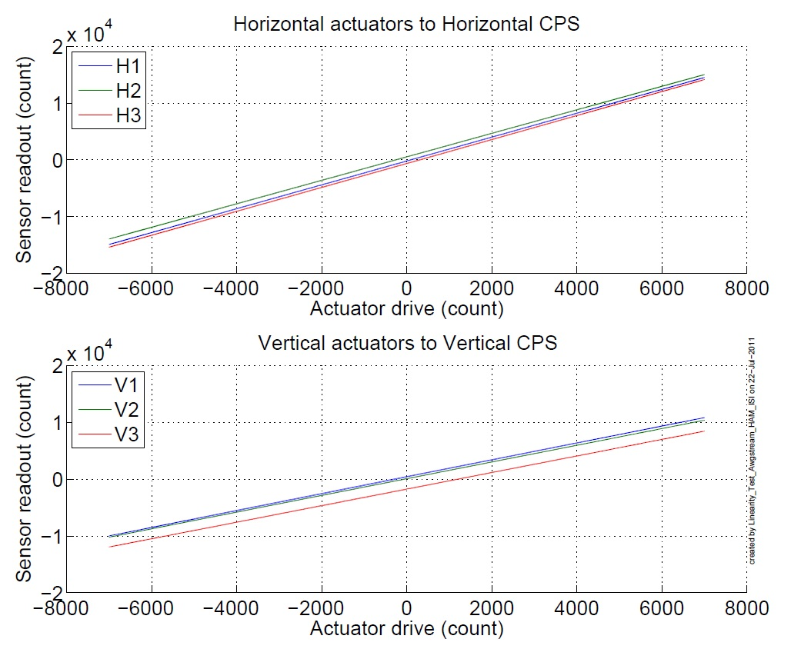
Figure - Horizontal and vertical actuators x HAM-ISI x sensors

Data files in SVN at:
/opt/svncommon/seisvn/seismic/HAM-ISI/X2/Data/Unit_4/Linearity_test
- LLO_HAM_ISI_Unit_4_Linearity_test_20110722.mat

Figures in SVN at:
/opt/svncommon/seisvn/seismic/HAM-ISI/X2/Data/Unit_4/Figures/Linearity_test
- LLO_HAM_ISI_Unit_4_Linearity_test_20110722.fig
- LLO_HAM_ISI_Unit_4_Linearity_test_20110722.pdf

Acceptance criteria:
- Horizontal and vertical slopes of the triplet actuators x HAM-ISI x sensors: Average slope +/- 1%

Issues/difficulties/comments regarding this test:
We barely failed that test, so we tried to repeat the tests but the result were very comparable. We believe that failing that test in those proportions is not a big issue.

Test result: Passed: Failed: X .

Step 15 - Cartesian Basis Static Testing
 | 1000 counts drive | X Drive | Y Drive | Z Drive | Rx Drive | Ry Drive | Rz Drive
Sensors readout  (count) | H1 | 253.65 | -470.19 | -4.74 | -454.37 | -286.1 | -2028.1
Sensors readout  (count) | H2 | 227.21 | 412.57 | -2.703 | 429.35 | -291.2 | -2051.8
Sensors readout  (count) | H3 | -533.67 | -1.68 | -7.58 | 2.62 | 547.4 | -2026.7
Sensors readout  (count) | V1 | -1.338 | -8.682 | 283.45 | -502.49 | -1703.7 | -7.515
Sensors readout  (count) | V2 | 5.659 | 4.266 | 285.55 | 1703.8 | 461.28 | 16.183
Sensors readout  (count) | V3 | -9 | 4.3 | 255.3 | -1207.2 | 1251.5 | -1.7
Sensors readout  (count) | Direction read out | 510.06 | 509.94 | 276.82 | 2594.82 | 2631.6 | 2568.2
Table - Tests in the general coordinate basis

Issues/difficulties/comments regarding this test:

Acceptance criteria:
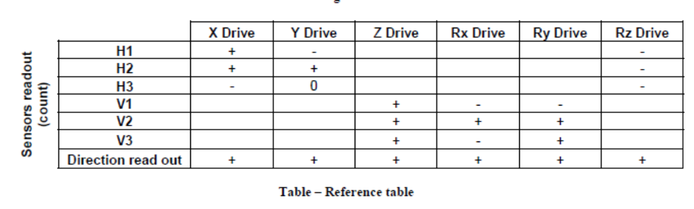
For a positive drive in the Cartesian basis:
- Local sensor readout must have the same sign that the reference table (CONT2ACT check)
- Cartesian sensors read out must be positive (DISP2CEN check) in the drive direction

Test result: Passed: X Failed: .

Step 16- Frequency response
Compensation filters of the new GS13 interface chassis are located in the geophone pre-filters bank. Powerspectra were measured with masses on the optic table not bolted.

Step 16.1 - Local to local measurements
Local to local transfer functions have been measured with 90 repetitions.
Data files in SVN at:
/opt/svncommon/seisvn/seismic/HAM-ISI/X2/Data/Unit_4/Transfer_Functions/Measurements/
Undamped/
- LLO_HAM_ISI_Unit_4_Data_TF_L2L_50mHz_500mHz_20110725-232107.mat
- LLO_HAM_ISI_Unit_4_Data_TF_L2L_500mHz_5Hz_20110725-201546.mat
- LLO_HAM_ISI_Unit_4_Data_TF_L2L_200Hz_800Hz_20110725-170904.mat
- LLO_HAM_ISI_Unit_4_Data_TF_L2L_5Hz_200Hz_20110725-184225.mat

Data collection script files:
opt/svncommon/seisvn/seismic/HAM-ISI/X2/Scripts/Data_Collection
- Run_TF_L2L_50mHz_500mHz.m
- Run_TF_L2L_500mHz_5Hz.m
- Run_TF_L2L_5mHz_200Hz.m
- Run_TF_L2L_200Hz_800Hz.m
Scripts files for processing and plotting in SVN at:
/opt/svncommon/seisvn/seismic/HAM-ISI/X2/Data/Unit_4/Transfer_Functions/Measurements/
Undamped/
- Plot_LLO_HAM_ISI_Unit_4_TF_L2L_2011_07_26.m
Figures in SVN at:
opt/svncommon/seisvn/seismic/HAMISI/X2/Data/Unit_4/Figures/Transfer_Functions/Measurements/
Undamped/
- LLO_HAM_ISI_Unit_4_TF_L2L_H_CPS_50mHz_800Hz_2011_07_26.fig
- LLO_HAM_ISI_Unit_4_TF_L2L_V_CPS_50mHz_800Hz_2011_07_26.fig
- LLO_HAM_ISI_Unit_4_TF_L2L_H_GS13_50mHz_800Hz_2011_07_26.fig
- LLO_HAM_ISI_Unit_4_TF_L2L_V_GS13_50mHz_800Hz_2011_07_26.fig
Storage of measured transfer functions in the SVN at:
opt/svncommon/seisvn/seismic/HAM-ISI/X2/Data/Unit_4/Transfer_functions/ Measurements/
Undamped/
- LLO_HAM_ISI_Unit_4_Data_TF_L2L_2011_07_26.mat

The local to local transfer functions are presented below.

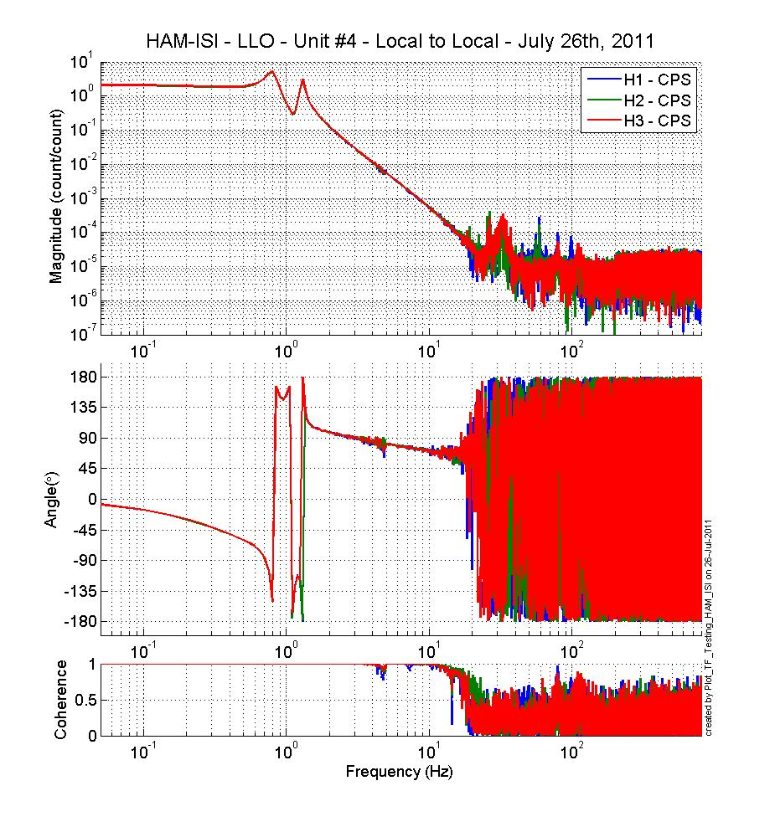
Figure - Local to Local Measurements – Horizontal capacitive sensors
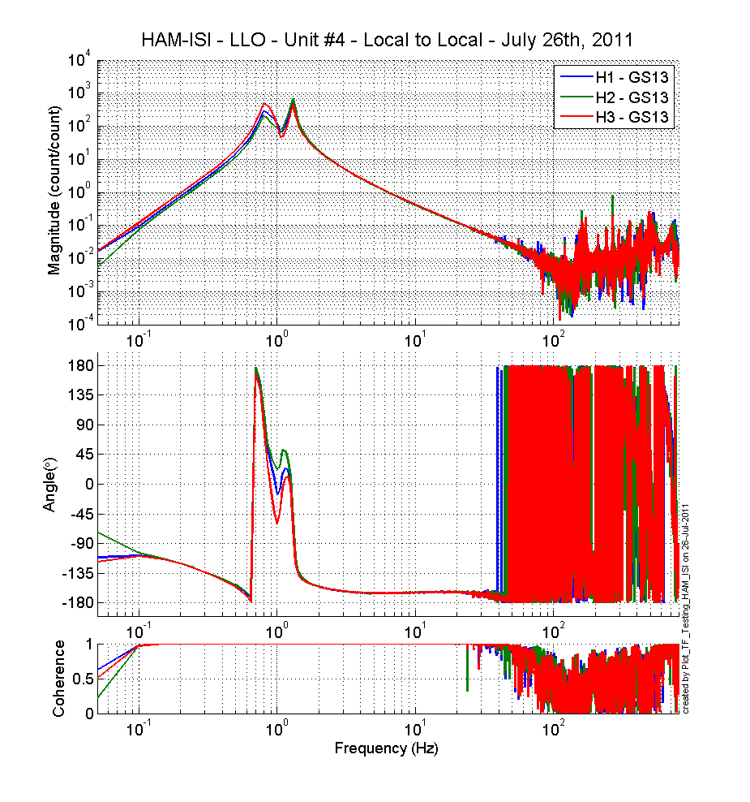
Figure - Local to Local Measurements – Horizontal inertial sensors

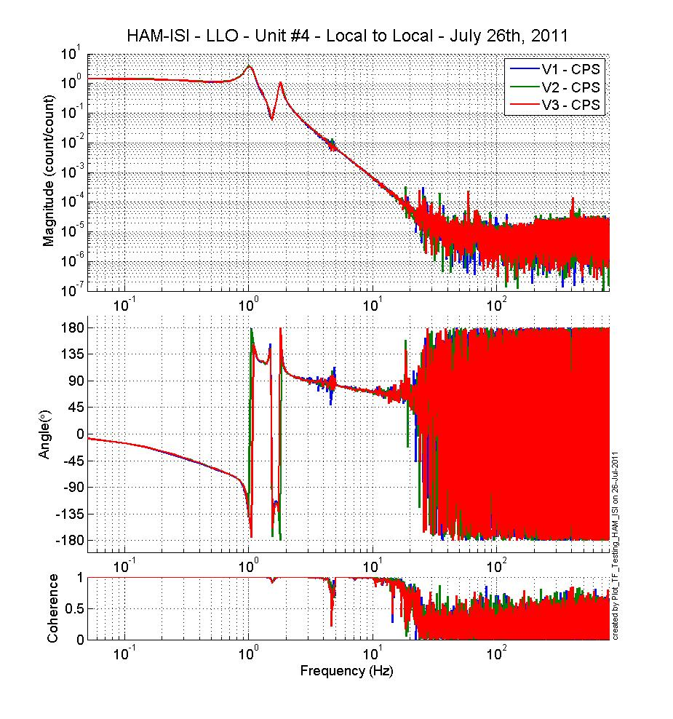
Figure - Local to Local Measurements – Vertical capacitive sensors
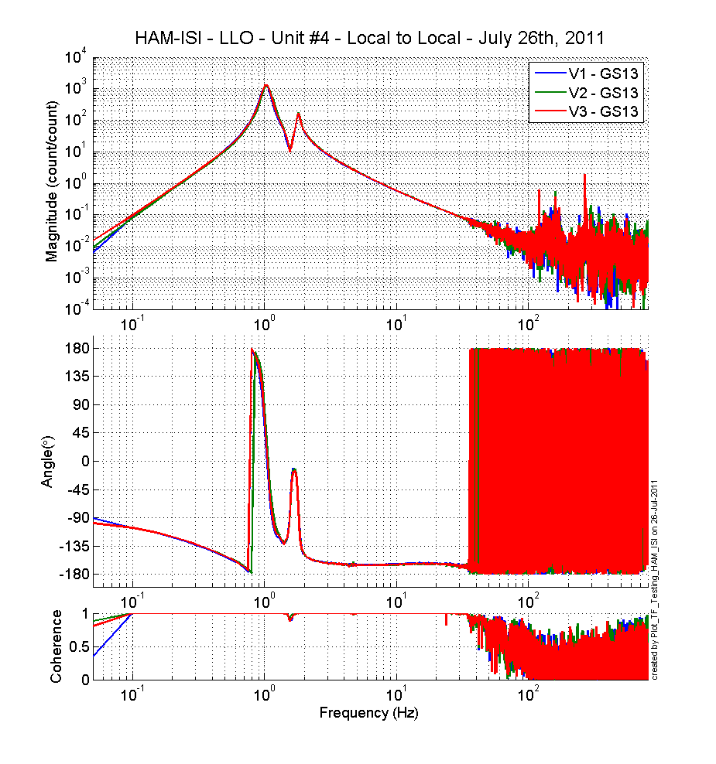
Figure - Local to Local Measurements – Vertical inertial sensors

Issues/difficulties/comments regarding this test:
Around 1 Hz, the horizontal inertial sensors have comparable behavior but slightly different amplitude.

Step 16.2 - Cartesian to Cartesian measurements
Cartesian to Cartesian transfer functions have been measured with 90 repetitions.
Data files in SVN at:
opt/svncommon/seisvn/seismic/HAM-ISI/X2/Data/Unit_4/Transfer_Functions/Measurements/
Undamped/
- LLO_HAM_ISI_Unit_4_Data_TF_C2C_50mHz_500mHz_20110723-090418.mat
- LLO_HAM_ISI_Unit_4_Data_TF_C2C_500mHz_5Hz_20110723-055855.mat
- LLO_HAM_ISI_Unit_4_Data_TF_C2C_5Hz_200Hz_20110723-042532.mat
- LLO_HAM_ISI_Unit_4_Data_TF_C2C_200Hz_800Hz_20110723-025209.mat

Scripts files for processing and plotting in SVN at:
opt/svncommon/seisvn/seismic/HAM-ISI/X2/Data/Unit_4/Transfer_Functions/Measurements/
Undamped/
- Plot_LLO_HAM_ISI_Unit_4_TF_C2C_2011_07_26
Figures in SVN at:
opt/svncommon/seisvn/seismic/HAM-ISI/X2/Data/Unit_4/Figures/Transfer_Functions/
Measurements/Undamped/
- LLO_HAM_ISI_Unit_4_TF_C2C_Z_RX_RY_CPS_50mHz_800Hz_2011_07_26.fig
- LLO_HAM_ISI_Unit_4_TF_C2C_X_Y_RZ_GS13_50mHz_800Hz_2011_07_26.fig
- LLO_HAM_ISI_Unit_4_TF_C2C_Z_RX_RY_CPS_50mHz_800Hz_2011_07_26.fig
- LLO_HAM_ISI_Unit_4_TF_C2C_Z_RX_RY_GS13_50mHz_800Hz_2011_07_26.fig

Storage of measured transfer functions in the SVN at:
/svncommon/seisvn/seismic/HAM-ISI/X2/Data/Unit_4/Transfer_functions/Measurements/Undamped
- LLO_HAM_ISI_Unit_4_Data_TF_C2C_2011_07_26
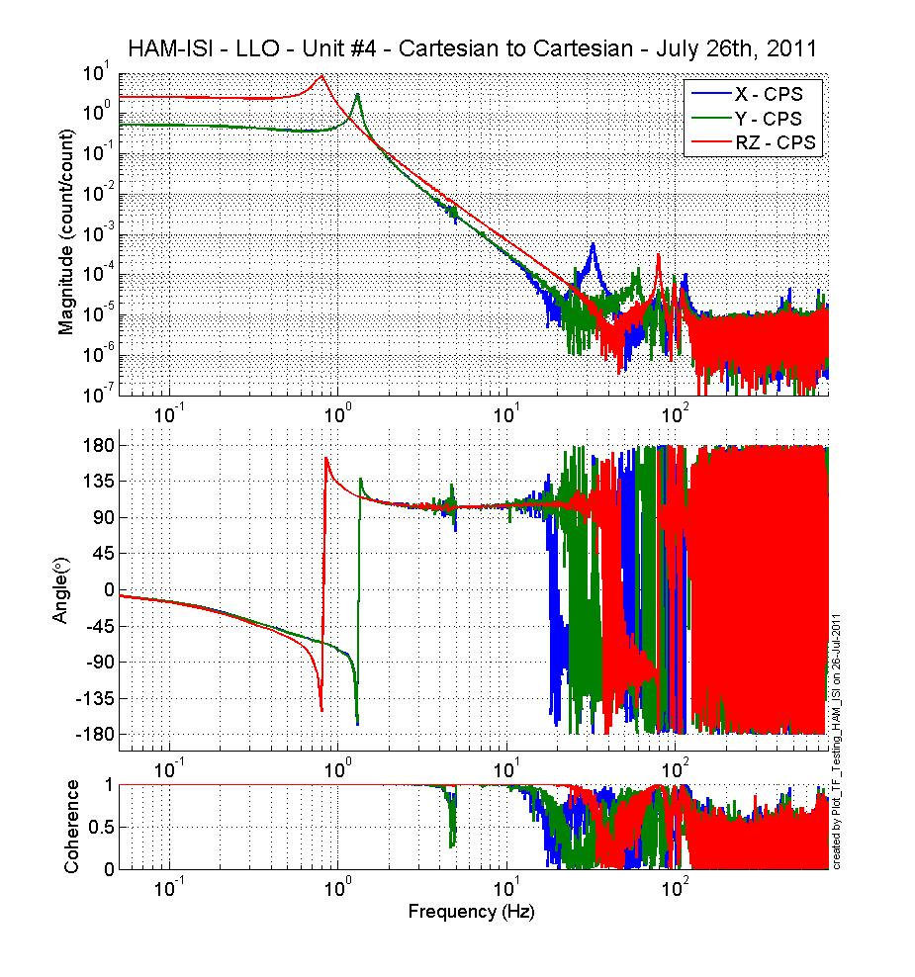
Figure - Cartesian to Cartesian CPS measurements – X, Y, RZ directions

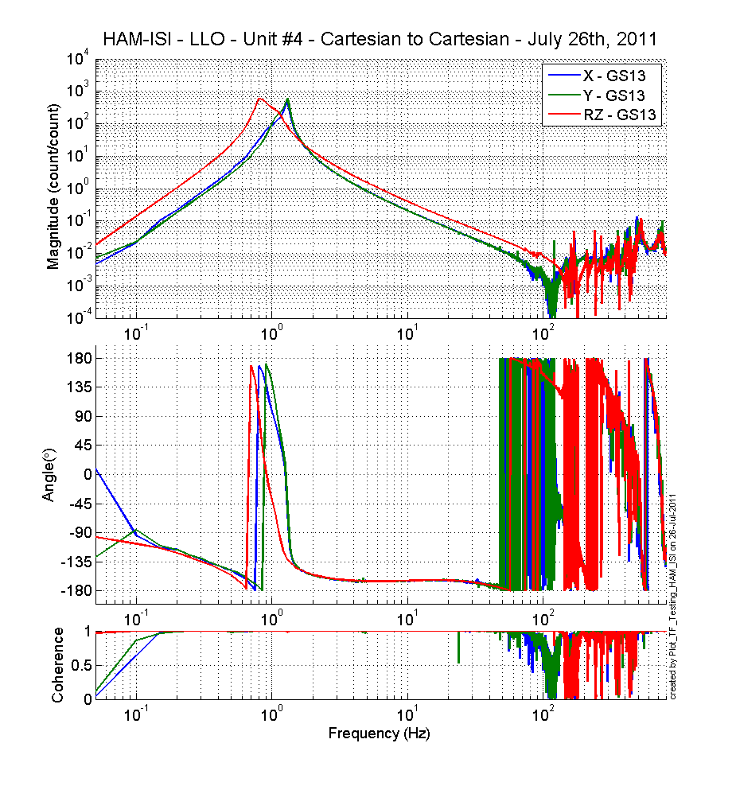
Figure - Cartesian to Cartesian GS-13 measurements – X, Y, RZ directions

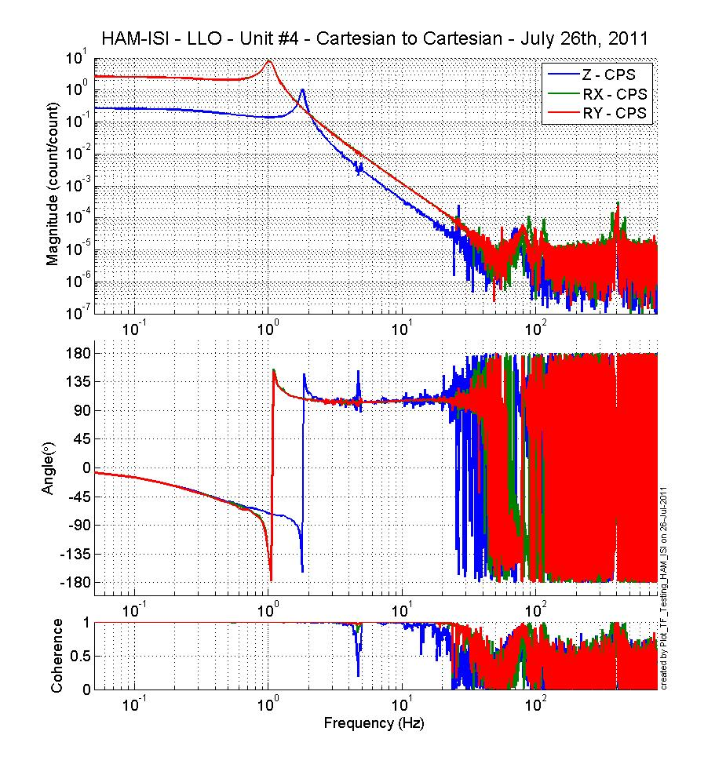
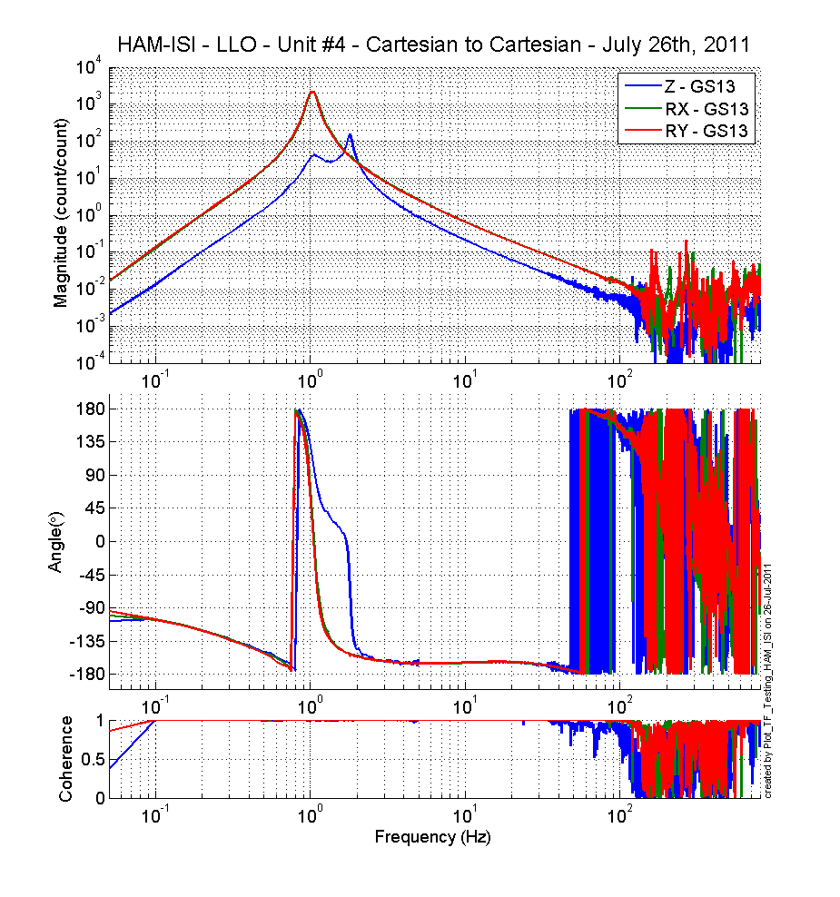
Figure - Cartesian to Cartesian measurements – Z, RX, RY directions

Issues/difficulties/comments regarding this test:

Acceptance criteria:
- Local to local measurements
  - On CPS, the phase must be 0º at DC
  - On Geophones, the phase must be -90º at DC
  - Identical shape in each corner
- Cartesian to Cartesian measurements
  - On CPS, the phase must be 0º at DC
  - On Geophones, the phase must be -90º at DC
  - Identical shape X/Y and RX/RY

Test result: Passed: X Failed: .

Step 17 - Transfer function comparison with Reference

Step 17.1 - Local to local - Comparison with Reference
This is the 2nd unit which is compared to LHO Unit #2 instead of LLO HAM 6 (v4 was comparing to LLO HAM 6 and both data can be found on the SVN).

Scripts files for processing and plotting in SVN at:
/opt/svncommon/seisvn/seismic/HAM-ISI/X2/Data/Unit_4/Transfer_Functions/Measurements/
Undamped/
- Plot_LLO_HAM_ISI_Unit_4_TF_L2L_2011_07_26

Local to local figures in SVN at:
/svncommon/seisvn/seismic/HAM-ISI/X2/Data/Unit_4/Figures/Transfer_Functions/Measurements/Undamped
- LLO_HAM_ISI_Unit_4_TF_L2L_H_CPS_50mHz_800Hz_wRef_2011_07_26.fig
- LLO_HAM_ISI_Unit_4_TF_L2L_V_CPS_50mHz_800Hz_wRef_2011_07_26.fig
- LLO_HAM_ISI_Unit_4_TF_L2L_H_GS13_50mHz_800Hz_wRef_2011_07_26.fig
- LLO_HAM_ISI_Unit_4_TF_L2L_V_GS13_50mHz_800Hz_wRef_2011_07_26.fig

GS13, Local to local measurement
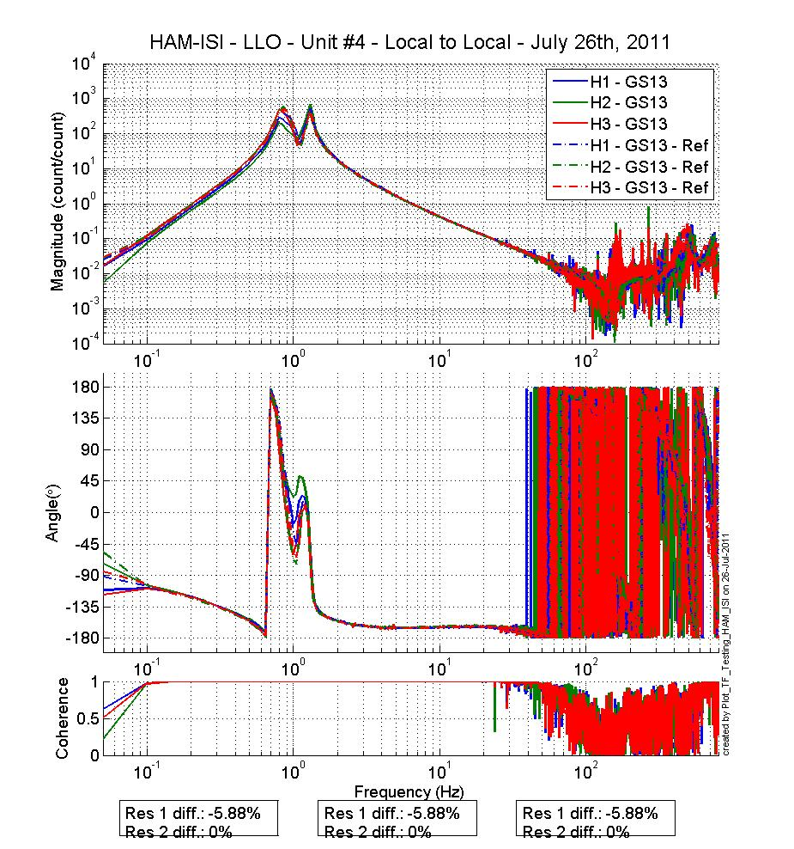
Figure - Local to local measurements comparison with LHO UNIT 2 – Horizontal GS-13
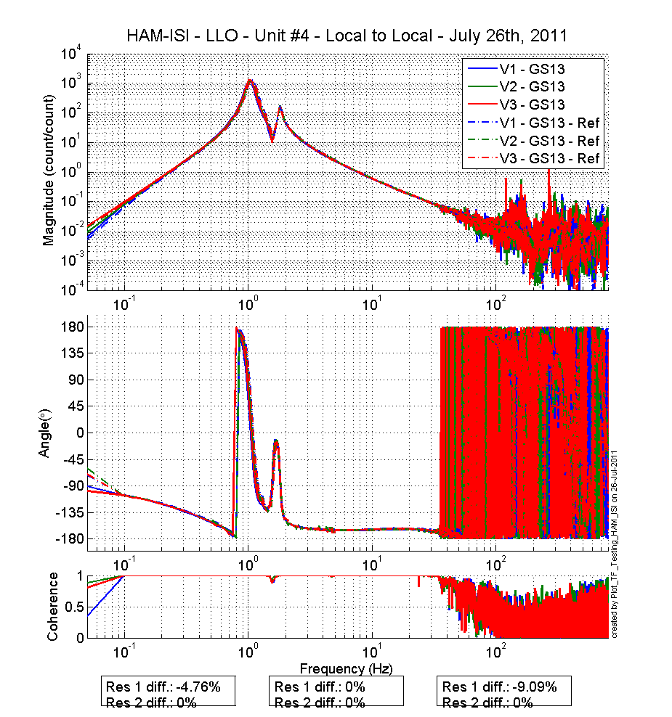
Figure - Local to local measurements comparison with LHO UNIT 2 – Vertical GS13
CPS, Local to local measurement, Undamped
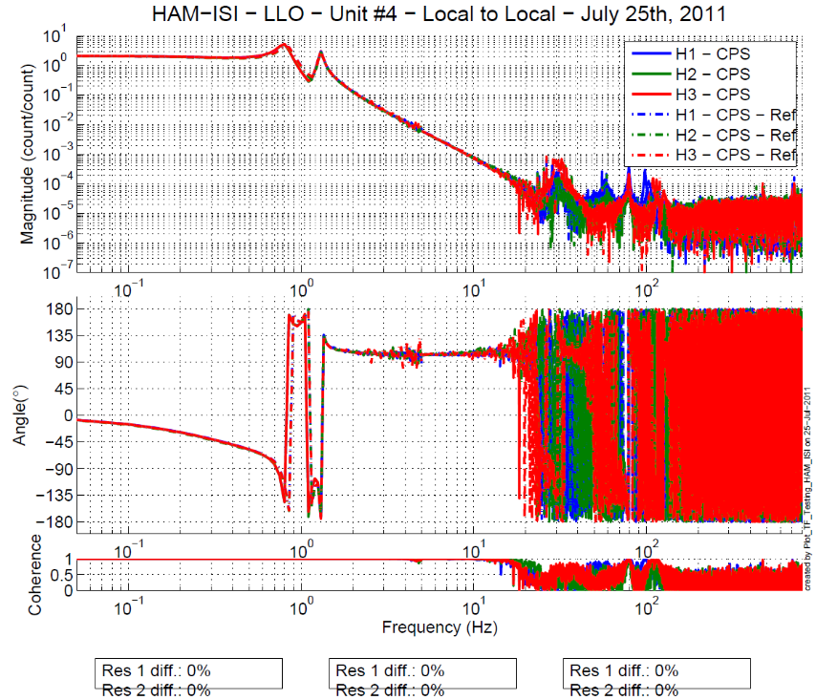
Figure - Local to local measurements comparison – Horizontal Position sensors

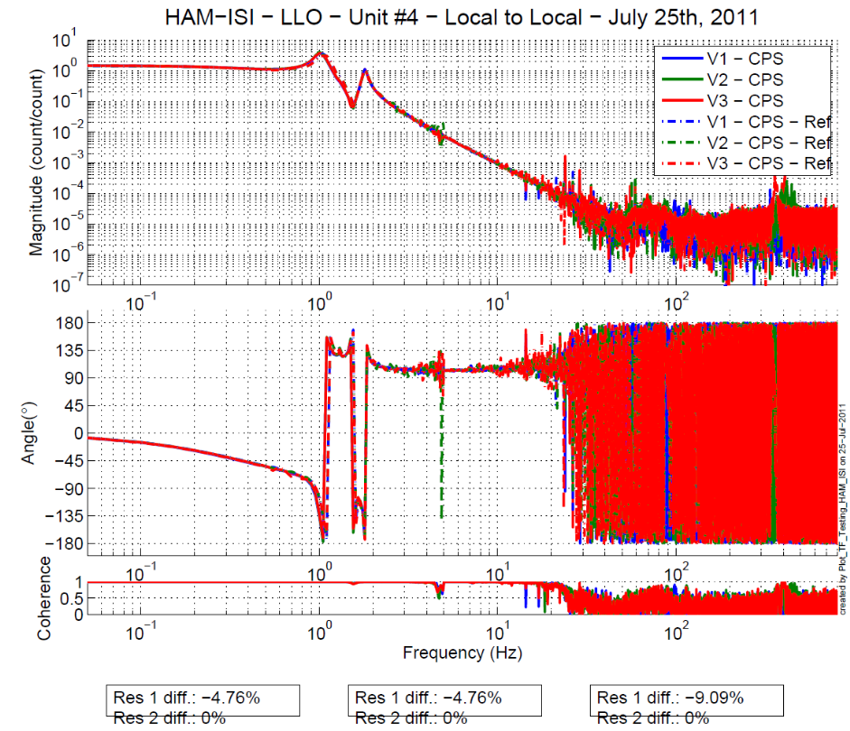
Figure - Local to local measurements comparison – Vertical Position sensors

Issues/difficulties/comments regarding this test
In order to get matching results with LHO Unit #2, we had to have the L2L transfer functions taken this way:
- CPS sensors TF: with the "comp" filters engaged in the pre-filters bank of the GS-13
- GS-13 sensors TF: with the "comp" filters engaged right next to the damping loops in the damping path, which seems a problem because here we're filter the excitation.

Step 17.2 - Cartesian to Cartesian - Comparison with Reference
Scripts files for processing and plotting in SVN at:
opt/svncommon/seisvn/seismic/HAM-ISI/X2/Data/Unit_4/Transfer_Functions/Measurements/
Undamped/
- Plot_LLO_HAM_ISI_Unit_4_TF_C2C_2011_07_26.m
Cartesian to Cartesian figures in SVN at :
/svncommon/seisvn/seismic/HAM-ISI/X2/Data/Unit_4/Figures/Transfer_functions/Measurements/Undamped
- LLO_HAM_ISI_Unit_4_TF_C2C_X_Y_RZ_CPS_50mHz_800Hz_wRef_2011_07_26.fig
- LLO_HAM_ISI_Unit_4_TF_C2C_X_Y_RZ_GS13_50mHz_800Hz_wRef_2011_07_26.fig
- LLO_HAM_ISI_Unit_4_TF_C2C_Z_RX_RY_CPS_50mHz_800Hz_wRef_2011_07_26.fig
- LLO_HAM_ISI_Unit_4_TF_C2C_Z_RX_RY_GS13_50mHz_800Hz_wRef_2011_07_26.fig

GS13, Cartesian to Cartesian measurement, Undamped
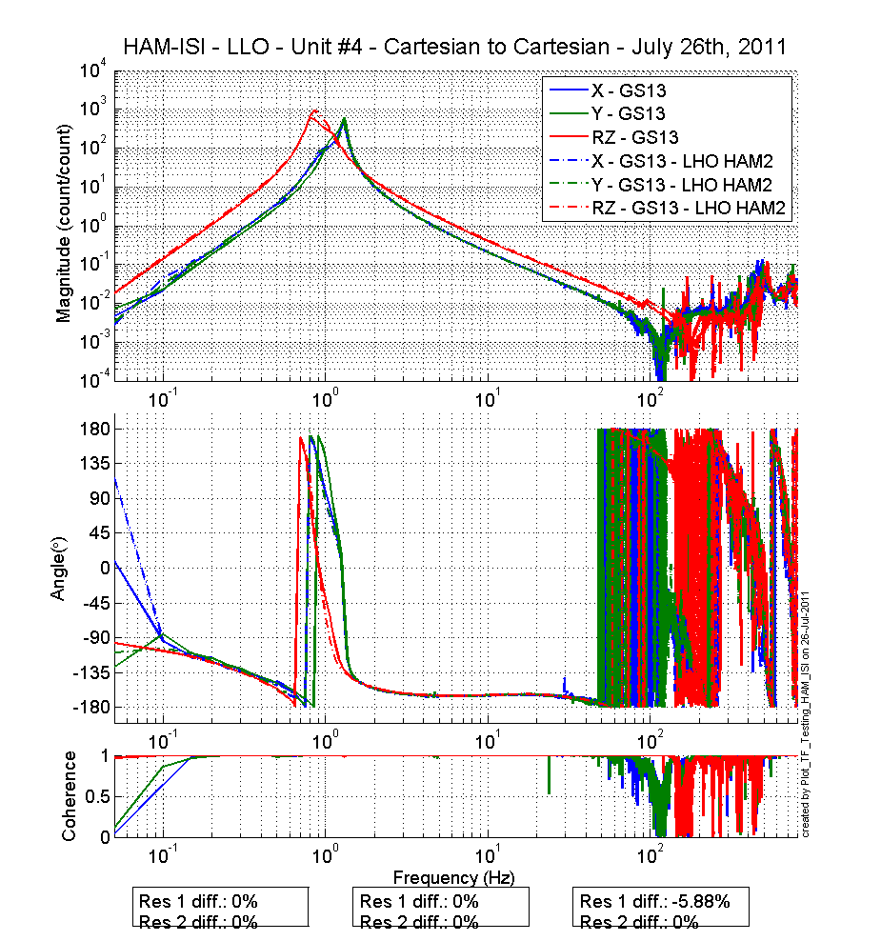
Figure - Cartesian to Cartesian measurements comparison with LHO Unit2 – Horiz GS13

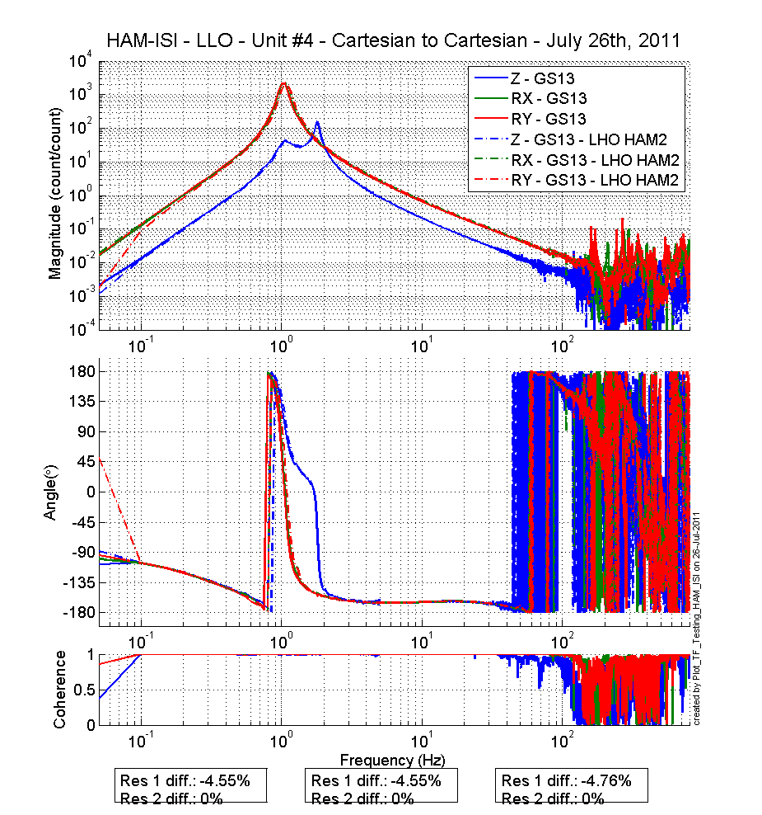
Figure - Cartesian to Cartesian measurements comparison with LHO Unit2 – Vertical GS13
CPS, Cartesian to Cartesian measurement, Undamped
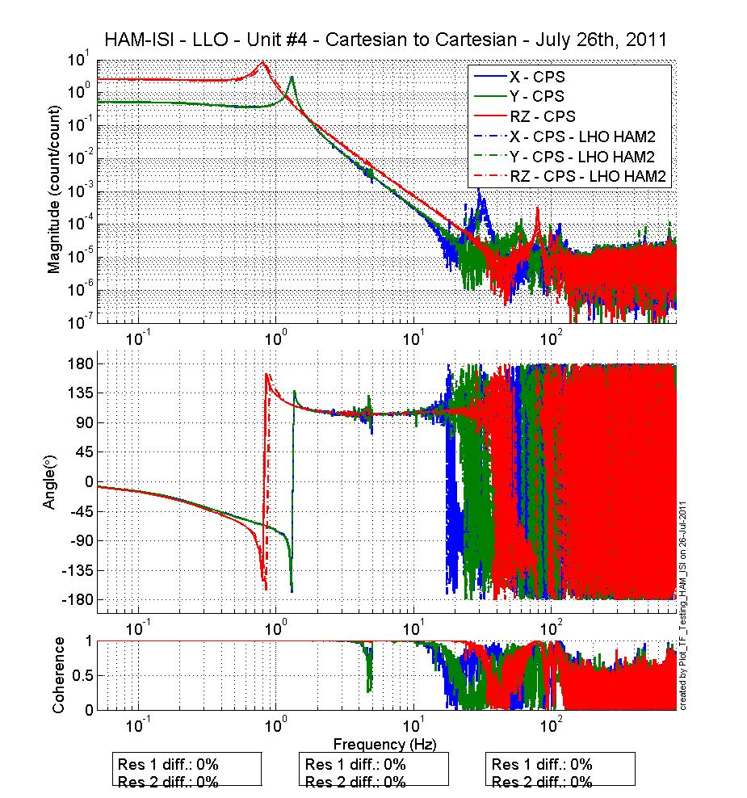
Figure - Cartesian to Cartesian measurements comparison with LHO Unit2 – Horizontal Position sensors

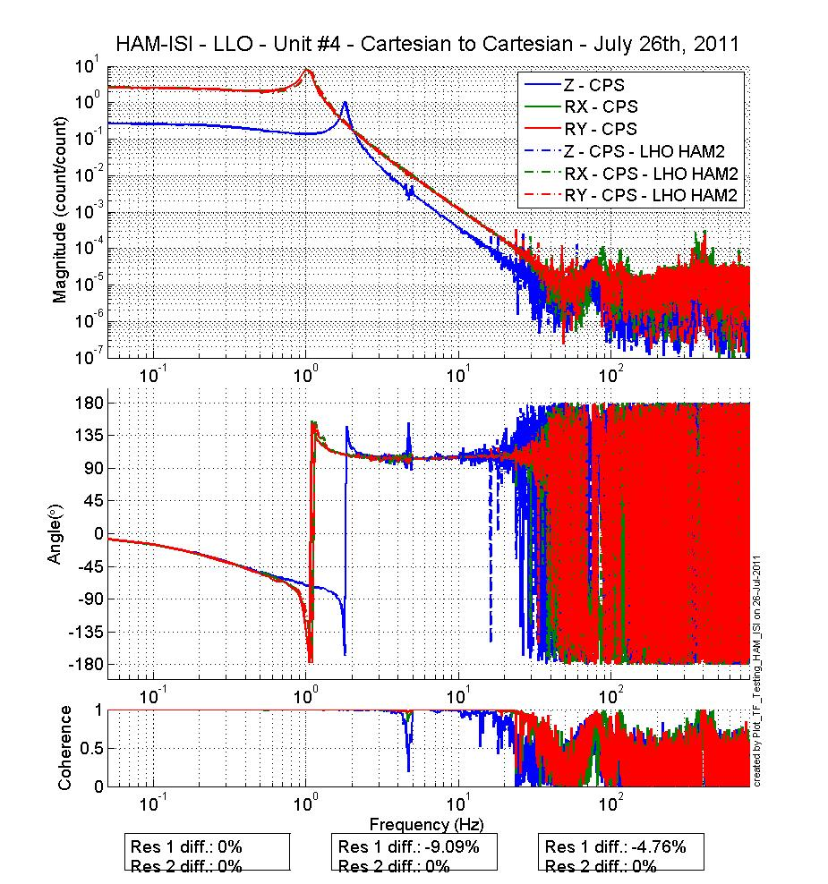
Figure - Cartesian to Cartesian measurements comparison with LHO Unit2 – Vertical Position sensor

Acceptance criteria:

- No difference with the reference transfer functions (SVN)
  - Phase – less than 10º - In Phase – Out of Phase
  - Damping (fit by eye with Reference transfer functions)
  - DC gain
  - Eigen frequencies shift less than 10%

Test result: Passed: X Failed: .

Step 18 - Lower Zero Moment Plane

Data collection script files:
opt/svncommon/seisvn/seismic/HAM-ISI/X2/Scripts/Data_Collection
- Run_Cart2Cart_10mHz_100mHz.m
Data files in SVN at:
opt/svncommon/seisvn/seismic/HAM-ISI/X2/Data/Unit_4/Transfer_Functions/Measurements/
Undamped/
- LZMP_LLO_HAM-ISI-Unit_4_2011_07_27.mat
Scripts files for processing and plotting in SVN at:
opt/svncommon/seisvn/seismic/HAM-ISI/X2/Data/Unit_4/Transfer_Functions/Measurements/
Undamped/
- LZMP_2011_07_27.m
Figures in SVN at:
opt/svncommon/seisvn/seismic/HAM-ISI/X2/Data/Unit_4/Figures/Transfer_Functions/
Measurements/Undamped/
- LZMP.fig

X & Y offsets:
X offset (mm) | 0.5852
Y offset (mm) | 0.3433
Table – Offset of the Lower Zero Moment Plane

The results from two measurements are presented on the figure below:
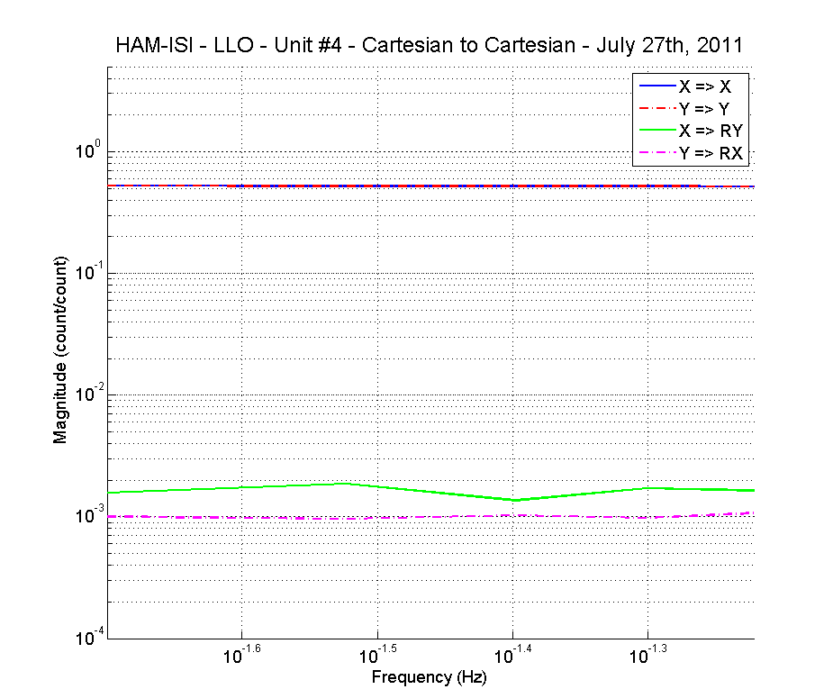
Figure - Lower Zero moment plane – Main and cross couplings at low frequency

Issues/difficulties/comments regarding this test
Because it was found on unit #2 that the results were not easily repeatable, we took 2 sets of data. It appears than the results can move by as much as 0.08 mm between different tests.

Acceptance criteria:
- X offset must be less than 2 mm
- Y offset must be less than 2 mm

Test result: Passed: X Failed: .

Step 19 - Damping loops
In this step, HAM6 damping loops are implemented. First, damping performances are evaluated in simulation. Second, Damping loops are implemented and performance is experimentally measured.

Step 19.1 - Transfer functions - Simulation
Scripts files for processing and plotting in SVN at:
/opt/svncommon/seisvn/seismic/HAM-ISI/X2/Data/Unit_4/Transfer_Functions/Simulation/Damping
- HAM_ISI_LLO_Unit_4_Damping_TF_2011_07_26.m
Figures in SVN at:
/svncommon/seisvn/seismic/HAM-ISI/X2/Data/Unit_4/Figures/Transfer_Functions/Simulations/
Damping/
- LLO_HAM_ISI_Unit_4_Damping_TF Horizontals_2011_07_26.fig
- LLO_HAM_ISI_Unit_4_Damping_TF Verticals_2011_07_26.fig

Results are saved in SVN at:
/opt/svncommon/seisvn/seismic/HAM-ISI/X2/Data/Unit_4/Transfer_Functions/Simulations/
Damping/
The following figures present the plant, controller, open loop, closed loop and sensitivity of vertical and horizontal damping loops. H1 (respectively V1) are plotted in solid line, H2 (respectively V2) are plotted in dash line, H3 (respectively V3) are plotted in dash-dot line.

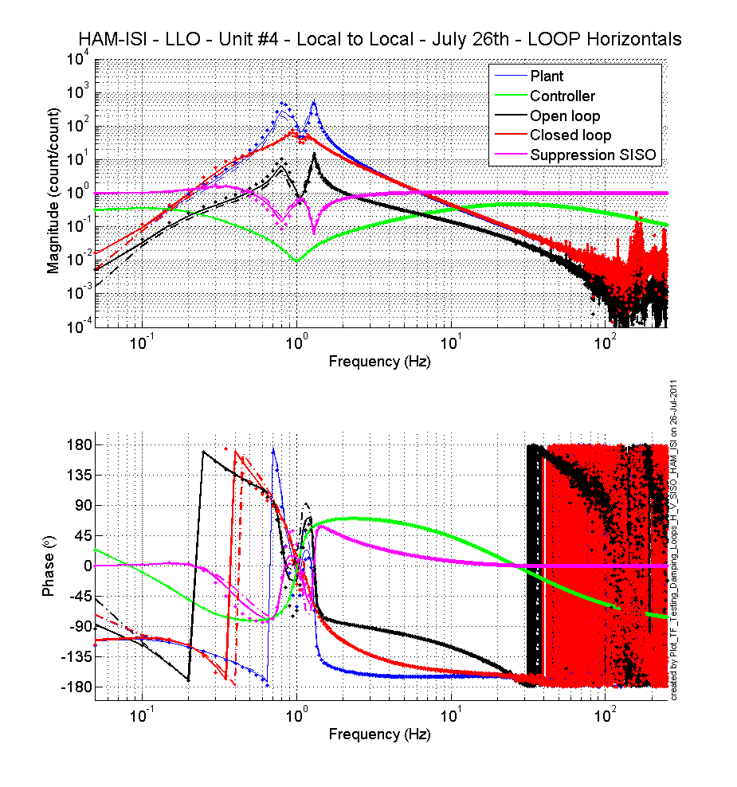
Figure - Horizontal damping loops - Simulation

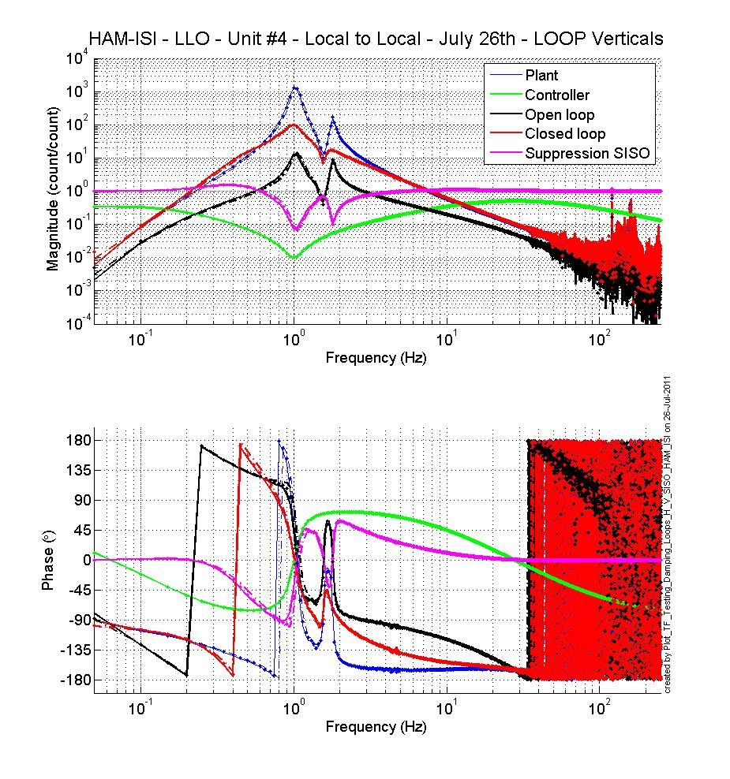
Figure - Vertical damping loops - Simulation
Acceptance criteria:

- HAM6 damping loops must implemented and stable with
  - Phase margin must be at least 45º
  - Gain margin must be at least 20dB

Test result: Passed: X Failed: .

Step 19.2 - Powerspectra – Experimental

Data files in SVN at:
/opt/svncommon/seisvn/seismic/HAM-ISI/X2/Data/Unit_4/Powerspectra/Damping/
Scripts files for taking data and plotting in SVN at:
/opt/svncommon/seisvn/seismic/HAM-ISI/X2/Scripts/Data_Collection/
- Powerspectra_Measurements_Undamped_Damped_HAM_ISI.m
Figures in SVN at:
/svncommon/seisvn/seismic/HAM-ISI/X2/Data/Unit_4/Figures/Powerspectra/Damping/
- LLO_HAM_ISI_Unit_4_Calibrated_PSD_CPS_Undamped_Damped_2011_07_25.fig
- LLO_HAM_Unit_4_Suppression_Exp_vs_Sim_2011_07_27.fig

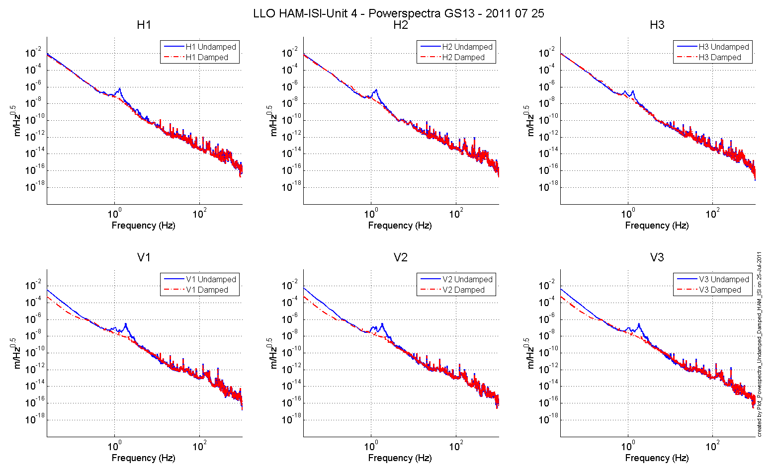

Sensitivity:
The figure below compare the sensitivity ('Undamped/Damped') of LLO HAM (Aug 2008) and LHO Unit 2. Performances are very similar, which confirms that we can use the damping loop as they are (modulo electronics change compensation). The plot also shows that the measured performance matches with the prediction.

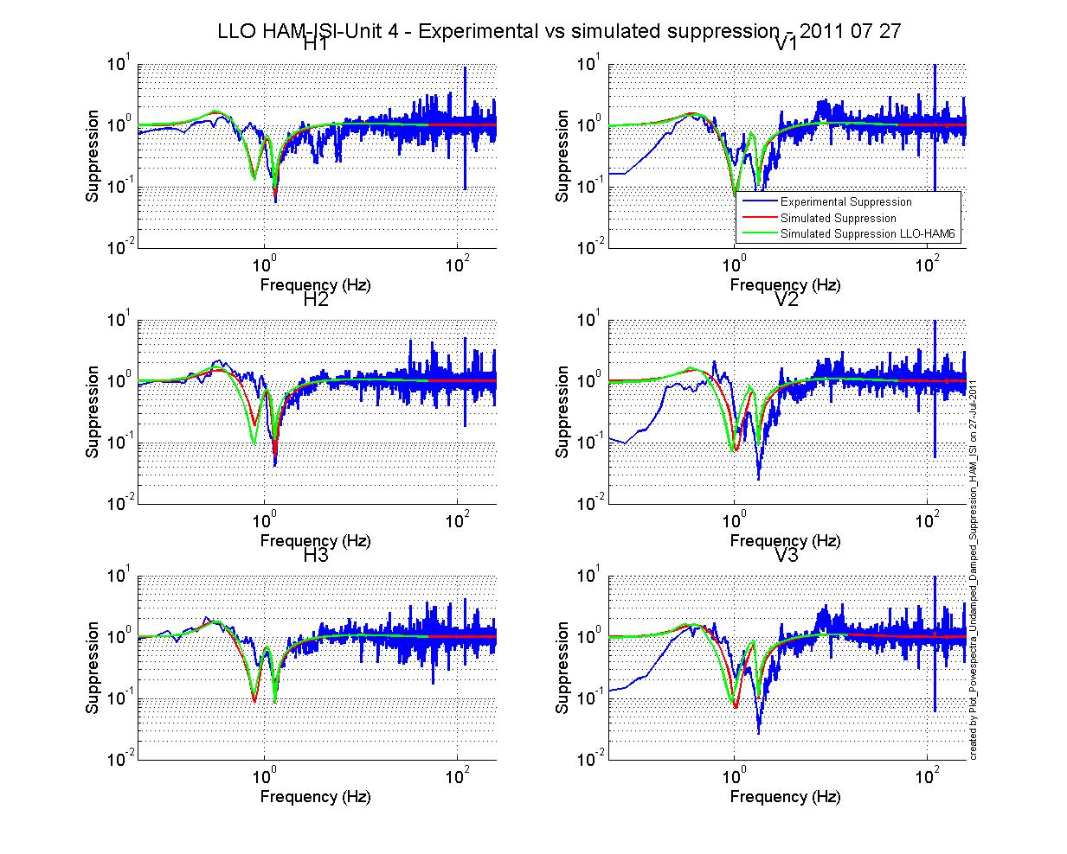
Figure – Horizontal (left) and vertical (right) damping loops - Experimental

Acceptance criteria:

- HAM6 damping loop must stable when all damping loops are engaged
- Similar damping effect than in simulated plots

Test result: Passed: X Failed: .

Conclusion
A few minor issues were found during the testing of this unit 4. The known issues are summed up here:
- Sensor gaps not recorded on the jig
- CPS 12064 has an Amplitude Spectral Density too high at 0.1Hz. This was previously noted by Rich M. as not so good but acceptable.
- Blade Spring Profile: the difference of height between the root and the tip of the blade is slightly bigger than 15 mils for Blade 1. This is thought as the best compromise that can be found with the shims available, while keeping the optical table leveled.
- GS-13 powerspectra on the locked table shows slightly more signals than expected around 100 mHz, but since the criteria was arbitrarily defined to compare with what we obtained on previous units, we passed that test.
- Linearity Test: the variation of the slope compared to the average slope, is slightly bigger than 1% for H2 & V1. The difference was low enough that it is dimmed not to be an issue.
Overall the system appeared really consistent, and behaved as expected.

