LIGO Laboratory / LIGO Scientific Collaboration

LIGO- E1000331 V2 LIGO May 16th, 2014

aLIGO HAM-ISI, Pre-integration Test Report, Phase I, LLO India #2 (post-assembly, before storage)
E1000331 – V2

Mike Vargas, Jeremy Birch, Joe Hanson, Céline Ramet

Distribution of this document:
Advanced LIGO Project

This is an internal working note
of the LIGO Laboratory

California Institute of Technology  LIGO Project – MS 18-34  1200 E. California Blvd.  Pasadena, CA 91125  Phone (626) 395-2129  Fax (626) 304-9834  E-mail: info@ligo.caltech.edu | Massachusetts Institute of Technology  LIGO Project – NW22-295  185 Albany St  Cambridge, MA 02139  Phone (617) 253-4824  Fax (617) 253-7014  E-mail: info@ligo.mit.edu
LIGO Hanford Observatory  P.O. Box 1970  Mail Stop S9-02  Richland WA 99352  Phone 509-372-8106  Fax 509-372-8137 | LIGO Livingston Observatory  P.O. Box 940  Livingston, LA 70754  Phone 225-686-3100  Fax 225-686-7189

Table of contents:

I. Pre-Assembly Testing 4
▪ Step 1: Position Sensors 4
▪ Step 2: GS13 6
▪ Step 2.1 – Horizontal GS-13s 6
Step 2.2 – Vertical GS-13s 7
▪ Step 3: Actuators 9
II. Tests to be performed during assembly 10
▪ Step 1: Inventory (E1000052) 10
▪ Step 2: Check torques on all bolts 10
▪ Step 3: Check gaps under Support Posts 10
▪ Step 4: Pitchfork/Boxwork flatness before Optical Table install 11
▪ Step 5: Blade spring profile 11
▪ Step 6: Gap checks on actuators-after installation on Stage 1 12
▪ Step 7: Check level of Stage 0 12
▪ Step 8: Check level of Stage 1 Optical Table 13
▪ Step 9: Mass budget 14
▪ Step 10: Shim thickness 15
▪ Step 11: Lockers adjustment 15
III. Tests to be performed after assembly 15
▪ Step 1 - Electronics Inventory 15
▪ Step 2 - Set up sensors gap 16
▪ Step 3 - Measure the Sensor gap 17
▪ Step 4 - Check Sensor gaps after the platform release 17
▪ Step 5 – Performance of the limiter 18
▪ Step 5.1 - Test Nº1 - Push “in the general coordinates” 18
▪ Step 5.2 - Test Nº2 – Push “locally” 18
▪ Step 6 - Position Sensors unlocked/locked Power Spectrum 19
▪ Step 7 - GS13 power spectrum -tabled tilted 22
▪ Step 8- GS13 pressure readout 24
▪ 24
▪ Step 9 - Coil Driver, cabling and resistance check 25
▪ Step 10 - Actuators Sign and range of motion (Local drive) 26
▪ Step 11 - Vertical Sensor Calibration 27
▪ Step 12 - Vertical Spring Constant 28
▪ Step 13 - Static Testing (Tests in the local basis) 28
▪ Step 14 - Linearity test 30
▪ Step 15 - Cartesian Basis Static Testing 32
▪ Step 16- Frequency response 33
▪ Step 16.1 - Local to local measurements 33
▪ Step 16.2 - Cartesian to Cartesian measurements 36
▪ Step 17 - Transfer function comparison with Reference 37
▪ Step 17.1 - Local to local - Comparison with Reference 37
▪ Step 17.2 - Cartesian to Cartesian - Comparison with Reference 41
▪ Step 18 - Lower Zero Moment Plane 43
▪ Step 19 - Damping loops 44
▪ Step 19.1 - Transfer functions - Simulation 44
▪ Step 19.2 - Powerspectra – Experimental 45

Introduction
This second Unit for LIGO India was built in fall 2013 and spring of 2014, and was tested in the spring of 2014, just after we got done building BSC-ISI at LLO.
The procedure document used to perform this test is:
- E1000309–V9 - aLIGO HAM-ISI, Pre-Integration Testing Procedure, Phase I (post assembly, before storage)
Other useful information can be found in:
- E1000300 - HAM-ISI LLO test stand: software and electronic check

Pre-Assembly Testing

Step 1: Position Sensors

S/N sensor | S/N board | ADE Gap Standoff(mm) | Location on the Jig | Gap Standoff on Jig(mm/in) | Voltage before zeroing | Voltage after zeroing. Prebake | Voltage after zeroing. Post bake
12011 | NR | NR | NR | NR | NR | NR | NR
12019 | NR | NR | NR | NR | NR | NR | NR
12075 | NR | NR | NR | NR | NR | NR | NR
12020 | NR | NR | NR | NR | NR | NR | NR
12008 | NR | NR | NR | NR | NR | NR | NR
12014 | NR | NR | NR | NR | NR | NR | NR

NR: not recorded

Sensors noise spectra measured before baking:

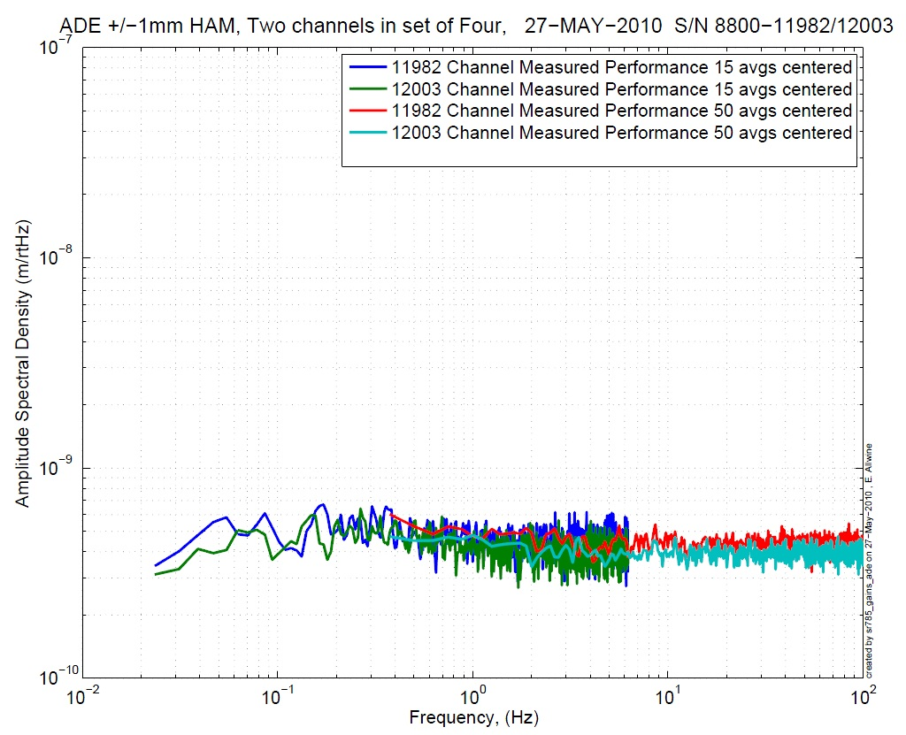  Figure 1: H1 and V1 sensor noise | 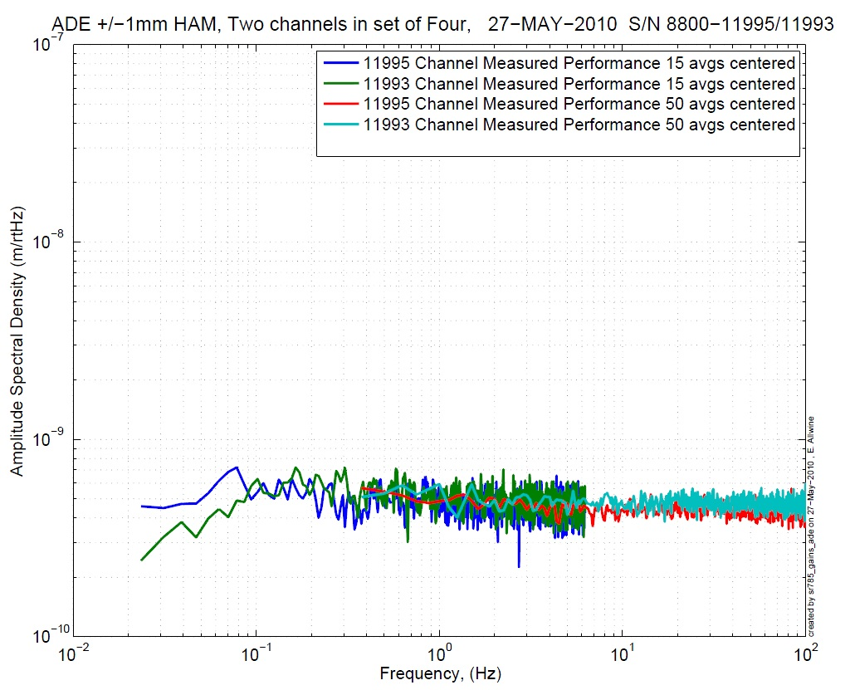  Figure 2: H2 and V2 sensor noise

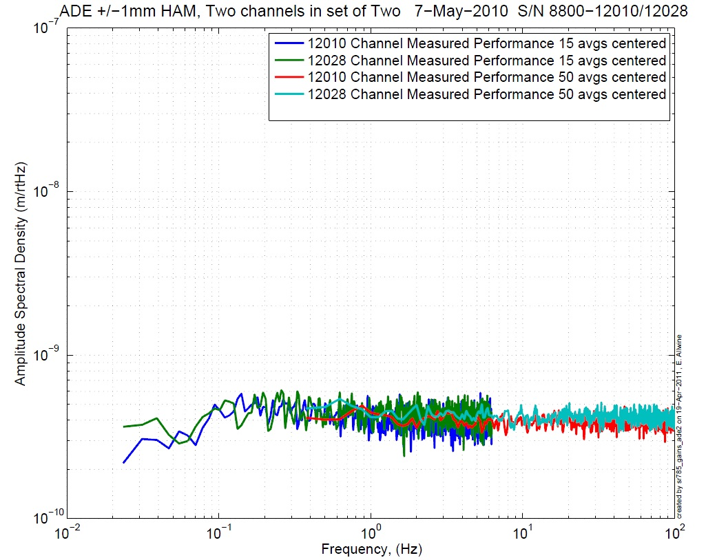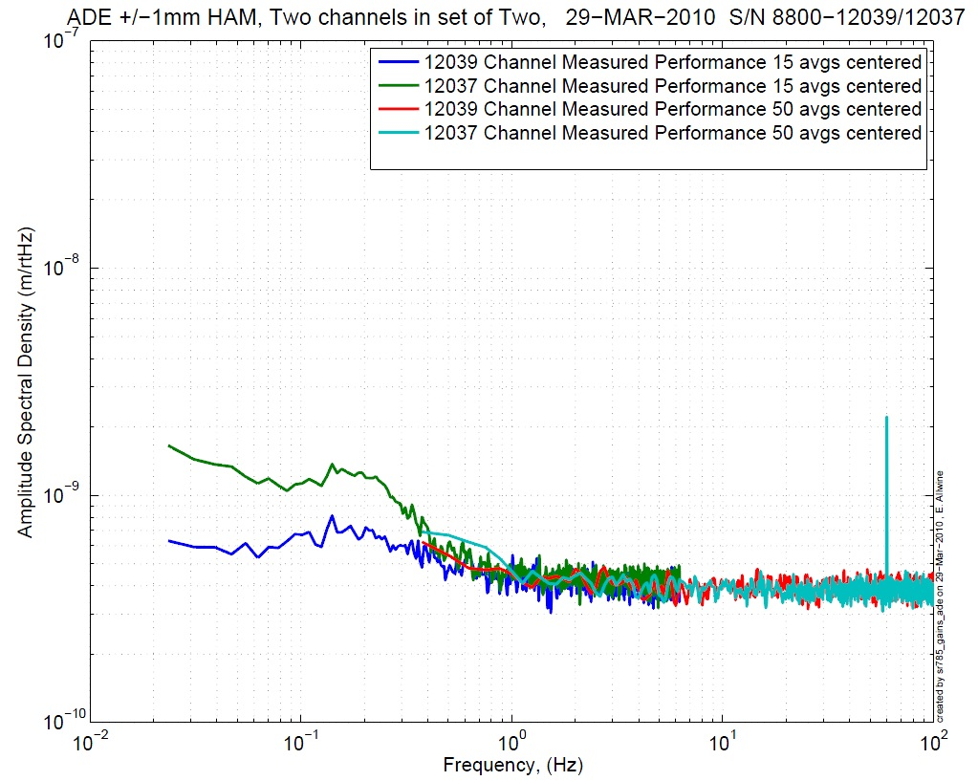
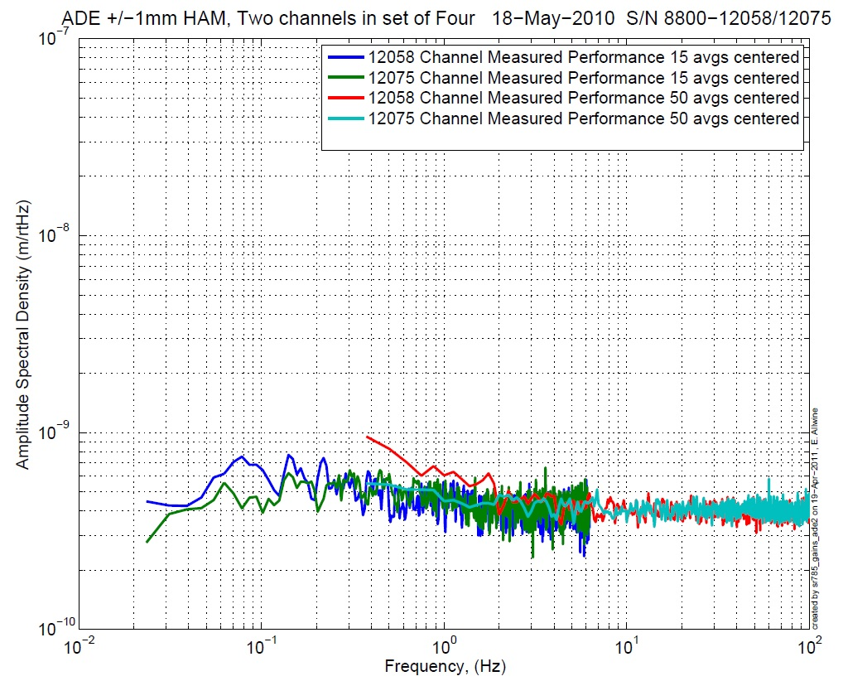
Figure 3: H3 (12010) and V3 (12037 & 12058) sensor noise

Acceptance Criteria:
- Power spectrum magnitudes must be lower than:
  - 9.e-10 m/√Hz at 0.1Hz
  - 6.e-10 m/√Hz at 1Hz

Issues/difficulties/comments regarding this test:

Test result: Passed: X Failed: .

Step 2: GS13

All the data related to GS-13 post podding testing can be found in the SVN at : SeismicSVN\seismic\Common\Data\aLIGO_GS13_TestData\PostMod_TestResults_PDFs
E1000058 spreadsheet provides the status of each individual GS-13 at LLO site during aLIGO HAM assembly

Data files in SVN at:
/ligo/svncommon/SeiSVN/seismic/Common/Data/aLIGO_GS13_TestData/PostMod_TestResults_RawASCII

Scripts files for processing and plotting in SVN at:
/ligo/svncommon/SeiSVN/seismic/Common/MatlabTools
- gs13qatest.m

Figures in SVN at:
/ligo/svncommon/SeiSVN/seismic/Common/Data/aLIGO_GS13_TestData/PostMod_TestResults_PDFs

Step 2.1 – Horizontal GS-13s

Huddle testing
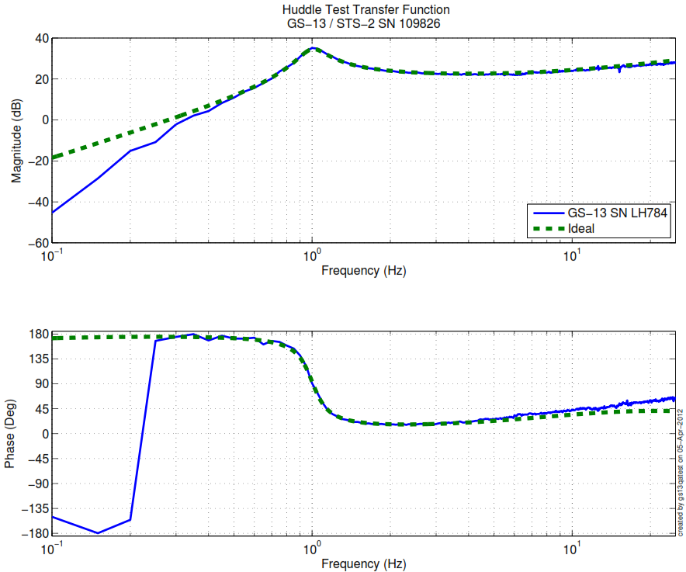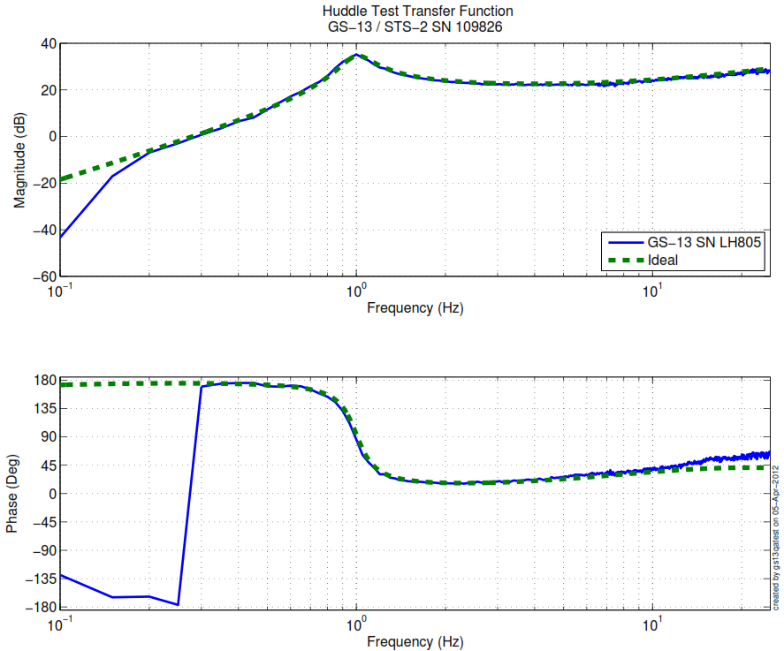
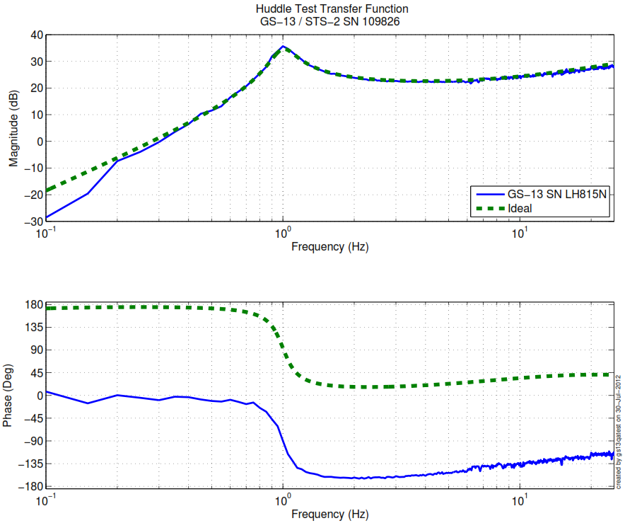
Figure 4: Huddle testing of Horiz GS-13 784, 805, and 815 after aLIGO modifications

Step 2.2 – Vertical GS-13s

Huddle testing

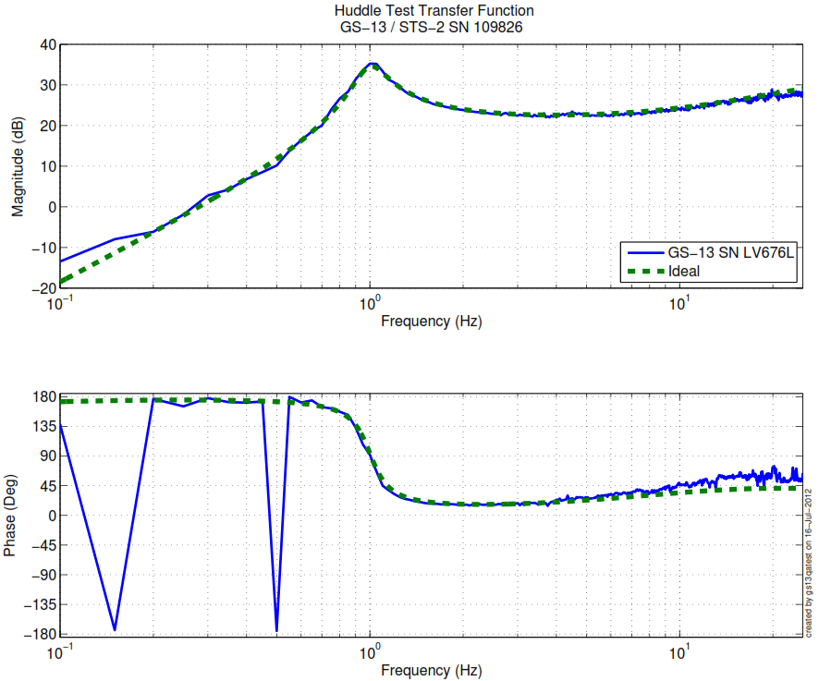
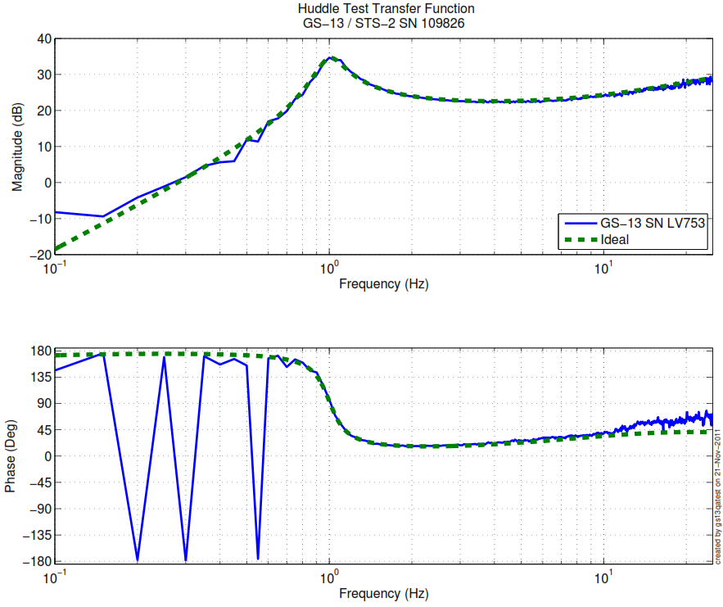
Figure 5: Huddle testing of Vert GS-13 676 and 753 after aLIGO modifications
Driven testing
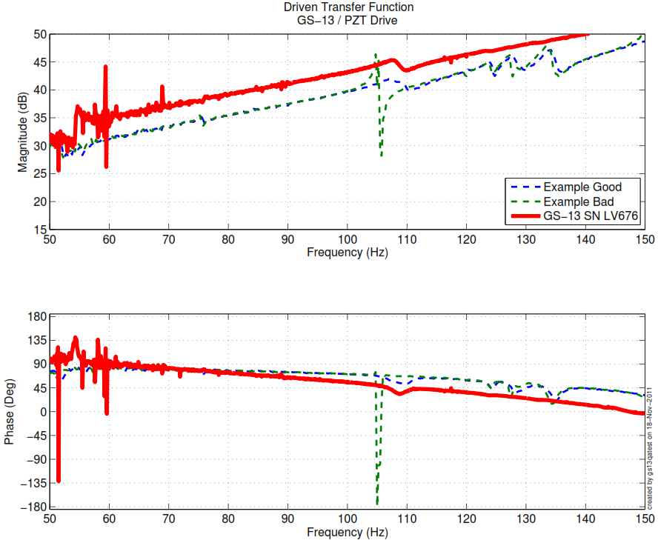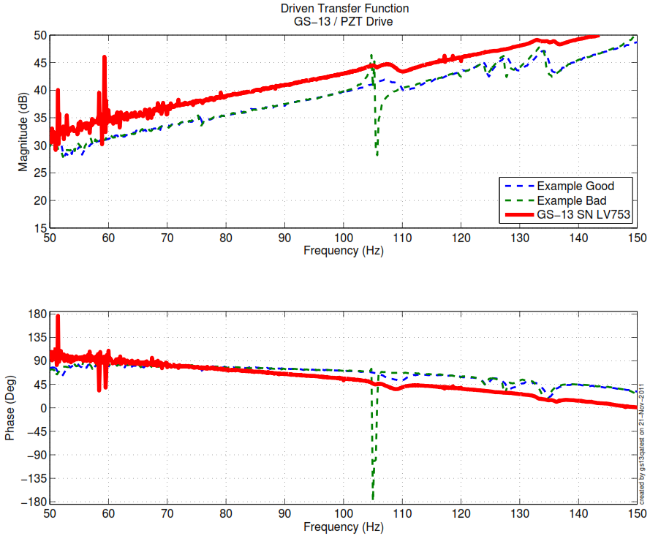
Figure 6: Driven Transfer Function of Vert GS-13 676, 704 and 753 after aLIGO modifications.

Acceptance Criteria:
- GS13 should have been already modified and tested. GS-13 Inspection/Pod Assembly (D047810). Checklist is defined in F090070-v6
- Resonant frequency at 1 Hz (huddle testing)
- No spring resonance on vertical driven tests
Notes:
- GS-13 V704 has incomplete Post-Modification testing data. Documentation shows that this seismometer was accepted after modification and testing, but no successful test data exists.
- Referencing Step 6, Figure 9 and Step 16.1, Table 22, it can be seen that there is no disparity between vertical inertial sensors. For these reasons, this seismometer is accepted for this unit.

Test result: Passed: X Failed: .

Step 3: Actuators
Actuator data can be found at: T0900564. Actuator inventory is made at Section II – Step 1.

Actuator Serial #: L011  Operator Name: Smith, Lane  Date: 8/12/2009  Time: 8:36 AM  Actuator Coil Resistance: 6.39 Ohms, PASS  Ambient Temperature: 68.9 F  Hi Pot Test Results: 1000 MOhms, PASS  X Travel Limit (inches): 0.517  Y Travel Limit (inches): 0.205  Z Travel Limit (inches): 0.475 | Actuator Serial #: L008  Operator Name: Smith, Lane  Date: 8/12/2009 Time: 10:03 AM  Actuator Coil Resistance: 6.33 Ohms, PASS  Ambient Temperature: 69.8 F  Hi Pot Test Results: 1000 MOhms, PASS  X Travel Limit (inches): 0.522  Y Travel Limit (inches): 0.206  Z Travel Limit (inches): 0.481
Actuator Serial #: L071  Operator Name: Gordon, Matt  Date: 11/19/2009 Time: 11:12 AM  Actuator Coil Resistance: 6.37 Ohms, PASS  Ambient Temperature: 72.0 F  Hi Pot Test Results: 1000 MOhms, PASS  X Travel Limit (inches): 0.527  Y Travel Limit (inches): 0.205  Z Travel Limit (inches): 0.507 | Actuator Serial #: L076  Operator Name: Gordon, Matt  Date: 11/19/2009 Time: 1:03 PM  Actuator Coil Resistance: 6.31 Ohms, PASS  Ambient Temperature: 71.3 F  Hi Pot Test Results: 1000 MOhms, PASS  X Travel Limit (inches): 0.534  Y Travel Limit (inches): 0.205  Z Travel Limit (inches): 0.508
Actuator Serial #: L077  Operator Name: Gordon, Matt  Date: 11/19/2009 Time: 10:40 AM  Actuator Coil Resistance: 6.34 Ohms, PASS  Ambient Temperature: 70.7 F  Hi Pot Test Results: 1000 MOhms, PASS  X Travel Limit (inches): 0.529  Y Travel Limit (inches): 0.205  Z Travel Limit (inches): 0.503 | Actuator Serial #: L156  Operator Name: Gordon, Matt  Date: 4/13/2010 Time: 5:13 PM  Actuator Coil Resistance: 6.37 Ohms, PASS  Ambient Temperature: 73.3 F  Hi Pot Test Results: 1000 MOhms, PASS  X Travel Limit (inches): 0.548  Y Travel Limit (inches): 0.205  Z Travel Limit (inches): 0.505

Acceptance Criteria:
- Actuators were previously tested and results are reported in T900564.

The tests report must contain:
- Test results (Passed: X Failed: ).””

Tests to be performed during assembly

Step 1: Inventory (E1000052)

DCC/Vendor number | Part name | Configuration | S/N | S/N | S/N
D071001 | Stage 0 base |  | 013
D071051 | Stage 1 base |  | 014
D071050 | Optical table |  | 014
D071002 | Spring Post |  | 009 | 012 | 023
D071100 | Spring |  | 021 | 035 | 040
D071102 | Flexure |  | 027 | 028 | 043
ADE | Position sensor | Horizontal | 12011 | 12019 | 12075
 |  | Vertical | 12020 | 12008 | 12014
D047812 | GS-13 pod | Horizontal | 97 | 83 | 43
 |  | Vertical | 41 | 75 | 96
D047823 | L4C pod | Horizontal
 |  | Vertical
D0902749 | Actuator | Horizontal | L008 | L071 | L076
 |  | Vertical | L011 | L077 | L156

Notes:

- CPS 12037 replaced with 12014 due to large fluctuations in signal. This CPS was previously removed from India_1 ISI.

Step 2: Check torques on all bolts

Acceptance Criteria:
- All bolts should trip the wrench, and start moving immediately after. If any bolts in a pattern move before torque is reached, recheck after all bolts are brought to spec.

Test result: Passed: X Failed: .

Step 3: Check gaps under Support Posts

Acceptance Criteria:
- A 0.001 inch shim cannot be passed freely through any connection to Stage 0 or between post and gussets. If shim can pass through, loosen all constraining bolts, and then retighten iteratively from the center of the part to the edges. Retest.
Test result: Passed: X Failed: .

Step 4: Pitchfork/Boxwork flatness before Optical Table install

Acceptance Criteria:
- Shim inserted won’t pass between parts.

Test result: Passed: X Failed: .

Step 5: Blade spring profile
Blade # | Base (") | Tip(") | Flatness (mils)
1 | 0.482 | 0.471 | + 11
2 | 0.479 | 0.468 | + 11
3 | 0.490 | 0.472 | + 18

Table 1 - Blade profile

Acceptance Criteria:
- Blades must be flat within 0.015" inches.

Test result: Passed: Failed: X .

Step 6: Gap checks on actuators-after installation on Stage 1

Actuator | Front Gap (1/1000") | Back Gap (1/1000")
H1 | 0.085 | 0.080
H2 | 0.085 | 0.085
H3 | 0.080 | 0.080
V1 | 0.085 | 0.085
V2 | 0.080 | 0.080
V3 | 0.085 | 0.085

Acceptance Criteria
- Gaps must be within 0.010” of design (i.e. 0.090” and .070” pass, but 0.095” and 0.065” doesn’t).

Test result: Passed: X Failed: .

Step 7: Check level of Stage 0

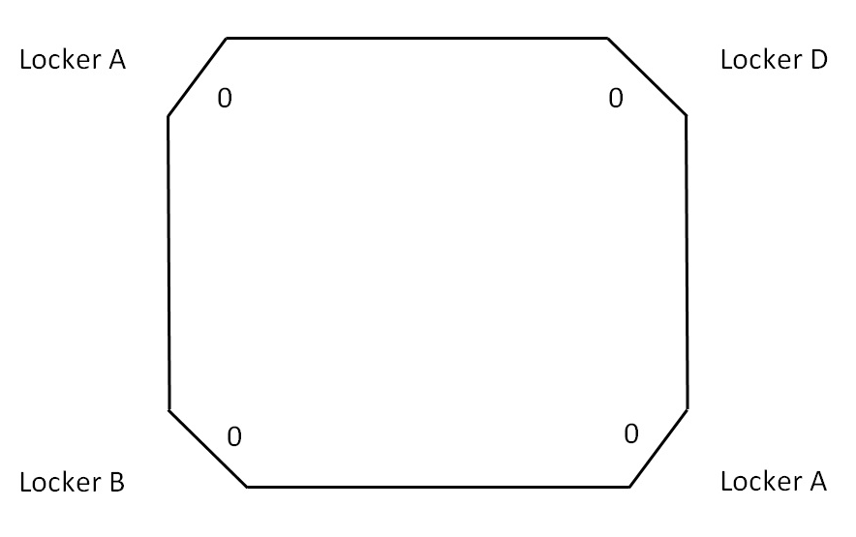
Locker C
Locker C
0

0

-0.006”
-0.006”

Max angle = (0.006)/72= 83 µrad

Acceptance Criteria
- The maximum angle of the table with the horizontal mustn’t exceed ~100µrad

Test result: Passed: X Failed: .

Step 8: Check level of Stage 1 Optical Table
Optical Level measurement of Stage 1 at large (12 - 15) number of points.

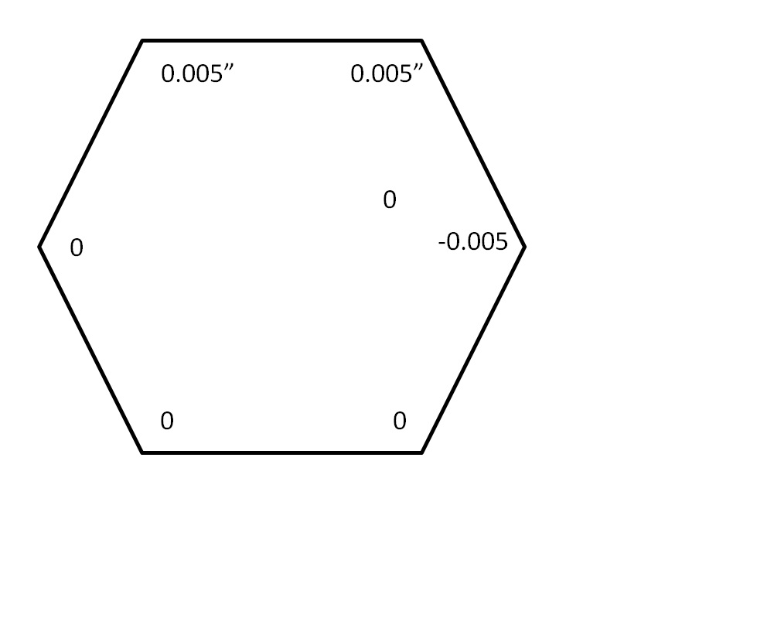
0

N

-0.002”

-0.005”

-0.005”

0

0

Max angle = (0.005)/85.59= 58 urad

Acceptance Criteria
- The maximum angle of the table with the horizontal mustn’t exceed ~100µrad

Test result: Passed: X Failed: Waived: >

Step 9: Mass budget

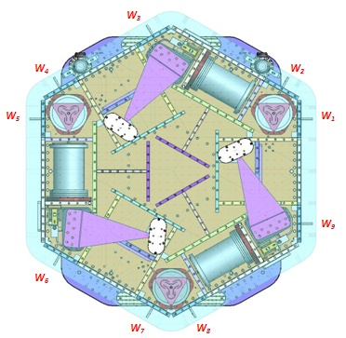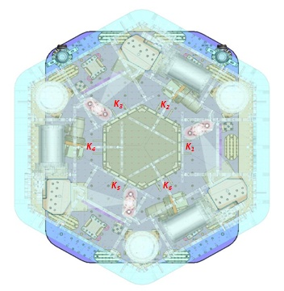
Figure 7: Keel Masses and Wall masses location

 |  | 00 | 01 | 02 | 03 | 04 | 05 | 06
 |  | 0.6 | 1.1 | 2.2 | 4.5 | 7.9 | 15.6 | 27.2 | lbs | kgs
w9 |  |  |  |  |  | 1 | 1 | 1 | 50.7 | 23.00
w1 |  |  |  |  |  |  | 1 | 1 | 42.8 | 19.41
w2 |  |  |  |  |  | 1 | 1 | 1 | 50.7 | 23.00
w3 |  |  |  |  |  |  | 2 | 1 | 58.4 | 26.49
w4 |  |  |  |  |  | 1 | 1 | 1 | 50.7 | 23.00
w5 |  | 1 |  |  |  |  | 2 | 1 | 59.0 | 26.76
w6 |  |  |  |  |  |  | 1 | 1 | 42.8 | 19.41
w7 |  | 3 | 1 |  |  |  | 1 | 1 | 45.7 | 20.73
w8 |  | 1 |  |  |  |  | 2 | 1 | 59.0 | 26.76
Side Masses Total |  | 5 | 1 | 0 | 0 | 3 | 12 | 9 | 459.8 | 208.56
Table 2: Wall masses distribution

 | 00 | 01 | 02 | 03 | 04 | 05 | 06
 | 0.6 | 1.1 | 2.2 | 4.5 | 7.9 | 15.6 | 27.2 | lbs | kgs
k1 |  |  |  |  | 1 |  | 1 | 35.1 | 15.95
k2 | 1 | 1 | 1 |  |  |  | 1 | 31.1 | 14.14
k3 |  |  |  |  | 1 |  | 1 | 35.1 | 15.95
k4 | 1 | 1 | 1 |  |  |  | 1 | 31.1 | 14.14
k5 |  |  |  |  | 1 |  | 1 | 35.1 | 15.95
k6 | 3 |  | 1 |  |  |  | 1 | 31.2 | 14.18
 | 5 | 2 | 3 | 0 | 3 | 0 | 6 | 198.7 | 90.32

 | Side | Keel | Top | Total
Weigh (kg) | 208.56 | 90.32 | 277 | 575.88
Torque x at O (N.m) | -38.79 | 0.00 | 0 | -38.79
Torque y at O (N.m) | -33.16 | 5.26 | 0 | -27.91
Table 3: Masses distribution (computed using T1100261)

Acceptance Criteria
The Mass budget must be
- 579.1 Kg (cf E1100427)+/-25Kg (5%)

Test result: Passed: X Failed: .

Step 10: Shim thickness

Lockers | Shim thickness (mils)
A | 120
B | 120
C | 120
D | 122
Table 4: Shims Thickness
Acceptance Criteria
- Inventory is complete

Test result: Passed: X Failed: .

Step 11: Lockers adjustment

D.I at Lockers | Dial indicators V | Dial indicators H
A | 0.5 | 1
B | 0.5 | 1.5
C | -1.5 | 0
D | 0.5 | 0
Table 5: Dial indicators read-out (in thousandths of an inch)
Issues/difficulties encountered during this test : N/A

Acceptance Criteria
- Vertical and horizontal displacement near the lockers must be lower than 2 mils (0.002”)

Test result: Passed: X Failed: .

Tests to be performed after assembly

Step 1 - Electronics Inventory

Hardware | LIGO reference | S/N
Coil driver | D0902744 | S1103354
 |  | S1000316
Anti Image filter | D070081 | S1000249
Anti aliasing filter | D1000269 | S1106137
 |  | S1106138
Interface chassis | D1000067 | S1102219
 |  | S1106356
 |  | S1106358
Table 6: Inventory electronics
Acceptance Criteria
- Inventory is complete
Test result: Passed: X Failed: .

Step 2 - Set up sensors gap

 | 10 Kg masses at each corners |  | No mass |  | No mass
Table locked | ADE boxes on |  | ADE boxes on |  | ADE boxes off
Sensors | Offset (Mean) | Std deviation | Offset (Mean) | Std deviation | Offset (Mean) | Std deviation
H1 | -7.1812 | 9.1566 | 476.19 | 30.281 | -0.062243 | 0.25114
H2 | 320.09 | 8.4585 | 422.99 | 36.762 | -0.2749 | 0.20577
H3 | -108.04 | 12.858 | -415.97 | 22.491 | 1.3305 | 0.23885
V1 | -111.39 | 16.755 | 75.356 | 51.32 | -2.7923 | 0.20891
V2 | -78.931 | 19.949 | 195.8 | 60.894 | -0.2679 | 0.23267
V3 | -95.993 | 77.577 | 106.75 | 357.73 | -0.7577 | 0.26977
Capacitive position sensor readout after gap set-up

Issues/difficulties/comments regarding this test:

Acceptance criteria:

- All mean values must be lower than 400 cts (a bit less than .0005”).
- All standard deviations below 5 counts.
- No cross talk

Test result: Passed: Failed: X .

Step 3 - Measure the Sensor gap

Sensors | Gap measured on the Jig | Gap measured on the table
H1 | NR | NR
H2 | NR | NR
H3 | NR | NR
V1 | NR | NR
V2 | NR | NR
V3 | NR | NR

Acceptance criteria:

Sensors gap measured on the jig and on the optic table must be:
- 0.080” +/-0.002”

Test result: Passed: Failed: Waived: X

Step 4 - Check Sensor gaps after the platform release

 | Table locked |  | Table unlocked
Sensors | Offset (Mean) | Std deviation | Offset (Mean) | Difference
H1 | -7.1812 | 9.1566 | -255.27 | 36.947
H2 | 320.09 | 8.4585 | 353.52 | 36.345
H3 | -108.04 | 12.858 | -978.25 | 69.47
V1 | -111.39 | 16.755 | -260.99 | 89.457
V2 | -78.931 | 19.949 | -186.44 | 76.184
`V3 | -95.993 | 77.577 | -1491.2 | 79.125
Table 7: Sensor gaps after platform release
Acceptance criteria:

- Absolute values of the difference between the unlocked and the locked table must be below:
  - 1600 cts for horizontal sensors (~0.002”)
  - 1600 cts for vertical sensors (~0.002”)
- Considering the acceptance criteria of step 4, all mean values must be lower than
  - 2000 cts for horizontal sensors (~0.0025”)
  - 2000 cts for vertical sensors (~0.0025”)

Comments:

Test result: Passed: X Failed: .

Step 5 – Performance of the limiter

Step 5.1 - Test Nº1 - Push “in the general coordinates”

 | CPS read out |  | Calculated after calibration
Sensors | UP (Counts) | Down (Counts) | UP (mil) | Down (mil)
V1 | 18721 | -20251 | 22.0 | -23.8
V2 | 19946 | -20165 | 23.4 | -23.7
V3 | 19799 | -20540 | 23.3 | -24.1
 | CPS read out |  | Calculated after calibration
Sensors | CW(-RZ) | CCW (+RZ) | CW (mil) | CCW (mil)
H1 | 24514 | -16809 | 28.8 | -19.8
H2 | 19831 | -21939 | 23.3 | -25.8
H3 | 20625 | -22704 | 24.2 | -26.7
Table 8: Optic table range of motion

Step 5.2 - Test Nº2 – Push “locally”

 | Push in positive direction | Push in negative direction | Railing | Actuator Gap Check
H1 | -22774 | 27815 |  | X
H2 | -24330 | 23542 |  | X
H3 | -24757 | 23959 |  | X
V1 | -19990 | 20504 |  | X
V2 | -32768 | 30676 |  | X
V3 | -24216 | 22532 |  | X
Table 9: Optic table range of motion

Acceptance criteria:
- The vertical sensor readout must be positive when the optic table is pushed in the +Z direction
- The horizontal sensor readout must be negative when the optic table is pushed in the +RZ direction
- Step 5.1
  - Absolutes value of all estimated motions must be higher than 16000counts (~0.020”)
- Step 5.2
  - No contact point on sensors
  - Absolute value of sensor read out must be higher than 16000counts (~0.020”)
  - No contact point on actuators

Test result: Passed: X Failed: .

Step 6 - Position Sensors unlocked/locked Power Spectrum

Data files in SVN at:
/ligo/svncommon/SeiSVN/seismic/HAM-ISI/X2/Data/India_2/ Powerspectra/Undamped
- LLO_HAM_ISI_India_2_Calibrated_PSD_CPS_GS13_Unlocked_Locked_20140516.mat

Scripts files for processing and plotting in SVN at:
/ligo/svncommon/SeiSVN/seismic/HAM-ISI/X2/Scripts/Data_collection/
- Powerspectra_Measurements_Locked_Unlocked_HAM_ISI.m
- Powerspectra_Measurements_Tilted_HAM_ISI.m

Figures in SVN at:
/ligo/svncommon/SeiSVN/seismic/HAM-ISI/X2/Data/India_2/Figures/Powerspectra/Undamped
- LLO_HAM_ISI_India_2_Calibrated_PSD_CPS_Unlocked_Locked_2014_05_16.fig
- LLO_HAM_ISI_India_2_Calibrated_PSD_GS13_Unlocked_Locked_2014_05_16.fig

CPS calibration:
The CPS power spectrums are calibrated by using a sensitivity of 30.2 nm/count.

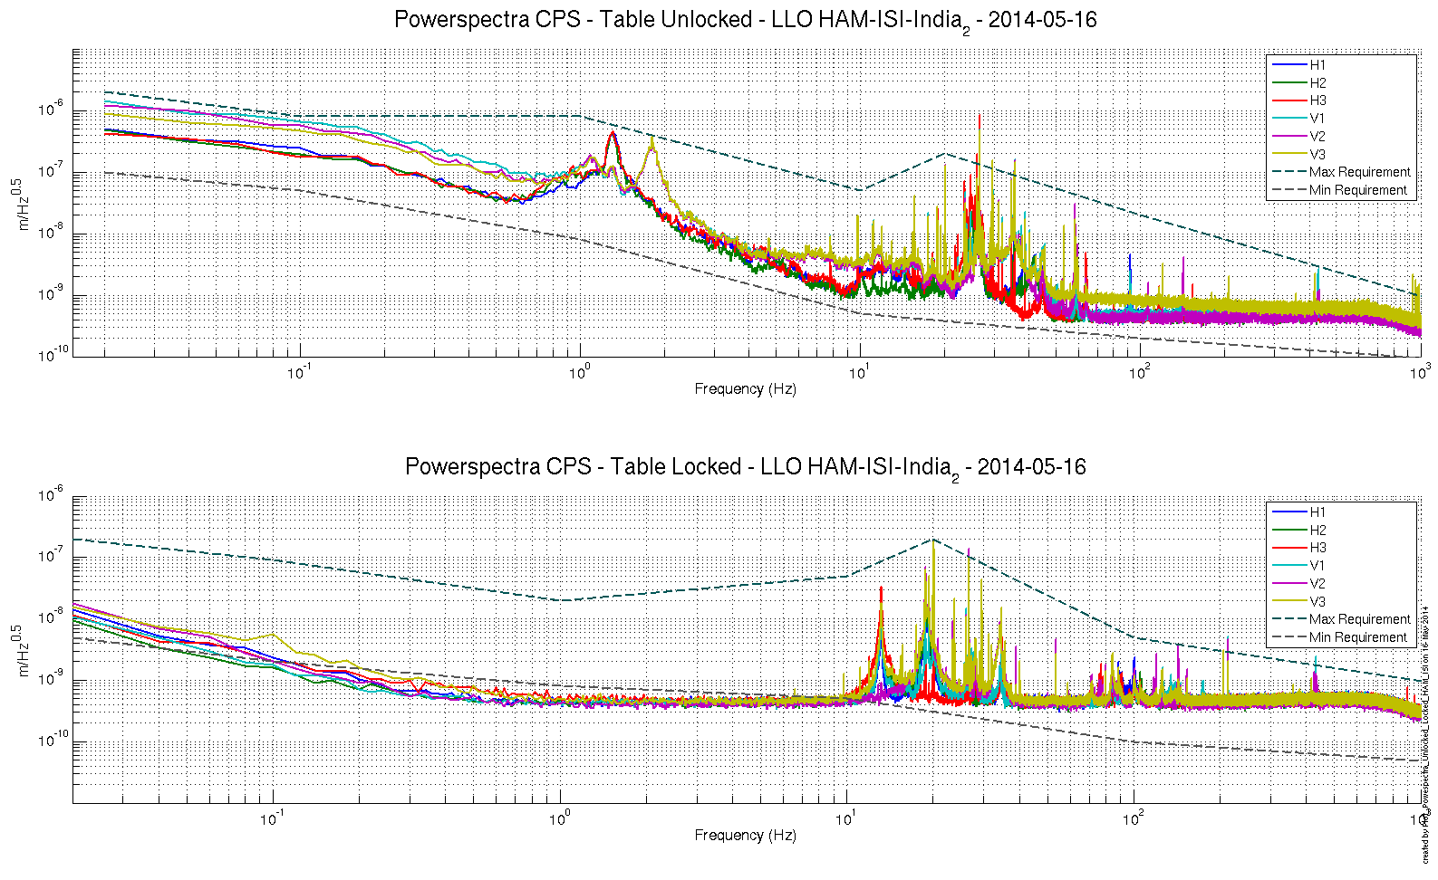
Figure 8: Calibrated CPS power spectrum

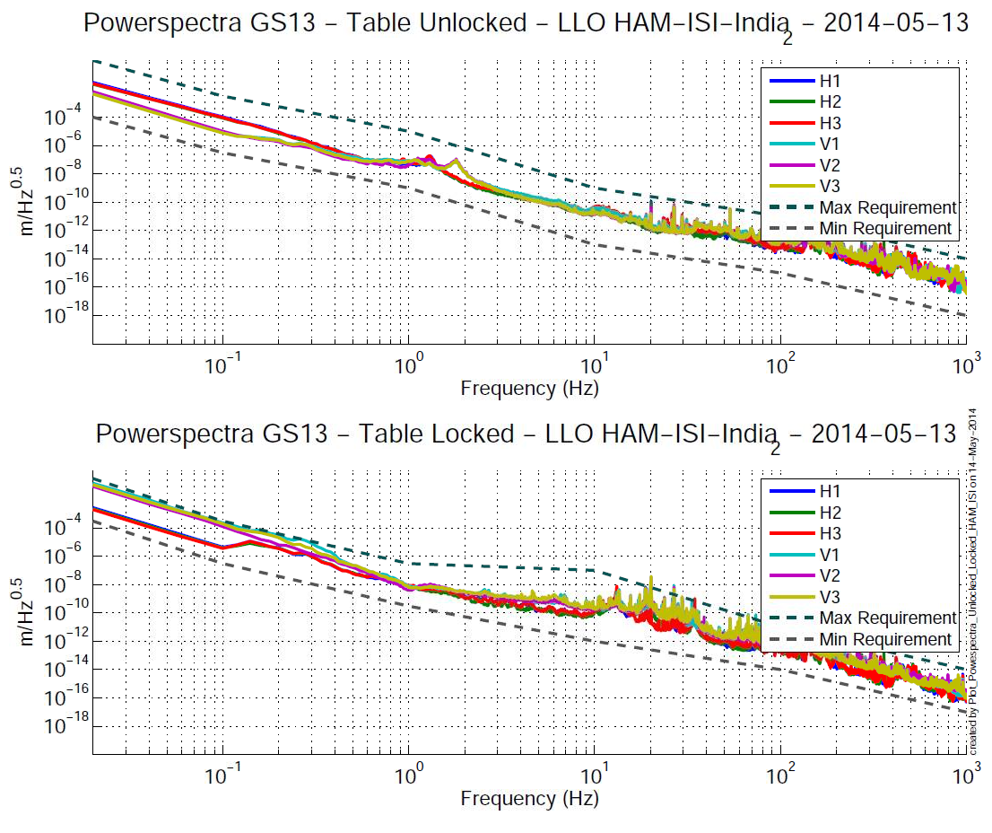
Figure 9: Power spectrum Calibrated GS13

Acceptance criteria:
- No cross talk (peaks at low frequencies + harmonics on measurements)
- Magnitudes of power spectra must be between requirement curves such as in the following figures (dashed lines)

Sensors | ISI state | Frequency (Hz) | 2x10⁻² | 1x10⁻¹ | 1 | 10 | 20 | 100 | 1000
GS-13 | Table locked | Max | 3x10⁻¹ | 3x10⁻⁴ | 3x10⁻⁷ | 10⁻⁷ |  | 10⁻¹¹ | 10⁻¹⁴
 |  | Min | 3x10⁻⁴ | 3x10⁻⁷ | 3x10⁻¹⁰ | 10⁻¹² |  | 10⁻¹⁴ | 10⁻¹⁷
 | Table unlocked | Max | 1 | 3x10⁻³ | 10⁻⁵ | 10⁻⁹ |  | 10⁻¹¹ | 10⁻¹⁴
 |  | Min | 10⁻⁴ | 3x10⁻⁷ | 10⁻⁹ | 10⁻¹³ |  | 10⁻¹⁵ | 10⁻¹⁸
CPS | Table locked | Max | 2*10⁻⁷ | 2x10⁻⁸ | 10⁻⁸ | 5x10⁻⁸ | 2x10⁻⁷ | 5x10⁻⁹ | 10⁻⁹
 |  | Min | 5x10⁻⁹ | 2x10⁻⁹ | 8x10⁻¹⁰ | 5x10⁻¹⁰ |  | 10⁻¹⁰ | 5x10⁻¹¹
 | Table unlocked | Max | 2x10⁻⁶ | 8x10⁻⁷ | 8x10⁻⁷ | 5x10⁻⁸ | 2x10⁻⁷ | 2x10⁻⁸ | 10⁻⁹
 |  | Min | 10⁻⁷ | 5x10⁻⁸ | 8x10⁻⁹ | 5x10⁻¹⁰ |  | 2x10⁻¹⁰ | 10⁻¹⁰
Table 10: Step 6 -Normal conditions-Sensors power spectra requirements

Test result: Passed: Failed: X .

Step 7 - GS13 power spectrum -tabled tilted
The figure below presents the GS13 power spectrum when the table is unlocked and loaded with a 20Kg mass at one of its corner.

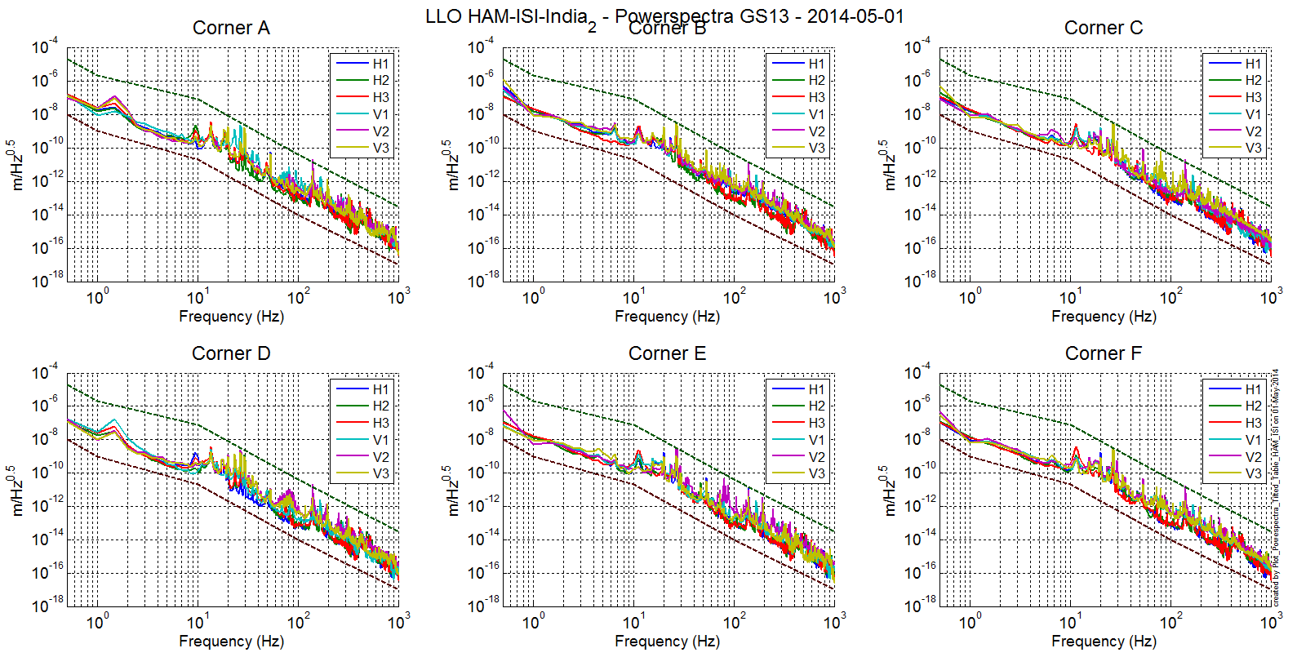
Figure 10: Power spectrum Calibrated GS13 with mass at corner

Data files in SVN at:
/ligo/svncommon/SeiSVN/seismic/HAM-ISI/X2/Data/India_2/ Powerspectra/Undamped
- LLO_HAM_ISI_India_2_Calibrated_PSD_GS13_Table_Tilted_2014_05_01.mat

Scripts files for taking and processing the data, and plotting it in SVN at:
/ligo/svncommon/SeiSVN/seismic/HAM-ISI/X2/Scripts/Data_collection/
- Powerspectra_Measurements_Tilted_HAM_ISI.m

Figures in SVN at:
/ligo/svncommon/SeiSVN/seismic/HAM-ISI/X2/Data/India_2/Figures/ Powerspectra/Undamped
- LLO_HAM_ISI_India_2_Calibrated_PSD_GS13_Table_Tilted_2014_05_01.fig
Acceptance criteria:
- With table unlocked and tilted, magnitudes of power spectra must be fully included within:

Sensor | ISI State | Frequency | 5x10⁻¹ Hz | 1 | 10 | 100 | 1000
GS-13 | Table Tilted | Max | 2x10⁻⁻⁵ | 2x10⁻⁻⁶ | 8x10⁻⁸ | 4x10⁻¹¹ | 3x10⁻¹⁴
 |  | Min | 10⁻⁸ | 10⁻⁹ | 2x10⁻¹¹ | 10⁻¹⁴ | 10⁻¹⁷
Table 11: Table Tilted- Sensors power spectra requirements

Test result: Passed: X Failed: .

Step 8- GS13 pressure readout
Scripts files for taking and processing the data, and plotting it in SVN at: seismic/SeiSVN/Common/MatlabTools
- gs13Presstest.m

Note: the figure hasn’t been plotted because of a bug in the script but the pressure sensors are all working fine and the pressure readouts are within requirements.

Issues/difficulties/comments regarding this test

Acceptance criteria:
- The pressure on all channels must be 25000 counts +/- 3000 counts
- All channels must follow comparable trend

Test result: Passed: X Failed: .

Step 9 - Coil Driver, cabling and resistance check

Actuator | V1 |  |  | H1 |  |  | V2
Coil driver | S1103354 – Fine 1 |  |  | S1103354 – Coarse 1 |  |  | S1103354 – Coarse 2
Anti image pin #
Cable # | 28 |  |  | 25 |  |  | 30
Resistance  (Ohm) | P1 - P2 |  | P2 - P3 | P1 - P2 |  | P2 - P3 | P1 - P2 |  | P2 - P3
 | O.L (infinity) |  | 6.5 | O.L (infinity) |  | 6.6 | O.L (infinity) |  | 6.6
MEDM offset  (1000 counts) | Measurement P2 (-) ; P1&P3 (+) |  |  | Measurement P2 (-) ; P1&P3 (+) |  |  | Measurement P2 (-) ; P1&P3 (+)
 | 0.309 |  |  | 0.310 |  |  | 0.309
Actuator | H2 |  |  | V3 |  |  | H3
Coil driver | S1000317 - Coarse 2 |  |  | S1000316 - Coarse 1 |  |  | S1000316 - Fine 1
Anti image pin #
Cable # | 29
Resistance  (Ohm) | P1 - P2 |  | P2 - P3 | P1 - P2 |  | P2 - P3 | P1 - P2 |  | P2 - P3
 | O.L (infinity) |  | 6.6 | O.L (infinity) |  | 6.6 | O.L (infinity) |  | 6.6
MEDM offset  (1000 counts) | Measurement P2 (-) ; P1&P3 (+) |  |  | Measurement P2 (-) ; P1&P3 (+) |  |  | Measurement P2 (-) ; P1&P3 (+)
 | 0.307 |  |  | 0.313 |  |  | 0.313
Table 12: Actuators resistance check

Acceptance criteria:

- The measured resistance between the middle pin and one side pin must be 6.5 +/-1 ohms
- Actuator neutral pins must be connected on pin #1 (left side pin of the plug)
- Actuator drive pins must be connected on pin #2 (middle pin of the plug)
- Actuator ground shield pins must be connected on pin #3 (right pin of the plug)
- All LEDs on the coil driver front panel must be green

The tests report must contain:
- The table “Actuators resistance check”
- Issues/difficulties/comments regarding this test
- Test result (Passed: X Failed: ).

Step 10 - Actuators Sign and range of motion (Local drive)

 | Negative drive | Positive drive
H1 readout (count) | -22140 | 26430
H2 readout (count) | -24069 | 24185
H3 readout (count) | -25004 | 23917
V1 readout (count) | -19381 | 19711
V2 readout (count) | -26106 | 25475
V3 readout (count) | -20547 | 21753
Table 13: Range of motion - Local drive

Data files in SVN at:
/ligo/svncommon/SeiSVN/seismic/HAM-ISI/X2/Data/India_2/Static_Tests
- LLO_HAM-ISI_India_2_Range_Of_Motion_20140513.mat

Scripts files for taking and processing the data, and plotting it in SVN at:
/ligo/svncommon/SeiSVN/seismic/HAM-ISI/X2/Scripts/Data_collection
- Range_Motion_HAM_ISI.m

Acceptance criteria:
- Main couplings sensors readout must be at least 16000 counts (~0.02”)
- A positive offset drive on one actuator must give positive sensor readout on the collocated sensor. Signs will also be tested when measuring local to local transfer functions.

Test result: Passed: X Failed: .

Step 11 - Vertical Sensor Calibration
Lockers | D.I readout with for  a negative drive | D.I readout without any drive | D.I readout with for  a positive drive
A | 19 | 0 | -19
B | 19 | 0 | -19.5
C | 20 | 0 | -20
D | 19.5 | 0 | -19.5
Average | 19.375 | 0 | -19.5 | 38.875
Sensors | Counts | Counts | Counts | Difference (Counts)
V1 | -16964 | -260.99 | 16451 | 33415
V2 | -16036 | -186.44 | 15852 | 31888
V3 | -18760 | -1491.2 | 15224 | 33984
 | -17253.33 | -646.21 | 15842.33 | 33095.66
Table 14: Calibration of capacitive position sensors

Vertical sensitivity: 33095/38.875 = 851 count/mil
or 851 count/mil / 1638 V/count = 0.52V/mil
or 25400nm/mil / 851 mil/count = 29.84 nm/count

Nominal Calibration

CPS Sensitivity: 20V/0.039" = 20V/39mils = 0.513V/mil

Calibration in counts: 2¹⁵ / 20 * 20/39 = 840 count/mil
or 25400 nm/mil * 1/840 mil/count = 30.2nm/count

Difference with Nominal sensitivity = (840-851)/840=-1.3%

Acceptance criteria:

- Deviation from nominal value < 2%. Nominal value is 840 count/mil.

Test result: Passed: X Failed: .

Step 12 - Vertical Spring Constant

Results presented below are obtained after the initial sensors calibration.
Sensors | Initial position | Measurement 1 | Measurement 2 | Measurement 3 | Mean diff counts | Mean diff m | K (N/m)
V1 | -658.05 | -4611.2 | -4628 | -4626 | -3968.95 | -1.18E-04 | 8.28E+04
V2 | -986.86 | -4898.7 | -4921.5 | -4900.6 | -3924.19 | -1.17E-04 | 8.37E+04
V3 | -1689 | -5413.5 | -5351.4 | -5415.3 | -3694.35 | -1.10-04 | 8.89E+04
 |  |  |  |  |  | Average (N/m) | 2.54E+04
Table 15: Vertical spring constant

Acceptance criteria:
- +/-2 % of 2.4704e5 N/m (i.e. between 2.421e5 and 2.520e5 N/m)
- +/- 5% of variation between each spring and the average

The measured error on the vertical stiffness is 2.8%

Test result: Passed: Failed: __X__

Note on this test: 1Kg masses were used, not the 2Kg recommended in the procedure.

Step 13 - Static Testing (Tests in the local basis)

 |  | H1 | H2 | H3 | V1 | V2 | V3
Actuators  (1000 counts) | H1 | 2076.97 | 1363.32 | 1347.99 | 75.28 | 29.85 | -556.61
 | H2 | 1146.47 | 2045.46 | 1018.31 | -154.52 | -98.44 | -379.43
 | H3 | 1116.37 | 1395.30 | 2077.51 | 152.68 | 136.05 | -571.07
 | V1 | 74.27 | 205.18 | -403.39 | 1548.72 | -150.51 | -1215.66
 | V2 | -504.93 | 43.99 | 60.73 | -834.82 | 1427.89 | -530.47
 | V3 | 216.47 | -565.26 | 33.67 | 19.78 | -460.09 | 2153.36
Table 16: Main and cross coupling

Data files in SVN at:
/ligo/svncommon/SeiSVN/seismic/HAM-ISI/X2/Data/India_2/Static_Tests
- LLO_HAM_ISI_India_2_Sensor_Readout_Local_20140411.mat

Scripts files for taking data in SVN at:
/ligo/svncommon/SeiSVN/seismic/HAM-ISI/X2/Scripts/Data_Collection
- Sensor_Readout_Local_Drive_MEDM_HAM_ISI.m

Note: the compensation filters were not on while taking this test because they were tripping the watchdogs. This explains why all the results in the table have been multiplied by (-1).
Issues/difficulties/comments regarding this test:

Acceptance criteria:

- Vertical
For a +1000 count offset drive on vertical actuators
  - Collocated sensors must be 1400 counts +/- 10%

- Horizontal
For a +1000 count offset drive on horizontal actuators
  - Collocated sensors must be 2000 counts +/- 10%
  - Non-collocated horizontal sensors must be 1250 counts +/-10%

Test result: Passed: Failed: X .

Step 14 - Linearity test

 | Slope | Offset | Average slope | Variation from  average (%)
H1 | 2.165 | -3087 | 2.142 | 1.1
H2 | 2.107 | -1091 |  | -1.6
H3 | 2.153 | 2553 |  | 0.50
V1 | 1.521 | -1482 | 1.517 | 0.20
V2 | 1.492 | 744 |  | -1.6
V3 | 1.5381 | 950 |  | 1.4
Table 17: Slopes and offset of the triplet Actuators - HAM-ISI - Sensors

Scripts files for taking data in SVN at:
/ligo/svncommon/SeiSVN/seismic/HAM-ISI/X2/Scripts/Data_Collection
- Linearity_Test_Awgstream_HAM_ISI.m

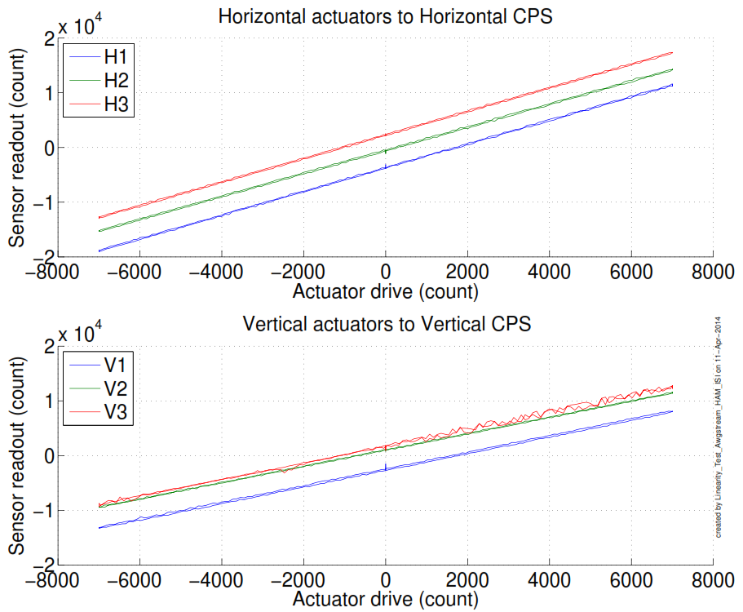
Figure 11: Horizontal and vertical actuators x HAM-ISI x sensors

Data files in SVN at:
/ligo/svncommon/SeiSVN/seismic/HAM-ISI/X2/Data/India_2/Linearity_test
- LLO_HAM_ISI_India_2_Linearity_test_20140411.mat

Figures in SVN at:
/ligo/svncommon/SeiSVN/seismic/HAM-ISI/X2/Data/India_1/Figures/Linearity_test
- LLO_HAM_ISI_India_2_Linearity_test_20140411.fig
- LLO_HAM_ISI_India_2_Linearity_test_20140411.pdf

Acceptance criteria:
- Horizontal and vertical slopes of the triplet actuators x HAM-ISI x sensors: Average slope +/- 2%

Test result: Passed: X Failed: .

Step 15 - Cartesian Basis Static Testing
 | 1000 counts drive | X Drive | Y Drive | Z Drive | Rx Drive | Ry Drive | Rz Drive
Sensors readout  (count) | H1
 | H2
 | H3
 | V1
 | V2
 | V3
 | Direction read out
Table 18: Tests in the general coordinate basis

Issues/difficulties/comments regarding this test: the compensation filters were not on while taking this test because they were tripping the watchdogs. This explains why all the results in the table have been multiplied by (-1).
The results in the table are very consistent with what we had for the previous units. The only issue we have on this test is the direction read out which is with the direction read out values, the calibration filters were on so these values are in nm instead of counts, explaining the high numbers.

Acceptance criteria:
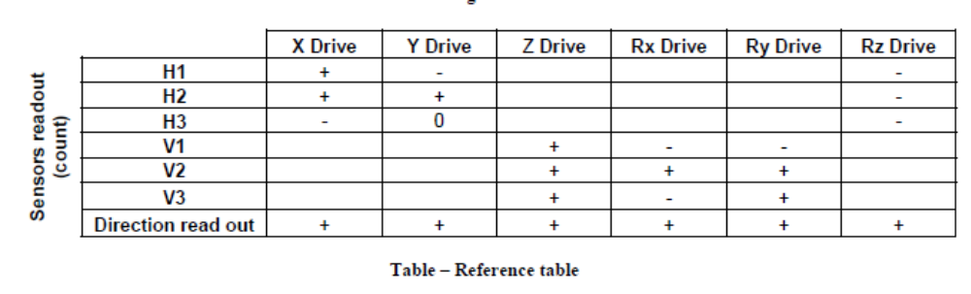
For a positive drive in the Cartesian basis:
- Local sensor readout must have the same sign that the reference table (CONT2ACT check)
- Cartesian sensors read out must be positive (DISP2CEN check) in the drive direction

Test result: Passed: Failed: X .

Step 16- Frequency response
Compensation filters of the new GS13 interface chassis are located in the geophone pre-filters bank. Powerspectra were measured with masses on the optic table not bolted.

Step 16.1 - Local to local measurements
Local to local transfer functions have been measured with 90 repetitions.
Data files in SVN at:
/ligo/svncommon/SeiSVN/seismic/HAM-ISI/X2/Data/India_2/Transfer_Functions/Measurements/
Undamped/
- LLO_HAM_ISI_India_2_Data_TF_L2L_50mHz_500mHz_20140507-224208.mat
- LLO_HAM_ISI_India_2_Data_TF_L2L_500mHz_5Hz_20140507-193635.mat
- LLO_HAM_ISI_India_2_Data_TF_L2L_5Hz_200Hz_20140507-180302.mat
- LLO_HAM_ISI_India_2_Data_TF_L2L_200Hz_800Hz_20140507-162928.mat
Data collection script files:
ligo/svncommon/SeiSVN/seismic/HAM-ISI/X2/Scripts/Data_Collection
- Run_TF_L2L_50mHz_500mHz.m
- Run_TF_L2L_500mHz_5Hz.m
- Run_TF_L2L_5mHz_200Hz.m
- Run_TF_L2L_200Hz_800Hz.m
Scripts files for processing and plotting in SVN at:
/ligo/svncommon/SeiSVN/seismic/HAM-ISI/X2/Data/India_2/Transfer_Functions/Measurements/
Undamped/
- Plot_LLO_HAM_ISI_India_2_TF_L2L_2014_05_07.m
Figures in SVN at:
ligo/svncommon/SeiSVN/seismic/HAMISI/X2/Data/India_2/Figures/Transfer_Functions/Measurements/Undamped/
- LLO_HAM_ISI_India_2_TF_L2L_V_CPS_50mHz_800Hz_2014_05_07.fig
- LLO_HAM_ISI_India_2_TF_L2L_H_GS13_50mHz_800Hz_2014_05_07.fig
- LLO_HAM_ISI_India_2_TF_L2L_H_CPS_50mHz_800Hz_2014_05_07.fig
- LLO_HAM_ISI_India_2_TF_L2L_V_GS13_50mHz_800Hz_2014_05_07.fig
Storage of measured transfer functions in the SVN at:
ligo/svncommon/SeiSVN/seismic/HAM-ISI/X2/Data/India_2/Transfer_functions/ Measurements/
Undamped/
- LLO_HAM_ISI_India_2_Data_TF_L2L_2014_05_07.mat

The local to local transfer functions are presented below.

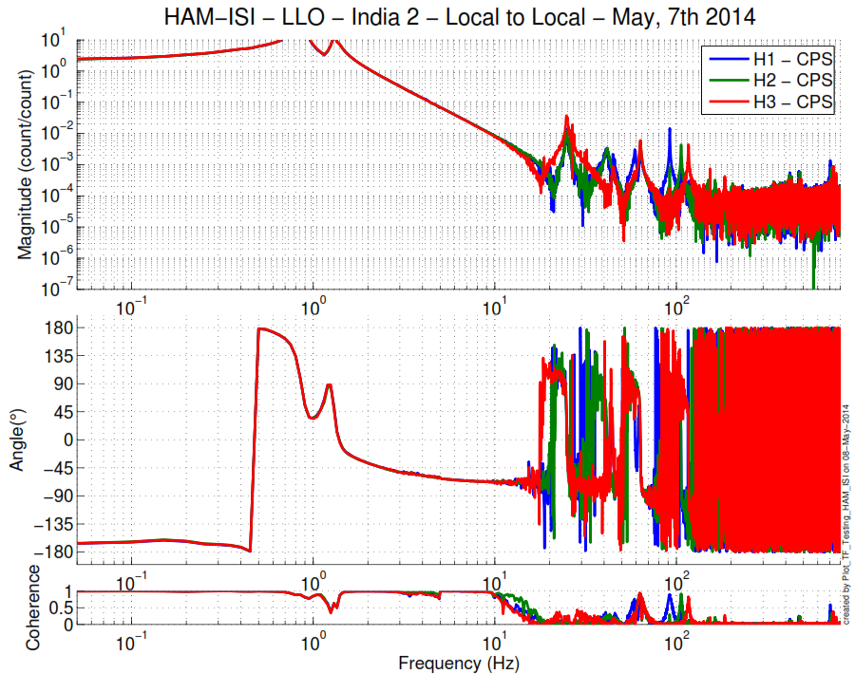
Figure 19: Local to Local Measurements – Horizontal capacitive sensors
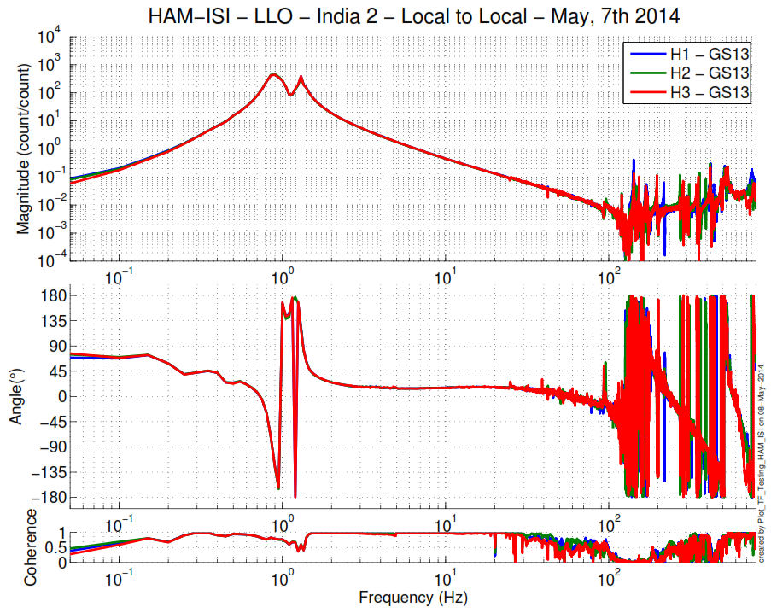
Table 20: Local to Local Measurements – Horizontal inertial sensors

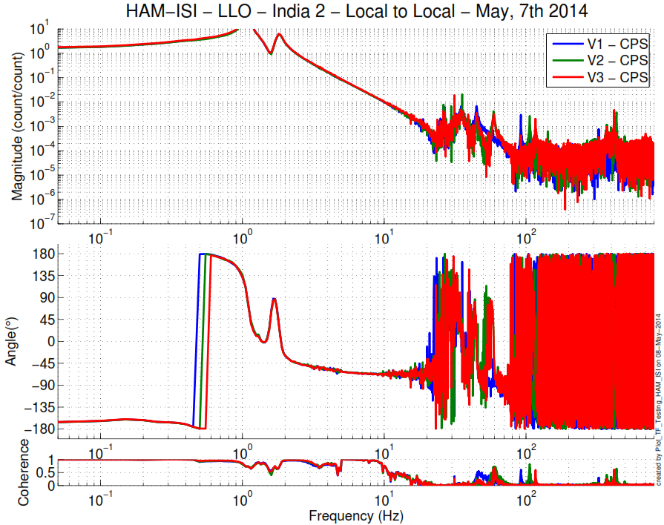
Table 21: Local to Local Measurements – Vertical capacitive sensors
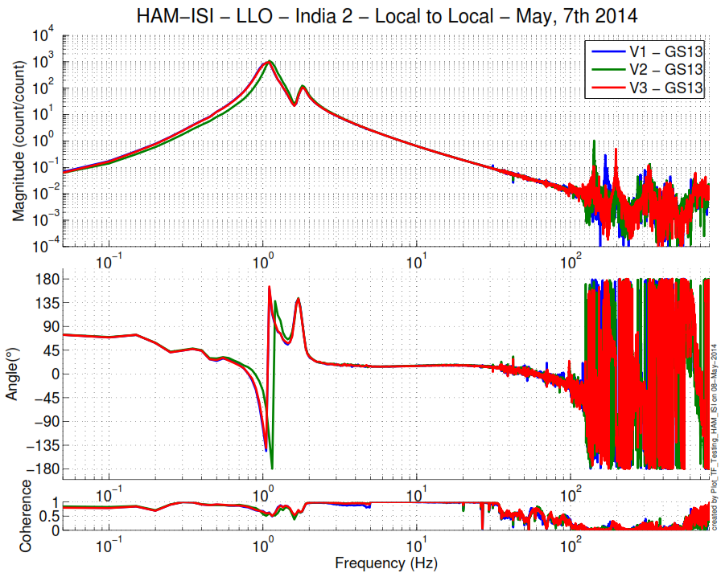
Table 22: Local to Local Measurements – Vertical inertial sensors

Issues/difficulties/comments regarding this test:
Around 1 Hz, the inertial sensors seem to indicate different behaviors of each corner.

Step 16.2 - Cartesian to Cartesian measurements

Issues/difficulties/comments regarding this test:

Acceptance criteria:
- Local to local measurements
  - On CPS, the phase must be 0º at DC
  - On Geophones, the phase must be -90º at DC
  - Identical shape in each corner
- Cartesian to Cartesian measurements
  - On CPS, the phase must be 0º at DC
  - On Geophones, the phase must be -90º at DC
  - Identical shape X/Y and RX/RY

Test result: Passed: Failed: . Waived: X

Step 17 - Transfer function comparison with Reference

Step 17.1 - Local to local - Comparison with Reference
This is the 2nd unit which is compared to LHO Unit #2 instead of LLO HAM 6 (v4 was comparing to LLO HAM 6 and both data can be found on the SVN).

Scripts files for processing and plotting in SVN at:
/ligo/svncommon/SeiSVN/seismic/HAM-ISI/X2/Data/India_2/Transfer_Functions/Measurements/
Undamped/
- Plot_LLO_HAM_ISI_India_2_TF_L2L_2014_05_07.m

Local to local figures in SVN at:
/svncommon/SeiSVN/seismic/HAM-ISI/X2/Data/India_1/Figures/Transfer_Functions/Measurements/Undamped
- LLO_HAM_ISI_India_2_TF_L2L_H_CPS_50mHz_800Hz_wRef_2014_05_07.fig
- LLO_HAM_ISI_India_2_TF_L2L_V_CPS_50mHz_800Hz_wRef_2014_05_07.fig
- LLO_HAM_ISI_India_2_TF_L2L_H_GS13_50mHz_800Hz_wRef_2014_05_07.fig
- LLO_HAM_ISI_India_2_TF_L2L_V_GS13_50mHz_800Hz_wRef_2014_05_07fig

GS13, Local to local measurement
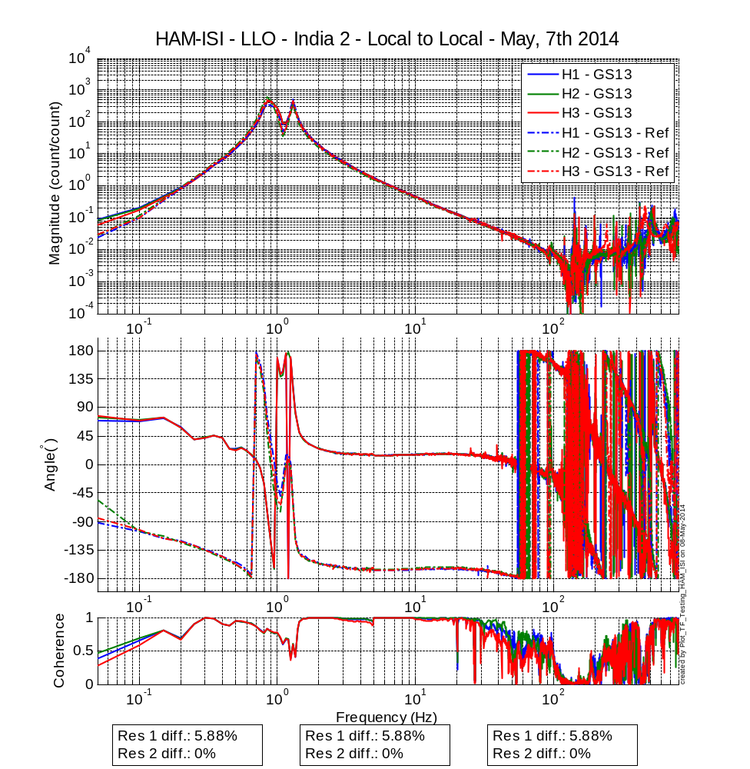
Figure - Local to local measurements comparison with LHO UNIT 2 – Horizontal GS-13
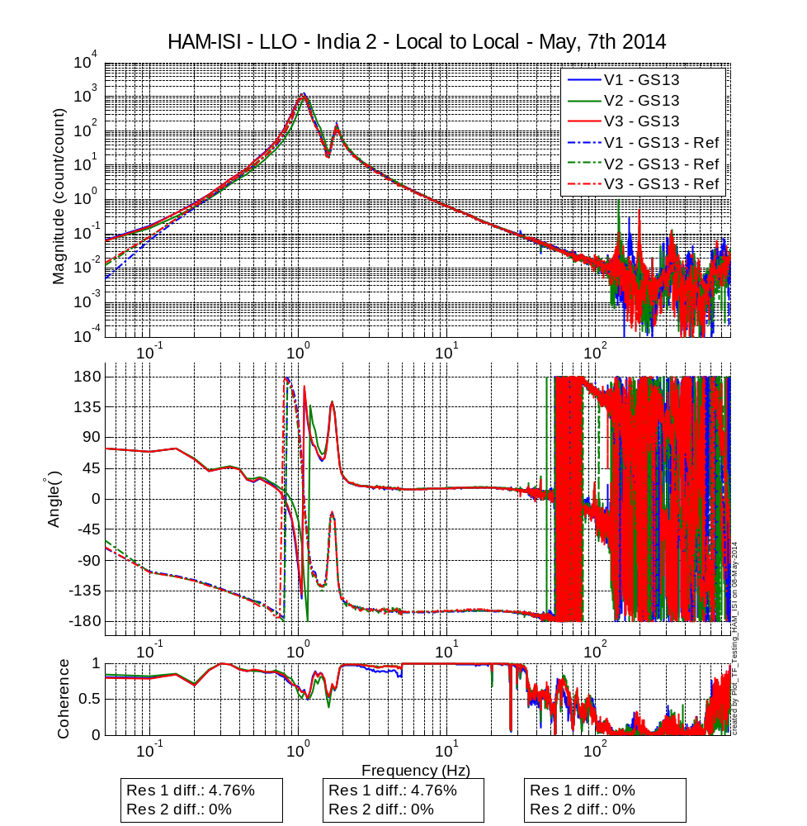
Figure - Local to local measurements comparison with LHO UNIT 2 – Vertical GS13
CPS, Local to local measurement, Undamped
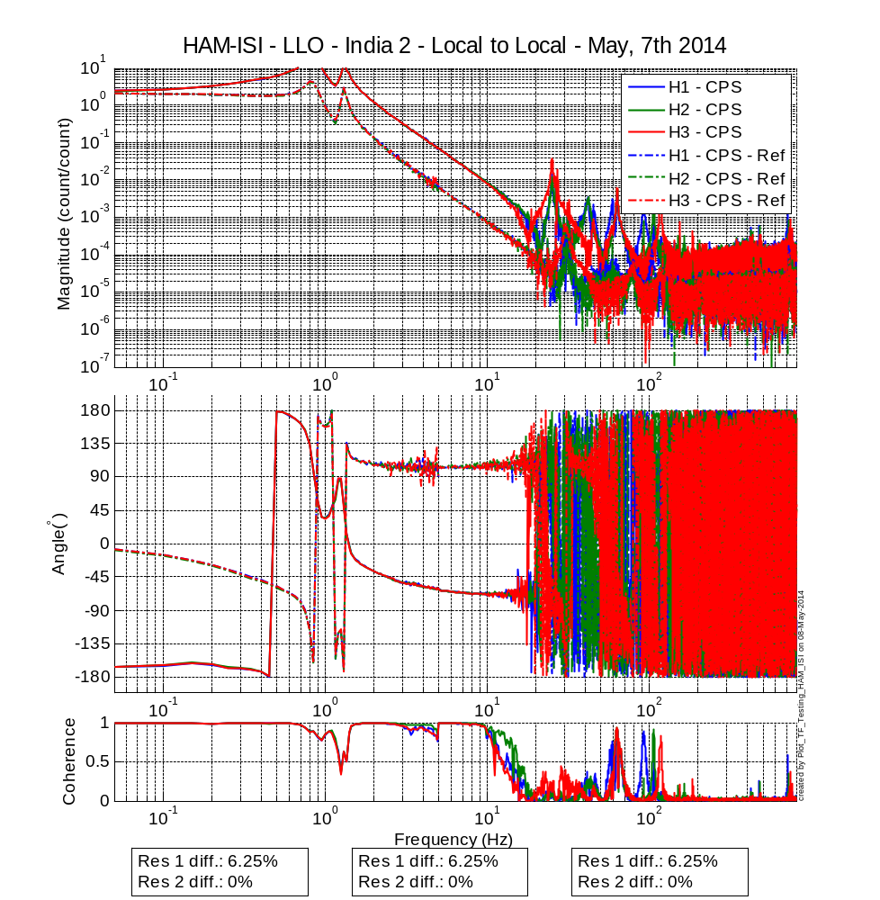
Figure - Local to local measurements comparison – Horizontal Position sensors
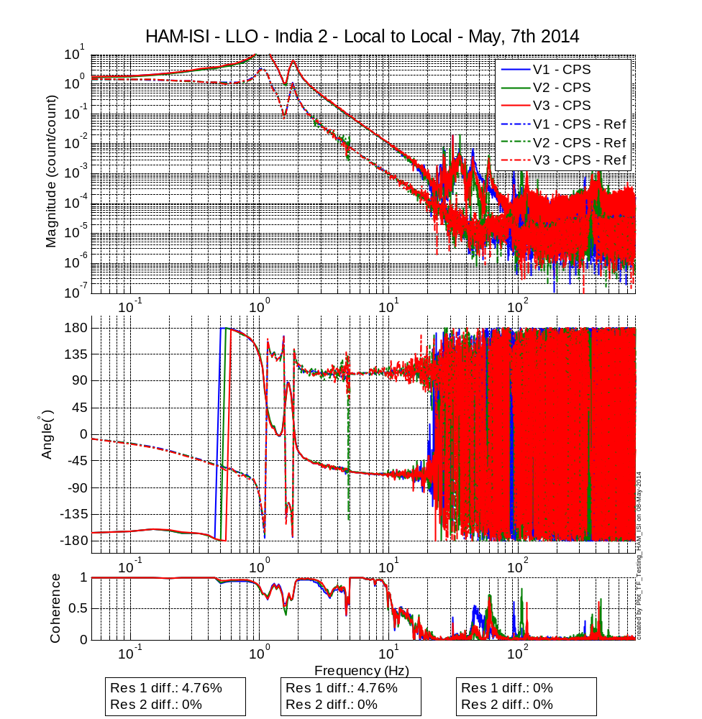
Figure - Local to local measurements comparison – Vertical Position sensors

Step 17.2 - Cartesian to Cartesian - Comparison with Reference
Scripts files for processing and plotting in SVN at:
ligo/svncommon/SeiSVN/seismic/HAM-ISI/X2/Data/India_1/Transfer_Functions/Measurements/
Undamped/
- Plot_LLO_HAM_ISI_India_1_TF_C2C_2011_08_02.m
Cartesian to Cartesian figures in SVN at :
/svncommon/SeiSVN/seismic/HAM-ISI/X2/Data/India_1/Figures/Transfer_functions/Measurements/Undamped
Acceptance criteria:

- No difference with the reference transfer functions (SVN)
  - Phase – less than 10º - In Phase – Out of Phase
  - Damping (fit by eye with Reference transfer functions)
  - DC gain
  - Eigen frequencies shift less than 10%

Test result: Passed: Failed: .

Step 18 - Lower Zero Moment Plane

Data collection script files:
ligo/svncommon/SeiSVN/seismic/HAM-ISI/X2/Scripts/Data_Collection
- Run_Cart2Cart_10mHz_100mHz.m
Data files in SVN at:
ligo/svncommon/SeiSVN/seismic/HAM-ISI/X2/Data/India_1/Transfer_Functions/Measurements/
Undamped/
- LZMP_LLO_HAM-ISI-India_1_2011_08_02.mat
Scripts files for processing and plotting in SVN at:
ligo/svncommon/SeiSVN/seismic/HAM-ISI/X2/Data/India_1/Transfer_Functions/Measurements/
Undamped/
- LZMP_2011_08_02.m
Figures in SVN at:
ligo/svncommon/SeiSVN/seismic/HAM-ISI/X2/Data/India_1/Figures/Transfer_Functions/
Measurements/Undamped/
- LZMP.fig

Acceptance criteria:
- X offset must be less than 2 mm
- Y offset must be less than 2 mm

Test result: Passed: Failed: .

Step 19 - Damping loops
In this step, HAM6 damping loops are implemented. First, damping performances are evaluated in simulation. Second, Damping loops are implemented and performance is experimentally measured.

Step 19.1 - Transfer functions - Simulation
Scripts files for processing and plotting in SVN at:
/ligo/svncommon/SeiSVN/seismic/HAM-ISI/X2/Data/India_1/Transfer_Functions/Simulation/Damping

Figures in SVN at:
/svncommon/SeiSVN/seismic/HAM-ISI/X2/Data/India_1/Figures/Transfer_Functions/Simulations/
Damping/

Results are saved in SVN at:
/ligo/svncommon/SeiSVN/seismic/HAM-ISI/X2/Data/India_1/Transfer_Functions/Simulations/
Damping/
Acceptance criteria:

- HAM6 damping loops must implemented and stable with
  - Phase margin must be at least 45º
  - Gain margin must be at least 20dB

Test result: Passed: Failed: .

Step 19.2 - Powerspectra – Experimental

Data files in SVN at:
/ligo/svncommon/SeiSVN/seismic/HAM-ISI/X2/Data/India_#/Powerspectra/Damping/
Scripts files for taking data and plotting in SVN at:
/ligo/svncommon/SeiSVN/seismic/HAM-ISI/X2/Scripts/Data_Collection/
- Powerspectra_Measurements_Undamped_Damped_HAM_ISI.m
Figures in SVN at:
/svncommon/SeiSVN/seismic/HAM-ISI/X2/Data/India_#/Figures/Powerspectra/Damping/

Acceptance criteria:

- HAM6 damping loop must stable when all damping loops are engaged
- Similar damping effect than in simulated plots

Test result: Passed: X Failed: .

Conclusion
A few issues were found during the testing of this HAM India 2. The known issues are summed up here:
- Sensor gaps not recorded on the jig (III Step 2 & 3).
- III Step 2 Setup Sensors Gap, the standard deviations are higher than the spec.
- The Vertical GS13 Post Modification Huddle and Driven Tests for SN V704 are not acceptable, although the seismometer passed QA. An acceptable test may have been run, but not saved. All further tests show no sign of incorrect modification.
- Step 5 Blade Profile, one blade is out of spec by 3 mil.
- III Step 12 Vertical Spring Constant, the average spring constant is out of spec by 0.8%.
- III Step 13 Static Testing in the Local Basis, H3-H1 & H2-H3 non-collocated sensors are out of spec by 9 and 107 counts, respectively.
- The Cartesian Basis Static Testing (III Step 15) script is not running correctly.

When this Unit is approved, it will be put in a shipping container and stored to be shipped to India later.

