LIGO Laboratory / LIGO Scientific Collaboration

E1000523-v4 LIGO 7 July 2011

Trillium Pod Assembly Procedure

A. Le Roux, M. Hillard

Distribution of this document:
Advanced LIGO Project

This is an internal working note
of the LIGO Laboratory.

California Institute of Technology  LIGO Project – MS 18-34  1200 E. California Blvd.  Pasadena, CA 91125  Phone (626) 395-2129  Fax (626) 304-9834  E-mail: info@ligo.caltech.edu | Massachusetts Institute of Technology  LIGO Project – NW22-295  185 Albany St  Cambridge, MA 02139  Phone (617) 253-4824  Fax (617) 253-7014  E-mail: info@ligo.mit.edu
LIGO Hanford Observatory  P.O. Box 1970  Mail Stop S9-02  Richland WA 99352  Phone 509-372-8106  Fax 509-372-8137 | LIGO Livingston Observatory  P.O. Box 940  Livingston, LA 70754  Phone 225-686-3100  Fax 225-686-7189

Clean room standards:

For a clean assembly, all LIGO standards should be followed, as presented in the latest version of the LIGO Contamination Control Plan (E0900047). Clean room garb including UHV gloves should be worn when working with clean parts.
All tools that come in contact with assembly should be cleaned to class B standards.
Assembly will be done under a portable clean room. Anytime a part of the assembly is not covered by the portable clean room or not being actively worked on, it should be covered with appropriate clean covers (C3 polyester or equivalent).
Figure 1: Exploded View of the whole Assembly
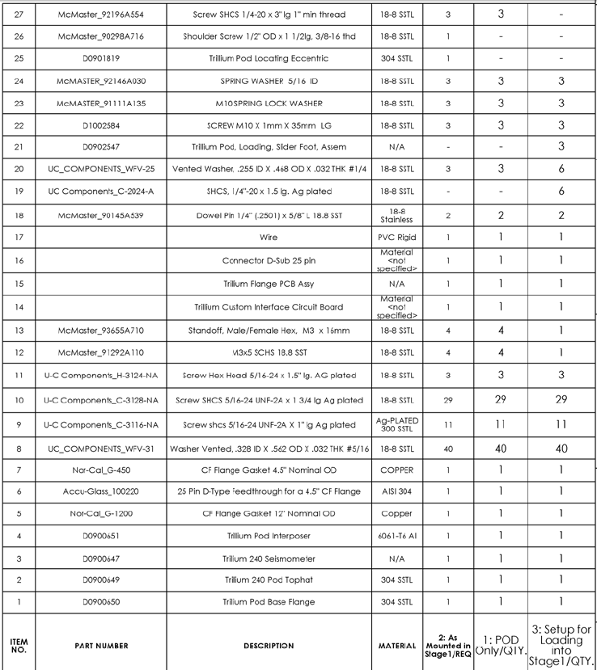

Figure 2: Bill of Material of the Trillium Pod Assembly

- Press the two undersized 1/4" x 5/8” long Dowel Pin into the Trillium Pod Base Flange (D0900650) .Pin should sit 0.25” proud of the mating surface.

Hardware:
(2) Undersized 1/4" x 5/8” long Dowel Pin
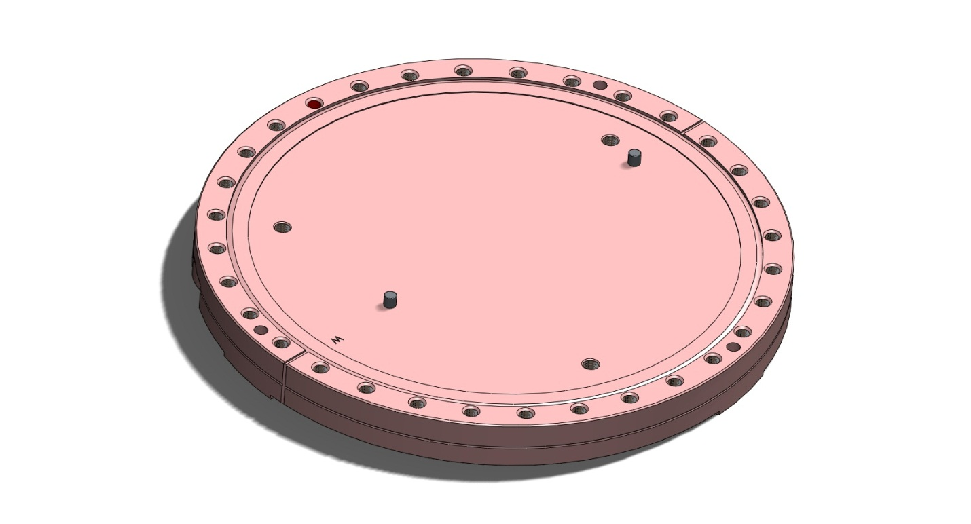

Figure 3: Dowel Pins pressed into the Trillium Pod Base Flange (D0900650)

- Mount the Trillium 240 Seismometer on the Trillium Interposer (D0900651), making sure to align “W” markings on the two parts. Torque screws to 50 in.lbs.

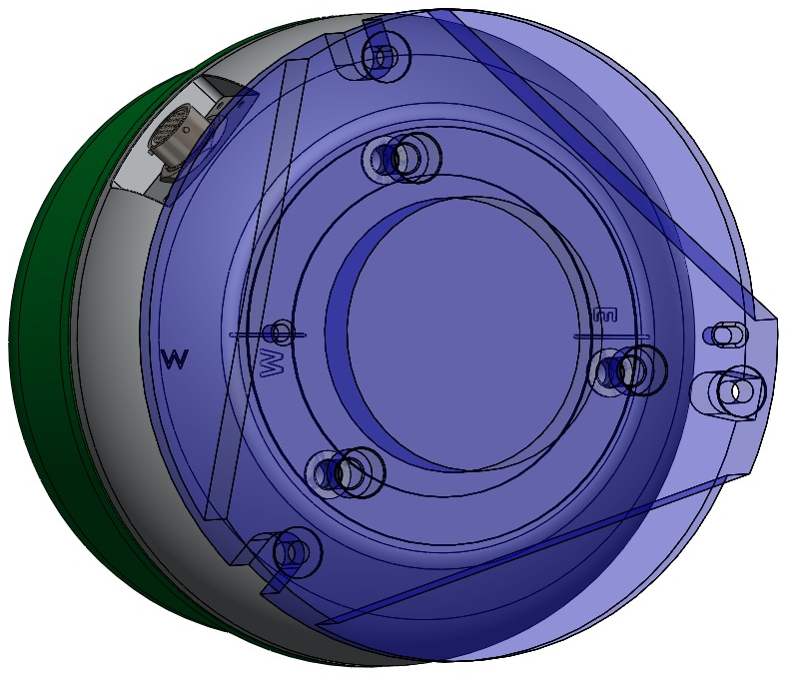

Figure 4: The Trillium 240 Seismometer is seated on the Trillium Interposer (D0900651) with the "W" markings aligned as circled on the screen shot above

Hardware:
(3) M10 x 1mm x 35mm long Stainless Steel SHCS
(3) M10 Springs Lock Washers

Figure 5: Trillium 240 Seismometer mounted on the Trillium Interposer (D0900651)

- Place the Trillium 240 Seismometer and the Trillium Interposer (D0900651), on the Trillium Pod Base Flange (D0900650) allowing pins to sit properly in hole and slot and aligning “W” markings. Torque screws to 250 in.lbs.

Hardware:
(3) 5/16”-24 x 1” Ag plated SHCS
(3) 5/16” Spring Lock Washers
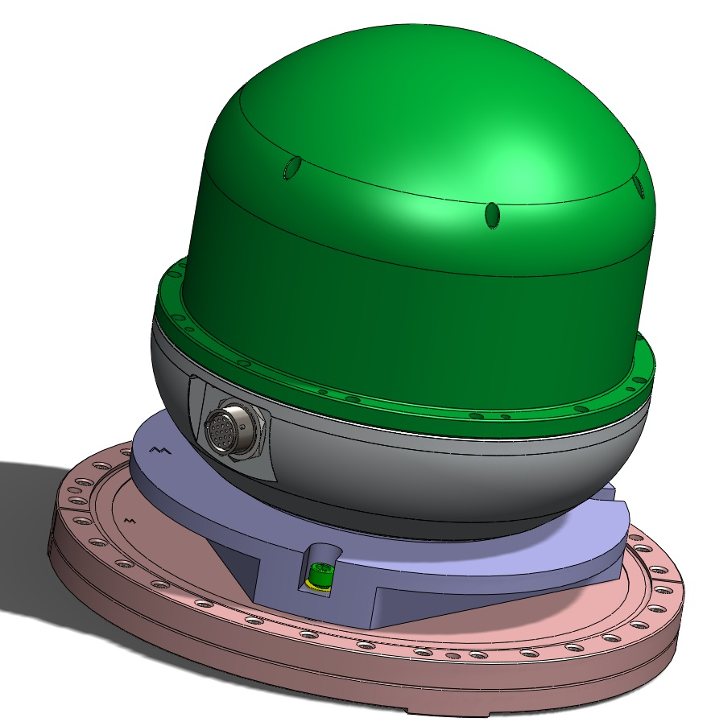

Figure 6: Sub-assembly composed of the Trillium 240 Seismometer and the Trillium Interposer (D0900651) mounted on the Trillium Pod Base Flange (D0900650)

Figure 7: Section of the Sub-Assembly above (see Figure 2: Bill of Material on Page 3 for the Number)
- Insert four M3 x 14mm long Standoff in the Trillium 240 Seismometer. Insert two M3 Washers on the two top Standoffs. Snug the four M3 x 14mm long Standoff in the Trillium 240 Seismometer.

Hardware:
(4) M3 x 14mm long Standoff
(4) M3 Washers
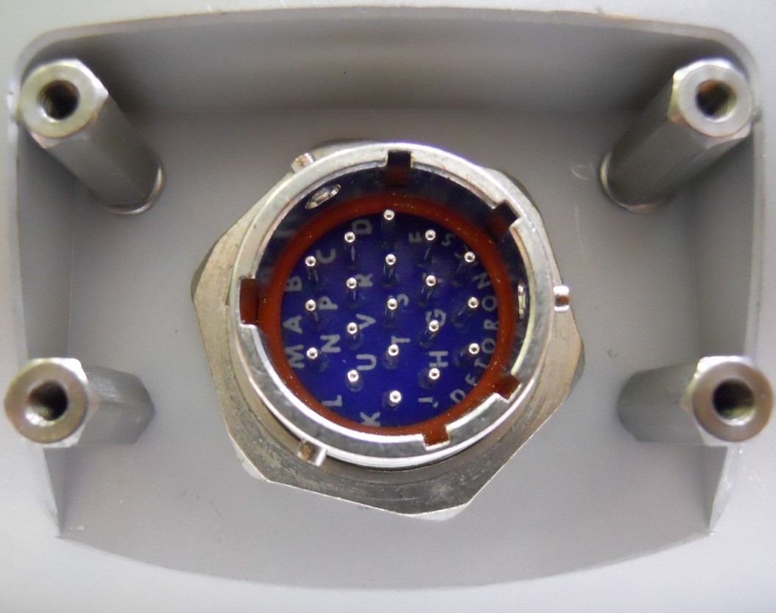
2 x (2) M3 Washers
(4) M3 x 14mm long Standoff

Figure 8: M3 x14mm Standoffs mounted on the Trillium 240 Seismometer

- After wiping it down with a clean cloth and methanol, place the Copper Gasket on the knife edge of the Trillium Pod Base Flange (D0900650)

- Place the Trillium Pod Chamber Top Hat (D0900649) over the Trillium Pod Base Flange (D0900650), aligning the vertical edge lines on both part.

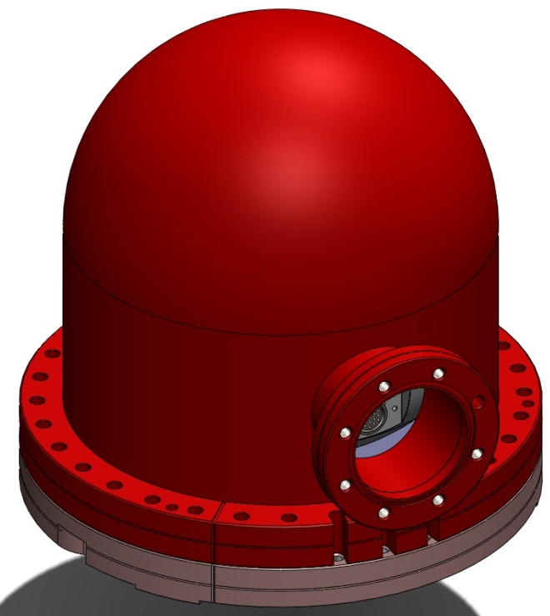

Figure 9: Trillium Pod Chamber Top Hat (D0900649) over the Trillium Pod Base Flange (D0900650), with the vertical edge lines aligned on both part

- Insert connector PCB into Top Hat Port and onto the Trillium connector, making sure that the board is sitting flat against the four standoffs. Use four M3 x 5mm long SHCS with four M3 Washers, to fasten the PCB to the standoffs.

Hardware:
(4) M3 x 5mm long SHCS
(4) M3 Washers

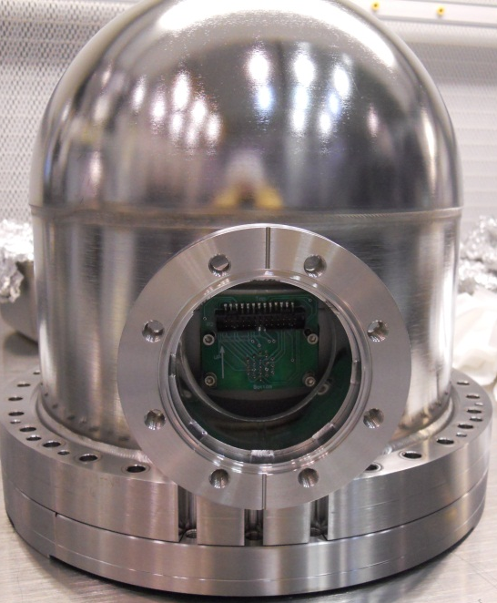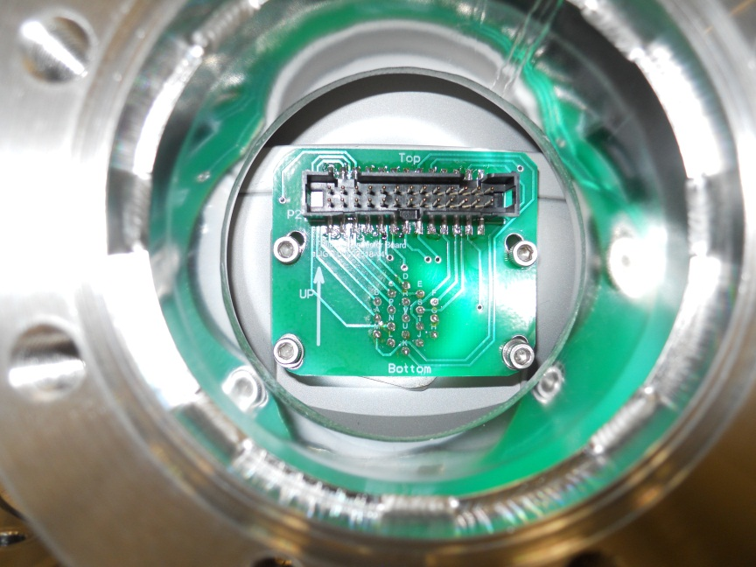

- Fasten the Trillium Pod Chamber Top Hat (D0900649) to the Trillium Pod Base Flange (D0900650) using thirty-three 5/16”-18x1.75” Ag Plated SHCS, three 5/16”-18x1.5” Ag Plated Hex Head and thirty-six 5/16” Vented Washers as shown on the Figure 10Tighten them hand tight. Check to see that the flange faces are parallel. Tighten 2 bolts diametrically opposite to an intermediate torque value (for example 150 in.lbs), repeat this operation with 2 other bolts oriented ~ 90 degrees from the two first ones for alignment purposes. Then torque all the bolts incrementally up to final torque value, using a circular clockwise pattern (250 in.lbs, 345 in.lbs [This torque value is higher than the Nor-Cal Spec.: 190 in.lbs, in order to make sure that the two flange faces are brought metal to metal]).

Hardware:
(33) 5/16”-24 x 1.75” Ag plated SHCS
(3) 5/16”-24 x 1.5” Ag plated HHCS
(36) 5/16” Vented Washers
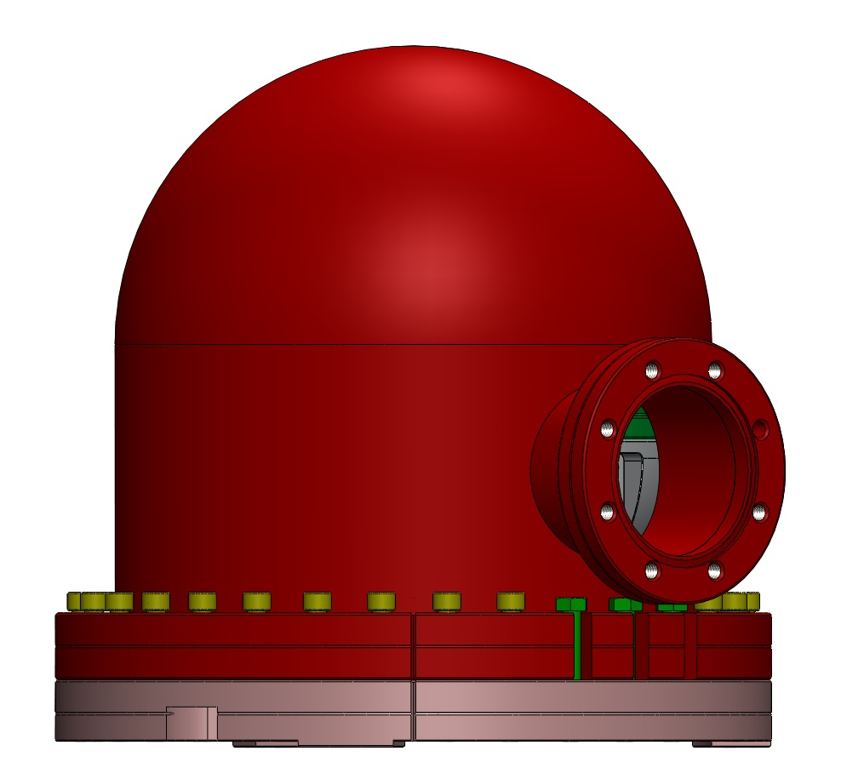
(3) 5/16”-24 x 1.5” Ag plated HHCS in the three “open” holes

Figure 10: Trillium Pod Chamber Top Hat (D0900649) bolted down on the Trillium Pod Base Flange (D0900650)

- Check that the flange faces are metal to metal.

- Plug Cable to the connector PCB, then insert CF450_250N copper seal and finally plug the other end of the cable to the Feed.

Figure 11: Cable and Copper Gasket mounted onto the Feed Thru

- Attach Feed Thru end of cable to 4.5” Feed Thru DB25 with 4-40 x 0.5” long SHCS.

Hardware:
(2) 4-40 x 0.5” long SHCS
(2) 4-40 Washers
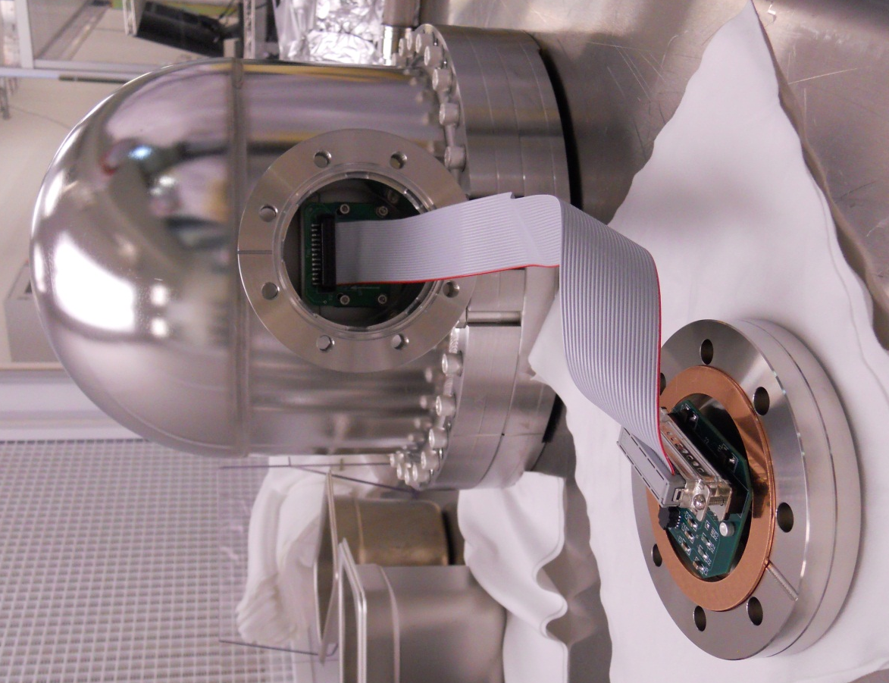

Figure 12: Trillium Pod Assembly with Cable bolted to the Feed Thru and ready to be filled with Neon and closed

- Fill the Trillium Pod Chamber with Neon for about 2 Minutes.

- Coil cable into Top Hat port, making sure not to twist it too hard and attach Feed Thru to Top Hat Port Flange with eight 5/16”-18 x 1.0” Ag Plated SHCS and eight 5/16” Vented Washers.

Hardware:
(8) 5/16”-18 x 1.0” Ag Plated SHCS
(8) 5/16” Vented Washers

- As previously, it is recommended that one insert and tighten the first 4 bolts in a star-like fashion (not one at a time around the circumference) for alignment purposes. Then torque all the bolts incrementally, up to the final torque value 345 in.lbs, using a circular clockwise pattern. [Once again, this torque value is higher than the Nor-Cal Spec.: 190 in.lbs, in order to make sure that the two flange faces are brought metal to metal]

- Check that the flange faces are metal to metal.

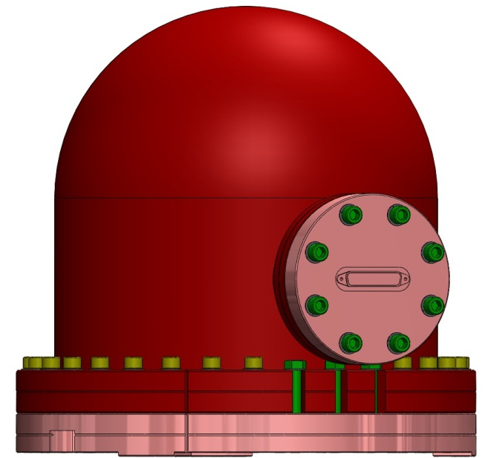

Figure 13: Complete Trillium Pod Assembly

- The Trillium Pod Assembly is now complete and needs to be Leak Tested!

