LIGO Laboratory / LIGO Scientific Collaboration

LIGO- T1000636-v1 LIGO October 20, 2010

Capacitive Position Sensor Probe
Aftermarket Shielding Procedure
Ben Abbott, Sam Abbott

Distribution of this document:
LIGO Scientific Collaboration

This is an internal working note
of the LIGO Laboratory.

California Institute of Technology  LIGO Project – MS 18-34  1200 E. California Blvd.  Pasadena, CA 91125  Phone (626) 395-2129  Fax (626) 304-9834  E-mail: info@ligo.caltech.edu | Massachusetts Institute of Technology  LIGO Project – NW22-295  185 Albany St  Cambridge, MA 02139  Phone (617) 253-4824  Fax (617) 253-7014  E-mail: info@ligo.mit.edu
LIGO Hanford Observatory  P.O. Box 1970  Richland WA 99352  Phone 509-372-8106  Fax 509-372-8137 | LIGO Livingston Observatory  P.O. Box 940  Livingston, LA 70754  Phone 225-686-3100  Fax 225-686-7189
http://www.ligo.caltech.edu/

Some of the tools and supplies that you will need to shield your Capacitive Position Sensor probe: (1) Braid bodger, (2) clean copper braid, (3) Insertion bullet, (4) PEEK Zipties, and (5) ziptie tensioning tool. Don’t forget your gloves (6)!

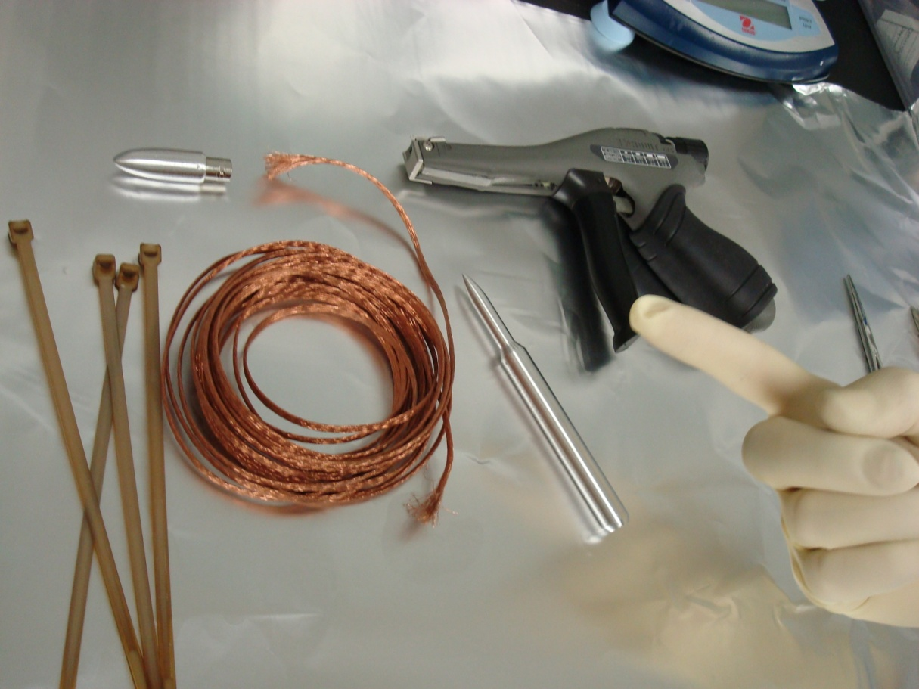

3
5
5

4 2

1 6

Step 1: Create a bubble in the braid by grasping it with both hands ~1 ½ inches apart, and pushing your hands slowly toward each other. The bulge should be far enough away from the end of the braid to leave you with enough of a pigtail to reach a screw on the in-vacuum ISI table.
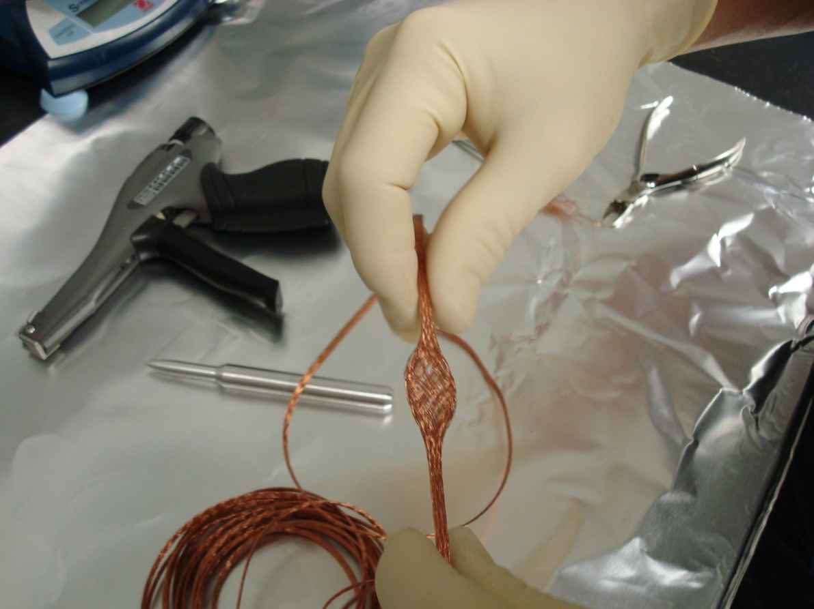

Step2: Insert the braid bodger into the bubble, and gently pry open the tube. Be careful not to just push the bodger all the way through the braid, without opening the braid into a tube.
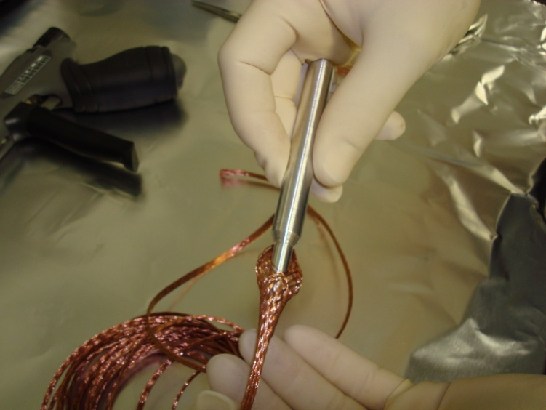
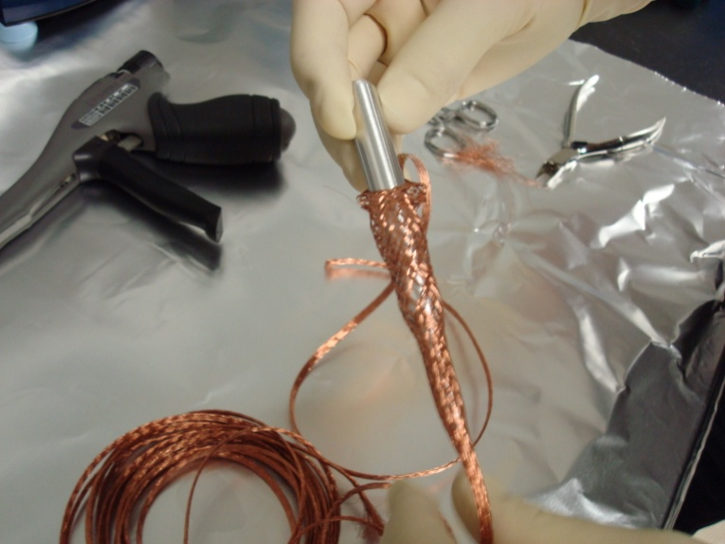

Step3: Remove the bodger, leaving a pronounced bulge in the now-opened braid. Attach the Insertion bullet to the BNC end of the Capacitive Position Sensor probe, and insert them into the bulge.

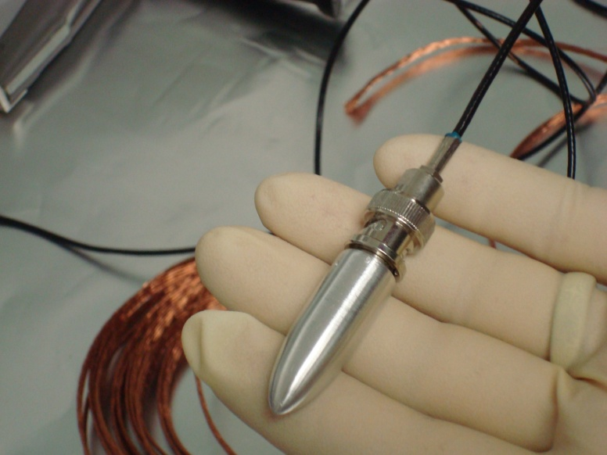
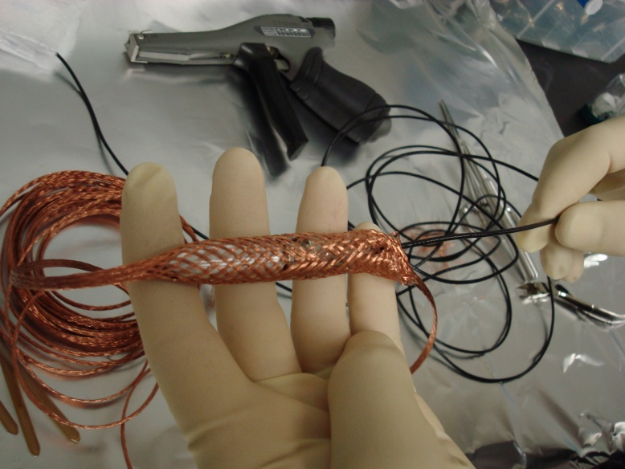

Step 4: Inch the insertion bullet into the braid in an inchwormy stop/start fashion as demonstrated in this movie: http://www.ligo.caltech.edu/~babbott/InsertionBullet.MPG Be careful to not disturb the joint between the cable and the probe itself. This joint is extremely fragile.

Step 5: Finish insertion when the braid end that you first put the bullet into reaches near to the probe itself.
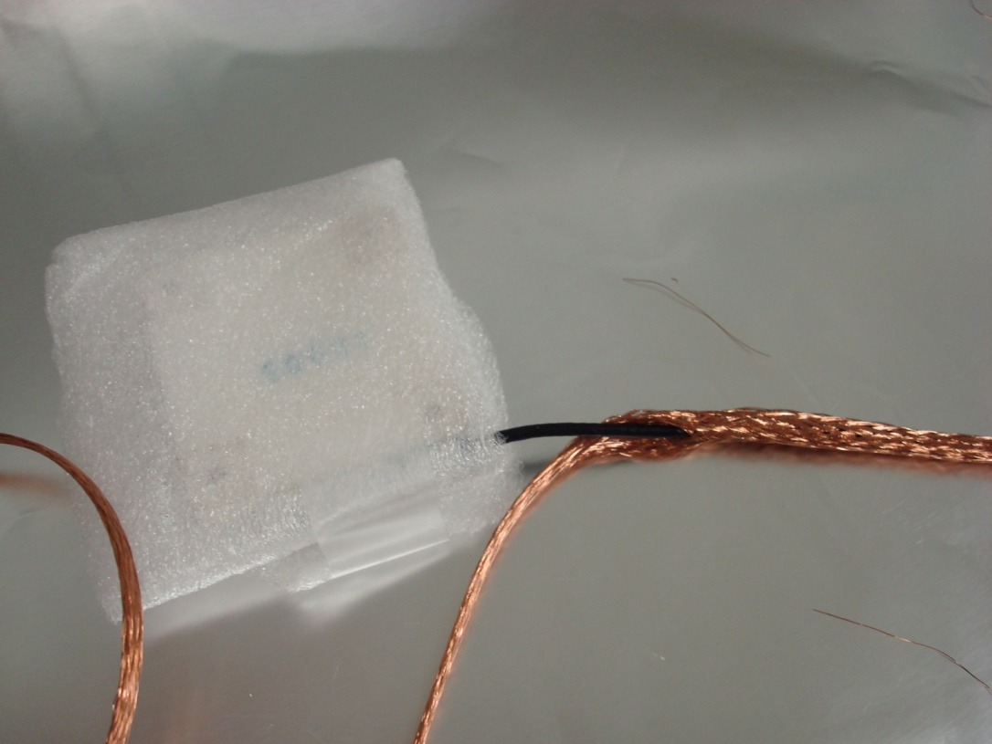

Pigtail
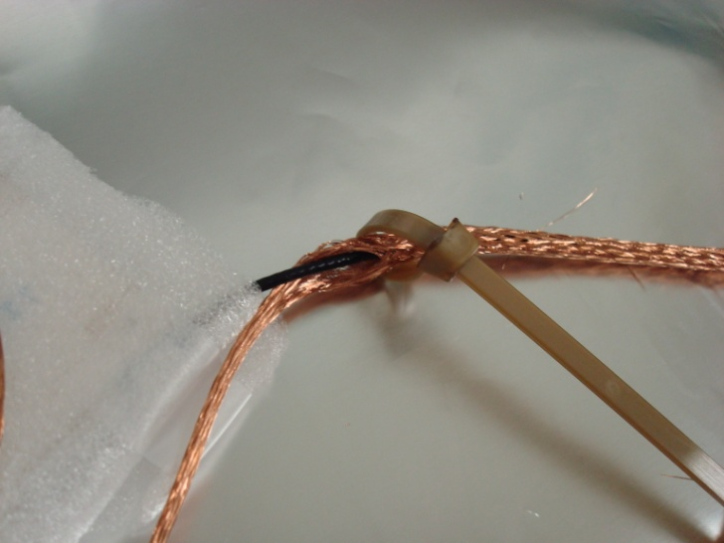
Step6: Place a PEEK Ziptie over the braid and cable, and tighten it with the cleaned ziptie tool (which should be set on its highest setting of 8)
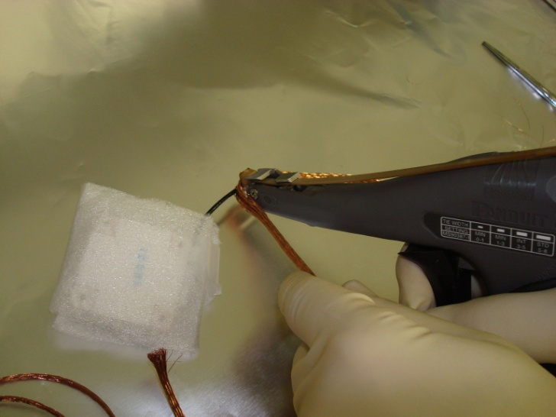

Step7: Smooth the now bulged braid down to the cable by drawing it through your hand from the ziptied end, to the BNC end (careful with the probe joint, and make sure that the probe-end ziptie doesn’t slip). When it’s nice and snug, trim the braid at the BNC end to be close, but definitely not touching the BNC cable (be careful not to cut or nick the coax cable!)
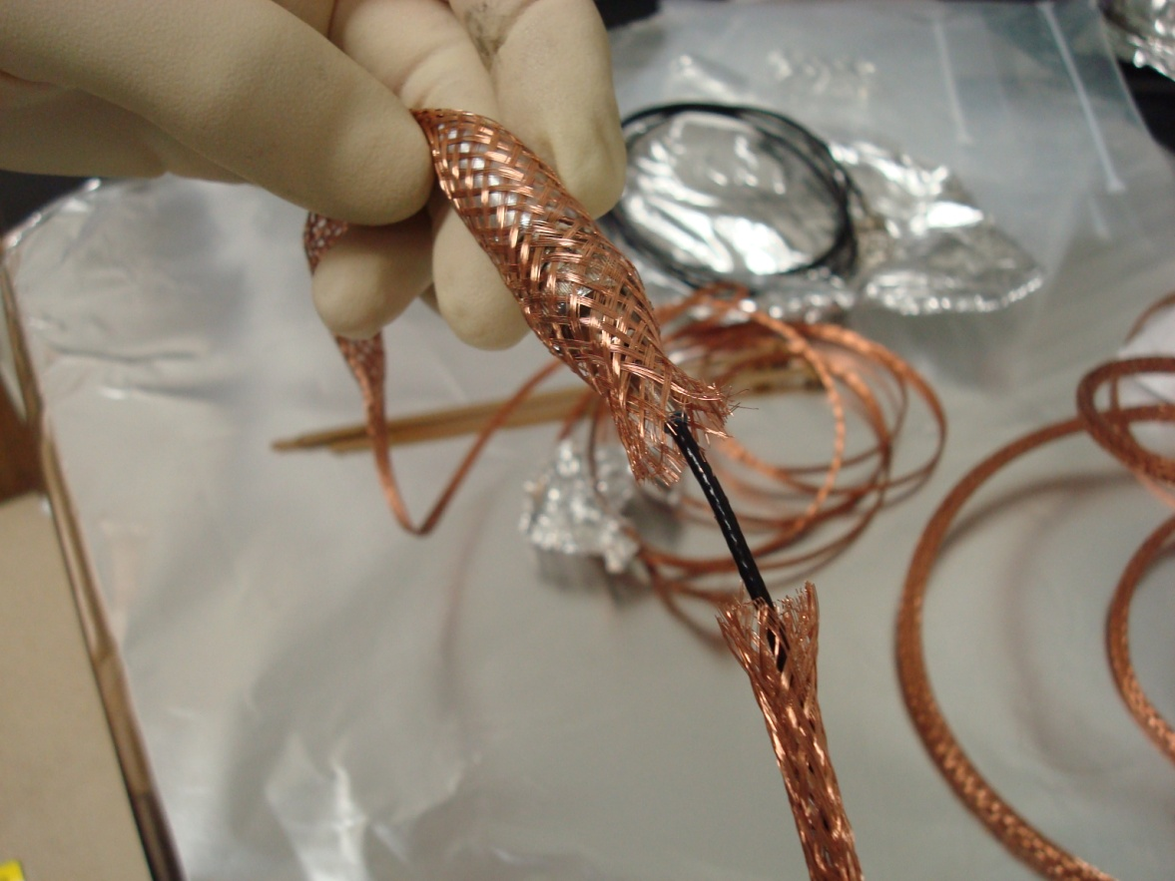

Insertion Bullet

BNC

Toward Probe

Step7: Loosely place a PEEK Ziptie over the braid and cable, and re-smooth the cable from the probe end to tighten the weave, and lengthen the shield as much as possible. Once it’s smoothed, tighten the ziptie with the cleaned ziptie tool, and trim any excess copper whiskers from the end, so the shield won’t make electrical contact with the BNC connector.

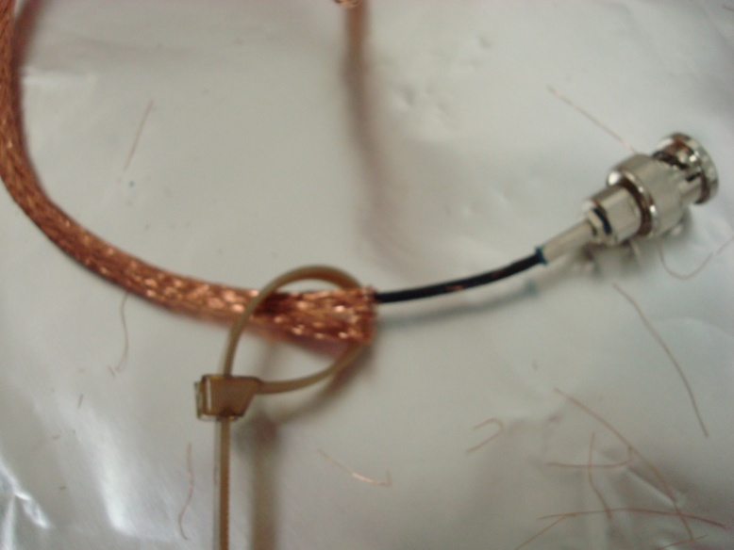
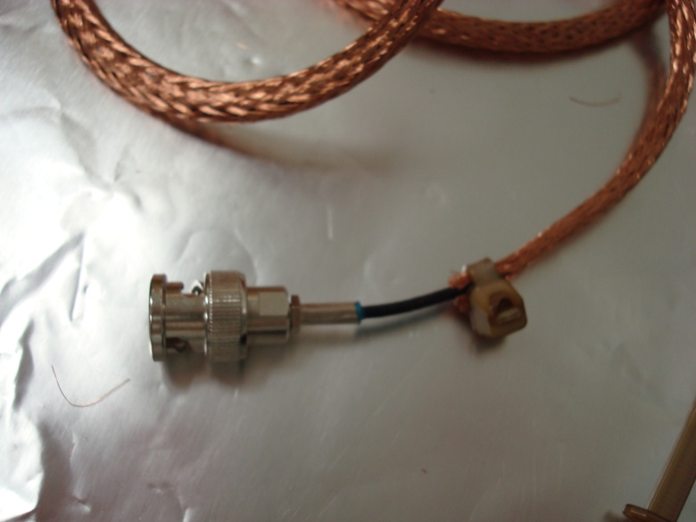

Your cable should now look something like this:
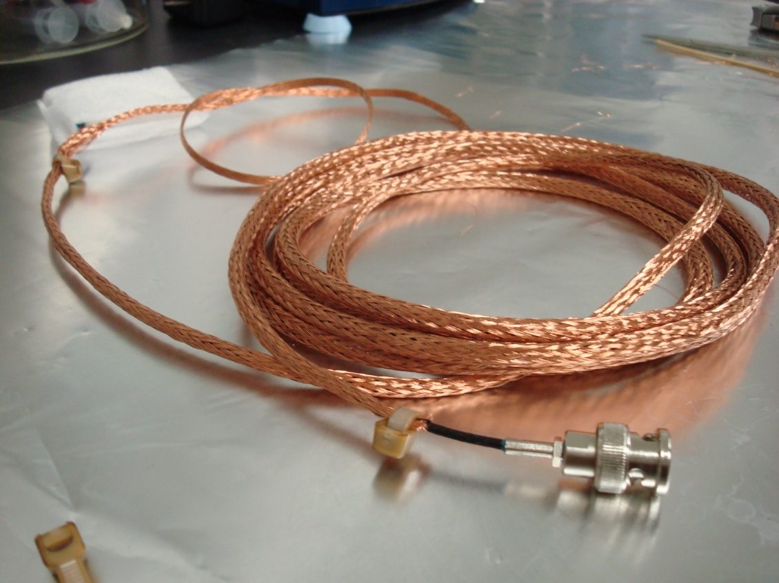

You can repeat the same procedure with dirty braid and nylon zipties for the 1m in-air cable. The pigtail on this cable should be at the LEMO connector end, and long enough to reach the grounding lugs on the Capacitive Position Sensor Power Board.

