APPROVALS | DATE | REV | DCN NO. | BY | CHECK | DCC | DATE
AUTHOR: | 3/2/11 | V1 | For Installation
CHECKED:
APPROVED:
DCC RELEASE

TABLE OF CONTENTS

1.0 General Scope
2.0 Codes / Standards /Permits
3.0 Safety Requirements
4.0 LIGO Site Requirements
5.0 Detailed Installation Scope
6.0 Equipment and Materials
7.0 Documentation by Seller
8.0 Attachments Summary

1.0 General Scope

1.1 This specification covers the minimum requirements for the moving and installation of new vacuum equipment required for the Advanced LIGO Modification of the LIGO Observatories. This specification covers only the LIGO Livingston, LA (LLO) Corner Station facility.

The Buyer will provide a full time representative to work with the Seller during these activities.

All equipment must be moved / installed while maintaining the strict Cleanliness of the LIGO research facility. Anytime a LIGO vessel is open to atmosphere, it must be protected by a Class 5 cleanroom (provided by LIGO) and Class 5 cleanroom procedures must be used.

All electrical wiring will be removed by others.

1.2 The Buyer will train the Seller personnel in site cleanliness and safety requirements (See Section 8.0 for detailed requirements) prior to the start of the work.

1.3 The California Institute of Technology (Caltech) is the Buyer for these components. The Seller is the successful bidder who is awarded this contract.

The Laser Interferometer Gravitational-Wave Observatory (LIGO) is operated by Caltech and the Massachusetts Institute of Technology (MIT) under a National Science Foundation grant and includes observatories located in the Hanford Reservation ,near Richland, WA (LHO) and in Livingston, LA (LLO).

Viewed from the Corner Station the left equipment arm is the “Y” arm and the right equipment arm is the “X” arm.

1.4 It is the Seller responsibility to follow the requirements of this specification or to propose alternate procedures and specifications to meet the requirements. All alternate approaches must be approved by the Buyer before use.

1.5 The Buyer reserves the right to refuse access to the LIGO facility to any of the Seller’s personnel for failure to adhere to LIGO Site Safety Rules or for refusing to work in a Safe and Clean manner.

1.6 All personnel must read and understand this complete document before proceeding with the work.

1.7 All drawing and specifications referenced herein are part of this specification and are available for viewing via the links in Section 8 of this document.

2.0 Codes / Standards / Permits

2.1 The following codes and standards (Latest Editions), as applicable, shall be followed for the installation and testing of the equipment:

ASTM - American Society for Testing Materials
OSHA - Occupational Safety and Health Act Noise Standard
Applicable - Local Codes and Standards
ISO 14644-1 – 1999 Cleanrooms and Associated Controlled Environments

AISC - American Institute of Steel Construction
ANSI - American National Standards Institute
B16.1 Cast Iron Pipe Flanges
B16.5 Steel Pipe Flanges
B31.1 Also For Utilities
B31.3 Chemical Plant and Petroleum Refinery Piping
B31.9 Building Services Piping
ASME - American Society of Mechanical Engineers
Section IX, Welding Qualifications -2007

AWS - American Welding Society

2.2 Permits

Before starting work on this project, it shall be the responsibility of the Seller to make certain that all necessary permits, licenses and approvals are obtained for the work to be performed at the site.

3.0 Safety Requirements

3.1 All work executed by the Seller shall comply with Federal OSHA regulations. The Seller is responsible for the Safety of their personnel.
3.2 The Seller shall also comply with the Buyer's on-site Construction Safety, Health and Environmental Management program.
3.3 The Seller shall be fully responsible for providing first aid equipment and other safety equipment required for their personnel.
3.4 The Seller’s foreman shall be responsible for the safe execution of the work at the site. Seller shall conduct weekly safety meetings with their crew and send a representative to all site wide safety meetings.
3.5 All piping shall be verified to have no internal pressure before it is cut or the connection is opened.
All electrical wiring will be removed by others.
3.6 When directed by LIGO, areas where construction work is being done shall be roped off by construction tape, to warn other site personnel.
3.7 The Bidders shall submit their Safety Rating as part of their bid submittal and update it quarterly during the contract.
3.8 All Riggers shall meet all LA State and OSHA requirements for Riggers and Crane Operators.

4.0 LIGO Site Requirements
4.1 The LIGO Observatories are ultra-clean research facilities. The Seller shall make every effort to maintain the normal LIGO cleanliness during installation activities. During equipment de-installation, it is realized that some dusting will occur. The Seller shall minimize the area affected by this dirty work by use of plastic rooms, vacuums, etc.

4.2 All installation work must be executed while maintaining the LIGO General Cleanliness Requirements and the requirements of Spec. E1000719. Some work will require clean room garb and practices. Seller’s staff shall have new steel toed shoes dedicated to the LIGO work. These shoes should remain on site for the duration of the work so as not to bring contamination from outside sources.
The Seller’s personnel must report for work in clean unscented clothing (i.e. no smoke, hydrocarbons, etc.) and be free of after-shave lotions or perfumes. The Buyer will provide all cleanroom clothing and gloves when needed.

4.3 Smoking is only allowed outside the LIGO buildings. Personnel shall be Smoke-Free for 10 minutes before re-entering the LIGO facilities.

4.4 All parts that touch a vacuum chamber internal surface must be cleaned to strict LIGO requirement (i.e temporary shipping covers). LIGO will clean temporary parts used in the installation for the Seller.

5.0 Detailed Installation Scope

All work shall be accomplished while maintaining the Cleanliness of the LIGO Research Facility.

The Buyer will conduct training for the Seller’s personnel relative to site cleanliness requirements and other special site requirements prior to the start of the work.

Critical Instructions should in RED.

5.1 General Work Scope

a) To complete the scope of this specification, the Seller will need to remove and re-install large vacuum doors (stainless steel dished heads with o-ring seals – Approx. Wt. 1000 to 1300 Lb.) and move heavy flanged equipment (HAM vessel (Without 60” port covers) Approx. Wt. – 9,000 Lb.). These pieces of equipment are bolted together with 7/8 inch fasteners which must be removed and replaced with hand tools. No impact wrenches are allowed. This work requires careful handling of heavy equipment (With critical O-Ring machined sealing surfaces on both ends) using Cranes, Forklifts, Hilman roller, etc.

b) Vessel Movement:

X Arm - The existing Mode Cleaner Spool must be removed. HAM1 must be removed to make room for the new Mode Cleaner spool (Larger Diameter MC). LHAM1 will be re-installed on the other side of LHAM2. Mode Cleaner Spools MCA and MCB can then be installed in between LHAM2 and LHAM3 (See Drawing D1003180)

Y Arm – The existing Mode Cleaner Spool must be removed. LHAM6 must be removed to make room for the new Mode Cleaner spool (Larger Diameter MC). LHAM6 will be re-installed on the other side of LHAM5. New Mode Cleaner Spools MCA and MCB can then be installed in between LHAM5 and LHAM4 (See Drawing D1003180)

c) An existing Y Arm Ham Vessel, LHAM5 (Dwg. D961094) must also be De-Installed and re-leveled. (X Arm LHAM1 does not need rework)

d) Much of the installation work takes place under clean room conditions, so the workers must be garbed in Class 5 cleanroom suits when working in Cleanrooms. All equipment ports, when not in a cleanroom shall have clean shipping covers installed on them. When ports are open inside a cleanroom, protective cleanroom cloth (provided by the Buyer) shall be kept over the open ports until the flanges are sealed up.

e) General installation instructions are given below for each item in section 5.2. The seller shall use these general instructions and their site knowledge to prepare their own detailed removal and installation procedures. All Seller procedures must be approved by the Buyer before use.

f) All components have delicate large flanged sealing surfaces. Sealing surface must be protected from damage during all installation operations. A minor scratch in the metal sealing surface (32 RMS finish) will ruin the sealing surface.
Each time “Protect Flanges” is specified in these procedures, the following shall be executed:

1. Cover each flange surface with Class 5 cleanroom material and secure with SS wire (Particulate protection). 2. Then cover each flange surface (covering the Class 5 material) with a clean aluminum shipping cover securing with tie-raps (Flange sealing surface protection).

g) All installation work shall be executed to LIGO Specifications and drawings referenced in section 8 of this specification.

h) All Viton O-Rings will be provided by the Seller.

i) Each Building has a Class 5 pressurized air system which the Seller may use.

j) Any temporary bracing required during installation shall be supplied by the Seller. Any surface that touches LIGO equipments shall be Stainless Steel. (Wood blocking shall not be used)

k) Any Seller personnel operating the LIGO Building Cranes or Outside Cranes shall be certified to operate that piece of equipment as required by OSHA and the state of LA.

l) All LIGO building traveling cranes are rated for 10,000 Lb. Max.

m) All equipment shall be lifted per the component vendor’s instructions

n) LIGO will remove all vacuum pumps, instrumentation, wiring and wiring trays, Ion pumps and valves prior to the start of this installation work.

o) The New Vacuum Equipment is being shipped with new clean orings installed on the equipment. All flange sealing surfaces and O-rings must be inspected and re-cleaned during the site installation process as detailed herein.

5.2 Detail Vacuum Equipment Scope

The following work shall be executed by the Seller:

5.2 (A) Detailed Scope – Y Arm Equipment

1) General :
The Last HAM in the Original LIGO Y Beamline, LHAM5 was originally install on a slight angle and must be Re-leveled for the Advanced LIGO installation. The top 1.0 inches of the Approx. 4 inch grout pad must be carefully chipped away to expose the anchor bolt nuts under the baseplate. The “low” end of the HAM will be raised using a washer (machined or purchased to the correct thickness) at each anchor bolt location.

2) Remove the existing Mode Cleaner Tube (MC):

a) Place a Cleanroom over the MC to LHAM5 60” flanges (Covering LHAM5 completely) and establish Class 5 air quality. Remove all flange bolts and then compress the HAM bellows 1.0 inches. “Protect flanges” on LHAM5 and the MC spool.

b) While LHAM5 is under the cleanroom, also remove the 60” flange door on the far end of LHAM5. Wrap the 60” flange cover in Class 5 cleanroom material and store outside of the cleanroom for later installation on LHAM6 (“Moved HAM). Clean 60” flange surface per Spec. E0900431. “Protect Flanges” on LHAM5.

c) Move the Cleanroom to the other end of the MC spool covering the MC to LHAM6 60” flanges and establish Class 5 air quality. Remove all flange bolts and then compass the MC bellows 1.5 inches. “Protect Flanges” on LHAM6 and the MC spool. Move the cleanroom to a storage area.

d) Prepare to lift the existing MC spool (Approx. weight: 6500 Lb.) by attaching lifting straps from the MC lifting points to the building crane. Raise the crane to take the slack out of the straps BUT DO NOT TRY TO LIFT THE MC SPOOL.

e) Build a plastic room around the MC leg baseplates. Remove the MC spool anchor bolts and chip away enough grout to free up the baseplates using a vacuum to control contamination.

f) Carefully lift the MC spool out of place and store it as directed by LIGO.

g) Place a Cleanroom over LHAM5 covering the 60” flange connection and establish Class 5 air quality. Remove aluminum shipping cover and Class 5 material from the grooved 60” flange (Toward the Vertex). Visually inspection the flange for damage. If the flange is undamaged, install a new Viton o-ring per Spec. E0900431. “Protect Flange” on LHAM5. Move the cleanroom to a storage area.

g) Build a plastic enclosure around the remaining grout pads and remove remaining grout down to the floor height using a vacuum to control contamination. Seal floor in the old grout area as directed by LIGO.
(Note: This step can be performed anytime before installing the new MC spools)

3) Re-Level LHAM5 as follows:

a) With LIGO assistance, verify the exact amount that the LHAM5 needs to be raised. The Centerline of the 60” flanges on each end of the HAM should be (TBD) inches above the floor. TBD to be supplied by LIGO

b) Build a plastic enclosure around LHAM5 and use a vacuum to control contamination. Remove the LHAM5 anchor bolt nuts. Chip away the top 1.0 inch of grout from under the baseplate (Only the top 1.0 inch of grout).
The anchor bolt nuts and washers under the HAM baseplate will hold the HAM as the grout is chipped away. Once the baseplate is free from the grout, lift HAM5 (Approx. weight: 9000 Lb.) off its anchor bolts using the building crane and set it down on the floor .

c) Remove old washers from the anchor bolts and replace with the new selected washers that will level the 60” flange centerlines. The existing anchor bolt nuts under the baseplates shall not be moved (To prevent possible thread damage). New nuts and washers shall be installed on the top of the baseplates.

Re-position LHAM5 on the anchor bolts and check the height and vertical centerline alignment of the 60” flange. Once the alignment is approved by LIGO, install new nuts and washer on top of the HAM baseplate and tighten nuts per E1000712. (If any threads are damaged, add washers on top of the baseplate to raise each nut to an area of New threads and re-torque).

4) Move / Install LHAM 6

a) Place a Cleanroom over LHAM6 covering the 60” flange connection to LHAM4 and all of LHAM6. Establish Class 5 air quality. Remove all flange bolts and then compress the LHAM6 bellows 1.0 inches. “Protect Flanges” on LHAM6 and LHAM4. Remove cleanroom to a storage area.

b) Build a plastic enclosure around LHAM6 and use a vacuum to control contamination. Remove the LHAM6 anchor bolt nuts. Chip away the top 1.0 inch of grout from under the baseplate .
The anchor bolt nuts and washers under the HAM baseplate will hold the HAM as the grout is chipped away. Once the baseplate is free from the grout, carefully lift LHAM6 (Approx. weight: 9000 Lb.) with the building crane and relocate it outside of LHAM5.

c) Position LHAM6 with a 12 inch gap in between it and LHAM6 and with the 60” flange vertical centerline on the beamline. Place the cleanroom over LHAM6/LHAM5 (Completely covering LHAM6). Reach thru the cleanroom ceiling with the crane hook and attach to LHAM 6. Establish Class 5 air quality. Install new Viton O-rings and a 60” port cover on the end port of LHAM6 (Previously removed from LHAM5). Install new O-Rings on the other end of LHAM6 and clean the 60” LHAM5 flat flange. All O-Rings are to be installed per Spec. E0900431.

d) Lift LHAM6 (While still in the cleanroom), place its Hard Flange (Non-Bellows) 60” flange 102 9/16 inches from the LHAM5 Hard Flange (Non-Bellows) 60” flange and vertically aligned to the beamline. Once the alignment is approved by LIGO, mark all anchor bolt locations. “Protect Flanges” on all open ports. Move the cleanroom to a storage area.

e) Lift LHAM6 and move it aside so the anchor bolt holes can be drilled.

f) A baseplate hole template is required to accurately drill the anchor bolt holes. Anchor bolts shall be installed per LIGO Spec. E1000712 and E1000719. Care shall be used to minimize contamination during anchor bolt hole drilling. The shipping covers should remain on the HAMS during this installation work unless protected by the Class 5 Cleanrooms.

g) After the concrete anchor bolt adhesive has cured, LHAM6 can be carefully lifted onto the anchor bolts using the Building Crane (Using the nuts and washers to hold each HAM baseplate). The LHAM6 bellows should still be compress 1.0 inch creating an Approx. 2 3/8 inch gap between LHAM5 and LHAM6.

h) Place the Cleanroom over the LHAM6 60” flange/LHAM5 60” flange connection and establish Class 5 air quality. Remove shipping covers on the 60” flanges. Clean flange sealing surfaces. Slowly release the tension on the 60” bellows while using the anchor bolt nuts to align flange bolt holes. The Centerline of the 60” flange on the end of LHAM6 should be (TBD) inches above the floor. TBD to be supplied by LIGO
Install and tighten all 60” flange bolts. Tighten the anchor bolt nuts in stages per E1000712.

5) Install Mode Cleaner Spools MCA and MCB (Between LHAM4 and LHAM5)

a) Once the LHAM6 vessel is De-installed and moved to the end of it Beamline, the new MC Spools can be installed. Move the MCA and MCB Spools from the LIGO storage building to the Corner Station and set them on the ground outside the Air-lock door. Clean off the MSS outside prior to moving it into the Air-lock room.

b) Move the MCA and MCB Spools into the air-lock room one at a time using appropriate rollers and construction equipment . With both doors closed, remove the final plastic shipping protection from the MCA spool. Clean the outside of the spool prior to opening the interior door of the Corner Station building. The Spool shipping covers (on the 60 inch flanges) remain in place until the MCA Spool is protected by the Class 5 cleanroon. Replace the bolts on the shipping holes with nylon tie-raps.

c) Roll the MCA Spool into the building far enough to get building crane access (MCA estimated shipping Wt. = 9500 Lb. / MCB = 9800 Lb.) Close Air-lock inner door. Remove the MSS “Breather System” from the shipping door and cover the hole in the shipping door with cleanroom material

d) Compress the MCA bellows 1 ½ inches using the bellows tie-rods (compress each side equally to keep the flanges parallel. Lift the MCA Spool (following vendor lifting instructions) with the building crane and set it carefully in between the LHAM4 and LHAM5 flanges one inch away from LHAM5. Place MCA baseplates on top of ½ inch CS plates (Which do not block the baseplate holes) to allow alignment with MCB. Align the MCA Spool along the Beamline per Spec E1000716-v1 . The buyer will provide a surveyor to help locate the spool on the beam centerline and will approve bolt hole locations prior to floor drilling.

e) Once the MCA is aligned, Compress the bellows on MCB 1 ½ inches and lift with the building crane.
Move MCB into place equally spaced in between MCA and LHAM4 lining up the MCA and MCB 60”bolt holes as close as possible. (All spools and HAMS still have 1/8 aluminum 60.5 inch shipping covers in place held by nylon tie-raps). Set the MCB spool baseplates into 12” long pieces of ½ CS rods to facilitate alignment (across the beamline to allow rolling of the MCB spool to bolt up the MC flanges while inside the cleanroom).

f) Move the HAM Cleanroom over the MCA/MCB flange connection and establish Class 5 air quality. Once Class 5 is established, slide the MCB Spool toward LHAM4 and remove the shipping covers on the 84 “ flanges. Clean flange surfaces (Leave the shipping orings in place). Slide the MCB Spool back toward MCA and install 20 – bolts (every other hole) to bolt up the 84 “ flange. Finish aligning the MCA & MCB spools to the beamline and LHAM4 and LHAM5.

g) Once both MCA and MCB are aligned and approved by LIGO, the anchor bolt locations can be marked on the floor. The ends of the MC spools should be 1.0 inches (+/- 0.250 inches) from the HAM flanges.

h) Unbolt the 84 “ flange bolts and slide MCB toward LHAM4. “Protect Flanges” on the MC spools. Move the HAM Cleanroom with the building crane to a storage location. Carefully lift and move MCB and then MCA aside with the building crane to allow drilling of the anchor bolts.

i) While MCA and MCB Spools are not needed for alignment, place each 60” and 84” flanges in a cleanroom and establish Class 5 air quality. Unwrap flanges and inspect the sealing surface, clean O-Rings and Flange Faces per E0900431. “Protect Flanges” on all ends and then remove the cleanroom.

j) A baseplate hole template is required to accurately drill the anchor bolt holes. Anchor bolts shall be installed per LIGO Spec. E1000712 and E1000719. Care shall be used to minimize contamination during anchor bolt hole drilling. The shipping covers and Class 5 cleanroom material should remain on the MC spools during this installation work unless protected by the Class 5 Cleanrooms.

k) After the concrete anchor bolt adhesive has cured, the MCB Spool (With its bellows still compressed 1.5 inches) can be lifted onto the anchor bolts using the Building Crane (Using the nuts and washers to hold each MCB baseplate). Place the HAM Cleanroom over the LHAM4 60” flange/MCB 60” flange and establish Class 5 air quality. Remove shipping covers on the 60” flanges. Clean sealing surfaces per Spec E0900431. Slowly release the tension on the 60” bellows while using the anchor bolt nuts to align flange bolt holes. Install and tighten all 60” flange bolts. Tighten the anchor bolt nuts in stages per E1000712.

l) Lift MCA with the building crane and unbolt / remove all legs. Carefully lower MCA into position between LHAM5 and MCB. Roll the HAM Cleanroom so it extends 4 feet beyond the 84” flange on MCB and covers the MCA 84” flange. Once the 84” flange of MCA is under Class 5 air quality, remove the shipping covers. While still supported by the crane, clean the sealing surfaces. Carefully bring the 84” flanges together and install 10 bolts equally spaced.

m) Re-install the legs on MCA and use the anchor bolt nuts/washers to support MCA and to roughly align the 60 “ flanges. Install and tighten all flange bolts on the 84” flange. Release MCA from the crane and roll the cleanroom down to cover the 60” flanges on MCA.

n) Once Class 5 air quality is established, remove the shipping covers from the 60” flanges on LHAM5 and MCA, clean flanges. Slowly release the tension on the bellows while using the anchor bolt nuts to align the flanges. Install all flange bolts and tighten.

o) Tighten all MCA and MCB anchor bolts per Spec. E1000712.

p) Grout all baseplates per Spec. E1000712 after MCA and MCB Spool alignment has been Approved by LIGO.

5.2 (B) Detailed Scope – X Arm Equipment

1) Remove the existing Mode Cleaner Tube (MC):

a) Place a Cleanroom over the MC to LHAM2 60” flanges (Covering LHAM2 completely) and establish Class 5 air quality. Remove all flange bolts and then compress the LHAM2 bellows 1.0 inches. “Protect Flanges” on LHAM2 and the MC spool.

b) While LHAM2 is under the cleanroom, also remove the 60” flange door on the far end of LHAM2. Wrap the 60” flange cover in Class 5 cleanroom material and store outside of the cleanroom for later installation on LHAM1 (“Moved HAM). Clean 60” flange surface per Spec. E0900431. “Protect Flange” on LHAM2. Move the cleanroom to a storage area.

c) Move the Cleanroom to the other end of the MC spool covering the MC to LHAM1 60” flanges and establish Class 5 air quality. Remove all flange bolts and then compass the MC bellows 1.5 inches. “Protect Flanges” on LHAM1 and the MC spool. Move the cleanroom to a storage area.

d) Prepare to lift the existing MC spool (Approx. weight: 6500 Lb.) by attaching lifting straps from the MC lifting points to the building crane. Raise the crane to take the slack out of the straps BUT DO NOT TRY TO LIFT THE MC SPOOL.

e) Build a plastic room around the MC leg baseplates. Remove the MC spool anchor bolts and chip away enough grout to free up the baseplates using a vacuum to control contamination.

f) Carefully lift the MC spool out of place and store it as directed by LIGO.

g) Place a Cleanroom over LHAM2 covering the 60” flange connection and establish Class 5 air quality. Remove aluminum shipping cover and Class 5 material from the grooved 60” flange (Toward the Vertex). Visually inspect the flanges and O-rings for damage. If damaged, install a new Viton O-ring per Spec. E0900431.

h) Build a plastic enclosure around the remaining grout pads and remove remaining grout down to the floor height using a vacuum to control contamination. Seal floor in the old grout area as directed by LIGO.
(Note: This step can be performed anytime before installing the new MC spools)

3) Move / Install LHAM 2

a) Place a Cleanroom over LHAM1 covering the 60” flange connection to LHAM3 and all of LHAM1. Establish Class 5 air quality. Remove all flange bolts and then compress the LHAM1 bellows 1.0 inches. “Protect Flanges” on LHAM1 and LHAM3. Remove the cleanroom to a storage area.

b) Build a plastic enclosure around LHAM1 and use a vacuum to control contamination. Remove the LHAM1 anchor bolt nuts. Chip away the top 1.0 inch of grout from under the baseplate .
The anchor bolt nuts and washers under the HAM baseplate will hold the HAM as the grout is chipped away. Once the baseplate is free from the grout, carefully lift LHAM1 (Approx. weight: 9000 Lb.) with the building crane and relocate it outside of LHAM2.

c) Position LHAM1 with a 12 inch gap in between it and LHAM2 and with the 60” flange vertical centerline on the beamline. Place the cleanroom over LHAM1/LHAM2 (Completely covering LHAM1). Reach thru the cleanroom ceiling with the crane hook and attach to LHAM 1. Establish Class 5 air quality. Install new Viton O-rings and a 60” port cover on the end port of LHAM1 (Previously removed from LHAM2). Install new O-Rings on the other end of LHAM1 and clean the 60” LHAM2 flat flange. All O-Rings are to be installed per Spec. E0900431.

d) Lift LHAM1 (While still in the cleanroom) and place it’s Hard Flange (Non-Bellows) 60” flange 102 9/16 inches from the LHAM2 Hard Flange (Non-Bellows) 60” flange with its 60” flanges vertical centerline aligned to the beamline. Once the alignment is approved by LIGO, mark all anchor bolt locations. “Protect Flanges” on all open ports. Move cleanroom to a storage area.

e) Lift LHAM1 and move it aside so the anchor bolt holes can be drilled.

f) A baseplate hole template is required to accurately drill the anchor bolt holes. Anchor bolts shall be installed per LIGO Spec. E1000712 and E1000719. Care shall be used to minimize contamination during anchor bolt hole drilling. The shipping cover should remain on the HAMS during this installation work unless protected by the Class 5 Cleanrooms.

g) After the concrete anchor bolt adhesive has cured, LHAM1 can be carefully lifted onto the anchor bolts using the Building Crane (Using the nuts and washers to hold each HAM baseplate). The LHAM1 bellows should still be compress 1.0 inch creating an Approx. 2 3/16 inch gap between LHAM1 and LHAM2.

h) Place the Cleanroom over the LHAM1 60” flange/LHAM1 60” flange connection and establish Class 5 air quality. Remove shipping covers on the 60” flanges. Clean flange sealing surfaces. Slowly release the tension on the 60” bellows while using the anchor bolt nuts to align flange bolt holes. The Centerline of the 60” flange on the end of LHAM1 should be (TBD) inches above the floor. TBD to be supplied by LIGO
Install and tighten all 60” flange bolts. Tighten the anchor bolt nuts in stages per E1000712.

4) Install Mode Cleaner Spools MCA and MCB (Between LHAM1 and LHAM3)

a) Once the LHAM1 vessel is De-installed and moved to the end of it Beamline, the new MC Spools can be installed. Move the MCA and MCB Spools from the LIGO storage building to the Corner Station and set them on the ground outside the Air-lock door. Clean off the MCA and MCB spools outside prior to moving it into the Air-lock room.

b) Move the MCA and MCB Spools into the air-lock room one at a time using appropriate rollers and construction equipment . With both doors closed, remove the final plastic shipping protection from the MCA spool. Clean the outside of the spool prior to opening the interior door of the Corner Station building. The Spool shipping covers (on the 60 inch flanges) remain in place until the MCA Spool is protected by the Class 5 cleanroon. Replace the bolts on the shipping holes with nylon tie-raps.

c) Roll the MCA Spool into the building far enough to get building crane access (MCA estimated shipping Wt. = 9500 Lb. / MCB = 9800 Lb.) Close Air-lock inner door. Remove the MSS “Breather System” from the shipping door and cover the hole in the shipping door with cleanroom material

d) Compress the MCA bellows 1 ½ inches using the bellows tie-rods (compress each side equally to keep the flanges parallel. Lift the MCA Spool (following vendor lifting instructions) with the building crane and set it carefully in between the LHAM2 and LHAM3 flanges 1.0 inch away from LHAM2. Place MCA baseplates on top of ½ inch CS plates (Which do not block the baseplate holes) to allow alignment with MCB. Align the MCA Spool along the Beamline per Spec E1000716-v1 . The buyer will provide a surveyor to help locate the spool on the beam centerline and will approve bolt hole locations prior to floor drilling.

e) Once the MCA is aligned, Compress the bellows on MCB 1 ½ inches and lift with the building crane.
Move MCB into place equally spaced in between MCA and LHAM3 lining up the MCA and MCB 60” flange bolt holes as close as possible. (All spools and HAMS still have 1/8 aluminum 60.5 inch shipping covers in place held by nylon tie-raps). Set the MCB spool baseplates on to 12” long pieces of ½ CS rods to facilitate alignment (across the beamline to allow rolling of the MCB spool to bolt up the MC flanges while inside the cleanroom).

f) Move the HAM Cleanroom over the MCA/MCB flange connection and establish Class 5 air quality. Once Class 5 is established, slide the MCB Spool toward LHAM3 and remove the shipping covers on the 84 “ flanges. Clean flange surfaces (Leaving the shipping orings in place) on the 84 inch flanges. Slide the MCB Spool back toward MCA and install 20 – bolts (every other hole) to bolt up the 84 “ flange. Finish aligning the MCA & MCB spools.

g) Once both MCA and MCB are aligned and approved by LIGO, the anchor bolt locations can be marked on the floor. The ends of the MC spools should be 1.0 inches (+/- 0.250 inches) from the HAM flanges.

h) Unbolt the 84 “ flange bolts and slide MCB toward LHAM3. “Protect Flanges” on the MC spools. Move the HAM Cleanroom with the building crane to a storage location. Carefully lift and move MCB and then MCA aside with the building crane to allow drilling of the anchor bolts.

i) While MCA and MCB Spools are not needed for alignment, place each 60” and 84” flanges in a cleanroom and establish Class 5 air quality. Unwrap flanges and inspect the sealing surface, inspect and clean O-Rings (Replace O-rings if damaged) and Flange Faces per E0900431. “Protect Flanges” on all ends and then remove the cleanroom.

j) A baseplate hole template is required to accurately drill the anchor bolt holes. Anchor bolts shall be installed per LIGO Spec. E1000712 and E1000719. Care shall be used to minimize contamination during anchor bolt hole drilling. The shipping covers and Class 5 cleanroom material should remain on the MC spools during this installation work unless protected by the Class 5 Cleanrooms.

k) After the concrete anchor bolt adhesive has cured, the MCB Spool (With its bellows still compressed 1.5 inches) can be lifted onto the anchor bolts using the Building Crane (Using the nuts and washers to hold each MCB baseplate). Place the HAM Cleanroom over the LHAM3 60” flange/MCB 60” flange and establish Class 5 air quality. Remove shipping covers on the 60” flanges. Clean sealing surfaces per Spec E0900431. Slowly release the tension on the 60” bellows while using the anchor bolt nuts to align flange bolt holes. Install and tighten all 60” flange bolts. Tighten the anchor bolt nuts in stages per E1000712.

l) Lift MCA with the building crane and unbolt / remove all legs. Carefully lower MCA into position between LHAM1 and MCB. Roll the HAM Cleanroom so it extends 4 feet beyond the 84” flange on MCB and covers the MCA 84” flange. Once the 84” flange of MCA is under Class 5 air quality, remove the shipping covers. While still supported by the crane, clean the sealing surfaces. Carefully bring the 84” flanges together and install 10 bolts equally spaced.

m) Re-install the legs on MCA and use the anchor bolt nuts/washers to support MCA and to roughly align the 60 “ flanges. Install and tighten all flange bolts on the 84” flange. Release MCA from the crane and roll the cleanroom down to cover the 60” flanges on MCA / LHAM2.

n) Once Class 5 air quality is established, remove the shipping covers from the 60” flanges on LHAM2 and MCA, clean flanges. Slowly release the tension on LHAM2 bellows while using the anchor bolt nuts to align the flanges. Install all flange bolts and tighten.

o) Tighten all MCA and MCB anchor bolts per Spec. E1000712.

p) Grout all baseplates per Spec. E1000712 after MCA and MCB Spool alignment has been Approved by LIGO.

5.2 (C) Detailed Scope – Piping Modifications

1. Because of the addition of the New (Larger) Mode Cleaner Spools MCA and MCB, the Clean Air, Vacuum Headers and utility piping originating from the Mechanical Room into the Vacuum Equipment Area (as the piping exits the pipe rack and rolls under the vacuum vessel beamline) needs to be modified to accommodate the Advanced LIGO equipment arrangement. (See Dwg. D970391 and D970393)

The P&ID and the piping drawings detail piping line numbers. The Piping Design Specification E1000713 details requirements for each line number.

2. All Piping modification shall conform to documents referenced in sections 2.0 “Codes and Standards” and 8.0 “Attachments” of this specification.

3. Working with LIGO representatives, the Seller shall redesign, fabricate and install Vacuum and utility piping for this area. The Seller shall prepare Piping arrangement drawing detailing the New piping design.
LIGO must approve all designs prior to material procurement and fabrication.
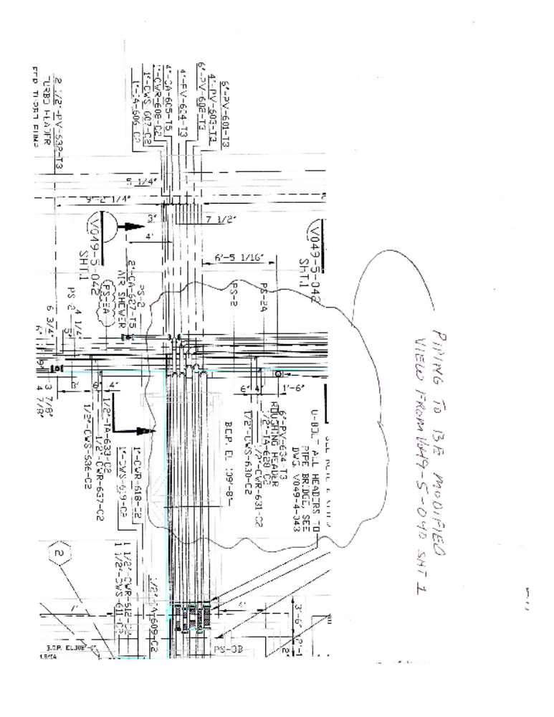
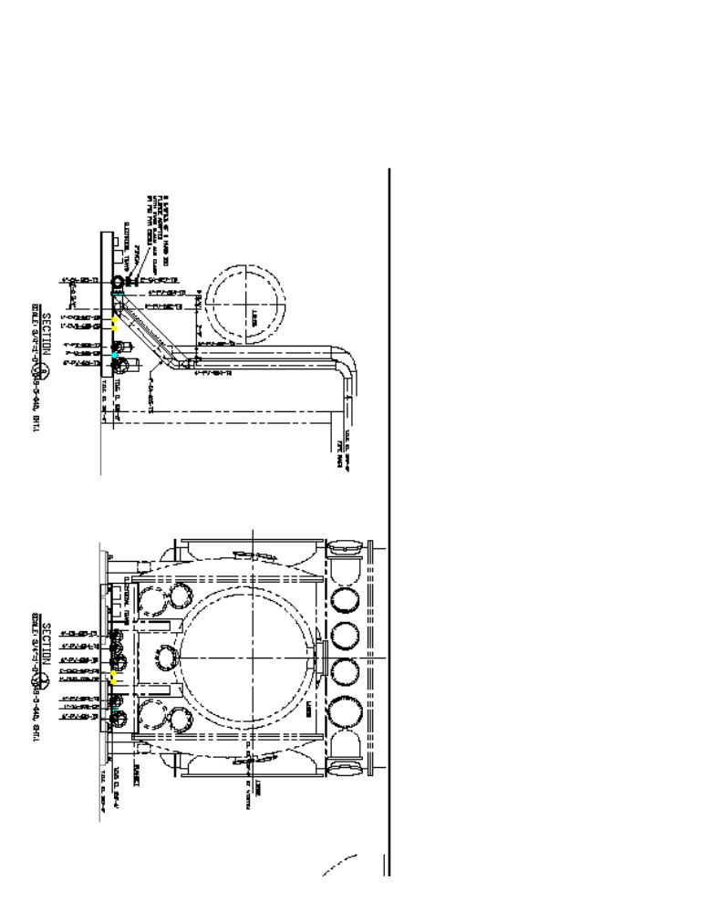

4. The Contractor shall supply all necessary welding procedures. Welding procedures shall be submitted by the Seller to the Buyer for acceptance prior to commencement of welding. The Contractor shall qualify welding procedures and welders in accordance with ASME Boiler and Pressure Vessel Code, Section IX, latest edition. All welding must be done outside the laser/vacuum equipment areas in a clean shop environment.

The Contractor shall protect piping systems from the entrance of moisture and foreign materials and protect all knife edges of “conflat” flanges. (See E1000718 for additional requirements).

5. Pipe Testing

Required tests shall be conducted in the presence of the Buyer's representative. The Buyer's representative shall be notified at least 4 hours prior to the performance of a test. The Buyer shall determine if test results are acceptable. Costs for repairing failed items and re-testing shall be by the Contractor.

The following tests shall be conducted:

a. Cooling Water - Pressure decay at 1.1 design pressure.
b. Instrument Air - Pressure decay at 1.1 design pressure
c. Class 100 Air - Press decay at 1.1 design pressure
d. Vacuum Piping – Helium Leak Testing

The Seller shall provide written documentation for all testing (Test sheet, Procedures, etc.)

6. Piping Insulation
Insulation shall be installed on equipment and piping as indicated on the Piping and Instrumentation Diagrams (P&ID’s). The Contractor shall provide all insulation materials. Insulation is to be installed by the Seller per E1000717.

Insulation for piping inside buildings shall be installed on piping spools prior to installation.

6.0 Equipment and Materials

6.1 Equipment and Materials Supplied By the Buyer for use by the Seller:
a) 5 Ton Building Cranes in each building and associated new lifting straps (for use inside the LIGO Buildings only).
b) “Baked” Viton O-Rings for each sealing flange
c) Clean small tools for removing nuts and bolts on equipment flanges (For use inside LIGO buildings only)
d) Cleanroom clothes and Cleanroom material for protecting flange sealing surfaces
e) All new vacuum equipment spools including nuts and bolts.

6.2 Equipment and Materials Supplied By the Seller:
The Seller must provide all additional materials needed to accomplish the scope of this specification that is not provided by the Buyer. All installation materials purchased shall be new and per specifications contained herein.

7.0 Documentation By the Seller

The Seller shall provide all documentation listed below:

a) Detailed equipment installation procedures
b) “As Installed Drawings” showing the exact location of all installed equipment. The equipment shall be referenced to building walls and Survey Monuments.
c) Grout testing reports
d) Completed Alignment Data Sheets
e) Piping Test Reports

8.0 Attachments Summary

The following attachments referenced herein are part of this specification and are available via the links below.

LIGO Building Equipment Layout/Piping Drawings:
LA Corner Station Layout - D1003180
LA Corner Piping Arr. (PSI V049-5-040) Sht. 1 - D970393
LA Corner Station Piping Section (PSI V049-5-042) Sht. 1 - D970393

Equipment Outline Drawings:

HAM Layout (PSI V049-4-002) - D961094
Existing MC Spool (PSI V049-4-B3A) - D961153
New MCA (GNB-114145-00) - C1001348
New MCB (GNB-114146-00) - C1001349

Specifications

Spec. for Anchor Bolt / Grout Installation - E1000712
Spec. for Contamination Control - E1000719
Spec. for Component Alignment - E1000716
Spec. for O-Ring and Flange Installation - E0900431
Piping Cleaning Procedure - E1000715
Spec. for Piping Design / Material - E1000713
Spec. for Piping Thermal Insulation - E1000717
Spec. for Vacuum / Clean Air Piping - E1000718

