*LIGO Laboratory / LIGO Scientific Collaboration*

LIGO-T1000682-v6 *Advanced LIGO* Date:

Notes on the aLIGO TCS Hartmann Sensor Camera and Sources

Author: Aidan Brooks

Distribution of this document:

LIGO Scientific Collaboration

This is an internal working note

of the LIGO Laboratory.

|  |  |
| --- | --- |
| **California Institute of Technology**  **LIGO Project – MS 18-34**  **1200 E. California Blvd.**  **Pasadena, CA 91125**  Phone (626) 395-2129  Fax (626) 304-9834  E-mail: info@ligo.caltech.edu | **Massachusetts Institute of Technology**  **LIGO Project – NW22-295**  **185 Albany St**  **Cambridge, MA 02139**  Phone (617) 253-4824  Fax (617) 253-7014  E-mail: info@ligo.mit.edu |
| **LIGO Hanford Observatory**  **P.O. Box 159**  **Richland WA 99352**  Phone 509-372-8106  Fax 509-372-8137 | **LIGO Livingston Observatory**  **P.O. Box 940**  **Livingston, LA 70754**  Phone 225-686-3100  Fax 225-686-7189 |

http://www.ligo.caltech.edu/

Table of Contents

1 Introduction 2

2 Source requirements 2

3 HWS system transmission spectra 3

3.1 H1/L1:ITM-HWSX (s-polarization) 4

3.1.1 Transmitted power 4

3.1.2 Cross-sampling 5

3.2 H1/L1:ITM-HWSY (p-polarization) 6

3.2.1 Transmitted power 6

3.2.2 Cross-sampling 7

3.3 H2:ITM-HWSX (p-polarization) 8

3.3.1 Transmitted power 8

3.3.2 Cross-sampling 9

3.4 H2:ITM-HWSY (s-polarization) 10

3.4.1 Transmitted power 10

3.4.2 Cross-sampling 11

4 Source selection 12

5 Alignment laser 12

# Introduction

The purpose of this document is to describe the potential sources for the Hartmann wavefront sensor based on the calculated system transmission.

# Source requirements

Using the Dalsa 1M60 camera for the HWS is a viable option if we can find an appropriate source in the visible and near-IR range. An appropriate source must have:

* 1. Enough transmission through the coatings to illuminate the Hartmann sensor with the minimum required power
  2. Must be broadband with a very short coherence length ( < 100 μm ) to prevent interference fringes from ghost beams.

The required power transmitted through the in-vacuum optics was derived in [[T0900655 - Required probe beam power and in-vacuum system transmitted power for the vertex Hartmann Wavefront Sensor (dependent on wavelength)]](https://dcc.ligo.org/cgi-bin/private/DocDB/ShowDocument?docid=8206), from which the transmission can be determined by dividing by the source power:

,

where *Pin* is the nominal source power of the Hartmann sensor beam. This assumes a required measurement rate of 1 measurement every 5s, which is fast compared to the fastest thermal time constant in the mirror (~40s) [see [[T0900655]](https://dcc.ligo.org/cgi-bin/private/DocDB/ShowDocument?docid=8206)]. This takes into account the attenuation from transmission through all extra-vacuum optics. The required power at the HWS is fixed and is, approximately,

.

# HWS system transmission spectra

The amount of transmission through all the in-vacuum optics in the HWS optical paths is shown below for the folded and unfolded interferometers. These curves are based on the nominal and measured coating spectra provided by CSIRO and LMA.

The required transmission for a 100mW source is also shown. Note: for simplicity the reflection of the folding mirror was assumed to be 80% for all wavelengths, in reality that is more likely for the range 700-900nm and R~100% for wavelengths above around 980nm through to about 1100-1200nm.

Typical SLED sources are available at powers of up to 5mW (although some higher power 20mW versions are available – with possible lifetime issues). A given model number will have a central wavelength within an, approximately, 20nm range and a FWHM of around 10-20nm. This means that we can select a specific central wavelength.

## H1/L1:ITM-HWSX (s-polarization)

### Transmitted power

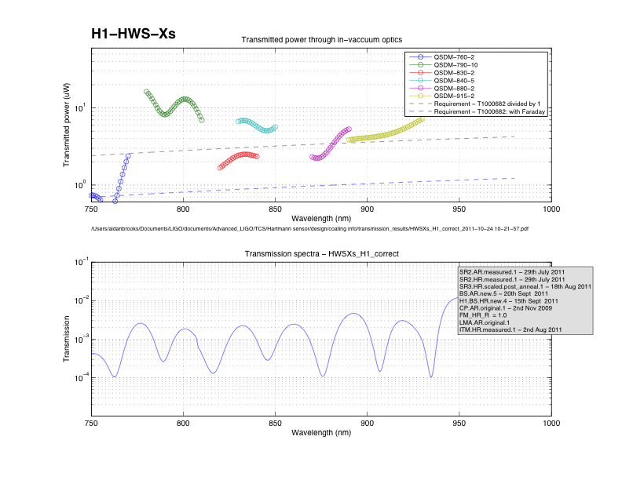

Figure : H1/L1-ITM HWSX (s-polarization): (lower) The cumulative in-vacuum transmission spectra for the HWS and (upper) the in-vacuum transmitted power for a variety of possible SLED sources with the required in-vacuum transmission (nominal and with Faraday injection) shown by the dashed lines.

The in-vacuum core optics reflections and transmissions experienced by the H1/L1:ITM-HWSX probe beam are:



The calculated transmitted power through the in-vacuum optics for a variety of SLED sources are shown in Figure 1 as is the in-vacuum transmission spectra.

### Cross-sampling

Cross-sampling will occur when a ghost beam from the ITM-HWSX probe beam propagates to ITMY and then couples back into the ITM-HWSX probe beam. The main ghost beam that hits ITMY has to experience the following additional coating interactions:



We can put an upper limit on the cross-sampling by using all the known coating spectra and assuming that all the unknown spectra (PR2, PRM, SRM) are 100% reflective for all wavelengths. The results of that analysis are shown in . The cross-sampling is below 5 × 10-6 for all wavelengths of interest (780 – 850 nm). This is significantly below the relative sensitivity range of the detector (= required sensitivity of 1.3nm / maximum expected optical path distortion from ITM of 1 μm = 1.3 × 10-3). As such, we can consider the ITMX probe beam to be sampling only ITMX with no contaminating ITMY signal.

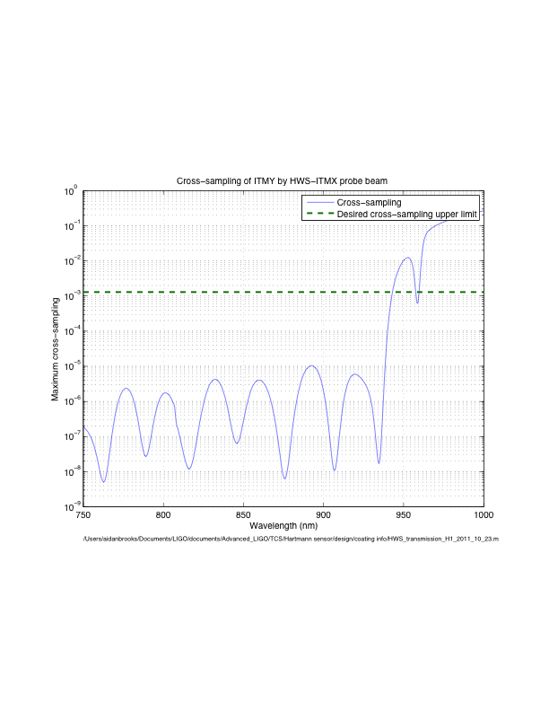

Figure : Upper-limit on cross-sampling of ITMY by ITM-HWSX probe beam.

## H1/L1:ITM-HWSY (p-polarization)

### Transmitted power

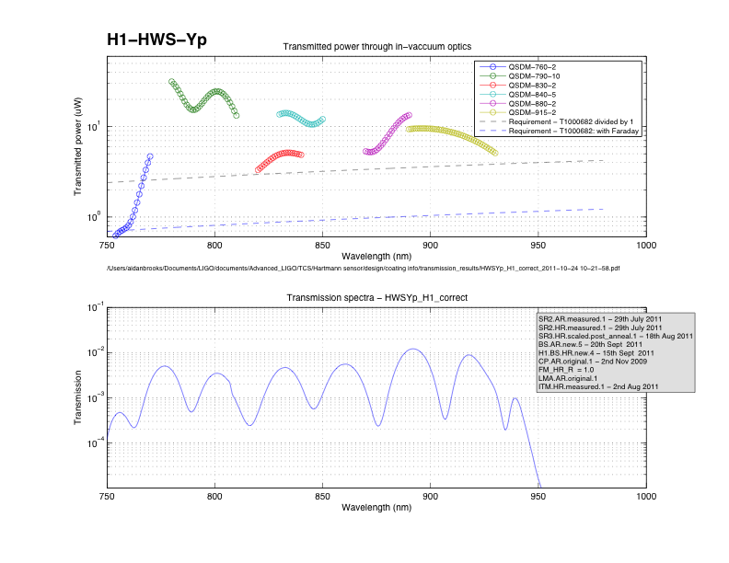

Figure : H1/L1-ITM HWSY (p-polarization): (lower) The cumulative in-vacuum transmission spectra for the HWS and (upper) the in-vacuum transmitted power for a variety of possible SLED sources with the required in-vacuum transmission (nominal and with Faraday injection) shown by the dashed lines.

The in-vacuum core optics reflections and transmissions experienced by the H1/L1:ITM-HWSY probe beam are:



The calculated transmitted power through the in-vacuum optics for a variety of SLED sources are shown in as is the in-vacuum transmission spectra.

Cross-sampling will occur when a ghost beam from the ITM-HWSY probe beam propagates to ITMX and then couples back into the ITM-HWSY probe beam. The cross-sampling value is given by:



This is plotted in Figure 4. This is less than the relative sensitivity range (1.3 × 10-3) of the HWS in the range [787, 849] nm and can be ignored for all but extremely high sensitivity measurements.

### Cross-sampling

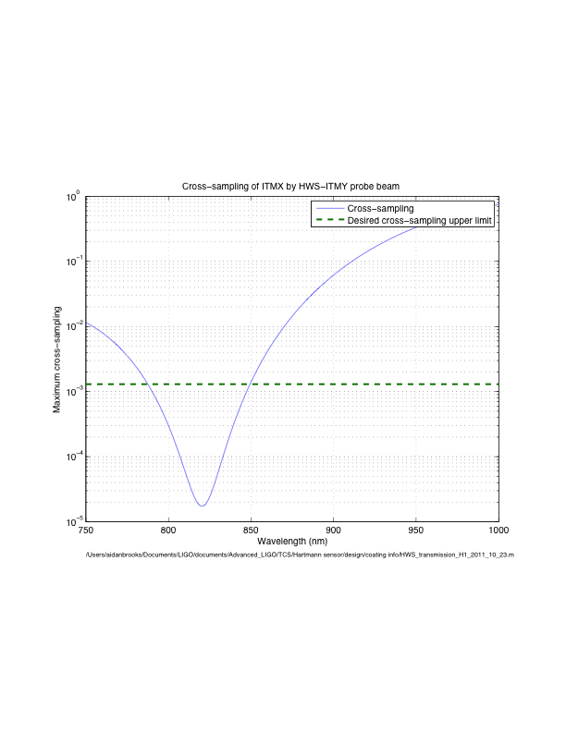

Figure : Cross-sampling spectrum of ITMX by ITM-HWSY probe beam.

## H2:ITM-HWSX (p-polarization)

### Transmitted power

The injection path for H2:ITM-HWSX is the same as that of H1/L1:ITM-HWSY with the addition of two reflections off the folding mirror:

 × 

At this time, the folding mirror spectrum is not designed. However, one of the specifications for this coating is that the reflection is > 80% in the HWS band (780 – 850nm). As such, the transmission spectra below were determined assuming that R = 80% for the FM coating at all wavelengths.

It should be noted that the beams splitter coating designs are different between H1/L1 and H2 and, as such, subtle differences between the H1/L1 and H2 cases are to be expected.

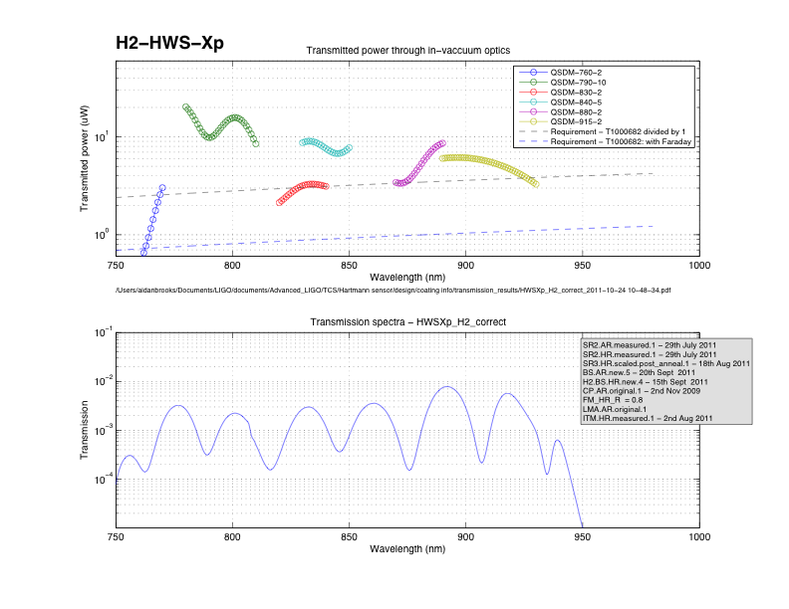

Figure : H2-ITM HWSX (p-polarization): (lower) transmission spectrum and (upper) transmitted power.

### Cross-sampling

The cross-sampling of ITMY by the H2-ITM-HWSX probe beam is calculated in the same fashion as in Section 3.2.2 (H1/L1:ITM-HWSY). The results are plotted in Figure 6.

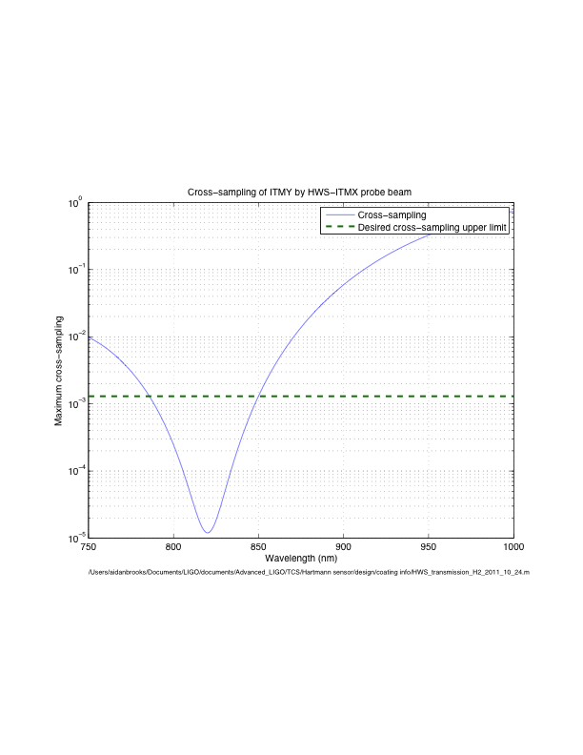

Figure : Cross-sampling spectrum of ITMY by H2-ITM-HWSX probe beam.

## H2:ITM-HWSY (s-polarization)

### Transmitted power

The H2:ITM-HWSY probe beam is the same as the H1/L1:ITM-HWSX probe beam with the addition of two folding mirror reflections. The transmitted powers of the H2:ITM-HWSY probe beam various SLED sources are shown in Figure 7.

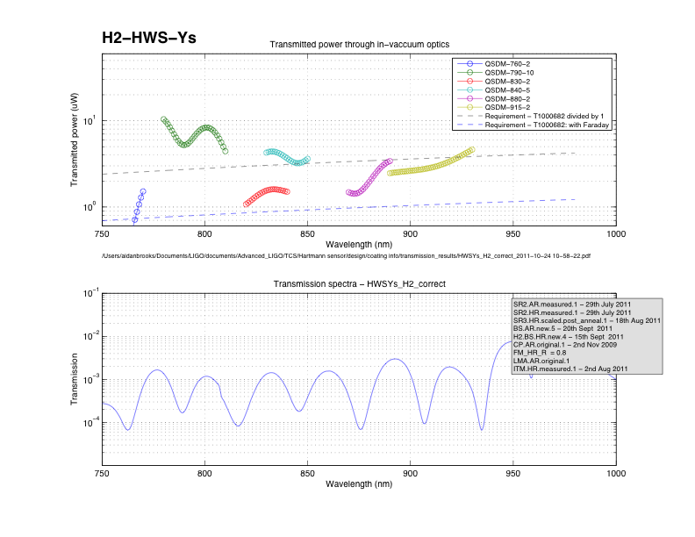

Figure : H2-ITM HWSY (s-polarization): (lower) transmission spectrum and (upper) transmitted power.

### Cross-sampling

As can be seen in Figure 8, the cross-sampling is not an issue for the H2-ITM-HWSY probe beam.

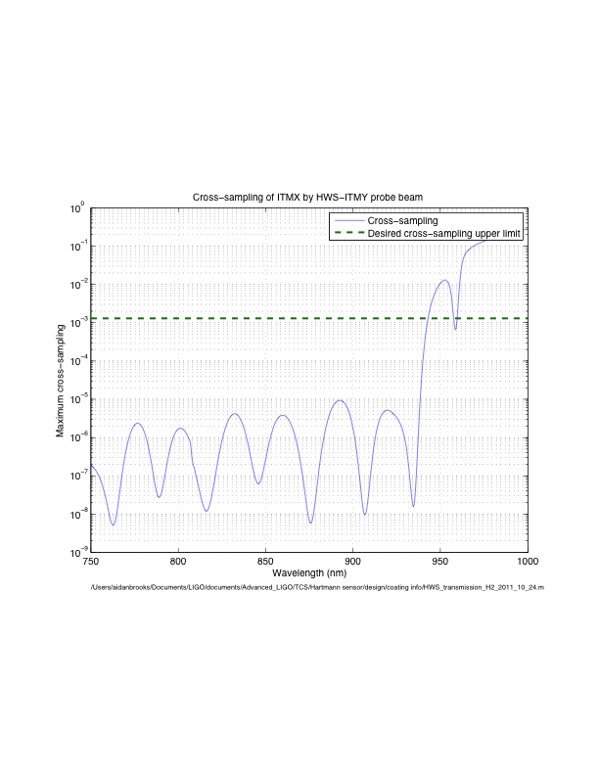

Figure : Cross-sampling spectrum of ITMX by H2-ITM-HWSY probe beam.

# Source selection

On the basis of the spectra and results in Section , the most balanced selection of sources for the all the HWS is as follows:

Table : Source selection for the HWS probe beams

|  |  |  |  |  |
| --- | --- | --- | --- | --- |
| **Probe beam** | **Source** | **Central wavelength** | **Transmitted power** | **Ratio to requirement** |
| H1/L1:ITM-HWSX | QSDM-790-10 (s-pol) | 800nm | 13 μW | 4.6 × |
| H1/L1:ITM-HWSY | QSDM-840-5 (p-pol) | 833nm | 14 μW | 4.7 × |
| H2:ITM-HWSX | QSDM-840-5 (p-pol) | 833nm | 9.0 μW | 3.0 × |
| H2:ITM-HWSY | QSDM-790-10 (s-pol) | 800nm | 8.3 μW | 3.0 × |

# Visible alignment laser

The transmission of the probe beam through the in-vacuum optics is far too small to effectively align the HWS to the ITM. We will inject a co-aligned visible alignment laser into the vacuum system to adjust the alignment, as described in [[T1100149 - Initial Alignment of the Vertex Hartmann Sensor]](https://dcc.ligo.org/cgi-bin/private/DocDB/ShowDocument?docid=39852). As such we need to know the transmission of the HWS beam in the visible regime.

The visible (500, 700) nm transmission spectra for H1/L1 are shown in Figure 9. The visible transmission spectra for H2 are shown in Figure 10.

At this time we do not have values from the transmission spectra for SR2 in the range [500, 700] nm. As such, the transmission spectra shown for H1-HWSYp and H2-HWSXp do not include the effect of SR2.

The optimum alignment laser wavelength for H1/L1 X s-polarization is clearly 543nm, likewise for H2 Y s-polarization.

The nominal optimum alignment laser wavelength for H1/L1 Y p-polarization and H2 X p-polarization appears to be 543nm but the ultimate choice will depend on the transmission spectra for SR2.

A 1mm diameter 3mW Green HeNe laser beam attenuated by 1000x is still clearly visible. Therefore, we anticipate that 543nm will be acceptable as an alignment laser provided the transmission through SR2 is > 10% at 543nm.

## H1/L1 visible transmission

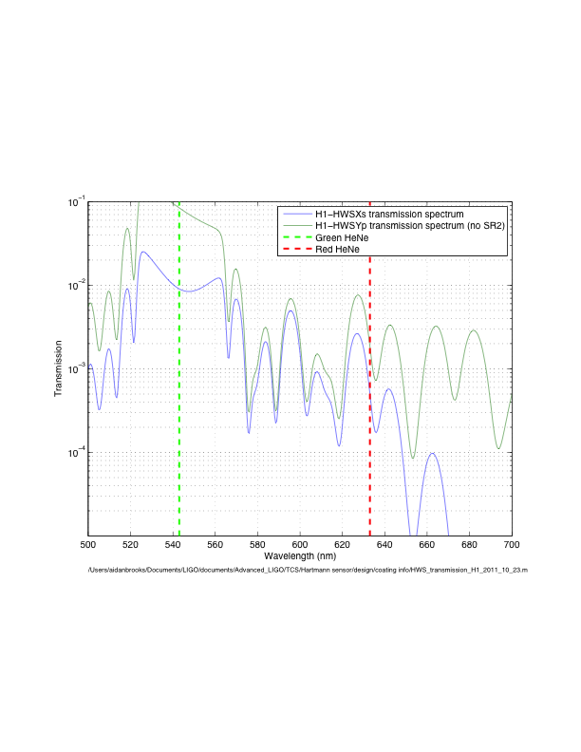

Figure : H1/L1 visible transmission spectra.

## H2 visible transmission

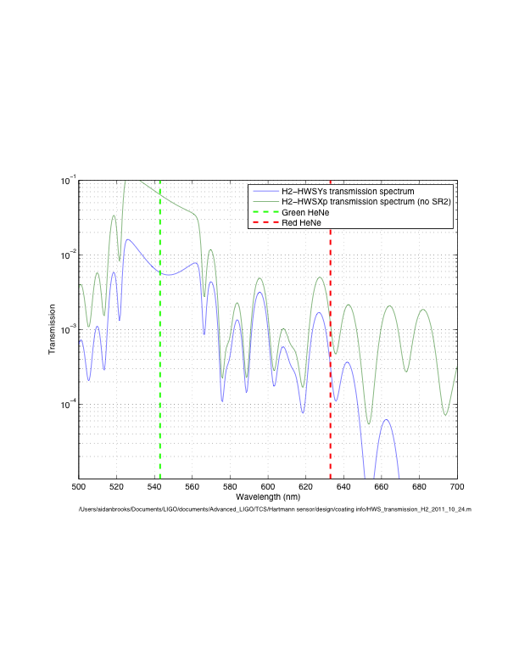

Figure : H2 visible transmission spectra