LIGO Laboratory / LIGO Scientific Collaboration

LIGO-T050257-00 ADVANCED LIGO 28 Nov 2005

Quad Pendulum Controls Prototype -
Identification of Modes

Mark Barton

Distribution of this document:
LIGO Science Collaboration

This is an internal working note
of the LIGO Project.

California Institute of Technology  LIGO Project – MS 18-34  1200 E. California Blvd.  Pasadena, CA 91125  Phone (626) 395-2129  Fax (626) 304-9834  E-mail: info@ligo.caltech.edu | Massachusetts Institute of Technology  LIGO Project – NW17-161  175 Albany St  Cambridge, MA 02139  Phone (617) 253-4824  Fax (617) 253-7014  E-mail: info@ligo.mit.edu
LIGO Hanford Observatory  P.O. Box 1970  Mail Stop S9-02  Richland WA 99352  Phone 509-372-8106  Fax 509-372-8137 | LIGO Livingston Observatory  P.O. Box 940  Livingston, LA 70754  Phone 225-686-3100  Fax 225-686-7189
http://www.ligo.caltech.edu/

Introduction

Purpose and Scope
This document presents analysis of data on the AdvLIGO quad pendulum controls prototype taken 10/31/05.

Applicable Documents
- LSC White Paper Baseline Design Description (LIGO-T990080-01-D).
- LIGO II Suspension Reference Design, The GEO Suspension Team, Jan 31 2000, (LIGO-T000012-00).
- Advanced LIGO Suspension System Conceptual Design (LIGO-T010103-03).
- Parameters for current ETM/ITM main chain noise prototype design (LIGO-T040214-01)
- Modifications to Quad Controls Prototype to fix the “d’s” (LIGO- T050172-00)
- Test of an angled load on a blade spring (LIGO-T050256-00)

Method

Measurement procedure
All measurements were done on the main chain of the quad controls prototype. The pendulum was allowed to come to equilibrium with the following forces and torques applied via the local control actuators:
- x: 100 mN
- y: 60 mN
- z: 100 mN
- yaw: 10 mN.m
- pitch: 1 mN.m
- roll: 10 mN.m
The dSpace controller was programmed to take 1000 s of data at 100 samples/s of both the raw inputs and the diagonalized signals used in the control. The servo was then disengaged, the data-taking was started and the static forces and torques were switched off approximately 25 s later. A section of the data of length 2^16 samples (655 s) starting just after the step was FFTed and the peaks were identified. See section 4.4 for the plots.

Generation of theoretical comparisons
Three parameter sets representing various approximations to the pendulum were prepared for use with the “xtra-lite” version of the Mathematica quad model. See section 4.1 for a commented listing of parameter set #3.
By default the parameters were drawn from T040214-01 (“Parameters for current ETM/ITM main chain noise prototype design”). Improved values of some parameters were drawn from additional sources:
- As-built values of masses and moments of inertia for the top two masses supplied by Mike Perreur-Lloyd (see Section 4.2)
- As-built values of masses and moments of inertia for the bottom two masses from CAD drawings, supplied by Calum Torrie (see Section 4.4).
- Modified wire-lengths from T050172-00 (“Modifications to Quad Controls Prototype to fix the d’s”). The modified d values in T050172-00 were not used. Rather, a blind eye was turned to the fact that the as-built pendulum doesn’t agree with the theory, and the desired effective d’s less the full 1/lambda flexure corrections were used, so as to match the fundamental pitch frequency. The effect on other pitch and longitudinal modes is probably modest, but due caution should be exercised in interpreting the comparisons.
- Blade stiffness corrections from T050256-00, based on CAD analysis by Ian Wilmut and Mark Barton.
- Assorted measurements at Caltech, including an effective value of the Young’s modulus of the bottom wires.
Parameter set #1 omits the off-axis components of the MOI tensors of the top two masses, and the blade stiffness corrections. It is similar to the sole parameter set in pre-release versions of this document, except that it includes the improved mass/MOI values for the bottom two masses, and the improved wire Young’s modulus.
Parameter set #2 adds in the blade stiffness corrections.
Parameter set #3 adds in the blade stiffness corrections and the off-axis MOI components.

Mode identification
The table below lists all significant peaks in the six PSD graphs (x/y/z/yaw/pitch/roll), together with the most likely matches to predicted mode frequencies. "*" indicates a peak was present in a particular PSD. "()" indicates a peak was weak or indistinct.
On the whole the measured spectra were relatively clean, especially at lower frequencies. A total of 32 frequencies were selected as candidate normal modes. Most of these appeared in more than one spectrum due to imperfect diagonalization, but at least the number of candidates was not grossly in excess of the total expected number of normal modes (24).
A total of 22 candidates could be matched with reasonable confidence to a predicted normal mode on the basis of the approximate frequency and the spectra in which each appeared.

ID | f (#1) | f (#2) | f (#3) | f (exp) | x | y | z | yaw | pitch | roll | note
pitch | 0.399 | 0.399 | 0.399 | 0.403 |  |  |  |  | ()
x | 0.445 | 0.445 | 0.445 | 0.440 | * |  |  | () | * | *
y | 0.469 | 0.464 | 0.464 | 0.464 |  | *
z | 0.676 | 0.582 | 0.582 | 0.549 |  |  | *
yaw | 0.686 | 0.686 | 0.686 | 0.684 |  |  |  | *
roll | 0.764 | 0.756 | 0.756 | 0.794 |  | () |  |  |  | *
x | 0.989 | 0.989 | 0.989 | 0.989 | * |  |  |  | *
y | 1.052 | 1.041 | 1.041 | 1.038 |  | * |  | () | ()
pitch | 1.383 | 1.383 | 1.380 | 1.355 |  |  |  |  | *
yaw | 1.431 | 1.431 | 1.431 | 1.428 | * | () | * | * | *
x | 1.990 | 1.990 | 1.990 | 1.978 | * |  |  |  | * | *
y | 2.107 | 2.087 | 2.087 | 2.075 |  | * |  | () |  | *
z | 2.543 | 2.349 | 2.349 | 2.222 |  |  | *
yaw | 2.542 | 2.543 | 2.543 | 2.515 |  |  |  | *
pitch | 2.916 | 2.916 | 2.947 | 2.576 |  |  |  |  | *
roll | 2.749 | 2.757 | 2.740 | 2.734 |  | () |  |  |  | *
yaw | 3.183 | 3.183 | 3.183 | 3.149 |  |  |  | *
pitch? | 3.291 | 3.291 | 3.284 | 3.162 |  | () |  |  |  | () | low participation at top mass, high roll cross-coupling
roll | 3.330 | 3.326 | 3.361 | 3.333 |  | * |  |  | * | * | high pitch cross-coupling
x | 3.416 | 3.416 | 3.416 | 3.381 | ** | * | () | * | * | *
z | 4.251 | 3.705 | 3.705 | 3.589 |  |  | *
roll | 5.541 | 5.003 | 5.093 | 5.029 |  | * |  |  | * | * | high pitch cross-coupling
? | ? | ? |  | 5.115 |  | * |  | () | * | *
? | ? | ? |  | 5.298 |  | * |  | * | * | *
? | ? | ? |  | 5.493 | * | * | * | * | * | *
? | ? | ? |  | 6.775 | * | * | * | * | * | *
? | ? | ? |  | 7.080 | * | * | * | * | * | *
? | ? | ? |  | 13.930 |  |  |  |  |  | () | broad
z | ? | ? |  | 15.750 |  |  | *
z | - | - |  | 16.470 |  |  | * |  |  | * | ground noise
z | 17.700 | 17.702 | 17.702 | ? |  |  |  |  |  |  | low participation at top mass
? | ? | ? |  | 19.480 |  |  |  |  |  | ()
? | ? | ? |  | 21.500 |  |  |  |  |  | () | broad
roll | 25.741 | 25.744 | 25.744 | ? |  |  |  |  |  |  | low participation at top mass

Discussion
In a pre-release version of this document, the high-frequency vertical and roll modes were tentatively identified as the observed peaks at 15.75 and 21.5 Hz, but this was ruled out by a measurement of the elasticity of the bottom wires. Also it should not have been expected that those modes would be visible at the top mass because the participation is extemely low. On the next build these modes will be identified using an eddy-current sensor under the bottom mass.
The identification of the feeble peak at 3.162 Hz as a pitch mode is somewhat tentative. A pitch mode is expected in that general location but the participation at the top mass is expected to be rather low, so the true peak may be submerged.
A mostly vertical mode at 16.47 Hz has been confidently identified as ground noise. Apparently the vibration from some nearby machinery is being semi-resonantly amplified by the flimsy top plate supporting the structure. (The amplitude is extraordinary: some 0.15 mm-pp!)
Modes at 5.115, 5.493, 6.775, 7.08, 13.93 and 19.48 Hz are probably some combination of machinery noise and resonances in the gazebo or support structure. This needs to be checked on the next build with an accelerometer and a spectrum analyzer.
For parameter set #1, which omits the blade stiffness correction, the predicted frequencies for the bottom three vertical modes are much too high. Including the blade stiffness, as in #2 and #3, greatly improves the agreement in vertical, although the lowest roll mode gets slightly worse.
Going from parameter set #2 to #3 produces only a tiny effect on the mode frequencies, but some of the mode shapes that involve pitch or roll of the top two masses are drastically changed. In particular, the mode at 3.361 Hz for parameter set #3 corresponds to the roll modes at 3.330 and 3.326 Hz for parameter sets #1 and 2, but has slightly more pitch motion of the top mass than roll! The roll mode at 5.541/5.003/5.093 Hz and the pitch mode at 3.291/3.291/3.284 Hz are nearly as badly affected. This may mean the controller design needs to be revisited.

Appendix

Parameters for Mathematica model
The parameter set #3 is given below. It includes the off-axis MOI values supplied by Mike Perreur-Lloyd (Section 4.2), and the blade stiffness corrections from Ian Wilmut’s data (T050256-00). The #2 parameter set has the off-axis MOI components (Inxy etc) set to 0. The #1 parameter set is as for #2 with the blade stiffness corrections (kffn, kff1, kff2) set to 1.

overrides = {
nx -> 0.1300, (* T040214-01 *)
ny -> 0.5000, (* T040214-01 *)
nz -> 0.0840, (* T040214-01 *)
denn -> 4000, (* T040214-01 *)
mn -> 22.1000, (* MPL, 9/1/05, with extra 0.5 kg *)
Inx -> 0.4557, (* MPL, 9/1/05 *)
Iny -> 0.0712, (* MPL, 9/1/05 *)
Inz -> 0.4546, (* MPL, 9/1/05 *)
ux -> 0.1300, (* T040214-01 *)
uy -> 0.5000, (* T040214-01 *)
uz -> 0.0840, (* T040214-01 *)
den1 -> 4000, (* T040214-01 *)
m1 -> 21.8000, (* MPL, 9/1/05 *)
I1x -> 0.5106, (* MPL, 9/1/05 *)
I1y -> 0.0598, (* MPL, 9/1/05 *)
I1z -> 0.5136, (* MPL, 9/1/05 *)
ix -> 0.1300, (* T040214-01 *)
ir -> 0.1570, (* T040214-01 *)
den2 -> 3860, (* T040214-01 *)
m2 -> 39.300, (* measured, CT 11/17/05, cf. CAD 39.494 *)
I2x -> 0.4708, (* CAD, CT 11/17/05 *)
I2y -> 0.2772, (* CAD, CT 11/17/05 *)
I2z -> 0.2762, (* CAD, CT 11/17/05 *)
tx -> 0.1300, (* T040214-01 *)
tr -> 0.1570, (* T040214-01 *)
den3 -> 3980, (* T040214-01 *)
m3 -> 39.400, (* measured, CT 11/17/05, cf. CAD 39.564 *)
I3x -> 0.4640, (* CAD, CT 11/17/05 *)
I3y -> 0.2737, (* CAD, CT 11/17/05 *)
I3z -> 0.2722, (* CAD, CT 11/17/05 *)

Inxy -> 0.04157, (* MPL, 9/1/05 *)
Inyz -> 0.000018, (* MPL, 9/1/05 *)
Inzx -> 0.000104, (* MPL, 9/1/05 *)
Inxz -> 0.000104, (* MPL, 9/1/05 *)
Inzy -> 0.000018, (* MPL, 9/1/05 *)
Inyx -> 0.04157, (* MPL, 9/1/05 *)

ln -> 0.4500, (* T050172 *)
l1 -> 0.3085, (* T040214-01 *)
l2 -> 0.3400, (* T040214-01 *)
l3 -> 0.6020, (* T050172 *)
rn -> 5.200 10^-04, (* MB, 9/29/05 *)
r1 -> 3.5000 10^-04, (* T040214-01 *)
r2 -> 3.1000 10^-04, (* T040214-01 *)
r3 -> 0.018 0.0254/2, (* 0.018" - spool, 11/18/05 *)
Yn -> 2.2000 10^+11, (* T040214-01 *)
Y1 -> 2.2000 10^+11, (* T040214-01 *)
Y2 -> 2.2000 10^+11, (* T040214-01 *)
Y3 -> 2.219 10^+11, (* measured - MB, 11/18/05 *)
kffn -> 1 + 0.01391*thetan + 1.926*^-6*thetan^3,
kff1 -> 1 + 0.01155*theta1 + 1.197*^-6*theta1^3,
kff2 -> 1 + 0.01021*theta2 + 1.632*^-6*theta2^3,
ufcn -> 2.3300*Sqrt[kffn], (* T040214-01 *)
ufc1 -> 2.4800*Sqrt[kff1], (* T040214-01 *)
ufc2 -> 1.8100*Sqrt[kff2], (* T040214-01 *)
dm -> 1.0000 10^-03 - flexn, (* T040214-01 *)
dn -> 1.0000 10^-03 - flex1, (* T040214-01 *)
d0 -> 1.0000 10^-03 - flex1, (* T040214-01 *)
d1 -> 1.0000 10^-03 - flex2, (* T040214-01 *)
d2 -> 1.0000 10^-03 - flex2, (* T040214-01 *)
d3 -> 1.0000 10^-03 - flex3, (* T040214-01 *)
d4 -> 1.0000 10^-03 - flex3, (* T040214-01 *)
twistlength -> 0, (* T040214-01 *)
d3tr -> 1.0000 10^-03, (* T040214-01 *)
d4tr -> 1.0000 10^-03, (* T040214-01 *)
sn -> 0, (* T040214-01 *)
su -> 0.003, (* T040214-01 *)
si -> 0.003, (* T040214-01 *)
sl -> 0.015, (* T040214-01 *)
nn0 -> 0.250, (* T040214-01 *)
nn1 -> 0.090, (* T040214-01 *)
n0 -> 0.200, (* T040214-01 *)
n1 -> 0.060, (* T040214-01 *)
n2 -> 0.140, (* T040214-01 *)
n3 -> 0.1635, (* T040214-01 *)
n4 -> 0.1585, (* T040214-01 *)
n5 -> 0.1585, (* T040214-01 *)
nwn -> 2,
nw1 -> 4,
nw2 -> 4,
nw3 -> 4,
mn3 -> mn+m13,
m13 -> m1+m23,
m23 -> m2+m3,
flexn -> Sqrt[nwn Mn1 Yn/(mn+m1+m2+m3)/g]*cn^(3/2),
flex1 -> Sqrt[nw1 M11 Y1/(m1+m2+m3)/g]*c1^(3/2),
flex2 -> Sqrt[nw2 M21 Y2/(m2+m3)/g]*c2^(3/2),
flex3 -> Sqrt[nw3 M31 Y3/m3/g]*c3^(3/2),
thetan -> 180 ArcSin[sin]/Pi,
theta1 -> 180 ArcSin[si1]/Pi,
theta2 -> 180 ArcSin[si2]/Pi,
theta3 -> 180 ArcSin[si3]/Pi,
damping[imag,fibretype] -> ((phisilica + phissilica/r3/2)&),
damping[imag,fibreatype] -> ((phisilica + phissilica/r3 + deltafibre*(2*N[Pi]*#1*taufibre)/(1+(2*N[Pi]*#1*taufibre)^2))&),
betasilica -> 2. 10^-4,
phisilica -> 0, (* bulk, not really 0 but neglected *)
phissilica -> 3. 10^-11, (* surface *)
Ysteel-> 2.2 10^11,
Ymarag -> 2.2 10^11,
betamarag -> -2.4 10^-4
};

Mode shapes affected by off-axis MOI components
For parameter set #2, without the off-axis MOI components of the top two masses, mode #19 at 3.326 Hz is a pure transverse/roll mode:
With the off-axis components in parameter set #3, the frequency is almost unchanged at 3.361 but there is a large amount of yaw as well:
In 3D this looks like:

Other modes particularly strongly affected are #22 at 5.003/5.093 Hz:
vs
and #18 at 3.291/3.284 Hz:
vs

Email from Mike Perreur-Lloyd with mass/MOI data
Subject: Re: Design Meeting tomorrow at 9am PT (5pm UK time)
Date Sent: Thursday, September 1, 2005 4:57 PM
Date Rec.: Thursday, September 1, 2005 8:57 AM
From: Michael Perreur-Lloyd <m.perreur-lloyd@physics.gla.ac.uk>
To: Mark Barton <mbarton@ligo.caltech.edu>
CC: […]
Mark,

Calum asked me to send around a complete set of Moment of Inertia values
for the Top and Upper-Intermediate Masses (from SolidWorks) as the
off-axis MoI's aren't shown in my PDS. They are as follows:

Top Mass (as per suspended mas - with 500g added mass):
Mass = 22.1kg
Moments of inertia: ( grams * square millimeters )
Taken at the center of mass and aligned with the output coordinate system.
Lxx = 455699288.396 Lxy = 41568802.174 Lxz = 104487.654
Lyx = 41568802.174 Lyy = 71164820.290 Lyz = 17750.300
Lzx = 104487.654 Lzy = 17750.300 Lzz = 454612632.509

U-I Main Mass:
Mass = 21.8kg
Moments of inertia: ( grams * square millimeters )
Taken at the center of mass and aligned with the output coordinate system.
Lxx = 510597526.974 Lxy = 27177156.301 Lxz = 4571.468
Lyx = 27177156.301 Lyy = 59821553.005 Lyz = 109303.974
Lzx = 4571.468 Lzy = 109303.974 Lzz = 513619165.446

U-I Reaction Mass:
Mass = 21.8kg
Moments of inertia: ( grams * square millimeters )
Taken at the center of mass and aligned with the output coordinate system.
Lxx = 507674431.623 Lxy = 27189678.981 Lxz = 4284.952
Lyx = 27189678.981 Lyy = 60264787.857 Lyz = 101957.129
Lzx = 4284.952 Lzy = 101957.129 Lzz = 512109447.571

Thanks.
Mike P-L

Email from Calum Torrie with additional mass/MOI data
Subject: UPDATED: - Parameters for test and pen mass (changed X,Y & Z to match our co-ordinate system)
Date Sent: Thursday, November 17, 2005 1:55 PM
Date Rec.: Thursday, November 17, 2005 1:55 PM
From: ctorrie <ctorrie@ligo.caltech.edu>
To: barton_m@ligo.caltech.edu
, Norna Robertson <nornar@stanford.edu>
, ctorrie <ctorrie@ligo.caltech.edu>

RE: UPDATED: - Parameters for test and pen mass (changed X,Y & Z to match
our co-ordinate system)

Dear Mark and Norna

The following numbers are updated (AGAIN) and from SolidWorks.
LAST TIME I GOT MY X,Y and Z CONFUSED!
The numbers in blue are from measured and are within ~ 200g of the SolidWorks
Cheers, Calum

***************************************************

Mass properties of D040132_ETM_ContP_ Assembly_Penultimate_Mass ( Assembly
Configuration - no bungs )

Output coordinate System: CS

Density = 4204.2512 kilograms per cubic meter

Mass = 39.4936 kilograms
(PEN Mass = 39.3kg)

Volume = 0.0094 cubic meters

Surface area = 0.8904 square meters

Center of mass: ( meters )
X = 0.0001
Y = 0.0000
Z = 0.0000

Principal axes of inertia and principal moments of inertia: ( kilograms *
square meters )
Taken at the center of mass.
Ix = (0.0000, -0.0001, 1.0000) Px = 0.2762
Iy = (0.0000, -1.0000, -0.0001) Py = 0.2772
Iz = (1.0000, 0.0000, 0.0000) Pz = 0.4708

Moments of inertia: ( kilograms * square meters )
Taken at the center of mass and aligned with the output coordinate system.
Lxx = 0.4708 Lxy = 0.0000 Lxz = -0.0000
Lyx = 0.0000 Lyy = 0.2772 Lyz = -0.0000
Lzx = -0.0000 Lzy = -0.0000 Lzz = 0.2762

Moments of inertia: ( kilograms * square meters )
Taken at the output coordinate system.
Ixx = 0.4708 Ixy = 0.0000 Ixz = 0.0000
Iyx = 0.0000 Iyy = 0.2772 Iyz = -0.0000
Izx = 0.0000 Izy = -0.0000 Izz = 0.2762

***********************************************************

Mass properties of D040038_ETM_Assembly_Test_Mass ( Assembly Configuration
- Default )

Output coordinate System: Coordinate System1

Density = 4296.1358 kilograms per cubic meter

Mass = 39.5643 kilograms
(TEST Mass = 39.4kg)

Volume = 0.0092 cubic meters

Surface area = 0.9023 square meters

Center of mass: ( meters )
X = 0.0000
Y = 0.0000
Z = 0.0000

Principal axes of inertia and principal moments of inertia: ( kilograms *
square meters )
Taken at the center of mass.
Ix = (0.0000, 0.0001, -1.0000) Px = 0.2722
Iy = (0.0000, 1.0000, 0.0001) Py = 0.2737
Iz = (1.0000, 0.0000, 0.0000) Pz = 0.4640

Moments of inertia: ( kilograms * square meters )
Taken at the center of mass and aligned with the output coordinate system.
Lxx = 0.4640 Lxy = -0.0000 Lxz = 0.0000
Lyx = -0.0000 Lyy = 0.2737 Lyz = -0.0000
Lzx = 0.0000 Lzy = -0.0000 Lzz = 0.2722

Moments of inertia: ( kilograms * square meters )
Taken at the output coordinate system.
Ixx = 0.4640 Ixy = -0.0000 Ixz = 0.0000
Iyx = -0.0000 Iyy = 0.2737 Iyz = -0.0000
Izx = 0.0000 Izy = -0.0000 Izz = 0.2722

****************************************************************

Power Spectra For Free-Swing Test

x
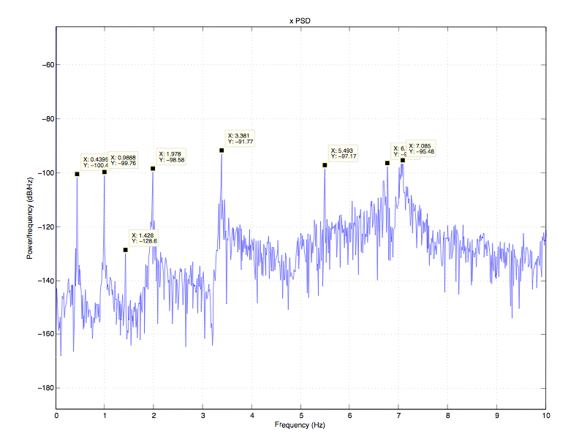

y
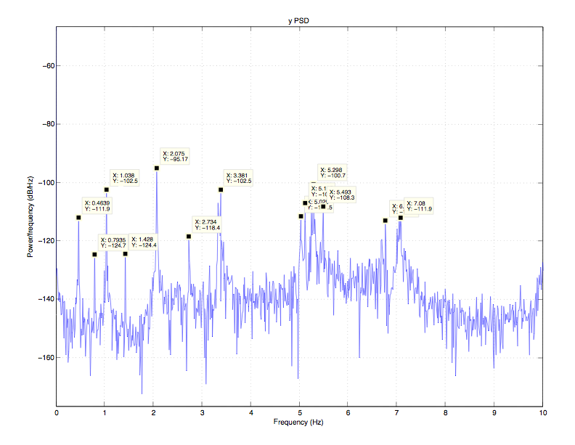

z

z – low frequencies
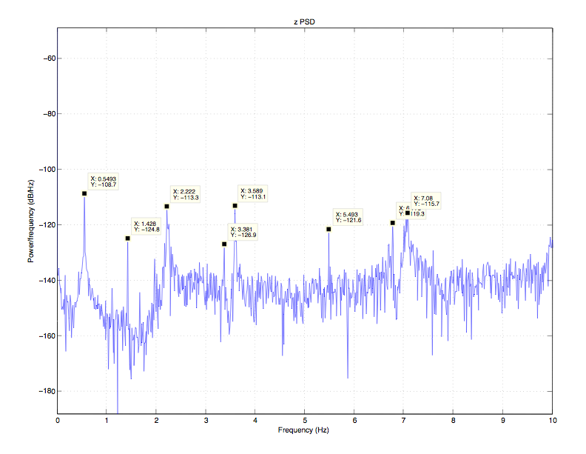

z - high frequencies
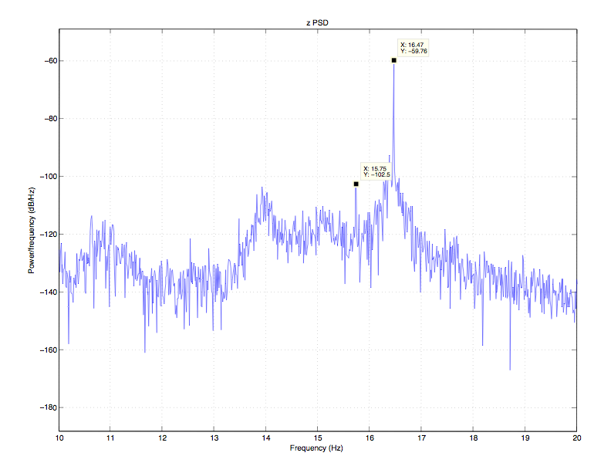

yaw
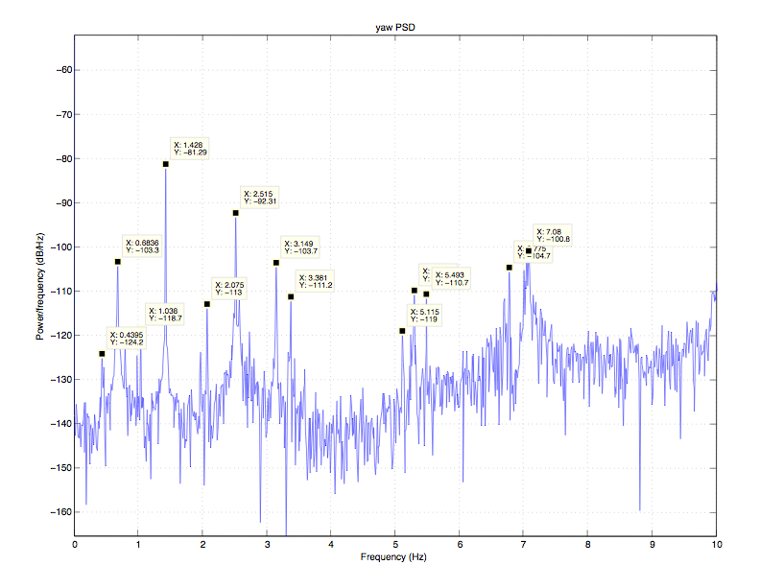

pitch
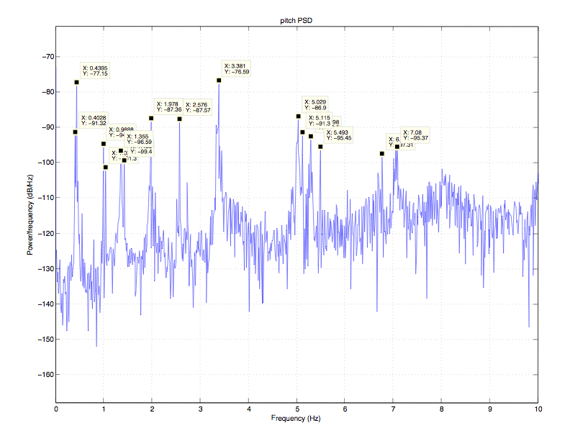

roll

roll - low frequencies
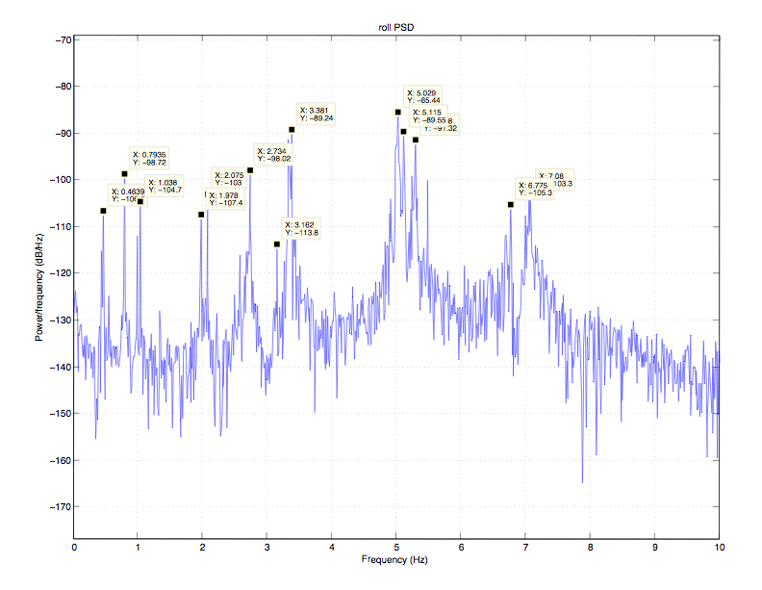

roll - high frequencies


