LIGO Laboratory / LIGO Scientific Collaboration

LIGO- LIGO-T060109-00-D LIGO 23th May 2006

Preliminary Weld Tests, mid May 2006
Stefano Molesti, Marcello Berchiolli, Yumei Huang, Riccardo DeSalvo

Distribution of this document:
LIGO Science Collaboration

This is an internal working note
of the LIGO Project.

California Institute of Technology  LIGO Project – MS 18-34  1200 E. California Blvd.  Pasadena, CA 91125  Phone (626) 395-2129  Fax (626) 304-9834  E-mail: info@ligo.caltech.edu | Massachusetts Institute of Technology  LIGO Project – NW17-161  175 Albany St  Cambridge, MA 02139  Phone (617) 253-4824  Fax (617) 253-7014  E-mail: info@ligo.mit.edu
LIGO Hanford Observatory  P.O. Box 1970  Mail Stop S9-02  Richland WA 99352  Phone 509-372-8106  Fax 509-372-8137 | LIGO Livingston Observatory  P.O. Box 940  Livingston, LA 70754  Phone 225-686-3100  Fax 225-686-7189
http://www.ligo.caltech.edu/
We have received five welding tests from Tecnoinox:
Two T-welds, labeled 1-2 and 3-4 respectively
A scalloped T-weld labeled 5-6,
A plug T-weld labeled 7-8-12-13
An egg-crate weld labeled 11

The T-welds labeled 1-2 and 3-4 (figure 1,2 and 3) appear at first sight to be quite good samples. The welds in the saw cuts appear compact and uniform.
Weld 1 looks the best, quite uniform and little waving, weld 3 and 4 are similar between themselves, the only problem is what appear as a bubble or small inclusion in weld 3 right under the 3 label (see figure 2).

The scalloped T-weld labeled 5 and 6, along the length appear quite acceptable along the weld length, with weld 6 looking better than weld 5, see figure 4.
The problem comes from the ends where, see figure 5, deep crevasses are left at the end of the weld. Machining oil that would certainly get in there by capillary action, and stay there. No cleaning technique could remove it. In vacuum the oil would start evaporating and damage the mirrors. This sort of crevasses is totally unacceptable.
Perhaps, if we were to open the scalloping much wider, the weld could be completed all around and full penetration of the weld achieved, making the weld acceptable.

Plug T-welds, figure 6, on the bottom side the plug 12 looks better than the 13, but on the top side, deep crevasses are totally unacceptable. Again deep scalloping and all-around welds may make it acceptable if deep penetration was achieved.

Similarly the welds in the egg-crate cross weld, labeled 11, look OK along the length, but crevasses are present at the ends.

We then start micro analysis of the T welds labeled 1-2-3-4, which look very promising.

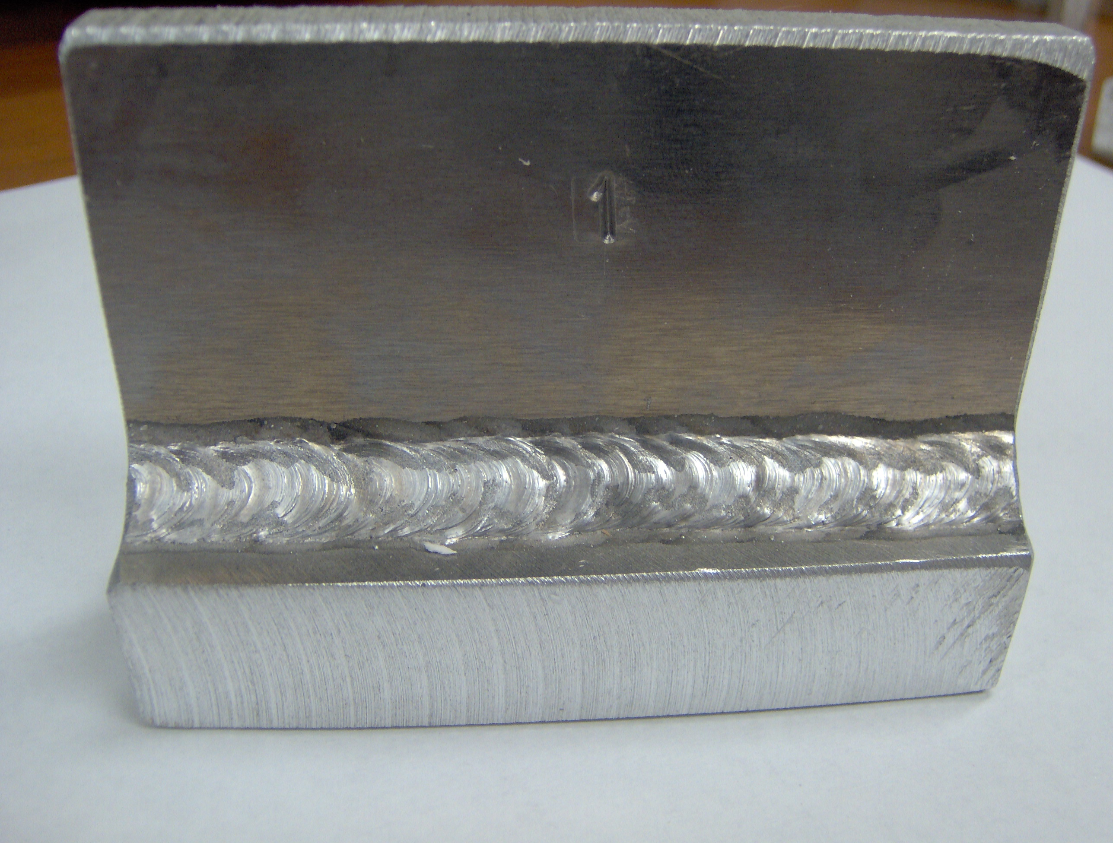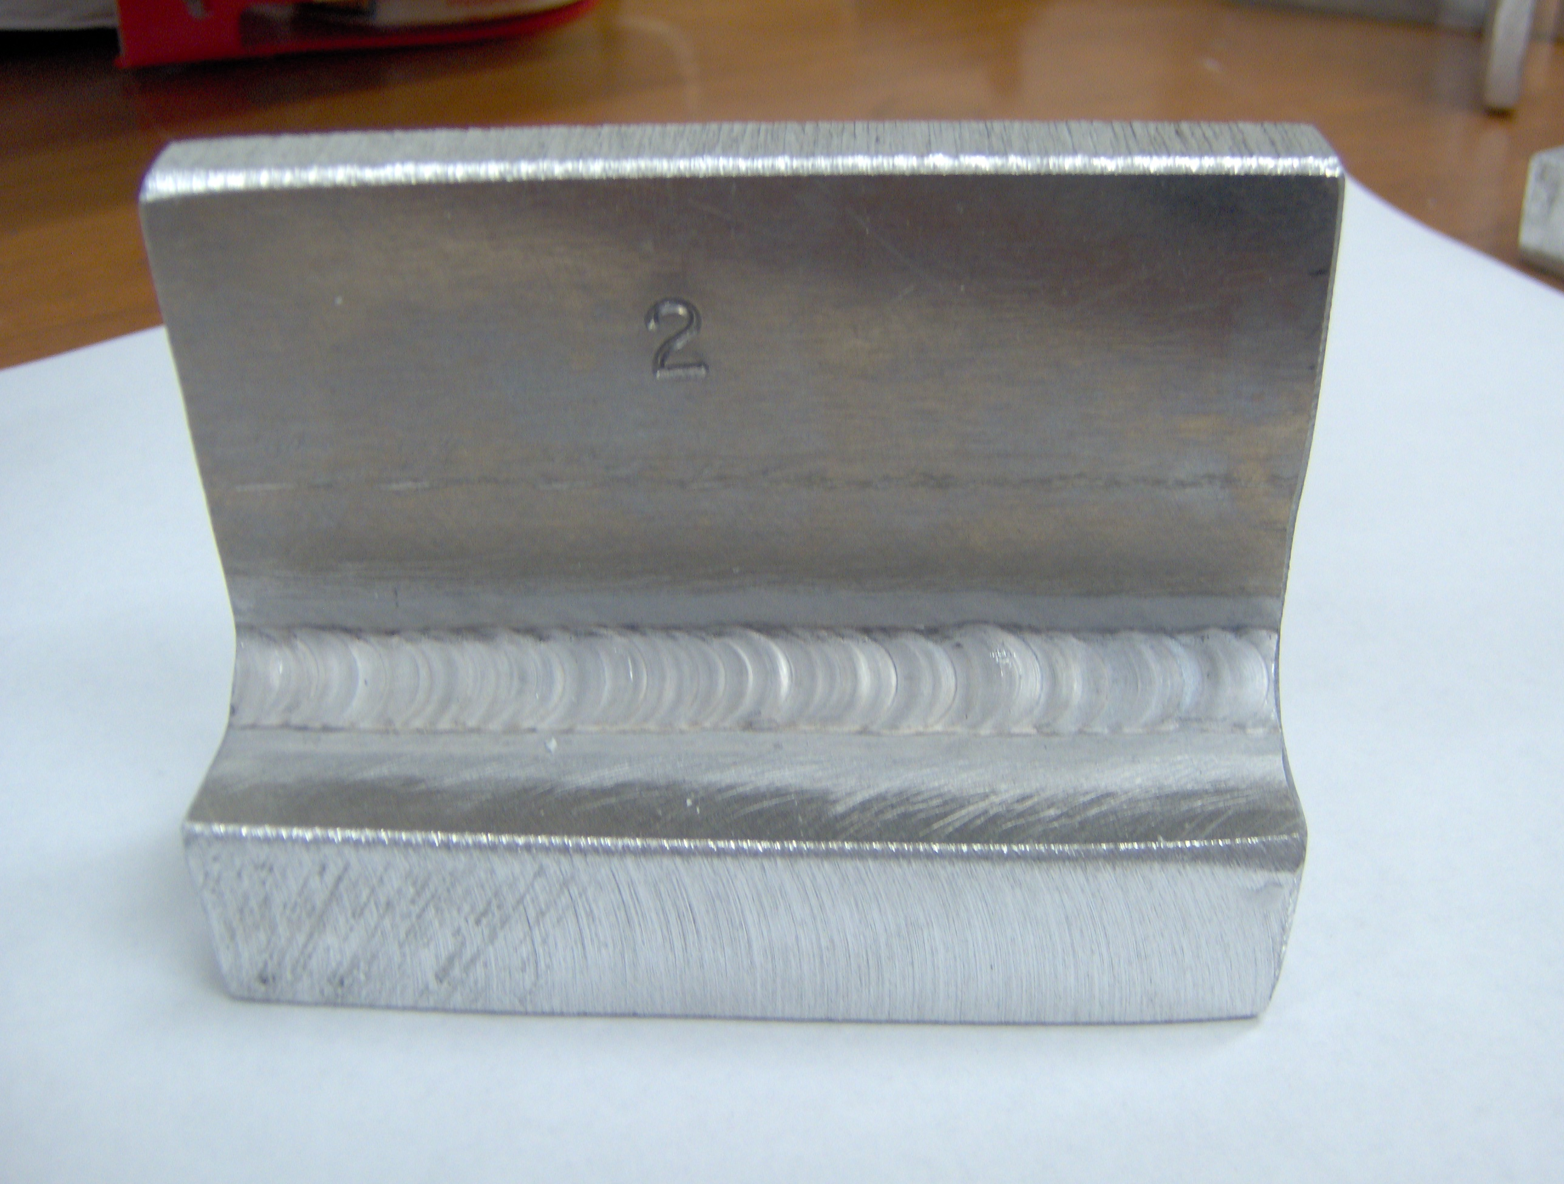
Figure 1: welds of sample 1.
Weld 1 MIG, He25%-Ar75% mix ,cold sample
Weld 2 TIG, He-Ar mix, sample pre-heated by MIG

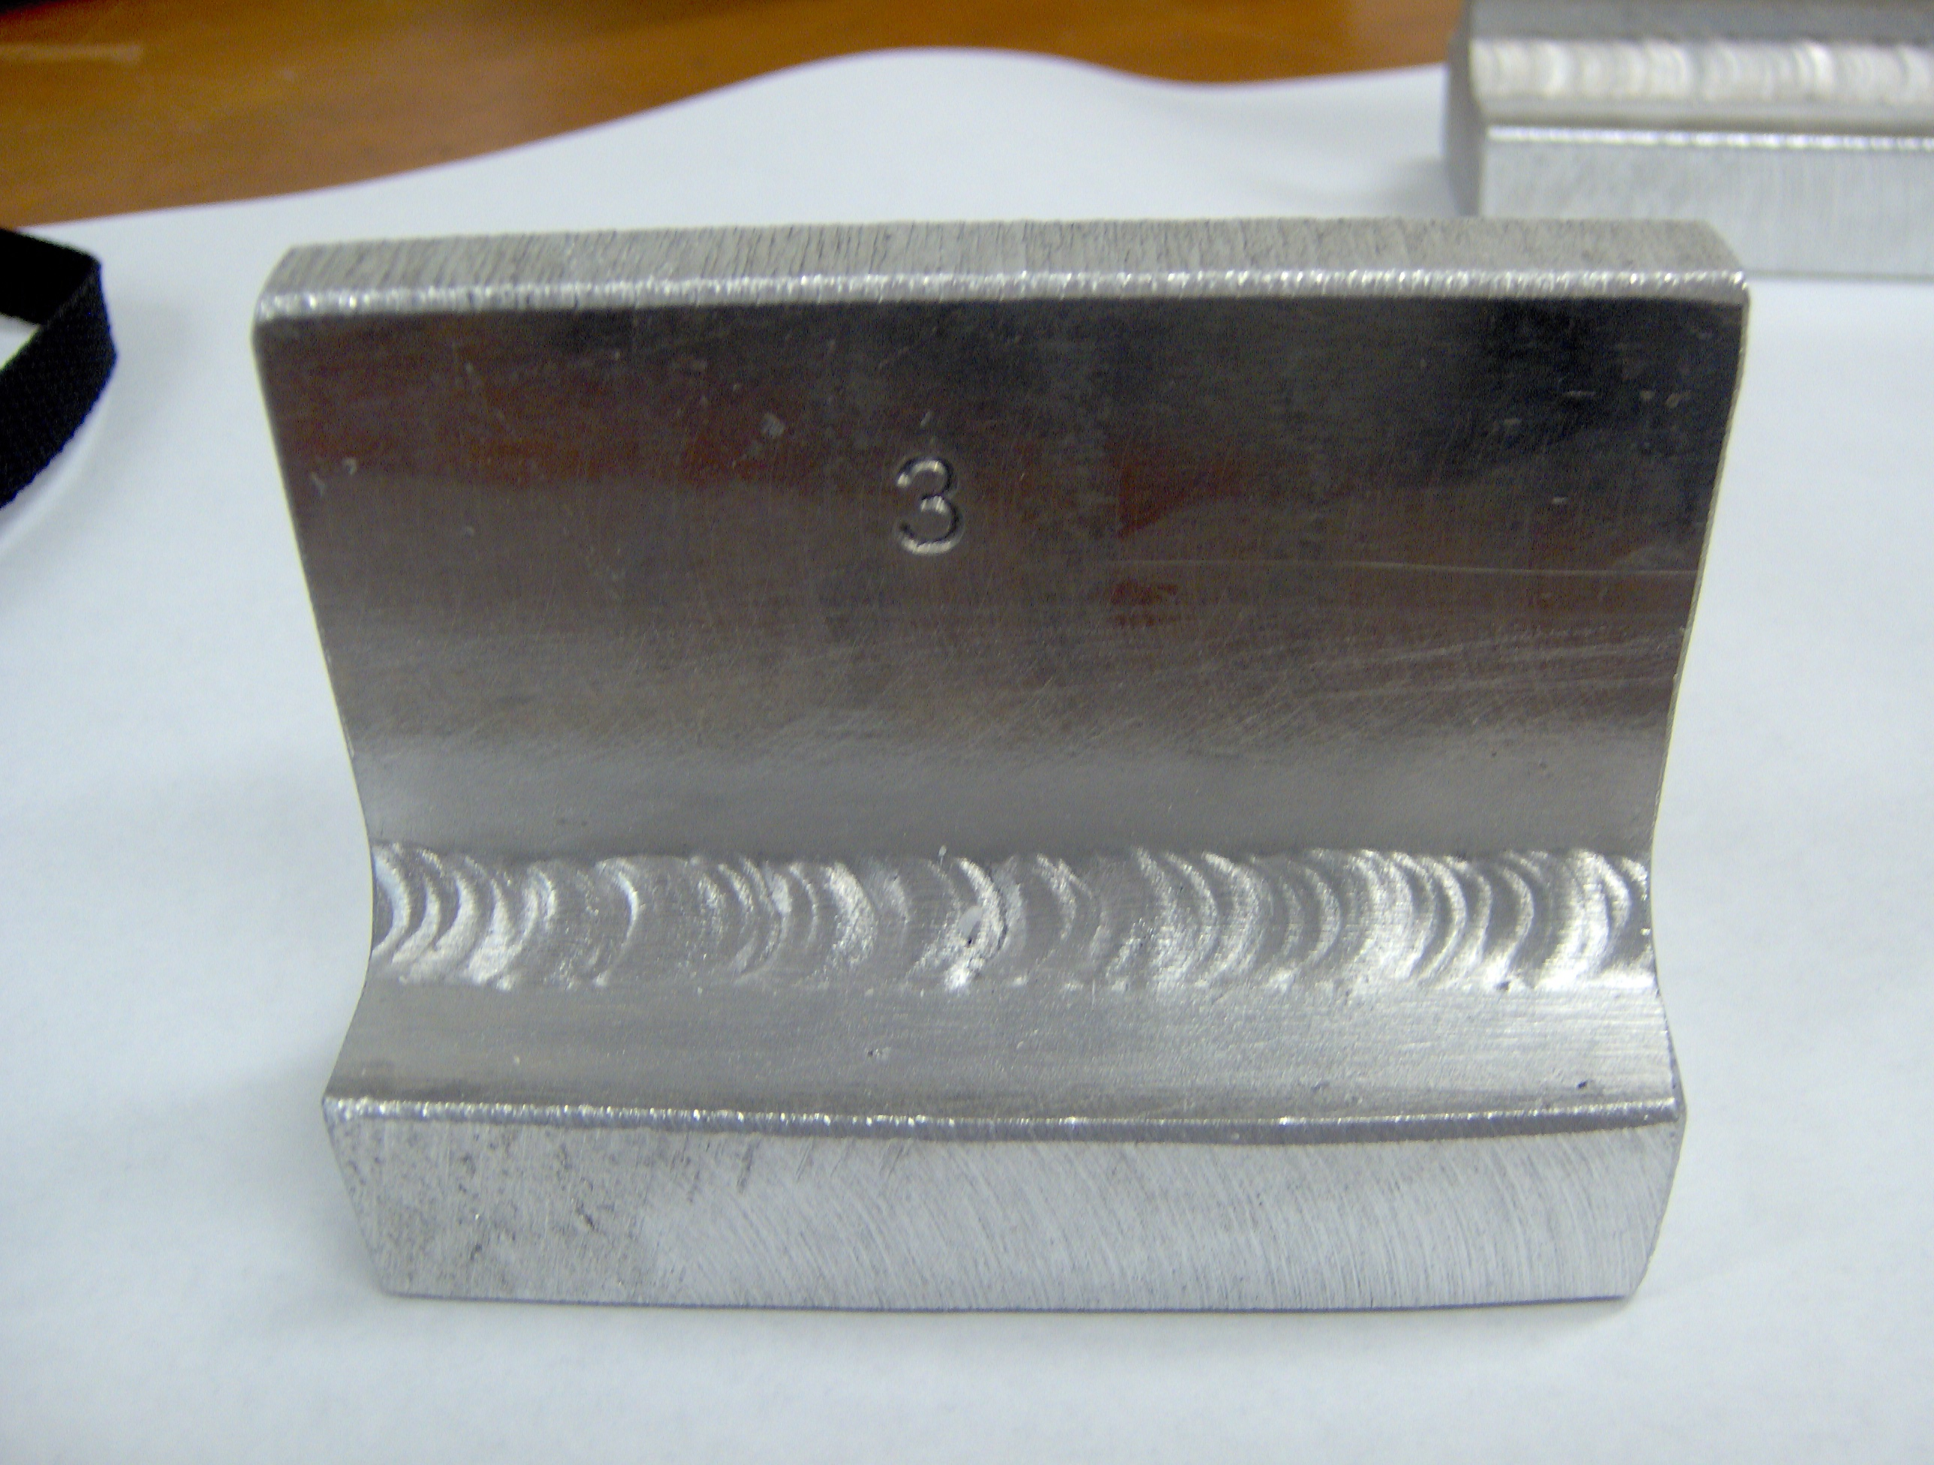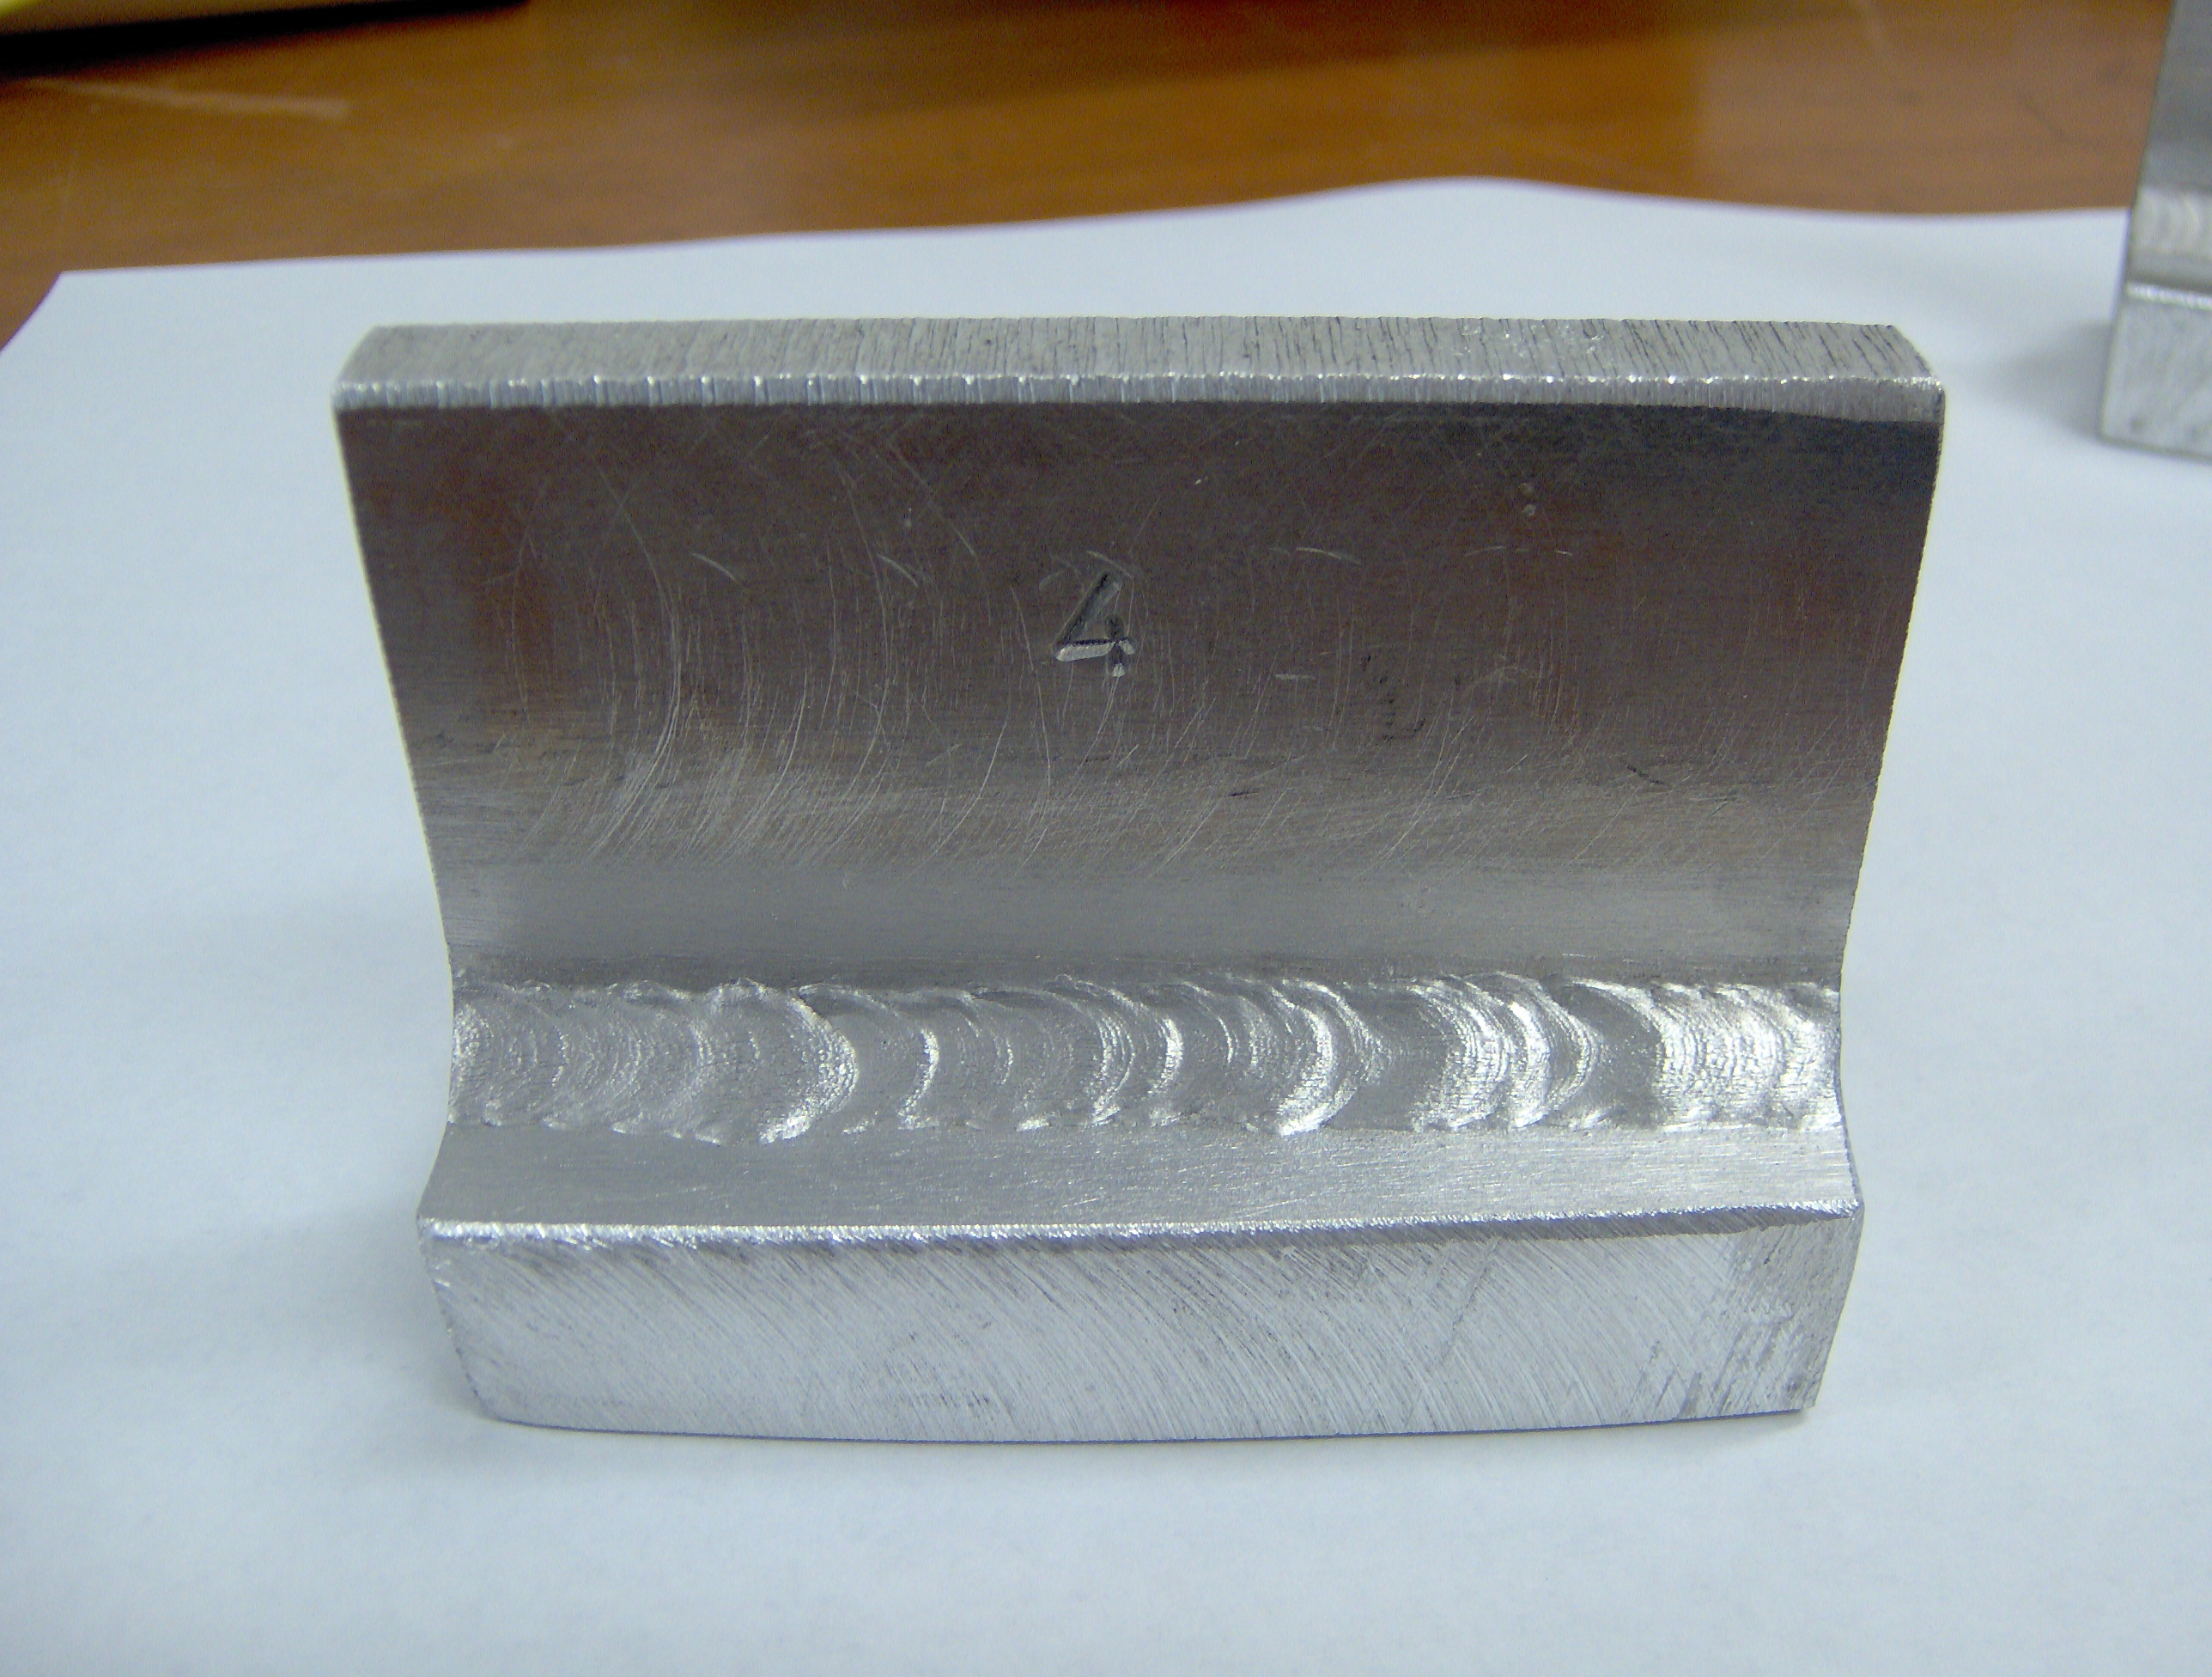
Figure 2: Welds of sample 2
Weld 3 TIG, Ar, sample pre-heated by MIG
Weld 4 MIG, He-Ar mix, cold sample

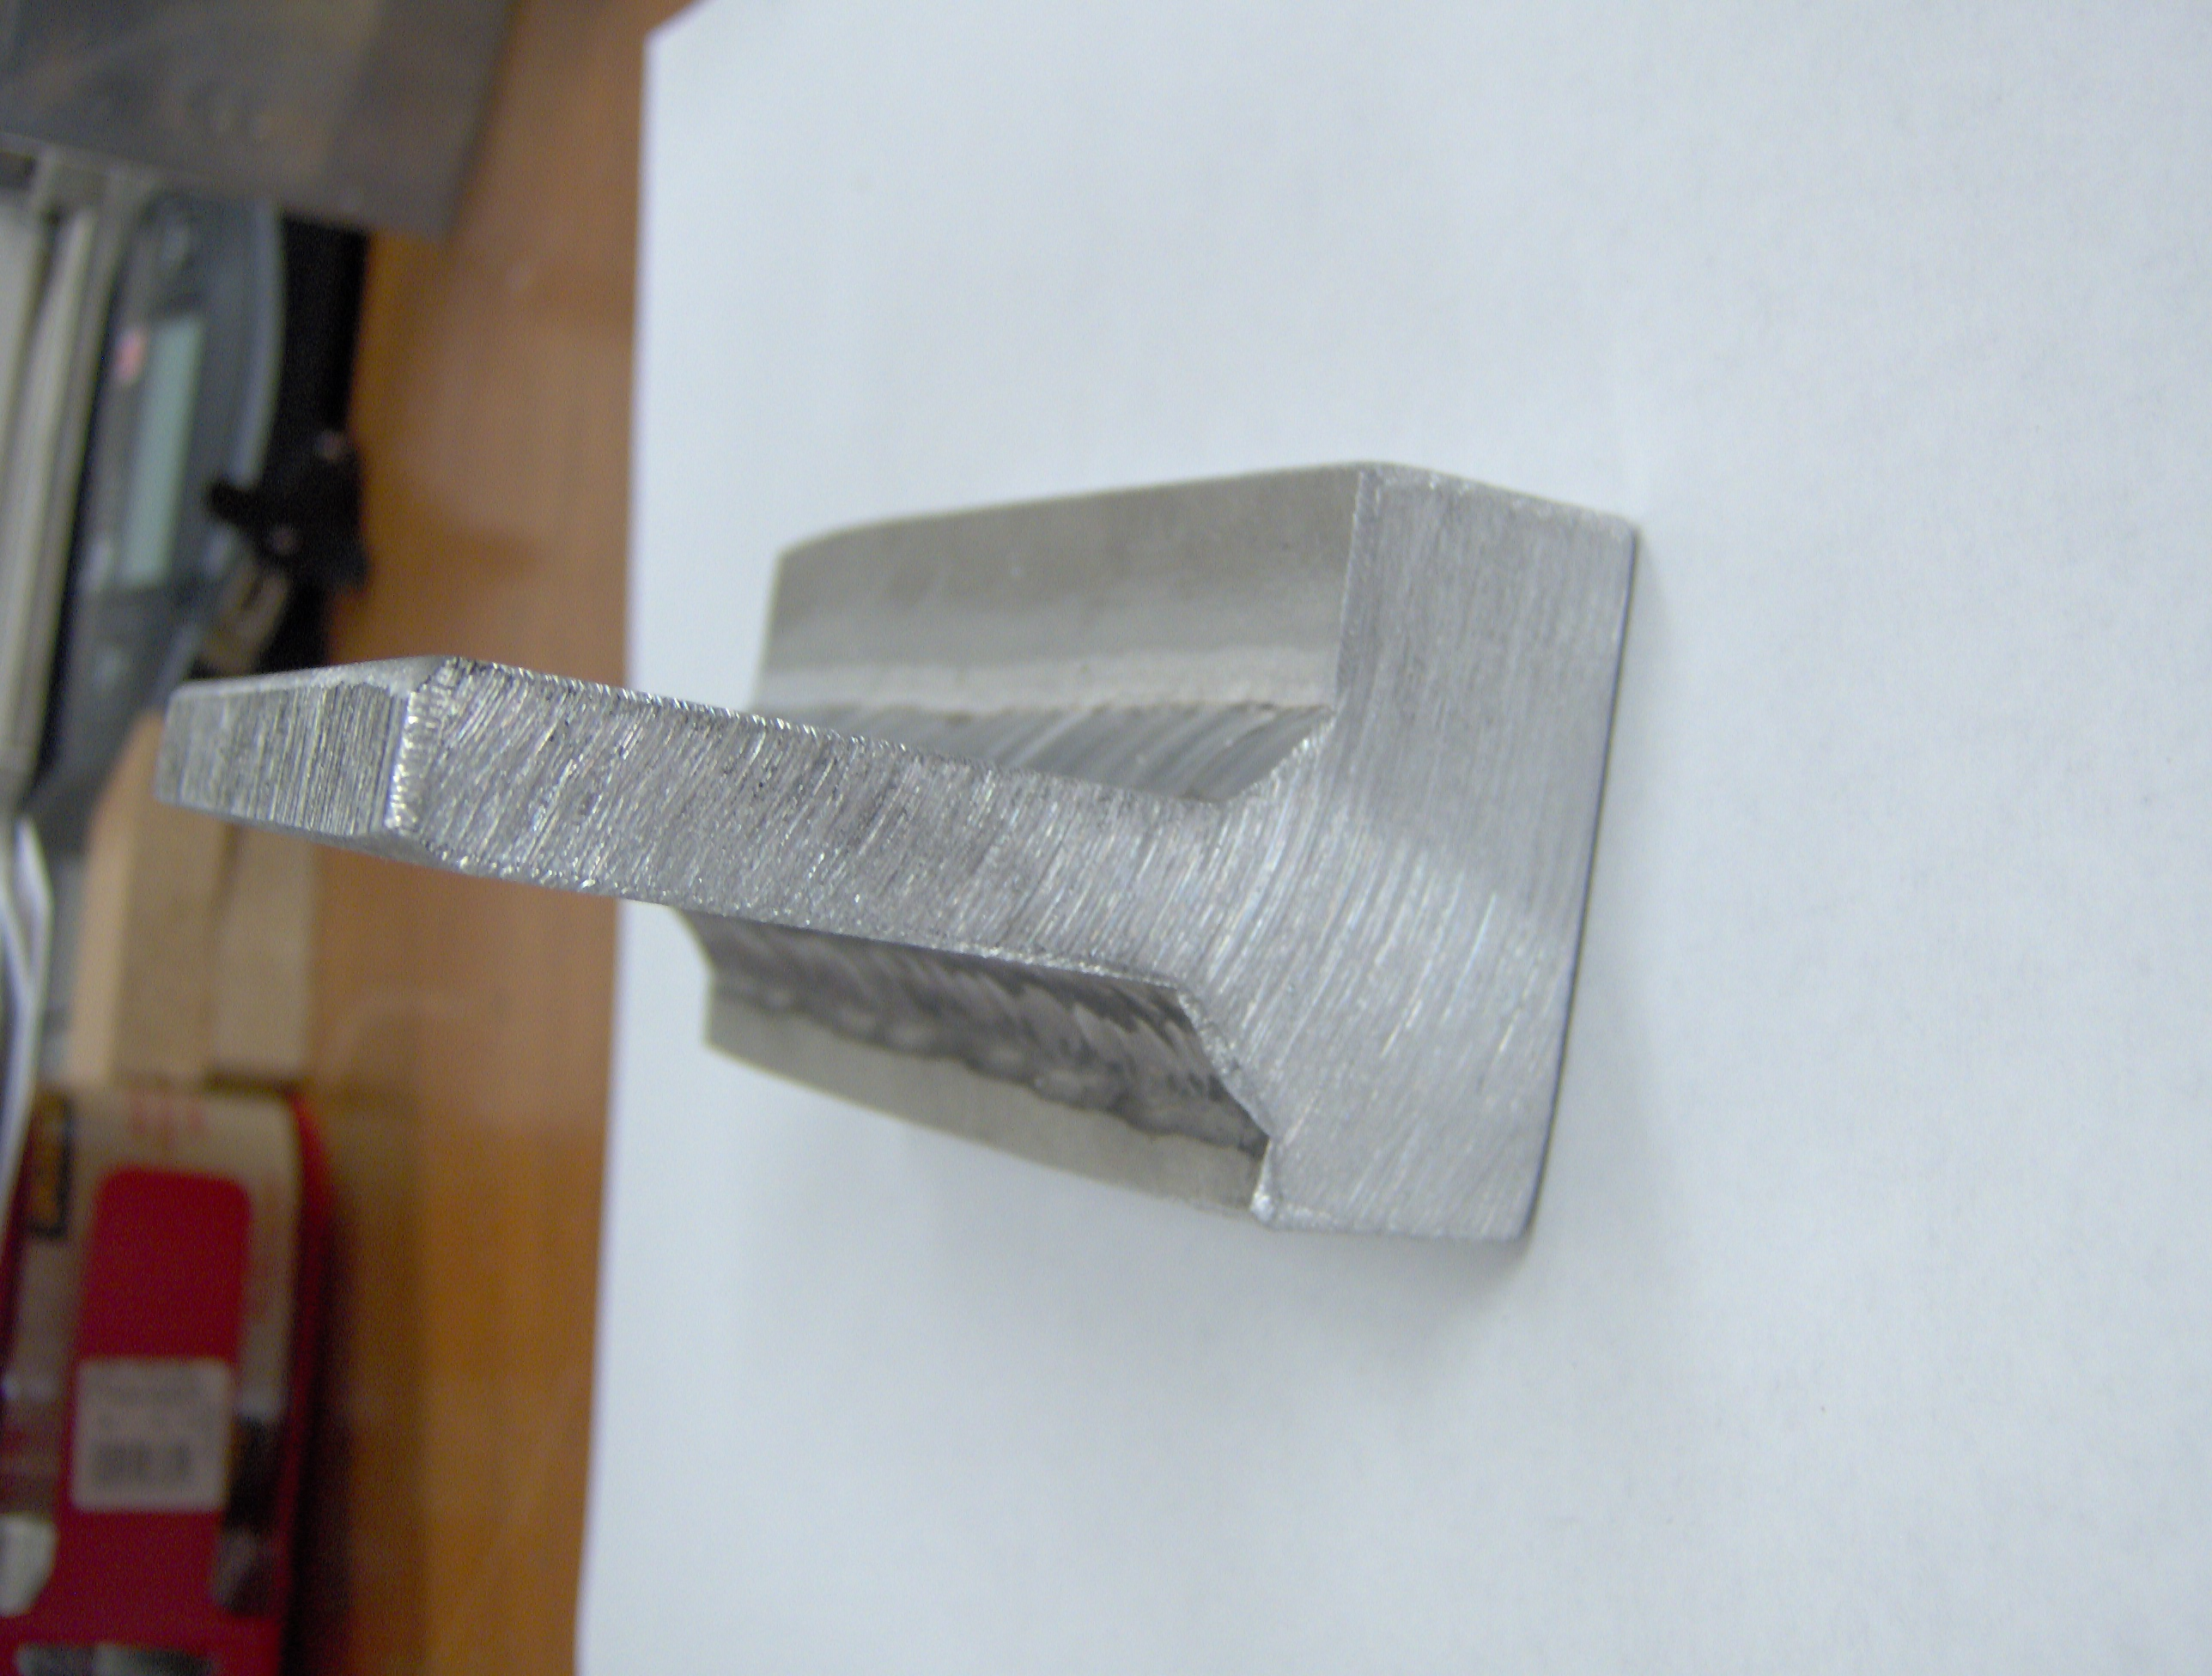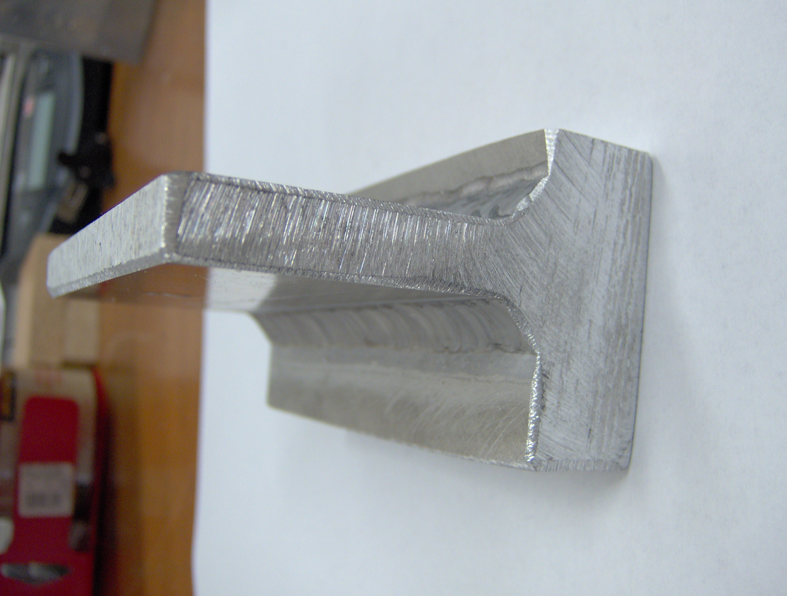

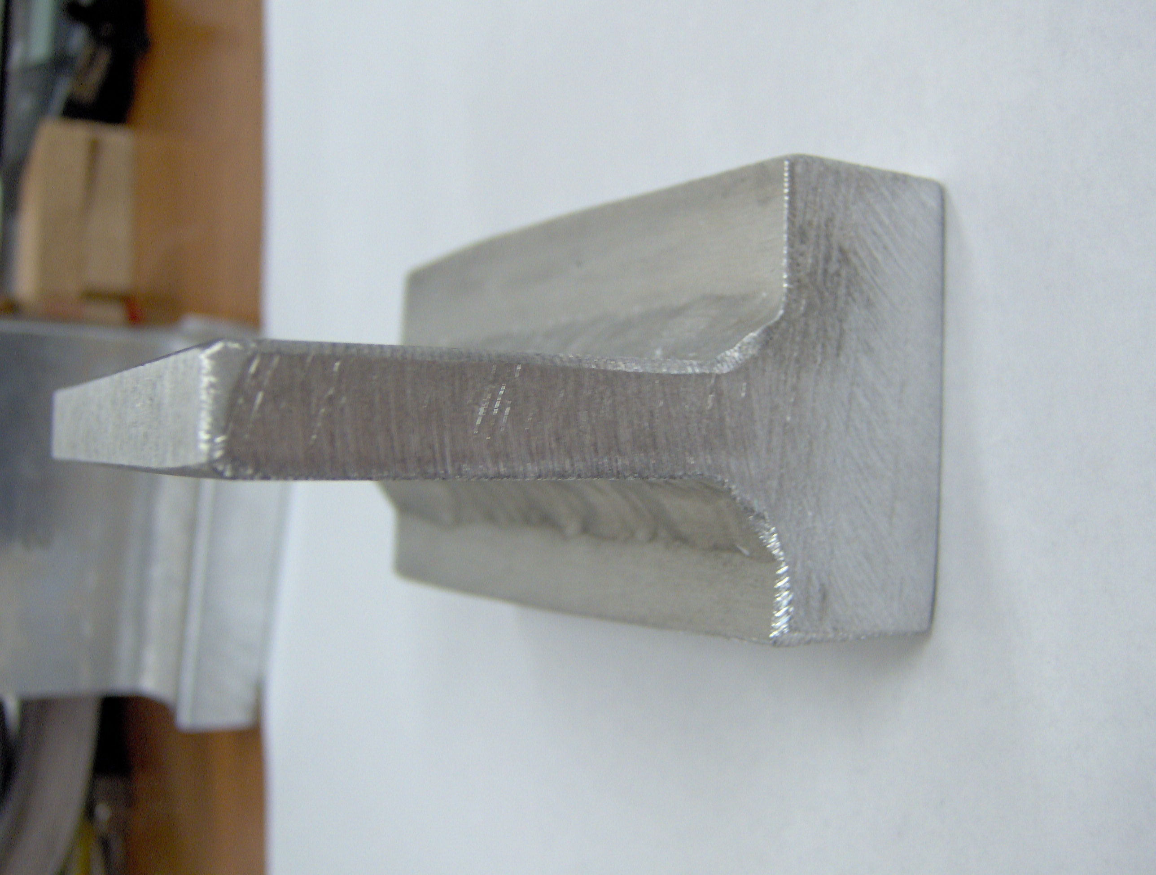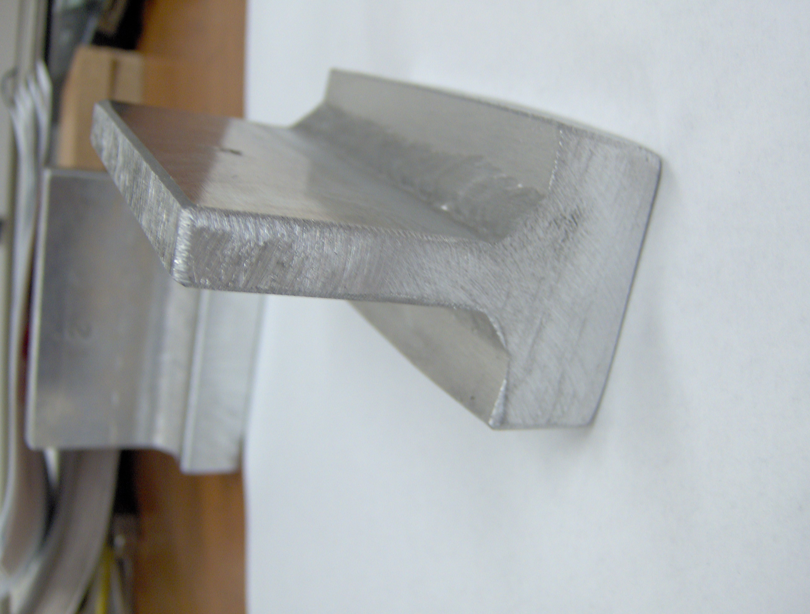
Figure 3: Weld saw-cut view of samples 1 and 2
Weld 1 MIG, He-Ar mix ,cold sample
Weld 2 TIG, He-Ar mix, sample pre-heated by MIG

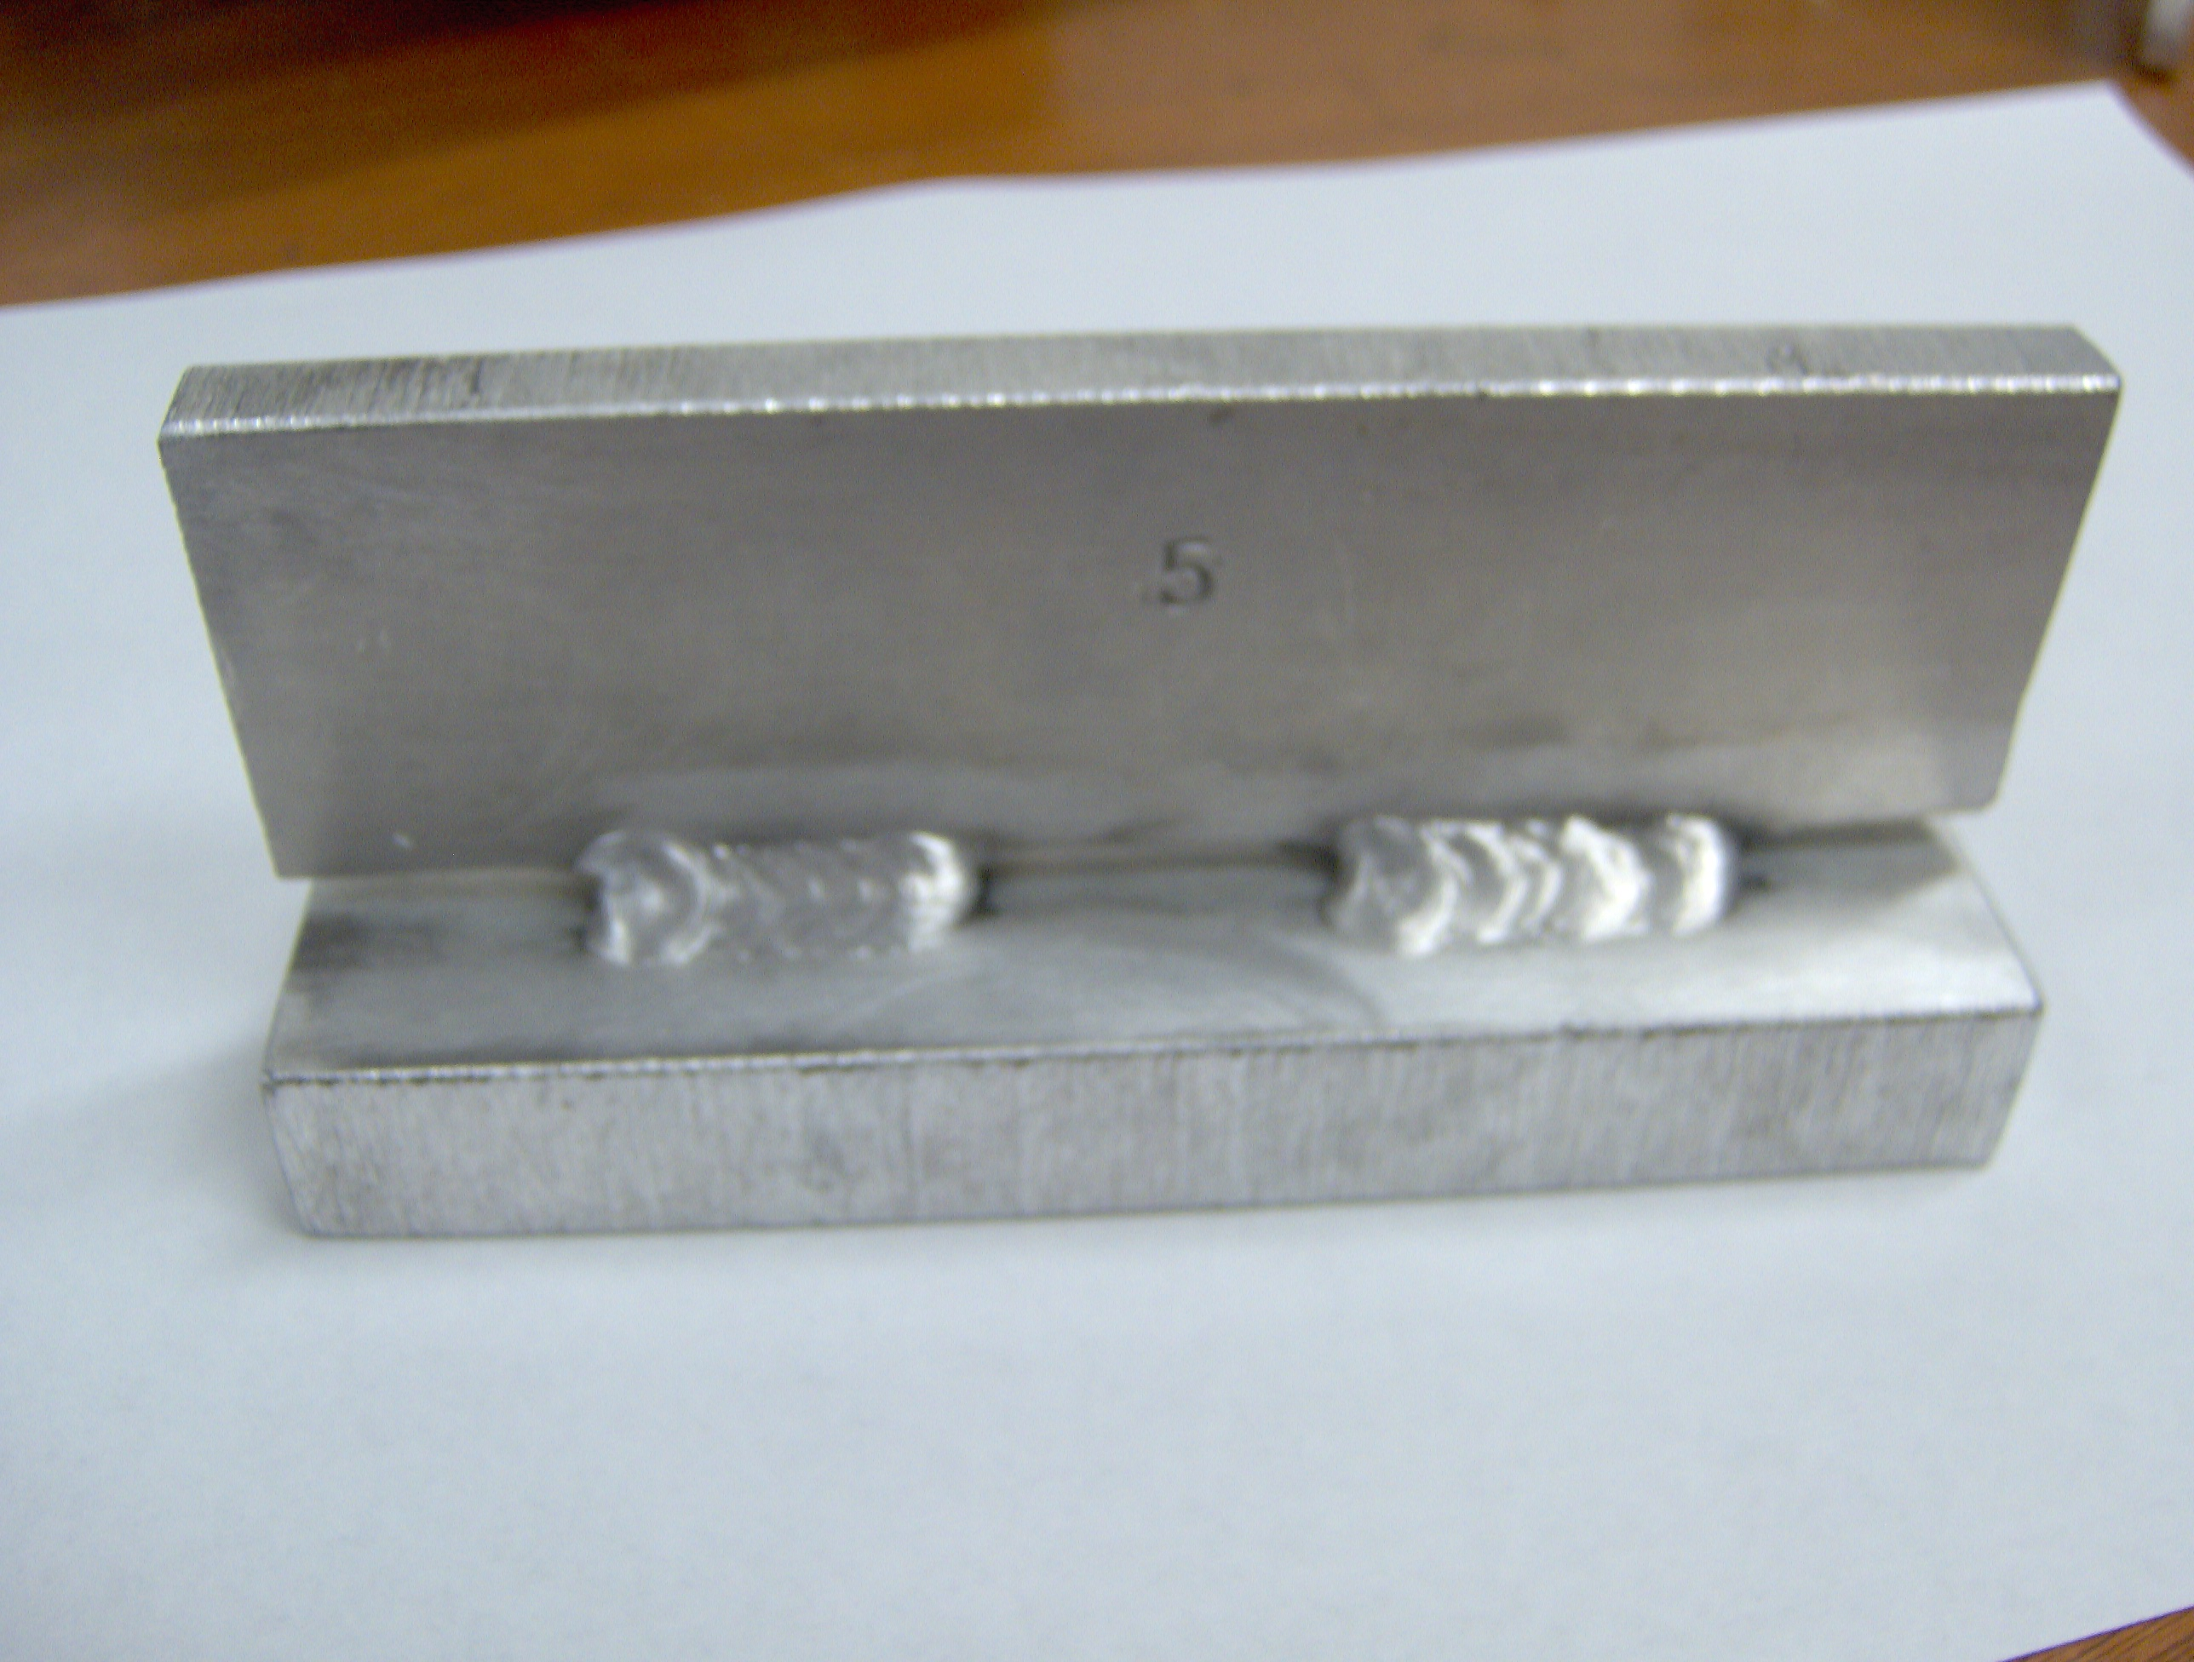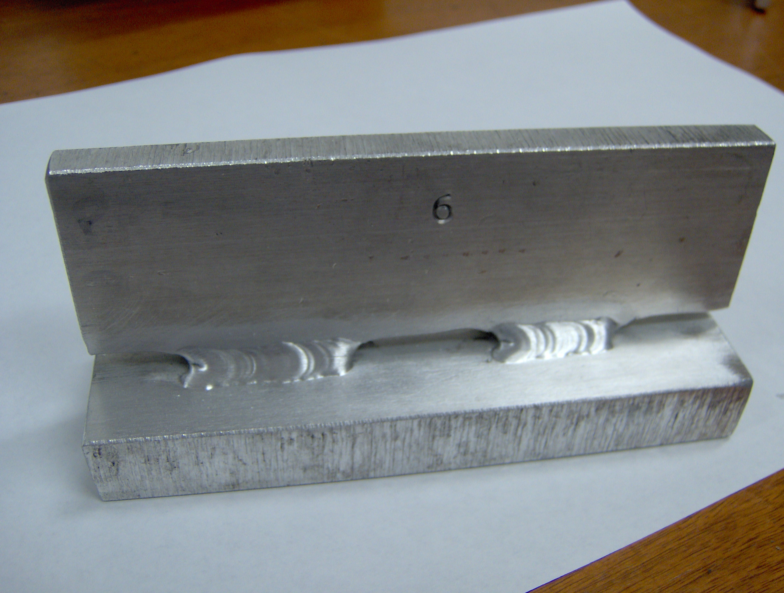
Figure 4 side view of scalloped T-weld
Weld 5 MIG, He-Ar mix ,cold sample
Weld 6 TIG, He-Ar mix, sample pre-heated by MIG

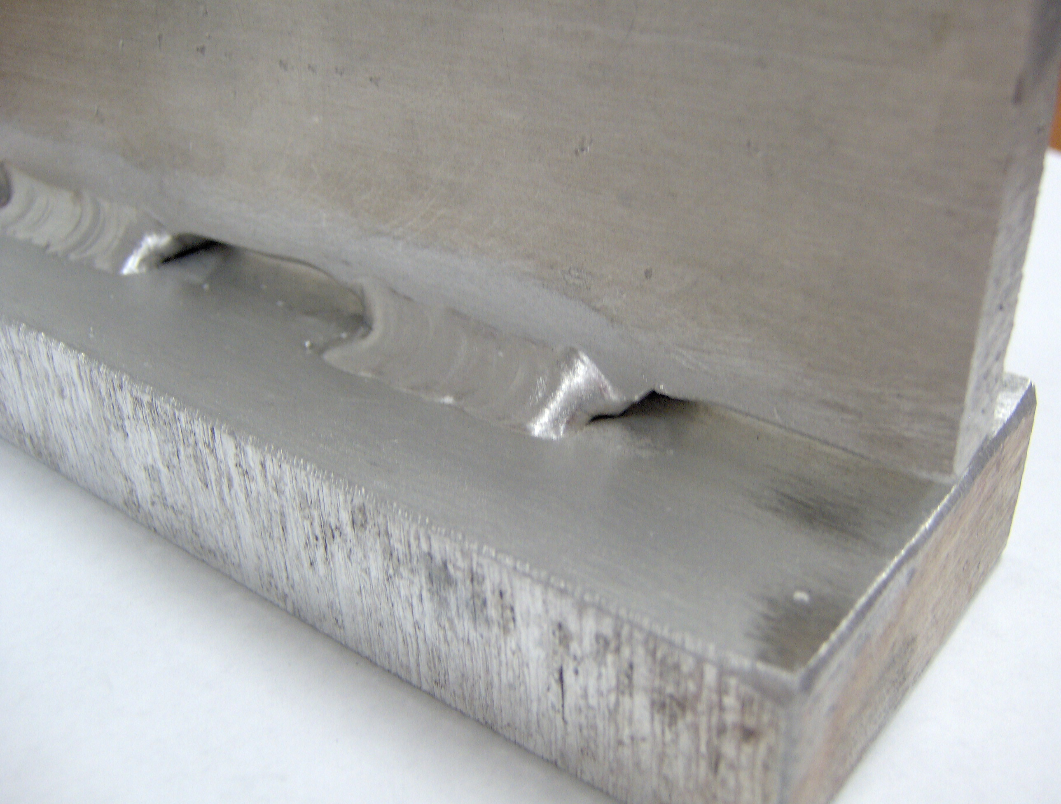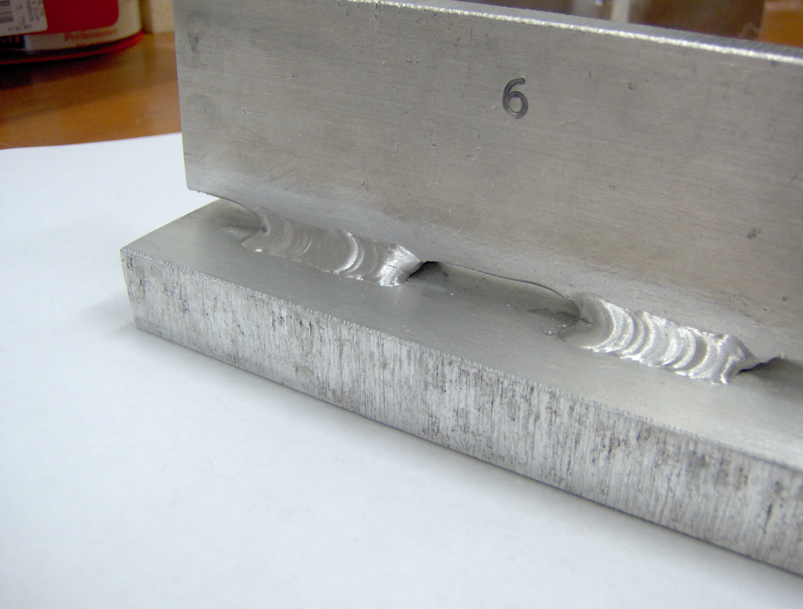
Figure 5 View of the ends of welds 5 and 6
Weld 5 MIG, He-Ar mix ,cold sample
Weld 6 TIG, He-Ar mix, sample pre-heated by MIG

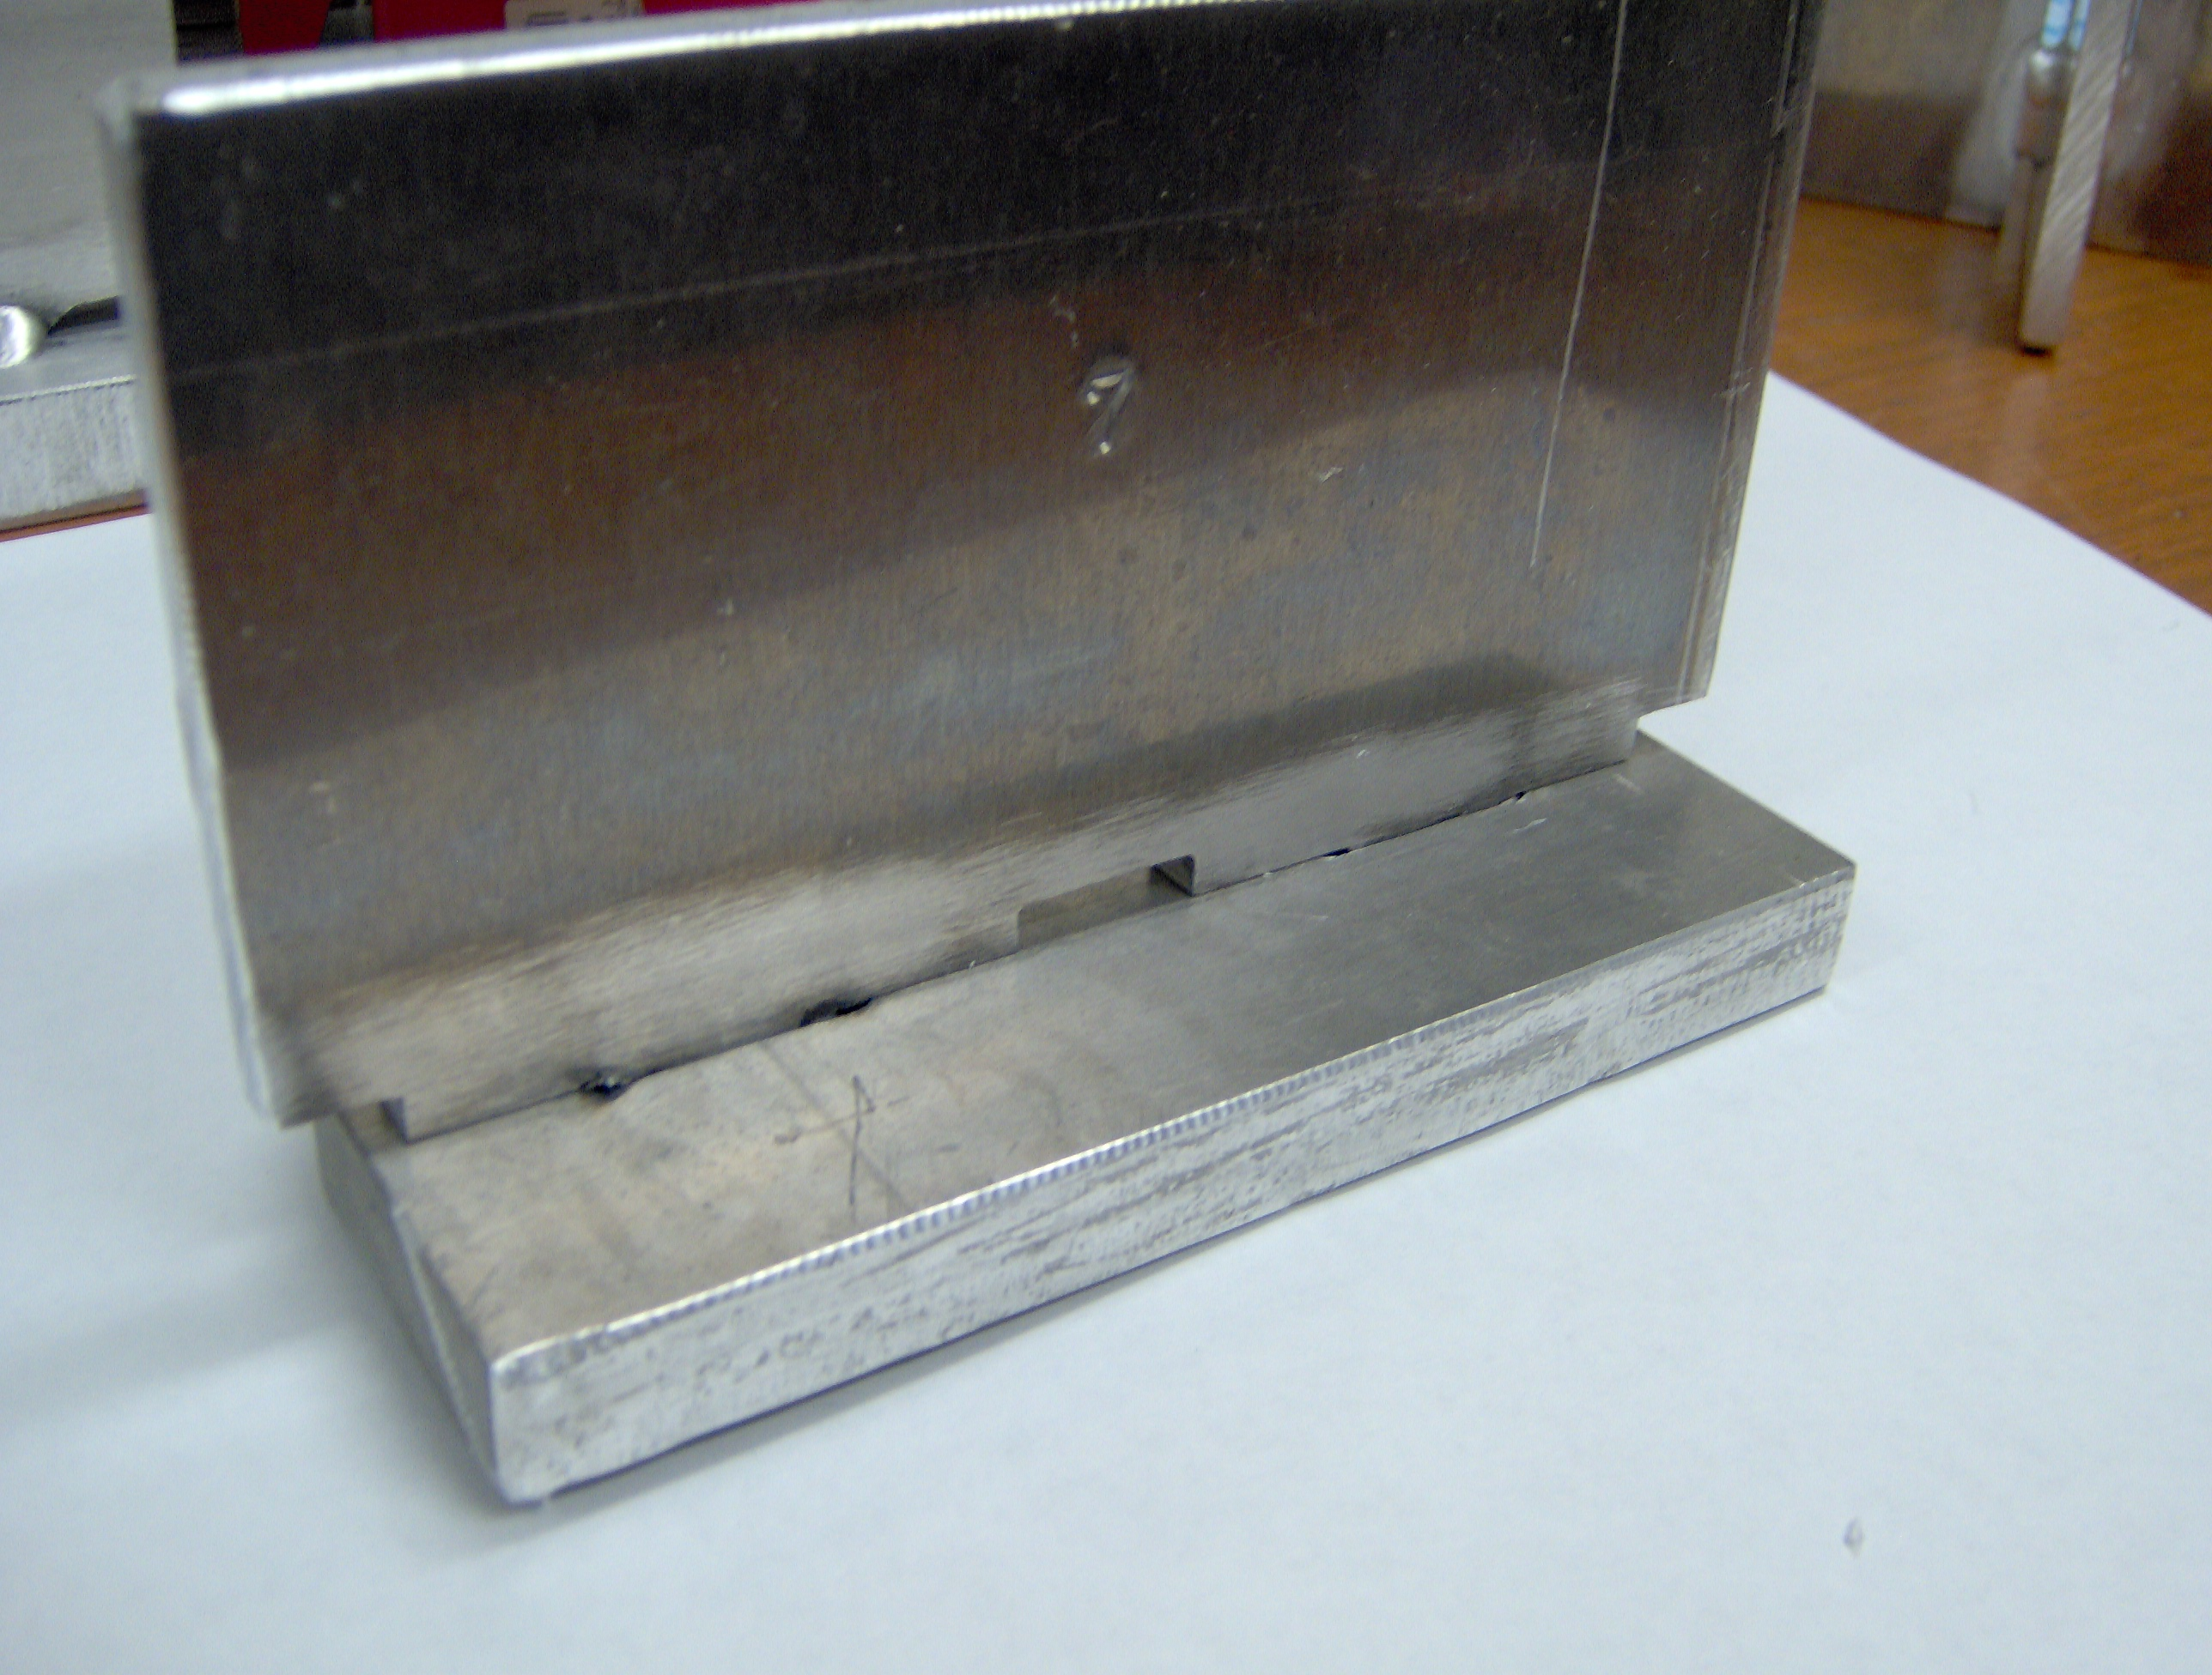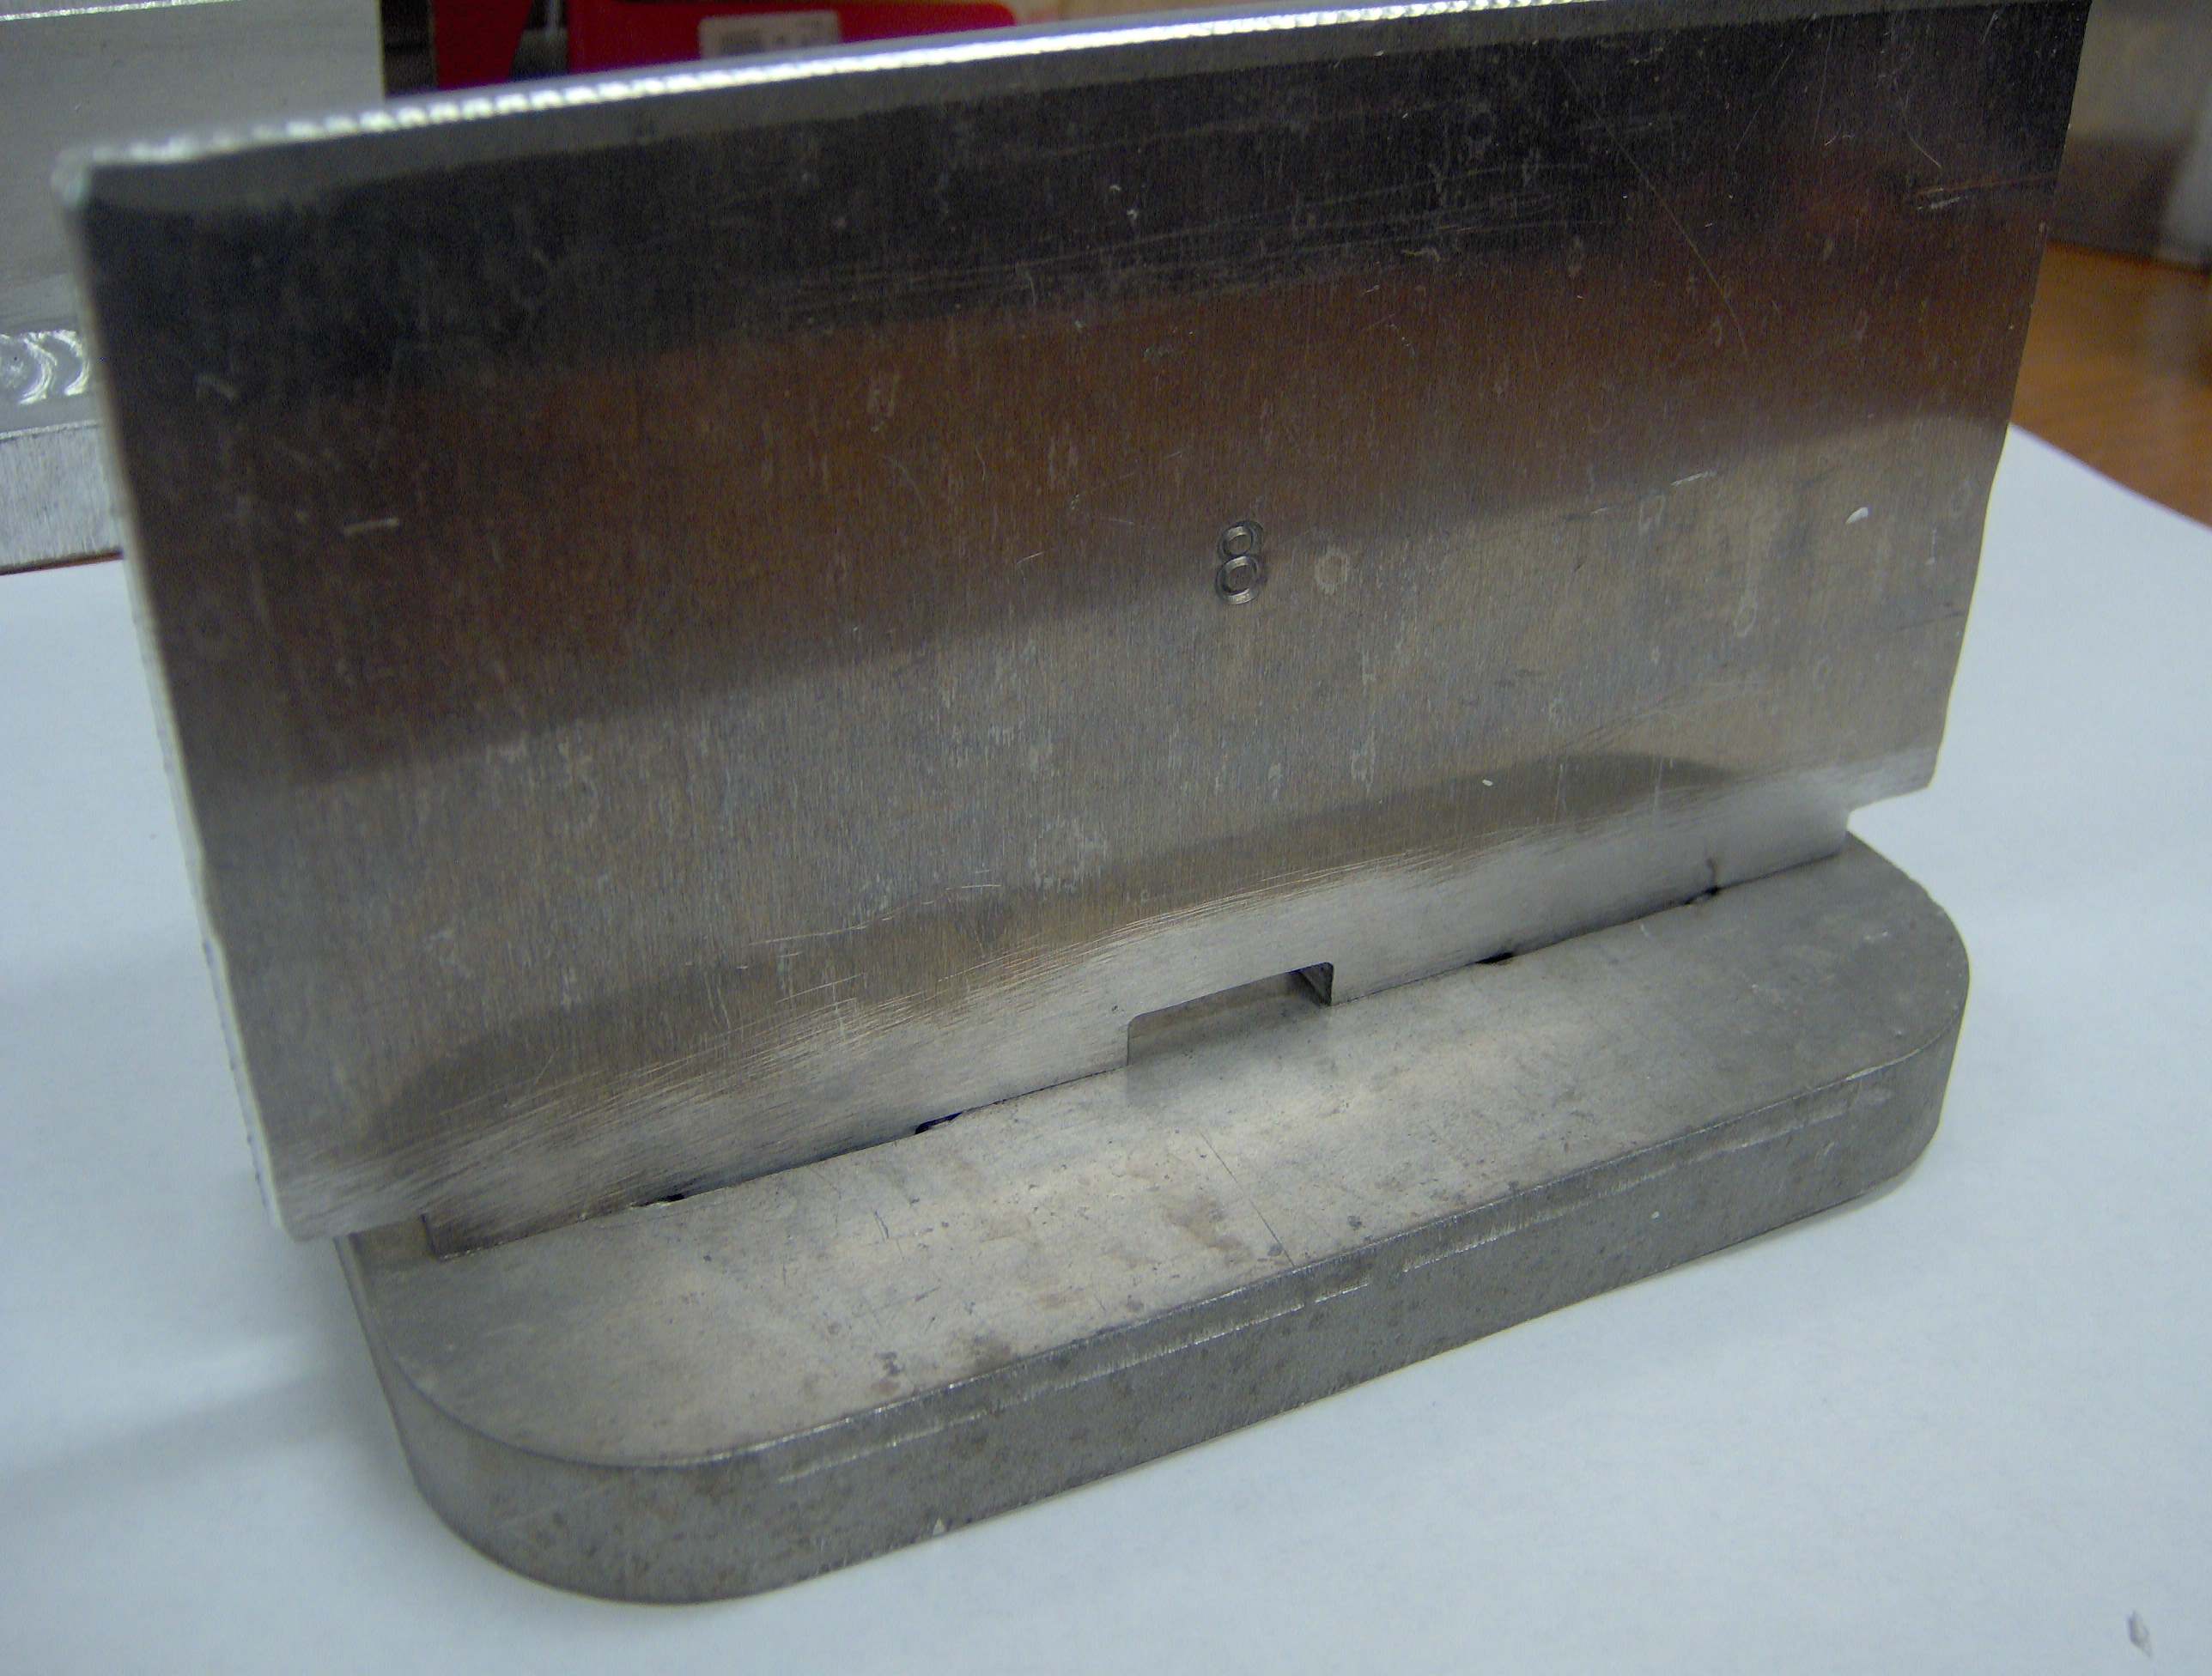

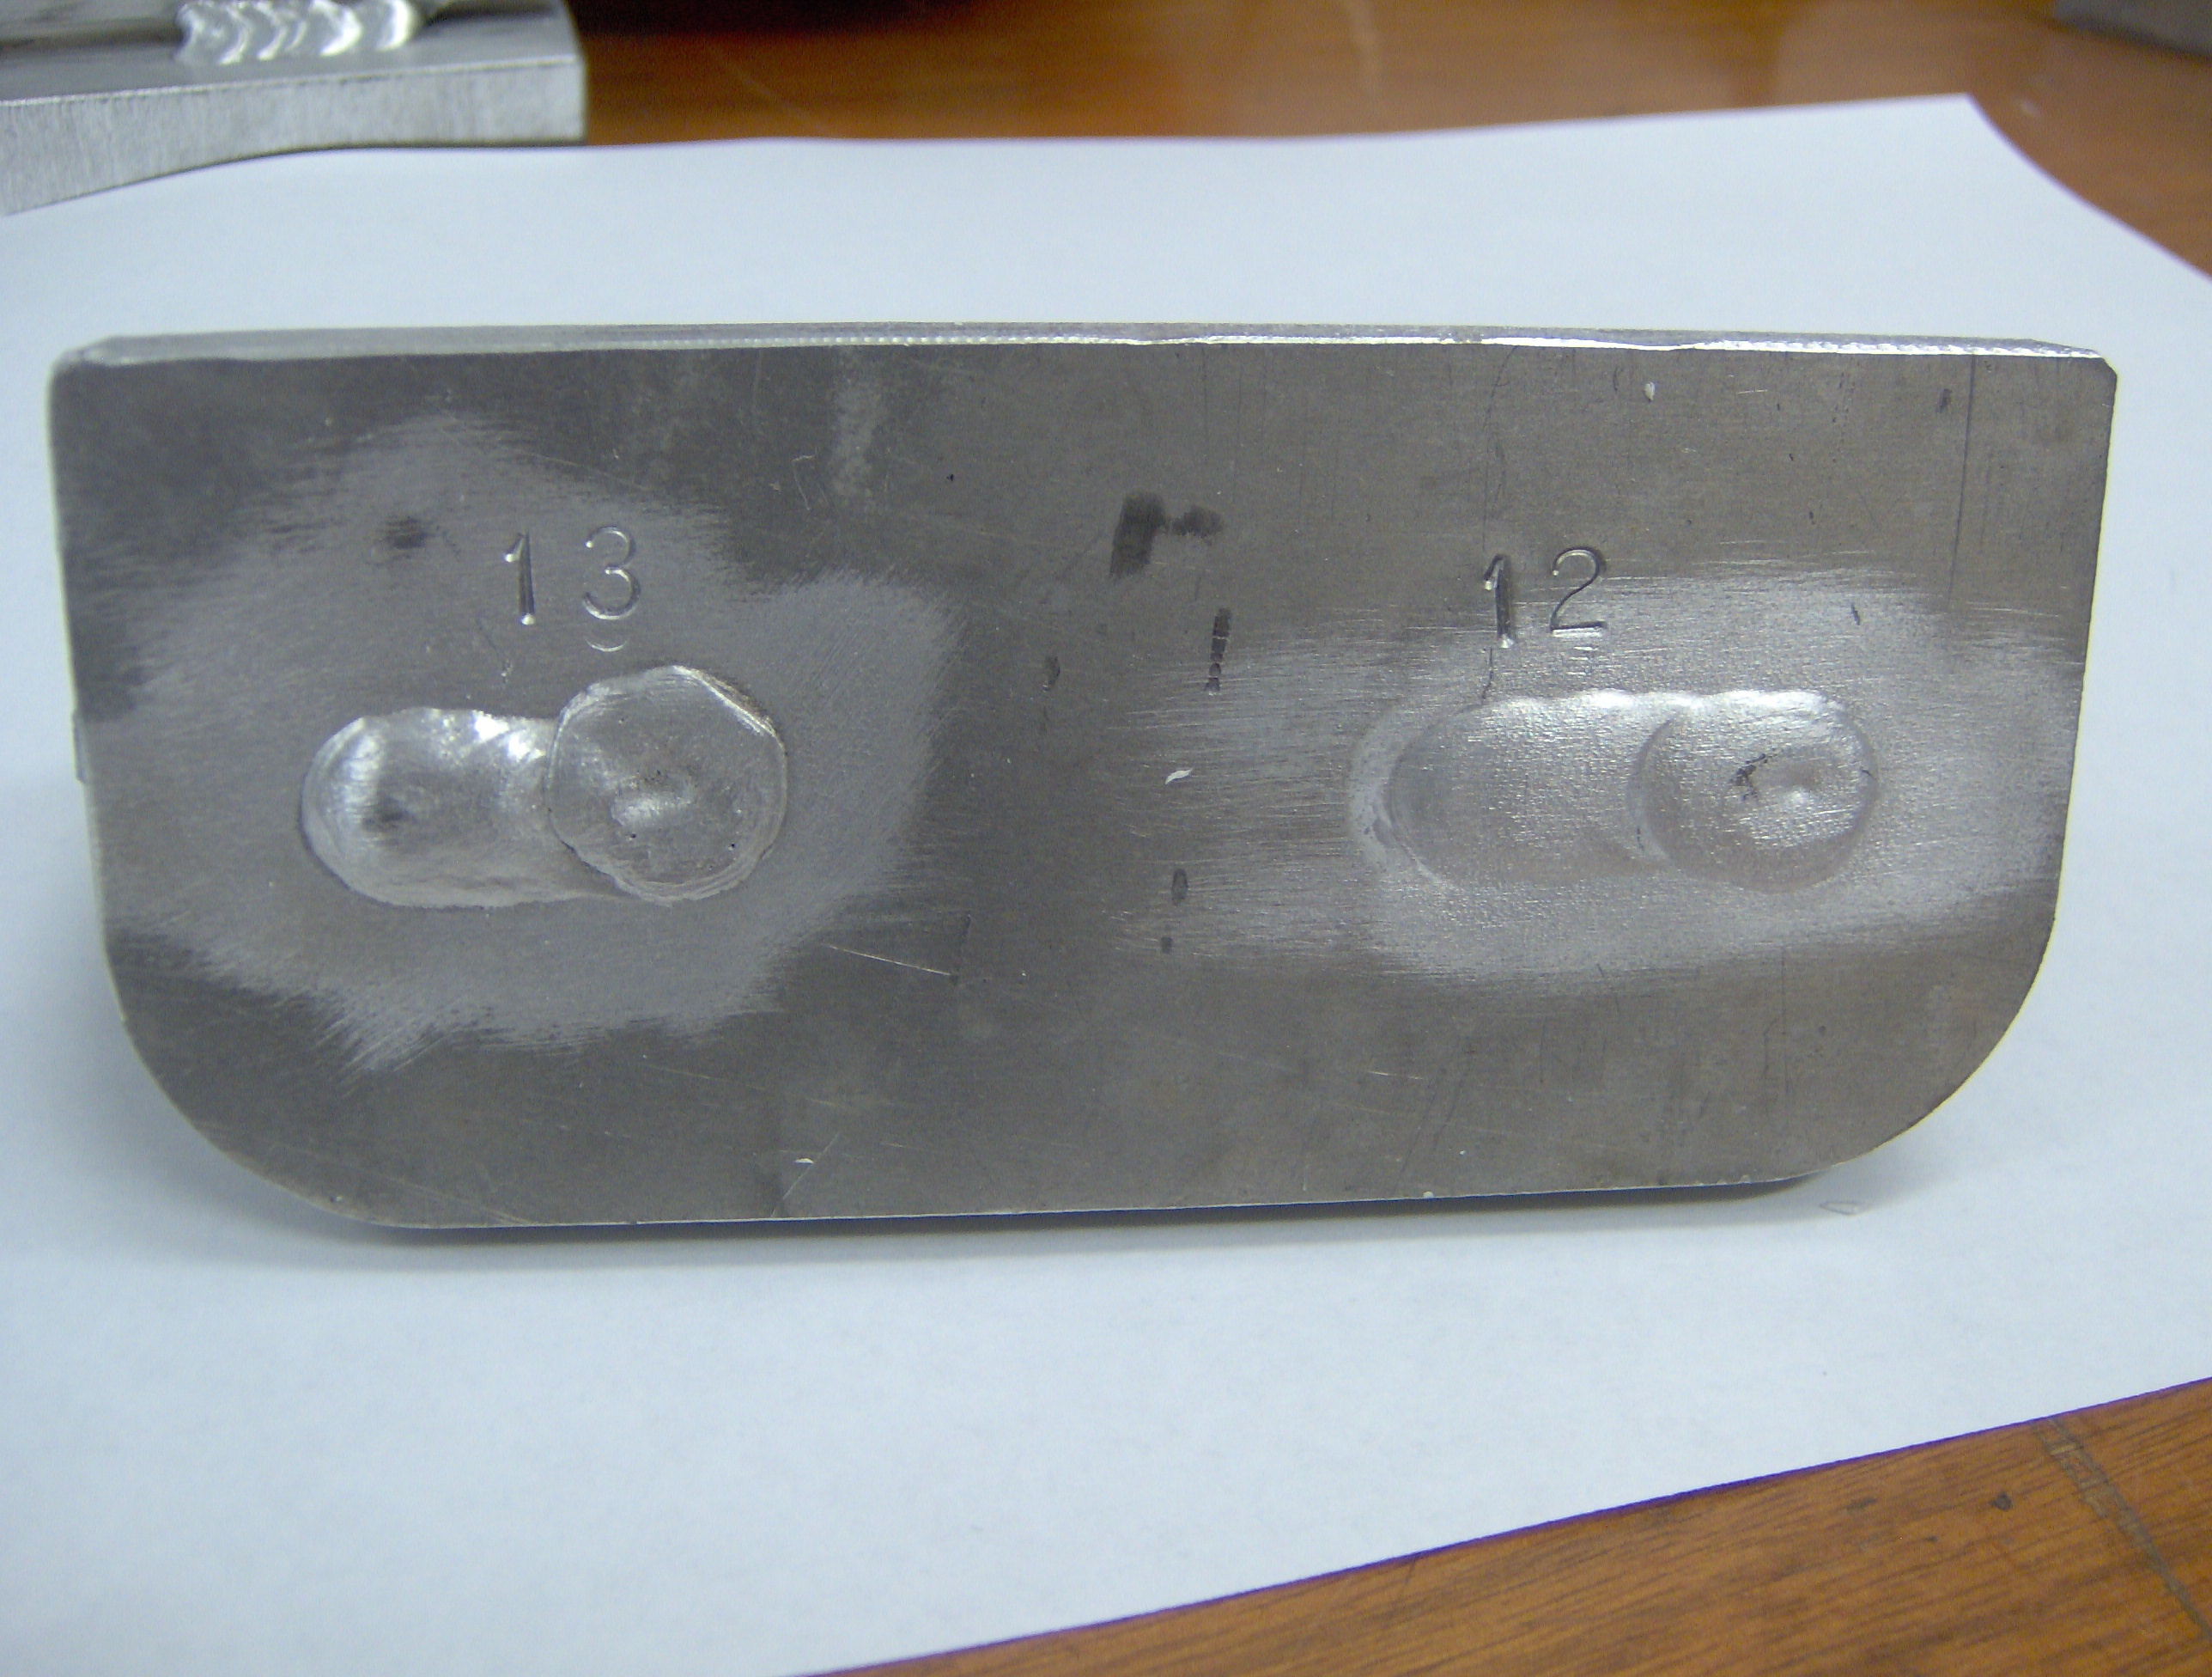

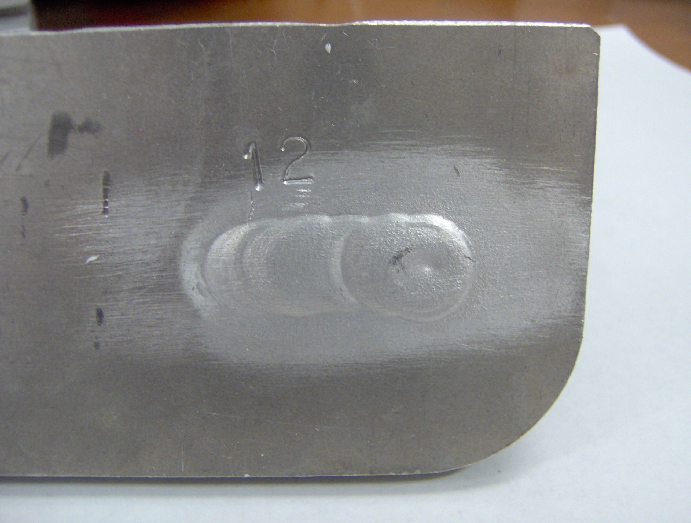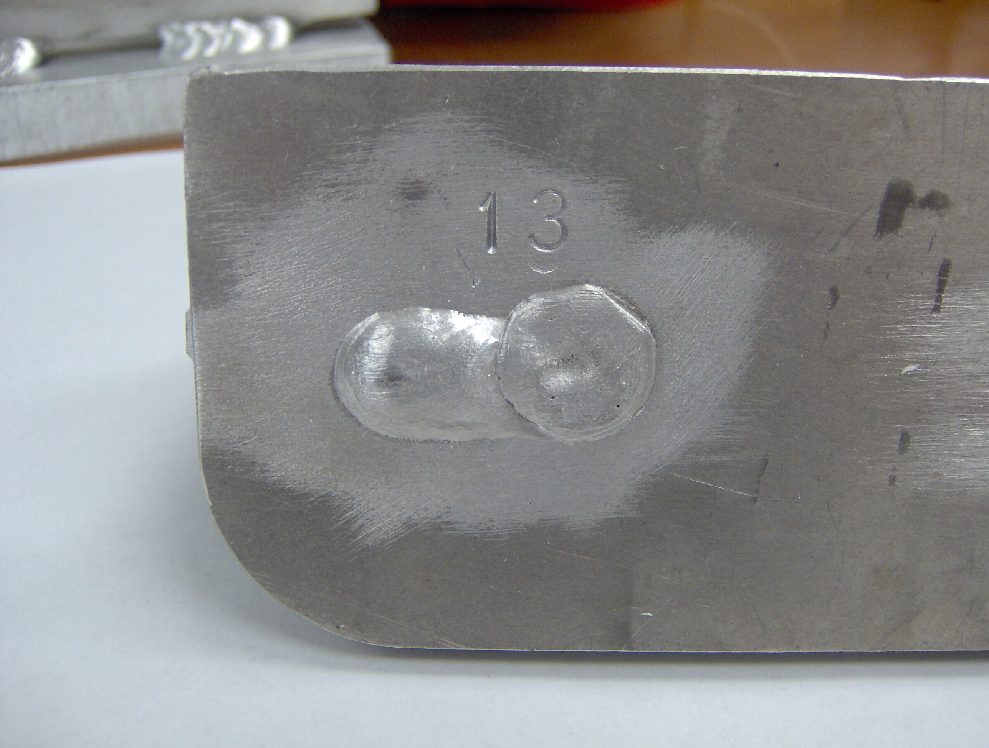

Figure 6, Plug T-welds
Weld 12 TIG, He-Ar mix, sample pre-heated by MIG
Weld 13 MIG, He-Ar mix, cold sample

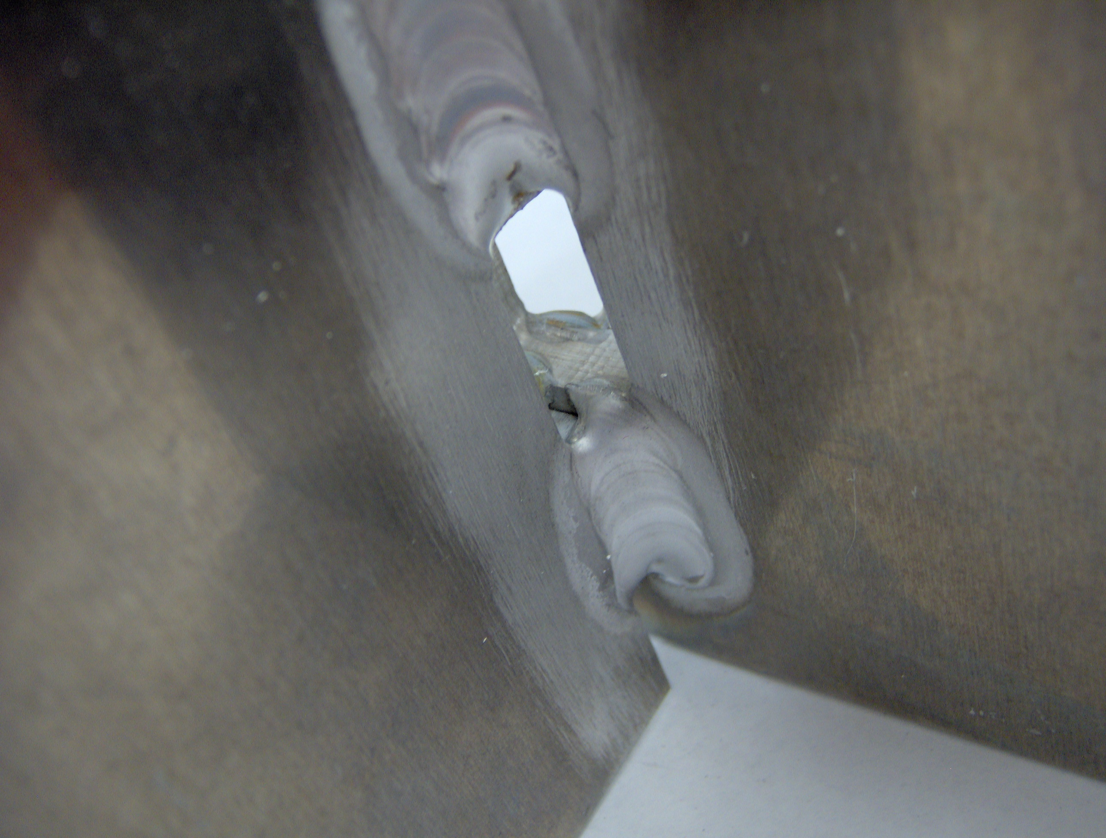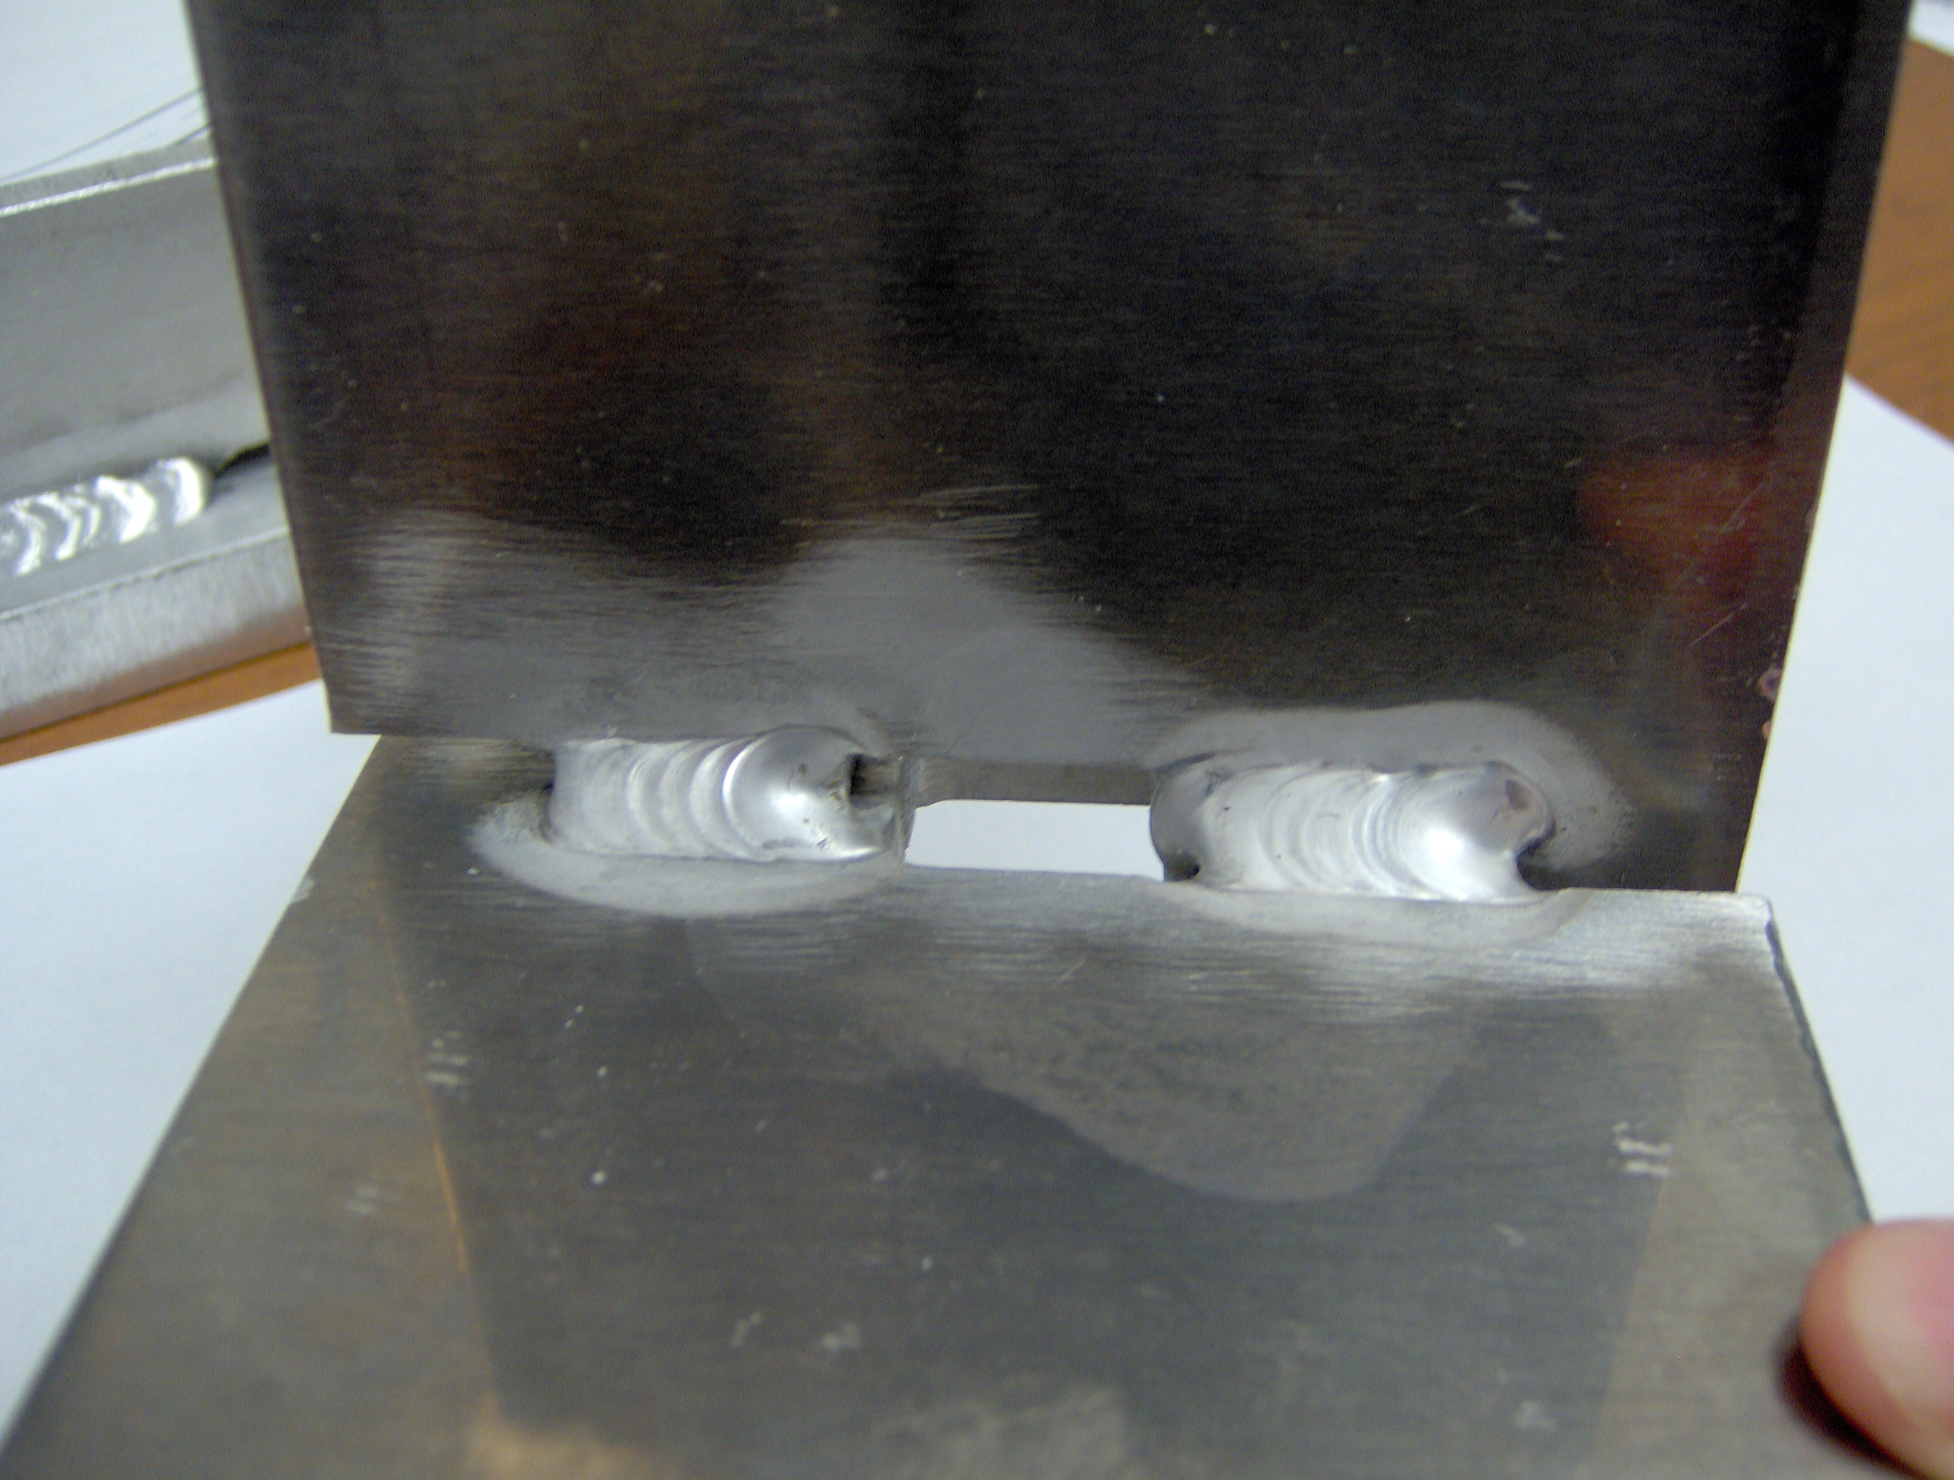

Figure 7 view of cross welds and crevasses.
Weld 11 TIG, Ar, cold sample

Preparation of the T-samples for precision cutting.
The Aluminum Oxide saw only accepts small samples, therefore we cut out a third of each sample, and reduced their sizes until we included only the weld region.
Then we cut several slices from each sample.
In doing this we took great care to copy the labels on all sub-samples, figure 8.

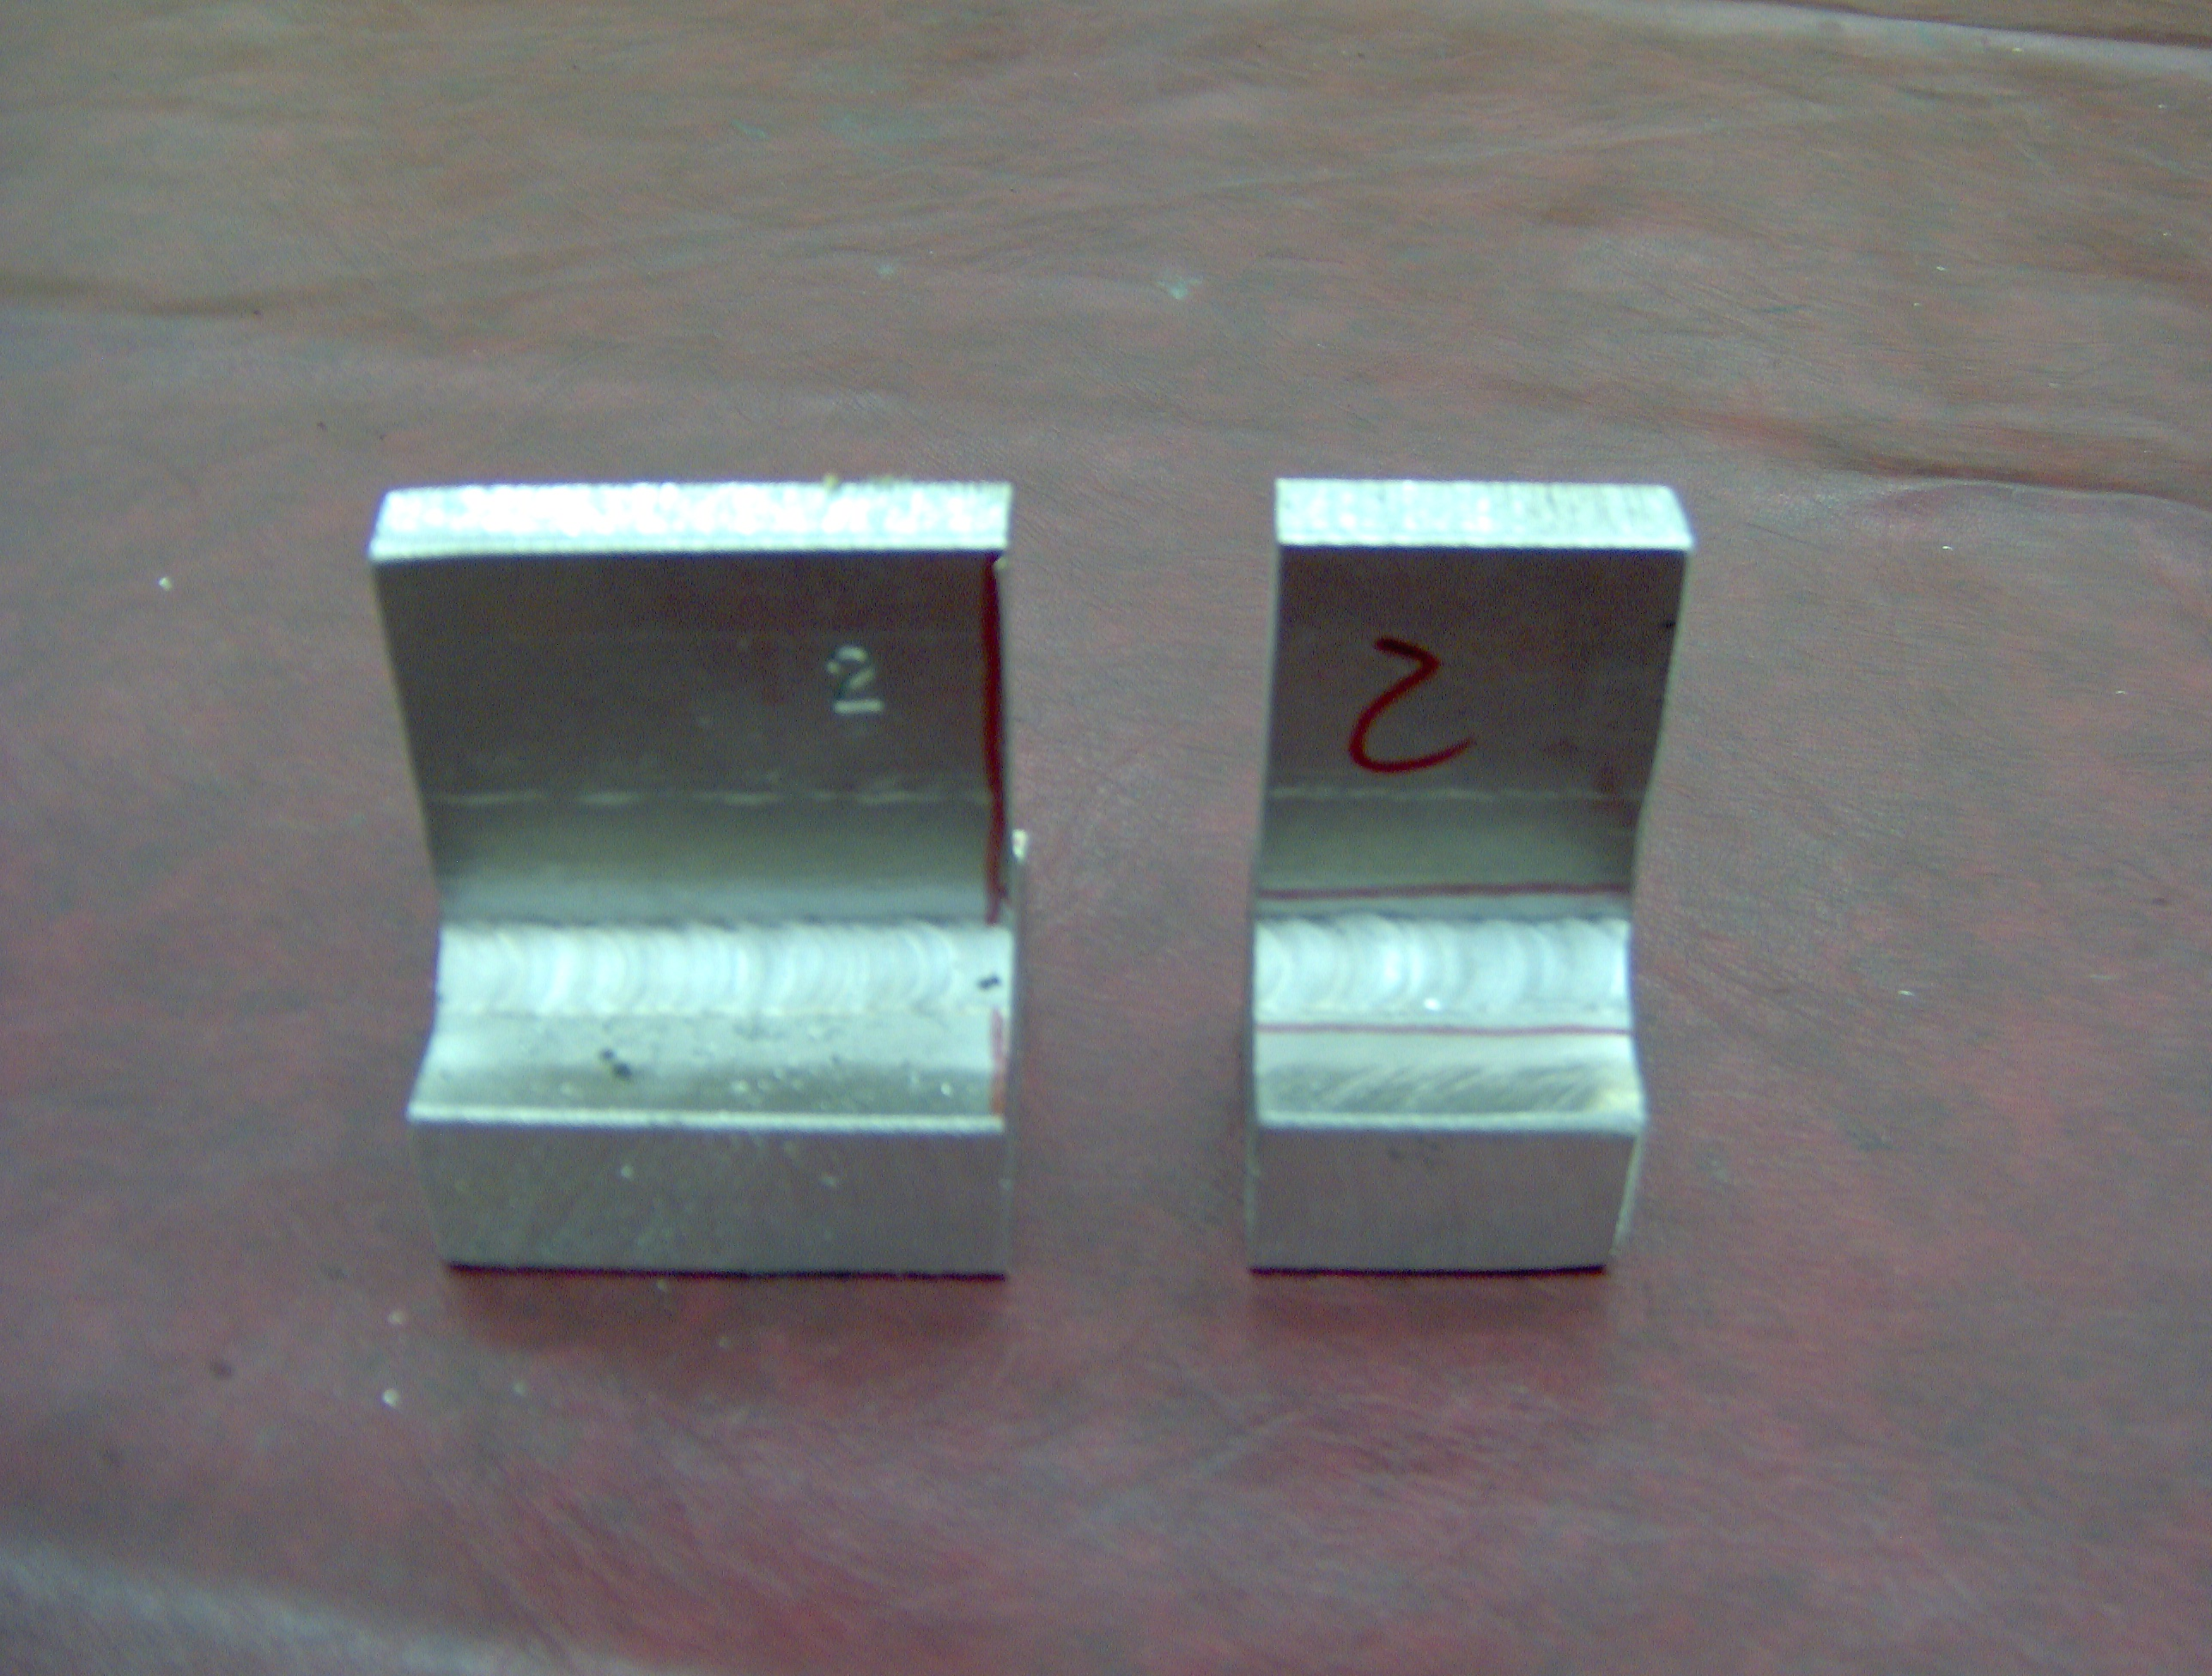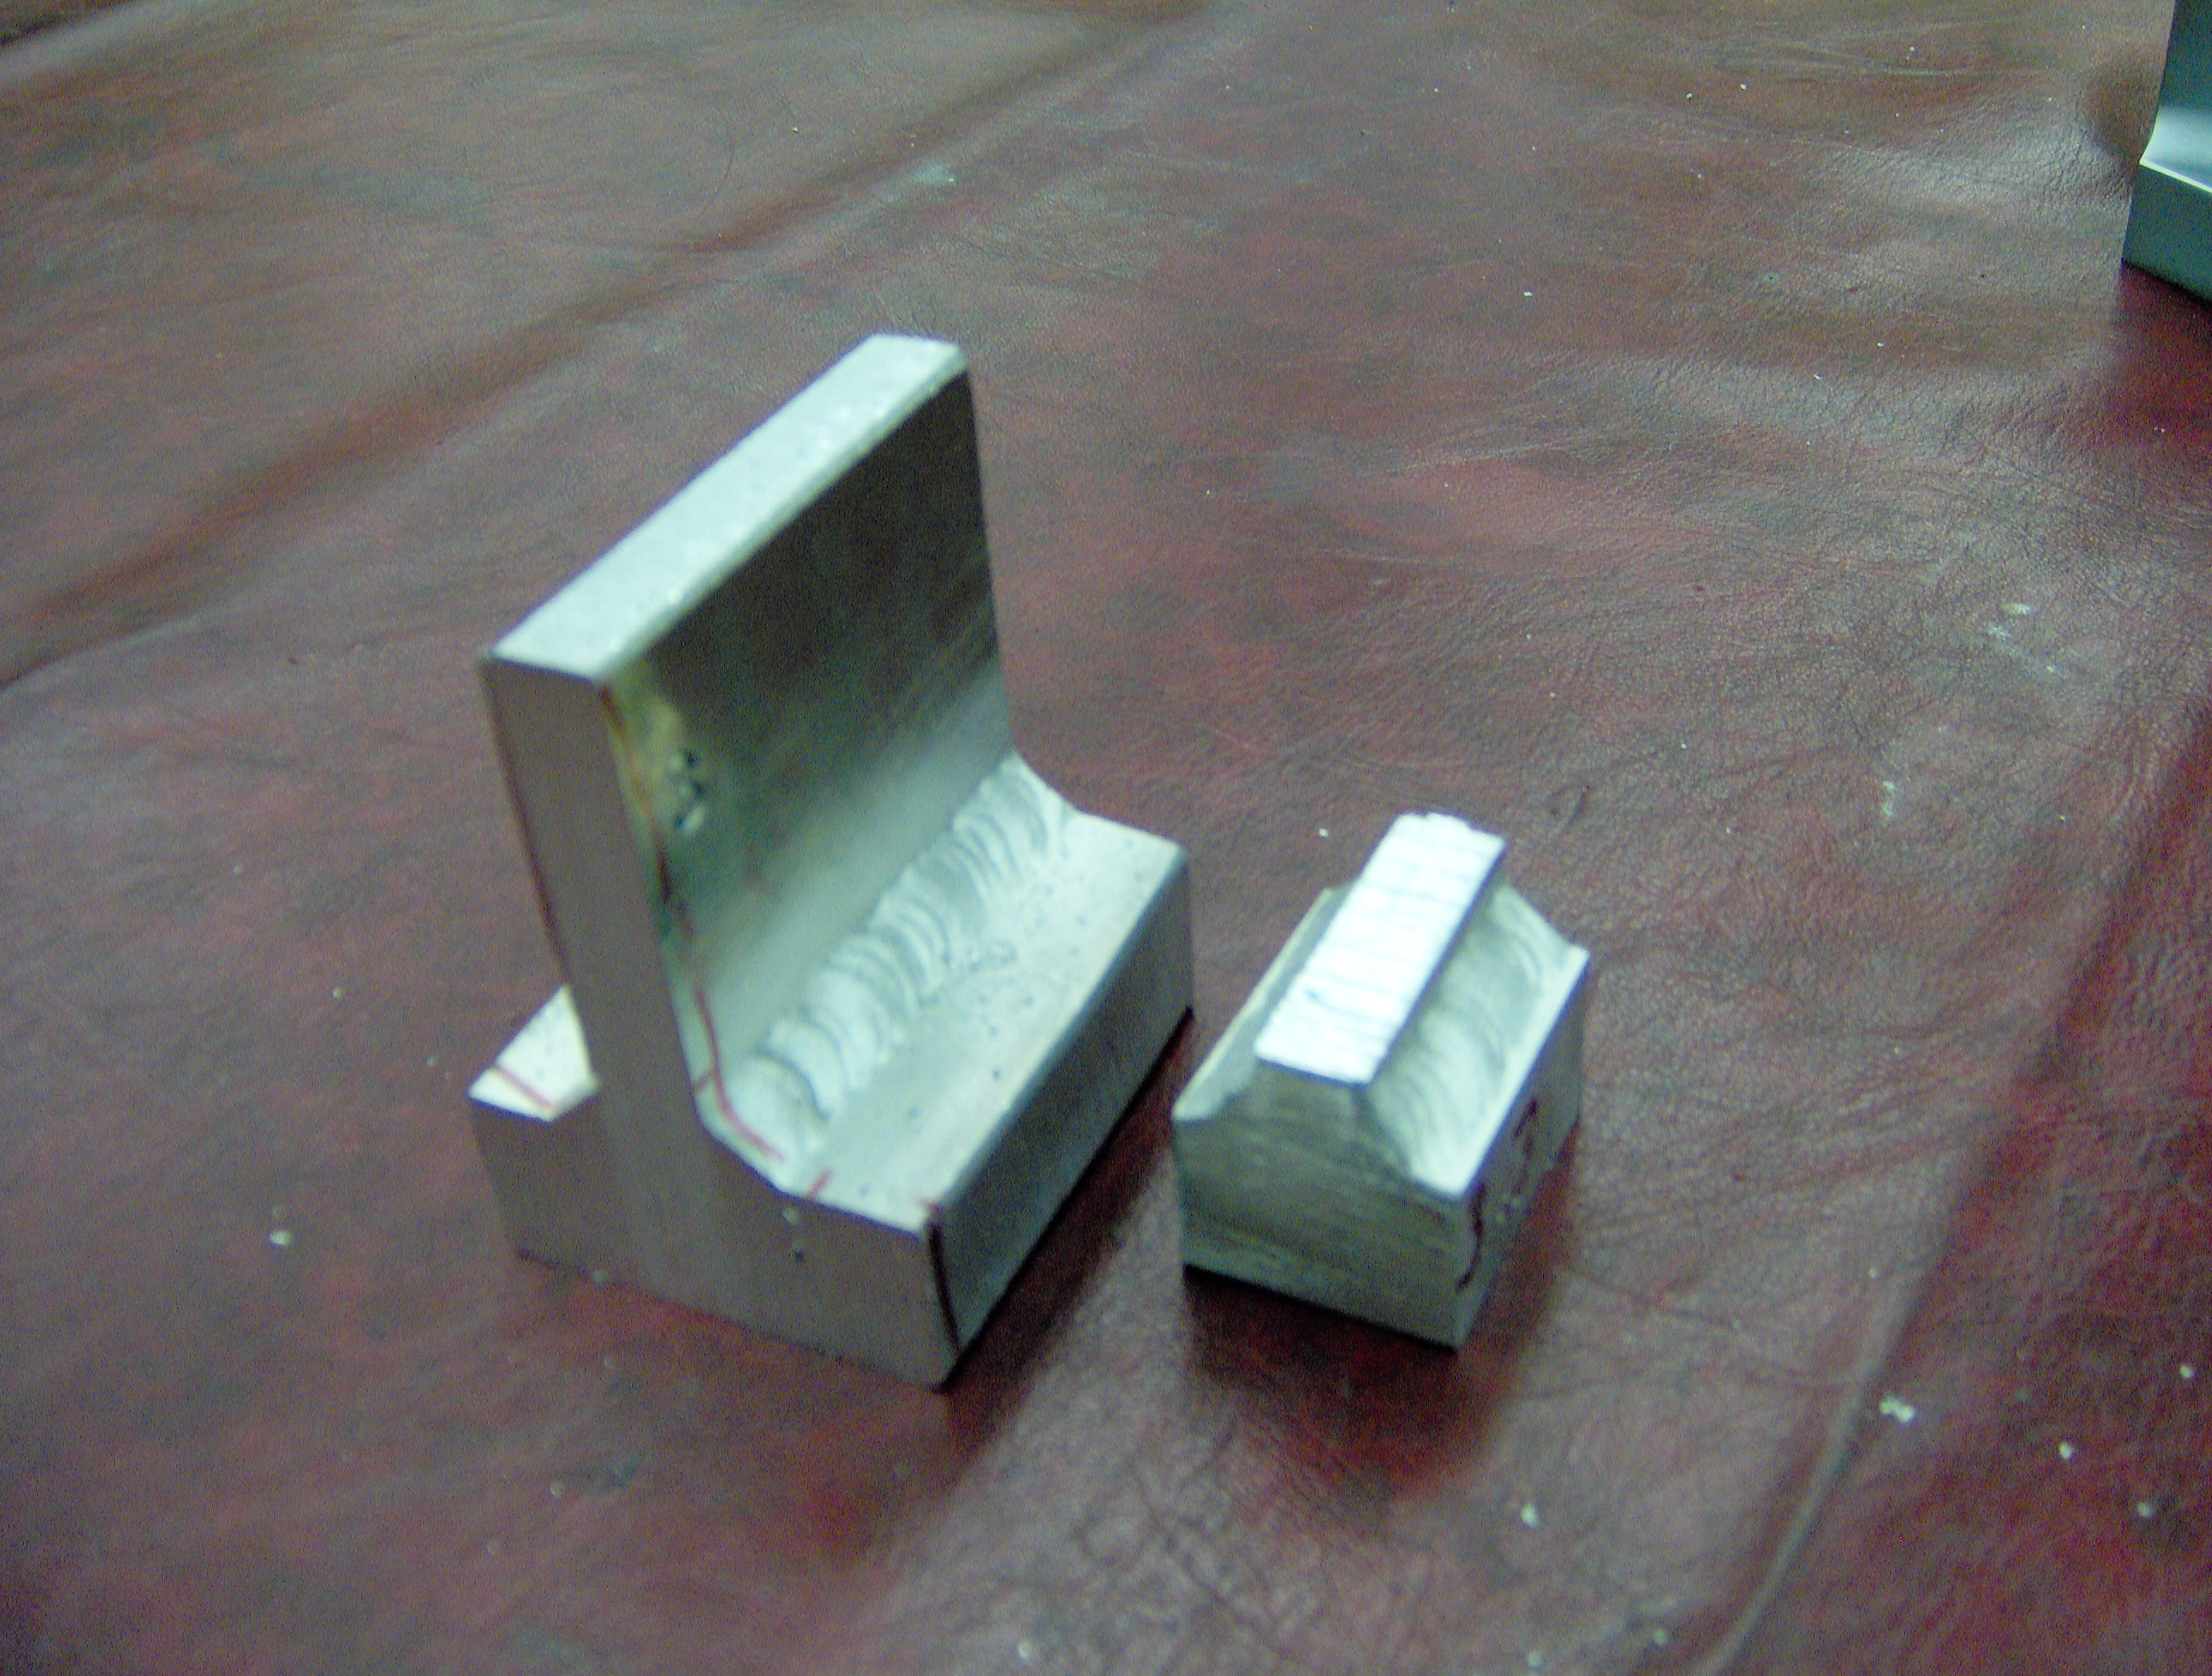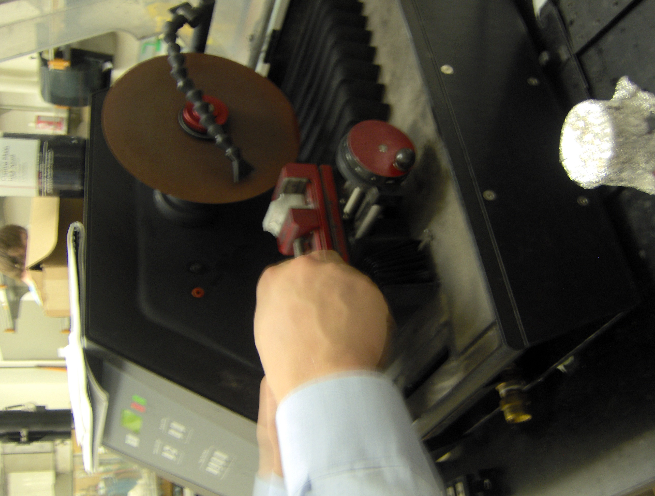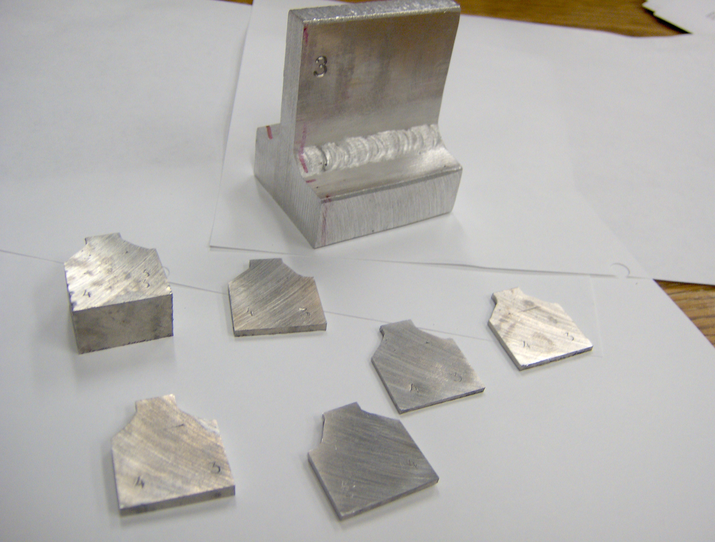

Figure 8, reducing the size of the samples for the precision saw and the cutting slices. Note the labels transferred to all sub samples.
We then proceeded to photograph each slide on the microscope, before and after 3 minute etching.

The many images are shown below.

Indeed the welds appear to be quite compact, with only some small isolated bubbles of little concern.

The problem comes from the hairline cracks visible in many, but not all sections.
The crack marks the boundary between the two parts welded together, and indicates that full penetration welding was not achieved. The lack of hairline crack in some welds indicated that occasionally full weld was achieved.
Likely if the contact surface had been reduced drastically by heavy chamfering, full depth welding would have probably achieved.
Unfortunately these long cracks have little chance of being completely isolated inside the aluminum welded body and would absorb machining oils and then produce virtual leaks by out-gassing in the vacuum.

The good quality of the weld fillet shows that full penetration welding can likely be achieved with this welding technique and different preparation of parts to be welded.

Weld 1&2, slice1a
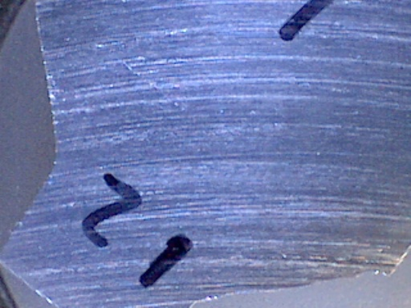
Weld 1&2 slice1a etched
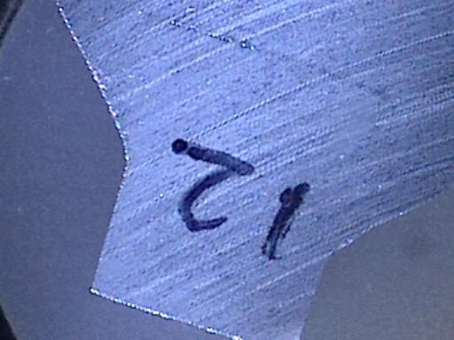

Weld 1&2 slice 1b
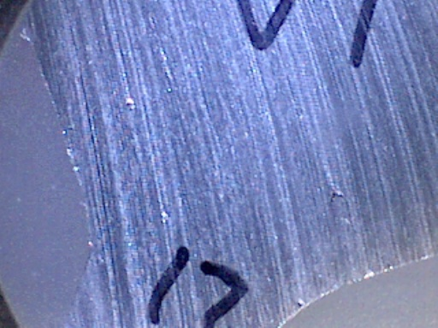
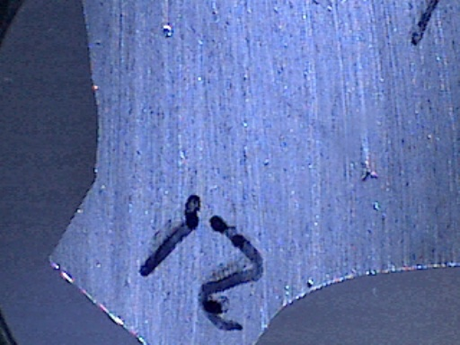
Weld 1&2 slice 1b etched

Weld 1&2 slice 2b
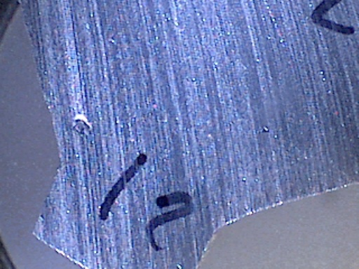
Weld 1&2 slice 2b etched
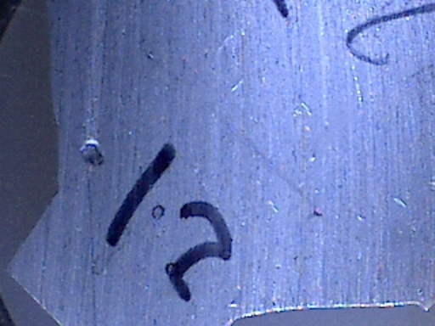
Weld 1&2 slice 3a
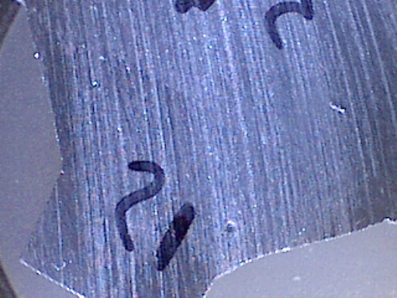

Weld 1&2 slice 3a etched
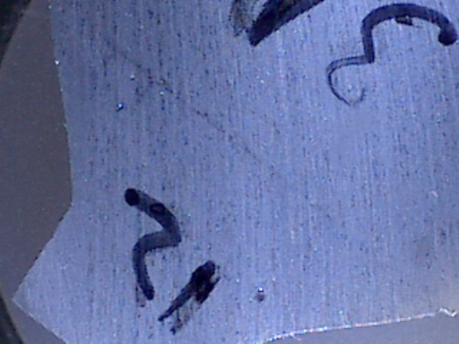

Weld 3&4 slice 1a
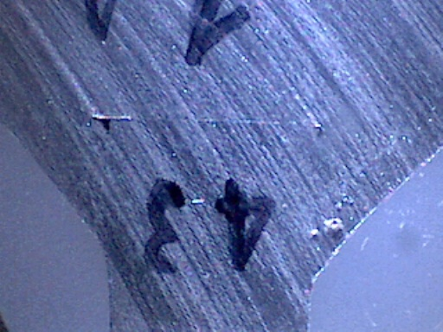

Weld 3&4 slice 1a etched
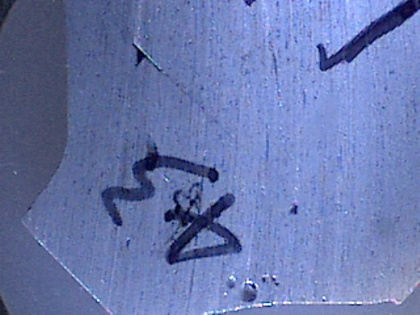

Weld 3&4 slice 1b
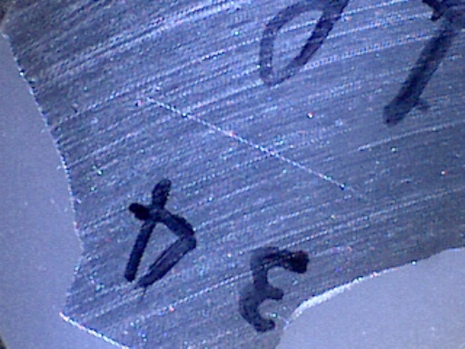

Weld 3&4 slice 1b etched
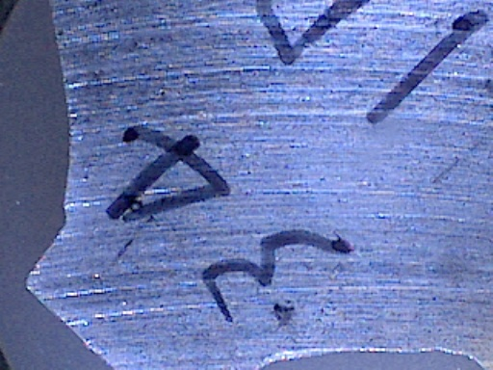

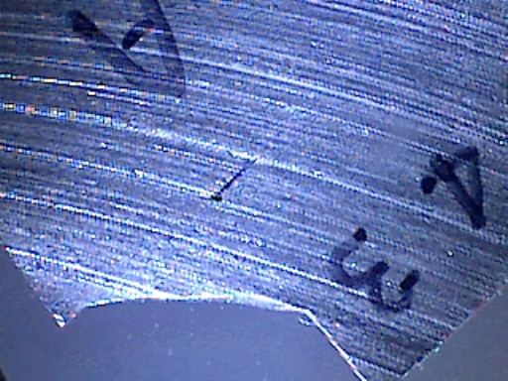
Weld 3&4 slice 2b_3
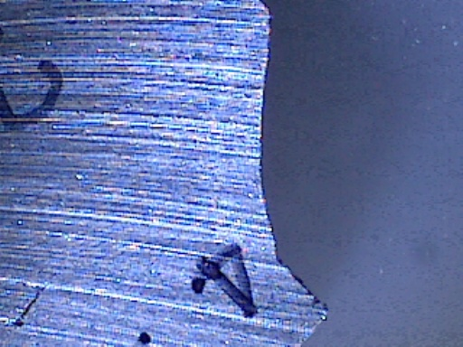
Weld 3&4 slice 2b_4
Weld 3&4 slice 2b etched
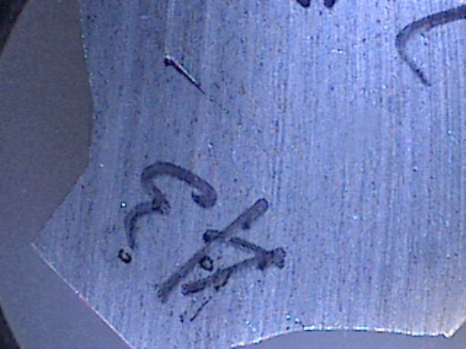
Weld 3&4 slice 3a side 3
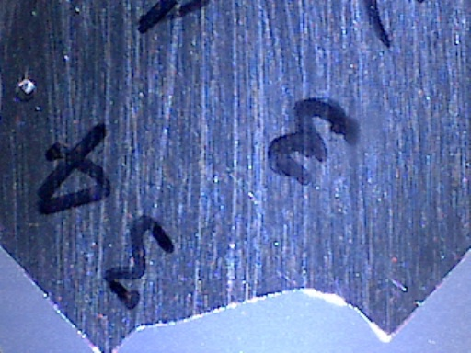
Weld 3&4 slice 3a side 3 etched
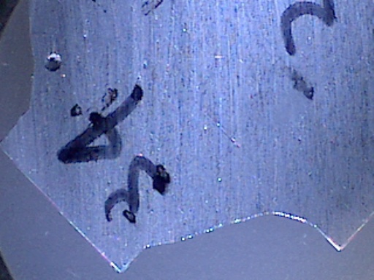

Weld 3&4 slice 3a side 4
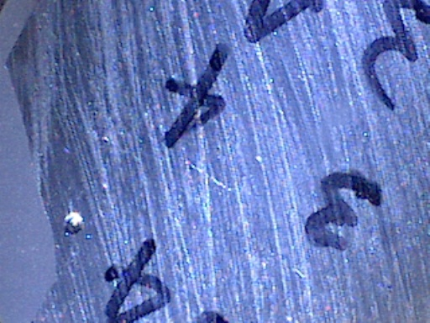
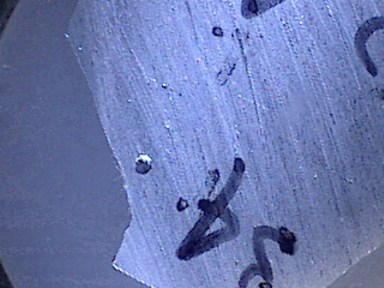
Weld 3&4 slice 3a side 4 etched

Weld 3&4 slice 4a
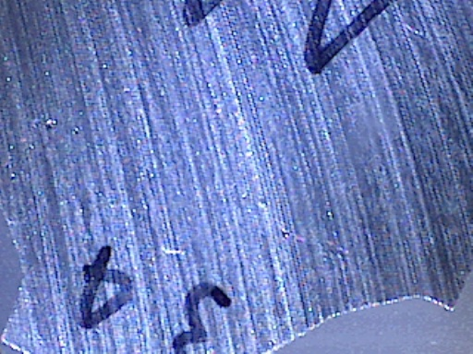

Weld 3&4 slice 4a etched
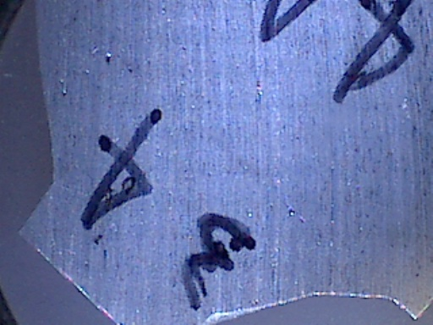

Weld 3&4 slice 4b
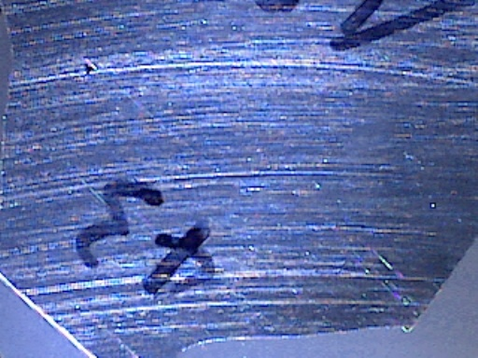

Weld 3&4 slice 4b etched
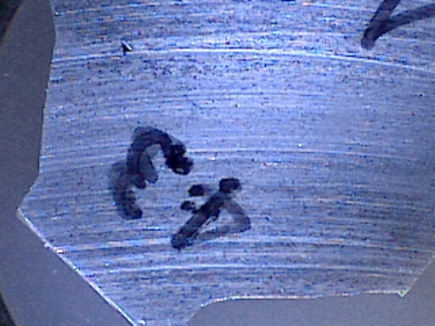

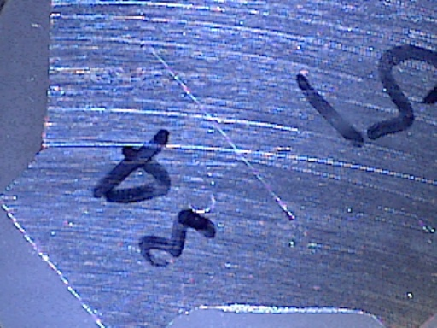
Weld 3&4 slice 5a
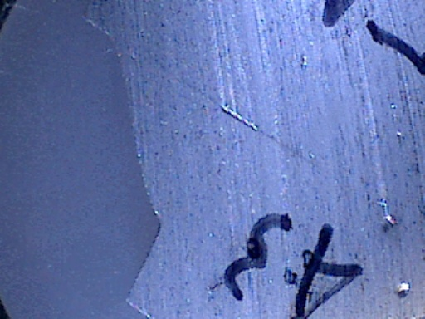
Weld 3&4 slice 5a side 3 etched
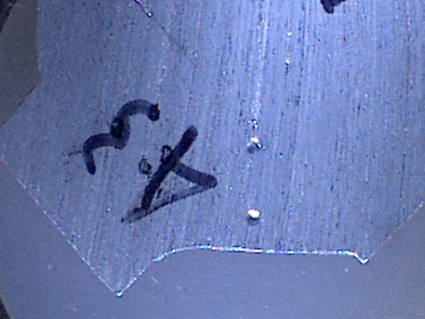
Weld 3&4 slice 5a side 4 etched
Weld 3&4 slice 5b
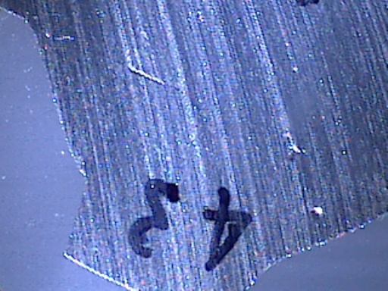
Weld 3&4 slice 5b side 3 etched
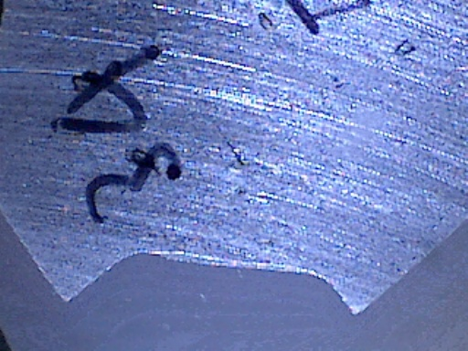
Weld 3&4 slice 5b side 4 etched
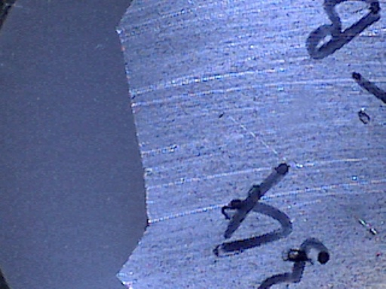

In the cuts it appears that the boundary between the two parts in welds 1, 2, 3, and 4 never melted significantly.
It appears to be a slightly larger gap on the TIG side, not surprising, given the fact that the MIG was the first cut and in cooling it has more than likely pulled the samples, lifting the other end.
TIG appears to be the best choice in all cases, and it is clear that welding from both sides does not appear to be of interest, especially seen the pulling effect that lifts the other end.
The contact area between parts before welds should be as thin as possible.

