LIGO Laboratory / LIGO Scientific Collaboration

LIGO-T070257-03-D 10/20/2007
ELI EQ STOP RETROFIT PROCEDURE
M. E. Zucker

Distribution of this document:
Detector Technical Review Board

This is an internal working note
of the LIGO Laboratory.

California Institute of Technology  LIGO Project – MS 18-34  1200 E. California Blvd.  Pasadena, CA 91125  Phone (626) 395-2129  Fax (626) 304-9834  E-mail: info@ligo.caltech.edu | Massachusetts Institute of Technology  LIGO Project – NW17-161  175 Albany St  Cambridge, MA 02139  Phone (617) 253-4824  Fax (617) 253-7014  E-mail: info@ligo.mit.edu
LIGO Hanford Observatory  P.O. Box 1970  Mail Stop S9-02  Richland WA 99352  Phone 509-372-8106  Fax 509-372-8137 | LIGO Livingston Observatory  P.O. Box 940  Livingston, LA 70754  Phone 225-686-3100  Fax 225-686-7189
http://www.ligo.caltech.edu/

Introduction & scope

This is the procedure for installing the new quartz-tipped EQ stops during the ELI vents at LLO and LHO. Only ETM’s and ITM’s on L1, H1 and H2 are being retrofitted; other optics will retain existing Viton-tipped stops.

The general procedure is to enter each ETM and ITM volume; cage the optic on the existing Viton-tipped stop; remove these stops one by one; and replace each with a new quartz-tip unit. The new stops are then withdrawn to the nominal gap in the process of releasing the optic, by calibrated rotation of the screw thread.

In some cases the existing screw may be difficult to remove due to galling or shedding of silver plating. Spectroscopic grade isopropanol in glass droppers will be used as a clean lubricant where needed. Isopropanol will also be used to lubricate a clean tap if repair of internal threads is deemed necessary.

The ½ - 13 bevel stops are radially expanded a little oversize and maintain radial spring tension inside the holes. An expander tool (Figure 1) and diameter gauge (Figure 2) will be provided and prepped (LIGO vacuum prep class B) for field fitting the expansion to internal thread condition as required. If there is not too much as-built variation found on the first few optics, a standardized pre-expansion may be used for later units to save time.

This procedure may be combined with other procedures to economize incursion time, for example:
- Adjustment of PAM magnets to reduce alignment biases
- Drag-wiping of LOS surface(s)

In such cases, separate engineering review is required to determine the best order of operations and prevent adverse interaction. A merged procedure will be developed for those applications to supersede this document.

Starting conditions
- Optical lever fiducials for optic undergoing work checked and logged
- OSEM voltages and coil currents for optic undergoing work checked and logged
- HEPI shut down to safe mode (L1 only)
- Verified clean BURT of all relevant EPICS channels (LOS, ASC, HEPI, etc.)
- Chamber volume vented to atmosphere
- LVEA and chamber exterior cleaned
- Cleanroom over entry/egress door, particle counts below limit
- Entry/egress door rigged off
- LOS on local damping (coil HV back on only after reaching full ATM)
- PSL locked/tagged out
- Any gate valves used for entry/egress locked open & tagged

Equipment & materials

Vacuum Hardware, Class A preparation
- 3/8-16 silver plated stainless steel barrel EQ stops, assembled with quartz tips, o-rings, jam nuts and washers: D070452 (8 ea. required per LOS plus a few spares)
- ½-13 BeCu alloy bevel EQ stops, preassembled with quartz tips and o-rings: D070451 (8 ea. per LOS plus a few spares)

Vacuum Installation Tooling, Class B preparation
- EQ Stop Expander Tool, D070457, preset for minimum (.002”) expansion
- ½-13 EQ Stop Diameter Gauge, D070461
- Spec-grade isopropanol in Class B prepped glass dispensing container
- UHV grade aluminum foil
- Cleanroom wipes
- Spare gloves
- 3/8-16 plug tap, HSS with TiN coating
- 3/8-16 .005” oversize plug tap, HSS
- tap wrench for above
- ½-13 plug tap, HSS with TiN coating
- ½-13 .005” oversize plug tap, HSS
- tap wrench for above
- Flashlights (tested)
- LOS inspection lights (tested)
- Inspection mirror
- Camera for recording procedure & configuration
- 6” or 150 mm steel scale
- 6” or 150 mm dial or digital caliper, .0005” or .01 mm resolution
- 2-way radios (2 ea., tested, same channel w/ outside man)
- 3/16” hex ball end screwdriver tool
- 3/16” hex ball end long “L” key
- 5/16” hex ball end screwdriver tool
- 5/16” hex ball end long “L” key
- 5/16” hex x 3/8 square drive socket, standard
- 5/16” hex ball end x 3/8 square drive socket, long
- 3/8” hex ball end screwdriver tool
- 3/8” hex ball end long hex “L” key
- 3/8” hex x 3/8 square drive socket, standard
- 3/8” hex ball end x 3/8 square drive socket, long
- 7 mm hex ball end screwdriver tool, standard
- 7 mm hex ball end screwdriver tool, extra long
- 7 mm hex ball end long hex “L” key
- 7 mm hex ball end x 3/8 square drive socket, standard
- 7 mm hex ball end x 3/8 square drive socket, long
- 7 mm open end wrench
- 9/16” combination wrench for jam nut
- 9/16” short form dual-angle open end wrench for jam nut
- 6” adjustable wrench
- 3/8 drive fine ratchet wrench
- 3/8 drive 2” short extension
- 3/8 drive 6” long extension
- 3/8 drive tommy bar
- 3/8 drive breaker bar
- 8” Channelock plier
- 6” straight hemostat
- 6” curved hemostat

Task steps

Barrel stops
  - Enter chamber area, establish work zone and tool laydown, and inspect optic and LOS. Document and photograph any conditions warranting concern and consult with ID as necessary before proceeding.
  - Run bevel stops in gradually and iteratively to just touch on all 8 points, with outside crew monitoring OSEM voltages. Idea is to freeze optic as close as possible to “nominal” alignment and position.
  - Run barrel stops in to just touch, still monitoring OSEM values.
  - Where applicable, remove Elliptical Glass Baffle from LOS frame and set aside.
  - Remove and replace upper barrel stops one at a time. Install with washers and jam nuts, but leave these loose a few turns. Be very gentle bringing the quartz tips against the glass.
  - If resistance is met in the screw threads withdraw and inspect threads; if necessary lubricate with alcohol and/or clear threads with wet tap before proceeding
  - Next, remove and replace lower barrel stops one at a time.
  - Recheck OSEM voltages and correct any deviations before proceeding to bevel stops

Bevel stops
  - Back off one bevel stop two or more full turns to open a gap
  - If torque resistance is encountered, drip isopropanol at point where screw enters threaded bracket such that drop runs downhill into hole (drip “inside” the bracket on lowers, “outside” on uppers)
  - Continue removing bevel stop, lubricating as needed, and withdraw.
  - If roughness is felt or significant debris is seen inside hole or on removed screw, carefully align a ½-13 tap with threads and chase in and out. Lubricate tap with isopropyl. Catch any shavings with cleanroom wipes. Clean internal threads with wipes to insure no particles remain.
  - Select a virgin ½-13 quartz tipped EQ stop screw and mike OD with Gauge Adapter D070461; note reading.
  - Install in Expander Tool D070457, insert plunger and compress to stop; open and withdraw plunger.
  - Re-mike OD with Gauge Adapter. OD should be between .0015 and.003 oversize. If not, stop and figure out why the expander isn’t working correctly. Note the expanded gauge reading.
  - Remove screw from expander tool and insert in the vacant LOS hole. Screw should take up all radial play and display mild torque resistance by the time the tip approaches within about 10 mm of mirror bevel.
  - If screw is still loose at this point, back it out. Reset Expander Tool depth stop for deeper plunger insertion, reinsert the screw, and re-cycle the expander. Recheck OD with Gauge Adapter. Try to expand no more than .001 at a step before retrying in LOS hole.
  - If screw is found to be too tight in LOS, such that significant torque is needed to proceed toward bevel, stop immediately. Apply alcohol and withdraw the screw. Set it aside and start over with another screw, beginning at reduced Expander depth. DO NOT FORCE OR USE A WRENCH FOR LEVERAGE---STOP SCREW WILL DISINTEGRATE!
  - When tension is correct, continue threading in to point of contact. ROTATING TIP CAN EASILY CHIP BEVEL; INSPECT VISUALLY WITH MIRROR TO GUIDE APPROACH, FEEL FOR CONTACT, AND HAVE GROUND CREW MONITOR OSEM SIGNALS FOR JARRING
  - Repeat procedures for remaining 7 stops. Note that bracket thread diameter and condition may vary substantially within a single LOS, possibly requiring resetting of expander tool several times.
  - When all bevel stops are installed and in contact, recheck OSEM voltages and address any discrepancy.
  - Where applicable, reinstall Elliptical Glass Baffle.

Release and set gaps
  - Using 7mm hex drive tool, back off each bevel stop (90±10) degrees rotation CCW (1/4 turn). This should open a gap of (0.49±.05) mm. Check OSEM voltages and visually inspect all gaps before proceeding to the next screw, and recheck after all bevel stops are withdrawn.
  - Starting with the upper barrel stops, insert a 5/16” hex drive tool and back each screw out 1/3 turn (two flats of the hex). This should open a gap of (0.5±.06) mm. Check OSEM voltages and visually inspect all other gaps before proceeding to the next screw.
  - Proceed similarly with lower barrel stops. Be aware that mirror will be free; any inadvertent contact may force the bevel into a quartz stop and knock off a chip, so WORK SLOWLY AND CAREFULLY
  - When optic is damped, visually inspect all gaps again to insure clearance is nominal. Recheck OSEM voltages to insure nothing is rubbing and equilibrium is retained. Adjust as required.
  - After all adjustments are complete, insert 5/16 hex tool into each barrel stop to hold position stationary, and gently tighten jam nut against washer with 9/16” wrench. Use only modest torque, this is not a high-vibration application.
  - Gather and remove all tools and materials.
  - Notify ID to request exit QA inspection.

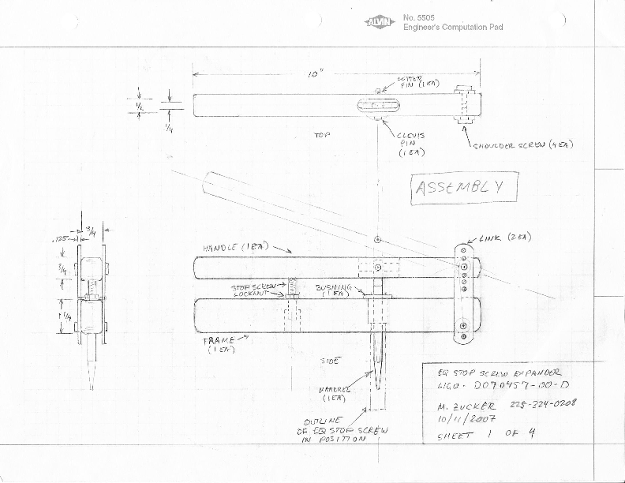
Figure 1: EQ Stop Screw Expander Tool, D070457
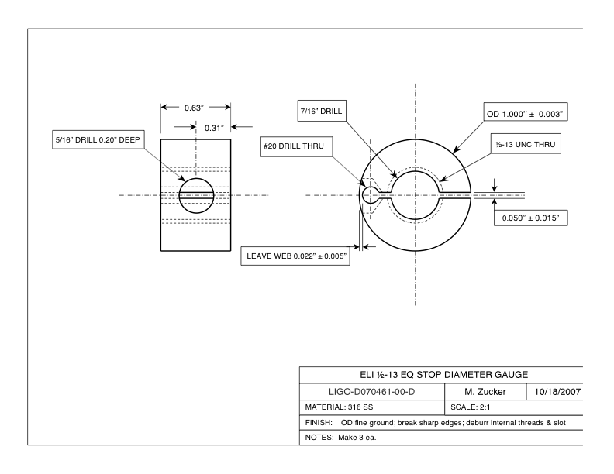
Figure 2: EQ Stop Diameter Gauge, D070461

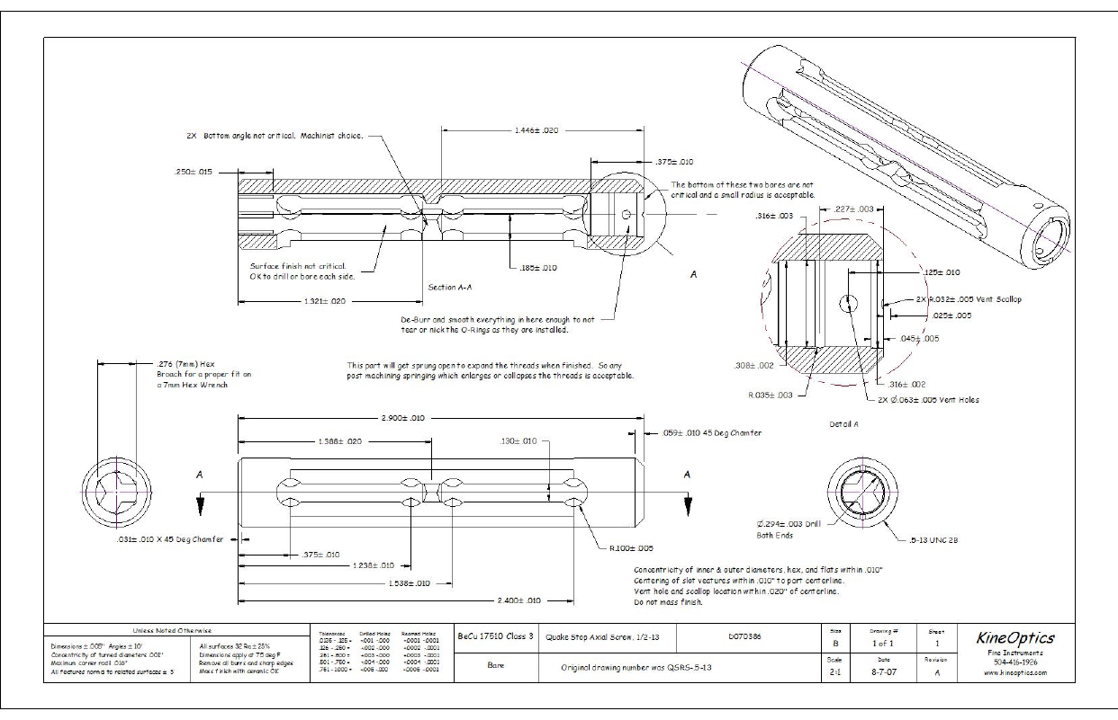
Figure 3: ½-13 Bevel Stop, D070386 (tip and o-rings not shown)

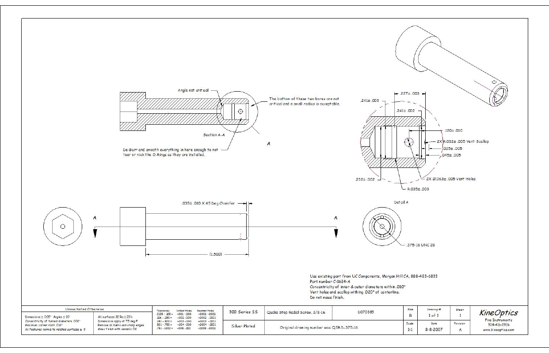
Figure 4: 3/8-16 Barrel Stop, D070385 (tip and o-rings not shown)

