This document lists the LLO Input Optics tasks for the August 2008 vent. The highlights are:
- Measure HAM1 power budget
- Center REFL beam on viewport
- Replace anti-refl beam dump
- Replace MMT1 A-frame
- Remove 3 isolation check beam optics
- Replace MC injection mirror
- Adjust SOS osems (TBD)
- Move MMT2
The idea is to first take care of all power budget measurements with a locked mode cleaner. This requires that the HAM1 North door and IOT1 remain in place. Once satisfied with the budget, we’ll remove IOT1 and the North door in order to replace the MC injection mirror.

1. Before the Vent:
- Remove First Contact from replacement MC injection mirror.
- Note location of REFL beam on viewport with RM aligned.
- Prepare viewport target for REFL beam.
- Prepare electronics for locking MC in air
- Gather the following supplies:
  - Ophir and Newport power meters
  - Replacement MC injection mirror
  - Cleaned and Class B baked tools and screws
  - Level
  - IR cards and viewers
  - Black glass beam dumps
  - Stainless steel vee-shaped beam dump
  - CDS LVEA laptop
  - Power meter holder
  - Polarizing beam splitter

2. Mark locations and heights of IOT1 and ISCT1 tables.
3. Move ISCT1 out of the way.

4. Remove the HAM1 South door.

5. Measure IOO power budget:
- Place level on center of table and take pictures for reference.
- Lock mode cleaner and misalign RM.
- With extreme caution given optics are unclamped, measure:
  - SM transmission (s-pol)
  - MMT1 transmission (p-pol)
  - Light incident on Faraday
  - Light in Anti-refl beam
  - Light in p+s pol light immediately after Faraday
- Check rotation of HWP between SM and MMT1:
  - Place PBS downstream of HWP
  - Measure power in both ports
  - Rotate HWP to maximize power in p-pol light
  - Check light in anti-REFL beam
- Align RM.
- Identify source of spot on the CVI mount holding the HWP between SM and MMT1. In the diagram, page 3, it appears to be a wrong polarization leakage through the input calcite wedge. Measure its power if possible.
- Make sure beam is not clipping on TFP DLC mount.
- Identify as many ghost beams as possible. In particular, look for source of 5-7 extra beams surrounding REFL.
- Verify alignment of the beam on all FI apertures.
- If time permits, measure reverse Faraday transmission (to REFL beam). Do this by placing a 0 deg mirror immediately after the Faraday.

6. Make REFL beam exit center of viewport.
- Look for leaks on REFL relay mirrors.
- Check centering of beam on mirrors.
- Use viewport target to adjust beam pointing out of chamber.

7. Clamp down MMT1, MMT3, and SM.

8. Gently tap on all DLC mounts to check for any unstable ball bearings. Replace if necessary.

9. Ensure the locking screw on the CVI rotation stage holding the HWP between SM and MMT1 is locked down tightly. Ditto for HWP within FI.

10. Replace anti-refl black glass beam dump with vee-shaped stainless steel dump.
- Use existing black glass to collect the specular beam from the vee. (Be careful not to block the beam going from MMT3 to PRM!)

11. Replace MMT1 A-frame with new baffle.

12. Remove 3 isolation check beam relay mirrors.

13. Remove IOT1 and HAM1 North door.

14. Replace bad MC injection mirror with good MC injection mirror.
- Measure transmitted power.

15. Check level on table and rebalance as necessary.

16. Unclamp all optics.

17. Take lots of pictures with Valera’s IR sensitive camera.

18. Remove HAM2 North door.

19. Move MMT2 10mm towards HAM1.

20. Optional (to be discussed):
- Adjust OSEM positions as needed.

21. Put all doors back on and replace IOT1 and ISCT1.
HAM 1 for eLIGO
HAM 2 for eLIGO

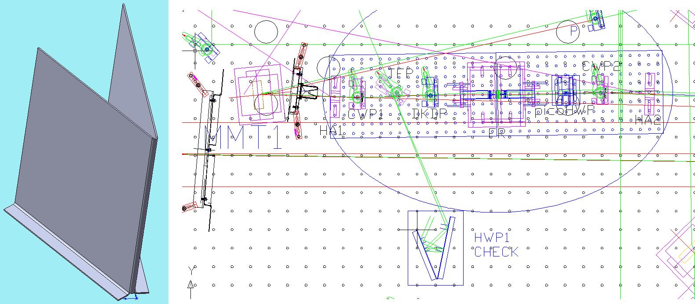
HAM 1 for eLIGO and stainless anti-REFL beam block.

