STS-2 Assembly T080260-00-R

The STS-2 must first be fitted with the auto locking motors and wire harness. Shyang has written a Doc titled “Procedure for STS-2 Locker”
Also remove the feet and washer from the STS-2’s 3 studs on the bottom of the instrument.

Now you can begin: Starting with the Base (20007796-1) lay on the bench with the knife edge up. Then with a Machinist level and fabricated level screws, level the base.

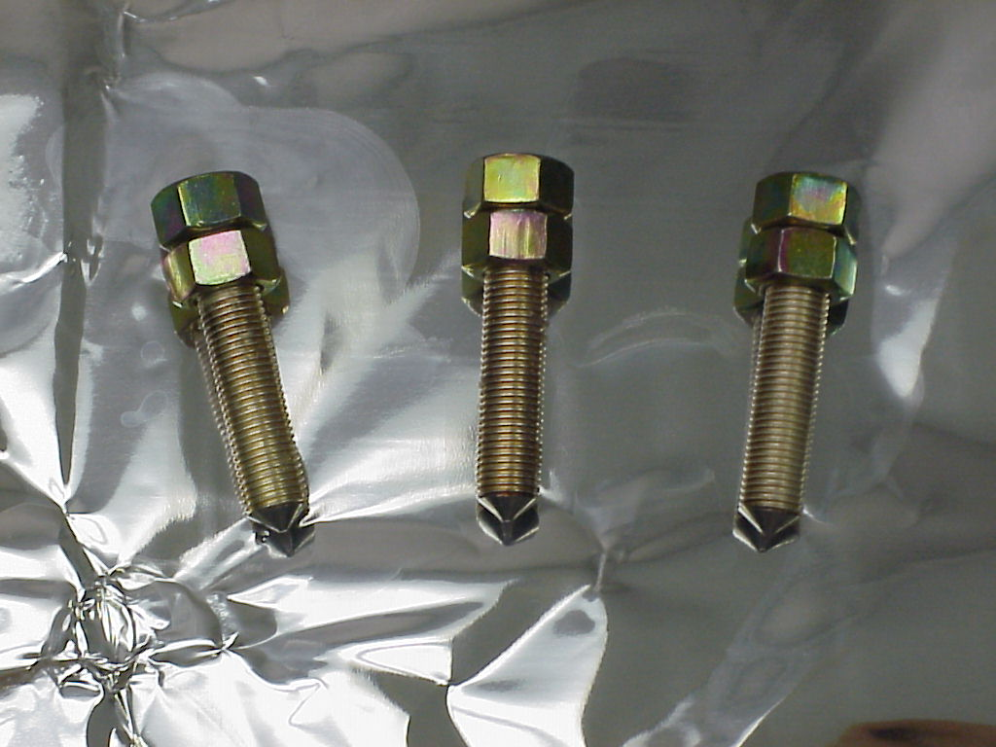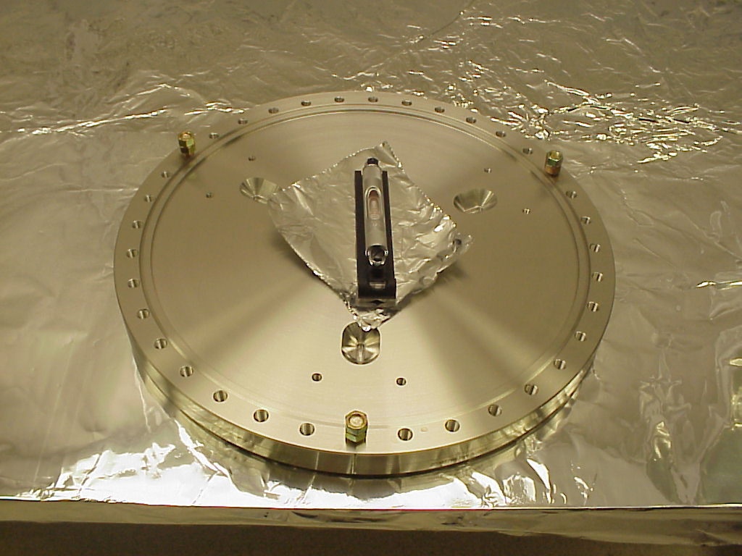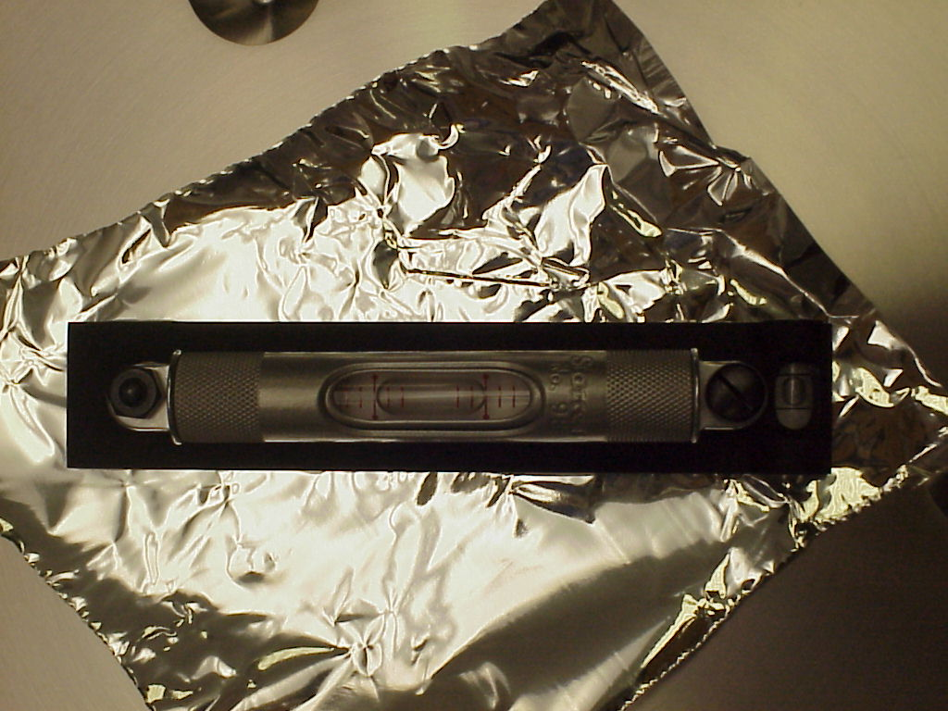

The locking nut (20007792-1) can be installed (with the boss facing the bottom of the STS-2) onto the 3 studs on the bottom of the STS-2, run them all the way up. Now install the Kinematic feet (20007791-1) on to the studs as well, run them up about half way through the foot. Caution here if you run them all the way up they will clip the bevel on the bottom of the STS-2.

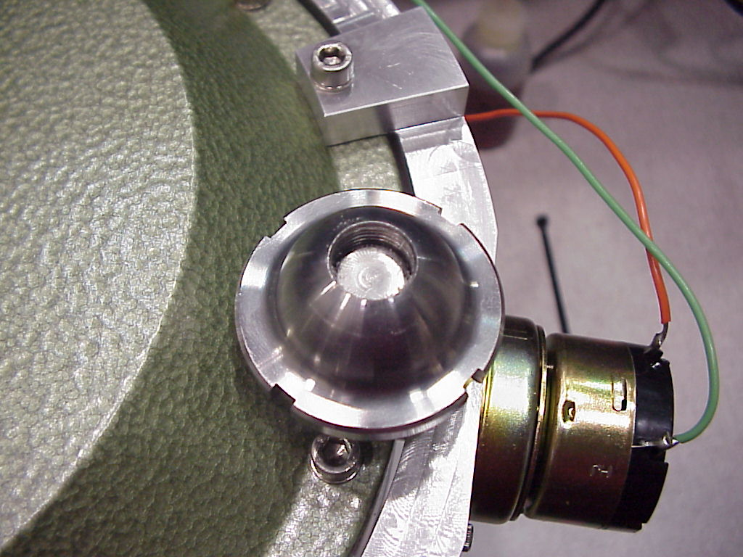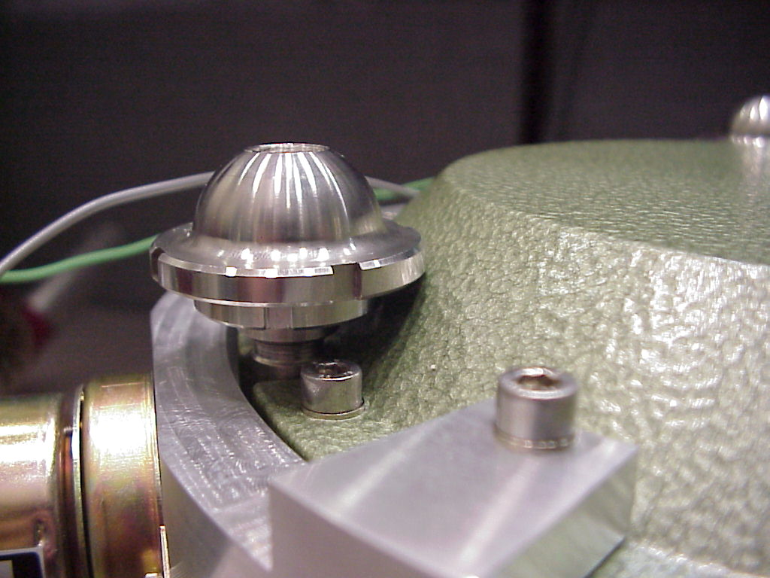

Now you can set the STS-2 onto the Base plate (20007796-1), with the X-axis facing away from the Base plate alignment mark
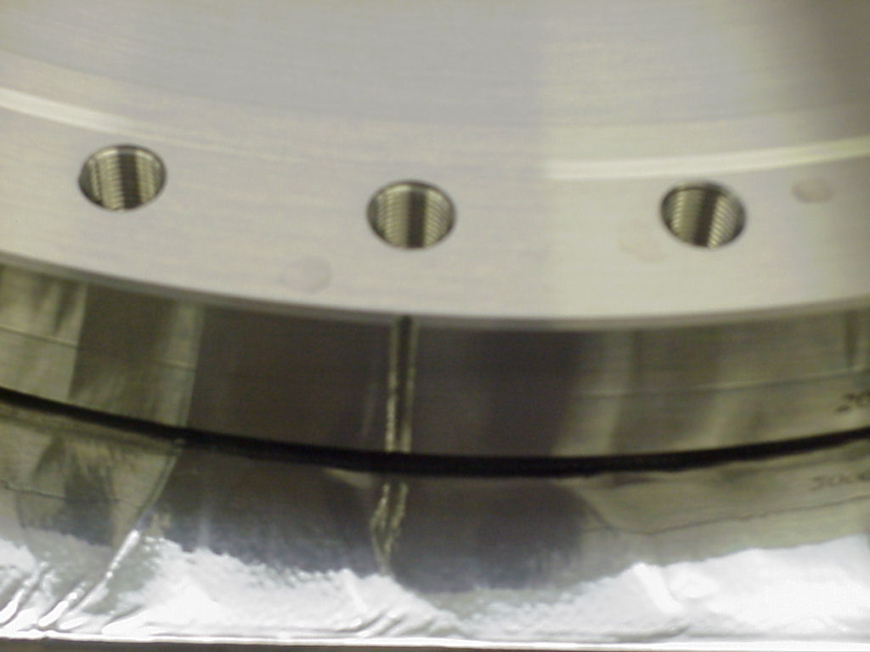

Now level the STS-2 using the Kinematic feet, and sighting the bull’s eye bubble on the rim of the STS-2.
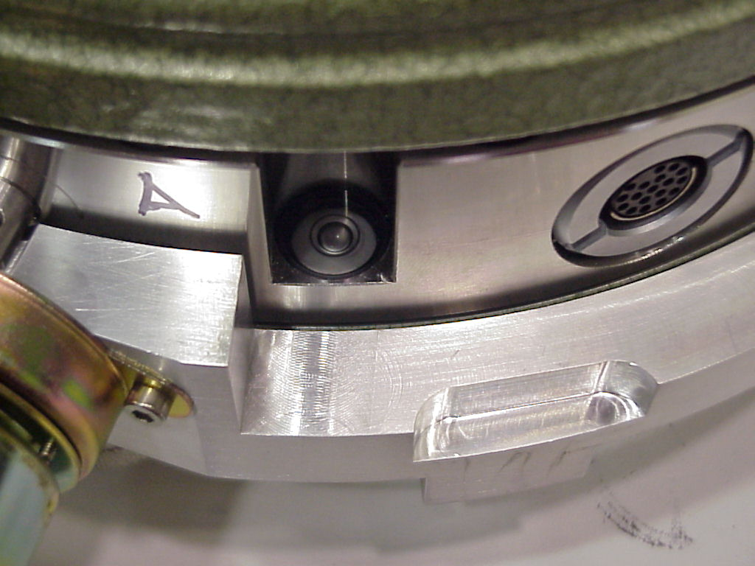
After leveling the STS-2, set in place the Foot Clamp (20007793-1) and Cross Bar (20007794-1) being careful not to ground or interfere with the motor wires. Make sure that the Cross bar protrusion is set into the indentation in the foot. Then install the ¼-28x 1 ½ bolts (C-2824-NA) and vented washers (WFV-25). Torque to 68oz in. The wires will need to be positioned on top of the Foot after it is clamped.
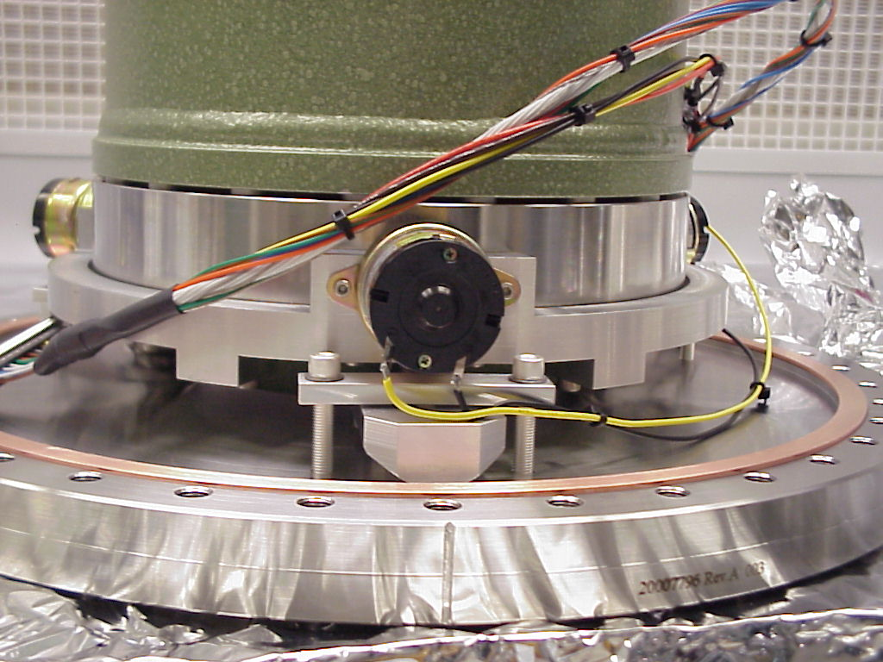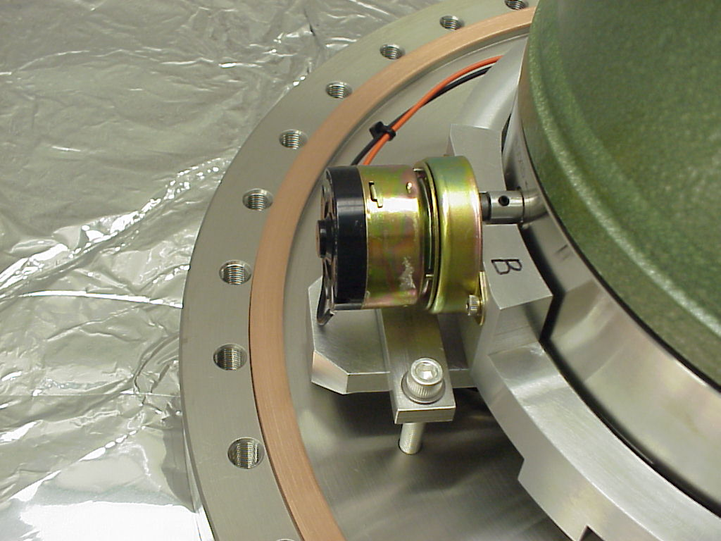
If this is not done you risk skinning or damaging the wire while installing the chamber.
After you have verified that the Bulls eye bubble is still centered (level) then you can remove the 3 fabricated level screws.
Install the Copper Gasket (G-1650) on the Base plate Knife edge.
For this next part you may need a helper: You will need to lower the Chamber (20007795-1) onto the base plate while feeding the D25 connector out of the feed through port. You will also need to be sure to align the scribe marks on the Base and Chamber.
Now you can install the (36) 3/8 -24x2in SHCS (C3832) and vented washers (WFV-38) and torque to 400in lbs? (New values pending)
Now we can install the feed through (100220). You will need to install a gasket (G-338) by loosely hanging it on the cable, now install the (2)4-40x 3/8 screws that attach the D connector to the feed through. You can now purge with neon (I allowed a 1 min purge at 10 psi. Then position the gasket over the knife edge and carefully place the feed through over the gasket, now install the (8) 5/16-24x1 ¼ (TWP-3120-NA AG) and vented washer (WFV-31) and torque to 300 in lbs? (New values pending)
This is now a completed Pod.

Parts list for STS-2 Pod

- 1ea STS-2
- 1ea Base 20007796-1
- 3ea Lock nut 20007792-1
- 3ea Kinematic feet 20007791-1
- 3ea Foot clamp 20007793-1
- 3ea Cross Bar 20007794-1
- 6ea ¼-28x1 ½ C-2824-NA AG
- 12ea vented washers WFV-25
- 1ea Copper Gasket G-1650
- 1ea Chamber 20007795-1
- 36ea 3/8-24x2” SHCS C3832 AG
- 36ea vented washer WFV-38
- 1ea Feed through 100220
- 1ea Copper gasket G-338
- 2ea 4-40x3/8 SHCS
- 8ea 5/16-24x11/4 TWP-3120-NA-AG
- 8ea vented washer WFV-31
- 1ea Cable
- 1ea Cam Flat 20007985
- 1ea Concave locator 20007983-1
- 1ea Flat locator 20007982-1
- 6ea Vented ¼-20x3/4 SHCS C-2012-A
- 1ea Motor mount??????
- 6ea 18-8 SHCS M5-.8mmx70mm MMC 9129A198
- 6ea Shim .003 93574A430
- 6ea Shim .005 93574A432
- 6ea Shim.007 93574A434
- 6ea Shim .010 93574A436
- 6ea Shim .020 93574A438
- 3ea Motor SDP/SI A 3Z15M00150D

