LIGO Laboratory / LIGO Scientific Collaboration

LIGO-E1100050-v4 LIGO 2/14/11

Responses to ACB FDR Questions

Michael Smith, Virginio Sannibale, Niem Nguyen, Lisa Austin

Distribution of this document:
LIGO Scientific Collaboration

This is an internal working note
of the LIGO Laboratory.

California Institute of Technology  LIGO Project – MS 18-34  1200 E. California Blvd.  Pasadena, CA 91125  Phone (626) 395-2129  Fax (626) 304-9834  E-mail: info@ligo.caltech.edu | Massachusetts Institute of Technology  LIGO Project – NW22-295  185 Albany St  Cambridge, MA 02139  Phone (617) 253-4824  Fax (617) 253-7014  E-mail: info@ligo.mit.edu
LIGO Hanford Observatory  P.O. Box 159  Richland WA 99352  Phone 509-372-8106  Fax 509-372-8137 | LIGO Livingston Observatory  P.O. Box 940  Livingston, LA 70754  Phone 225-686-3100  Fax 225-686-7189
http://www.ligo.caltech.edu/

Introduction
This document presents the answers to the AOS SLC Arm Cavity Baffle design review committee. The questions were posed in M1100009-v1.

Recommendation
The review committee for the AOS SLC Arm Cavity Baffle, recommends that all of the questions / actions listed in the section below be completed prior to proceeding, unless implicitly stated. The committee would like to stress that the production purchase order should not be placed/executed until the actions assigned form the review have been completed. Of course the procurement package can be assembled and even bid in parallel with completion of the action items. The committee also notes that in addition to these actions listed all of the drawings should be reviewed and signed off by Systems and the Quality Assurance Manufacturing Team (QAME) prior to proceeding. The Committee requests a follow up meeting in 1 weeks time, Friday 21st January at 9am PT to discuss status of actions and to hear more about the photodiode design.

1) Reminder - The committee also notes that in addition to these actions listed all of the drawings should be reviewed and signed off by Systems and the Quality Assurance Manufacturing Team (QAME) prior to proceeding.
2) Reminder - Please work with QAME on selection of appropriate vendors and if necessary on splitting the contract (machined and sheet)
3) Reminder - Niem work with systems (Ed) to create a sketch of each ACB in each chamber (showing relationship of ACB to quad and ACB to stage 0)

See the document: E1000404 ACB Interface in BSC Chambers
4) New Action - in terms of cables etc ..., as well as confirming flanges allocated to ACB, the ACB team must also identify cable lengths from cable bracket to flange and summarize cable bracket /clamps needs - THIS IS URGENT FOR OTHER RFQ's!

Chamber Cable length Feedthrough
H1 BSC1 N/A
H1 BSC3 N/A
H1 BSC9 230"x2 LIGO-D1003081: Flange Layout – H1 Beam Splitter Chamber 9 (BSC9) ETMX
H1 BSC10 165"x2 LIGO-D1003082: Flange Layout – H1 Beam Splitter Chamber 10 (BSC10) ETMY
H2 BSC7 165"x2 LIGO-D1003086: Flange Layout – H2 Beam Splitter Chamber 7 (BSC7) ITMX
H2 BSC8 230"x2 LIGO-D1003087: Flange Layout – H2 Beam Splitter Chamber 8 (BSC8) ITMY
L1 BSC1 165"x1 LIGO-D1003088: Flange Layout – L1 Beam Splitter Chamber 1 (BSC1) ITMY
L1 BSC3 230"x1 LIGO-D1003090: Flange Layout – L1 Beam Splitter Chamber 3 (BSC3) ITMX
L1 BSC4 230"x1 LIGO-D1003091: Flange Layout – L1 Beam Splitter Chamber 4 (BSC4) ETMX
L1 BSC5 165"x1 LIGO-D1003092: Flange Layout – L1 Beam Splitter Chamber 5 (BSC5) ETMY

Number of Cable Clamps = ?
Number of 25D Cable Brackets = ?

5) Reminder - We would like to hear about the Photo diode design?
The Photodiode in the photo detector is from PerkinElmer, YAG-444AH photodiode. It has a circular active area 200 mm² and with a 16.0 um diameter. The photodiode is mounted in a TO-36 package.
These are the nominal parameters for the photo detector.
Table 1: ACB Photodiode Parameters
Photodiode Parameters
Parameter | Symbol | Value | Units
Peak Wavelength | l | 1000 | nm
Responsivity | R | 0.7 | A/W
SLCDiameter | D | 16.0 | um
Active Area | A | 200 | mm²
Diode Capacitance | C | 35 | pF
Rise/Fall Time | t | 5 | ns
Dark Current | A | <200 | nA
Breakdown Voltage | V | >200 | V
Operating Voltage | V | 180 | V

6) Ref question - Do we need further baffling in the manifold tube? (see question 12)
No, see figure below; the curves titled "spool" and "Manifold" represent the light that passes out of the BSC chamber and hits the respective items and re-scatters back into the IFO mode.

7) ACTION - SPARES, PLEASE REVIEW SPARES QUANTITY!!!! - NIEM (Jeff to help)

The spares for the machine parts will consist of a complete 2-hole baffle assembly. The spares for the fasteners, hardware, magnets will be 10% overage. The photodiodes spares will be 10% overage. One complete extra set of photodiode assembly for the 2-hole baffle, including cables, and cable clamps. The spares for maraging steel blade springs will be 50% overage.

8) ACTION, URGENT - Update of damper position / arrangement - i.e. make copper and sstl thicker
The thickness of the copper plate was increased. Drawings are revised.

Background
The review committee was presented the following information, LIGO-T1000747-v3, at a presentation style review meeting. All of the committee agreed that the content was well presented. This document is the committee recommendations resulting from the Final Design Review.

II) QAME comments Attached to file-card of M1000009

Review Committee Comments

NIEM Arm Cavity Baffle Drawing QAME Review Summary of Comments

- 18 gage sheet metal components should have R.08 bend radius (currently R.03) for manufacturing and porcelain adhesion reasons.
The porcelainized part, D1001027, with .03 bend radius was presented to Dennis, Calum, Mike, Heidy & Liam on Jan 7, 2011.
Decision: The .03 bend radii on existing drawings are acceptable.
- Were K-factors incorporated in the calculation of the flat (pre-bend) sheet metal drawings?
Flat layouts for sheet metal part is not required. Therefore K-factor is not incorporated.
- Dimensions of holes on sheet metal drawings are not friendly for manufacturing. Suggest dimensioning all holes in an X-Y fashion based off a single datum (preferably on the flat drawing because that is how the manufacturer will make the part).
Flat layouts for sheet metal part is not required.
- Standardize the General Note
Waiting for new drawing templates for sheet metal parts.
- There are frequent dimensions to 3 decimal places on the sheet metal parts that would appear to be unnecessarily tight for the application.
In processing to change drawings per re-redlines on Jan. 19
- Shall we add a note on the porcelain coated parts that the dimensions apply before coating?
Waiting for new drawing templates.
- Specify material type in one location only (currently specified in Material box and sometimes also in the notes)
Revised as required.
- Do the aluminum components with tapped holes need thread inserts?
Changed materials from alum to 304 s/s for P/NS D1002609 & D1002844.
- The Arm Cavity Baffle Mounting Hinge is somewhat difficult to manufacture due to the R.38.
Hinges were fabricated feasibly on Nov. 2010.
Who (machining vendor or LIGO) will be responsible for nickel plating the spring blade?
Coastline Metal finishing Corp.

III) MIKE
Hazard Analysis comments Attached to file card of M1100009 IV)
Hazard Analysis was revised according to Nolting's comments.

E1000890-v2 ACB Hazard Analysis

V)
Position of photo-detectors

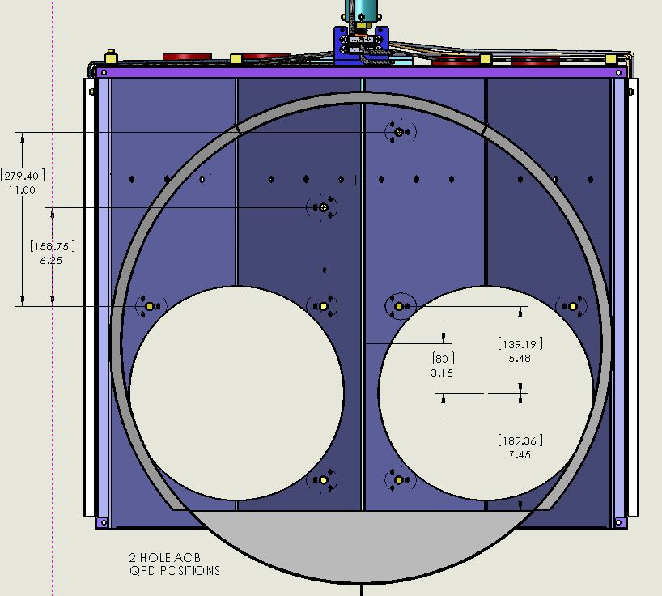
Figure 1: Locations of Photodetectors in 2-Hole ACB
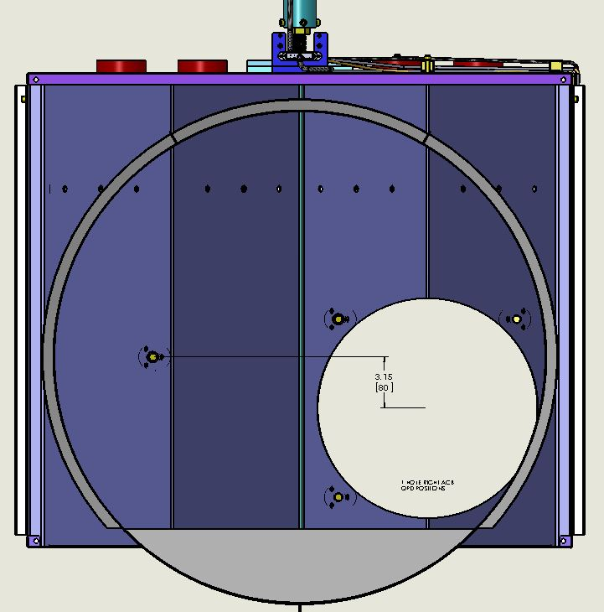
Figure 2: Locations of Photodetectors in 1-Hole Right ACB
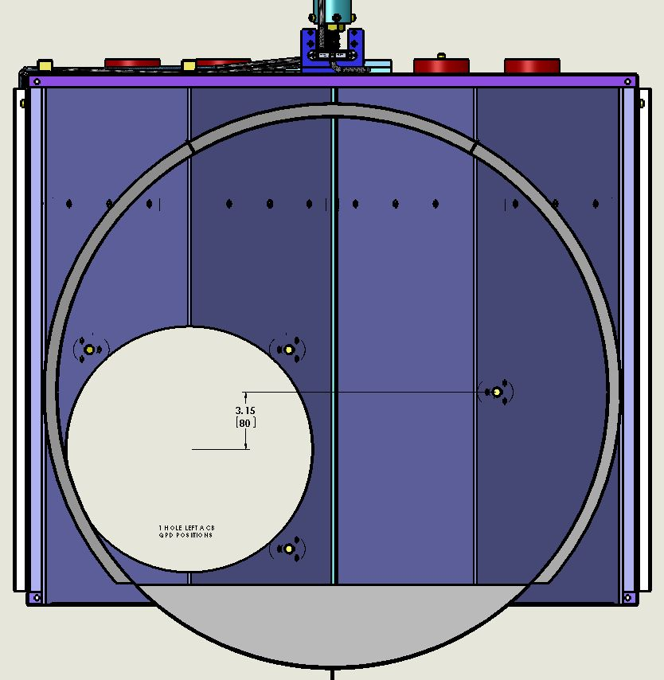
Figure 3: Figure 3: Locations of Photodetectors in 1-Hole Left ACB

VI) Questions from committee / actions for the ACB team See section below of this documentLIGO Laboratory M1000009-v1 17 Dec 2010 Form F0900005-v1 LIGO LABORATORY Page 3 of 4

Questions

1) MIKE
Could you tell us if you have looked at the stresses between the base of the spring and the bracket it attaches to, it appears to be a small mounting surface, please comment?

The blade spring is designed for constant stress at every cross section, with a factor 3 margin of safety for the yield stress. The mounting surface will experience a compressive force equal to the 70 lb weight of the load, which will cause a negligible stress. The bolts holding the blade will experience a tension load caused by the bending moment of the blade base pulling against the bolts. They are sized to withstand that tension force.

2) MIKE
The new photodiode hardware on the back of the baffle, which has shiny components such as silver plated screws, should be checked to be sure that diffuse large angle scattering is not a problem, or it should be covered with a baffle. To prevent specular reflections we should watch for surfaces on the back side of the baffle that are nearly normal to a radius from the center of the optic face (such as the PEEK backs of the photodiodes and the edges of the shelves).

A ZEMAX simulation of diffuse scattering from the surface of the ITM showed that no specularly reflected rays will return to the COC mirror. The diffuse scattering from the Peek and from the cabling does not cause excessive displacement noise, as shown in Figure 4.

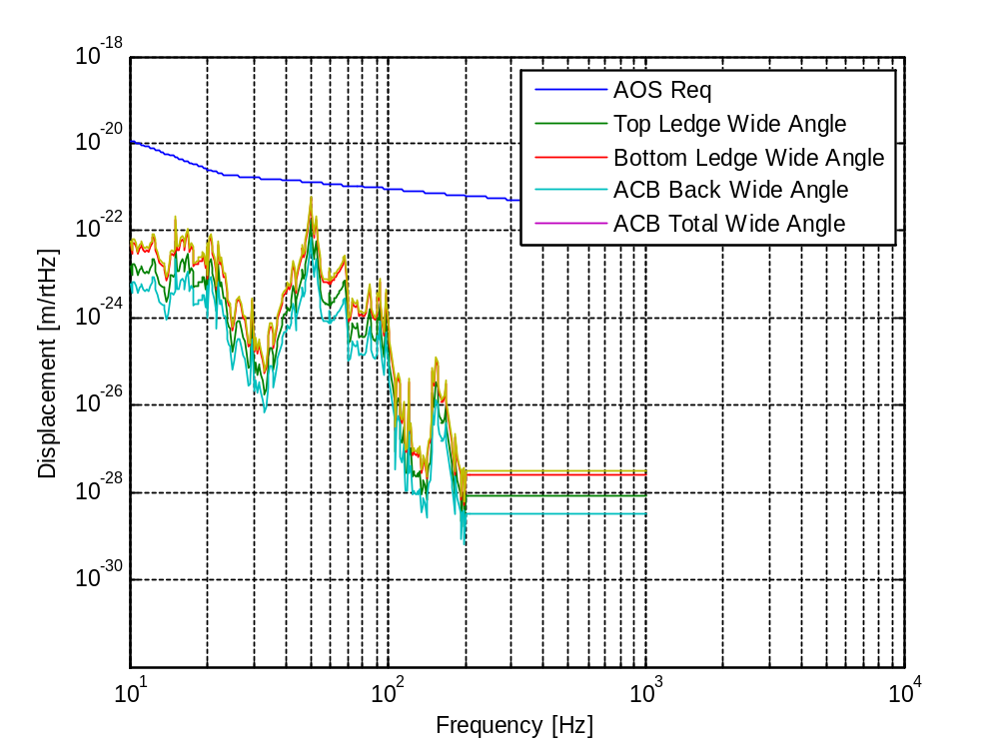
Figure 4: TM Wide Angle Scatter, re-scattered by ACB surfaces

3) MIKE
Does the light that passes through the small annulus between the baffle and the optic hit anything that might be reflective and nearly normal to the beam, producing a glint?
For H2 it will hit the FM elliptical baffle and be caught by the ITM elliptical baffle, and for H1 & L1 the light will be directly caught by the ITM elliptical baffle. Some of the light hits the quad SUS earthquake stops; this will not cause a problem--see Earthquake Stop Scatter .

10) ACTION on Mike and team - Question 3, on the light anulus: If the anulus does hit parts of the suspension structure, are those parts nearly normal to the beam? In other words, could here be a glint problem? Also, what about at the end stations, will the light anulus hit baffles there? I cant remember if the end cap baffles installed for eLIGO will remain in place over the reflective flanges on the end cap.
see 2.5.3 above: the annular beam does not hit the SUS structure, only the earthquake stops.

4) NIEM
If the baffle swings down rapidly from the out-of-the-way configuration, are there any parts that might bump into the table or quad if the baffle overshoots due to compliance of the support?
An additional safety lanyard will be attached to the baffle when it is swung out of the way to restrict any motion beyond the vertical, should the baffle swing toward the vertical.

5) MIKE
Are there any clear paths between the center of the optic face and the table that are not blocked by the baffle (especially since the top shelf is short)? I worry about this for large angle scattering.

The Lambertian scattering from the H1 ITMX HR surface was analyzed with ZEMAX ray tracing. The table below summarizes the fractional power hitting each of the surfaces listed. A pictorial view of the wide angle scattered light is shown in . The light that is not caught by the ACB baffle and the upper and lower ledges, 1) hits the upper and lower portions of the BSC, 2) is caught by the wide angle baffle plates, 3) passes through the BSC flange and hits the adjacent spool piece, and 4) the remainder of the light passes into the following BSC chamber or into the manifold (for L1 and H2). The calculated displacement noise cause by re-scattering from each of the listed surfaces is shown in Figure 4 and Figure 5

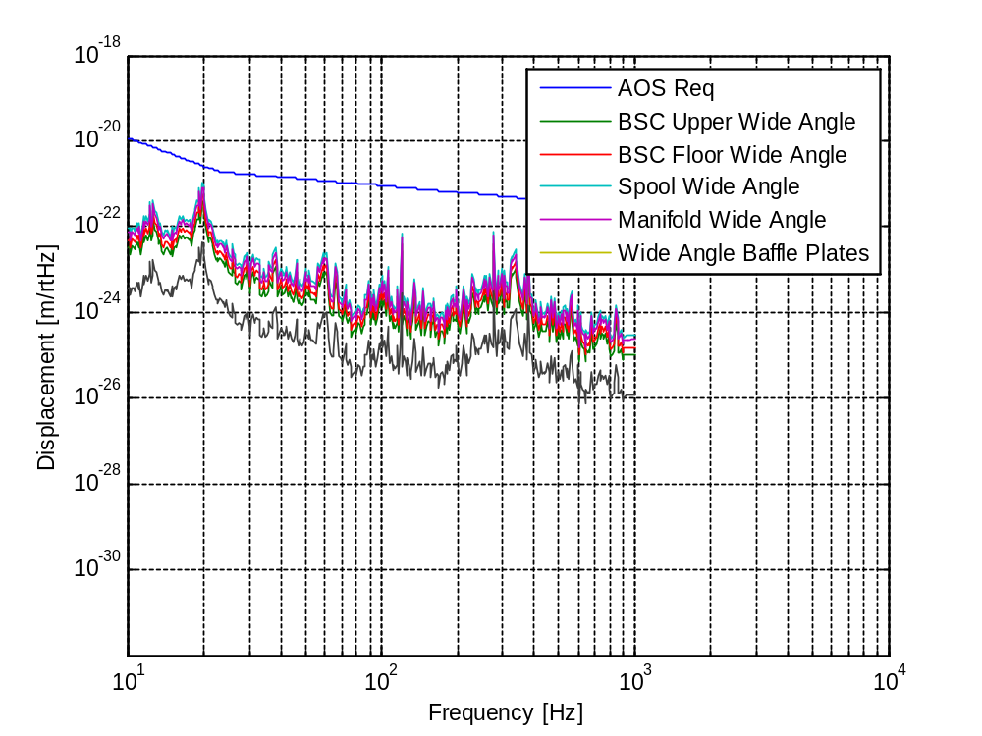

Figure 5: TM Wide Angle Scatter, re-scattered from Chamber Walls and Manifold

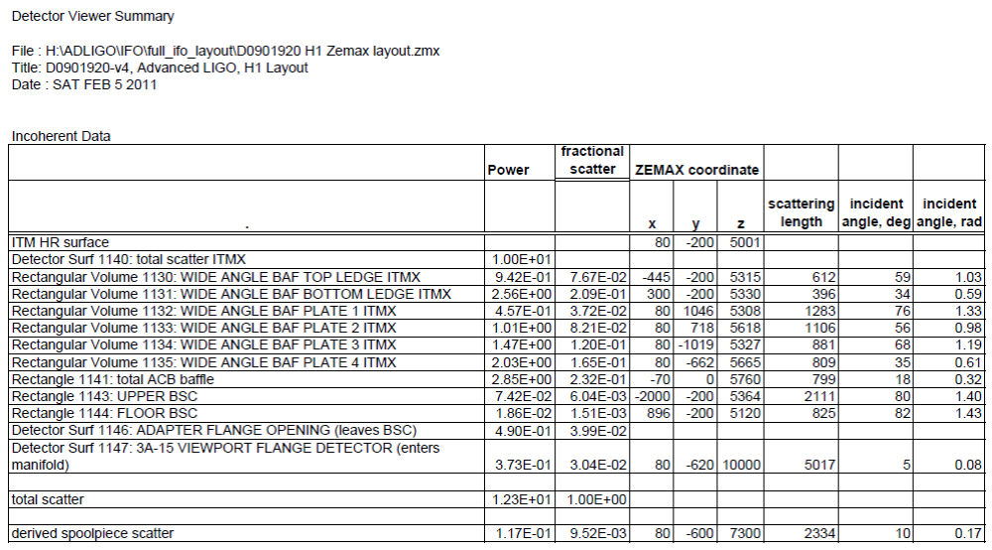

11) ACTION on Mike and team Question 5, on light that misses the baffle and hits the table: Could the fraction of light that misses the baffle and hits the table be a large angle scattering problem?
No. See Q 6.

12) ACTION on committee / systems / SLC -

a) Is this acceptable, do we need further baffles in the manifold tube?

No, see Figure 4 and Figure 5

b) Do we need to increase the size of the "shark fins"? This should not impact SOW / RFQ prep. So recommendation is to leave design as is for now for RFQ and can switch out before PO placed if required.
Yes, the upper and lower wide angle scatter ledges will have extender shelves to bring the ledges as close to the TM as possible.

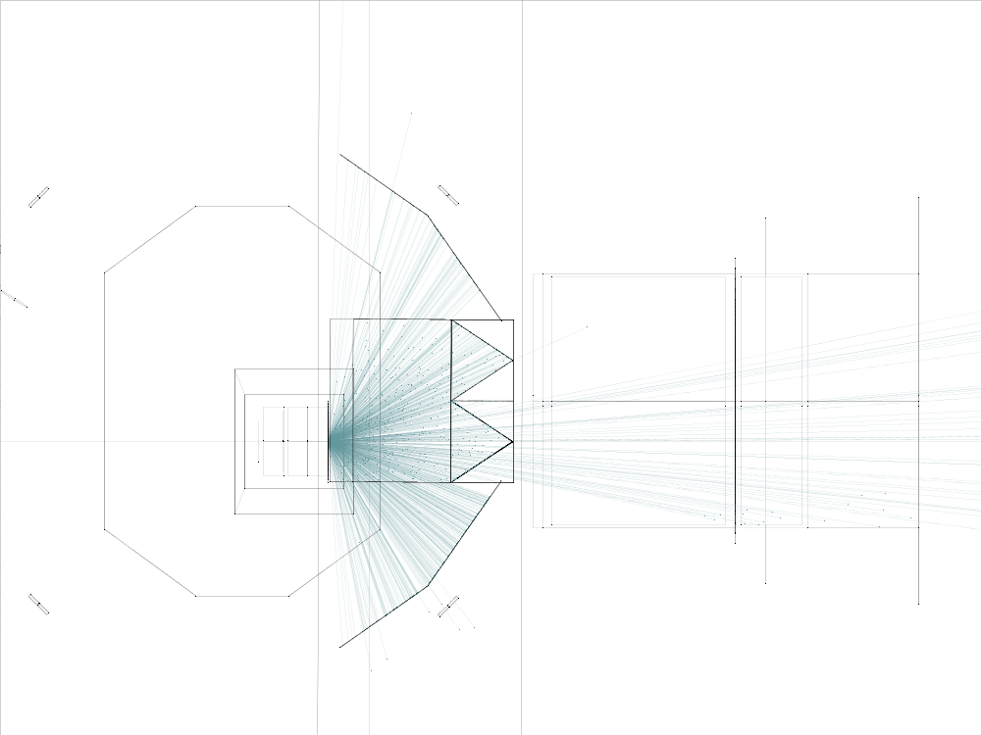
Figure 6: ZEMAX Lambertian Scatter Ray Trace from H1 ITMX HR, Top View

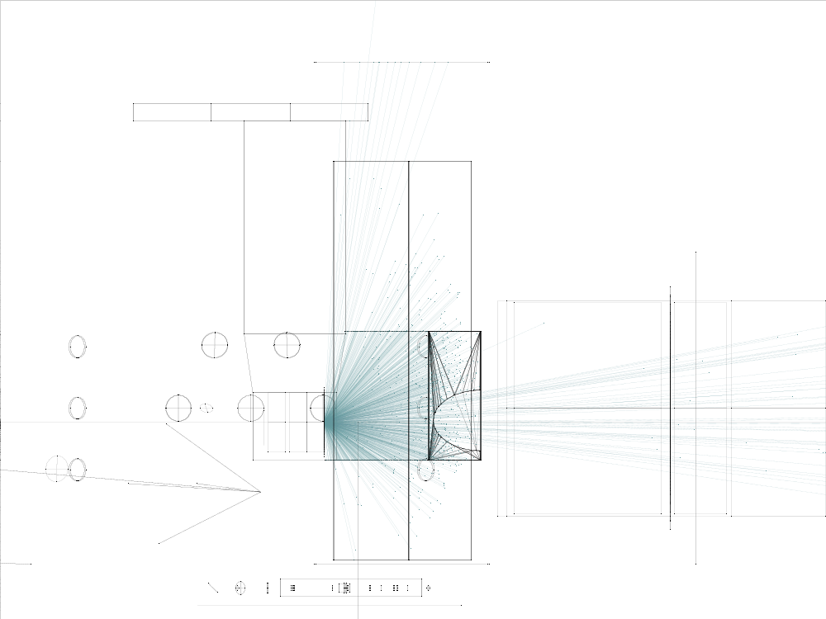
Figure 7: ZEMAX Lambertian Scatter Ray Trace from H1 ITMX HR, Side View
13) NEW QUESTION RE: WIDE ANGLE SCATTERING FROM THE SUS STRUCTURE

The quad SUS lower structure has an octagonal structural ring that surrounds the HR surface of the TM, which will catch some of the wide angle light scattered. A structural plate above the ring with an extended ledge will block the wide angle scattered light from hitting the upper stage of the SUS.
The wide angle scattering displacement noise from the octagonal ring and ledge was calculated and are shown in Figure 9.

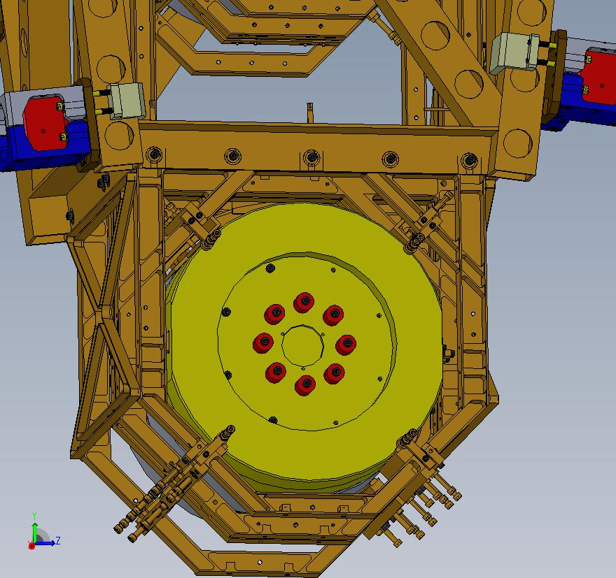
Octagonal Structural Ring
Structural Plate
Figure 8: Lower Quad SUS Structure

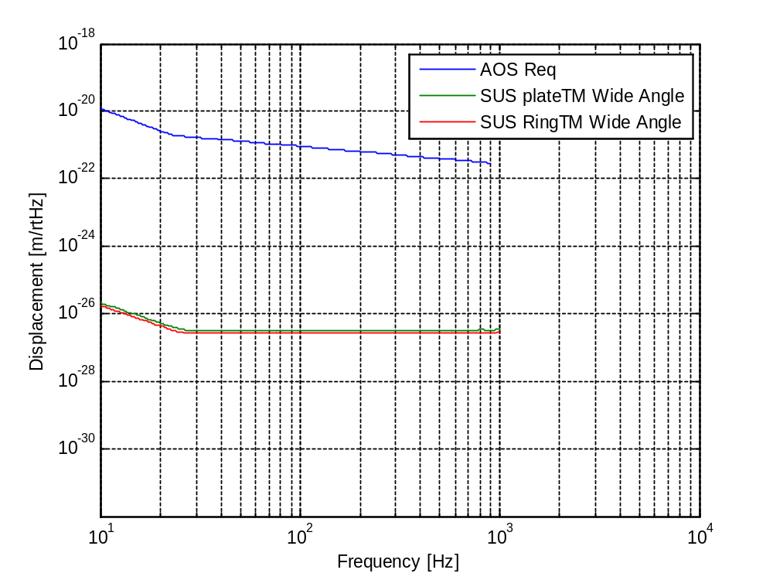
Figure 9: SUS Wide Angle Scatter

6) VIRGINIO
Compared to the previous version, this document, Magnetic Field Measurements, contains the correct analysis of the magnetic field using a power law; according to the magnetic induction approximation formula analogous to the electric dipole approximation

The results of those measurements and extrapolations from the fit show that the magnetic
field spectrum at a distance of 0.7m is estimated to be about 1 pTrms/√Hz above 10Hz, a
value one order of magnitude lower than the natural magnetic field measured at Hanford.
Considering that the expected seismic noise on a Caltech’s build third floor is presumably
larger than the one at the sites, the spectrum noise is dominated by the instrument
noise, and the number of permanent magnets used will be reduced by a factor two, the
residual magnetic field spectrum estimation at a distance of 0.7 m is conservative.
The following figure shows the location of the ACB magnetic with respect to the TM SUS magnets; the actual distance is 797 mm (the ACB magnet plate will be rotated 90 deg away from the TM SUS in this figure).

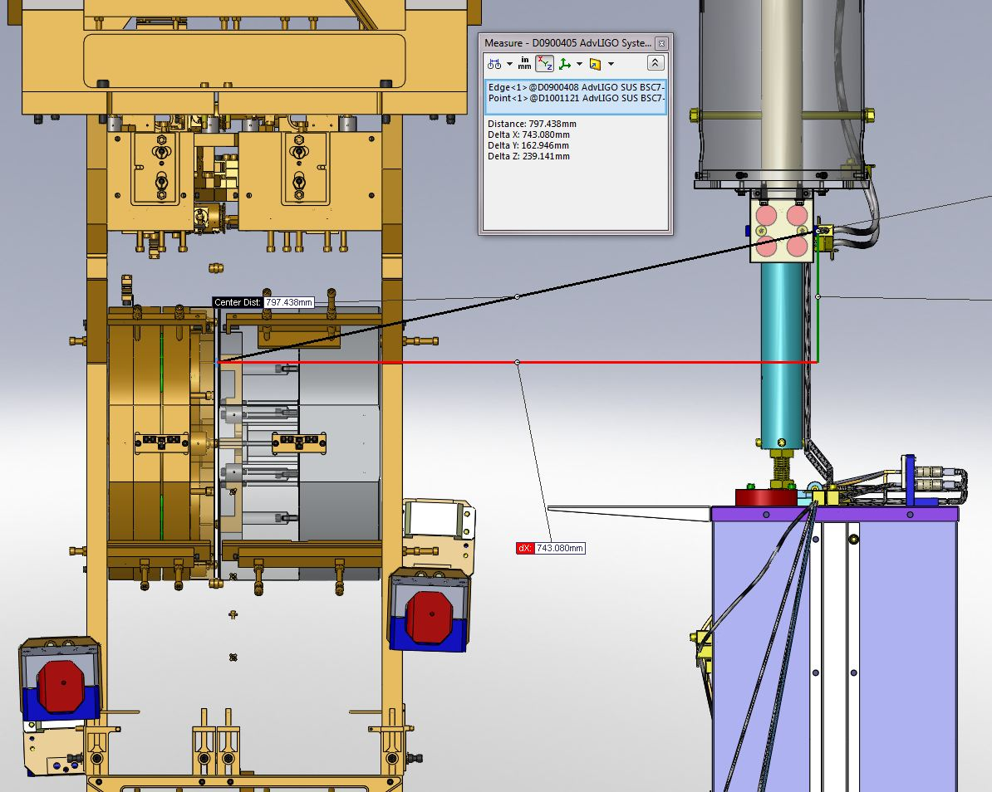

7) NIEM
Clamping to stage 0. In T1000747 figures 18 and 20 are not consistent. Please work with systems to update the layout of all of the ACB wrt stage 0 to confirm clamping option proposed will in fact work.
A clear view of the clamping arrangement is in Figure 10.
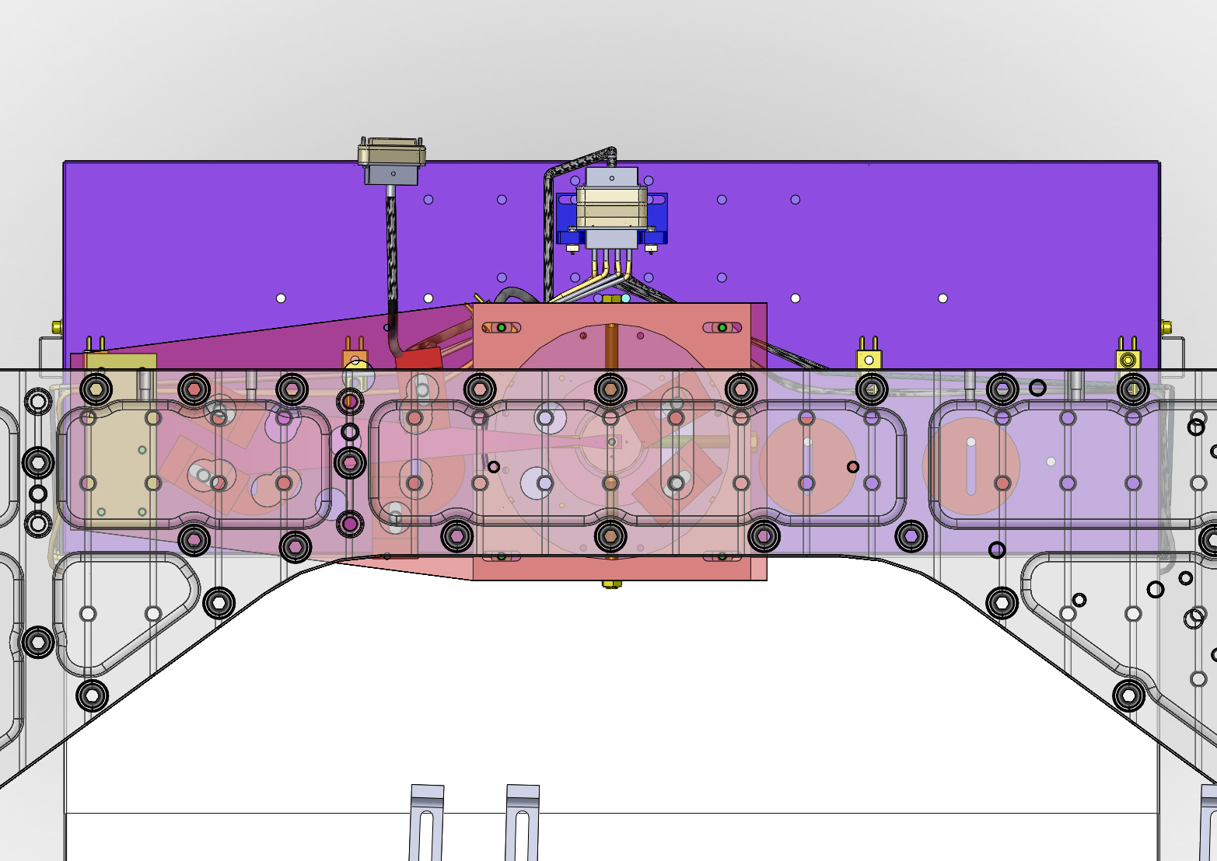
Figure 10: Clamping Detail for the ACB Top Mounting Plate

The detailed mounting locations of the various ACB installations on Stage 0 are shown in the following figures; reference E1000404 ACB Interface BSC Chambers H1, H2 for aLIGO.
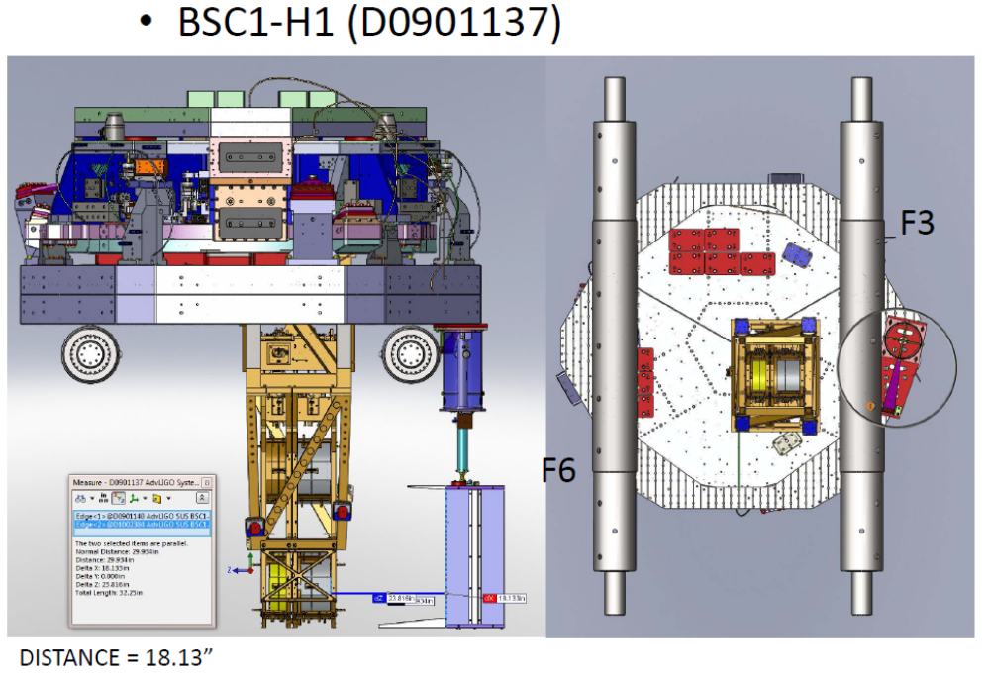
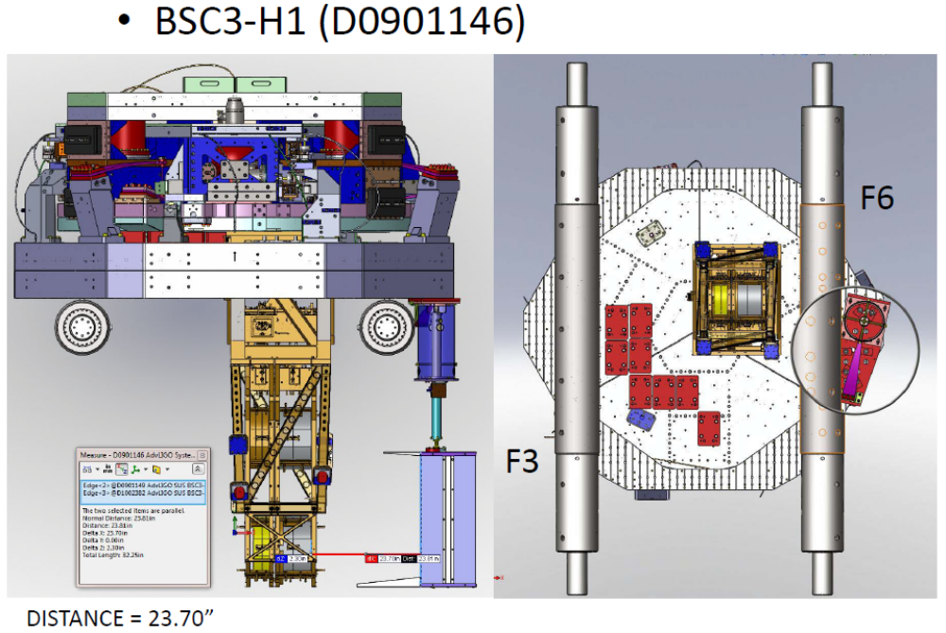

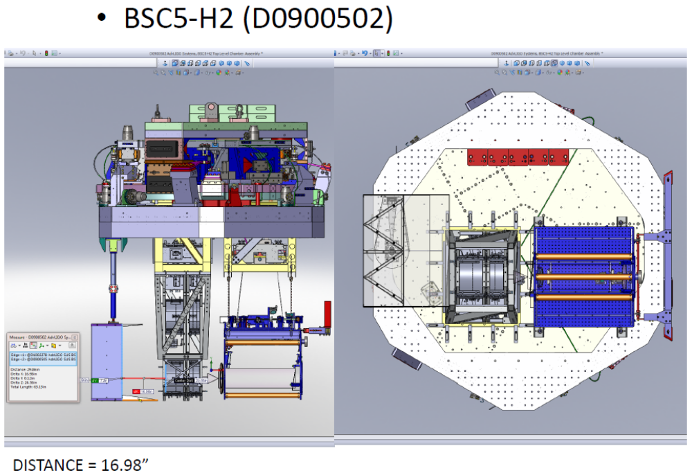

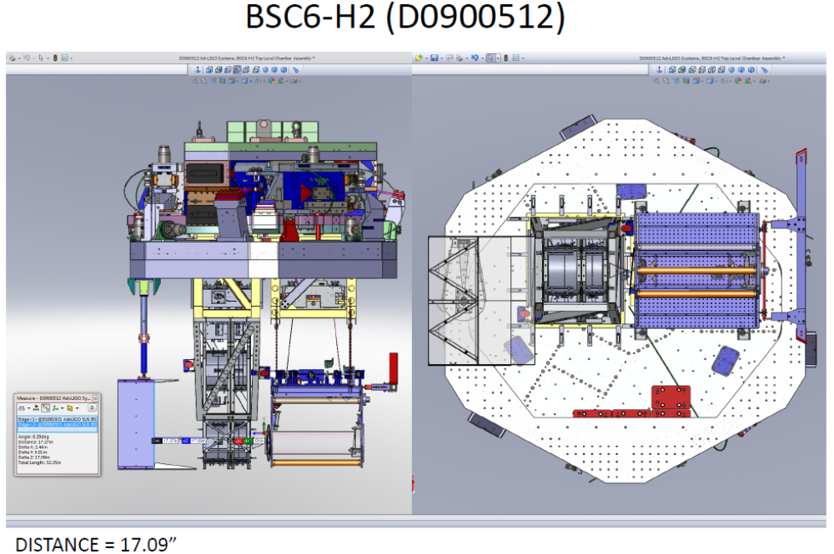

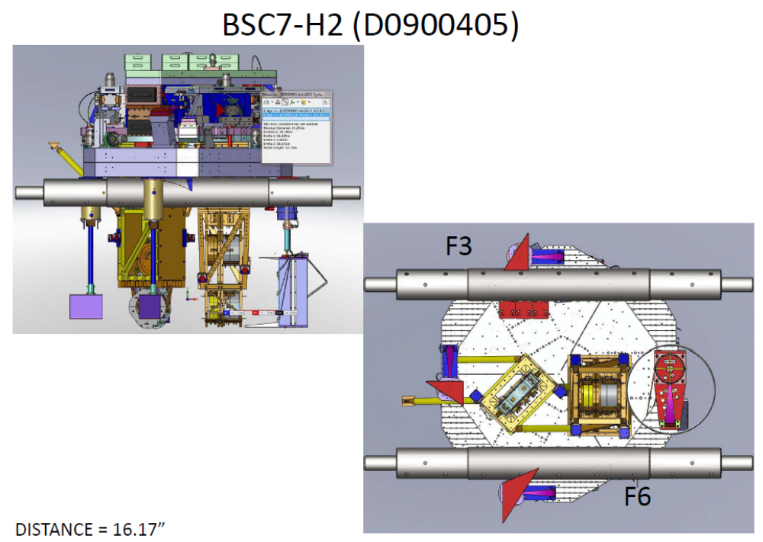

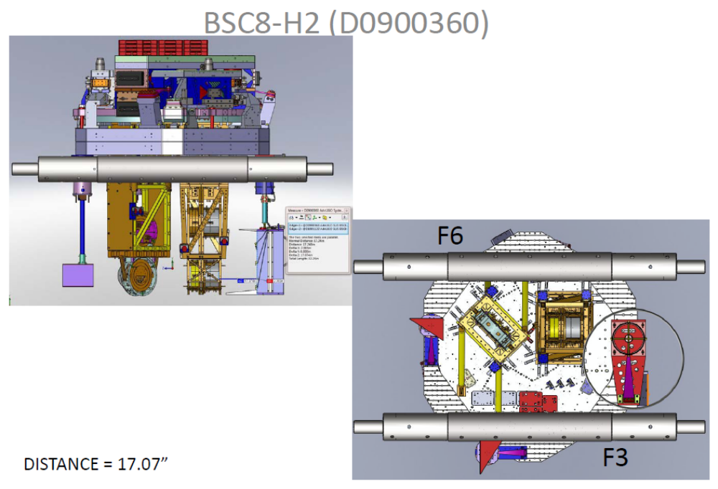

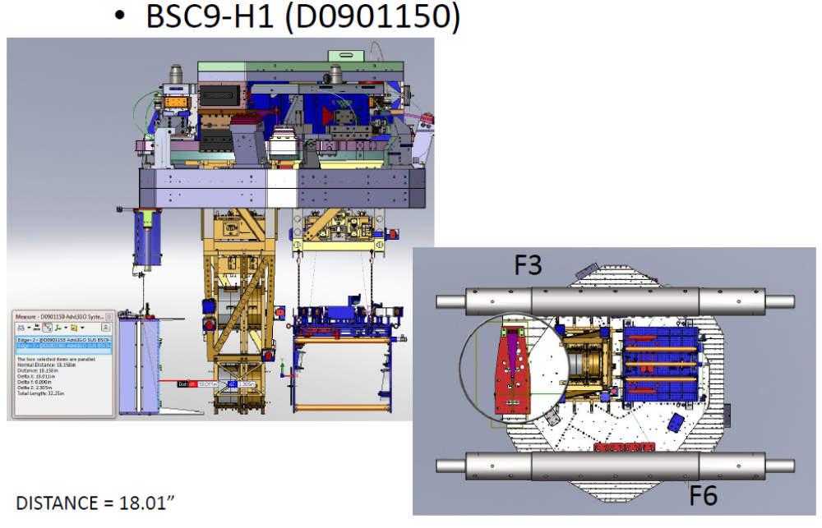

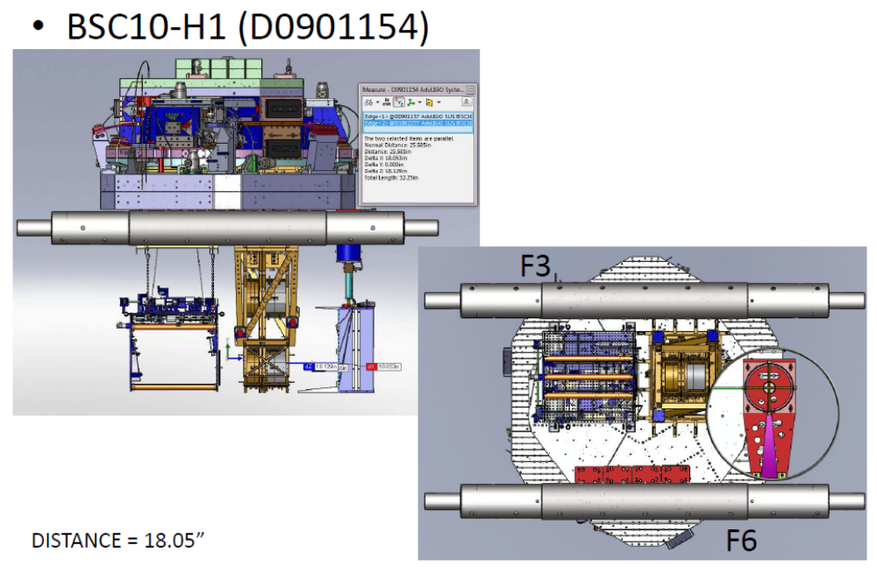

8) MIKE
In terms of the radius on the sheet metal parts we endorse the idea of having the prototype piece coated asap under the guidance of Heidy Kelman, Systems and the QAME team.
A prototype ACB part with a 0.030 ID and 0.080 OD radius was porcelainized. The part showed no indication of lack of adherence or separation on the 0.080 OD radius, which is the most critical stress concentration area. The metallurgist at West Coast Porcelain said that he sees no problem with coating these small radii.

9) NIEM
Do we have cables/ feedthroughs for the QPDs included with Emery Brown's feedthrough layout. Please work with Emery to confirm this. (should not hold up procurement of ACB parts)
DONE

10) MIKE
Do we have a glint line in the bend, apex of the V? ACTION - Analysis is required on this. Could a 5 deg tilt be included in design and would this be adequate?
I measured the BRDF of a typical porcelainized steel sample and calculated the glint from the baffle edges and apex bend using measured BRDF function. The edge glint is negligible when the baffle is tilted forward by 1 deg.
The present baffle design will be hung at a 3 deg tilt by placing a wedged washer between the hinge plates.

see T1100056 Arm Cavity Baffle Edge Scatter

14) ACTION on Mike Smith - Tilting BRDF - need to look at again? - URGENT!! Worried this could impact design.
DONE, see 2.5.10.

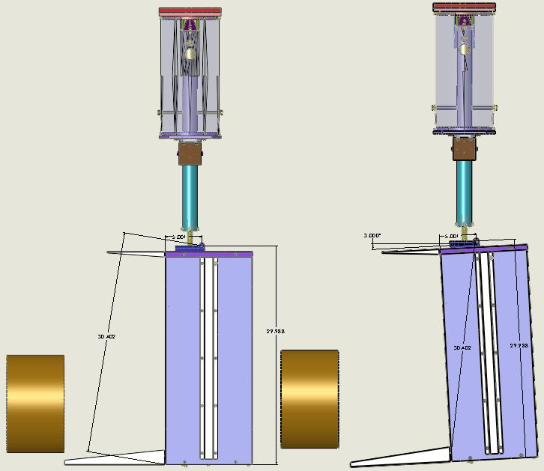
Figure 11: ACB Shown Hanging with 3 Deg Tilt
Figure 12: Total Displacement Noise ACB Scatter Versus Tilt Angle
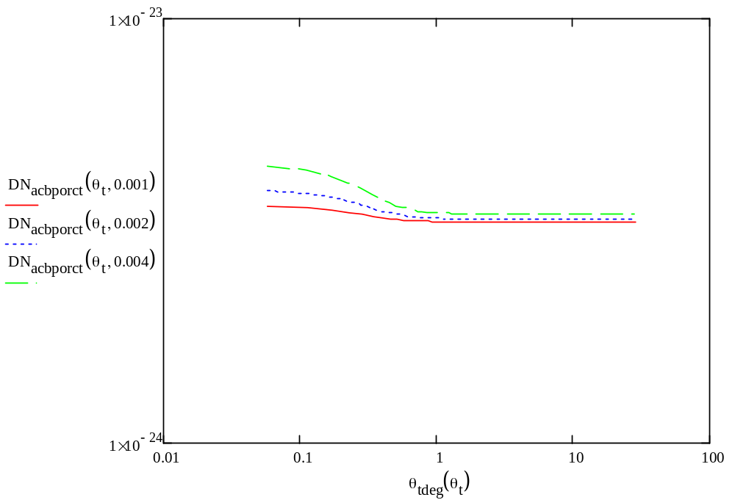

11) MIKE
Alignment procedure, please define? (should not hold up procurement of ACB parts)
The ACB will be aligned concentric with the TM outer radius by mean of sighting with a theodolite or an alignment telescope placed on the TM centerline and perpendicular to the TM HR surface.

12) MIKE
Installation procedure, please define including any tooling required? (should not hold up procurement of ACB parts). All please define what happens if needed to access optic - would like to see installation / repair plan?LIGO Laboratory M1000009-v1 17 Dec 2010 Form F0900005-v1 LIGO LABORATORY Page 4 of 4
TBD

13)MOHANA
Photo detector - quad diode in documentation? We believe a solid-diode should be used. Please confirm? YES see Q 5

Subsequently is the cabling for a solid diode, please confirm? YES

14) MOHANA
Are AOS buying diodes? Yes. Diodes should be part of this review. Photo-diode should be made part of this review. Need follow up on this. Would to hear more at follow up meeting, see below.

15)VIRGINIO
15) ACTION on Virginio - please update document with LASTI (SEI) confirmation of tests and post to DCC.

See the following Document https://dcc.ligo.org/DocDB/0029/T1000737/002/LIGO-T1000737-v2.pdf contains the measured modes of the suspension. Yaw frequency mode was measured on a similar suspension with smaller moment of inertia and was found to be less than 2Hz.

16) NIEM
In terms of earthquake stops inspect holes, confirm location and usefulness - add to assembly and installation documents (should not hold up procurement of ACB parts)

The 1 1/2 dia holes in the down tube next to the earthquake stop rods are adequate to allow a determination of the clearance between the rods and the rod holes after installation.

17)NIEM
Do you have counterweights for spring? - yes included. These should be defined in drawing package. If included they were missed by review team.
Counter weights are included in the BOM.

18) MIKE
Installation tooling and in situ repair tooling was not included, please define. Also assumptions were made of FMP tooling without checking. Need discussions with layout / install / systems / FMP asap. (should not hold up procurement of ACB parts)
TBD

19) VIRGINIO
Would like data from LASTI of ACB on Stage 0. Need to show payload and attachment meets requirements. Please request data from LASTI if you haven't already done so.

Please refer to document https://dcc.ligo.org/DocDB/0029/T1000737/002/LIGO-T1000737-v2.pdf

20) Why no side shelves (figure 9)? -

Answer (MS) - There are additional baffles on the walls of the BSC.

21) LISA
Production schedule? - This was presented as MARCH 2011. With 8 to 10 weeks to manufacture plus 2 to 3 weeks for RFQ / SOW etc ... and even with delays to overall schedule this is URGENT.

Lisa has an updated schedule. See M1000076 SLC Schedule
16) ACTION on Mike and Lisa. Please work on updated schedule. Please work with QAME team on a) time estimates and b) potentially splitting order to 2 vendors? Also please remember to request shorter than default 4 week RFQ phase.
Will do!

