CRYOGENIC INTERFEROMETERS:

Some Good Reasons for Pursuing Them

Amaldi Conference
11 July 2003

Adalberto Giazotto

LIGO-G030367-00-Z

The Fabry-Perot Michelson optical scheme:

FW

W W _{LASER} 2W FW

Where F is the finesse and W the power on the beam-splitter

Radiation Pressure (RP) and Shot Noise (SN) are Quantum noises and undergoe Heisenberg Uncertainty Principle:

RADIATION PRESSURE SHOT NOISE

$$\frac{F^{2}}{1+{\left({FωL}/c\right)}^{2}}$$

The terms W and

have dramatic effects on the detector sensitivity and bandwidth:

Radiation Pressure
Shot Noise
ĥ

BS pow.10³ W

10⁴ W

10⁵ W

10⁶ W

10⁷ W

Hz
10 100 1000

Recent development on
Sagnac are “natural” QND ITF

x(t)

L L

d Δn₂(t)

A
B

Δn₁(t)
V(t)
φ=ε sin(ω_{M}t)→
φ
Quantum-Non-Demolition
(QND) techniques are
extremely interesting.
Sagnac ITF measures
mirror speed dx/dt⇒iωx and
RP fluctuations cancels out
up to (ωd/c)² terms.

Unfortunately in Sagnac ITF
Shot Noise is overwhelming
(with respect to Michelson
ITF) due to the ωd/c~O(10⁻⁵)
term in the signal:
$$V(ω)\text{\sim }\left[ω\frac{d}{c}\right]\text{FLh}+\frac{λ}{4π}\sqrt{\frac{hυ}{W}}$$

More suitable optical schemes have been investigated succesfully; as an example the Courty, Heidman, Pinard scheme:
Radiation Pressure and
Shot Noise after correction
ĥ
Before Correction

After Correction
No LP filter With LP filter

Hz
10 100 1000
Courty, Heidman, Pinard scheme for QND

Detuned Cavity
L

Virgo Short
cavity cavity

This method should be used on each FP cavity and allows in priciple to reduce very strongly RP effects; the price to pay is anyway an increase of Shot Noise which can be reduced by increasing the power on Beam Splitter (BS).
After these considerations an optimistic statement could be the following:
Radiation Pressure effects can be transformed in a Shot noise increase and, in priciple, this noise can be reduced by increasing the power on the BS.

In an optimistic view, since it seems we can reduce strongly RP and SN problems by using QND methods and by increasing the power on BS, we are left to worry about two enormous problems:
- Thermal Noise
- Lensing effects in the mirrors due to the power increase.

Going to low temperature could be an interesting option giving several advantages.

6 good reasons for going to low temperature:

1)For reducing Phothermal noise

2)For reducing the thermodynamical noise

3)For reducing the thermoelastic noise

4)For reducing Electromagnetic coupling Mirror-Environment by making the superconductive the cryostat surrounding the mirror. (See Mitrofanov)

5)For Reducing TN

6)For reducing Mirror Optical Lensing

- Pendulum and Bulk TN
The TN displacement noise due to pendulum and mirror bulk are expected to contains the term (Tφ)^{1/2} and φ decreases as T decreases; we can expect at 4K a factor 1/100 TN noise reduction with respect 300 K.

- Mirror Coating internal losses:
more complex seems the problem of coating internal friction and coating-mirror surface friction.
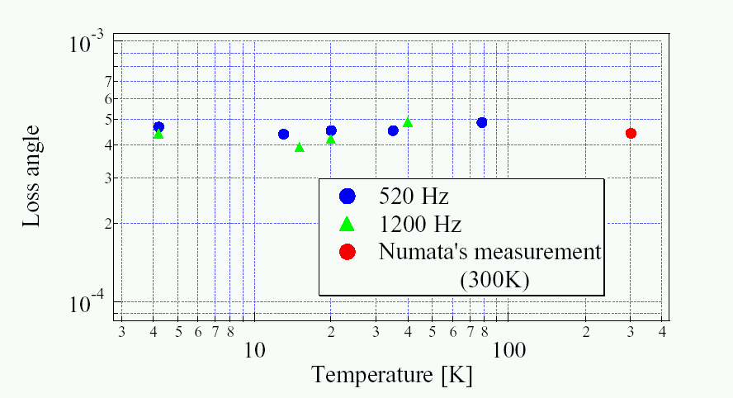Very preliminary experimental data show no improvement on the coating loss angle by going to low temperature (Yamamoto):

These are very preliminary results and tests need to be repeated again with different bulk and coating materials (at present it is Ta₂O₅) and in particular to check what is the scaling law.
At present the following scaling law is considered valid
$φ_{\text{Total}}=φ_{\text{Bulk}}+\frac{E_{C}}{E_{B}}φ_{\text{Coating}}$
Where E_{C} and E_{B} are the Coating and bulk stored energy respectively. By assuming the same Young’s modulus for both coating and bulk, the displacement of the mirror is:
${\tilde{x}}_{\text{Total}}(ω)=\frac{\sqrt{\text{16}k_{B}T(φ_{\text{Bulk}}+\frac{E_{C}}{E_{B}}φ_{\text{Coating}})}}{ω^{1/2}E^{1/2}w_{0}^{1/2}}$
In any case even if φ_{Coating} does not decrease at low temperature but remain constant, as shown by Yamamoto, and limits the maximum Q reacheable,
This is a key point: we may still try to reduce X̃_{Total} by a factor ~ 10 by going to 4K

Some ideas on how to reach 4-5K

As an example: if we have 8-10 MW in the FP cavities and coating losses are ~5 10⁻⁸ we need to extract ~0.5 W @ 4 K

Si
CaF₂
Si

Let us suppose a mirror
support like this:

How good is the Q of
Material connections???

2) The equation for T is the following:

$C_{V}\frac{\text{dT}}{\text{dt}}=ΔW−\left[β(T)\frac{σ}{L}+5,6\text{.}{\text{10}}^{−8}\text{.}4T^{3}S_{M}\right]\left(T−T_{0}\right)$
Where β(T) is the mirror supporting rods/wires thermal conductivity coefficient, σ the area where the heat goes trough, L the length of heat extraction device and C_{v} the specific heat , T₀ the thermostat temperature and S_{M} the total mirror surface.
In the stationary case dT/dt=0, we obtain:

$$T−T_{0}=\frac{ΔW}{β(T)\frac{σ}{L}+5,6\text{.}{\text{10}}^{−8}\text{.}4T^{3}S_{M}}$$

As an example we consider two kinds of materials:

1)Mirrors in Fluorite (CaF₂) because is not Birefringent.

2)Mirror supporting hinges in Silicon (Si) because it has high thermal conductivity at low temperature and low Young modulus.
In the following we consider only lensing due to the thermal expansion coefficient and assume dn/dT~10⁻¹²T³, negligeable.

1)Room Temperature Case

CaF₂ Ther. exp. coef. α_{CaF2}(300)=1,9 10⁻⁵ K⁻¹
CaF₂ Ther. cond. coef. β_{CaF2}(300)=10W/(m.K)
S_{i} Ther. cond. coef. β_{Si}(300)=100W/(m.K)

ΔS

S

Mirror radiating area S=0,3 m²
ΔT@300K is Stefan-Boltzmann dominated:
ΔT ~ΔW/1.8~ 0.1 K

With S=.1m ⇒ΔS=Sα_{CaF2}(300) ΔT~2 10⁻⁷m

2) Temperature 5K

CaF₂ Ther. exp. coef. α_{CaF2}(5)= 10⁻⁹ K⁻¹
CaF₂ Ther. cond. coef. β_{CaF2}(5)=600W/(m.K)
S_{i} Ther. cond. coef. β_{Si}(5)=600W/(mK)

As an example, for transporting 0,5 W away from mirror we may use 4 S_{i} hinges;
Si
₂

L Si A
δ

If we have A=3 10⁻²m, L=0,3 m it follows δ=1,6 10⁻³m. and ΔT=1K.

This corresponds to a negligeable lensing effect:

ΔS

S

ΔS=S α_{CaF2}(5) ΔT ~10⁻¹⁰m

A problem is then how to extract ~0,5 W from mirrors preserving the Superattenuator softness.

jellyfish

Cryostat
COLD FINGER
Al or Cu
~1 m
~ 40 cm

Some Ideas for a cooled Last Stage

Vertical TN
Filter
Cryostat

Cold Bar

Jellyfish
Marionette reference mass
Mirror
Reference mass

Conduct. pipe

Test 4K cryo chamber by some Virgo groups-Leiden- ACIGA-GEO

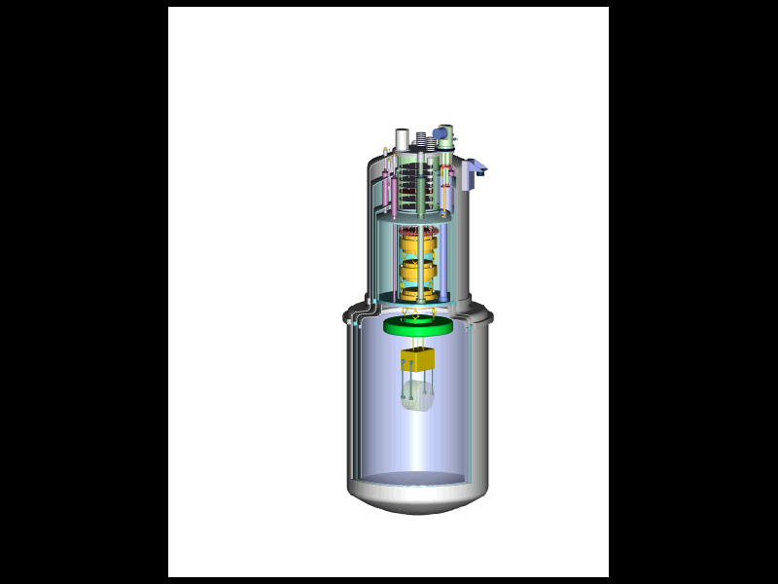
4 m
Yamamoto experiment needs to be
repeated to check down to mK if
there are phase transition.
The mechanism for coatings high loss angle is today not
understoodt.

