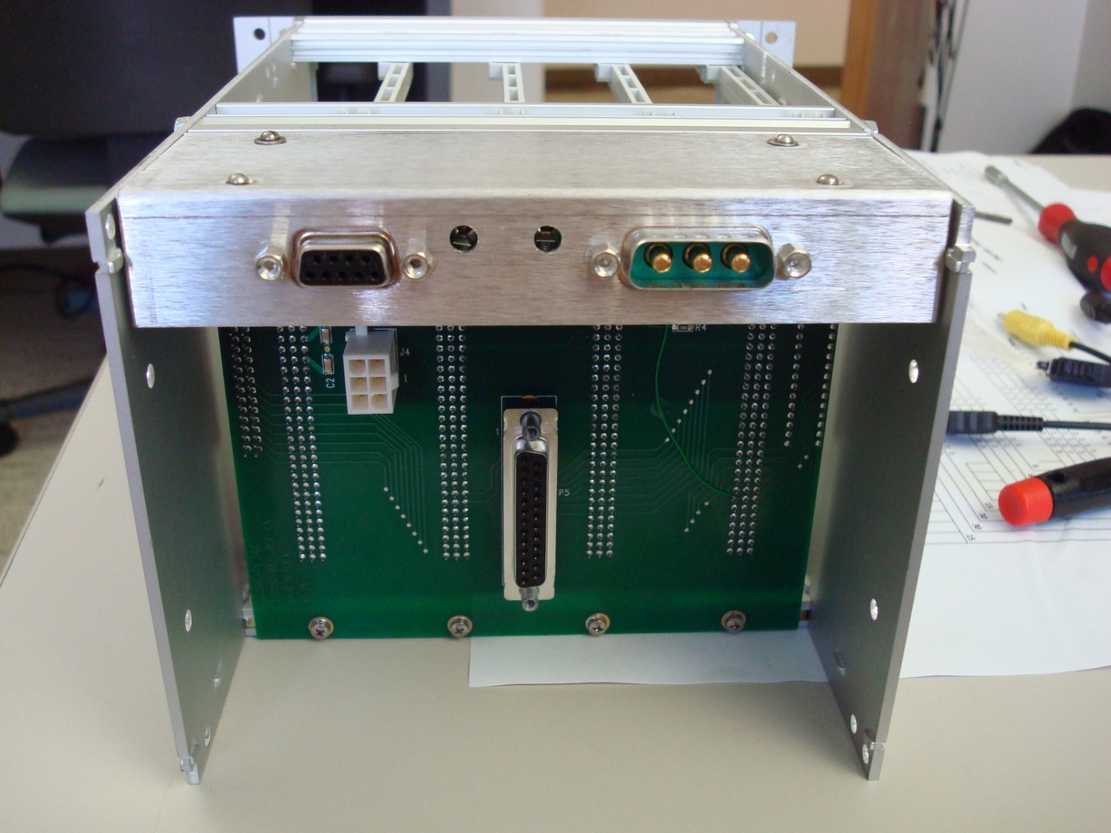

Synchronous distribution connector Power from rack

These holes are for your target ground wires to pass through.

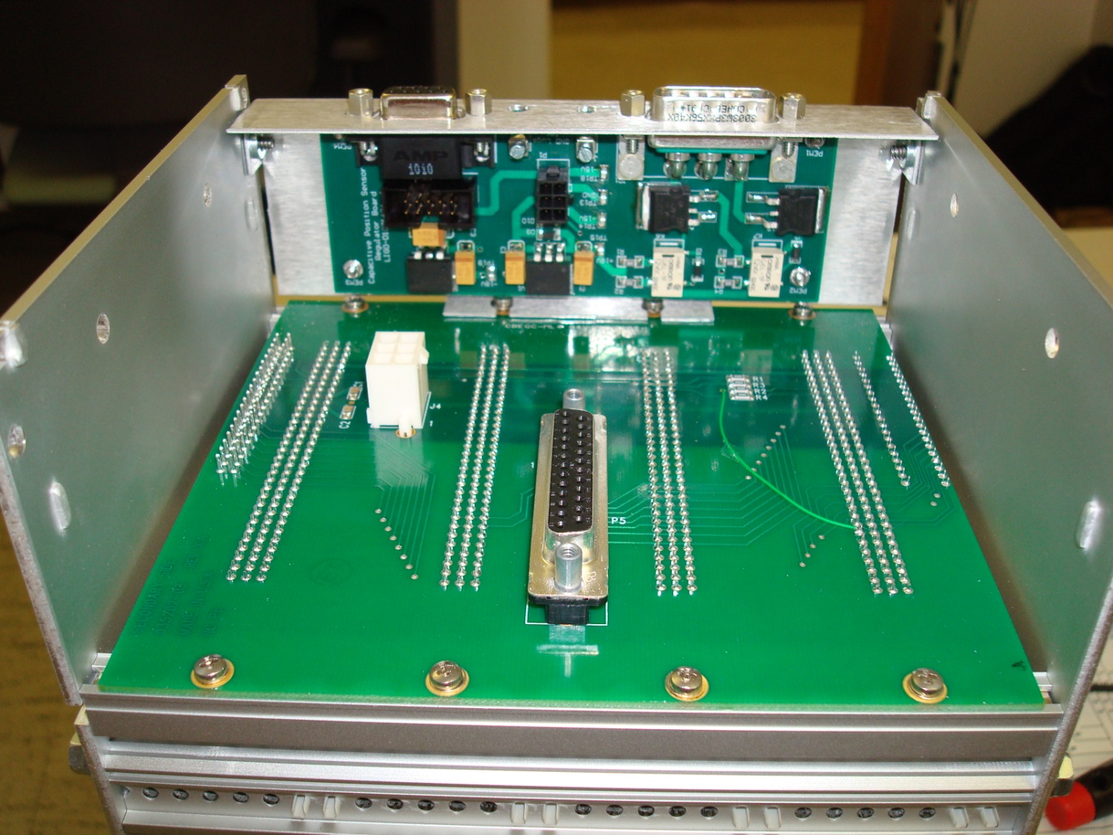

This connector (P2) connects to the new Microsense connector that is located here on *your* backplane to distribute the sync signal In/out the D9 connector.

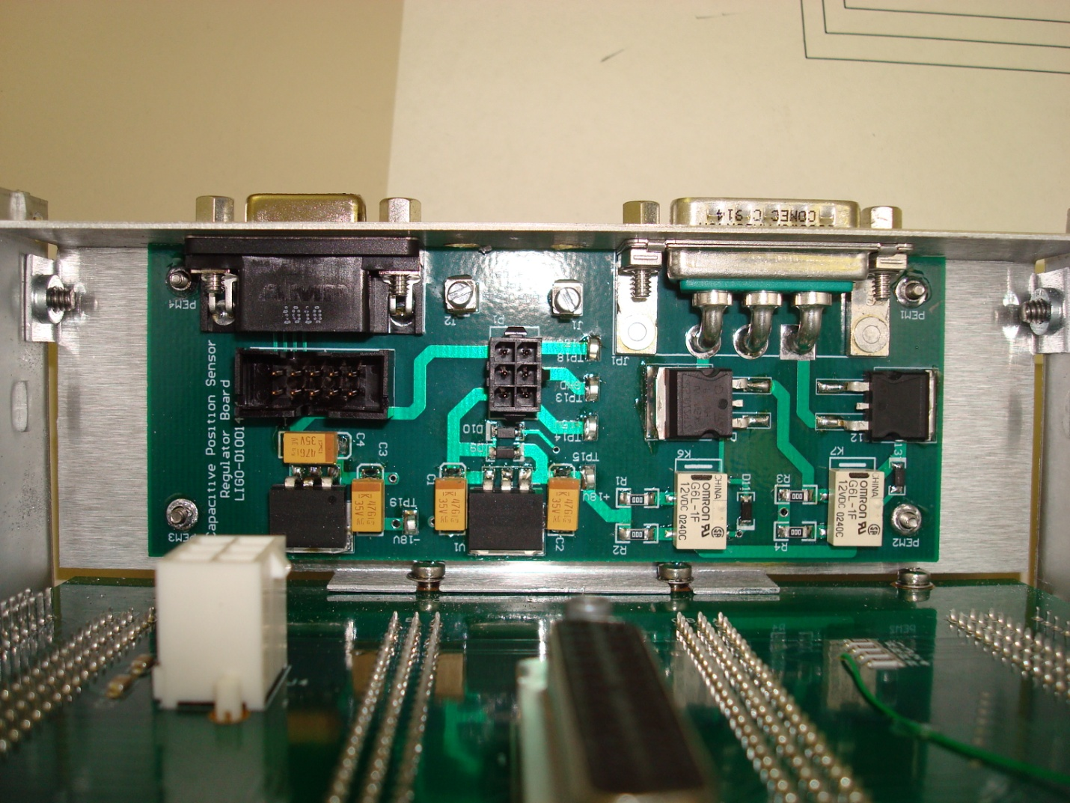

This connector will connect to this one to transmit power from the regulator board to the rack.