*LIGO Laboratory / LIGO Scientific Collaboration*

LIGO-T1100149-v15 *LIGO* Date:6-May-14

Vertex Hartmann Sensor: Initial and Maintenance Alignment Procedures

Authors: Aidan Brooks, Phil Willems, Mindy Jacobson,

Cheryl Vorvick, Dennis Coyne, Doug Cook, Eric James

Distribution of this document:

LIGO Scientific Collaboration

This is an internal working note

of the LIGO Laboratory.

|  |  |
| --- | --- |
| **California Institute of Technology**  **LIGO Project – MS 18-34**  **1200 E. California Blvd.**  **Pasadena, CA 91125**  Phone (626) 395-2129  Fax (626) 304-9834  E-mail: info@ligo.caltech.edu | **Massachusetts Institute of Technology**  **LIGO Project – NW22-295**  **185 Albany St**  **Cambridge, MA 02139**  Phone (617) 253-4824  Fax (617) 253-7014  E-mail: info@ligo.mit.edu |
| **LIGO Hanford Observatory**  **P.O. Box 159**  **Richland WA 99352**  Phone 509-372-8106  Fax 509-372-8137 | **LIGO Livingston Observatory**  **P.O. Box 940**  **Livingston, LA 70754**  Phone 225-686-3100  Fax 225-686-7189 |

http://www.ligo.caltech.edu/

# References

* T1000230, *Auxiliary Optics System (AOS) Initial Alignment System (IAS) Final Design Document*
* T1100293, *ITM Hartmann sensors: Alignment tolerance, resolution and range requirements*
* G1000013, *Livingston aLIGO Installation Schedule*
* G1000061, *Hanford aLIGO Installation Schedule*
* T1100445, *AOS SLC Signal Recycling Cavity Baffles Final Design*
* T1000179, *aLIGO Hartmann Sensor Optical Layouts (H1, L1) Input Test Masses*

# Introduction

The purpose of this document is to describe the initial and maintenance alignment procedures for the vertex Hartmann sensors (located on HAM4 in H1, L1 and HAM10 in H2).

# Equipment list

* Laminated and mounted target card
* Iris on tripod
* “PS971-B - Retroreflector, Ø25.4 mm, L=22 mm, AR-Coated: 650-1050 nm” mounted on translation stage
* Stainless steel ruler
* “50-850-APC - GRIN Fiber Collimator, 850 nm, FC/APC Connector” + “SM1PT - SM1-Threaded Adapter for GRIN Collimators“
* IR Viewer

# Prerequisites

This section describes the requisite state of the interferometer alignment and construction prior to attempting the HWS alignment.

1. The beam-splitter, ITMX, ITMY, SR3 and SR2 optics will be installed [SUS/COC]
2. The beam-splitter, ITMX, ITMY, SR3 and SR2 optics will have undergone initial alignment [IAS]
3. CO2 laser projector fold mirrors will be installed in BSC2 [TCS]
4. The HWS in-vacuum optics will be installed in nominal positions determined by cookie-cutters [TCS]
5. The HWS in-air table will be installed next to HAM4 on the +X side [FAC/TCS] and will have its periscopes installed in addition to the irises
6. The HAM4 +X door will be on the chamber, the HAM4 –X door will be off the chamber [FAC]
7. All beam dumps and scraper baffles should be installed on the HAM4 table. [SLC]

# Initial alignment with surveying beam

## Set up total station

Datum: Monuments TBD.

Equipment: Total Station with Davidson Laser Autocollimator (LAC) mounted on top and co-boresighted with the Total Station. Green laser mounted as the illumination source for the LAC.

Accuracy: 100μrad

Procedure:

* Remove spool on the X-arm between BSC3 and the adjacent gate valve.
* Set the Total Station / LAC at approximately 1810 mm above the floor directly over monument TBD.
* Adjust the Total Station height to be -80.0 mm (global coordinate system) using elevation mark TBD.
* Setup the Brunson Optical Square directly over monument TBD, at the same height as the Total Station, and sight TBD to get alignment parallel to the X global axis
* Set the Total Station to be square to the Brunson Optical Square.
* Yaw the Total Station precisely 90 degrees and set this yaw angle reference to zero. Pitch the Total Station 12.5 microradians (2.58 arcsec) UP. (The Total Station is now pointing along the X-arm optical axis.
* Adjust elevation until laser is at the elevation of the optical axis.
* The laser is now on the optical axis.

## Align Optics

Datum: Optical axis as established by a 532 nm green laser mounted on the total station.

Equipment: Total station with green laser co-boresighted.

Accuracy: Various, see text in procedures.

Procedure:

Adjust the positions of the first HWS optics (the HWS collection optics) so that the surveying beam is incident on these optics:

* 1. Y-ARM HWS beam: Vary the position of HWSY STEER M1 until the incident beam is centered on it to within 1mm.
  2. X-ARM HWS beam: The center of this optic is offset from the center of the axis to avoid this optic clipping the main IFO beam by 10mm in **the direction normal to the beam axis**.
* Adjust the orientation of all the installed HWS optics such that the reflected surveying beam is incident on the centers [within +/- 2mm] of the subsequent optics and viewports.
* Verify the beam is passing through the center of scraper baffles to within +/- 2mm. Adjust the position of these baffles as necessary
* Adjust the orientation of the DCBS on both X and Y probe beams to steer the reflected beam into the HAM SCRAPER BAFFLES (T1100445)
* Adjust the orientation of the VAC LENSes for both X and Y probe beams such that the reflected beam is incident on the HAM SCRAPER BAFFLES.
* Lock the alignment of the installed optics.
* On the in-air HWS table, adjust the position of the upper periscope mirrors so that the beam is centered on them (do not adjust the beam pointing using the last in-vacuum steering optic).
* Align the beam down the periscope and across the table.
* Place irises onto the table, separated by at least 300mm to locate the beam axis.

# Stages of HWS Alignment procedure

1. Alignment Stage 1:This occurs once the BS, ITMs, SR2 and SR3 are installed and involves surveying the site and locating the axis between BS, ITM, SR2 and SR3 to within 100 μradians. The Hartmann sensor in-vacuum optics would be installed at this stage.
   1. For L1: This stage coincides with activities "IN-L1-P3150" through "IN-L1-P3160", spanning the period 18-Jan-12 through to 28-Mar-12 in the LLO aLIGO Installation Schedule.
   2. For H2: This stage coincides with activity "IN-H2-FI1810", which spans the period from 21-May-12 to 24-Jul-12 in the LHO aLIGO Installation Schedule.
   3. For H1: This stage coincides with activity "IN-H1-F3140", which spans the period from 25-Sep-12 to 08-Feb-12 in the LHO aLIGO Installation Schedule.
2. Alignment Stage 2: this stage occurs once the vacuum system has been sealed and pumped down. The in-air table is aligned independently and then its optical axis is mated to the in-vacuum optical axis. Stage 3 will also be used to recover from a misalignment.
3. Alignment Stage 3: The imaging of the Hartmann sensor is accomplished in this Stage. Once the entire HWS optical axis is aligned, the Hartmann sensor must be moved along the optical axis until it is at the conjugate plane of the ITM.

## Alignment Stage 1:

Duration: Nominal 2 or 3 hours (if IAS has pre-aligned ITM-BS-SR3-SR2 and ITM-BS\_AR-SR3 axes). Allow a total of two days for coarse alignment as contingency.

Goals: 1-Y. Align the output beam to the surveyed ITM-BS-SR3-SR2 axis

1-X. Align the output beam to the surveyed ITM-BS\_AR-SR3 axis

2. Align the Hartmann sensor optics such that the beam is centered on every optic.

3. Align the input beam (heading out from IFO) to the viewport.

### Procedure [Coarse Alignment]:

Either an eye safe (~3mW) fiber-coupled 532nm green laser or a 633nm HeNe laser can be used for this purpose. We will use the same laser that IAS for alignment.

The beam size of the alignment laser is TBD. Modeling in ZEMAX has shown that the dispersion from SR2, BS and ITM is negligible.

T1100149-v10_alignment_diagrams_v2.pdf

Figure 1: Stage 1 alignment of the in-vacuum Hartmann sensor optics. The alignment beam from the theodolite (purple line) is injected through the optical axis of ITM and CP. It splits at BS\_AR with the reflection providing the HWSX probe beam axis (solid line) and the transmission providing the HWSY probe beam axis (dashed line). These are reflected off SR3 (not shown) and steered onto the HAM4 ISI table. Note: HAM SCRAPER BAFFLES are not shown.

#### Alignment with surveying beam

1. Place the theodolite at a location near the X-arm cryopump (or the H2 equivalents) as shown in Figure 1. Set up an axis, to within 100μradians of the nominal IFO axis, that is steered through ITM, through and off the BS (for Y- and X- axes, respectively), reflected off SR3 and is incident on:
   1. the center of SR2 for the Y-ARM HWS beam.
   2. HARTMANN HWSX STEER M1 for the X-ARM HWS beam.
2. Adjust the positions of the first HWS optics (the HWS collection optics) so that the surveying beam is incident on these optics:
   1. Y-ARM HWS beam: Vary the position of HWSY STEER M1 until the incident beam is centered on it to within 1mm
   2. X-ARM HWS beam: The center of this optic is offset from the center of the axis to avoid this optic clipping the main IFO beam by 10mm in **the direction normal to the beam axis**.
3. Adjust the orientation of all the installed HWS optics such that the reflected surveying beam is incident on the centers [within +/- 2mm] of the subsequent optics and viewports.
   1. Use the laminated target shown in Figure 2. The holes allow one to align the target to the edges of the optic and also to see where the center of the beam is. The center hole is deliberately offset.
   2. As the alignment beam passes through the HAM SCRAPER BAFFLES, highlighted in blue in Figure 3, verify that the beam passes through the center of the baffles. Loosen and move the baffles transverse to the beam as necessary to achieve this.
4. Verify the beam is passing through the center of scraper baffles to within +/- 2mm. Adjust the position of these baffles as necessary
5. Adjust the orientation of the DCBS on both X and Y probe beams to steer the reflected beam into the HAM SCRAPER BAFFLES (T1100445)
6. Adjust the orientation of the VAC LENSes for both X and Y probe beams such that the reflected beam is incident on the HAM SCRAPER BAFFLES.
7. Lock the alignment of the installed optics.

**If TCSHT4 table is present**

1. On the in-air HWS table, adjust the position of the upper periscope mirrors so that the beam is centered on them (do not adjust the beam pointing using the last in-vacuum steering optic).
2. Align the beam down the periscope and across the table.
3. Place irises onto the table, separated by at least 300mm to locate the beam axis.

**If TCSHT4 is absent (see** Figure 4**)**

1. Align the final mirrors (HWSX M3, HWSY M3) such that the beam passes through the center of the nominal viewport position (defined by an iris on a tripod).
   1. The transverse positions of the final optics (HWSY VACLENS, HWSX DCBS and HWSX VACLENS) should be nominally correct after previously positioning, but can be tweaked here such that the beam passes through their centers.

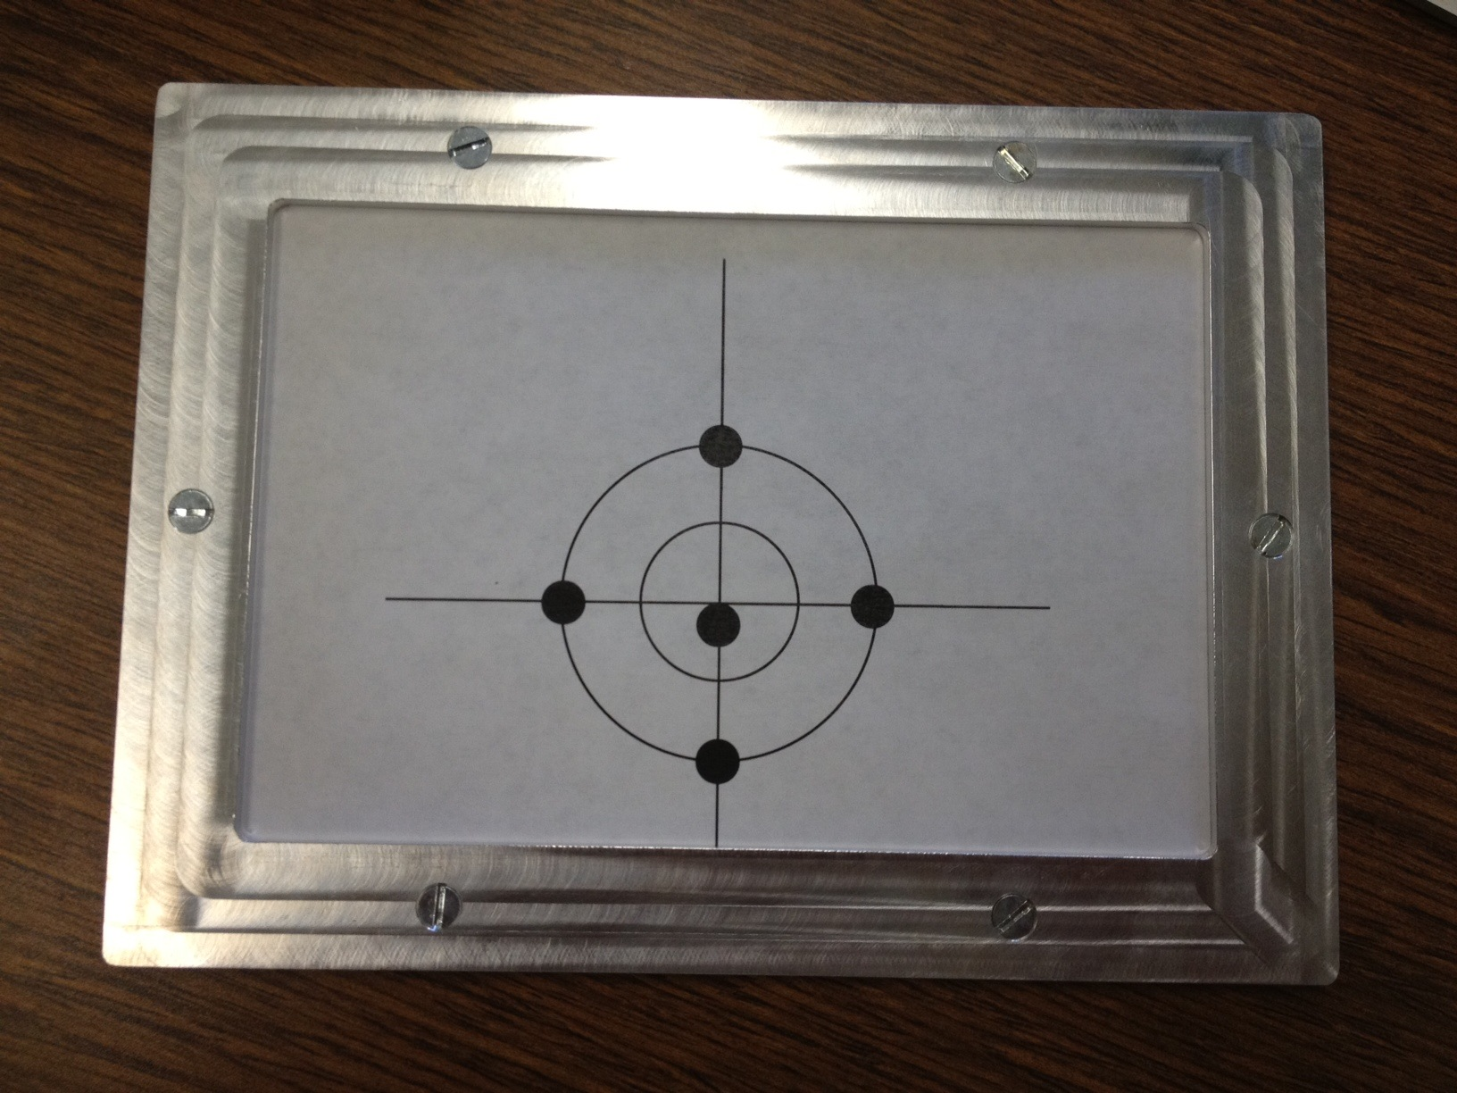

Figure 2: Laminated target with holes in holder

**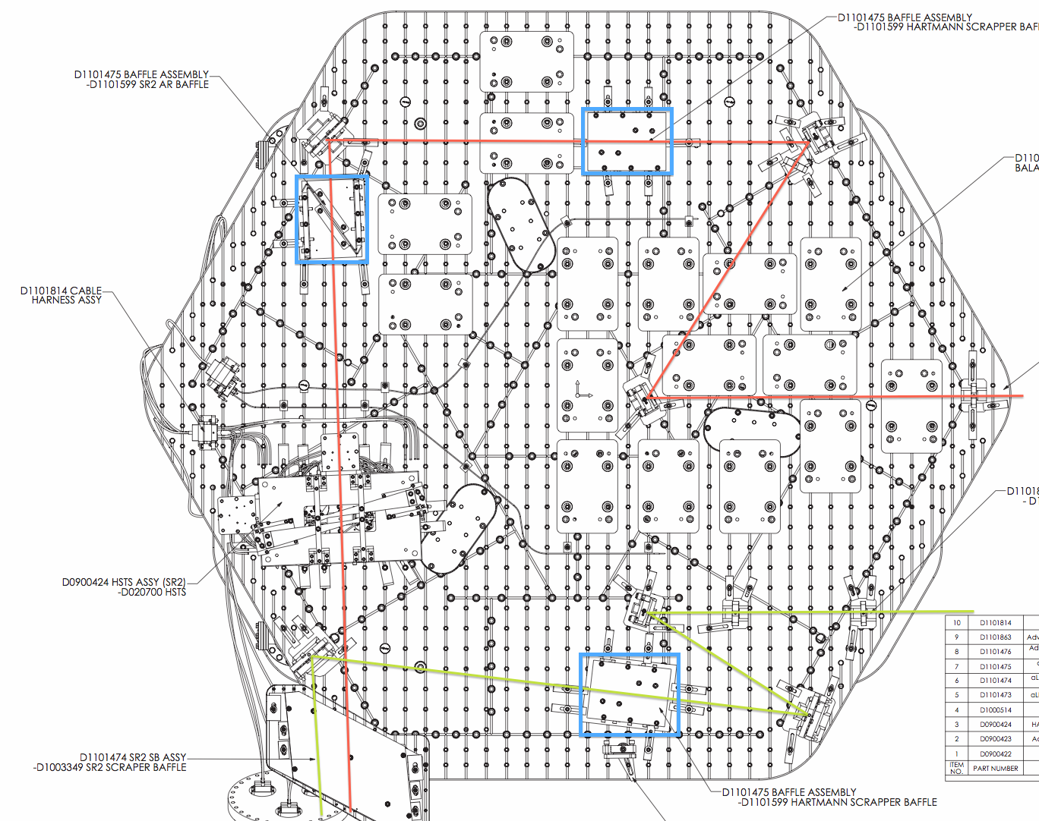**

Figure 3: Engineering diagram (D0900421) of HAM4. The scraper baffles are highlighted in blue. These may need to be adjusted during alignment to allow the alignment beam to pass directly through the center of these baffles.

**Notes:**

The transmission through the optical system to the HWS optics is calculated knowing the transmission spectra for each of the individual coatings (<https://nebula.ligo.caltech.edu/optics/>). The minimum transmission ranges from 0.15% to 0.6% for s and p polarizations at 532nm and 633nm.

For an input beam radius of 0.5mm at the ITM, the beam radius on the HWS optics in HAM4 is a maximum of 5mm. For 1mW of input laser power, the intensity after SR2 is around 20-30 nW/mm2. We have verified that 35nW/mm2 of 633nm radiation can be seen reasonably well on white paper in dim/dark viewing conditions. The human eye sees green better than red and will have no trouble seeing green at a similar intensity.

T1100149-v11_alignment_diagrams_no-table.pdf

Figure 4: Aligning in-vacuum optics without TCSHT4 in place

## Alignment Stage 2

### Part 1: on-table alignment

See T1400318 for the initial on-table alignment procedure.

### Part 2: Adjust the alignment into the vacuum system – use ALS green beam

1. Turn on and lock the ALS green beam to the FP arm cavity.
2. Observe the leakage field of that beam out of the vacuum system on the position detectors.
3. Adjust the pico-motor steering mirrors until the ALS beam yields the same coordinates on the position detectors as the previous two steps did. **The input axis is now aligned to the in-vacuum optical axis**.

## Alignment Stage 3 [Imaging the ITM]

1. Remove the Hartmann plate from the HWS
2. Bolt a Stainless Steel ruler alongside the HWS so that it can slide along the optical axis
3. Induce a sinusoidal YAW motion on the ITM at frequency *f.*
4. Measure the amplitude of the centroid of the Gaussian beam on the HWS.
5. Move the HWS along the optical axis by 5mm.
6. Repeat Steps 3 and 4 a total of 6x.
7. Locate the conjugate plane of the HWS relative to the ITM by plotting the amplitude of the oscillation (and include the sign) vs distance along the ruler. Fit a straight line to this data and determine the position at which this line crosses zero.
8. Move the HWS to the conjugate plane
9. Move the HWS one lever arm distance back from the conjugate plane (~11mm) to place the conjugate plane on the Hartmann plate rather than the CCD.
10. Replace the Hartmann plate
11. Determine the magnification by comparing the tilt at the HWS with the tilt measured by the optical lever.

### Required and demonstrated imaging precision

The conjugate plane of the HWS by the ITM must be located with a precision of +/-1500mm as described in [[T1000715 - Requirements for the ITM Hartmann Wavefront Sensor optical layout]](https://dcc.ligo.org/cgi-bin/private/DocDB/ShowDocument?docid=26293).

Therefore, we need to determine the corresponding precision in the measurement of the amplitude of the displacement of the beam on the HWS.

Vary the ITM yaw by a sinusoidal modulation with amplitude of Δφ. The displacement of the beam at the distance *Ltol* is ΔxCONJ = Δφ *Ltol*. The displacement of the beam at the on the HWS is ΔxHWS = ΔxCONJ/*M*, where *M* = 17.5x.

Assume a maximum angular change at the HWS of ~ 2 mrad (this displaces the Hartmann spots on the CCD by ~2 pixels). This corresponds to a yaw at the ITM of ~110 μrad at the ITM.

Therefore, the displacement of the Gaussian beam on the HWS must be sensed to better than:

,

Therefore, we need to measure the displacement of the Gaussian beam to better ~80% of a pixel (1 pixel = 12μm).

The measured error in the displacement of the Gaussian beam in the lab is 0.014 pixels. This corresponds to a precision in locating the image plane by the ITM of ~25mm. [Brooks Lab Book 11, page 144].

#### Positioning of HWS beam on ITM

This is accomplished via Step 22 in Section 6.2.3 and by ensuring that the ALS beam is co-linear with the 780-850nm beam.

# Outstanding issues

1. What is the status of the First Contact on the optics during this procedure?
2. Can we move the Hartmann table into position while the theodolites are in positions?

# Appendix: Alignment precision analysis (paraxial)

The 1D alignment precision of P-DET1 and P-DET2 is analyzed here. We wish to determine the precision that we can resolve the input location and angle, *yin* and *αin*, respectively.The *i*-th detector is placed a distance, *Li*, after a lens. The ABCD matrix for position on the detector is given by:



The sensing matrix, *Msens*, is:

.

The input axis (*yin*, *αin*) is given by:

.

Optimizing the sensing matrix is achieved by solving for minimum (wrt *L1* and *L2*) in the uncertainty in the input position. The uncertainty in the positions, *yi*, are the same and set by the detector. For a Thorlabs PDP90A, this is approximately 2.2 μm.

If we substitute in the common mode length, *X* = (*L1* + *L2*)/2 and the differential mode length, *x* = (*L1* - *L2*)/2, we find that the uncertainty in  is minimized if *X = f*, in other words, the two detectors are equal distances from the foci on opposite sides of the foci.

Lastly, we need only optimize the distance each detector is from the focus. The position sensitivity is improved as this is increased. However, the beam sizes become larger the further the detectors are from the focus. The Thorlabs PDP90A can sense the locations of beams of diameter 0.2mm to 7mm. If we specify that the Gaussian beam diameter of a beam can be no more than 1/3 the maximum diameter (= 2.3mm), we know the input sizes of the probe and alignment beams (= 17.4mm and 0.86mm, respectively), we assume that, to first order, the beams are collimated and we assume that f = 200mm, then we find that *x* ≈ 27mm.

Under these conditions, the positional uncertainty in the input axis is ≈ 11μm and the angular uncertainty is ≈ 8μrad.