LIGO Laboratory / LIGO Scientific Collaboration

LIGO- E1100297 LIGO January 20th, 2012

aLIGO BSC-ISI, Pre-integration Testing report,
Unit 4 - Phase I (post-assembly)
E1100297 – V2

Vincent Lhuillier

Distribution of this document:
Advanced LIGO Project

This is an internal working note
of the LIGO Laboratory

California Institute of Technology  LIGO Project – MS 18-34  1200 E. California Blvd.  Pasadena, CA 91125  Phone (626) 395-2129  Fax (626) 304-9834  E-mail: info@ligo.caltech.edu | Massachusetts Institute of Technology  LIGO Project – NW22-295  185 Albany St  Cambridge, MA 02139  Phone (617) 253-4824  Fax (617) 253-7014  E-mail: info@ligo.mit.edu
LIGO Hanford Observatory  P.O. Box 1970  Mail Stop S9-02  Richland WA 99352  Phone 509-372-8106  Fax 509-372-8137 | LIGO Livingston Observatory  P.O. Box 940  Livingston, LA 70754  Phone 225-686-3100  Fax 225-686-7189

Table of contents:

Introduction 4
I. Pre-Assembly Testing 5
▪ Step 1 - CPS Test and calibration – E1100369 5
▪ Step 2 - GS13 – Inspection/Assembly – E1000058 – E1100740 5
▪ Step 3 - L4C – Inspection/Assembly – E1000136 – E1100740 5
▪ Step 4 - T240 – Inspection/Assembly - E1100326 – E1100740 6
▪ Step 5 - Actuators - T0900564 - T1100234 – E1100741 6
II. Tests to be performed during assembly 7
▪ Step 1 - Test stand level 7
▪ Step 2 - Actuators Inventory 7
▪ Step 3 - Sensors Inventory 7
▪ Step 4 - Electronics Inventory 9
▪ Step 5 - Check level of Stage 0 after top-bottom plate assembly 9
▪ Step 6 - Check gaps under the blade posts 9
▪ Step 7 - Blade post shim thickness 10
▪ Step 8 - Blade 0-1 post launch angle 10
▪ Step 9 - Gap checks on actuators 10
▪ Step 10 - Mass budget 11
▪ Step 11 - Lockers adjustment 12
▪ Step 12 – Cables inventory – E1100822 13
▪ Step 13 - Cable routing 14
III. Tests to perform after assembly 14
▪ Step 1- Geophones pressure readout 14
▪ Step 2- Set up sensors gap – Locked vs unlocked position 14
▪ Step 3 - Measure the Sensor gap 15
Step 4- Performance of the limiters 15
o Step 4.1 - Test Nº1 - Push “in the general coordinates Z/RZ” 15
o Step 4.2 - Test Nº2 – Push “locally” 16
▪ Step 5 - Sensors Powespectra 17
▪ Step 6 - Coil Driver, cabling and resistance check 20
▪ Step 7- Actuators Sign and range of motion (Local drive) 21
o Step 7.1 - Actuators sign 21
o Step 7.2 - Range of motion - Local drive 21
▪ Step 8 - Vertical Sensor Calibration 22
▪ Step 9 - Vertical Spring Constant 22
▪ Step 10 - Static Testing (Tests in the local basis) 23
▪ Step 11- Static Testing - In the general coordinate basis (Static test - CPS) 24
o Step 11.1 – Change of basis matrices from Cartesian to Local 24
o Step 11.2 – Base change matrices from Cartesian to Cartesian 25
▪ Step 12 - Linearity test 26
▪ Step 13 – Transfer functions – Local to Local 28
▪ Step 14 - Symmetrization – Calibration 32
▪ Step 15 – Change of base – Cartesian to Cartesian - Simulations 32
▪ Step 16- Transfer functions - Cartesian to Cartesian - Measurements 35
▪ Step 17 - Lower Zero Moment Plan 35
o Step 17.1 - Stage 1 - LZMP 35
o Step 17.2 - Stage 2 - LZMP 35
▪ 35
▪ Step 18- Damping Loops – Transfer function – Simulations 36
o Step 18.1 - Damping Loops – Stage 2 36
o Step 18.2 - Damping Loops – Stage 1 36
▪ Step 19- Damping Loops – Powerspectra 36
▪ Step 20- Isolation Loops – for one unit per site 36
IV. BSC-ISI testing Summary 37

Introduction

The BSC-ISI testing is performed in three phases:
1) BSC-ISI, Pre-integration Testing, Phase I (post-assembly)
2) BSC-ISI, Pre-integration Testing, Phase II: Tests done after Transport (and possible storage), during mating phase with Suspensions, before insertion.
3) BSC-ISI, Integration Phase Testing: Procedure and results related to the commissioning in the chamber.

This document presents the series of tests (Phase I) performed on the fourth BSC-ISI assembled at LHO.

The testing procedure document E1000486-v5 was used.

All results are posted on the SVN at:
https://svn.ligo.caltech.edu/svn/seismic/BSC-ISI/X1/Unit4/

The following type of document can be found in the SVN:
- Excel spreadsheet (.xls)
- Data location
- Figures location
- Masses distribution scheme (ppt)

Pre-Assembly Testing

Step 1 - CPS Test and calibration – E1100369
CPS sensors are tested (calibration and noise test) at MIT before being cleaned and baked at LLO. The list of installed sensors used for testing (phase I) are reported in step II.3.

All data related to the CPS testing can be found in the SVN at
/svn/seismic/Common/Data/aLIGO_BSC_ISI_CPS/

Test result: Passed: X Failed: . Waived :. .

Step 2 - GS13 – Inspection/Assembly – E1000058 – E1100740
GS13 are tested and podded at LLO. We had to replace one GS-13 on this Unit due to a bad feed thru, the cable screw wouldn’t go all the way, leaving the cable the possibility to wobble. The feed thru is going to be inspected and tested again.
The list of installed sensors used for testing (phase I) are reported in step II.3.

All the data related to GS-13 post podding testing can be found in the SVN at : /svn/seismic/Common/Data/aLIGO_GS13_TestData/PostMod_TestResults_PDFs

E1000058 and E1100740 spreadsheets provide the status of each individual GS-13 at LLO site for HAM-ISI and BSC-ISI and the installation location of the geophones.

Test result: Passed: X Failed: . Waived :. .

Step 3 - L4C – Inspection/Assembly – E1000136 – E1100740
L4C are tested and podded at LLO. The list of installed sensors used for testing (phase I) are reported in step II.3.

All the data related to L4C post podding testing can be found in the SVN at : /svn/seismic/Common/Data/aLIGO_L4C_TestData/TestResults_PDFs/

Test result: Passed: X Failed: . Waived :. .

Step 4 - T240 – Inspection/Assembly - E1100326 – E1100740
T240 are tested and podded at LLO. We haven’t had to replace the T240s on this Unit, and these are the ones with the new Voltage Regulator, it seems that they are working fine and keep the pressure sensor from dying. The list of installed sensors used for testing (phase I) are reported in step II.3.

All the data related to T240 post podding testing can be found in the SVN at :
seismic/Common/Data/aLIGO_T240_TestData/AsReceived_TestResults_PDFs.

E1100326 and E1100740 spreadsheets provide the status of each individual T240 at LLO site for BSC-ISI and the installation location of the geophones.

Test result: Passed: X Failed: . Waived :. .

Step 5 - Actuators - T0900564 - T1100234 – E1100741
The list of installed sensors used for testing (phase I) are reported in step II.2
Large actuators data can be found at: T0900564. Actuator inventory is made at Section II – Step 2.
Small actuators data can be found at: T1100234. Actuator inventory is made at Section II – Step 2.

Test result: Passed: X Failed: . Waived :. .

Tests to be performed during assembly

Step 1 - Test stand level
The Test Stand was transformed and re-leveled to dock a BSC-ISI.

Test result: Passed: X Failed: . Waived :. .

Step 2 - Actuators Inventory
The actuators S/N are reported in the table below. Further information can be found in T0900564 and T1100234.

Stage 1 |  | Stage 2
Actuator | Actuator S/N | Actuator | Actuator S/N
ST1 - H1 | 04 | ST2 - H1 | 42
ST1 - H2 | 18 | ST2 - H2 | 41
ST1 - H3 | 186 | ST2 - H3 | 44
ST1 - V1 | 27 | ST2 - V1 | 46
ST1 - V2 | 177 | ST2 - V2 | 48
ST1 - V3 | 31 | ST2 - V3 | 45
Table 1 - Actuators' inventory

Test result: Passed: X Failed: . Waived :. .

Step 3 - Sensors Inventory
The sensors S/N are reported in the table below.

CPS Stage 1 | CPS S/N | ADE board serial #
H1 | 12951 | 12339
H2 | 13235 | 12410
H3 | 12959 | 12384
V1 | 12958 | 12341
V2 | 13444 | 12424
V3 | 12895 | 12826
Table 2 - Capacitive position sensors' inventory – Stage 1

CPS Stage 2 | CPS S/N | ADE board serial #
H1 | 12948 | 13076
H2 | 12961 | 12430
H3 | 13430 | 12576
V1 | 12904 | 12335
V2 | 12892 | 13064
V3 | 12945 | 12451
Table 3 - Capacitive position sensors' inventory – Stage 2

Geophones GS13 | Serial Number | POD
H1 | 865 | 67
H2 | 816 | 92
H3 | 862 | 43
V1 | 668 | 51
V2 | 768 | 58
V3 | 750 | 72
Table 4 - GS13 inventory

Geophones L4C | Serial Number | POD
H1 | 1104 | 96
H2 | 1120 | 94
H3 | 961 | 46
V1 | 925 | 35
V2 | 917 | 125
V3 | 801 | 42
Table 5 - L4C inventory

Geophones T240 | Serial Number | POD
1 | 107 | 37
2 | 143 | 34
3 | 103 | 4
Table 6 - T240 inventory

Test result: Passed: X Failed: . Waived :. .

Step 4 - Electronics Inventory
Write down in the table below all serial numbers all the electronic equipment:

Hardware | Ligo reference | S/N
Interface Chassis - Corner 1 | D1002432 | S110223
Interface Chassis - Corner 2 | D1002432 | S1102224
Interface Chassis - Corner 3 | D1002432 | S1102218
Anti-Alliasing Chassis - Corner 1 | D1002693 | S1102693
Anti-Alliasing Chassis - Corner 2 | D1002693 | S1102694
Anti-Alliasing Chassis - Corner 3 | D1002693 | S1102679
Anti-image Chassis | D070081 | S1000250
Binary Input Chassis | D1001726 | S1101309
Binary Input Chassis | D1001726 | S11031308
Binary Output Chassis | D1001728 | S1101347
T240 Interface - Corner 1 | D1002694 | S1101040
T240 Interface - Corner 2 | D1002694 | S1101838
T240 Interface - Corner 3 | D1002694 | S1101839
I/O Chassis | n/a
Coil driver Pod 1 | D0902744 | S1000266
Coil driver Pod 2 | D0902744 | S1000269
Coil driver Pod 3 | D0902744 | S110692
Table 7 - Electronic equipment

Note:

Test result: Passed: X Failed: . Waived :. .

Step 5 - Check level of Stage 0 after top-bottom plate assembly

Note: This test has not been performed

Test result: Passed: Failed: . Waived :. X .

Step 6 - Check gaps under the blade posts

Test result: Passed: X Failed: . Waived :. .

Step 7 - Blade post shim thickness
This table shows the shims thickness installed under the lockers.

Stage 0-1 |  | Stage 1-2
Lockers | Shim thickness (mil) | Lockers | Shim thickness (mil)
Corner 1 | 122 | Corner 1 | 122
Corner 2 | 122 | Corner 2 | 120
Corner 3 | 127 | Corner 3 | 123
Table 8 - Shims thickness

Acceptance criteria: Both D0901805 Stage 0-1 Locker Shims & D0902551 Stage 1-2 Locker Shims goes from .110” up to .130” with an increment of .001”.

Test result: Passed: X Failed: . Waived :. .

Step 8 - Blade 0-1 post launch angle

Test result: Passed: Failed: . Waived :. X .

Step 9 - Gap checks on actuators

Test result: Passed: X Failed: . Waived :. .

Step 10 - Mass budget
Note: The second version of the blade spacers was used. Consequently, the additional payload is expected to be close from design.

Six vibration absorbers were installed on stage 1. Masses on stage 2 are resting on Viton pads.

Stage 1:
The stage 1 payload is reported in the table below:
Stage 1
Location | Weight (lb)
Corner 1 | 50.0
Corner 2 | 55.0
Corner 3 | 34.0
Total | 139.0
Table 9 - Payload Stage 1

Nominal payload on stage 1: 109Kg – 101lb
Additional payload on stage 1 is 46 kg (101lb) less than expected but good enough.
Nominal mass of stage 1=916Kg - 2019lb
Stage 2:
The stage 2 payload is reported in the table below:
Mass Budget - Mass type | Quantity | Weight | Unit | Weight (lb)
 | 3 | 610 | lb | 1830
 | 2 | 233 | lb | 466
type 0 | 2 | 0.5 | lb | 1
type 1 | 9 | 1.1 | lb | 9.9
type 2 | 0 | 2.2 | lb | 0
type 3 | 3 | 4.5 | lb | 13.5
type 4 | 5 | 7.9 | lb | 39.5
type 5 | 1 | 15.6 | lb | 15.6
type 6 | 8 | 27.2 | lb | 217.6
 |  |  |  | 2593.1
Table 10 - Payload Stage 2

Nominal payload: 1183.4Kg – 2609lb
Total nominal mass of Stage 2: 2913.9Kg – 6424lb
Additional stage 2 payload is 16lb lighter than the design.

Error mass on stage 0-1 blades: -120/(6424+2019)=-1%
The Overall error on the payload is really low.

Test result: Passed: X Failed: . Waived :. .

Step 11 - Lockers adjustment

Stage 0-1 |  | Stage 1-2
Lockers | Shim thickness (mil) | Lockers | Shim thickness (mil)
Corner 1 | 122 | Corner 1 | 122
Corner 2 | 122 | Corner 2 | 120
Corner 3 | 127 | Corner 3 | 123
Table 11 - Shims under lockers

Test result: Passed: X Failed: . Waived :. .
\

Step 12 – Cables inventory – E1100822
The final Class A cables have been used for the testing of this Unit.
DCC Number | Description | Length (in) | Serial Number | Location
D1100154 | 25-pin M-to-two 9-pin F straight | 48 | S1104259 | L4C - C2
D1100154 | 25-pin M-to-two 9-pin F straight | 48 | S1104261 | L4C - C1
D1100154 | 25-pin M-to-two 9-pin F straight | 48 | S1104264 | L4C - ext - C3
D1100155 | 25-pin M-to-two 9-pin F straight | 120 | S1104123 | GS-13 - C3
D1100155 | 25-pin M-to-two 9-pin F straight | 120 | S1104247 | GS-13 - C1
D1100155 | 25-pin M-to-two 9-pin F straight | 120 | S1104248 | GS-13 - C2
D1100148 | 2-wire, 14awg 3-pin M to 3-pin F | 80 | S1106904 | ST1 - H3 - ext - C3
D1100148 | 2-wire, 14awg 3-pin M to 3-pin F | 80 | S1106914 | ST2 - V1 - ext - C1
D1100148 | 2-wire, 14awg 3-pin M to 3-pin F | 80 | S1106916 | ST2 - H3 - ext - C3
D1100148 | 2-wire, 14awg 3-pin M to 3-pin F | 80 | S1106918 | ST1 - H2 - ext
D1100148 | 2-wire, 14awg 3-pin M to 3-pin F | 80 | S1106919 | ST2 - V2 - ext
D1100148 | 2-wire, 14awg 3-pin M to 3-pin F | 80 | S1106920 | ST1 - V3 - ext
D1100148 | 2-wire, 14awg 3-pin M to 3-pin F | 80 | S1106922 | ST2 - H2 - ext
D1100148 | 2-wire, 14awg 3-pin M to 3-pin F | 80 | S1106926 | ST1 - V1 - ext
D1100148 | 2-wire, 14awg 3-pin M to 3-pin F | 80 | S1106928 | ST2 - V3 - ext
D1100148 | 2-wire, 14awg 3-pin M to 3-pin F | 80 | S1106938 | ST1 - H1 - ext
D1100148 | 2-wire, 14awg 3-pin M to 3-pin F | 80 | S1106942 | ST1 - V2 - ext
D1100150 | 2-wire, 14awg 2 pins to 3-pin F | 40 | S1107082 | ST1 - H1
D1100150 | 2-wire, 14awg 2 pins to 3-pin F | 40 | S1107089 | ST1 - V2
D1100150 | 2-wire, 14awg 2 pins to 3-pin F | 40 | S1107093 | ST1 - H3
D1100150 | 2-wire, 14awg 2 pins to 3-pin F | 40 | S1107099 | ST1 - H2 - ext
D1100150 | 2-wire, 14awg 2 pins to 3-pin F | 40 | S1107101 | ST1 - V3
D1100150 | 2-wire, 14awg 2 pins to 3-pin F | 40 | S1107102 | ST1 - V1
D1100151 | 2-wire, 14awg 2 pins to 3-pin F | 60 | S1107162 | ST2 - V2
D1100151 | 2-wire, 14awg 2 pins to 3-pin F | 60 | S1107171 | ST2 - H2
D1100151 | 2-wire, 14awg 2 pins to 3-pin F | 60 | S1107182 | ST2 - V3
D1100151 | 2-wire, 14awg 2 pins to 3-pin F | 60 | S1107194 | ST2 - V1
D1100151 | 2-wire, 14awg 2 pins to 3-pin F | 60 | S1107198 | ST2 - H1
D1100152 | 25-pin F-to-25-pin F | 110 | S1107230 | Trill - C3
D1100152 | 25-pin F-to-25-pin F | 110 | S1107236 | Trill - C2
D1100152 | 25-pin F-to-25-pin F | 110 | S1107238 | Trill - C1
D1100153 | 25-pin F-to-25-pin F | 80 | S1107309 | GS-13 - ext - C2
D1100153 | 25-pin F-to-25-pin F | 80 | S1107320 | L4C - ext - C1
D1100153 | 25-pin F-to-25-pin F | 80 | S1107321 | L4C - ext - C3
D1100153 | 25-pin F-to-25-pin F | 80 | S1107322 | L4C - ext - C2
D1100153 | 25-pin F-to-25-pin F | 80 | S1107323 | GS-13 - ext - C3
D1100153 | 25-pin F-to-25-pin F | 80 | S1107325 | GS-13 - ext - C1
D1100148 | 2-wire, 14awg 3-pin M to 3-pin F | 80 | S1106999 | ST2 - H1 - ext
D1100151 | 2-wire, 14awg 2 pins to 3-pin F | 60 | S1107208 | ST2 - H3
Test result: Passed: X Failed: . Waived:. .

Step 13 - Cable routing
The final Class A cables have been used for the testing of this Unit.
The cabling has been done following E1101027 aLIGO BSC-ISI Cable Routing Manual.

Test result: Passed: X Failed: . Waived :. .

Tests to perform after assembly

Step 1- Geophones pressure readout
Raw pressure measured by the geophones is reported in the table below:

 | Pressure (counts)
Sensors | Corner 1 | Corner 2 | Corner 3
ST1-L4C-P | -279 | -254 | -256
ST1-L4C-D | 24769 | 24652 | 24652
ST1-GS13-P | 1029 | 974 | 977
ST1-GS13-D | 24540 | 24729 | 24729
ST1-T240-P | 13542 | 13140 | 13142
Table 12 - Raw Pressure

Test result: Passed: X Failed: . Waived :. .

Step 2- Set up sensors gap – Locked vs unlocked position
During this step, sensors gap are adjusted. This step considers that the lockers have been finely setup during assembly.

 | Table locked |  | Table unlocked |  | Difference locked - unlocked
Sensors | Offset (Mean) | Std deviation | Offset (Mean) | Std deviation | Offset (Mean) | mil
ST1 - H1 | 178.4 | 7.7 | 341.5 | 40.0 | -163 | -0.19
ST1 - H2 | 222.8 | 6.8 | 487.9 | 28.1 | -265 | -0.32
ST1 - H3 | -337.0 | 7.4 | 11.6 | 26.3 | -349 | -0.41
ST1 - V1 | 30.8 | 5.5 | -439.1 | 30.1 | 470 | 0.56
ST1 - V2 | -174.3 | 5.6 | -274.9 | 32.8 | 101 | 0.12
ST1 - V3 | 408.3 | 8.2 | 249.5 | 24.9 | 159 | 0.19
ST2 - H1 | -386.8 | 23.2 | -319.3 | 35.5 | -67 | -0.02
ST2 - H2 | -182.3 | 42.5 | -257.1 | 37.6 | 75 | 0.02
ST2 - H3 | -592.0 | 43.0 | -265.7 | 55.9 | -326 | -0.10
ST2 - V1 | 16.7 | 31.1 | -576.3 | 72.9 | 593 | 0.18
ST2 - V2 | -125.6 | 40.4 | 96.9 | 83.2 | -222 | -0.07
ST2 - V3 | -227.5 | 30.9 | -1139.7 | 61.2 | 912 | 0.27
Table 13 - Capacitive position sensors readout after gap set-up

Acceptance criteria:
- In the locked position, all mean values must be lower than 400 counts for stage 1 CPS and 1600 counts for stage 2 CPS on Dataviewer (a bit less than .0005”).
- In the locked position, all standard deviations below 25 counts for stage 1, 100 counts for stage 2
- Absolute values of the difference between the unlocked and the locked table must be below:
Stage 1
  - 1600 cts for horizontal sensors (~0.002”)
  - 1600 cts for vertical sensors (~0.002”)
Stage 2
  - 6500 cts for horizontal sensors (~0.002”)
  - 6500 cts for vertical sensors (~0.002”)
- Considering the acceptance criteria of step 2, all mean values must be lower than
Stage 1
  - 2000 cts for horizontal sensors (~0.0025”)
  - 2000 cts for vertical sensors (~0.0025”)
Stage 2
  - 8000 cts for horizontal sensors (~0.0025”)
  - 8000 cts for vertical sensors (~0.0025”)

Note: The CPS will be readjusted once SUS will installed

Test result: Passed: X Failed: . Waived :. .

Step 3 - Measure the Sensor gap
Test Failure mitigation:
This test was not performed. The sensor gaps have not been measured. These sensors have already been tested at LASTI. Moreover, risks of scratching the target are so high that we preferred not performing this test. In the future, this test will be removed from the testing procedure.

Test result: Passed: Failed: . Waived :. X .

Step 4- Performance of the limiters

Step 4.1 - Test Nº1 - Push “in the general coordinates Z/RZ”

Test result: Passed: Failed: . Waived :. X .

Step 4.2 - Test Nº2 – Push “locally”

Sensors | Push in positive direction | Push in negative direction | Mil | Mil | Railing | Actuator Gap Check
ST1 - H1 | 20000 | -17000 | 24 | -20 |  | X
ST1 - H2 | 18000 | -16000 | 21 | -19 |  | X
ST1 - H3 | 18500 | -18000 | 22 | -21 |  | X
ST1 - V1 | 25000 | -21000 | 30 | -25 |  | X
ST1 - V2 | 21000 | -21000 | 25 | -25 |  | X
ST1 - V3 | 20000 | -19000 | 24 | -23 |  | X
ST2 - H1 |  |  |  |  | X | X
ST2 - H2 |  |  |  |  | X | X
ST2 - H3 |  |  |  |  | X | X
ST2 - V1 |  |  |  |  | X | X
ST2 - V2 |  |  |  |  | X | X
ST2 - V3 |  |  |  |  | X | X
Table 14 - Stages range of motion – “Push locally”

Acceptance criteria:
- The vertical sensor readout must be positive when the optical table is pushed in the +Z direction
- The horizontal sensor readout on Stage 2 must be positive when the optic table is pushed in the +RZ direction
- Step 4.2
  - Absolutes value of all estimated motions must be higher than 15000counts for stage 1 (~0.018”)
  - Absolutes value of all estimated motions must be higher than 32000counts for stage 2 (~0.010”)

Test result: Passed: X Failed: . Waived :. .

Step 5 - Sensors Powespectra
The geophones powerspectra have been measured and can be found in the SVN:

seismic/BSC-ISI/X1/UNIT_4/Data/Spectra/Undamped/
- X1_ISI_ITMX_ASD_m_LOC_CPS_T240_L4C_GS13_2013_01_09_124251.mat (Unlocked)
- X1_ISI_ITMX_ASD_m_LOC_CPS_T240_L4C_GS13_2013_01_22_073717.mat (Locked)

seismic/BSC-ISI/X1/UNIT_4/Data/Figures/Spectra/Undamped/
- X1_ISI_ITMX_ASD_m_LOC_CPS_T240_L4C_GS13_2013_01_09_124251.fig (Unlocked)
- X1_ISI_ITMX_ASD_m_LOC_CPS_T240_L4C_GS13_2013_01_22_073717.fig (Locked)

Stage locked – unlocked
The powerspectra are measured in two different configurations:
- Stage 1 locked – Stage 2 locked
- Stage 1 unlocked – Stage 2 unlocked

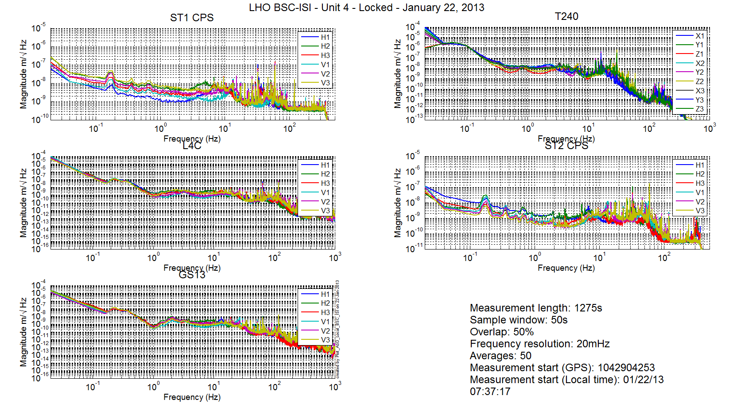
Figure 1: Spectra Stage 1 Locked Stage 2 Locked

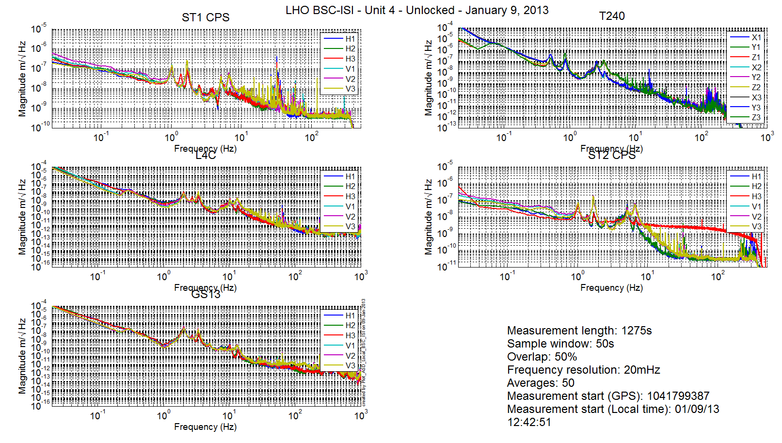
Figure 2: Spectra Stage 1 Unlocked Stage 2 Unlocked

Note: ST2 CPS-V3 was changed on January 10th 2013.

Stage Tilted
The powerspectra are measured when the ISI is unlocked a mass is placed on stage 2 to tilt Stage 1 and Stage 2.
The six configurations are the following in six different configurations:
- Mass placed in the actuator pocket at corner 1
- Mass placed in the pocket under the blade 0-1 at corner 1
- Mass placed in the actuator pocket at corner 2
- Mass placed in the pocket under the blade 0-1 at corner 2
- Mass placed in the actuator pocket at corner 3
- Mass placed in the pocket under the blade 0-1 at corner 3

/seismic/BSC-ISI/X1/UNIT_4/Data/Spectra/Undamped/
- X1_ISI_ITMX_ASD_m_L4C_GS13_Stage_Tilted_2013_01_09.mat

seismic/BSC-ISI/X1/UNIT_4/Data/Figures/Spectra/Undamped/
- X1_ISI_ITMX_Tilted_ASD_m_LOC_ST1_L4C_2013_01_09.fig
- X1_ISI_ITMX_Tilted_ASD_m_LOC_ST2_GS13_2013_01_09.fig
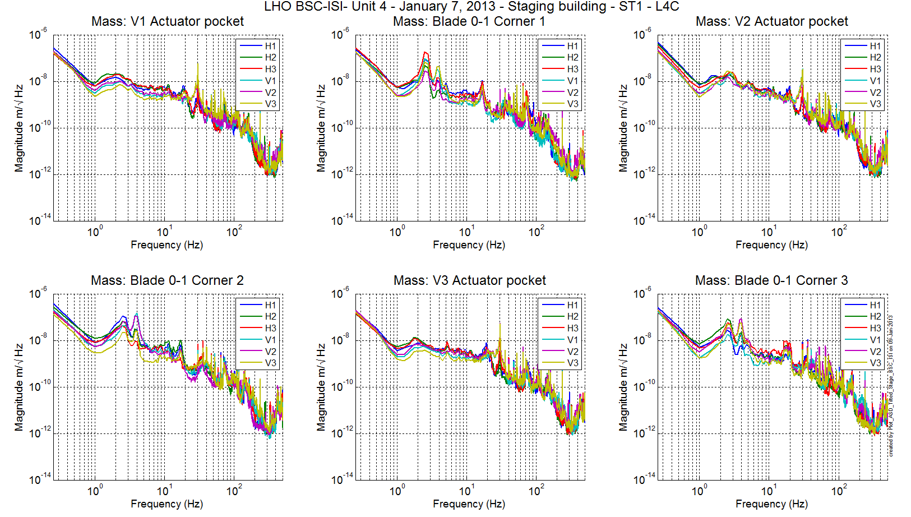
Figure 3 - ST1 L4C – Tilted

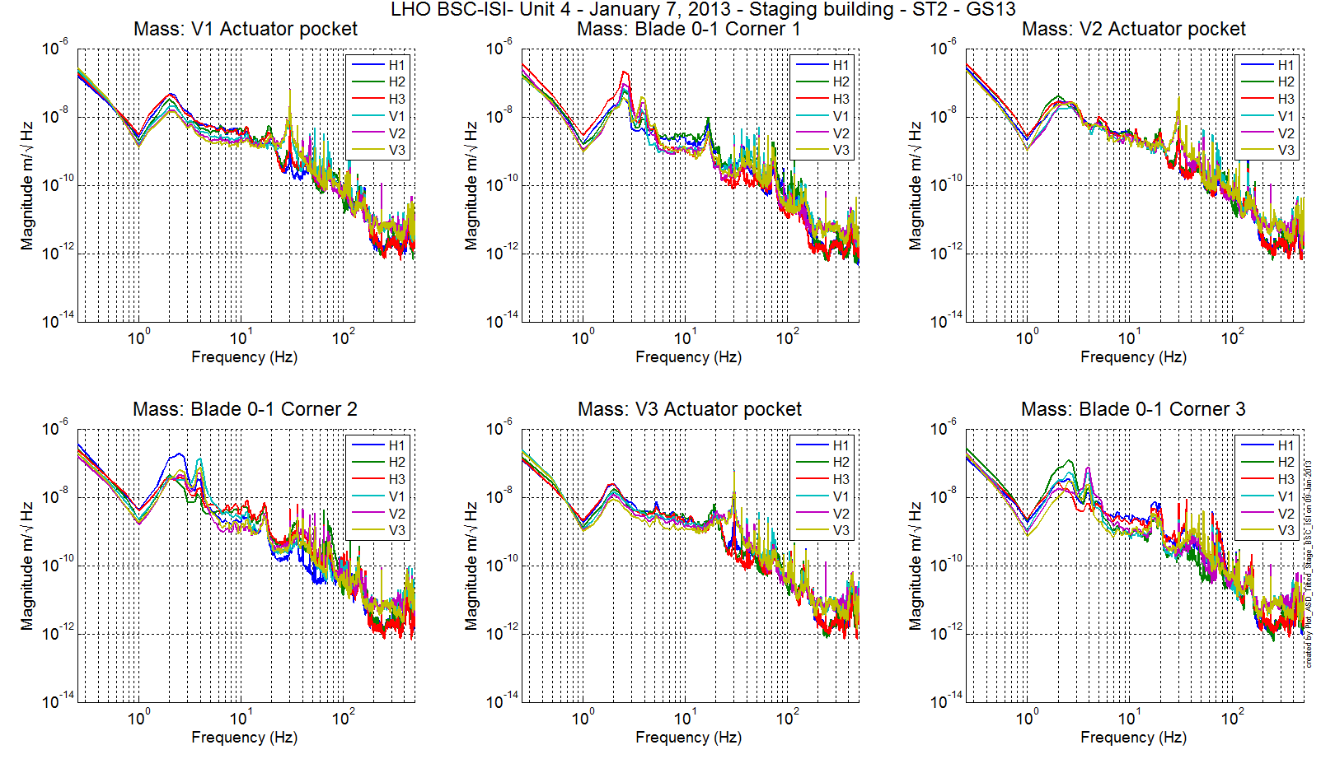
Figure 4 - ST1 GS13 – Tilted

Test result: Passed: X Failed: . Waived :. .

Step 6 - Coil Driver, cabling and resistance check
Resistances of the couple (actuators + in vacuum cables) were measured using the voltage and current the coil drivers read back. Resistances of the couple actuator + in-vacuum cables are reported in the table below:

Actuator | Coil driver name | Resistance (Ω)
ST1 H1 | Coil1 Coarse 1 | 6.4
ST2 H1 | Coil 1 Fine 1 | 10.1
ST2 V1 | Coil 1 Fine 2 | 10.1
ST1 V1 | Coil 1 Coarse 2 | 6.3
ST1 H2 | Coil 2 Coarse 2 | 6.4
ST2 H2 | Coil 2 Fine 1 | 10.1
ST2 V2 | Coil 2 Fine 2 | 10.1
ST1 V2 | Coil 2 Coarse 2 | 6.4
ST1 H3 | Coil 3 Coarse 1 | 6.4
ST2 H3 | Coil 3 Fine 1 | 10.1
ST2 V3 | Coil 3 Fine 2 | 10
ST1 V3 | Coil 3 Coarse 2 | 6.3
Table 15 - Actuator Resistance

Acceptance criteria:
- For the actuators of stage 1, the measured resistance between the middle pin and one side pin must be 6.3 +/-0.5 ohms
- For the actuators of stage 2, the measured resistance between the middle pin and one side pin must be 10.3 +/-0.5 ohms
- Actuator neutral pins must be connected on pin #1 (left side pin of the plug)
- Actuator drive pins must be connected on pin #2 (middle pin of the plug)
- Actuator ground shield pins must be connected on pin #3 (right pin of the plug)
- All LEDs on the coil driver front panel must be green the binary input bit must be in the upper state.

Test result: Passed: X Failed: . Waived :. .

Step 7- Actuators Sign and range of motion (Local drive)

Step 7.1 - Actuators sign

Test result: Passed: X Failed: . Waived :. .

Step 7.2 - Range of motion - Local drive
In this step, range of motion of the two stages is checked when applying a local drive (30000 counts) on actuators.
seismic/BSC-ISI/X1/UNIT_4/Data/Static_Tests/ :
- X1_ISI_ITMX_Range_Of_Motion_20130122.mat

Sensor readout (counts) | Negative drive | no drive | Positive drive | Amplitude count | mil
ST1 - H1 | -16071 | 423 | 16158 | 32229 | 38
ST1 - H2 | -16485 | 248 | 15918 | 32404 | 39
ST1 - H3 | -16772 | -136 | 15418 | 32190 | 38
ST1 - V1 | -15172 | -142 | 14976 | 30148 | 36
ST1 - V2 | -14631 | -79 | 14610 | 29241 | 35
ST1 - V3 | -14048 | 746 | 15548 | 29596 | 35
ST2 - H1 | -10631 | -436 | 9755 | 20387 | 6.1
ST2 - H2 | -10014 | 71 | 10172 | 20186 | 6.0
ST2 - H3 | -9734 | 207 | 10157 | 19891 | 5.9
ST2 - V1 | -12560 | -187 | 12190 | 24750 | 7.4
ST2 - V2 | -11800 | 491 | 12782 | 24582 | 7.3
ST2 - V3 | -12892 | -844 | 11208 | 24100 | 7.2
Table 16 - Range of motion - Local drive

Acceptance criteria:
- Amplitude p-p must be at least 30000 counts (0.035”) for Stage 1 CPS H
- Amplitude p-p must be at least 25000 counts (0.03”) for Stage 1 CPS V
- Amplitude p-p must be at least 18000 counts (0.005”) for Stage 2 CPS H
- Amplitude p-p must be at least 22000 counts (0.006”) for Stage 2 CPS V
- Signs of actuators drive and sensors read out have to be the same

Note: The motion of the platform can be computed. For a 30000 counts drive in the +Z direction, the platform should move by 12.6 mil on Stage 1 and 3.6mil on Stage 2.

In the Cartesian basis, the platform should move (calculation) by:
Stage 1 - Platform move for 32K counts drive: | 12.63 | mil
Stage 2 - Platform move for 32K counts drive: | 3.59 | mil

Note: The range of motion in the case of a “local drive” is in agreements with the measurements done on the previous units.

Test result: Passed: X Failed: . Waived :. .

Step 8 - Vertical Sensor Calibration
This test is inaccurate due to the important hysteresis introduced by the dial indicators. Moreover, the sensors calibrations have been checked at LASTI. This test has not been performed on LLO Unit 2.

Test result: Passed: Failed: . Waived :. X .

Step 9 - Vertical Spring Constant
This test is realized by loading the ISI when one stage is locked and using the capacitive position sensors as reference.

The stiffness measurements of the spring are reported in the tables below. The nominal blade stiffness are:
- Stage 1: 1241lb/in
- Stage 2: 1465lb/in

Blade Stage 0-1
Stage 2 Locked & Stage 1 Unlocked.

 | Mean no load | Mean load 15Kg | Mean Load 30Kg | Diff – Load 15Kg | Diff – Load 30Kg
V1 | -446.5 | -8055 | -15592 | -7610 | -15144
V2 | -261 | -7886 | -15707 | -7622 | -15449
V3 | 231.5 | -7476 | -15082 | -7713 | -15308
 |  |  |  | -7648.89 | -15300 | count
 |  |  |  | -9.19 | -18.383 | mil
 |  |  |  | -1198.39 | -1198.2 | lb/in
 |  |  |  | -3.43 | -3.45 | %

The blades from stage 0 to stage 1 are too soft by 3.5%.

Blade Stage 1-2
Stage 1 Locked & Stage 2 Unlocked. Stage 2 is loaded with 3 x 5Kg masses and the measurements are repeated three times (by rotating the masses).

 | Mean No load | Mean Load | Diff
V1 | -550 | -26001 | -25451
V2 | -4.5 | -26472 | -26467.5
V3 | -1160 | -26673 | -25513
 |  |  | -25811 | count
 |  |  | -7.75 | mil
 |  |  | -1408 | lb/in
 |  |  | -3.88 | %
In this section we measured the blade stiffness:
- Stage 0-1 blades are softer by 3.5% than design
- Stage 1-2 blades are softer by 3.9% than design

Test mitigation: Blades are softer than design. The low stiffness measurement is in good agreements with the mass budget. The rigid body modes frequencies should be close from design.

Test result: Passed: X Failed: . Waived :. .

Step 10 - Static Testing (Tests in the local basis)
The static tests results are reported in the SVN at :
seismic/BSC-ISI/X1/UNIT_4/Data/Static_Tests/

The table below shows the main and the cross-coupling when the actuators are driven in the local basis:
 |  | Sensors
 |  | ST1 - H1 | ST1 - H2 | ST1 - H3 | ST1 - V1 | ST1 - V2 | ST1 - V3
Actuators | ST1 - H1 | 4287 | 1723 | 1736 | -6 | 5 | -1
Actuators | ST1 - H2 | 1691 | 4206 | 1706 | 5 | 20 | 3
Actuators | ST1 - H3 | 1673 | 1664 | 4161 | -5 | 6 | -6
Actuators | ST1 - V1 | 42 | -177 | 90 | 3527 | -650 | -623
Actuators | ST1 - V2 | 98 | 36 | -146 | -606 | 3425 | -626
Actuators | ST1 - V3 | -157 | 98 | 40 | -645 | -597 | 3458
Table 17 - Static test - Local to local - Stage 1

 |  | Sensors
 |  | ST2 - H1 | ST2 - H2 | ST2 - H3 | ST2 - V1 | ST2 - V2 | ST2 - V3
Actuators | ST2 - H1 | 2391 | 373 | 356 | -2 | -1 | -6
Actuators | ST2 - H2 | 364 | 2387 | 368 | 13 | 20 | -10
Actuators | ST2 - H3 | 359 | 357 | 2337 | -12 | 22 | 23
Actuators | ST2 - V1 | 80 | 144 | -211 | 2895 | 326 | -51
Actuators | ST2 - V2 | -199 | 87 | 118 | -7 | 2901 | 327
Actuators | ST2 - V3 | 117 | -189 | 89 | 275 | 14 | 2827
Table 18 - Static test - Local to local - Stage 2

Acceptance criteria:
- Main couplings readout must be positive
- Comparison with the reference tables:
  - Main coupling differences mustn’t exceed 200 counts
  - Cross coupling differences mustn’t exceed 50 counts

Test result: Passed: X Failed: . Waived :. .

Step 11- Static Testing - In the general coordinate basis (Static test - CPS)

Step 11.1 – Change of basis matrices from Cartesian to Local
The static tests results are reported in the SVN at :
/seismic/BSC-ISI/X1/UNIT_4/Data/Static_Tests/

 |  | Sensors
 |  | ST1 - H1 | ST1 - H2 | ST1 - H3 | ST1 - V1 | ST1 - V2 | ST1 - V3
Actuators | ST1 - X | 1740 | -802 | -797 | 0 | 0 | 7
Actuators | ST1 - Y | 10 | 1491 | -1419 | -7 | -1 | 3
Actuators | ST1 - Z | -14 | 0 | -10 | 764 | 719 | 729
Actuators | ST1 - RX | 16 | 168 | -148 | -2915 | 2418 | 444
Actuators | ST1 - RY | -179 | 115 | 74 | -1171 | -1895 | 3049
Actuators | ST1 - RZ | 3113 | 3112 | 3088 | -7 | 7 | -10
 |  | Sensors
 |  | ST2 - H1 | ST2 - H2 | ST2 - H3 | ST2 - V1 | ST2 - V2 | ST2 - V3
Actuators | ST2 - X | 668 | -1325 | 645 | -58 | -27 | 7
Actuators | ST2 - Y | 1179 | 35 | -1150 | -20 | -42 | -31
Actuators | ST2 - Z | -6 | 28 | -2 | 1011 | 1055 | 1011
Actuators | ST2 - RX | -284 | 12 | 268 | -2479 | 2452 | 1
Actuators | ST2 - RY | 149 | -301 | 181 | -1619 | -1418 | 2813
Actuators | ST2 - RZ | 1776 | 1797 | 1745 | -45 | -54 | -32
Table 19 - Static test - Cartesian to local - Stage 1 – Stage 2

Acceptance criteria:

- Comparison with the reference tables:
  - Differences mustn’t exceed 100 counts

Test result: Passed: X Failed: . Waived :. .

Step 11.2 – Base change matrices from Cartesian to Cartesian
The static tests results are reported in the SVN at :
/seismic/BSC-ISI/X1/UNIT_4/Data/Static_Tests/

 |  | Sensors
 |  | ST1 - X | ST1 - Y | ST1 - Z | ST1 - RY | ST1 - RY | ST1 - RZ
Actuators | ST1 - X | 1715 | -9 | -5 | -4 | 7 | 53
Actuators | ST1 - Y | 3 | 1674 | -3 | 4 | 0 | 32
Actuators | ST1 - Z | 8 | -4 | 731 | -25 | -1 | -10
Actuators | ST1 - RX | -2 | 362 | -17 | 3006 | 15 | 9
Actuators | ST1 - RY | -360 | 19 | -7 | 26 | 2974 | 6
Actuators | ST1 - RZ | 31 | 7 | -8 | 8 | -8 | 3236
Table 20 - Static test Cartesian drive – Cartesian to local – Stage 1

 |  | Sensors
 |  | ST2 - X | ST2 - Y | ST2 - Z | ST2 - RY | ST2 - RY | ST2 - RZ
Actuators | ST2 - X | 1349 | 12 | -22 | -7 | 21 | -2
Actuators | ST2 - Y | 5 | 1337 | -43 | -31 | 6 | 25
Actuators | ST2 - Z | 7 | -13 | 1028 | 10 | -28 | 8
Actuators | ST2 - RX | 1 | -28 | -25 | 4185 | 67 | 2
Actuators | ST2 - RY | 19 | -10 | -77 | 62 | 4244 | 14
Actuators | ST2 - RZ | -7 | 27 | -34 | -16 | 3 | 2564
Table 21 - Static test Cartesian drive – Cartesian to local – Stage 2

Acceptance criteria:

- Main couplings readout must be positive
- Comparison with the reference tables:
  - Main coupling differences mustn’t exceed 200 counts
  - Cross coupling differences mustn’t exceed 50 counts

Test result: Passed: X Failed: . Waived :. .

Step 12 - Linearity test
The “Linearity test” was performed twice (rearranging the cables). The second time, all corners seemed to respond similarly.

The linearity test data can be found in the SVN at:
/seismic/BSC-ISI/X1/UNIT_4/Data/Linearity_Test/
X1_ISI_ITMX_Linearity_test_20130110.mat

The linearity test figures can be found in the SVN at:
/seismic/BSC-ISI/X1/UNIT_4/Data/Figures/Linearity_Test/
- X1_ISI_ITMX_Linearity_test_20130110.fig

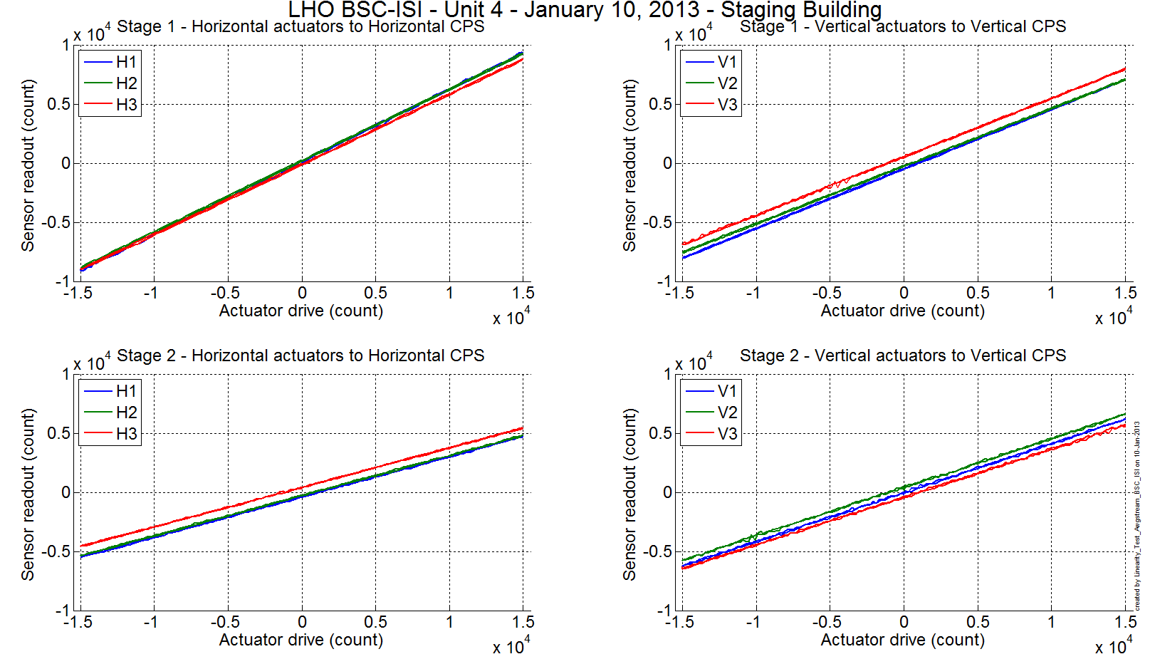
Figure 5 - Linearity Test

Slope – Offset:

 |  | Slope | Offset | Average slope | Variation from  average(%)
Stage 1 | ST1 - H1 | 0.613 | 108 | 0.6034 | 1.67
Stage 1 | ST1 - H2 | 0.604 | 204 | 0.6034 | 0.07
Stage 1 | ST1 - H3 | 0.593 | -107 | 0.6034 | -1.74
Stage 1 | ST1 - V1 | 0.504 | -487 | 0.4954 | 1.68
Stage 1 | ST1 - V2 | 0.488 | -253 | 0.4954 | -1.53
Stage 1 | ST1 - V3 | 0.495 | 536 | 0.4954 | -0.15
Stage 2 | ST2 - H1 | 0.341 | -401 | 0.3380 | 0.87
Stage 2 | ST2 - H2 | 0.339 | -281 | 0.3380 | 0.33
Stage 2 | ST2 - H3 | 0.334 | 411 | 0.3380 | -1.20
Stage 2 | ST2 - V1 | 0.414 | -32 | 0.4100 | 0.99
Stage 2 | ST2 - V2 | 0.412 | 413 | 0.4100 | 0.41
Stage 2 | ST2 - V3 | 0.404 | -410 | 0.4100 | -1.41
Table 22 - Slopes and offset of the triplet Actuators - BSC-ISI – Sensors

Acceptance criteria:
- Horizontal and vertical slopes of the triplet actuators x BSC-ISI x sensors: Average slope +/- 2.5%

Test result: Passed: X Failed: . Waived :. .

Step 13 – Transfer functions – Local to Local
Note: two vibration absorbers were installed in corner 1 and 2 vibration absorbers were installed in corner 3. No TMDs were installed on the stage 0-1 blades.

Data files measurement of local to local transfer functions in SVN at:
seismic/BSC-ISI/X1/UNIT_4/Data/Transfer_Functions/Measurements/Undamped/
- X1_ISI_ITMX_Data_L2L_10mHz_100mHz_ST1_ST2_20130111-050023.mat
- X1_ISI_ITMX_Data_L2L_100mHz_700mHz_ST1_ST2_20130110-233712.mat
- X1_ISI_ITMX_Data_L2L_700mHz_10Hz_ST1_ST2_20130110-184619.mat
- X1_ISI_ITMX_Data_L2L_10Hz_100Hz_ST1_ST2_20130111-064353.mat
- X1_ISI_ITMX_Data_L2L_100Hz_500Hz_ST1_ST2_20130110-171116.mat
- X1_ISI_ITMX_Data_L2L_500Hz_1000Hz_ST1_ST2_20130110-155437.mat

Script file for processing and plotting local to local transfer functions in SVN at:
/seisvn/seismic/BSC-ISI/X1/UNIT_4/Scripts/Control_Scripts
- Step_1_TF_L2L_10mHz_1000Hz_X1_ISI_Unit_4.m

Figures of local to local transfer functions (Main couplings) in SVN at:
/seismic/BSC-ISI/X1/UNIT_4/Data/Figures/Transfer_Functions/Measurements/Undamped/

Measured of local to local transfer functions in the SVN at:
/svncommon/seisvn/seismic/BSC-ISI/X1/UNIT_4/Data/Transfer_Functions/Simulations/Undamped

Note 1: The transfer functions are measured from the Output filter bank (excitation variable) to the input (IN1) of the input filter bank. The transfer functions presented below are raw transfer functions without any electronic compensation of the sensor electronic. The actuator and the coil driver electronic compensation are introduced in these transfer functions.

Note 2: The L4Cs are out of phase (should be -90 before 1Hz). A minus sign is added in the calibration filters that convert count to nm/s.

Note 3: The first resonance of the test stand can be seen at 33Hz on Stage 1 CPS.

Note 4: The first resonance of the structure observed on stage 1 by the L4C is around 210Hz.

Note 5: There is a poor coherence on the GS13 transfer functions. It can be explained by the weak drive of the fine actuators. Moreover, the stage 2 of the ISI is strongly excited by the fans of the clean rooms. These two factors strongly affect the quality of the measurements.

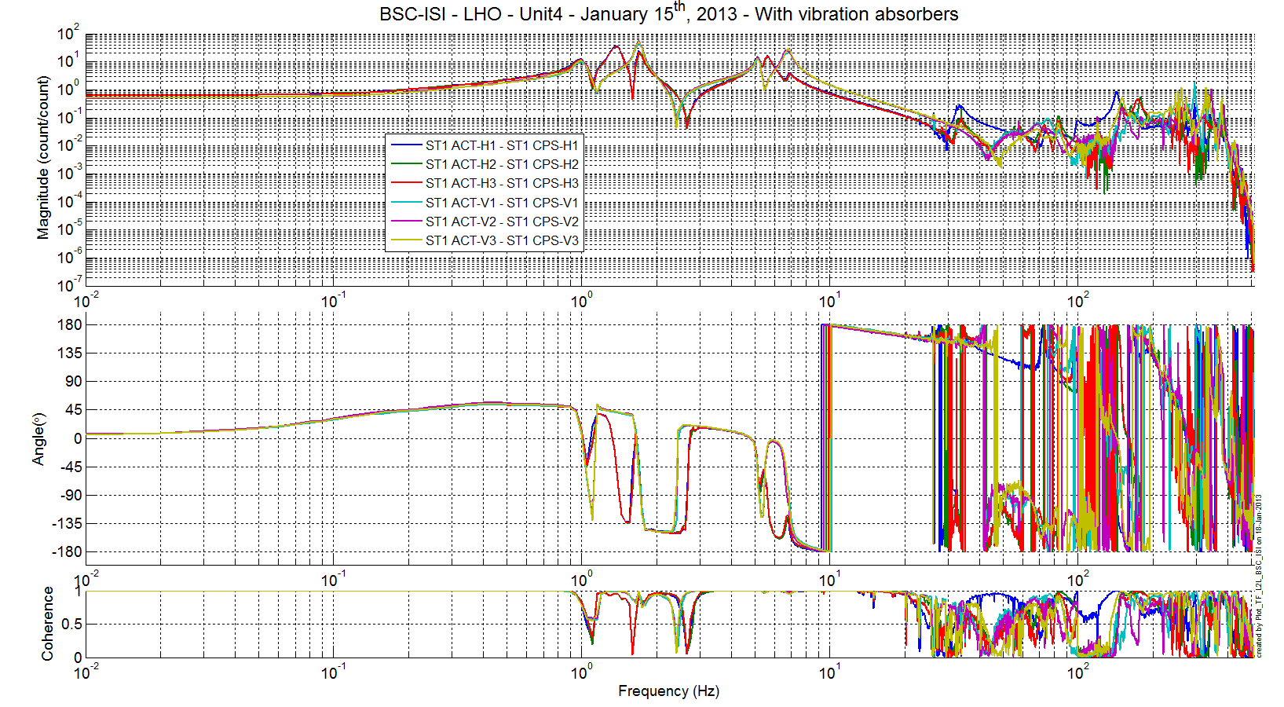
Figure 6: TF L2L Raw - ST1 Act to ST1 CPS

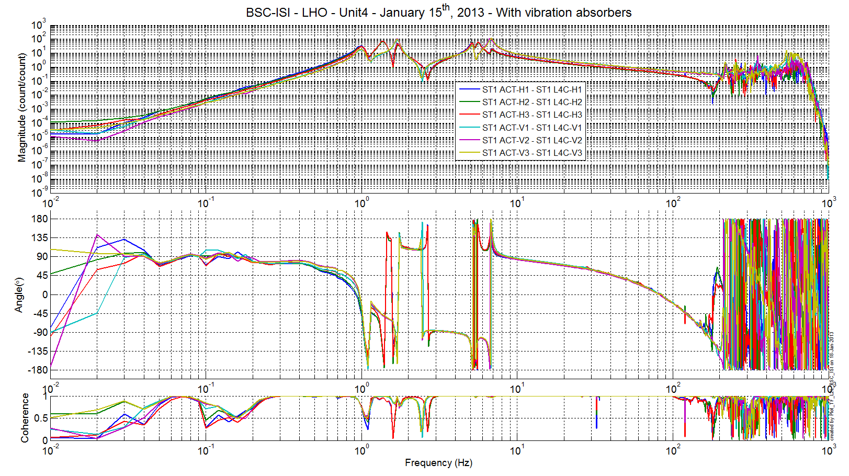
Figure 7: TF L2L Raw - ST1 Act to ST1 L4C

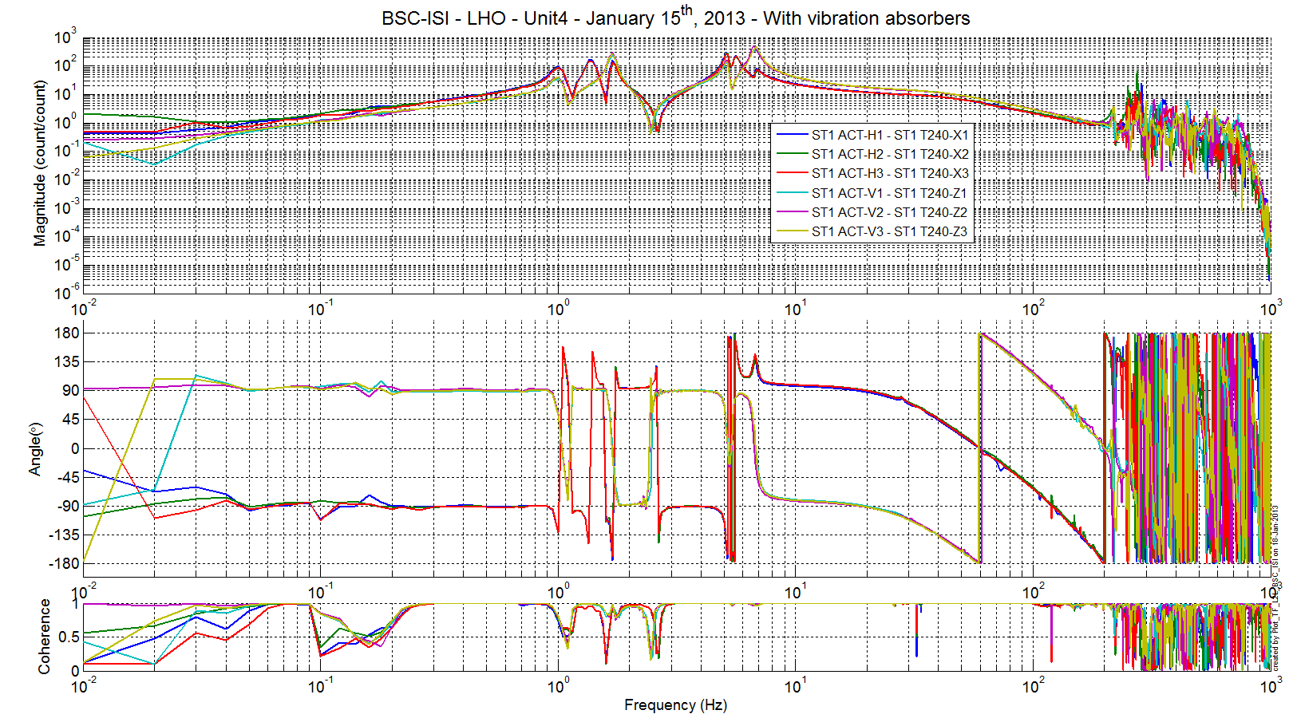
Figure 8 - TF L2L Raw - ST1 Act to ST1 T240

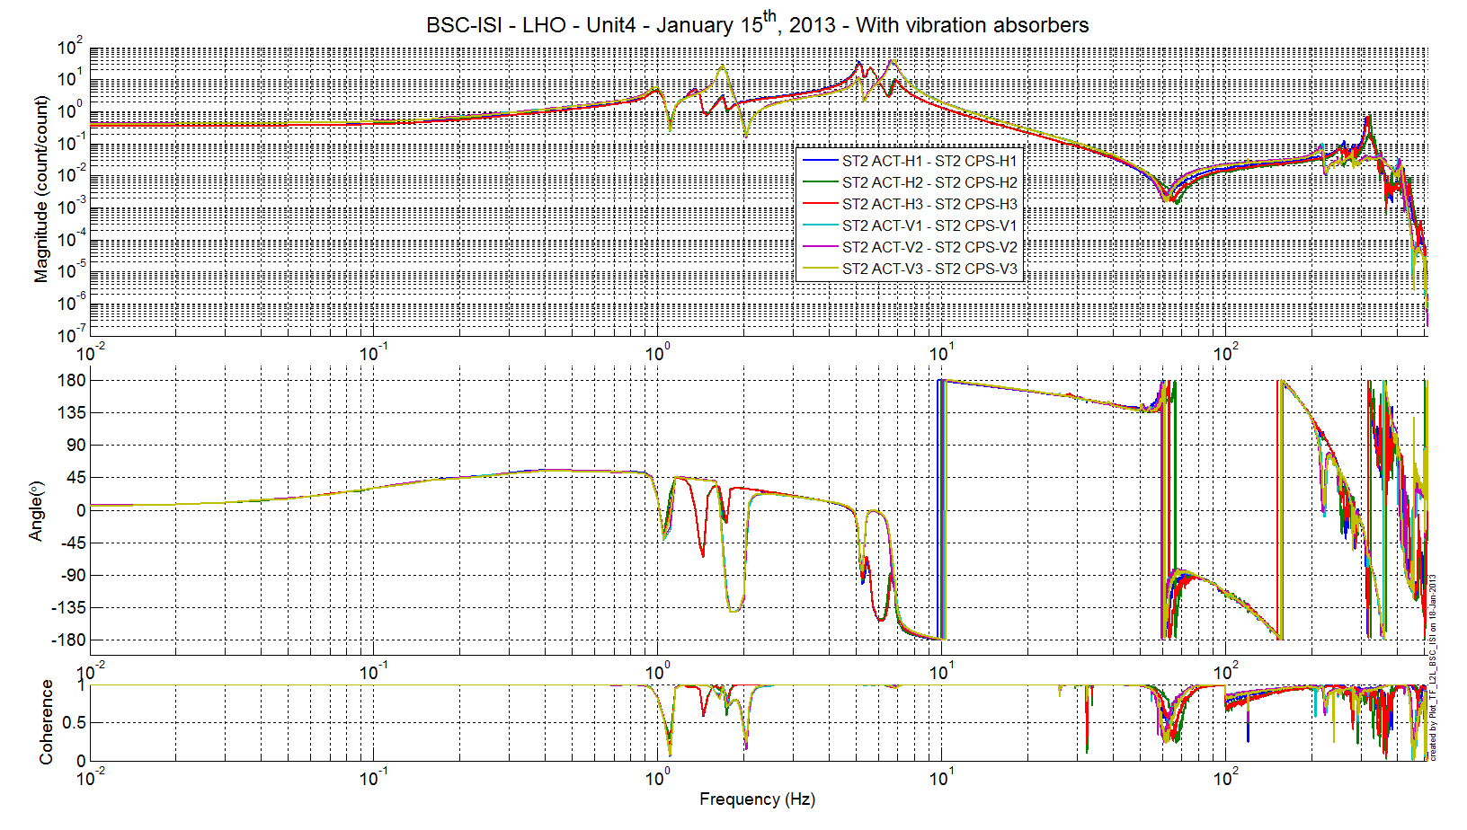
Figure 9: TF L2L Raw - ST2 Act to ST2 CPS

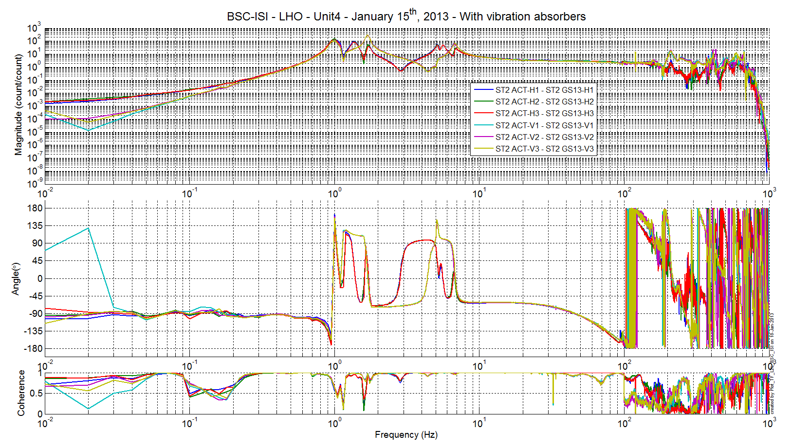
Figure 10: TF L2L Raw - ST2 Act to ST2 GS13

Test result: Passed: X Failed: . Waived :. .

Step 14 - Symmetrization – Calibration
Not performed

Test result: Passed: _ Failed: . Waived :. X .

Step 15 – Change of base – Cartesian to Cartesian - Simulations
The transfer functions in the Cartesian basis can be found in the SVN at:
seismic/BSC-ISI/X1/UNIT_4/Data/Figures/Transfer_Functions/Simulations/Undamped/
- X1_ISI_ITMX_TF_C2C_Symmetrized_from_ST1_ACT_to_ST1_CPS_2013_01_15.fig
- X1_ISI_ITMX_TF_C2C_Symmetrized_from_ST1_ACT_to_ST1_L4C_2013_01_15.fig
- X1_ISI_ITMX_TF_C2C_Symmetrized_from_ST1_ACT_to_ST1_T240_2013_01_15.fig
- X1_ISI_ITMX_TF_C2C_Symmetrized_from_ST2_ACT_to_ST2_CPS_2013_01_15.fig
- X1_ISI_ITMX_TF_C2C_Symmetrized_from_ST2_ACT_to_ST2_GS13_2013_01_15.fig

Note: The resonances of the structure seen at high frequencies are less visible in the Cartesian

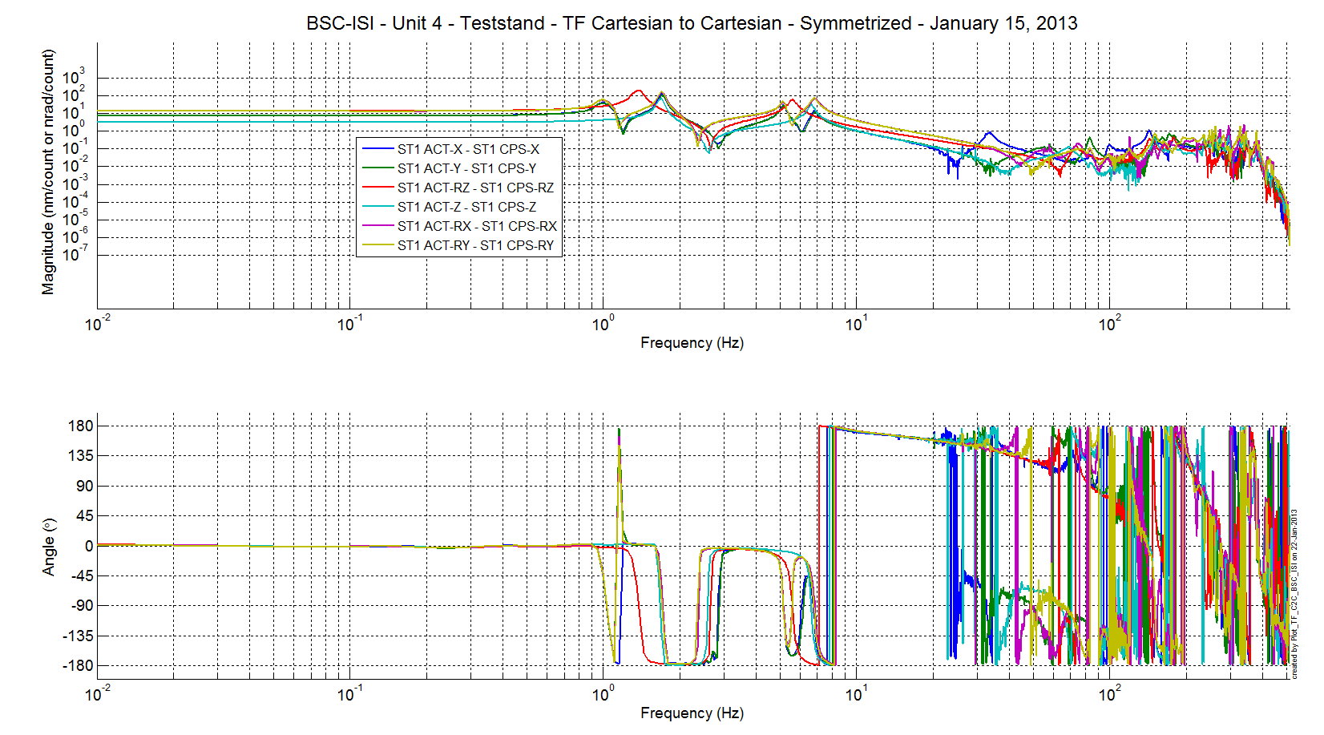
Figure 11 – Transfer functions in the Cartesian basis – ST1 CPS

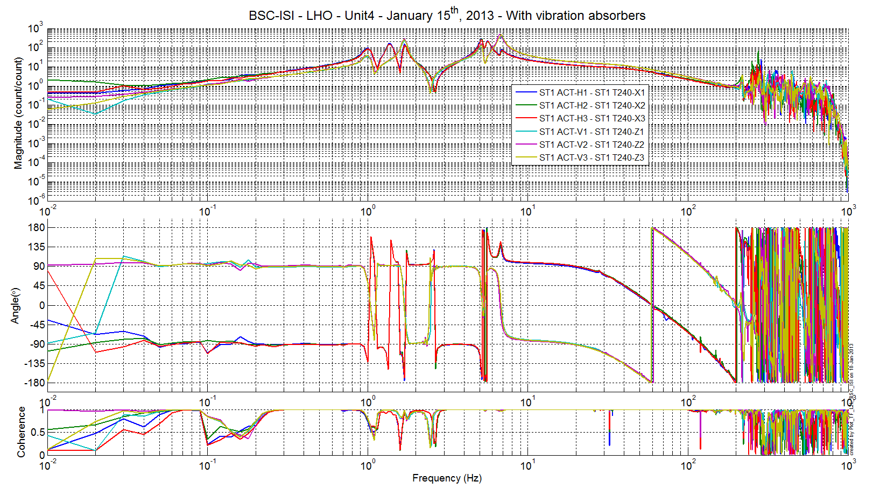
Figure 12 - Transfer functions in the Cartesian basis – ST1 T240

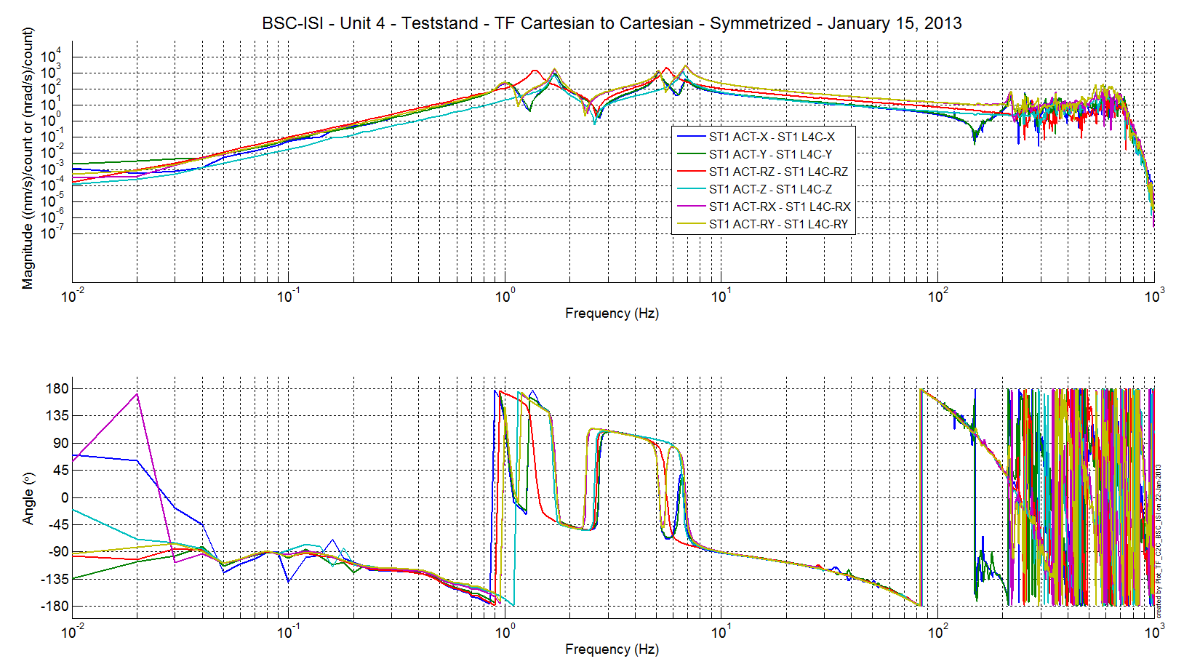
Figure 13 - Transfer functions in the Cartesian basis – ST1 L4C

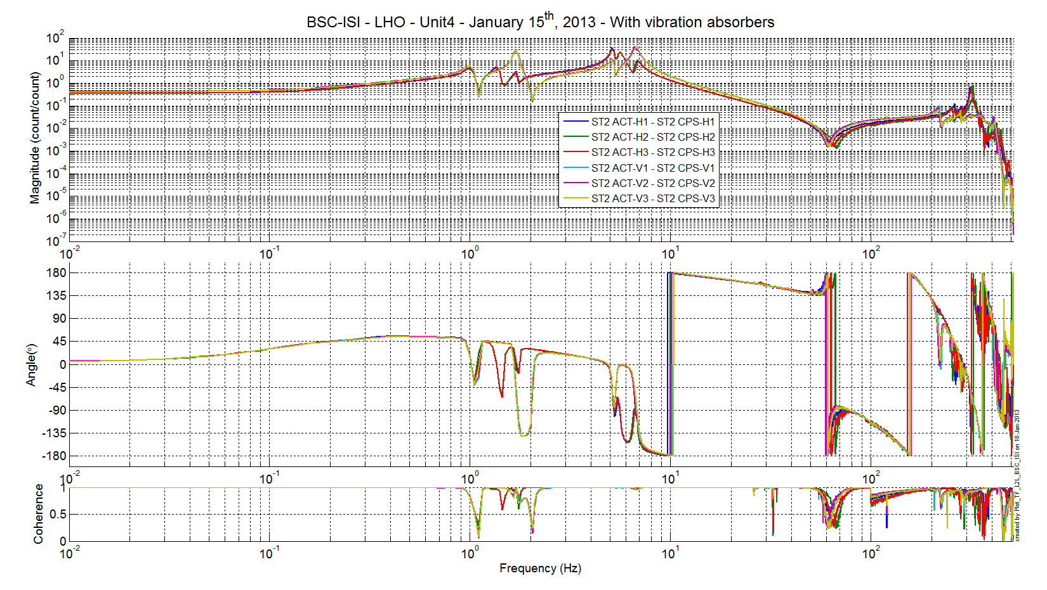
Figure 14 - Transfer functions in the Cartesian basis – ST2 CPS

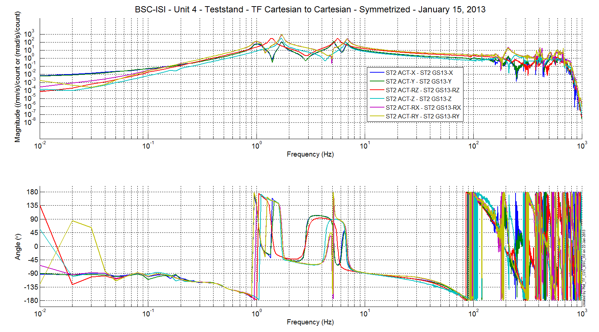
Figure 15 - Transfer functions in the Cartesian basis – ST2 GS13

Test result: Passed: X Failed: . Waived :. .

Step 16- Transfer functions - Cartesian to Cartesian - Measurements

Test result: Passed: Failed: . Waived :. X .

Step 17 - Lower Zero Moment Plan

Step 17.1 - Stage 1 - LZMP

Test result: Passed: Failed: . Waived :. X .

Step 17.2 - Stage 2 - LZMP

Test result: Passed: Failed: . Waived :. X .

Step 18- Damping Loops – Transfer function – Simulations

Step 18.1 - Damping Loops – Stage 2

Test result: Passed: Failed: . Waived :. X .

Step 18.2 - Damping Loops – Stage 1

Test result: Passed: Failed: . Waived :. X .

Step 19- Damping Loops – Powerspectra

Test result: Passed: Failed: . Waived :. X .

Step 20- Isolation Loops – for one unit per site

Test result: Passed: Failed: . Waived :. X .

BSC-ISI testing Summary
This is the third “aLigo BSC-ISI” tested at LHO. The testing procedure document E1000483-v5 was used. Tests were done during in January 2013.

The LHO ISI-BSC2 is validated per the tests presented in this report. All results are posted on the SVN at:
https://svn.ligo.caltech.edu/svn/seismic/BSC-ISI/X1/UNIT_4/Data

FAILED AND WAIVED TESTS

- List of tests that failed/waived and won’t be redone
- Step III.9 – Spring constant – The blades are slightly softer than the design. However, the blade softness’s are in good agreements with what was measured on the other units.

- List of tests that failed/waived, that need to be re-done during phase 2

- List of tests skipped that won't be performed because not feasible during phase II (i.e. stage 0 leveling)
- Step II.5 – Check level of Stage 0 after top-bottom plate assembly
- Step II.8 – Blade 0-1 Post Launch Angle – No need for this test, the budget mass looks good and we already reposition the Blades after noticing a gap between the Blade and its Spacer on Stage 0-1 (see comment on Step 9 – Vertical Spring Constant).

- List of tests skipped that we won't do because they are not essential (i.e. redundant with another test)
- Step III.3 – Measure the Sensor gap - This test was not performed. The sensor gaps have not been measured. These sensors have already been checked at LASTI. Moreover, risks of scratching the target are so high that we preferred not performing this test. In the future, this test will be removed from the testing procedure.
- Step III.8 – Vertical sensor calibration - The test is not realized in a proper way to evaluate accurately the calibration of the vertical CPS.

- Lists of tests skipped that needs to be done during phase II.
- Step III.14 – Symmetrization – Calibration
- Step III.17 – Lower Zero Moment Plan
- Step III.18.1 – Damping Loops – Stage 2
- Step III.18.2 – Damping Loops – Stage 1
- Step III.20 – Isolation loops

