LIGO Laboratory / LIGO Scientific Collaboration

LIGO- E1100300 LIGO May 16th, 2014

aLIGO BSC-ISI, Pre-integration Testing report,
Unit 9 - Phase I (post-assembly)
E1100302 – V1

Jim Warner

Distribution of this document:
Advanced LIGO Project

This is an internal working note
of the LIGO Laboratory

California Institute of Technology  LIGO Project – MS 18-34  1200 E. California Blvd.  Pasadena, CA 91125  Phone (626) 395-2129  Fax (626) 304-9834  E-mail: info@ligo.caltech.edu | Massachusetts Institute of Technology  LIGO Project – NW22-295  185 Albany St  Cambridge, MA 02139  Phone (617) 253-4824  Fax (617) 253-7014  E-mail: info@ligo.mit.edu
LIGO Hanford Observatory  P.O. Box 1970  Mail Stop S9-02  Richland WA 99352  Phone 509-372-8106  Fax 509-372-8137 | LIGO Livingston Observatory  P.O. Box 940  Livingston, LA 70754  Phone 225-686-3100  Fax 225-686-7189

Table of contents:

I. Pre-Assembly Testing 4
II. Tests to be performed during assembly 6
III. Tests to perform after assembly 13
IV. BSC-ISI testing Summary 27

Introduction

The BSC-ISI testing is performed in three phases:
1) BSC-ISI, Pre-integration Testing, Phase I (post-assembly)
2) BSC-ISI, Pre-integration Testing, Phase II: Tests done after Transport (and possible storage), during mating phase with Suspensions, before insertion.
3) BSC-ISI, Integration Phase Testing: Procedure and results related to the commissioning in the chamber.

This document presents the series of tests (Phase I) performed on the fourth BSC-ISI assembled at LHO.

The testing procedure document E1000486-v5 was used.

All results are posted on the SVN at:
https://svn.ligo.caltech.edu/svn/seismic/BSC-ISI/X1/Unit_9/

The following type of document can be found in the SVN:
- Excel spreadsheet (.xls)
- Data location
- Figures location
- Masses distribution scheme (ppt)

Pre-Assembly Testing

Step 1 - CPS Test and calibration – E1100369
CPS sensors are tested (calibration and noise test) at MIT before being cleaned and baked at LHO. The list of installed sensors used for testing (phase I) are reported in step II.3.

All data related to the CPS testing can be found in the SVN at
/svn/seismic/Common/Data/aLIGO_BSC_ISI_CPS/

Test result: Passed: X Failed: . Waived :. .

Step 2 - GS13 – Inspection/Assembly – E1000058 – E1100740
GS13 are tested and podded at LLO.

We had several GS-13s fail on this unit. Initially, 1h and 1v, then another vertical. A third vertical failed after a transfer function with too high drive.

The list of installed sensors used for testing (phase I) are reported in step II.3.

All the data related to GS-13 post podding testing can be found in the SVN at : /svn/seismic/Common/Data/aLIGO_GS13_TestData/PostMod_TestResults_PDFs

E1000058 and E1100740 spreadsheets provide the status of each individual GS-13 at LLO site for HAM-ISI and BSC-ISI and the installation location of the geophones.

Test result: Passed: X Failed: . Waived :. .

Step 3 - L4C – Inspection/Assembly – E1000136 – E1100740
L4C are tested and podded at LLO. The list of installed sensors used for testing (phase I) are reported in step II.

One vertical L4C failed.

All the data related to L4C post podding testing can be found in the SVN at : /svn/seismic/Common/Data/aLIGO_L4C_TestData/TestResults_PDFs/

Test result: Passed: X Failed: . Waived :. .

Step 4 - T240 – Inspection/Assembly - E1100326 – E1100740
T240 are tested and podded at LLO. We haven’t had to replace the T240s on this Unit, and these are the ones with the new Voltage Regulator, it seems that they are working fine and keep the pressure sensor from dying. The list of installed sensors used for testing (phase I) are reported in step II.3.

All the data related to T240 post podding testing can be found in the SVN at :
seismic/Common/Data/aLIGO_T240_TestData/AsReceived_TestResults_PDFs.

E1100326 and E1100740 spreadsheets provide the status of each individual T240 at LLO site for BSC-ISI and the installation location of the geophones.

Test result: Passed: X Failed: . Waived :. .

Step 5 - Actuators - T0900564 - T1100234 – E1100741
The list of installed sensors used for testing (phase I) are reported in step II.2
Large actuators data can be found at: T0900564. Actuator inventory is made at Section II – Step 2.
Small actuators data can be found at: T1100234. Actuator inventory is made at Section II – Step 2.

Test result: Passed: X Failed: . Waived :. .

Tests to be performed during assembly

Step 1 - Test stand level
The Test Stand was transformed and re-leveled to dock a BSC-ISI.

Test result: Passed: X Failed: . Waived :. .

Step 2 - Actuators Inventory
The actuators S/N are reported in the table below. Further information can be found in T0900564 and T1100234.

Stage 1 |  | Stage 2
Actuator | Actuator S/N | Actuator | Actuator S/N
ST1 - H1 | 196 | ST2 - H1 | 65
ST1 - H2 | 185 | ST2 - H2 | 36
ST1 - H3 | 186 | ST2 - H3 | 30
ST1 - V1 | 182 | ST2 - V1 | 34
ST1 - V2 | 167 | ST2 - V2 | 74
ST1 - V3 | 165 | ST2 - V3 | 64
Table 1 - Actuators' inventory

Test result: Passed: X Failed: . Waived :. .

Step 3 - Sensors Inventory
The sensors S/N are reported in the table below.

CPS Stage 1 | CPS S/N | ADE board serial #
H1
H2
H3
V1
V2
V3
Table 2 - Capacitive position sensors' inventory – Stage 1

CPS Stage 2 | CPS S/N | ADE board serial #
H1
H2
H3
V1
V2
V3
Table 3 - Capacitive position sensors' inventory – Stage 2

Geophones GS13 | Serial Number | POD
H1
H2 | 20
H3 | 40
V1 | 29
V2 | 39
V3 | 49
Table 4 - GS13 inventory

Geophones L4C | Serial Number | POD
H1 | 147
H2 | 122
H3 | 20
V1 | 145
V2 | 9
V3 | 7
Table 5 - L4C inventory

Geophones T240 | Serial Number | POD
1 | 46
2 | 23
3 | 47
Table 6 - T240 inventory

Test result: Passed: X Failed: . Waived :. .

Step 4 - Electronics Inventory
Write down in the table below all serial numbers all the electronic equipment:

Hardware | Ligo reference | S/N
Interface Chassis - Corner 1 | D1002432 | S110223
Interface Chassis - Corner 2 |  | S1102224
Interface Chassis - Corner 3 |  | S1102218
Anti-Alliasing Chassis - Corner 1 | D1002693 | S1102693
Anti-Alliasing Chassis - Corner 2 |  | S1102694
Anti-Alliasing Chassis - Corner 3 |  | S1102679
Anti-image Chassis | D070081 | S1000250
Binary Input Chassis | D1001726 | S1101309
Binary Input Chassis |  | S11031308
Binary Output Chassis | D1001728 | S1101347
T240 Interface - Corner 1 | D1002694 | S1101040
T240 Interface - Corner 2 |  | S1101838
T240 Interface - Corner 3 |  | S1101839
I/O Chassis | n/a
Coil driver Pod 1 | D0902744 | S1000266
Coil driver Pod 2 |  | S1000269
Coil driver Pod 3 |  | S110692
Table 7 - Electronic equipment

Note:

Test result: Passed: X Failed: . Waived :. .

Step 5 - Check level of Stage 0 after top-bottom plate assembly

Note: This test has not been performed. The test stand was leveled before assembly began.

Test result: Passed: Failed: . Waived :. X .

Step 6 - Check gaps under the blade posts

Test result: Passed: X Failed: . Waived :. .

Step 7 - Blade post shim thickness
This table shows the shims thickness installed under the lockers.

Stage 0-1 |  | Stage 1-2
Lockers | Shim thickness (mil) | Lockers | Shim thickness (mil)
Corner 1 | 115 | Corner 1 | 122
Corner 2 | 117 | Corner 2 | 121
Corner 3 | 129 | Corner 3 | 120
Table 8 - Shims thickness

Acceptance criteria: Both D0901805 Stage 0-1 Locker Shims & D0902551 Stage 1-2 Locker Shims goes from .110” up to .130” with an increment of .001”.

Test result: Passed: X Failed: . Waived :. .

Step 8 - Blade 0-1 post launch angle

Test result: Passed: Failed: . Waived :. X .

Step 9 - Gap checks on actuators

Test result: Passed: X Failed: . Waived :. .

Step 10 - Mass budget
Note: The second version of the blade spacers was used. Consequently, the additional payload is expected to be close from design.

Four vibration absorbers were installed on stage 1. Masses on stage 2 are resting on Viton pads.

Stage 1:
The stage 1 payload is reported in the table below:

Corner 1 | 2 vib abs, 1x Type 3, 1x Type 2
Corner 2 | 1 vib abs, 1x Type 2, 3x Type 5, 1x Al 2612
Corner 3 | 1 vib abs, 3x Type 5, 1x Type 4 1x Al 2612
Stage 1
Location | Weight (lb)
Corner 1 | 33
Corner 2 | 21.5
Corner 3 | 25.5
Total | 80
Table 9 - Payload Stage 1

Nominal payload on stage 1: 109Kg – 240lb
Additional payload on stage 1 is 160lb less than expected but good enough.
Nominal mass of stage 1= 1966lb

Stage 2:
The stage 2 payload is reported in the table below:

Mass Budget | Quantity | Weight | Unit | Weight (lb)
 | 3 | 610 | lb | 1830
 | 2 | 233 | lb | 466
type 0 | 3 | 0.5 | lb | 1.5
type 1 | 15 | 1.1 | lb | 16.5
type 2 |  | 2.2 | lb | 0
type 3 |  | 4.5 | lb | 0
type 4 | 1 | 7.3 | lb | 7.9
type 5 | 12 | 15.6 | lb | 187.2
type 6 | 5 | 27.2 | lb | 136
Misc | 2x 2612  2x 2613  1x 5kg |  | lb | 64.1
 |  |  |  | 2709.2
Table 10 - Payload Stage 2

Nominal payload: 2709lb
Total nominal mass of Stage 2: 2913.9Kg – 6524lb
Additional stage 2 payload is 100lb heavier than the design.

Error mass on stage 0-1 blades: -(-100+160)/(6424+2019) = -.7%

The Overall error on the weight of the payload is really low.

Test result: Passed: X Failed: . Waived :. .

Step 12 – Cables inventory – E1100822
The final Class A cables have been used for the testing of this Unit.
DCC Number | Description | Serial Number | Location | Inventory date | Tested
D1100154 | 25-pin M-to-two 9-pin F straight |  | L4C corner2 |  | YES
D1100155 | 25-pin M-to-two 9-pin F straight |  | GS-13 corner2 |  | YES
D1100148 | 2-wire, 14awg 3-pin M to 3-pin F |  | Act St1 V3 |  | YES
D1100148 | 2-wire, 14awg 3-pin M to 3-pin F |  | Act St2 V2 |  | YES
D1100148 | 2-wire, 14awg 3-pin M to 3-pin F |  | Act St2 H3 |  | YES
D1100148 | 2-wire, 14awg 3-pin M to 3-pin F |  | Act St2 H2 |  | YES
D1100148 | 2-wire, 14awg 3-pin M to 3-pin F |  | Act St1 H2 |  | YES
D1100150 | 2-wire, 14awg 2 pins to 3-pin F |  | Act St1 H3 |  | YES
D1100150 | 2-wire, 14awg 2 pins to 3-pin F |  | Act St1 V3 |  | YES
D1100150 | 2-wire, 14awg 2 pins to 3-pin F |  | Act St1 V2 |  | YES
D1100150 | 2-wire, 14awg 2 pins to 3-pin F |  | Act St1 V1 |  | YES
D1100150 | 2-wire, 14awg 2 pins to 3-pin F |  | Act St1 H2 |  | YES
D1100150 | 2-wire, 14awg 2 pins to 3-pin F |  | Act St1 H1 |  | YES
D1100151 | 2-wire, 14awg 2 pins to 3-pin F |  | Act St2 H2 |  | YES
D1100151 | 2-wire, 14awg 2 pins to 3-pin F |  | Act St2 V2 |  | YES
D1100151 | 2-wire, 14awg 2 pins to 3-pin F |  | Act St2 H3 |  | YES
D1100151 | 2-wire, 14awg 2 pins to 3-pin F |  | Act St2 V3 |  | YES
D1100151 | 2-wire, 14awg 2 pins to 3-pin F |  | Act St2 V1 |  | YES
D1100151 | 2-wire, 14awg 2 pins to 3-pin F |  | Act St H1 |  | YES
D1100152 | 25-pin F-to-25-pin F |  | T240 corner3 |  | YES
D1100152 | 25-pin F-to-25-pin F |  | T240 corner1 |  | YES
D1100152 | 25-pin F-to-25-pin F |  | T240 corner2 |  | YES
D1100153 | 25-pin F-to-25-pin F |  | L4C corner2 |  | YES
D1100153 | 25-pin F-to-25-pin F |  | GS-13 corner3 |  | YES
D1100153 | 25-pin F-to-25-pin F |  | L4C corner3 |  | YES
D1100153 | 25-pin F-to-25-pin F |  | GS-13 corner2 |  | YES
D1100153 | 25-pin F-to-25-pin F |  | L4C corner1 |  | YES
D1100153 | 25-pin F-to-25-pin F |  | GS-13 corner1 |  | YES
D1100148 | 2-wire, 14awg 3-pin M to 3-pin F |  | Act St2 V3 ext |  | YES
D1100148 | 2-wire, 14awg 3-pin M to 3-pin F |  | Act St2 H1 ext |  | YES
D1100148 | 2-wire, 14awg 3-pin M to 3-pin F |  | Act St1 V1 |  | YES
D1100148 | 2-wire, 14awg 3-pin M to 3-pin F |  | Act St1 H3 ext |  | YES
D1100148 | 2-wire, 14awg 3-pin M to 3-pin F |  | Act St1 H1 ext |  | YES
D1100148 | 2-wire, 14awg 3-pin M to 3-pin F |  | Act St1 V2 ext |  | YES
D1100148 | 2-wire, 14awg 3-pin M to 3-pin F |  | Act St2 V1 ext |  | YES
D1100154 | 25-pin M-to-two 9-pin F straight |  | L4C corner1 ext |  | YES
D1100155 | 25-pin M-to-two 9-pin F straight |  | GS-13 corner1 |  | YES
D1100155 | 25-pin M-to-two 9-pin F straight |  | GS-13 corner3 |  | YES
D1100154 | 25-pin M-to-two 9-pin F straight |  | L4C corner3 |  | YES
Test result: Passed: X Failed: . Waived:. .

Step 13 - Cable routing
The final Class A cables have been used for the testing of this Unit.
The cabling has been done following E1101027 aLIGO BSC-ISI Cable Routing Manual.

Test result: Passed: X Failed: . Waived :. .

Tests to perform after assembly

Step 1- Geophones pressure readout
Raw pressure measured by the geophones is reported in the table below:
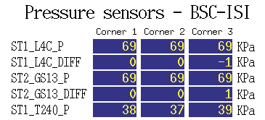

Table 11 - Raw Pressure

A screenshot of the MEDM pressure screen is saved in the Misc directory for Unit 6

Note: The T240’s chassis has the old gain for the pressure sensors.

Test result: Passed: Failed: . Waived :. X .

Step 2- Set up sensors gap – Locked vs unlocked position
During this step, sensors gap are adjusted. This step considers that the lockers have been finely setup during assembly.
 | Table locked |  | Table unlocked |  | Difference locked - unlocked
Sensors | Offset (Mean) | Std deviation | Offset (Mean) | Std deviation | Offset (Mean) | mil
ST1 - H1 | 276 | 6.7 | -425 | 17 | 701 | 0.83
ST1 - H2 | -202 | 7.3 | -1120 | 12 | 918 | 1.09
ST1 - H3 | 18 | 3.9 | -1177 | 12 | 1195 | 1.42
ST1 - V1 | 1477 | 5.6 | 564 | 14 | 913 | 1.09
ST1 - V2 | 208 | 3.9 | 451 | 10 | 243 | 0.29
ST1 - V3 | 392 | 5 | 244 | 10 | 148 | 0.18
ST2 - H1 | -1632 | 7 | 16 | 17 | 1616 | 0.49
ST2 - H2 | -748 | 20 | -323 | 13 | 425 | 0.13
ST2 - H3 | -1565 | 11 | 777 | 17 | 2342 | 0.7
ST2 - V1 | 779 | 15.5 | 3808 | 35 | 3029 | 0.9
ST2 - V2 | 1572 | 23 | 2276 | 28 | 704 | 0.21
ST2 - V3 | 871 | 17 | 3047 | 27 | 2176 | 0.65
Table 12 - Capacitive position sensors readout after gap set-up

Acceptance criteria:
- In the locked position, all mean values must be lower than 400 counts for stage 1 CPS and 1600 counts for stage 2 CPS on Dataviewer (a bit less than .0005”).
- In the locked position, all standard deviations below 25 counts for stage 1, 100 counts for stage 2
- Absolute values of the difference between the unlocked and the locked table must be below:
Stage 1
  - 1600 cts for horizontal sensors (~0.002”)
  - 1600 cts for vertical sensors (~0.002”)
Stage 2
  - 6500 cts for horizontal sensors (~0.002”)
  - 6500 cts for vertical sensors (~0.002”)
- Considering the acceptance criteria of step 2, all mean values must be lower than
Stage 1
  - 2000 cts for horizontal sensors (~0.0025”)
  - 2000 cts for vertical sensors (~0.0025”)
Stage 2
  - 8000 cts for horizontal sensors (~0.0025”)
  - 8000 cts for vertical sensors (~0.0025”)

Note: The CPS will be readjusted once SUS will installed

Test result: Passed: X Failed: . Waived :. .

Step 3 - Measure the Sensor gap
Test Failure mitigation:
This test was not performed. The sensor gaps have not been measured. These sensors have already been tested at LASTI. Moreover, risks of scratching the target are so high that we preferred not performing this test. In the future, this test will be removed from the testing procedure.

Test result: Passed: Failed: . Waived :. X .

Step 4- Performance of the limiters

Step 4.1 - Test Nº1 - Push “in the general coordinates Z/RZ”

Test result: Passed: Failed: . Waived :. X .

Step 4.2 - Test Nº2 – Push “locally”

Sensors | Push in negative direction | Push in positive direction | Mil | Mil | Railing | Actuator Gap Check
ST1 - H1 | -18000 | 19000 | -21 | 23 |  | X
ST1 - H2 | -17000 | 19000 | -20 | 23 |  | X
ST1 - H3 | -16000 | 17000 | -19 | 20 |  | X
ST1 - V1 | -20000 | 20000 | -24 | 24 |  | X
ST1 - V2 | -22000 | 19000 | -26 | 23 |  | X
ST1 - V3 | -22000 | 20000 | -26 | 24 |  | X
ST2 - H1 |  |  |  |  | X | X
ST2 - H2 |  |  |  |  | X | X
ST2 - H3 |  |  |  |  | X | X
ST2 - V1 |  |  |  |  | X | X
ST2 - V2 |  |  |  |  | X | X
ST2 - V3 |  |  |  |  | X | X
Table 13 - Stages range of motion – “Push locally”

Acceptance criteria:
- The vertical sensor readout must be positive when the optical table is pushed in the +Z direction
- The horizontal sensor readout on Stage 2 must be positive when the optic table is pushed in the +RZ direction
- Step 4.2
  - Absolutes value of all estimated motions must be higher than 15000counts for stage 1 (~0.018”)
  - Absolutes value of all estimated motions must be higher than 32000counts for stage 2 (~0.010”)

Test result: Passed: X Failed: . Waived :. .

Step 5 - Sensors spectra
The geophones spectra have been measured and can be found in the SVN:

seismic/BSC-ISI/X1/Unit_9/Data/Spectra/Undamped/
- X1_ISI_ITMX_ASD_m_LOC_CPS_T240_L4C_GS13_2014_11_12_145403.mat (Unlocked)
- X1_ISI_ITMX_ASD_m_LOC_CPS_T240_L4C_GS13_2014_11_14_152331.mat (Locked)

seismic/BSC-ISI/X1/Unit_9/Data/Figures/Spectra/Undamped/
- X1_ISI_ITMX_ASD_m_LOC_CPS_T240_L4C_GS13_2014_11_12_145403.fig (Unlocked)
- X1_ISI_ITMX_ASD_m_LOC_CPS_T240_L4C_GS13_2014_11_14_152331.fig (Locked)

Stage locked – unlocked
The spectra are measured in two different configurations:
- Stage 1 locked – Stage 2 locked
- Stage 1 unlocked – Stage 2 unlocked

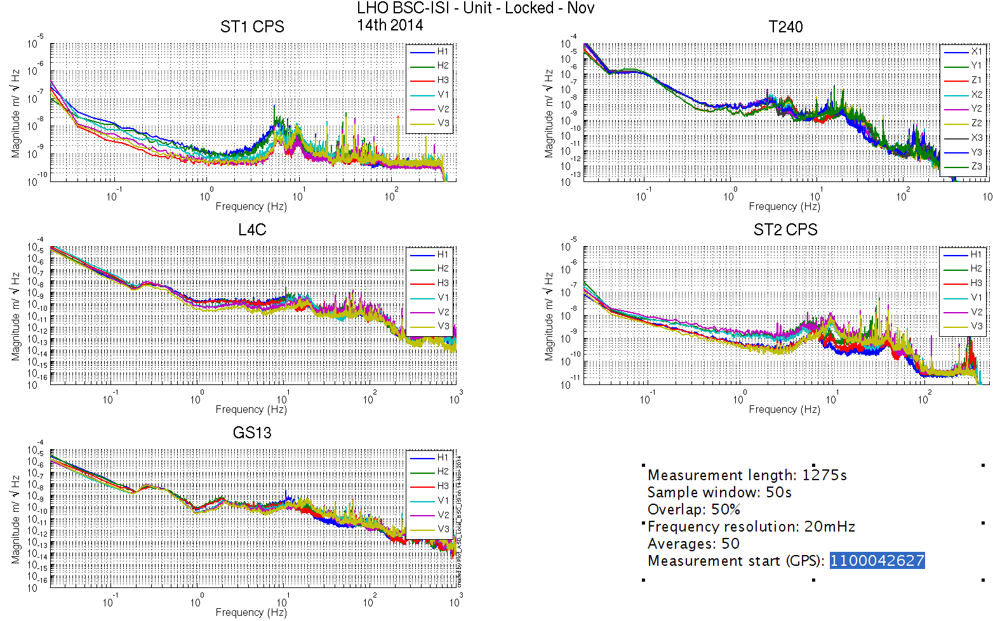
Figure 1: Calibrated Spectra Stage 1 Locked and Stage 2 Locked

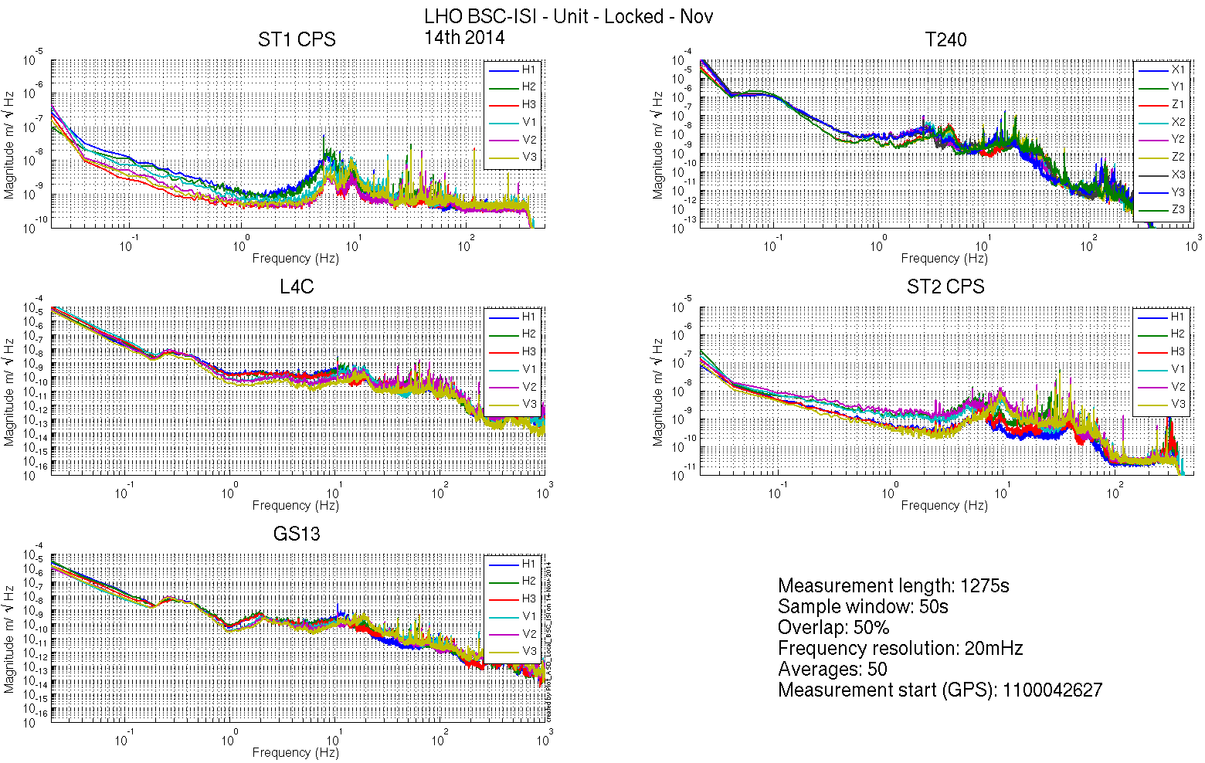
Figure 2: Calibrated Spectra Stage 1 Unlocked and Stage 2 Unlocked

Stage Tilted
The Spectra are measured when the ISI is unlocked a mass is placed on stage 2 to tilt Stage 1 and Stage 2.
The six configurations are the following in six different configurations:
- Mass placed in the actuator pocket at corner 1
- Mass placed in the pocket under the blade 0-1 at corner 1
- Mass placed in the actuator pocket at corner 2
- Mass placed in the pocket under the blade 0-1 at corner 2
- Mass placed in the actuator pocket at corner 3
- Mass placed in the pocket under the blade 0-1 at corner 3

/seismic/BSC-ISI/X1/Unit_9/Data/Spectra/Undamped/
- X1_ISI_ITMX_ASD_m_L4C_GS13_Stage_Tilted_2014_11_14.mat

seismic/BSC-ISI/X1/Unit_9/Data/Figures/Spectra/Undamped/
- X1_ISI_ITMX_Tilted_ASD_m_LOC_ST1_L4C_2014_11_14.fig
- X1_ISI_ITMX_Tilted_ASD_m_LOC_ST2_GS13_2014_11_14.fig
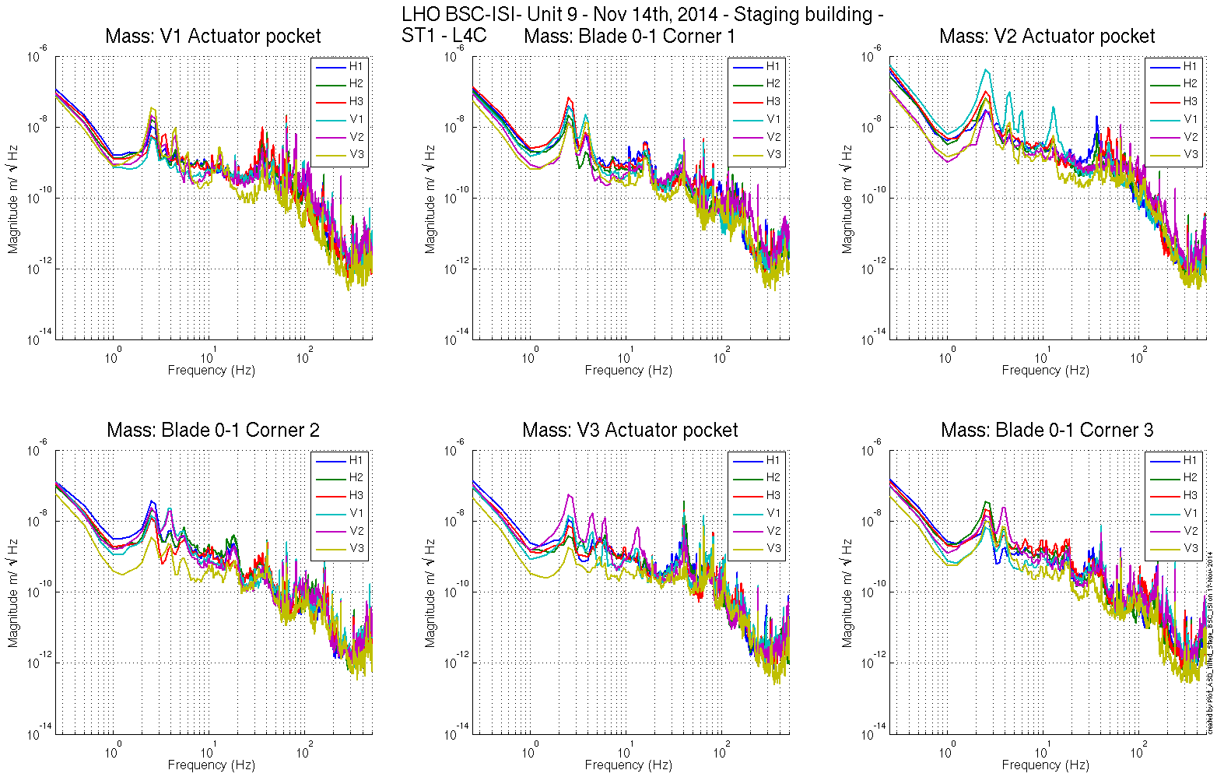
Figure 3 - ST1 L4C – Tilted

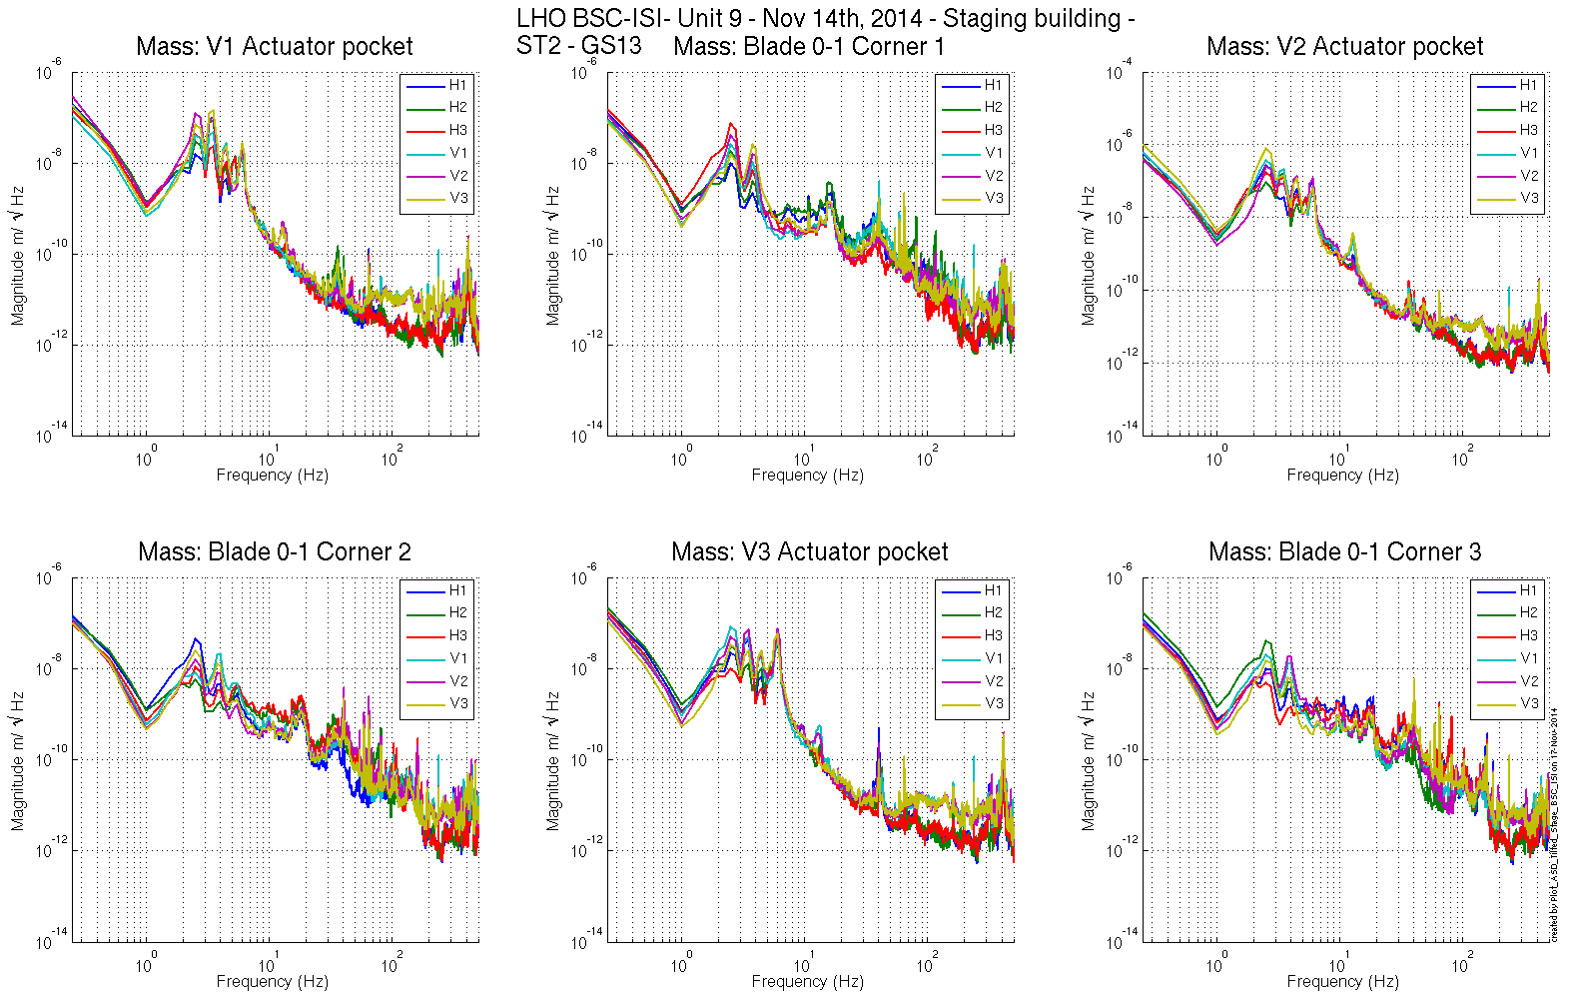
Figure 4 - ST1 GS13 – Tilted

Test result: Passed: X Failed: . Waived :. .

Step 6 - Coil Driver, cabling and resistance check
Resistances of the couple (actuators + in vacuum cables) were measured using the voltage and current the coil drivers read back. Resistances of the couple actuator + in-vacuum cables are reported in the table below:

Actuator | Resistance (Ω)
ST1 H1 | 6.6
ST1 H2 | 6.3
ST1 H3 | 6.2
ST1 V1 | 6.2
ST1 V2 | 6.4
ST1 V3 | 6.2
ST2 H1 | 10.1
ST2 H2 | 9.6
ST2 H3 | 10
ST2 V1 | 10.4
ST2 V2 | 10
ST2 V3 | 9.7
Table 14 - Actuator Resistance

Acceptance criteria:
- For the actuators of stage 1, the measured resistance between the middle pin and one side pin must be 6.3 +/-0.5 ohms
- For the actuators of stage 2, the measured resistance between the middle pin and one side pin must be 10.3 +/-0.5 ohms
- Actuator neutral pins must be connected on pin #1 (left side pin of the plug)
- Actuator drive pins must be connected on pin #2 (middle pin of the plug)
- Actuator ground shield pins must be connected on pin #3 (right pin of the plug)
- All LEDs on the coil driver front panel must be green the binary input bit must be in the upper state.

Test result: Passed: X Failed: . Waived :. .

Step 7- Actuators Sign and range of motion (Local drive)

Step 7.1 - Actuators sign

Test result: Passed: X Failed: . Waived :. .

Step 7.2 - Range of motion - Local drive
In this step, range of motion of the two stages is checked when applying a local drive (30000 counts) on actuators.
seismic/BSC-ISI/X1/Unit_9/Data/Static_Tests/ :
X1_ISI_ITMX_Range_Of_Motion_20141114.mat

Sensor readout (counts) | Negative drive | no drive | Positive drive | Amplitude count | mil
ST1 - H1 | -15946 | -233 | 16151 | 32097 | 38
ST1 - H2 | -16468 | -745 | 16157 | 32625 | 39
ST1 - H3 | -15540 | -966 | 16616 | 32156 | 38
ST1 - V1 | -14241 | 790 | 15930 | 30171 | 36
ST1 - V2 | -13942 | 693 | 15449 | 29391 | 35
ST1 - V3 | -14283 | 460 | 15270 | 29553 | 35
ST2 - H1 | -9914 | 206 | 10327 | 20241 | 6
ST2 - H2 | -10091 | 0 | 10080 | 20171 | 6
ST2 - H3 | -8576 | 927 | 10457 | 19034 | 5.7
ST2 - V1 | -7499 | 3738 | 15080 | 22579 | 6.7
ST2 - V2 | -9793 | 1683 | 13169 | 22962 | 6.8
ST2 - V3 | -9343 | 2636 | 14584 | 23927 | 7.1
Table 15 - Range of motion - Local drive

Acceptance criteria:
- Amplitude p-p must be at least 30000 counts (0.035”) for Stage 1 CPS H
- Amplitude p-p must be at least 25000 counts (0.03”) for Stage 1 CPS V
- Amplitude p-p must be at least 18000 counts (0.005”) for Stage 2 CPS H
- Amplitude p-p must be at least 22000 counts (0.006”) for Stage 2 CPS V
- Signs of actuators drive and sensors read out have to be the same

Note: The motion of the platform can be computed. For a 30000 counts drive in the +Z direction, the platform should move by 12.6 mil on Stage 1 and 3.6mil on Stage 2.

In the Cartesian basis, the platform should move (calculation) by:
Stage 1 - Platform move for 32K counts drive: | 12.63 | mil
Stage 2 - Platform move for 32K counts drive: | 3.59 | mil

Note: The range of motion in the case of a “local drive” is in agreements with the measurements done on the previous units.

Test result: Passed: X Failed: . Waived :. .

Step 8 - Vertical Sensor Calibration
Not done.

Test result: Passed: Failed: . Waived :. X .

Step 9 - Vertical Spring Constant
This test is realized by loading the ISI when one stage is locked and using the capacitive position sensors as reference.

The stiffness measurements of the spring are reported in the tables below. The nominal blade stiffness are:
- Stage 1: 1241lb/in
- Stage 2: 1465lb/in

Blade Stage 0-1
Stage 2 Locked & Stage 1 Unlocked. Stage 2 is loaded with 3 x 10kg masses and the measurements are repeated three times (by rotating the masses).

 | Mean No load | Mean Load | Diff
V1 | 994 | -14142 | 15138
V2 | 911 | -14277 | 15178
V3 | 602 | -14780 | 15382
 |  |  | 15235 | count
 |  |  | 18.2 | mil
 |  |  | 1202 | lb/in
 |  |  | 3 | %

Blade Stage 1-2
Stage 1 Locked & Stage 2 Unlocked. Stage 2 is loaded with 3 x 5Kg masses and the measurements are repeated three times (by rotating the masses).

 | Mean no load | Mean load | Diff 1
V1 | 5508 | -19854 | 25361
V2 | 3737 | -21196 | 24934
V3 | 4585 | -20691 | 25275
 |  |  | 25190 | count
 |  |  | 7.6 | mil
 |  |  | 1442 | lb/in
 |  |  | 1.5 | %

Test mitigation: Blades are softer than design.

Test result: Passed: X Failed: . Waived :. .

Step 10 - Static Testing (Tests in the local basis)
The static tests results are reported in the SVN at :
seismic/BSC-ISI/X1/Unit_9/Data/Static_Tests/
- X1_ISI_ITMX_Offset_Local_Drive_20141118.mat

The table below shows the main and the cross-coupling when the actuators are driven in the local basis:

 |  | Sensors
 |  | ST1 - H1 | ST1 - H2 | ST1 - H3 | ST1 - V1 | ST1 - V2 | ST1 - V3
Actuators | ST1 - H1 | 4316 | 1737 | 1744 | 17 | 2 | -8
 | ST1 - H2 | 1701 | 4200 | 1694 | 5 | -2 | -2
 | ST1 - H3 | 1686 | 1678 | 4157 | -5 | -8 | 19
 | ST1 - V1 | 52 | -164 | 104 | 3576 | 682 | -625
 | ST1 - V2 | 112 | 70 | -167 | -650 | 3478 | -635
 | ST1 - V3 | -169 | 89 | 35 | -637 | -614 | 3506
Table 16 - Static test - Local to local - Stage 1

 |  | Sensors
 |  | ST2 - H1 | ST2 - H2 | ST2 - H3 | ST2 - V1 | ST2 - V2 | ST2 - V3
Actuators | ST2 - H1 | 2398 | 362 | 345 | -30 | -53 | -11
 | ST2 - H2 | 341 | 2388 | 368 | -8 | -26 | -30
 | ST2 - H3 | 352 | 349 | 2232 | -50 | -20 | -8
 | ST2 - V1 | 75 | 126 | -182 | 2680 | 273 | -29
 | ST2 - V2 | -204 | 73 | 110 | -40 | 2699 | 279
 | ST2 -V3 | 118 | -215 | 74 | 302 | -60 | 2822
Table 17 - Static test - Local to local - Stage 2

Acceptance criteria:
- Main couplings readout must be positive
- Comparison with the reference tables:
  - Main coupling differences mustn’t exceed 200 counts
  - Cross coupling differences mustn’t exceed 50 counts

Test result: Passed: X Failed: . Waived :. .

Step 11- Static Testing - In the general coordinate basis (Static test - CPS)
Not performed.

Test result: Passed: Failed: . Waived :. X .

Step 11.2 – Base change matrices from Cartesian to Cartesian
Not performed.

Test result: Passed: Failed: . Waived :. X.

Step 12 - Linearity test
The “Linearity test” was performed twice (rearranging the cables). The second time, all corners seemed to respond similarly.

The linearity test data can be found in the SVN at:
/seismic/BSC-ISI/X1/Unit_9/Data/Linearity_Test/
X1_ISI_ITMX_Linearity_test_20141117.mat

The linearity test figures can be found in the SVN at:
/seismic/BSC-ISI/X1/Unit_9/Data/Figures/Linearity_Test/
X1_ISI_ITMX_Linearity_test_20141117.fig
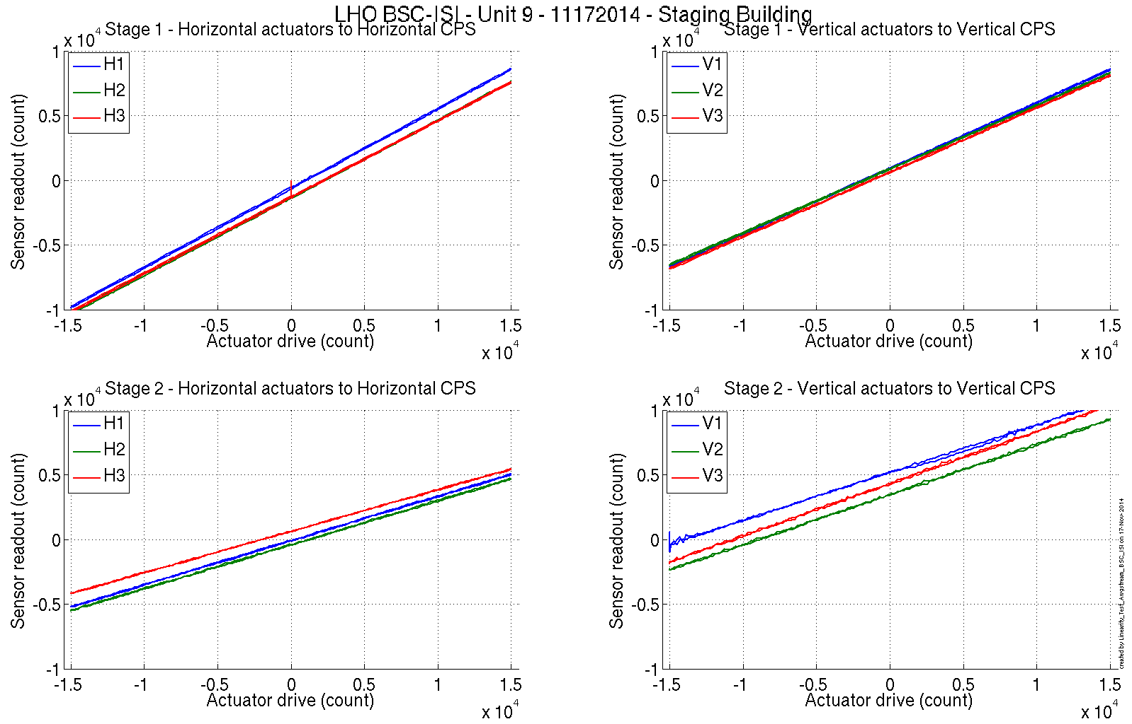
Figure 5 - Linearity Test

Slope – Offset:

 |  | Slope | Offset | Average slope | Variation from  average(%)
Stage 1 | ST1 - H1 | 0.61 | -608 | 0.6 | 2.2
 | ST1 - H2 | 0.60 | -1348 |  | -0.6
 | ST1 - H3 | 0.59 | -1293 |  | -1.6
 | ST1 - V1 | 0.51 | 935 | 0.5 | 1.6
 | ST1 - V2 | 0.49 | 877 |  | -1.2
 | ST1 - V3 | 0.50 | 631 |  | -0.4
Stage 2 | ST2 - H1 | 0.34 | -87 | 0.33 | 2.3
 | ST2 - H2 | 0.34 | -410 |  | 1.7
 | ST2 - H3 | 0.32 | 631 |  | -4
 | ST2 - V1 | 0.37 | 5155 | 0.39 | -4.8
 | ST2 - V2 | 0.38 | 3460 |  | 0.3
 | ST2 - V3 | 0.4 | 4311 |  | 4.5
Table 18 - Slopes and offset of the triplet Actuators - BSC-ISI – Sensors

Acceptance criteria:
- Horizontal and vertical slopes of the triplet actuators x BSC-ISI x sensors: Average slope +/- 2.5%

Test result: Passed: X Failed: . Waived :. .

Step 13 – Transfer functions – Local to Local
Note: two vibration absorbers were installed in corner 1 and 2 vibration absorbers were installed in corner 3. No TMDs were installed on the stage 0-1 blades.

Data files measurement of local to local transfer functions in SVN at:
seismic/BSC-ISI/X1/Unit_9/Data/Transfer_Functions/Measurements/Undamped/
- X1_ISI_ITMX_Data_L2L_10Hz_100Hz_ST1_ST2_20141112-155812.mat
- X1_ISI_ITMX_Data_L2L_500Hz_1000Hz_ST1_ST2_20141112-224529.mat
- X1_ISI_ITMX_Data_L2L_100Hz_500Hz_ST1_ST2_20141113-004957.mat
- X1_ISI_ITMX_Data_L2L_700mHz_10Hz_ST1_ST2_20141113-105128.mat
- X1_ISI_ITMX_Data_L2L_100mHz_700mHz_ST1_ST2_20141113-174239.mat
- X1_ISI_ITMX_Data_L2L_10mHz_100mHz_ST1_ST2_20141113-230552.mat

Script file for processing and plotting local to local transfer functions in SVN at:
/seisvn/seismic/BSC-ISI/X1/Unit_9/Scripts/Control_Scripts
- Step_1_TF_L2L_Raw_X1_ISI_TST.m

Figures of local to local transfer functions (Main couplings) in SVN at:
/seismic/BSC-ISI/X1/Unit_9/Data/Figures/Transfer_Functions/Measurements/Undamped/
- X1_ISI_ITMX_TF_L2L_Raw_from_ST1_ACT_to_ST1_CPS_2014_11_13.fig
- X1_ISI_ITMX_TF_L2L_Raw_from_ST1_ACT_to_ST1_T240_2014_11_13.fig
- X1_ISI_ITMX_TF_L2L_Raw_from_ST1_ACT_to_ST1_L4C_2014_11_13.fig
- X1_ISI_ITMX_TF_L2L_Raw_from_ST2_ACT_to_ST2_CPS_2014_11_13.fig
- X1_ISI_ITMX_TF_L2L_Raw_from_ST2_ACT_to_ST2_GS13_2014_11_13.fig

Measured of local to local transfer functions in the SVN at:
/svncommon/seisvn/seismic/BSC-ISI/X1/Unit_9/Data/Transfer_Functions/Simulations/Undamped
- X1_ISI_ITMX_TF_L2L_Raw_2014_11_13.mat

Note 1: The transfer functions are measured from the Output filter bank (excitation variable) to the input (IN1) of the input filter bank. The transfer functions presented below are raw transfer functions without any electronic compensation of the sensor electronic. The actuator and the coil driver electronic compensation are introduced in these transfer functions.

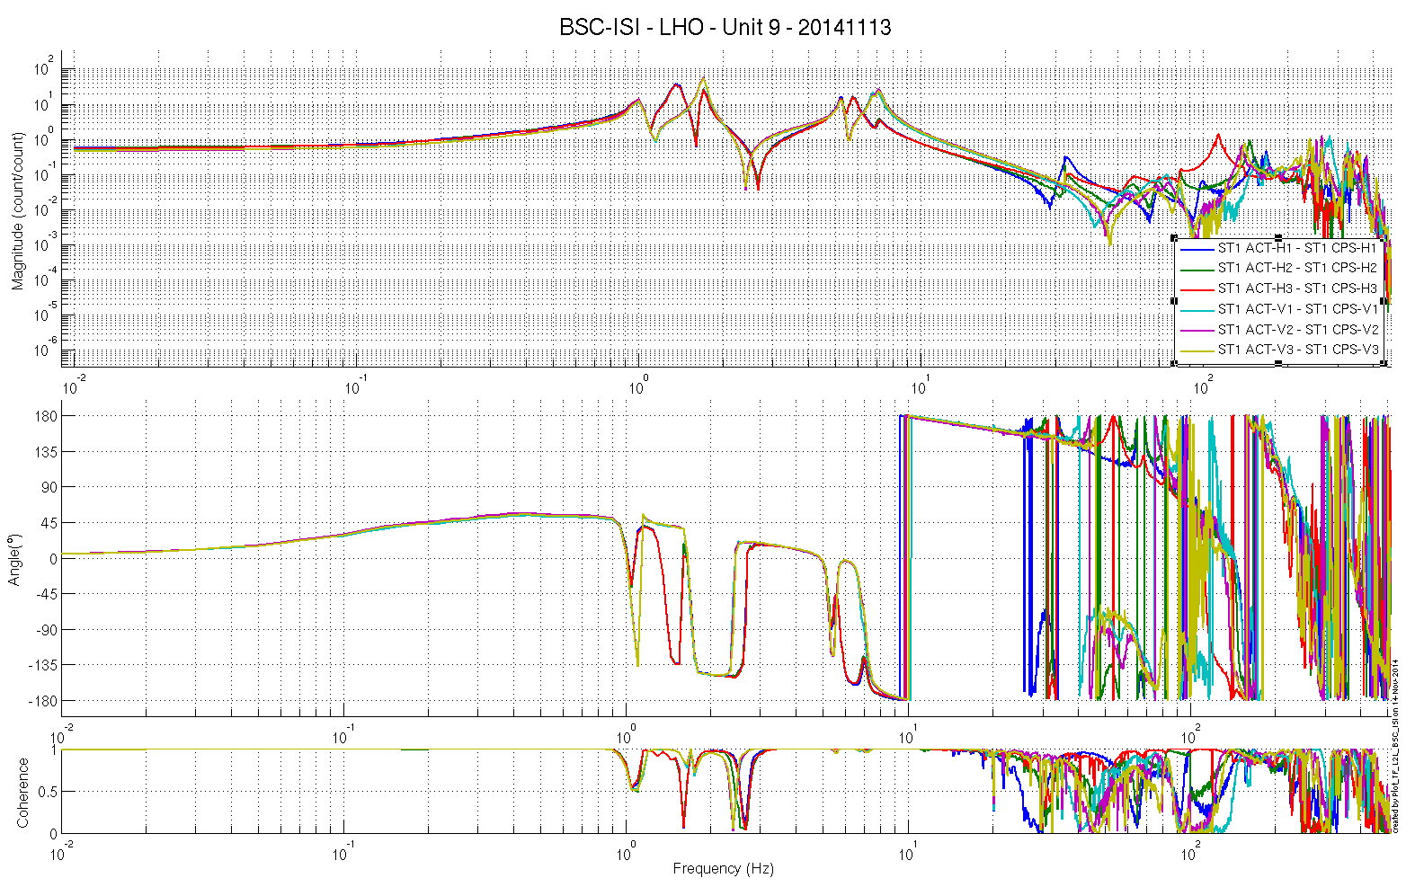
Figure 6: TF L2L Raw - ST1 Act to ST1 CPS
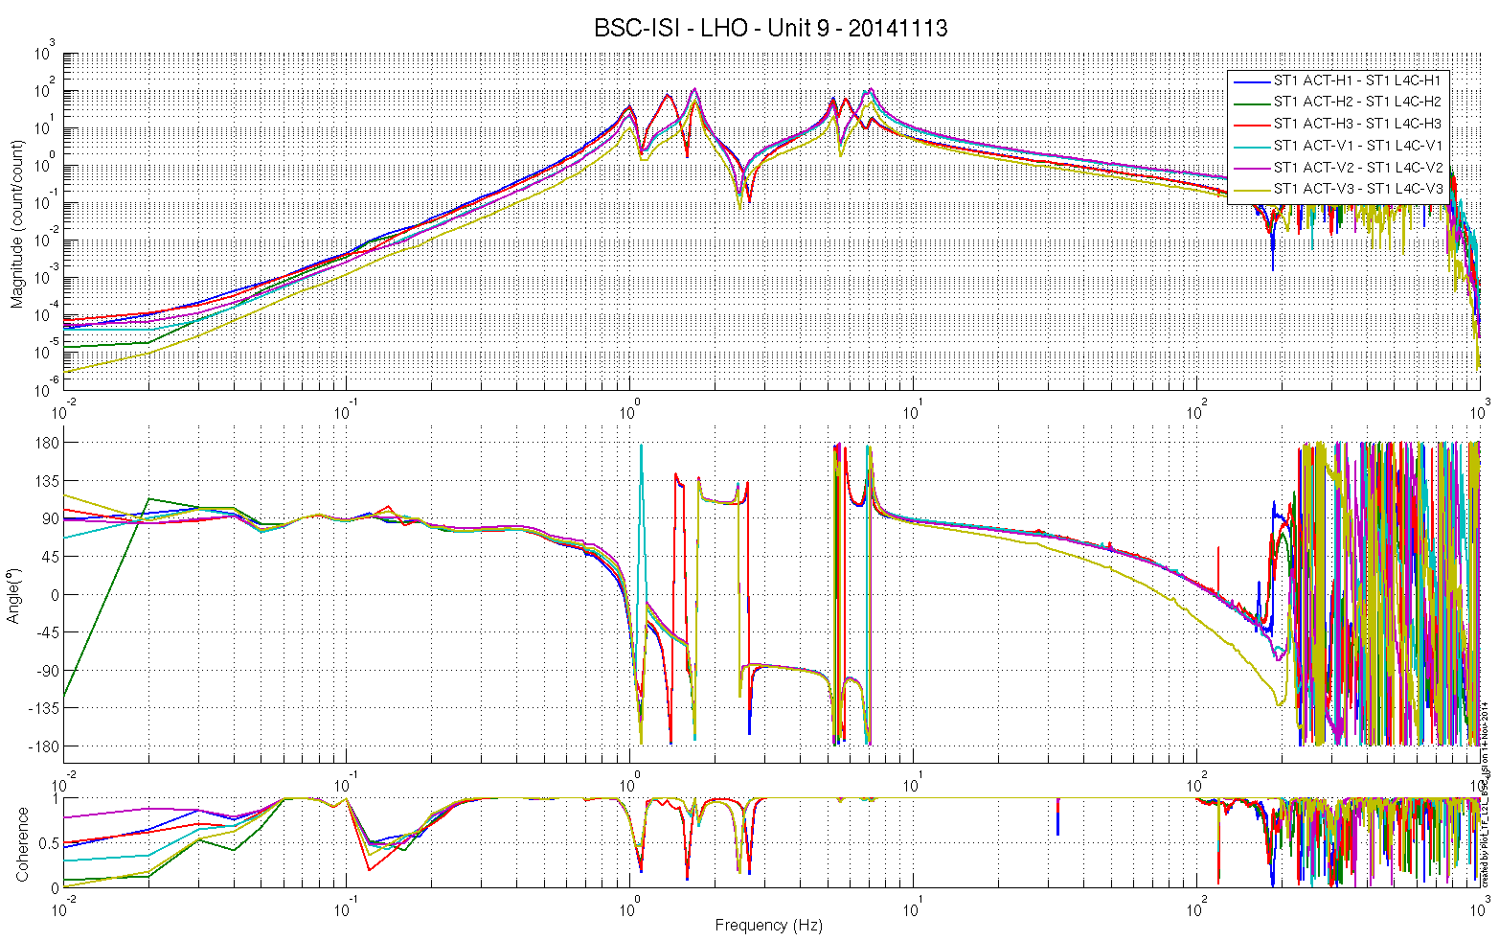
Figure 7: TF L2L Raw - ST1 Act to ST1 L4C
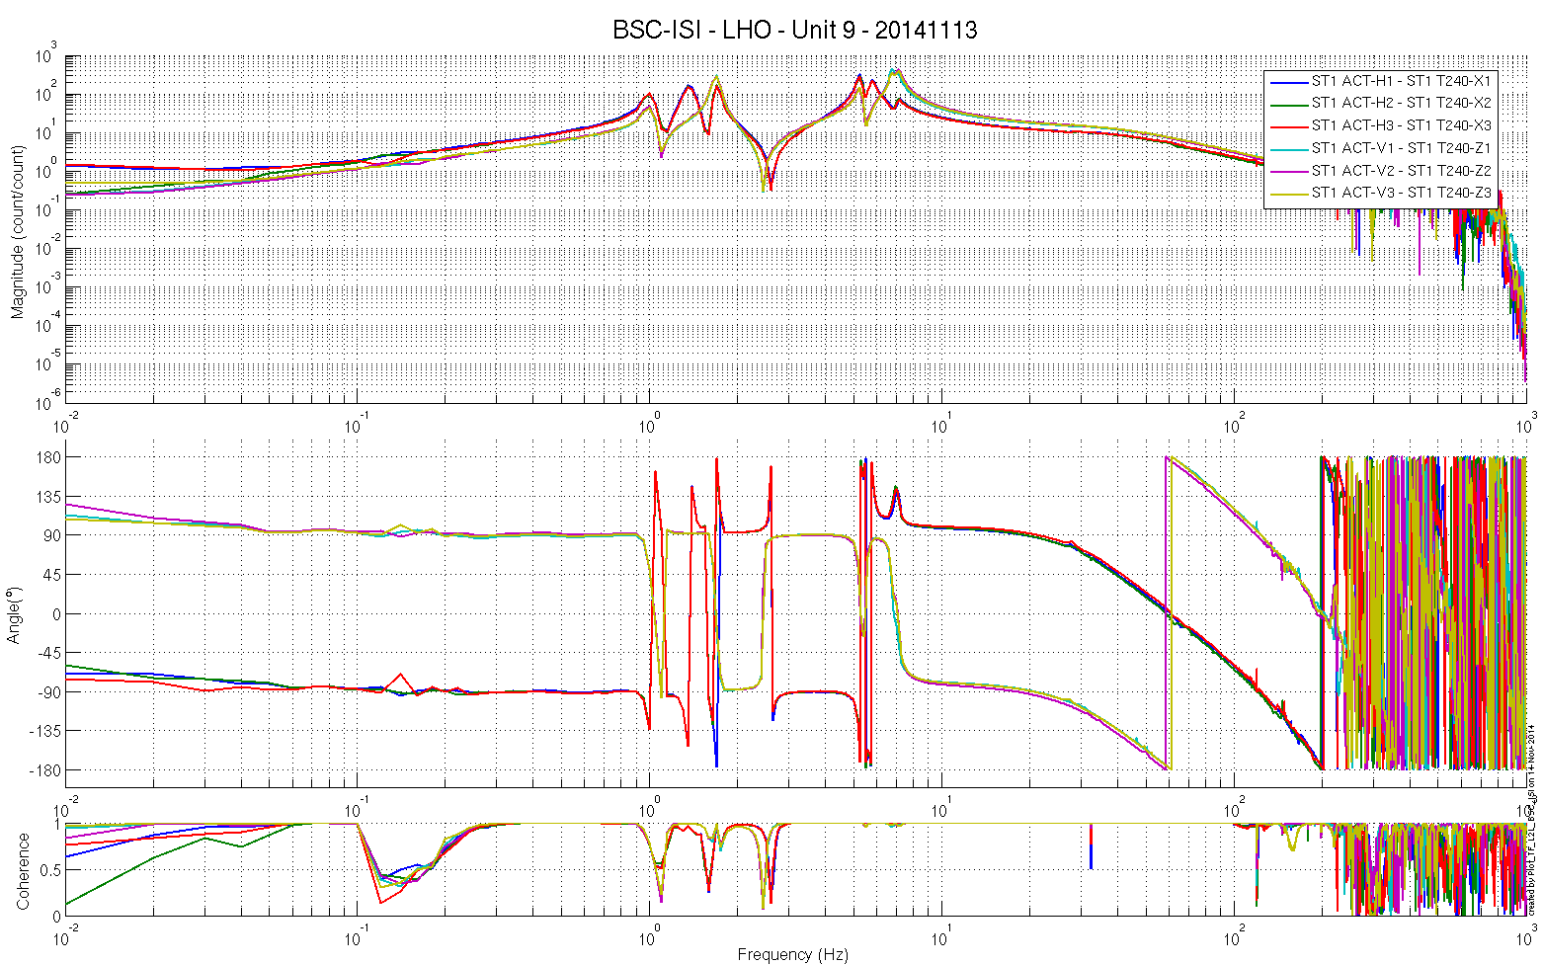
Figure 8 - TF L2L Raw - ST1 Act to ST1 T240
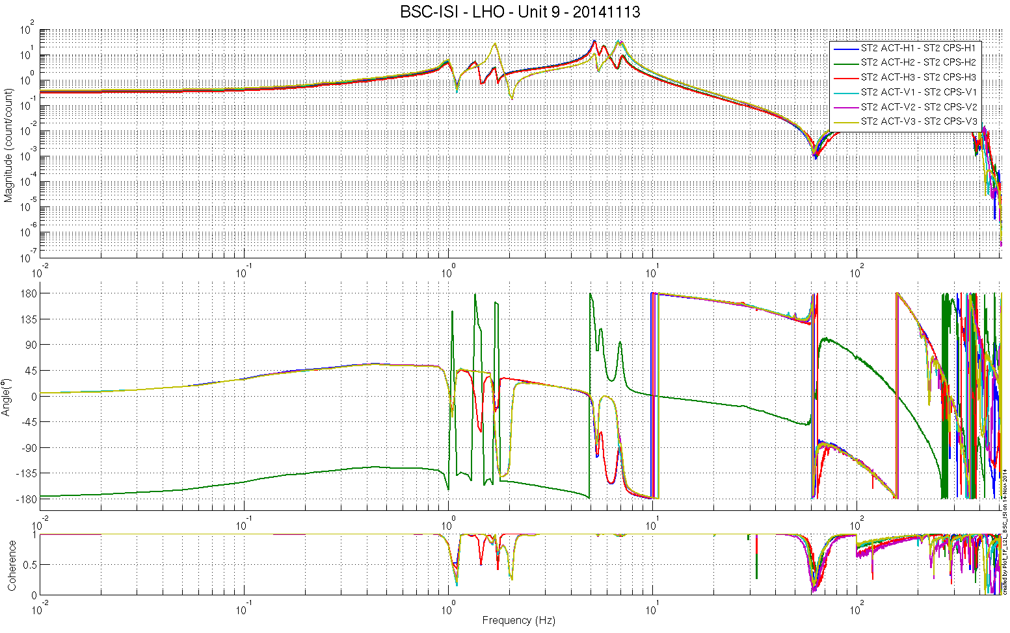
Figure 9: TF L2L Raw - ST2 Act to ST2 CPS
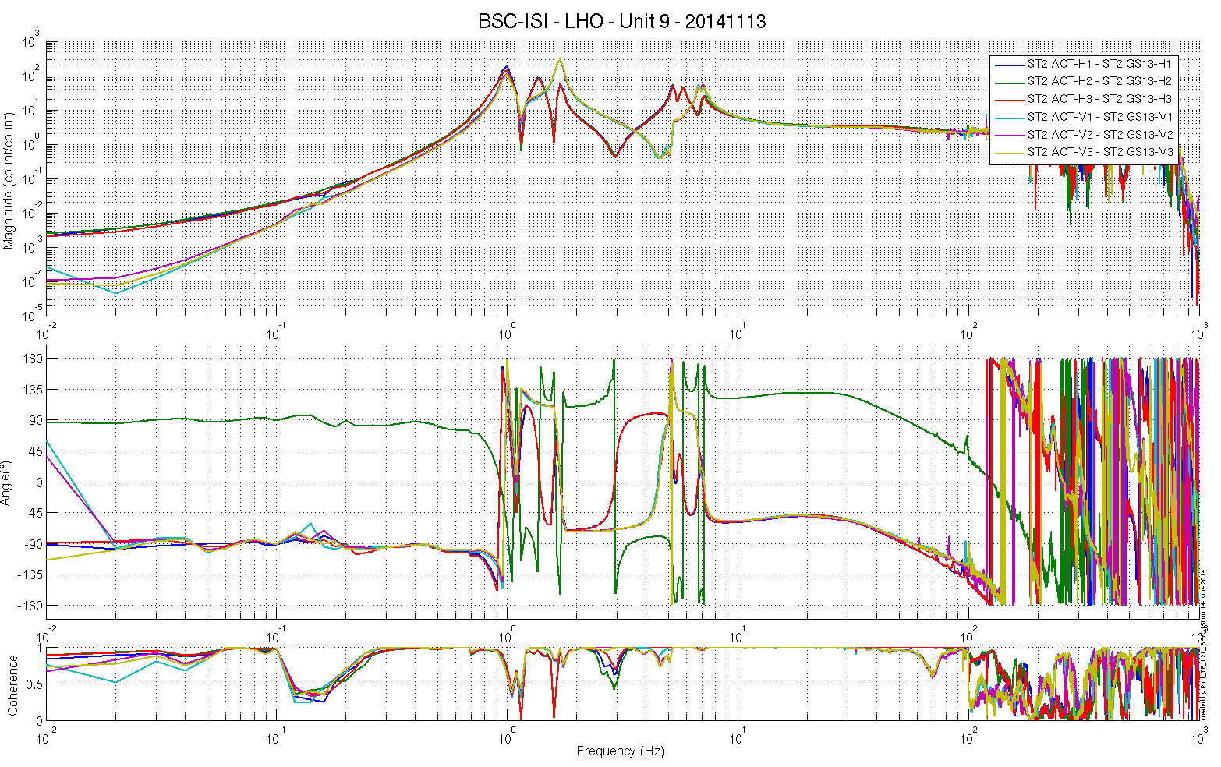
Figure 10: TF L2L Raw - ST2 Act to ST2 GS13

Test result: Passed: X Failed: . Waived :.

BSC-ISI testing Summary
This is the third “aLigo BSC-ISI” tested at LHO. The testing procedure document E1000483-v5 was used. Tests were done during in March 2013.

The LHO ISI-BSC Unit 5 is validated per the tests presented in this report. All results are posted on the SVN at:
https://svn.ligo.caltech.edu/svn/seismic/BSC-ISI/X1/Unit_9/Data

FAILED AND WAIVED TESTS

- List of tests that failed/waived and won’t be redone
- Step III.9 – Spring constant – The blades are slightly softer than the design. However, the blade softness’s are in good agreements with what was measured on the other units.

- List of tests that failed/waived, that need to be re-done during phase 2

- List of tests skipped that won't be performed because not feasible during phase II (i.e. stage 0 leveling)
- Step II.5 – Check level of Stage 0 after top-bottom plate assembly
- Step II.8 – Blade 0-1 Post Launch Angle – No need for this test, the budget mass looks good and we already reposition the Blades after noticing a gap between the Blade and its Spacer on Stage 0-1 (see comment on Step 9 – Vertical Spring Constant).

- Step III.3 – Measure the Sensor gap - This test was not performed. The sensor gaps have not been measured. These sensors have already been checked at LASTI. Moreover, risks of scratching the target are so high that we preferred not performing this test. In the future, this test will be removed from the testing procedure.
- Step III.8 – Vertical sensor calibration - The test is not realized in a proper way to evaluate accurately the calibration of the vertical CPS.

- Lists of tests skipped that needs to be done during phase II.
- Step III.14 – Symmetrization – Calibration
- Step III.17 – Lower Zero Moment Plan
- Step III.18.1 – Damping Loops – Stage 2
- Step III.18.2 – Damping Loops – Stage 1
- Step III.20 – Isolation loops

