LIGO Laboratory / LIGO Scientific Collaboration

LIGO- E1100304 LIGO August 13th, 2012

aLIGO BSC-ISI, Pre-integration Testing report,
Phase I (post-assembly)
E1100294 – V3

Adrien Le Roux, Celine Ramet

Distribution of this document:
Advanced LIGO Project

This is an internal working note
of the LIGO Laboratory

California Institute of Technology  LIGO Project – MS 18-34  1200 E. California Blvd.  Pasadena, CA 91125  Phone (626) 395-2129  Fax (626) 304-9834  E-mail: info@ligo.caltech.edu | Massachusetts Institute of Technology  LIGO Project – NW22-295  185 Albany St  Cambridge, MA 02139  Phone (617) 253-4824  Fax (617) 253-7014  E-mail: info@ligo.mit.edu
LIGO Hanford Observatory  P.O. Box 1970  Mail Stop S9-02  Richland WA 99352  Phone 509-372-8106  Fax 509-372-8137 | LIGO Livingston Observatory  P.O. Box 940  Livingston, LA 70754  Phone 225-686-3100  Fax 225-686-7189

Table of contents:

Introduction 4
I. Pre-Assembly Testing 5
▪ Step 1 - CPS Test and calibration – E1100369 5
▪ Step 2 - GS13 – Inspection/Assembly – E1000058 – E1100740 5
▪ Step 3 - L4C – Inspection/Assembly – E1000136 – E1100740 5
▪ Step 4 - T240 – Inspection/Assembly - E1100326 – E1100740 6
▪ Step 5 - Actuators - T0900564 - T1100234 – E1100741 6
II. Tests to be performed during assembly 7
▪ Step 1 - Test stand level 7
▪ Step 2 - Actuators Inventory 7
▪ Step 3 - Sensors Inventory 7
▪ Step 4 - Electronics Inventory 9
▪ Step 5 - Check level of Stage 0 after top-bottom plate assembly 10
▪ Step 6 - Check gaps under the blade posts 10
▪ Step 7 - Blade post shim thickness 10
▪ Step 8 - Blade 0-1 post launch angle 11
▪ Step 9 - Gap checks on actuators 11
▪ Step 10 - Mass budget 12
▪ Step 11 - Lockers adjustment 14
▪ Step 12 – Cables inventory – E1100822 14
▪ Step 13 - Cable routing 15
III. Tests to perform after assembly 16
▪ Step 1- Geophones pressure readout 16
▪ Step 2- Set up sensors gap – Locked vs unlocked position 17
▪ Step 3 - Measure the Sensor gap 18
▪ Step 4- Performance of the limiters 18
o Step 4.1 - Test Nº1 - Push “in the general coordinates Z/RZ” 18
o Step 4.2 - Test Nº2 – Push “locally” 19
▪ Step 5 - Sensors Powespectra 19
▪ Step 6 - Coil Driver, cabling and resistance check 25
▪ Step 7- Actuators Sign and range of motion (Local drive) 26
o Step 7.1 - Actuators sign 26
o Step 7.2 - Range of motion - Local drive 26
▪ Step 8 - Vertical Sensor Calibration 27
▪ Step 9 - Vertical Spring Constant 28
▪ Step 10 - Static Testing (Tests in the local basis) 30
▪ Step 11- Static Testing - In the general coordinate basis (Static test - CPS) 32
o Step 11.1 – Change of basis matrices from local to Cartesian 32
o Step 11.2 – Base change matrices from Cartesian to Local 33
▪ Step 12 - Linearity test 35
▪ Step 13 – Transfer functions – Local to Local 37
▪ Step 14 - Symmetrization – Calibration 42
▪ Step 15 – Change of base – Cartesian to Local - Simulations 42
▪ Step 16- Transfer functions - Cartesian to Cartesian - Measurements 42
▪ Step 17 - Lower Zero Moment Plan 42
o Step 17.1 - Stage 1 - LZMP 42
o Step 17.2 - Stage 2 - LZMP 42
▪ Step 18- Damping Loops – Transfer function – Simulations 42
o Step 18.1 - Damping Loops – Stage 2 42
o Step 18.2 - Damping Loops – Stage 1 42
▪ Step 19- Damping Loops – Powerspectra 42
▪ Step 20- Isolation Loops – for one unit per site 45
IV. BSC-ISI testing Summary 46

Introduction

The BSC-ISI testing is performed in three phases:
1) BSC-ISI, Pre-integration Testing, Phase I (post-assembly)
2) BSC-ISI, Pre-integration Testing, Phase II: Tests done after Transport (and possible storage), during mating phase with Suspensions, before insertion.
3) BSC-ISI, Integration Phase Testing: Procedure and results related to the commissioning in the chamber.

This document presents the series of tests (Phase I) performed on the ISI-BSC2 (ITMY) in the High Bay before its move to the LVEA (Teststand). Tests were done during March 2012.

This is the first “aLigo BSC-ISI” built and tested with the “aLigo electronic” at the LLO site. The testing procedure document E1000486-v3 was used.

All results are posted on the SVN at:
https://svn.ligo.caltech.edu/svn/seismic/BSC-ISI/X2/Data/BSC2/

The following type of document can be found in the SVN:
- Excel spreadsheet (.xls)
- Data location
- Figures location
- Masses distribution scheme (ppt)

Pre-Assembly Testing

Step 1 - CPS Test and calibration – E1100369
CPS sensors are tested (calibration and noise test) at MIT before being cleaned and baked at LLO. The list of installed sensors used for testing (phase I) are reported in step II.3.

All data related to the CPS testing can be found in the SVN at
/svn/seismic/Common/Data/

Test result: Passed: X Failed: . Waived :. .

Step 2 - GS13 – Inspection/Assembly – E1000058 – E1100740
GS13 are tested and podded at LLO.
The list of installed sensors used for testing (phase I) are reported in step II.3.

All the data related to GS-13 post podding testing can be found in the SVN at : /svn/seismic/Common/Data/aLIGO_GS13_TestData/GeoTech_TestResults_PDFs/

E1000058 and E1100740 spreadsheets provide the status of each individual GS-13 at LLO site for HAM-ISI and BSC-ISI and the installation location of the geophones.

Test result: Passed: X Failed: . Waived :. .

Step 3 - L4C – Inspection/Assembly – E1000136 – E1100740
L4C are tested and podded at LLO The list of installed sensors used for testing (phase I) are reported in step II.3.

All the data related to L4C post podding testing can be found in the SVN at : svn/seismic/Common/Data/aLIGO_L4C_TestData/TestResults_PDFs/

E1000136 and E1100740 spreadsheets provide the status of each individual L4C at LLO site for HAM-ISI and BSC-ISI and the installation location of the geophones.

Test result: Passed: X Failed: . Waived :. .

Step 4 - T240 – Inspection/Assembly - E1100326 – E1100740
T240 are tested and podded at LLO. We had to replace 2 out of 3 T240 because their Pressure Sensor was not working properly. By the end of the test, it seems that we lost signals from these 2 pressure sensors again; we’ll have to replace them. The list of installed sensors used for testing (phase I) are reported in step II.3.

All the data related to T240 post podding testing can be found in the SVN at :
seismic/Common/Data/aLIGO_T240_TestData/AsReceived_TestResults_PDFs.

E1100326 and E1100740 spreadsheets provide the status of each individual T240 at LLO site for BSC-ISI and the installation location of the geophones.

Test Failure mitigation:
The pressure sensors of 2 geophones (corner 2 and 3 – S/N will be noted when the geophones will be removed from the ISI before the cartridge install) are not working. They will be replaced during phase 2- testing. It seems that the Z axis is saturating on the T240 in Corner 1.

Test result: Passed: Failed: X . Waived :. .

Step 5 - Actuators - T0900564 - T1100234 – E1100741
The list of installed sensors used for testing (phase I) are reported in step II.2

Large actuators data can be found at: T0900564. Actuator inventory is made at Section II – Step 2.
Small actuators data can be found at: T1100234. Actuator inventory is made at Section II – Step 2.

Test result: Passed: X Failed: . Waived :. .

Tests to be performed during assembly

Step 1 - Test stand level
The HAM-ISI Teststand was transformed and re-leveled to dock a BSC-ISI.

Test result: Passed: X Failed: . Waived :. .

Step 2 - Actuators Inventory
The actuators S/N are reported in the table below. Further information can be found in T0900564 and T1100234.

Stage 1 |  | Stage 2
Actuator | Actuator S/N | Actuator | Actuator S/N
H1 | L078 | H1 | S036
H2 | L073 | H2 | S094
H3 | L080 | H3 | S033
V1 | L138 | V1 | S101
V2 | L024 | V2 | S087
V3 | L082 | V3 | S082
Table 1 - Actuators' inventory

Test result: Passed: X Failed: . Waived :. .

Step 3 - Sensors Inventory
The sensors S/N are reported in the table below.
CPS Stage 0-1 | CPS S/N | ADE board serial #
H1 | 13623 | 15873
H2 | 13627 | 15888
H3 | 13579 | 16048
V1 | 13628 | 15893
V2 | 13580 | 15869
V3 | 13682 | 15846

Table 2 - Capacitive position sensors' inventory – Stage 0-1

CPS Stage 1-2 | CPS S/N | ADE board serial #
H1 | 13633 | 15899
H2 | 13586 | 12824
H3 | 13680 | 16053
V1 | 13678 | 15904
V2 | 13638 | 15905
V3 | 13574 | 16121

Geophones GS13 | Serial Number | POD
H1 | 842 | 71
H2 | 841 | 47
H3 | 822 | 65
V1 | 740 | 77
V2 | 728 | 57
V3 | 703 | 62
Table 3 - GS13 inventory

Geophones L4C | Serial Number | POD
H1 | 824 | 5
H2 | 1106 | 51
H3 | 1099 | 98
V1 | 941 | 13
V2 | 17 | 103
V3 | 922 | 49
Table 4 - L4C inventory

Geophones T240 | Serial Number | POD
1 | 117 | 15
2 | 148 | 17
3 | 114 | 12

Note:
The trilliums in Corner 2 & 3 have been removed because of the non-working pressure sensors. The trillium from Corner 1 has been replaced too because we couldn’t zero its Z axis. The inventory of the T240 used for the testing is the following:

Geophones T240 | Serial Number | POD
1 | 103 | 4
2 | 102 | 30
3 | 123 | 3

Table 5 - T240 inventory

Test result: Passed: X Failed: . Waived :. .

Step 4 - Electronics Inventory
Write down in the table below all serial numbers all the electronic equipment:

Hardware | LIGO reference | S/N
Interface Chassis - Corner 1 | D1002432 | S1102219
Interface Chassis - Corner 2 | D1002432 | S1106356
Interface Chassis - Corner 3 | D1002432 | S1106358
Anti-Alliasing Chassis - Corner 1 | D1002693 | S1106137
Anti-Alliasing Chassis - Corner 2 | D1002693 | S1106138
Anti-Alliasing Chassis - Corner 3 | D1002693 | S1106136
Anti-image Chassis | D070081 | S1000251
Binary Input Chassis | D1001726 | S1101287
Binary Input Chassis | D1001726 | S1101285
Binary Output Chassis | D1001728 | S1101322
T240 Interface - Corner 1 | D1002694 | S1104420
T240 Interface - Corner 2 | D1002694 | S1104425
T240 Interface - Corner 3 | D1002694 | S1104426
I/O Chassis | n/a | Xp005
Coil driver Pod 1 | D0902744 | S1000317
Coil driver Pod 2 | D0902744 | S1000316
Coil driver Pod 3 | D0902744 | S1103313
Table 6 - Electronic equipment

Note: We had to change the Corner 1 Interface Chassis SN S1106357 with S1102219 (the pressure readout was wrong on the L4C, pressure higher than the atmospheric pressure). We also had to change the T240 Interface for Corner 1 SN S1104427 with S1104420 because on the Z axis the Trillium was saturating. These changes fixed our issues!

Test result: Passed: X Failed: . Waived :. .

Step 5 - Check level of Stage 0 after top-bottom plate assembly

Note : This test has not been performed

Test result: Passed: Failed: . Waived :. X .

Step 6 - Check gaps under the blade posts

Test result: Passed: X Failed: . Waived :. .

Step 7 - Blade post shim thickness
This table shows the shims thickness installed under the lockers.

Stage 1 |  | Stage 2
Lockers | Shim thickness (mil) | Lockers | Shim thickness (mil)
A | .128” | A | .114”
B | .126” | B | .116”/.115”
C | .120” | C | .125”
Table 7 - Shims thickness

Test result: Passed: X Failed: . Waived :. .

Step 8 - Blade 0-1 post launch angle
This test has not been performed on LLO Unit 1.

Test result: Passed: Failed: . Waived :. X .

Step 9 - Gap checks on actuators

Test result: Passed: X Failed: . Waived :. .

Step 10 - Mass budget
The figure below presents the location of the masses on both stages.

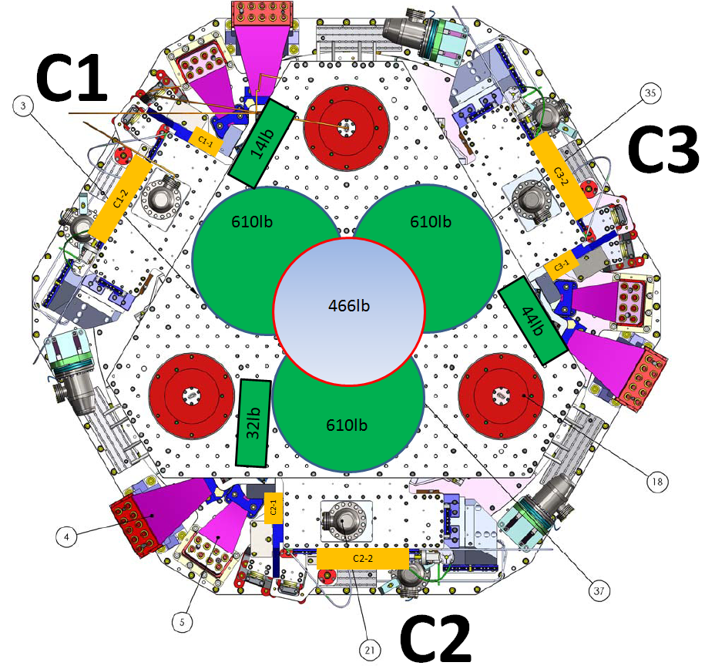
Figure - Masses distribution

Stage 1:
Stage 1
Location | Weight (lb) | Weight (Kg)
C1-1 | 12 | 5.44
C1-2 | 15 | 6.80
C1-3 | 3.5 | 1.59
C2-1 | 12 | 5.44
C2-2 | 0 | 0
C2-3 | 6.5 | 2.95
C3-1 | 12 | 5.44
C3-2 | 15 | 6.8
C3-3 | 4 | 1.81
Total | 80 | 36.29
Table 8 - Payload Stage 1

Nominal payload: 108.9Kg – 240lb
Added masses are 73Kg – 160lb lighter than expected.
Total mass of stage 1=912Kg - 2010lb

Stage 2:
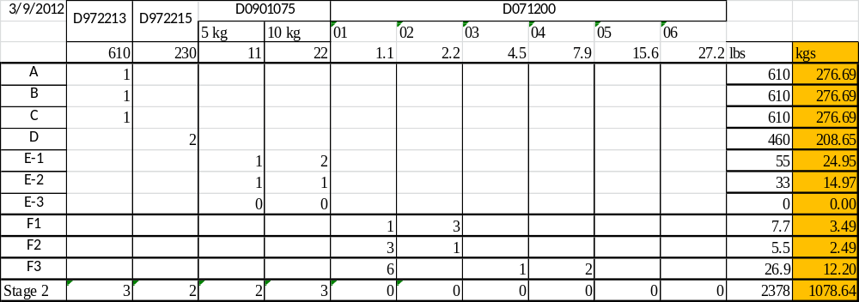
Table 9 - Payload Stage 2

Nominal payload: 1185Kg – 2612lb
The added masses is 106Kg lighter than expected.
Total nominal mass of Stage 2: 2830Kg – 6239lb
Error on the nominal overall mass of stage 2: 106/2830=3.7%

Test result: Passed: X Failed: . Waived :. .

Step 11 - Lockers adjustment
No value has been recorded during the locker adjustments. Measurements using the CPS sensors when the stages are locked and unlocked have been done Step III.2.

 | Stage 1 |  | Stage 2
D.I at Lockers | Dial indicators V | Dial indicators H | Dial indicators V | Dial indicators H
A
B
C
Table 10 - Dial indicators read-out (stage locked-unlocked independently)

Test failure mitigation:
Step III.2 passed. Consequently, this test can be waived.

Test result: Passed: Failed: . Waived :. X .

Step 12 – Cables inventory – E1100822
The final Class A cables have been used for the testing of this Unit.

 | Type of Cable | Corner 1 | Corner 2 | Corner 3
St1 V Actuators | Pigtail | D1100150 – S1107075 | D1100150 – S1107076 | D1100151 – S1107154
St1 V Actuators | Extension | D1100148 – S1106901 | D1100148 – S1106915 | D1100148 – S1106906
St1 H Actuators | Pigtail | D1100150 – S1107077 | D1100150 – S1107074 | D1100151 – S1107153
St1 H Actuators | Extension | D1100148 – S1106911 | D1100148 – S1106905 | D1100148 – S1106913
St2 V Actuators | Pigtail | D1100150 – S1107066 | D1100150 – S1107061 | D1100151 – S1107152
St2 V Actuators | Extension | D1100148 – S1106929 | D1100148 – S1106927 | D1100148 – S1106909
St2 H Actuators | Pigtail | D1100150 – S1107067 | D1100150 – S1107062 | D1100151 – S1107142
St2 H Actuators | Extension | D1100148 – S1106903 | D1100148 – S1106925 | D1100148 – S1106910
L4C | Pigtail | D1100154 – S1107344 | D1100154 – S1107335 | D1100155 – S1107381
L4C | Extension | D1100152 – S1107224 | D1100153 – S1107265 | D1100152 – S1107221
GS-13 | Pigtail | D1100154 – S1104260 | D1100154 – S1104262 | D1100155 – S1107393
GS-13 | Extension | D1100153 – S1107267 | D1100153 – S1107268 | D1100153 – S1107264
T240 |  | D1100152 – S1107223 | D1100153 – S1107263 | D1100152 – S1107222

Test result: Passed: X Failed: . Waived :. .

Step 13 - Cable routing
The final Class A cables have been used for the testing of this Unit.

Test result: Passed: X Failed: . Waived :. .

Tests to perform after assembly

Step 1- Geophones pressure readout

 | Pressure (counts)
Sensors | Corner 1 | Corner 2 | Corner 3
ST1-L4C-P | 99.246 | 99.431 | 99.364
ST1-L4C-D | 1.3005 | 1.5408 | 1.409
ST1-GS13-P | 99.945 | 77.236 | 77.093
ST1-GS13-D | -1.0452 | -0.79306 | -0.65837
ST1-T240-P | 155.04 | 30.717 | 153.29

Test Failure mitigation:
L4C-P in Corner 1 was giving strange signal, but it didn’t come from the pressure sensor, it was coming from the interface SN S1106357. This interface was replaced with S1102219.
Replacing the Interface Chassis of Corner 1 fixed the issue we had about the pressure sensor Readout on the GS-13. This issue is still here on Corner 2 & 3, but we know the problem comes from the interfaces used for Corner 2 & 3.
Pressure sensors of 2 T240 (corner 2 and 3 – S/N will be noted when the geophones will be removed from the ISI before the cartridge install) are not working. These 2 T240 have been replaced by 2 new ones. Even after that, we still have an issue with the pressure sensor on the T240 in Corner 2. In the meantime, the issue has been identified and the sensor will be replaced while we’ll test this Unit in the LVEA.

Test result: Passed: Failed: X . Waived :. .

Step 2- Set up sensors gap – Locked vs unlocked position
During this step, sensors gap are adjusted. This step considers that the lockers have been finely setup during assembly.

09-Mar-12
 | Table locked |  | Table unlocked |  | Difference locked - unlocked
Sensors | Offset (Mean) | Std deviation | Offset (Mean) | Std deviation | Offset (Mean) | mil
ST1 - H1 | 72.8 | 153.6 | 704.8 | 69.7 | -632.01 | -0.75
ST1 - H2 | 5.9 | 64.6 | 176.4 | 57.4 | -170.52 | -0.20
ST1 - H3 | 91.5 | 50.7 | 495.4 | 59.6 | -403.88 | -0.48
ST1 - V1 | -95.7 | 30.9 | 19.9 | 44.5 | -115.56 | -0.14
ST1 - V2 | 172.7 | 173.3 | 542.0 | 60.3 | -369.30 | -0.44
ST1 - V3 | 20.7 | 37.5 | -515.4 | 75.9 | 536.12 | 0.64
ST2 - H1 | 254.0 | 44.9 | 1404.2 | 83.6 | -1150.17 | -0.34
ST2 - H2 | -205.9 | 44.5 | 1192.5 | 73.1 | -1398.35 | -0.42
ST2 - H3 | 147.0 | 43.3 | 1873.1 | 61.5 | -1726.07 | -0.51
ST2 - V1 | 237.0 | 33.3 | 1176.3 | 112.7 | -939.28 | -0.28
ST2 - V2 | 117.5 | 42.0 | -378.5 | 167.1 | 495.99 | 0.15
ST2 - V3 | 377.7 | 46.1 | 1842.2 | 179.4 | -1464.55 | -0.44
Table 11 - Capacitive position sensors readout after gap set-up

Acceptance criteria:

- In the locked position, all mean values must be lower than 400 counts for stage 1 CPS and 1600 counts for stage 2 CPS (a bit less than .0005”).
- In the locked position, all standard deviations below 5 counts for stage 1, 20 counts for stage 2
- Absolute values of the difference between the unlocked and the locked table must be below:
Stage 1
  - 1600 cts for horizontal sensors (~0.002”)
  - 1600 cts for vertical sensors (~0.002”)
Stage 2
  - 6500 cts for horizontal sensors (~0.002”)
  - 6500 cts for vertical sensors (~0.002”)
- Considering the acceptance criteria of step 2, all mean values must be lower than

Stage 1
  - 2000 cts for horizontal sensors (~0.0025”)
  - 2000 cts for vertical sensors (~0.0025”)
Stage 2
  - 8000 cts for horizontal sensors (~0.0025”)
  - 8000 cts for vertical sensors (~0.0025”)

Test result: Passed: X Failed: . Waived :. .

Step 3 - Measure the Sensor gap
Test Failure mitigation:
This test was not performed. The sensor gaps have not been measured. These sensors have already been tested at LASTI. Moreover, risks of scratching the target are so high that we preferred not performing this test. In the future, this test will be removed from the testing procedure.

Test result: Passed: Failed: X . Waived :. .

Step 4- Performance of the limiters

Step 4.1 - Test Nº1 - Push “in the general coordinates Z/RZ”
 | CPS read out |  | Calculated after calibration
Sensors | "-Z" (Counts) | "+Z" (Counts) | "-Z" (mil) | "+Z" (mil)
ST1 - V1 - ST2 LCK | -21198.0 | 18704 | -25.24 | 22.27
ST1 - V2 - ST2 LCK | -10790.0 | 5099.2 | -12.85 | 6.07
ST1 - V3 - ST2 LCK | -5476.5 | 1697 | -6.52 | 2.02
ST2 - V1 - ST1 LCK | -32768.0 | 32064.0 | -9.75 | 9.54
ST2 - V2 - ST1 LCK | -18026.0 | 12255.0 | -5.36 | 3.65
ST2 - V3 - ST1 LCK | -10138.0 | 5906.1 | -3.02 | 1.76

 | CPS read out |  | Calculated after calibration
Sensors | "-RZ" (Counts) | "+RZ" (Counts) | "-RZ" (mil) | "+RZ" (mil)
ST1 - V1 - ST2 LCK | 16298.0 | -19291.0 | 19.40 | -22.97
ST1 - V2 - ST2 LCK | 11708.0 | -11812.0 | 13.94 | -14.06
ST1 - V3 - ST2 LCK | 14500.0 | -9968.0 | 17.26 | -11.87
ST2 - V1 - ST1 LCK | -28546.0 | 28919.0 | -8.50 | 8.61
ST2 - V2 - ST1 LCK | -18266.0 | 21936.0 | -5.44 | 6.53
ST2 - V3 - ST1 LCK | -27197.0 | 25196.0 | -8.09 | 7.50

Test result: Passed: X Failed: . Waived :. .

Step 4.2 - Test Nº2 – Push “locally”

Sensors | Push in positive direction | Push in negative direction | Mil | Mil | Railing | Actuator Gap Check
ST1 - H1 | 18602 | -21606 | 22.15 | -25.72
ST1 - H2 | 17820 | -20323 | 21.21 | -24.19
ST1 - H3 | 16670 | -16484 | 19.85 | -19.62
ST1 - V1 | 22443 | -22485 | 26.72 | -26.77
ST1 - V2 | 20832 | 24648 | 24.80 | -29.34
ST1 - V3 | 22032 | -23871 | 26.23 | -28.42
ST2 - H1 | 32733 | -32768 | 9.74 | -9.75 | X
ST2 - H2 | 32715 | -32768 | 9.74 | -9.75 | X
ST2 - H3 | 32757 | -32768 | 9.75 | -9.75 | X
ST2 - V1 | 32767 | -32768.00 | 9.75 | -10 | X
ST2 - V2 | 32767 | -32768.00 | 9.75 | -10 | X
ST2 - V3 | 32767 | -32768.00 | 9.75 | -10 | X
Table 12 - Stages range of motion – “Push locally”

Acceptance criteria:
- The vertical sensor readout must be positive when the optic table is pushed in the +Z direction
- The horizontal sensor readout must be negative when the optic table is pushed in the +RZ direction
- Step 4.2
  - Absolutes value of all estimated motions must be higher than 15000counts for stage 1 (~0.018”)
  - Absolutes value of all estimated motions must be higher than 32000counts for stage 2 (~0.010”)

Test result: Passed: X Failed: . Waived :. .

Step 5 - Sensors Powespectra
Some of the powerspectra have been measured with a non working capacitive positive sensor (ST1-V2 - CPS)
The geophones powerspectra have been measured and can be found in the SVN:

/seismic/BSC-ISI/X2/BSC2/Data/Figures/Spectra/Undamped/
- LLO_ISI_BSC2_Powerspectra_ct_ST1_Unlocked_ST2_Unlocked_2012_03_26.fig
- LLO_ISI_BSC2_Powerspectra_ct_ST1_Locked_ST2_Locked_2012_03_26.fig
- LLO_ISI_BSC2_Powerspectra_ct_ST1_Locked_ST2_Unlocked_2012_03_26.fig
- LLO_ISI_BSC2_Powerspectra_ct_ST1_Unlocked_ST2_Locked_2012_03_26.fig
- LLO_ISI_BSC2_Tilted_ASD_CT_LOC_ST1_L4C_2012_03_28.fig
- LLO_ISI_BSC2_Tilted_ASD_CT_LOC_ST2_GS13_2012_03_28.fig

/seismic/BSC-ISI/X2/BSC2/Data/Spectra/Undamped/
- LLO_ISI_BSC2_Calibrated_PSD_CPS_T240_L4C_GS13_Locked_vs_Unlocked2012_03_26
- LLO_ISI_BSC2_ASD_m_LOC_CPS_T240_L4C_GS13_2012_03_21_214851.mat
- LLO_ISI_BSC2_ASD_m_L4C_GS13_Stage_Tilted_2012_03_28.mat

Stage locked – unlocked
The powerspectra are measured in four different configurations:
- Stage 1 locked – Stage 2 locked
- Stage 1 unlocked – Stage 2 locked
- Stage 1 locked – Stage 2 unlocked
- Stage 1 unlocked – Stage 2 unlocked
The series of plots below present calibrated powerspectra:
- The de-whitening filters are suppressed

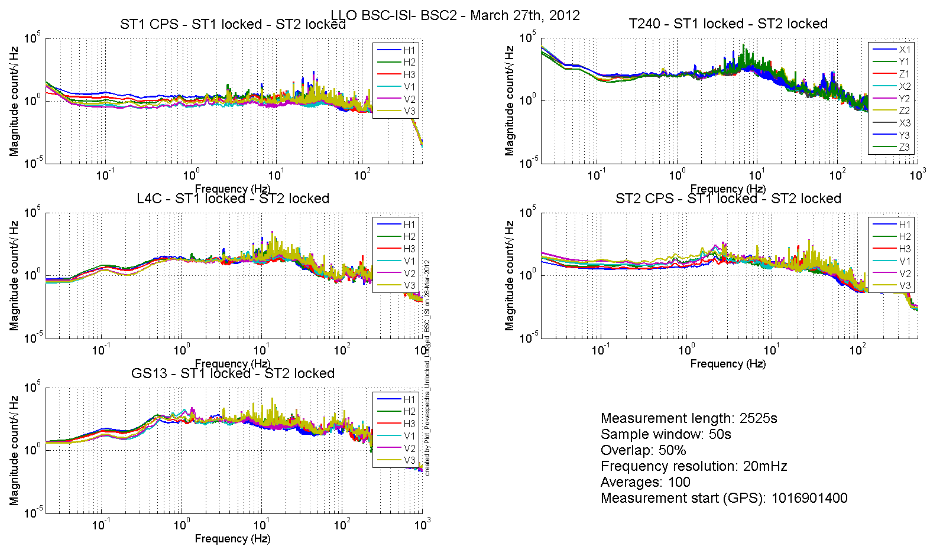
Figure 1: Spectra Stage 1 Locked Stage 2 Locked

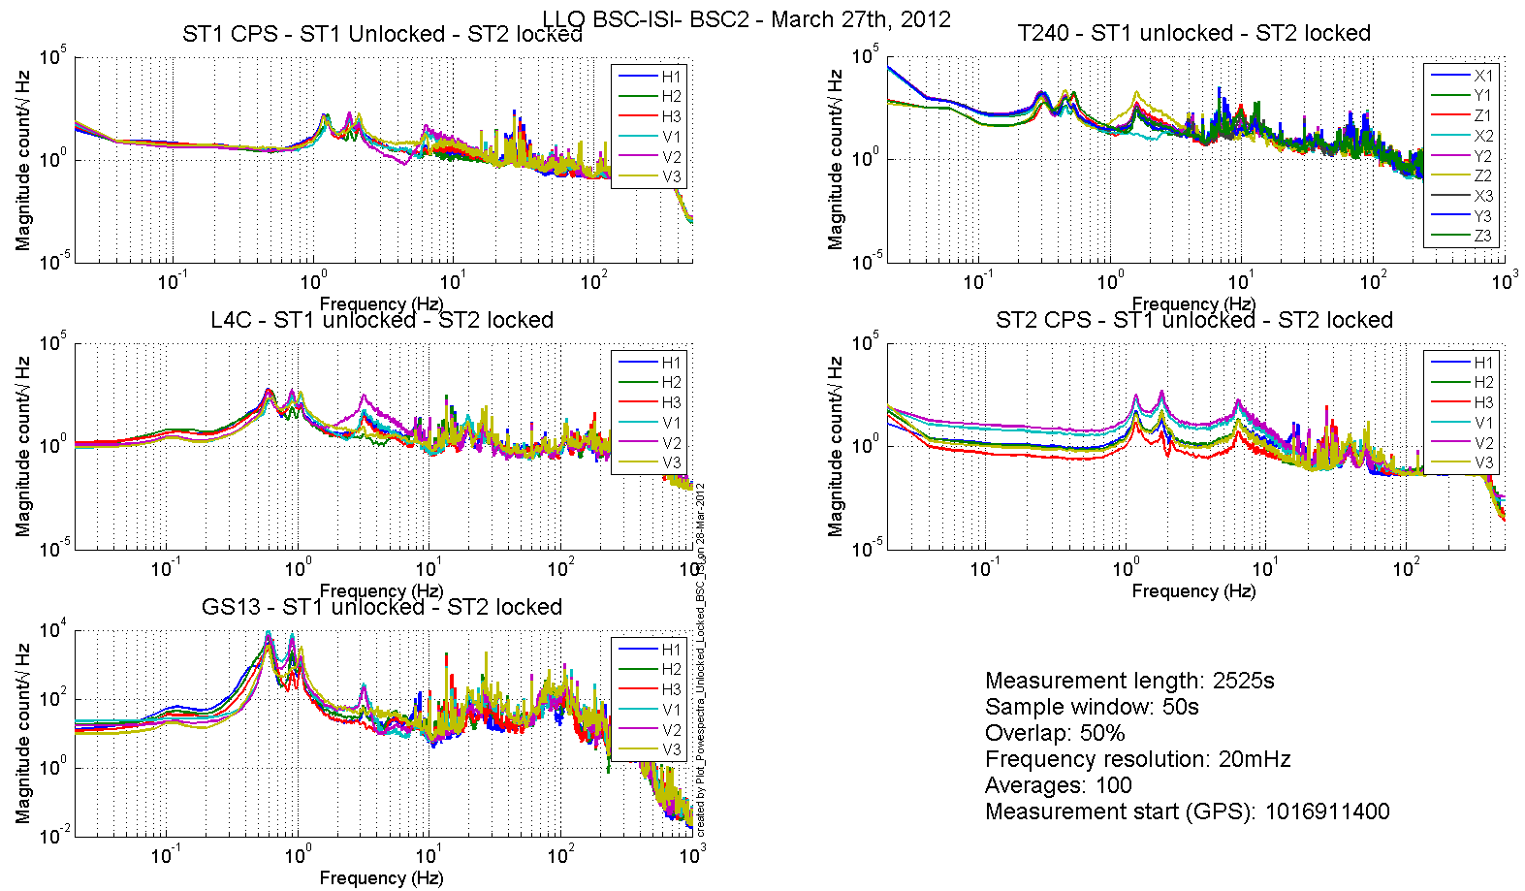
Figure 2: Spectra Stage 1 Unlocked Stage 2 Locked

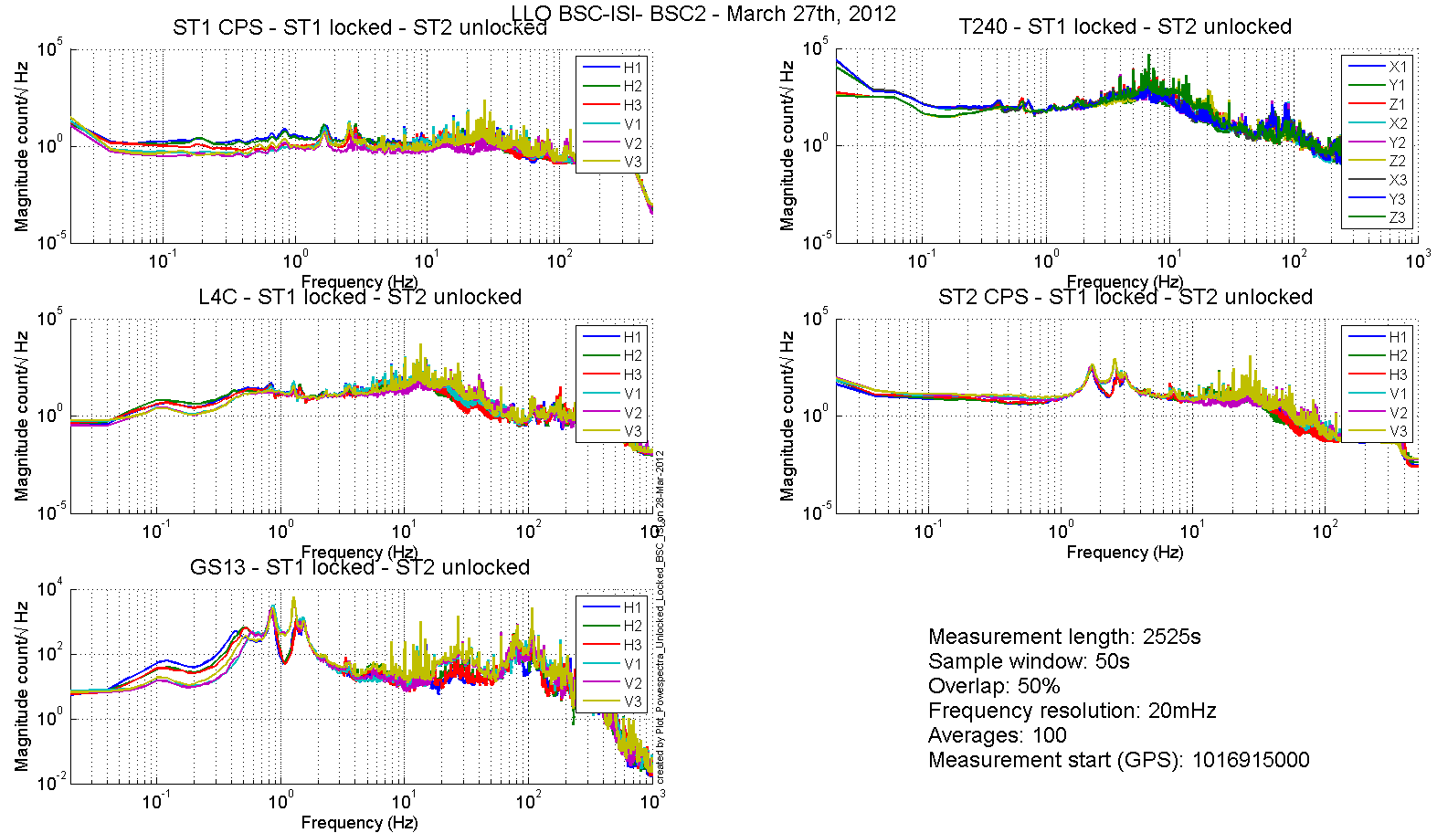
Figure 3: Spectra Stage 1 Locked Stage 2 Unlocked

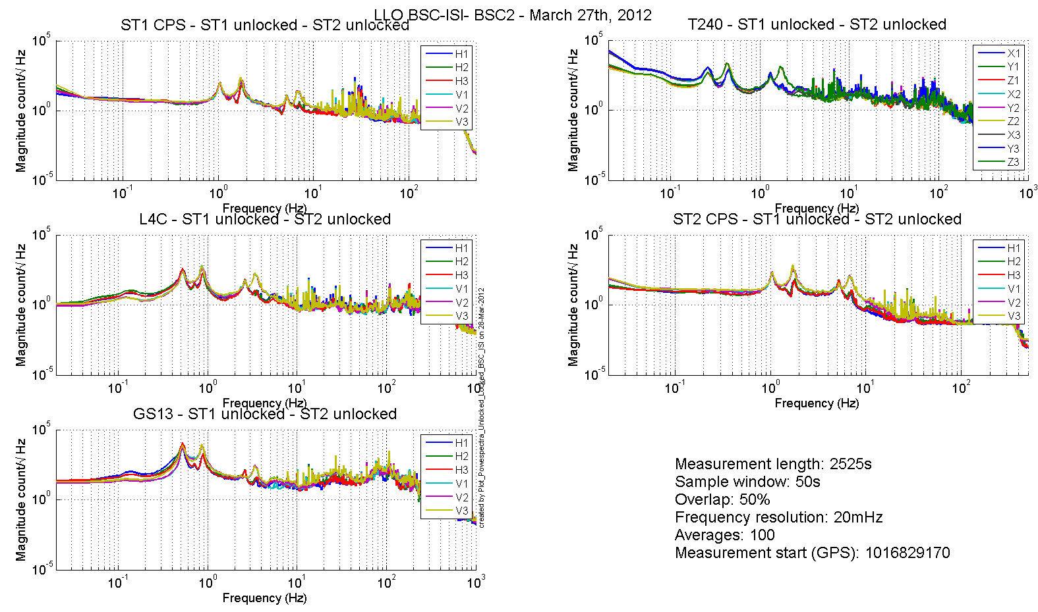
Figure 4: Spectra Stage 1 Unlocked Stage 2 Unlocked

Stage Tilted
The powerspectra are measured when the ISI is unlocked a mass is placed on stage 2 to tilt stage 1 and stage 2.
The six configurations are the following in six different configurations:
- Mass placed in the actuator pocket at corner 1
- Mass placed in the pocket under the blade 0-1 at corner 1
- Mass placed in the actuator pocket at corner 2
- Mass placed in the pocket under the blade 0-1 at corner 2
- Mass placed in the actuator pocket at corner 3
- Mass placed in the pocket under the blade 0-1 at corner 3

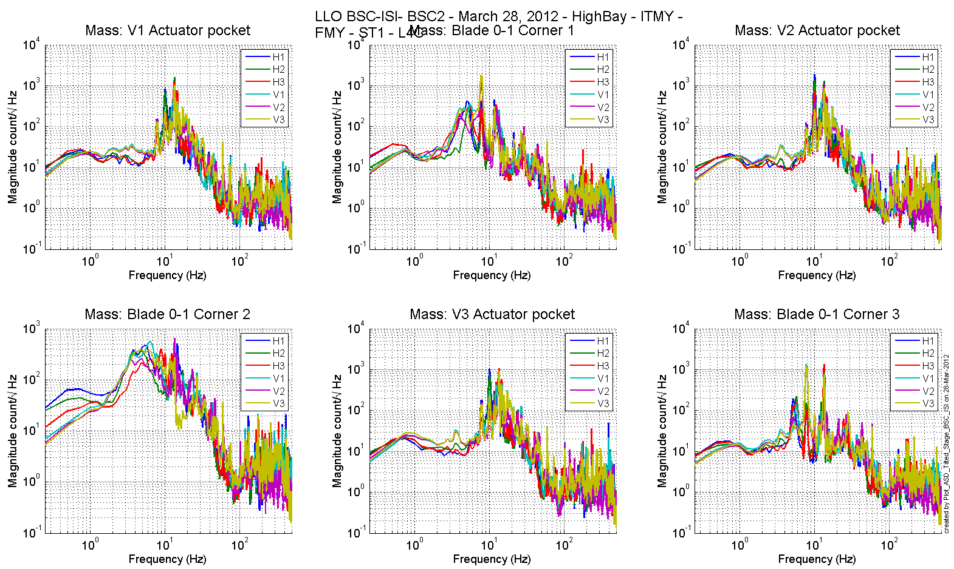
Figure 5 - ST1 L4C – Tilted

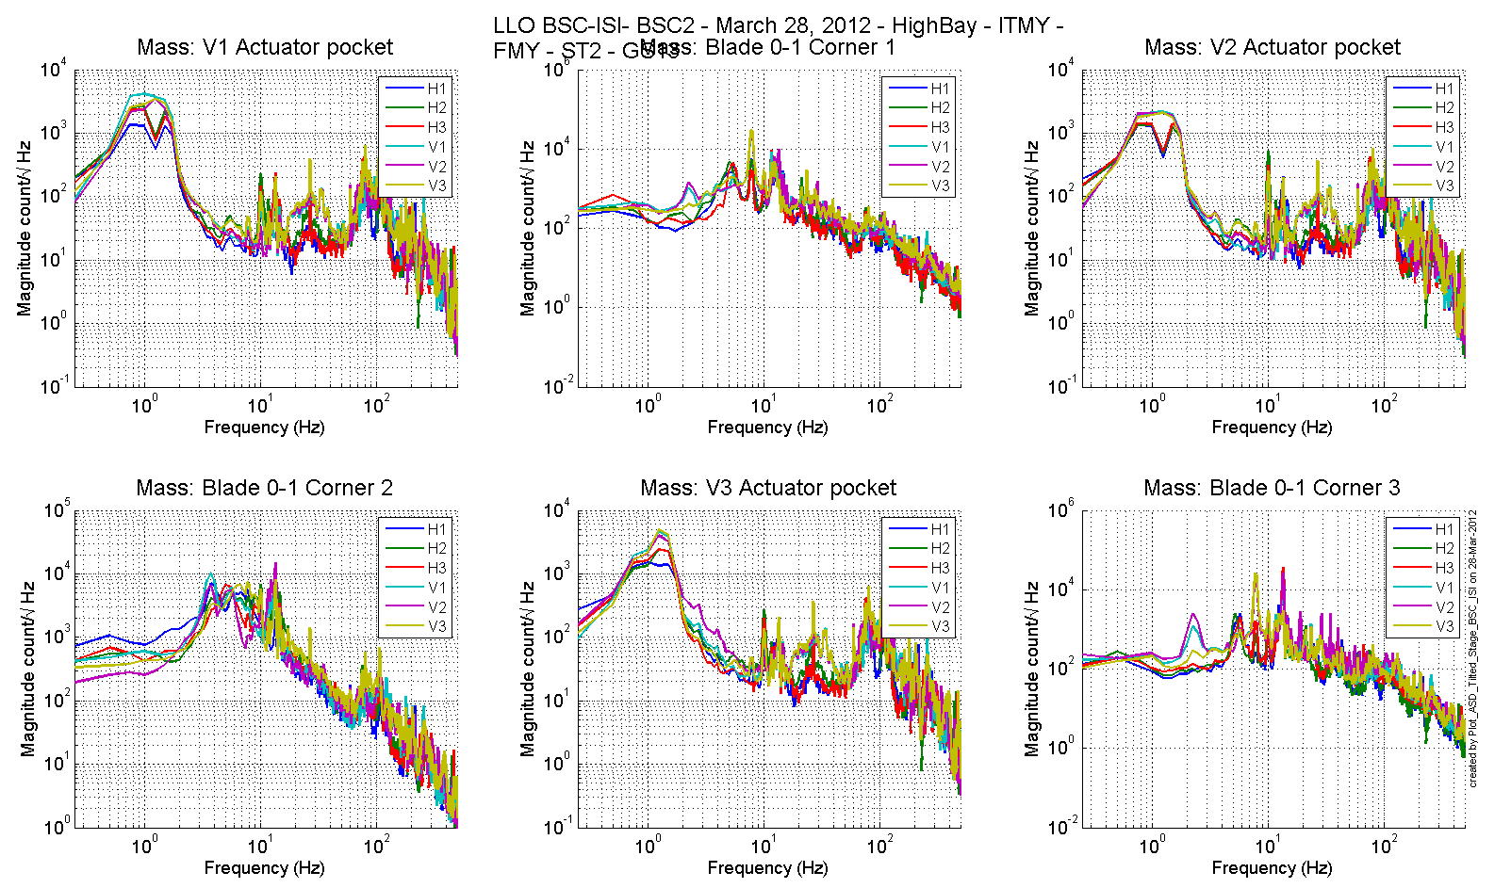
Figure 6 - ST1 GS13 – Tilted

Step 6 - Coil Driver, cabling and resistance check
Resistances of the couple actuator + cables are reported in the table below:

Actuator | Coil driver name | Resistance (Ω)
ST1 H1 | Coil1 Coarse 1 | 6.6
ST2 H1 | Coil 1 Fine 1 | 10.4
ST2 V1 | Coil 1 Fine 2 | 10.8
ST1 V1 | Coil 1 Coarse 2 | 6.5
ST1 H2 | Coil 2 Coarse 2 | 6.6
ST2 H2 | Coil 2 Fine 1 | 10.8
ST2 V2 | Coil 2 Fine 2 | 10.7
ST1 V2 | Coil 2 Coarse 2 | 6.6
ST1 H3 | Coil 3 Coarse 1 | 6.5
ST2 H3 | Coil 3 Fine 1 | 10.5
ST2 V3 | Coil 3 Fine 2 | 10.7
ST1 V3 | Coil 3 Coarse 2 | 6.5

Acceptance criteria:

- For the actuators of stage 1, the measured resistance between the middle pin and one side pin must be 6.3 +/-0.5 ohms
- For the actuators of stage 2, the measured resistance between the middle pin and one side pin must be 10.3 +/-0.5 ohms
- Actuator neutral pins must be connected on pin #1 (left side pin of the plug)
- Actuator drive pins must be connected on pin #2 (middle pin of the plug)
- Actuator ground shield pins must be connected on pin #3 (right pin of the plug)
- All LEDs on the coil driver front panel must be green the binary input bit must be in the upper state.

Note: The coil drivers have been fixed such that the read back bit is in a upper state when the coil driver is working properly (upper state when everything is fine).

Test result: Passed: X Failed: . Waived :. .

Step 7- Actuators Sign and range of motion (Local drive)

Step 7.1 - Actuators sign

Test result: Passed: X Failed: . Waived :. .

Step 7.2 - Range of motion - Local drive
In this step, range of motion of the two stages is checked when applying a local drive (30000 counts) on actuators.

Sensor readout (counts) | Negative drive | no drive | Positive drive | Amplitude count | mil
ST1 - H1 | -16971 | 219 | 16191 | 33162 | 39
ST1 - H2 | -16834 | -412 | 15765 | 32599 | 39
ST1 - H3 | -15955 | -137 | 16479 | 32434 | 39
ST1 - V1 | -14910 | 74 | 15112 | 30022 | 36
ST1 - V2 | -14689 | 379 | 15530 | 30219 | 36
ST1 - V3 | -15927 | -756 | 14420 | 30347 | 36
ST2 - H1 | -8292 | 2036 | 12350 | 20642 | 6
ST2 - H2 | -8297 | 1851 | 11994 | 20291 | 6
ST2 - H3 | -7877 | 2356 | 12571 | 20448 | 6
ST2 - V1 | -10609 | 1829 | 14252 | 24861 | 7
ST2 - V2 | -10328 | 2419 | 15017 | 25345 | 8
ST2 - V3 | -10899 | 1642 | 14144 | 25043 | 7
Table 13 - Range of motion - Local drive

Acceptance criteria:
- Amplitude must be at least 32000 counts (+/-0.02”) for Stage 1 CPS
- Amplitude must be at least 20000 counts (~0.010”) for Stage 2 CPS
- Signs of actuators drive and sensors read out have to be the same

Note: The motion of the platform can be computed. For a 30000 counts drive in the +Z direction, the platform should move by 12.6 mil on stage 1 and 3.6mil on stage 2.

In the Cartesian basis, the platform should move (calcultaion) by:
Stage 1 - Platform move for 32K counts drive: | 12.63 | mil
Stage 2 - Platform move for 32K counts drive: | 3.59 | mil

Test result: Passed: Failed: X . Waived :. .

Step 8 - Vertical Sensor Calibration
This test is inaccurate due to the important hysteresis introduced by the dial indicators. Moreover, the sensors calibrations have been checked at LASTI. This test has not been performed on LLO Unit 1.

Test result: Passed: Failed: . Waived :. X .

Step 9 - Vertical Spring Constant
This test is realized by loading the ISI when one stage is locked and using the capacitive position sensors as reference.

The stiffness measurements of the spring are reported in the tables below. The nominal blade stiffness are:
- Stage 1: 1241lb/in
- Stage 2: 1465lb/in

Blade Stage 0-1
Stage 2 Locked & Stage 1 Unlocked. Stage 1 is loaded with 3 x 5Kg masses and the measurements are repeated three times (by rotating the masses).

 | No load | Load 15 Kg | Load 30Kg | Diff 1 | Diff 2
V1 | 239.73 | -7416.8 | -14911.33333 | -7656.53 | -15151.06333
V2 | 657.65 | -6703.233333 | -14317 | -7360.883333 | -14974.65
V3 | -540.21 | -8206.966667 | -15797.66667 | -7666.756667 | -15257.45667

-15127.72333 | count
-18.00919444 | mil
-1223.065906
1.44513248 | %

The blades from stage 0 to stage 1 are too soft by 14.99%.

Blade Stage 1-2
Stage 1 Locked & Stage 2 Unlocked. Stage 2 is loaded with 3 x 5Kg masses and the measurements are repeated three times (by rotating the masses).

 | No load | Load | Diff
V1 | 2060.8 | -24388.33333 | 26449.13333
V2 | 742.17 | -24923.33333 | 25665.50333
V3 | 1997.2 | -24143 | 26140.2

26085 | count
7.76 | mil
1406.221939 | lb/in
4.012154362 | %

The blades from stage 1 to stage 2 are too soft by 4%.

Note:
A dirty assembly was build at LASTI for fit-check and testing purpose before the first assembly at LHO & LLO. During balancing, the total added mass on top of stage 2 to simulate the payload was far from nominal. Investigations on the blades stiffness showed an extra softness of the blade of both stages. But the mass deduction to compensate this extra softness didn’t explain the difference with the nominal payload. In order to be closer to the nominal payload, the angles of the blade spacers were corrected (correction equivalent to +253lb on stage 0-1 blade and +507lb on stage 1-2 blade). These discrepancies between the initial design and assembly can be explained by:
- Inaccuracy in Solidworks estimation. It might underestimate masses of actual components (metal parts, hardware, instruments...)
- Measurement errors of the blade stiffness
- Machining errors (launch angles, assembly stack up...)
- Extra compliance due to the stages deformation

On this first Unit built at LLO, after noticing a small gap between the Blade and its Spacer all the Blades have been untorqued, put in the same position (using oversized .5015” dowel pins, with the Blade brought as far back as possible) and retorqued to a higher value (150 ft. lbs instead of the initial 110) without using methanol. After that, the gap was barely noticeable.

Facts:
- Nominal load on Stage 0-1 blades is 8240 lb (per initial design estimation)
- -1.45% of 8240 lb is -120 lbs.
- +253 lb are compensated per ST1 - launch angle correction (E1100284, line 9)
- So we should be at +253-120= 133 lb above nominal (60kg).

Test result: Passed: X Failed: . Waived :. .

Step 10 - Static Testing (Tests in the local basis)
The table below shows the main and the cross-coupling when the actuators are driven in the local basis:

The static tests results are reported in the SVN at :
/seismic/BSC-ISI/X2/BSC2/Data/Static_Tests/
- LLO_ISI_BSC2_Offset_Local_Drive_20120327.mat

 |  | Sensors
 |  | ST1 - H1 | ST1 - H2 | ST1 - H3 | ST1 - V1 | ST1 - V2 | ST1 - V3
Actuators | ST1 - H1 | 4451.5 | 1778.6 | 1782.8 | 11.7 | -23.2 | 19.8
Actuators | ST1 - H2 | 1770.8 | 4388.5 | 1765.5 | 8.5 | -22.5 | -2.8
Actuators | ST1 - H3 | 1747.8 | 1755.1 | 4363.1 | -17.8 | 3.8 | 8.8
Actuators | ST1 - V1 | 33.3 | -161.6 | 80.8 | 3514.2 | -664.6 | -602.3
Actuators | ST1 - V2 | 103.4 | 39.5 | -167.8 | -614.8 | 3514.8 | -648.1
Actuators | ST1 - V3 | -153.7 | 95.5 | 56.0 | -637.5 | -623.4 | 3539.6
Table 14 - Static test - Local to local - Stage 1

 |  | Sensors
 |  | ST2 - H1 | ST2 - H2 | ST2 - H3 | ST2 - V1 | ST2 - V2 | ST2 - V3
Actuators | ST2 - H1 | 2401.0 | 383.5 | 348.7 | 13.5 | -77.9 | -10.4
Actuators | ST2 - H2 | 351.7 | 2395.5 | 336.3 | -65.8 | -85.9 | -4.8
Actuators | ST2 - H3 | 363.5 | 341.5 | 2379.2 | -77.1 | -79.7 | -134.8
Actuators | ST2 - V1 | 70.9 | 126.9 | -203.1 | 2773.0 | 213.4 | -62.2
Actuators | ST2 - V2 | -233.3 | 68.7 | 98.4 | -161.4 | 2891.9 | 242.7
Actuators | ST2 - V3 | 78.5 | -152.6 | 68.0 | 266.3 | -140.0 | 2830.1
Table 15 - Static test - Local to local - Stage 2

Acceptance criteria:

- Main couplings readout must be positive
- Comparison with the reference tables:
  - Main coupling differences mustn’t exceed 200 counts
  - Cross coupling differences mustn’t exceed 50 counts

Reference tables for acceptance criteria:

 |  | Sensors
 |  | ST1 - H1 | ST1 - H2 | ST1 - H3 | ST1 - V1 | ST1 - V2 | ST1 - V3
Actuators | ST1 - H1 | 4380 | 1750 | 1750 | 0 | 0 | 0
Actuators | ST1 - H2 | 1750 | 4380 | 1750 | 0 | 0 | 0
Actuators | ST1 - H3 | 1750 | 1750 | 4380 | 0 | 0 | 0
Actuators | ST1 - V1 | 50 | -170 | 90 | 3500 | -650 | -650
Actuators | ST1 - V2 | 90 | 50 | -170 | -650 | 3500 | -650
Actuators | ST1 - V3 | -170 | 90 | 50 | -650 | -601 | 3500
Table - Main couplings – Static – Stage 1

 |  | Sensors
 |  | ST2 - H1 | ST2 - H2 | ST2 - H3 | ST2 - V1 | ST2 - V2 | ST2 - V3
Actuators | ST2 - H1 | 2401 | 360 | 360 | 0 | 0 | 0
Actuators | ST2 - H2 | 360 | 2401 | 360 | 0 | 0 | 0
Actuators | ST2 - H3 | 360 | 360 | 2377 | 0 | 0 | 0
Actuators | ST2 - V1 | 80 | 130 | -200 | 3050 | 330 | 0
Actuators | ST2 - V2 | -200 | 800 | 130 | 0 | 2950 | 330
Actuators | ST2 - V3 | 130 | -200 | 80 | 330 | 0 | 2950
Table - Main couplings – Static – Stage 2

Test result: Passed: X Failed: . Waived :. .

Step 11- Static Testing - In the general coordinate basis (Static test - CPS)

Step 11.1 – Change of basis matrices from Cartesian to Local
The table below shows the main and the cross-coupling when the actuators are driven in the Cartesian basis:

The static tests results are reported in the SVN at :
/seismic/BSC-ISI/X2/BSC2/Data/Static_Tests/
- LLO_ISI_BSC2_Offset_Cartesian_Drive_20120409.mat

 |  | Sensors
 |  | ST1 - H1 | ST1 - H2 | ST1 - H3 | ST1 - V1 | ST1 - V2 | ST1 - V3
Actuators | ST1 - X | 1778.2 | -848.2 | -846.7 | 15.7 | 0.4 | -26.1
Actuators | ST1 - Y | 2.4 | 1517.1 | -1505.1 | 14.3 | -11.4 | -18.1
Actuators | ST1 - Z | -3.0 | 0.6 | -27.5 | 744.6 | 758.3 | 725.8
Actuators | ST1 - RX | 6.2 | 152.1 | -150.8 | -2918.3 | 2459.1 | 413.8
Actuators | ST1 - RY | -196.5 | 102.2 | 64.2 | -1178.1 | -1955.6 | 3089.3
Actuators | ST1 - RZ | 3209.3 | 3211.9 | 3213.3 | -20.5 | -32.9 | -27.0
 |  | Sensors
 |  | ST2 - H1 | ST2 - H2 | ST2 - H3 | ST2 - V1 | ST2 - V2 | ST2 - V3
Actuators | ST2 - X | 676.5 | -1346.8 | 664.4 | -34.4 | -25.3 | -72.9
Actuators | ST2 - Y | 1157.8 | 1.2 | -1193.9 | -29.4 | -50.6 | -38.2
Actuators | ST2 - Z | 1.0 | -15.5 | -3.8 | 1017.9 | 1031.5 | 982.4
Actuators | ST2 - RX | -309.8 | 20.3 | 250.1 | -2469.1 | 2555.5 | -153.7
Actuators | ST2 - RY | 116.6 | -311.0 | 158.8 | -1499.7 | -1123.3 | 2849.0
Actuators | ST2 - RZ | 1774.4 | 1776.0 | 1754.1 | -81.3 | -53.8 | -55.4
Table 16 - Static test cartesian drive – Cartesian to local

Reference table static test Cartesian to local:

 |  | Sensors
 |  | ST1 - H1 | ST1 - H2 | ST1 - H3 | ST1 - V1 | ST1 - V2 | ST1 - V3
Actuators | ST1 - X | 1800 | -820 | -820 | 0 | 0 | 0
Actuators | ST1 - Y | 0 | 1500 | -1500 | 0 | 0 | 0
Actuators | ST1 - Z | 0 | 0 | 0 | 772 | 750 | 700
Actuators | ST1 - RX | 0 | 160 | -160 | -2950 | 2450 | 450
Actuators | ST1 - RY | -200 | 110 | 70 | -1150 | -2000 | 3050
Actuators | ST1 - RZ | 3200 | 3200 | 3200 | 0 | 0 | 0
Table 17 - Reference table - Cartesian to Local - Stage 1

 |  | Sensors
 |  | ST2 - H1 | ST2 - H2 | ST2 - H3 | ST2 - V1 | ST2 - V2 | ST2 - V3
Actuators | ST2 - X | 700 | -1350 | 650 | 0 | 0 | 0
Actuators | ST2 - Y | 1200 | 0 | -1150 | 0 | 0 | 0
Actuators | ST2 - Z | 0 | 0 | 0 | 1100 | 1100 | 1100
Actuators | ST2 - RX | -300 | 0 | 300 | -2500 | 2500 | -50
Actuators | ST2 - RY | 200 | -300 | 200 | -1500 | -1400 | 3000
Actuators | ST2 - RZ | 1800 | 1800 | 1800 | 40 | 40 | 40
Table 18 - Reference table - Cartesian to Local - Stage 2

Acceptance criteria:

- Comparison with the reference tables:
  - Differences mustn’t exceed 100 counts

Test result: Passed: X Failed: . Waived :. .

Step 11.2 – Base change matrices from Cartesian to Cartesian
The static tests results are reported in the SVN at :
/seismic/BSC-ISI/X1/Data/BSC8/Static_Tests/
- LLO_ISI_BSC2_Offset_Cartesian_Drive_20120327.mat

 |  | Sensors
 |  | ST1 - X | ST1 - Y | ST1 - Z | ST1 - RY | ST1 - RY | ST1 - RZ
Actuators | ST1 - X | 1772.1 | -12.4 | 4.1 | 0.9 | -20.6 | 32.8
Actuators | ST1 - Y | 8.7 | 1734.4 | -0.4 | -8.5 | -4.4 | 5.7
Actuators | ST1 - Z | 10.2 | -8.7 | 741.1 | 6.2 | 3.9 | -14.9
Actuators | ST1 - RX | 40.8 | 351.9 | -5.2 | 3032.1 | -9.5 | 10.3
Actuators | ST1 - RY | -370.4 | 13.0 | -19.7 | 11.4 | 3033.3 | -5.1
Actuators | ST1 - RZ | 12.4 | 2.6 | -1.7 | 7.3 | 0.2 | 3346.1
 |  | Sensors
 |  | ST2 - X | ST2 - Y | ST2 - Z | ST2 - RY | ST2 - RY | ST2 - RZ
Actuators | ST2 - X | 1350.7 | -16.2 | -42.5 | -6.5 | -18.6 | -10.1
Actuators | ST2 - Y | 10.1 | 1349.2 | -53.2 | 2.7 | -35.1 | -25.1
Actuators | ST2 - Z | 24.9 | -17.2 | 1059.3 | 6.5 | -15.1 | -18.0
Actuators | ST2 - RX | -9.0 | -31.1 | -79.9 | 4325.8 | -105.3 | -18.0
Actuators | ST2 - RY | 19.7 | -17.8 | 56.9 | 241.5 | 4055.2 | -32.7
Actuators | ST2 - RZ | 10.0 | -7.2 | -67.0 | 11.3 | 5.3 | 2551.5
Table 19 - Static Test - Cartesian to Cartesian

Reference table static test Cartesian to Cartesian:

 |  | Sensors
 |  | ST1 - X | ST1 - Y | ST1 - Z | ST1 - RY | ST1 - RY | ST1 - RZ
Actuators | ST1 - X | 1750 | 0 | 0 | 0 | 0 | 0
Actuators | ST1 - Y | 0 | 1750 | 0 | 0 | 0 | 0
Actuators | ST1 - Z | 0 | 0 | 750 | 0 | 0 | 0
Actuators | ST1 - RX | 0 | 375 | 0 | 3000 | 0 | 0
Actuators | ST1 - RY | -375 | 0 | 0 | 0 | 3000 | 0
Actuators | ST1 - RZ | 0 | 0 | 0 | 0 | 0 | 3300
 |  | Sensors
 |  | ST2 - X | ST2 - Y | ST2 - Z | ST2 - RY | ST2 - RY | ST2 - RZ
Actuators | ST2 - X | 1350 | 10 | 30 | 0 | 25 | 20
Actuators | ST2 - Y | -10 | 1350 | 20 | -25 | 0 | 20
Actuators | ST2 - Z | 0 | 0 | 1100 | -10 | -30 | 20
Actuators | ST2 - RX | 10 | -15 | 20 | 4300 | 30 | 20
Actuators | ST2 - RY | 30 | 0 | 30 | 40 | 4300 | 20
Actuators | ST2 - RZ | 0 | 10 | 30 | -25 | -15 | 2600

Acceptance criteria:

- Main couplings readout must be positive
- Comparison with the reference tables:
  - Main coupling differences mustn’t exceed 200 counts
  - Cross coupling differences mustn’t exceed 50 counts

Test result: Passed: X Failed: . Waived :. .

Step 12 - Linearity test
The linearity test figure are reported in the SVN at :
/seismic/BSC-ISI/X2/BSC2/Data/Figures/Linearity_Test/
- LLO_ISI_BSC2_Linearity_test_20120321.fig
- LLO_ISI_BSC2_Linearity_test_20120321.pdf

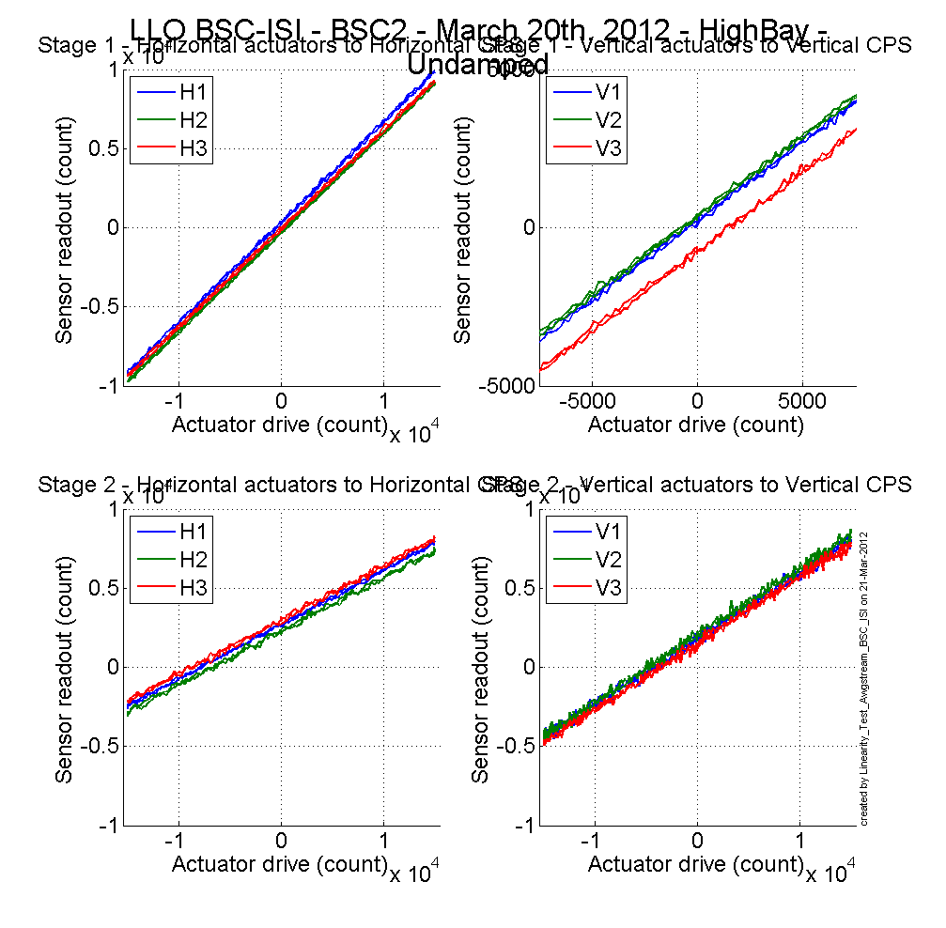
Figure 7 - Linearity Test

Slope – Offset:

 |  | Slope | Offset | Average slope | Variation from  average (%)
Stage 1 | ST1 - H1 | 0.633 | 349 | 0.6265 | 1.10
Stage 1 | ST1 - H2 | 0.626 | -273 | 0.6265 | -0.01
Stage 1 | ST1 - H3 | 0.620 | -43 | 0.6265 | -1.08
Stage 1 | ST1 - V1 | 0.499 | 231 | 0.5021 | -0.56
Stage 1 | ST1 - V2 | 0.503 | 391 | 0.5021 | 0.09
Stage 1 | ST1 - V3 | 0.504 | -725 | 0.5021 | 0.47
Stage 2 | ST2 - H1 | 0.343 | 2706 | 0.3403 | 0.66
Stage 2 | ST2 - H2 | 0.338 | 2289 | 0.3403 | -0.78
Stage 2 | ST2 - H3 | 0.341 | 2998 | 0.3403 | 0.12
Stage 2 | ST2 - V1 | 0.413 | 1809 | 0.4179 | -1.10
Stage 2 | ST2 - V2 | 0.422 | 2015 | 0.4179 | 1.07
Stage 2 | ST2 - V3 | 0.418 | 1524 | 0.4179 | 0.03
Table - Slopes and offset of the triplet Actuators - BSC-ISI - Sensors

Acceptance criteria:

- Horizontal and vertical slopes of the triplet actuators x BSC-ISI x sensors: Average slope +/- 3%

Test result: Passed: X Failed: . Waived :. .

Step 13 – Transfer functions – Local to Local
Data files measurement of local to local transfer functions in SVN at:
/svncommon/SeiSVN/seismic/BSC-ISI/X2/BSC2/Data/Transfer_Functions/Measurements/Undamped
- LLO_ISI_BSC2_Data_L2L_10mHz_100mHz_ST1_ST2_20120327-041856.mat
- LLO_ISI_BSC2_Data_L2L_100mHz_700mHz_ST1_ST2_20120326-225602.mat
- LLO_ISI_BSC2_Data_L2L_700mHz_10Hz_ST1_ST2_20120327-062157.mat
- LLO_ISI_BSC2_Data_L2L_10Hz_100Hz_ST1_ST2_20120326-192909.mat
- LLO_ISI_BSC2_Data_L2L_100Hz_500Hz_ST1_ST2_20120326-174416.mat
- LLO_ISI_BSC2_Data_L2L_500Hz_1000Hz_ST1_ST2_20120326-161949.mat

Script file for processing and plotting local to local transfer functions in SVN at:
/seisvn/seismic/BSC-ISI/X2/Scripts/Control_Scripts
- Step_1_TF_L2L_10mHz_1000Hz_LLO_ISI_BSC2.m

Figures of local to local transfer functions (Main couplings) in SVN at:
/seisvn/seismic/BSC-ISI/X2/BSC2/Data/Figures/Transfer_Functions/Measurements/Undamped
- LLO_ISI_BSC2_TF_L2L_Raw_from_ST1_ACT_to_ST1_CPS_2012_03_27.fig
- LLO_ISI_BSC2_TF_L2L_Raw_from_ST1_ACT_to_ST1_CPS_2012_03_27.fig
- LLO_ISI_BSC2_TF_L2L_Raw_from_ST2_ACT_to_ST2_CPS_2012_03_27.fig
- LLO_ISI_BSC2_TF_L2L_Raw_from_ST2_ACT_to_ST2_GS13_2012_03_27.fig

Measured of local to local transfer functions in the SVN at:
/svncommon/seisvn/seismic/BSC-ISI/X2/BSC2/Data/Transfer_Functions/Simulations/Undamped
- LLO_ISI_BSC2_TF_L2L_Raw_10mHz_1000Hz_2012_03_27.mat

Note 1: The transfer functions are measured from the Output filter bank (excitation variable) to the input (IN1) of the input filter bank. The transfer functions presented below are raw transfer functions without any electronic compensation of the sensor electronic. The actuator and the coil driver electronic compensation are introduced in these transfer functions.

Note 2: The L4Cs are out of phase (should be -90 before 1Hz). A minus sign is added in the calibration filters that convert count to nm/s.

Note 3: The resonance observed at 33Hz on Stage 1 CPS is the resonance of the test stand. When the transfer functions will be measured in the LVEA, this resonance should be observed at lower frequency (19Hz). The High Bay test stand has short feet in comparison with the LVEA test stand (some comparison plots will be presented the testing report – phase II).

Note 4: The first high frequency resonance observed on stage 1 by the L4C is at 216Hz. The next resonance is observed at 244Hz. The first mode of the blade has been measured at ~250Hz at LASTI.

Note 5: There is a poor coherence on the GS13 transfer functions. It can be explained by the weak drive of the fine actuators. Moreover, the stage 2 of the ISI is strongly excited by the fans of the clean rooms. These two factors strongly affect the quality of the measurements. Also, we might have an issue with the GS-13 gain because they were saturating a lot, which can also explain the poor quality of the signal.

Note 6: On the ST2-ACT to ST2-GS13 transfer functions, the first high frequency resonances are observed at 120Hz and 162Hz.

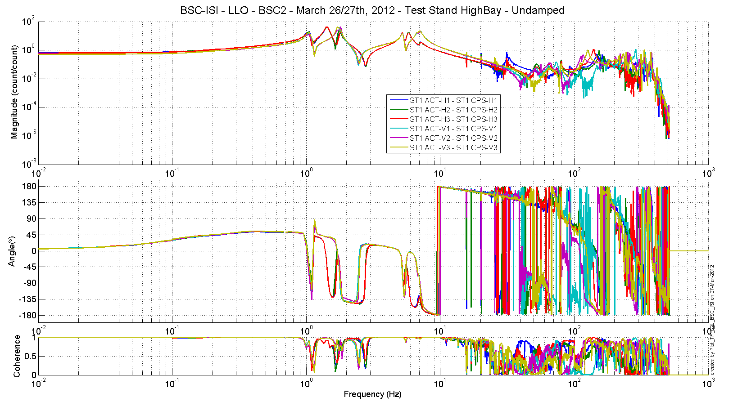
Figure 8 - TF L2L Raw - ST1 Act to ST1 CPS

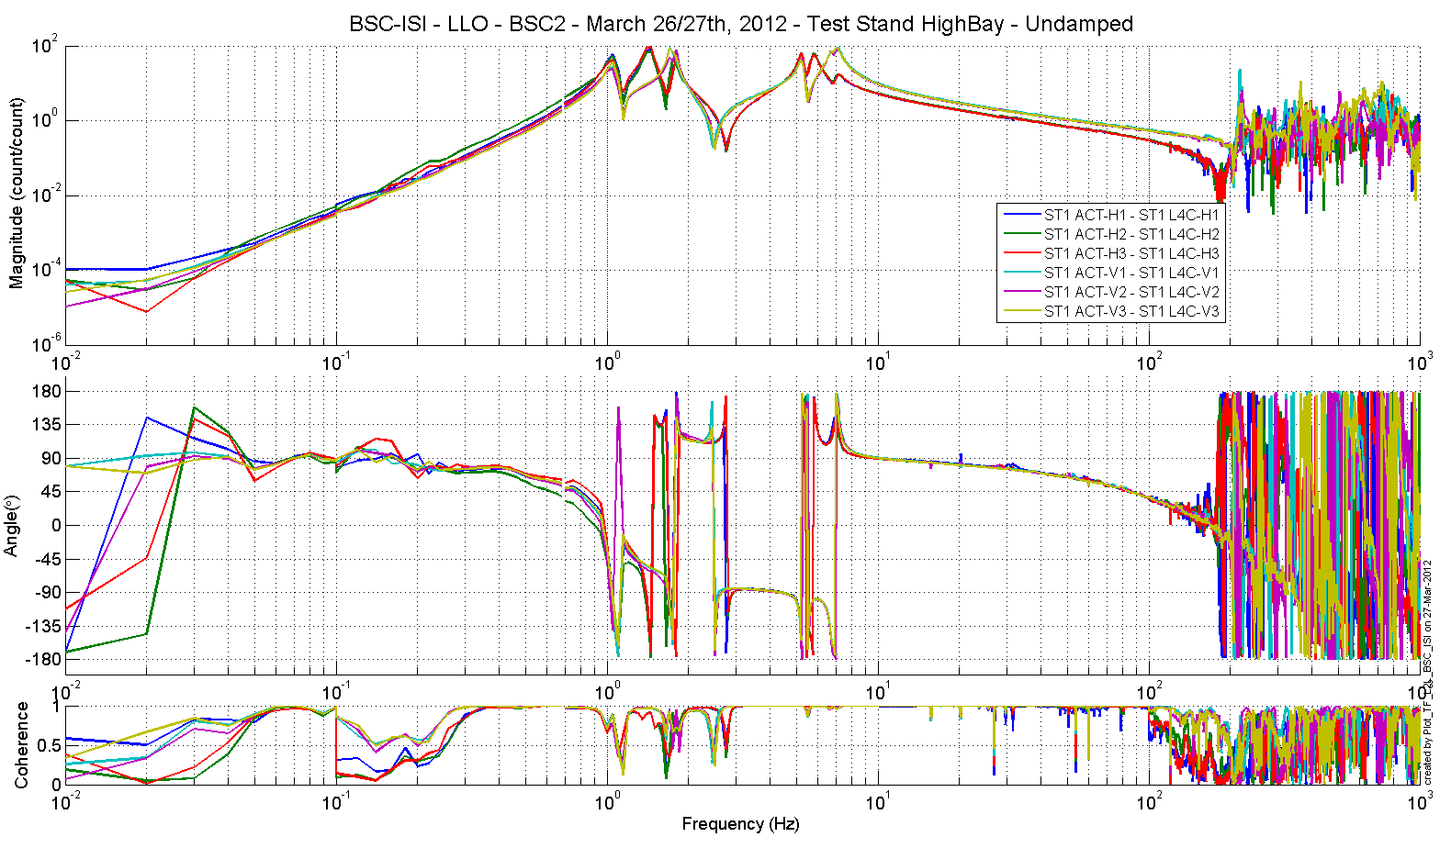
Figure 9 - TF L2L Raw - ST1 Act to ST1 L4C
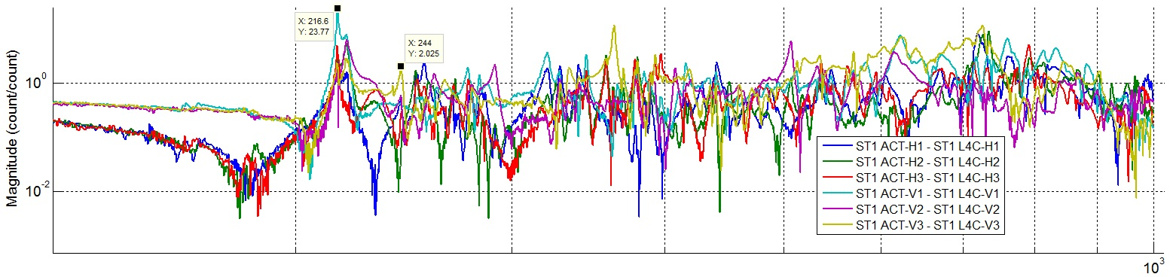

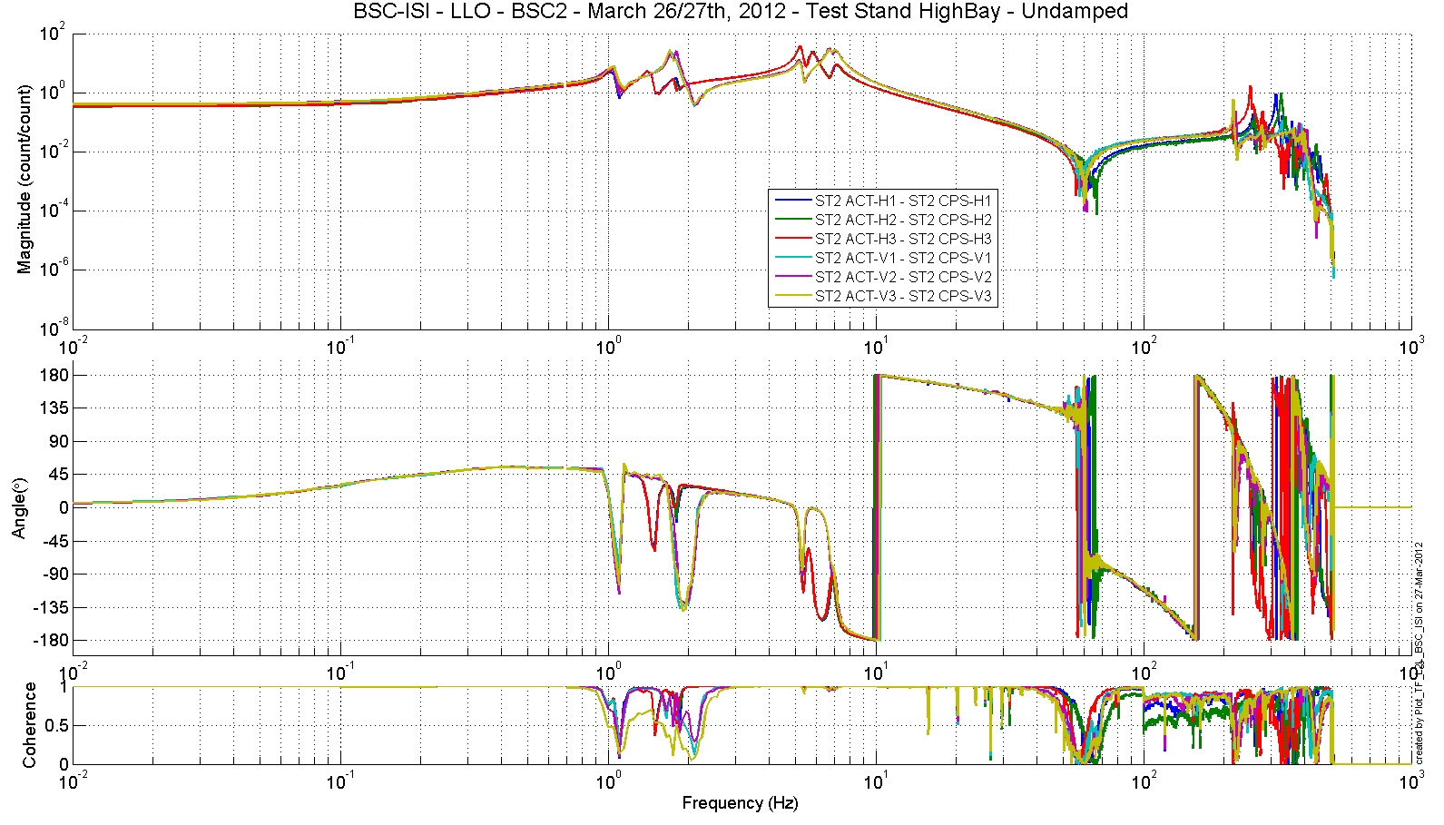
Figure 10 - TF L2L Raw - ST2 Act to ST2 CPS

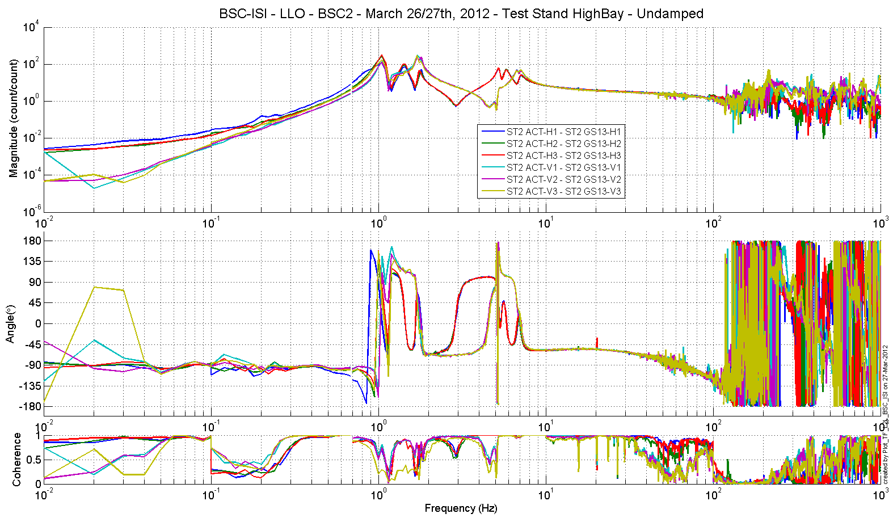
Figure 11 - TF L2L Raw - ST2 Act to ST2 GS13

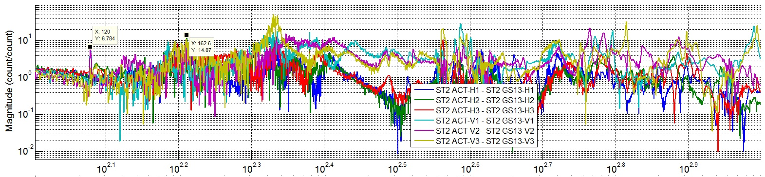

Test result: Passed: X Failed: . Waived :. .

Due to schedule pressure, it was decided it was reasonable to postpone the following tests. They will be performed during Phase II.

Step 14 - Symmetrization – Calibration
Not performed

Step 15 – Change of base – Cartesian to Local - Simulations
Not performed

Step 16- Transfer functions - Cartesian to Cartesian - Measurements
Not performed

Step 17 - Lower Zero Moment Plan

Step 17.1 - Stage 1 - LZMP
Not performed

Step 17.2 - Stage 2 - LZMP
Not performed

Step 18- Damping Loops – Transfer function – Simulations

Step 18.1 - Damping Loops – Stage 2
Not performed

Step 18.2 - Damping Loops – Stage 1
Not performed

Step 19- Damping Loops – Powerspectra

Data files measurement of damping Power Spectra in SVN at:
/svncommon/SeiSVN/seismic/BSC-ISI/X2/BSC2/Data/Spectra/Damping
- LLO_ISI_BSC2_ASD_m_L4C_GS13_Undamped_vs_Damping_2012_04_06_211305.mat

Figures of local to local transfer functions (Main couplings) in SVN at:
/seisvn/seismic/BSC-ISI/X2/BSC2/Data/Figures/Spectra/Damping
- LLO_ISI_BSC2_ASD_CT_CART_ST1_L4C_Undamped_vs_Damping_2012_04_06_211305.fig
- LLO_ISI_BSC2_ASD_m_CART_ST1_L4C_Undamped_vs_Damping_2012_04_06_211305.fig
- LLO_ISI_BSC2_ASD_CT_CART_ST2_GS13_Undamped_vs_Damping_2012_04_06_211305.fig
- LLO_ISI_BSC2_ASD_m_CART_ST2_GS13_Undamped_vs_Damping_2012_04_06_211305.fig

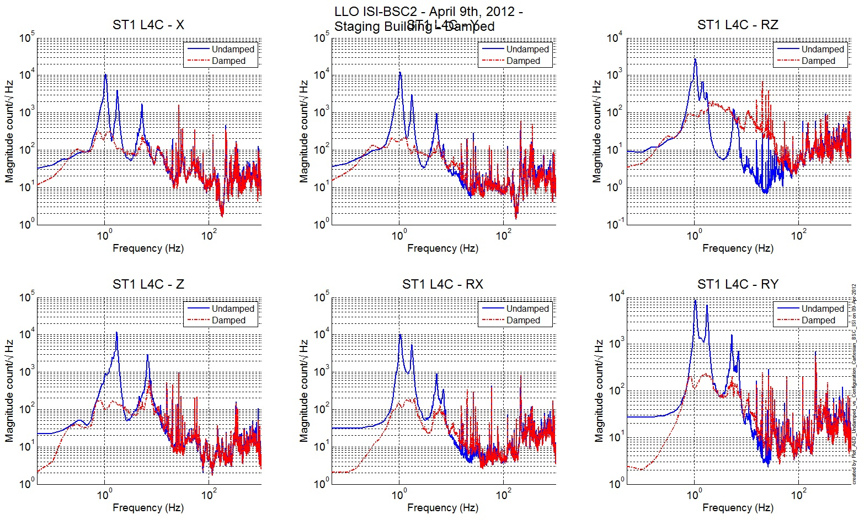
Figure 12: LLO_ISI_BSC2_ASD_CT_CART_ST1_L4C_Undamped_vs_Damping_2012_04_06_211305.fig

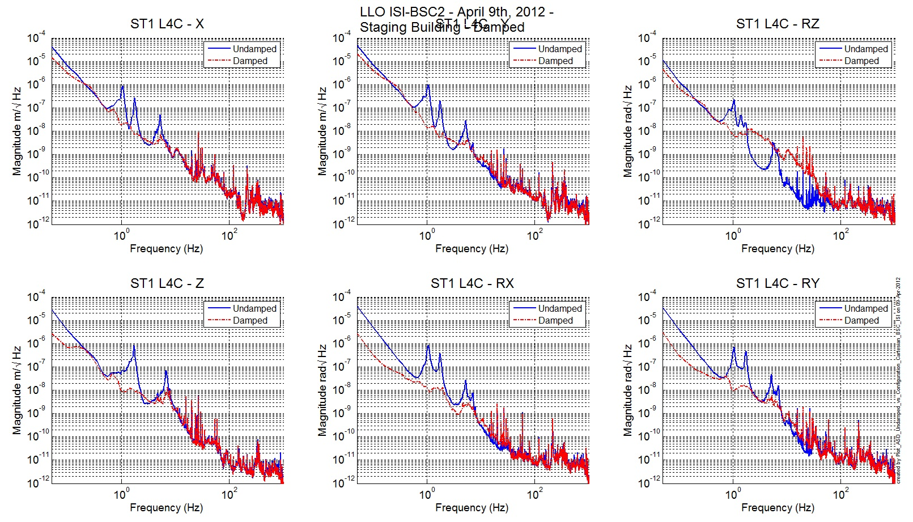
Figure 13: LLO_ISI_BSC2_ASD_m_CART_ST1_L4C_Undamped_vs_Damping_2012_04_06_211305.fig

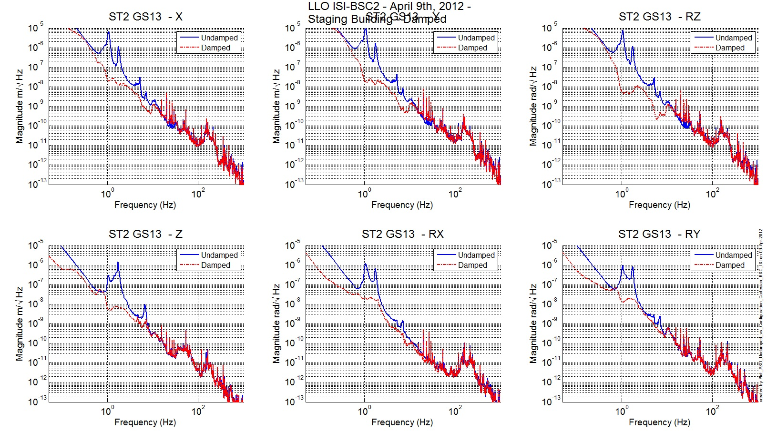
Figure 14: LLO_ISI_BSC2_ASD_CT_CART_ST2_GS13_Undamped_vs_Damping_2012_04_06_211305.fig

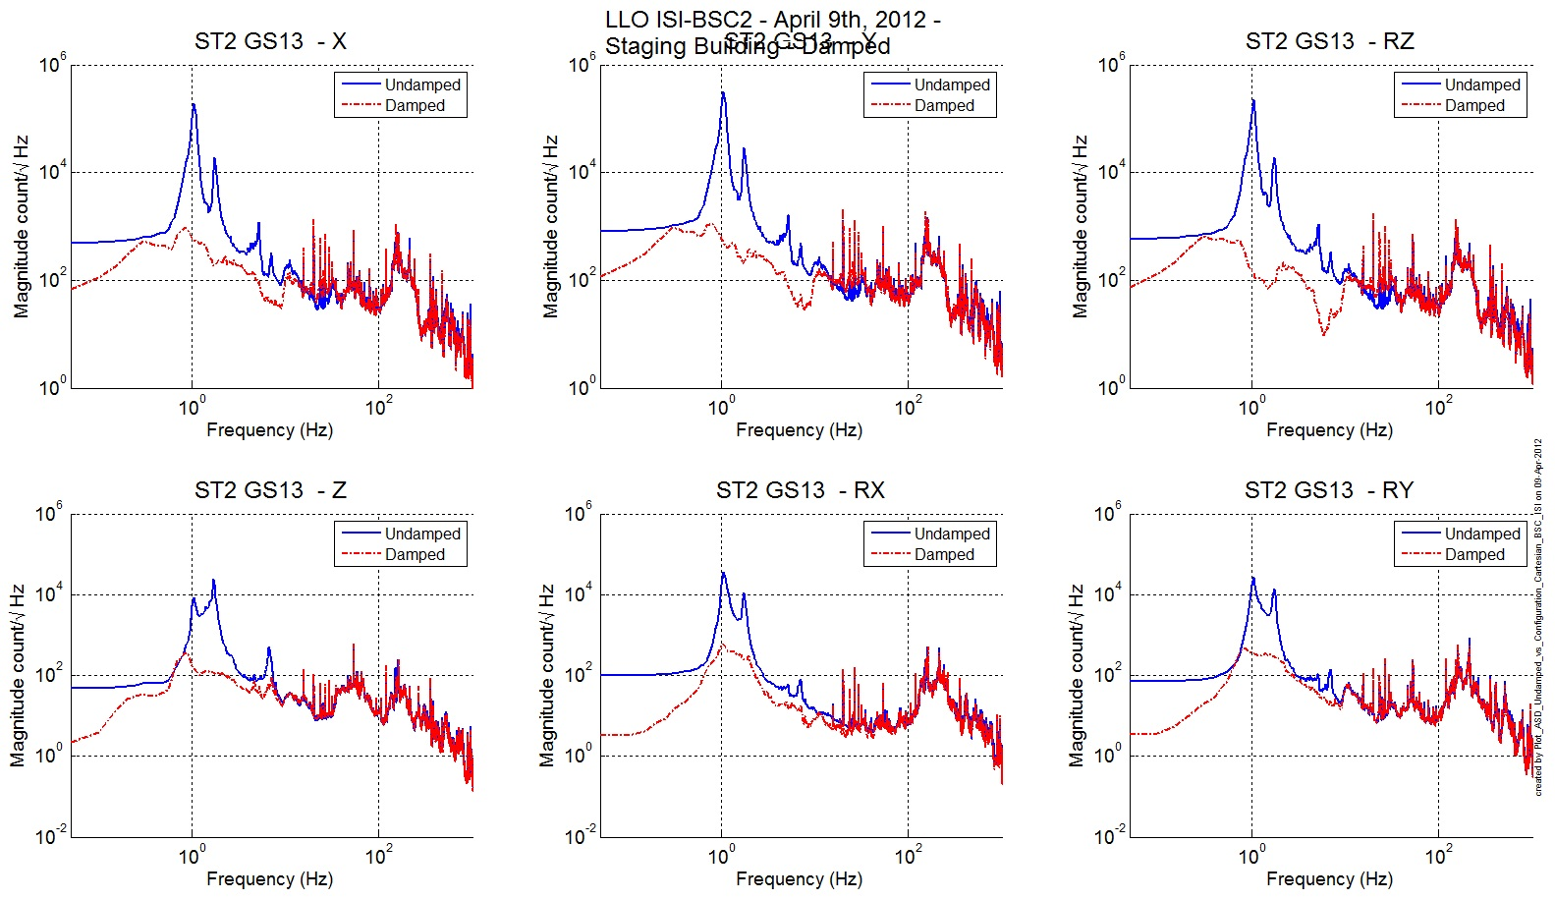
Figure 15: LLO_ISI_BSC2_ASD_m_CART_ST2_GS13_Undamped_vs_Damping_2012_04_06_211305.fig

Test result: Passed: X Failed: . Waived :. .

Step 20- Isolation Loops – for one unit per site
Not performed

BSC-ISI testing Summary
This is the first “aLigo BSC-ISI” tested at LLO. The testing procedure document E1000483-v3 was used. Tests were done during March 2012.

Moreover due to few sensors issues, mainly on T240’s pressure sensors some results are incomplete but sufficient to consider the ISI properly assembled. Tests will be redone during testing phase II.

The ISI-BSC2 is officially validated per the tests presented in this report. All results are posted on the SVN at:
https://svn.ligo.caltech.edu/svn/seismic/BSC-ISI/X2/BSC2/Data

FAILED AND WAIVED TESTS

- List of tests that failed/waived and won’t be redone
- Step II.11 – Lockers adjustment – No value has been recorded during the locker adjustments. Measurements using the CPS sensors when the stages are locked and unlocked have been done Step III.2.

- List of tests that failed/waived, that need to be re-done during phase 2
- Step I.4 – T240 – Inspection/Assembly – Several issues with the pressure sensors on T240 causing several swaps of instrument. The T240 in Corner 2 has still a bad pressure sensor but it will be change in the LVEA.
- Step III.1 – Geophones pressure readout - Pressure sensors of 1 T240 is not working. Plus, we want to check that the GS-13 Interface is working correctly and gives the correct pressure read outs.
- Step III.7 – Range of motion – Local drive – The readouts on Stage 1 Vertical CPS are between 30000 & 32000 counts and not above 32000 counts like it is required. This is not a major issue but the test will be redone.

- List of tests skipped that won't be performed because not feasable during phase II (i.e. stage 0 leveling)
- Step II.5 – Check level of Stage 0 after top-bottom plate assembly
- Step II.8 – Blade 0-1 Post Launch Angle – No need for this test, the budget mass looks good and we already reposition the Blades after noticing a gap between the Blade and its Spacer on Stage 0-1 (see comment on Step 9 – Vertical Spring Constant).
- Step II.11 – Lockers Adjustment – The Lockers have already been adjusted with the dial indicators, we just didn’t record the value, but they are well adjusted (see all passed tests).

- List of tests skipped that we won't do because they are not essential (i.e. redundant with another test)
- Step III.3 – Measure the Sensor gap - This test was not performed. The sensor gaps have not been measured. These sensors have already been checked at LASTI. Moreover, risks of scratching the target are so high that we preferred not performing this test. In the future, this test will be removed from the testing procedure.

- Step III.8 – Vertical sensor calibration - The test is not realized in a proper way to evaluate accurately the calibration of the vertical CPS.

- Lists of tests skipped that needs to be done during phase II.
- Step III.14 – Symmetrization – Calibration
- Step III.15 – Change of bases – Cartesian to local - Simulations
- Step III.16 – Transfer functions – Cartesian to Cartesian - Simulations
- Step III.17 – Lower Zero Moment Plan
- Step III.18.1 – Damping Loops – Stage 2
- Step III.18.2 – Damping Loops – Stage 1
- Step III.20 – Isolation loops

The ISI-BSC will be moved from the HighBay to the LVEA test stand as soon as it has been approved.

