Comments on Modal Analysis of the PCal Pylon

LIGO-T1100379-v1  
Dennis Coyne  
17 July 2011

# Introduction

A Finite Element Analysis (FEA) of the Photon Calibrator (PCal) pylon (aka pier) is given in document LIGO-D1101270-v3. In this memo, some approximate calculations of the first resonant frequencies is given for Model 2 of LIGO-D1101270-v3 and compared to the FEA results[1].

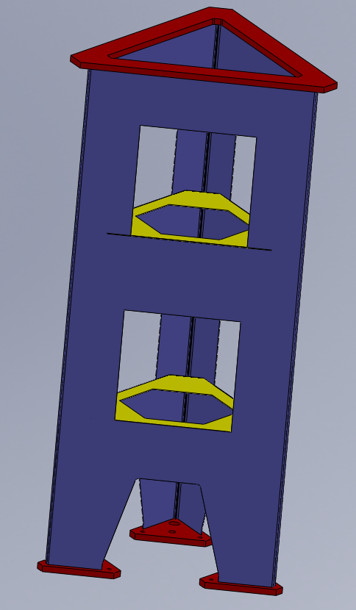

# Cross-Section Moments of Inertia

A representation of a horizontal cross-section of the pylon (density = .001 g/mm^3, wall thickness = 1.9 mm, depth (thickness) = .001 mm)

|  |  |
| --- | --- |
|  |  |

To determine the area moment of inertia, divide the solidworks moments of inertia by the density and the depth (i.e. divide by 10-6, and then convert to m4 (from mm4; divide by 1012), so I = 1.35 x 10-4 m4

A quicker approximation for the area moment of inertia can be made by using the moment of inertia of a thin walled triangle, less the moments of inertia of the missing sides:



From W.C. Young, Roark’s Formulas for Stress and Strain, 6th edition, Table 1, case 28, for a hollow regular polygon with n sides:

$$I=\frac{na^{3}t}{8}\left(\frac{1}{3}+\frac{1}{\tan^{2}{α}}\right)\left[1-3\frac{t \tan{α}}{α}+4{\left(\frac{t \tan{α}}{α}\right)}^{2}-2{\left(\frac{t \tan{α}}{α}\right)}^{3}\right]$$

where n = 3, a is the length of the sides of the triangle, or a = 690 mm,  is the angle subtended by each side, or  = 360/n = 120 deg and t = the wall thickness = 1.9 mm, so I = 1.32 x 10-4 m4

# First Bending Frequency

The Pcal Pylon is not a slender beam. However, it is a little beam-like in that it is longer (1.6 m) than it is wide (0.7 m), though not by much. So while we should not expect a simple bean bending frequency to be a close match it may serve to give a very rough approximation to the first beam-like bending mode and give us a rough dependence on the governing parameters. From R.D. Blevins, Formulas for Natural Frequency and Mode Shape, for a cantilevered beam with an end mass (Table 8-8, case 2), the first bending frequency is

$$f_{1}=\frac{1}{2π}{\left[\frac{3EI}{L^{3}\left(M+.24M_{b}\right)}\right]}^{1/2}$$

where E = elastic modulus (= 193 GPa for stainless steel), I is the area moment of inertia of the beam cross-section (=1.35 x 10-4 m4, determined in the previous section), L is the beam length (= 1.65 m), M is the added discrete mass at the end of the beam (= 55.7 kg, the sum of the upper ring mass, 25.7 kg, and the payload mass, 30 kg) and Mb is the mass of the beam itself (= 40.1 kg, determined with SolidWorks). Consequently, f1 = 81 Hz.

The corresponding first bending modes from the FEA analysis are modes 5 and 6 at 56 Hz. The beam analysis over estimates the first bending frequency by a factor of 1.45

|  |  |
| --- | --- |
|  |  |

# First Torsional Frequency

The Pcal Pylon is not a uniform shaft. In particular the holes in its sides disrupt uniform shear flow. As a consequence we should not expect a simple shaft torsional frequency analysis to match the finite element analysis (or more importantly test results) very well. However it may serve to give a very rough approximation to the first torsional frequency and give us a rough dependence on the governing parameters. From R.D. Blevins, Formulas for Natural Frequency and Mode Shape, for a uniform shaft with an end inertial mass (Table 8-19, case 6), the first torsional frequency is

$$f_{1}=\frac{λ_{1}}{2πL}{\left(\frac{CG}{μI_{p}}\right)}^{1/2}$$

where the eigenvalue 1 is the solution to the transcendental equation:

$$\cot{λ}=\left(\frac{J}{μLC}\right)λ$$

which is given in Figure 8-23, L is the shaft length (see below), G is the shear modulus:

■ is Poisson’s ratio,  is the density, Ip is the polar area moment of inertia of the cross-section about the axis of torsion (=2.70 x 10-4 m4 from a previous section), C is the torsional constant of the cross-section (Table 8-18) and J is the mass moment of inertia about the axis of rotation of the inertial mass at the end of the shaft.

The torsional constant, C, should have a value between that of a thin-walled closed section (triangle) and a thin-walled open section (triangle interrupted by holes in the sides). For the closed section (Blevins, Table 8-18, case 12):

$$C_{1}=\frac{4A^{2}t}{S}$$

Where A is the area enclosed by the midwall perimeter of the section (0.21 m2), t is the wall thickness (1.9 mm) and S is the length of the midwall perimeter (2.1 m), so C1 = 156 m4

For the open section (Blevins, Table 8-18, case 11):

$$C_{2}=\frac{St^{3}}{3}$$

where S = 0.99 m and so C2 = 2.26 x 10-3 m4. The ratio between the closed and open sections is ~105 – an extremely large variation. As a consequence, it may be most accurate to use the open section C (i.e. C2) but with a shaft length of just the portions of the shaft with cutouts, or L = 1.017 m.

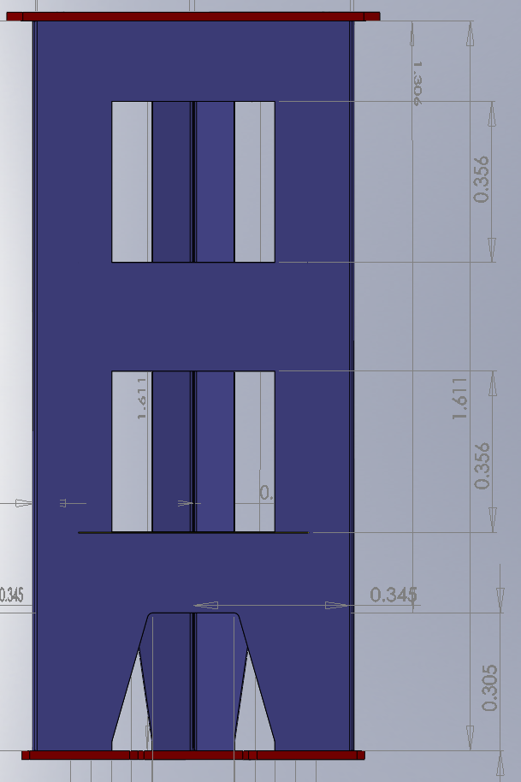

For the mass moment of inertia, J, I’ll “cheat” and use the SolidWorks value, rather than give a formula based on a geometric approximation. Note that this value of J is for the stiffening ring at the top of the pylon in the finite element model, and not for the “beam” cross-section below. Moreover, in reality it will likely be dominated by the moment of inertia of the payload mass on the top of the pylon. According to the SolidWorks model, J = 2.44 kg m2

The resulting calculation of the first torsional frequency is then f1 = 1925 Hz. While this is very likely an overestimate, it indicates that (for the model and assumptions made) the torsional mode is quite high in frequency. The FEA analysis shows no torsional mode within the first 20 modes (to 93 Hz).

# First Plate Bending Mode

The first vibration frequency of a simple isotropic rectangular plate[2],[3],[4] is:

where f is the frequency in Hz, the plate dimensions are L by Ly with a thickness of h,  is the material plate areal density, k11 is the coefficient of the first mode and D = Eh3 /12(1-2) is the bending stiffness of the plate. The value of the coefficient, k11, depends upon the boundary conditions of the plate, as indicated in the following Table.

|  |  |
| --- | --- |
|  | |
| **Boundary Condition (BC)** | **Coefficient, k11** |
| Free, Free (FF) | 9.87 ( = 0.3) |
| Simple, Free (SF) | |  |  |  |  |  |  |  | | --- | --- | --- | --- | --- | --- | --- | |  | 1 | 1.6 | 2 | 2.5 | 3 | 5 | | k11 | 11.843 | 14.409 | 16.481 | 19.244 | 22.205 | 35.133 | |
| Simple, Simple (SS) | $$π^{2}\left(1+α^{2}\right)$$ |
| Clamped, Simple (CS) | $$π^{2}\sqrt{1+2.33 α^{2}+2.44 α^{4}}$$ |
| Clamped, Clamped (CC) | $$π^{2}\sqrt{1+2.50 α^{2}+5.14 α^{4}}$$ |

The panels of the PCal pylon can be roughly approximated by rectangular panels which have simple supports on 3 sides and 1 free edge with L = 0.24 m, Ly = 0.36 m,  = 1.5, as shown in the Figure below.

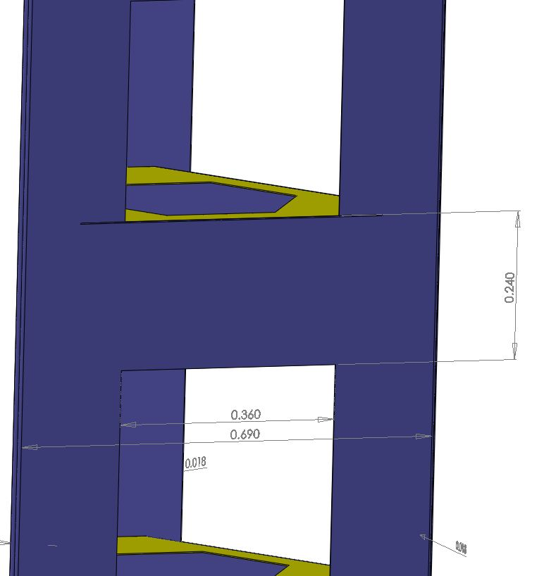

With simple-free boundary conditions (BC) then k11 = 14.1, D = 120 Pa and f = 49 Hz.

The first four modes of the FEA calculation are panel modes with frequencies of 40 Hz, 47 Hz, 48 Hz and 48 Hz. I’m not sure why the first frequency is so much lower than the others (it shouldn’t be due to symmetry; could be the mesh is not refined enough), but this is relatively good agreement with the approximate analytical calculation.

|  |  |
| --- | --- |
|  |  |
|  |  |

# Improvements

The payload mass is currently only represented by a 30 kg discrete mass with no rotary inertia. In reality the payload will be mounted on a relatively large table atop the pylon. This could lower the torsional mode significantly and could create low frequency table tip/tilt modes.

The low frequency panel modes can be increased by bending the lower edges to change the boundary condition from free to simple. This would increase the first frequency from 49 Hz to ~111 Hz.

To increase the first bending frequencies one could consider increasing the thickness of the stainless steel sheet. Doubling the thickness should increase the first bending frequencies by 31%, so from 56 Hz to ~73 Hz. Doubling the thickness would also increase the panel first resonance to ~200 Hz (if the lower edge is bent over).

Even better would be to change the material from stainless steel to graphite epoxy. The stiffness of graphite epoxy is higher, the density is considerably lower and it has much higher material damping. Fiber reinforced materials can be tailored to be anisotropic, but it is likely that an isotropic formulation (layup) would suffice. As an example, consider Cytec Thornel P-55 Carbon Fiber/Epoxy composite:

E = 220 GPa

❒ = 1700 kg/m3

And I’ve assumed  = 0.3 (for now, but this can be checked). Using the same geometry as the original model 2, an FEA analysis gives 79 Hz for the first bending frequencies and 106 Hz for the first panel frequencies. Adding a lower lip to the panels (to reinforce them) and increasing the thickness would further increase the first frequencies.

1. The FEA model results reported in this memo were generated from the SolidModel posted in the DCC with LIGO-D1101270-v3, using ANSYS. Although close to the results reported in LIGO-D1101270-v3, they are somewhat different due to a different mesh.
2. W. Pilkey, P. Chang, Modern Formulas for Statics and Dynamics, McGraw Hill, 1978, pg.338.
3. A. Leissa, Vibration of Plates, NASA SP-160.
4. D. Coyne, Frequency Analysis of the Quadruple Pendulum Structure, LIGO-T030044-x0