CALIFORNIA INSTITUTE OF TECHNOLOGY

MASACHUSETTS INSTITUTE OF TECHNOLOGY

LIGO-E1100984-v8 *Advanced LIGO* 6/08/13

SLC Signal Recycling Cavity Baffle

Installation

Hazard Analysis

Michael Smith, Lisa C. Austin

**LIGO Hanford Observatory LIGO Livingston Observatory**

**P.O. Box 1970; Mail Stop S9-02 19100 LIGO Lane**

**Richland, WA 99352 Livingston, LA 70754**

Phone (509) 37208106 Phone (225) 686-3100

Fax (509) 372-8137 Fax (225) 686-7189

E-mail: [info@ligo.caltech.edu](mailto:info@ligo.caltech.edu) E-mail: info@ligo.caltech.edu

**California Institute of Technology Massachusetts Institute of Technology**

**LIGO – MS 100-36 LIGO – MS NW22-295**

**Pasadena, CA 91125** **Cambridge, MA 02139**

Phone (626) 395-2129 Phone (617) 253-4824

Fax (626) 304-9834 Fax (617) 253-7014

E-mail: [info@ligo.caltech.edu](mailto:info@ligo.caltech.edu) E-mail: [info@ligo.mit.edu](mailto:info@ligo.mit.edu)

**APPROVAL SIGNATURES**

___________________________________________________________

Michael Smith, SLC Date

___________________________________________________________

Lisa Austin, SLC Subsystem Leader Date

___________________________________________________________

Dennis Coyne, LIGO Chief Engineer Date

___________________________________________________________

Richard Oram, LLO Operations Manager Date

___________________________________________________________

John Worden, LHO Operations Manager Date

__________________________________________________________

Brian O’Reilly, Advanced LIGO LLO Installation Lead Date

__________________________________________________________

Michael Landry, Advanced LIGO LHO Installation Lead Date

__________________________________________________________

David Shoemaker, aLIGO Leader Date

__________________________________________________________

David Nolting, LIGO Lab Safety Officer Date

__________________________________________________________

Albert Lazzarini, LIGO Directorate Date

**CHANGE LOG**

|  |  |
| --- | --- |
| **Date, version** | **Summary of Changes** |
| 2012-03-15  V3 | * Added Change Log * Corrected HAM references in Section 1. * Added hyperlinks as needed * Updated Sections: 2. Summary of hazards, 3. Overview, 5. Hazards Analysis, and 6. Signal Recycling Cavity Baffles Hazard Analysis Severity Table |
| 2012-04-23  V4 | * Corrected Cal Tech mail stop on page 1. * Updated Section 6 with comments committee review. |
| 2012-08-03  V5 | * Reformatted pages 1 and 2. * Referenced all IFOs and HAMs in Section 2. |
| 2013-05-09  V6 | * Added sharp edge hazard |
| 2013-05-23  V7 | * Corrected signature page * Removed reference to H2 IFO * Removed eye hazard * Removed reference to O2 level hazard * Updated reference documents |
| 2013-06-08  V8 | * Corrected LHO address on page 1. |

# Scope

This document covers safety concerns related to the assembly and installation of the Signal Recycling Cavity Baffles in L1-HAM4, L1-HAM5, H1-HAM4, and H1-HAM5.

It must be read before beginning the installation of the Signal Recycling Cavity Baffles and used in conjunction with the following installation procedures.

LIGO-E1200615: [aLIGO Chamber (Top Level) Installation Procedure: LHAM4](https://dcc.ligo.org/LIGO-E1200615-v3)

LIGO-E1200444: [aLIGO Chamber (Top Level) Installation Procedure: LHAM5](https://dcc.ligo.org/LIGO-E1200444-v5)

LIGO-E1300204: [aLIGO Chamber (Top Level) Installation Procedure: WHAM4](https://dcc.ligo.org/LIGO-E1300204-x0)

LIGO-E1300205: [aLIGO Chamber (Top Level) Installation Procedure: WHAM5](https://dcc.ligo.org/LIGO-E1300205-x0)

# Summary of Hazards

There are 5 Hazards to be concerned with in the installation of the Signal Recycling Cavity Baffles

1. Back strain due to heavy lifting and bending
2. Bumping one’s head or body in the tighter spaces of the HAM chamber
3. Finger damage from torque wrench
4. Contamination hazard of the vacuum system
5. Hand cut from sharp baffle edges

These hazards are described in detail later in the document.

# Overview

During the assembly, installation and alignment of the signal recycling cavity baffles, a task leader shall be assigned to supervise all activities.

Most of the signal recycling cavity baffles weigh < 30 lbs, and they will be lifted manually onto the HAM ISI table and slid into position. The SR2 Scraper Baffle weighs approximately 66 lbs, and must be lifted by two persons onto the HAM ISI table and slid into position. The baffle base will be clamped with appropriate dog-clamps. The baffles have sharp edges and could present a cutting hazard.

The baffles may be installed when HAM tables are occupied with their optics.

This assembly and installation requires overall common sense and good lab practices. Personnel must have good working knowledge of how to safely use the tools associated with the build and installation. All personnel must have appropriate safety training to work at a LIGO facility.



Hartmann Beam Dump (typical)

Hartmann Scraper Baffle

SR2

SR2 Scraper Baffle

SR2 AR Baffle

Figure 1: H1 & L1 HAM4: SR2 Scraper Baffle, SR2 AR Baffle, Hartmann Scraper Baffle, Hartmann Beam Dump

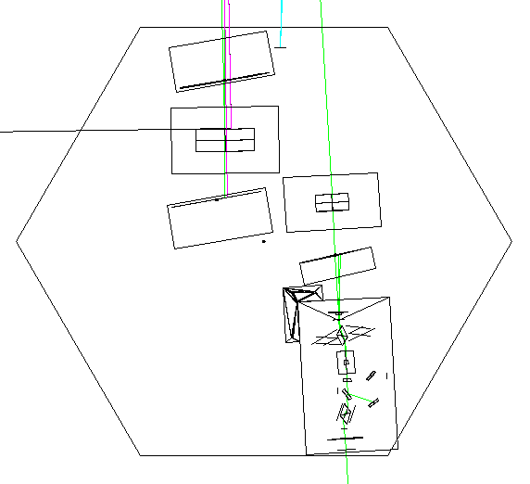

SRM HR Baffle

SR2

SR3 AR Baffle

SR3

SR3 HR Baffle

Figure 2: H1/L1 HAM5: SR3 HR Baffle, SR3 AR Baffle, SRM HR Baffle

# Related Documentation

SLC and Viewports Installation Plan (LIGO- LIGO-E1000099-v1)

Advanced LIGO Safety: Processes and Guidelines (LIGO-M070360)

LIGO Project System Safety Plan (LIGO-M950046)

LIGO Contamination Control Plan (LIGO-E0900047)

aLIGO Chamber Entry/Cleaning/Exit Checklist (LIGO-E1201035)

LLO Safety Procedure documents (<http://www.ligo-la.caltech.edu/contents/internalmain.htm>)

LIGO-E1200615: [aLIGO Chamber (Top Level) Installation Procedure: LHAM4](https://dcc.ligo.org/LIGO-E1200615-v3)

LIGO-E1200444: [aLIGO Chamber (Top Level) Installation Procedure: LHAM5](https://dcc.ligo.org/LIGO-E1200444-v5)

LIGO-E1300204: [aLIGO Chamber (Top Level) Installation Procedure: WHAM4](https://dcc.ligo.org/LIGO-E1300204-x0)

LIGO-E1300205: [aLIGO Chamber (Top Level) Installation Procedure: WHAM5](https://dcc.ligo.org/LIGO-E1300205-x0)

LIGO-D1200985: [AdvLIGO SUS HAM4-H1, SR2 Scraper Baffle](https://dcc.ligo.org/LIGO-D1200985-v1)

LIGO-D1200986: [AdvLIGO SUS HAM4-H1, SR2 AR Baffle](https://dcc.ligo.org/LIGO-D1200986-v1)

LIGO-D1101599: [aLIGO AOS SR2 AR_HARTMANN BAFFLE ASSEMBLY](https://dcc.ligo.org/LIGO-D1101599-v3)

LIGO-D1201314: [AdvLIGO SUS HAM5-H1, XYZ Local CS for SRM AR Baffle](https://dcc.ligo.org/LIGO-D1201314-v1)

LIGO-D1201315: [AdvLIGO SUS HAM5-H1, XYZ Local CS for SR3 HR-AR Baffle](https://dcc.ligo.org/LIGO-D1201315-v3)

LIGO-D1101474: [aLIGO SUS HAM4-L1, XYZ Local CS for SR2 Scraper Baffle](https://dcc.ligo.org/LIGO-D1101474-v6)

LIGO-D1101475: [aLIGO SUS HAM4-L1, XYZ Local CS for SR2 AR / HARTMANN Baffles](https://dcc.ligo.org/LIGO-D1101475-v8)

LIGO-D1101782: [AdvLIGO SUS HAM5-L1, XYZ Local for SRM AR Baffle](https://dcc.ligo.org/LIGO-D1101782-v4)

LIGO-D1101783: [AdvLIGO SUS HAM5-L1, XYZ Local for SR3 HR-AR Baffle](https://dcc.ligo.org/LIGO-D1101783-v7)

# Hazard Analysis

Each hazard and mitigation approach or measure is listed in the severity table in the next section.

## Lifting and Bending Strain

Each piece of the baffle weighs no more than 35 lbs. Back strain may occur from improperly lifting and bending to place a heavy baffle onto the HAM ISI table. This may be mitigated by using proper bending and lifting techniques while installing the baffles.

## Vacuum Spatial Awareness

As there will need to be assembly inside the vacuum chamber, personnel should be mindful of where they stand and move as to not damage nearby objects and bump their heads, knees, etc. Damage from accidental bumps can be mitigated from being spatially aware of the working area and by spotting one another.

## Pinching/Cutting of Hands

The installer could hurt their hand or fingers by improper use of the torque wrench used to tighten the dog-clamp bolts, but this can be mitigated with proper attention to how parts are handled. The team must inspect all parts before handling to identify locations of potential hazards (sharp edges and the like).

## Vacuum Contamination

The vacuum system will be opened during this installation process and has the potential to be contaminated. All work must be done in positive pressure clean rooms and all personnel must be garbed in appropriate Class A garb. Standard Class A procedures must be practiced at all times.

## Cutting of Hands from Sharp Edges

The installer could hurt their hand or fingers by touching the sharp edges of the baffle, especially the knife edge of the baffle beam hole. The team must inspect all parts before handling to identify locations of potential hazards (sharp edges and the like). This may be mitigated by covering the sharp edge with a thin piece of class B Teflon while reaching through the hole or working in the vicinity of a sharp edge during installation of the baffles.

# Signal Recycling Cavity Baffles Hazard Analysis Severity Table

|  |  |  |  |  |  |  |  |  |  |  |
| --- | --- | --- | --- | --- | --- | --- | --- | --- | --- | --- |
| Hazard | Cause | Effect | Unmitigated  Severity | Unmitigated  Probability  Level | Unmitigated Risk Index | Comment | Mitigation | Mitigation Severity | Mitigated Probability Level | Mitigated Risk Index |
| Lifting and bending strain | heavy lifting and bending | Injury to personnel; damage to equipment | Marginal | occasional | **3C** | Individually, the parts weigh no more than 30 lbs | Use appropriate lifting techniques and precautions | minor | improbable | **4E** |
| Head Bumping in vacuum tight spaces | Unawareness of surroundings | Injury to personnel; damage to equipment | Marginal | occasional | **3C** | At least two people must be in vacuum for lifting purposes and spotting as well | Due to limited space, persons entering should plan how they will maneuver around the space safely. | minor | improbable | **4E** |
| Finger/Hand Pinching and cutting | Hands caught in between parts when installing | Injury to personnel; damage/ contamination to equipment | Marginal | remote | **3D** |  | Use appropriate tool precautions and be aware of pinch points and wrench leverage and swing radius. | minor | remote | **4D** |
| Vacuum Contamination | Exposed Vacuum Chamber; removal of covers/ wraps | damage to environment | marginal | occasional | **3C** |  | All parts handled in clean rooms outside of vacuum; all personnel dressed in Class A approved garb | minor | remote | **4D** |
| Finger/Hand cutting | Hands touching sharp edges when installing | Injury to personnel; damage/ contamination to equipment | Marginal | remote | **3D** |  | Be aware of sharp edges. Place protective Teflon sheet between hand and sharp edge. | minor | remote | **4D** |

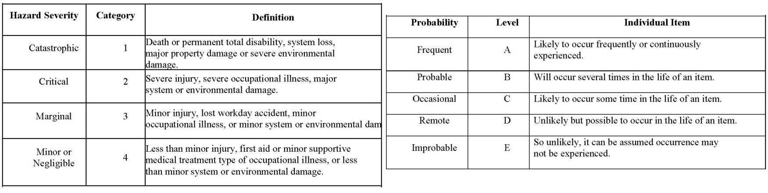

|  |  |  |  |  |  |
| --- | --- | --- | --- | --- | --- |
|  |  |  | **PROBABILITY** |  |  |
| **SEVERITY OF** | E | D | C | B | A |
| **CONSEQUENCE** | Improbable | Remote | Occasional | Probable | Frequent |
| 1 |  |  |  |  |  |
| Catastrophic |  |  |  |  |  |
| 2 |  |  |  |  |  |
| Critical |  |  |  |  |  |
| 3 |  |  |  |  |  |
| Marginal |  |  |  |  |  |
| 4 |  |  |  |  |  |
| Negligible |  |  |  |  |  |
|  |  |  |  |  |  |
| **Hazard Risk Index** |  |  | **Risk Code Criteria** | |  |
|  |  |  |  |  |  |
| **1A, 1B, 1C, 2A, 2B, 3A** |  | **Unacceptable** | |  |  |
| **1D, 2C, 2D, 3B, 3C** |  | **Undesirable (Directorate decision required)** | | | |
| **1E, 2E, 3D, 3E, 4A, 4B** |  | **Acceptable with review by Directorate** | | | |
| **4C, 4D, 4E** |  | **Acceptable without review** | |  | |