LIGO Laboratory / LIGO Scientific Collaboration

LIGO- E1100994 LIGO Oct 23rd, 2012

aLIGO HAM-ISI Testing Procedure,
Phase II : Integration Process
E1100994 – V6

Hugo Paris, Fabrice Matichard, Celine Ramet, Hugh Radkins
for the SEI team

Distribution of this document:
Advanced LIGO Project

This is an internal working note
of the LIGO Laboratory

California Institute of Technology  LIGO Project – MS 18-34  1200 E. California Blvd.  Pasadena, CA 91125  Phone (626) 395-2129  Fax (626) 304-9834  E-mail: info@ligo.caltech.edu | Massachusetts Institute of Technology  LIGO Project – NW22-295  185 Albany St  Cambridge, MA 02139  Phone (617) 253-4824  Fax (617) 253-7014  E-mail: info@ligo.mit.edu
LIGO Hanford Observatory  P.O. Box 1970  Mail Stop S9-02  Richland WA 99352  Phone 509-372-8106  Fax 509-372-8137 | LIGO Livingston Observatory  P.O. Box 940  Livingston, LA 70754  Phone 225-686-3100  Fax 225-686-7189

Table of contents:

Introduction 3
I- Full Chamber-Side Testing 6
I.1- Introduction 6
I.2- Full Chamber-Side Testing Steps 7
II- Shortened Chamber-Side Testing 8
II.1- Introduction 8
II.2- CPS Check 9
II.3- Sensor Spectra 10
II.3.1- CPS noise spectra 11
II.3.2- GS13 Spectra 12
III- IN-CHAMBER TESTING 13
III.1- Introduction 13
III.2- In Chamber Tests List: 14
III.3- How to use the In-Chamber Test List 15
III.3.1- Initial In-Chamber Testing: 15
III.3.2- Intermediate In-Chamber Testing: 15
III.3.3- Final In-Chamber Testing: 15
Conclusion 16

Introduction

HAM-ISI testing is divided in three phases:
- Phase I, Assembly validation
- Phase II, Integration
- Phase III, Control and commissioning
This document presents the tests to perform during HAM-ISI Phase II, Integration Process.

By "integration" we mean "assembly with other sub-systems". It includes all the tests performed after Phase I, Assembly Validation, until Phase III, Control and Commissioning such as:
- Chamber-Side testing
- Installation/insertion of the ISI in the chamber, which leads to the Initial in-Chamber Testing
- Mating with suspensions, optics, auxiliary systems, etc. , which leads to repetitions of the Intermediate In-Chamber testing.
- Final in-chamber testing is performed once all the suspensions, optics and other auxiliary items are installed in their final configuration (no more changes will be done on the optical layout)

Each of these parts should be reported chronologically, under a single Integration-Process Report. A report should be created for each Unit.

Tests are performed in accordance with the present procedure. The level and the order of the tests depend on the history of each Unit. Please refer the following Integration-Process Diagram to establish a testing plan for each Unit.

Each red rhombus of this diagram corresponds to a part of the Integration Process. Each part of the integration process is described along this document.

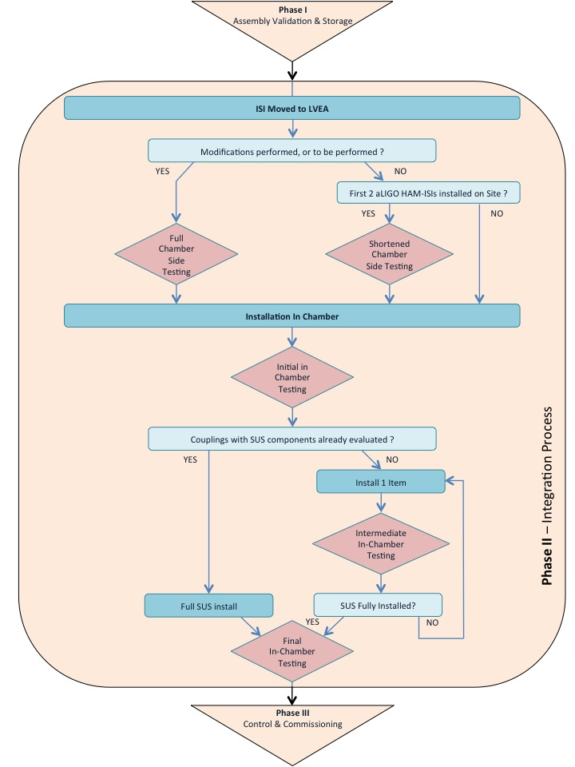

At the end of Phase II, Integration Process:

- The HAM-ISI is in the chamber
- All the suspensions, optics and auxiliary items are installed in their final configuration (no more changes will be made on the optical layout)
- The Integration Process report is complete and posted in the DCC
- The chamber can be closed and pumped down once the SEI team has validated the Integration Process report.
- Phase III, Control and Commissioning can start.

Note:

Experience showed that rubbing cables were a recurrent issue. It is good practice to always check that all cables connecting stage 1 to stage 0:
- Are set away from stage 1
- Are loose enough so their stiffness doesn’t affect the stiffness observed on the ISI
- Have only two points of contacts along the Stage1–to-Stage 0 loop:
  - Point of contact #1: stage 0’s cable clamp
  - Point of contact #2: stage 1’s cable clamp
- Are set this way permanently, with cable clamps that are tight enough

Rubbing often occurs along the blade posts. The horizontal actuator cables that are set against the posts tend to be loose and rub on stage 1: See picture below. A good remedy is to add cable clamps next to the horizontal actuator, behind the actuator door.

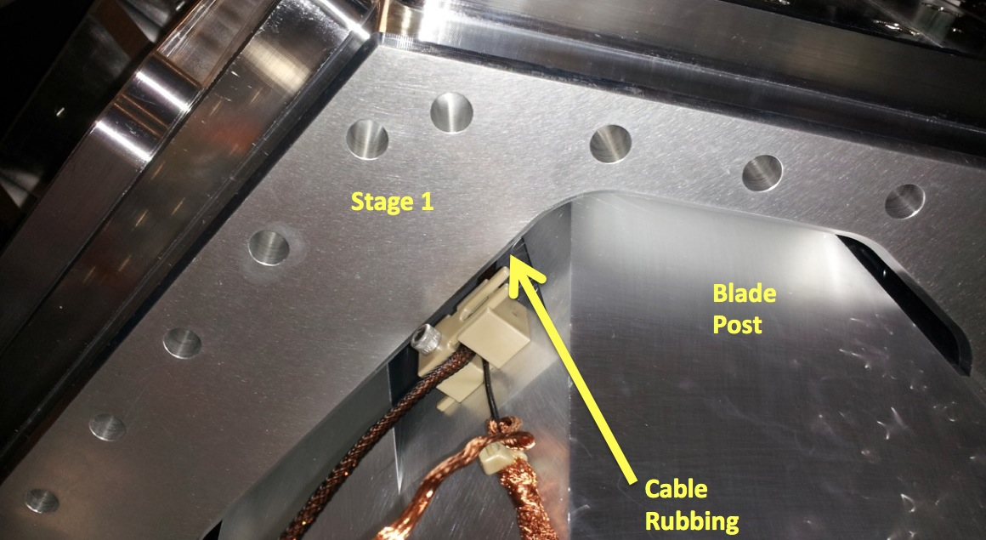

Full Chamber-Side Testing

Introduction
At the beginning of the Chamber-Side Testing:
- Assembly Validation testing was performed on the ISI
- The Assembly Validation test report is available on the DCC
- The Assembly Validation report was validated by the SEI team
- The ISI was stored in a container, moved from the staging building to the LVEA
- The container was opened under a clean room and the ISI is installed on a test stand.
- The optical table is payloaded with masses, and properly balanced.
- The ISI is unlocked

The goal of the Chamber-Side Testing is to ensure that the changes applied to the HAM-ISI after the Assembly Validation did not affect its performance.

At the end of the Chamber-Side Testing:
- All sensors are production sensors
- All sensors were checked
- Data related to the tests is available on the SVN
- The Integration Process report is updated with tests results
- This part of the Integration Process is validated by the SEI team
- The HAM-ISI is ready for its in-chamber insertion

During this part of the Integration Process, the changes made to the HAM-ISI are important enough to require a full testing. The tests to be performed are inspired from the Assembly Validation testing. These tests are listed in the table below. The table gives a rule for each test. These rules help defining the testing plan of the ISI. Please refer to the Assembly Validation Procedure (DCC document E1000309) for more details about the tests.

Full Chamber-Side Testing Steps
Tests of E100309 | Rule / Comments
I. Pre-Assembly Testing 6
▪ Step 1 - Position Sensors | Update to reflect the changes made since the Assembly Validation
▪ Step 2 - GS13 - E1000058 – E1200081 – Testing prior to shipping | Update to reflect the changes made since the Assembly Validation
▪ Step 3 - L4C - E1000058 – E1200081 | Update to reflect the changes made since the Assembly Validation
▪ Step 4 - Actuators – E1000136 8 | Update to reflect the changes made since the Assembly Validation
▪ Step 5 - Seismometer inspection after shipping | Update to reflect the changes made since the Assembly Validation
II. Tests to be performed during assembly
▪ Step 1 - Parts Inventory (E1000052) | Update to reflect the changes made since the Assembly Validation
▪ Step 2 - Check torques on all bolts | If walls were opened
▪ Step 3 - Check gaps under Support Posts | Waive
▪ Step 4 - Pitchfork/Boxwork flatness before Optical Table install | Waive
▪ Step 5 - Blade spring profile | Perform
▪ Step 6 - Gap checks on actuators-after installation on Stage 1 | Perform
▪ Step 7 - Check level of Stage 0 | Waive
▪ Step 8 - Check level of Stage 1 Optical Table | Perform
▪ Step 9 - Mass budget | Perform
▪ Step 10 - Shim thickness | Perform
▪ Step 11 - Lockers adjustment | Waive unless step III.4 is too far from requirements
III. Tests to be performed after assembly
▪ Step 0.1 - Testing folder set up | Perform
▪ Step 0.2 - MEDM set-up for testing | Perform
▪ Step 1 - Electronics Inventory | Perform
▪ Step 2 - Set up sensors gap | Waive unless the absolute value of CPS readouts is higher than 400cts
▪ Step 3 - Measure the gaps on the CPSs | Waived to avoid scratching Targets
▪ Step 4 - Check Sensor gaps after the platform release | Defines if step II.11 is needed
▪ Step 5 – Performance of the limiter | Performed with drive in step III.10 - Range Of Motion
▪ Step 5.1 - Test Nº1 - Push “in the general coordinates” | Performed with drive in step III.10 - Range Of Motion
▪ Step 5.2 - Test Nº2 – Push “locally” | Performed with drive in step III.10 - Range Of Motion
▪ Step 6 - Position Sensors unlocked/locked Power Spectrum | Perform
▪ Step 7 - GS13 power spectrum -tabled tilted | Perform
▪ Step 8 - GS13 pressure readout | Perform
▪ Step 9 - Coil Driver, cabling and resistance check | Perform
▪ Step 10 - Actuators Sign and range of motion (Local drive) | Perform
▪ Step 11 - Vertical Sensor Calibration | Waive unless a vertical CPS was changed
▪ Step 12 - Vertical Spring Constant | Waive unless (a) blade(s) was(ere) changed.
▪ Step 13 - Static Testing (Tests in the local basis) | Perform
▪ Step 14 - Linearity test | Perform
▪ Step 15 - Cartesian Basis Static Testing | Perform
▪ Step 16.1 - Local to local TF measurement | Perform
▪ Step 16.2 - GS13 Response Extraction | Perform
▪ Step 16.3 - GS13 Response Fitting | Waive unless extra time is available, or concerns arose
▪ Step 16.4 - Symmetrization Filters | Waive unless extra time is available, or concerns arose
▪ Step 16.5 - Cartesian to Cartesian TF Computation | Waive unless extra time is available, or concerns arose
▪ Step 17.1 - Local to local - Comparison with Reference | Waive unless extra time is available, or concerns arose
▪ Step 17.2 - Cartesian to Cartesian - Comparison with Reference | Waive unless extra time is available, or concerns arose
▪ Step 18 - Lower Zero Moment Plane | Waive unless extra time is available, or concerns arose
▪ Step 19 - Damping loops | Waive unless extra time is available, or concerns arose
▪ Step 19.1 - Simulation of damping performance - TF | Waive unless extra time is available, or concerns arose
▪ Step 19.2 - Experimental evaluation of damping performance - Spectra | Waive unless extra time is available, or concerns arose

Shortened Chamber-Side Testing

Introduction
The tests presented in this section replace the regular Side-Chamber Testing to speed up the validation process by waiving:
- Electronics checks
- Static Tests
- Range of motions (see Step 3.10 of E1000309)
- Linearity Tests (see Step 3.14 of E1000309)
- Transfer Functions (see Step 3.17 of E1000309)

At the beginning of the Shortened Chamber-Side Testing:
- Assembly validation testing was performed on the ISI
- The Assembly Validation test report is available on the DCC
- The Assembly Validation report was validated by the SEI team
- The ISI was stored in a container, moved from the staging building to the LVEA, and installed under a clean room in the LVEA, on its container’s base
- The container is sitting on lab-jacks to allow level adjustments without unlocking the ISI
- The Unit is equipped with production sensors
- The optical table is not loaded with masses yet
- The ISI is locked

The goal of the Shortened Chamber-Side Testing is to ensure that the sensors and their electronics (cables, ADE boxes of the CPSs, etc.) did not alter during storage/transportation.

At the end of the Shortened Chamber-Side Testing:
- All sensors have been checked
- Data related to the tests is available on the SVN
- The Integration Process report is updated with tests results
- This part of the Integration Process is validated by the SEI team
- The HAM-ISI is ready for its in-chamber insertion

In this procedure, SVN Paths are given in green and Matlab® scripts/functions are given in blue. Fields that need to be updated (site, unit, test) are given in grey.

CPS Check
During this step, we want to make sure that the CPSs, their cables and their electronics are functional.
Procedure to follow for this test:
- Connect the CPSs of Corner #1 (H and V) on a feedthrough
- Connect the in-air side of the feedthrough to the ADE Boxes
- Power* and synchronize both ADE boxes
- Use the BNC output of the ADE box to record the voltage outputted by each of the CPSs of the connected corner
- Insert a shim in the CPS gap
! Be careful not to scratch the targets!
- Make sure the voltage outputted by the CPSs is impacted
- Repeat step 1 to 7 for Corner #2 and Corner #3
- Fill out the table below

Corner | Direction | Voltage  (No shim) | Sensor reacts to shim insertion
1 | H
 | V
2 | H
 | V
3 | H
 | V
Table – CPS Check

*: ADE boxes are powered with +/-18V 3pin power cables

NOTE:
- ADE boxes must be connected to the same power supply
- ADE boxes must share the same ground.
- ADE boxes must be grounded to the test stand
- Not having the ADE boxes grounded to the test stand causes the CPS readouts to vary with the number of probes that are connected to the ADE boxes (LHO aLog #2972).

Acceptance Criteria:
- All CPS were tested
- All CPS react to shim insertion
- The voltages are within ⁺/-5volts

The tests report must contain:
- Issues/difficulties/comments regarding this test
- Table – CPS check
- Test results (Passed: Failed: ).”

Sensor Spectra
For this test, an sr785 spectrum analyzer is used. The maximum number of points available for the FFT (800) limits the frequency resolution. Measurements are performed in two sections that are combined afterwards to allow getting good resolution in low frequency. Sections overlap to allow checking for potential mismatch.
Procedure to follow for this test:
- Connect the sr785 analyzer to a laptop with a gpib interface and an Ethernet cable
- Run the program SEI_Chamber_Side_fft.exe from a terminal on the laptop with the following parameters:
Section A
Unit: HAM_ISI_Unit_<UnitNumber>_Chamber_Side_Locked__
Instrument: <Instrument>_Corner_<CornerNumber>
Section: Section_A
Freq. span: 100Hz
Section B
Unit: HAM_ISI_Unit_<UnitNumber>_Chamber_Side_Locked__
Instrument: <Instrument>_Corner_<CornerNumber>
Section: Section_A
Freq. span: 800Hz
- Data is saved under the folder from which SEI_Chamber_Side_FFT.exe is lunched as:
SEI-<Unit>-<Instrument>-<Section>-<Date>.txt
- Open Data_Extraction_From_GPIB_2_Sections.m
- Create a new data set and run the script
- Plots are automatically saved under the data folder
- Save test data and plots under the SVN at:
/SeiSVN/seismic/HAM-ISI/H2/HAM2/Data/Spectra/Chamber_Side/
/SeiSVN/seismic/HAM-ISI/H2/HAM2/Figures/Spectra/Chamber_Side/Sections_Check/
/SeiSVN/seismic/HAM-ISI/H2/HAM2/Figures/Spectra/Chamber_Side/Sections_Combined/

Programs to run the sr785 from a laptop under the SVN at:
/SeiSVN/seismic/HAM-ISI/H2/HAM3/Scripts/Chamber_Side/sr785_Programs/

Testing Scripts under the SVN at:
/SeiSVN/seismic/HAM-ISI/H2/HAM3/Scripts/Chamber_Side/Testing_Scripts /

CPS noise spectra
During this step, we want measure the noise spectra of the CPSs and make sure they are not too high.
Procedure to follow for this test:
- Connect the CPSs of corner #1 (H and V) on a feedthrough
- Connect the in-air side of the feedthrough to the ADE Boxes
- Power* and synchronize both ADE boxes
- Connect the BNC output of the ADE box for the 2 CPSs to the two input channels of an sr785 spectrum analyzer
- Channel #1: H
- Channel #2: V
5) Take power spectra as described in Procedure to follow to take power spectra
6) Repeat steps 1 to 5 for Corner #2 and Corner #3

*ADE boxes take ⁺/-18V

NOTE:
- ADE boxes must be connected to the same power supply
- ADE boxes must share the same ground.
- ADE boxes must be grounded to the test stand
- Not having the ADE boxes grounded to the test stand causes the CPS readouts to vary with the number of probes that are connected to the ADE boxes (LHO aLog #2972).

Acceptance Criteria:
- CPS noise spectra must be below 10⁻⁴Vrms/√Hz
- Plots of Spectra are saved under the SVN

The tests report must contain:
- Plots of CPS spectra
- SVN paths
- Issues/difficulties/comments regarding this test
- Test results (Passed: Failed: ).”

GS13 Spectra
During this test we want to take spectra of the GS13s to make sure that they are still functional.
Procedure to follow for this test:
- Connect the in- vacuum cable of the GS13s of corner 1 (H and V) to a feedthrough
- Connect the in-air side of the feedthrough to a GS13 interface
- Connect the power supply to the GS13 interface* and turn it ON
- Use a breakout board to collect data from the ADC output of the GS13 interface**
- Send data from the breakout board to the input channels of an sr785 Spectrum analyzer:
- Channel #1: H
- Channel #2: V
- Take power spectra as described in Procedure to follow to take power spectra
- Turn the GS13 interface OFF (important!) and repeat steps 1 through 6 for Corner #2 and

* D070164 interface takes ⁺/-18V

** On D070164 interface:
- Horizontal GS13: Pins 6-9
- Vertical GS13: pins 8-21

Acceptance Criteria:
- GS13s responses must not drop in low frequency
- Plots of powerspectra are saved under the SVN
The tests report must contain:
- Plots of GS13 spectra
- SVN paths
- Issues/difficulties/comments regarding this test
- Test results (Passed: Failed: ).”

III- IN-CHAMBER TESTING

Introduction
The HAM-ISI In-Chamber Testing includes 3 sections:
- Initial In-Chamber Testing
- Intermediate In-Chamber Testing
- Final In-Chamber testing.

Each of these sections is an iteration of the In-Chamber Test Sequence, which is presented here. The number of iterations needed may vary from one unit to another. The Integration-Process Diagram given at the beginning of this document can help establishing a testing plan.

The iterations of the In-Chamber Test Sequence should be documented in a chronological order, under the same report as the chamber-side testing, as follow:
- Chamber-Side Testing (full or shortened version)
- Initial In-Chamber Testing
- Intermediate In-Chamber Testing
- Final In-Chamber testing.

The tests listed here are inspired from the Assembly Validation Testing. Please refer to the HAM-ISI Assembly Validation Testing Procedure (DCC document E1000309) for test details.

In Chamber Tests List:
Test Name | Corresponding Step in  E1000309
Parts Inventory  Cables inventory  Electronics Inventory  Mass budget  CPS Spectra - Locked/Unlocked  GS13 Spectra - Tabled Tilted  GS13 pressure readout  Blade spring profile  Shim thickness  Lockers adjustment (meas.) => Setup Lockers  CPS Setup (meas.) => Setup CPSs  Range Of Motion  Static Testing - Local Basis & Cartesian Basis  Linearity test  Local to Local TF measurement  TF comparison with Reference  GS13 Response Extraction & Fitting  Symmetrization Filters & Symmetrized TF  Cartesian to Cartesian TF Computation  Lower Zero Moment Plane | II.1  II.12  III.1  II.9  III.6  III.7  III.8  II.5  II.10  II.11 and/or III.4  III.2  III.10  III.12 and III.15  III.14  III.16.1  III.17.6 and III.17.7  III.16.2 and III.16.3  III.16.4  III.16.5  III.18

Color Chart
Inventory
Information recorded in order to keep track of the parts and changes made.
Quick mechanical tests
These tests are important and they all take less than 1h.
Important
These tests involve the triplet actuator-Structure-Sensor. They are the most important ones. They should not be waived*.
*LZMP can be kept for the final in-chamber testing.
Post-processing
These tests are performed on other test’s data. They are not a priority as they can be done after data is recorded.

How to use the In-Chamber Test List
The sequence in which the tests of the In-Chamber tests list are performed can vary from one situation to another. For example, one can keep the mechanical tests/adjustments that require physical access to the ISI for the end of the phase, if the chamber is currently closed.

Some test can occasionally be waived. Here is a list of them:

Initial In-Chamber Testing:
- Setup Lockers
- Setup CPSs
- Symmetrization Filters & Symmetrized TF
- Cartesian to Cartesian TF Computation
Note: This is the best time to perform the inventory. It is however possible that changes are planned and/or the chamber is closed. In that case, inventory can be kept for the Intermediate phase or the Final phase.

Intermediate In-Chamber Testing:
- All Inventories - If no change occurred since initial phase
- Range of motion - If already performed once in chamber
- Static Tests - If already performed once in Chamber
- Blade spring profile, Shim thickness, Lockers adjustment (meas.), CPS Setup (meas.)

- If already performed once in chamber

- Needs to be redone once lockers and CPSs are adjusted.
- GS13 Response Extraction & Fitting - If already performed once in chamber
- Symmetrization Filters & Symmetrized TF
- Cartesian to Cartesian TF Computation
- Setup Lockers
- Setup CPSs

Final In-Chamber Testing:
No test can be waived.
Everything must be up to specification, unless waived by the SEI team.
In addition to the regular test sequence:
Watchdog must be tested, and approved
Damping loops must be running

Conclusion

The test report must contain a section for each part of the Integration Process:
- Chamber-Side Testing (full or shortened version)
- Initial In-Chamber Testing
- Intermediate In-Chamber Testing (all iterations reported chronologically)
- Final In-Chamber testing.

The test report must contain a conclusion, which describes:
- A summary of the main events of the history of the Unit (assembly Validation, Insertion in chamber, etc.)
- The particularities of the Unit
- The test waived
- The test failed
- The tests that need to be redone
- Complementary inquiries and related results

The highlights of this conclusion must be featured in the abstract of the DCC page of the report.

