LASER INTERFEROMETER GRAVITATIONAL WAVE OBSERVATORY
LIGO
CALIFORNIA INSTITUTE OF TECHNOLOGY
MASACHUSETTS INSTITUTE OF TECHNOLOGY
LIGO-E1101018-v5 18 February 2013
AOS SLC ITM Elliptical Baffle
Assembly & Install
Hazard Analysis
Michael Smith, Lisa C. Austin

LIGO Hanford Observatory LIGO Livingston Observatory
P.O. Box 1970; Mail Stop S9-02 19100 LIGO Lane
Richland, WA 99352 Livingston, LA 70754
Phone (509) 37208106 Phone (225) 686-3100
Fax (509) 372-8137 Fax (225) 686-7189
E-mail: info@ligo.caltech.edu E-mail: info@ligo.caltech.edu

California Institute of Technology Massachusetts Institute of Technology
LIGO – MS 100-36 LIGO – MS NW22-295
Pasadena, CA 91125 Cambridge, MA 02139
Phone (626) 395-2129 Phone (617) 253-4824
Fax (626) 304-9834 Fax (617) 253-7014
E-mail: info@ligo.caltech.edu E-mail: info@ligo.mit.edu

APPROVAL SIGNATURES

__________________________________________________________
Michael Smith, SLC Task Leader Date

__________________________________________________________
Dennis Coyne, LIGO Chief Engineer Date

__________________________________________________________
John Worden, LHO Site Safety Officer Date

__________________________________________________________
David Nolting, LLO Site Safety Officer Date

__________________________________________________________
Brian O’Reilly, Advanced LIGO LLO Installation Lead Date

__________________________________________________________
Michael Landry, Advanced LIGO LHO Installation Lead Date

__________________________________________________________
David Shoemaker, aLIGO Leader Date

__________________________________________________________
David Nolting, LIGO Lab Safety Officer Date

__________________________________________________________
Albert Lazzarini, LIGO Directorate Date

CHANGE LOG

Date, version | Summary of Changes
2012-04-04  V2 | - Added Change Log  - Incorporated changes from Final Design Review committee
2012-07-02  V3 | - Corrected title of Section 6  - Update Sections 5 & 6
2012-09-24  V4 | - Changed title  - Added hazard: Damage to Installed Baffle by External Personnel Working in Vicinity
2013-02-18  V5 | - Added version numbers to Change Log  - Corrected ‘Table of Figures’ links  - Updated Section 1, Scope, with appropriate installation chamber and Assembly and Installation Procedure document numbers  - Corrected and updated assembly numbers and hyperlinks in Section 3.1  - Corrected Blade Assembly number throughout document  - Corrected wording in Section 3.2  - Changed Figure 8 and 12  - Added hyperlinks throughout document  - Updated Suspension and Box Assembly weights  - Clarified Hazard 3 throughout document

Table of Contents
1 Scope 6
2 Summary of Hazards 7
3 Overview 8
3.1 ITM Elliptical Baffle Suspension Assembly Procedure 9
3.1.1 ITM Elliptical Baffle Blade Pre-load 9
3.1.2 ITM Elliptical Baffle Suspension Assembly 11
3.1.3 ITM Elliptical Baffle Aperture Box Assembly 11
3.1.4 Pre-balancing the ITM Elliptical Baffle Assembly 12
3.2 ITM Elliptical Baffle Installation Procedure 12
3.2.1 Suspension Assembly Attachment to Stage 0 12
3.2.2 ITM Elliptical Baffle Aperture Box Attachment 14
3.3 ITM Elliptical Baffle Aperture Alignment Procedure 15
4 Related Documentation 17
5 Hazard Analysis 18
5.1 Strain from lifting assembly 18
5.1.1 Placing Suspension Assembly in Installation Stand 18
5.1.2 Placing ITM Elliptical Baffle Suspension Assembly and the Installation Stand on Lift Table 18
5.1.3 Lifting the Baffle Aperture Box 19
5.1.4 Handling of Installation Tooling 20
5.2 Sudden Release of Tensioned Spring 20
5.3 Damage to the Beamsplitter Suspension and Mirror 21
5.4 Damage Caused by Dropped Loads 21
5.4.1 Suspension Assembly 21
5.4.2 Aperture Assembly 21
5.5 Overstress/damage to the flexure 21
5.6 Pinching/Cutting of Hands and Bumps to the Head, Etc. 22
5.7 Vacuum Contamination 22
5.8 Damage to Installed Baffle by Personnel Working in Vicinity 22
6 Arm Cavity Baffle Hazard Analysis Severity Table 23

Table of Figures
Figure 1: ITM Elliptical Baffle 8
Figure 2: D1200140: ITM Elliptical Baffle Blade Assembly in Bending Configuration 10
Figure 3: D1200140: ITM Elliptical Baffle Blade Assembly in Post-bending Configuration 10
Figure 4: ITM Elliptical Baffle Suspension Assembly 11
Figure 5: Elliptical Baffle Aperture Box Assembly. 11
Figure 6: ITM Elliptical Baffle suspension assembly in installation stand on top of lift table 13
Figure 7: ITM Elliptical Baffle suspension assembly attached to Stage 0 13
Figure 8: ITM Elliptical Baffle Aperture assembly on lift table 14
Figure 9: Mating the Elliptical Baffle Aperture top plate with the plate on the SUS Assembly. 15
Figure 10: ITM Elliptical Baffle ALIGNMENT CROSSHAIR TARGET 16
Figure 11: ACB suspension Assembly placed on top of the installation stand 18
Figure 12: ITM Elliptical Baffle Aperture Box and Lift Table 19
Figure 13: D1200140, Blade Assembly in Post-bending Configuration 20
Figure 14: ITM Elliptical baffle hanging freely within earthquake stops 21

Scope
This document covers safety concerns related to the assembly and installation of the ITM Elliptical Baffle into the BSC2 chambers for Advanced LIGO. It must be read before beginning the installation of the various baffles and beam dumps, and used in conjunction with the ITM Elliptical Baffle Assembly Procedure, document number LIGO-E1200677, and the ITM Elliptical Baffle Installation Procedure, document number LIGO-E1101021.

Summary of Hazards

The major hazards to be aware of in the assembly, installation, and alignment of the ITM Elliptical Baffle include:

- Personnel strain from lifting the baffle (4E)
- Sudden release of tensioned springs (4D)
- Damage to adjacent Beamsplitter (BS) suspension due to working in vicinity
- Dropped loads (4E)
- Overstress/damage of the flexure (4D)
- Pinching/ Cutting of hands against the parts being assembled (4E)
- Contamination hazard of the vacuum system (4D)
- Damage to installed baffle due to personnel working in vicinity

These hazards are described in detail later in the document.

Overview

A Solid Works model of the ITM Elliptical Baffle Assembly (D1003238) is shown in Error: Reference source not found.

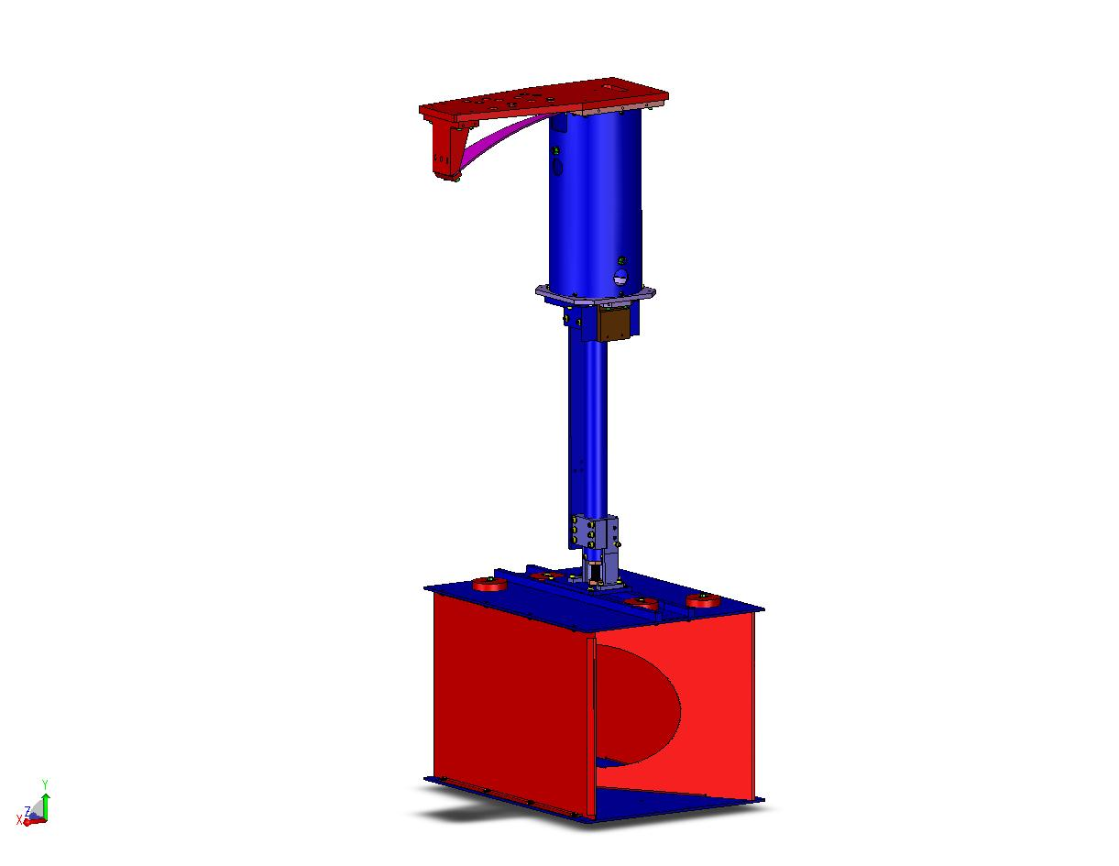
Figure 1: ITM Elliptical Baffle

It consists of an upper SUS assembly and a lower Aperture Box assembly that join together at the top plate of the Aperture Box.
During the assembly and installation of the ITM Elliptical Baffle assembly, a task leader should be assigned to supervise all activities. The task leader needs to be experienced with suspensions and their accompanying hardware.

This assembly and installation requires overall common sense and good lab practices. Personnel must have good working knowledge of how to safely use the tools associated with the build. All personnel must have appropriate safety training to work at a LIGO facility.

ITM Elliptical Baffle Suspension Assembly Procedure

The suspension mechanism (D1101885), consisting of:
- Blade Assembly (D1200140),
- Upper (D1002582) and Lower (D1101887) Tube Assemblies, joined together
- Damping Tube Assembly (D1002564)
- Anti-Rotation Assembly (D1201228)

The detailed assembly procedure is described in E1200677, Advanced LIGO ITM Elliptical Baffle Assembly Procedure.

ITM Elliptical Baffle Blade Pre-load
The blade spring bracket and the blade spring will be mounted temporarily to the interface plate, rotated 180 deg to its normal position; the interface plate is clamped to a suitable flat table surface so that the blade spring extends outward beyond the edge of the table, as shown in the Figure 2. Pre-loading weights of approximately 62 lbs. will be hung from the tip of the blade spring until the blade spring bends into an arc that matches the surface of the ITM Elliptical Baffle bend fixture; after which, the bend fixture will be attached with bolts to the blade.
Following the pre-bending procedure, the pre-bent blade and the blade mounting bracket will be properly attached to the interface plate, as shown in Figure 3; then, the bend fixture will be removed.

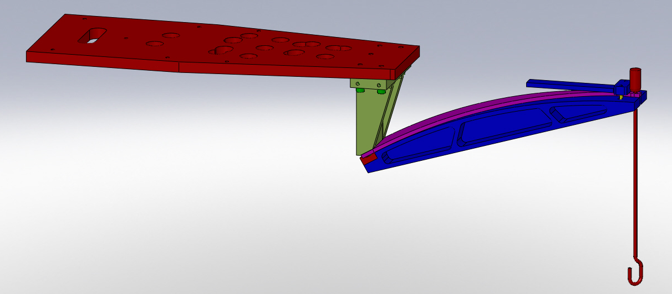
Figure 2: D1200140: ITM Elliptical Baffle Blade Assembly in Bending Configuration

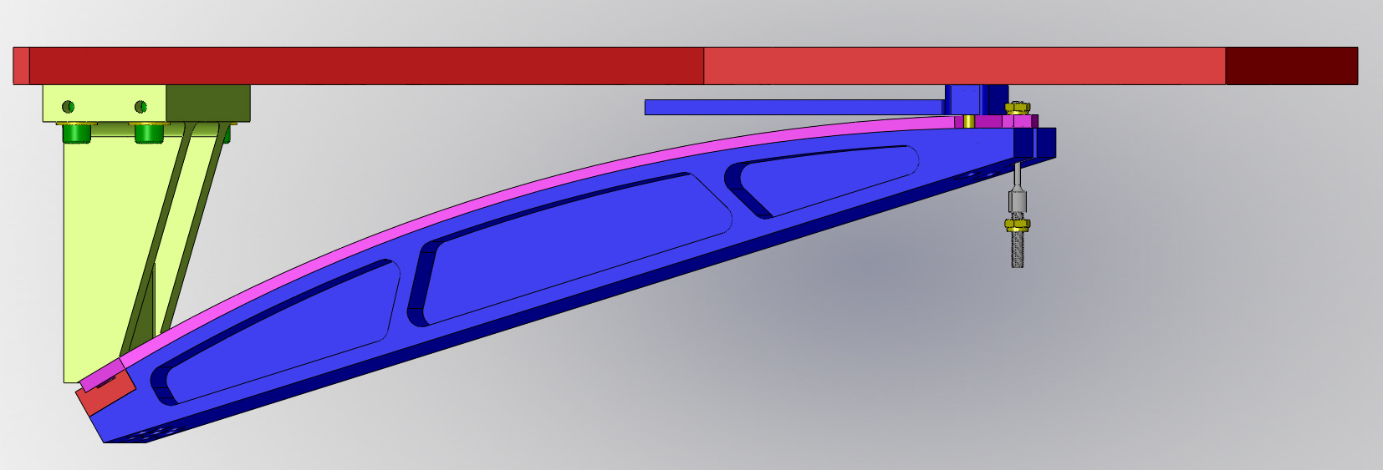
Figure 3: D1200140: ITM Elliptical Baffle Blade Assembly in Post-bending Configuration

During this operation, a hazard exists from the sudden release of the tensioned spring, which will be discussed in section 5.

ITM Elliptical Baffle Suspension Assembly
The completed ITM Elliptical Baffle suspension assembly is shown in Figure 4.
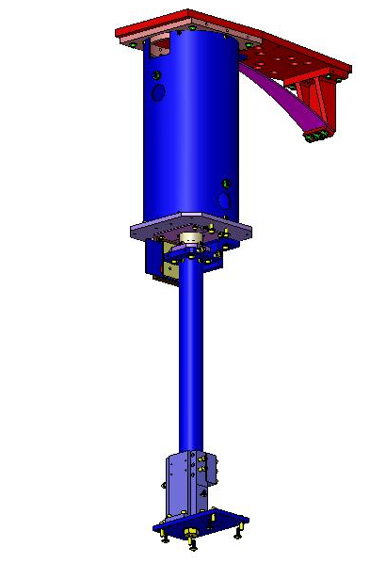
Figure 4: ITM Elliptical Baffle Suspension Assembly

ITM Elliptical Baffle Aperture Box Assembly
The ITM Elliptical Baffle Aperture Box will be assembled on a suitable table outside of the BSC, as shown in Figure 5.

Figure 5: Elliptical Baffle Aperture Box Assembly.

Pre-balancing the ITM Elliptical Baffle Assembly
The ITM Elliptical Baffle Suspension Assembly will be mounted to a level overhead platform, such as a test stand, and the Aperture Box assembly will be attached and balanced according to the procedure described in E1200677 ITM Elliptical Baffle Assembly Procedure.

ITM Elliptical Baffle Installation Procedure
Installation of the ITM Elliptical Baffle in the BSC chamber follows the installation procedure (E1101021) which has basically the same steps as the installation onto the test stand, except that the balancing steps will already have been accomplished and will not be repeated in the chamber. After completing the ITM Elliptical Baffle installation, the installation tooling will be removed from the chamber.

The potential hazards that may occur during the installation procedure are the same as for the balancing procedure. In addition, there are the hazards of contaminating the vacuum environment and damaging the installed Beamsplitter (BS) Suspension or the Input Test Mass (ITM) Suspension which are in the vicinity of the ITM Elliptical Baffle assembly.

Suspension Assembly Attachment to Stage 0
Two people will mount the ITM Elliptical Baffle suspension assembly (D1101885, 55 lbs.) into the installation stand (D1200581, 39 lbs.), and place the suspension and installation stand on the lift table prior. The installation stand is secured to the lift table with dog clamps.
Two persons will pull up on the lift bars of the telescoping installation stand that sits on top of the lifting table, and a third person will lock the stand into the highest possible position, as shown in Figure 7. Then, the ITM Elliptical Baffle Suspension will be raised up to Stage 0 using the scissor jacks of the lifting table. During this procedure, the potential hazard of back strain may occur, and there is a potential hazard of injury from a heavy falling object.
The ITM Elliptical Baffle interface plate will be attached securely to Stage 0 (Figure 7) by means of dog clamps. During this procedure, there is a potential hazard of finger and hand injury.

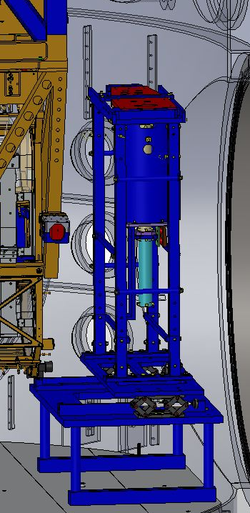
Figure 6: ITM Elliptical Baffle suspension assembly in installation stand on top of lift table

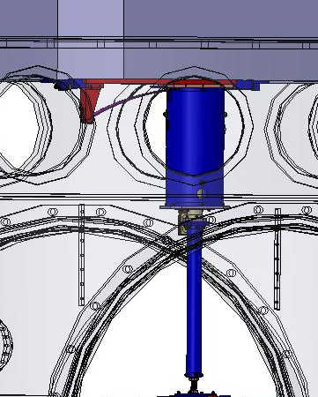
Figure 7: ITM Elliptical Baffle suspension assembly attached to Stage 0

ITM Elliptical Baffle Aperture Box Attachment
The ITM Elliptical Baffle Aperture Box Assembly (D1101806, 44 lbs.) is lifted by two people and placed on the lift table, shown in Error: Reference source not found.
During this procedure, the potential hazard of back strain may occur, and there is a potential hazard of injury from a falling heavy object.

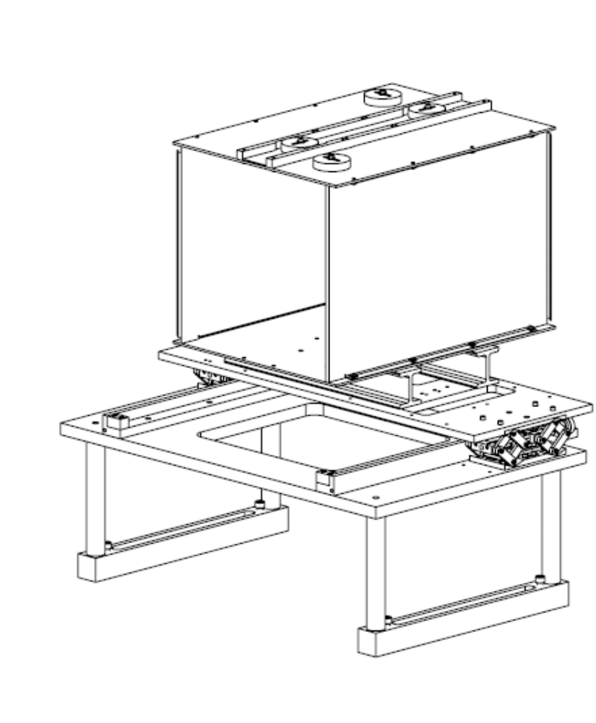
Figure 8: ITM Elliptical Baffle Aperture assembly on lift table

Raise the ITM Elliptical Aperture Box by turning the screws of the scissor jacks until the ITM Elliptical Baffle Aperture Box top plate mates with the holes in the plate attached to the suspension assembly, and attach with the mounting bolts.

Figure 9: Mating the Elliptical Baffle Aperture top plate with the plate on the SUS Assembly.

ITM Elliptical Baffle Aperture Alignment Procedure
During the alignment procedure, the short transport bracket must be attached to the down tube so that the down tube cannot rotate while the baffle height is being adjusted. The Anti-rotation Bracket down-tube clamp will be loose so that the ITM Elliptical Baffle Aperture Box can be raised or lowered by turning the large mounting bolt that connects to the down-tube.

Horizontal alignment will be achieved by translating the interface plate that mounts to Stage 0 transverse to the beam centerline; height alignment will be achieved by turning the bolt that attaches the baffle hinge plate to the down tube to raise or lower the baffle aperture. The ITM Elliptical Baffle aperture alignment, both horizontally and vertically, will be measured by sighting the crosshair of the target D1102073.

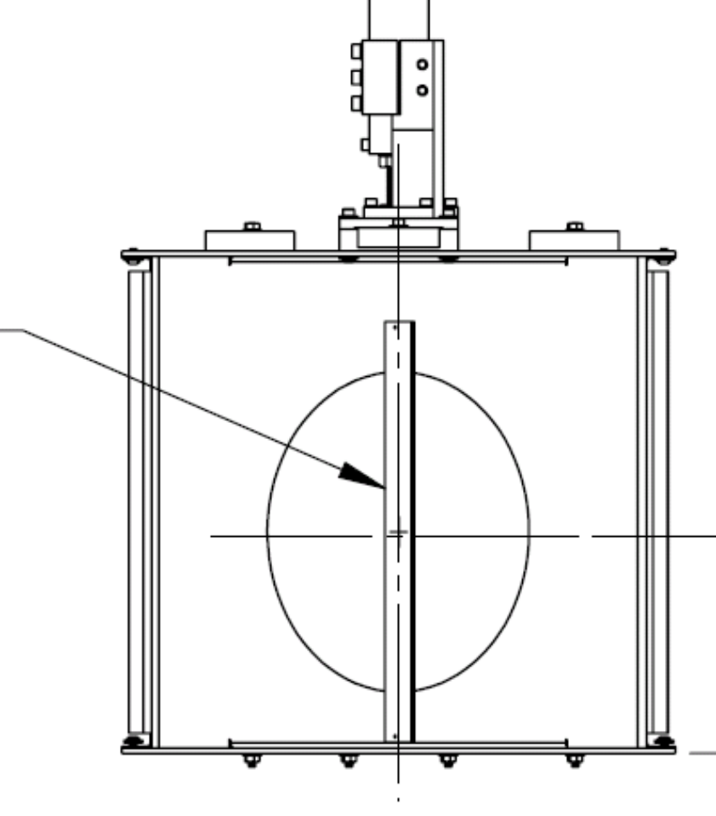

Figure 10: ITM Elliptical Baffle ALIGNMENT CROSSHAIR TARGET

After the ITM Elliptical Baffle aperture is aligned, the anti-rotation bracket will be clamped to the down-tube, and all transport and height adjustment brackets and target must be removed.

Caution! When the fixation brackets are removed, the baffle is free to swing freely within the earth quake stop limits and it may be damaged or misaligned by pulling or pushing against it by external means.

Related Documentation
ITM Elliptical Baffle Assembly Procedure (LIGO-E1200677)
ITM Elliptical Baffle Installation Procedure (LIGO- E1101021)
Advanced LIGO Safety: Processes and Guidelines (LIGO-M070360)
LIGO Project System Safety Plan (LIGO-M950046)
LIGO Contamination Control Plan (LIGO-E0900047)
aLIGO Chamber Entry/Cleaning/Exit Checklist (LIGO-E1201035)
LLO Safety Procedure documents: http://www.ligo-la.caltech.edu/contents/internalmain.htm
LIGO Observatories Operations Safety and Environmental Protection Manual - M980242-v2
General Safety Rules for aLIGO De-Install-Install Activities - T1000629-v2

Hazard Analysis
Each hazard and mitigation approach or measure is discussed in this section and listed in the severity table in the next section.

Strain from lifting assembly
The total weight of the ITM Elliptical Baffle is approximately 100 lbs. The baffle will be installed in two separate parts: the Suspension Assembly and the Aperture Box Assembly. The following procedures may cause a strained back or pinched finger hazard.

Placing Suspension Assembly in Installation Stand
The Suspension Assembly is assembled upside down and then lifted by two people from the assembly table top and rotated 180̊ with the interface plate resting on the top brackets of the Installation Stand, and secured with an upper clamp and side beam safety plates.
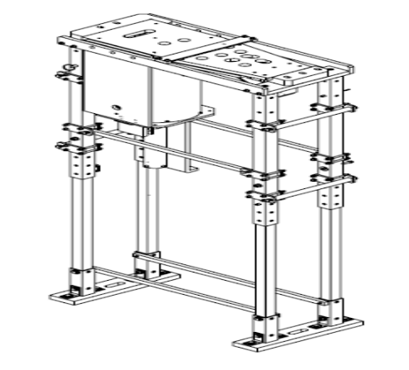
Figure 11: ACB suspension Assembly placed on top of the installation stand
The complete ITM Elliptical Baffle Suspension Assembly weighs approximately 55 lbs, and the unbalanced weight of the assembly can add awkwardness to the lift. Difficulty with the lift can be mitigated by utilizing two people for the lift and having a verbal recitation stating 1) where each person will hold the assembly, 2) what each person’s movement and path during the lift will be, and 3) describing the final placement in the Stand.

Placing ITM Elliptical Baffle Suspension Assembly and the Installation Stand on Lift Table
The complete ITM Elliptical Baffle Suspension Assembly plus the Stand weighs approximately 94 lbs. It must be carried and placed on top of the lift table. The combined weight must be lifted and carried by two people. Handles have been provided for ease in lifting and transportation.

Lifting the Baffle Aperture Box
Whenever heavy objects are lifted by more than one person, the group of people who are lifting the load together should be paired with equal height and strength, if possible, to avoid unbalancing or overloading any single individual.
The complete ITM Elliptical Baffle Aperture Box weighs approximately 44 lbs. The aperture box will be transported into the chamber either through the BSC door or through the opening provided by the removal of a spool piece. Two people will carry the Baffle Aperture Box to mitigate the strain of lifting. The path from starting point to destination must be clear. Baffle Box will be lifted approximately 12 inches and placed onto I-Beams positioned on the lift table.

Figure 12: ITM Elliptical Baffle Aperture Box and Lift Table

Handling of Installation Tooling
The lifting table and installation stand will be brought into the BSC chamber by two or more people and placed on the floor of the BSC below the installation baffle location--the individual parts weigh < 50 lbs--and it will be assembled in place or carried in. Teflon pads are used on the feet to allow the table to be slide across the floor while in chamber.

Sudden Release of Tensioned Spring
The ITM Elliptical Baffle suspension utilizes a blade spring that is placed under bending tension during its assembly. The spring is loaded with approximately 62 lbs by the suspended baffle. In the event that the tension in the springs should suddenly be released, the blade tip will spring up against the bottom side of the top mounting plate, shown in Figure 3; this will prevent the spring from traveling further.

Figure 13: D1200140, Blade Assembly in Post-bending Configuration

If the sudden release in tension is caused by the suspension flexure breaking, the baffle will be caught by the earthquake stops, as shown in Figure 14, and will not fall farther than a 1/4 inch.

Safety glasses must be worn at all times when springs or wires are under tension to prevent injury in the unlikely event that a wire breaks or a wire clamp slips, resulting in the release of a fast moving wire end or shrapnel; safety glasses are always advised to reduce potential eye hazards.
Once the blade spring is installed into the Blade Assembly (D1200140), joined to the Upper (D1002582) and Lower (D1101887) Tube Assemblies, and the Damping Tube Assembly (D1002564), as shown in Figure 14, safety glasses are no longer required since the spring is constrained; however, it is recommended that eye protection be worn at all times when working around objects that have stored mechanical energy that may be released inadvertently.
.

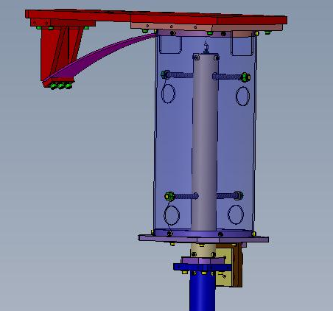

Figure 14: ITM Elliptical baffle hanging freely within earthquake stops

Damage to the Beamsplitter Suspension and Mirror
The ITM Elliptical Baffle will be installed inside the BSC in close proximity to the triple suspension structure and the BS mirror. A protective barrier will be installed temporarily between the ITM Elliptical Baffle and the triple suspension structure during the initial phase of installing the ITM Elliptical Baffle; in spite of this protective barrier, dropping a tool or object onto the triple structure may cause serious damage to the structure or to the supporting elements of the mirror.

Damage Caused by Dropped Loads
The assembly and installation involves manual manipulation of relatively heavy objects (up to 50 lbs). The potential exists for dropping these loads which would likely damage the parts and represents a potential injury to feet and toes. Steel toed shoes must be worn during the assembly and installation.

Suspension Assembly
The Suspension Assembly will be assembled upside down on a table top and then placed into the installation stand. The suspension may be dropped and cause injury to the personnel supporting it.

Aperture Assembly
The baffle Aperture Assembly must be placed on top of the lift table during installation onto the overhead plate or inside the BSC. The assembly may be dropped and cause injury to the personnel supporting it.

Overstress/damage to the flexure
The suspension flexure rod can be damaged by over torqueing or tightening during the assembly process. This risk is mitigated by following the assembly procedure steps carefully, including the prescribed torque value.

The flexure can be damaged by applying a large bending load before the suspension limiters (stops) have been installed. This risk is mitigated by following the assembly procedure steps carefully and taking care not to apply a side load to the upper/lower tube assembly before the Damping Tube Assembly has been installed.

Pinching/Cutting of Hands and Bumps to the Head, Etc.
The individual pieces of the baffle are thin pieces of metal, and though the edges have been beveled, there is a potential to receive cuts if parts are handled improperly. Each team member should inspect to their satisfaction the prospective part to be handled to determine if that part has a potentially hazardous sharp edge. Hands may also be pinched when assembling parts to one another, but this can be mitigated with proper attention to handling the parts.
During the assembly inside the vacuum chamber, personnel should be mindful of where they stand and move as to not damage nearby objects and bump their heads, knees, etc. Damage from accidental bumps can be mitigated by being spatially aware of the working area and by spotting one another.

Vacuum Contamination
The vacuum system will be opened during this installation process and has the potential to be contaminated. All work must be done in positive pressure clean rooms and all personnel must be garbed in appropriate Class A garb. Standard Class A procedures must be practiced at all times.
Should a glove tear due to cuts, there is a potential to cause vacuum contamination problems.

Damage to Installed Baffle by Personnel Working in Vicinity
Whenever anyone is working inside the chamber in the vicinity of the ITM Elliptical Baffle, the short transport locking bracket (D1101285) must be attached to the lower suspension tube assembly to avoid twisting and stressing the baffle/SUS as a result of external applied forces.

Arm Cavity Baffle Hazard Analysis Severity Table

Item # | Hazard | Cause | Effect | Unmitigated  Severity | Unmitigated  Probability  Level | Unmitigated Risk Index | Comment | Mitigation | Mitigation Severity | Mitigated Probability Level | Mitigated Risk Index
1 | Strain from lifting heavy assembly | Lifting heavy assembly without support | Injury to personnel, damage to equipment | marginal | occasional | 3C | Total assembly weighs ~100 lbs (without or with weights), CA/OSHA one man lift value is 50 lbs | At least two people must lift assembly. Lift table with jacks shall be used to mate assembly when in chamber. | minor | improbable | 4E
2 | Sudden release of tensioned springs | spontaneous failure of flexure, or overstress of flexure by applying a heavier than design load | Injury to personnel, damage to equipment | critical | remote | 2D | Blade spring has ~60 lbs of load | Safety Glasses are required to prevent eye injury; Blade spring is constrained in the tooling and assembly to limit motion; Overload is prevented once the Damping Tube subassembly is installed (motion limiters). | minor | remote | 4D
3 | Damage to BS Suspension | Bumping of BS SUS or impact to BS Optic | Mis-alignment or damage to BS SUS | critical | occasional | 2C |  | Use barrier between ITM Elliptical Baffle and BS SUS; Place BS Optic on EQ stops; Cover BS Optic with protective cover | marginal | remote | 3D
4 | Dropped parts | Slipping from personnel hands | Damage to parts, feet and toes | minor | probable | 4B | Maximum weight is 100 lbs. | Personnel are to wear steel toes shoes during installation | minor | improbable | 4E
5 | Overstress/  damage of the flexure | Personnel applying excessive torque, or lateral load to the tube assembly | Damage to flexure | marginal | occasional | 3C |  | Careful procedure with prescribed torque value | marginal | remote | 3D
6 | Pinching/cutting of hands and bumps to the head | Injured by dog clamps, touching sharp edges, accidentally walking into suspension | Minor head injury  Minor finger and hand injury | minor | probable | 4B |  | Personnel to work with caution and be aware of structures in vicinity | minor | improbable | 4E
7 | Vacuum Contamination | Exposed vacuum chamber; removal of covers/wraps | Damage to environment | minor | occasional | 3C |  | All parts handled in clean rooms outside of vacuum; all personnel dressed in Class A approved garb | minor | remote | 4D
8 | Damage to Installed Baffle by Personnel | Bumping of freely suspended baffle | Damage to flexure and SUS | marginal | occasional | 3C |  | Fasten transport bracket whenever personnel are working in vicinity | minor | remote | 4D

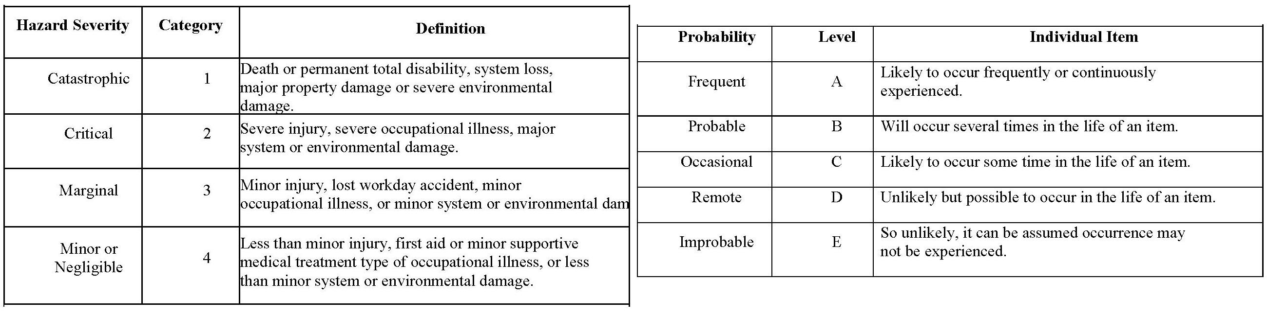

 |  |  | PROBABILITY
SEVERITY OF | E | D | C | B | A
CONSEQUENCE | Improbable | Remote | Occasional | Probable | Frequent
1
Catastrophic
2
Critical
3
Marginal
4
Negligible
Hazard Risk Index |  |  | Risk Code Criteria
1A, 1B, 1C, 2A, 2B, 3A |  | Unacceptable
1D, 2C, 2D, 3B, 3C |  | Undesirable (Directorate decision required)
1E, 2E, 3D, 3E, 4A, 4B |  | Acceptable with review by Directorate
4C, 4D, 4E |  | Acceptable without review

