Tumbleweeds-X arm Road.
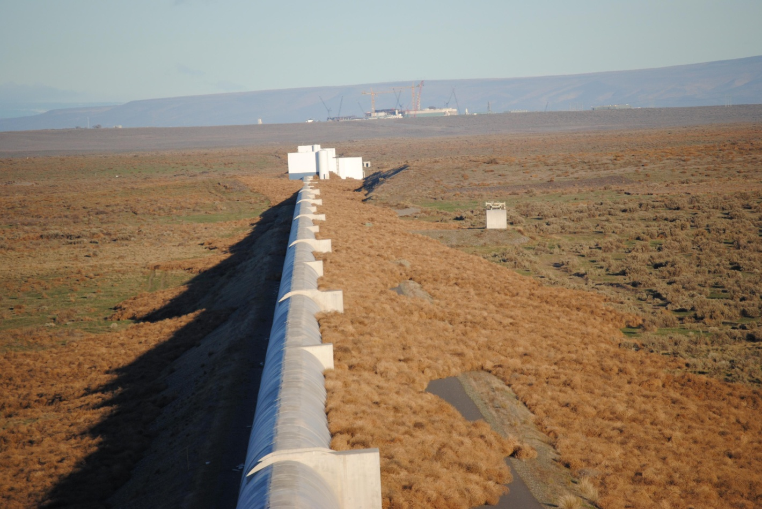
Tumbleweeds-Corner Station.
