*LIGO Laboratory / LIGO Scientific Collaboration*

E1101064-v1 *LIGO* 1/27/15

Figure Metrology Measurement Procedure for Core Optics

GariLynn Billingsley

Distribution of this document:

LIGO Scientific Collaboration

This is an internal working note

of the LIGO Laboratory.

|  |  |
| --- | --- |
| **California Institute of Technology**  **LIGO Project – MS 18-34**  **1200 E. California Blvd.**  **Pasadena, CA 91125**  Phone (626) 395-2129  Fax (626) 304-9834  E-mail: info@ligo.caltech.edu | **Massachusetts Institute of Technology**  **LIGO Project – NW22-295**  **185 Albany St**  **Cambridge, MA 02139**  Phone (617) 253-4824  Fax (617) 253-7014  E-mail: info@ligo.mit.edu |
| **LIGO Hanford Observatory**  **P.O. Box 159**  **Richland WA 99352**  Phone 509-372-8106  Fax 509-372-8137 | **LIGO Livingston Observatory**  **P.O. Box 940**  **Livingston, LA 70754**  Phone 225-686-3100  Fax 225-686-7189 |

http://www.ligo.caltech.edu/

# Introduction

This document describes the set up, measurement and analysis procedures for characterization of the figure of the core optics for the Advanced LIGO detector.

# Setup

This document pertains to use of the Zygo interferometer located in 012/014 Downs on the Caltech campus. This software used is MetroPro 8.3.5. A user-built custom application is used for measurement and analysis. The measurement application is called LIGO_Dual_Ap_GB-1.app. The analysis application is called BIG_Map_GPI.app

## Cold start

### Power up

The instrument mainframe is turned on first, via a rocker arm switch on the optical output face, just below the beam aperture. The laser is turned on by power switch and interlock key, both located on the laser power supply, attached to the back of the mainframe. There is a beam block at the mainframe output that is always left open.

Start the MetroProLIGO application from the desktop on the control PC. If not already auto-started, click on the button: LIGO_Dual_Ap_GB-1.app

### Collimator

The instrument has two collimators. The most commonly used is for full aperture measurement. In this configuration the mainframe is at the far position, and lowered down on the kinematic mounts. The small collimator, accessed via rubber flap on the center, south side of the table, is pulled out to the edge of the table.

### Reference Optic

#### Reference Optic Mount

The reference optic is mounted on French cleats at the collimator output. Once mounted, the optic cell is pushed as far north in the mount as possible – providing for repeatable reference subtraction. Earthquake stops are braced against the top of the mount to prevent the cell from jumping off in the event of an earthquake. In common metrology terms these reference optics are called transmission flats or transmission spheres. There are nylon thumbscrews on some of the cells, these are to prevent swinging during transportation, the screws should be backed away from the optic during measurement.

|  |  |  |  |
| --- | --- | --- | --- |
| Reference Name | Description | Use with | Certification Report |
| Flat C | Highest quality flat S1 is coated with the Zygo “Dynaflect” coating, providing measurement contrast for coated and uncoated optics | Beamsplitter  Compensation plate | C1002795 |
| Flat A | S1 is Dynaflect coated | Use S2 for return in transmission and 45 degree Beamsplitter reflection. | xxxxx |
| TM | -2100 meter radius of curvature. Dynaflect coated | ITM ETM | C1002794 |
| 36m | -36 meter radius of curvature. Dynaflect coated | PR3 SR3 | C1102035 |
| 34m | -34 meter radius of curvature. Dynaflect coated | F-PR3 | C1102247 C0900453 |

#### Reference Optic Alignment

1. Place the 2” retroreflector centered in front of the reference optic.
2. Turn mainframe into 2X mode using the turret knob on the back of the mainframe.
3. Using the wired remote, select “align” mode, this is a toggle between coarse and fine alignment.
4. Using the alignment knobs on the reference optic, move the return spot to the center of the align screen.
5. Toggle back to fine alignment using the “align” button on the wired remote
6. Using the wired remote, change the focus so that you can see the internal lines in the retroreflector.
7. Using the wired remote, select “spot” mode. This allows you to see fringes on the remote monitor.
8. Using the alignment knobs on the reference optic, null the fringes from the retroreflector.
9. Return the instrument to 1X and “ring” mode. Store the retroreflector at the side of the instrument with the optic facing the collimator shroud.

CAUTION: There are two return reflections from A2 (S1 & S2); the left image is correct.

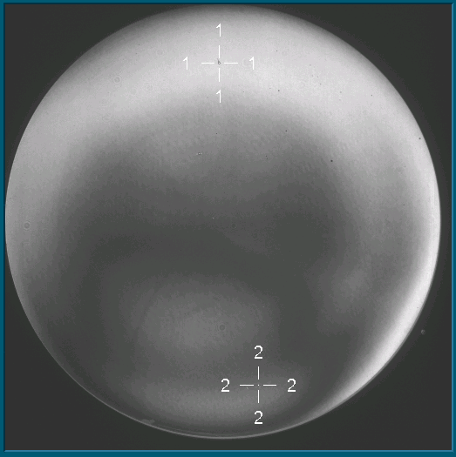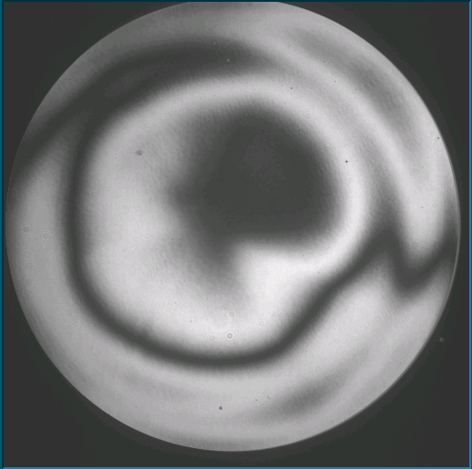

Figure : Correct (S2) and incorrect (bulk+S1) fringe patterns for reference A2

## Measurement Preparation

### Preparation of the optic

Using First Contact**™**,place a ~2mm dot on the test optic, located at the edge of the coating and aligned with the arrow fiducial. Place two more edge dots, one at 2:00 and one at 5:00 on the optic face, viewed with the arrow at 12:00, looking at side 1.

### Placement

Place the optic as described in section 2.3 for each type. In general the path length is minimized, and there is insulation placed on the tabletop underneath the beam path. Starting in the “Align” mode, use the air bearing to move the optic mount in yaw, center the return beam on the crosshair. Change to “View” mode, use the optic mount knobs to null the fringes. Place magnetic mounts behind the optic mount and slide the optic mount until the fringe pattern is visually centered in the measurement aperture.

Shroud the measurement with netting and lens tissue (to minimize air current) and null the fringes.

### Focus

Use the Mask editor in “live” to zoom in on one of the first contact dots. Drag the application window to the left so it is visible on the remote monitor. Use the wired remote to adjust for best focus.

### Software

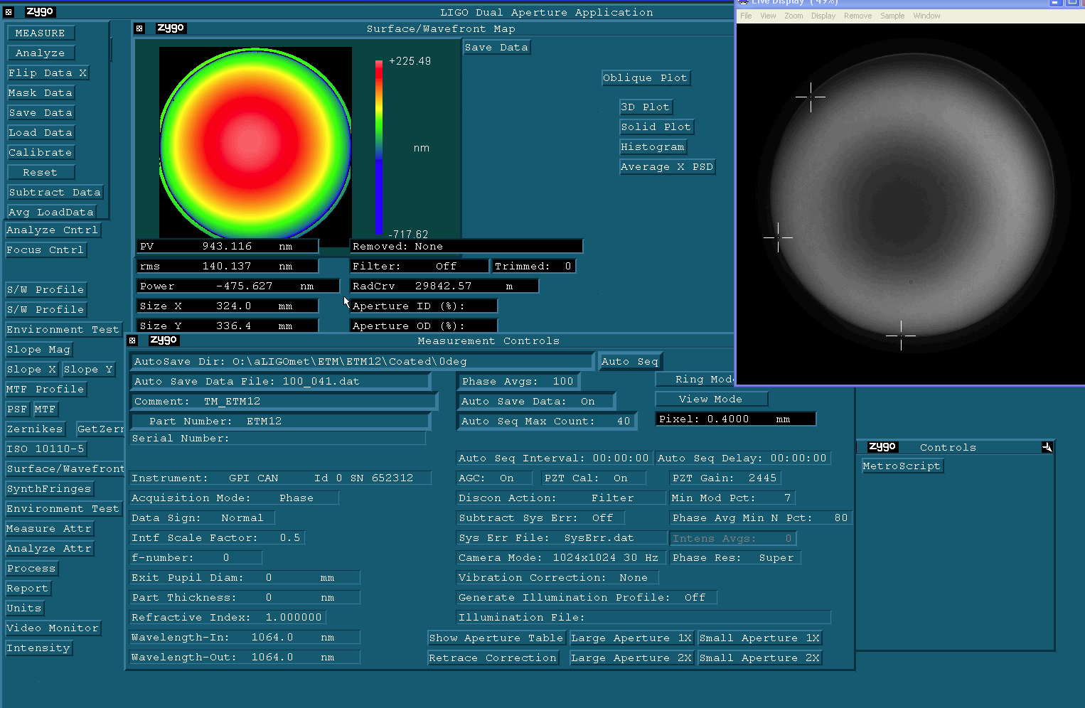

Figure : Basic software setup for data acquisition. The top four lines in the Measurement Controls window must be set for the current test. A close up of the Measurement Controls box is shown in Figure 2.

#### Left side of measurement controls box

AutoSave Dir: All data are stored under the “coreopt” user name and aLIGOmet directory. After that the directory name should describe the type\serialnumber\coatingstatus\measurementName.

Auto Save Data File: describes the number of phase averages, in this case 100, and the auto sequence storage number.

Comment: Describes the measurement cavity. In this case TM represents the Test Mass reference, and ETM12 is the optic under test

Part number: The part number of the optic under test

#### Right side of measurement controls box

Phase Avgs: set to 100

Auto Save Data: set to On

Auto Seq Max Count: set to 40

Ring Mode (toggle between spot mode and ring mode)

View Mode (toggle between align mode and view mode)

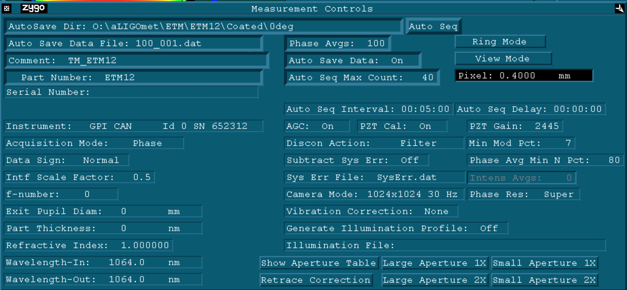

Figure : Measurement Controls Box

#### Set Pixel size

To set the pixel size click the “Calibrate” button in the upper left of the data acquisition screen shown in .

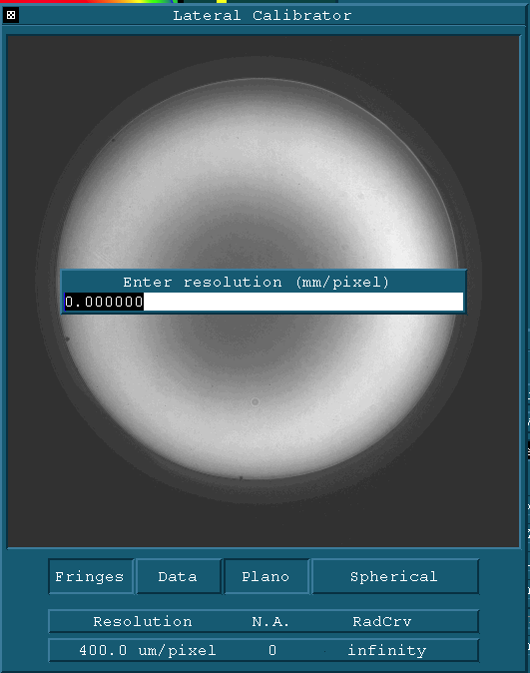

Figure : set calibration by right clicking the bottom button and choose “enter Cal” from the drop down menu

|  |  |  |
| --- | --- | --- |
| Name | “Enter Resolution” | Full aperture size (mm) |
| Full | 0.4 | 409.36 |
| 2x | 0.192 | 196.49 |
| 10x | 0.047 | 48.10 |
| 20x | 0.023 | 23.54 |

For the large collimator the change between “Full” and “2x” is accomplished by rotating the turret on the back of the interferometer mainframe.

For the small collimator the turret changes between 10x and 20x.

#### Set Fiducials

To set the fiducials, start with the “Mask” button in the upper left of the data acquisition screen shown in . The button labeled “fiducials” toggles between the mask editor and the fiducial editor.

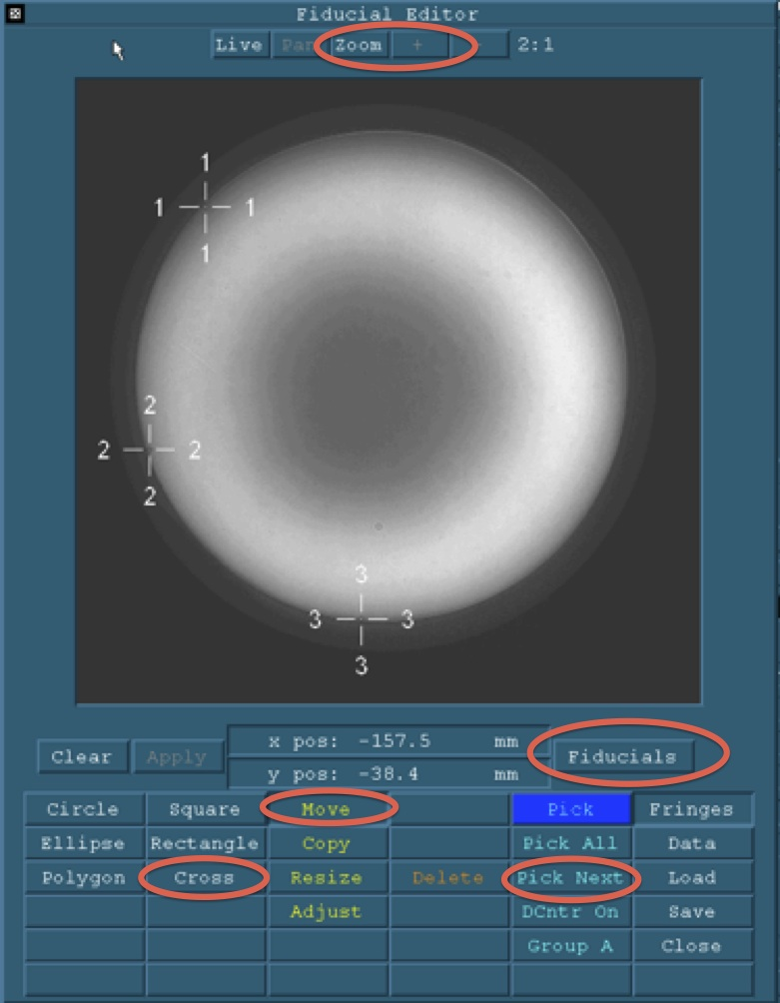

Figure : The fiducial editor is found under the Mask editor by toggling the button at the right labeled Fiducials

To set fiducials choose the “cross” button and click on the image of the first contact dots applied in the Focus section, beginning with the dot placed at the arrow fiducial on the optic. Fiducials 2 and 3 are the subsequent dots proceeding counter clockwise.

After setting the third fiducial click the “Zoom” button at the top, then the “+” button several times, then the “move” button. Use the arrow keys to center the crosshair on the first contact dot.

Choose “pick next” and center the other two crosshairs on their respective dots. Changes are saved automatically.

Note: Fiducial #1 always corresponds to the location of the arrow fiducial engraved on the optic barrel.

Note: Zygo Video is flipped in X, as though you are looking through the optic toward the interferometer. In the analysis phase we perform a flip in software before saving final data.

## Placement and iteration

### Test Masses

The test mass Surface 1 is set close to the reference optic, the cavity length is less than 80 mm. Test mass fine alignment is controlled via a web interface at <https://sheeva01.ligo.caltech.edu>. This is a secure controller, so the username and password are located on the control computer. Control connectors must be plugged in to the motor control at the north side of the optical table.

The test mass is measured at eight different rotational angles in 45 degree increments. Reference . The zero degree measurement is defined as having the fiducial arrow at 12:00 when viewing the optic face. The 45 degree measurement is when the arrow is at 1:30 etc. To rotate the optic, elevate the Test Mass onto the mount rollers using the BLACK crank knob on the side of the test mass mount. In the odd rotations (45, 135, 225, 315) the optic must be positioned carefully to be sure that the Test Mass Ear Flats do not rest on the mount pads. This is easy to verify by sighting through opposing fiducial lines and rotating the optic so that the fiducial lines center on the small silver colored mount screws.

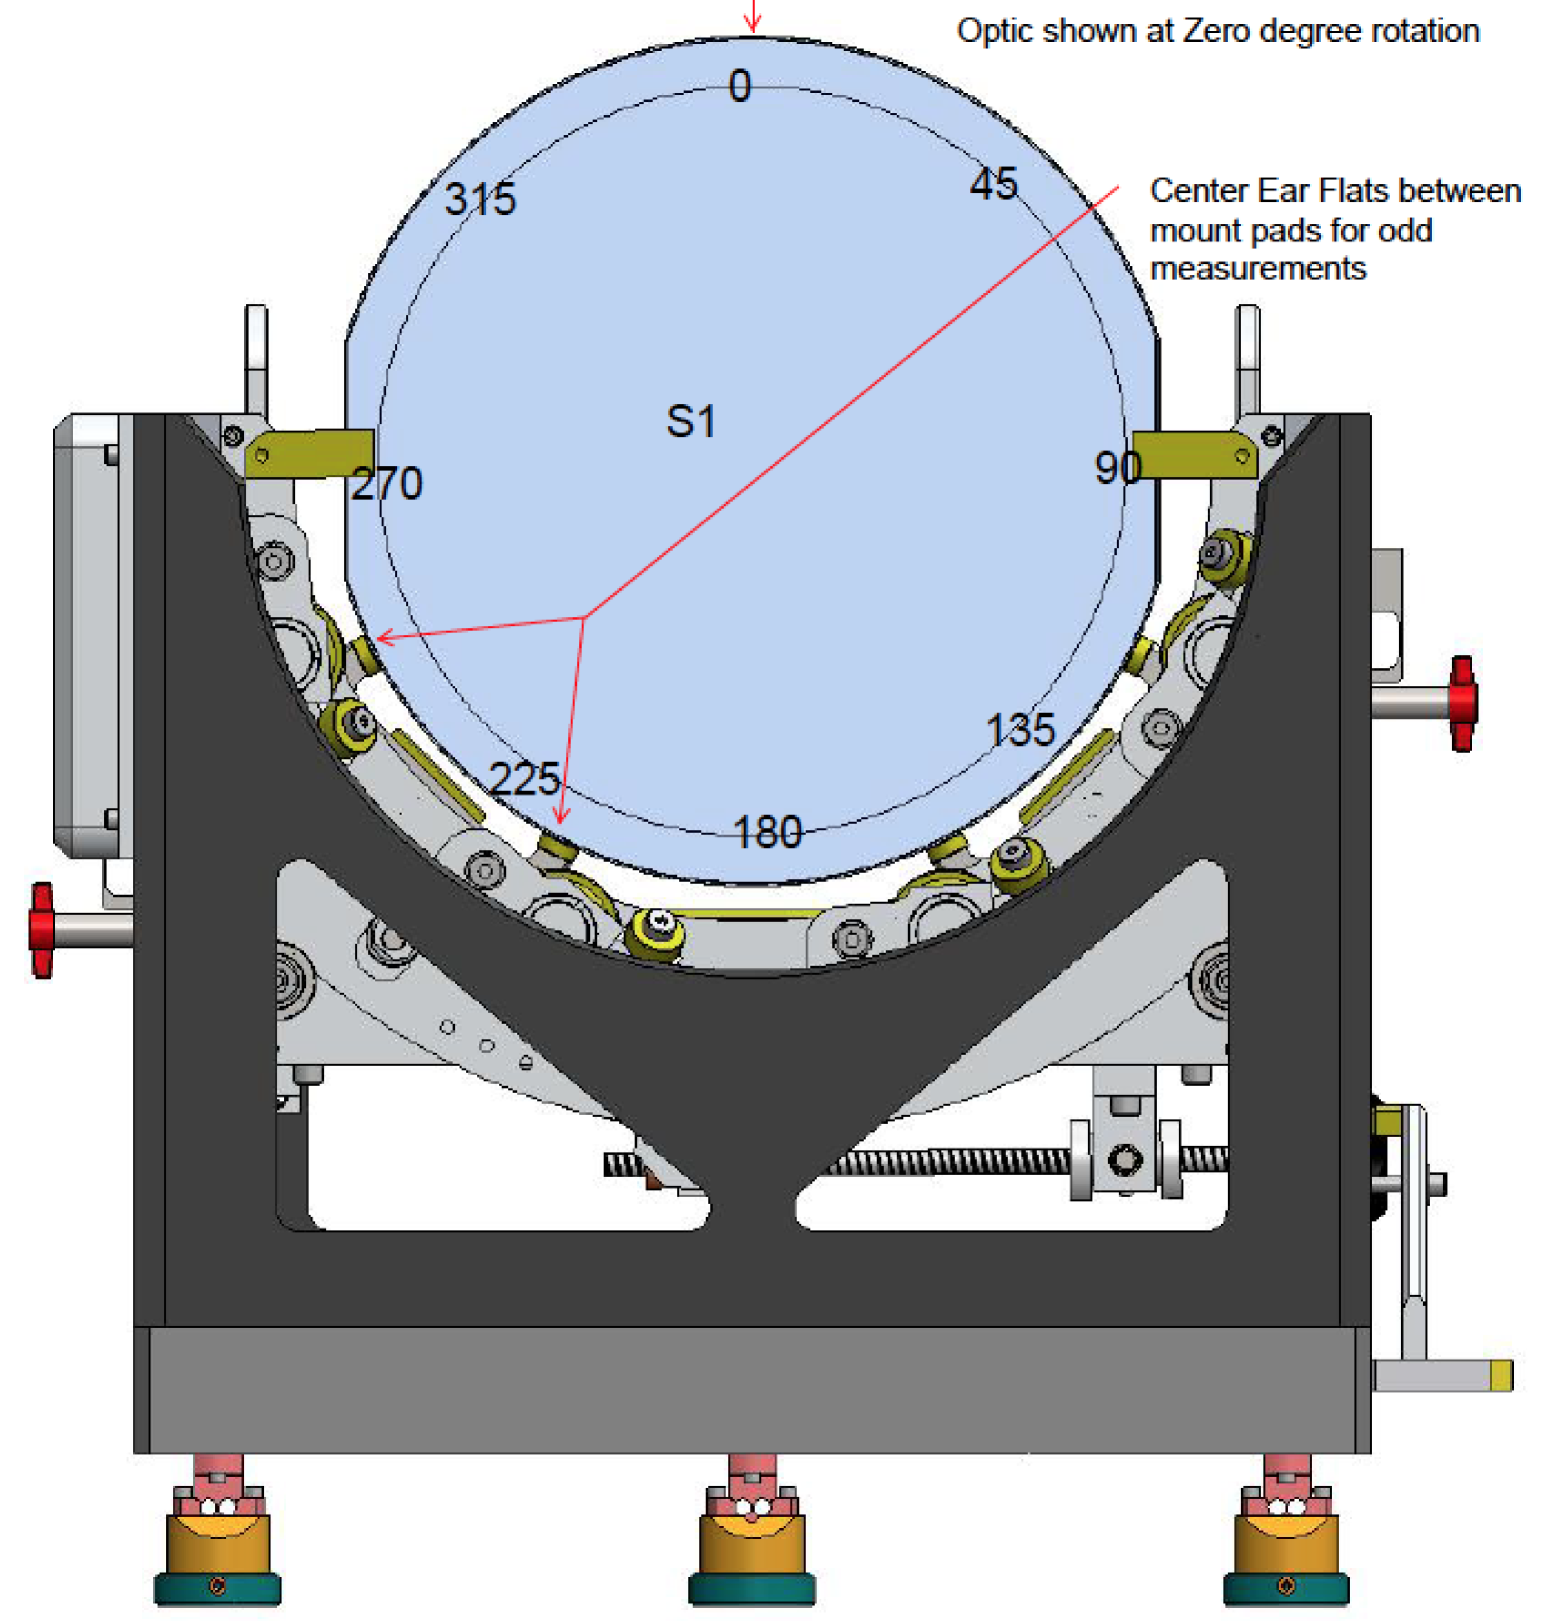

Figure : Test Mass mount see LIGO-C0900329 for more information

### Compensation Plate

The Compensation Plate is measured in transmission. Due to the fragile gold coating on the barrel, the CP is measured in only one orientation; arrow up. The uncoated side of the A flat is used as the return optic. See the analysis section for how to subtract A2. Fiducials must be placed in data, use natural marks on A2. The Compensation Plate mount is a scaled version of the Test Mass mount.

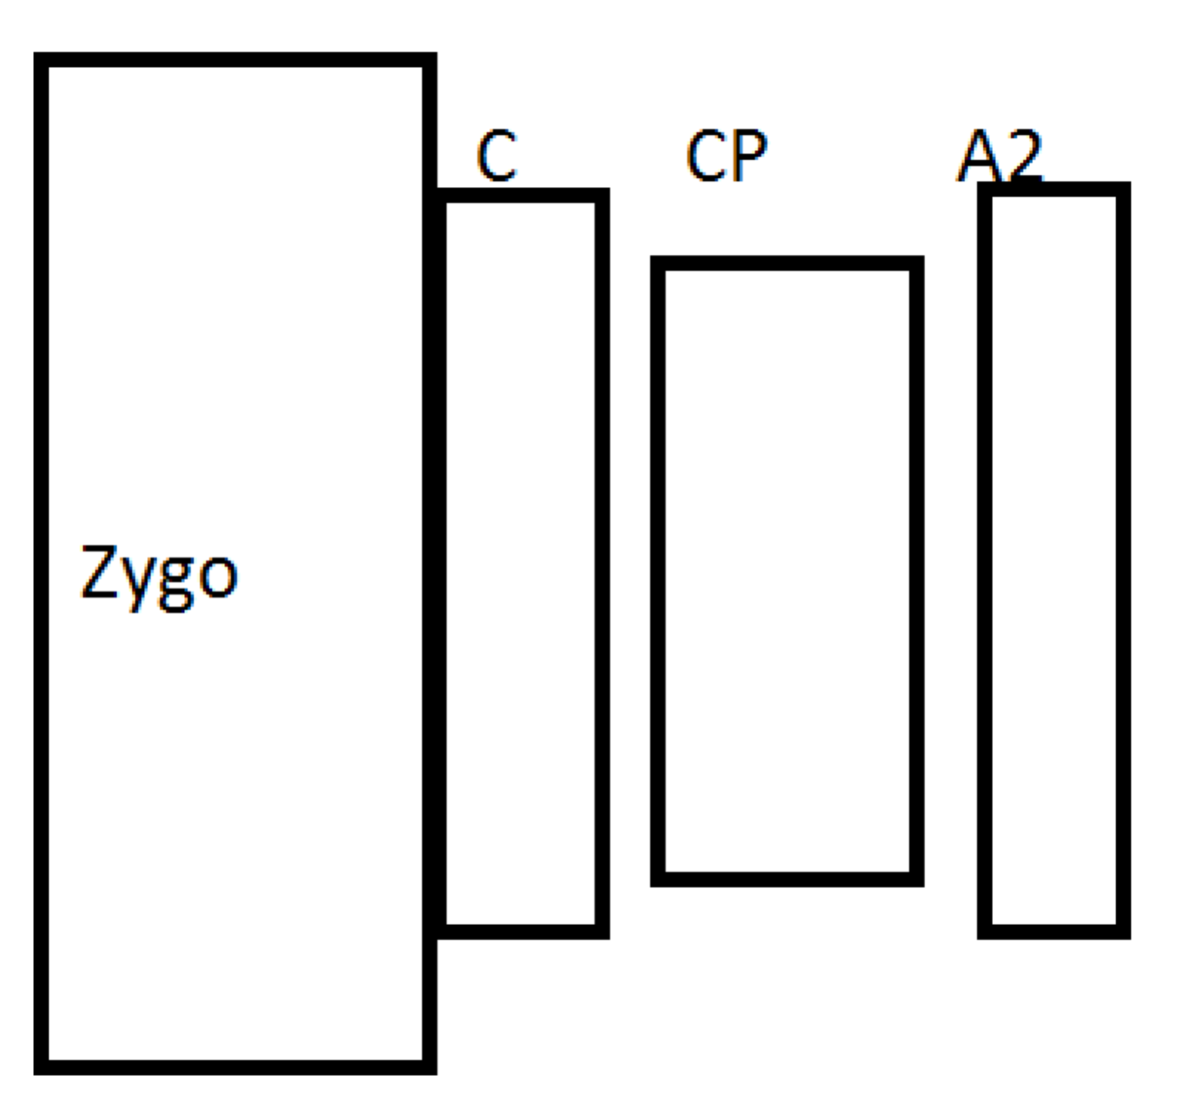Figure : Compensation Plate transmission measurement

### Beamsplitter

The Beamsplitter is measured from the HR side and the AR side at normal incidence, in the same manner as the Test Mass. In addition there are four measurements at 45 degrees, all with the Beamsplitter oriented as suspended. Note the location of the fiducial arrow in the following diagrams. See LIGO-C1002474 for instructions on loading and using the optic mount. The same caution applies for surface A2 as is shown in Figure 1.

|  |  |
| --- | --- |
| PRY: Reflection between Power Recycling and Y arm. | SRX: Reflection between Signal Recycling and X arm. |
| STY: Transmission between Signal Recycling and Y arm. | PTX: Transmission between Power Recycling and X arm. |

Figure : 45 degree Beamsplitter configurations and terminology

## PR3 and SR3

The R3 optic is measured in the same way as the Test Mass. See LIGO-C1002474 for instructions on loading and using the optic mount. It is good to position the R3 far enough away from the reference to minimize fringes, this minimizes the “fringe imprint” on the data. It is absolutely critical to measure the distance between the reference surface and the test optic. Use a precision scale, resting on the edge of the reference, sighting along (to minimize parallax) the surface of the test optic.

## End Reaction Mass

The End reaction Mass is measured in the same way as the Compensation Plate.

# Analysis

## Nomenclature

100_001.dat The first data set in a run (001) comprised of 100 phase shifts.  
100_002.dat The second data set in a run (002) comprised of 100 phase shifts  
100_001-020.dat An average of the first 20 data sets  
0.dat The stable average of 40 data sets taken at the zero clocking position.  
0-r.dat 0.dat minus the reference file (stored in the local folder for clarity)  
ODD.dat The fiducial average of 45-r.dat, 135-r.dat, 225-r.dat and 315-r.dat  
EVEN.dat The fiducial average of 0-r.dat, 90-r.dat, 180-r.dat and 270-r.dat  
ETM04 The fiducial average of ODD and EVEN, flipped in x and oriented arrow up.

The optic name and serial number are only used for a data set after the data are properly oriented.

## Check Stability-all measurements

Forty data sets are stored during each run. The difference in data during the run is used to determine if the environment was sufficiently stable.

1. Average the first 20 data sets – store as 100_001-020 (or 100_101-120 if this is the second attempt; use a different century to denote a different data set)

2. Average the second 20 data sets – store as 100_021-040.

3. Click the “Subtract Data” button at the top left of the analysis screen – choose the set that was stored in step 1.

All Zernike coefficients through 15 should be at 0.2 nm or less with the exception of Tilt and Power.

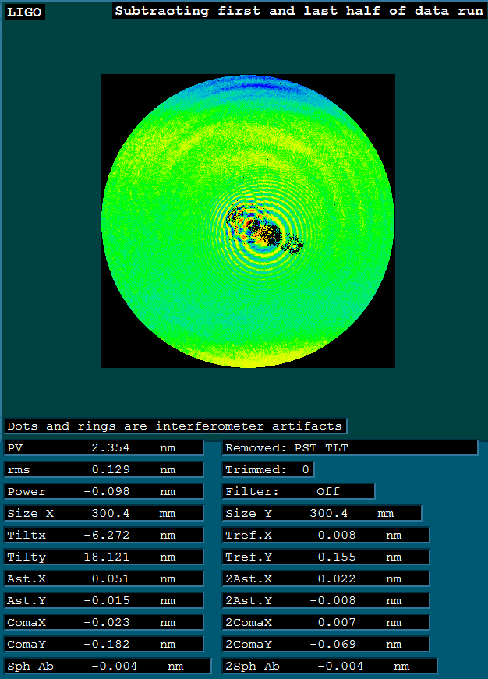

## Reference subtraction and Averaging for Test Mass, R3 and Beamsplitter normal incidence measurements.

For each rotational position: Check the stability of the data.

1. Average the final (or best!) 40 consecutive data sets for each rotational position.

2. Store the average for each position in the rotation folder (eg. 0) as 100_001-040.dat. Also store the average as 0.dat in the analysis folder (eg COATED). These names are for the zero degree average. Use 45.dat, or…315.dat as appropriate.

3. Subtract the appropriate reference data set: the most current. Create a new analysis folder if another reference is used at another time. Store a copy of the reference file in the analysis folder, for clarity. In the example file structure for ETM08 there is only one analysis folder “coated.”

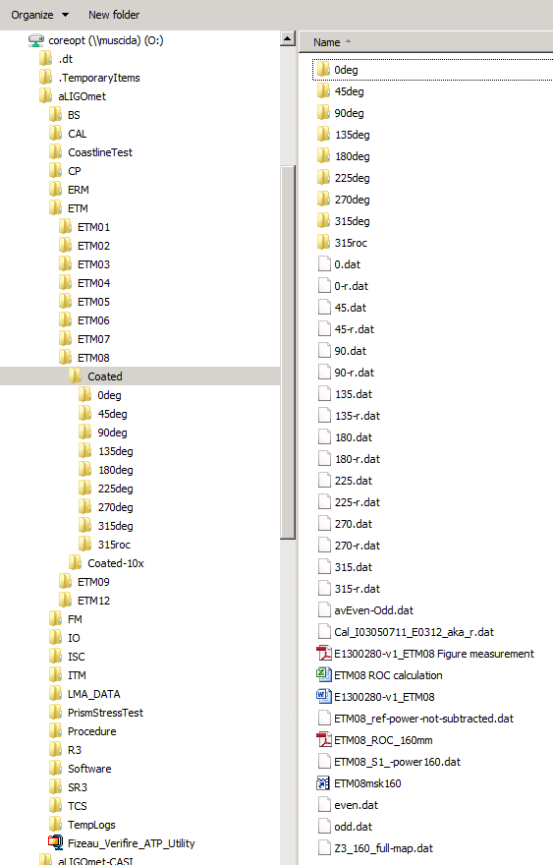4. Store the reference subtracted data set as 0-r.dat, or 45-r.dat… etc. As appropriate, adding the –r to the filename indicate that the reference was subtracted.

5. Change to the Fiducial average setting: Click the “Fiducials” button at the center left of the analysis display. Choose “Fiducials” from the drop-down menu.

|  |  |
| --- | --- |
| Fiducial pull down menu | Fiducial settings |

6. Average the four Odd data sets and store as ODD.dat : Click “Avg LoadData” and CTRL-Click on the four odd data sets: 45-r.dat, 135-r.dat, 225-r.dat and 315-r.dat.

7. Average the four Even data sets and store as EVEN.dat : Click “Avg LoadData” and CTRL-Click on the four even data sets: 0-r.dat, 90-r.dat, 180-r.dat and 270-r.dat.

8. Subtract the odd data set from the even. This provides an estimate of the overall error in the measurement. Note the rms over 160 and 300 mm for most optics and 225 and 350 mm for the Beamsplitter. These are reported under “measurement uncertainty” in the final report.

9. Average EVEN.dat and ODD.dat

10. Flip the data set: Click “Flip Data X” at the left of the analysis screen.

11. View the Fiducials (found by clicking the “Mask Data” button, then the Mask/Fiducial toggle as shown in Figure 5. IMPORTANT: choose the “Data” view instead of “Fringes” view (lower right.)

12. Click “Rotate Data” from the left side of the analysis screen. Use trial and error until the #1 fiducial is at the top center of the data set. + rotations are counter-clockwise. All rotations are relative. Non-integer values may be used.

13. Save as serial number ie. ETM04.dat. At this point, for the Test Mass and R3 there is still residual power from the reference sphere.

## Removing Residual Power

Future chapters:

High Spatial frequency measurements for test masses

Homogeneity measurement for input test mass

Radius of curvature calculation and measurement uncertainty