*LIGO Laboratory / LIGO Scientific Collaboration*

LIGO-T1100536-v1 *Advanced LIGO* Date:

Hartmann Wavefront System: Defocus error budget

Authors: Aidan Brooks

Distribution of this document:

LIGO Scientific Collaboration

This is an internal working note

of the LIGO Laboratory.

|  |  |
| --- | --- |
| **California Institute of Technology**  **LIGO Project – MS 18-34**  **1200 E. California Blvd.**  **Pasadena, CA 91125**  Phone (626) 395-2129  Fax (626) 304-9834  E-mail: info@ligo.caltech.edu | **Massachusetts Institute of Technology**  **LIGO Project – NW22-295**  **185 Albany St**  **Cambridge, MA 02139**  Phone (617) 253-4824  Fax (617) 253-7014  E-mail: info@ligo.mit.edu |
| **LIGO Hanford Observatory**  **P.O. Box 159**  **Richland WA 99352**  Phone 509-372-8106  Fax 509-372-8137 | **LIGO Livingston Observatory**  **P.O. Box 940**  **Livingston, LA 70754**  Phone 225-686-3100  Fax 225-686-7189 |

http://www.ligo.caltech.edu/

# Introduction

The purpose of this document is to briefly describe the noise budget for the sources of spurious defocus error in the HWS probe beam.

# Background

The defocus, *S*, (defined implicitly as the coefficient of the quadratic term of wavefront distortion, *W =0.5 S r2*), is the inverse of the radius of curvature of an optic. It allows for linear addition of different defocus terms to determine the resulting defocus,



which is easier to deal with, rather than working with all the inverses associated with radii of curvature changes:



Defocus is the lowest order characterization of thermal distortion in the test mass (excluding pitch and yaw variations). Therefore, it is useful to know the noise budget for the defocus in the HWS.

# Defocus contribution

## Photo-electron shot noise

In 1D, the gradient measured at a single location on the Hartmann sensor, , is given by:

,

where  is the pixel size,  is the displacement of the spot (in pixels) and *L* is the lever arm distance between the Hartmann plate and the CCD (=11mm). The uncertainty in the displacement of the spot is approximately given by  where *N* is the maximum number of photo-electrons stored in a pixel per measurement (~160,000 e- for the Dalsa 1M60 cameras used in the HWS). The error in the gradient is then:

.

The HWS measures the gradient of any wavefront change,  in 1D. A purely quadratic wavefront change then has a gradient:

.



We find that if we have a set of measurements of the gradient that are equally noisy, are uniformly distributed across an aperture of diameter, *d*, and separated by a pitch *p* then the standard error in a fit to *S* is approximately (note: where does the factor sqr 12 come from?):

.

For the HWS, the diameter of the CCD is 12.3mm and the pitch between the Hartmann plate holes is 430 μm.

## Thermal expansion of the Hartmann sensor

As the Hartmann plate and CCD thermally expand, the measured locations of the holes are displaced from their original positions by an amount that is proportional to the distance of the hole from the center of the plate. The result is an apparent linear change in the gradient of the wavefront and thus an apparent quadratic change in the wavefront itself: a systematic defocus error.

The magnitude of this effect, relative to temperature, is given, theoretically, by:



where  and  are the coefficients of thermal expansion of the Hartmann plate (Invar ~ 1.2×10-6 K-1) and the CCD (Silicon ~ 3×10-6 K-1), respectively.

## Thermal expansion of the imaging telescope

If the HWS imaging telescope thermally defocuses, a real defocus will be introduced into the probe beam. This is, however, a systematic error in the measurement of the defocus in the ITM. If the entire telescope is considered (including thermal expansion in the fused silica optics), the change in defocus with respect to temperature at the HWS is (note: show the terms that comprise this equation):



# Results

A low frequency temperature spectrum was taken from LHO using 12 months of temperature data. This was used to determine the temperature dependent contributions to defocus. The total defocus error is determined from the quadrature sum of the shot-noise defocus with the linear sum of the temperature dependent defocus effects.

The defocus at the ITM is the defocus at the HWS divided by the magnification (17.5×) squared.

The results are presented in Figure 1. In addition to the errors, the defocus expected from 4mW absorption, 400mW absorption and also the maximum tolerable defocus limit calculated in T1000722. (note: state the conclusion of figure 1)

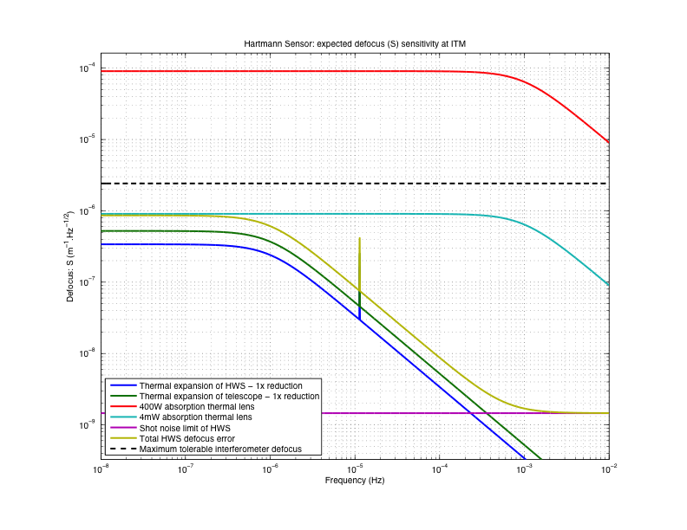

Figure : Defocus error budget

## Secondary beam and temperature stabilization of the HWS

A second analysis was performed assuming that the temperature of the HWS is stabilized by a factor of 5x and the secondary probe beam is used to reduce the systematic error from the telescope defocus by a factor of 5x.

The results are shown in Figure 2. (note: state the conclusion of the improvement over figure 1, as shown in figure 2.)

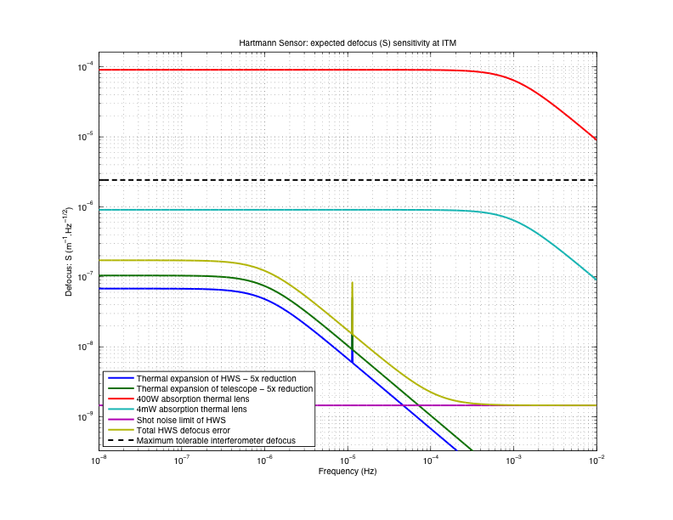

Figure : Defocus error budget with temperature stabilized HWS and secondary HWS beam used to eliminate 80% of the defocus error from the telescope.