AUTHOR: | DATE | CHECKED:
Michael Smith | 1-30-12 | Peter Fritschel
Lisa C. Austin | 3-11-12 | Mike Smith

This specification is for anti-reflection coated, laser-quality, wedged window. It will be used at the input of the OFI to correct the input beam angle
Applicable Documents
Requirements
Physical Configuration

Diameter | 1.00″ +/- 0.01″
Thickness | 0.375″ +/- 0.010″ (at thickest point)
Wedge | 1 degree +/- 6 arc minute  Thick edge of optic to be marked with a scribe line across the barrel
Bevel | 45 deg. bevel on both edges, width approx. 0.03″ or as appropriate to prevent chipping
Clear Aperture | Exceeds 85% of diameter
Markings | Markings: Part and serial number, as defined below, shall be scribed on the barrel
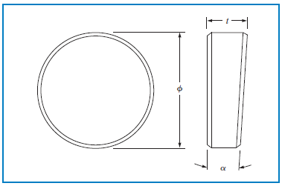

Substrate Material
Fused silica, Corning 7980 or equivalent, grade 0A or better
Part and Serial Number
The Part/Serial number shall be of the format:
D1200434-v1 YY is incremental, starting at 01

Surfaces 1 and 2, measured over the clear aperture
Surface Quality: Surfaces 1 and 2
Laser grade polish: 10-5 scratch-dig surface quality
Transmitted wavefront error:
λ/20 p-v or less, at 633 nm

Surface roughness, Surfaces 1 and 2:
< 1 Angstrom RMS
Anti-Reflection Coatings:
R < 0.05% for 0-5 deg. AOI, s- & p-polarization, 1064 nm
Applied to surfaces S1 and S2.
Durability per MIL-C-675C, Coating Adhesion and Durability, or current compatible standard, to be approved by LIGO.

Testing and Documentation
Specification | Test Method | Frequency of Inspection | Data Delivered
Physical Dimensions | Visual Inspection | 100% | Certification
Surface Quality | Visual Inspection | 100% | Certification
Transmitted Wavefront Error | Interferometry | 100% | Certification
AR Coatings | Spectrophotometer | Witness sample for each coating run | Spectral scans

