LIGO Laboratory / LIGO Scientific Collaboration

LIGO- E1200225-v6 Advanced LIGO 3/11/2013

Coding Standard for TwinCAT Slow Controls Software

Daniel Sigg

Distribution of this document:
LIGO Scientific Collaboration

This is an internal working note
of the LIGO Laboratory.

California Institute of Technology  LIGO Project – MS 18-34  1200 E. California Blvd.  Pasadena, CA 91125  Phone (626) 395-2129  Fax (626) 304-9834  E-mail: info@ligo.caltech.edu | Massachusetts Institute of Technology  LIGO Project – NW22-295  185 Albany St  Cambridge, MA 02139  Phone (617) 253-4824  Fax (617) 253-7014  E-mail: info@ligo.mit.edu
LIGO Hanford Observatory  P.O. Box 159  Richland WA 99352  Phone 509-372-8106  Fax 509-372-8137 | LIGO Livingston Observatory  P.O. Box 940  Livingston, LA 70754  Phone 225-686-3100  Fax 225-686-7189
http://www.ligo.caltech.edu/

Table of Contents
1 Introduction 4
1.1 Programming Languages 4
1.2 Project Directories 4
1.2.1 Target Area 5
1.3 Project Archive 5
1.3.1 Organization 5
1.3.3 Version Numbers 7
1.4 Cycle Time 7
1.5 Data Tags (Channels) 7
1.5.1 Input/Output Convention 7
1.5.2 Interface Variables 7
1.6 OPC Interface 7
2 Program Organization 8
2.1 Library 8
2.1.1 Hardware Input Structure 8
2.1.3 Hardware Output Structure 9
2.1.4 Interface Structure 9
2.1.6 Error Handling 10
2.1.7 Function Block 10
2.1.9 Initialization 11
2.1.10 Visual Screen Templates 12
2.2 Global Variables 12
2.3 Program 13
2.5 Project Files 14
2.5.1 Imports 14
2.5.2 Site and Location Customization 15
2.5.3 Interferometer and OPC Export Variable 16
2.6 Installation and Configuration Scripts 16
3 TwinCAT Project Setup 17
3.1 Setting the Options in the Project 17
3.1.1 Project Information 17
3.1.2 Fonts and Path Options 17
3.1.3 Build Options 19
3.1.4 TwinCAT Options 19

3.2 PLC Common Infrastructure 20
3.2.1 Common libraries 20
3.2.2 Error Handling 20
3.2.3 Software version 23
3.2.5 Run-time information 24
4 Naming Scheme 25
4.1 Names 25
4.1.1 Variable Names 25
4.1.2 Type Names 25
4.1.3 Function and Method Names 25
4.1.4 Function Block Names 25
4.1.5 Names of Visuals 25
4.1.6 Suffix Summary 26
4.2 Hardware Channels 26
4.3 Library Objects 27
4.3.1 Name Space 27
4.3.2 Folder Names 27
4.4 External Tags 28
5 OPC Access and Properties 29
5.1 OPC Access 29
5.2 OPC Properties 29
5.3 Automatic Type Support 31
5.4 Enumerated Types 31
5.5 Array Variables 32
5.7 EPICS Database Generation 33
6 Documentation 34
6.1 Project Information 34
6.2 Type Information 34
6.3 Global Variables 35
6.4 Interfaces 35
6.5 Functions 35
6.6 Function Blocks 36
6.7 Visuals 36

Introduction
The purpose of this document is to facilitate a single coding standard among the slow controls software written for the TwinCAT system. TwinCAT contains an embedded IEC 61131-3 software PLC which is the main focus here. The document gives guidance how to build a reusable programming structure, how to name objects like variable, structures and function blocks, and how to document a library module.

Programming Languages
The IEC 61131-3 programming standard supports 5 different languages: structured text (ST), function block diagram (FBD), ladder diagram (LD), instruction list (IL) and sequential function chart (SFC). TwinCAT 3 also supports C/C++ and Matlab/Simulink. For the advanced LIGO slow control systems only structured text shall be used with TwinCAT 2.11. For TwinCAT 3 advanced LIGO also supports C/C++ for integrating already written modules.

Programming language | Description | TwinCAT version
Structured Text | One of the IEC 61131-3 programming languages, Pascal like | 2.11 and 3
C/C++ | For integrating previously written modules | 3
Table 1: Supported languages.

Project Directories
The project directories on a front-end or development machine are organized in a development area under version control and a target area where the run-times reside.

Items | Path | Owner
TwinCAT | C:\TwinCAT | Beckhoff
Code | C:\SlowControls | Subversion
Target | C:\ SlowControls\Target | Run-time

Target Area
The target area contains the files associated with a specific run-time. The directory structure is organized by target and PLC. The run-time files associated with a specific run-time are copied to the target directory using an installation script. This requires that the code are is a committed revision within subversion.

Items | Path
Target Area | C:\SlowControls\Target
Example target system area | C:\SlowControls\Target\H1ECATC1
Example target PLC 1 code | C:\SlowControls\Target\H1ECATC1\PLC1
Example target PLC 2 code | C:\SlowControls\Target\H1ECATC1\PLC2
Example target PLC 3 code | C:\SlowControls\Target\H1ECATC1\PLC3
Example target PLC 4 code | C:\SlowControls\Target\H1ECATC1\PLC4
TwinCAT boot files | C:\TwinCAT\Boot

Project Archive
All project files are stored in a subversion (SVN) archive on redoubt.ligo-wa.caltech.edu.

Item | Link | Type
Server | redoubt.ligo-wa.caltech.edu | web
Archive | /slowcontrols | web
Full path | https://redoubt.ligo-wa.caltech.edu/svn/slowcontrols/trunk | checkout
Table 2: Subversion archive.

Organization
The slow controls archive contains the folder TwinCAT for storing all files related to TwinCAT. There are currently two sub folders TwinCAT\Library for storing libraries and TwinCAT\Source for the storing project files. Scripts are stored in the TwinCAT\Script\Common folder. The configuration scripts and the system configuration associated with a real-time computer are stored in a target folder within TwinCAT\Script\Configuration. There are up to 4 PLCs allowed in TwinCAT 2.11.

Items | Path
System documents | SlowControls\Documents
Network documents | SlowControls\Documents\Network
TwinCAT files | SlowControls\TwinCAT
TwinCAT documents | SlowControls\TwinCAT\Documents
TwinCAT coding standard | SlowControls\TwinCAT\Documents\CodingStandard
TwinCAT library files | SlowControls\TwinCAT\Library
Individual TwinCAT library | SlowControls\TwinCAT\Library\CommonModeServo
… | …
TwinCAT program source files | SlowControls\TwinCAT\Source
Current TwinCAT source files | SlowControls\TwinCAT\Source\Current
Source files for interferometer | SlowControls\TwinCAT\Source\Current\Interferometer
Corner source files | SlowControls\TwinCAT\Source\Current\Interferometer\Corner
End station source files | SlowControls\TwinCAT\Source\Current\Interferometer\End
Import files | SlowControls\TwinCAT\Source\Current\Import
… | …
Script files | SlowControls\Scripts
Common script files | SlowControls\Scripts\Common
Configuration files | SlowControls\Scripts\Configuration
Target configuration files | SlowControls\Scripts\Configuration\H1ECATC1
System configuration files | SlowControls\Scripts\Configuration\H1ECATC1\SYS
PLC configuration files | SlowControls\Scripts\Configuration\H1ECATC1\PLC
… | …
EPICS related files | SlowControls\EPICS
EPICS utilities | SlowControls\EPICS\Utilities
… | …
Modbus related files | SlowControls\Modbus
Modbus target files | SlowControls\Modbus\Target
Individual Modbus target | SlowControls\Modbus\Target\H1ModbusC1
… | …
Table 3: Organization of the archive.

Version Numbers
The production code is managed by subversion release numbers. The subversion number is part of the run-time code and is archived. When significant changes to a library are made that require supporting both the old and new versions, a new library project has to be created. If the original library was called TimingMasterFanout then new version would be called TimingMasterFanoutV2.

Cycle Time
An IEC 61131-3 system consists of system task and at least one programmable logic controller (PLC). The system task is responsible for interfacing the hardware and starting the PLC tasks. The field bus of choice in advance LIGO is EtherCAT. The system task transfers data between a shared memory region and hardware at a fixed cycle time. TwinCAT 2.11 supports up to four different update rates. For advanced LIGO the standard update rate is 10 ms. For a limited number of channels a faster update rate of 1 ms is supported.

Task | Description | Rate
Standard | All non time critical software and supervisory tasks | 10 ms
Fast | Time critical functions such as RS422 support at 115kbaud | 1 ms
Table 4: Supported update rates.
The tasks with the fast update rate are running at a higher priority (lower number).

Data Tags (Channels)

Input/Output Convention
From the perspective of the TwinCAT program and configuration input channels refer to inputs from the EtherCAT terminals, e.g., analog-to-digital converters and binary inputs, whereas output channels refer to outputs to the EtherCAT terminals, e.g., digital-to-analog converters and binary outputs. The same is true for user inputs which are inputs into TwinCAT and readbacks which are outputs from TwinCAT.

Interface Variables
All external tags (channels) have an initialization record which is periodically updated and is declared PERSISTENT. Upon power failure and loading a new code its value as retained as much as possible. Any initialization that is required, when the PLC is started or when a new version is loaded, needs to be dealt with in software. See the saverestore library.

OPC Interface
We are using the TwinCAT OPC comments denoted by (*~ ... *) to make global variables accessible to the OPC server. Variable names in TwinCAT are translated one-to-one into OPC tag names, which in turn are translated into EPICS channels using a conversion rule. OPC properties are used to describe additional information such as limits, precision and state names. These OPC properties are translated into corresponding EPICS database fields.

Program Organization
The development blocks for the advanced LIGO slow controls software are individual libraries. Each of the basic libraries is tailored to control a single electronics chassis or controller.
A typically library consists of
- one or more type describing the hardware inputs,
- one or more type describing the hardware outputs,
- a type describing the user interface channels or tags (input and output),
- one or more function blocks containing the run-time code, and
- a set of visual templates that can be used for diagnostics.
The main program then consists of a global variable list and a series of function block calls.

Library
This section gives an example of the structures and the function block defined for the LowNoiseVco library.

Hardware Input Structure
TYPE LowNoiseVcoInStruct :
STRUCT
PowerOk: BOOL; (* Voltage monitor readback *)
TuneMon: INT; (* Monitor for the frequency offset *)
ReferenceMon: INT; (* RF power at the reference input *)
DividerMon: INT; (* RF power at the divider input *)
OutputMon: INT; (* RF power at the output amp *)
ReferenceTemp: INT; (* Temperature of the reference RF detector *)
DividerTemp: INT; (* Temperature of the divider RF detector *)
OutputTemp: INT; (* Temperature of the output RF detector *)
Excitation: BOOL; (* Monitors the excitation input enable *)
Frequency: LREAL; (* Measured frequency *)
FrequencyLive: BOOL; (* Keep alive for frequency measurement *)
END_STRUCT
END_TYPE;

Hardware Output Structure
TYPE LowNoiseVcoOutStruct :
STRUCT
TuneOfs: INT; (* Setpoint for the frequency offset *)
ExcitationEn: BOOL; (* Enables the excitation input *)
END_STRUCT
END_TYPE;

Interface Structure
All elements of an interface structure are getting exported with read and write permission. To prevent output tags from showing an invalid value each output parameter has to overwritten at each cycle. Output parameters in the interface structure should never be read.

TYPE LowNoiseVcoStruct :
STRUCT
(* error handling *)
Error: BOOL; (* Error flag *)
ErrorCode: DWORD; (* Error code *)
ErrorMessage: STRING;(* Error message *)
(* output tags *)
PowerOk: BOOL; (* Voltage monitor readback *)
TuneMon: LREAL; (* Monitor for the frequency offset in V *)
ReferenceMon: LREAL; (* RF power at the reference input in dBm *)
DividerMon: LREAL; (* RF power at the divider input in dBm *)
OutputMon: LREAL; (* RF power after the output amplifier dBm *)
ReferenceTemp: LREAL; (* Temperature of the reference RF detector *)
DividerTemp: LREAL; (* Temperature of the divider RF detector *)
OutputTemp: LREAL; (* Temperature of the output RF detector in C *)
ExcitationSwitch: BOOL; (* Monitor the excitation input enable *)
Frequency: LREAL; (* Frequency of the VCO output *)
FrequncyServoFault: BOOL; (* Indicates a fault in the frequency servo *)
(* input tags *)
TuneOfs: LREAL; (* Setpoint for the frequency offset in V *)
ExcitationEn: BOOL; (* Enables the excitation input *)
FrequencySet: LREAL; (* Setpoint for the VCO frequency output *)
FrequencyServoEn: BOOL; (* Enables the frequency PID *)
END_STRUCT
END_TYPE;

Error Handling
Each main function block needs to provide error handling using three variables defined in the interface structure: Error, ErrorCode and ErrorMessage. The error flag is set true to indicate an error condition. The error code is a bit encoded value listing the error conditions with zero indicating no error. The error code number can be used to flag multiple errors by setting corresponding bits. Error conditions are described in the documentation associated with the library. The error message is a human readable string describing the error condition. It can contain up to 80 characters. When required the definition STRING(255) can be used to support up to 255 characters. If multiple errors are flagged, the error message needs to reflect this. A simple library without error conditions needs to set the error flag to false, the error code to zero and the error message to an empty string.

Function Block
A function block has to declare input and output variables. In the simplest case the input parameter is the hardware input structure, the hardware output structure is the output parameter and the interface structure is the in/out parameter.

FUNCTION_BLOCK LowNoiseVcoFB
VAR_INPUT
LowNoiseVcoIn: LowNoiseVcoInStruct; (* Input structure *)
END_VAR
VAR_OUTPUT
LowNoiseVcoOut: LowNoiseVcoOutStruct; (* Output structure *)
END_VAR
VAR_IN_OUT
LowNoiseVco: LowNoiseVcoStruct; (* Interface structure *)
END_VAR
…

Initialization
All function blocks controlling hardware have to support initialization and have to be able to store the current state. This is done by passing a SaveRestoreEnum parameter as well as an additional interface structure that holds the previously stored values.

FUNCTION_BLOCK LowNoiseVcoFB
…
VAR_INPUT
Request: SaveRestoreEnum; (* init/save request *)
END_VAR
VAR_IN_OUT
LowNoiseVcoInit: LowNoiseVcoStruct; (* saved interface struct *)
END_VAR
…

The additional interface structure should is used to pass the previously saved parameters to the initialization routine. It is also used to store these parameters. The Init parameter will either request no operation, an initialization operation, a save operation, or a transition to a safe operation mode. Typically, only state machines will have to implement the transition to a safe operation mode. Within the function block the initialization code would look like:

(* Code *)
CASE Request OF
(* initialization *)
Restore:
LowNoiseVco := LowNoiseVcoInit;
(* additional initialization steps can be added here *)
SafeMode:
(* only for state machines *)
Save:
LowNoiseVcoInit := LowNoiseVco;
Noop:
(* always ignore *)
END_CASE;
…

The LowNoiseVcoInit variable will be stored in a global persistent block. This means its values are preserved between reboots and recompilations as long as the LowNoiseVcoStruct stays the same. Changing the LowNoiseVcoStruct or one of its elements will invalidate its persistent memory and reinitialize with all zeros. However, a change in an unrelated structure should not affect the low noise VCO.
The restore request is basically an initialization request and will be issued once after a reboot or a reload of the program. The save request will be issued at regular intervals, but at a low rate, maybe once a minute. The safe mode request might be issued upon a fatal error or a user request. It would typically affect the entire PLC program and not just one library.
Restoring to the previously saved values is probably the best option in most circumstances, but is unlikely to be appropriate in all cases. For example, a state machine probably needs to start in a well defined initialization state and not in whatever state it was left in. In these cases additional code needs to be added to the restore request.

Visual Screen Templates
Either one or a set of visual screen templates are associated with a library. The top-level screen template should be a representation of the hardware controlled by the library. It should interface the interface structure, and display all its input and output parameters. Input parameters should be modifiable by the user. Since the library only knows abstract data types, the visual screen template shall deploy placeholder variables to represent actual data. For example, the VCO template screen might reference “$vco$.OutputMon” in the numeric field describing the output RF power. $vco$ is the placeholder parameter that will be replaced with the actual data of type LowNoiseVcoStruct, when the visual template is embedded into a master screen. In most cases the visual template screens should leave their background transparent, so that it can be set by the master screen.

Global Variables
Global variables are used to store hardware input structure, the hardware output structure, the associated function blocks and a hierarchical structure representing all interface structure as part of an interferometer structure. The later is outlined in section 3.4 and is used to represent the opc naming tree which in turn is translated into an EPICS name.
Persistent global variables are used to store the initialization structures. Their values are retained between reboots and restarts of the program. They will be reinitialized with zeros, when the structure itself is modified, so.

VAR_GLOBAL
I1: IfoStruct; (*~ (OPC : 1 : visible for OPC-Server) *)

AlsVcoIn AT %I*: LowNoiseVcoInStruct; (* Input *)
AlsVcoOut AT %Q*: LowNoiseVcoOutStruct; (* Output *)
AlsVcoFB: LowNoiseVcoFB; (* Function block *)
…
END_VAR
VAR_GLOBAL PERSISTENT
AlsVcoInit: LowNoiseVcoStruct; (* Save/restore *)
…
END_VAR
The variable names for the input, output, interface and initialization structures follow the naming of the structure elements within I1 that lead to the VCO. The interferometer tag isn’t included in the name to support copy/paste between different interferometers. The actual addresses are wildcards and are configured through the system manager.

Program
The main program can be a simple series of function block calls. There can be multiple programs to separate subsystems. These programs need to be attached to the standard task, which updates at the 10 ms rate. If a function block requires 1 ms update rate, it needs to be located in separate program that is attached to the fast task.

PROGRAM ALS
VAR
SaveRestore: SaveRestoreFB;(* function block for save/restore *)
GotoSafe: BOOL; (* goto safe mode when transitioning high *)
Request: SaveRestoreEnum; (* save/restore request *)
END_VAR

SaveRestore ( SaveInterval := T#1m,
GotoSafe := GotoSafe,
Request => Request );

AlsVcoFB ( LowNoiseVcoIn := AlsVcoIn,
LowNoiseVcoOut => AlsVcoOut,
LowNoiseVco := I1.Als.VCO,
Request := Request,
LowNoiseVcoInit := AlsVcoInit );
…
END_PROGRAM;

Project Files
Project files must not be written site specific. To facilitate this the source files for the interferometer are separated into two subdirectories: corner and end. Each project file must contain at least two imports to determine the subversion number and to specify the target interferometer as well as the appropriate end station. The project name indicates the PLC it is intended for and has the form “PLC1.pro” or similar.

Imports
A normal project files defines two global variable resources which are linked to a file and are imported before compilation: Global_Variables_Version and Global_Variables_IFOVAR.
Global_Variables_Version looks like this:
VAR_GLOBAL CONSTANT
SvnRevision: DINT := 0;
END_VAR
Whereas Global_Variables_IFOVAR looks like this
VAR_GLOBAL CONSTANT
IfoId: IfoIdEnum := IfoT1; (* IfoH1, IfoL1 or IfoH2 *)
LocId: LocationIdEnum := EndX; (* Corner, EndX or EndY, MidX or MidY *)
END_VAR
VAR_GLOBAL
(* Must reflect intreferometer and X/Y end station *)
T1 AT %MB0: IfoXStruct;
(*~ (OPC :1 : visible for OPC-Server)
(OPC_PROP[8610] :Plc2: OPC-Server name) *)
END_VAR
In the source directory the interferometer is set to the test system. The important point is that during installation these two global variable resources will be overwritten with the correct information appropriate for the target. In particular, the installation script guarantees that the current source code revision has no local modifications and sets the SvnRevision number accordingly. Similarly, the interferometer parameters are set to the appropriate configuration for the specific target. These variables are available in the code and can be used in the rare instances where sites or end stations need to be distinguished.

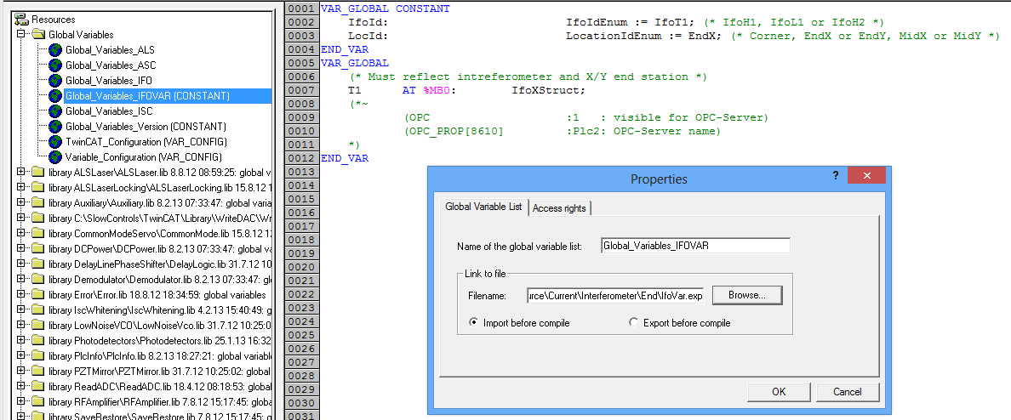

Site and Location Customization
The main program defines
VAR_GLOBAL
Ifo AT %MB0: IfoStruct;
END_VAR
which is getting aliased to an H1 or L1 variable during the installation process. For the X-end station the structure is IfoXStruct, for Y-end it is IfoYStruct and for the corner it stays IfoStruct. A program running in the corner, has to define an IfoStruct only. A program which runs in either the X-end or the Y-end has to define all three. It should use “End” in the IfoStruct to denote the end station, “X” within the IfoXStruct and “Y” within the IfoYStruct.
The Ifo variable is the one you use in the main program, since it is the same between all instantiations of the code. The former is used by OPC or TwinCAT-EPICS-gateway to communicate with the outside world. So, internally one may see variable names start with Ifo.TCS.End..., whereas EPICS/opc would see L1:TSC-X_...
The programmer has to define IfoStruct, IfoXStruct and IfoYStruct.in the main code. These structures need to be identical with the only difference that in IfoXStruct the parameter name is X, Y in IfoYStruct, and End in IfoStruct. Of course, if the system name is TCS, then one has to define a TcsXStruct, TcsEndStruct and TcsYStruct, each with its own X, Y and End parameters.
Dynamically, the variable IfoId and LocId (both enums) are available to distinguish site and location.

Interferometer and OPC Export Variable
In the above example the OPC export variable was name after the interferometer T1 and was of the type IfoXStruct. In order to hide the interferometer details form the normal program a generic interferometer variable is defined in the Global_Variables_IFO resource. It looks like this:
VAR_GLOBAL
Ifo AT %MB0: IfoStruct;
END_VAR
Notice that both variables are located at the same address! The program would use Ifo, whereas the OPC server would read T1, but both instances represent the same data in memory. For this to work in the end station, three similar structures are required: IfoStruct (generic), IfoXStruct (OPC in EX) and IfoYStruct (OPC in EY). These structures absolutely must contain the same element types in the same order. For example, the ifo structure could contain an ALS subsystem structure. They would be named AlsStruct, AlsXStruct and AlsYStruct, respectively. Now, these ALS structure all contain the structure AlsEndStruct, but now the element names are different. They are End, X and Y, respectively. This way the code addresses Als variable with the prefix Ifo.Als.End, whereas the L1 target in the Y end station would provide its OPC access at L1.Als.Y.

Installation and Configuration Scripts
The installation scripts are located in the folder SlowControls\Scripts\Common. A separate documentation is available with T1300175.
Typically, a user would run the “install_tc_target” shortcut which starts a GUI that allows the selection of a target with associated PLCs as well as the desired action. Targets are defined in the Scripts\Configuration folder. Each target requires its own folder in there, and each PLC requires its own folder within the target folder. Target specific configuration scripts are specified in the target folder, whereas PLC specific configurations are specified in the PLC folder. Typically, the target configuration script should be sufficient.
Each target folder also requires a SYS folder which contains the TwinCAT system configuration file (*.tsm). The TwinCAT system configuration in principle is identical between sites and end stations, but there may be slight difference between locations that cannot be easily parameterized. Since software updates are much more frequent than hardware changes, this should not pose a problem.

TwinCAT Project Setup

Setting the Options in the Project

Project Information
Set the title information to the appropriate PLC and station. Since there are typically only source files for corner and end station, there should be no indication of interferometer or which of the two end stations.

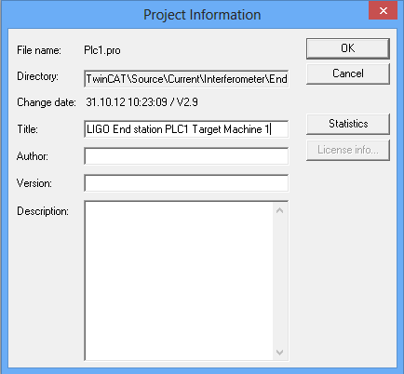

Fonts and Path Options
Choose a fixed point font such as “Courier New”. The project library path should include the path to the slow controls libraries.
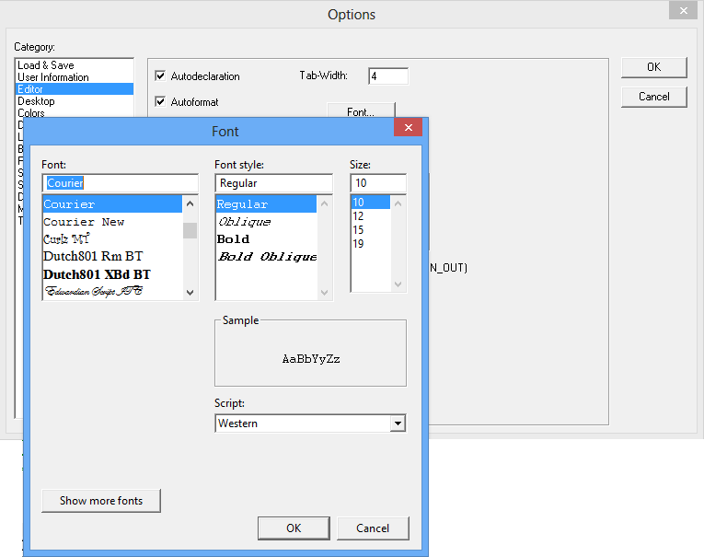

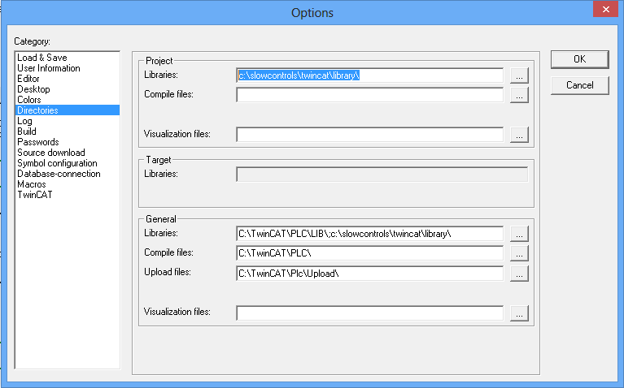

Build Options
Make sure the “check overlapping memory areas” option is selected.

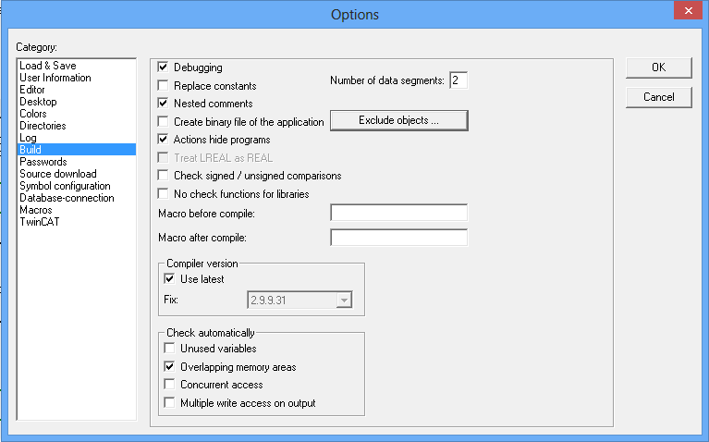

TwinCAT Options
Make sure the “Enable inline string functions” option is selected. This will allow us to use the string functions in more than one task. By default they are not multi-thread safe. This option page also allows to change the allocation for the different memory regions. For large project these limits may have to be increased.
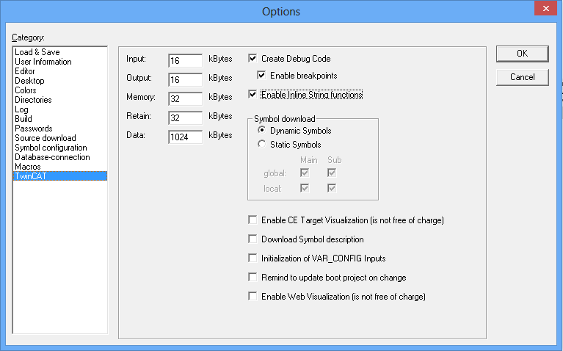

PLC Common Infrastructure
Each PLC project is required to implement the PlcInfo library. This library provides support for reporting errors at the PLC level, it exports the software subversion number and it provides a set of run-time information specific to the PLC.

Common libraries
The following libraries need to be imported for every project.

SaveRestore | Support for saving user interface settings to a persistent memory block. It also supports restoring these settings upon restart.
Error | Support for error handling and reporting.
PlcInfo | Support for reporting software version, run-time information and top level errors

Error Handling
Each user interface structure is required to contain an error reporting structure of type ErrorStruct. Error handling is supported with “Error” library. However, this abstraction cannot be propagated to the highest level because a PLC only covers a subset of the available channels. For instance, there are “H1:ALS“ channels in the corner and both end stations. This means that each of the three associated PLCs will have a user structure H1.Als defined. If it would contain an error structure, the names would collide. There is also no error at the H1 level for the same reason. Instead, the error hierarchical error structures stop at the level one below. For instance, corner station PLC would contain an error structure in the H1.Als.C structure, whereas the end stations would contain error structures in the H1.Als.X and H1.Als.Y structures, respectively. Within each PLC code each subsystem has a corresponding top level error reporting structure. These top level local error structures are combined in a PLC error structure which is reported in the PlcInfo structure. The PlcInfo structures are defined in the H1.Sys.EtherCAT structure. Each PLC has exactly one of these structures and the name of the structure contains the target designator. For instance, the user can access H1.Sys.EtherCat.C1Plc2, H1.Sys.EtherCat.X1Plc2 and H1.Sys.EtherCat.Y1Plc2 and the Error element therein to learn about errors occurring with PLC2 of corner, end X and end Y, respectively.

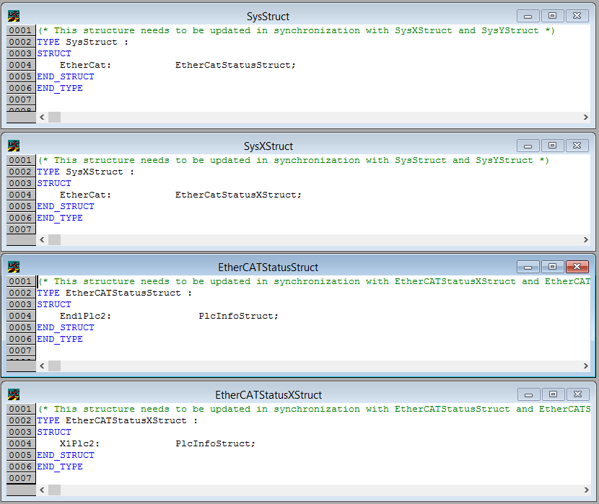

Since there is only one end station program, a little bit of magic with the overlapping H1 and Ifo variables is required to make it all work.
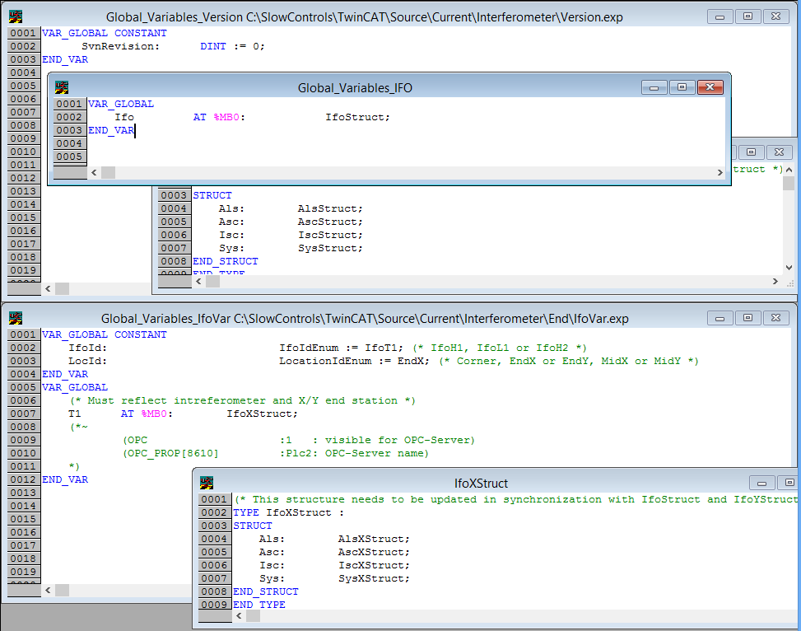

The program unit for the Sys also requires a call to the top level error handler for the PLC which collects the error from each subsystem and combines them into the PLC status information.

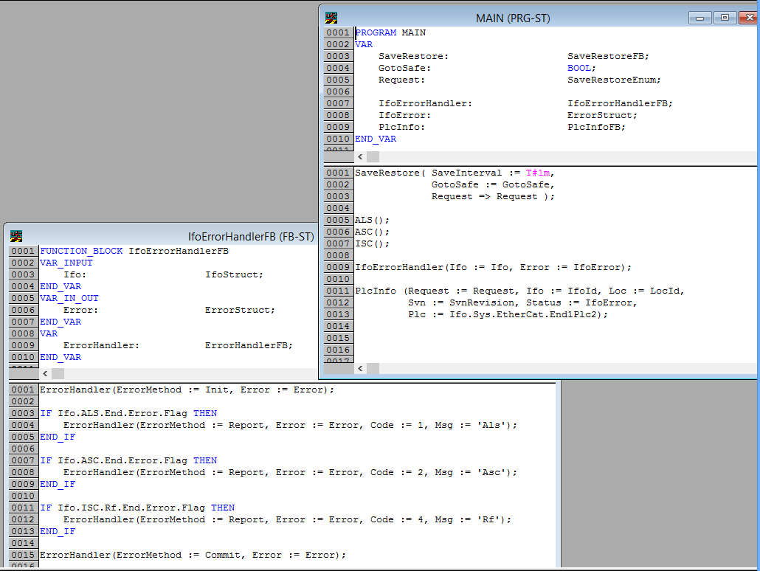

Software version
The subversion revision is a number describing a snapshot of the software in the archive. The installation scripts for a PLC with make sure the archive is up-to-date before compiling the project. The active subversion number is imported into the code and available to the user as part of the PlcInfo structure.

Run-time information
Let’s take a look at the most important elements of the PlcInfo structure.

IfoId | Interferometer identification, e.g. H1 or L1
LocationId | Location of the computer, i.e., Corner, EndX or EndY
Status | Top level error structure of the PLC
SvnRevision | Subversion revision number
StartTime | Time the PLC was started
CurrentTime | Current system time
Hostname | Computer name of the machine running the PLC
CpuUsage | Percentage of CPU usage
SysLatencyActual | Actual system latency
SysLatencyMax | Maximum system latency

Naming Scheme

Names
Generally, verbose and descriptive names are preferred to short and abbreviated ones. This will make the code more readable and help in maintenance and support. For example, Index is preferred over I and TimingMasterFanout is preferred over Tmfo.

Variable Names
The naming of variables preferably should be unique in all libraries, following the camel case notation: For each variable a meaningful, preferably short, English name should be used, the base name. Always the first letter of a word of the base name is to be written uppercase, the remaining letters lowercase; example: FastGain or InputOffset. Abbreviations are written starting with an uppercase and then all lower case; example: VcoGain or TimingMasterFanout. Pointer variables shall use the suffix Ptr, whereas constant variables may use the suffix Const.

Type Names
Type names follow the same rule as variable names. A complex type shall incorporate a suffix to denote is derivation: Enum for ENUM, Struct for STRUCT and Array for ARRAY.
Structure members follow the rules of variables.

Function and Method Names
Function and method names follow the same rules as variables but with the suffix Fun. Internal helper functions such as conversion routines can also use a lowercase name, so that they look more in line with mathematical notation.

Function Block Names
The names of function blocks follow the same rules as variables but with the suffix FB. Interfaces in TwinCAT 3 use the suffix I.

Names of Visuals
Visual interfaces have the suffix Vis.

Suffix Summary

Element | Description | suffix
Constant | Constant value (optional, may be clear from context) | Const
Pointer | Pointer to a variable | Ptr
ENUM | Enumerated type | Enum
STRUCT | Record type | Struct
ARRAY | Array type | Array
Function | Function or Method declaration | Fun
Function block | Function block declaration | FB
Interface | Abstract function block or interface | I
Visual | Screen interface for diagnostics | Vis
Table 5: Required suffix notation.

Hardware Channels
Variables that are connected to hardware channels are separated into input variables and output variables. They must be located in the input and output shared memory regions, respectively. A variable describing a list of input channels must have the suffix In. The corresponding structure must have the suffix InStruct. An output channel list uses the suffix Out, whereas the output structure uses OutStruct. Channels with different cycle time must be placed into different structures. The above names are for the standard cycle time of 10 ms. Channels that need to be updated at the fast rate need to prepend Fast to the above suffixes.

Element | Description | suffix
Input variable | Input variable with standard update rate | In
Output variable | Output variable with standard update rate | Out
Input variable | Input variable with fast update rate | FastIn
Output variable | Output variable with fast update rate | FastOut
Input STRUCT | Input channel structure with standard update rate | InStruct
Output STRUCT | Output channel structure with standard update rate | OutStruct
Input STRUCT | Input channel structure with fast update rate | FastInStruct
Output STRUCT | Output channel structure with fast update rate | FastOutStruct
Table 6: Input and output channel notation.

A code fragment declaring input and output channels in the global variable space:
PicoMotorFastIn AT %IB0100: PicoMotorFastInStruct;
PicoMotorFastOut AT %QB0200: PicoMotorFastOutStruct;
PicoMotorIn AT %IB0102: PicoMotorInStruct;
PicoMotorOut AT %QB0204: PicoMotorOutStruct;

Library Objects

Name Space
Libraries can optionally choose a name space following the variable name notation. This name space is then used to prefix all exported objects. For example: the library TimingMasterFanout has the name space prefix Timing. Within this library TimingSlaveDuoToneStructure, TimingReadSlaveFun and TimingMasterFanoutFB are a valid structure, function and function block, respectively.
Simple libraries that consist of an input structure, an output structure, an interface structure and a function block are not required to choose an explicit name space, but are expected to use the library name as the base for all four objects. Hence, they are defining an implicit name space with the same name as the library name. For example: the library CommonMode may contain the structures CommonModeInStruct, CommonModeOutStruct and CommonModeStruct as well as the function block CommonModeFB.

Folder Names
Program object units (POUs) and data types are organized in folders. These folders are purely organizational and are intended to help grouping items together for easier maintenance. In a library all exported types, functions and function blocks are typically located at the top level. If there are many objects, it may make sense to group them into folders. In any case, internal objects should always be moved into a folder named Internal.

External Tags
External tags (channels) are organized in a hierarchical structure. Each system defines its own structure. This continues with structures for subsystems that are contained in the system structures.
TYPE AlsEndStruct :
STRUCT
Laser: ALSLaserStruct;
VCO: LowNoiseVcoStruct;
PZT1: PZTMirrorStruct;
PZT2: PZTMirrorStruct;
…
END_STRUCT
END_TYPE;

TYPE AlsYStruct :
STRUCT
Y: AlsEndStruct;
END_STRUCT
END_TYPE
…
TYPE IfoStruct:
STRUCT
Als: AlsYStruct;
Asc: AscYStruct;
Lsc: LscYStruct;
Tcs: TcsYStruct;
END_STRUCT
END_TYPE;

VAR_GLOBAL PERSISTENT
I1: IfoStruct; (*~ (OPC : 1 : visible for OPC-Server) *)
END_VAR;
This allows for exporting the entire interferometer interface structure at once and it allows for generating tag names automatically while preserving the hierarchical organization.

OPC Access and Properties

OPC Access
The global variable describing the interface structure of the interferometer is made accessible to the OPC server by using the OPC comments. Meaning,
H2: IfoStruct; (*~ (OPC : 1 : visible for OPC-Server)
(OPC_PROP[8610] : h2ecatc1 : server name) *)
will make the entire h2 variable with all its sub elements will be visible through the OPC interface. In turn, it can be interfaced to EPICS. Individual tags such as the FastGain of the LaserServo will be available from the OPC server as “H2.Isc.Als.LaserServo.FastGain”. The default EPICS channel name constructed from this tag will then become “H2:Isc-Als_LaserServo_FastGain”. Be aware that IEC 61131-3 names are not case sensitive. The same is true for the corresponding TwinCAT OPC names, whereas EPICS channel names are case sensitive.

OPC Properties
OPC properties are used to further describe the external tags. These properties are also used to fill in the EPICS database fields. The properties have to be attached to the elements at the end of the hierarchical structure. These are variables with a basic type like INT or LREAL. Due to the program organization most of these variables are defined in libraries through structures. Therefore, the OPC properties are written after the structure elements using the OPC comment structure. For example:
TYPE LowNoiseVcoStruct :
STRUCT
(* output tags *)
PowerOk: BOOL; (*~
(OPC_PROP[0005] :1: read-only)
(OPC_PROP[0101] :Voltage monitor readback: DESC)
(OPC_PROP[0106] :OK: ONAM)
(OPC_PROP[0107] :OOR: ZNAM) *)
TuneMon: LREAL; (*~
(OPC_PROP[0005] :1: read-only)
(OPC_PROP[0101] :Frequency offset monitor: DESC)
(OPC_PROP[0100] :V: EGU)
(OPC_PROP[0103] :-10: LOPR)
(OPC_PROP[0102] :+10: HOPR)
(OPC_PROP[8500] :3: PREC) *)
...
END_STRUCT
END_TYPE;

Property ID | Description | Record
5 | Access control: 1 – read-only, 3- read/write | all
100 | EGU: Engineering units | numeric
101 | DESC: Description | all
102 | HOPR: High operations value | numeric
103 | LOPR: Low operation value | numeric
104 | DRVH: Maximum instrument range | numeric
105 | DRVL: Minimum instrument range | numeric
106 | ONAM: Label for closed (one) state | binary
107 | ZNAM: Label for open (zero) state | binary
306 | HYST: alarm deadband | numeric
307 | HIHI: hihi alarm level | numeric
308 | HIGH: high alarm level | numeric
309 | LOW: low alarm level | numeric
310 | LOLO: lolo alarm level | numeric
8500 | PREC: Display precision | numeric
8510 to 8525 | ZRST, ONST, ... FFST: Zero string, one string, ... fifteen string | mb binary
8600 | EPICS data type (bi, bo, ai, ao, longin, longout, stringin, stringout, mbbi, mbbo, mbbiDirect, and mbboDirect) | all
8601 | Input or output: overwrites the default behavior | all
8602 | TSE: Time stamp; default is -2 | all
8603 | PINI: default 1 for input and 0 for output records | all
8604 | DTYP: default is opc; can be overwritten with opcRaw | all
8610 | Default OPC server name; default is opc | top level
8700 | OSV: one alarm severity | binary
8701 | ZSV: zero alarm severity | binary
8702 | COSV: change of state alarm severity | (mb) binary
8703 | UNSV: unknown state alarm severity | mb binary
8710 to 8725 | ZRSV, ONSV, … FFSV: zero, one, … fifteen state alarm severity | mb binary
8800 to 8999 | FIELD: Any database field can be specified in the comment string; does not perform any checks; use only when truly desperate | don’t use
Table 7: Supported OPC properties.

Only a small subset of EPICS database fields are supported. In general, fields associated with conversion and calculations are not supported, since all processing should be done within the PLC program. The supported general properties are listed in the above table.
If a property is specified for a structure, it is used as the default value for all its elements. It can be overwritten by each element below. NO_ALARM, MINOR and MAJOR are the allowed alarm severity values. HIHI and LOLO alarms are assigned major severity, if they are defined; whereas LOW and HIGH alarms are assigned minor severity, if they are defined. Custom fields for are currently not supported.

Automatic Type Support
By default all variables that are read-only will be represented by EPICS input records, whereas all variables that have read/write access will be represented by EPICS output records. This behavior can be overwritten, but there should never be a reason to.
The table below shows the default EPICS type selected for the database depending on the TwinCAT datatype.
Type | Description
longin/longout | SINT, INT, DINT, LINT, USINT, UINT, UDINT, ULINT, BYTE, WORD, DWORD, LWORD
bi/bo | BOOL
mbbi/mbbo | Enumerated data type with 16 or fewer labels
stringin/stringout | STRING
ai/ao | REAL, LREAL, any other
Table 8: Automatic type support.

Enumerated Types
An enumerated type will be converted into a multi-bit binary record, if there are 16 or fewer labels and if all numeric representations are between 0 and 15. There is no conversion possible. The numeric value of the enum type has to be the same as its EPICS representation, i.e., The zero value will be set to 0, etc. The string values of the multi-bit binary record are automatically set to the labels of the enumerated type.

Since enum labels need to be unique in TwinCAT, one usually has to add a prefix to guarantee that there are no name conflicts. This leads to somewhat cumbersome names in EPICS. It is therefore possible to specify the EPICS enum labels specifically. Example:
TYPE IfoIdEnum : (IfoH1, IfoL1, IfoH2, IfoT1, IfoI1);
END_TYPE
(*~
(OPC_PROP[8510] :H1: ZRST)
(OPC_PROP[8511] :L1: ONST)
(OPC_PROP[8512] :H2: TWST)
(OPC_PROP[8513] :T1: THST)
(OPC_PROP[8514] :I1: FRST)
*)
This leads to EPICS labels of the form H1, L1, etc. rather than the default IfoH1, IfoL1, etc.

Array Variables
Array variables are supported by IEC 61131-3 and can be exported through OPC as well. They will also be accessible through EPICS, but require an extension to the LIGO channel naming convention. For example, if the structure “L1.Io.Wfs1” contains the members:
TYPE DemodComplex:
STRUCT
I: LREAL;
Q: LREAL;
END_STUCT
END_TYPE;

Gain: ARRAY [1..4] OF LREAL;
Rotation: ARRAY [1..4,1..4] OF LREAL;
Signal: ARRAY [1..4] OF DemodComplex;
The corresponding OPC and EPICS variables are (with m and n ranging from 1 to 4):
Type | OPC name | EPICS name
LREAL | L1.Io.Wfs1.Gain[m] | L1:Io-Wfs1_Gain[m]
LREAL | L1.Io.Wfs1.Rotation[m][n] | L1:Io-Wfs1_Rotation[m][n]
LREAL | L1.Io.Wfs1.Signal[m].I | L1:Io-Wfs1_Signal[m]_I
LREAL | L1.Io.Wfs1.Signal[m].Q | L1:Io-Wfs1_Signal[m]_Q
Table 8: Array variables with OPC and EPICS.
Each individual array index will be exported as separate EPICS channel.

EPICS Database Generation
All EPICS fields must be defined in the PLC through OPC properties. TwinCAT will automatically generate an XML file with the extension “.tpy” which can be parsed to generate an EPICS database file. The program EpicsDbGen is available to do this. It is called from the command line as follows:

Usage: EpicsDbGen ['options'] -i 'input' -o 'output'
Generates an EPICS database from a TwinCAT tpy file.
-ea exports all variables regardless of their opc setting
-l[l][a|e|b] generate an [extended] [atomic|epics|burt] channel listing
-r[n|d] [no|dot] conversion rule for EPICS names
-c[u|l] force upper/lower case for EPICS names
-nd eliminates leading dot
-ni replaces array brackets with underscore
-ns ignores channels of type string
-sio splits database into input only and input/ouput recrods
-sn 'num' splits database into files with no more than num records
-i 'input' input file name (stdin when omitted)
-o 'output' output database file (stdout when omitted)

The input file is the TwinCAT file with the extension “.tpy”. The output file can either be a list of channels or an EPICS database file depending on the arguments. If no input file is specified, input from the standard input is taken. If no output file is specified, the output is written to the standard output.
The argument “-a” specifies that all global variables will be exported. The “-l” argument generates a channel name list rather than a database file. With the “-ll” extension a long list is generated. Normally, the case of the TwinCAT variable is preserved. However, the option “-cu” forces all upper case names, whereas the option “-cl” forces all lower case names. If the option “-ni” is specified, array indices of the form “[n]” are replaced by “_n” when translating to the EPICS channel name.
The option “-sio” can be used to split the database records between input and in/out into separate files. The option “-sn N” can be used to split files, so that they contain no more than N records. Both options can be used individually or combined. If either option is used, an output file has to be specified. For example, if the file name is “PLC.db”, the “-sio” option will generate two files “PLC.in.db” and “PLC.io.db”. With the option “-sn 1000”, we will get “PLC.001.db”, “PLC.002.db”, etc. Each file but the last will contains exactly 1000 records. Both options together will generate files of the form “PLC.in.001.db” and “PLC.io.001.db”.

Documentation
A template for documenting a TwinCAT library exists in the DCC, F1200003. It contains the project information, a description of the function blocks as well as detailed listing of the input and output types. Some specialized libraries may require additional information for functions, interfaces or global variables. An example can be found in E1200226.

Project Information
The following project information is required: title, version, name space, author and a short description.

Field | Description | Mandatory
Title | Name of the library, usually in camel case, e.g., LowNoiseVco | Yes
Version | Library version number, usually 1, 2, etc. | Yes
TwinCAT | Version of TwinCAT for which the library was developed | Yes
Name space | Name space of the library | Yes, if exists
Author | Name of the programmer | Yes
Description | Short description of the purpose of the library | Yes
Error code | Lists the available error codes | Yes
Table 9: Project Information.

Type Information
Each external type of a library require the following information: name, definition and short description. For a complex type each element should contain a short description as well.

Field | Description | Mandatory
Type name | Name of the type, e.g., LowNoiseVcoStruct | Yes
Definition | Type definition used by the library | Yes
Description | Short description of the purpose of the type | Yes
Elements | For complex types a list of elements | Yes, if exist
Table 9: Type Information.

Global Variables
Generally, there should be no need for global variables in a library. If they exist, the following information is required: name, type, a possible initialization value and a short description.

Field | Description | Mandatory
Variable name | Name of the global variable | Yes
Type | Type of the global variable | Yes
Initialization | Initialization value of the variable | Yes, if exist
Description | Short description of the purpose of the variable | Yes
Table 9: Global variables.

Interfaces
In TwinCAT 3 abstract classes are called interfaces. They contain a list of abstract methods. Each interface definition requires name, list of methods and a short description.

Field | Description | Mandatory
Interface name | Name of the type, e.g., LowNoiseVcoStruct | Yes
Methods | List of methods used by the interface | Yes
Arguments | Each method can have a list of arguments | Yes, if exist
Description | Short description of the purpose of the interface | Yes
Table 9: Interfaces.

Functions
Each function requires the following information: name, return type, list of input parameters, list of output parameters, list of in/out parameters and a short description.

Field | Description | Mandatory
Name | Name of the, e.g., TimingSlaveDuoToneReadFunc | Yes
Return | Return type | Yes
Inputs | List of input parameters | Yes, if exist
Outputs | List of output parameters | Yes, if exist
In/Outs | List of in/out parameters | Yes, if exist
Description | Short description of the purpose of the function or function block | Yes
Table 9: Functions.

Function Blocks
Each function and function block requires the following information: name, list of input parameters, list of output parameters, list of in/out parameters and a short description. In TwinCAT 3 function block are treated as classes and can extend a base class, inherit from an interface definition and contain methods. If used, the information of all class elements are required.

Field | Description | Mandatory
Name | Name of the function or function block, e.g., LowNoiseVcoFB | Yes
Parent | For classes that extend a parent function block | Yes, if exist
Interfaces | For classes that implement an interface | Yes, if exist
Inputs | List of input parameters | Yes, if exist
Outputs | List of output parameters | Yes, if exist
In/Outs | List of in/out parameters | Yes, if exist
Methods | List of methods used by the function block | Yes, if exist
Description | Short description of the purpose of the function or function block | Yes
Table 9: Function blocks.

Visuals
Each visual screen element requires the following information: screen snapshot, name, a short description and a list of placeholders. Placeholders are parameters denoted by $paramter_name$ in the visuals that are required to be defined when the visual is embedded. Since the visual of a library usually represents an interface structure, there should be at least one placeholder parameter denoting a variable of this type.

Field | Description | Mandatory
Name | Name of the function or function block, e.g., IscWhiteningVis | Yes
Description | Short description of the purpose of the function or function block | Yes
Placeholder | Parameters used for variable substitution | Yes, if exist
Table 9: Visuals.

