AUTHOR(S) | DATE | Document Change Notice, Release or Approval
Eric James | 9 July, 2012 | see LIGO DCC record Status
This document is intended to serve as a description of this assembly until a real assembly drawing can be made.

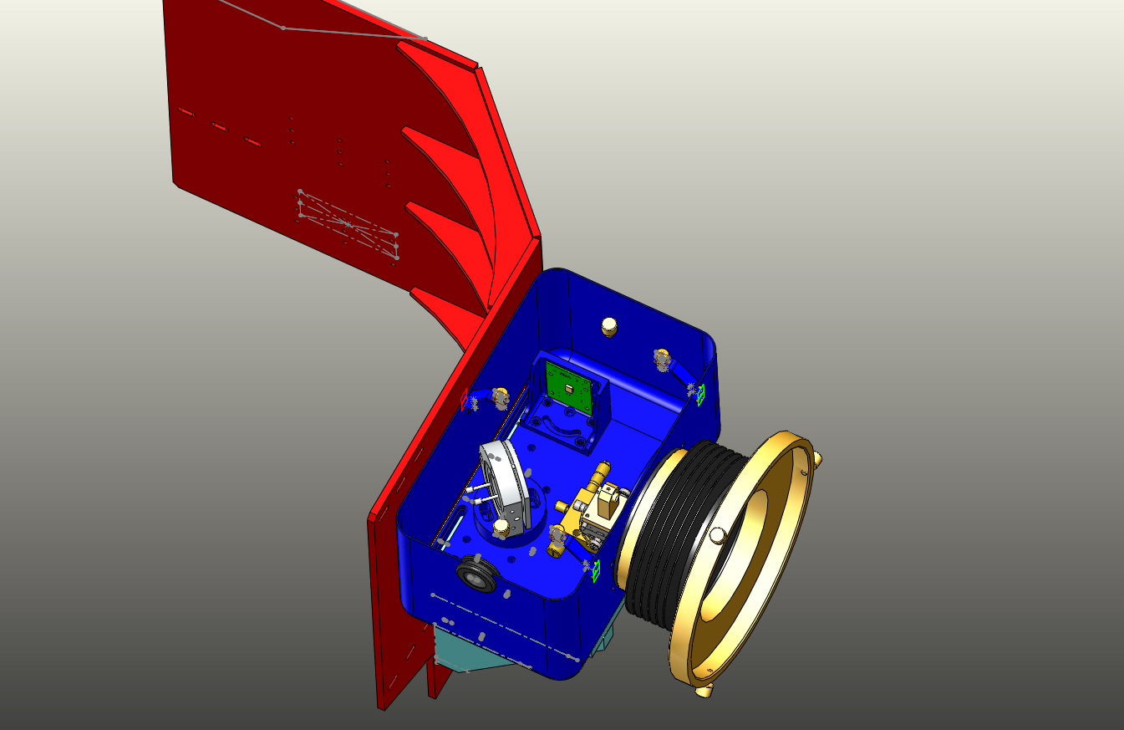

Figure 1: Beam Splitter Transceiver Assembly. Shown with cover removed.

Bill of Material
Item | Part number | Description | Quant.
1 | D1100302 | HEPI Pier Adapter Assembly | 1
2 | D1001627 | TRX Mounting Base | 1
3 | D1001628 | Mirror Base | 1
4 | D1001620 | QPD Bracket | 1
5 | D1100290 | QPD Board Assembly | 1
6 |  | 15-pin M-M Cable, Photodiode Board | 1
7 | KSP-60-C1A-S05 | OptoSigma Rotary Stage | 1
8 | GOHT40A10-MO2 0600-S10 | OptoSigma Goniometer | 1
9 | SL38 | Newport Gimbol Mirror Mount | 1
10 |  | Pico Motors w/Cables | 2
11 | D1102242 | Transmitter Telescope Mount | 1
12 | D0901362-1 | Projection Telescope Assembly, Short | 1
13 | D1200823 | Transceiver Enclosure Assembly | 1
14 | D1200622 | 6-inch Reducer | 1
15 | CT-6 | Gortiflex 6" Rubber Bellows | 1
16 |  | 1/4-20 x 3/4" SHCS | 10
17 |  | 1/4-20 Hex Nuts | 4
18 |  | M3 x 10 SHCS | 4
19 |  | M3 x 6 SHCS | 4
20 |  | #4-40 x 5/8" SHCS | 4
21 |  | 1/4-20 x 3" SHCS | 1
22 |  | 3" Band Clamp | 1
23 | 45945K37 | McMaster -Carr 6" Band Clamp | 2
24 | 92421A540 | McMaster -Carr 1/4-20 Brass Thumb Screw | 3
25 | 9600K62 | McMaster-Carr Rubber Grommet | 1
26 | F12 635S | Fermion Laser w/ 10m fiber | 1
27 | D1200461 | Laser Power Board | 1
28 | D1100013 | Whitening Chassis | 1
29 | D1101248 | Anti-aliasing Chassis | 1
30 |  | 9-pin M-F Cable, Anti-aliasing Chassis | 1
31 |  | BNC M-M Cable, Laser | 1
32
33
34
35

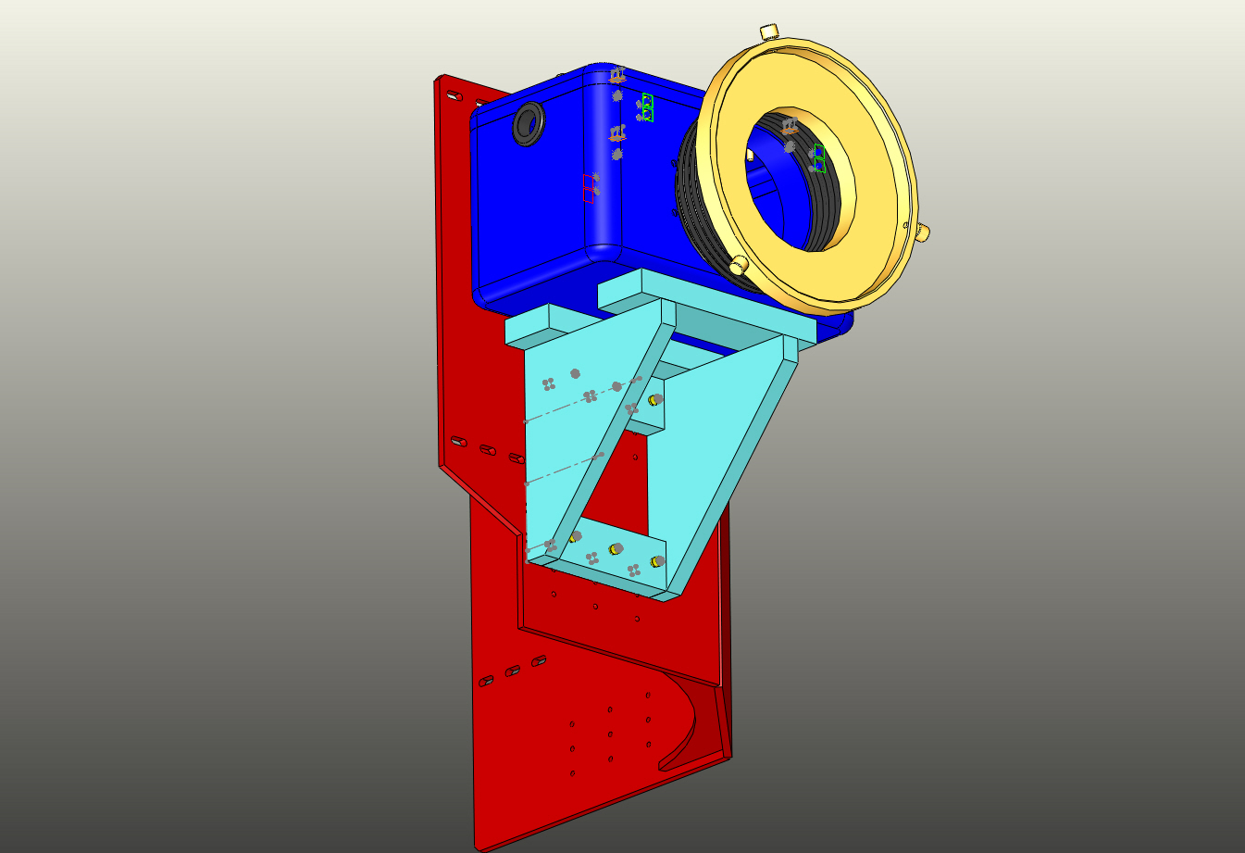
Figure 2: Beam Splitter Transceiver Assembly seen from below

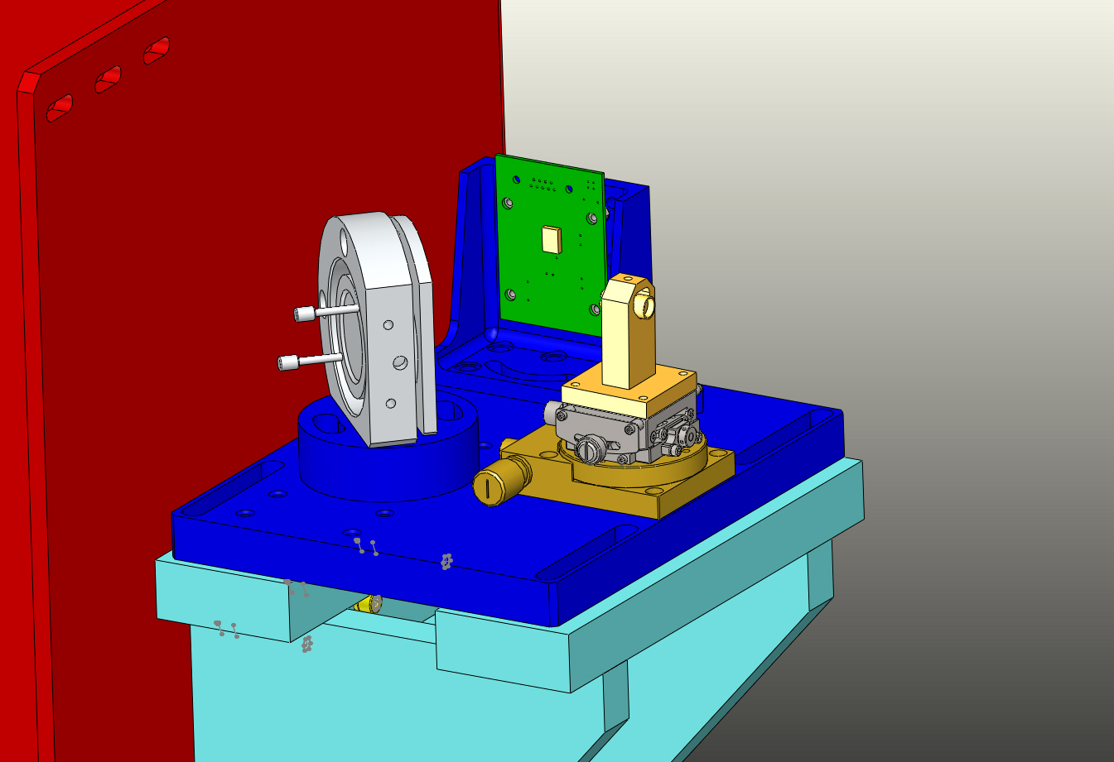
Figure 4: Entire enclosure removed.

