LIGO Laboratory / LIGO Scientific Collaboration

LIGO- E1200416-v2 Advanced LIGO 6/14/2012

TwinCAT Library for Demdodulators

Daniel Sigg

Distribution of this document:
LIGO Scientific Collaboration

This is an internal working note
of the LIGO Laboratory.

California Institute of Technology  LIGO Project – MS 18-34  1200 E. California Blvd.  Pasadena, CA 91125  Phone (626) 395-2129  Fax (626) 304-9834  E-mail: info@ligo.caltech.edu | Massachusetts Institute of Technology  LIGO Project – NW22-295  185 Albany St  Cambridge, MA 02139  Phone (617) 253-4824  Fax (617) 253-7014  E-mail: info@ligo.mit.edu
LIGO Hanford Observatory  P.O. Box 159  Richland WA 99352  Phone 509-372-8106  Fax 509-372-8137 | LIGO Livingston Observatory  P.O. Box 940  Livingston, LA 70754  Phone 225-686-3100  Fax 225-686-7189
http://www.ligo.caltech.edu/

Library
Title | Demodulator
Version | 2
TwinCAT version | 2.11
Name space | Demodulator
Author | Daniel Sigg
Description | Monitors the 4-channel demodulator, D0902796, the 2-channel demodulator, D1000181, and the 2-channel phase-frequency discriminator, D1002476.  Demodulators are used by ISC for length and alignment sensing, whereas phase-frequency demodulators are used for laser locking. Each channels comes with an RF monitor of the LO and the RF inputs. The 2-channel chassis implement an additional power supply monitor, which indicates that the supply voltages are within range. Each channel of the phase-frequency discriminator has a monitor of the sign of the frequency comparison.  The RF detector measures the power off a -20 dB directional coupler. It is a logarithmic device and has the following equation:  LO: $P=-69\text{ dBm}+16.667 \text{dBm}\text{/V}×U$  RF: $P=-72\text{ dBm}+16.667 \text{dBm}\text{/V}×U$  The 4-channel demodulator chassis used for ASC has the LO split between all channels, whereas the LO for the LSC is per channel.
Error codes | 1 – Power supply voltages out-of-range  2 – LO power level out-of-range  3 – RF power level overload  4 – Sign is wrong
Library dependencies | Error

Demodulator Type
TYPE DemodulatorTypeEnum :
(Quad, Single, SingleFast, PhaseFrequency);
END_TYPE
Type name | DemodulatorTypeEnum
Description | Enumerates the different types of available demodulators
Definition | ENUM
Element | Name: Quad  Description: Denotes an ASC quad demodulator chassis used for wavefront sensing
Element | Name: Single  Description: Denotes a single channel of an LSC quad demodulator chassis used for length sensing
Element | Name: SingleFast  Description: Denotes a single channel of a fast LSC dual demodulator chassis used for length sensing
Element | Name: PhaseFrequency  Description: Denotes a single channel of an LSC dual phase-frequency discriminator chassis used for laser locking

Hardware Input Type
TYPE DemodulatorInStruct :
STRUCT
RFMon: INT;
LOMon: INT;
Sign: BOOL;
PowerOk: BOOL;
END_STRUCT
END_TYPE
Type name | DemodulatorInStruct
Description | Structure of the hardware inputs that are wired up for a demodulator channel. The phase-frequency discriminator only uses the sign. The 2-channel chassis share a power ok bit. The power ok bit is reflected in the hardware output structure. The second channel daisy chains its power ok input from the output of the first channel.
Definition | STRUCT
Element | Name: RFMon  Type: INT  Description: Monitors the RF power at the RF input
Element | Name: LOMon  Type: INT  Description: Monitors the RF power at the LO input
Element | Name: Sign  Type: BOOL  Description: Sign of phase-frequency discriminator
Element | Name: PowerOk  Type: BOOL  Description: Voltage monitor readback

Hardware Input Type
TYPE DemodulatorQuadInStruct:
STRUCT
Seg: ARRAY [1..4] OF DemodulatorInStruct;
END_STRUCT
END_TYPE
Type name | DemodulatorQuadInStruct
Description | An array of four DemodulatorInStruct used to describe a four channel demodulator chassis used for wavefront sensing
Definition | STRUCT
Element | Name: Seg  Type: ARRAY [1..4] OF DemodulatorInStruct  Description: Quad array of demodulator channels

Hardware Output Type
TYPE DemodulatorOutStruct :
STRUCT
PowerOk: BOOL;
END_STRUCT
END_TYPE
Type name | DemodulatorOutStruct
Description | Structure of the hardware outputs that are wired up for a demodulator channel. The power ok bit is a simple reflection of the power ok bit at the input. It is used for daisy chaining multiple channels.
Definition | STRUCT
Element | Name: PowerOk  Type: BOOL  Description: Voltage monitor readback

User Interface Type
TYPE DemodulatorLscStruct :
STRUCT
Error: ErrorStruct;
DemodulatorType: DemodulatorTypeEnum;
RFMon: LREAL;
RFMax: LREAL;
LOMon: LREAL;
LONom: LREAL;
Sign: BOOL;
SignNom: BOOL;
PowerOk: BOOL;
END_STRUCT
END_TYPE
Type name | DemodulatorLscStruct
Description | Structure of the user interface tags that are used to control a single channel of a demodulator or a phase-frequency discriminator
Definition | STRUCT
Output Tag | Name: Error  Type: ErrorStruct  Description: For error handler
Output Tag | Name: DemodulatorType  Type: DemodulatorTypeEnum  Description: Demotes the type of demodulator or phase-frequency discriminator channel
Output Tag | Name: RFMon  Type: LREAL  Description: Monitors the RF power at the RF input in dBm
Input Tag | Name: RFMax  Type: LREAL  Description: Maximum value for the RF power at the RF input in dBm
Output Tag | Name: LOMon  Type: LREAL  Description: Monitors the RF power at the LO input in dBm
Input Tag | Name: LONom  Type: LREAL  Description: Nominal value for the RF power at the LO input in dBm
Output Tag | Name: Sign  Type: BOOL  Description: Monitors the sign of a phase-frequency discriminator
Input Tag | Name: SignNom  Type: LREAL  Description: Nominal value for the sign of a phase-frequency discriminator
Output Tag | Name: PowerOk  Type: BOOL  Description: Voltage monitor readback

User Interface Type
TYPE DemodulatorAscStruct :
STRUCT
Error: ErrorStruct;
RFMon: ARRAY [1..4] OF LREAL;
RFMax: LREAL;
LOMonChannel: ARRAY [1..4] OF LREAL;
LOMon: LREAL;
LONom: LREAL;
END_STRUCT
END_TYPE
Type name | DemodulatorAscStruct
Description | Structure of the user interface tags that are used to control a four channel demodulator chassis used for wavefront sensing
Definition | STRUCT
Output Tag | Name: Error  Type: ErrorStruct  Description: For error handler
Output Tag | Name: RFMon  Type: ARRAY [1..4] OF LREAL  Description: Monitors the RF power at each RF input in dBm
Input Tag | Name: RFMax  Type: LREAL  Description: Maximum value for the RF power at the RF inputs in dBm
Output Tag | Name: LOMonChannel  Type: LREAL  Description: RF power at each of the LO inputs in dBm
Output Tag | Name: LOMon  Type: LREAL  Description: RF power at the LO input in dBm (sum of all channels)
Input Tag | Name: LONom  Type: LREAL  Description: Nominal value for the RF power at the LO input in dBm

Function Block
FUNCTION_BLOCK DemodulatorLscFB
VAR_INPUT
DemdulatorType: DemodulatorTypeEnum;
DemdulatorIn: DemdulatorInStruct;
END_VAR
VAR_OUTPUT
DemdulatorOut: DemdulatorOutStruct;
END_VAR
VAR_IN_OUT
DemdulatorLsc: DemdulatorLscStruct;
END_VAR
VAR
END_VAR
Name | DemodulatorLscFB
Description | Controls a single channel of a demodulator or phase-frequency discriminator chassis. One function block for each demodulator channel needs to be instantiated.
Input argument | Name: DemdulatorType  Type: DemodulatorTypeEnum  Description: Defines the used demodulator chassis
Input argument | Name: DemdulatorIn  Type: DemdulatorInStruct  Description: Input hardware structure
Output argument | Name: DemdulatorOut  Type: DemdulatorOutStruct  Description: Output hardware structure
In/out argument | Name: DemdulatorLsc  Type: DemdulatorLscStruct  Description: User Interface structure

Function Block
FUNCTION_BLOCK DemodulatorAscFB
VAR_INPUT
DemdulatorIn: DemodulatorQuadInArray;
END_VAR
VAR_IN_OUT
DemdulatorAsc: DemdulatorAscStruct;
END_VAR
VAR
END_VAR
Name | DemodulatorAscFB
Description | Controls a quad channel demodulator chassis. One function block for each ASC demodulator chassis needs to be instantiated.
Input argument | Name: DemdulatorIn  Type: DemodulatorQuadInStruct  Description: Input hardware structure
In/out argument | Name: DemdulatorAsc  Type: DemdulatorAscStruct  Description: User Interface structure

Visual
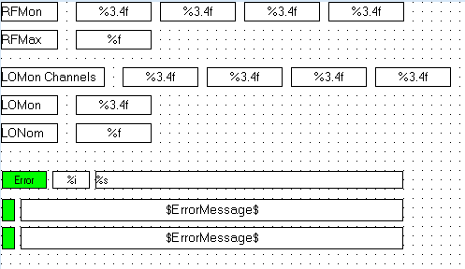
Name | DemodulatorAscVis
Description | Displays RF Max and Mon, LO Mon and Nom, power status, sign status, and error status
Placeholder | Name: DemodulatorAsc  Type: DemodulatorAscStruct  Description: Asc Demodulator structure

Visual
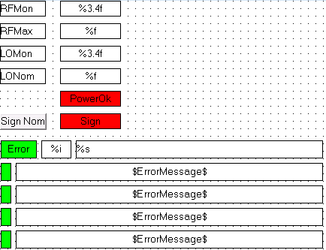
Name | DemodulatorLscPhaseFrequencyVis
Description | Displays RF Max and Mon, LO Mon and Nom, power status, sign status, and error status
Placeholder | Name: DemodulatorLsc  Type: DemodulatorLscStruct  Description: Phase frequency Lsc Demodulator structure

Visual
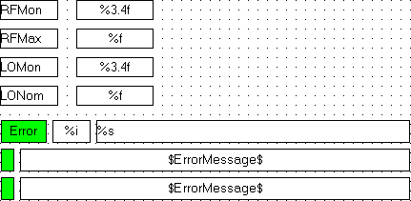
Name | DemodulatorLscQuadVis
Description | Displays RF Max and Mon, LO Mon and Nom, and error status
Placeholder | Name: DemodulatorLsc  Type: DemodulatorLscStruct  Description: Quad Lsc Demodulator structure

Visual
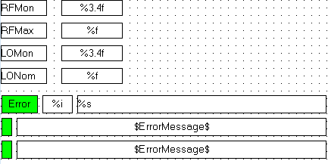
Name | DemodulatorLscSingleVis
Description | Displays RF Max and Mon, LO Mon and Nom, and error status
Placeholder | Name: DemodulatorLsc  Type: DemodulatorLscStruct  Description: Single Lsc Demodulator structure

Visual
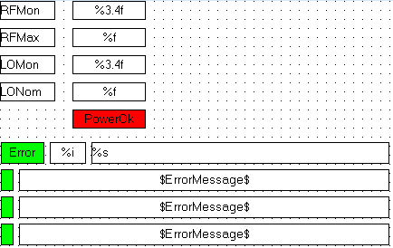
Name | DemodulatorLscSingleFastVis
Description | Displays RF Max and Mon, LO Mon and Nom, power status, and error status
Placeholder | Name: DemodulatorLsc  Type: DemodulatorLscStruct  Description: Single Fast Lsc Demodulator structure

