LIGO Laboratory / LIGO Scientific Collaboration

LIGO- E1200506 LIGO Jan 23rd, 2013

aLIGO HAM-ISI, Installation Test Report, Phase II
Chamber-Side Testing & Initial Chamber Testing
LHO HAM2-ISI (Unit #4)
E1200506-V4

Hugo Paris, Fabrice Matichard, Brian Lantz, Hugh Radkins, Jim Warner, Corey Gray

Distribution of this document:
Advanced LIGO Project

This is an internal working note
of the LIGO Laboratory

California Institute of Technology  LIGO Project – MS 18-34  1200 E. California Blvd.  Pasadena, CA 91125  Phone (626) 395-2129  Fax (626) 304-9834  E-mail: info@ligo.caltech.edu | Massachusetts Institute of Technology  LIGO Project – NW22-295  185 Albany St  Cambridge, MA 02139  Phone (617) 253-4824  Fax (617) 253-7014  E-mail: info@ligo.mit.edu
LIGO Hanford Observatory  P.O. Box 1970  Mail Stop S9-02  Richland WA 99352  Phone 509-372-8106  Fax 509-372-8137 | LIGO Livingston Observatory  P.O. Box 940  Livingston, LA 70754  Phone 225-686-3100  Fax 225-686-7189

Table of contents:

Chamber-Side Testing 4
▪ Test 1 - CPS Check 5
▪ Test 2.1 – CPS noise spectra 6
▪ Test 2.2 – GS13 Spectra 10
Conclusion 14
Initial Chamber Testing 15
▪ Step 1: Cables Inventory 16
▪ Step 2: Level of Stage 1 16
▪ Step 3: Mass Budget 17
▪ Step 4: Shim Thickness 17
▪ Step 5: Blade Spring Profile 18
▪ Step 6: Lockers Adjustment 19
▪ Step 7: CPS Gap 19
▪ Step 8: CPS and GS13 Spectra - ISI Unlocked 20
▪ Step 9: GS13 ASD - Tabled Tilted 22
▪ Step 10: GS13 pressure readout 23
▪ Step 11: Actuators Sign and range of motion (Local drive) 23
▪ Step 12: Static Testing (Tests in the local basis) 24
▪ Step 13: Linearity test 25
▪ Step 14: Frequency response 27
▪ Step 14.1: Local to local measurements 27
▪ Step 14.2: Local to local measurements V.S. LLO 29
▪ Step 15: Pre-Commissioning 32
Conclusion 34

PHASE II Testing

The phase II of HAM-ISI testing corresponds to the tests performed after the Assembly Validation, and before the Control and Commissioning of the Units. It is divided in two parts. The present document is divided in two sections: One for each part of the Phase II testing:

Part.1 Chamber-Side testing
Part.2 Initial Chamber Testing
Part.3 Final Chamber Testing

Chamber-Side Testing is a basic sensor check with a spectrum analyzer. Units can be inserted in their chamber of destination once they pass.

Initial Chamber Testing takes place in open chamber, with the optics off, and HEPI locked. The ISI is then connected to the electronic rack with the final in-field cables. Models are installed and running. Tests are performed with Matlab® scripts.

Optics and Suspensions can be installed right after the end of this phase of testing. No test is performed during their installation.

Final Chamber Testing starts once Optics and Suspensions are installed. The lockers and the CPSs usually need to be reset at this point.

Introduction
Chamber-Side Testing

HAM-ISI Unit #4 is intended to populate HAM2 chamber. The tests presented here were performed between May 11th and May 16th, in accordance to the second version of the Pre-Integration Chamber-Side Testing procedure (E1200513-v2).

Additional tests were performed on the CPSs on May 29th 2012. They revealed the need to ground the ADE boxes to the test stand (LHO aLog #2972).

At the beginning of the Chamber-Side Testing:
- Assembly validation testing has been performed on the ISI
- Phase I test report was validated (E1000314)
- The ISI was stored in a container, moved from the staging building to the LVEA, and installed under a clean room in the LVEA, on its container’s base
- The container is sitting on lab-jacks to allow level adjustments without unlocking the ISI
- The Unit is equipped with production GS13s
- The optical table is not loaded with masses yet
- The ISI is locked

The goal of the Chamber-Side Testing is to ensure that the sensors and their electronics (ADE boxes of the CPSs) did not alter during storage/transportation.

At the end of the Chamber-Side Testing:
- All sensors have been checked
- Data related to the tests is available on the SVN
- The HAM-ISI is on the chamber-side, ready for the in-chamber insertion

Test 1 - CPS Check
During this step, we want to make sure that the CPSs, their cables and their electronics are functional.

Corner | Direction | Voltage | Sensor reacts to shim insertion
 |  | (No shim)
1 | H | 1.169 | X
 | V | 0.359 | X
2 | H | -0.32 | X
 | V | 3.159 | X
3 | H | -2.09 | X
 | V | 3.934 | X
Table – CPS Check

Issues/difficulties/comments regarding this test:
- ADE boxes were connected to the same power supply
- ADE boxes must share the same ground.
- ADE boxes must be grounded to the test stand
- Not having the ADE boxes grounded to the test stand causes the CPS readouts to vary with the number of probes that are connected to the ADE boxes (LHO aLog #2972).

Acceptance Criteria:
- All CPS were tested
- All CPS react to shim insertion
- The voltages recorded with no shim are within ⁺/-5V.

Test result: Passed: X Failed: .

Test 2.1 – CPS noise spectra
During this step, we want measure the noise spectra of the CPSs and make sure that it is not too high.

A spectrum analyzer is used. The maximum number of points available for the FFT (800) limits the frequency resolution. Measurements are performed in two sections that are combined afterwards to allow getting good resolution in low frequency. Sections overlap to allow checking for potential mismatch.

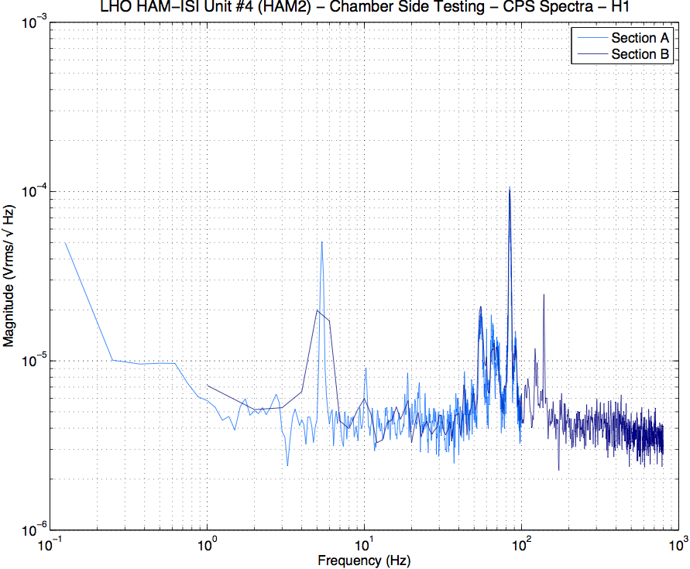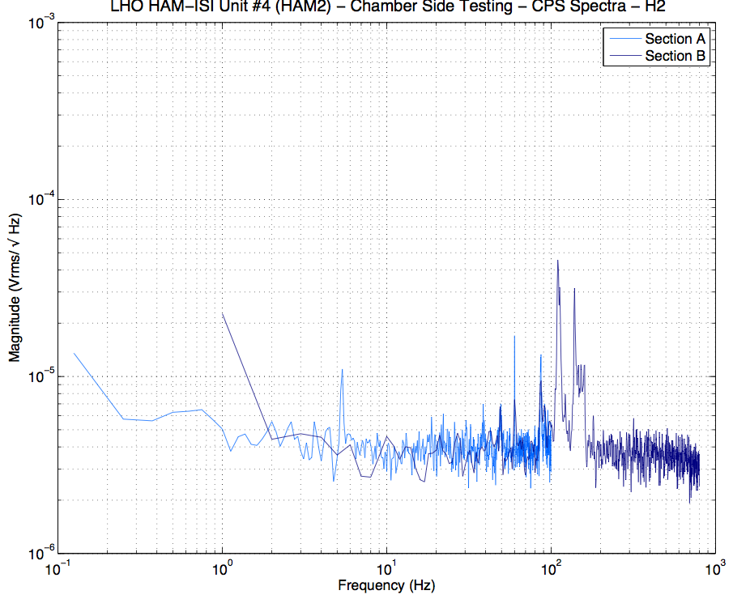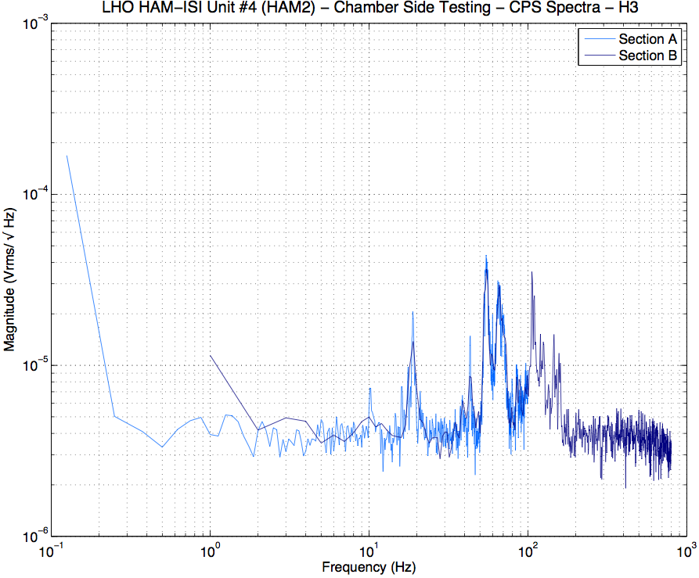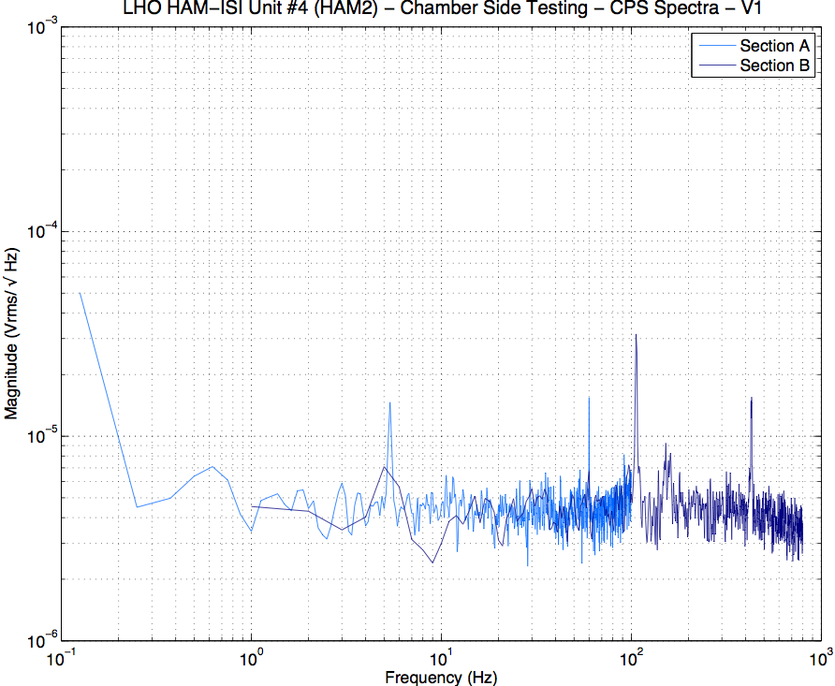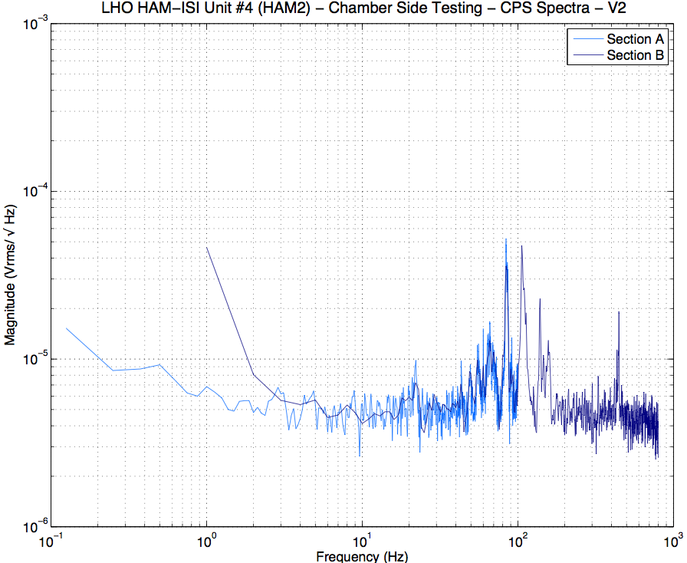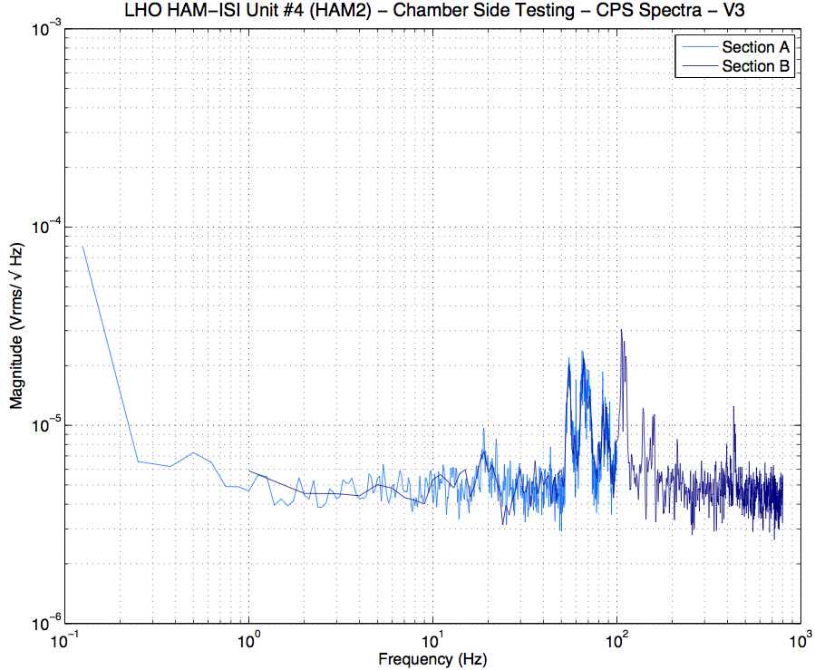
Figure – CPS Spectra - Section Check

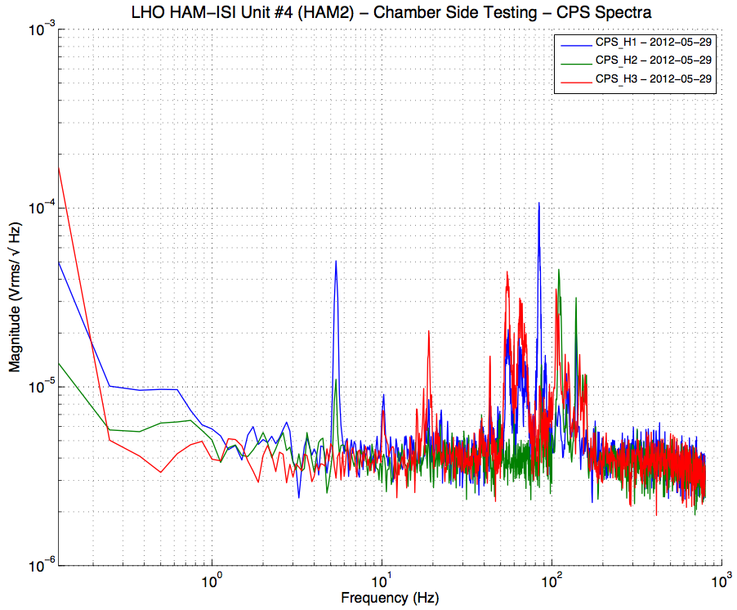
Figure – Horizontal CPSs spectra

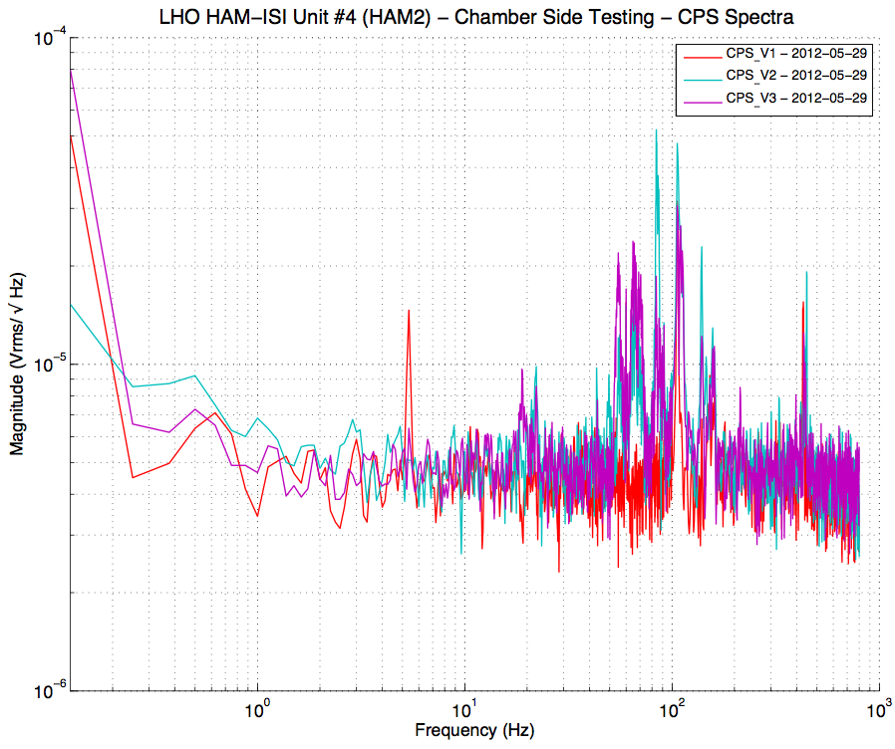
Figure – Vertical CPSs Spectra
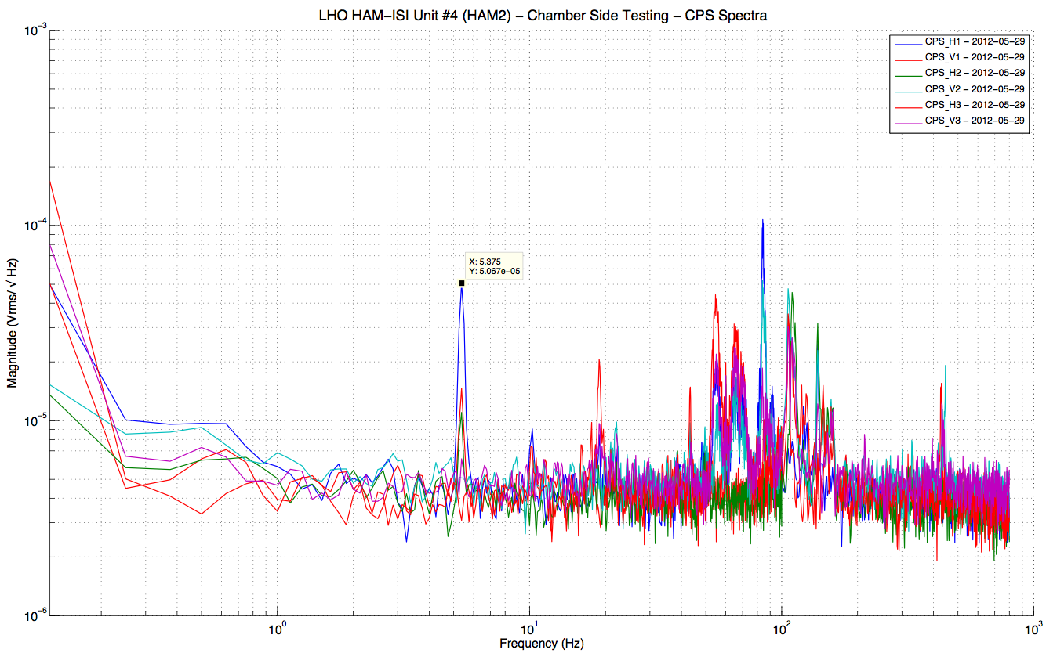
Figure – All CPSs Spectra

Data in the SVN at:
/SeiSVN/seismic/HAM-ISI/H1/HAM2/Data/Spectra/Chamber_Side/
SEI-HAM_ISI_Unit_4_Chamber_Side_Locked__-CPS__Corner_1-Section_A-2012-05-29.214020.txt
SEI-HAM_ISI_Unit_4_Chamber_Side_Locked__-CPS__Corner_1-Section_B-2012-05-29.214344.txt
SEI-HAM_ISI_Unit_4_Chamber_Side_Locked__-CPS__Corner_2-Section_A-2012-05-29.215421.txt
SEI-HAM_ISI_Unit_4_Chamber_Side_Locked__-CPS__Corner_2-Section_B-2012-05-29.215154.txt
SEI-HAM_ISI_Unit_4_Chamber_Side_Locked__-CPS__Corner_3-Section_A-2012-05-29.220122.txt
SEI-HAM_ISI_Unit_4_Chamber_Side_Locked__-CPS__Corner_3-Section_B-2012-05-29.220623.txt

Sections Check plots in the SVN at
/SeiSVN/seismic/HAM-ISI/H1/HAM2/Figures/Spectra/Chamber_Side/Sections_Check/
HAM_ISI_Unit_4_ASD_Volts_SECTION_CHECK_CPS__H1_ISI_Chamber_Side_Locked__2012_05_29.fig
HAM_ISI_Unit_4_ASD_Volts_SECTION_CHECK_CPS__H2_ISI_Chamber_Side_Locked__2012_05_29.fig
HAM_ISI_Unit_4_ASD_Volts_SECTION_CHECK_CPS__H3_ISI_Chamber_Side_Locked__2012_05_29.fig
HAM_ISI_Unit_4_ASD_Volts_SECTION_CHECK_CPS__V1_ISI_Chamber_Side_Locked__2012_05_29.fig
HAM_ISI_Unit_4_ASD_Volts_SECTION_CHECK_CPS__V2_ISI_Chamber_Side_Locked__2012_05_29.fig
HAM_ISI_Unit_4_ASD_Volts_SECTION_CHECK_CPS__V3_ISI_Chamber_Side_Locked__2012_05_29.fig

Sections Combined plots in the SVN at:
/SeiSVN/seismic/HAM-ISI/H1/HAM2/Figures/Spectra/Chamber_Side/Sections_Combined/
HAM_ISI_Unit_4_ASD_Volts_CPS__H_ISI_Chamber_Side_Locked___2012_05_29.fig
HAM_ISI_Unit_4_ASD_Volts_CPS__ISI_Chamber_Side_Locked___2012_05_29.fig
HAM_ISI_Unit_4_ASD_Volts_CPS__V_ISI_Chamber_Side_Locked___2012_05_29.fig

Programs to run the sr785 from a laptop under the SVN at:
/SeiSVN/seismic/HAM-ISI/H1/HAM2/Scripts/Chamber_Side/sr785_Programs/

Testing Scripts under the SVN at:
/SeiSVN/seismic/HAM-ISI/H1/HAM2/Scripts/Chamber_Side/Testing_Scripts /

Issues/difficulties/comments regarding this test:
- H1, V1 and H2 spectra feature a narrow peak at 5.375Hz.
- This peak is also noticeable on the spectra taken two weeks earlier, with the GS13s:
  - It is recorded at the same locations: H1, V1, and H2 (see below, and p.9)
  - It is recorded with very similar proportions: H1 is the most affected.
  - Even if the frequency it is observed at varied between the two measurements (5.25Hz vs 5.375Hz), it is very similar.
- Seeing this peak at the same locations, and at almost the same frequency, on two measurements taken 15 days apart from each other, with a different set of sensors/electronics, shows us that this peak is not caused by a malfunctioning of the sensor(s) and/or the electronics, and reveals that this peak is related to real motion.
- Measurements were performed in the LVEA, during the day, which is a noisy environment.

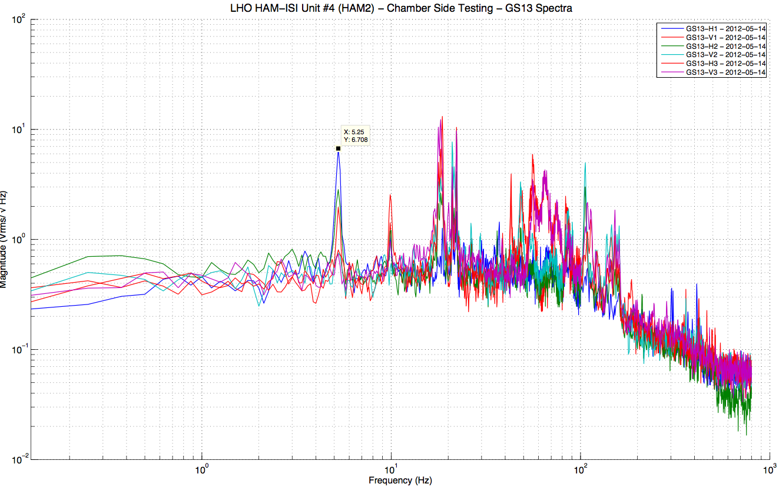
figure - GS13 spectra measured an May 14th 2012

Acceptance Criteria:
- Sections Match together
- CPS noise spectra must be below 10⁻⁴Vrms/√Hz
- Plots of Spectra are saved under the SVN

Test result: Passed: X Failed: .

Test 2.2 – GS13 Spectra
During this test we want to take spectra of the GS13s to make sure that they are still functional.

A spectrum analyzer is used. The maximum number of points available for the FFT (800) limits the frequency resolution. Measurements are performed in two sections that are combined afterwards to allow getting good resolution in low frequency. Sections overlap to allow checking for potential mismatch.

\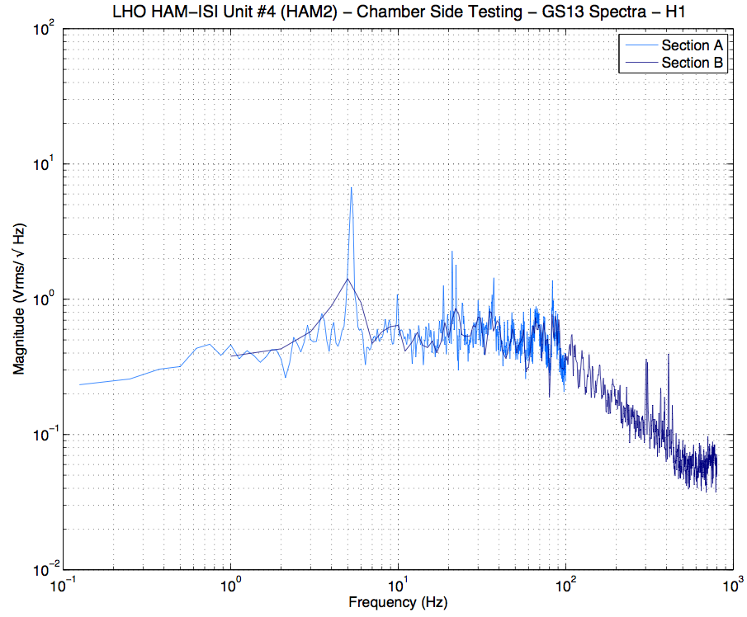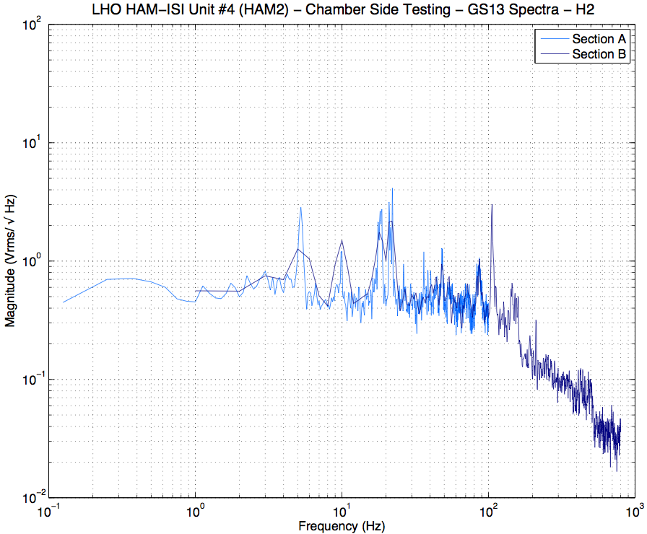 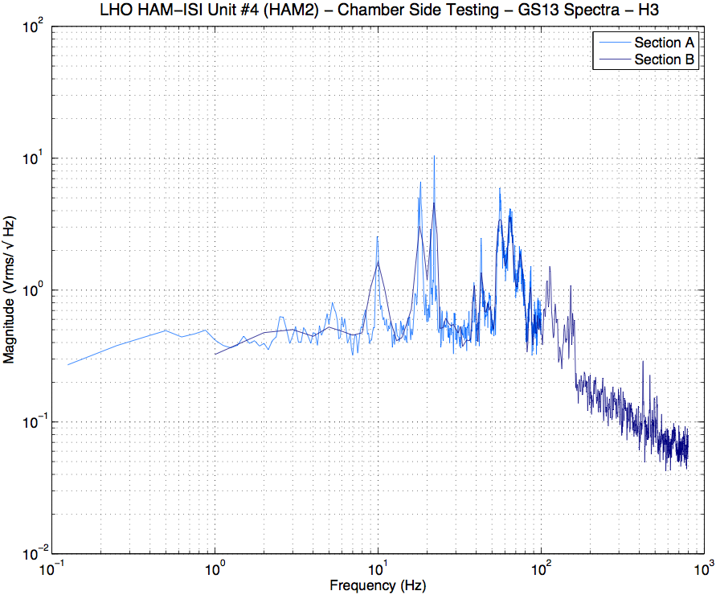 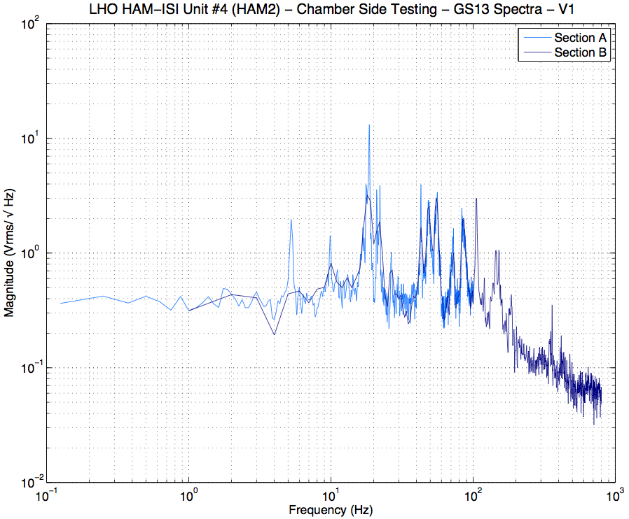 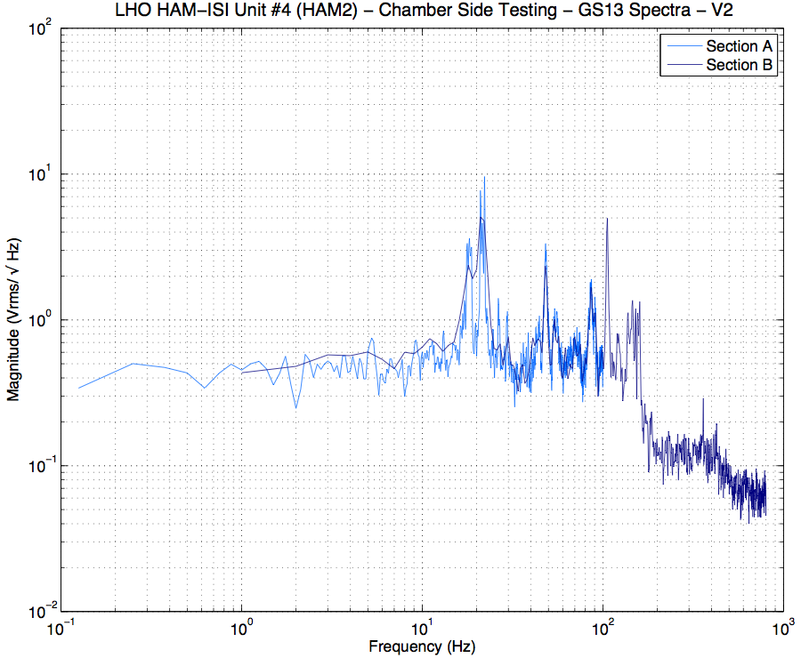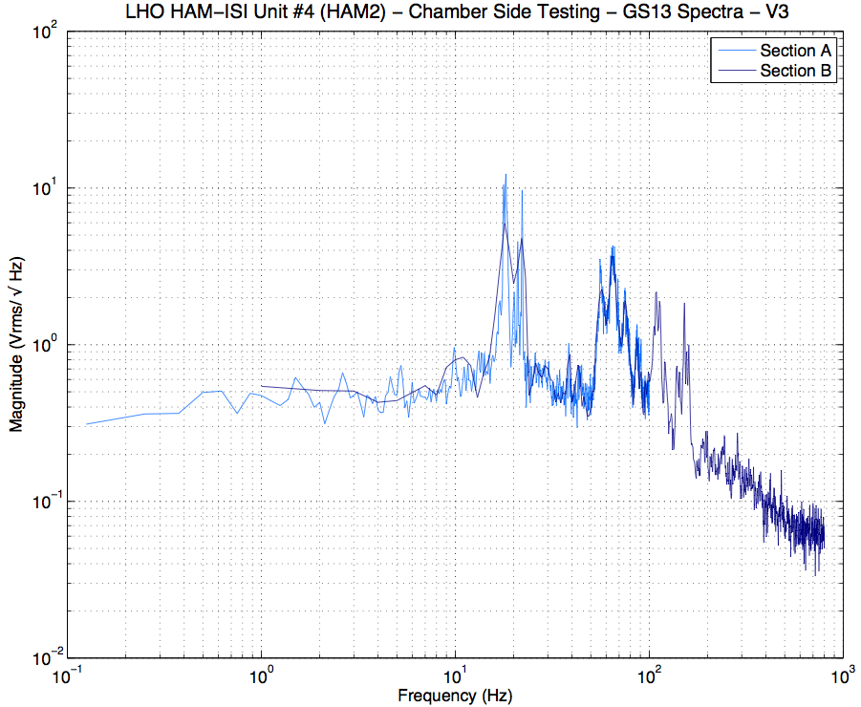
Figure – GS13 Spectra- Section Check

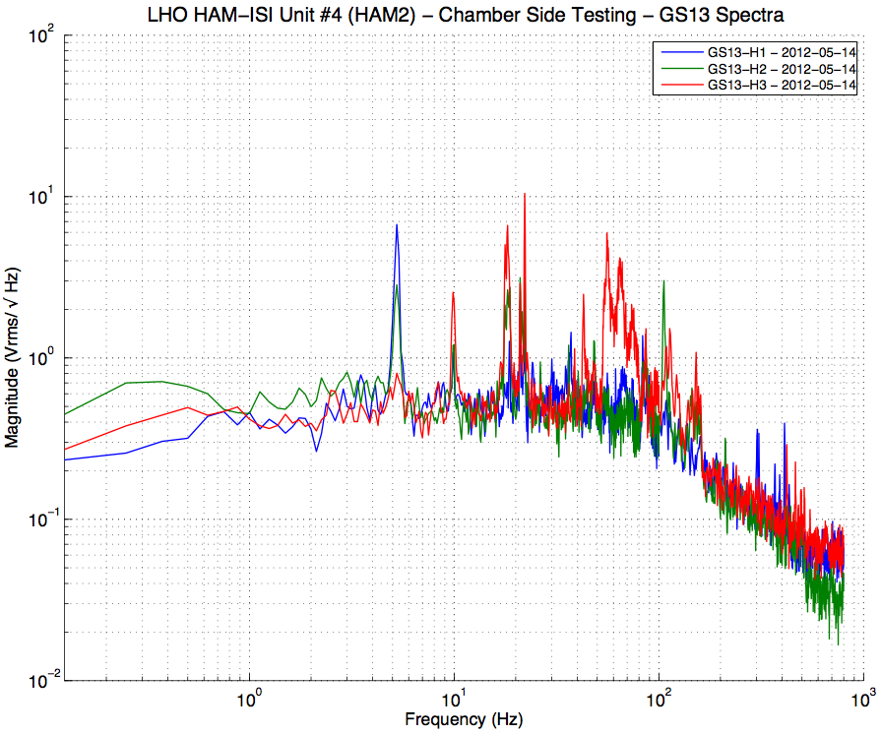
Figure – Horizontal GS13s Spectra

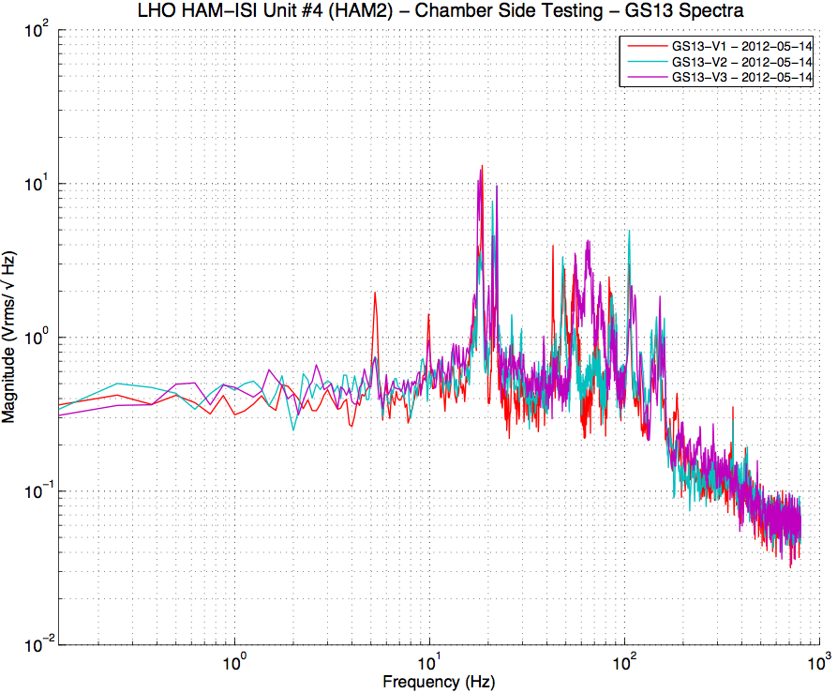
Figure – Vertical GS13s Spectra

Figure – Horizontal and Vertical GS13s Spectra

Data in the SVN at:
/SeiSVN/seismic/HAM-ISI/H1/HAM2/Data/Spectra/Chamber_Side/
SEI-HAM_ISI_Unit_4_Chamber_Side_Locked__-GS13_Corner_1-Section_A-2012-05-14.224516.txt
SEI-HAM_ISI_Unit_4_Chamber_Side_Locked__-GS13_Corner_1-Section_B-2012-05-14.224342.txt
SEI-HAM_ISI_Unit_4_Chamber_Side_Locked__-GS13_Corner_2-Section_A-2012-05-14.225614.txt
SEI-HAM_ISI_Unit_4_Chamber_Side_Locked__-GS13_Corner_2-Section_B-2012-05-14.225910.txt
SEI-HAM_ISI_Unit_4_Chamber_Side_Locked__-GS13_Corner_3-Section_A-2012-05-14.230655.txt
SEI-HAM_ISI_Unit_4_Chamber_Side_Locked__-GS13_Corner_3-Section_B-2012-05-14.230957.txt

Sections Check plots in the SVN at
/SeiSVN/seismic/HAM-ISI/H1/HAM2/Figures/Spectra/Chamber_Side/Sections_Check/
HAM_ISI_Unit_4_ASD_Volts_SECTION_CHECK_GS13_H1_ISI_Chamber_Side_Locked__2012_05_14.fig
HAM_ISI_Unit_4_ASD_Volts_SECTION_CHECK_GS13_H2_ISI_Chamber_Side_Locked__2012_05_14.fig
HAM_ISI_Unit_4_ASD_Volts_SECTION_CHECK_GS13_H3_ISI_Chamber_Side_Locked__2012_05_14.fig
HAM_ISI_Unit_4_ASD_Volts_SECTION_CHECK_GS13_V1_ISI_Chamber_Side_Locked__2012_05_14.fig
HAM_ISI_Unit_4_ASD_Volts_SECTION_CHECK_GS13_V2_ISI_Chamber_Side_Locked__2012_05_14.fig
HAM_ISI_Unit_4_ASD_Volts_SECTION_CHECK_GS13_V3_ISI_Chamber_Side_Locked__2012_05_14.fig

Sections Combined plots in the SVN at:
/SeiSVN/seismic/HAM-ISI/H1/HAM2/Figures/Spectra/Chamber_Side/Sections_Combined/
HAM_ISI_Unit_4_ASD_Volts_GS13_H_ISI_Chamber_Side_Locked___2012_05_14.fig
HAM_ISI_Unit_4_ASD_Volts_GS13_ISI_Chamber_Side_Locked___2012_05_14.fig
HAM_ISI_Unit_4_ASD_Volts_GS13_V_ISI_Chamber_Side_Locked___2012_05_14.fig
Programs to run the sr785 from a laptop under the SVN at:
/SeiSVN/seismic/HAM-ISI/H1/HAM2/Scripts/Chamber_Side/sr785_Programs/

Testing Scripts under the SVN at:
/SeiSVN/seismic/HAM-ISI/H1/HAM2/Scripts/Chamber_Side/Testing_Scripts /

Issues/difficulties/comments regarding this test:
- H1, V1 and H2 spectra feature a narrow peak at 5.25Hz.
- This peak was associated to real motion. See comments p.9 for more details.
- Measurements were performed in the LVEA, during the day, which is a noisy environment.

Acceptance Criteria:
- Sections Match together
- GS13s responses must not drop in low frequency
- Plots of powerspectra are saved under the SVN

Test result: Passed: X Failed: .

Conclusion
Chamber-Side Testing

HAM-ISI Unit #4 is intended to populate HAM2 chamber. The tests presented here were performed between May 11th and May 16th, in accordance to the second version of the Pre-Integration Chamber-Side Testing procedure (E1200513-v2).

Additional tests were performed on the CPS on May 29th 2012. They revealed the need to ground the ADE boxes to the test stand (LHO aLog #2972).

All sensors appeared to be functional.

Introduction
Initial Chamber Testing

This part of the Phase II testing was performed during the last 2 weeks of August 2012. It took place in open chamber, with the optics off, and HEPI locked. The ISI was then connected to the electronic rack with the final in-field cables. Models were installed. Tests were performed with the seismic Matlab® scripts.

Optics and Suspensions can be installed right after the end of this phase of testing. No test is performed during their installation.

Final Chamber Testing starts once Optics and Suspensions are installed. The lockers and the CPSs usually need to be reset at this point.

Step 1: Cables Inventory

Cable Connects |  | Cable S/N
Part Name | Configuration | Corner 1 | Corner 2 | Corner 3
GS13 | Horizontal | S1104678– 36” | S1106657 | S1104775
 | Vertical
L4C | Horizontal | NA | NA | NA
 | Vertical | NA | NA | NA
Actuator | Horizontal | S1104758 – 95” | S1104757 -95” | S1104770-95”
 | Vertical | S1104102 – 70” | S1104764 – 95” | S1104759 – 95”
Table – Cables inventory
NA: Not applicable

Issues/difficulties/comments regarding this test:
Some cables were changed since Assembly Validation.

Test result: Passed: X Failed: .

Step 2: Level of Stage 1

NE | SE | SW | NW | Notes
-2 | -5 | +5 | +2 | Stage-0: 0.001”
See LHO aLog #4478
The biggest difference measured between two corners was 7mils.

Max angle = 0.007” / 76” = 92 µrad

Issues/difficulties/comments regarding this test:
Measurement should be performed again once payload changes.

Acceptance Criteria
- The maximum angle of the table with the horizontal mustn’t exceed ~100µrad

Test result: Passed: X Failed: .

Step 3: Mass Budget
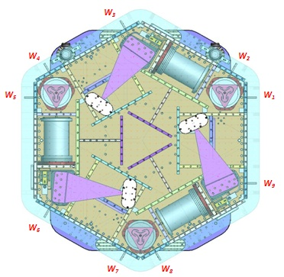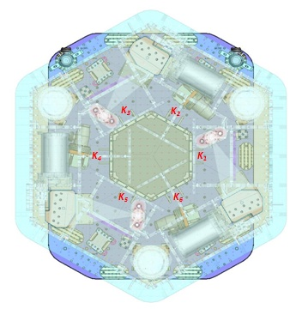
Figure – Wall Masses (W) and Keel masses (K) location. South of picture = corner 1

Issues/difficulties/comments regarding this test:
The payload will change a lot with the installation of suspensions. Mass budget was postponed to final in-chamber testing.

Acceptance Criteria
The Mass budget must be
- 579.1 Kg (cf. E1100427)+/-25Kg (5%)

Test result: Passed: Postponed: X .

Step 4: Shim Thickness

Issues/difficulties/comments regarding this test:
Unchanged from assembly validation.

Test result: Passed: X Failed: .

Step 5: Blade Spring Profile

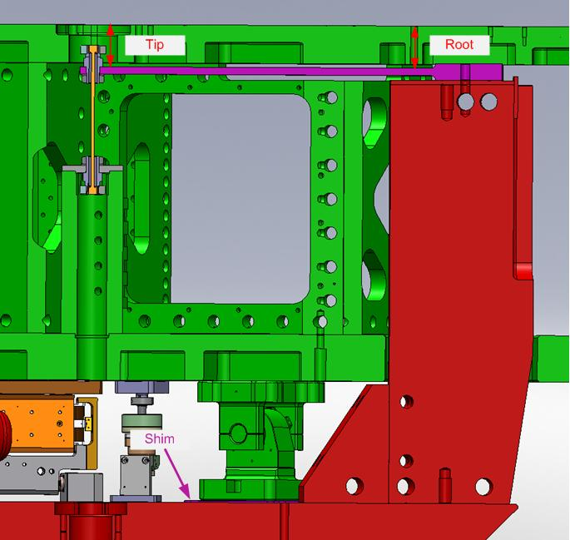
figure – Blade spring profile measurement points

Blade # | Root (Mils) | Tip(Mils) | Flatness (mils)
1
2
3
Table – Blade Spring Profile

Issues/difficulties/comments regarding this test:
Postponed to final in chamber testing.
Acceptance Criteria:
- Recorded for traceability.
- Flatness preferred within 0.015" inches.

Test result: Passed: Postponed: X .

Step 6: Lockers Adjustment

The maximum difference recorded on the CPSs between the unlocked and the locked positions is out of the preferred ⁺/₋1600cts range.
It is however good enough for this phase of testing. Lockers and CPS Gaps will be set up prior to the Final In-Chamber Testing.

Acceptance criteria:
- Recorded for traceability
- Preferred within ⁺/₋1600cts

Test result: Passed: Postponed: X .
.

Step 7: CPS Gap

CPS mean readouts are out of the preferred ⁺/₋400cts range.
It is however good enough for this phase of testing. Lockers and CPS Gaps will be set up prior to the Final In-Chamber Testing.

Acceptance criteria:
- Recorded for traceability
- Preferred within ⁺/₋400cts

Test result: Passed: Postponed: X .

Step 8: CPS and GS13 Spectra - ISI Unlocked

Data files in SVN at:
/seismic/HAM-ISI/H1/HAM2/Data/Spectra/Undamped/
- LHO_ISI_HAM2_ASD_m_CPS_T240_L4C_GS13_Locked_vs_Unlocked_2012_08_27.mat

Scripts files for taking and processing the data, and plotting it in SVN at:
seismic/HAM-ISI/Common/Testing_Functions_HAM_ISI/
- Plot_ASD_Unlocked_Locked_HAM_ISI.m
- Plot_ASD_Unlocked_Locked_Group_HAM_ISI.m

Figures in SVN at:
seismic/HAM-ISI/H1/HAM2/Data/Figures/Spectra/Undamped/
- LHO_ISI_HAM3_ASD_m_GS13_Requirements_Locked_vs_Unlocked_2012_08_27.fig
- LHO_ISI_HAM3_ASD_m_CPS_Requirements_Locked_vs_Unlocked_2012_08_27.fig

CPS calibration:
The CPS power spectrums are calibrated by using a sensitivity of 30.2 nm/count.

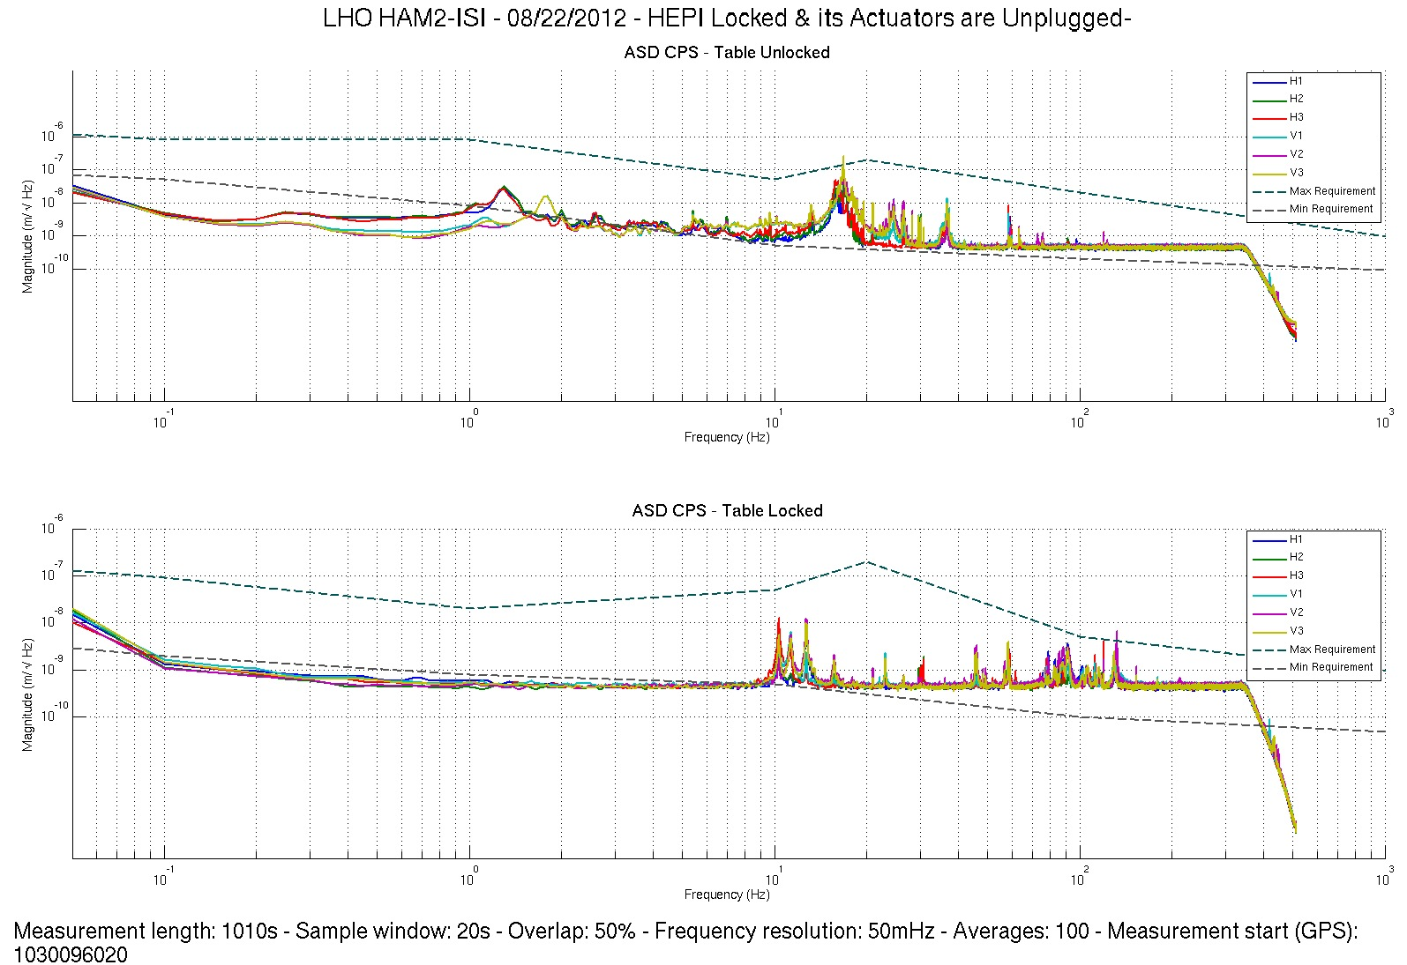 Figure - Calibrated CPS power spectrum – ISI Unlocked/Locked

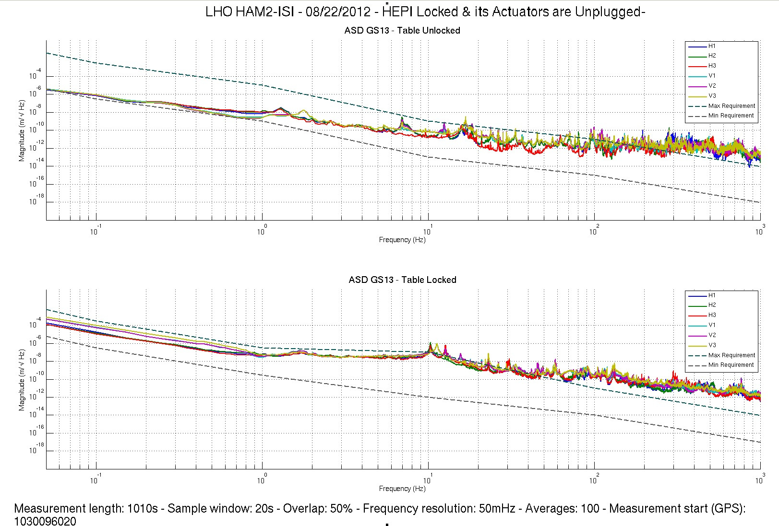
Figure – Power spectrum Calibrated GS13 – ISI Unlocked/Locked

Acceptance criteria:
- No cross talk (peaks at low frequencies + harmonics on measurements)
- Magnitudes of power spectra must be between requirement curves

Test result: Passed: X Failed: .

Note:
- When a seismometer fails, its low frequency response is affected. Spectra are within requirements in low frequency. The GS13s installed on this unit are functional.
- GS13 requirement curves need to be updated.

Step 9: GS13 ASD - Tabled Tilted

The figure below presents the GS13 power spectrum when the table is unlocked and loaded with a 10Kg mass at each of its corner.

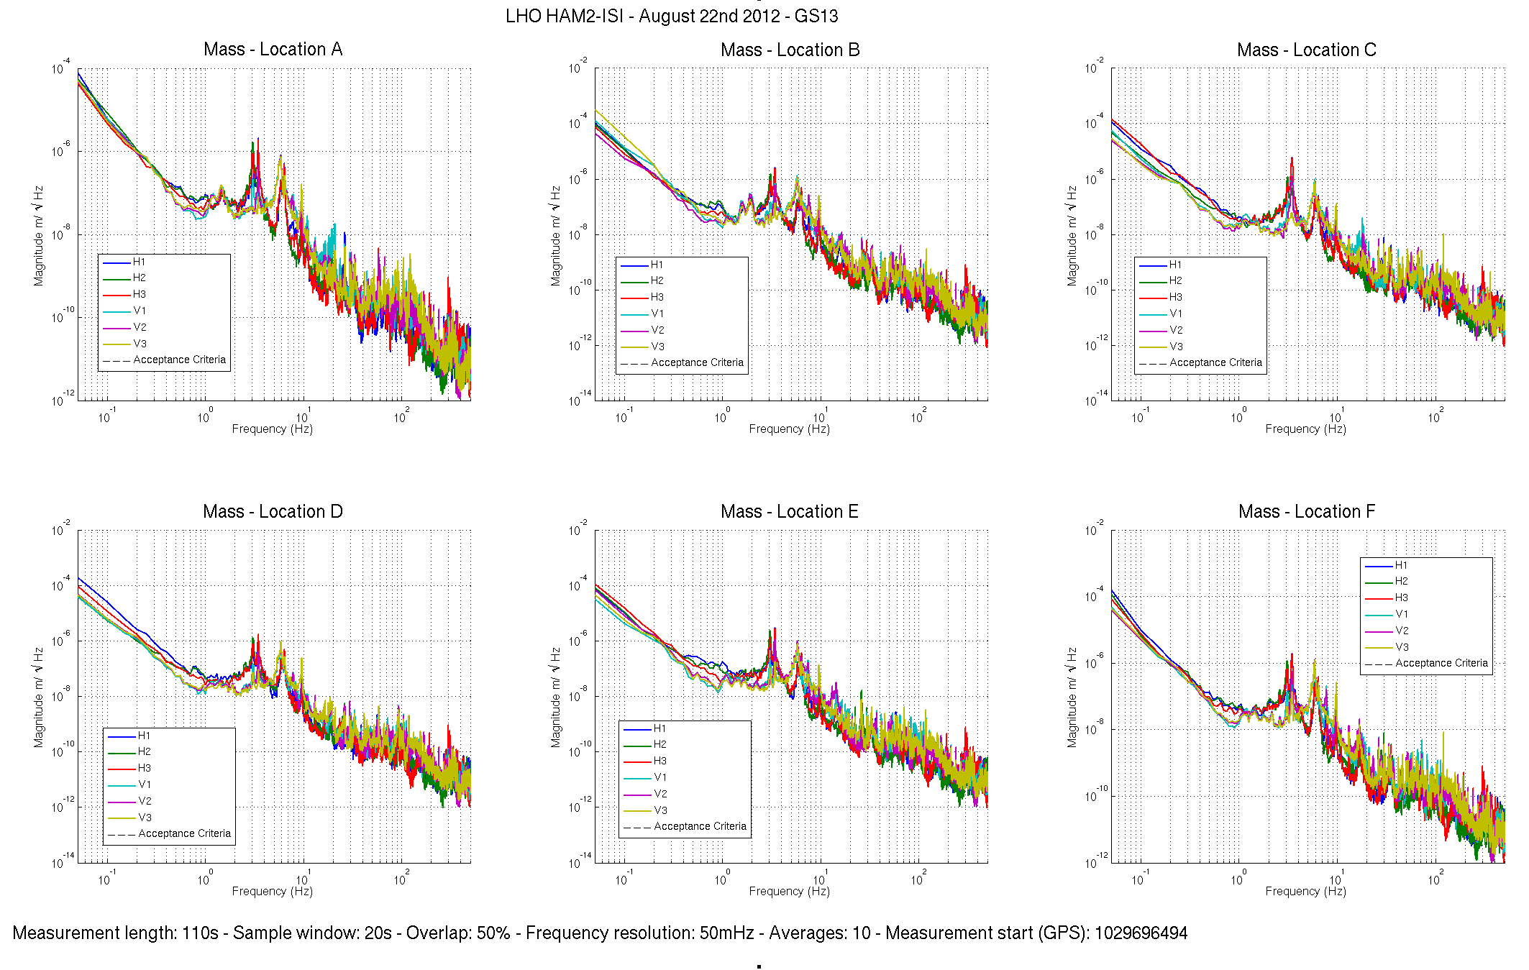
Figure – ASD Calibrated GS13 with mass at corner

Data files in SVN at:
/seismic/HAM-ISI/H1/HAM3/Data/Spectra/Undamped/
- LHO_ISI_HAM2_ASD_m_GS13_Stage_Tilted_2012_08_22.mat

Scripts files for taking and processing the data, and plotting it in SVN at:
seismic/HAM-ISI/Common/Testing_Functions_HAM_ISI/
- Plot_ASD_Tilted_Stage_HAM_ISI.m

Figures in SVN at:
seismic/HAM-ISI/H1/HAM3/Data/Figures/Spectra/Undamped/
- LHO_ISI_HAM2_m_PSD_GS13_Tilted_2012_08_22.fig

Issues/difficulties/comments regarding this test:
- Good concordance between sensors of the same type and direction.
- No drop of response in low frequency

Test result: Passed: X Failed: .

Step 10: GS13 pressure readout
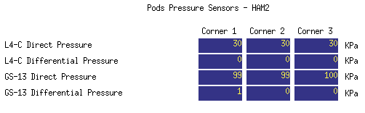
Figure – Pressure Readouts (07/16/2012)

Acceptance criteria:
- The pressure on GS13_P channels must be 102KPa +/-8 KPa (25000 counts +/- 3000 counts)
- GS13_P must vary the same way in each corner and GS13_DIFF must be constant (channels follow comparable trend)

Test result: Passed: X Failed: .

Step 11: Actuators Sign and range of motion (Local drive)

 | Negative drive | No Drive | Positive drive | ROM (Counts)
H1 readout (count) | -24247 | -4141 | 23271 | 47518
H2 readout (count) | -23587 | -2483 | 23341 | 46928
H3 readout (count) | -23968 | -1076 | 24978 | 48946
V1 readout (count) | -18264 | 928 | 21177 | 39441
V2 readout (count) | -24047 | -37 | 24667 | 48714
V3 readout (count) | -22779 | -873 | 20038 | 42817
Table - Range of motion - Local drive

Acceptance criteria:
- Main couplings sensors readout must be at least 16000 counts (~0.02”)
- A positive offset drive on one actuator must give positive sensor readout on the collocated sensor. Signs will also be tested when measuring local-to-local transfer functions.

Test result: Passed: X Failed: .

Step 12: Static Testing (Tests in the local basis)
 | Sensors (counts)
 | H1 | H2 | H3 | V1 | V2 | V3
H1 | 1812 | 1138 | 1145 | -9 | 0 | -10
H2 | 1124 | 1804 | 1136 | -8 | 6 | -8
H3 | 1154 | 1148 | 1838 | -9 | 8 | -14
V1 | 179 | 158 | -340 | 1307 | -47 | -546
V2 | -335 | 175 | 178 | -578 | 1318 | -34
V3 | 160 | -341 | 164 | -26 | -562 | 1298
Table - Main couplings and cross couplings

Issues/difficulties/comments regarding this test:

Acceptance criteria:
- Vertical
For a +1000 count offset drive on vertical actuators
  - Collocated sensors must be 1400 counts +/- 10%

- Horizontal
For a +1000 count offset drive on horizontal actuators
  - Collocated sensors must be 2000 counts +/- 10%
  - Non-collocated horizontal sensors must be 1250 counts +/-10%

Test result: Passed: X Failed: .

Step 13: Linearity test

 | Slope | Offset | Average slope | Variation from  average(%)
H1 | 1.8281 | -4151.4 | 1.83 | -0.26
H2 | 1.8098 | -2481.7 |  | -1.26
H3 | 1.8606 | -1082.4 |  | 1.51
V1 | 1.312 | 933.38 | 1.32 | -0.33
V2 | 1.3159 | -22.437 |  | -0.03
V3 | 1.3211 | -884.41 |  | 0.36
Table - Slopes and offset of the triplet Actuators - HAM-ISI - Sensors

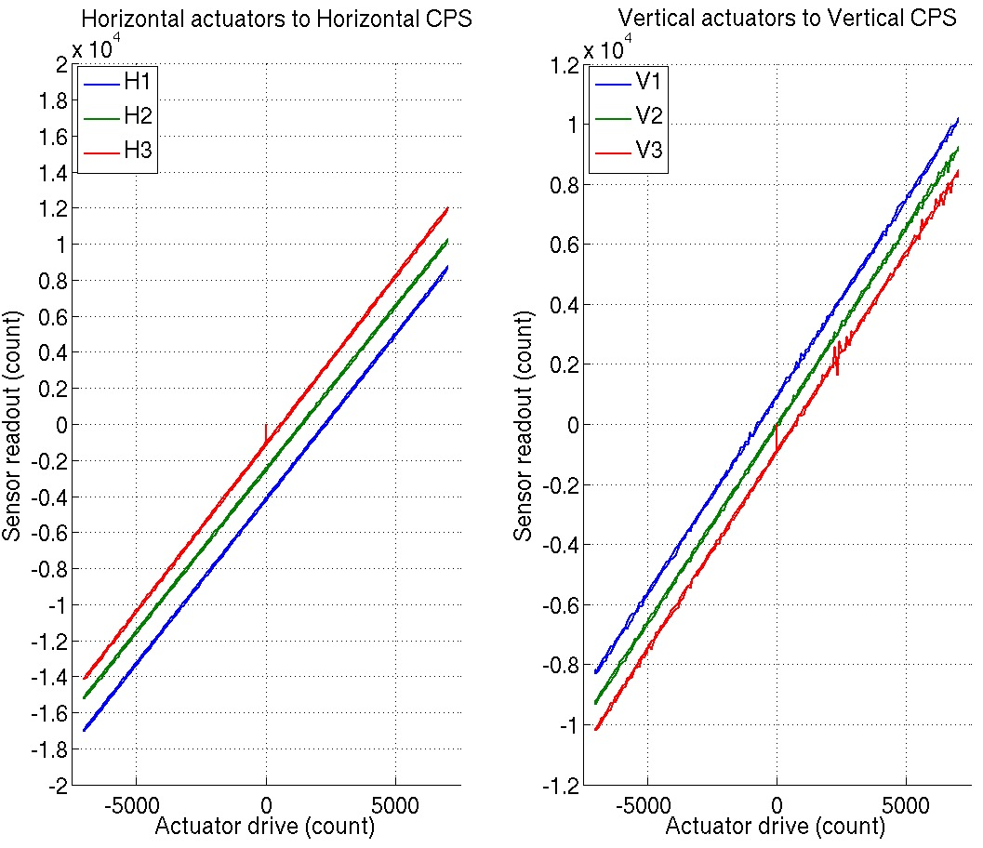
Figure - Horizontal and vertical actuators x HAM-ISI x sensors

Scripts files for taking data in SVN at:
seismic/HAM-ISI/Common/Testing_Functions_HAM_ISI/
- Linearity_Test_Awgstream_HAM_ISI.m
- Reprocess_Linearity_Test.m

Data files in SVN at: seismic/HAM-ISI/H1/HAM2/Data/Linearity_Test/
- LHO_ISI_HAM2_Linearity_test_20120827.mat

Figures in SVN at:
seismic/HAM-ISI/H1/HAM2/Data/Figures/Linearity_Test/
- LHO_ISI_HAM2_Linearity_test_Reprocessed_With_Right_Data_Rate_20120827.fig
Issues/difficulties/comments regarding this test:
Needed to wright a script to reprocess test data. The original scrip did not account for the new data rate on the CPSs.
H3 is borderline but acceptable.
Acceptance criteria:
- Horizontal and vertical slopes of the triplet actuators x HAM-ISI x sensors = Average slope +/- 1.5%

Test result: Passed: X Failed: .

Step 14: Frequency response
All input/output filters are ON. HEPI is locked. The chamber is closed with sheets on.

Step 14.1: Local to local measurements
Data files in SVN at:
seismic/HAM-ISI/H1/HAM2/Data/Transfer_Functions/Measurements/Undamped/
- LHO_ISI_HAM_Unit_2_Data_TF_L2L_10mHz_100mHz_20120825-023353.mat
- LHO_ISI_HAM_Unit_2_Data_TF_L2L_100mHz_500mHz_20120825-013201.mat
- LHO_ISI_HAM_Unit_2_Data_TF_L2L_500mHz_5Hz_20120824-192209.mat
- LHO_ISI_HAM_Unit_2_Data_TF_L2L_5Hz_200Hz_20120824-174819.mat
- LHO_ISI_HAM_Unit_2_Data_TF_L2L_200Hz_1000Hz_20120824-160521.mat
Data collection script files:
seismic/HAM-ISI/H1/HAM2/Scripts/Data_Collection/
- Run_Exc_Batch_H1_HAM2.m
Scripts files for processing and plotting in SVN at:
seismic/HAM-ISI/H1/HAM2/Scripts/Control_Scripts/Version_0/
- Step_1_TF_Loc_to_Loc_H1_ISI_HAM2.m
Figures in SVN at:
seismic/HAM-ISI/H1/HAM2/Data/Figures/Transfer_Functions/Measurements/Undamped/
- H1_ISI_HAM2_TF_L2L_Raw_from_ACT_to_CPS_2012_08_24.fig
- H1_ISI_HAM2_TF_L2L_Raw_from_ACT_to_GS13_2012_08_24.fig
Storage of measured transfer functions in the SVN at:
seismic/HAM-ISI/H1/HAM2/Data/Transfer_Functions/Simulations/Undamped/
- H1_ISI_HAM2_TF_L2L_Raw_2012_08_24.mat

The local to local transfer functions and presented below.

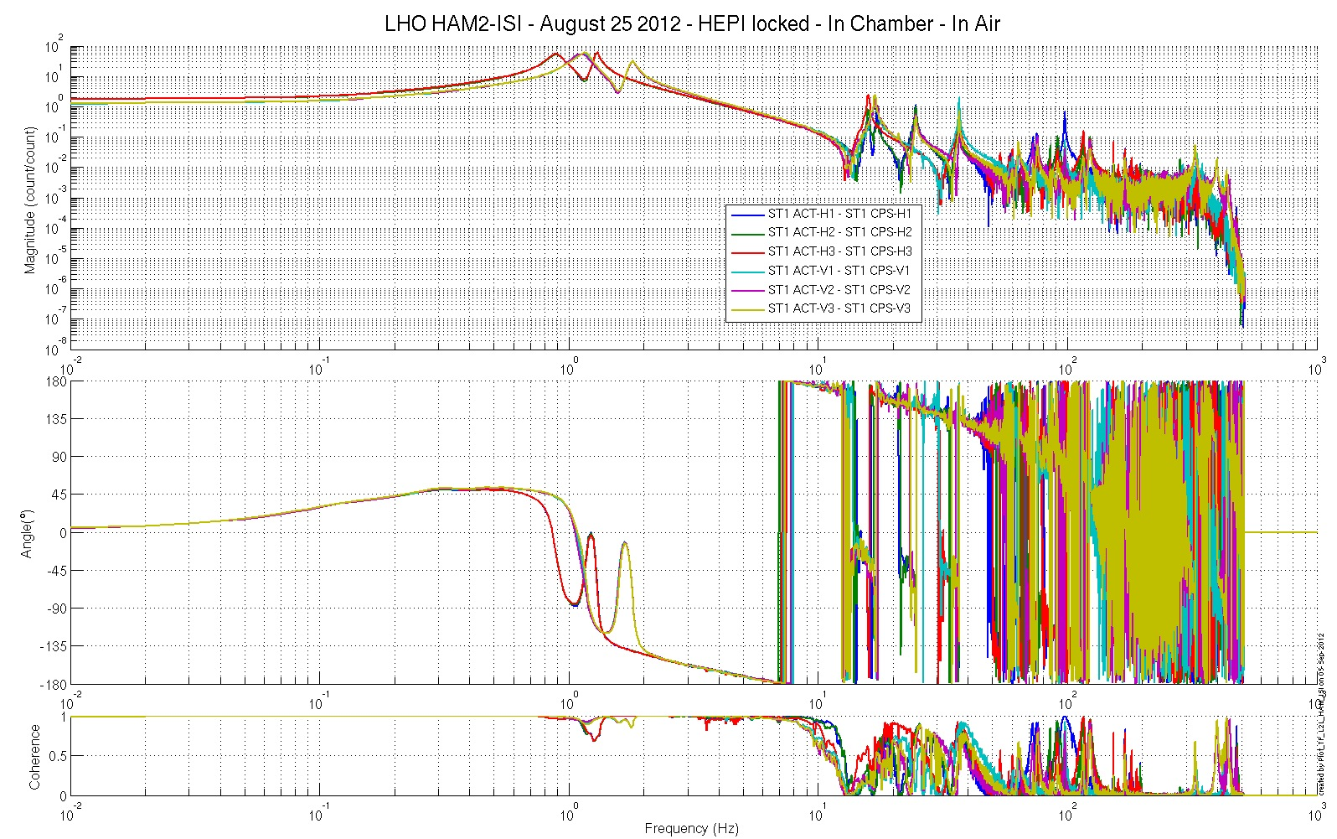
Figure - Local to Local Measurements –Capacitive Position Sensors

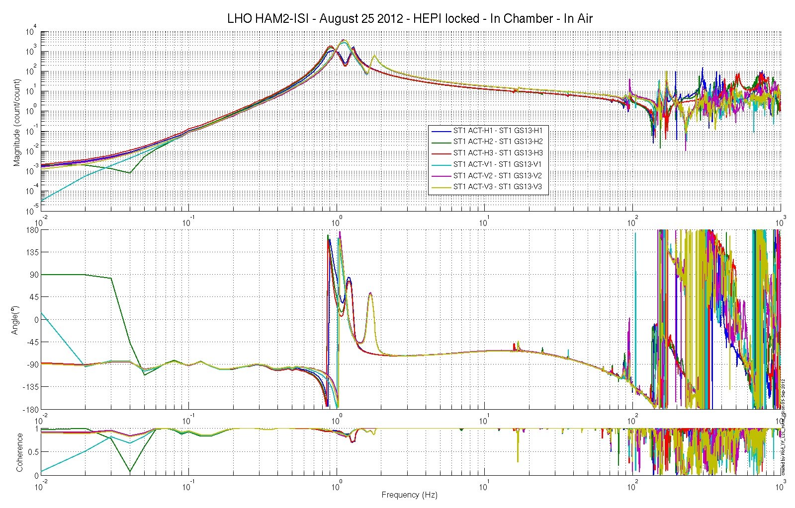
Figure - Local to Local Measurements – Inertial sensors

Step 14.2: Local to local measurements V.S. LLO

Data files in SVN at:
LHO:
seismic/HAM-ISI/H1/HAM2/Data/Transfer_Functions/Measurements/Undamped/
- LHO_ISI_HAM_Unit_2_Data_TF_L2L_10mHz_100mHz_20120825-023353.mat
- LHO_ISI_HAM_Unit_2_Data_TF_L2L_100mHz_500mHz_20120825-013201.mat
- LHO_ISI_HAM_Unit_2_Data_TF_L2L_500mHz_5Hz_20120824-192209.mat
- LHO_ISI_HAM_Unit_2_Data_TF_L2L_5Hz_200Hz_20120824-174819.mat
- LHO_ISI_HAM_Unit_2_Data_TF_L2L_200Hz_1000Hz_20120824-160521.mat

LLO:
seismic/HAM-ISI/L1/HAM2/Data/Transfer_Functions/Simulations/Undamped/
- LLO_ISI_HAM3_TF_L2L_Raw_2012_03_21.mat
Scripts files for processing and plotting in SVN at:
seismic/HAM-ISI/H1/HAM2/Scripts/Control_Scripts/Version_2/
- Step_1_TF_Loc_to_Loc_H1_ISI_HAM2.m
- Plot_TF_L2L_HAM_with_LLO.m
Figures in SVN at:
seismic/HAM-ISI/H1/HAM2/Data/Figures/Transfer_Functions/Comparisons/L2L/
- H1_ISI_HAM3_TF_L2L_Raw_from_ACT_H_to_CPS_H_vs_LLO_2012_03_21.fig
- H1_ISI_HAM3_TF_L2L_Raw_from_ACT_V_to_CPS_V_vs_LLO_2012_03_21.fig
- H1_ISI_HAM3_TF_L2L_Raw_from_ACT_H_to_GS13_H_vs_LLO_2012_03_21.fig
- H1_ISI_HAM3_TF_L2L_Raw_from_ACT_V_to_GS13_V_vs_LLO_2012_03_21.fig

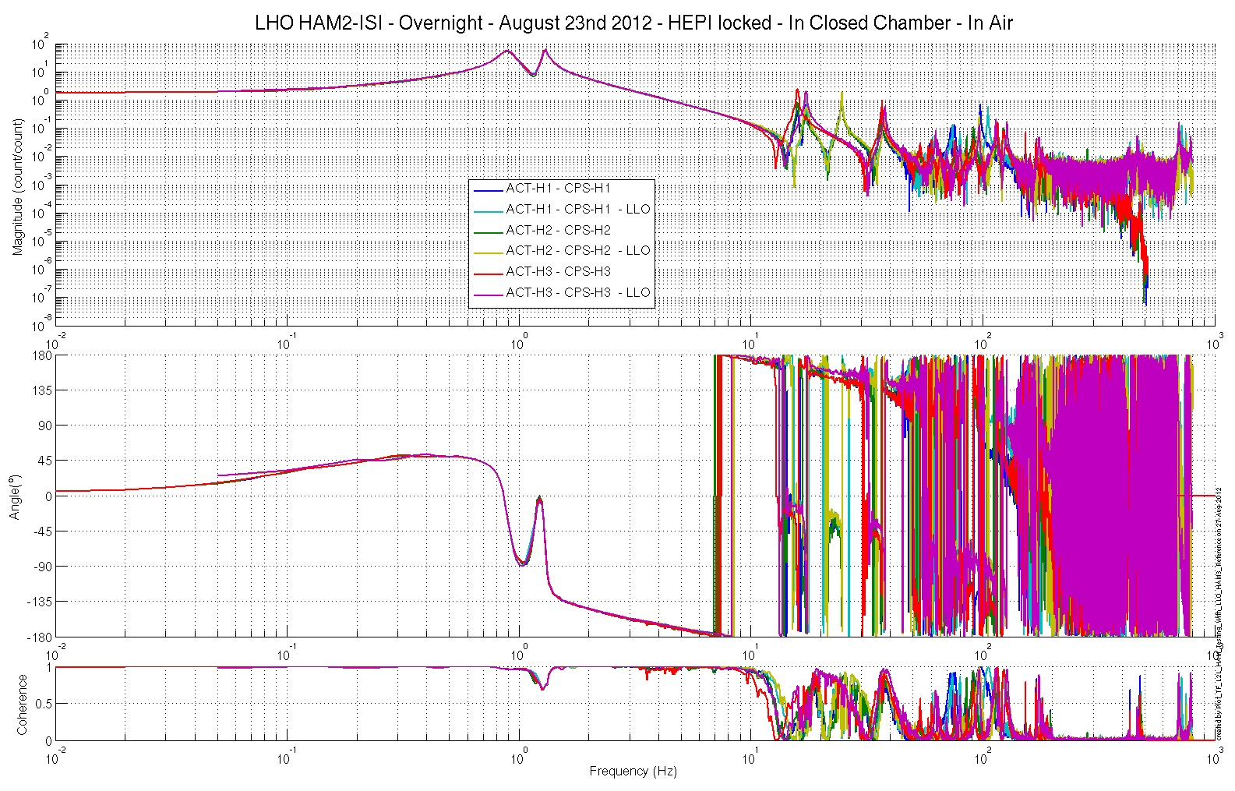
Figure – TF L2L – Horizontal CPS

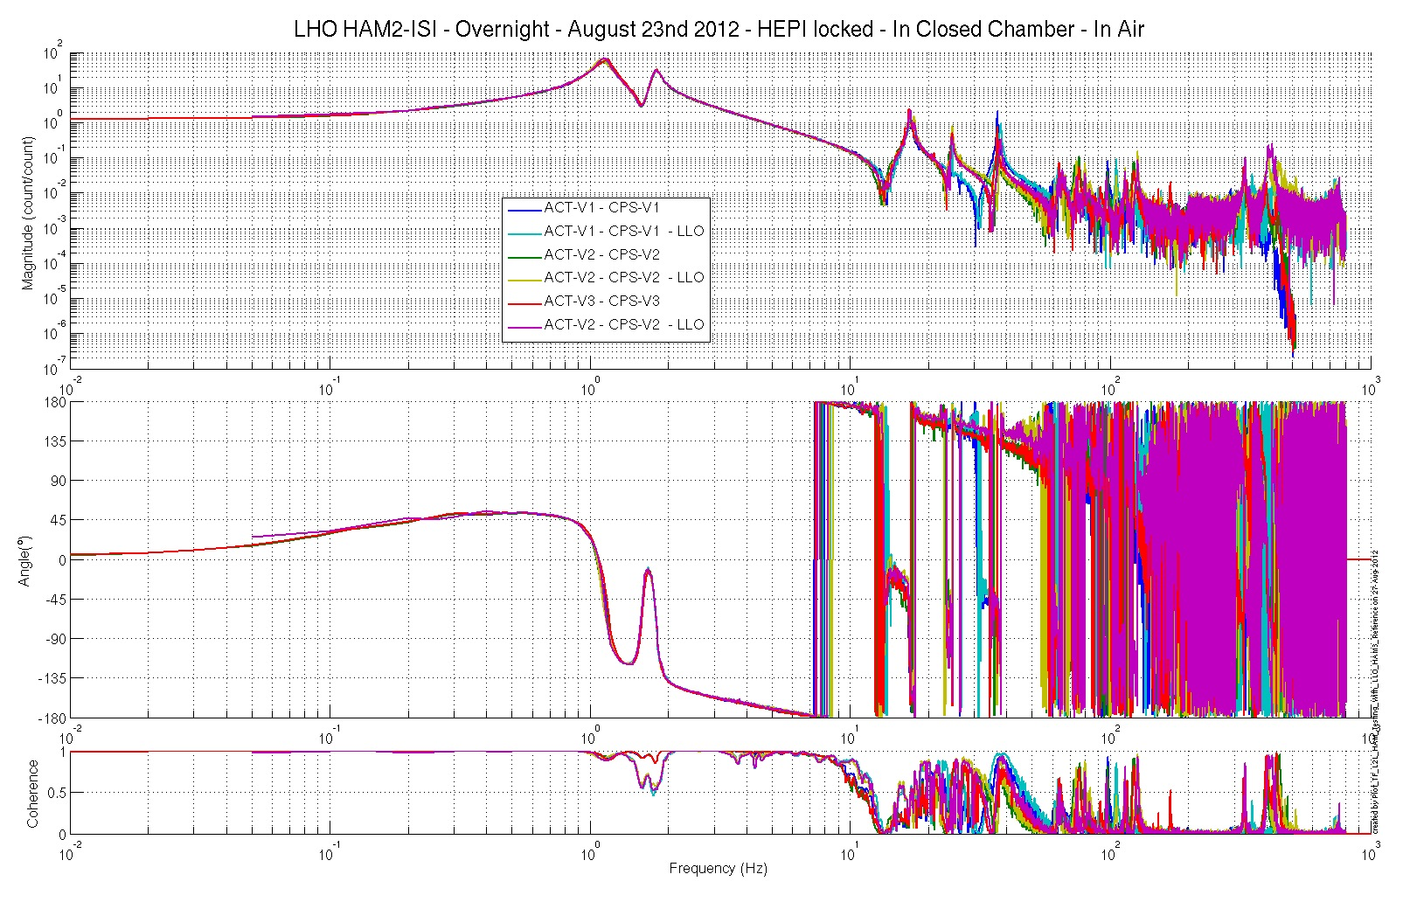
Figure – TF L2L – Vertical CPS
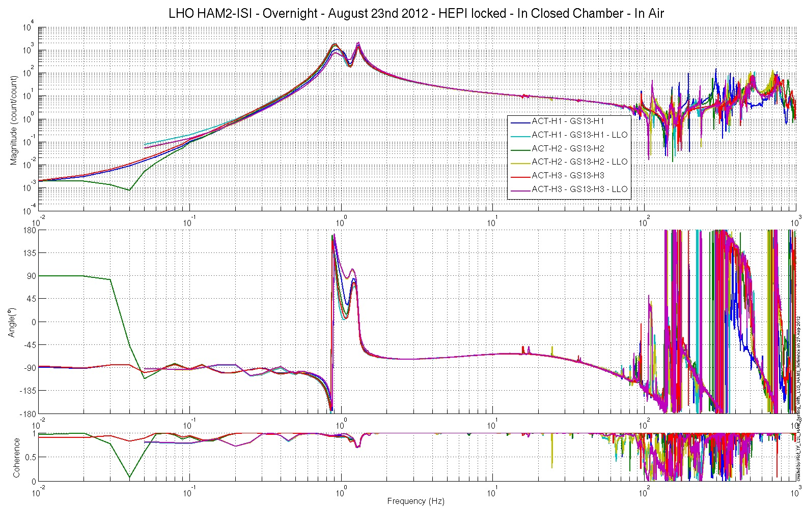
Figure – TF L2L – Horizontal GS13

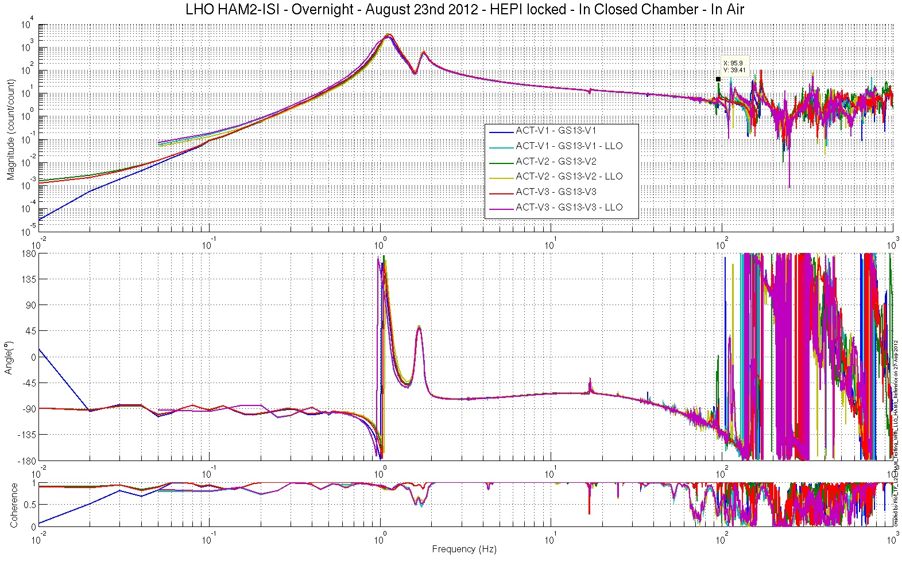
Figure – TF L2L – Vertical GS13

Issues/difficulties/comments regarding this test:
Good concordance with TF measured under the same conditions at LLO.
The big dummy mass used on top of the ISI to ceompensate for the absence of suspensions turned out to be perturbating the TF measurements. We put 2 small screwdriver tips under it to constrain it more. The results presented here are the ones taken after the screwdriver tips fix.
These results were posted in the LHO aLog, entry #4025. The initial chamber testing was validated on them.

Test result: Passed: X Failed: .

Step 15: Pre-Commissioning
Time was available at the end of the initial chamber testing. We used it to test the new commissioning scripts (Version 2), and see how much isolation we could get in this configuration.

We installed the HAM-ISI control loops level-1 and Level-2 on HAM2-ISI. Notches were needed to account for HEPI resonances. They were added in both levels of controllers. Details of the investigation that led to this conclusion can be found in LHO aLogs #4341 and #4345.

The MEDM commands allowed changing smoothly between states.

Results are presented below.
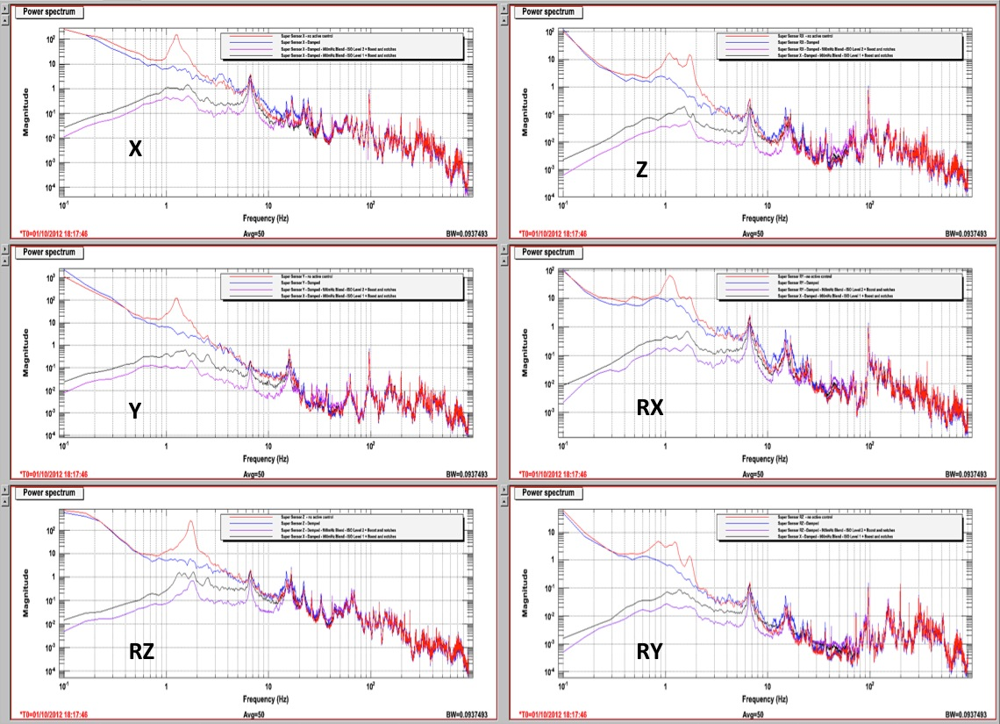

Conclusion
Initial In-Chamber testing

The Initial Chamber Testing of HAM2-ISI was performed during the last two weeks of August.
Other tasks were also performed then:
- Models were installed
- In-field cables were installed
- Electronic rack was troubleshooted:
  - BIO-related cables missing fifth pin
  - DAC/ADC card numbers in the IO chassis figured out
  - BIO card used by the model figured out
Some Pre-Commissioning work was performed late September, in anticipation of phase III testing. It is presented in step 15. Results are encouraging for commissioning.

Very few issues were found during the Initial In-Chamber Testing of this unit. The known issues are summed up here:
- CPSs and lockers will need to be reset after SUS install, as expected
- Overnight Transfer Function often crashed du to incompatibility between Ubuntu OS and Mac computers.

Introduction
Final Chamber Testing

This part of the Phase II testing takes place in open chamber, with sheets on.

This is the last phase of testing before the chamber is closed for the IMC test. All the suspensions and optics needed for the IMC test are on. PRM and PR3 are not.

At this time, HEPI pipes are not flushed yet. Hence, HEPI is locked.

IO was done with installing optics on December 17th 2012.

Tests presented here were performed between December 17th and December 19th 2012. Chamber started to be closed on Dec. 20th 2012.

Final In-Chamber Testing

Step 1: Parts Inventory (E1000052)
DCC Number | Part name | Configuration | Corner 1 S/N | Corner 2 S/N | Corner 3 S/N
D071001 | Stage 0 base | NA | 11
D071051 | Stage 1 base | NA | 11
D071050 | Optical table | NA | 12
D071002 | Spring Post | NA | 18 | 19 | 16
D071100 | Spring | NA | 12 | 8 | 47
D071102 | Flexure | NA | 10 | 17 | 9
ADE | Position sensor | Horizontal | 12046 Master 0 | 12034 slave 180 | 12070 Slave 0
 |  | Vertical | 12018 slave 180 | 12042 slave 0 | 12081 Slave 180
D047812 | GS-13 pod | Horizontal | 44 | 93 | 07
 |  | Vertical | 88 | 14 | 30
D047823 | L4C pod | Horizontal | NA | NA | NA
 |  | Vertical | NA | NA | NA
D0902749 | Actuator | Horizontal | 124 | 99 | 107
 |  | Vertical | 108 | 51 | 64
Table – Parts inventory

NA: Not applicable
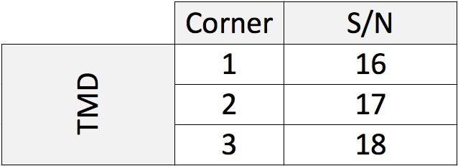
Table – Tuned Mass Dampers

Issues/difficulties/comments regarding this test:
Same parts as during the Assembly Validation testing. Serial numbers were retrieved from report E1000313-v2.
Corner 1 and 3 CPSs are now connected to the same ADE box for in-air cable to reach feedthroughs.
TMDs were added since (LHO aLog # 4902).

Acceptance Criteria:
Inventory is complete

Test result: Passed: X Failed: .

Step 2: Cables inventory:
Issues/difficulties/comments regarding this test:
No cables were changed since the Initial In-Chamber testing. Please refer to the Initial In-Chamber testing - Step I section of this report for details.

Acceptance Criteria:
Inventory is complete

Test result: Passed: X Failed: .

Step 3: Electronics inventory

Hardware | LIGO reference | S/N
Coil driver | D0902744 | S1103344
 |  | S1103363
Anti Image filter | D1100202 | S1202069
Anti aliasing filter | D1000269 | S1202072
 |  | S1202073
Interface chassis | D1000067 | S1201754
 |  | S1201755
Table – Electronics Inventory, December 19th 2012

Issues/difficulties/comments regarding this test:
This same rack of electronics was used for the initial in-chamber testing.
Acceptance Criteria:
Inventory is complete

Test result: Passed: X Failed: .

Step 4: Payload Survey

During this step, the ISI is payloaded with suspensions and optics. PRM and PR3 will be installed aster the IMC test (as it was done at LLO). The masses added to finish loading and balancing the ISI were recorded. See tables and figure below.

 | 00 | 01 | 02 | 03 | 04 | 05 | 06
 | 0.6 | 1.1 | 2.2 | 4.5 | 7.9 | 15.6 | 27.2 | lbs | kgs
w9 | 0 | 0 | 0 | 0 | 0 | 0 | 0 | 0 | 0.00
w1 | 1 |  |  | 1 | 1 |  |  | 13 | 5.90
w2 |  | 1 |  | 1 |  | 1 |  | 21.2 | 9.62
w3 |  |  | 1 |  |  |  |  | 2.2 | 1.00
w4 |  |  |  | 2 | 1 |  |  | 16.9 | 7.67
w5 |  |  | 1 |  |  | 1 |  | 17.8 | 8.07
w6 | 0 | 0 | 0 | 0 | 0 | 0 | 0 | 0 | 0.00
w7 | 1 | 2 | 1 |  |  |  |  | 5 | 2.27
w8 | 0 | 0 | 0 | 0 | 0 | 0 | 0 | 0 | 0.00
Side Masses Total | 2 | 3 | 3 | 4 | 2 | 2 | 0 | 76.1 | 34.52
Table – Wall Mass Distribution

 | 00 | 01 | 02 | 03 | 04 | 05 | 06
 | 0.6 | 1.1 | 2.2 | 4.5 | 7.9 | 15.6 | 27.2 | lbs | kgs
k1 |  |  |  |  |  | 2 |  | 31.2 | 14.15
k2 |  |  |  |  | 1 |  | 1 | 35.1 | 15.92
k3 |  |  |  |  |  | 2 |  | 31.2 | 14.15
k4 |  |  |  |  | 1 |  | 1 | 35.1 | 15.92
k5 |  |  |  |  |  | 2 |  | 31.2 | 14.15
k6 |  |  |  |  | 1 |  | 1 | 35.1 | 15.92
Keel Masses Total | 0 | 0 | 0 | 0 | 3 | 6 | 3 | 198.9 | 90.22
Table – Keel Mass Distribution

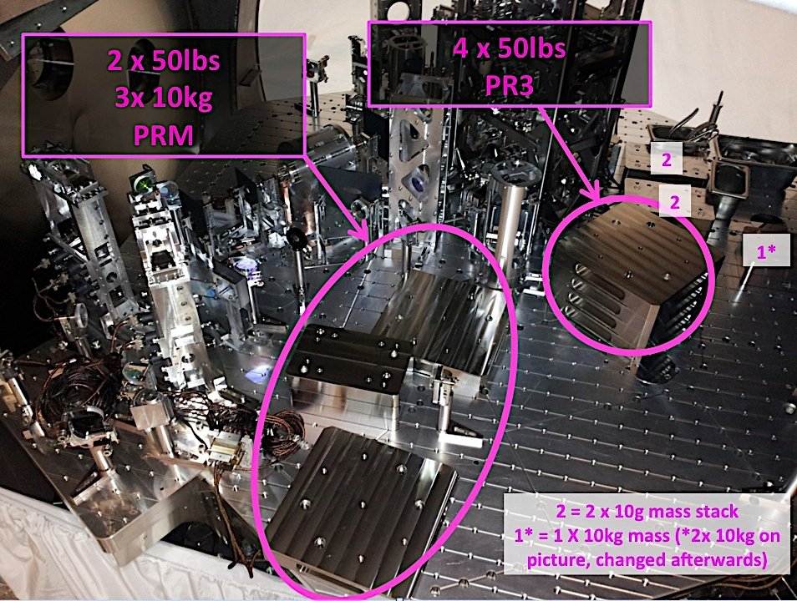
Figure – Optical Table Mass Distribution (60kg added with 10kg masses)

 | Side | Keel | Top | Total
Weigh (kg) | 34.52 | 90.22 | 216.08 | 340.82
Table – Mass Budget Sum Up

Figure – Wall Masses (W) and Keel masses (K) location. South of picture = corner 1

Issues/difficulties/comments regarding this test:
- Only wall masses and optical table masses were changed since the Initial In-Chamber testing. Keel masses were retrieved from this phase. Please refer to the related section for details.
- 50lbs and 10kg masses were used to account for the absence of PR3 and PRM. Please refer to the picture of the optical table on the previous page, and to the LHO alog# 4921, for more details.

Acceptance Criteria:
- Amount and position of wall masses is recorded
- Amount and position of keel masses is recorded
- Amount and position of optical table masses is recorded

Test result: Passed: X Failed: .

Step 5: Locked/Unlocked Spectra

Data files in SVN at:
/seismic/HAM-ISI/H1/HAM2/Data/Spectra/Undamped/
- LHO_ISI_HAM2_ASD_m_CPS_T240_L4C_GS13_Locked_vs_Unlocked_2012_12_17.mat

Scripts files for taking and processing the data, and plotting it in SVN at:
seismic/HAM-ISI/Common/Testing_Functions_HAM_ISI/
- ASD_Measurements_Locked_Unlocked_HAM_ISI.m
- Plot_ASD_Unlocked_Locked_HAM_ISI.m
- Plot_ASD_Unlocked_Locked_Group_HAM_ISI.m
seismic/HAM-ISI/H1/HAM2/Data/Spectra/
- Measurements_List_Spectra_Locked_H1_ISI_HAM2.m

Figures in SVN at:
seismic/HAM-ISI/H1/HAM2/Data/Figures/Spectra/Undamped/
- LHO_ISI_HAM2_ASD_m_GS13_Requirements_Locked_vs_Unlocked_2012_12_17.fig
- LHO_ISI_HAM2_ASD_m_CPS_Requirements_Locked_vs_Unlocked_2012_12_17.fig

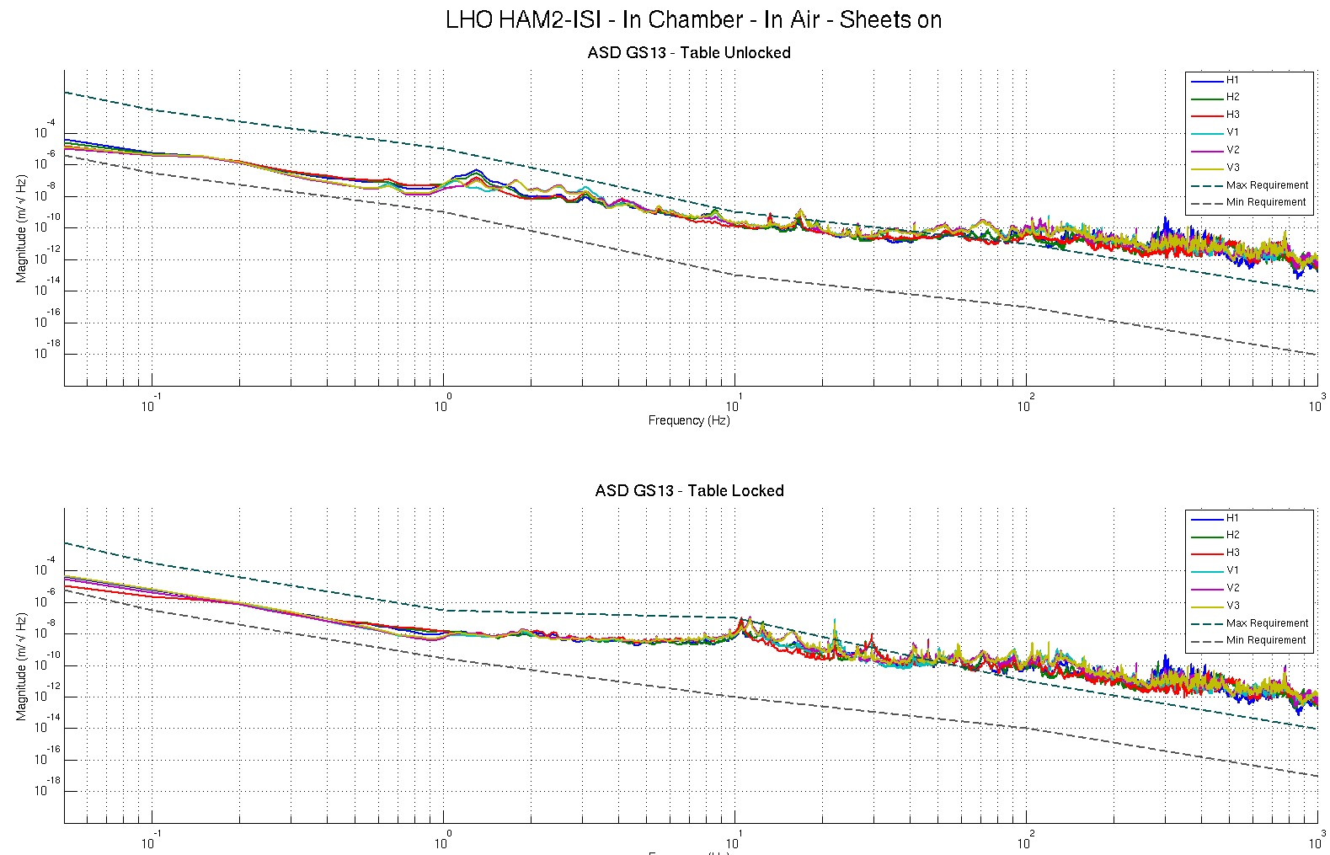
Figure - Calibrated CPS power spectrum – ISI Unlocked/Locked

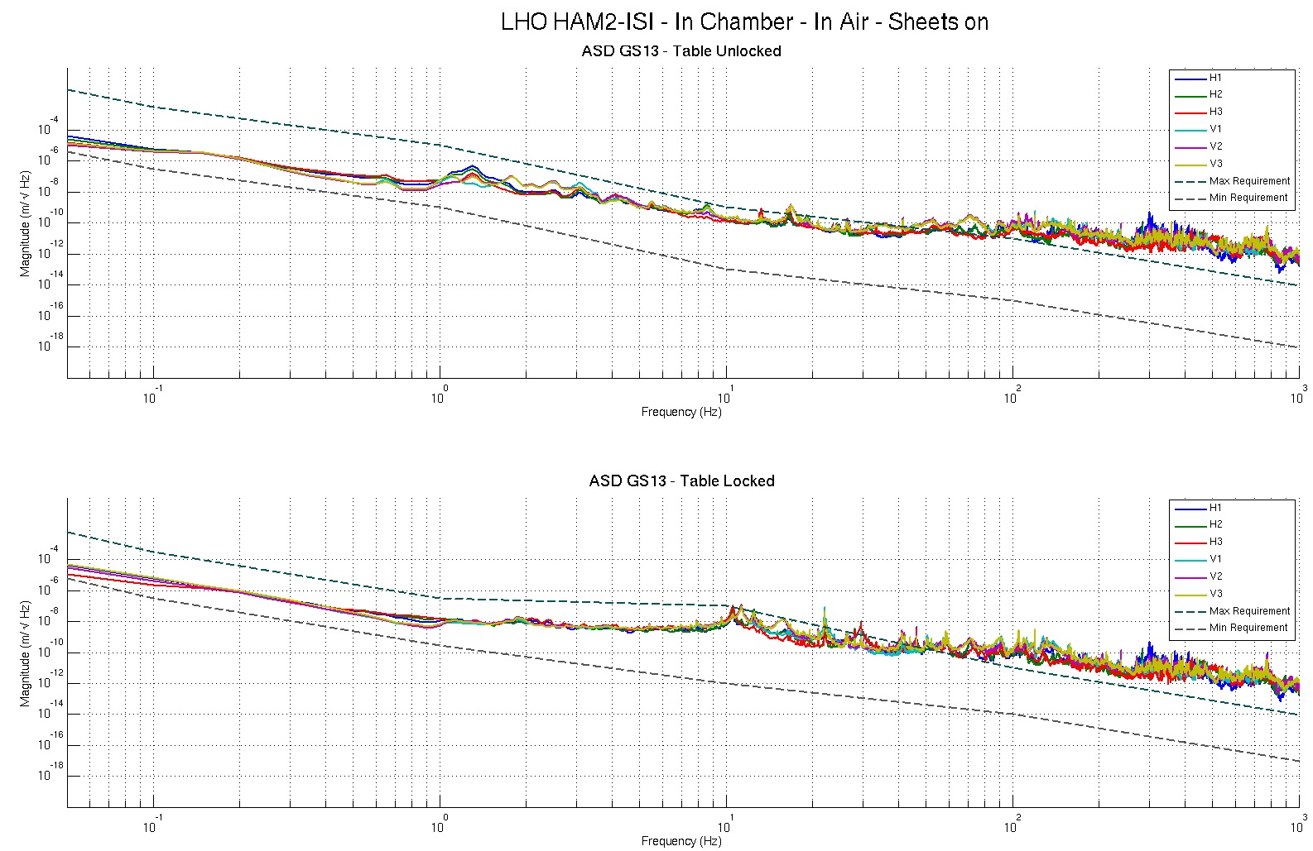
Figure – Power spectrum Calibrated GS13 – ISI Unlocked/Locked

Issues/difficulties/comments regarding this test:
- The testing functions used here need to load the calibration filters. The way we save these filters recently changed. The functions were updated to reflect these changes. Please, refer to SEI aLog #147 for more details.
- The CPS power spectra are calibrated by using a sensitivity of 30.2 nm/count.
- Even though asd2.m is now available, the functions used here still called pwelch.

Acceptance criteria:
- No cross talk (peaks at low frequencies + harmonics on measurements)
- Magnitudes of power spectra must be between requirement curves such as in the following figures (dashed lines)

Test result: Passed: X Failed: .

Comment:
GS13 requirement curves need to be updated.

Step 6: Tilted Spectra

Spectra with the ISI titled were already taken during the initial in-chamber testing.. The GS13s were not changed, neither were they moved since. Locked and unlocked spectra are fine We are confident that the GS13s are fully functional.

Please, refer to the Initial In-Chamber Testing section, step 9, for details.

Test result: Passed: X Failed: .

Step 7: Pressure Readouts

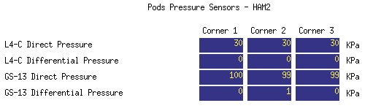
Figure – Pressure Readouts December 19th 2012

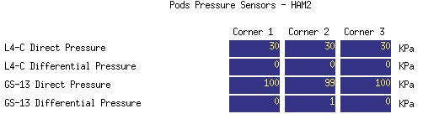
Figure – Pressure Readouts, Jan 22nd 2013, after pumpdown

Issues/difficulties/comments regarding this test:
- The ISI is in air, with sheet covers on the chamber
- No relevant variation of in-pod pressure over time, and after pumpdown.

Acceptance criteria:
- The pressure on GS13_P channels must be 102KPa +/-8 KPa (25000 counts +/- 3000 counts)
- GS13_P must vary the same way in each corner and GS13_DIFF must be constant (channels follow comparable trend)

Test result: Passed: X Failed: .

Step 8: Lockers/CPS Adjustment

Lockers’ adjustments were performed on December 15th after IO finalized the installation of the main elements of payload for HAM2-ISI. Details about this operation can be found in LHO aLog #4942.

CPS Offsets were off-requirements, but small enough to avoid sensors contacting targets, and good enough for the upcoming IMC test. The zero of the CPS was NOT reset after working on the lockers to save time and allow testing, and then pumpdown, by Christmas break. CPSs will be reset once the chamber is re-opened, after the IMC test.

The goal of this step is to make sure that the locked/unlocked shift read with the CPSs is within requirement.

Shift | Unlocked (Counts) | Locked (Counts) | Shift
H1 | -3860 | -3613.00 | 467.98
H2 | -2136 | -2109.00 | 334.36
H3 | -286 | -101.00 | 199.12
V1 | 828 | 561.00 | 25.64
V2 | -147 | -376.00 | 168.82
V3 | -303 | -285.00 | 141.63
Table – Locker’s Adjustments, December 15th 2012

Issues/difficulties/comments regarding this test:
- Locked-Unlocked shift is way below requirements. Same comment applies to the readouts.
- No shim was changed. Lockers were just adjusted horizontally.
- The zero of the CPSs will be reset after the IMC test.

Acceptance criteria (per E1000309-v12):
- Shift < 1600 cts
- Readouts < 2000 cts

Test result: Passed: X Failed: .

Step 9: Shim Thickness
Lockers | Shim thickness (mil)
A | 126
B | 126
C | 122
D | 122
Table – Shim Thicknesses, December 15th 2012

Issues/difficulties/comments regarding this test:
- No shim was changed. Lockers were only adjusted horizontally.

Acceptance Criteria
- The shim thickness should be 125 mils +/-5

Test result: Passed: X Failed: .

Step 10: Blade Spring Profile

Blade # | Flatness (mils)
1 | 8
2 | X
3 | 2
Table – Blade Spring Profile, December 15th 2012

Issues/difficulties/comments regarding this test:
- Access to the optical table holes used for this measurement is very limited once suspensions are installed. The profile of the blade of corner 2 could not be measured in this configuration.
- Transfer functions and Pre-commissioning tests show that the flatness of the blade of corner 2 will not be an issue for the IMC test.

Acceptance Criteria:
- Blades must be flat within 0.015" inches.

Test result: Passed: X Failed: .

Step 11: Level of Stage 1

The level of the Optical Table with the optical Level: +-0.1mm. See LHO aLog #4942 for more details.

Max angle = 0.004” / 79” ~ 50 µrad

Issues/difficulties/comments regarding this test:
- This measurement was performed after locker’s adjustments (see step 8)

Acceptance Criteria
- The maximum angle of the table with the horizontal mustn’t exceed ~100µrad
Test result: Passed: X Failed:

.

Step 12: Range of Motion

 | Negative drive | No Drive | Positive drive | ROM (Counts)
H1 readout (count) | -27780 | -3800 | 20480 | 48260
H2 readout (count) | -24800 | -1900 | 21300 | 46100
H3 readout (count) | -23500 | -400 | 24800 | 48300
V1 readout (count) | -18500 | 1100 | 20600 | 39100
V2 readout (count) | -21200 | 150 | 22900 | 44100
V3 readout (count) | -21800 | -800 | 19600 | 41400
Table – Range of Motion, December 19th 2012

ROM: Range Of Motion

Issues/difficulties/comments regarding this test:
- Compensation filters are ON.
- Symmetrization filters are OFF

Acceptance criteria:
- Main couplings sensors readout must be at least 16000 counts (~0.02”)
- A positive offset drive on one actuator must give positive sensor readout on the collocated sensor. Signs will also be tested when measuring local-to-local transfer functions.

Test result: Passed: X Failed: .

Step 13: Static Testing

Local to Cartesian transform matrices were already proofed during assembly-validation and Pre-commissioning. Hence, static testing is only performed in the local basis.

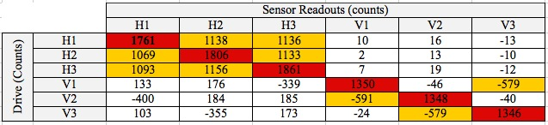
Table – Local Static Testing, December 19th 2012

Issues/difficulties/comments regarding this test:
- H1 response to H1 drive is very slightly below requirement.
- Some non-collocated horizontal sensors response are very slightly out of requirement.
- Transfer functions and Pre-commissioning tests show that this is not an issue for the IMC test.

Acceptance criteria:
- Vertical axis
For a +1000 count offset drive on vertical actuators
  - Collocated sensors must be 1400 counts +/- 10%

- Horizontal axis
For a +1000 count offset drive on horizontal actuators
  - Collocated sensors must be 2000 counts +/- 10%
  - Non-collocated horizontal sensors must be 1250 counts +/-10%

Test result: Passed: X Failed: .

Step 14: Linearity Test

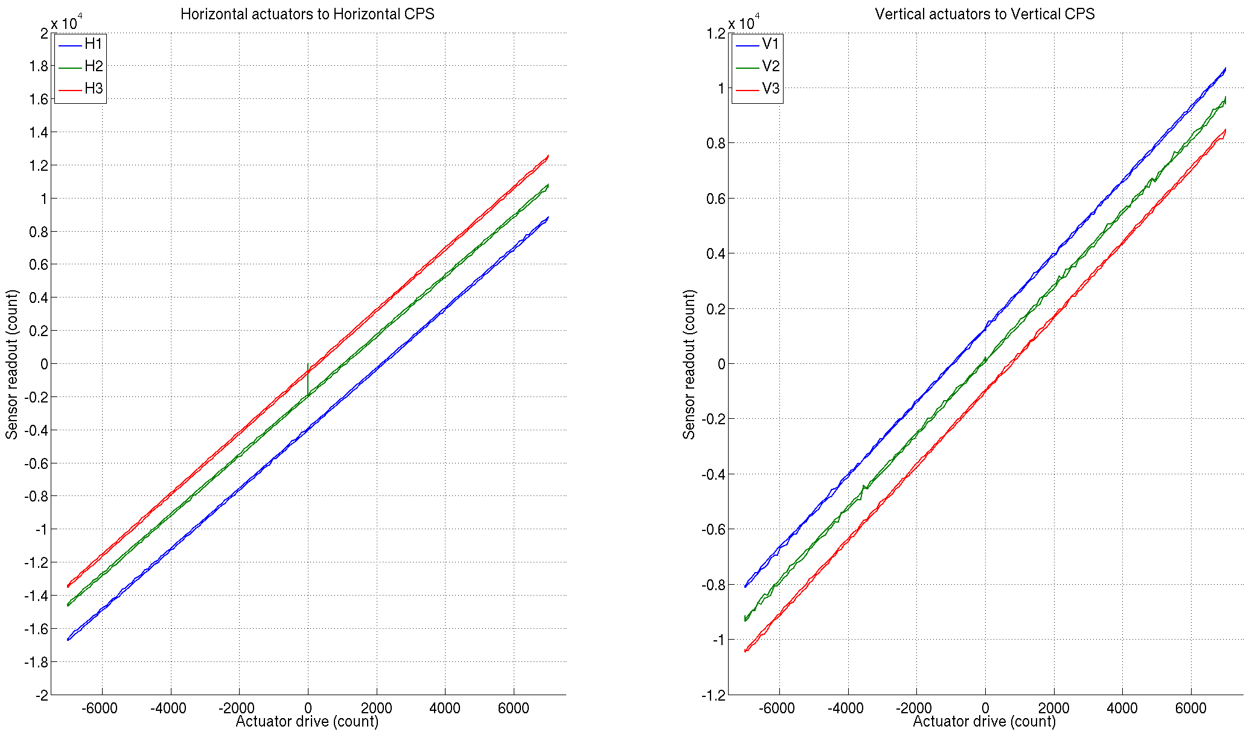
Table – Linearity test, December 17th 2012

 | Slope | Offset | Average slope | Variation from  average(%)
H1 | 1.82 | -3939.89 | 1.83 | -0.37
H2 | 1.81 | -1903.29 |  | -1.05
H3 | 1.85 | -474.80 |  | 1.43
V1 | 1.34 | 1291.50 | 1.34 | -0.39
V2 | 1.34 | 139.11 |  | -0.16
V3 | 1.35 | -993.25 |  | 0.55
Table – Linearity test, slopes and offsets

Issues/difficulties/comments regarding this test:
- Linearity_Test_Awgstream_HAM_ISI___Updated_Data_Rate.m is used instead of the regular script to account for the new data rate of the CPSs (1024, instead of 2048)

Scripts files for taking data in SVN at:
seismic/HAM-ISI/Common/Testing_Functions_HAM_ISI/
- Linearity_Test_Awgstream_HAM_ISI___Updated_Data_Rate.m

Data files in SVN at:
seismic/HAM-ISI/L1/HAM2/Data/Linearity_Test/
- LHO_ISI_HAM2_Linearity_test_20121217.mat

Figures in SVN at:
seismic/HAM-ISI/H1/HAM2/Data/Figures/Linearity_Test/
- LHO_ISI_HAM2_Linearity_test_20121217.fig

Acceptance criteria:
- Horizontal and vertical slopes of the triplet actuators x HAM-ISI x sensors = Average slope +/- 1.5%

Test result: Passed: X Failed: .

Step 15: Local to Local Transfer Function Measurements

All input/output filters, but Symmetrization, are ON. HEPI is locked. The chamber is closed with sheets on.

Step 15.1: Local to local measurements
Data files in SVN at:
seismic/HAM-ISI/H1/HAM2/Data/Transfer_Functions/Measurements/Undamped/
- LHO_ISI_HAM_Unit_2_Data_TF_L2L_200Hz_1000Hz_20121219-035007.mat
- LHO_ISI_HAM_Unit_2_Data_TF_L2L_5Hz_200Hz_20121219-050745.mat
- LHO_ISI_HAM_Unit_2_Data_TF_L2L_500mHz_5Hz_20121218-214032.mat
- LHO_ISI_HAM_Unit_2_Data_TF_L2L_100mHz_500mHz_20121219-064124.mat
- LHO_ISI_HAM_Unit_2_Data_TF_L2L_10mHz_100mHz_20121219-074303.mat
Data collection script files:
seismic/HAM-ISI/H1/HAM2/Scripts/Data_Collection/
- Run_Exc_Batch_H1_HAM2.m
Scripts files for processing and plotting in SVN at:
seismic/HAM-ISI/H1/HAM2/Scripts/Control_Scripts/Version_2/
- Step_1_TF_Loc_to_Loc_H1_ISI_HAM2.m
seismic/HAM-ISI/H1/HAM2/Data/Transfer_Functions/Simulations/Undamped/
- Measurements_List_H1_ISI_HAM2.m (Measurement # 10)
Figures in SVN at:
seismic/HAM-ISI/H1/HAM2/Data/Figures/Transfer_Functions/Measurements/Undamped/
- H1_ISI_HAM2_TF_L2L_Raw_from_ACT_to_CPS_2012_12_19.fig
- H1_ISI_HAM2_TF_L2L_Raw_from_ACT_to_GS13_2012_12_19.fig
Storage of measured transfer functions in the SVN at:
seismic/HAM-ISI/H1/HAM2/Data/Transfer_Functions/Simulations/Undamped/
- H1_ISI_HAM2_TF_L2L_Raw_2012_12_19.mat

The local to local transfer functions are presented below.

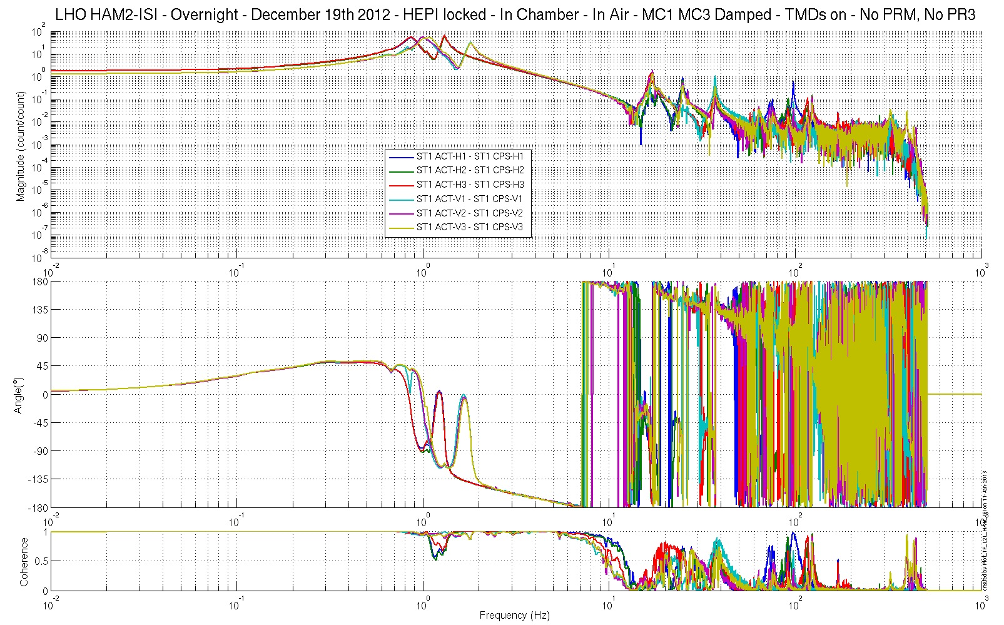Figure – Local-to-Local Transfer Function – Capacitive Position Sensors

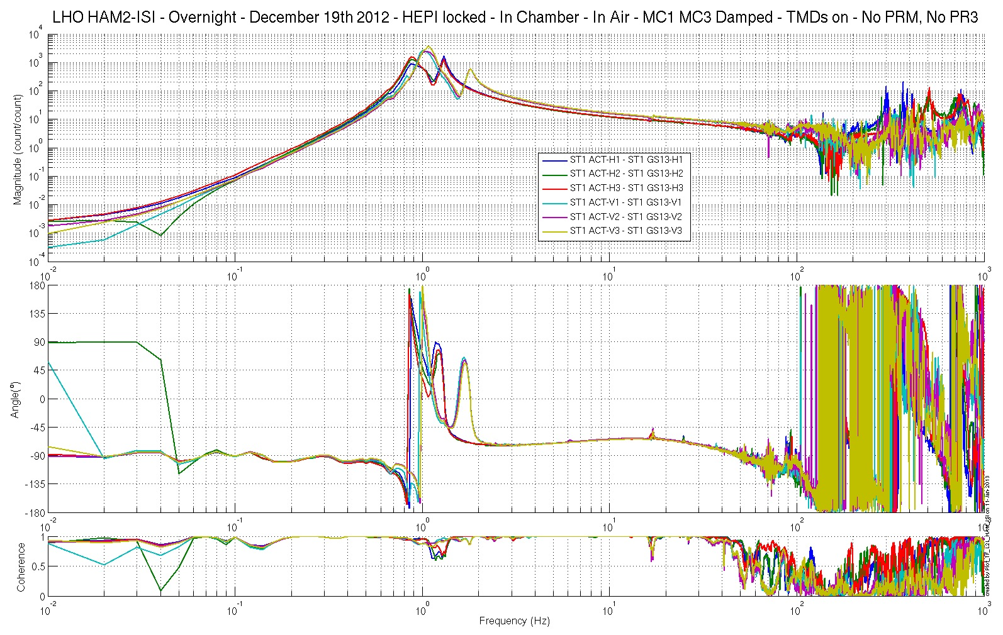
Figure– Local-to-Local Transfer Function – Inertial Sensors

Step 15.2: Local to local measurements V.S. LLO

Data files in SVN at:
LHO:
seismic/HAM-ISI/H1/HAM2/Data/Transfer_Functions/Measurements/Undamped/
- LHO_ISI_HAM_Unit_2_Data_TF_L2L_200Hz_1000Hz_20121219-035007.mat
- LHO_ISI_HAM_Unit_2_Data_TF_L2L_5Hz_200Hz_20121219-050745.mat
- LHO_ISI_HAM_Unit_2_Data_TF_L2L_500mHz_5Hz_20121218-214032.mat
- LHO_ISI_HAM_Unit_2_Data_TF_L2L_100mHz_500mHz_20121219-064124.mat
- LHO_ISI_HAM_Unit_2_Data_TF_L2L_10mHz_100mHz_20121219-074303.mat

LLO:
seismic/HAM-ISI/L1/HAM2/Data/Transfer_Functions/Simulations/Undamped/
- L1_ISI_HAM2_TF_L2L_Raw_2012_09_27.mat
Scripts files for processing and plotting in SVN at:
seismic/HAM-ISI/H1/HAM2/Scripts/Control_Scripts/Version_2/
- Step_1_TF_Loc_to_Loc_H1_ISI_HAM2.m
seismic/HAM-ISI/H1/HAM2/Scripts/Control_Scripts/Version_2/New_Functions/
- Plot_TF_L2L_HAM_with_LLO.m

Figures in SVN at:
seismic/HAM-ISI/H1/HAM3/Data/Figures/Transfer_Functions/Comparisons/L2L/
- H1_ISI_HAM2_TF_L2L_Raw_from_ACT_H1_to_CPS_H1_vs_LLO_2012_12_19.fig
- H1_ISI_HAM2_TF_L2L_Raw_from_ACT_H1_to_GS13_H1_vs_LLO_2012_12_19.fig
- H1_ISI_HAM2_TF_L2L_Raw_from_ACT_H2_to_CPS_H2_vs_LLO_2012_12_19.fig
- H1_ISI_HAM2_TF_L2L_Raw_from_ACT_H2_to_GS13_H2_vs_LLO_2012_12_19.fig
- H1_ISI_HAM2_TF_L2L_Raw_from_ACT_H3_to_CPS_H3_vs_LLO_2012_12_19.fig
- H1_ISI_HAM2_TF_L2L_Raw_from_ACT_H3_to_GS13_H3_vs_LLO_2012_12_19.fig
- H1_ISI_HAM2_TF_L2L_Raw_from_ACT_V1_to_CPS_V1_vs_LLO_2012_12_19.fig
- H1_ISI_HAM2_TF_L2L_Raw_from_ACT_V1_to_GS13_V1_vs_LLO_2012_12_19.fig
- H1_ISI_HAM2_TF_L2L_Raw_from_ACT_V2_to_CPS_V2_vs_LLO_2012_12_19.fig
- H1_ISI_HAM2_TF_L2L_Raw_from_ACT_V2_to_GS13_V2_vs_LLO_2012_12_19.fig
- H1_ISI_HAM2_TF_L2L_Raw_from_ACT_V3_to_CPS_V3_vs_LLO_2012_12_19.fig
- H1_ISI_HAM2_TF_L2L_Raw_from_ACT_V3_to_GS13_V3_vs_LLO_2012_12_19.fig

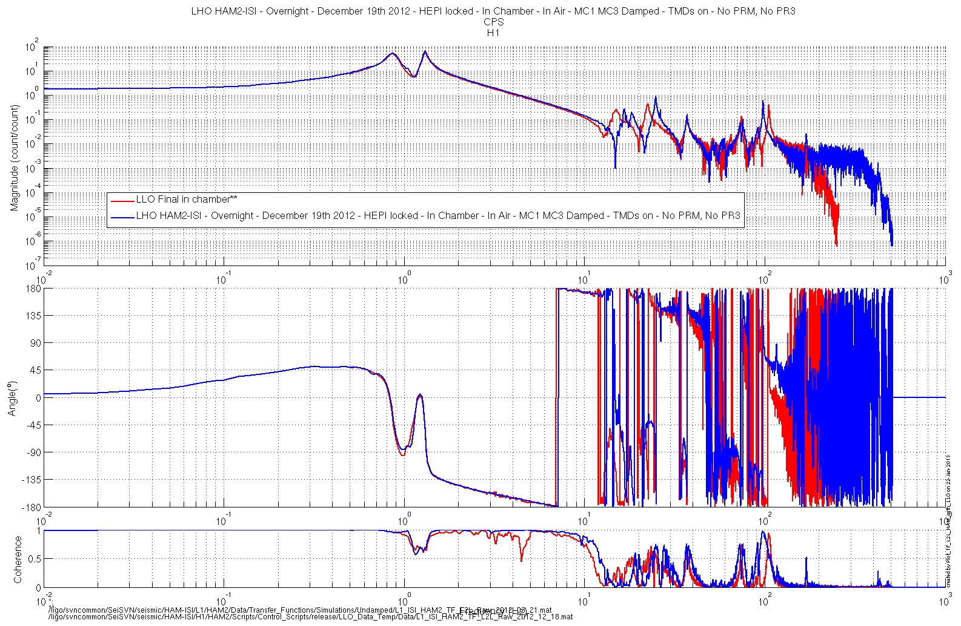
Figure– Local-to-Local Transfer Function – CPS H1 – Comparison with LLO

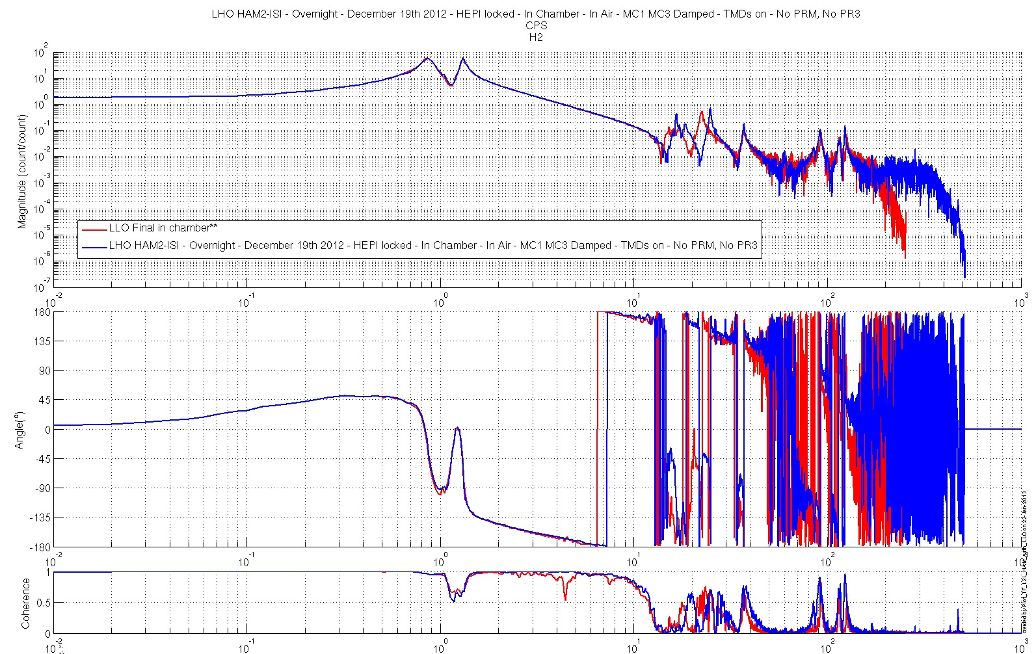
Figure– Local-to-Local Transfer Function – CPS H2 – Comparison with LLO
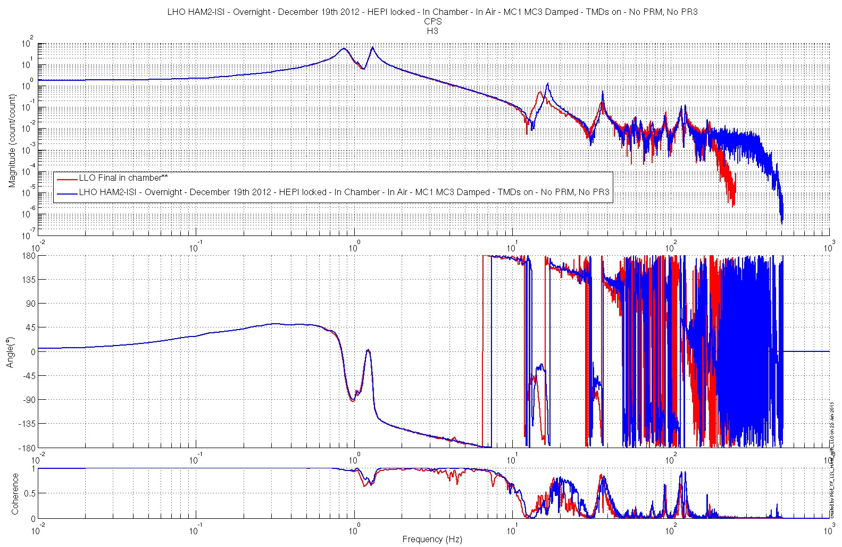
Figure– Local-to-Local Transfer Function – CPS H3 – Comparison with LLO

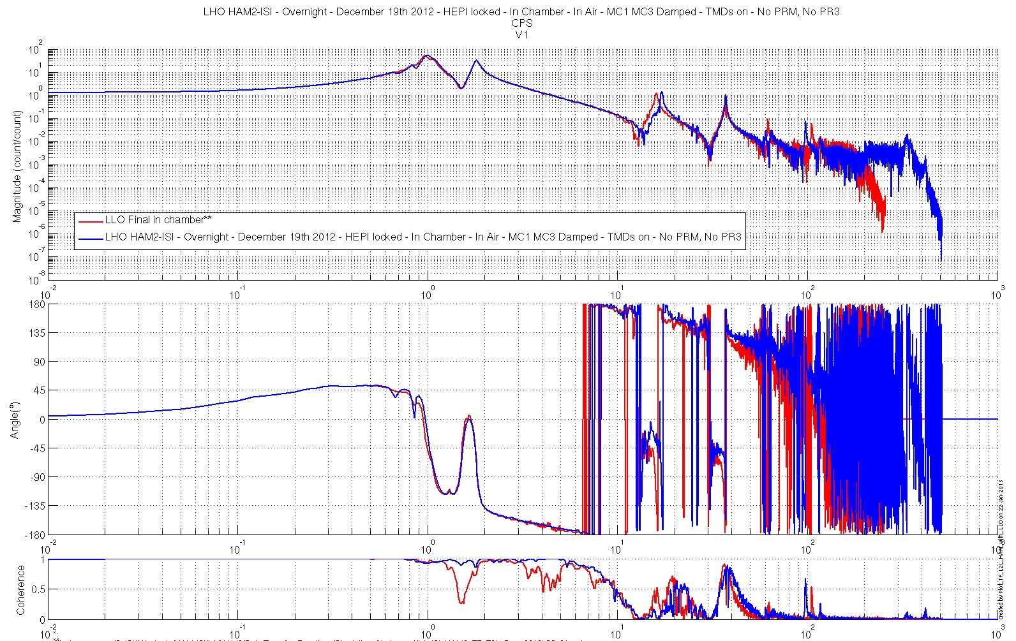
Figure– Local-to-Local Transfer Function – CPS V1 – Comparison with LLO
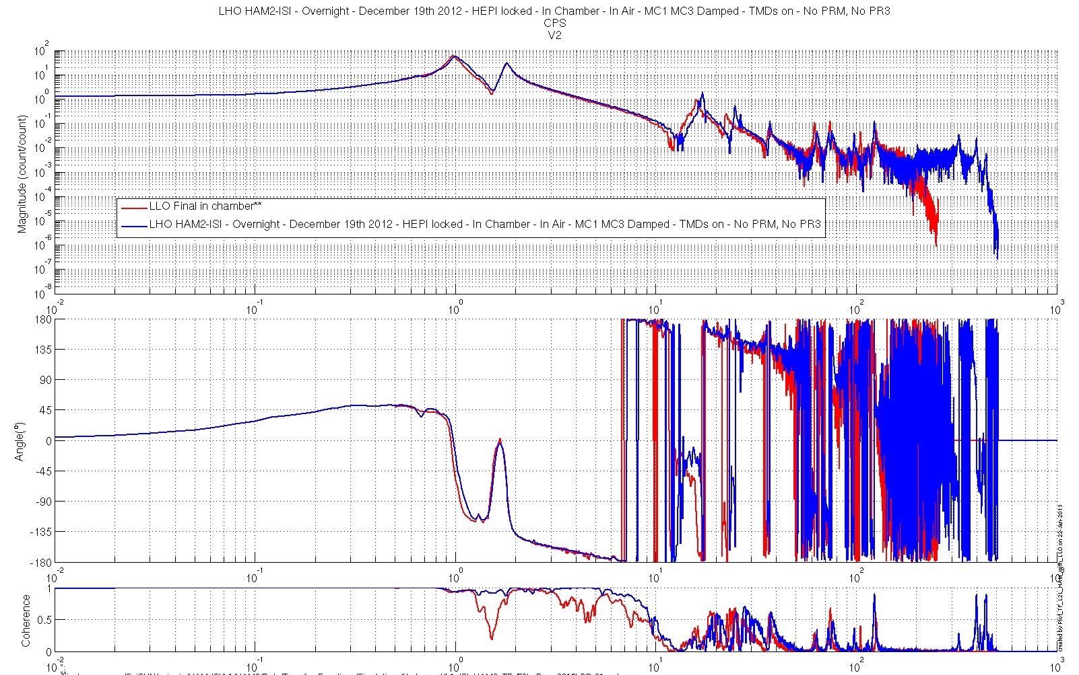
Figure– Local-to-Local Transfer Function – CPS V2 – Comparison with LLO

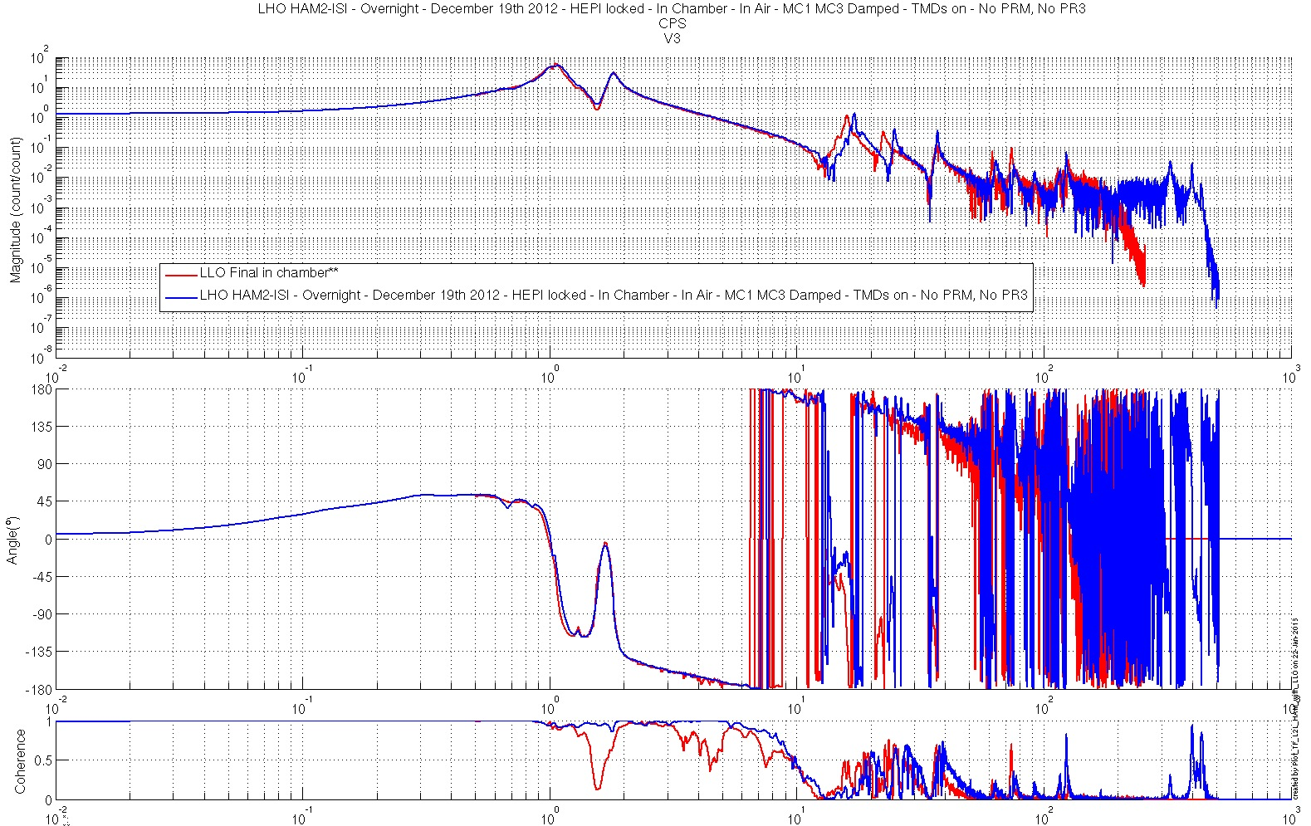
Figure– Local-to-Local Transfer Function – CPS V3 – Comparison with LLO
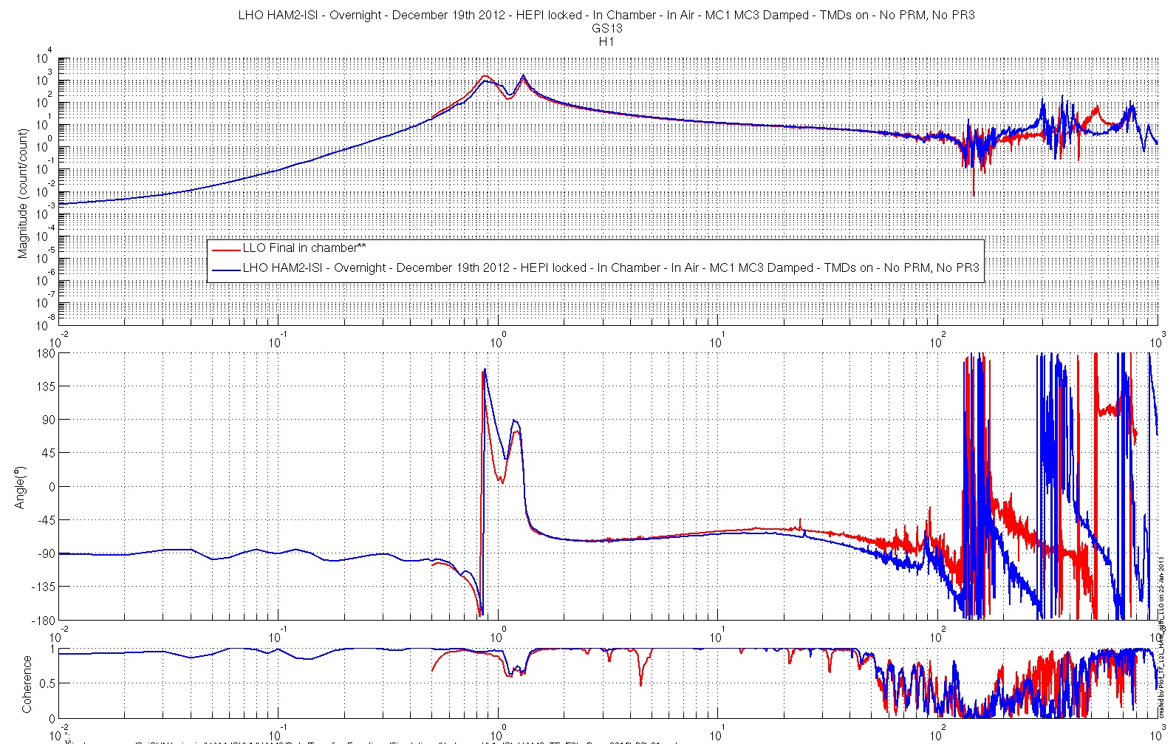
Figure– Local-to-Local Transfer Function – GS13 H1 – Comparison with LLO

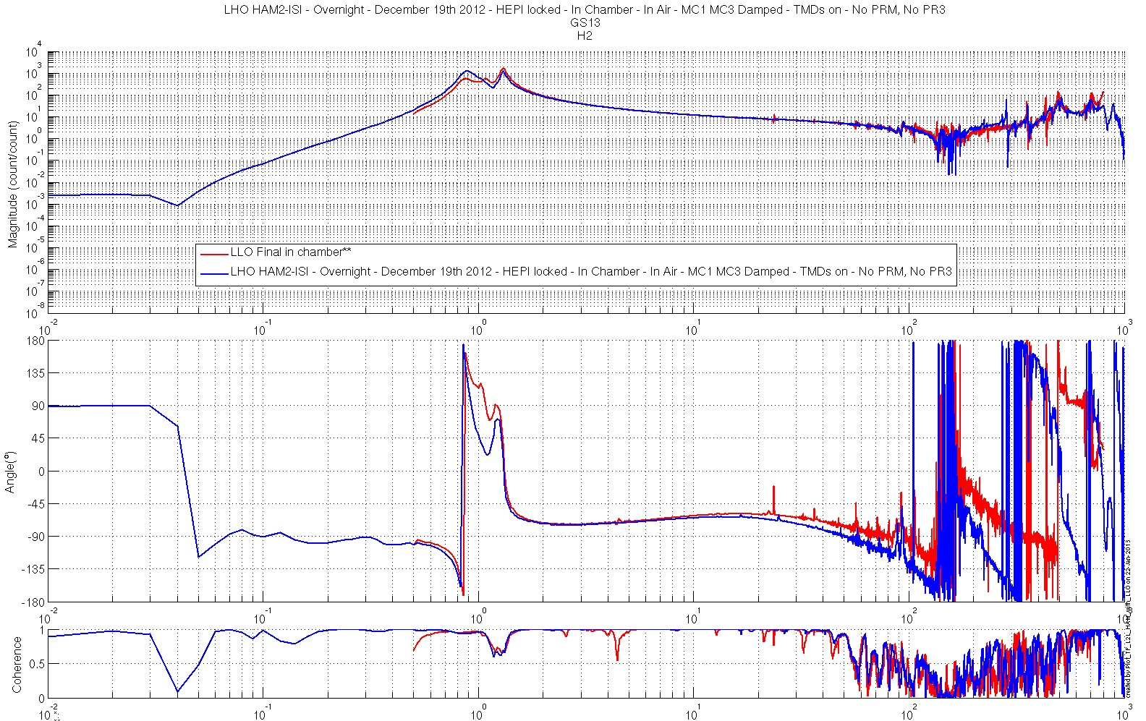
Figure– Local-to-Local Transfer Function – GS13 H2 – Comparison with LLO
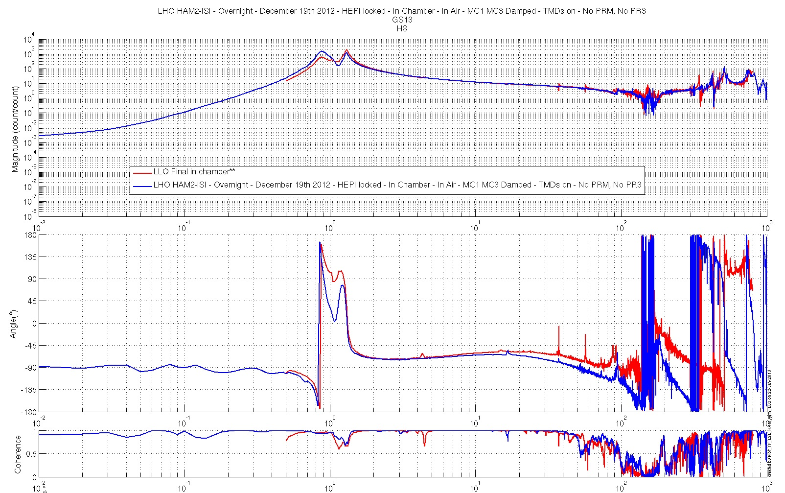
Figure– Local-to-Local Transfer Function – GS13 H3 – Comparison with LLO

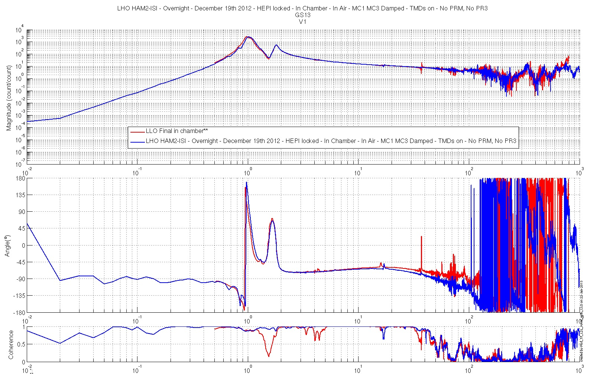
Figure– Local-to-Local Transfer Function – GS13 V1 – Comparison with LLO
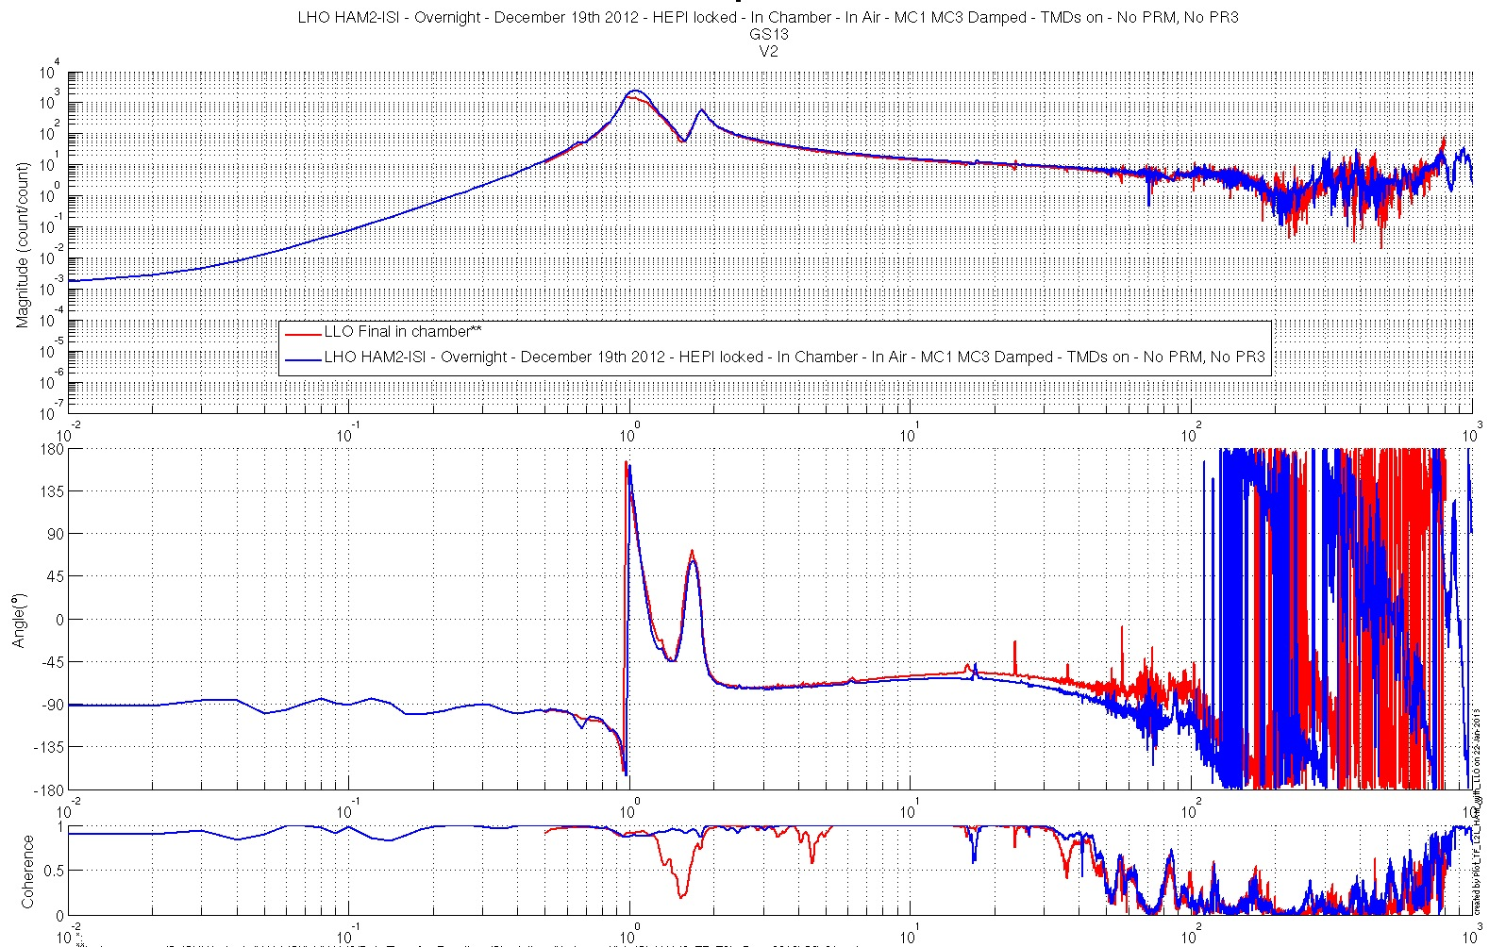
Figure– Local-to-Local Transfer Function – GS13 V2 – Comparison with LLO

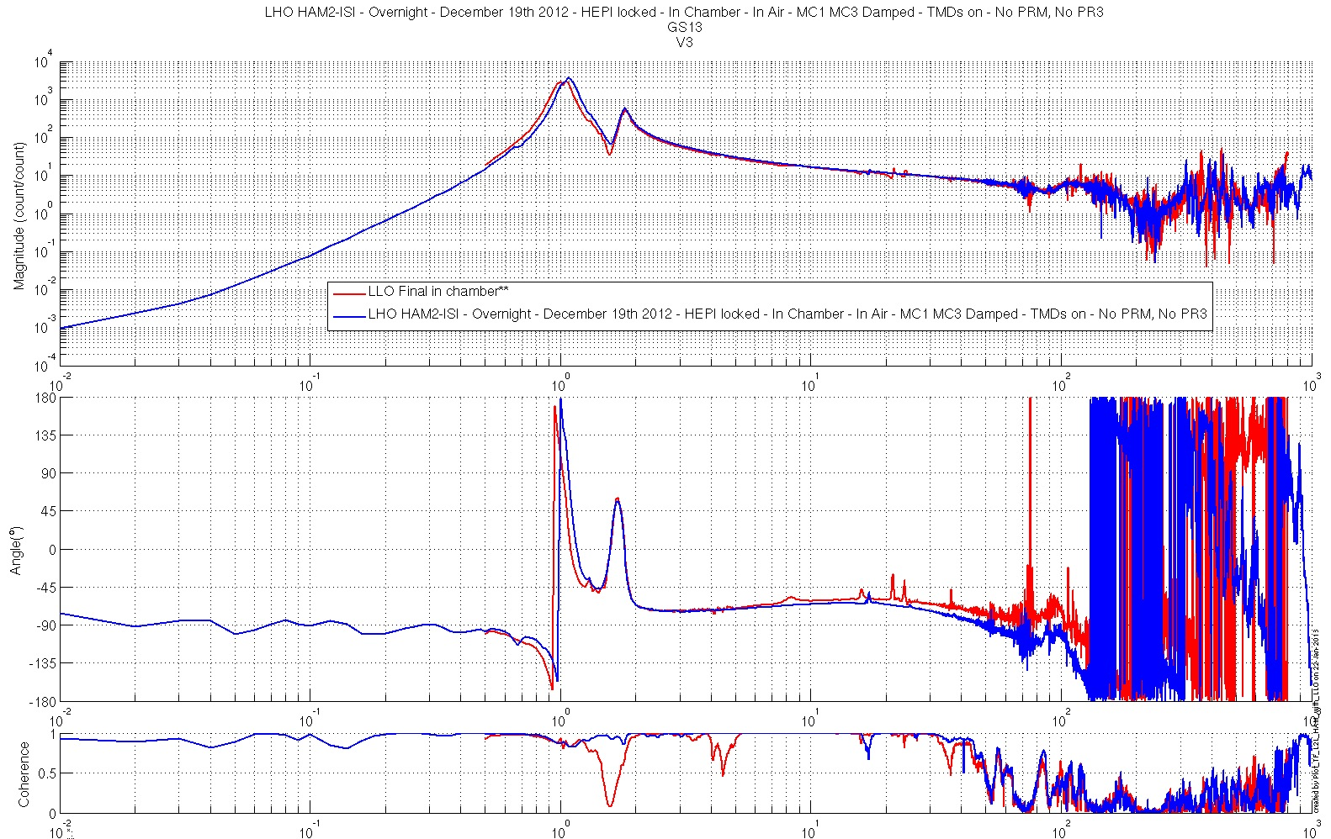
Figure– Local-to-Local Transfer Function – GS13 V3 – Comparison with LLO
Issues/difficulties/comments regarding this test:
- Transfer functions corresponding to the same phase of testing could not be found for LLO HAM2-ISI.
- The transfer functions used as reference were measured at LLO on December 18th. It is likely that HEPI was then unlocked.

Acceptance criteria:
- Good concordance with TF measured under the same conditions at LLO.
- Local to local measurements
  - On CPS, the phase must be 0º at DC
  - On Geophones, the phase must be -90º at DC
  - Identical shape in each corner
- Cartesian to Cartesian measurements
  - On CPS, the phase must be 0º at DC
  - On Geophones, the phase must be -90º at DC
  - Identical shape X/Y and RX/RY

Test result: Passed: X Failed: .

Step 16: Symmetrized Transfer functions

The following symmetrized transfer functions were calculated from the Local-to-Local transfer functions presented above, in step 15. They are provided as extra material. Hence, they are not subject to acceptance (fail/pass).

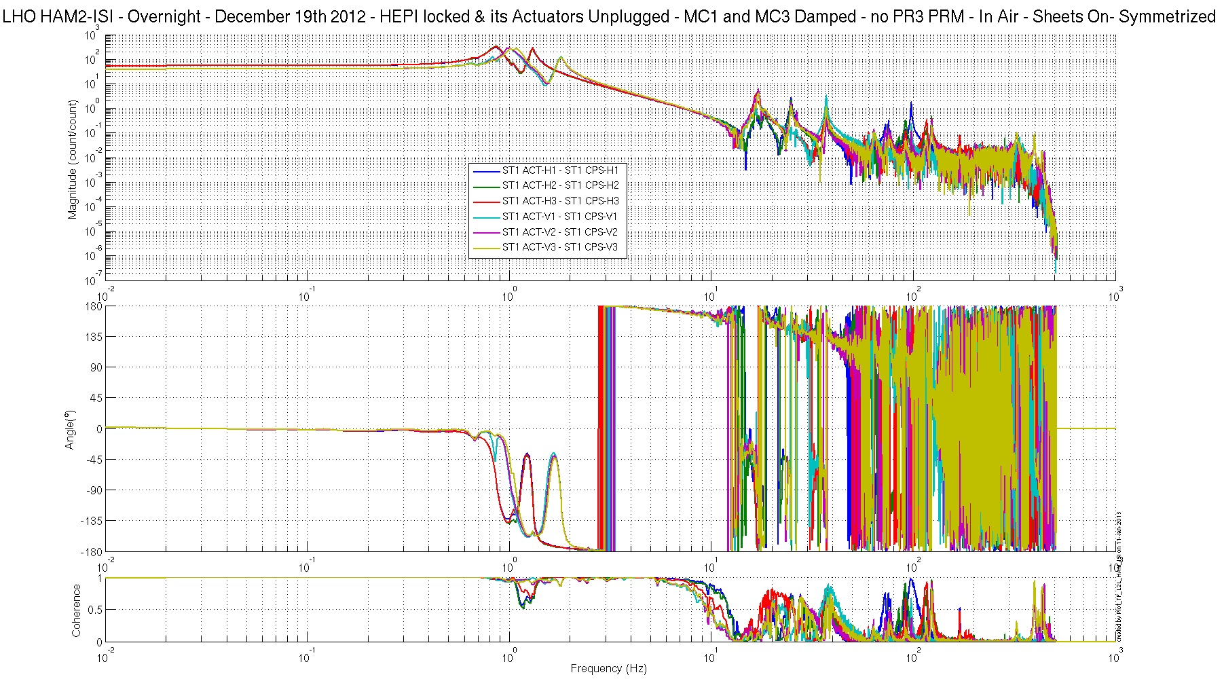
Figure– Local-to-Local Transfer Function – Capacitive Position Sensors – Symmetrized

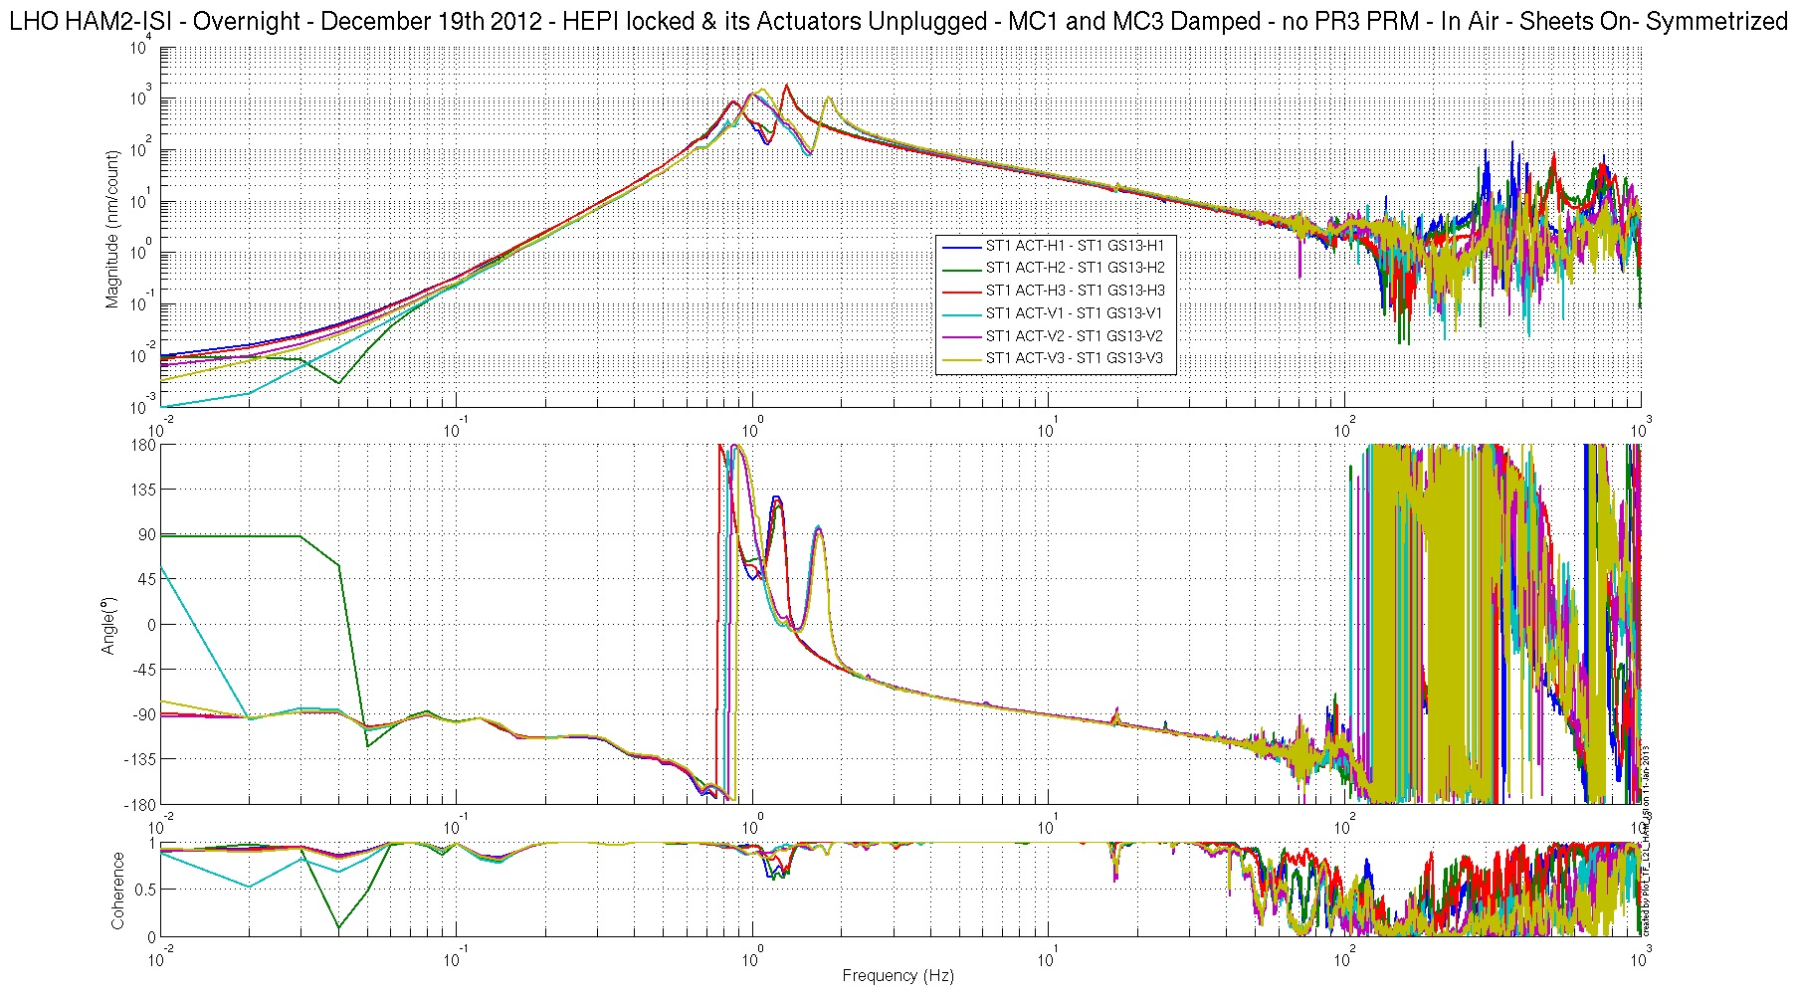
Figure– Local-to-Local Transfer Function – GS13s – Symmetrized

Step 17: Cartesian-to-Cartesian Transfer functions.

The following Cartesian-to-Cartesian symmetrized transfer functions were calculated from the Local-to-Local transfer functions presented above, in step 15. They are provided as extra material. Hence, they are not subject to acceptance (fail/pass).

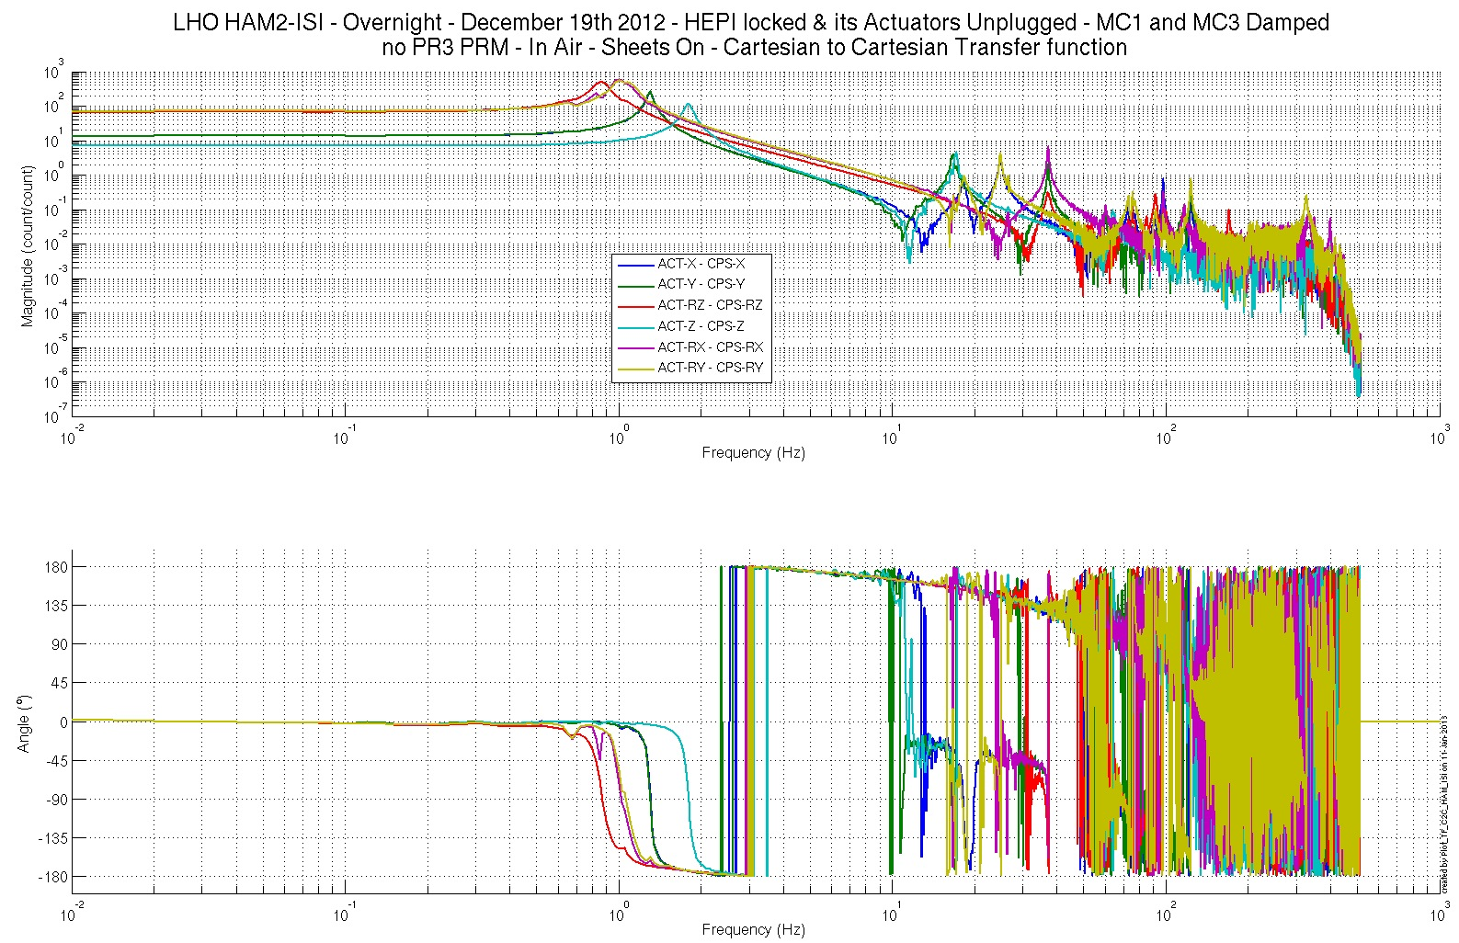
Figure– Cartesian-to-Cartesian Transfer Function – CPSs – Symmetrized

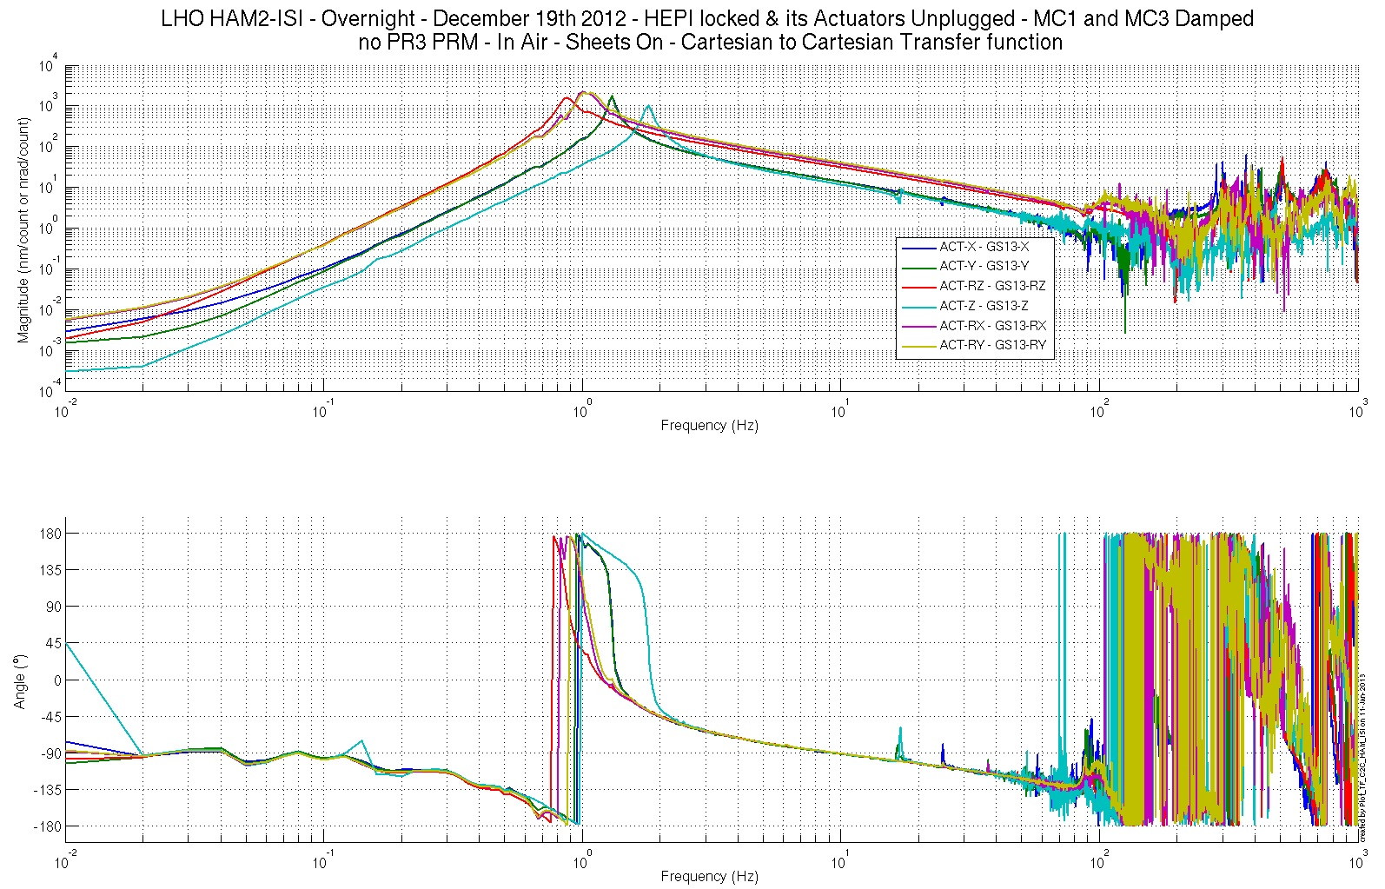 Figure– Cartesian-to-Cartesian Transfer Function – GS13s – Symmetrized

Conclusion
Final Chamber Testing

This part of the Phase II testing took place in open chamber, with sheets on. All the suspensions, and optics, needed for the IMC test were on. PRM and PR3 will be installed after the IMC test.

At this time, HEPI pipes are not flushed yet. Hence, HEPI is locked.

This was the last phase of testing before the chamber was closed for the IMC test.

The chamber was closed on Dec 20th, after SEI approval of the latest set of transfer functions (12/19/2013)

Waved Tests:
- Step 6 – Tilted Spectra: Locked/Unlocked spectra look fine and this test was already validated during the Initial In-Chamber Testing section (step 9)
- Step 10 - The profile of the blade of corner 2 could not be measured. Pre-commissioning tests and transfer function indicate that it will not be an issue for the IMC test.
- LZMP: It is a lengthy measurement that needs tweaking before being run with suspensions on. Indeed, suspensions trip when the test is run.

Particularities to be kept in mind:
- CPS gaps need to be reset after IMC test.

