LIGO Laboratory / LIGO Scientific Collaboration

LIGO- E1200507 LIGO Dec 13th, 2012

aLIGO HAM-ISI, Installation Test Report, Phase II
Chamber-Side Testing & Initial Chamber Testing
LHO HAM3-ISI (unit #5)
E1200507-V5

Hugo Paris, Fabrice Matichard
Hugh Radkins, Jim Warner, Greg Grabeel, Corey Gray, Mitchell Robinson, Eric Allwine

Distribution of this document:
Advanced LIGO Project

This is an internal working note
of the LIGO Laboratory

California Institute of Technology  LIGO Project – MS 18-34  1200 E. California Blvd.  Pasadena, CA 91125  Phone (626) 395-2129  Fax (626) 304-9834  E-mail: info@ligo.caltech.edu | Massachusetts Institute of Technology  LIGO Project – NW22-295  185 Albany St  Cambridge, MA 02139  Phone (617) 253-4824  Fax (617) 253-7014  E-mail: info@ligo.mit.edu
LIGO Hanford Observatory  P.O. Box 1970  Mail Stop S9-02  Richland WA 99352  Phone 509-372-8106  Fax 509-372-8137 | LIGO Livingston Observatory  P.O. Box 940  Livingston, LA 70754  Phone 225-686-3100  Fax 225-686-7189

Table of contents:

I. CHAMBER SIDE TESTING 5
▪ Test 1 - CPS Check 5
▪ Test 2.1 – CPS noise spectra 6
▪ Test 2.2 – GS13 Spectra 10
II. INITIAL IN CHAMBER TESTING 16
▪ Step 1: Cables Inventory 16
▪ Step 2: Electronics Inventory 16
▪ Step 3: Level of Stage 1 17
▪ Step 4: Mass Budget 17
▪ Step 5: Shim Thickness 18
▪ Step 6: Blade Spring Profile 19
▪ Step 7: Lockers Adjustment 20
▪ Step 8: CPS Gap 20
▪ Step 9: CPS and GS13 Spectra - ISI Unlocked 21
▪ Step 10: GS13 ASD - Tabled Tilted 23
▪ Step 11: GS13 pressure readout 24
▪ Step 12: Actuators Sign and range of motion (Local drive) 24
▪ Step 13: Static Testing (Tests in the local basis) 25
▪ Step 14: Linearity test 26
▪ Step 15: Frequency response 28
▪ Step 15.1: Local to local measurements 28
▪ Step 15.2: Local to local measurements V.S. LLO 30
III. Final In-Chamber Testing 35
▪ Step 1: Parts Inventory (E1000052) 35
▪ Step 2: Cables inventory: 36
▪ Step 3: Electronics inventory 36
▪ Step 4: Payload Survey 36
▪ Step 5: Locked/Unlocked Spectra 38
▪ Step 6: Tilted Spectra 40
▪ Step 7: Pressure Readouts 40
▪ Step 8: Lockers/CPS Adjustment 41
▪ Step 9: Shim Thickness 42
▪ Step 10: Blade Spring Profile 42
▪ Step 11: Level of Stage 1 43
▪ Step 12: Range of Motion 44
▪ Step 13: Static Testing 44
▪ Step 14: Linearity Test 45
▪ Step 15: Local to Local Transfer Function Measurements 47
▪ Step 15.1: Local to local measurements 47
▪ Step 15.2: Local to local measurements V.S. LLO 49
▪ Step 16: Symmetrized Transfer functions 56
▪ Step 17: Cartesian-to-Cartesian Transfer functions. 57
57

PHASE II Testing

The phase II of HAM-ISI testing corresponds to the tests performed after the Assembly Validation, and before the Control and Commissioning of the Units. It is divided in two parts. The present document is divided in two sections: One for each part of the Phase II testing:

Part.1 Chamber-Side testing
Part.2 Initial Chamber Testing

Chamber-Side Testing is a basic sensor check with a spectrum analyzer. Units can be inserted in their chamber of destination once they pass.

Initial Chamber Testing takes place in open chamber, with the optics off, and HEPI locked. The ISI is then connected to the electronic rack with the final in-field cables. Models are installed and running. Tests are performed with Matlab® scripts.

Optics and Suspensions can be installed right after the end of this phase of testing. No test is performed during their installation.

Final Chamber Testing starts once Optics and Suspensions are installed. The lockers and the CPSs usually need to be reset at this point.

Introduction
Chamber-Side Testing

HAM-ISI Unit #5 was intended to populate HAM3 chamber. The tests presented in this first part of the phase II testing report were performed between June 12th and June 13th 2012, in accordance with the second version of the Pre-Integration Chamber-Side Testing procedure (E1200513-v2).

At the beginning of the Chamber-Side Testing:
- Assembly validation testing has been performed on the ISI
- Phase I test report was validated (E1000314)
- The ISI was stored in a container, moved from the staging building to the LVEA, and installed under a clean room in the LVEA, on its container’s base
- The container is sitting on lab-jacks to allow level adjustments without unlocking the ISI
- The Unit is equipped with production GS13s
- The optical table is not loaded with masses yet
- The ISI is locked

The goal of the Chamber-Side Testing is to ensure that the sensors and their electronics (ADE boxes of the CPSs) did not alter during storage/transportation.

At the end of the Chamber-Side Testing:
- All sensors have been checked
- Data related to the tests is available on the SVN
- The HAM-ISI is on the chamber-side, ready for the in-chamber insertion

CHAMBER SIDE TESTING

Test 1 - CPS Check
During this step, we want to make sure that the CPSs, their cables and their electronics are functional.

Corner | Direction | Voltage | Sensor reacts to shim insertion
 |  | (No shim)
1 | H | 1.405 | X
 | V | 4.63 | X
2 | H | 1.781 | X
 | V | 1.099 | X
3 | H | -0.202 | X
 | V | 2.732 | X
Table – CPS Check

Issues/difficulties/comments regarding this test:
- ADE boxes were connected to the same power supply
- ADE boxes must share the same ground.
- ADE boxes must be grounded to the test stand
- Not having the ADE boxes grounded to the test stand causes the CPS readouts to vary with the number of probes that are connected to the ADE boxes (LHO aLog #2972).

Acceptance Criteria:
- All CPS were tested
- All CPS react to shim insertion
- The voltages recorded with no shim are within ⁺/-5V.

Test result: Passed: X Failed: .

Test 2.1 – CPS noise spectra
During this step, we want measure the noise spectra of the CPSs and make sure that it is not too high.

A spectrum analyzer is used. The maximum number of points available for the FFT (800) limits the frequency resolution. Measurements are performed in two sections that are combined afterwards to allow getting good resolution in low frequency. Sections overlap to allow checking for potential mismatch.

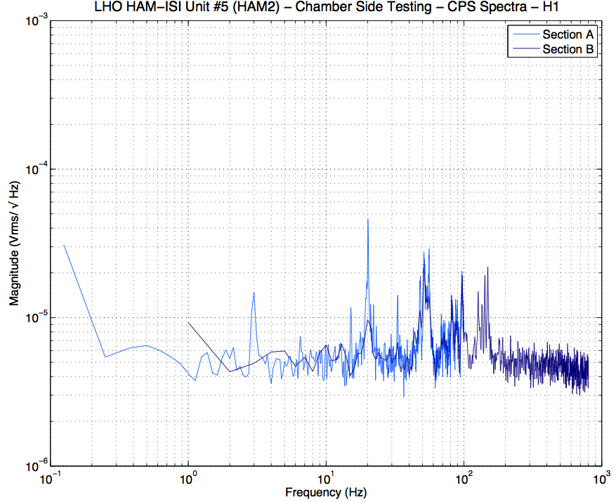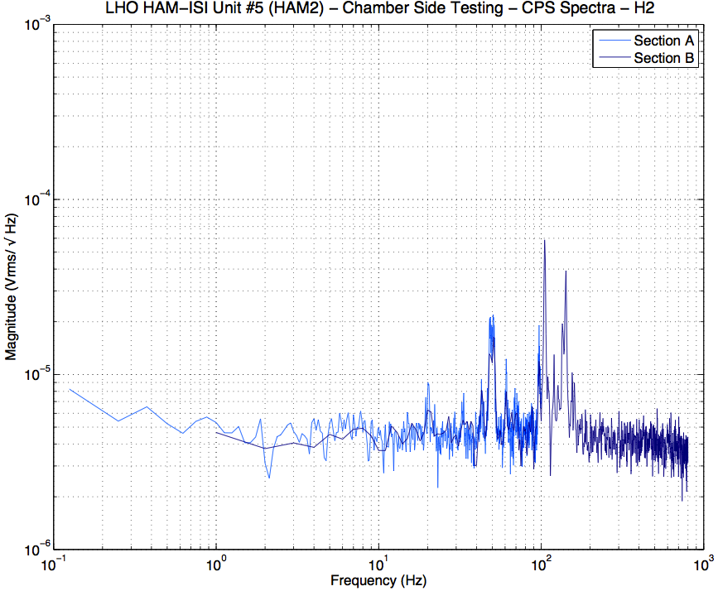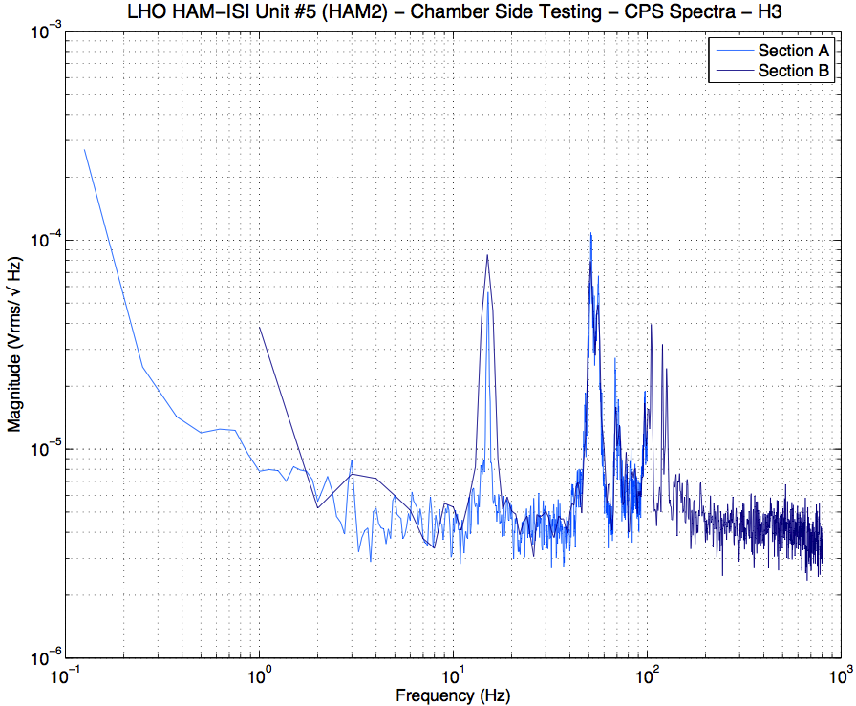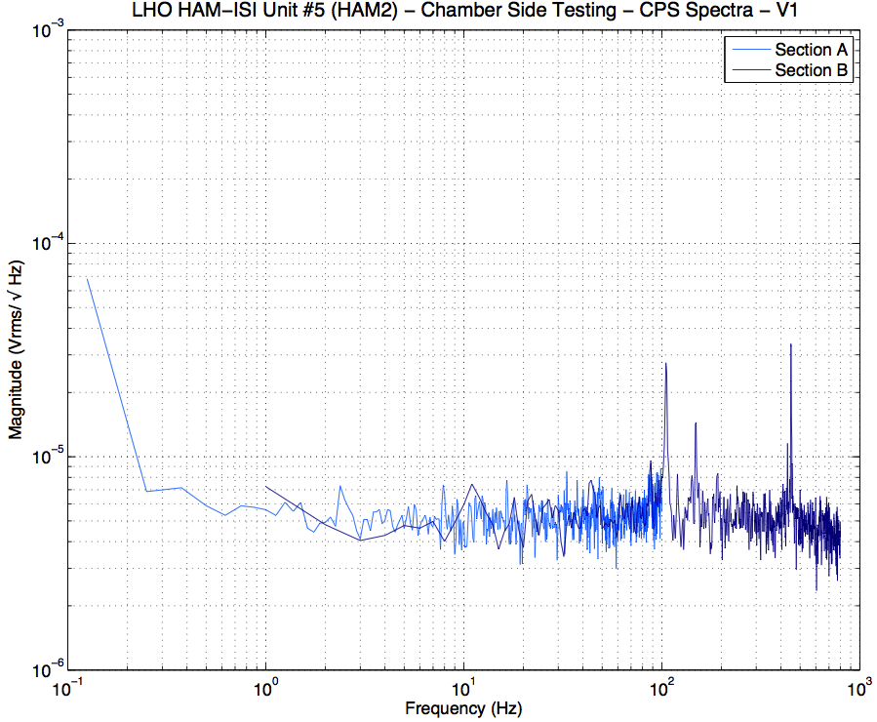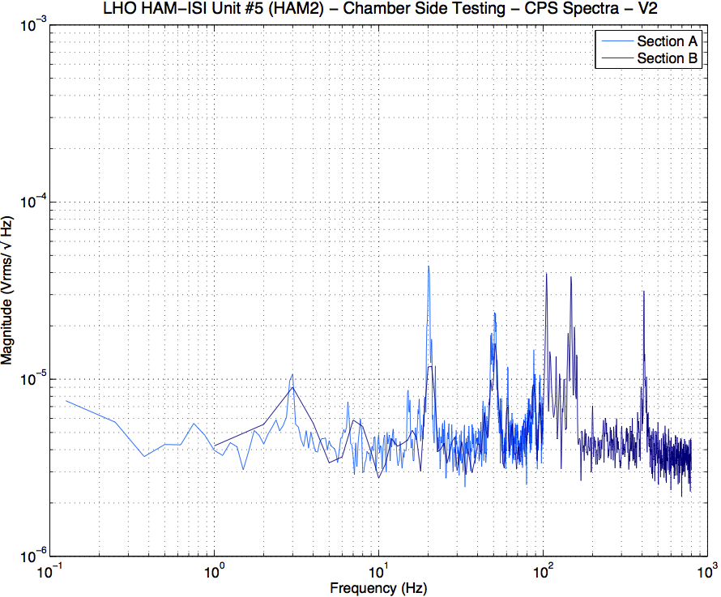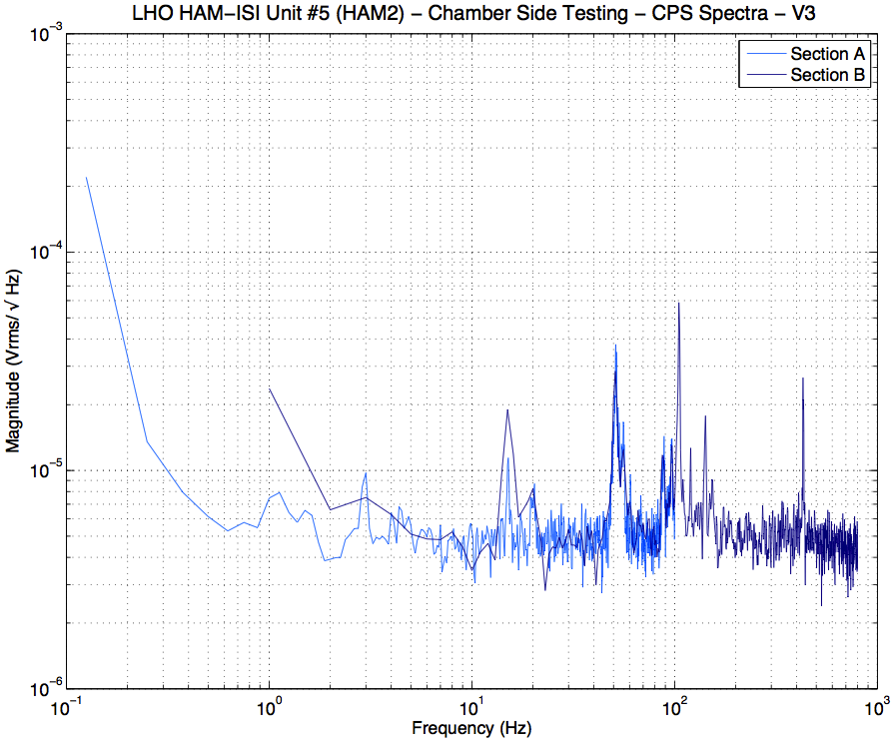
Figure – CPS Spectra - Section Check

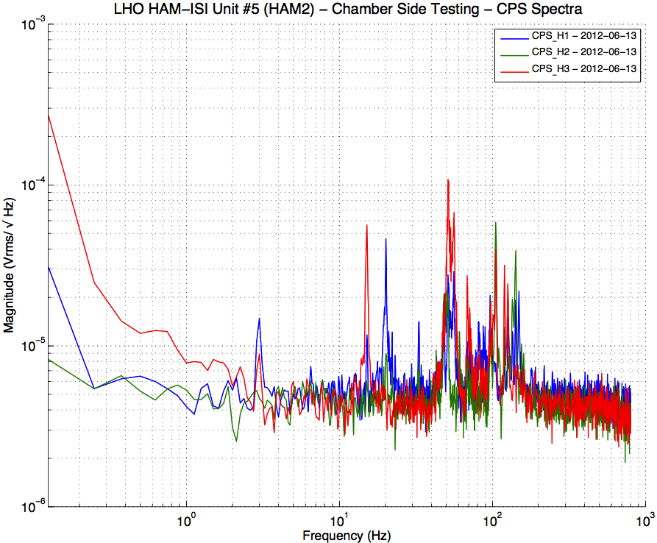
Figure – Horizontal CPSs spectra

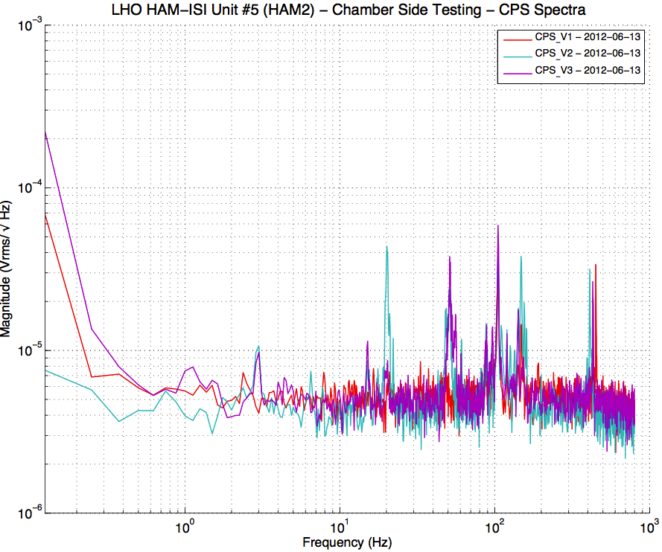
Figure – Vertical CPSs Spectra
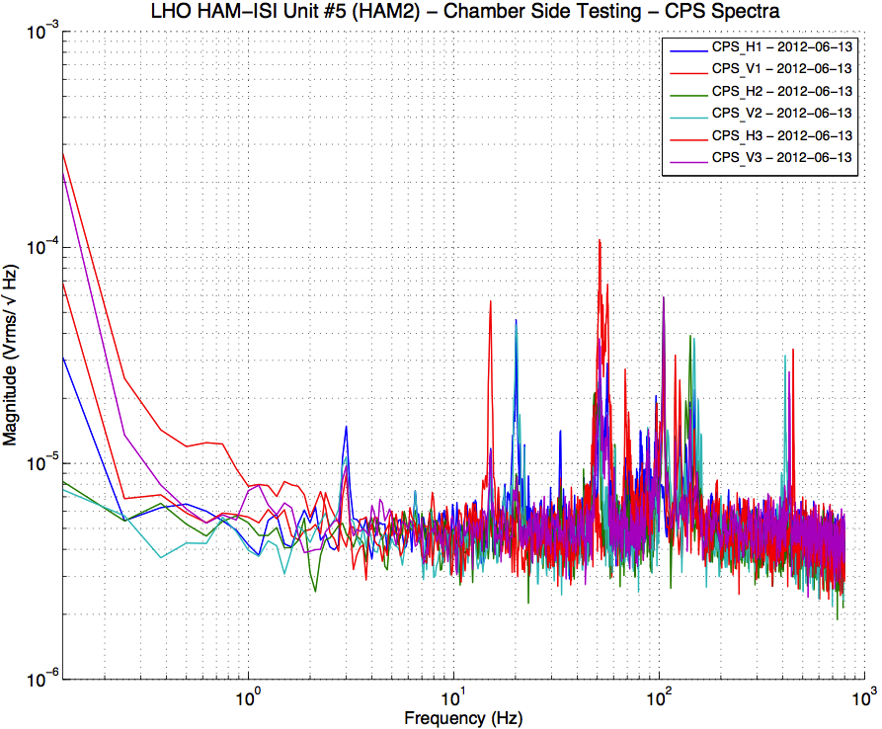
Figure – All CPSs Spectra

Data in the SVN at:
/SeiSVN/seismic/HAM-ISI/H1/HAM3/Data/Spectra/Chamber_Side/
SEI-HAM_ISI_Unit_5_Chamber_Side_Locked__-CPS__Corner_1-Section_A-2012-06-13.182243.txt
SEI-HAM_ISI_Unit_5_Chamber_Side_Locked__-CPS__Corner_1-Section_B-2012-06-13.182536.txt
SEI-HAM_ISI_Unit_5_Chamber_Side_Locked__-CPS__Corner_2-Section_A-2012-06-13.173829.txt
SEI-HAM_ISI_Unit_5_Chamber_Side_Locked__-CPS__Corner_2-Section_B-2012-06-13.174121.txt
SEI-HAM_ISI_Unit_5_Chamber_Side_Locked__-CPS__Corner_3-Section_A-2012-06-13.183353.txt
SEI-HAM_ISI_Unit_5_Chamber_Side_Locked__-CPS__Corner_3-Section_B-2012-06-13.183632.txt

Sections Check plots in the SVN at
/SeiSVN/seismic/HAM-ISI/H1/HAM3/Figures/Spectra/Chamber_Side/Sections_Check/
HAM_ISI_Unit_5_ASD_Volts_SECTION_CHECK_CPS__H1_ISI_Chamber_Side_Locked__2012_06_13.fig
HAM_ISI_Unit_5_ASD_Volts_SECTION_CHECK_CPS__V1_ISI_Chamber_Side_Locked__2012_06_13.fig
HAM_ISI_Unit_5_ASD_Volts_SECTION_CHECK_CPS__H2_ISI_Chamber_Side_Locked__2012_06_13.fig
HAM_ISI_Unit_5_ASD_Volts_SECTION_CHECK_CPS__V2_ISI_Chamber_Side_Locked__2012_06_13.fig
HAM_ISI_Unit_5_ASD_Volts_SECTION_CHECK_CPS__H3_ISI_Chamber_Side_Locked__2012_06_13.fig
HAM_ISI_Unit_5_ASD_Volts_SECTION_CHECK_CPS__V3_ISI_Chamber_Side_Locked__2012_06_13.fig

Sections Combined plots in the SVN at:
/SeiSVN/seismic/HAM-ISI/H1/HAM3/Figures/Spectra/Chamber_Side/Sections_Combined/
HAM_ISI_Unit_5_PSD_Volts_CPS__H_ISI_Chamber_Side_Locked___2012_06_13.fig
HAM_ISI_Unit_5_PSD_Volts_CPS__V_ISI_Chamber_Side_Locked___2012_06_13.fig
HAM_ISI_Unit_5_PSD_Volts_CPS__ISI_Chamber_Side_Locked___2012_06_13.fig

Programs to run the sr785 from a laptop under the SVN at:
/SeiSVN/seismic/HAM-ISI/H1/HAM3/Scripts/Chamber_Side/sr785_Programs/

Testing Scripts under the SVN at:
/SeiSVN/seismic/HAM-ISI/H1/HAM3/Scripts/Chamber_Side/Testing_Scripts /

Issues/difficulties/comments regarding this test:
Results in accordance with HAM2

Acceptance Criteria:
- Sections Match together
- CPS noise spectra must be below 10⁻⁴Vrms/√Hz
- Plots of Spectra are saved under the SVN

Test result: Passed: X Failed: .

Test 2.2 – GS13 Spectra
During this test we want to take spectra of the GS13s to make sure that they are still functional.

A spectrum analyzer is used. The maximum number of points available for the FFT (800) limits the frequency resolution. Measurements are performed in two sections that are combined afterwards to allow getting good resolution in low frequency. Sections overlap to allow checking for potential mismatch.

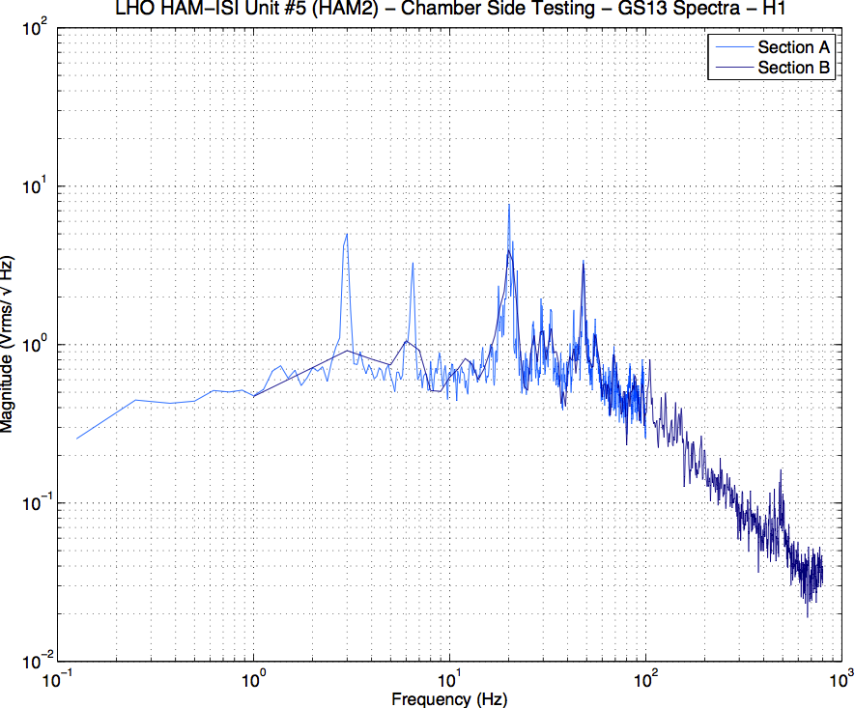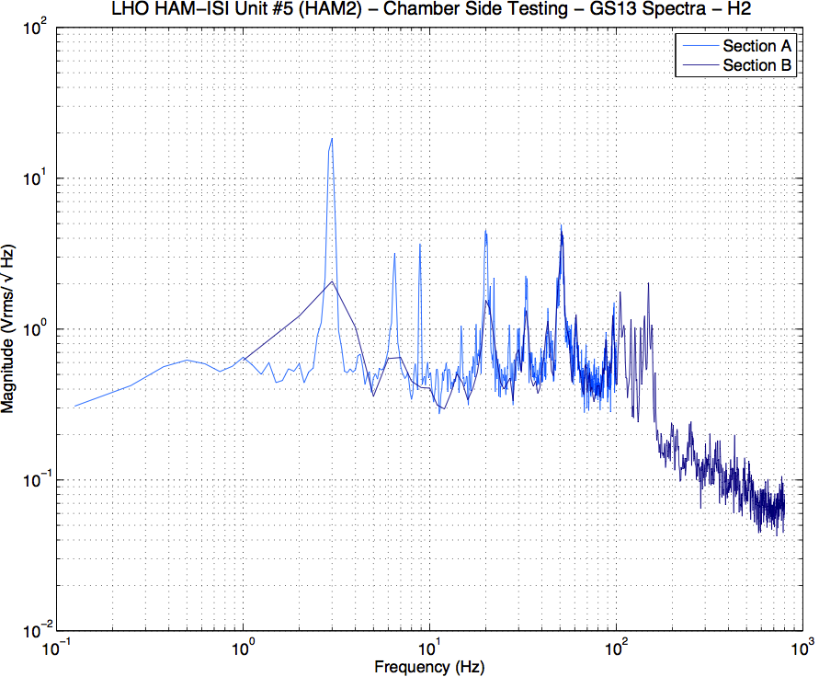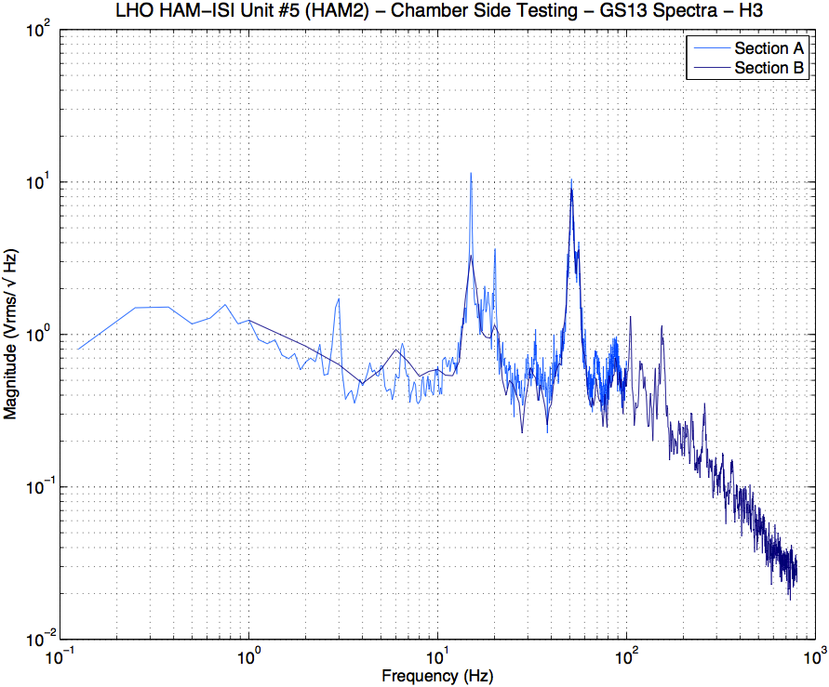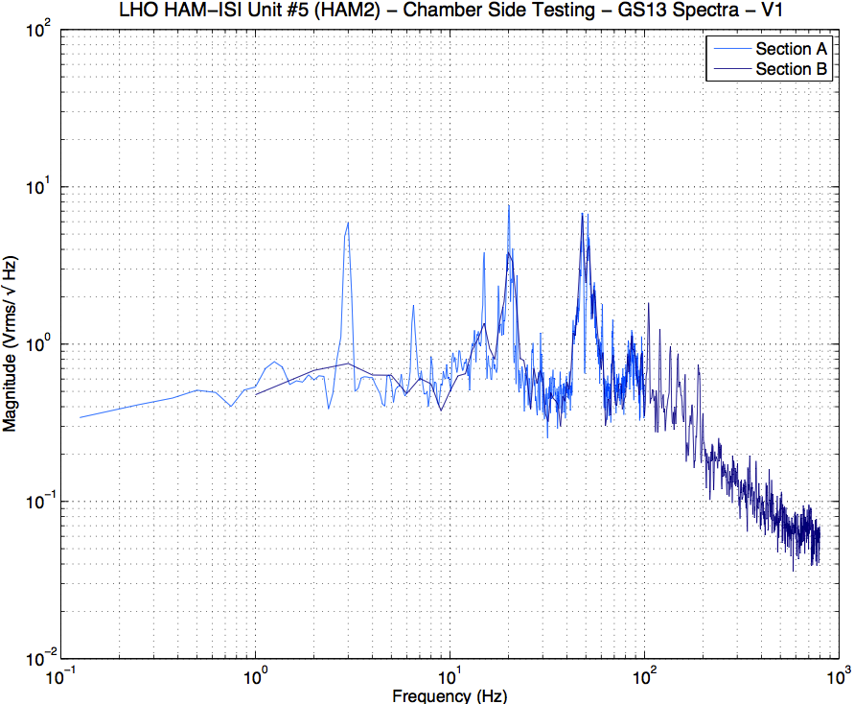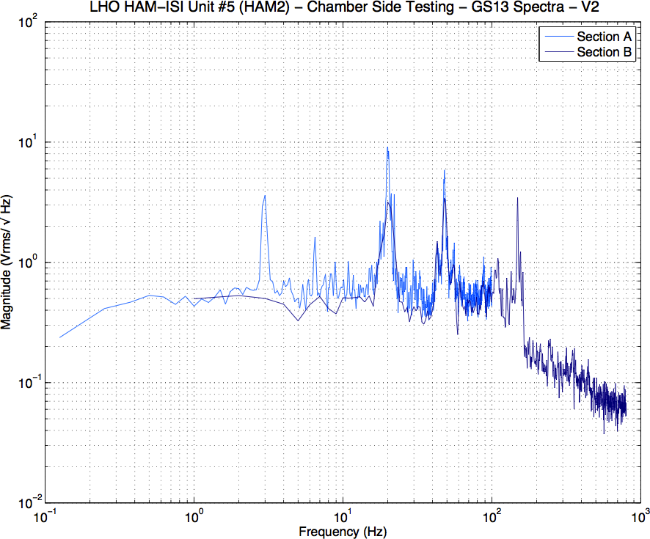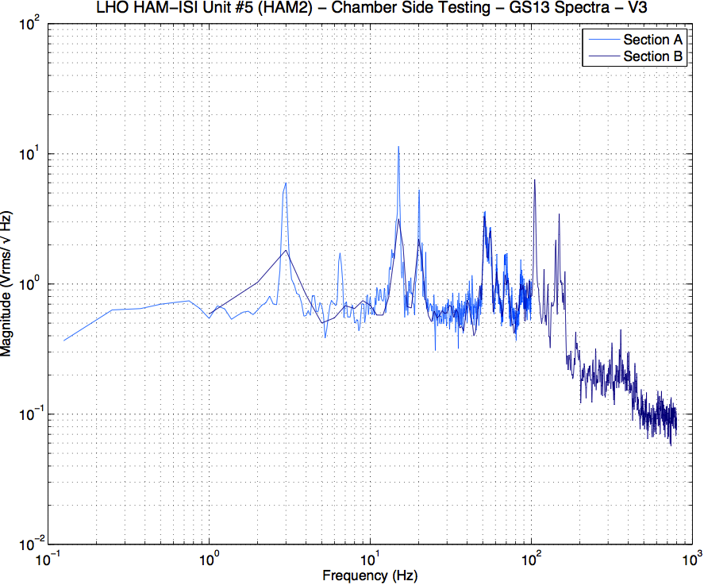
Figure – GS13 Spectra- Section Check

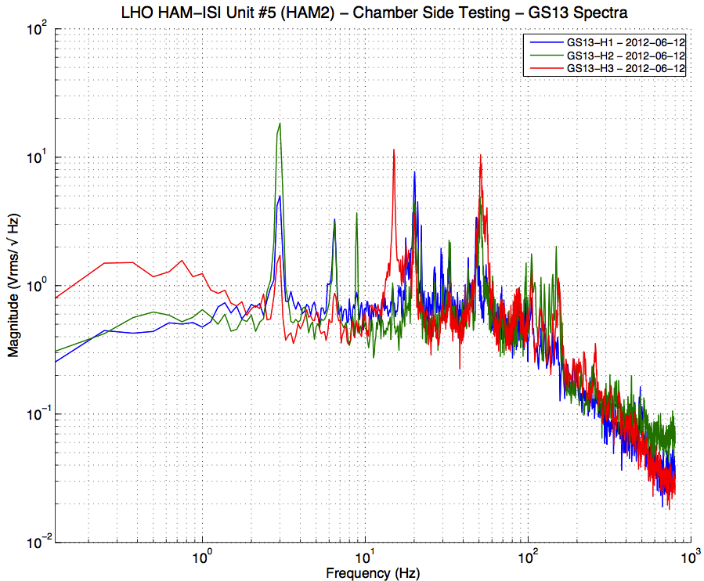
Figure – Horizontal GS13s Spectra

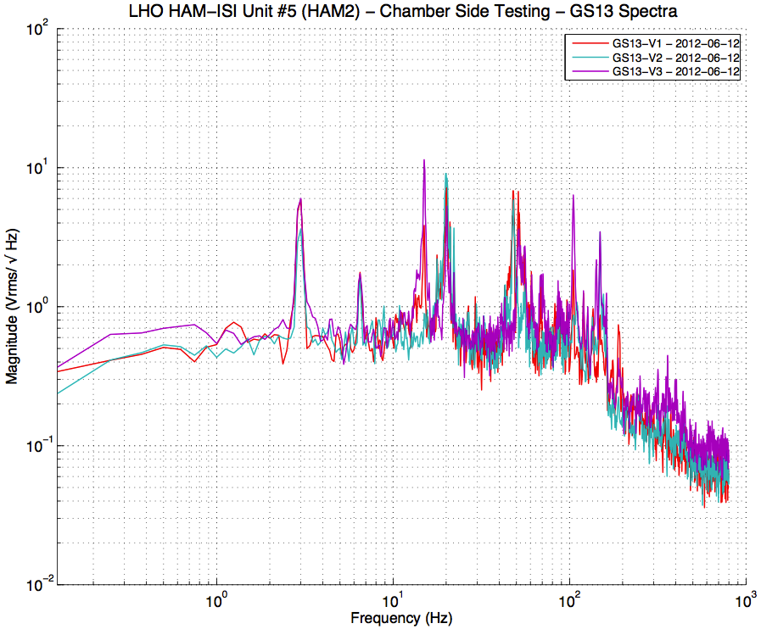
Figure – Vertical GS13s Spectra
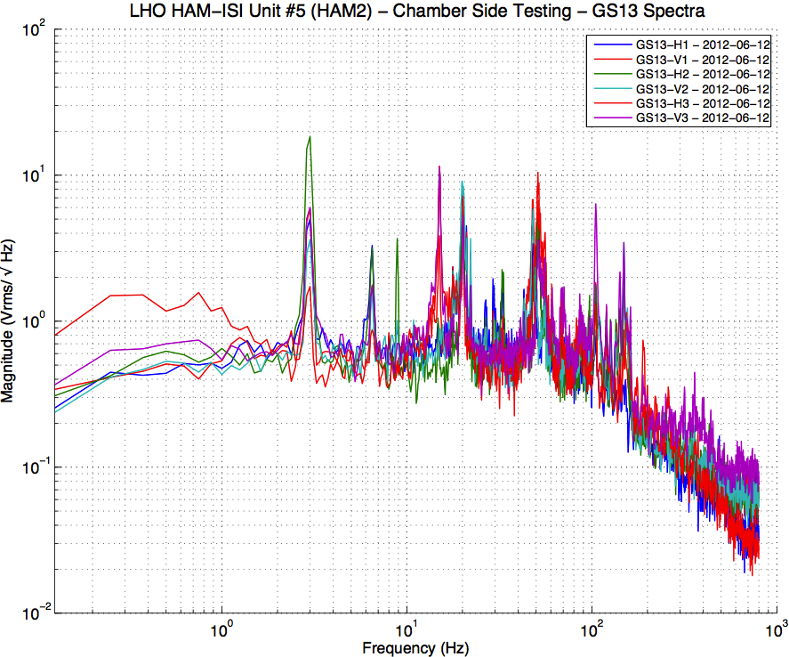
Figure – Horizontal and Vertical GS13s Spectra

Data in the SVN at:
/SeiSVN/seismic/HAM-ISI/H1/HAM3/Data/Spectra/Chamber_Side/
SEI-HAM_ISI_Unit_5_Chamber_Side_Locked__-GS13_Corner_1-Section_A-2012-06-12.225110.txt
SEI-HAM_ISI_Unit_5_Chamber_Side_Locked__-GS13_Corner_1-Section_B-2012-06-12.225350.txt
SEI-HAM_ISI_Unit_5_Chamber_Side_Locked__-GS13_Corner_2-Section_A-2012-06-12.224428.txt
SEI-HAM_ISI_Unit_5_Chamber_Side_Locked__-GS13_Corner_2-Section_B-2012-06-12.224715.txt
SEI-HAM_ISI_Unit_5_Chamber_Side_Locked__-GS13_Corner_3-Section_A-2012-06-12.231439.txt
SEI-HAM_ISI_Unit_5_Chamber_Side_Locked__-GS13_Corner_3-Section_B-2012-06-12.231742.txt

Sections Check plots in the SVN at
/SeiSVN/seismic/HAM-ISI/H1/HAM3/Figures/Spectra/Chamber_Side/Sections_Check/
HAM_ISI_Unit_5_ASD_Volts_SECTION_CHECK_GS13_H1_ISI_Chamber_Side_Locked__2012_06_12.fig
HAM_ISI_Unit_5_ASD_Volts_SECTION_CHECK_GS13_H2_ISI_Chamber_Side_Locked__2012_06_12.fig
HAM_ISI_Unit_5_ASD_Volts_SECTION_CHECK_GS13_H3_ISI_Chamber_Side_Locked__2012_06_12.fig
HAM_ISI_Unit_5_ASD_Volts_SECTION_CHECK_GS13_V1_ISI_Chamber_Side_Locked__2012_06_12.fig
HAM_ISI_Unit_5_ASD_Volts_SECTION_CHECK_GS13_V2_ISI_Chamber_Side_Locked__2012_06_12.fig
HAM_ISI_Unit_5_ASD_Volts_SECTION_CHECK_GS13_V3_ISI_Chamber_Side_Locked__2012_06_12.fig

Sections Combined plots in the SVN at:
/SeiSVN/seismic/HAM-ISI/H1/HAM3/Figures/Spectra/Chamber_Side/Sections_Combined/
HAM_ISI_Unit_5_PSD_Volts_GS13_H_ISI_Chamber_Side_Locked___2012_06_12.fig
HAM_ISI_Unit_5_PSD_Volts_GS13_V_ISI_Chamber_Side_Locked___2012_06_12.fig
HAM_ISI_Unit_5_PSD_Volts_GS13_ISI_Chamber_Side_Locked___2012_06_12.fig

Programs to run the sr785 from a laptop under the SVN at:
/SeiSVN/seismic/HAM-ISI/H1/HAM2/Scripts/Chamber_Side/sr785_Programs/

Testing Scripts under the SVN at:
/SeiSVN/seismic/HAM-ISI/H1/HAM2/Scripts/Chamber_Side/Testing_Scripts /

Issues/difficulties/comments regarding this test:
- One can notice a bump below 1Hz on H3 spectrum. Measurements were performed in the LVEA, one corner at a time. It is very likely that this bump comes from a change in the spectral content of the activities (Grouting, welding, craning, …) that were on-going in the LVEA.
- Results are in accordance with HAM2

Acceptance Criteria:
- Sections Match together
- GS13s responses must not drop in low frequency
- Plots of powerspectra are saved under the SVN

Test result: Passed: X Failed: .

Conclusion
Chamber-Side Testing

HAM-ISI Unit #5 was intended to populate HAM3 chamber. The tests presented here were performed between June 12th and June 13th 2012, in accordance with the second version of the Pre-Integration Chamber-Side Testing procedure (E1200513-v2).

All sensors appeared to be functional.

This Unit is ready to be inserted in HAM3 chamber. Initial Chamber Testing can then proceed.

Introduction
Initial Chamber Testing

This part of the Phase II testing takes place in open chamber, with the optics off, and HEPI locked. The ISI is then connected to the electronic rack with the final in-field cables. Models are installed and running. Tests are performed with Matlab® scripts.

Optics and Suspensions can be installed right after the end of this phase of testing. No test is performed during their installation.

Final Chamber Testing starts once Optics and Suspensions are installed. The lockers and the CPSs usually need to be reset at this point.

INITIAL IN CHAMBER TESTING

HAM3-ISI was installed in in its chamber on June 15th 2012. In field cables were received on July 25th. Their installation finished on July 27th. This initial in chamber testing was conducted in the following 4 days until the chamber was relinquished for installation of Optics and Suspensions on August 1st.

Step 1: Cables Inventory
Actuator cables were replaced in chamber to reach the feedthrough. S/N were recorded.

Cable Connects |  | Cable S/N
Part Name | Configuration | Corner 1 | Corner 2 | Corner 3
GS13 | Horizontal | S1104712 | S1106659 | S1106664
 | Vertical
L4C | Horizontal | NA | NA | NA
 | Vertical | NA | NA | NA
Actuator | Horizontal | S1104756 – 95” | S1104492 -70” | S1106678
 | Vertical | S1106679 | S1104490 | S1105207
Table – Cables inventory

Acceptance Criteria:
Inventory is complete

Test result: Passed: X Failed: .

Step 2: Electronics Inventory

Hardware | LIGO reference | S/N
Coil driver | D0902744 | S1103321
 |  | S1103358
Anti Image filter | D1100202 | S1202068
Anti aliasing filter | D1000269 | S1202074
 |  | S1202075
Interface chassis | D1000067 | S1201752
 |  | S1201753
Acceptance Criteria:
Inventory is complete
Test result: Passed: X Failed: .

Step 3: Level of Stage 1

The optical table is within a ⁺/₋0.1mm levelness (LHO aLog #3586).
The biggest difference between two corners is then 0.2mm, which corresponds, approximately, to 8mils.

Max angle = 0.008” / 86” = 93µrad

Acceptance Criteria
- The maximum angle of the table with the horizontal mustn’t exceed ~100µrad

Test result: Passed: X Failed: .

Step 4: Mass Budget
 | 00 | 01 | 02 | 03 | 04 | 05 | 06
 | 0.6 | 1.1 | 2.2 | 4.5 | 7.9 | 15.6 | 27.2 | lbs | kgs
w9 |  |  | 1 | 3 |  |  |  | 15.7 | 7.12
w1 | 1 | 0 | 1 | 1 |  |  |  | 7.3 | 3.31
w2 |  |  |  |  | 2 |  |  | 15.8 | 7.17
w3 |  |  | 1 | 3 |  |  |  | 15.7 | 7.12
w4 |  |  | 1 | 2 |  |  |  | 11.2 | 5.08
w5 |  |  |  | 2 | 0 |  |  | 9 | 4.08
w6 |  |  | 1 | 1 | 1 |  |  | 14.6 | 6.62
w7 | 1 | 1 |  |  |  |  |  | 1.7 | 0.77
w8 |  |  |  |  | 2 |  |  | 15.8 | 7.17
Side Masses Total | 2 | 1 | 5 | 12 | 5 | 0 | 0 | 106.8 | 48.44
Table – Wall masses distribution

 | 00 | 01 | 02 | 03 | 04 | 05 | 06
 | 0.6 | 1.1 | 2.2 | 4.5 | 7.9 | 15.6 | 27.2 | lbs | kgs
k1 |  |  |  |  | 1 |  | 1 | 35.1 | 15.92
k2 |  |  |  |  |  | 2 |  | 31.2 | 14.15
k3 |  |  |  |  | 1 |  | 1 | 35.1 | 15.92
k4 |  |  |  |  |  | 2 |  | 31.2 | 14.15
k5 |  |  |  |  | 1 |  | 1 | 35.1 | 15.92
k6 |  |  |  |  |  | 2 |  | 31.2 | 14.15
Keel Masses Total | 0 | 0 | 0 | 0 | 3 | 6 | 3 | 198.9 | 90.22
Table – Keel masses distribution

50lbs | 597lbs | 10kg | Total (kg)
4 | 1 | 6 | 421.51
Table – Optic table masses distribution

 | Side | Keel | Top | Total
Weigh (kg) | 48.44 | 90.22 | 421.51 | 560.18
Table – Mass budget sum up

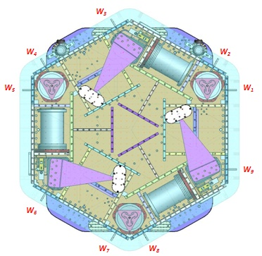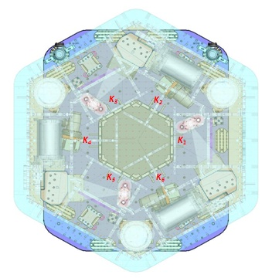
Figure – Wall Masses (W) and Keel masses (K) location. South of picture = corner 1

Issues/difficulties/comments regarding this test:
The mass budget was reported to be 565.10kgs during Assembly Validation. It is now 5kg lighter.
- Bundles of ISC cables were installed on the ISI between the two phases of testing.
- The ISI was roughly balanced for the Initial In Chamber Testing.

Acceptance Criteria
The Mass budget must be
- 579.1 Kg (cf. E1100427)+/-25Kg (5%)

Test result: Passed: X Failed: .

Step 5: Shim Thickness

Issues/difficulties/comments regarding this test:
- Shims were not changed since Assembly Validation Testing. The results presented here come from the Assembly Validation testing report.
- Locker D is hard to close. It will be reset once Suspensions are installed.

Lockers | Shim thickness (mils)
A | 120
B | 120
C | 121
D | 122
Table – Shims Thickness

Test result: Passed: X Failed:

.

Step 6: Blade Spring Profile

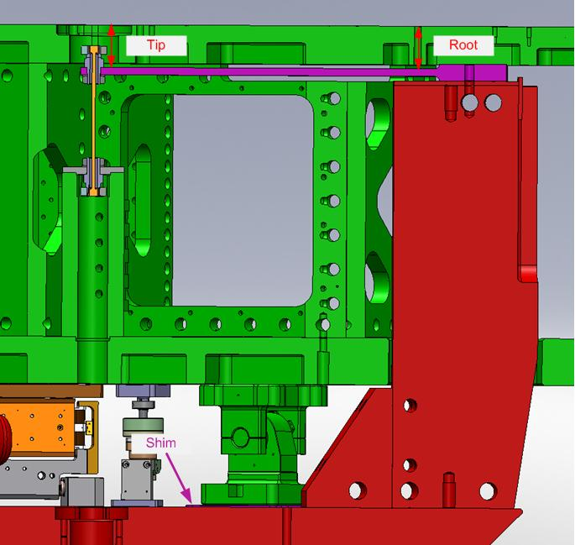
figure – Blade spring profile measurement points

Blade # | Root (Mils) | Tip(Mils) | Flatness (mils)
1 | 388 | 375 | 13
2 | 399 | 381 | 18
3 | 390 | 378 | 12
Table – Blade Spring Profile

Issues/difficulties/comments regarding this test:
Blade #2 is slightly out of the preferred range. The measurement was performed on a locked ISI. The locked position is not optimal, as lockers need to be reset.

Acceptance Criteria:
- Recorded for traceability.
- Flatness preferred within 0.015" inches.

Test result: Passed: X Failed: .

Step 7: Lockers Adjustment

The maximum difference recorded on the CPSs between the unlocked and the locked positions is about 1V which roughly corresponds to 3280cts

Issues/difficulties/comments regarding this test:
- The maximum difference recorded on the CPSs between the unlocked and the locked positions is out of the preferred ⁺/₋1600cts range.
- Lockers should be set up with CPS Gaps, after this phase of testing.
- Lockers are reset after the installation of suspensions.

Acceptance criteria:
- Recorded for traceability
- Preferred within ⁺/₋1600cts

Test result: Passed: Failed: X .
.

Step 8: CPS Gap

H1 readout (count) | 1426
H2 readout (count) | 3444
H3 readout (count) | -374
V1 readout (count) | -1071
V2 readout (count) | 2678
V3 readout (count) | 904
Table – CPS sensor readouts – ISI Unlocked, no drive

Issues/difficulties/comments regarding this test:
- CPS mean readouts are out of the preferred ⁺/₋400cts range.
- CPS Gap should not be set up during this phase of testing.
- CPSs are reset after the installation of suspensions.

Acceptance criteria:
- Recorded for traceability
- Preferred within ⁺/₋400cts

Test result: Passed: X Failed: .

Step 9: CPS and GS13 Spectra - ISI Unlocked

Data files in SVN at:
/seismic/HAM-ISI/H1/HAM3/Data/Spectra/Undamped/
- LHO_ISI_HAM3_ASD_m_CPS_T240_L4C_GS13_Locked_vs_Unlocked_2012_08_01.mat

Scripts files for taking and processing the data, and plotting it in SVN at:
seismic/HAM-ISI/Common/Testing_Functions_HAM_ISI/
- Plot_ASD_Unlocked_Locked_HAM_ISI.m
- Plot_ASD_Unlocked_Locked_Group_HAM_ISI.m

Figures in SVN at:
seismic/HAM-ISI/H1/HAM3/Data/Figures/Spectra/Undamped/
- LHO_ISI_HAM3_ASD_m_GS13_Requirements_Locked_vs_Unlocked_2012_08_01.fig
- LHO_ISI_HAM3_ASD_m_CPS_Requirements_Locked_vs_Unlocked_2012_08_01.fig

CPS calibration:
The CPS power spectrums are calibrated by using a sensitivity of 30.2 nm/count.

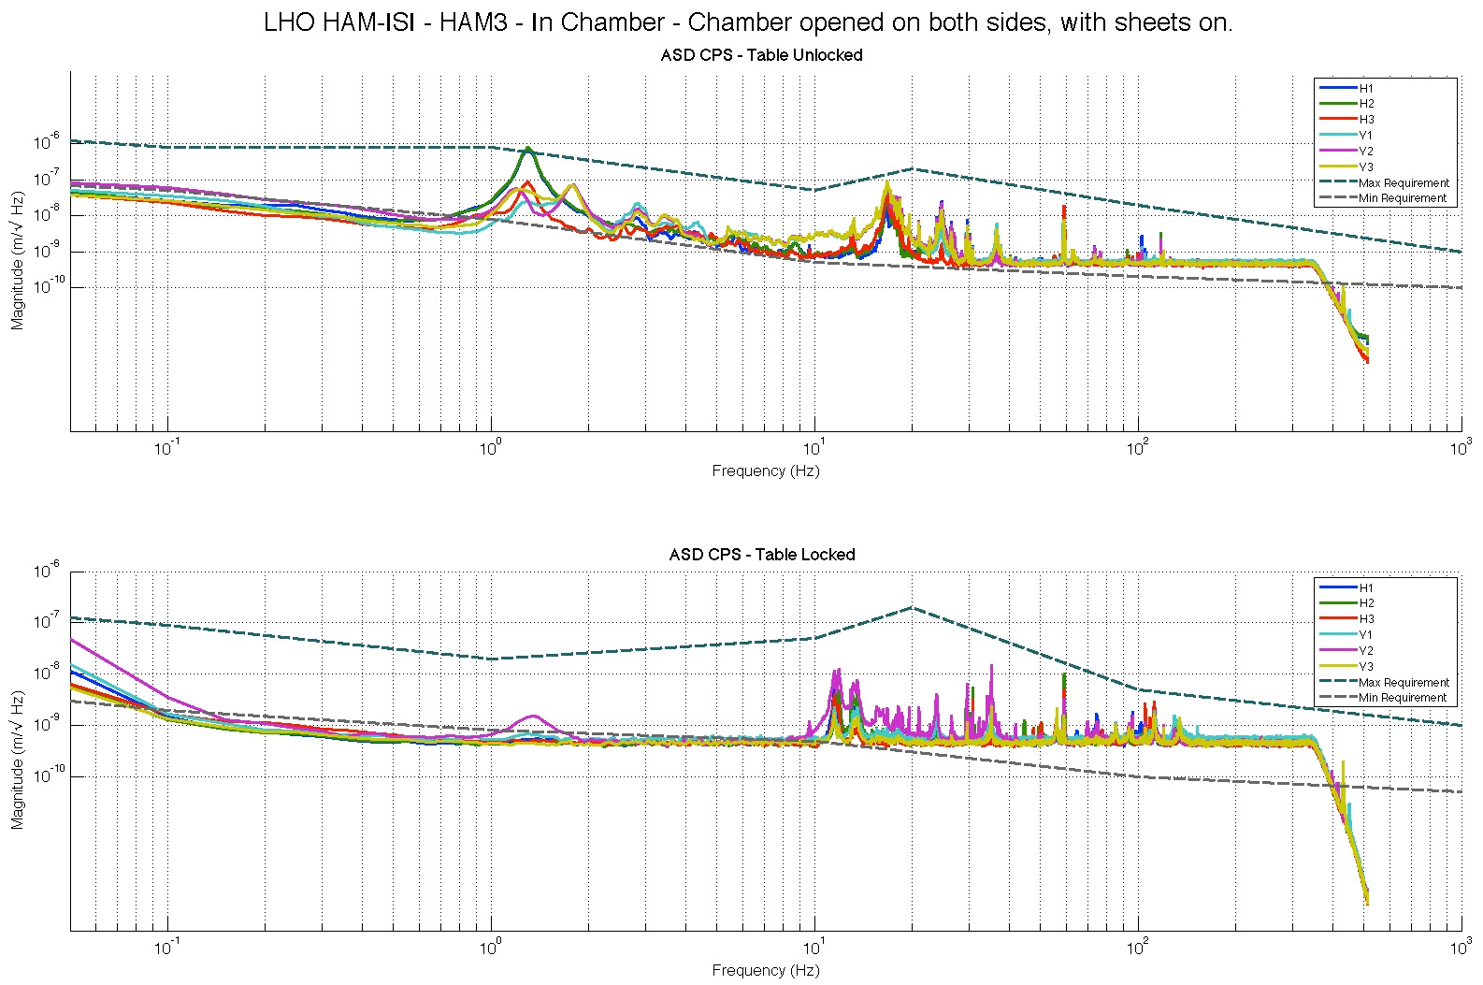
Figure - Calibrated CPS power spectrum – ISI Unlocked/Locked

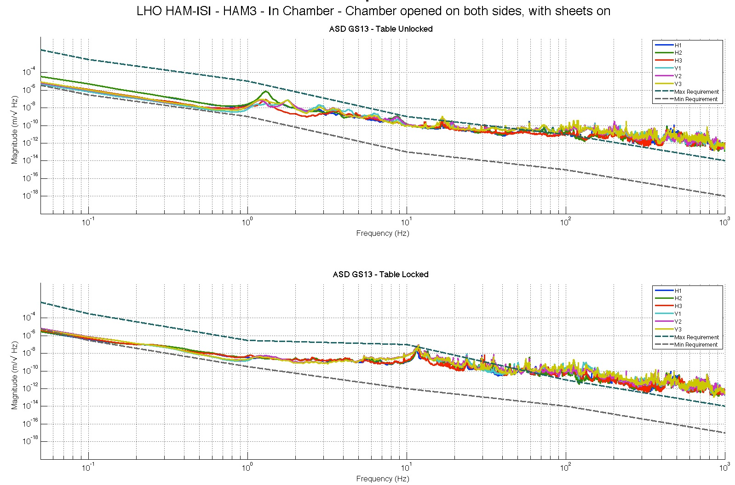
Figure – Power spectrum Calibrated GS13 – ISI Unlocked/Locked

Issues/difficulties/comments regarding this test:
- Locked data was recorded during the weekend, after the optical table payload was removed (421.51kg).

Acceptance criteria:
- No cross talk (peaks at low frequencies + harmonics on measurements)
- Magnitudes of power spectra must be between requirement curves such as in the following figures (dashed lines)

Test result: Passed: X Failed: .

Comment:
GS13 requirement curves need to be updated.

Step 10: GS13 ASD - Tabled Tilted

The figure below presents the GS13 power spectrum when the table is unlocked and loaded with a 10Kg mass at each of its corner.

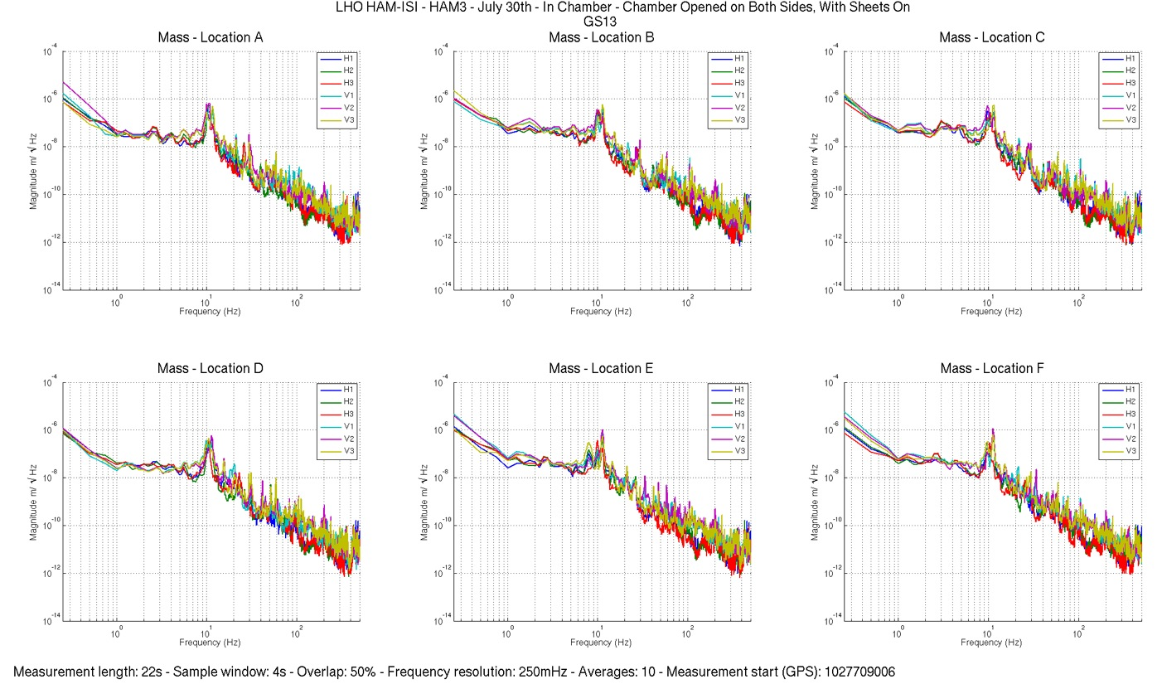
Figure – ASD Calibrated GS13 with mass at corner

Data files in SVN at:
/seismic/HAM-ISI/H1/HAM3/Data/Spectra/Undamped/
- LHO_ISI_HAM3_ASD_m_GS13_Stage_Tilted_2012_07_30.mat

Scripts files for taking and processing the data, and plotting it in SVN at:
seismic/HAM-ISI/Common/Testing_Functions_HAM_ISI/
- Plot_ASD_Tilted_Stage_HAM_ISI.m

Figures in SVN at:
seismic/HAM-ISI/H1/HAM3/Data/Figures/Spectra/Undamped/
- LHO_ISI_HAM3_m_PSD_GS13_Tilted_2012_07_30.fig

Issues/difficulties/comments regarding this test:
- Good concordance between sensors of the same type and direction.
- No drop of response in low frequency

Test result: Passed: X Failed: .

Step 11: GS13 pressure readout
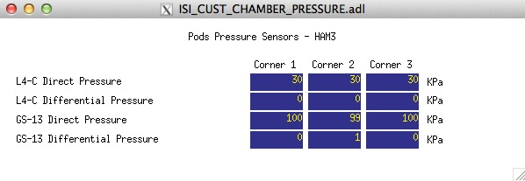
Figure – Pressure Readouts (07/16/2012)

Acceptance criteria:
- The pressure on GS13_P channels must be 102KPa +/-8 KPa (25000 counts +/- 3000 counts)
- GS13_P must vary the same way in each corner and GS13_DIFF must be constant (channels follow comparable trend)

Test result: Passed: X Failed: .

Step 12: Actuators Sign and range of motion (Local drive)

 | Negative drive | No Drive | Positive drive
H1 readout (count) | -24490 | 1426 | 23074
H2 readout (count) | -23748 | 3444 | 24363
H3 readout (count) | -25384 | -374 | 23516
V1 readout (count) | -19328 | -1071 | 19568
V2 readout (count) | -23790 | 2678 | 27001
V3 readout (count) | -22602 | 904 | 21003
Table - Range of motion - Local drive

Acceptance criteria:
- Main couplings sensors readout must be at least 16000 counts (~0.02”)
- A positive offset drive on one actuator must give positive sensor readout on the collocated sensor. Signs will also be tested when measuring local-to-local transfer functions.

Test result: Passed: X Failed: .

Step 13: Static Testing (Tests in the local basis)
 | Sensors (counts)
 | H1 | H2 | H3 | V1 | V2 | V3
H1 | 1767 | 1187 | 1081 | 37 | 3 | -6
H2 | 1093 | 2025 | 1054 | 23 | 16 | 5
H3 | 1101 | 1228 | 1821 | 6 | 31 | -5
V1 | 30 | 304 | -298 | 1298 | 6 | -525
V2 | -349 | 236 | 207 | -548 | 1371 | -74
V3 | -43 | -269 | 41 | 18 | -594 | 1270
Table - Main couplings and cross couplings

Issues/difficulties/comments regarding this test:
Are slightly out of requirement:
H1-H1
H1-H3
H2-H1
H2-H3

Acceptance criteria:
- Vertical
For a +1000 count offset drive on vertical actuators
  - Collocated sensors must be 1400 counts +/- 10%

- Horizontal
For a +1000 count offset drive on horizontal actuators
  - Collocated sensors must be 2000 counts +/- 10%
  - Non-collocated horizontal sensors must be 1250 counts +/-10%

Test result: Passed: X Failed: .

Step 14: Linearity test

 | Slope | Offset | Average slope | Variation from  average(%)
H1 | 1.870777269 | 1347.670059 | 1.87 | -0.22
H2 | 1.894068116 | 3340.203042 |  | 1.03
H3 | 1.859687541 | -436.1386068 |  | -0.81
V1 | 1.352814518 | -900.9032343 | 1.35 | 0.00
V2 | 1.354952394 | 2654.182689 |  | 0.16
V3 | 1.350689415 | 742.9662125 |  | -0.16
Table - Slopes and offset of the triplet Actuators - HAM-ISI - Sensors

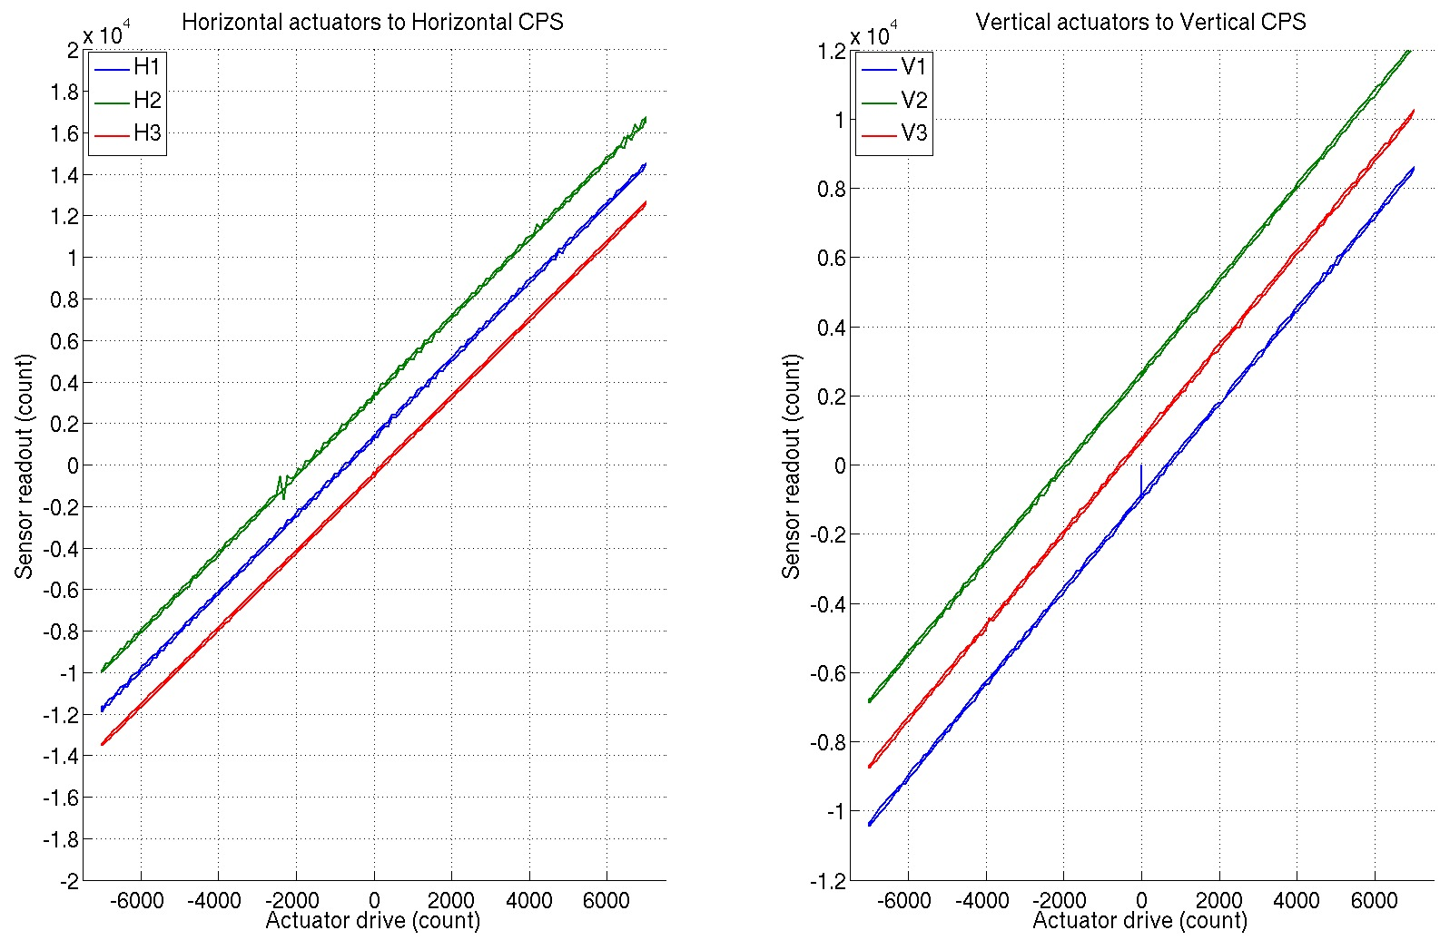
Figure - Horizontal and vertical actuators x HAM-ISI x sensors

Scripts files for taking data in SVN at:
seismic/HAM-ISI/Common/Testing_Functions_HAM_ISI/
- Linearity_Test_Awgstream_HAM_ISI.m
- Reprocess_Linearity_Test.m

Data files in SVN at: seismic/HAM-ISI/L1/HAM3/Data/Linearity_Test/
- LHO_ISI_HAM3_Linearity_test_20120801.mat

Figures in SVN at:
seismic/HAM-ISI/H1/HAM3/Data/Figures/Linearity_Test/
- LHO_ISI_HAM3_Linearity_test_20120801.fig

Issues/difficulties/comments regarding this test:
Needed to right a script to reprocess test data. The original scrip did not account for the new data rate on the CPSs.
Acceptance criteria:
- Horizontal and vertical slopes of the triplet actuators x HAM-ISI x sensors = Average slope +/- 1.5%

Test result: Passed: X Failed: .

Step 15: Frequency response
All input/output filters are ON. HEPI is locked. The chamber is closed with sheets on.

Step 15.1: Local to local measurements
Data files in SVN at:
seismic/HAM-ISI/H1/HAM3/Data/Transfer_Functions/Measurements/Undamped/
- LHO_ISI_HAM3_Data_TF_L2L_200Hz_1000Hz_20120731-193225.mat
- LHO_ISI_HAM3_Data_TF_L2L_5Hz_200Hz_20120731-204959.mat
- LHO_ISI_HAM3_Data_TF_L2L_500mHz_5Hz_20120731-190148.mat
- LHO_ISI_HAM3_Data_TF_L2L_100mHz_500mHz_20120801-093231.mat
Data collection script files:
seismic/HAM-ISI/H1/HAM3/Scripts/Data_Collection/
- Run_Exc_Batch_H1_HAM3.m
Scripts files for processing and plotting in SVN at:
seismic/HAM-ISI/H1/HAM3/Scripts/Control_Scripts/Version_0/
- Step_1_TF_Loc_to_Loc_H1_ISI_HAM3.m
Figures in SVN at:
seismic/HAM-ISI/H1/HAM3/Data/Figures/Transfer_Functions/Measurements/Undamped/
- H1_ISI_HAM3_TF_L2L_Raw_from_ACT_to_CPS_2012_08_01.fig
- H1_ISI_HAM3_TF_L2L_Raw_from_ACT_to_GS13_2012_08_01.fig
Storage of measured transfer functions in the SVN at:
seismic/HAM-ISI/H1/HAM3/Data/Transfer_Functions/Simulations/Undamped/
- H1_ISI_HAM3_TF_L2L_Raw_2012_08_01.mat

The local to local transfer functions and presented below.

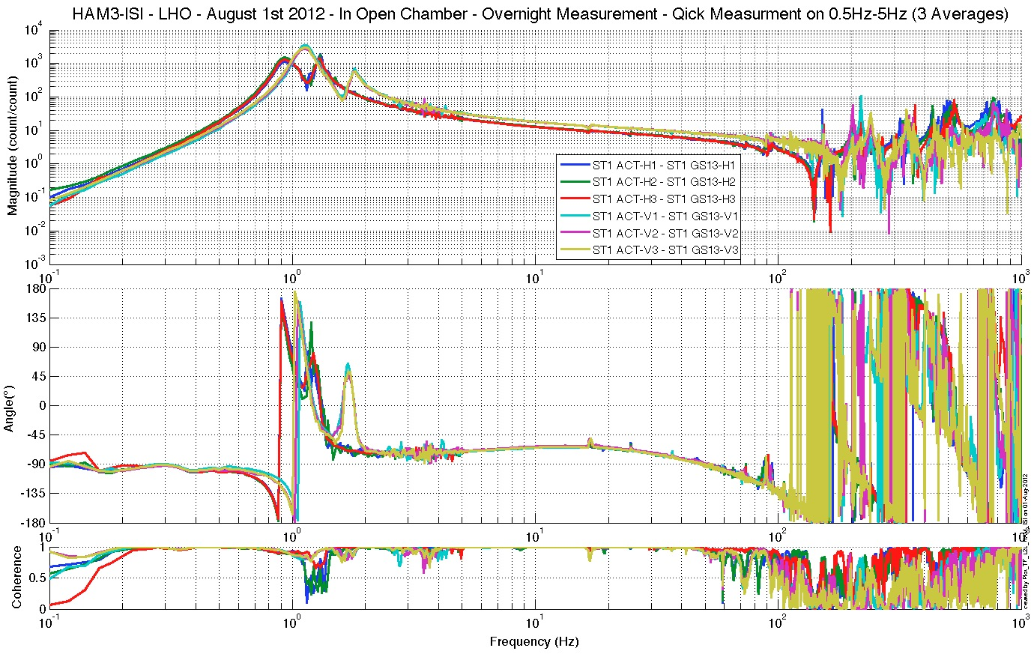
Figure - Local to Local Measurements –Capacitive Position Sensors

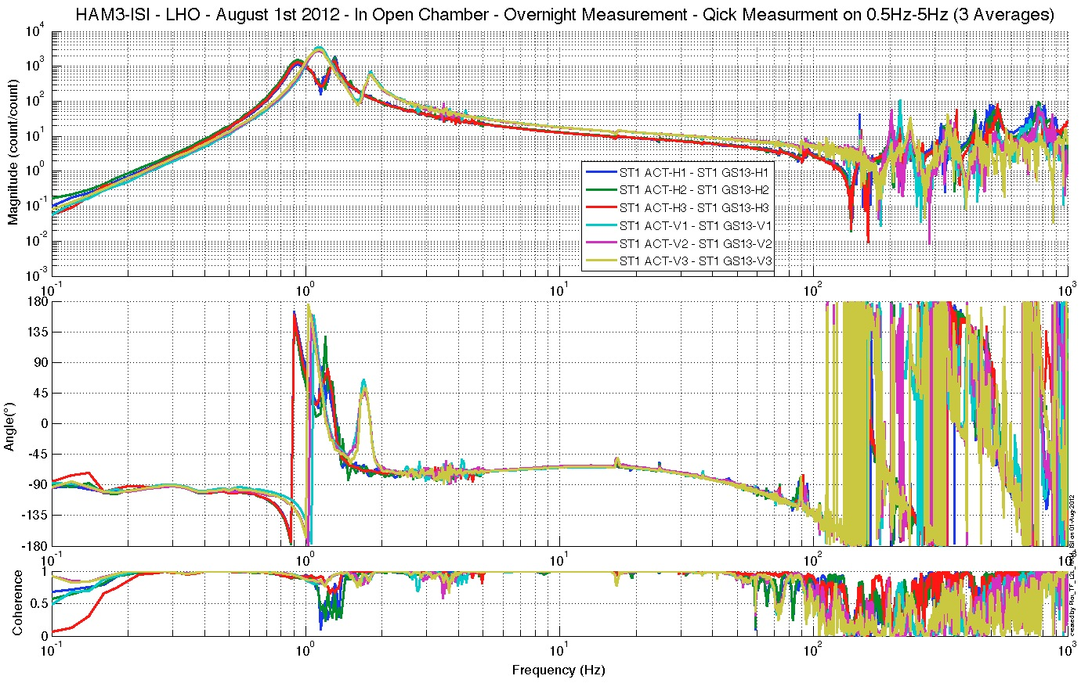
Figure - Local to Local Measurements – Inertial sensors

Step 15.2: Local to local measurements V.S. LLO

Data files in SVN at:
LHO:
seismic/HAM-ISI/H1/HAM3/Data/Transfer_Functions/Measurements/Undamped/
- LHO_ISI_HAM3_Data_TF_L2L_200Hz_1000Hz_20120731-193225.mat
- LHO_ISI_HAM3_Data_TF_L2L_5Hz_200Hz_20120731-204959.mat
- LHO_ISI_HAM3_Data_TF_L2L_500mHz_5Hz_20120731-190148.mat
- LHO_ISI_HAM3_Data_TF_L2L_100mHz_500mHz_20120801-093231.mat
LLO:
seismic/HAM-ISI/L1/HAM3/Data/Transfer_Functions/Simulations/Undamped/
- LLO_ISI_HAM3_TF_L2L_Raw_2012_02_18.mat
Scripts files for processing and plotting in SVN at:
seismic/HAM-ISI/H1/HAM3/Scripts/Control_Scripts/Version_0/
- Step_1_TF_Loc_to_Loc_H1_ISI_HAM3.m
- Plot_TF_L2L_HAM_with_LLO.m

Figures in SVN at:
seismic/HAM-ISI/H1/HAM3/Data/Figures/Transfer_Functions/Comparisons/L2L/
- H1_ISI_HAM3_TF_L2L_Raw_from_ACT_H_to_CPS_H_vs_LLO_2012_02_18.fig
- H1_ISI_HAM3_TF_L2L_Raw_from_ACT_V_to_CPS_V_vs_LLO_2012_02_18.fig
- H1_ISI_HAM3_TF_L2L_Raw_from_ACT_H_to_GS13_H_vs_LLO_2012_02_18.fig
- H1_ISI_HAM3_TF_L2L_Raw_from_ACT_V_to_GS13_V_vs_LLO_2012_02_18.fig

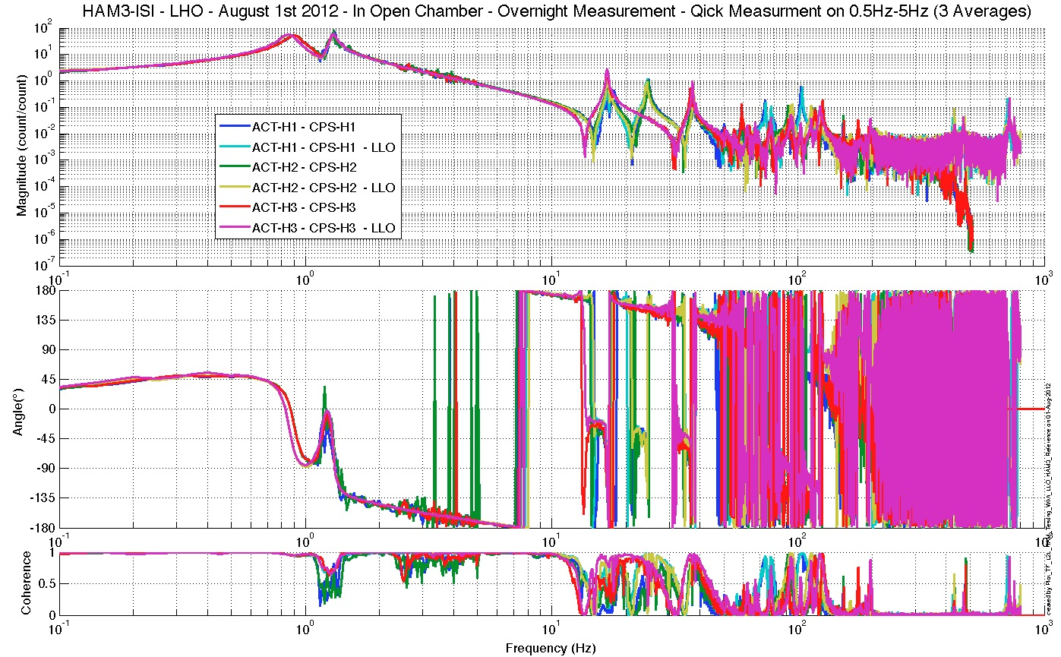 Figure – TF L2L – Horizontal CPS

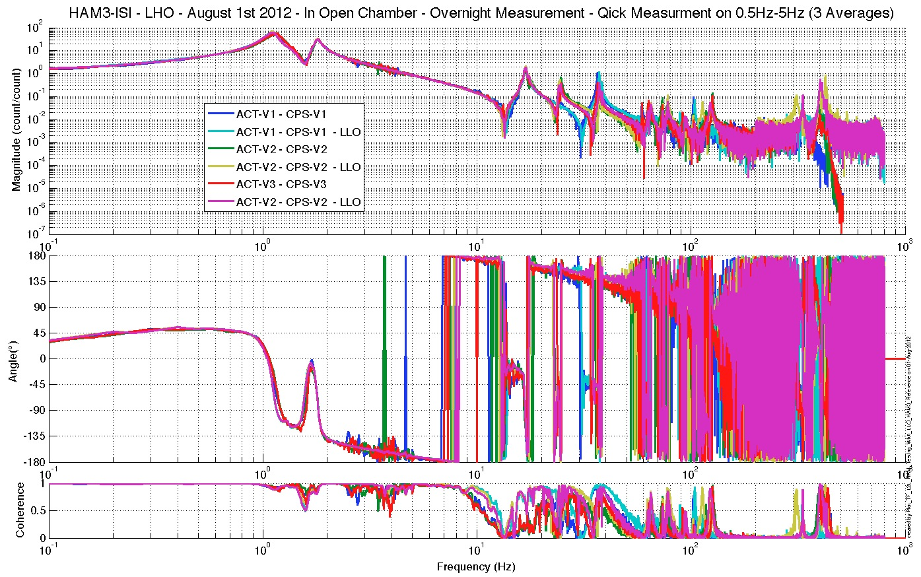
Figure – TF L2L – Vertical CPS

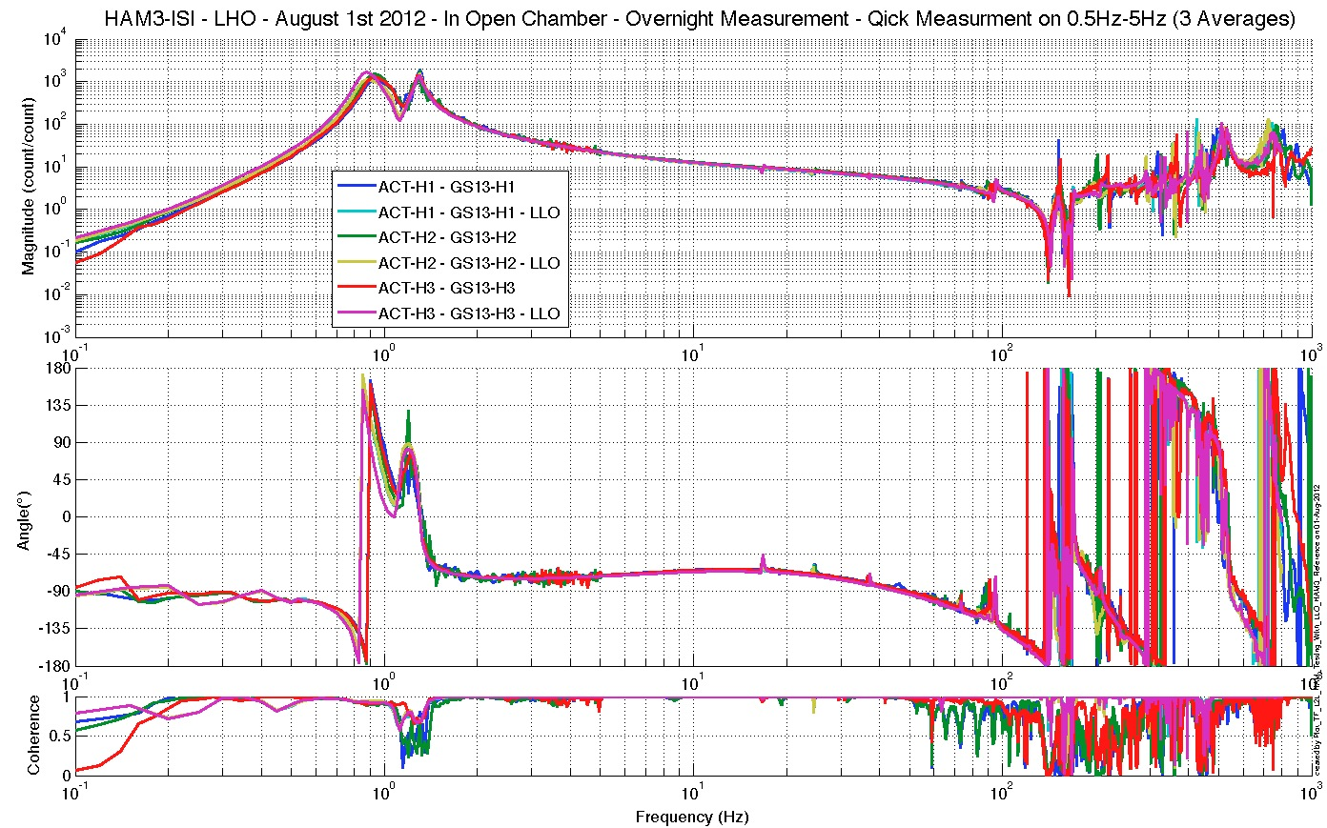
Figure – TF L2L – Horizontal GS13
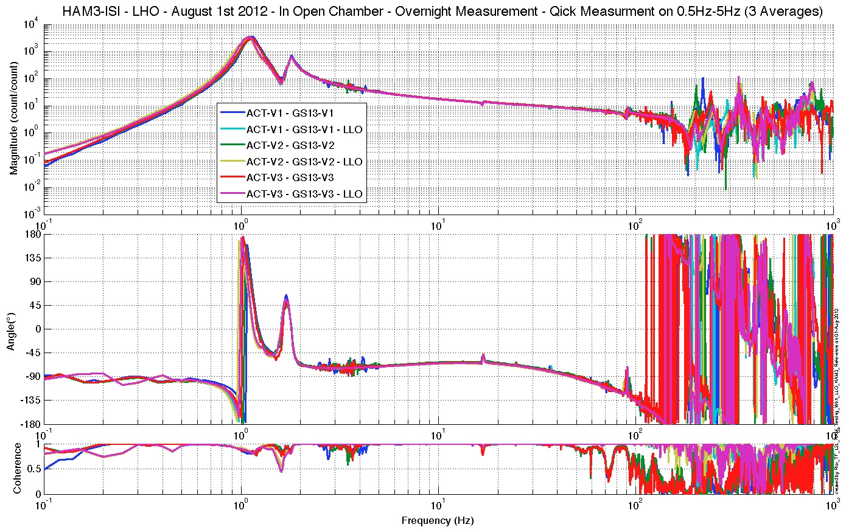
Figure – TF L2L – Vertical GS13

Acceptance criteria:
- Good concordance with TF measured under the same conditions at LLO.
- Local to local measurements
  - On CPS, the phase must be 0º at DC
  - On Geophones, the phase must be -90º at DC
  - Identical shape in each corner
- Cartesian to Cartesian measurements
  - On CPS, the phase must be 0º at DC
  - On Geophones, the phase must be -90º at DC
  - Identical shape X/Y and RX/RY

Test result: Passed: X Failed: .

Conclusion
Initial In-Chamber testing

The ISI was tested between Friday July 27th and Wednesday August 1st 2012. All the tests presented here were performed during that period. Other tasks were also performed then:
- Models were installed
- In-field cables were installed
- Electronic rack was troubleshooted:
  - BIO-related cables missing fifth pin
  - DAC/ADC card numbers in the IO chassis figured out
  - BIO card used by the model figured out

Very few issues were found during the Initial In-Chamber Testing of this unit. The known issues are summed up here:
- CPSs and lockers will need to be reset after SUS install, as expected
- Some readouts are slightly under requirements on Local to Local static test.
- Overnight Transfer Function crashed du to incompatibility between Ubuntu OS and Mac computers.

Introduction
Final Chamber Testing

This part of the Phase II testing takes place in open chamber. All the suspensions and opticas are on. HEPI is locked.

This is the last phase of testing before the chamber is closed for the IMC test.

IO was done with installing optics on December 4th 2012. No tests could be performed during the day, due to IO alignment work, until December 7th.

Tests presented here were performed between December 4th and December 8th 2012.

Final In-Chamber Testing

Step 1: Parts Inventory (E1000052)
DCC Number | Part name | Configuration | Corner 1 S/N | Corner 2 S/N | Corner 3 S/N
D071001 | Stage 0 base | NA | 10
D071051 | Stage 1 base | NA | 12
D071050 | Optical table | NA | 11
D071002 | Spring Post | NA | 2 | 3 | 8
D071100 | Spring | NA | 38 | 13 | 29
D071102 | Flexure | NA | 2 | 4 | 14
ADE | Position sensor | Horizontal | 12007 Master 0 | 12022 S1ave 180 | 12035 Slave 0
 |  | Vertical | 11983 Slave 180 | 12006 Slave 0 | 12027 Slave 180
D047812 | GS-13 pod | Horizontal | 13 | 38 | 71
 |  | Vertical | 74 | 72 | 4
D047823 | L4C pod | Horizontal | NA | NA | NA
 |  | Vertical | NA | NA | NA
D0902749 | Actuator | Horizontal | 23 | 115 | 117
 |  | Vertical | 105 | 98 | 116
Table – Parts inventory

NA: Not applicable

 | Corner | S/N
TMD | 1 | 10
 | 2 | 11
 | 3 | 12
Table – Tuned Mass Dampers

Issues/difficulties/comments regarding this test:
Same parts as during the Assembly Validation testing. Only TMDs were added since.

Acceptance Criteria:
Inventory is complete

Test result: Passed: X Failed: .

Step 2: Cables inventory:
Issues/difficulties/comments regarding this test:
No cables were changed since the Initial In-Chamber testing. Please refer to the Initial In-Chamber testing section of this report for details.

Acceptance Criteria:
Inventory is complete

Test result: Passed: X Failed: .

Step 3: Electronics inventory

Issues/difficulties/comments regarding this test:
No electronics were changed since the Initial In-Chamber testing. Please refer to the Initial In-Chamber testing section of this report for details.

Acceptance Criteria:
Inventory is complete

Test result: Passed: X Failed: .

Step 4: Payload Survey

During this step, the ISI is fully payloaded with suspensions and optics. The masses added to finish loading and balancing the ISI were recorded. See table below.

 | 00 | 01 | 02 | 03 | 04 | 05 | 06
 | 0.6 | 1.1 | 2.2 | 4.5 | 7.9 | 15.6 | 27.2 | lbs | kgs
w9 | 0 | 0 | 0 | 0 | 0 | 0 | 0 | 0 | 0.00
w1 | 2 | 1 | 2 | 1 |  |  |  | 11.2 | 5.08
w2 | 1 |  | 1 | 1 |  |  |  | 7.3 | 3.31
w3 | 1 |  | 0 | 1 |  |  |  | 5.1 | 2.31
w4 | 2 |  | 1 | 1 | 1 |  |  | 15.8 | 7.17
w5 |  |  | 1 |  |  |  |  | 2.2 | 1.00
w6 | 1 |  |  |  |  |  |  | 0.6 | 0.27
w7 |  | 1 |  | 1 |  |  |  | 5.6 | 2.54
w8 |  | 1 |  | 1 | 1 |  |  | 13.5 | 6.12
Side Masses Total | 7 | 3 | 5 | 6 | 2 | 0 | 0 | 61.3 | 27.81
Table – Wall Mass Distribution
 | 00 | 01 | 02 | 03 | 04 | 05 | 06
 | 0.6 | 1.1 | 2.2 | 4.5 | 7.9 | 15.6 | 27.2 | lbs | kgs
k1 |  |  |  |  | 1 |  | 1 | 35.1 | 15.92
k2 |  |  |  |  |  | 2 |  | 31.2 | 14.15
k3 |  |  |  |  | 1 |  | 1 | 35.1 | 15.92
k4 |  |  |  |  |  | 2 |  | 31.2 | 14.15
k5 |  |  |  |  | 1 |  | 1 | 35.1 | 15.92
k6 |  |  |  |  |  | 2 |  | 31.2 | 14.15
Keel Masses Total | 0 | 0 | 0 | 0 | 3 | 6 | 3 | 198.9 | 90.22
Table – Keel Mass Distribution

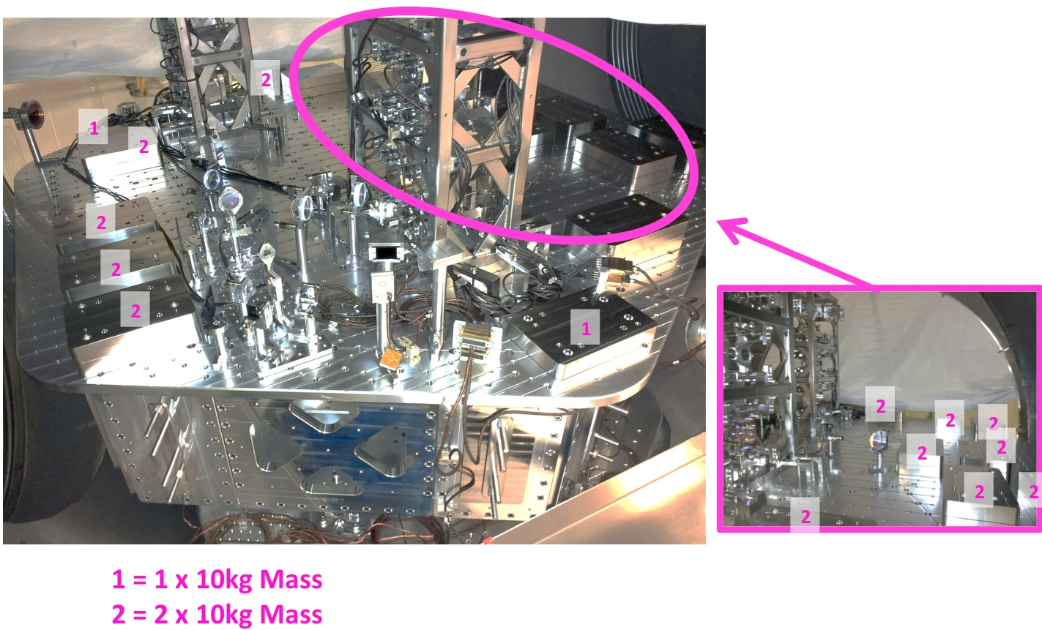
Figure – Optical Table Mass Distribution (280kg added with 10kg masses)

Figure – Wall Masses (W) and Keel masses (K) location. South of picture = corner 1
Issues/difficulties/comments regarding this test:
Only wall masses and optical table masses were changed since the Initial In-Chamber testing. Keel masses were retrieved from this phase. Please refer to the related section for details.

Acceptance Criteria:
- Amount and position of wall masses is recorded
- Amount and position of keel masses is recorded
- Amount and position of optical table masses is recorded

Test result: Passed: X Failed: .

Step 5: Locked/Unlocked Spectra

GPS time of measurement:
Locked = 1039370100 ;
UnLocked = 1039341393 ;

Data files in SVN at:
/seismic/HAM-ISI/H1/HAM3/Data/Spectra/Undamped/
- LHO_ISI_HAM3_ASD_m_CPS_T240_L4C_GS13_Locked_vs_Unlocked_2012_12_12.mat

Scripts files for taking and processing the data, and plotting it in SVN at:
seismic/HAM-ISI/Common/Testing_Functions_HAM_ISI/
- ASD_Measurements_Locked_Unlocked_HAM_ISI.m
- Plot_ASD_Unlocked_Locked_HAM_ISI.m
- Plot_ASD_Unlocked_Locked_Group_HAM_ISI.m

Figures in SVN at:
seismic/HAM-ISI/H1/HAM3/Data/Figures/Spectra/Undamped/
- LHO_ISI_HAM3_ASD_m_GS13_Requirements_Locked_vs_Unlocked_2012_12_12.fig
- LHO_ISI_HAM3_ASD_m_CPS_Requirements_Locked_vs_Unlocked_2012_12_12.fig

Issues/difficulties/comments regarding this test:
- The testing functions used here need to load the calibration filters. The way we save these filters recently changed. The functions were updated to reflect these changes. Refer to SEI aLog #147 for more details.
- The CPS power spectra are calibrated by using a sensitivity of 30.2 nm/count.
- Even though asd2.m is now available, the functions used here still use pwelch.

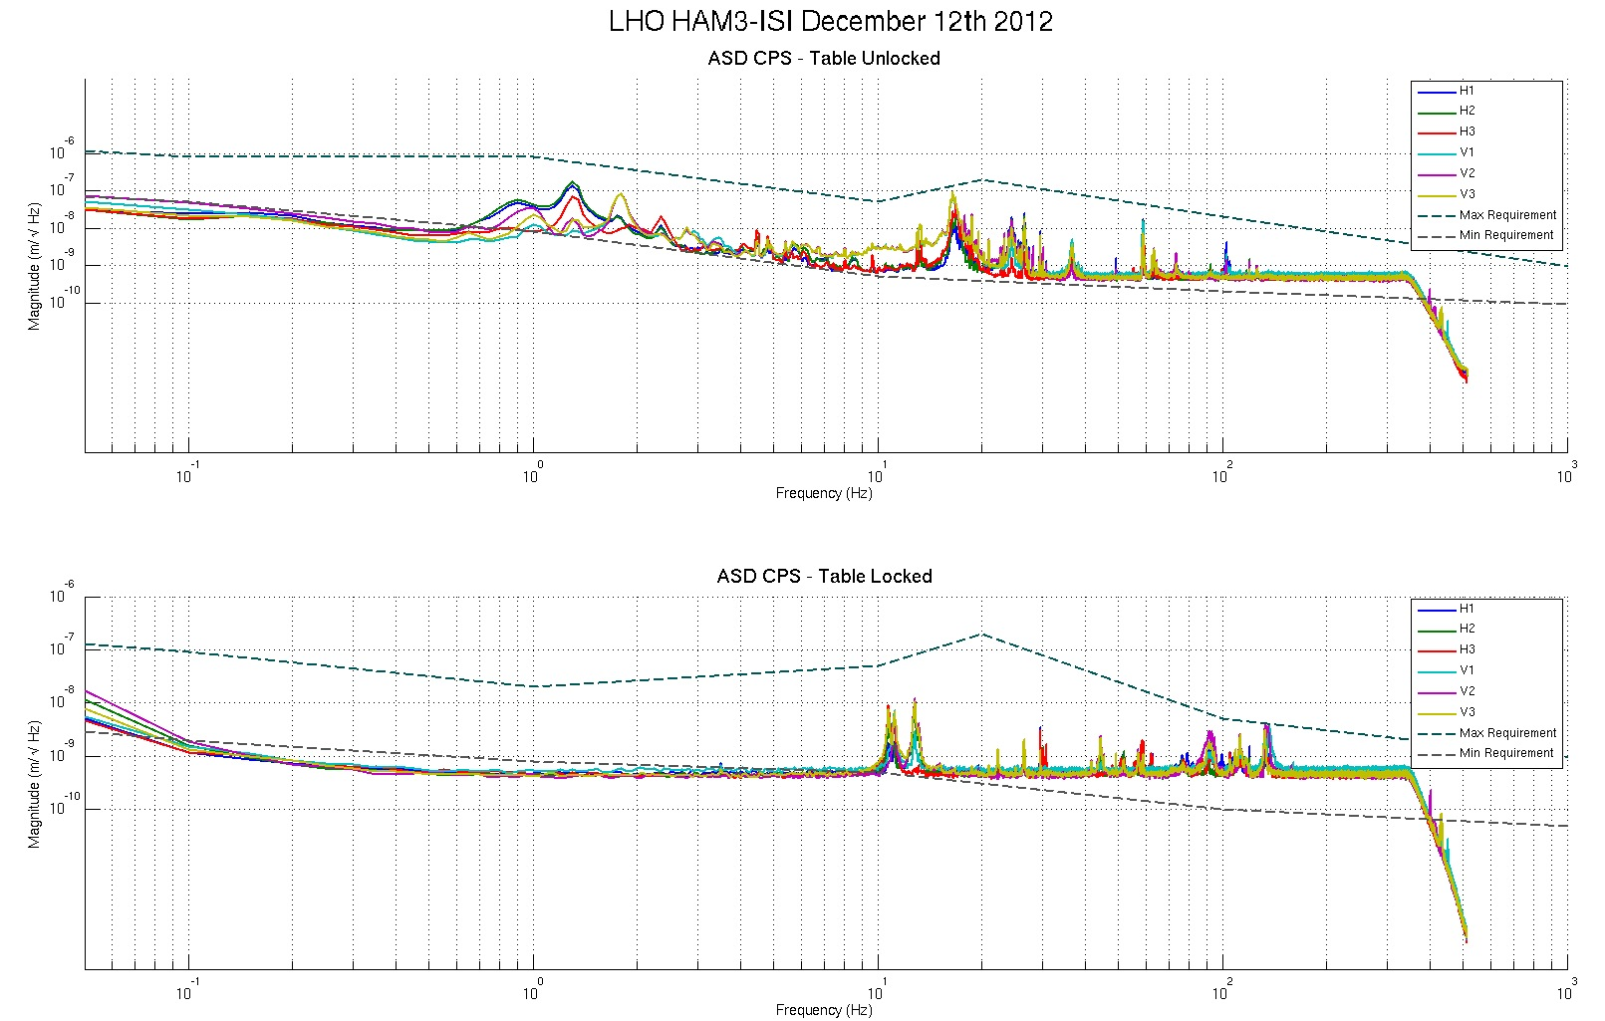
Figure - Calibrated CPS power spectrum – ISI Unlocked/Locked

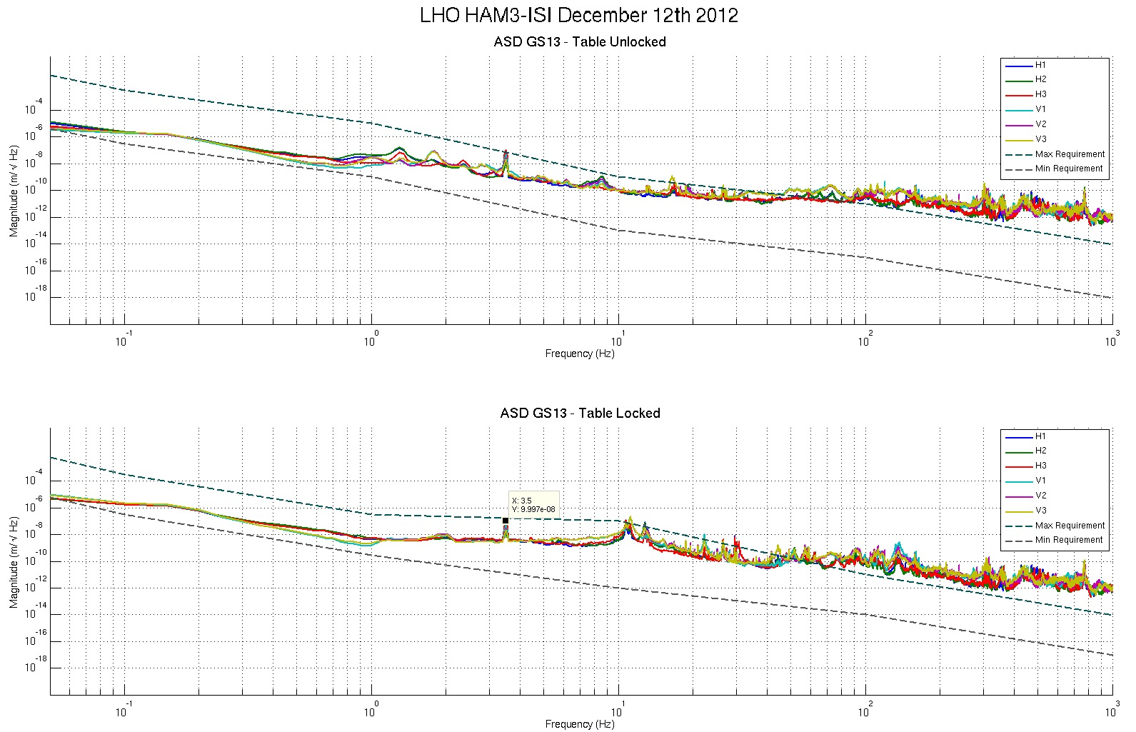
Figure – Power spectrum Calibrated GS13 – ISI Unlocked/Locked

Issues/difficulties/comments regarding this test:
- The unusual peak seen at 3.5Hz on the GS13 spectra comes from Robert Schofield’s magnetic coupling test, for which he inject a magnetign field 5 order of magnitude stronger than regular ambient level, under BSC1, right next to HAM3. See LHO aLog #4920 for more details.
- Good concordance between sensors of the same type and direction.
- No drop of response in low frequency.
- The testing functions used here need to load the calibration filters. The way we save these filters recently changed. The functions were updated to reflect these changes. Refer to SEI aLog #147 for more details.
- The CPS power spectra are calibrated by using a sensitivity of 30.2 nm/count.
- Even though asd2.m is now available, the functions used here still use pwelch.

Acceptance criteria:
- No cross talk (peaks at low frequencies + harmonics on measurements)
- Magnitudes of power spectra must be between requirement curves such as in the following figures (dashed lines)

Test result: Passed: X Failed: .

Comment:
GS13 requirement curves need to be updated.

Step 6: Tilted Spectra

Spectra with the ISI titled were already taken during the initial in-chamber testing.. The GS13s were not changed nor moved since. Locked and unlocked spectra are fine We are confident that the GS13s are fully functional.

Refer to the Initial In-Chamber Testing section, step 10 for details.

Test result: Passed: X Failed: .

Step 7: Pressure Readouts

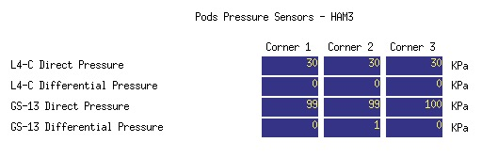
Figure – Pressure Readouts December 7th 2012
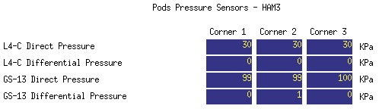
Figure – Pressure Readouts December 13th 2012

Issues/difficulties/comments regarding this test:
- Pressure readouts are exactly the same after 6 days.
- Pressure readouts are within requirements
- The ISI is in air, with sheet covers on the chamber

Acceptance criteria:
- The pressure on GS13_P channels must be 102KPa +/-8 KPa (25000 counts +/- 3000 counts)
- GS13_P must vary the same way in each corner and GS13_DIFF must be constant (channels follow comparable trend)

Test result: Passed: X Failed: .

Step 8: Lockers/CPS Adjustment

Lockers’ adjustments were performed on December 4th after IO finalized the payload of HAM3-ISI. Details about this operation can be found in LHO aLog #4831.

The zero of the CPS was reset after working on the lockers.

The goal of this step is to make sure that the locked/unlocked shift read with the CPSs is within requirement. If the zeroing was performed correctly, CPS readout values should also be within requirements.

Shift | Unlocked (Counts) | Locked (Counts) | Shift
H1 | -380 | 87.98 | 467.98
H2 | 170 | 504.36 | 334.36
H3 | -60 | 139.12 | 199.12
V1 | 120 | 145.64 | 25.64
V2 | -350 | -518.82 | 168.82
V3 | 250 | 108.37 | 141.63
Table – Locker’s Adjustments December 4th 2012

Issues/difficulties/comments regarding this test:
- Locked-Unlocked shift is way below requirements. Same comment applies to the readouts.
- The cavity was flashing before unlocking the ISI. We unlocked and it was still flashing.
- We turned the damping on, and the cavity was still flashing
- We turned the Level 2 controllers designed during the pre-commissioning control tests and the cavity was still flashing.

Acceptance criteria (per E1000309-v12):
- Shift < 1600 cts
- Readouts < 2000 cts

Test result: Passed: X Failed: .

Step 9: Shim Thickness

Lockers | Shim thickness (mil)
A | 120
B | 120
C | 121
D | 129
Table – Shim Thicknesses, October 11th 2012

Issues/difficulties/comments regarding this test:
- Only the shim of locker D was changed since the initial in-Chamber testing.
- The shim of locker D was changed from 122 mils to 129 mils.
- The thickness of the shims of lockers A, B and C, were retrieved from the initial In-Chamber section.

Acceptance Criteria
- The shim thickness should be 125 mils +/-5

Test result: Passed: X Failed: .

Step 10: Blade Spring Profile

Issues/difficulties/comments regarding this test:
- Only the profile of corner 2 blade could be measured due to lack of access once suspensions are installed. We measured 17 mils for the flatness of this blade.
- The flatness of the blade of corner 2 is slightly out of requirements but there is not much we can do about it because the lockers seem to be set right.
- Transfer functions, Pre-commissioning tests, and experience show that this is not an issue. Team SEI decided to move forward, keeping this feature in mind.

Acceptance Criteria:
- Blades must be flat within 0.015" inches.

Note that the tip measurement should be constant and that root value can be impacted by shims change.

Test result: Passed: Failed: X .

Step 11: Level of Stage 1

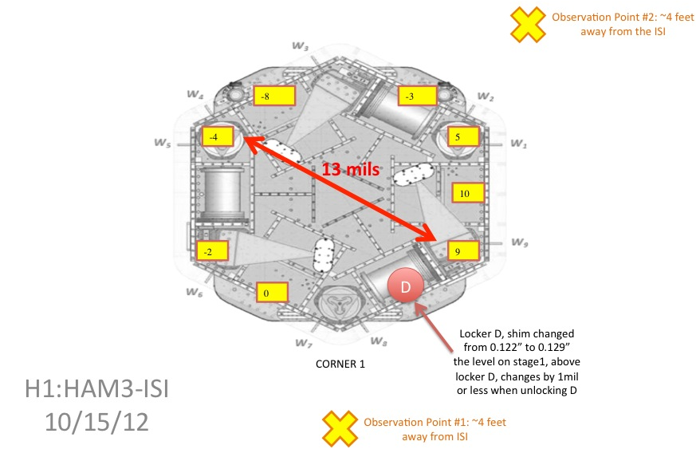
Figure – Level of Stage 1

Max angle = 0.013” / 78.61” ~ 165 µrad

Issues/difficulties/comments regarding this test:
- This measurement was performed after changing the shim on locker D (see step 8)
- Level is out of requirements
- Transfer functions, Pre-commissioning tests, and experience show that this is not an issue. Team SEI decided to move forward, keeping this feature in mind.

Acceptance Criteria
- The maximum angle of the table with the horizontal mustn’t exceed ~100µrad
Test result: Passed: Failed: X .

Step 12: Range of Motion

 | Negative drive | No Drive | Positive drive | ROM (Counts)
H1 readout (count) | -22700 | 97 | 23400 | 46100
H2 readout (count) | -22700 | 437 | 23400 | 46100
H3 readout (count) | -23200 | 121 | 24200 | 47400
V1 readout (count) | -18900 | 115 | 19500 | 38400
V2 readout (count) | -20100 | -479 | 20500 | 40600
V3 readout (count) | -20500 | 175 | 19000 | 39500
Table – Range of Motion, Dec 7th

ROM: Range Of Motion

Issues/difficulties/comments regarding this test:
- Compensation filters are ON.
- Symmetrization filters are OFF

Acceptance criteria:
- Main couplings sensors readout must be at least 16000 counts (~0.02”)
- A positive offset drive on one actuator must give positive sensor readout on the collocated sensor. Signs will also be tested when measuring local-to-local transfer functions.

Test result: Passed: X Failed: .

Step 13: Static Testing

Local to Cartesian transform matrices were already proofed during assembly-validation and Pre-commissioning. Hence, static testing is only performed in the local basis.

The following test was performed on December 11th 2012.

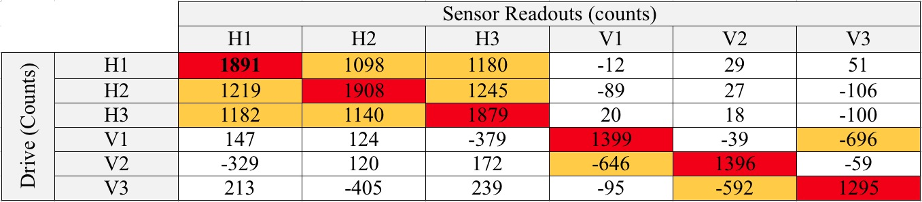
Table – Local Static Testing, Decembre 11th 2012

Issues/difficulties/comments regarding this test:
- H2 response to H1 drive is slightly below requirement.
- Transfer functions, Pre-commissioning tests, and experience show that this is not an issue.

Acceptance criteria:
- Vertical axis
For a +1000 count offset drive on vertical actuators
  - Collocated sensors must be 1400 counts +/- 10%

- Horizontal axis
For a +1000 count offset drive on horizontal actuators
  - Collocated sensors must be 2000 counts +/- 10%
  - Non-collocated horizontal sensors must be 1250 counts +/-10%

Test result: Passed: X Failed: .

Step 14: Linearity Test

This test was performed on December 5th 2012. Similar results were observed on December 7th, even though the covers were not rubbing, and thus were rubbing against the ISI.

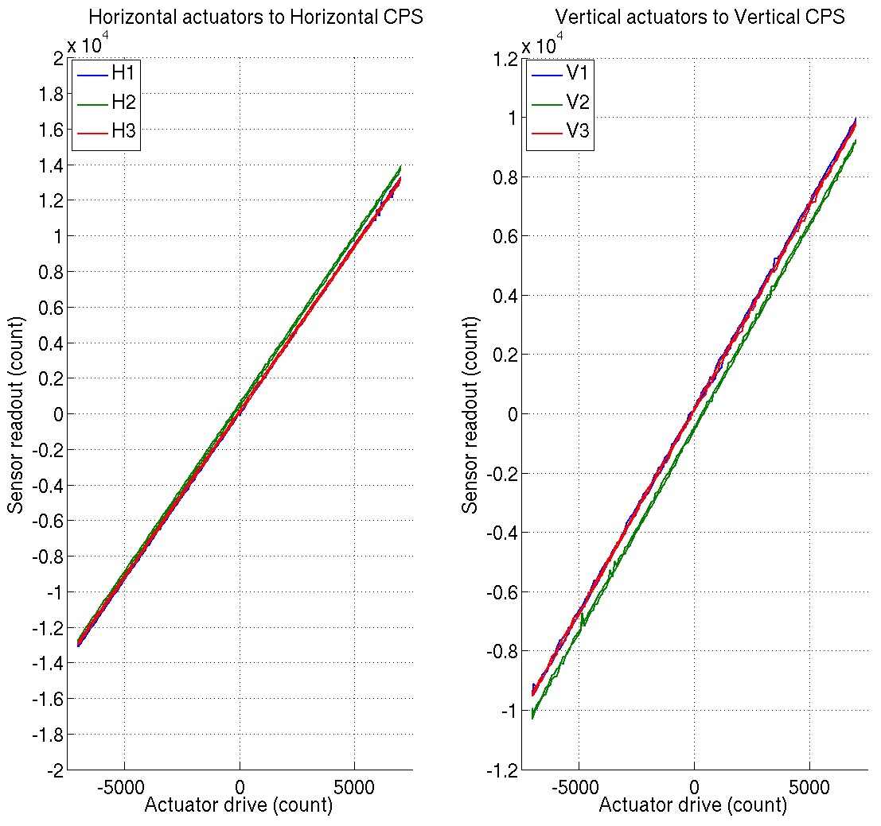
Table – Linearity test, December 5th 2012

 | Slope | Offset | Average slope | Variation from  average (%)
H1 | 1.87 | 90.04 | 1.88 | -0.19
H2 | 1.89 | 506.96 |  | 0.98
H3 | 1.86 | 118.85 |  | -0.80
V1 | 1.38 | 203.39 | 1.38 | 0.27
V2 | 1.38 | -478.64 |  | 0.01
V3 | 1.37 | 154.30 |  | -0.28
Table – Linearity test, slopes and offsets, December 5th 2012

Issues/difficulties/comments regarding this test:
Average slopes are more consistent now that the ISI is finely balanced and that we use the final in-field cables.
Linearity_Test_Awgstream_HAM_ISI___Updated_Data_Rate.m is used instead of the regular script to account for the new data rate of the CPSs (1024, instead of 2048)

Scripts files for taking data in SVN at:
seismic/HAM-ISI/Common/Testing_Functions_HAM_ISI/
- Linearity_Test_Awgstream_HAM_ISI___Updated_Data_Rate.m

Data files in SVN at:
seismic/HAM-ISI/L1/HAM3/Data/Linearity_Test/
- LHO_ISI_HAM3_Linearity_test_20121205.mat

Figures in SVN at:
seismic/HAM-ISI/H1/HAM3/Data/Figures/Linearity_Test/
- LHO_ISI_HAM3_Linearity_test_20121205.fig

Acceptance criteria:
- Horizontal and vertical slopes of the triplet actuators x HAM-ISI x sensors = Average slope +/- 1.5%

Test result: Passed: X Failed: .

Step 15: Local to Local Transfer Function Measurements

All input/output filters are ON. HEPI is locked. The chamber is closed with sheets on.

Step 15.1: Local to local measurements
Data files in SVN at:
seismic/HAM-ISI/H1/HAM3/Data/Transfer_Functions/Measurements/Undamped/
- LHO_ISI_HAM3_Data_TF_L2L_10mHz_100mHz_20121208-100239.mat
- LHO_ISI_HAM3_Data_TF_L2L_100mHz_500mHz_20121208-081113.mat
- LHO_ISI_HAM3_Data_TF_L2L_500mHz_5Hz_20121207-224150.mat
- LHO_ISI_HAM3_Data_TF_L2L_5Hz_200Hz_20121207-195823.mat
- LHO_ISI_HAM3_Data_TF_L2L_200Hz_1000Hz_20121207-172553.mat
Data collection script files:
seismic/HAM-ISI/H1/HAM3/Scripts/Data_Collection/
- Run_Exc_Batch_H1_HAM3.m
Scripts files for processing and plotting in SVN at:
seismic/HAM-ISI/H1/HAM3/Scripts/Control_Scripts/Version_2/
- Step_1_TF_Loc_to_Loc_H1_ISI_HAM3.m
seismic/HAM-ISI/H1/HAM3/Data/Transfer_Functions/Simulations/Undamped/
- Measurements_List_H1_ISI_HAM3.m (Measurement # 18)
Figures in SVN at:
seismic/HAM-ISI/H1/HAM3/Data/Figures/Transfer_Functions/Measurements/Undamped/
- H1_ISI_HAM3_TF_L2L_Raw_from_ACT_to_CPS_2012_12_08.fig
- H1_ISI_HAM3_TF_L2L_Raw_from_ACT_to_GS13_2012_12_08.fig
Storage of measured transfer functions in the SVN at:
seismic/HAM-ISI/H1/HAM3/Data/Transfer_Functions/Simulations/Undamped/
- H1_ISI_HAM3_TF_L2L_Raw_2012_12_08ßß.mat

The local to local transfer functions and presented below.

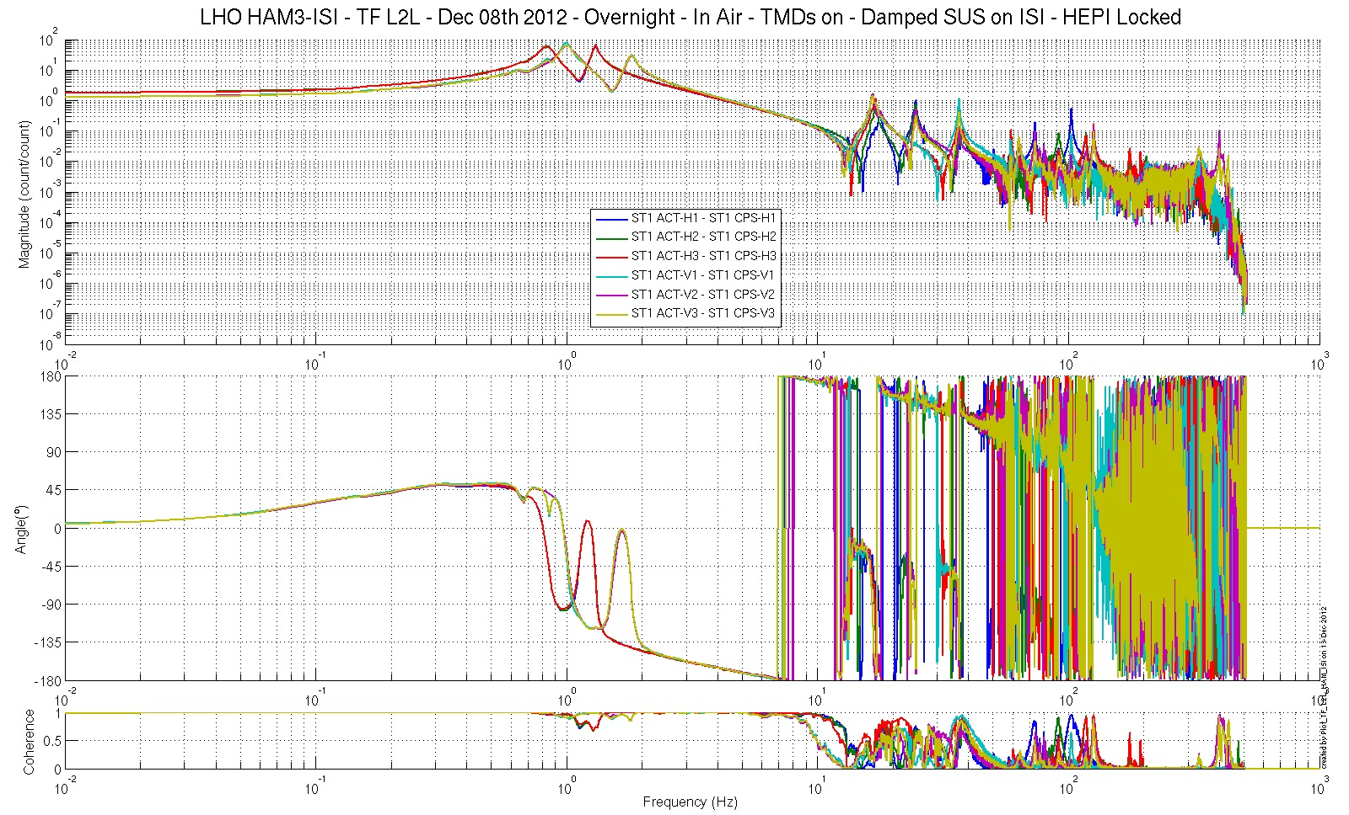
Figure – Local-to-Local Transfer Function – Capacitive Position Sensors

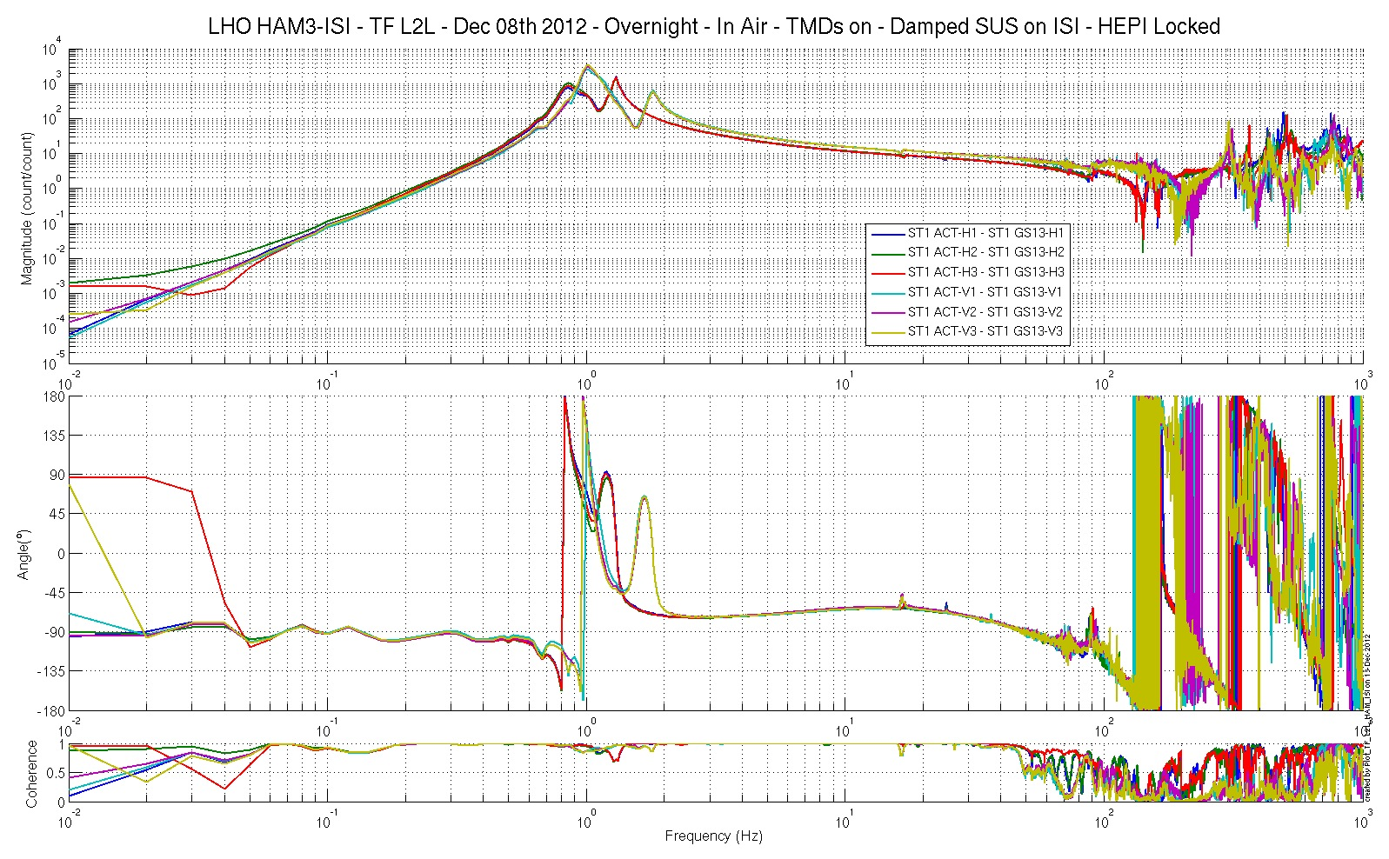
Figure– Local-to-Local Transfer Function – InertialSensors

Step 15.2: Local to local measurements V.S. LLO

Data files in SVN at:
LHO:
seismic/HAM-ISI/H1/HAM3/Data/Transfer_Functions/Measurements/Undamped/
- LHO_ISI_HAM3_Data_TF_L2L_10mHz_100mHz_20121208-100239.mat
- LHO_ISI_HAM3_Data_TF_L2L_100mHz_500mHz_20121208-081113.mat
- LHO_ISI_HAM3_Data_TF_L2L_500mHz_5Hz_20121207-224150.mat
- LHO_ISI_HAM3_Data_TF_L2L_5Hz_200Hz_20121207-195823.mat
- LHO_ISI_HAM3_Data_TF_L2L_200Hz_1000Hz_20121207-172553.mat

LLO:
seismic/HAM-ISI/L1/HAM3/Data/Transfer_Functions/Simulations/Undamped/
- L1_ISI_HAM3_TF_L2L_Raw_2012_05_12.mat
Scripts files for processing and plotting in SVN at:
seismic/HAM-ISI/H1/HAM3/Scripts/Control_Scripts/Version_2/
- Step_1_TF_Loc_to_Loc_H1_ISI_HAM3.m
seismic/HAM-ISI/H1/HAM3/Scripts/Control_Scripts/Version_2/New_Functions/
- Plot_TF_L2L_HAM_with_LLO.m

Figures in SVN at:
seismic/HAM-ISI/H1/HAM3/Data/Figures/Transfer_Functions/Comparisons/L2L/
- H1_ISI_HAM3_TF_L2L_Raw_from_ACT_H1_to_CPS_H1_vs_LLO_2012_12_08.fig
- H1_ISI_HAM3_TF_L2L_Raw_from_ACT_H1_to_GS13_H1_vs_LLO_2012_12_08.fig
- H1_ISI_HAM3_TF_L2L_Raw_from_ACT_H2_to_CPS_H2_vs_LLO_2012_12_08.fig
- H1_ISI_HAM3_TF_L2L_Raw_from_ACT_H2_to_GS13_H2_vs_LLO_2012_12_08.fig
- H1_ISI_HAM3_TF_L2L_Raw_from_ACT_H3_to_CPS_H3_vs_LLO_2012_12_08.fig
- H1_ISI_HAM3_TF_L2L_Raw_from_ACT_H3_to_GS13_H3_vs_LLO_2012_12_08.fig
- H1_ISI_HAM3_TF_L2L_Raw_from_ACT_V1_to_CPS_V1_vs_LLO_2012_12_08.fig
- H1_ISI_HAM3_TF_L2L_Raw_from_ACT_V1_to_GS13_V1_vs_LLO_2012_12_08.fig
- H1_ISI_HAM3_TF_L2L_Raw_from_ACT_V2_to_CPS_V2_vs_LLO_2012_12_08.fig
- H1_ISI_HAM3_TF_L2L_Raw_from_ACT_V2_to_GS13_V2_vs_LLO_2012_12_08.fig
- H1_ISI_HAM3_TF_L2L_Raw_from_ACT_V3_to_CPS_V3_vs_LLO_2012_12_08.fig
- H1_ISI_HAM3_TF_L2L_Raw_from_ACT_V3_to_GS13_V3_vs_LLO_2012_12_08.fig

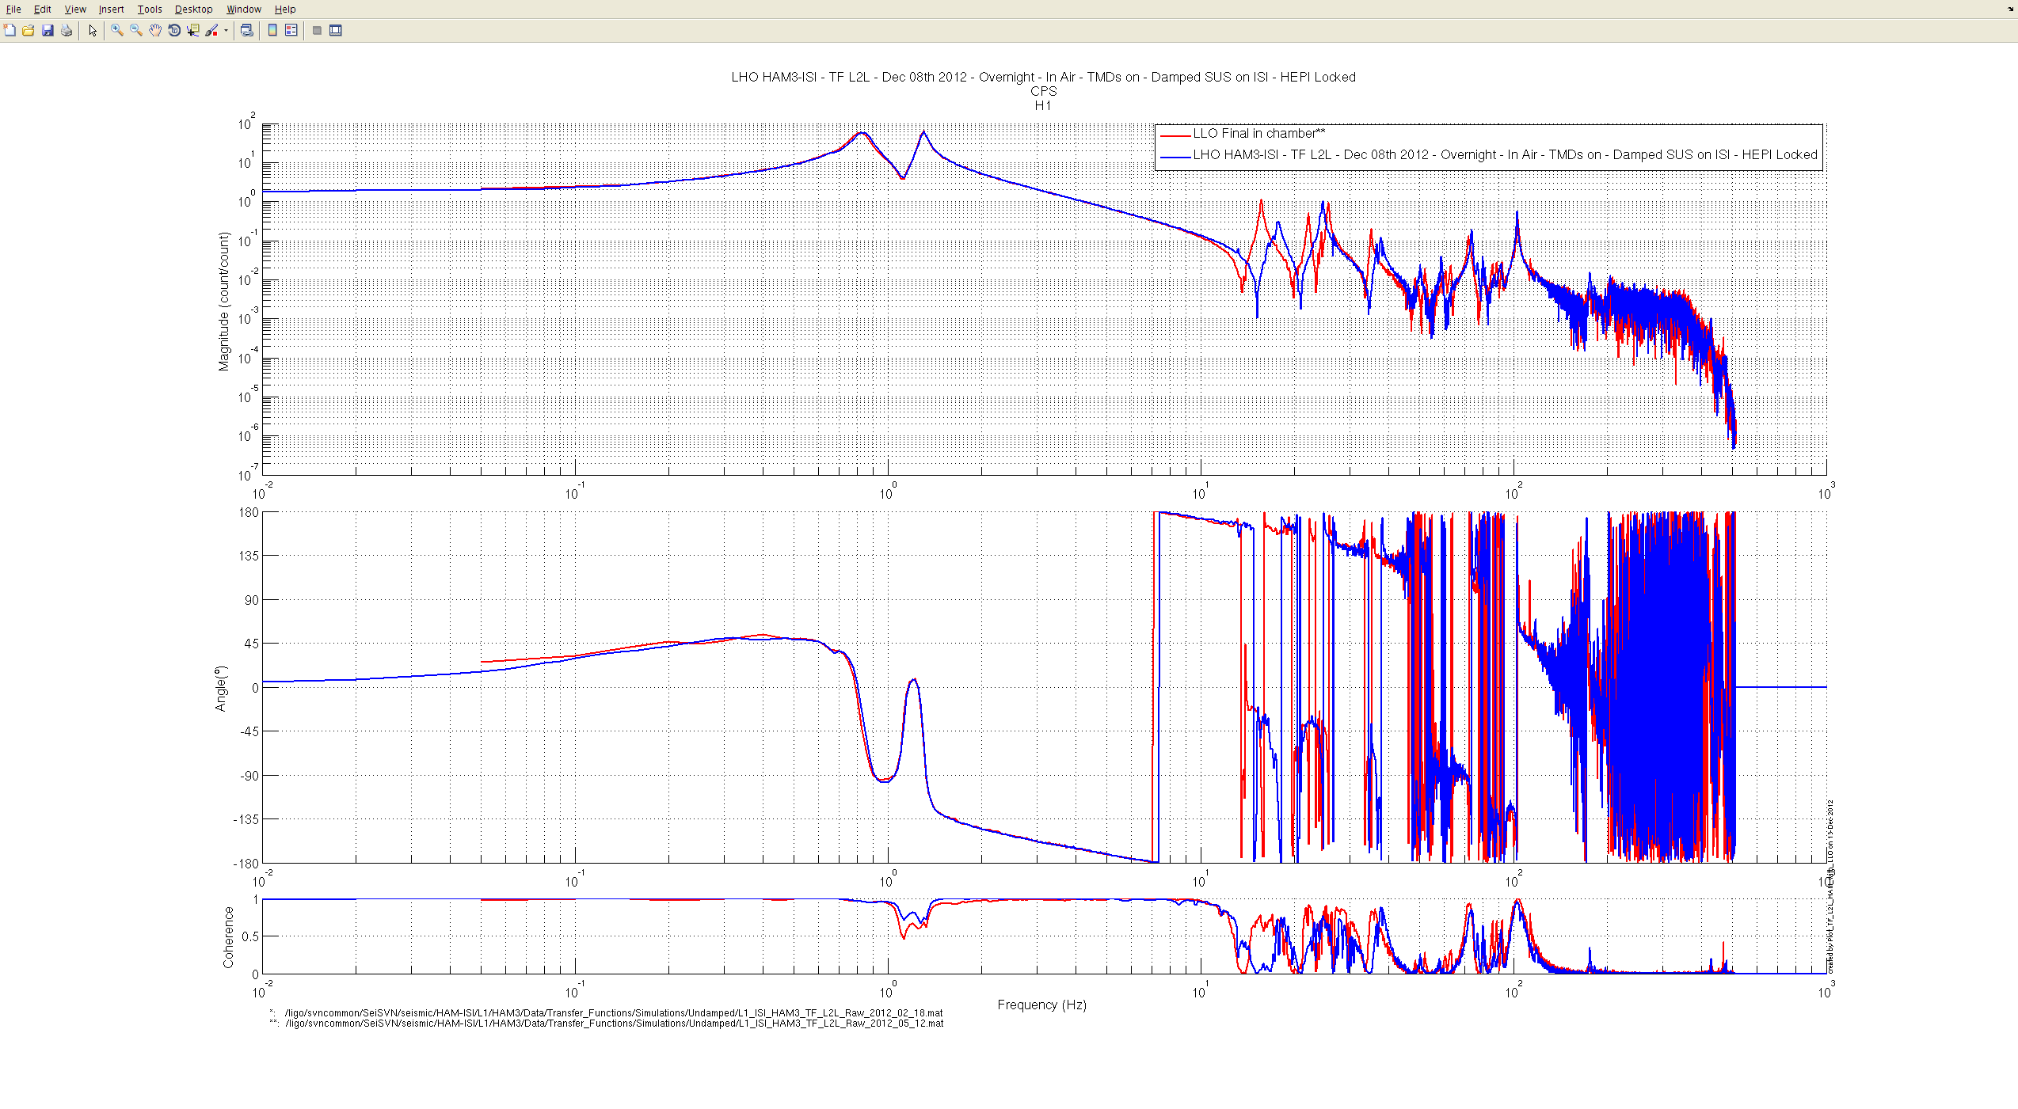
Figure– Local-to-Local Transfer Function – CPS H1 – Comparison with LLO

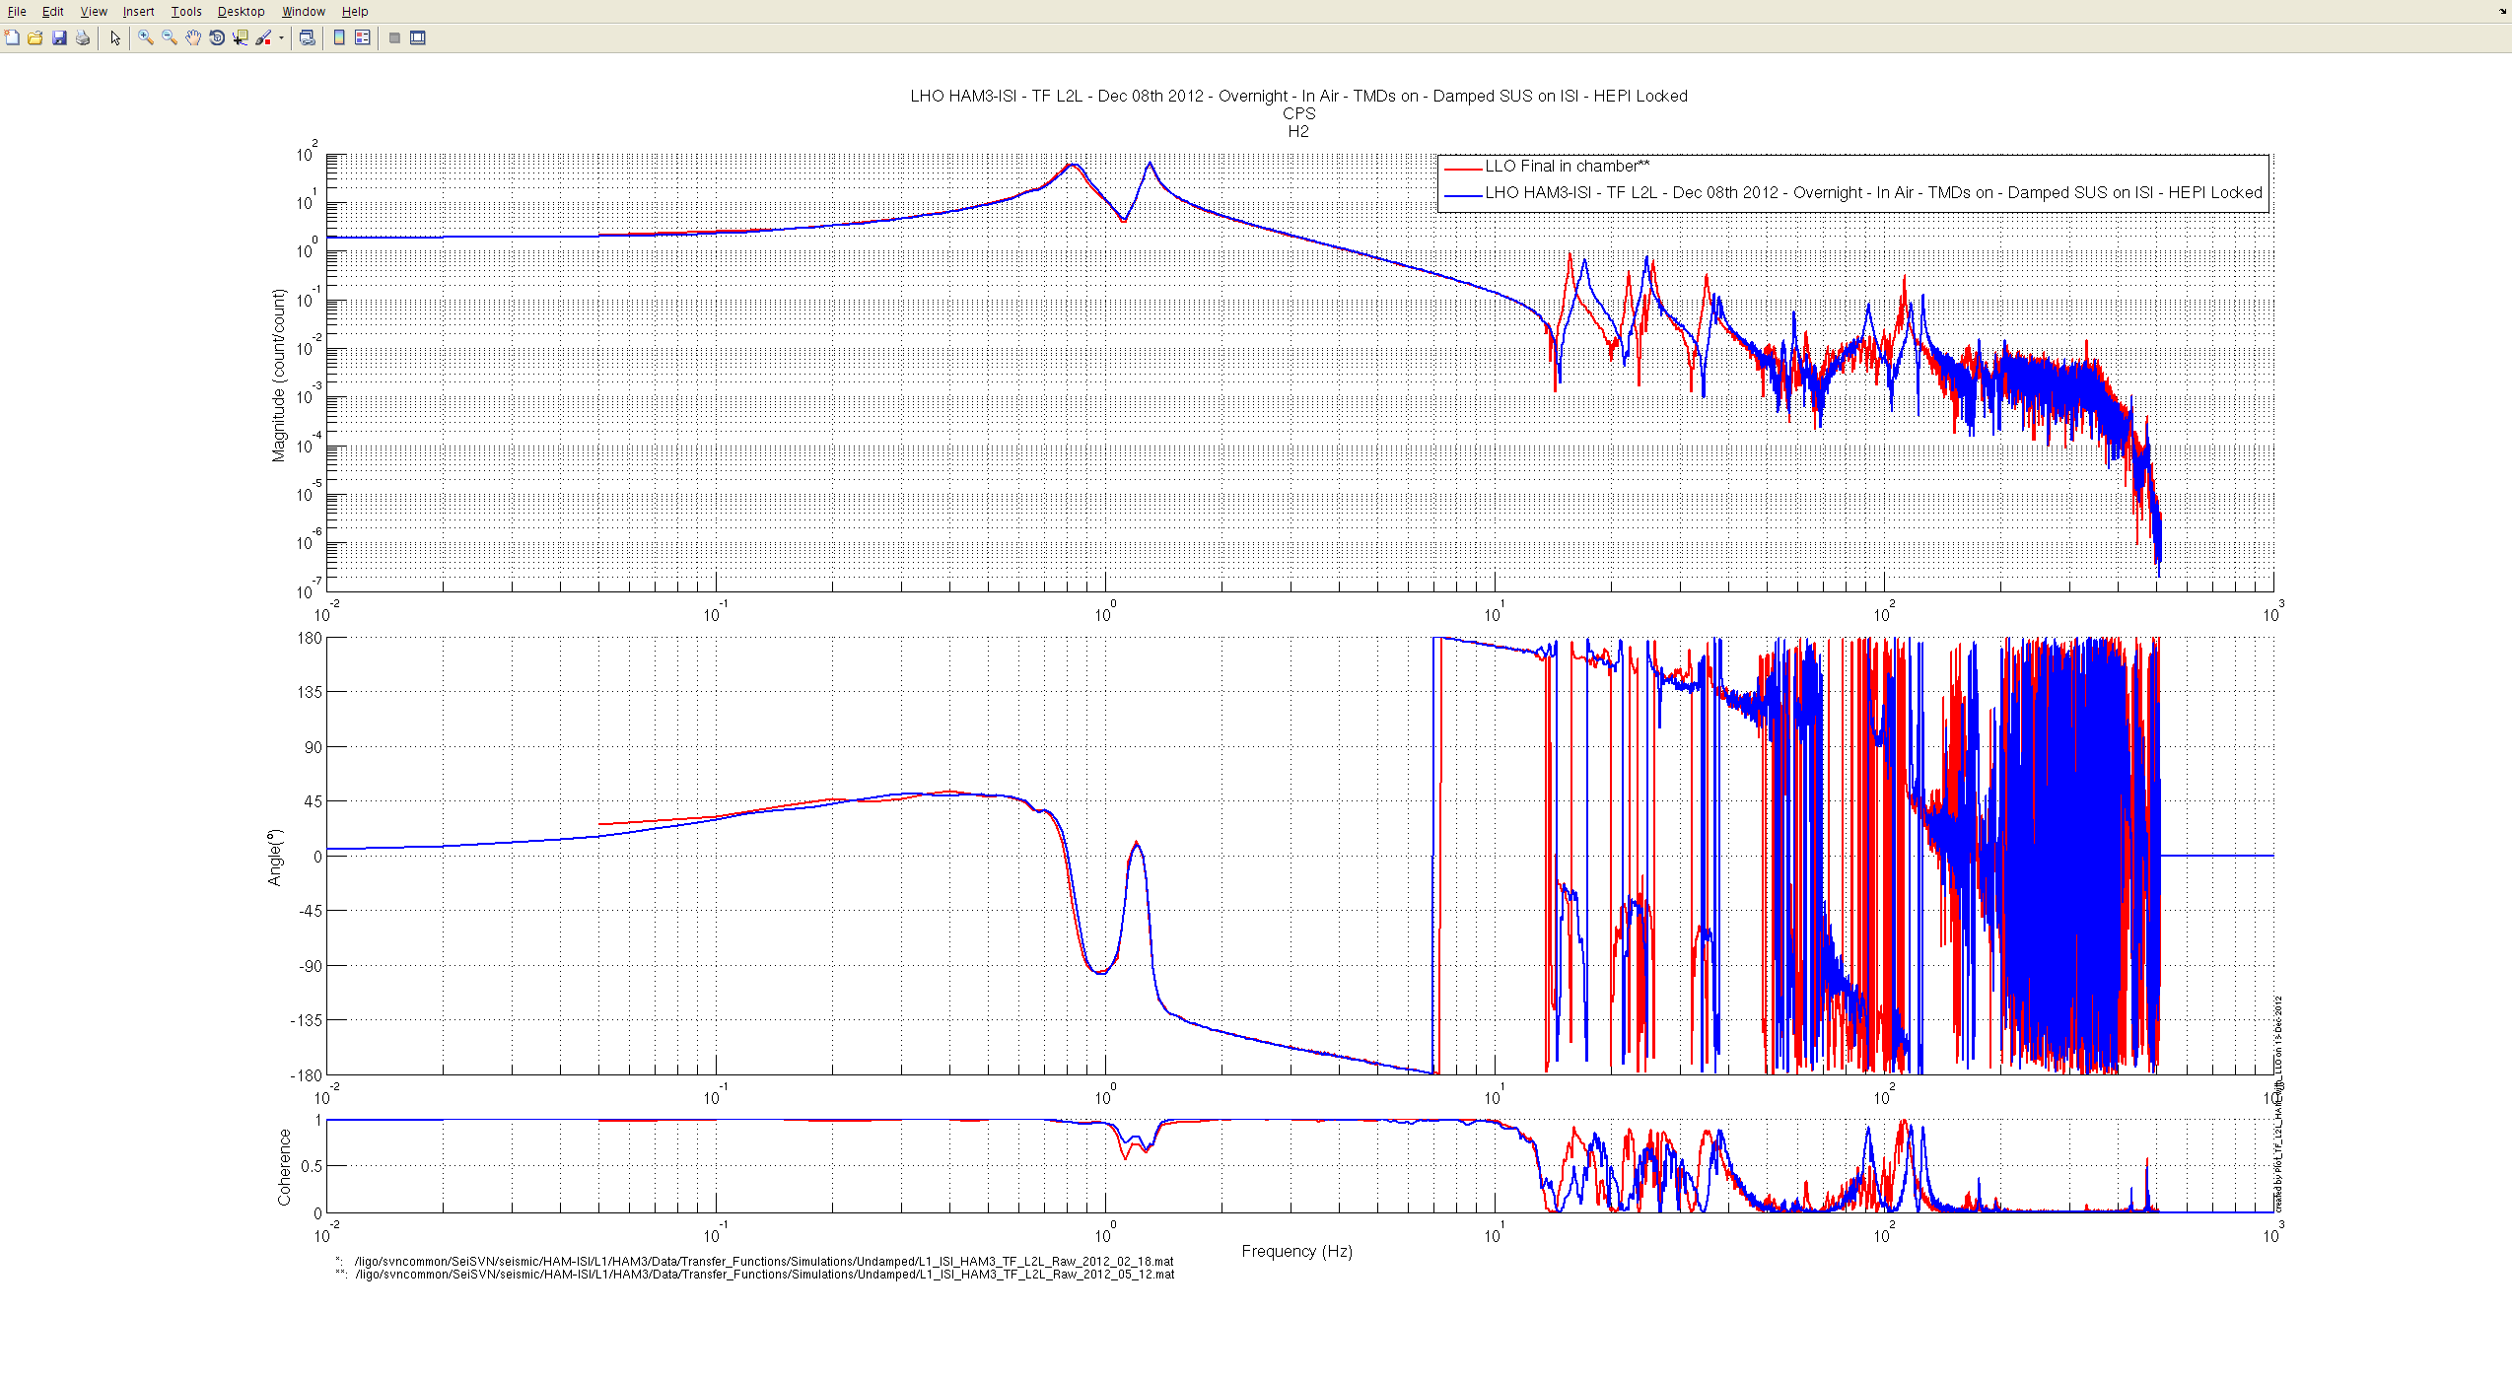
Figure– Local-to-Local Transfer Function – CPS H2 – Comparison with LLO

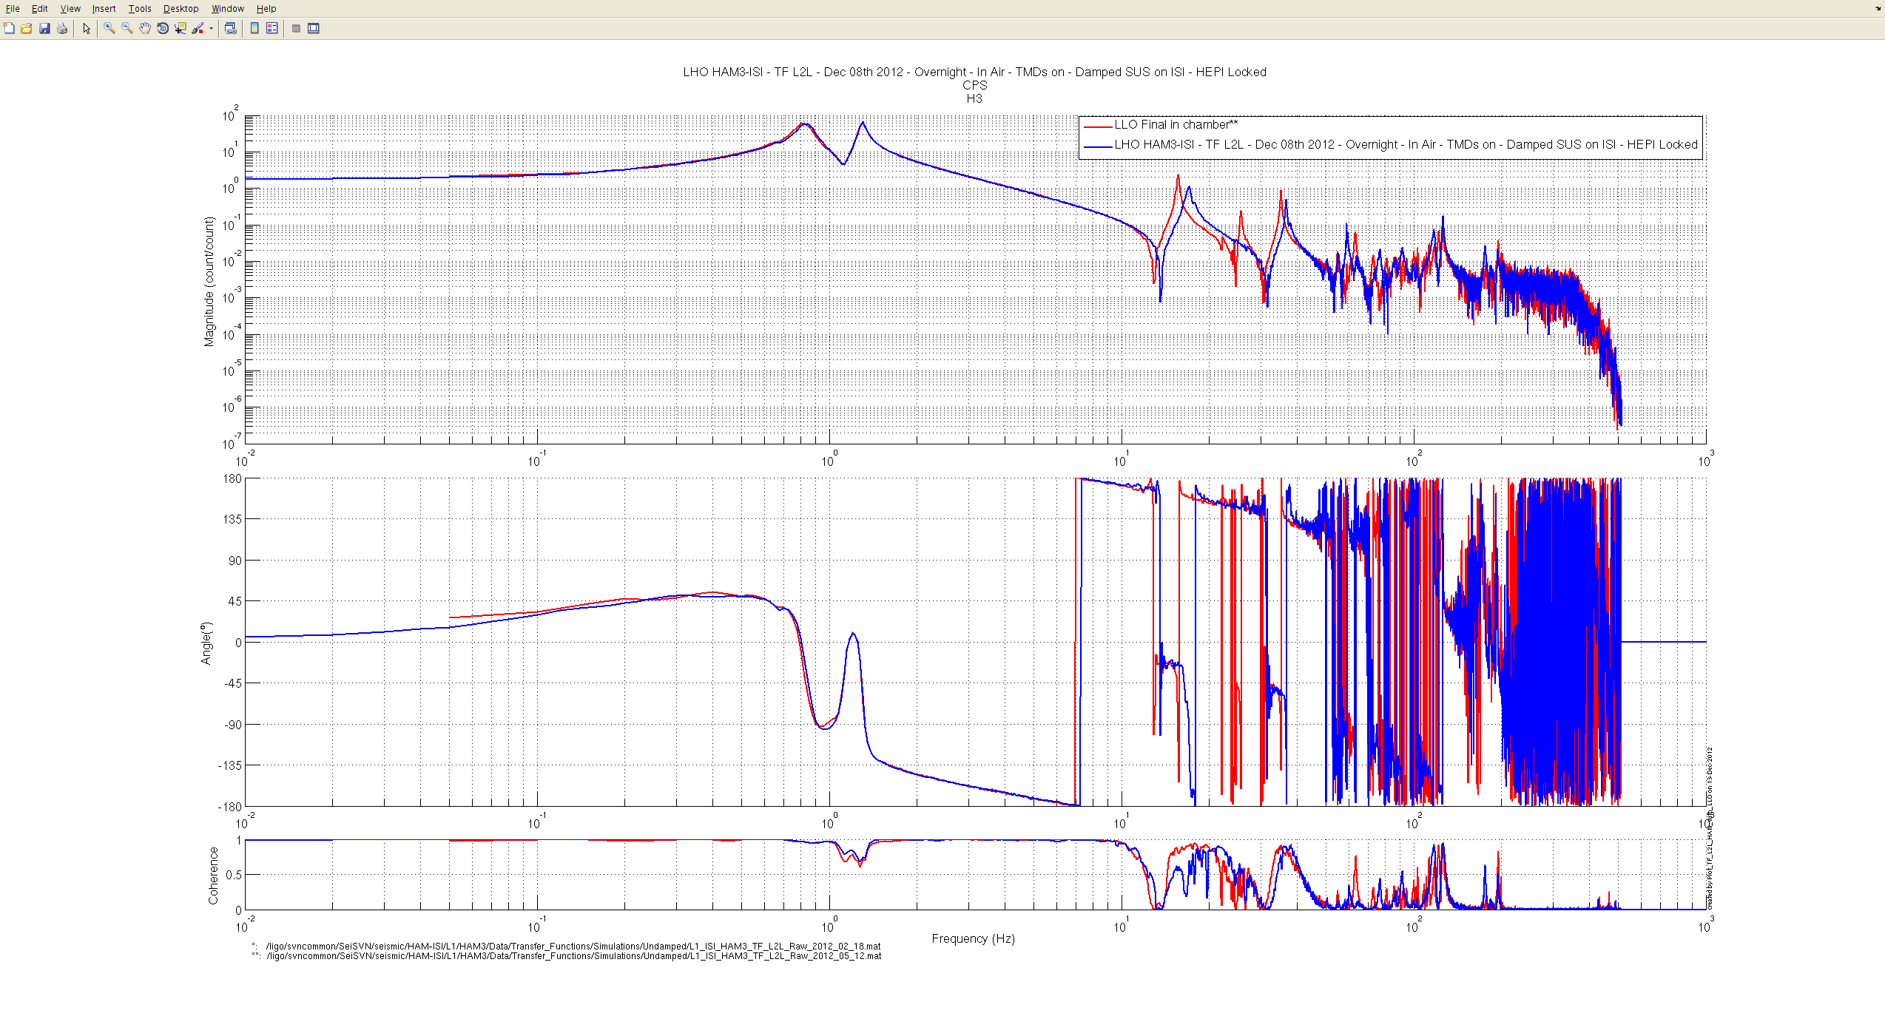
Figure– Local-to-Local Transfer Function – CPS H3 – Comparison with LLO

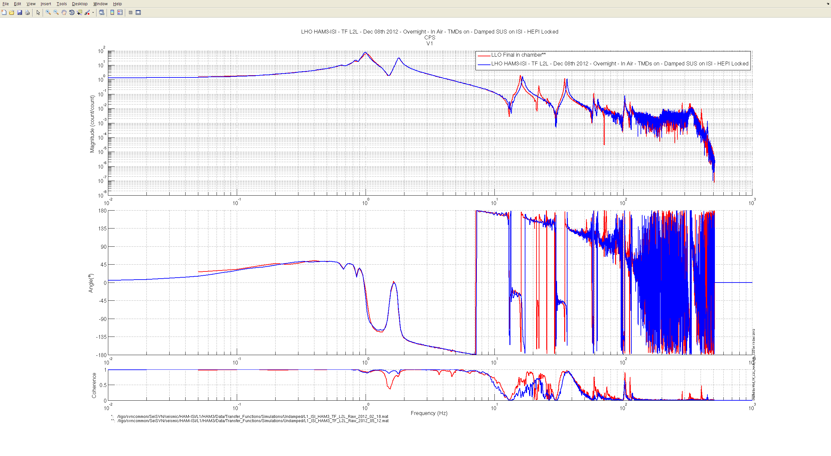
Figure– Local-to-Local Transfer Function – CPS V1 – Comparison with LLO

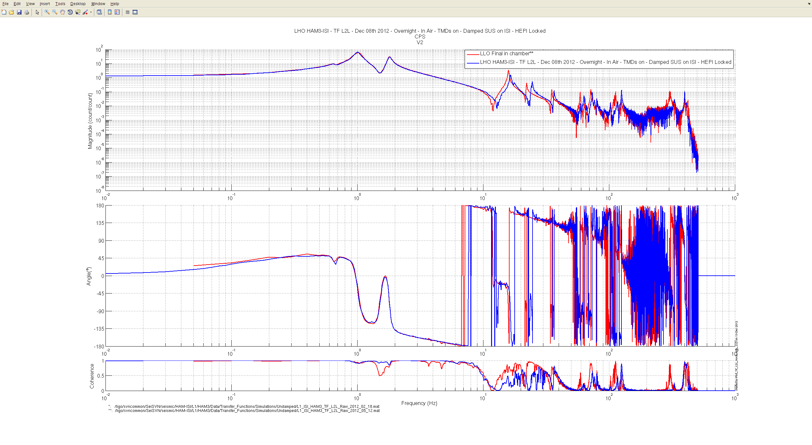
Figure– Local-to-Local Transfer Function – CPS V2 – Comparison with LLO

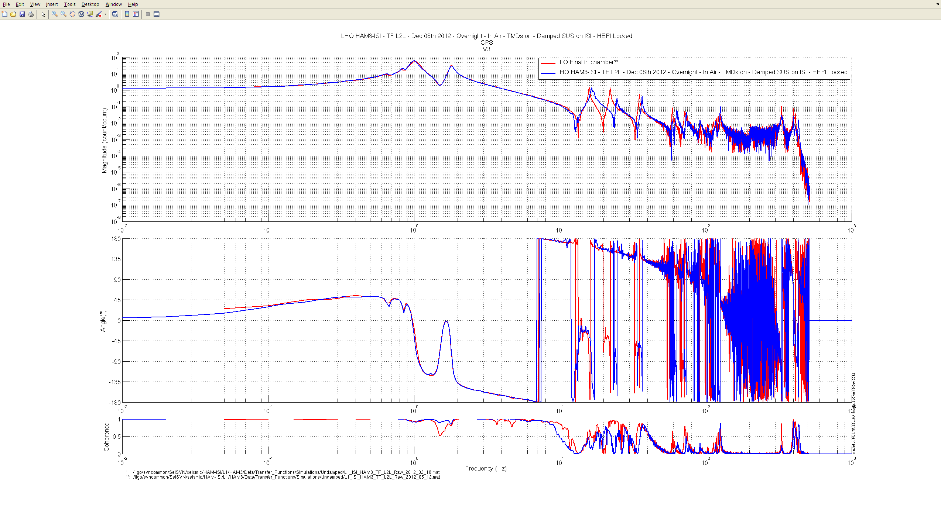
Figure– Local-to-Local Transfer Function – CPS V3 – Comparison with LLO

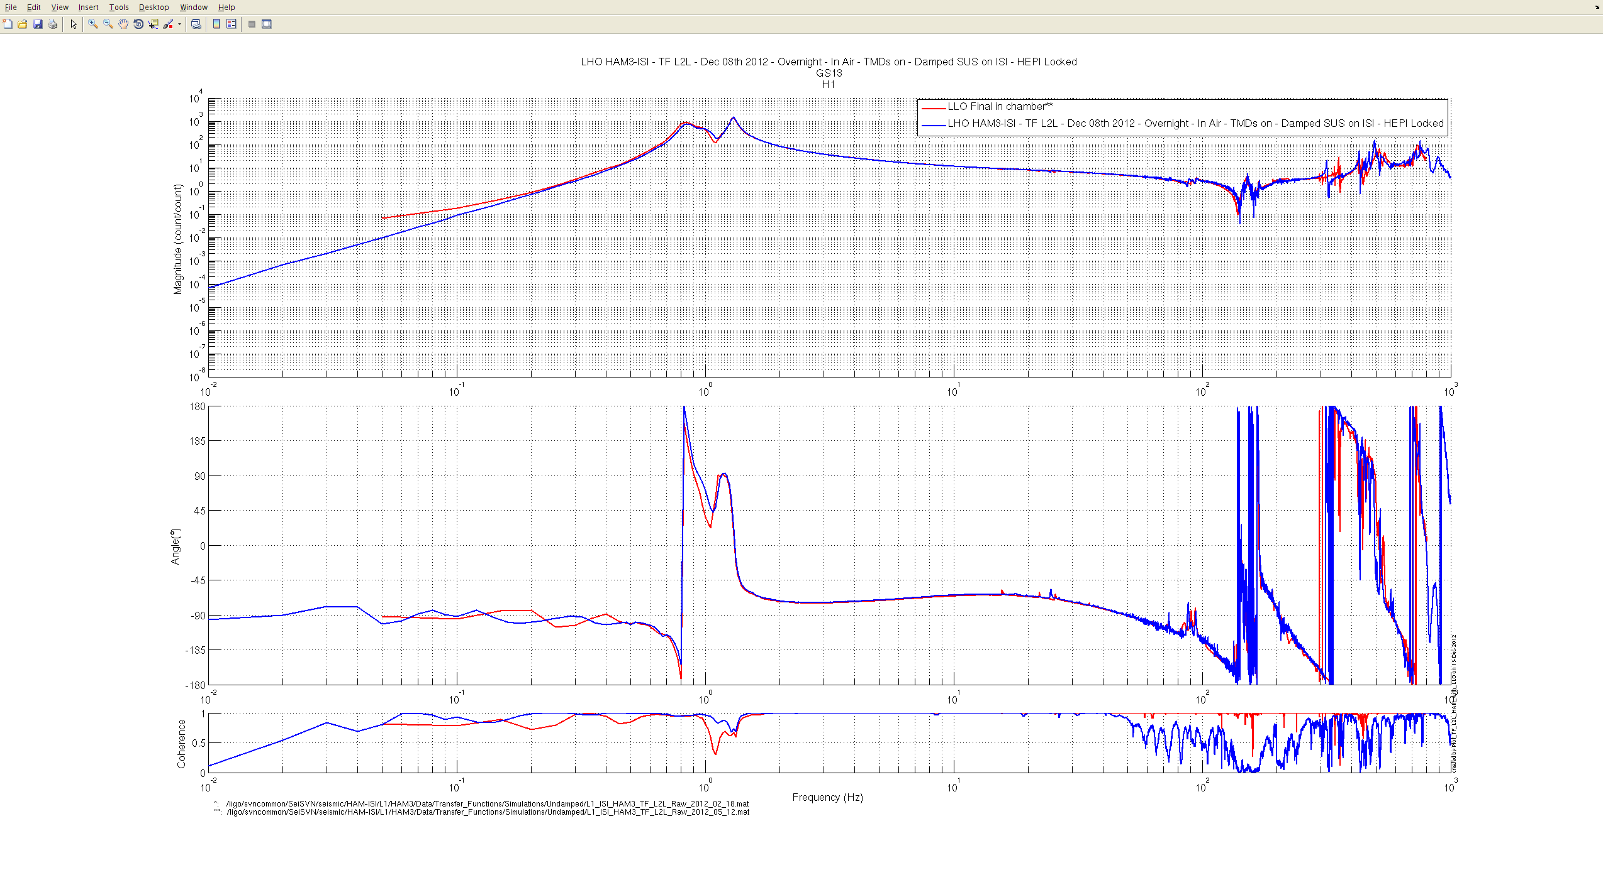
Figure– Local-to-Local Transfer Function – GS13 H1 – Comparison with LLO

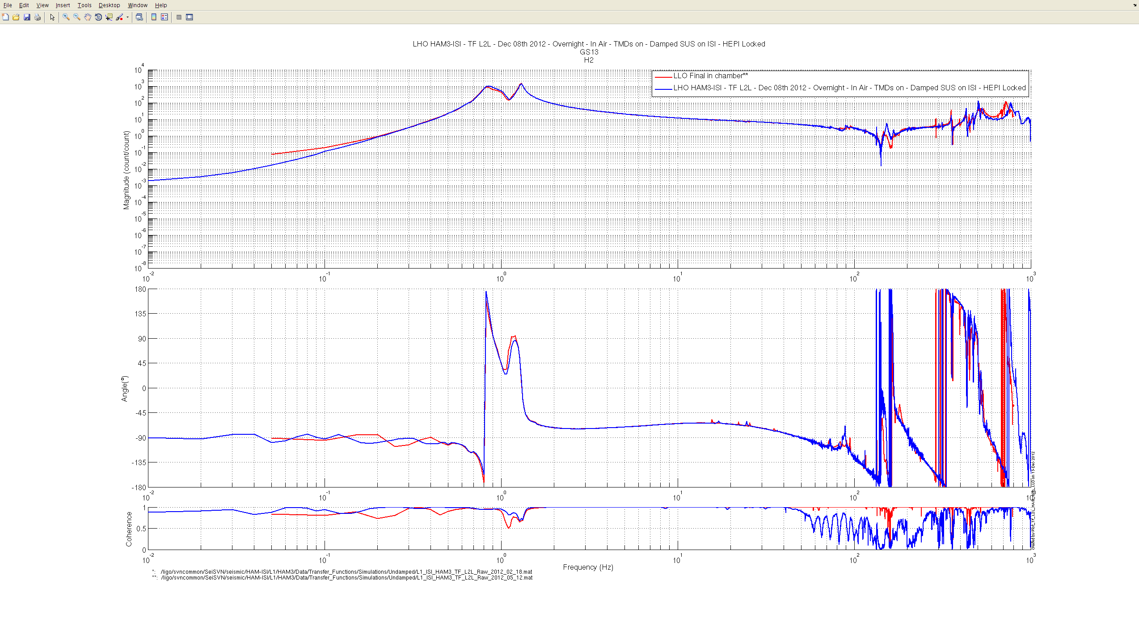
Figure– Local-to-Local Transfer Function – GS13 H2 – Comparison with LLO

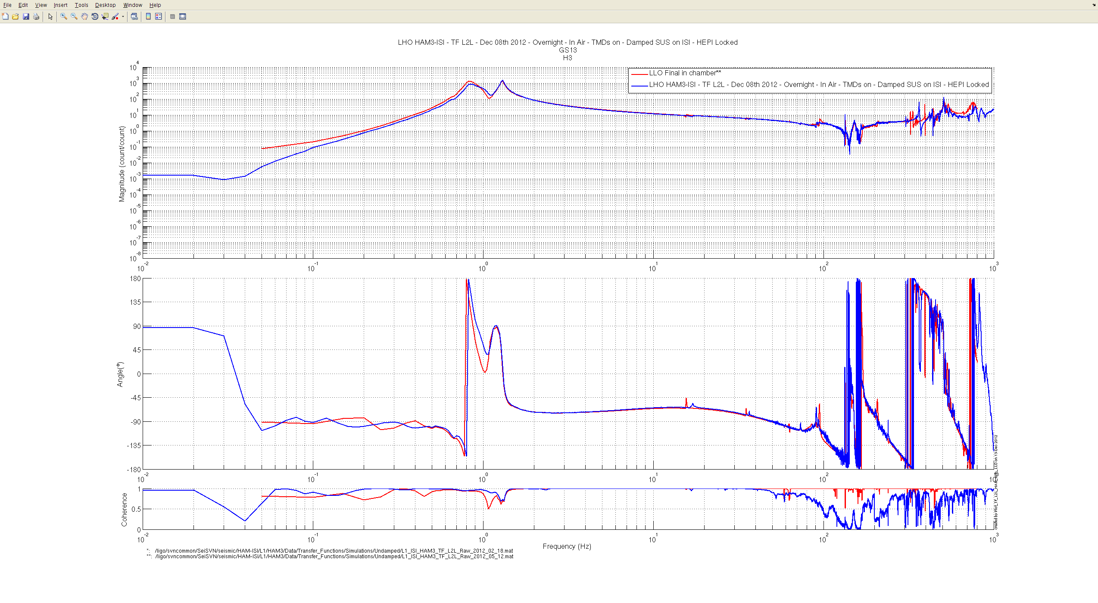
Figure– Local-to-Local Transfer Function – GS13 H3 – Comparison with LLO

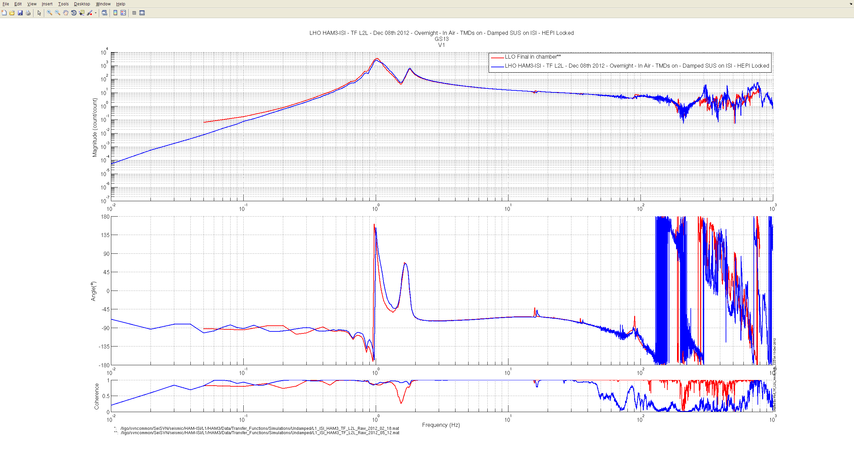
Figure– Local-to-Local Transfer Function – GS13 V1 – Comparison with LLO

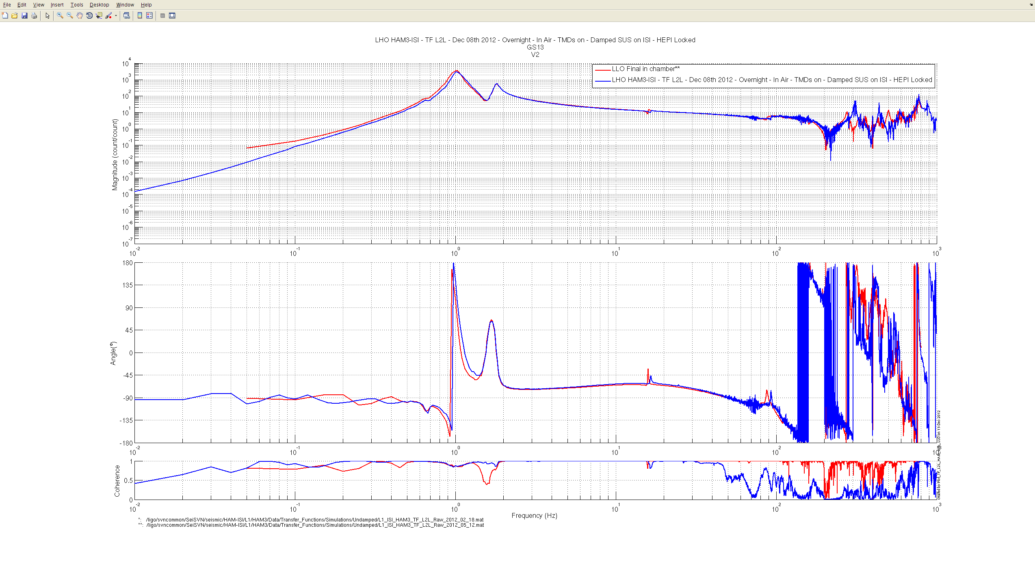
Figure– Local-to-Local Transfer Function – GS13 V2 – Comparison with LLO

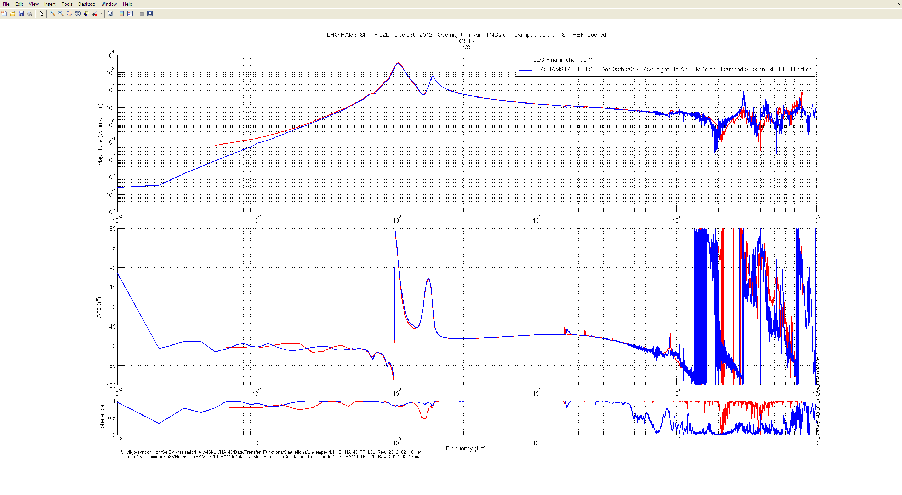
Figure– Local-to-Local Transfer Function – GS13 V3 – Comparison with LLO

Issues/difficulties/comments regarding this test:
- Transfer functions measured with vertical GS13s are slightly noisier than LLO, above ~150Hz.
- As it should not be an issue for the input mode cleaner test, we decide to move on, while keeping this feature in mind.

Acceptance criteria:
- Good concordance with TF measured under the same conditions at LLO.
- Local to local measurements
  - On CPS, the phase must be 0º at DC
  - On Geophones, the phase must be -90º at DC
  - Identical shape in each corner
- Cartesian to Cartesian measurements
  - On CPS, the phase must be 0º at DC
  - On Geophones, the phase must be -90º at DC
  - Identical shape X/Y and RX/RY

Test result: Passed: X Failed: .

Step 16: Symmetrized Transfer functions

The following symmetrized transfer functions were calculated from the Local-to-Local transfer functions presented above, in step 15. They are provided as extra material. Hence, they are not subject to acceptance (fail/pass).

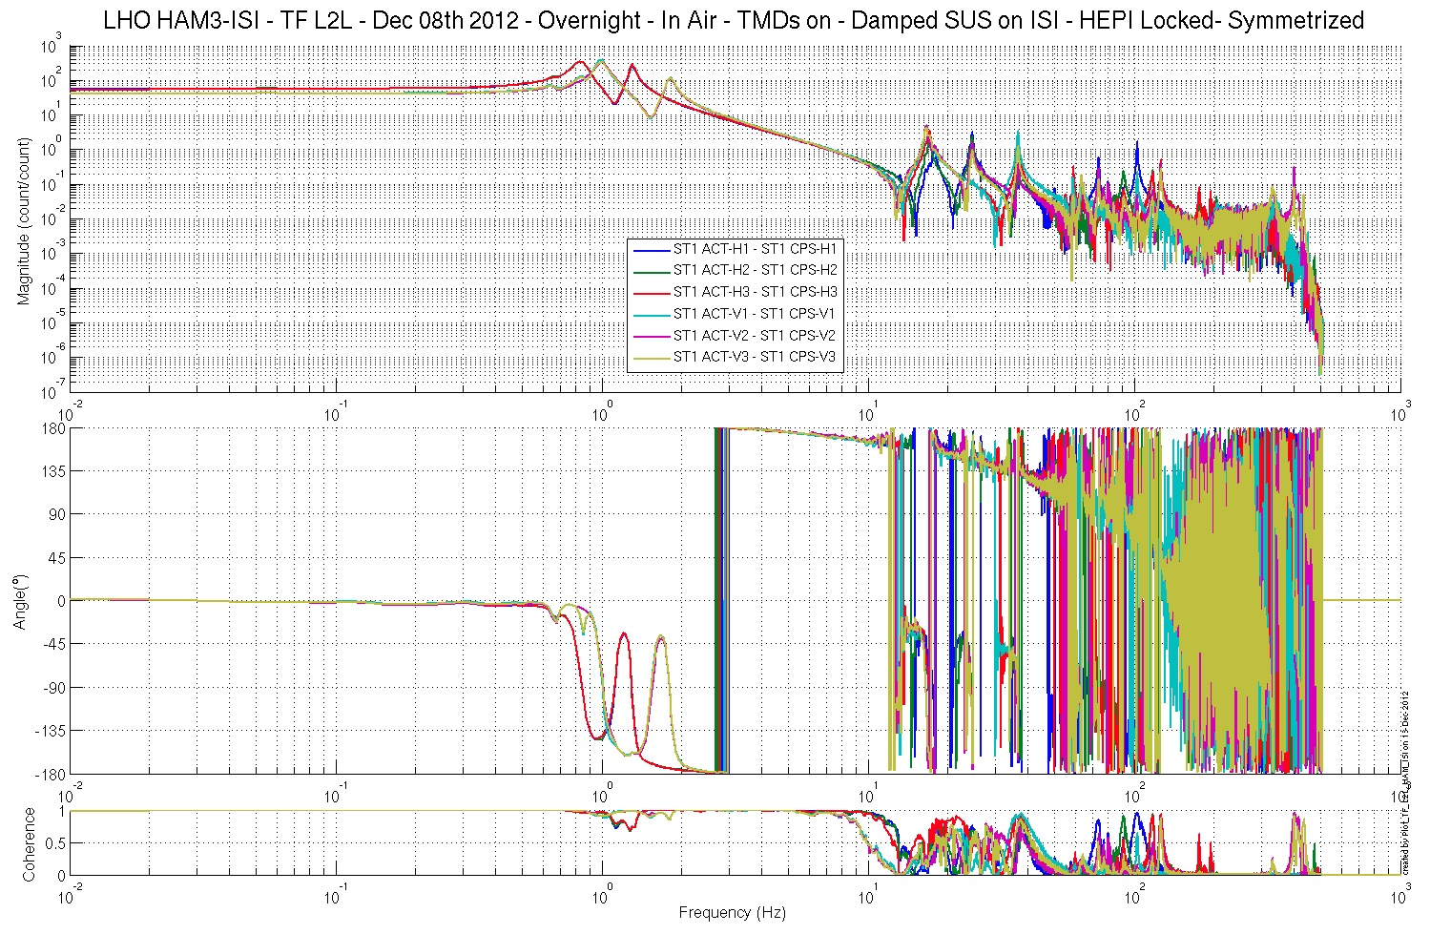
Figure– Local-to-Local Transfer Function – Capacitive Position Sensors – Symmetrized
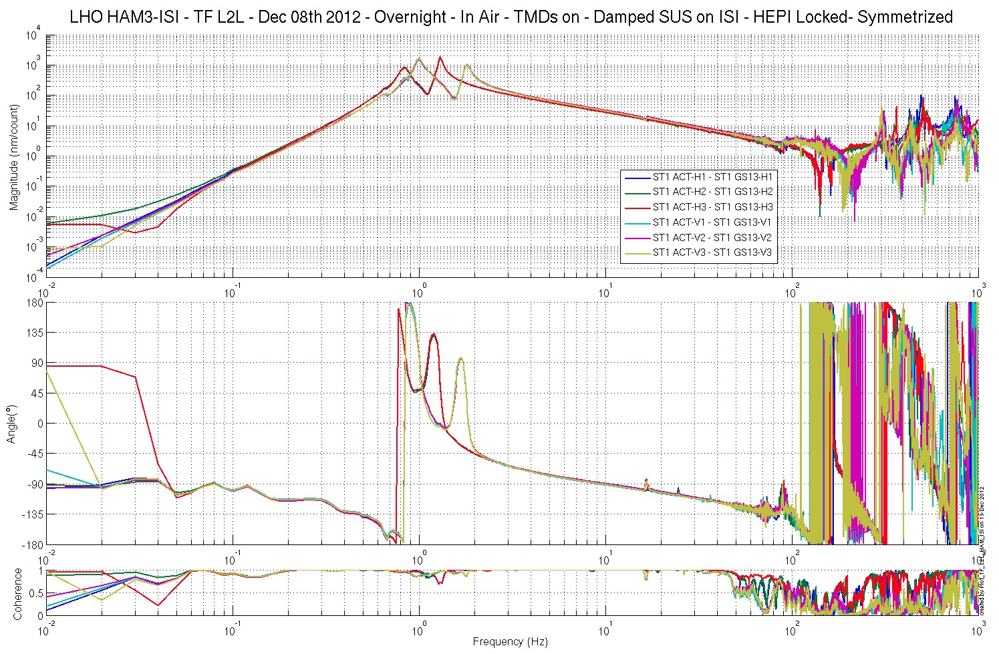
Figure– Local-to-Local Transfer Function – GS13s – Symmetrized

Step 17: Cartesian-to-Cartesian Transfer functions.

The following symmetrized transfer functions were calculated from the Local-to-Local transfer functions presented above, in step 15. They are provided as extra material. Hence, they are not subject to acceptance (fail/pass).

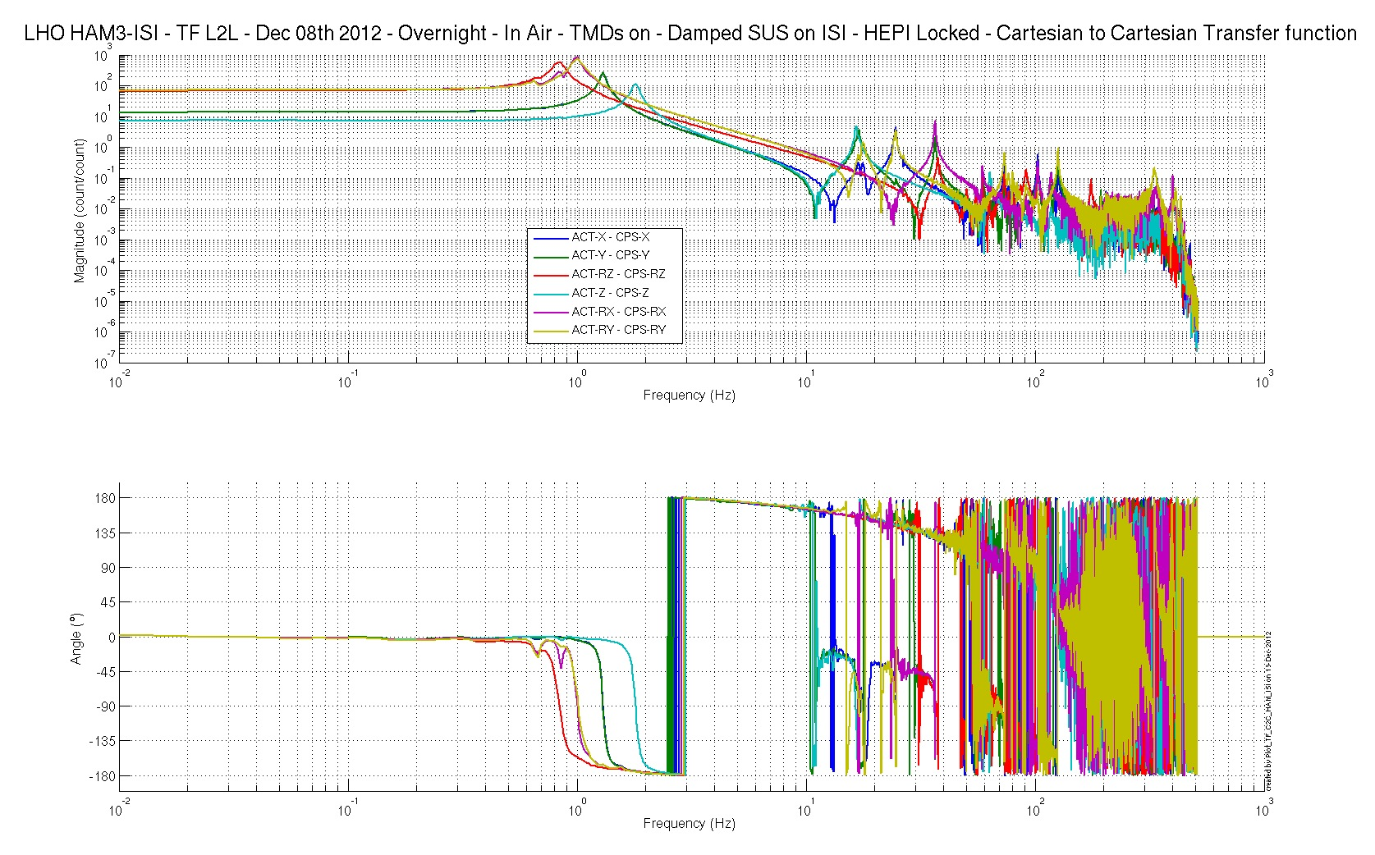
Figure– Cartesian-to-Cartesian Transfer Function – CPSs – Symmetrized
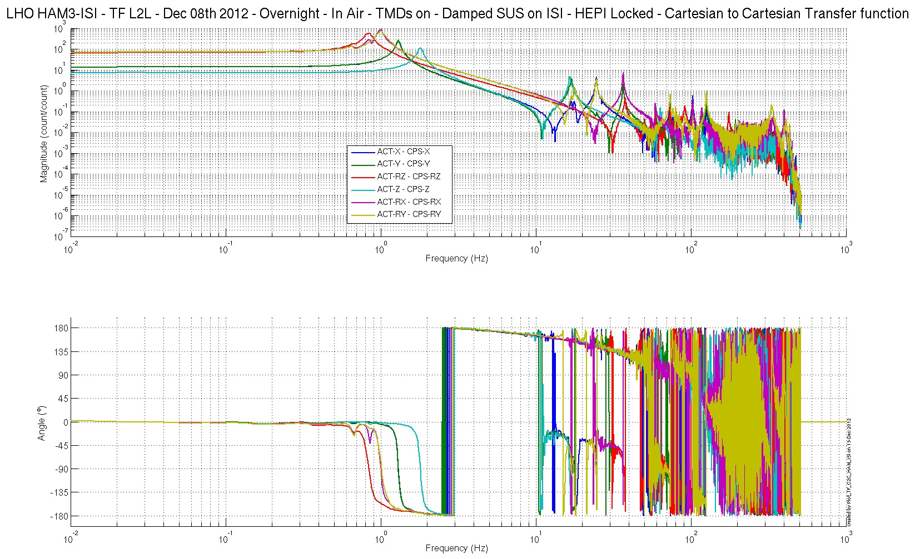
Figure– Cartesian-to-Cartesian Transfer Function – CPSs – Symmetrized

Conclusion
Final Chamber Testing

This part of the Phase II testing takes place in open chamber. All the suspensions and optics were on. HEPI was locked.

This was the last phase of testing before the chamber is closed for the IMC test. Once this section of the Phase II report is validated, the report is closed.

Next step is removal of the first contact from the optics of MC2 and PR2. The suspensions will be locked for this operation. They will be left unlocked, and damped after this operation. The ISI is locked for this operation and will be unlocked once it is done.

A final set of transfer functions will be taken before the doors come on the chamber. This set of transfer functions should be approved by the SEI team before closing up the chamber.

Tests that failed:
- The level of stage 1 is slightly out of requirement. The pre-commissioning work performed on the ISI (installation of damping loops and first 2 levels of isolation, without suspensions) did not seem to be impacted. As there is not much that could be done, the SEI team decided to move on while keeping this feature in mind.
- The blade of corner 2, which is the only one that can be measured is bent slightly out of requirement (17 mils of flatness instead of 15 mils). Like for the level of the optical table, SEI decided to move on while keeping this feature in mind.

Waved Tests:
- LZMP: It is a lengthy measurement that needs tweaking before being run with suspensions on. Indeed, suspensions trip when the test is run.

Particularities to be kept in mind:
- The optical table is slightly out of level (165µrad instead of 100µrad)
- The blade of corner 2 is bent more that recommended (17 mils of inflation, instead of 15 mils)
- TFs measured with vertical GS13s are slightly noisier than they are at LLO, above ~150Hz.
- A small screw ( 4-40 x 0.112) was dropped while populating the optical table. The screw could not be found. Details available in LHO aLog #4354

