E1200535-v17
TMS WORK TO DO LIST GOING FORWARD
( all items large and small _rough outline, not in order , or standard format )
7-20-2012

1. D1101130 ASSEMBLY - UPDATE THIS TO SHOW THE PRODUCTION SET CONTAINING THE REMOVABLE END BRACKETS AND CAPTURED SCREWS, AND NUT PLATE, WITH THE ASSOCIATED HARDWARE - NOTE THE FIRST ARTICLE HAS THE ORIGINAL CONFIGURATION THIS SHOULD BE KEPT AS FIRST ARTICLE CONFIG.
Note: we do not need an access hole in the weldment to access the breadboard screw
2. D060492 QUAD WELDED FRAME NEEDS TO BE UPDATED IN THE TMS DRAWING AND ASSEMBLIES TO SHOW THE 'UK' STYLE CONSTRUCTION.
THIS CORNER ATTACHMENT FOR THE CHANNEL STIFFENER WELDED IN BRACKET ATTACH POINT (4 PL) RATHER THAN THE NOW SHOWN GUSSET JUST WELDED IN THE CORNER ON THE SURFACE OF THE TUBE.
ALSO TO CHECK THE DRAWING FOR THE CHANNEL STIFFENER THAT THE PORT HOLE IS SHOWN FOR THE CONNECTOR CLEARANCE FOR THE BREADBOARD REF. 'UK' PART TD-1084-436
ALSO A NEW TOOL FOR ACCESS TO THE BREAD BOARD CAP SCREW OR THE SCREW IS CHANGED TO A HEX HEAD TO EASE ACCESS.

PICTURES OF THE UK AT CALTECH, AND OUR DRAWING NOTE THE GUSSET

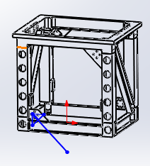
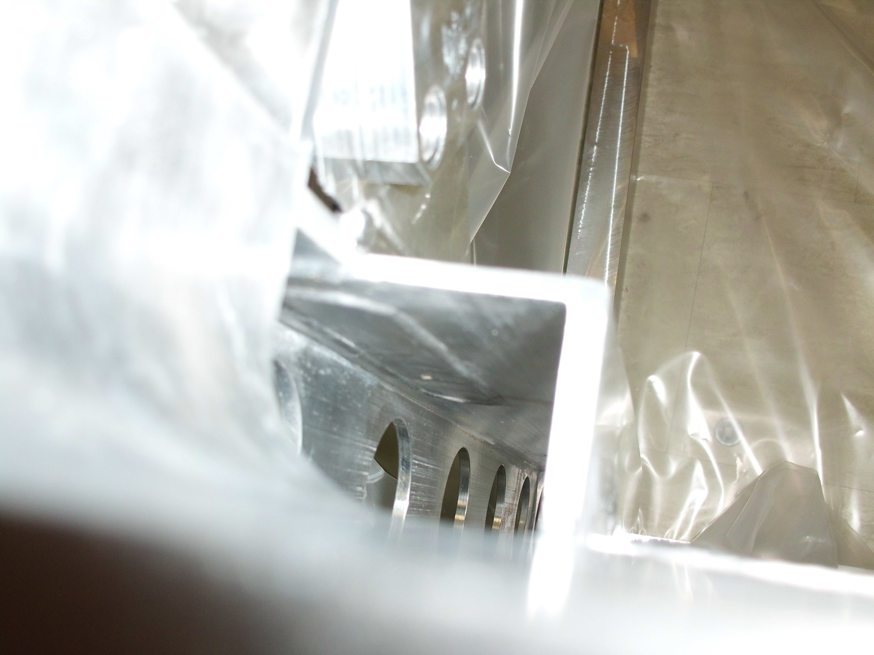

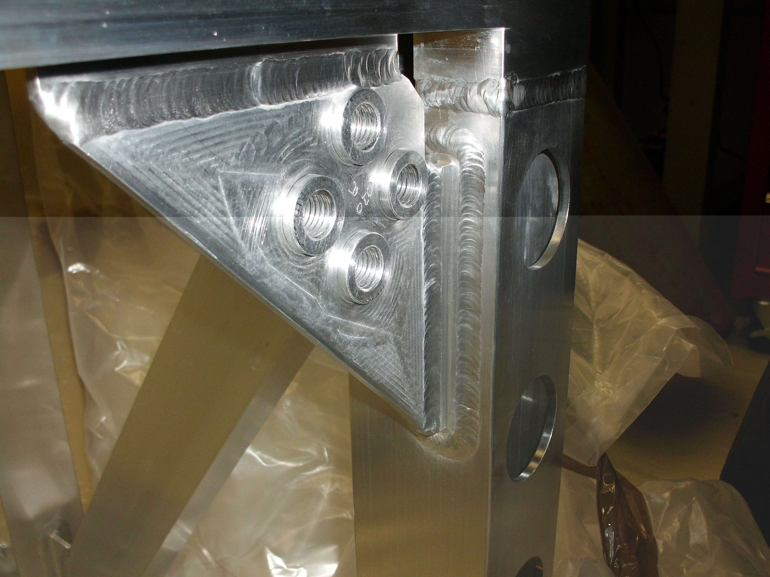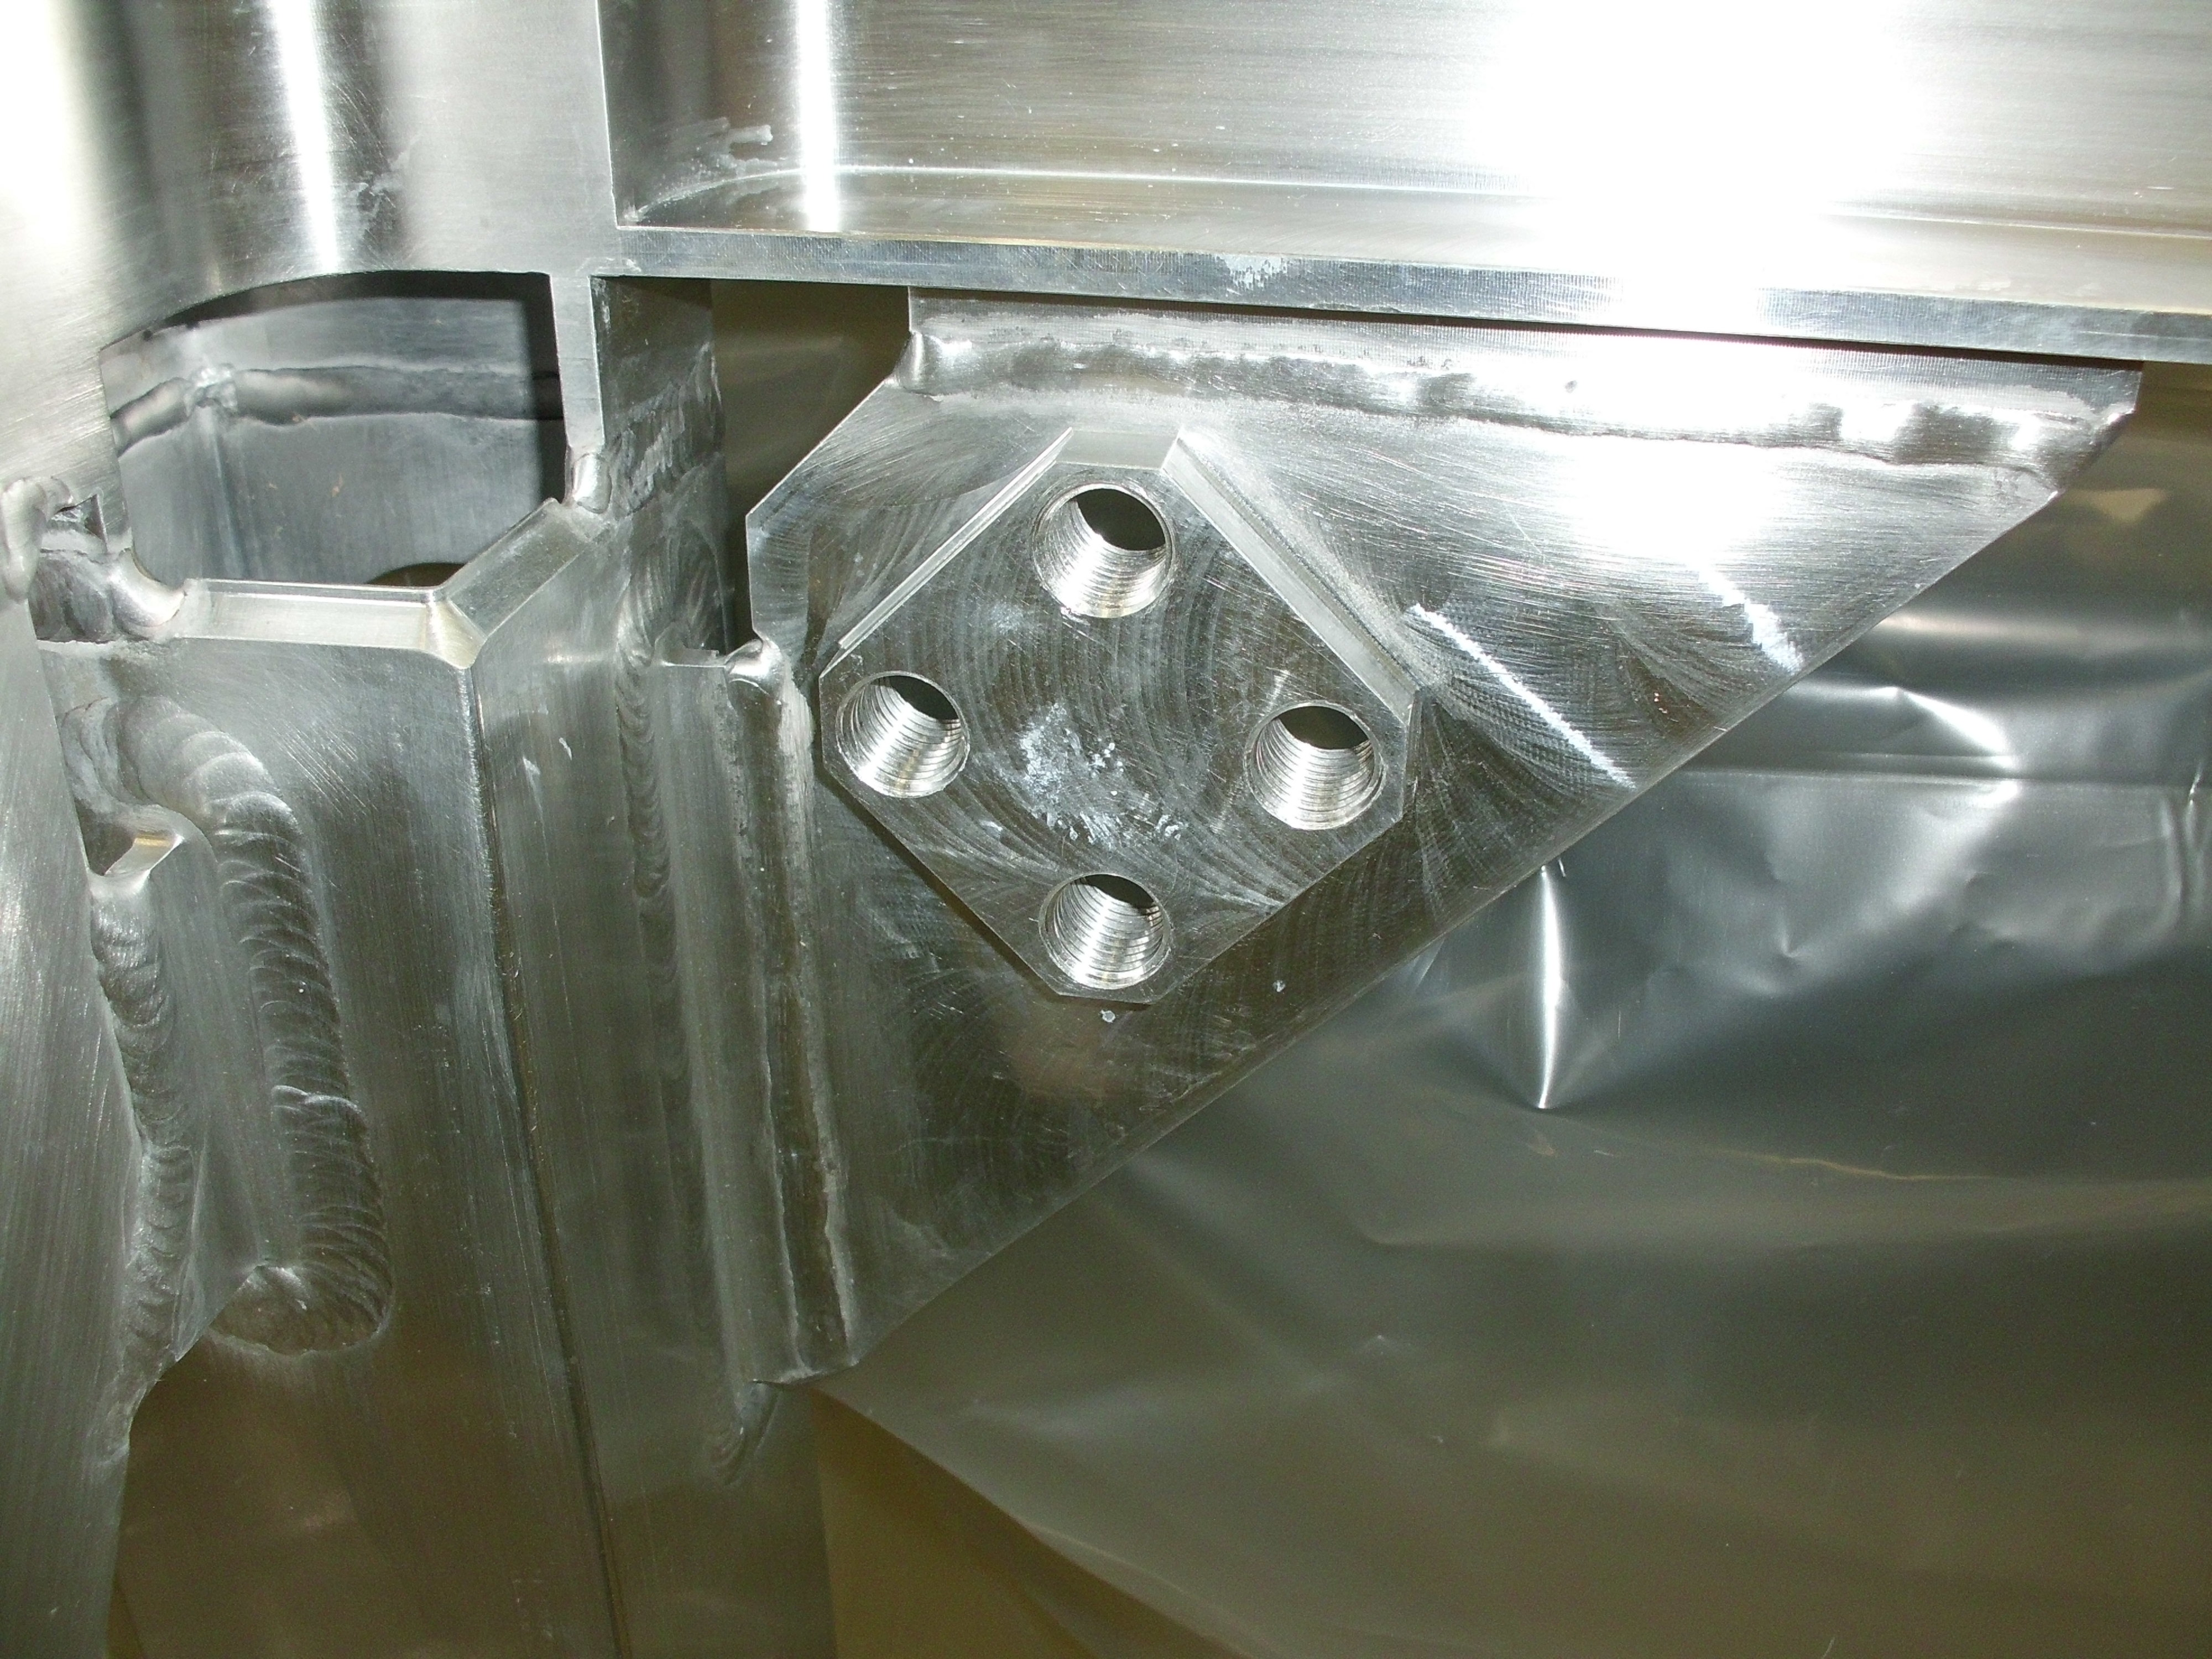

ACCESS TO THIS SCREW (SEE NOTE ABOVE) not needed anymore 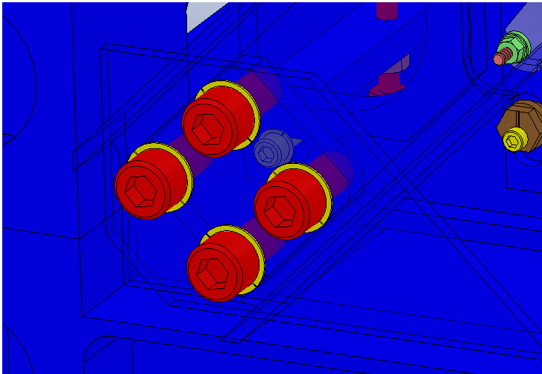

REF BELOW FOR STIFFENER AND ATTACHMENT GUSSET INFORMATION

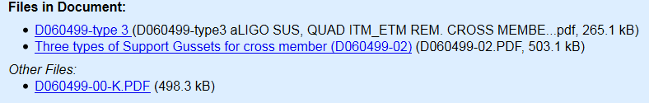

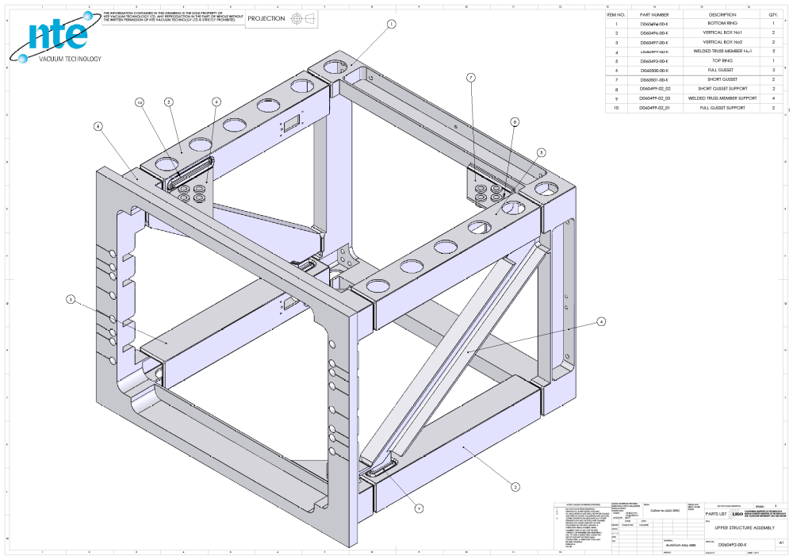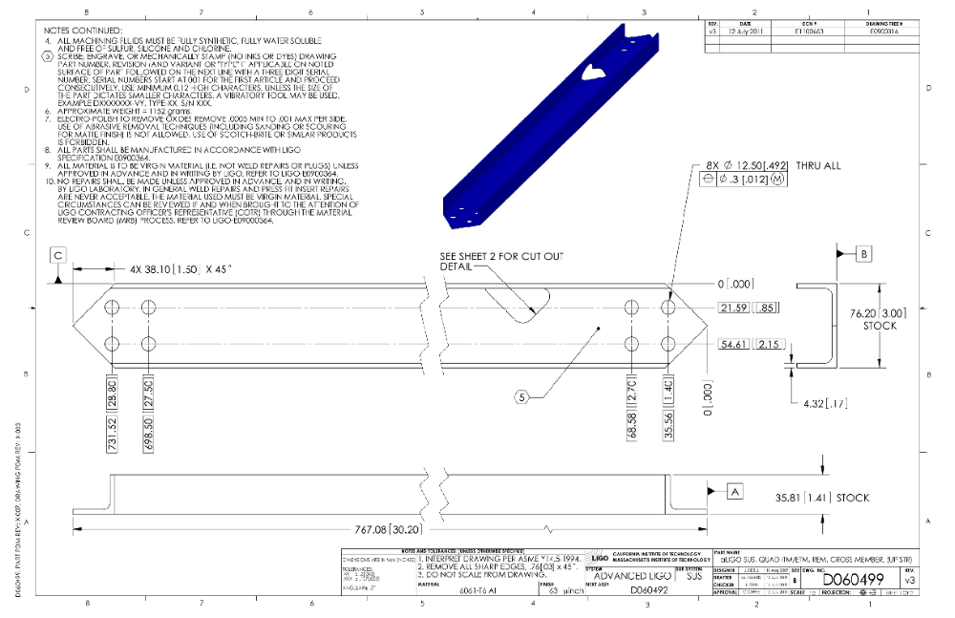

*****************************************
3. MAKE A ALLEN TOOL FOR THE ADJUSTMENT OF THE SCONDARY MIRROR SCREWS AND THE F1 AND F2 MIRROR ADJUSTORS THRU THE TELESCOPE END PLATE ACCESS HOLE. THIS IS A RIGHT ANGLE BEND ON A SMALL BALL END ALLEN WRENCH. THESE ARE AT CALTECH AND NEED TO BE BENT FOR THE PURPOSE

**************************
4. CABLE LAYOUTS FOR THE REMAINING CHAMBERS FOR TMS. NOTE THE NUMBERS ALREADY SELECTED BELOW FOR BSC ASSEMBLIES
TOP ASSEMBLIES:
- Here are the TMS Top Assemblies with their BSC Assemblies (TMS; BSC):
  - D0900411; D0900502 (WBSC5)
  - D0900419; D0900512 (WBSC6)
  - D0902163; D0901150 (WBSC9)
  - D0902168; D0901154 (WBSC10)
  - D0900435; D0900471 (LBSC4)
  - D0900436; D0900506 (LBSC5)

5. REF excel BOM for D1102291 in DCC

6. REF THE 1880 WILL BE: RIGHT / LEFT/ FIRST ARTICLE / PRODUCTION
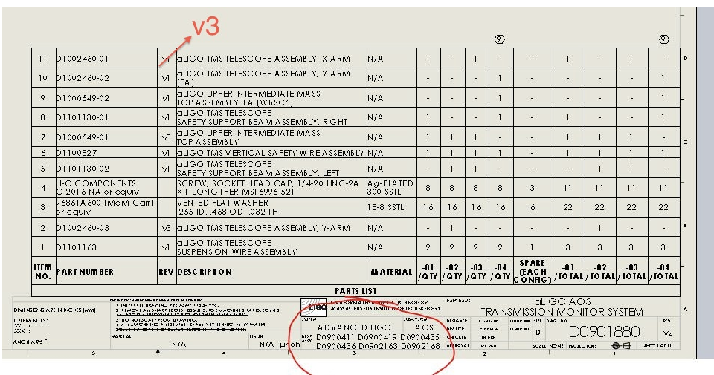
7. SECONDARY MIRROR MOUNT FACE PLATE
8. GENIE REPLACEMENT TOOL FOR ALIGNMENT PHASE
9. ZEMAX RAY TRACE
10. VIEWPORT LOCATION TOOL
11. VIEW PORT FIXTURES
12. CHANGE SAFETY WIRE TO STAINLESS STEEL DUE TO RUST
13. A CAPTIVE SCREW HAS TO BE MADE FOR THE ATTACHMENT OF THE WIRE CLAMP TO THE OPTICAL TABLE
14. look at D1101307_- - - for updating
15. look at D1101130_- - - for updating

16. make 4 sets of viewport window location transfer tooling need asap

17. send back to coater two sets of primary and secondary tms mirrors, we need a coating fix for 'fog' and pin holes - - -have talked to L and L about this , they say they can do the work
18. New or revision modified drawings sent to Lisa for DCN's (follow up and check these by looking at sent emails to Lisa)
19. Keita mirror mount to replace siskiyou
20. complete balloon and bom for assembly drawing of the mirror mount tooling in 19 above

21. shipping boxes maybe the gray's in the highbay - Kurt B has done done some work on this

22. June 12 2012 email to Calum re masses to replace the magnets on TMS sus + items to do on TMS
REF. the mass replacements are on the list of suspension parts to make and should be in process now
for all the production units.
i believe the FA has to stand 'as is' due to the lack of attachment holes for the mass
i can recheck this to replace the magnets we should request Norna's group to make a few extra of their design and purchase them from SUS
Note: as of 6-12-12 we have not made all the parts yet for TMS:
1. the secondary mirror mount adapter plate, the tool to replace the genit in setup are two items
2. the boxes for shipping or storing an assembled unit (s)
3. new wire for the front safety pendent
4. i'm not sure on the glass beam dump internal to tele
5. a second set of stabilization tooling Lisa was ordering
6. the comparison of used and not used SUS parts to replace
7. cables
to replace the magnets we should request Norna's group to make a few extra of their design and purchase them from SUS

******************
23.
issue of correct version to order or put in the ICS re. v4 or v3
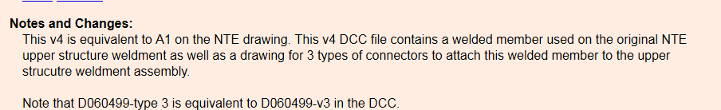
for weldment and side channel stiffener

*****************************************
24.
to follow up on checking the correctness of parts ordered and placed in the design as being the correct parts due to last minute revisions are we current on assemblies and part revisions for all TMS

********************************************
25.
D1200245
Stephany,
either a relief or a radius is ok, on these 3 boss features,
in each case making the minimum, practical, is desired.
when the vendor chooses which way to go, i would like to enter a redline in the dcc to
update the drawing
**********************************************

26. D1200845 / D1200939 NEEDS TO BE COMPLETED
many drawings exist but, this was done in a rush for viewport tooling to the sites asap basis
need to go back to get dcn's / cross referencing between next assembly
and proper callouts for purchase parts and new and modified parts
look in PDM works for everything. AOS or HAMViewportTargetTool 'Project folder'
ref there is a 'large door tool' and a 'Small door tool' some numbers need deletion because the early tool combined the parts
ref.
all parts are common just the number of targets changes from one window to two windows on the small tool
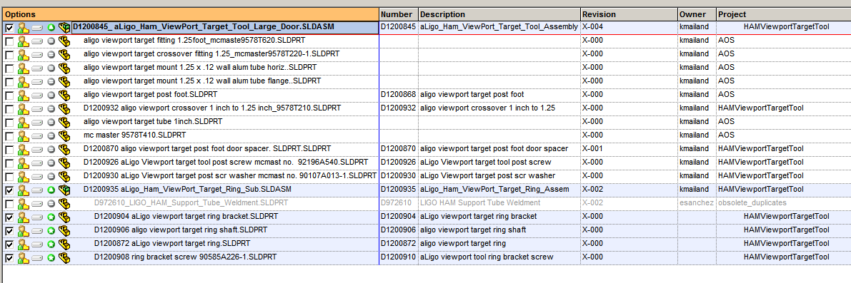

*******************************************
27. the front support wire needs to be changed to s s wire 304 x .06" diameter see the drawing for this part and bump the material and revision number.

******************************************
28,


*************
29.
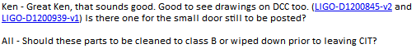
*******************************
30.
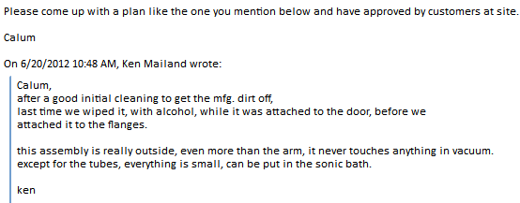

**************************************
31.

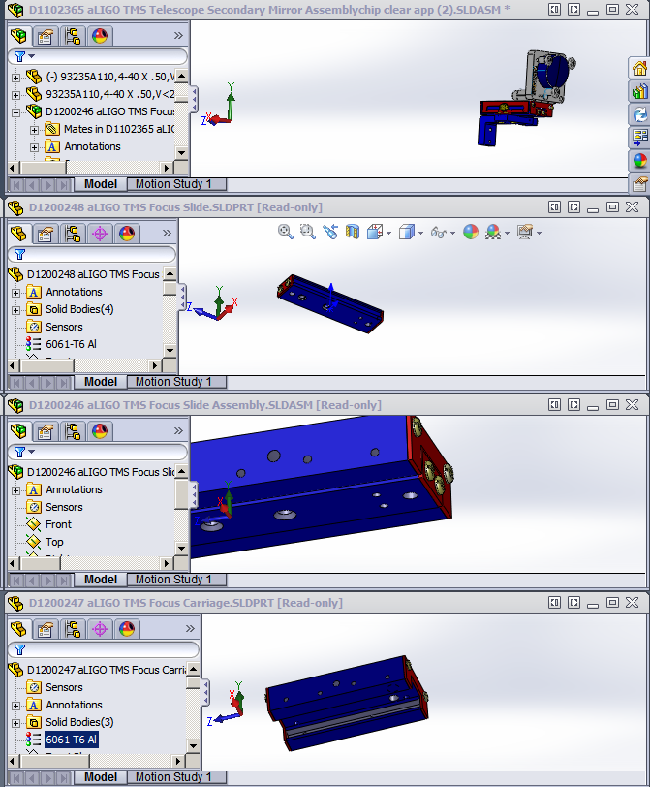
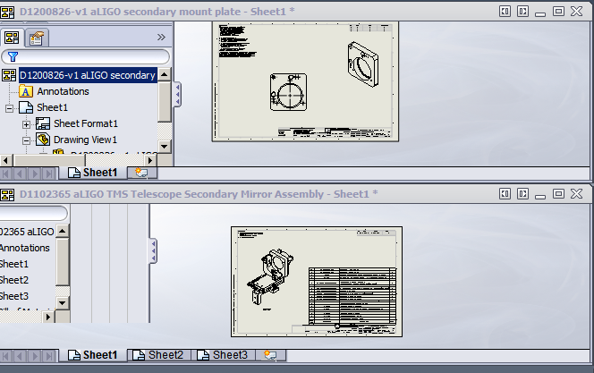
**********************************************************
32
ORDER QUOTED STRONGER SPRING FOR SECONDARY MIRROR MOUNT

**************************************************
33.
MAKE DRAWING FOR CAPTIVE SCREW FOR THE TMS TELESCOPE WIRE ATTACHMENT BRACKET

**********************************************
34.
COORDINATE THE ACQUISITION OF THE FINE PITCH F1 AND F2 SCREWS
FROM ISC
NOTE: ALSO THE 1 INCH MIRROR MOUNTS TO BE USED AS THE SECONDARY MIRROR MOUNT IN THE TMS TELESCOPE
**********************************************

35.
There are measurements done on TMSY at https://alog.ligo-wa.caltech.edu/aLOG/index.php?callRep=1825
Are they acceptable?

*************************************************************

36. look at email sent to Lisa and Calum approx 5-25- - 6-5, for To Do for TMS

******************************************************************
37.
Invar tube update to show turn and not grind od

***********************************************************
38.
Hi Ken -from Calum
Lisa is out of town this week but available. Let's do this, can you please review and update as appropriate the following links on the DCC. We can discuss then call Lisa.
- LIGO-D0901880: aLIGO AOS Transmission Monitor System Assembly
  - is this the top level?
  - is it's top level BOM up to date?
  - does it call all correct children?
  - do the children have bom's?
- LIGO-T1100304: TMS ASSEMBLY DOCUMENTATION and TOOLING
- LIGO-D1101307-v1: TOOLING LAYOUT-aLIGO TMS Telescope Cartridge lift Safety Supports
  - which one is it?
- LIGO-D0900419: AdvLIGO SUS BSC6-H2, XYZ Local CS for TMS ETM Tel Assy
  - this one looks done
- LIGO-D0900411: AdvLIGO SUS BSC5-H2, XYZ Local CS for ETM Tel Assy
- LIGO-D0900435: AdvLIGO SUS BSC4-L1, XYZ Local CS for ETM Tel Assy
- LIGO-D0900436: AdvLIGO SUS BSC5-L1, XYZ Local for ETM Tel Assy
- LIGO-D0902163: AdvLIGO SUS BSC9-H1, XYZ Local CS for ETM Tel Assy
- LIGO-D0902168: AdvLIGO SUS BSC10-H1, XYZ Local CS for ETM Tel Assy
  - these all need work to get them up to D0900419 level, this is work split between Ed / Eddie and Ken (Ed / Eddie do pdf's etc ... And Ken helps on linking correct documents and review of e.g. TMS position / configurations)
Once we have it to a level we are happy with we can then involve others.
*****************************************************
*****************************************************
39.
LIGO-D1200525-v1: aLIGO TMS Mass Base Assembly
check the part v1 and v2 in this assembly re. D1200312
use the V2 version that combines two of the parts in the FA into one
but re reference the assembly

*******************************************

40.
CAPTIVE SCREW FOR TELE TO TABLE WIRE CLAMP
D1200988
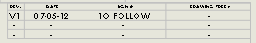

D1200989
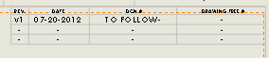

*********************************
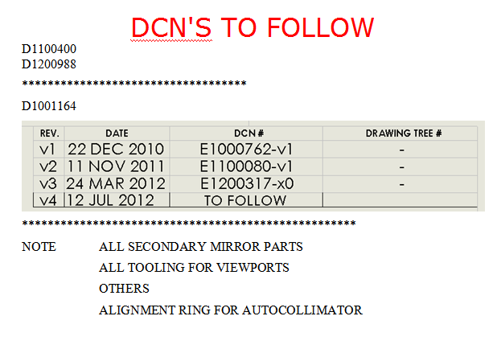
******************************************
41.


